National Anti-Racism Strategy

July 2012

Foreword
This Strategy is built on the work and contributions of many Australians. Our objective is to continue to build a strong, resilient and vibrant community in Australia, where we extend our taste for diversity beyond an appreciation of cuisines and celebrations to inclusiveness in the workplace, education, sporting activities, community events and many other aspects of our lives.
Our consultations across Australia in the past six months confirm what the research has told us. Racism exists. Sometimes it is hurtful words directed towards an individual or a community. Sometimes it is a prejudiced attack yelled out from a passing car or appearing in an online forum. Sometimes it is the cultural glass ceiling that hinders advancement to positions of responsibility. It is also institutionalised in the systemic racism that means that our First Peoples experience poorer health, education and employment outcomes than other Australians.
This Strategy is part of a suite of measures that are designed to protect all Australians from racism. It will complement the positive activities that occur through cultural diversity and reconciliation programs. It complements the domestic protections that are afforded under Commonwealth, state and territory legislation and that are articulated in our commitments under the Convention on the Elimination of Racial Discrimination. Maybe it will be brought into play every time we hear that phrase – ‘I’m not racist, but ….’
I hope that over the next three years this Strategy will have attracted multiple supporters from many areas of public life; and that we see plans for actions that not only support diversity but additionally address the racism that is so often a barrier for people in our community.
I look forward to working with you all on the implementation of this Strategy.

Dr Helen Szoke
Race Discrimination Commissioner
Australian Human Rights Commission

About the Strategy
In 2011, the Australian Government committed to develop and implement a National Anti-Racism Strategy for Australia. The Strategy will be implemented between July 2012 and June 2015. It will focus on public awareness, education resources and youth engagement and will be underpinned by research, consultation and evaluation.
Our aim
The aim of the National Anti-Racism Strategy is:
To promote a clear understanding in the Australian community of what racism is, and how it can be prevented and reduced.
Our objectives
The objectives of the Strategy are to:
- create awareness of racism and how it affects individuals and the broader community
- identify, promote and build on good practice initiatives to prevent and reduce racism, and
- empower communities and individuals to take action to prevent and reduce racism and to seek redress when it occurs.
Our partners
The Strategy has been developed through a partnership led by the Race Discrimination Commissioner, a member of the Australian Human Rights Commission, which draws on the expertise of the following government and community bodies: the Department of Immigration and Citizenship; the Attorney-General’s Department; the Department of Families, Housing, Community Services and Indigenous Affairs; the Australian Multicultural Council; the National Congress of Australia’s First Peoples and the Federation of Ethnic Communities’ Councils of Australia.

What is racism?
Racism can take many forms, such as jokes or comments that cause offence or hurt, sometimes unintentionally; name-calling or verbal abuse; harassment or intimidation, or commentary in the media or online that inflames hostility towards certain groups.
At its most serious, racism can result in acts of physical abuse and violence.
Racism can directly or indirectly exclude people from accessing services or participating in employment, education, sport and social activities.
It can also occur at a systemic or institutional level through policies, conditions or practices that disadvantage certain groups.
It often manifests through unconscious bias or prejudice.
On a structural level, racism serves to perpetuate inequalities in access to power, resources and opportunities across racial and ethnic groups.
The belief that a particular race or ethnicity is inferior or superior to others is sometimes used to justify such inequalities.

Why do we need a National Anti-Racism Strategy?
Australia is a vibrant, multicultural country. We are home to the world’s oldest continuous cultures, Aboriginal and Torres Strait Islander cultures, as well as Australians who identify with more than 270 ancestries. This rich, cultural diversity is one of our greatest strengths. It is central to our national identity.
Most new migrants feel a strong sense of belonging to Australia, a feeling that deepens over time.¹ However, the reality is that too many individuals and communities in Australia experience prejudice, discrimination and racism on a regular basis.
Racism can have serious consequences for the people who experience it. It can shatter their confidence and their sense of worth. It can undermine their ability to perform at work or in their studies. It can also affect their physical health and life expectancy.²
More broadly, racism locks people out of social and economic opportunities, entrenching disadvantage.
It adds unnecessary costs to our workplaces and our economy and it works against our goal of building a fair, inclusive community.
Ultimately, racism hurts us all.
The National Anti-Racism Strategy is about working together to take action against racism, in all its different forms, wherever we see or experience it.
“Racism creates a divide. Australia is one country but it doesn’t feel like it.”
National Anti-Racism Strategy survey respondent

- One in seven Australians say they experienced discrimination because of their colour or background in 2011, a figure that has been increasing steadily in recent years.3
- Around one in five Australians say they have experienced race-hate talk, such as verbal abuse, racial slurs or name-calling.4
- Around one in ten Australians say they have experienced race-based exclusion in the workplace or social events.5
- More than one in 20 Australians say they have been physically attacked because of their race.6

Who experiences racism in Australia?
Racist behaviour, such as name-calling and abuse, can be directed against, and emanate from, members of any racial group. However, some people in Australia are more vulnerable to racism and discrimination, particularly Aboriginal and Torres Strait Islander peoples and people from culturally and linguistically diverse backgrounds. Members of certain religious groups also experience discrimination on the basis of their race or ethnicity.
It is important to understand that the experiences of these groups can be very different.
“I’m a proud Australian but (racism) does make me cringe. We can do better.”
National Anti-Racism Strategy survey respondent

Aboriginal and Torres Strait Islander peoples continue to confront racism and discrimination on an almost daily basis: from the general public, at work, when accessing and using services and in connection with the law and justice system.⁷
Many also experience the continuing legacy of racially discriminatory laws and government policies of the past, which were grounded in the belief that Aboriginal and Torres Strait Islander people and cultures were inherently inferior.⁸
The consequences of these policies – which meant Aboriginal and Torres Strait Islander peoples did not have the same access to resources, opportunities and power as other Australians – have been profound, creating an historical disadvantage that has been passed from one generation to the next.⁹
Australians from culturally and linguistically diverse backgrounds also confront prejudice and discrimination on a regular basis. However, the experiences of these diverse communities can vary greatly, being shaped in large part by their particular histories of migration and settlement.
Research indicates that people born overseas face higher levels of racism than people from culturally and linguistically diverse backgrounds born in Australia, especially in the workplace.¹⁰ We also know that migrants who have recently arrived in Australia – especially those who are visibly different because of their skin colour or their dress – are more likely to encounter prejudice and discrimination than ‘settled’ migrants.¹¹
The National Anti-Racism Strategy sets out a series of high-level initiatives to combat the interpersonal and systemic racism encountered by people from culturally and linguistically diverse backgrounds in Australia. It also recognises and will respond to the racism and social exclusion experienced by Aboriginal and Torres Islander peoples.
“Racism is a constant ‘background noise’ in the lives of Aboriginal and Torres Strait Islander people.”
Submission by Victorian Aboriginal Child Care Agency

How did we hear from people?
- We held 23 consultations across every state and territory, including five consultations with Aboriginal and Torres Strait Islander communities, involving almost 700 people.
- We received over 1500 electronic surveys and 200 submissions.

Listening to the community
The National Anti-Racism Strategy has been directly shaped by the views of Australians from all parts of the country, through a wide-ranging consultation process held between March and May 2012.
A strong message came through from the public during the consultations: taking action against racism in all its forms is critically important if we want to build a fair and inclusive community.
There was also broad agreement about the priority areas where interpersonal and systemic racism should be addressed, including:
- schools and higher education
- the media
- government service provision
- workplaces
- online, and
- sport.
Respondents highlighted the particular importance of reaching young Australians with strong anti-racism messages and creating ‘safe spaces where young people could talk across race lines’.
“I feel that although I have an Australian citizenship, I am treated as a second-class citizen.”
National Anti-Racism Strategy survey respondent

In addition, a significant number of respondents noted that the National Anti-Racism Strategy should support initiatives which promote respect and recognition of Aboriginal and Torres Strait Islander peoples and cultures.
Many examples of successful public awareness programs and education resources were also provided during the consultations.¹²

Building on existing measures to tackle racism
Australia is committed to eliminating racism and racial discrimination.
In September 1975, the Australian Government ratified the International Convention on the Elimination of Racial Discrimination, which sets out Australia’s international legal obligations to eliminate racism and guarantee the right to equality.
The Racial Discrimination Act 1975 (Cth) is one important way that Australia meets to its obligations under the Convention. The Racial Discrimination Act promotes equality before the law and prohibits discrimination on the basis of race, colour, descent and national or ethnic origin. In 1995, the Racial Discrimination Act was extended to make ‘racial hatred’ unlawful. Racial hatred is doing something in public based on the race, colour, national or ethnic origin of a person or group of people which is likely to offend, insult, humiliate or intimidate.¹³
There are also laws in every Australian state and territory to protect people from racial discrimination.
More recently, Australia has formally endorsed the United Nations Declaration on the Rights of Indigenous Peoples, which reaffirms that Aboriginal and Torres Strait Islander people, in exercising their rights, should be free from discrimination.
Effective laws are critical tools for addressing racism and discrimination. They also send a strong message about our shared values and the importance of a fair go for all. However, laws alone are not enough.

Racism – it stops with us
This Strategy calls on all members of the Australian community to work towards eradicating the barriers to equality that result from racism.
Ultimately, racism stops because of the actions we take individually and collectively. We all have a role to play in taking action against racism wherever we see it and supporting initiatives to stop it from happening.
Community education and building on good practices at the local, state and national level are essential for preventing racism and promoting social inclusion.
For example, a number of state governments have implemented policies and programs to identify and address ‘invisible’ racism and discrimination in the way they work.
Likewise, local councils around the country have developed a broad range of activities to promote cultural diversity and build bridges between people from different communities.
Many non-government organisations, business groups, employers and peak sporting bodies have also taken steps, big and small, to combat racism, counter negative stereotypes and open up new opportunities for Australians of all backgrounds.
The National Anti-Racism Strategy will build on the positive work that is taking place right around the country, in particular by sharing examples of good practice and encouraging initiatives that engage young people, promote public awareness and build a storehouse of high-quality education resources.

What we will do
The National Anti-Racism Strategy seeks to combat racism by promoting a clear understanding in the Australian community of what racism is and how it can be prevented and reduced.
It will implement the following high-level actions to generate progress on the Strategy’s three objectives.
Objective 1: Create awareness of racism and its effects on individuals and the broader community
- Launch and implement a campaign to create public awareness of racism and what we can do about it.
- Identify and work with champions who will promote the objectives of the Strategy and activities to combat racism in identified priority settings.
- Support and promote research on the prevalence of racism in areas of public life to increase awareness of its economic and social impacts.
Objective 2: Identify, promote and build on good practice initiatives to prevent and reduce racism
- Align with and reinforce policies and legal protections that promote respect and equality for Australians of all racial, ethnic and cultural backgrounds.
- Establish a clearinghouse of resources which demonstrate good practice in preventing and reducing racism, with a specific focus on young people.
- Work with stakeholders in identified priority settings to support and promote good practice initiatives to address systemic racism.
- Build partnerships with all levels of government and non-government organisations to support and promote good practice initiatives to address systemic racism at national, state and local levels.
Objective 3: Empower communities and individuals to take action to prevent and reduce racism and to seek redress when it occurs
- Identify and promote resources to support individuals and communities to respond effectively to interpersonal and systemic racism
- Identify and promote information to individuals and communities at particular risk of racism to strengthen their access to legal protections.

Implementing the Strategy to achieve success
To ensure its success, the National Anti-Racism Strategy will be implemented in a staged process over a three year period.
From July 2012: We will launch and implement a public awareness campaign on what racism looks like and what we can do about it. Over the course of the year we will focus on building community awareness of racism, promoting research into its economic and social costs and identifying how we can most effectively support and complement other existing initiatives that prevent and reduce racism and promote respect and equality.
From July 2013: One of our key activities will be to establish a clearinghouse of anti-racism education resources which will, in part, draw on material gathered from research conducted in the previous year. We will also begin collating good practice resources to support individuals and communities to take action against racism. In addition, we will begin collaborating with organisations working in our priority areas to identify good practice approaches to combating systemic racism.
From July 2014: Using the resources we have collected and developed, we will work with our supporters to build the capacity of individuals and communities to respond effectively to racism in all its forms.
The members of the National Anti-Racism Strategy Partnership will work collaboratively to implement the Strategy. At the conclusion of the three years, the progress and outcomes of the Strategy will be assessed and evaluated.

Building partnerships to achieve our goals
Taking action against racism is in everyone’s interest. By working together, we can change things for the better.
That is why the National Anti-Racism Strategy centres on building close partnerships with individuals and organisations from all parts of the Australian community.

Our aim is to draw together a wide variety of supporters in the following priority settings:
- schools and higher education
- the media
- government service provision
- workplaces
- online, and
- sport.
Our supporters will help to implement the Strategy by identifying examples of good practice in the sectors where they work, by encouraging others to take action against racism and by using their influence to shape attitudes and opinions.
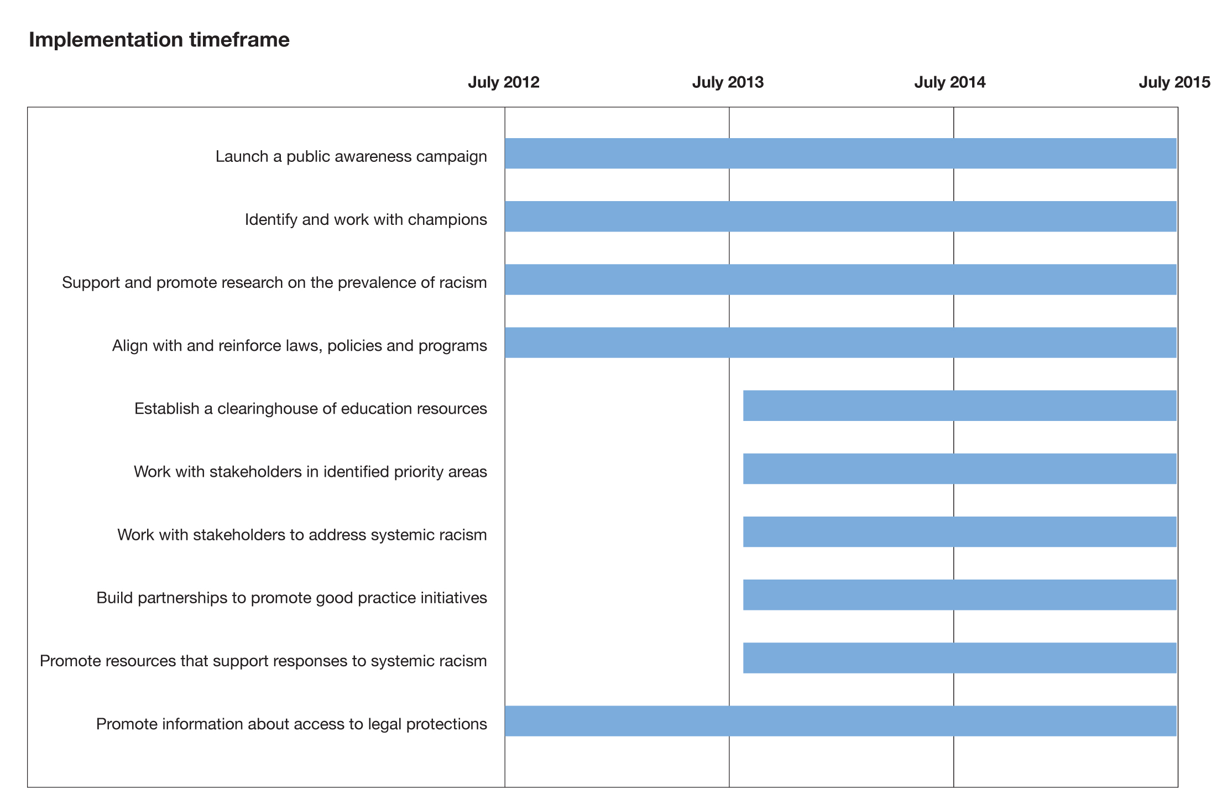

Making a lasting impact
The National Anti-Racism Strategy complements, reinforces and builds on existing laws, initiatives and policies. It is intended to generate sustained momentum towards three goals:
- more Australians recognise that racism is unacceptable in our community
- more Australians become involved in practical action against racism, wherever it happens
- individuals and communities are empowered to respond effectively to racism through access to information and resources, legal protections and, where necessary, mechanisms for redress.

Get involved
National Anti-Racism Strategy Secretariat
Phone: 02 9284 9600 or 1800 620 241 (TTY)
Email: antiracismsecretariat@humanrights.gov.au
Web: www.humanrights.gov.au
Address: Level 3, 175 Pitt Street
SYDNEY NSW 2000
GPO Box 5218
SYDNEY NSW 2001
The Australian Human Rights Commission resolves complaints from people who have experienced racial discrimination.
For free advice on discrimination and your rights, or to make a complaint, call the Commission’s Complaints Information Line on 02 9284 9888, 1300 656 419 (local call) or 1800 620 241 (TTY).
Information about making or responding to a complaint is available at http://www.humanrights.gov.au.
You can also email the Commission at mailto:complaintsinfo@humanrights.gov.au.

References
1 The Ipsos McKay Report found that 60% of first-generation migrants felt a strong sense of belonging to Australia, which rose to 80% by the second generation, in line with the national average. Ipsos Eureka Social Research Institute, Ipsos McKay Report: SBS Immigration Nation (2011). At: http://www.sbs.com.au/aboutus/corporate/view/id/556/h/SBS-Ipsos-Immigration-Nation-Research-Full-Report.
2 M Sweet, ‘Tackling discrimination is good for health’ (2007), Issue 30, Winter Vic Health Letter, p4-7. At http://www.vichealth.vic.gov.au/en/Publications/VicHealth-Letter/Making-the-link-between-cultural-discrimination-and-health.aspx. Further, a growing body of evidence suggests that discrimination and racism are linked to a range of adverse health conditions among Aboriginal and Torres Strait Islander peoples, such as smoking, substance use, psychological distress and poor self-assessed health status. See Y Paradies, ‘A systematic review of empirical research on self-reported racism and health’ (2006) International Journal of Epidemiology 35(4) p 1. http://ije.oxfordjournals.org/cgi/reprint/dyl056v1. Similarly, some research suggests a link between ethnic and racial discrimination and poor mental health and wellbeing; see: Vic Health, Ethnic and race-based discrimination as a determinant of mental health and wellbeing (2009). At: http://www.vichealth.vic.gov.au.
3 The research was based on a random phone survey of 2,000 people conducted in June-July 2011; A Markus, Mapping Social Cohesion 2011: the Scanlon Foundation Survey (2011). At: http://www.arts.monash.edu.au/mapping-population/scanlon-foundation-surveys.php.
4 The Challenging Racism Project included research based on random phone surveys with 12,500 people conducted between 2001 and 2008. K Dunn, Challenging Racism: The Anti-Racism Research Project. At: http://www.uws.edu.au/social_sciences/soss/research/challenging_racism/findings_by_region.
5 K Dunn, Challenging Racism: The Anti-Racism Research Project.
6 K Dunn, Challenging Racism: The Anti-Racism Research Project.
7 Australian Institute of Health and Welfare, The health and welfare of Australia’s Aboriginal and Torres Strait Islander people: An overview 2011, note 42. At: http://www.aihw.gov.au/publication-detail/?id=10737418989.
8 Note by the Secretary-General transmitting the report of the Regional Meeting of Indigenous Peoples on the World Conference against Racism, Racial Discrimination, Xenophobia and Related Intolerance, Sydney, Australia, 20-22 February 2001; para. 24.
9 Reconciliation Australia, Australian Reconciliation Barometer 2010 (2010). The Question and Answer Fact Sheet notes respondents’ belief that previous race-based policies continue to affect some Aboriginal and Torres Strait Islander people today. At: http://www.reconciliation.org.au/home/resources/factsheets/q-a-factsheets/baromter-2010.
10 K Dunn et al, Challenging Racism: the anti-racism research project, State level comparisons, (Paper for the 4Rs Conference, Sydney, 30 Sept - 3 Oct 2008). At: http://www.uws.edu.au/ssap/school_of_social_sciences_and_psychology/research/challenging_racism/publications.

11 For example, the 2010 and 2011 Scanlon Foundation surveys indicated a long‐term change in Australian opinion, with a large measure of acceptance of groups once stigmatised: ‘The level of negative feeling towards immigrants from Italy and Greece was found to be less than 3%; it was 7% towards immigrants from Vietnam and 13% from China.’ A Markus, Mapping Social Cohesion 2011: the Scanlon Foundation Survey (2011), pp 1-2. At: http://www.arts.monash.edu.au/mapping-population/scanlon-foundation-surveys.php.
12 Australian Human Rights Commission, National Anti-Racism Strategy consultation report (2012). At: http://www.humanrights.gov.au.
13 More detailed information about the Racial Discrimination Act 1975 (Cth) is available from the Australian Human Rights Commission. See: http://www.humanrights.gov.au.

