Office of the
Public Advocate

Disability
Action Plan

2016-2019

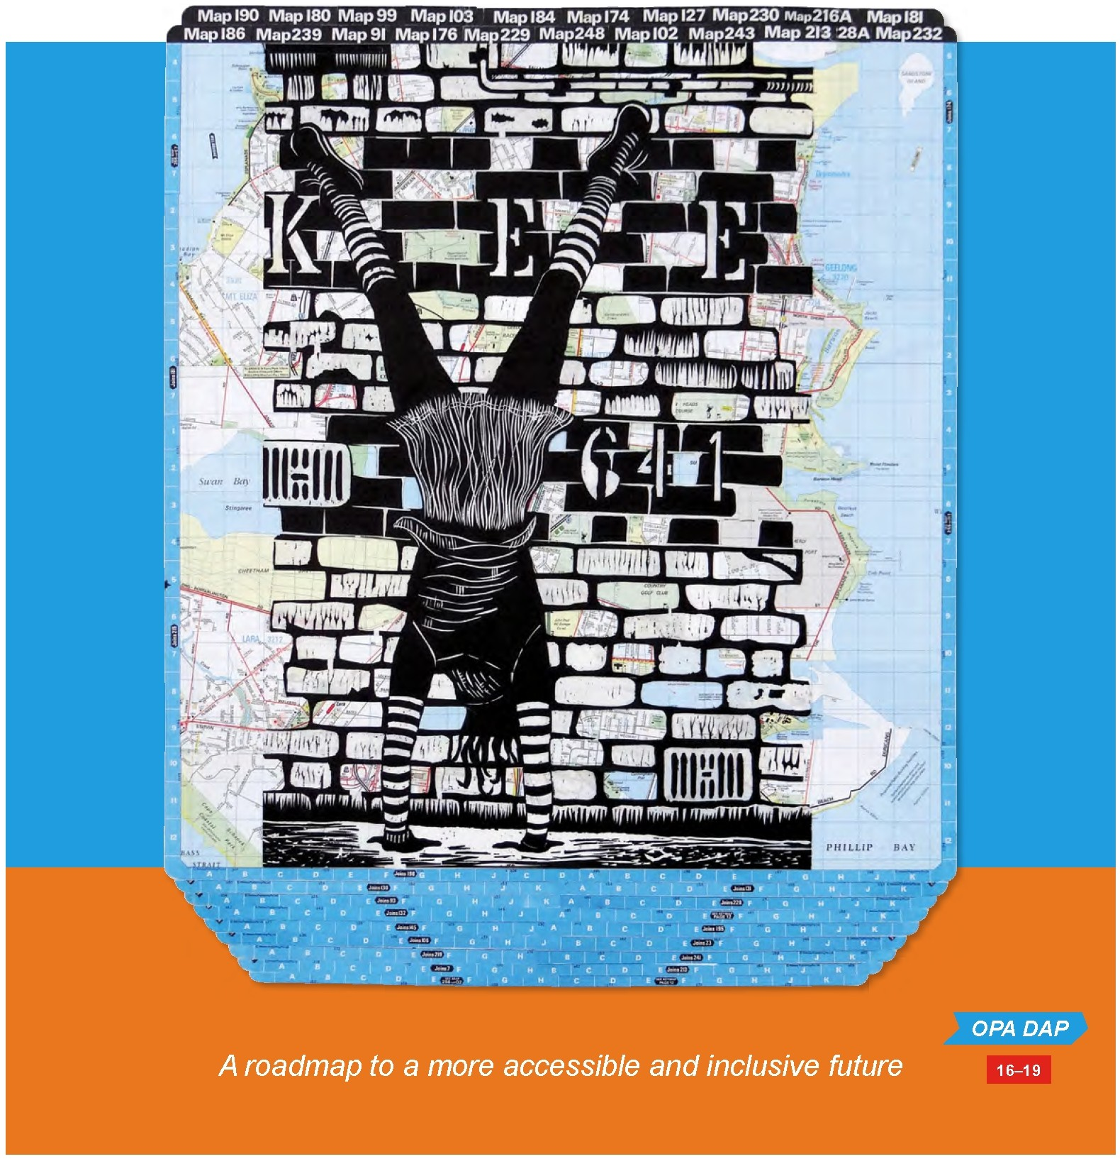


Foreword

The Office of the Public Advocate’s (OPA) vision is of a just and inclusive society that respects and promotes the dignity and human rights of all people. The Disability Action Plan is a key way to ensure that this vision, and OPA’s specific contribution to it, is embedded in OPA’s workplace culture.

The plan aims to address the disability-related barriers that prevent people with disability from:
• accessing OPA’s workplace and facilities when necessary

• participating in life at OPA as employees, volunteers, interns or trainees

• obtaining information they need from OPA in accessible formats

• expressing their wishes, and having these wishes met to the fullest extent possible, as OPA clients
• contributing to the systemic advocacy of OPA

• experiencing positive attitudes towards themselves in the community and having their human rights respected.

OPA values the contribution that people with disability make to the life of the community and to the organisation. The strategies, goals and actions outlined in this plan ensure that OPA’s work with people with disability is best practice and inclusive, in fulfilment of its human rights vision.

Colleen Pearce
Public Advocate

About the artist
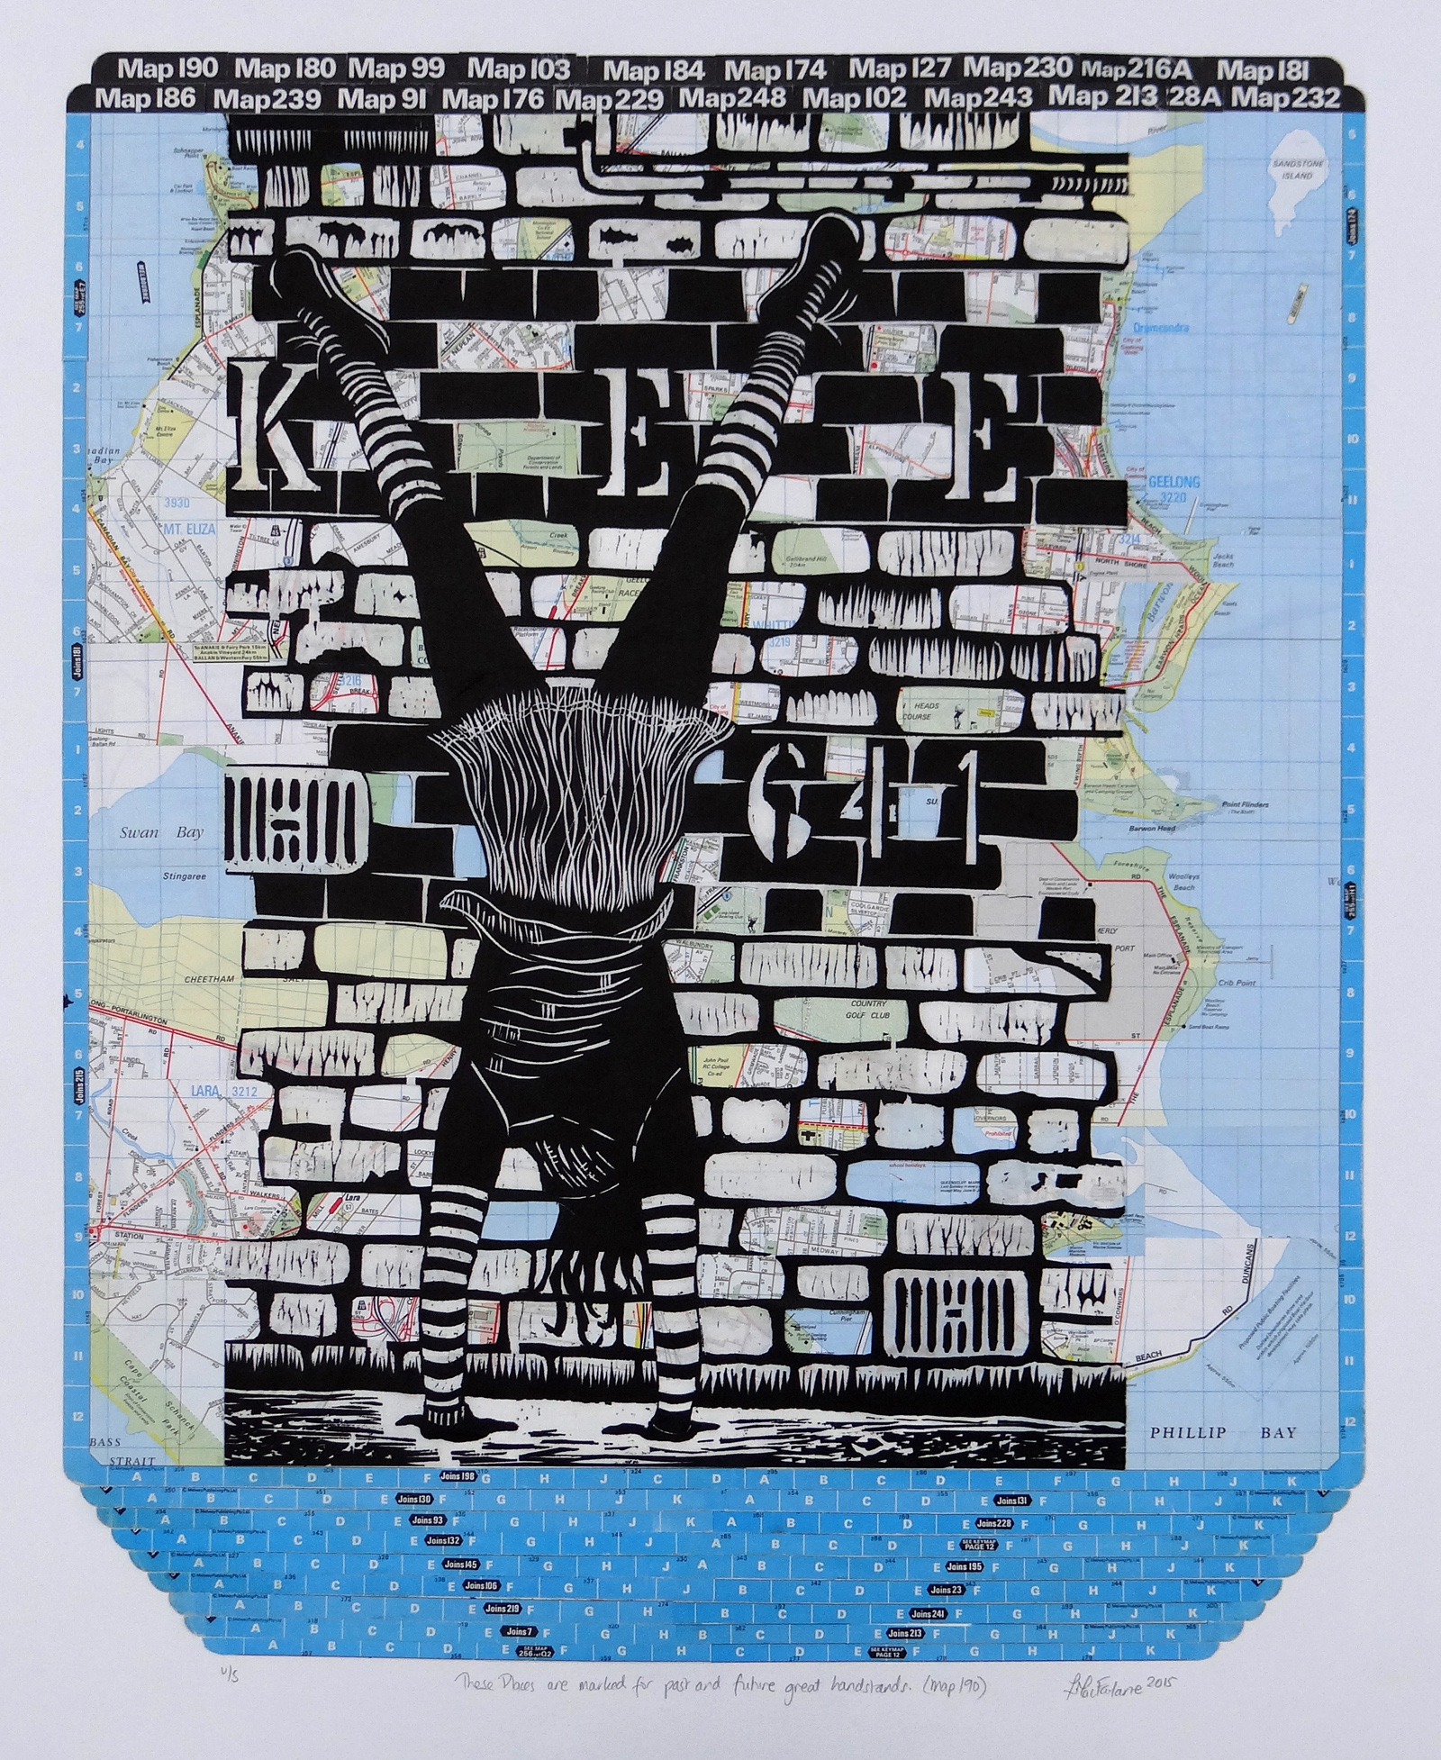
These places are marked for past and future great handstands (map 190)
by Larissa MacFarlane (woodcut and collage).

“This artwork is part of my ongoing investigation into my daily ritual of performing handstands. Over the past eleven years, I have done at least one handstand every day. Some may consider this a weird obsession, but handstands are in fact a key part of managing my ongoing physical and mental illnesses. My handstands are not public performances, but private moments which bring me grounding, pain relief and joy. This artwork shows the real and imagined geographical breadth of my handstand practice.”

- Larissa MacFarlane

OPA DAP

02

Introduction

About OPA

The Office of the Public Advocate (OPA) is a Victorian independent statutory body and human rights organisation. Its mission is to uphold the rights and interests of people with disability and work to eliminate abuse, neglect
and exploitation.

Disability refers to physical, sensory and intellectual disability, as well as psychosocial disability.

The Disability Action Plan (the plan) is one of four strategic documents that provide a foundation for OPA’s human rights focus and its vision for a just and inclusive society that respects and promotes the dignity and human rights of all people.

The other three strategic plans are:

• OPA’s Cultural Diversity Strategic Plan 2011-2014

• OPA’s Koori Inclusion Action Plan 2015-2018 and

• OPA’s Strategic Plan 2013-2016.
03

This plan is particularly relevant to OPA’s vision, purpose and values.

OPA’s values

OPA’s organisational values underpin and reflect OPA’s commitment to promote disability best practice.

Respect: treat everyone equally and with dignity and justice, accept each person’s individuality, acknowledge diversity and promote self-determination.

Compassion: accept people as they are and understand, acknowledge and have empathy for their circumstances.

Inclusiveness: strive to empower all people to contribute and participate.

Ethical behaviour: act at all times in a principled and informed manner, treat people fairly, accept accountability and uphold justice.

Independence: be free-thinking, unbiased and impartial, and challenge the status quo.

Legal and policy frameworks

The plan also supports OPA’s commitments to meet its international, national and state-based legislative obligations to promote the human rights of staff, volunteers and clients.

The human rights principles OPA supports are included in:

• The United Nations’ Convention on the Rights of Persons with
Disabilities 2006

• Disability Discrimination Act 1992 (Commonwealth)

• Charter of Human Rights and Responsibilities Act 2006 (Victoria)

• Disability Act 2006 (Victoria)

• Equal Opportunity Act 2010 (Victoria).

The Equal Opportunity Act requires OPA to act in accordance with its
duty under section 15 to eliminate discrimination, sexual harassment and victimisation from its organisation as far as possible.

As a Victorian public sector body, OPA is also required to have a plan under section 38 of the Disability Act.
04

The key purposes of the plan are to reduce barriers to people with disability by:

• improving access to goods, services and facilities

• obtaining and retaining employment of people with disability

• promoting inclusion and participation in the community of people with disability
• achieving tangible changes in attitudes and practices that discriminate against people with disability.

OPA also supports the policy objectives of the Victorian State Disability Plan
2013-2016, in particular:

• Goal Two: Upholding rights and promoting participation

• Outcome Four: To better protect human rights.

The development of the plan

These legal and policy frameworks informed the development of this plan. OPA staff had significant input into the development of the plan. It also benefitted from the expertise of various disability organisations on specific aspects of the plan, as well as from OPA’s external disability advisory group, which includes people with lived experience of disability, as well as people from community-based disability organisations.

The structure of the plan

The plan includes the following seven strategies:

• accessible workplace and facilities

• accessible and inclusive communication access

• employment and volunteering

• training and professional development

• programs and services

• engaging with and involving stakeholders
05

• monitoring and evaluating the plan.
Accessible workplace and facilities

OPA's goal: To achieve an accessible workplace by ensuring that staff, volunteers and visitors to OPA are able to access and move freely around the OPA workplace and facilities, in accord with OPA's security policy, without any barriers to physical access.

What will we do | What will success look like | Responsibility | Timeline
Complete a disability access audit of OPA and its facilities early in the life cycle of the plan, which identifies physical barriers to accessing OPA premises and facilities. | Disability access issues are identified and are addressed as soon as practicable. | Manager, Corporate Services  Manager, Quality and Compliance | 2016
Prioritise access improvements for action in each year of the plan. | Implementation plans for access improvements are put in place for each year of the plan. | Leadership Team | Ongoing
Develop schematic designs of proposed enhancement to disability access as required.  Liaise with the building owner on any physical access issues, and implement identified actions within OPA's influence and control, in order to improve disability access for people with disability. | Access to OPA's workplace and facilities is best practice for people with disability. | Manager, Corporate Services | Ongoing

Accessible and inclusive communication access
OPA's goal: To ensure that people with communication access needs do not experience barriers when attempting to contact OPA or access information that OPA provides.

What will we do | What will success look like | Responsibility | Timeline
Ensure OPA's website meets and maintains AA accessibility standards as per Web Content Accessibility Guidelines (WCAG) 2.0. | People with disability support needs are able to obtain information from OPA's website and Advice Service in a way that meet their needs. | Director of Strategy  Communications Coordinator | Ongoing
Make information available in alternative formats to meet a variety of disability support needs for OPA clients, staff, volunteers, visitors and the public. | Scope Victoria accredits OPA to use its Communication Access symbol.  Communication access to OPA's information and to the Advice Service is best practice for people with a range of disability support needs. | Manager, Quality and Compliance | 2016
Ensure Easy English versions of OPA publications are available where possible, or a plain English summary if development of an easy English version is not feasible. | OPA identifies and addresses disability communication access issues as soon as practicable. | Communications Coordinator  Coordinator, Advice and Education Service | Ongoing
Investigate the feasibility of developing an Easy English section of OPA's public website. | Increased opportunities for people with disability to access information suitable for their needs. | Communications Coordinator | 2016

What will we do | What will success look like | Responsibility | Timeline
OPA's Advice Service will conduct an audit or survey investigating whether new technologies such as Live Chat would improve disability communication access to OPA's Advice Service. | Improvements to disability communication access are prioritised for action in each year of the plan. | Coordinator, Advice and Education Service | 2017
OPA will promote its ability to provide interpreters, attendant carers and other supports during OPA-initiated community education presentations. | OPA-initiated community education presentations are fully inclusive of people with disability. | Coordinator, Advice and Education Service | Ongoing
Ensure people contacting OPA are able to do so in a variety of ways that address their support needs, including but not limited to:  - utilising available accessible communication technologies  - providing sign interpreters to Deaf people who want or need to communicate in person  - ensuring all new OPA business cards are Braille embossed  - captioning all new videos and captioning one older video each year  - providing audio descriptions of captioned videos if necessary. | OPA increases use of accessible technologies for communication. | Leadership Team | Ongoing
OPA will promote a variety of contact options on its website, publications and business cards. | OPA's use of accessible communication technologies is best practice. | Communications Coordinator  Manager, Corporate Services | Ongoing

Employment and volunteering

OPA's goal:

1. To reduce barriers to people with disability becoming employees or volunteers (including student placements or interns) at OPA.

2. To increase the proportion of staff and volunteers with disability at OPA to ten per cent of our paid and volunteer workforce, reflecting the proportion of working-aged people (15-64 years) with disability currently in the workforce.

3. Work towards increasing the percentage of people with disability employed or volunteering at OPA to 15 per cent, reflecting the percentage of people with disability of workforce age.

What will we do | What will success look like | Responsibility | Timeline
Undertake a short anonymous survey at least once every three years to determine how many OPA employees and volunteers are people with disability, and whether their support needs are being met. | OPA has an understanding Director of Strategy of any outstanding disability support issues that need addressing, and has a plan to address them.  OPA employees and volunteers feel more confident in declaring if they have a disability, and more comfortable identifying whether their disability support needs are being met. | Director of Strategy | December 2016  Ongoing
Ensure all advertisements for employees and volunteers state clearly that:  'OPA embraces diversity among our staff and volunteers and encourages applications from people with disability, including people with mental ill-health, as well as people from all cultural backgrounds, including Aboriginal and Torres Strait Islander people.' | Increased public recognition of OPA's commitment to engage people with disability as employees or volunteers, with more people with disability encouraged to apply for employment or volunteer positions. | Leadership Team | Ongoing

What will we do | What will success look like | Responsibility | Timeline
Ensure all positions at OPA are advertised widely through Disability Employment Services and community disability networks, including services or networks that support people with cognitive impairment. | Increased opportunities for people with disability (including students) to volunteer, gain employment or internships at OPA. | Manager, Corporate Services | Ongoing
Identify staff positions which are suitable for people with cognitive impairment, or which could be adapted to suit a person with cognitive impairment. | Increased opportunities for people with cognitive impairment to gain employment at OPA. | Manager, Corporate Services  Leadership Team | December 2016
Implement a policy for a graduate internship for people with disability, in order to facilitate the employment of interns in an unpaid capacity. | Increased opportunities for people with disability (including students) to volunteer, gain employment or internships at OPA. | Director of Strategy  Leadership Team | September 2016
Ensure all applicants with disability who advise in their application that they have a disability (and who meet the selection criteria for a position) are offered an interview. This includes paid, volunteer, and trainee positions (including student and graduate interns). | Increased opportunities for people with disability to gain an interview at OPA. | Leadership Team | Ongoing
Offer unsuccessful interviewees with disability the opportunity to receive feedback on their interviews. | Unsuccessful interviewees with disability gain increased opportunities to gain interview experience and to receive feedback to increase their chances of achieving employment in the future. | Leadership Team | Ongoing

What will we do | What will success look like | Responsibility | Timeline
Ensure that, whenever practicable, OPA's work environment supports flexible work practices that meet the disability support needs of staff or volunteers at OPA. | OPA's employment policies and practices are best practice. | Leadership Team | Ongoing
Join the Australian Network on Disability, via the Department of Justice and Regulation membership if the department joins this network.  Investigate the possibility of OPAjoining individually, if the department does not join this network. | Increased opportunities for people with disability to gain work experience and an understanding of OPA, and a pool of potential future employees identified. | Manager, Corporate Services | 2016
Across OPA, encourage the use of traineeships, including the 'stepping into' program of undergraduate internships managed by the Australian Network on Disability. | Increased opportunities for undergraduate interns with disability in the 'stepping into' program to gain work experience opportunities at OPA and an understanding of OPA, and a pool of potential future employees identified. | Director of Strategy | Ongoing
Accommodate disability support needs and adjust individual workplaces for staff with disability employed at OPA.  Promote the return to work of any OPA staff member acquiring a disability or mental ill health during employment at OPA. | Disability support needs of individual staff with disability are met and valued staff with disability are retained.  Increased rate of return to work for OPA staff with disability. | Manager, Corporate Services | Ongoing

Training and professional development

OPA's goal: To ensure staff and volunteers are appropriately knowledgeable, trained and skilled in disability issues, are kept up-to-date on emerging trends, and are appropriately skilled in client relations, particularly regarding clients with disability.

What will we do | What will success look like | Responsibility | Timeline
At least once every two years, OPA training will include information on human rights issues and legislation relevant to OPA, including but not limited to:  - the Disability Discrimination Act (Commonwealth)  - Equal Opportunity Act (Victoria)  - OPA's Disability Action Plan  - Victorian Charter on Human Rights and Responsibilities  - human rights and other legislative issues associated with disability, mental illness and cognitive disability. | Employees at OPA have an increased awareness of, and increased skill levels regarding, people with disability and legislative requirements. | Practice Committee  Principal Legal Officer | Ongoing
At least once every two years, OPA training will include information about current perspectives on disability policy relevant to its work. | Employees at OPA have an increased awareness of, and increased skill levels regarding people with disability. | Practice Committee  Principal Legal Officer | Ongoing

What will we do | What will success look like | Responsibility | Timeline
Ensure OPA's volunteers have up-to-date information on disability legislation and other human rights legislation, the OPA disability action plan, and other issues affecting people with disability through training days or the use of newsletters and OPA's Volunteer Hub. | Volunteers have increased awareness of legislative requirements and issues affecting people with disability. | Manager, Volunteer Programs | Ongoing
Maintain a list of relevant disability and aged care organisations, information and relevant resources on the OPA intranet. | Maintained and increased staff awareness of the range of disability information available to support OPA's work. | Director of Strategy | Ongoing

Programs and services

OPA's goal: To ensure OPA clients with disability do not experience barriers
to accessing OPA services and programs, and have their individual needs for
services and support acknowledged and appropriately met.

What will we do | What will success look like | Responsibility | Timeline
Provide advocacy that promotes autonomy and the best interests of people with disability. | Autonomy and increased access to services, security and enjoyment of life for people with disability are promoted. | Manager, Advocate Guardian Program | Ongoing
Conduct investigation services, including own motion investigations, in cases where there are issues of exploitation, abuse or neglect of people with disability relating to guardianship matters. | Exploitation, abuse and neglect of people with disability are reduced. | Manager, Advocate Guardian Program | Ongoing
Provide guardianship that promotes autonomy and the best interests of people with disability | Decisions made promote the best interests and autonomy of OPA clients | Manager, Advocate Guardian Program | Ongoing

What will we do | What will success look like | Responsibility | Timeline
OPA will provide its clients with appropriate supports to ensure that their disability communication needs are met. This could include, but is not limited to:  - Using a Telephone Typewriter or the Australian Communication Exchange (National Relay Service) where appropriate  - Auslan interpreters for Deaf people  - Deaf-blind Interpreters  - Other forms of augmentative communication appropriate to the needs of the person. | Clients of OPA with disability communication support needs are provided with a range of communication support options. | Leadership Team | Ongoing
Identify in each OPA Business Plan systemic issues affecting people with disability and pursue improvements to policies, practices, services and laws. | The autonomy and human rights of people with disability are promoted through OPA’s systemic advocacy work. | Leadership Team, Director of Strategy | Ongoing
Maintain an accessible, easy to use complaints procedure. | The complaints process is accessible, easy to use, well publicised and responsive. | Manager, Quality and Compliance | Ongoing
Information on the complaints procedure is included in staff orientation material and OPA’s website. | Staff are well-informed about the complaints procedure and give effect to it. | Manager, Quality and Compliance | Ongoing

Engaging with and involving stakeholders

OPA's goal: To engage in respectful partnerships with key stakeholders in the disability advocacy, elder advocacy and other relevant sectors, and develop partnerships that provide opportunities for open, transparent discussion and an exchange of ideas.

What will we do | What will success look like | Responsibility | Timeline
Identify key stakeholders in priority areas of policy development and systemic advocacy for OPA. | Key stakeholders have the opportunity to participate, inform and influence policy development and systemic issues. | Director of Strategy | Ongoing
Stakeholders with disability who are involved in policy development and systemic issues will have any barriers to their participation addressed. | Stakeholders with disability are able to participate effectively in policy development and systemic advocacy.  OPA stakeholder engagement is best practice. | Director of Strategy | Ongoing
Provide opportunities to exchange ideas on current systemic and policy issues to inform OPA's activities. | The views and concerns of people with disability people with disability inform OPA's policies and practices. | Director of Strategy | Ongoing

Monitoring and evaluating the plan

OPA's goal: To monitor and evaluate the plan to ensure that it remains a living, relevant document, championed by staff, and is subject to continuous improvement.

What will we do | What will success look like | Responsibility | Timeline
Ensure that an identifiable manager is the driver of the plan. | The plan is embedded in OPA culture and is implemented and monitored in a timely, efficient manner. | Director of Strategy | Ongoing
All managers responsible for implementing actions in the plan will reflect that responsibility in their annual performance plan. | Implementing the plan is endorsed as a priority for OPA's Leadership Team. | Leadership Team | Ongoing
Use the lived experience and knowledge of the Policy and Research Reference Group as a consumer consultative group for developing and monitoring of the plan. | The Policy and Research Reference Group have input into the development of the plan and receive an update of progress annually. | Director of Strategy | Ongoing
Establish a plan staff consultative committee with representatives from programs and areas across OPA, who will monitor and evaluate the effectiveness of the plan, and contribute to the development of the next plan. | The members of this committee receive feedback on the plan and act as ‘champions’ or staff representatives of the plan. | Director of Strategy | Ongoing
Provide a bi-annual update, to the OPA staff consultative committee on the progress of the plan. | Updates on the plan are embedded in OPA‘s staff consultation processes. | Director of Strategy | Bi-annually

What will we do | What will success look like | Responsibility | Timeline
Incorporate the plan into OPA's business planning process. | All OPA activities are consistent with, and promote, the objectives and strategies of the plan. | Manager, Corporate Services | Annually
Information about the achievements of the plan is publically available. | The plan is available on OPA’s website.  The plan is reported on in the OPA annual report (as required by s.38 (3) Disability Act 2006 (Victoria)). | Director of Strategy | Annually
Register the plan with the Australian Human Rights Commission. | A link to the plan is available on the Australian Human Rights Commission website. | Director of Strategy

Office of the Public Advocate
Level 1, 204 Lygon Street, Carlton, Victoria 3053
DX 210293 Phone: 1300 309 337
TTY: 1300 305 612 NRS: 133 677 Fax: 1300 787 510
www.publicadvocate.vic.gov.au

