What do you think about privacy?

-------------------------------------------------------------------------------------------------------------------------------------------------------

1. What does privacy mean to you?
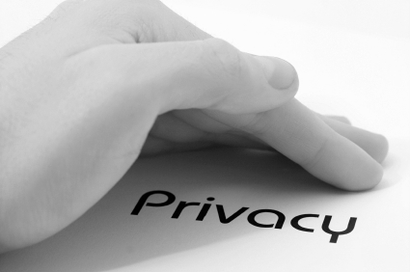

2. When is privacy most important? At home? Online? At School?
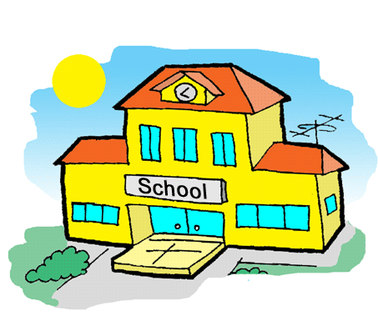

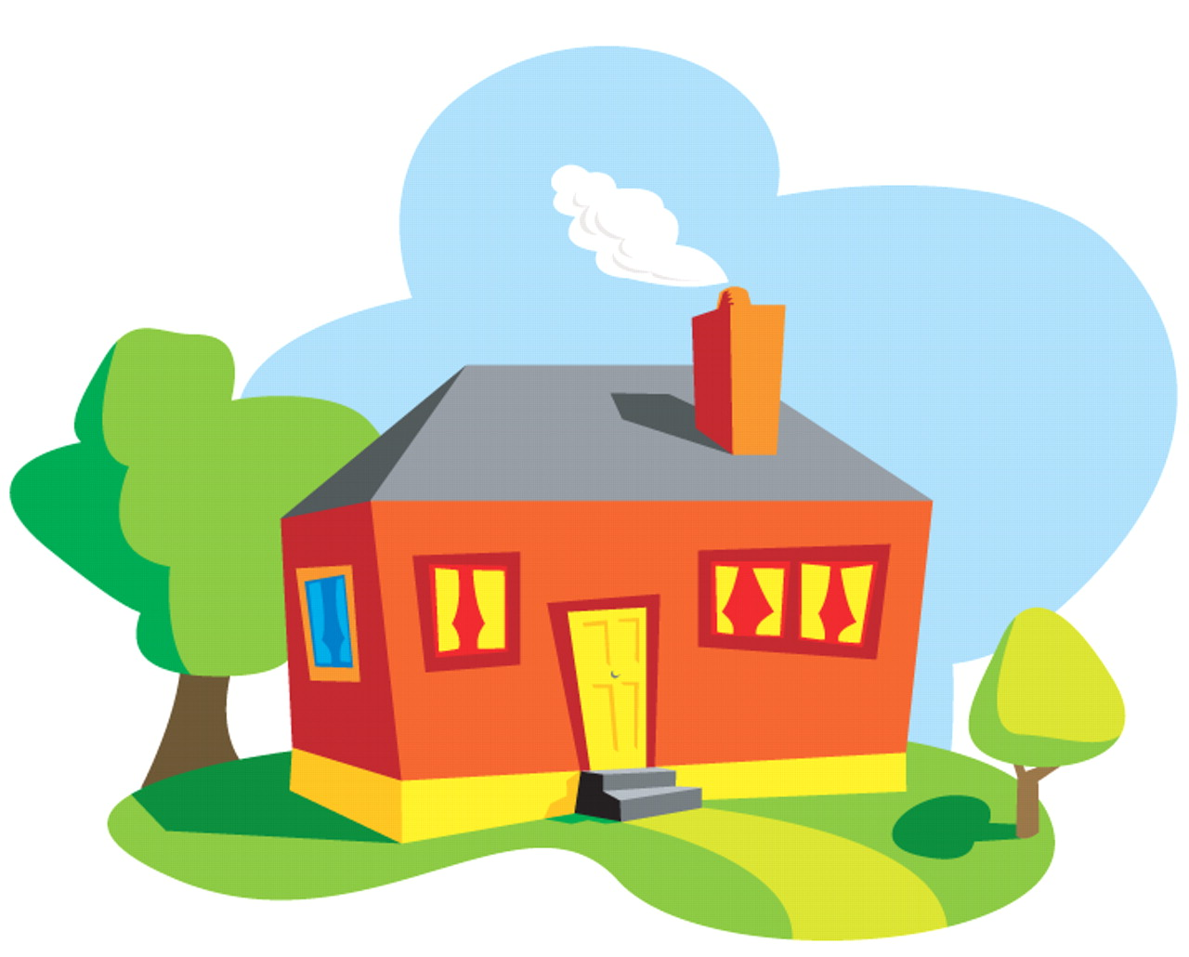

3. Do children know enough about privacy?

4. Should there be ways to stop people breaking your privacy?

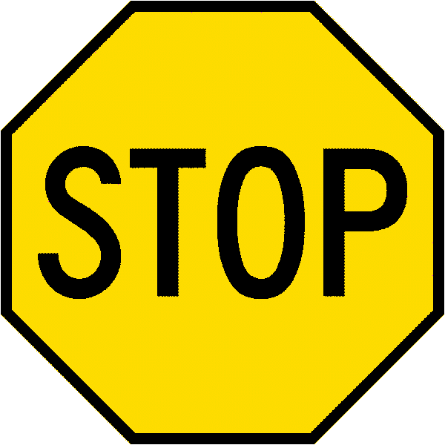

5. What information should other children know about privacy?

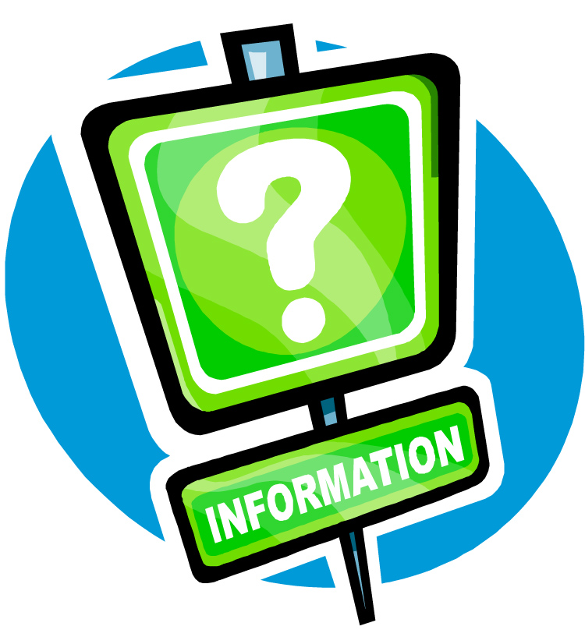

School/Youth Group:
Age:

