**REQUEST TO JOIN EXEMPTION APPLICATION LODGED BY THE DEPARTMENT OF   
FAMILIES, HOUSING, COMMUNITY SERVICES AND INDIGENOUS AFFAIRS (FaHCSIA)   
UNDER S55 OF *THE DISABILITY DISCRIMINATION ACT* (1992) (CTH)**

INVe seek to join/support the exemption application submitted by FaHCSIA as follows:

* I/We seek an exemption for all existing ADEs from sections 15 and 24 of the DDA, and the Commonwealth (and officers of the Commonwealth) from section 29 for a period of three years.
* This exemption would apply to use of the BSWAT to:

1. assess wages for employees; and
2. pay wages to ADE employees based on assessments conducted under the BSWAT.

* The proposed exemption would apply while alternative wage setting arrangements are being considered, devised and/or established and implemented by FaHCSIA.

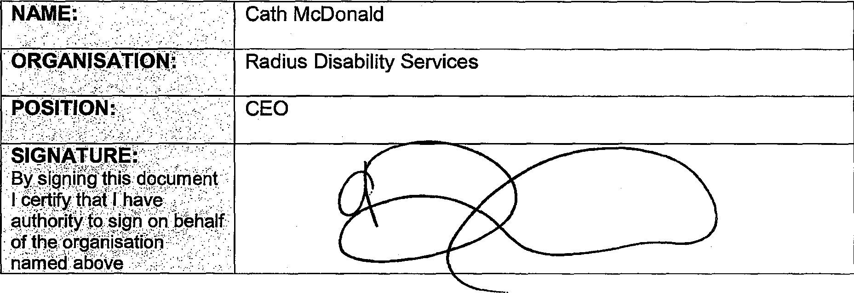

Cath McDonald

Radius Disability Services

CEO

**sioNATyRg:.**

**By** .signing thie **document** I certify that ! have authority **to sigh on behalf**

of Orgahisafion   
named above

**COMMENTS**

Radius Disability Services has used the BSWAT wage assessment **tool for a number of years, but has been unable to do so since the High Court decision in late 2012. We are concerned about the inequity of this situation for our supported employees. Radius' Board of Directors' Human Rights Subcommittee has encouraged Radius to join FaHCSIA's action.**

**Approx. 70 of our 120 supported employees are either already overdue, or will fall due, for their triennial assessment this calendar year. We have not been able to** process these assessments.

**We have been in a recruitment phase for the last six months, and new supported employees who have reached an employment outcome have not been able to have a wage assessment conducted, and remain on the 'training wage', which at Radius is set at $2/hr.**

**The exemption FaHCSIA has applied for will allow us to progress these** issues **and** re-establish wage equity in our ADE.