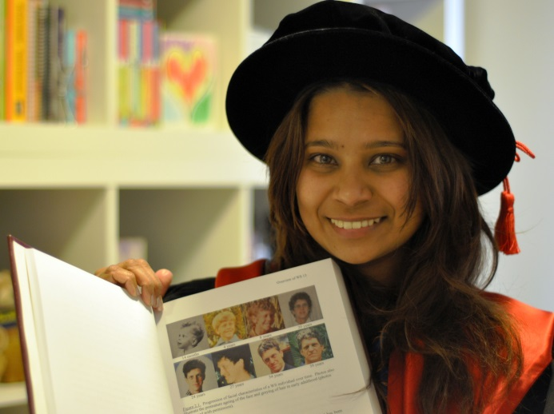
Rashika Gomez Phd
Melbourne University
Thesis – Williams Syndrome
9th. August, 2013
-Tony Walsh-
Australia’s first surviving, clinically diagnosed person with Williams – one of the subjects of her thesis.

Tony Walsh 23-07-1965 - 07-07-2004

Dear Family and Friends,
In the hurly-burly of life it is so easy to overlook the importance which each of us has, in relation to the rest of our world. Several things have happened, and are happening that remind us of our son’s journey – and the impact he has had on others – whom we have never met.

This lovely young lady has been working on her thesis for many years – and over the years - we have corresponded via email. Tony has been gone from our lives, but never from our hearts, for nine years. On Friday Rashika graduated from Melbourne University, and she has shared these photos with us. Thank-you, Rashika. We did not want Tony to be just a case study – we wanted him to be the “real” person he was - so he is named, and accompanied with photos which show his pictorial journey through life.

Those of us who knew Tony know that we have 40 years of “Tony” stories- precious memories of laughs, some tears and some (many?) frustrations. And that was Tony. He didn’t come with an instruction manual – we all just did the best we could and blazed a trail - so we could all cope. He had the best life he could possibly have had – and we were very blessed.

So this week we have shared his life with Rashika – who will, no doubt - use the insights she has obtained – to help others.

Through the week Ron had occasion to go into town to get a padlock for a new retractable hose, which is fitted, visible to the road, on a special post. Very easy to remove – if one is strong enough. He had other things to do, and forgot to go to the hardware store but, he remembered as he was heading back to the car. Had to pass the Pawnbrokers – and thought – he could probably pick one up there. Tony, of course, used to haunt the Pawnbrokers and Cash Converters. When Ron entered with his query, he was directed to a table out the back – “you might find what you want out there”. When Ron had what he wanted he headed back to the counter and asked – “how much”. The following conversation ensued:

“You’re Mr Walsh, aren’t you. You’re Tony’s Dad”.
“Yes” replied Ron – “Did you know Tony?. He’s been gone 9 years now.”
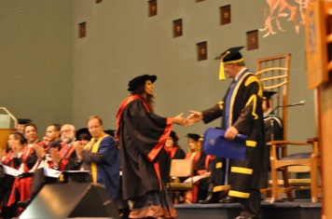
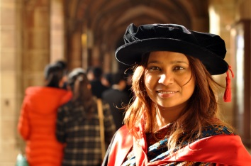
“Yes-‘ was the response “ we knew Tony. He was a “special” friend. (Tony used to call all the people he really liked his “special” friends). Tony would come in and he and I (apparently this is the owner/manager) would spend a lot of time out the back chatting and going through “stuff”. He was a special person. We’ll never forget him, and we miss him”.

“You know’, said Ron, “he couldn’t write and there were lots of things he couldn’t do, but he could read and was pretty smart in some ways. We miss him too.”

“So, replied the owner, this padlock – for you – costs nothing”, “Consider it a special memento – so every time you use your hose it will remind you of Tony”.

We have never been into the Pawnbrokers and the only reason Ron went there last week was he forgot to go to the hardware store, and his car was parked near where we always used to drop Tony off on a Saturday morning to spend his $20 pocket money. Tony would ring from the nearby public phone when he was ready for us to come and pick him up.

So, in the past week our lives have crossed paths with people, whom we have never met. The lives of these people have been influenced by Tony, unknown to us – his family, who knew and loved him best. Nine years after his death – it is very consoling to know that the ripples of his Journey continue to spread.

