

**SENATOR THE HON MITCH FIFIELD ASSISTANT MINISTER FOR SOCIAL SERVICES**

PARLIAMENT HOUSE TELEPHONE: (02) 6277 7280

CANBERRA ACT 2600 FACSIMILE: (02) 6273 4138

MN13-001982

Mr Graeme Innes AM

Disability Discrimination Commissioner

GPO Box 5218

SYDNEY NSW 2001

Dear Mr limes

As the new Minister responsible for disability issues, I have sought briefings from the Department of Social Services (the Department) about the outcomes of the Federal Court judgement *Nojin & Prior v Commonwealth [20121 FCAFC 192* and the lodgement of the application for an exemption from sections 15, 24 and 29 of the *Disability Discrimination Act 1992* (DDA) by the former Department of Families, Community Services and Indigenous Affairs (FaHCSIA), The advice I have received has confirmed that this issue is complex and will take some time to address. The Australian Government is committed to ensuring this matter is addressed as quickly as possible and in a fair and equitable manner which is consistent with the DDA.

The Government supports this application. The Government believes it is important that there is time to ensure an orderly transition to a new wage assessment process which is compliant with the DDA. However, an immediate move to a new wage setting model will likely see the closure of some ADEs, resulting in workers with a disability being left without employment, The Government is very keen to avoid this outcome, Enabling ADEs to resume wage assessments using the BSWAT temporarily will allow time to develop a new approach to wage setting in close consultation with the sector and people with a disability,

The DDA exemption application provides a clear commitment to developing a plan that will result in the transition to a new wage assessment model. The plan will be a priority for the Department.

The Department will then move to swiftly implement that action plan, and provide ongoing reports on progress every six months. I have directed the Department that issues around wage setting and sector viability must be addressed within three years, and it is my strong preference that if possible this be completed in an earlier timeframe,

-2

As outlined in the application, the Department is committed to ongoing engagement. I also remain committed to consulting and involving people with disability, their families and carers, peak bodies and other stakeholders on the issues affecting ADEs and their employees. My intention is to conduct the next round of consultations once the Government has had the opportunity to develop a plan for long term resolution of these important matters.

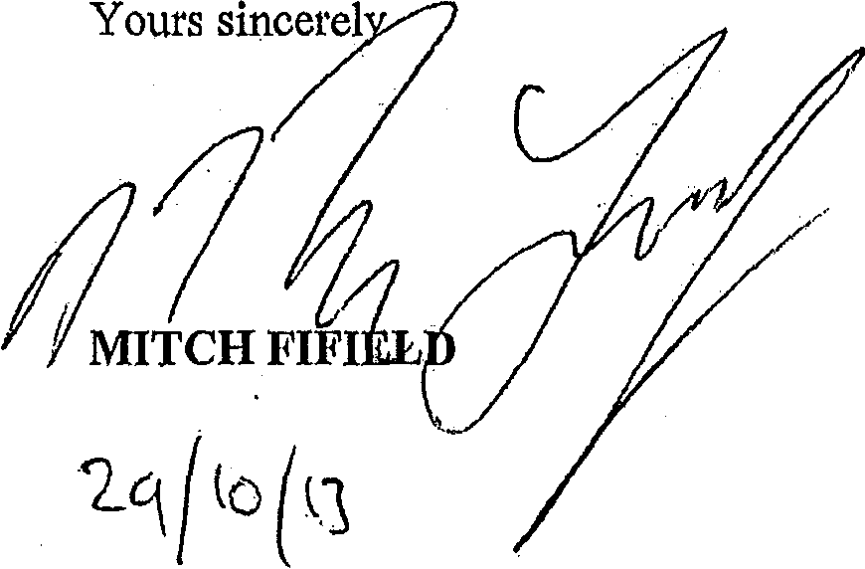

Yours sincerel