**REQUEST TO JOIN EXEMPTION APPLICATION LODGED BY THE DEPARTMENT OF   
FAMILIES, HOUSING, COMMUNITY SERVICES AND INDIGENOUS AFFAIRS (FaHCSIA)   
UNDER S55 *OF THE DISABILITY DISCRIMINATION ACT (1992)* (CTH)**

INVe seek to join/support the exemption application submitted by FaHCSIA as follows:

* 1/We seek an exemption for all existing ADEs from sections 15 and 24 of the DDA, and the Commonwealth (and officers of the Commonwealth) from section 29 for a period of three years.
* This exemption would apply to use of the BSWAT to:

1. assess wages for employees; and
2. pay wages to ADE employees based on assessments conducted under the BSWAT.

* The proposed exemption would apply while alternative wage setting arrangements are being considered, devised and/or established and implemented by FaHCSIA.

Marita Brady

SkillsConnection ADE trading name Jiffy Services CEO

:SIONATY1

By %

ni6 t

8ig9199t :

have authority to n

namedon behalf of the organisation

above

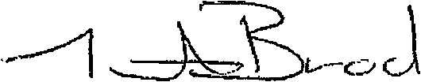

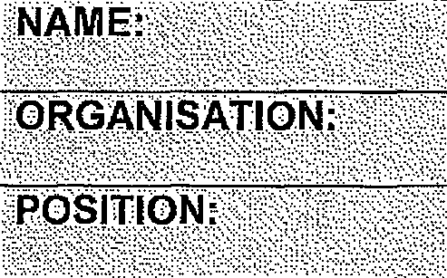

**'ORGANISATION**

**COMMENTS**

The current issues facing ADE'S in relation to BSWAT has an immediate impact on our ADE Jiffy Services as 90 % of our employees are due for a wage assessment in the first quarter 2014 If the Australian Human Rights Commission grants the exemption, for BSWAT assessments to re-commence this would provide us the time required to investigate other options.