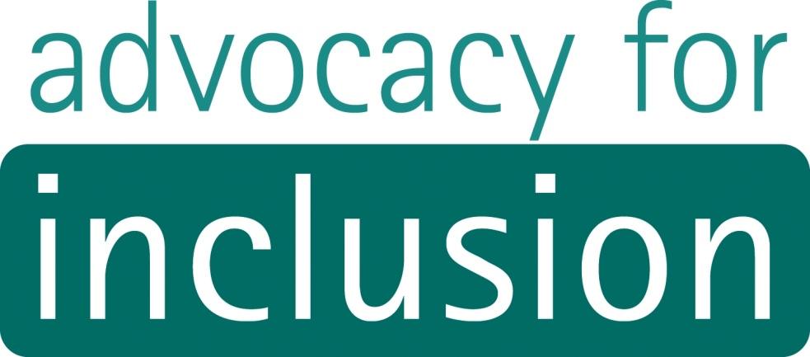

Submission to Australian Human Rights Commission
Access to justice in the criminal justice system for people with disabilities

Advocacy for Inclusion
August 2013

About Advocacy for Inclusion

Advocacy for Inclusion acknowledges the Ngunnawal people as the traditional owners of the land on which we work.

Advocacy for Inclusion provides individual, self and systemic advocacy services for people with disabilities. We provide information, education, and representation to effectively advocate for positive and inclusive outcomes for people with disabilities.

We act with and on behalf of individuals in a supportive manner, or assist individuals to act on their own behalf, to obtain a fair and just outcome for the individual concerned.

Advocacy for Inclusion works within a human rights framework and acknowledges the United Nations Convention on the Rights of Persons with Disabilities, and the ACT Human Rights Act.

Contact details:
2.02 Griffin Centre
20 Genge Street
Canberra City ACT 2601

Phone: 6257 4005
Fax: 6257 4006
Email: info@advocacyforinclusion.org
ABN: 90 670 934 099

General Manager: Christina Ryan
Policy Officer: Ellen Read

August 2013
(c) Copyright Advocacy for Inclusion Incorporated
This publication is copyright, apart from use by those agencies for which it has been produced. Non-profit associations and groups have permission to reproduce part of this publication as long as the original meaning is retained and proper credit is given to Advocacy for Inclusion Inc. All other individuals and agencies seeking to reproduce material from this publication should obtain the permission of the General Manager of Advocacy for Inclusion.

Introduction

Advocacy for Inclusion is a not-for-profit non-government community organisation in the Australian Capital Territory. We provide individual, self and systemic advocacy services to people with disabilities to promote their human rights and inclusion in the community. We work directly with some of the most marginalised people with disabilities who face discrimination and barriers in the criminal justice system, and are denied access to the criminal justice system altogether.

People with disabilities face barriers in all areas of the criminal justice system. In this submission, Advocacy for Inclusion focuses on:

- The lack of recognition of violence in disability supported accommodation as a legal matter;

- The lack of acknowledgement of people with disabilities as having the capacity and the right to be properly engaged in criminal justice proceedings.
This submission also provides links to other work by Advocacy for Inclusion, which include further discussion.

- Violence in disability supported accommodation

Advocacy for Inclusion works on numerous cases that deal with violence in disability supported accommodation. Following public discussion in Canberra about violence in group homes, Advocacy for Inclusion undertook an audit of our advocacy cases at that time. This showed that 25 per cent of all cases related to violence in group homes and over 30 per cent of all cases related to sexual violence or exploitation.

Disability specific households are not covered in Domestic Violence legislation in the ACT or anywhere else in Australia except NSW. It is recognised in section 6 (a) of the ACT Domestic Violence and Protection Orders Act 2008 that people experiencing violence in a domestic relationship need a greater level of protective response. For this reason, it provides protections from domestic violence which are more robust than those applied to personal violence.

People with disabilities are at greater risk of experiencing violence. Many researchers assert that living in institutional settings, such as supported accommodation, compounds this risk. However, these domestic circumstances are excluded from this “greater level of protective response” as they are simply not covered by the law. This is a major barrier to people with disabilities accessing the criminal justice system to address matters of violence. It results in a lack of legal frameworks that enable a robust response and guide the community to know that violence in these contexts is unacceptable.

Violence in supported accommodation may or may not resemble the typical patterns of family violence, such as deliberate manipulation and abuse of power by a male partner. However, supported accommodation environments are usually directed by the service provider. There is a power dynamic, wherein residents are dependent on the service provider and have little say over household routines, the provision of support, or who lives in their household. They often have high support needs and have no immediate accommodation alternatives catering to these needs. Victims of violence have great difficulty having the user of violence removed or finding alternative accommodation. People with disabilities consequently live in violent situations for many months and even years.

Disability service providers have obligations to house both the person subjected to violence and the user of violence. Disability service providers find themselves in a particularly difficult situation and do not know how to appropriately meet the needs of both of their tenants. Usually, they do not recognise the behaviour as “violence”, and instead conceptualise it as part and parcel of living in a disability specific context.

Service providers usually try to ‘manage’ the violent behaviour, rather than find more suitable accommodation for the user of violence. People with disabilities become trapped in cycles of violence in their homes.

No access to justice

2 Ramcharan, P. (2009). A view from people with disabilities and family carers: A final research report to the Office of the Senior Practitioner. Page 2. www.dhs.vic.gov.au/__data/assets/pdf_file/0008/608588/osp_experiencesofrestrictivepractices_pdf_0509.pdf

Section 5 of the NSW Crimes (Domestic and Personal Violence) Act 2007 extends to people with disabilities living in residential facilities by including these living arrangements in the definition of domestic relationship.

For the purposes of this Act, a person has a domestic relationship with another person if the person:

(d) is living or has lived in the same household as the other person, or

(e) is living or has lived as a long-term resident in the same residential facility as the other person and at the same time as the other person (not being a facility that is a correctional centre within meaning of the Crimes (Administration of Sentences) Act
1999 or a detention centre within the meaning of the Children (Detention Centres) Act 1987), or

(f) has or has had a relationship involving his or her dependence on the ongoing paid or unpaid care of the other person

This framework in NSW has promoted greater recognition of the issue, leading to better responses by service providers and by government. It holds authorities accountable to take action when necessary and it also gives accommodation service providers legal back up when it is necessary to relocate a tenant who is using violence against another tenant. It will force the system to appropriately accommodate people with disabilities and help prevent violence from occurring in the first place. This framework should be adopted in the ACT and other jurisdictions to afford people with disabilities the same safeguards against domestic violence as other people.

However, there is resistance among the community against this change. Many find it difficult to conceptualise supported accommodation as a “domestic” situation in the same way that other permanent living arrangements are. For this reason, they believe that violence in these arrangements should be dealt with outside of the law. Some are concerned that by including disability specific contexts in the legislation people with disabilities will be inappropriately criminalised.

The answer does not lie in excluding people with disabilities, who are highly vulnerable to abuse and violence and who have among the highest need in the community, from safeguards and protections. The lack of legislative recognition unjustly denies them access to the criminal justice system to resolve matters of domestic violence on an equal basis with people without disabilities.

The expectation that accommodation service providers will naturally keep people with disabilities safe from abuse and violence is sorely misguided, as has been demonstrated time and time again with revelations of widespread abuse and violence in Australian institutional settings. These settings must no longer be regarded as outside domestic violence law.

- Guardianship and the criminal justice system

Case study

Daniel has a cognitive disability and was recently charged with a serious criminal offence. Daniel approached Advocacy for Inclusion for help during the legal proceedings because he didn’t know what was going. His lawyer, Paula, didn’t explain much to him and instead insisted on talking to his uncle, who is his main significant family member and support person. Daniel’s advocate, Kelly, agreed to contact Paula on his behalf.

When Kelly asked about the details of the court proceeding Paula initially refused to disclose the information. She said that she would only talk to Daniel’s uncle. She reminded Paula of the consent to exchange information forms that had been sent through. Kelly explained that Daniel wants Paula to communicate with him and explain what is going.

Paula replied “this offense could result in jail time for Daniel and his case has to be treated very carefully. Daniel doesn’t understand what is going on because of his disability. There is not really any point in explaining it all to him. I’ve been talking to his uncle about it. He is his main carer and is responsible for him.”

Kelly explained that Daniel is an adult; it is his right to be informed about the legal proceedings and to have an advocate. Paula finally disclosed some the details of what she was planning to do, including applying for Daniel to have his fitness to plead assessed. She also advised Daniel’s uncle to apply for a guardianship order. “He needs somebody to make decisions on his behalf. A guardianship order would have stopped him from getting into this mess in the first place.”

Kelly followed up with Daniel’s uncle afterwards. He was convinced that a guardianship order will improve the situation, even though Daniel has always made his own decisions with some informal support.

Since then, Paula has stopped taking Kelly’s phone calls and continues to only discuss the matter with Daniel’s uncle. This violates Daniel’s right to an advocate and his right to participate in the criminal proceedings about him.

This study resembles cases at Advocacy for Inclusion. For many people with disabilities, legal proceedings are extremely daunting and complex. Some face barriers to understanding the progress of their case. For this reason many need support to understand and engage in the process but this is rarely offered.

Advocacy for Inclusion finds that police officers, lawyers, and court staff are unskilled in working with people with disabilities. They make assumptions that the person with disability is unable to be engaged and make a credible statement or give evidence, even with supports. The need for support is often not even considered.

Lawyers will speak directly with family members instead of to the person with disability about their case. This means that people with disabilities are not being properly represented and heard. They are left in the dark about how their case is progressing and are not afforded the support they need to understand and engage in the process. Lawyers themselves become barriers to justice.

In this particular case, the person’s family was pressured to apply for a guardianship order, seemingly because it would support the case that Daniel was unfit to plead. It was also related to the assumption that a guardianship order is the solution to a person’s problems. The ongoing ramifications for Daniel would be losing recognition of his authority to make decisions about his own life, but without any solution to his criminal matters. Even without the guardianship order, the lawyer treated Daniel as though he already had no such authority simply because of his disability.

Advocacy for Inclusion is also aware that being assessed as having cognitive impairment, and subsequently being found unfit to plead, is related to the indefinite detention of people with disabilities particularly Aboriginal people living in remote areas. More information about this issue can be found here: http://www.pwd.org.au/adjc/issues-in-the-northern-territory-adjc.html

Further information

For more discussion about violence see:

- Pages 29-32 in Advocacy for Inclusion’s Submission to ACT Budget Consultation 2013–14 http://www.advocacyforinclusion.org/index.php/publications-home/budget-submissions

- Pages 3-7 in Submission to CEDAW Committee General Discussion on Access to Justice and Submission to CRPD General Discussion on Women and Girls with Disabilities
http://www.advocacyforinclusion.org/index.php/publications-home/access-to-justice

For more discussion about access to criminal justice generally see:

- Pages 43-45 in Advocacy for Inclusion’s Submission to ACT Budget Consultation 2013–14 http://www.advocacyforinclusion.org/index.php/publications-home/budget-submissions

- Pages 10-11 in Submission to CEDAW Committee General Discussion on Access to Justice and Submission to CRPD General Discussion on Women and Girls with Disabilities
http://www.advocacyforinclusion.org/index.php/publications-home/access-to-justice

For more discussion about guardianship practices generally see:

- Supported Decision Making, Legal Capacity and Guardianship http://www.advocacyforinclusion.org/index.php/publications-home/decision-making

Advocacy for Inclusion expresses thanks for the opportunity to contribute to the Australian Human Right’s Commission’s consultation.

The Canberra Times. (14 September 2011). Tribunal ends assault nightmare for gentle giant. The Canberra Times. www.canberratimes.com.au/act-news/tribunal-ends-assault-nightmare-for-gentle-giant-20110914-1wraf.html
Chenoweth, L. (1995). The mask of benevolence: Cultures of violence and people with disabilities. Journal of Australian Studies, 19(43), 36-44.
Fitzsimons, N. (2009). Combatting violence and abuse against people with disabilities: A call to action. USA: Paul H. Brookes Publications.
Sobsey, R. (1994). Violence and abuse in the lives of people with disabilities: The end of silent acceptance? Paul H. Brookes Publications.

