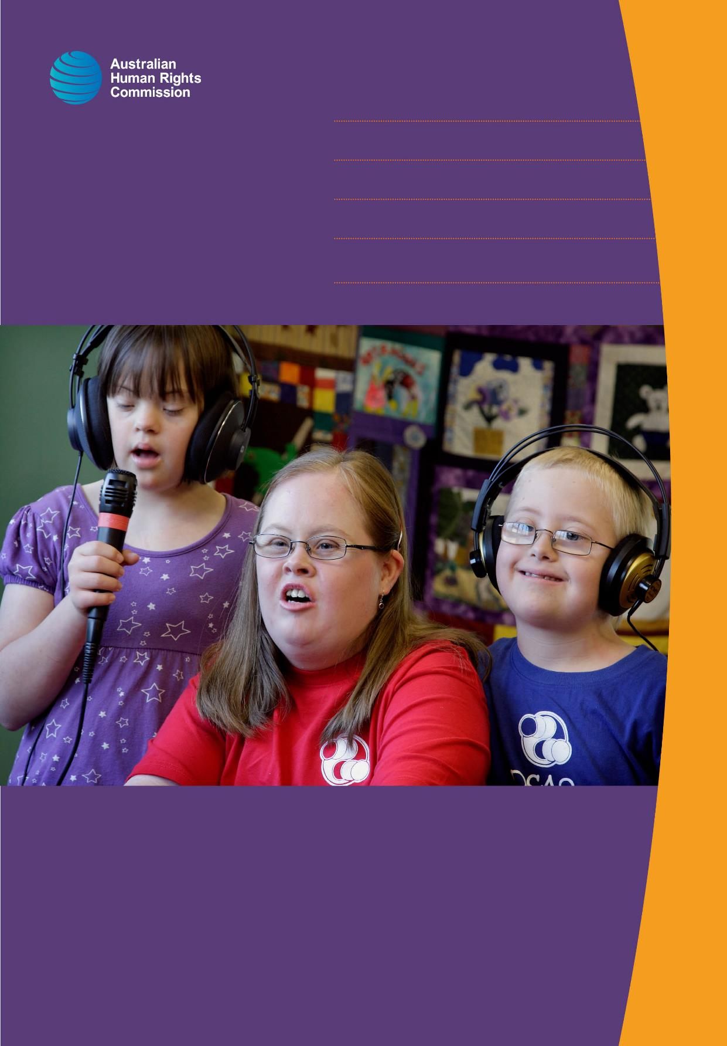**Disability Rights:**

**Facilitating the empowerment**

**of people with disability**

UNIT OF COMPETENCY CHCDIS007 • TRAINER’S MANUAL • 2016

© Australian Human Rights Commission 2016.

The Australian Human Rights Commission encourages the dissemination and exchange of information presented in this publication and endorses the use of the **Australian Governments Open Access and Licensing Framework** (AusGOAL).



All material presented in this publication is licensed under the **Creative Commons Attribution 4.0 International Licence**, with the exception of:

• photographs and images;

• the Commission’s logo, any branding or trademarks;

• where otherwise indicated.

To view a copy of this licence, visit [**http://creativecommons.org/licenses/by/4.0/legalcode**](http://creativecommons.org/licenses/by/4.0/legalcode).

In essence, you are free to copy, communicate and adapt the publication, as long as you attribute the Australian Human Rights Commission and abide by the other licence terms.

**Please give attribution to:** © Australian Human Rights Commission 2016.

**Disability Rights: Facilitating the empowerment of people with disability** • CHCDIS007 • Trainer’s Manual • 2016

**Acknowledgments**

The ‘Disability Rights: Facilitating the empowerment of people with disability’ Trainer’s Manual and Learner Guide were drafted by Lauren Henley, Annie Pettit, Rebecca Rolls, Alexandra Walker and Siobhan Tierney.

This publication can be found in electronic format on the Australian Human Rights Commission’s website at **http://www.humanrights.gov.au/about/publications/**.

For further information about the Australian Human Rights Commission or copyright in this publication, please contact:

Education and Innovation Team

Australian Human Rights Commission

GPO Box 5218

SYDNEY NSW 2001

Telephone: (02) 9284 9600

Email: **communications@humanrights.gov.au**

**Design and layout** Dancingirl Designs

**Cover photography** Renate Hottmann-Schaefer

# Table of contents

Table of contents 3

About this Unit of Competency 5

About this resource 8

About the Commission 8

About human rights-based approaches 8

Course overview and performance criteria 9

How to use this resource 13

Icons used in this resource 15

A brief history of the disability rights movement in Australia. 16

Introductory session 19

Introductory Session: Endnotes 23

Topic 1: Getting the facts straight 24

1.1 Evolving definitions and demographics of disability 25

1.2. Common conditions and impairments which can contribute to disability 35

1.3. Community attitudes towards people with disability 42

1.4. Disability etiquette 53

Topic 1: Endnotes 57

Topic 2: Discrimination and anti-discrimination law 60

2.1. Australian anti-discrimination legislation 61

2.2. Accessibility standards 64

2.3. Direct and indirect discrimination 70

2.4. Reasonable adjustment and inherent requirements 72

Topic 2: Endnotes 77

Topic 3: The Convention on the Rights of Persons with Disabilities 78

3.1. About the Disability Convention 79

3.2. Implementation and monitoring 88

3.3. Progressive realisation 90

Topic 3: Endnotes 95

Topic 4: An overview of the disability service system 96

4.1. About disability services 97

4.2. The National Disability Insurance Scheme 100

4.3. My Aged Care 104

4.4. The National Standards for Disability Services 107

Topic 4: Endnotes 113

Topic 5: Communicating effectively with service users 114

5.1. Augmentative and alternative communication 115

5.2. Easy English 121

5.3. Translation and interpreting services 124

5.4. Alternative accessible formats 128

Topic 6: Achieving cultural awareness in your work 131

6.1. Culturally and linguistically diverse communities 132

6.2. Aboriginal and Torres Strait Islander peoples 137

6.3. Unconscious bias and casual racism 141

Topic 7: Person-centred practice in action 150

7.1. Assisting service users to understand their rights 151

7.2. Supported decision-making and the role of family, friends and carers 154

7.3. Dignity of risk 163

7.4. Advocacy and referral 168

7.5. Inclusive practices 173

Topic 8: Legal and ethical considerations of service delivery 181

8.1. Legal and ethical frameworks 182

8.2. Responding to service users at risk of harm 184

8.3. Protecting privacy and confidentiality 193

8.4. Managing conflicts of interest 197

8.5. Monitoring workplace health and safety 199

Unit summary and close 203

# About this Unit of Competency

This unit of competency (*CHCDIS007 – Facilitate the Empowerment of People with Disability*) has been designed to provide learners with the skills and knowledge required to facilitate the empowerment of people with disability, through the delivery of services driven by a person-centred, rights-based approach.

The learning outcomes and performance criteria set out below have been endorsed by Australian and state and territory governments, and have been approved for use throughout Australia.[1]

(Elements define the essential learning outcomes, while performance criteria describe the performance needed to demonstrate achievement of the element).

**Element 1. Demonstrate commitment to empowerment for people with disability**

*Performance criteria*

1.1 Identify changes in the legal, political and social frameworks within which the work is undertaken

1.2 Identify ways society can affect the level of participation experienced by a person with disability

1.3 Reflect on personal values and attitudes regarding disability and acknowledge their potential impact when working in disability contexts

1.4 Develop and adjust own approaches to facilitate empowerment

**Element 2. Foster human rights**

*Performance criteria*

2.1 Assist the person with disability to understand their rights

2.2 Deliver services that ensure the rights and priorities of the person are upheld in the context of person-centeredness

2.3 Ensure the cultural priorities of the person are identified, accepted and upheld

2.4 Identify breaches of human rights and respond and report according to organisation procedures

2.5 Identify indications of possible abuse and/or neglect and report according to organisation procedure

**Element 3. Facilitate choice and self-determination**

*Performance criteria*

3.1 Using a person-centred approach work in a manner that acknowledges the person with disability as their own expert

3.2 Facilitate person-centred options for action on relevant issues and discuss with the person and/or family and/or carer and/or relevant other

3.3 Provide assistance to the person with disability to facilitate communication of their personal goals

3.4 Provide person-centred support in a manner that encourages and empowers the person with disability to make their own choices

3.5 Assist with strategies to ensure that the person is comfortable with any decisions that are being made on their behalf

3.6 Assist with accessing advocacy services and other complaint mechanisms as required

**Knowledge Evidence**

At the completion of this unit, learners must be able to demonstrate the essential knowledge required to effectively manage tasks outlined in the elements and performance criteria of this unit. This includes knowledge of:

* history and recent developments in disability
* social versus medical model of service
* institutionalised versus person-centred, self-directed model of support
* social constructs of disability and the impact of own attitudes on working with people with disabilities
* how and when to seek support from more experienced and qualified staff
* types of disability, including:
  + acquired brain injury
  + autism spectrum disorder
  + cognitive disability
  + developmental delay
  + intellectual disability
  + neurological impairment
  + physical disability
  + sensory disability, including hearing, vision impairment
  + speech/language disability
* support practices for people, including but not limited to, the following conditions:
  + genetic factors
  + physical trauma
  + psychological trauma
  + chronic lifestyle conditions
  + acquired brain injury
* legal and ethical considerations for working with people with disability:
  + codes of conduct
  + discrimination
  + dignity of risk
  + duty of care
  + human rights, including the United nations convention on the rights of persons with disabilities (UNCRPD)
  + informed consent
  + mandatory reporting
  + privacy, confidentiality and disclosure
  + work role boundaries – responsibilities and limitations
  + work health and safety
* principles of:
  + empowerment
  + rights-based approaches
  + person-centred practices
  + self-advocacy
  + active support
  + active listening
  + social justice, and the importance of knowing and respecting each person as an individual
  + strengths-based approaches
* strategies that assist people with disabilities to exercise their rights and support independent action and thinking, including use of technology (e.g. laptops or tablets) to facilitate choice
* how to access and use advocacy services and complaint mechanisms
* indicators of abuse and/or neglect in relation to people with disabilities

# About this resource

This resource has been developed by the Australian Human Rights Commission (the Commission) to enable trainers to teach *CHCDIS007 - Facilitate the Empowerment of People with Disability* using a disability rights framework and a human rights-based approach.

## About the Commission

The Australian Human Rights Commission is an independent government body, established to promote and protect human rights in Australia.

The goal of the Commission is to make human rights part of everyday life and empower all Australians to understand and exercise their human rights.

Through the Commission’s role administering the *Disability Discrimination Act 1992* (Cth), the Commission possesses a unique level of experience and knowledge about policy issues arising in relation to the rights of people with disability.

For more information about the Commission’s work in relation to the rights of people with disability go to: <https://www.humanrights.gov.au/our-work/disability-rights>

## About human rights-based approaches

A human rights-based approach is about translating the principles, standards and goals of international human rights law into the policies, practices, and practical realities of everyday life.

Human rights principles and standards provide guidance about *what* should be done to achieve freedom and dignity for all. A human rights-based approach emphasises *how* this can be achieved.

Details of a human rights-based approach will vary depending on the nature of the organisation concerned and the issues it deals with, however most approaches commonly hold that actions and decisions should be informed by the key human rights principles of participation, accountability, equality, non-discrimination and empowerment.

# Course overview and performance criteria

The content and activities included throughout this resource address each of the key unit elements and performance criteria for *CHCDIS007 - Facilitate the Empowerment of People with Disability*.

The course overview outlines how each of the training topics relates to the unit performance criteria.

| **Topic** | **Time** | **Content** | **Performance criteria** |
| --- | --- | --- | --- |
| **Introduction** | 30 mins | Introductions, housekeeping and course outline | N/A |
| **Topic 1:**  **Getting the facts straight** | 3 hours | * 1. Evolving definitions and demographics of disability   2. Common conditions and impairments   3. Community attitudes towards people with disability   4. Disability etiquette | * 1. Identify changes in the legal, political and social frameworks within which the work is undertaken   2. Identify ways society can affect the level of impairment experienced by a person with disability   3. Reflect on personal values and attitudes regarding disability and acknowledge their potential impact when working in disability contexts   4. Develop and adjust own approaches to facilitate empowerment |
| **Topic 2:**  **Discrimination and anti-discrimination law** | 2 hours 15 mins | 2.1. Australian anti-discrimination legislation  2.2. Accessibility standards  2.3. Direct and indirect discrimination  2.4. Reasonable adjustment and inherent requirements | 1.1 Identify changes in the legal, political and social frameworks within which the work is undertaken  1.2 Identify ways society can affect the level of impairment experienced by a person with disability  1.4 Develop and adjust own approaches to facilitate empowerment |
| **Topic 3:**  **The Convention on the Rights of Persons with Disabilities** | 1 hour 40 mins | 3.1. About the Disability Convention  3.2. Implementation and monitoring  3.3. Progressive realisation | 1.1 Identify changes in the legal, political and social frameworks within which the work is undertaken  1.2 Identify ways society can affect the level of impairment experienced by a person with disability  1.4 Develop and adjust own approaches to facilitate empowerment |
| **Topic 4:**  **An overview of the disability service system** | 1 hour 45 mins | 4.1. About disability services  4.2. The National Disability Insurance Scheme  4.3. My Aged Care  4.4. The National Standards for Disability Services | 1.1 Identify changes in the legal, political and social frameworks within which the work is undertaken  1.2 Identify ways society can affect the level of impairment experienced by a person with disability  1.4 Develop and adjust own approaches to facilitate empowerment |
| **Topic 5:**  **Communicating effectively with service users** | 2 hours | 5.1. Augmentative and alternative communication  5.2. Easy English  5.3. Translation and interpreting services  5.4. Alternative accessible formats | 1.4 Develop and adjust own approaches to facilitate empowerment   * 1. Deliver services that ensure the rights and needs of the person are upheld in the context of person-centeredness   3.3 Provide assistance to the person with disability to facilitate communication of their personal goals |
| **Topic 6:**  **Achieving cultural awareness in your work** | 2 hours 40 mins | 6.1. Culturally and linguistically diverse communities  6.2. Aboriginal and Torres Strait Islander peoples  6.3. Unconscious bias and casual racism | 2.2 Deliver services that ensure the rights and needs of the person are upheld in the context of person-centeredness  2.3 Ensure the cultural needs of the person are identified, accepted and upheld |
| **Topic 7:**  **Person-centred practice in action** | 3 hours 20 mins | 7.1. Assisting service users to understand their rights  7.2. Supported decision-making and the role of family, friends and carers  7.3. Dignity of risk  7.4. Advocacy and referral  7.5. Inclusive practices | * 1. Develop and adjust own approaches to facilitate empowerment   2.1 Assist the person with disability to understand their rights  2.2 Deliver services that ensure the rights and needs of the person are upheld in the context of person-centeredness   * 1. Using a person-centred approach work in a manner that acknowledges the person with disability as their own expert   2. Facilitate person-centred options for action on relevant issues and discuss with the person and/or family and/or carer and/or relevant other   3. Provide assistance to the person with disability to facilitate communication of their personal goals   4. Provide person-centred support in a manner that encourages and empowers the person with disability to make their own choices   5. Assist with strategies to ensure that the person is comfortable with any decisions that are being made on their behalf   6. Assist with accessing advocacy services and other complaint mechanisms as required |
| **Topic 8:**  **Legal and ethical considerations of service delivery** | 2 hours 35 mins | 8.1. Legal and ethical frameworks  8.2. Responding to service users at risk of harm  8.3. Protecting privacy and confidentiality  8.4. Managing conflicts of interest | * 1. Identify breaches of human rights and respond and report according to organisation procedures   2. Identify indications of possible abuse and/or neglect and report according to organisation procedure |
| **Unit summary and close** | 30 mins | Overview of topics covered, reflections, debrief and close | N/A |

Please note times are indicative only and can be adapted according to the duration of training and learner’s interests.

# How to use this resource

1. This resource does not include assessment tasks. Trainers are required to set their own assessment tasks to assess the extent to which learners meet the performance criteria.
2. This resource is to be used with the accompanying Learner Guide for CHCDIS007. Trainers should familiarise themselves with both the Trainer Manual and Learner Guide before teaching this unit of competency.
3. Trainers should undertake their own research to obtain information about any disability services, laws, policies and procedures that are specific to the state or territory where the training is being delivered and adapt the training content accordingly.
4. In light of the progressive roll out of the National Disability Insurance Scheme and the implementation of a number of new reforms across the aged care sector, policies and practices in these areas are changing on a regular basis. Trainers should therefore ensure that they are aware of any current initiatives that relate to this unit of competency.
5. A large number of practical exercises and viewing activities have been included throughout this resource to provide learners with deeper insights and practical experience of the topics covered. It may not be possible to cover all activities in the delivery of this unit of competency, however trainers should aim to keep delivery as engaging as possible in line with adult learning theory. Trainers should use their own discretion and adapt the material to suit their own training style.
6. Video links have been provided for the viewing activities that have been included in this resource, however URL links may be subject to change. Each viewing activity includes the name of the publisher and the title of the video, so videos should be easily obtained by performing a simple web search. Trainers should ensure they are familiar with upcoming viewing activities prior to commencing each topic.
7. While this training has been designed for a face-to-face learning environment, the accompanying Learner Guide has been designed to be flexible enough to meet the needs of learners undertaking training via correspondence and may be easily adapted for this purpose.
8. Icons have been included throughout this resource to assist in navigation and indicate where activities and information are located.
9. The Trainer’s Manual and Learner Guide for this unit of competency are both available in PDF and WORD format.

When delivering this unit of competency, ensure that you are using the Trainer’s Manual and Learner Guide **in the same file format** to ensure that the page numbers between the two documents correspond. (For example, if delivering this training using the PDF Trainer Manual, be sure to provide learners with the PDF version of the Learner Guide.)

Be aware that PDF documents are not fully accessible to people with a print disability, such as people who are blind or vision impaired. If there is someone in your class with a print disability, ensure that you use the WORD versions of both the Trainer’s Manual and Learner Guide.

1. **This resource is only intended as a guide. It is not a substitute for legal advice.**

# Icons used in this resource

|  |  |
| --- | --- |
| This icon indicates an activity for individuals | This icon indicates an activity for individuals |
| This icon indicates an activity for a group or class discussion | This icon indicates an activity for a group or class discussion |
| This icon indicates facts and statistics | This icon indicates facts and statistics |
| This icon is used to highlight further reading and important information | This icon highlights further reading and important information |
| This icon indicates a viewing activity | This icon indicates a viewing activity |
| This icon indicates a suggested section to read out | This icon indicates a suggested section to read out |
| This icon indicates a trainer’s note | This icon indicates a trainer’s note |
| This icon indicates a discussion question | This icon indicates a discussion question or scenario |

# A brief history of the disability rights movement in Australia.

While the most significant milestones in disability rights will be covered progressively throughout this resource, trainers are encouraged to read through the following overview to familiarise themselves with the history of the disability rights movement prior to the delivery of this training.

| Year | Events |
| --- | --- |
| 1908 | The Australian Government introduced the Invalid Pension, which increased the independence of people with disability. |
| 1915 – 1945 | Many soldiers returned from the First World War with impairments. With the increased numbers of people with disability, it was necessary to consider alternative forms of care other than institutionalisation. This demographic change prompted a shift towards better recognition of the needs of people with disability, resulting in the establishment of government-funded rehabilitation programs. |
| 1945 – 1970s | The consequences of the Second World War had a similar impact and strengthened the belief that people with disability have a right to lead decent lives.  Concurrently, the *Universal Declaration of Human Rights* was adopted by United Nations General Assembly in 1948, recognising all human beings were entitled to certain fundamental rights.  After the war, the Commonwealth Rehabilitation Service (CRS) was established to assist injured men and women from the armed forces. A number of volunteer organisations also extended their services to people with disability. |
| 1970s – 1980s | In the 1970s, there began to be a shift away from services provided to people with disability by people without disability only, to the involvement of people with disability interested in their own treatment and by extension, in their own movement.  Up until the late 1970’s, the views of people with disability were mainly filtered through the voices of disability service providers, professionals working in the area of disability and family members.  This was also occurring at the international level. At the time, it was a policy of the key international disability organisation, Rehabilitation International, that while people with disability could attend its periodic international conference as observers; they were not permitted to speak.  People with disability strongly protested against this policy at the 1980 conference of Rehabilitation International, held in Winnipeg, Canada where a decision was made to establish a new international organisation of and for people with disability.  Disabled Peoples International was founded and now has members in over 160 countries throughout the world. |
| 1981 | 1981 was a turning point in the history of the Australian and international disability rights movements. The United Nations declared 1981 to be the International Year of Disabled Persons and Disabled Peoples International held its first World Assembly in Singapore.  During this year, people with disability began to think of disability more as a public issue rather than a private problem. The concept of systemic discrimination and oppression also emerged as a motive for the development of a social movement in Australia and overseas.  The developments in 1981 meant disability became more than a diagnosis and something to be dealt with by medical professionals. People with disability began to recognise the social nature of their condition and became united in claiming self-determination and self-representation to overcome their social discrimination and oppression as a group. |
| 1986 | In 1986, disability rights advocacy was recognised as a programme area to be funded in Australia under the Disability Services Act 1986 (Cth). The Act also established standards to ensure service quality and establish a framework under which service providers were to operate. |
| 1992 | In 1992, the Australian Parliament passed the *Disability Discrimination Act 1992* (DDA). The Act made disability discrimination unlawful and promoted equal rights, equal opportunity and equal access for people with disability. |
| 2007 | The *United Nations Convention on the Rights of Persons with Disabilities* opened for signature on 30 March 2007, with 82 countries – including Australia – electing to become signatories to the Disability Convention. This is the highest number of signatories to a UN Convention on its opening day in history. The Disability Convention entered into force on 3 May 2008. |
| 2010 | Subsequent to Australia’s ratification of the *Convention on the Rights of Persons with Disabilities*, the Council of Australian Governments endorsed the *National Disability Strategy 2010-2020*. The *National Disability Strategy* (NDS) is Australia’s whole of government plan for the progressive realisation of the rights set out in the *Convention on the Rights of Persons with Disabilities*. |
| 2012 | In 2012, the Australian Human Rights Commission celebrated the 20th anniversary of the *Disability Discrimination Act* 1992 through the project [*Twenty Years: Twenty Stories*](https://www.humanrights.gov.au/twentystories/).  *Twenty Years: Twenty Stories* is a collection of video stories which highlight how Australia has come a long way in recognising and respecting the rights of people with disability, however, there is still much more to be done. |
| 2013 | In 2013, the National Disability Insurance Scheme, a scheme of lifetime care and support for people with disability, commenced rollout in several launch sites across Australia. The scheme operates under key human rights principles such as participation, equality and empowerment and is a key step towards Australia’s implementation of Article 19 of the Convention of the Rights of Persons with Disabilities (Living independently and being included in the community). |

This timeline has been adapted from information prepared by People with Disability Australia (PWDA).[2]

# Introductory session

**Approximate duration:** 30 minutes

### Activity: Thinking about empowerment

|  |  |
| --- | --- |
| This icon indicates an activity for a group or class discussion | **Activity type**: Group activity  **Duration:** 10 minutes  **Equipment needed:** Butchers paper or smartboard, Learner Guide (pages 6-8) |

**Instructions:**

1. Introduce yourself to the group and briefly outline the key elements that will be covered throughout this unit of competency.
2. Ask learners to introduce themselves and share their experience of working with people with disability.
3. Ask learners what they think is meant by the term ‘empowerment’ and write down any relevant buzz words on a piece of butchers paper or smart board.
4. Conduct the ‘Empowerment survey’ activity located on page 7 of the Learner Guide.

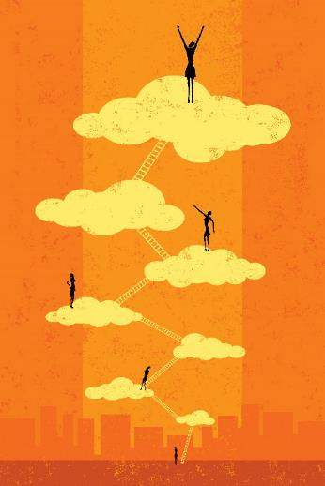

### Activity: Empowerment survey

| This icon indicates an activity for individuals | **Activity type:** Individual written exercise  **Duration:** 10 minutes  **Equipment needed:** Learner Guide (page 7) |
| --- | --- |

**Purpose:** to identify an individual’s sense of inclusion and empowerment in a group context.

**Instructions:**

1. Ask participants to turn to page 7 of the Learner Guide and explain that for this task, learners should reflect on their time at high school, in the workplace or in another group environment and think about their own experiences when responding to the questions. The survey questions have also been included on the following page.
2. Inform learners that they will have 10 minutes to complete the task and ask them to begin. Explain that this is a reflective task only and learners will not be required to share their answers with anyone else.
3. Following the activity, invite learners to share their observations about what they thought it meant to be empowered in a group situation and how it felt when this did or didn’t happen.
4. Revisit the list of words relating to empowerment that were written down earlier and ask learners if they would add any words to this list after completing the Empowerment Survey activity.
5. Read out the following information for context before commencing Topic

| This icon indicates a suggested section to read out | **What is empowerment?**  According to the Oxford Dictionary, to ‘empower’ someone is to ‘make someone stronger and more confident, especially in controlling their life and claiming their rights…’[3]  Empowerment is an active and multi-faceted process, whereby people realise their potential and ability to make decisions and work towards attaining the goals they have set. Empowerment of an individual brings about self-acceptance and self-confidence, social and political understanding, and a personal ability to take part in decision-making and have control over the resources in their environment.[4]  Throughout this training, we’ll be exploring how you can facilitate the empowerment of people with disability in your work by adopting a person-centred approach to service delivery. |
| --- | --- |

### Activity sheet: Empowerment survey

1. **How often did you feel part of the group?**

* Never
* Rarely
* Sometimes
* Often
* All of the time

1. **How often did you feel left out?**

* Never
* Rarely
* Sometimes
* Often
* All of the time

**Can you identify why?**

_________________________________________________________________________________________________________________________________________________________________________________________________________

1. **How often did you feel isolated from others?**

* Never
* Rarely
* Sometimes
* Often
* All of the time

**Can you identify why?**

_________________________________________________________________________________________________________________________________________________________________________________________________________

1. **How often did you feel that there were people who understood you?**

* Never
* Rarely
* Sometimes
* Often
* All of the time

1. **How often did you feel that there were people you could talk to?**

* Never
* Rarely
* Sometimes
* Often
* All of the time

1. **How often did you feel you could support others in their learning?**

* Never
* Rarely
* Sometimes
* Often
* All of the time

1. **How often did you feel you made a difference in that environment (school, workplace)?**

* Never
* Rarely
* Sometimes
* Often
* All of the time

## Introductory Session: Endnotes

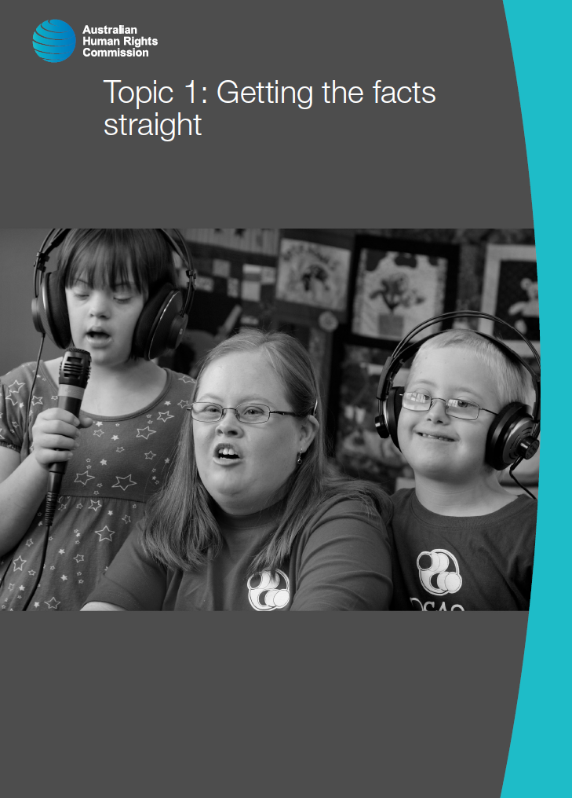

# Topic 1: Getting the facts straight

**Approximate duration:** 3 hours

**Topic sequence:**

1.1. Evolving definitions and demographics of disability (60 minutes)

1.2. Common conditions and impairments which can contribute to disability (40 minutes)

1.3. Community attitudes towards people with disability (60 minutes)

1.4. Disability etiquette (20 minutes)

**Equipment needed:**

* Audio-visual equipment with internet connection
* Learner Guide (pages 9-39)
* Simulator goggles from Vision Australia (optional)

## 1.1 Evolving definitions and demographics of disability

**Approximate duration**: 60 minutes

### Activity: Defining disability

|  |  |
| --- | --- |
| This icon indicates an activity for individuals | **Activity type:** Individual written exercise  **Duration:** 5 minutes  **Equipment needed:** Learner Guide (page 10) |

**Purpose:** To encourage learners to think about how they would define disability, which will allow these definitions to be explored and challenged later in the training.

**Instructions:**

1. Ask learners to turn to the written exercise on page 10 of their Learner Guide. Read out the exercise instructions below, as they appear in the Learner Guide:

|  |  |
| --- | --- |
| cid:BDB4A4DA-67E7-4FE4-B7FA-22F5370C0AF7@iiNet | Think about how you would define disability in your own words. This is a reflection task only and you will not be required to share your definition with anyone else. Write down your definition in the space provided. |

1. Inform learners that they will have five minutes to complete the task and ask them to begin.

| cid:5260E570-9B9A-4BB5-A758-F4F6BD34314F@iiNet | **Discussion question**  Do you think that the status of people with disability in Australian society has changed over time? |
| --- | --- |

**About the evolving status of people with disability**

In the early 1900s, the majority of Australians with disability either lived with their families or were forced into institutional settings. People with disability were commonly segregated from the rest of society and were not expected to play an active role in the community.[5]



Things started to change after the First World War, as a number of soldiers returned with high levels of impairment and there were simply too many people with disability for institutionalisation to be a viable option.

This led to the establishment of government-funded rehabilitation programs, which became even more pivotal after the Second World War when the Australian Government established the Commonwealth Rehabilitation Service.

It was at this time that volunteer organisations started to extend services to people with disability and it was generally understood that people with disability deserved a better standard of living. But despite these changes, people with disability had little control over their lives and continued to be the subject of decisions that were made by others.[6]

### Activity: What is disempowerment?

|  |  |
| --- | --- |
| This icon indicates an activity for a group or class discussion | **Activity type:** Class discussion  **Duration:** 10 minutes  **Equipment needed:** Learner Guide (page 6) |

1. Ask learners to turn back to the activity they completed in the introductory session (on page 6 of the Learner Guide) which explored the concept of empowerment.
2. Ask learners to read over their own responses to the questions in this activity and think about the way disability services operated in Australia prior to the 1950s, with people with disability having little choice or control over the services they received.
3. Ask learners to share their thoughts about how it might feel to be placed in a situation where they were not actively involved in decisions that would have a significant impact on their life.
4. Explain to learners that from the mid-1970s onwards, people with disability began to acknowledge the social nature of their condition and the definition of disability started to change shape.

### Viewing activity

|  |  |
| --- | --- |
| This icon indicates a viewing activity | **Video:** ‘[Social model animation](https://www.youtube.com/watch?v=9s3NZaLhcc4)’  **Source:** Geoff Adams-Spink  **Duration:** 1 minute 26 seconds |

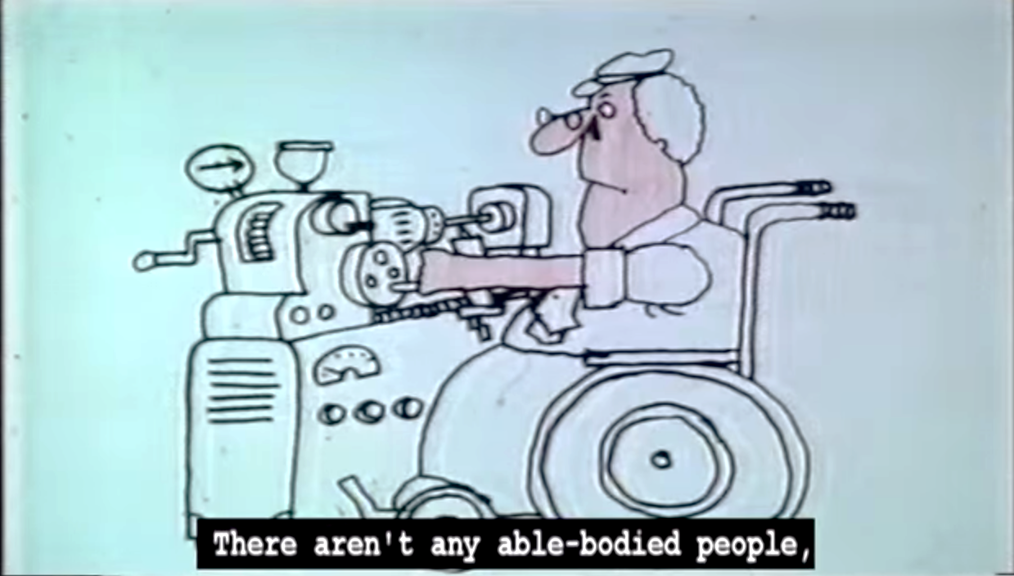

**Summary:** This video tells a story about a world where disability is the norm and people without disability experience limitations because of the way things are designed.

**Instructions:**

1. Play the video ‘Social model animation’.
2. After viewing the video, facilitate a discussion about the video, asking learners if the video has made them think about disability differently.

**Points to inform discussion:**

* The video was based on the social model of disability, rather than the medical model.
* The social model of disability recognises that disability is the result of interactions between features of a person’s body and features of the society in which he or she lives. These interactions often place restrictions on the individual's ability to participate fully in society on an equal basis to others (see diagram below).

**The social model of disability**

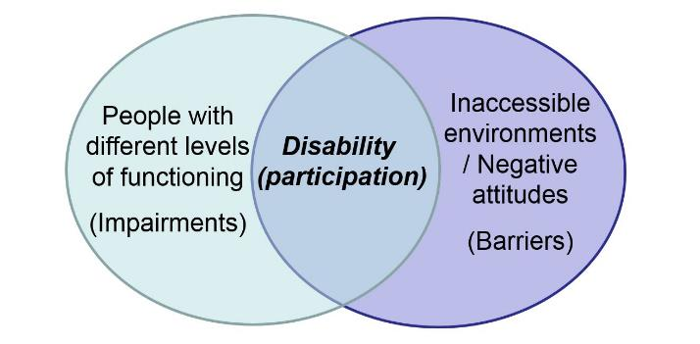

Diagram illustrating the conceptualisation of disability according to the social model of disability

**Examples:**

A student who is blind is unable to participate in a school exam as the exam questions have been provided to her in print. The medical model of disability would say that the student is the problem because she cannot read the printed questions. The social model of disability, on the other hand, recognises that the student is capable of answering the questions, but her access has been limited by the way in which the questions have been presented.

A man who is a wheelchair user is unable to access his local library as it does not have ramp access. The medical model of disability would say that the man is the problem because he can’t use the stairs. Whereas the social model of disability recognises that the man is still capable of using the building, but that his participation is limited by the fact that the building has not been designed in a way that makes it accessible.

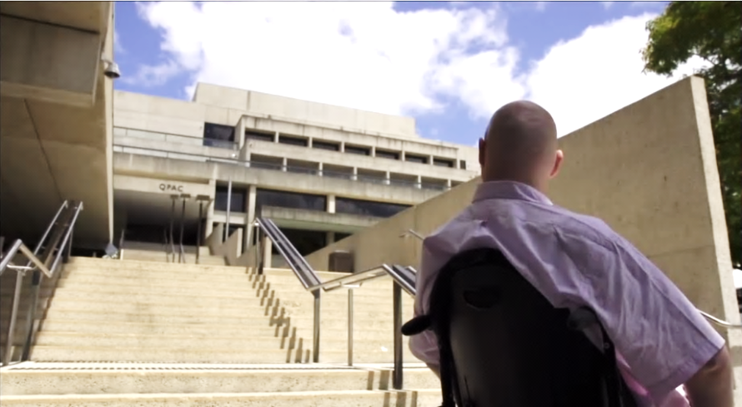

A woman who is an experienced teacher working in a prestigious school wants to migrate to another country with her husband as it will be a good career move for her. She also has HIV. Her immigration application is denied and she is not allowed to migrate. The medical model of disability would say that the problem is with the woman, as she has what is perceived to be a high health risk that may cost the government money. The social model of disability recognises that the woman is prevented from migrating due to stigma, misinformation, bad laws and poor public policies that are not in line with current scientific data.

### International standard for measuring disability

In 2001, the World Health Organisation adopted a new framework for measuring health and disability, known as the *International Classification of Functioning, Disability and Health* (ICF).[7]

This classification system draws on the social model of disability and recognises that disability ‘is a complex phenomenon, reflecting the interaction between features of a person’s body and features of the society in which he or she lives.’[8]

Importantly, the adoption of the ICF has led to a shift in the way disability is measured at a population level.

The social model of disability places a greater focus on the impact of disability rather than a medical diagnosis. This approach recognises that two different people with the same type of condition or impairment can experience differing levels of functional limitation or restrictions in daily life depending on a range of external factors, such as where they live.

For data collection purposes, the Australian Bureau of Statistics defines disability as: ‘any limitation, restriction or impairment which restricts everyday activities and has lasted or is likely to last for at least six months.’[9]

Using this measurement, we know that over 4 million Australians, or 1 in 5 people have a disability or long-term health condition.[10]

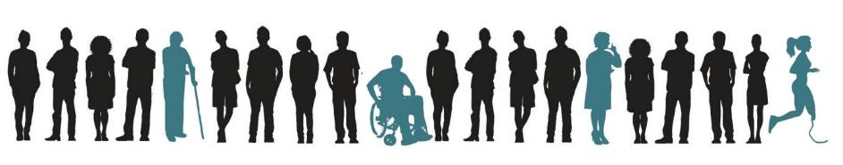

As a result of the strong correlation between age and disability, the prevalence of disability is also anticipated to increase as Australia’s population ages.

In 2009, around 3.4% of children aged four and under were affected by disability, compared with 40% of people aged 65-69 and 88% of people over 90.[11]

Keep the social model of disability in the back of your mind during the next activity, as we explore some of the inequalities that still exist for people with disability in Australia today.

### Activity: What are the stats?

|  |  |
| --- | --- |
| This icon indicates an activity for individuals | **Activity type:** Individual written exercise/class discussion  **Duration:** 15 minutes  **Equipment needed:** Learner Guide (page 15) |

**Purpose:** To encourage learners to think about the way in which the rights of people with disability may still be limited in Australia.

**Instructions:**

1. Instruct learners to turn to the multiple choice activity on page 15 of their Learner Guide
2. Read the instructions below, as they appear in the Learner Guide:

|  |  |
| --- | --- |
| cid:BDB4A4DA-67E7-4FE4-B7FA-22F5370C0AF7@iiNet | Read through the multiple choice questions below and circle the answer that you think is correct. This is a reflective task only and you will not be required to share your answers with anyone else. |

1. Inform learners that they have five minutes to complete the activity and ask them to begin.
2. After five minutes, go through the answers to each question using the answer sheet on the following page and provide learners with an opportunity to share their observations.
3. Ask learners if they were surprised by any of the statistics in the activity and if it has made them think about the ways in which the rights of people with disability may be limited.

### Answer sheet: What are the stats?

**1. How many times more likely are young people with mental health disorders and/or cognitive impairment to be imprisoned in comparison to those without disability?**

A) 2 times as likely

B) 4 times as likely

C) 6 times as likely

D) 8 times as likely

**ANSWER:** C. 6 times as likely.[12]

**2. The labour force participation rate of people in Australia without disability is 83%. What is the labour force participation of people with disability?**

A) 33%

B) 54%

C) 64%

D) 72%

**ANSWER:** B. 54%.[13]

**3. What proportion of women with an intellectual disability will experience sexual abuse at some point in their life?**

A) 1 in 10

B) 3 in 10

C) 6 in 10

D) 9 in 10

**ANSWER:** D. 9 in 10. 90% of women with intellectual disability will experience sexual abuse at some point in their life. 60% of women with intellectual disability will experience sexual abuse before they reach 30 years of age.[14]

**4. What is the percentage of Australians with disability who live near or below the poverty line?**

A) 16%

B) 29%

C) 45%

D) 72%

**ANSWER:** C. 45%. 45% of Australians with disability live near or below the poverty line.[15]

**5. What percentage of people with a disability aged 18-64yrs have completed Year 12?**

A) 25 %

B) 36%

C) 50%

D) 62%

**Answer:** B. 36% of people with disability aged 18-64 have completed year 12, in comparison to 60% of those without a disability.[16]

**6. People with high support needs** **are how many times less likely to participate in activities outside the home?**

A) 3 times

B) 6 times

C) 8 times

D) 9 times

**Answer:** D.People with a profound disability are nine times less likely to participate in activities outside the home.[17]



|  |  |
| --- | --- |
| This icon indicates facts and statistics | For more statistics and information on people with disability in Australia, visit the Australian Human Rights Commission’s ‘[Face the Facts: Disability Rights](https://www.humanrights.gov.au/face-facts-disability-rights)’ page.  This webpage also features a number of infographics, which have been included on the following page and can be shared with learners to visually reinforce some of the statistics from the quiz. |

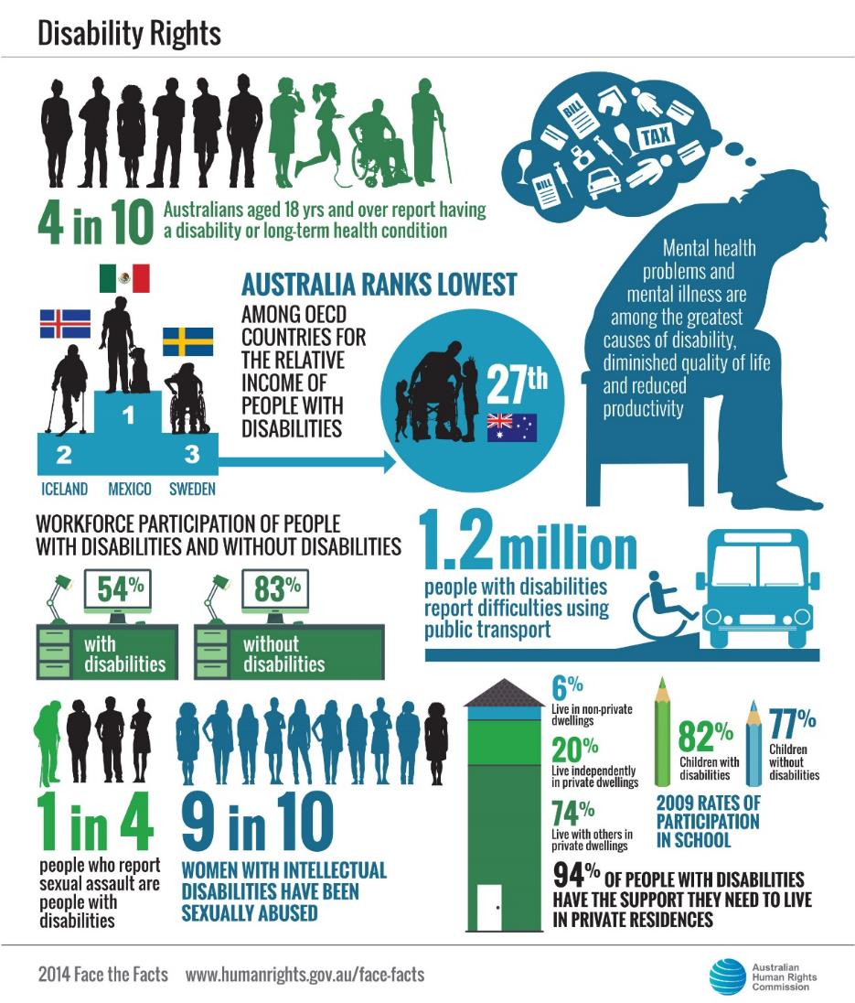

### What do the stats tell us?

These facts demonstrate that people with disability continue to face widespread disadvantage in Australian society.

The level of disadvantage that is experienced by a person with disability can vary greatly depending on their individual circumstances.

Women, children, Aboriginal and Torres Strait Islander peoples, peoples from culturally and linguistically diverse backgrounds, older people and people who are gay, lesbian, bisexual, transgender or intersex all typically face varying forms of marginalisation in Australian society.

When a person from one or more of these groups also has a disability, the level of marginalisation that is experienced by that person is often more severe. This multi-faceted experience is known as ‘intersectionality’, or ‘intersectional discrimination.’

An example of this is evident in the answer to the third quiz question: 90% of women with intellectual disability will experience sexual abuse at some point in their lives.

If we take disability out of the equation, we know that women already experience a higher rate of sexual violence than men. According to data published by the Australian Bureau of Statistics, in 2012, an estimated 17% of all women aged 18 years and over had experienced sexual violence since the age of 15, compared with 4% of men aged 18 years and over.[18]

Women with intellectual disability are often more vulnerable than women without disability, and consequently experience even higher rates of sexual violence.

The growing understanding that a person’s level of participation can be enhanced or diminished by various environmental factors has resulted in governments around the world recognising that society has a role to play in addressing the barriers faced by people with disability.

There are now several frameworks in place in Australia to advance the rights of people with disability, which will be explored in greater detail throughout this unit of competency.

These include:

* The United Nations Convention on the Rights of Persons with Disabilities
* The National Disability Strategy
* The National Disability Insurance Scheme
* The National Standards for Disability Services
* Anti-discrimination legislation and standards

For now though, let’s look at the concept of disability itself in a little more detail.

## 1.2. Common conditions and impairments which can contribute to disability

**Approximate duration:** 40 minutes

There are six main types of conditions or impairments that may lead someone to experience disability. These are:

* **Physical** (impacts on personal mobility or movement of the body)
* **Sensory** (impacts on vision and/or hearing)
* **Psychiatric or psycho-social** (impacts on thought processes or behaviour)
* **Neurological** (impacts on the ability to control movements)
* **Cognitive** (can impact on a person’s thought processes and memory)
* **Intellectual** (can impact on communication and/or learning).

Let’s consider some specific conditions and impairments that fall into each of these categories and explore their prevalence in Australian society.

|  |  |
| --- | --- |
| This icon indicates a trainer’s note | **Trainer’s note:** This entire section has been created in a ‘question and answer’ format to get learners thinking about what they know about the prevalence of disability in Australian society. |

All of the questions, as well as answer options for each question, have been provided on pages 168-170 of the Learner Guide. Work through each of the questions one at a time and provide learners with an opportunity to discuss which answer they think is the correct one before covering the additional information provided for each question.

**Question 1: Every …………, 5 Australians sustain a spinal cord injury**

***Answer options:***

* Hour
* Day
* Week
* Month

**Answer: Five Australians sustain a spinal cord injury every week.[19]**

A spinal cord injury is a form of physical impairment. It is defined as any damage to the spinal cord that results in a loss of function. It is frequently caused by accident or trauma, but may also be caused by diseases such as polio or spina bifida.

The term quadriplegia is used to describe paralysis, or loss of movement below the neck (also known as tetraplegia). While paraplegia refers to paralysis or loss of movement below the chest.[20]

**Question 2: Every …..... , 10 to 15 Australians sustain a severe brain injury.**

***Answer options:***

* Hour
* Day
* Week
* Month

**Answer: 10 to 15 Australians sustain a severe brain injury every week.[21]**

According to the Australian Bureau of Statistics 2003 survey of Disability, Ageing and Carers, around 1 in 45 Australians (432,700) had an acquired brain injury with activity limitations and participation restrictions.[22] Acquired brain injury is defined as any injury to the brain that occurs after birth. An acquired brain injury can be caused by accident or trauma, stroke, brain infection, alcohol or other drugs or diseases of the brain such as Parkinson’s disease.

Acquired brain injury is a form of neurological or cognitive impairment.[23] It differs from intellectual disability, as people with acquired brain injury generally retain their intellectual abilities but may have difficulty coordinating, controlling or communicating their thoughts.[24]

**Question 3: Every …….. hours, a child in Australia is born with cerebral palsy.**

***Answer options:***

* 2
* 5
* 10
* 15

**Answer: A child in Australia is born with cerebral palsy every 15 hours.[25]**

Cerebral palsy, or CP*,* is caused by damage to a child’s brain either during pregnancy, or shortly after.[26]

Although it is caused by injury to the brain, cerebral palsy is classified as a physical impairment as it most commonly effects physical mobility and muscle control.

Cerebral palsy can vary greatly in severity and form and people with cerebral palsy sometimes also have vision or hearing impairment, intellectual disability or difficulty with speech.[27]

### Viewing activity

|  |  |
| --- | --- |
| This icon indicates a viewing activity | **Video:** ‘[What is cerebral palsy?](https://www.youtube.com/watch?v=Rsk3VQ-gr34)’  **Source:** The Cerebral Palsy Alliance,  **Duration:** 10 minutes 28 seconds |

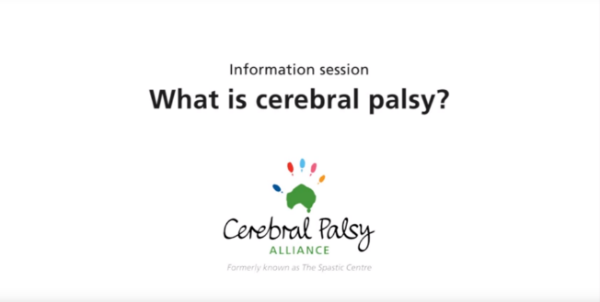

**Summary:** This video from the Cerebral Palsy Alliance talks about cerebral palsy -what it is, how it is caused and how it is generally described and highlights the ways in which children with cerebral palsy can be supported to fulfil their individual potential, goals and aspirations.

**Instructions:**

* Play the video ‘What is cerebral palsy?’
* Ask learners if they have any comments or questions about the video before moving on.

**Question 4: One in …….. children born in Australia each year will have Down syndrome.**

***Answer options:***

* 100
* 1,000
* 10,000
* 100,000

**Answer: One in every one thousand children born in Australia each year will have Down syndrome.[28]**

Each cell in the human body typically has 46 chromosomes. When there is an extra chromosome, Down syndrome occurs. People with Down syndrome typically have some level of intellectual impairment and may experience challenges with health and development.[29]

**Question 5: Every …….. hours, a child in Australia is diagnosed with autism spectrum disorder.**

***Answer options:***

* 2
* 7
* 14
* 24

**Answer: A child in Australia is diagnosed with autism spectrum disorder every seven hours.[30]**

Autism spectrum disorder is estimated to affect one in 100 Australians. It has been described by Autism Spectrum Australia as:

‘Lifelong developmental disabilities characterised by marked difficulties in social interaction, impaired communication, restricted and repetitive interests and behaviours and sensory sensitivities’.[31]

**Question 6: Every …….. hours, a child in Australia will be born with an intellectual disability.**

***Answer options:***

* 2
* 8
* 12
* 16

**Answer: Every two hours, a child in Australia is born with an intellectual disability.[32]**

Intellectual disability occurs in the developmental period before the age of 18. An individual who is assessed as having an IQ of 70 or less is often defined as having an intellectual disability.

Intellectual disability impacts people in different ways, but may affect an individual’s communication abilities, self-care, social skills or learning.[33]

**Question 7: One in …….. Australians will experience mental illness in any 12-month period.**

***Answer options:***

* 5
* 10
* 15
* 20

**Answer: 20% of Australians, or one in five, will experience a mental illness within a 12-month period.**[34]

‘Mental illness’ is an umbrella term that includes conditions such as depression, anxiety, personality disorder/bipolar disorder, substance abuse, post-traumatic stress disorder and schizophrenia.

The term ‘mental illness’ is now used less frequently and instead the term ‘psycho-social disability’ is more commonly used.

45% of Australians will experience a psycho-social disability at some stage during their life, though the impact may vary in severity and duration. At least a third of young people will have experienced an episode of mental illness by the time they reach the age of 25.[35]

**Question 8: Over …….. Australians experience blindness or vision loss.**

***Answer options:***

* 200,000
* 300,000
* 400,000
* 500,000

**Answer: Over 300,000 Australians experience some form of blindness or vision loss that cannot be corrected.**

This number increases to over 400,000 when counting individuals with treatable conditions, such as cataracts, that they have not yet received medical intervention for.[36]

Blindness or vision impairment can be caused by a number of different conditions, including, but not limited to:

* Macular degeneration
* Retinitis pigmentosa
* Diabetic retinopathy
* Accident or trauma

**Question 9: One in …….. Australians experience hearing loss.**

***Answer options:***

* 6
* 8
* 10
* 20

**Answer: One in six Australians experience hearing loss and around 30,000 Australians experience total hearing loss.**

Hearing loss can be caused by a number of different conditions, such as Ménière's disease or usher syndrome. It can also be caused by exposure to loud noise, exposure to some drugs and chemicals, accident or injury and the aging process. More than half of the population between the ages of 60 and 70 have some degree of hearing loss, compared with more than 70% of people over 70 and more than 80% of people over 80.[37]

**Question 10: Around …….. % of Australians have difficulty reading or understanding written information.**

***Answer options:***

* 12
* 24
* 36
* 44

**Answer: Around 44% of Australian adults have difficulty reading or understanding written information.**[38]

Reading can be difficult for a wide range of people, including people with cognitive impairments such as dyslexia, people with intellectual disability or acquired brain injury and some people from culturally and linguistically diverse backgrounds.

|  |  |
| --- | --- |
| This icon indicates facts and statistics | This activity has been adapted from information available on the ‘[Disability Statistics](http://www.hwns.com.au/Resource-centre/disability-statistics)’ webpage of the House with No Steps website.[39] |
| This icon indicates a trainer’s note | **Trainer’s note:** You might like to familiarise learners with some other forms of conditions or impairments if time permits. A few suggestions have been provided below.   * Multiple sclerosis * Osteogenesis imperfecta * Prader-Willi syndrome * Cystic fibrosis * Muscular dystrophy |

### Optional activity: Fade to black

|  |  |
| --- | --- |
| This icon indicates an activity for a group or class discussion | **Activity type**: Interactive class activity  **Duration:** 20 minutes  **Equipment needed:** Simulator goggles from Vision Australia (PH: 1300 847 466) |

**Purpose:** To demonstrate the impact of different types of vision conditions.

**Instructions:** Hand out the simulator goggles and provide learners with an opportunity to try each of the simulated vision conditions. Encourage further discussion.

## 1.3. Community attitudes towards people with disability

**Approximate duration:** 60 minutes

The social model of disability tells us that people with disability are often more limited by the barriers that society puts in their way than by the direct effects of a particular condition or impairment.

When we think about barriers, we might think about things like inaccessible public transport, housing and infrastructure. But it’s also important to understand the extent to which attitudinal barriers can limit the full and equal participation of people with disability.

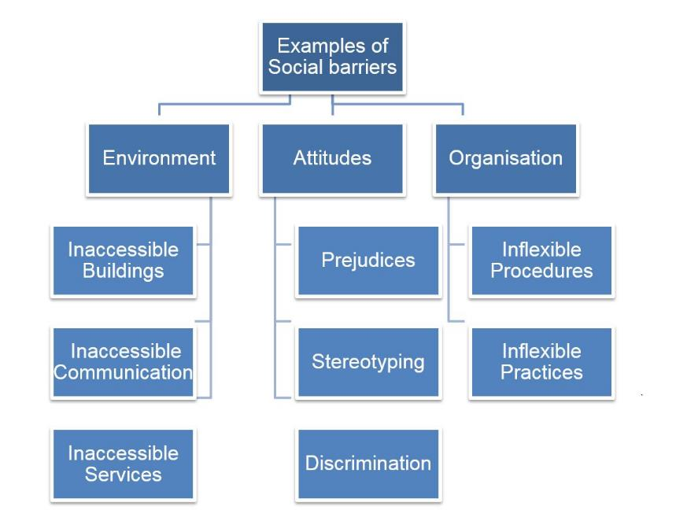

In 2010, the National People with Disabilities and Carer Council published a report entitled *SHUT OUT: The Experience of People with Disabilities and their Families in Australia,*[40] which was informed by over 750 submissions from people with disability, their families and carers. Significantly, the report noted:

A lack of social inclusion and the multiple barriers to meaningful participation in the community faced by people with disabilities were the most frequently raised issues in the submissions and consultations. More than half the submissions received (56 per cent) identified exclusion and negative social attitudes as critical issues.

People with disabilities and their families, friends and carers reported daily instances of being segregated, excluded, marginalised and ignored. At best they reported being treated as different. At worst they reported experiencing exclusion and abuse, and being the subject of fear, ignorance and prejudice.

People with disabilities believe little progress has been made in challenging prevailing attitudes towards disability.

Submissions suggested that there are still widespread misconceptions and stereotypes informing the attitudes and behaviour of service providers, businesses, community groups, governments and individuals.

As a result, discrimination is a feature of daily life for many people with disabilities and their families.[41]

|  |  |
| --- | --- |
| This icon indicates a discussion question | **Discussion question:** What do you think is meant by the term ‘discrimination’? |

**Points to inform discussion:**

* Discrimination involves someone being treated less favourably because of a personal attribute that is inherent to them such as: age, race, sex, sexual orientation or disability.
* People with disability are often subjected to discrimination as a result of the negative attitudes and misconceptions that continue to be held by people in the community.
* In the ‘What are the stats?’ activity in Section 1.1 for example, we saw that the rate of workforce participation of people with disability is much lower than it is for the rest of the population.

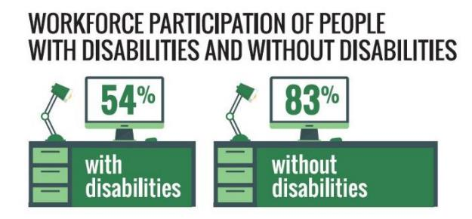

* Employers can sometimes make assumptions about the ability of a person with disability to perform the requirements of a particular role. For example, many employers hold concerns that employing a person with disability may pose a risk to the safety of the work environment. However statistics show that employees with disability actually have fewer workplace injuries, make fewer workers compensation claims and take fewer days off than employees without disability.[42]

These negative attitudes and misconceptions can impact heavily upon people with disability in their day-to-day interactions with others. This is explored further in the following viewing activity featuring a video of comedian and disability activist, Stella Young.

### **Viewing activity**

|  |  |
| --- | --- |
| This icon indicates a viewing activity | **Video:** ‘[Inspiration porn and the objectification of disability](http://tedxsydney.com/site/item.cfm?item=A83E0095E6074F5CF983ACC0FB69395C)’  **Source**: TEDxSydney  **Duration**: 9 minutes 26 seconds |

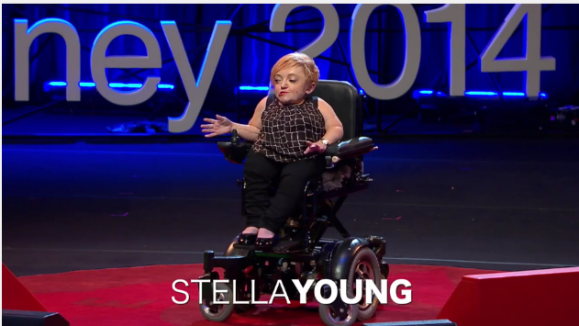

**Summary**: This is a video of the TED Talk delivered by comedian and disability activist Stella Young in Sydney in 2014.

**Instructions:**

1. Play the video ‘Inspiration porn and the objectification of disability’.
2. After viewing the video, facilitate a discussion about the video content.

|  |  |
| --- | --- |
| cid:5260E570-9B9A-4BB5-A758-F4F6BD34314F@iiNet | **Discussion questions:**   * What were some of the stereotypical attitudes and behaviours towards people with disability that Stella touched on in the video? * What are the negative impacts of these attitudes and behaviours? * What do you think Stella was trying to achieve? * How, if at all, has the video made you think about your own attitude towards people with disability? |

### Activity: Reflecting on common interactions

|  |  |
| --- | --- |
| This icon indicates an activity for individuals | **Activity type:** Individual written exercise  **Duration:** 20 minutes  **Equipment needed:** Learner Guide (page 27) |

**Purpose:** To encourage learners to think about some of the ways that people typically think about and interact with people with disability and the impact of these interactions.

**Instructions:**

1. Ask learners to turn to the written exercise on page 27 of their Learner Guide.
2. Explain that this is a reflective task only and that they will not be required to share their answers with the rest of the class.
3. Instruct learners to read through each of the four scenarios listed and think about the emotions they would be feeling, or the thoughts that would be running through their mind, if they were the person with disability in each of these scenarios. For reference, the scenarios are located on the following page.
4. Depending on the group dynamic, you might like to read each scenario aloud, providing learners with a few minutes to write down their thoughts on each one before reading out the next. Also explain that these scenarios have been directly informed by the everyday experiences of people with disability.
5. Allow approximately 10 minutes for learners to write down their thoughts in the space provided.
6. Ask if there are any comments or questions before moving on.

|  |  |
| --- | --- |
| This icon indicates a trainer’s note | **Trainer’s note:** The following notes offer guidance on why some of the interactions described in the scenarios were problematic and reflect a lack of understanding about different types of disability.  **Scenario 1** - It can be common for people to assume that people with disability are less intelligent than other people, regardless of the particular type of condition that person has. In this scenario the person has a vision impairment, which would not have any impact on their ability to hear or understand information.  **Scenario 2** - It is common for people to intrude on the privacy of people with disability and ask invasive or confronting questions when such questions would never be asked of a person without disability.  **Scenario 3** - People with assistance animals are often interrupted by people who are interested in the animal, but pay no regard to the person with disability themselves and do not seem to consider what they are doing at that particular moment in time. Remember that a person with an assistance animal may sometimes deal with situations such as these several times a day, which can be quite exhausting.  **Scenario 4** - It is often wrongly assumed that people with disability do not have the capacity to speak for themselves, so people will frequently direct questions to a person with the individual with disability, rather than the individual with disability themselves. |

### Activity sheet: Reflecting on common interactions

**Scenario 1**

You are a person who is blind. You need to get a train home from Central Station. You vaguely remember hearing something about there being track work taking place on your line, so you decide that you should check with a member of staff. You have had orientation and mobility training to learn how to navigate the station independently, so you make your way to the customer service desk. You voice your enquiry to the man behind the desk. He responds by telling you that there is track work and explaining the alternate travel arrangements, but he speaks to you very loudly, in a slow and deliberate voice.

|  |  |
| --- | --- |
| This icon is used to highlight further reading and important information | **Background information:**People who are blind or vision impaired commonly receive ‘Orientation and Mobility’ training from a suitably qualified instructor to help them navigate new and unfamiliar environments confidently and independently. |

**Scenario 2**

You are a wheelchair user who uses a wheelchair accessible taxi (WAT) to get to and from work. As you are sitting in the taxi one morning, the driver turns to you and asks ‘Were you born like that?’

**Scenario 3**

You had a stroke several years ago and have limited dexterity in your hands. You have an assistance dog that is trained to assist you with various tasks throughout the day. You are sitting at a bus stop with your friend, waiting to get the bus home. You are midway through telling him a joke you heard on the radio yesterday. But just as you are nearing the punch line, you are interrupted by a complete stranger who asks if they can pat your dog.

**Scenario 4**

You are a woman with Down syndrome who has very low support needs and works in open employment. You and a colleague decide to visit a nearby café for lunch. You are both at the counter ready to order. It is clear that it is your turn to be served, but the woman behind the counter looks at your friend and says, ‘What would she like?’

### What are invisible disabilities?

A common underlying misconception about disability is that disability is always obvious. But this is not the case. There are many forms of disability that are invisible or not immediately recognisable.

|  |  |
| --- | --- |
| This icon indicates a trainer’s note | **Trainer’s note:** You may wish to begin this section by instructing learners to read the online opinion piece ‘We need a radical rethink on disability’[43], published on ABC’s Open Drum on 23 April 2015. This article serves to highlight some of the disadvantages that people with invisible disabilities experience. |
| This icon indicates a discussion question | **Discussion scenario:**  Imagine you’re in the carpark at your local shopping centre. You see a woman exit a vehicle that is parked in an accessible parking space that has been reserved for customers with disability. The woman does not appear to have any sort of impairment and walks into the shopping centre without any fuss.  **Discussion question:** What would you think or feel in this situation? | |

**Points to inform discussion:**

* It is true that people without disability sometimes park in accessible parking spaces illegally, however it is also common for people with invisible forms of disability to be abused for parking in one of these spaces, simply because the challenges they face are not visibly evident to onlookers. Anyone with a disability parking permit is entitled to use an accessible parking space.
* There are many invisible conditions that may justify someone requiring access to a parking space that is located nearer to the shop entrance, including but not limited to:
  + back or brain injury
  + chronic illness or pain
  + heart conditions
  + muscular, neurological, seizure, bone or spinal disorders
  + organ transplant
  + oxygen impairment.[44]

People with invisible forms of disability such as mental illness, intellectual impairment, brain injury, autism spectrum disorder and chronic illnesses, such as diabetes and HIV, can experience particular forms of exclusion and discrimination. Many people with invisible forms of disability report that the stigma that surrounds their disability can be just as distressing as the condition itself.

|  |  |
| --- | --- |
| This icon indicates a discussion question | **Discussion question:** What do you think the word stigma means?  The Oxford Dictionary defines stigma as: a mark of disgrace associated with a particular circumstance, quality or person.[45]  **Discussion question:** What do you think are some of the ways stigma might impact on people with invisible disabilities? |

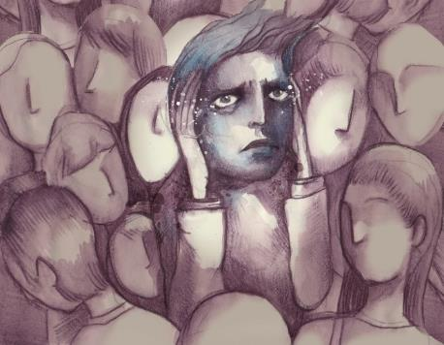

### Examples of stigma experienced by people with invisible disability

The following are some examples of how stigma can affect people with different disabilities.

**Diabetes**

According to a study undertaken by the Juvenile Diabetes Foundation in 2015, 46% of Australians with Type 1 diabetes have felt excluded from activities or have experienced bullying.[46]

Research suggests that people with diabetes are often:

* Treated unfairly in the workplace. Some employees or colleagues may treat a team member who has disclosed they have diabetes differently due to misconceptions about what they are and are not capable of, or how the condition is managed.
* Blamed by others. Many individuals believe that people who have diabetes have brought the condition upon themselves through leading an unhealthy lifestyle.
* Judged or treated negatively in social situations due to food choices or self-care needs; these might include self-monitoring of blood glucose levels and taking insulin.[47]

**HIV/AIDS**

Individuals with Human Immunodeficiency Virus (HIV) are often stigmatised and excluded as a result of people negatively associating their condition with homosexuality, drug use, sex work or infidelity.

Many people also lack an understanding of how HIV is contracted, which can lead to irrational behaviour and fear.[48] Anyone can be susceptible to HIV/AIDS, regardless of their sexual orientation. Contracting HIV is possible from blood-to-blood contact, sharing needles or unsafe sex.

**Psycho-social disabilities**

Stigma also continues to cause widespread discrimination amongst people with psycho-social disability or mental illness. Sane Australia states:

Most often stigma against people with a mental illness involves inaccurate and hurtful representations of them as violent, comical or incompetent, which serves to dehumanise sufferers of mental illness and make them objects of fear or ridicule.[49]

### Viewing activity

|  |  |
| --- | --- |
| This icon indicates a viewing activity | **Video:** ‘[A Life without Stigma](https://www.youtube.com/watch?v=kYoi9RAxzvQ)’  **Source**: SANE Australia  **Duration:** 3 minutes 22 seconds |

[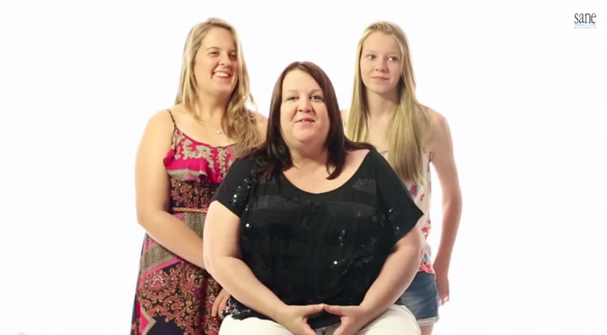](https://www.youtube.com/watch?v=kYoi9RAxzvQ)

**Summary:** Four everyday Australians talk about how they have been affected by prejudice against mental illness, and how we can all live a life without stigma

**Instructions:**

1. Explain that negative community attitudes often create barriers to the full and equal participation of people with invisible forms of disability. There is still a great deal of stigma surrounding psycho-social disability/mental illness in particular and it is important that this stigma is challenged.
2. After playing the video, invite learners to share any thoughts or reflections before moving on.

Inaccurate representations of people with mental illness can be challenged by gaining a greater insight into the facts and figures surrounding mental illness in Australia.

According to Sane Australia:

* Nearly half (45%) of the population will experience a mental disorder at some stage in their lives.
* Almost one in five Australians (20%) will experience a mental illness in a 12-month period.
* During a one-year period, anxiety disorders will affect 14% of the population and depression will affect 6%.
* Depression is one of the most common conditions in young people and increases during adolescence.
* At least one third of young people have had an episode of mental illness by the time they are 25 years old.
* Research indicates that people receiving treatment for a mental illness are no more violent or dangerous than the general population.
* People living with a mental illness are more likely to be victims of violence, especially self-harm.
* Mental illnesses are not purely ‘psychological’ and can have many physical features.
* Anyone can develop a mental illness and no one is immune to mental health problems.
* Most people with mental illness recover well and are able to lead fulfilling lives in the community when they receive appropriate ongoing treatment and support.[50]



Almost one in five Australians will experience a mental illness in a 12-month period.

In regards to employment, the Australian Public Service Commission’s guide for employers, *Working Together: Promoting mental health and wellbeing at work* states:

Many people with mental health conditions, across a wide range of workplaces, are highly successful employees. Organisations employing people with mental health conditions report good attendance and punctuality, as well as motivation, quality of work, and job tenure on par with or greater than other employees.[51]

|  |  |
| --- | --- |
| This icon is used to highlight further reading and important information | **Further reading:**  Sane Australia, [*The SANE Guide to Reducing Stigma*](https://www.sane.org/images/PDFs/SANE-Guide-to-Reducing-Stigma.pdf) (2014). |

## 1.4. Disability etiquette

**Approximate duration:** 20 minutes

While people generally have the best of intentions, they can often interact with people with disability in a way that is unhelpful, patronising or offensive.

This section provides important information to help you interact with people with disability in a manner that is both helpful and respectful.

### Offering assistance

Try not to assume a person will require assistance simply because they have a disability. While some people with disability may need or appreciate assistance from time-to-time, this is not always the case. Ask yourself if it appears as though the person actually requires assistance or whether they already appear to have everything under control.

If you are unsure of whether or not someone requires assistance, there is nothing wrong with politely asking. Approach the person in the same way you would approach anyone else and ask if there is anything you are able to do to assist them. This will ensure that the person with disability is still in control of the situation, that their space is respected and that you do not act in a way that is contrary to their needs or wishes.

You might also like to familiarise yourself with sighted guide technique (a technique which enables a person who is blind to use a person with sight as a guide) in case you come across someone who is blind or vision impaired who requires this assistance in the future.

Some key points for using the sighted guide technique are outlined in the following viewing activity.

### Viewing activity

|  |  |
| --- | --- |
| This icon indicates a viewing activity | **Video:** ‘[Guiding and communicating with a person who is blind or has low vision](http://www.visionaustralia.org/living-with-low-vision/learning-to-live-independently/in-the-community/useful-tips-and-mobility-fact-sheets/guiding-a-person-who-is-blind-or-has-low-vision)’  **Source:** Vision Australia  **Duration:** 12 minutes 31seconds |

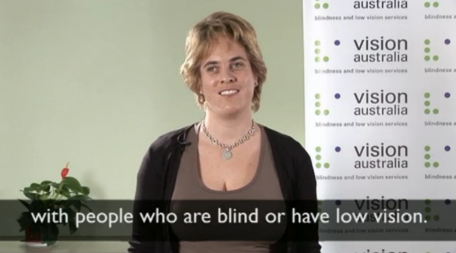

**Summary:** This video demonstrates the proper etiquette for communicating with, and assisting someone who is blind or vision impaired.

**Instructions:**

1. Play the video ‘Guiding and communicating with a person who is blind or has low vision’.
2. Ask learners if they have any comments or questions about the video before moving on.

### Mobility aids

Just as it is inappropriate to physically touch a person without their expressed permission, it is also inappropriate to touch, move, or interfere with someone’s mobility aid without their expressed permission, whether it is a wheelchair, a mobility scooter, a cane or a guide dog.

Assistance animals must remain focused on their work at all times to ensure the safety of their handler. For this reason, you should never pat, talk to, feed or otherwise distract an assistance animal while the animal is working. It is also important to remember that under federal law, the only public premises where assistance animals are not allowed are commercial kitchens, hospital burns units and operating theatres and some national parks.

### Questions

It is common for people with disability to be subject to intrusive questions about their condition or impairment. Some people might find this questioning confronting or offensive, while others may have acquired their disability through traumatic circumstances and might find it difficult to discuss.

Before asking questions about a person’s condition or impairment, you should consider whether it is necessary for you to acquire this information, and ask yourself if you would ask the same question of a person without disability.

### Language

Just as definitions of disability have evolved over time, certain terms that were once considered acceptable when referring to people with disability have come to be understood as unacceptable, offensive or politically incorrect. The disability rights movement has played an instrumental role in this shift in thinking, as people with disability have started to express their own views about the labels that have been used to define them.

Language is a topic that there is never likely to be complete agreement on, however best practice in Australia involves the use of person-centred language. This involves putting the person before the impairment. If you were to refer to someone as a ‘paraplegic man’, you are recognising them by their impairment first. If using person-centred language, you would change this sentence to ‘a man with paraplegia’. Person-centred language demonstrates that you respect people with disability as individuals, rather than labelling them, or recognising them primarily by their impairment.

If you are working directly with a person with disability, you should be guided by the language that they prefer. Otherwise, you should be consistent in your use of person-centred language, as this is the standard that has been agreed upon by all Australian Governments and the majority of non-government organisations.

You should avoid using terms like ‘suffers from’, or ‘is a victim of’ when referring to someone’s condition or impairment. Try to take the emotive terms out of the sentence e.g. ‘Juan is blind’ or ‘Sarah experiences depression.’[52]

### Activity: What’s hot and what’s not

|  |  |
| --- | --- |
| This icon indicates an activity for a group or class discussion | **Activity type:** Whole group activity  **Duration:** 10 minutes  **Equipment needed**: Learner Guide (page 38) |

**Instructions:**

1. Ask learners to turn to the word list on page 38 of their Learner Guide.
2. The list includes the words from the ‘Outdated term’ column of the following table, as well as blank space for students to write the preferred term.
3. Using the table below, move through the words included in the left-hand column one-by-one and provide learners with an opportunity to try and think of a more politically correct term before revealing the preferred terms in the right-hand column.
4. Make sure you create a safe space for students to make mistakes during this activity by explaining that all of these terms were considered acceptable at some point in time, so it is okay not to know the correct answer.
5. When all of the terms have been covered, ask learners if they have any comments or questions before moving on.

|  |  |
| --- | --- |
| **Outdated term** | **Preferred terms** |
| Handicapped | Has disability, person with disability |
| Spastic | Person with Cerebral Palsy, person with disability |
| Insane, crazy person | Person with psycho-social disability, person with mental illness |
| Dwarf, midget | Person with Dwarfism, person of small stature |
| Mongoloid | Person with Down Syndrome |
| Slow | Has intellectual disability / person with intellectual disability, person with learning difficulties |
| Wheelchair-bound | Wheelchair-user |
| Cripple | Person with physical disability, wheelchair-user |
| Fit, attack | Seizure |
| Disabled toilet | Accessible toilet |

The word list for this activity has been adapted from the NSW Department of Family and Community Services’ [*What’s Hot and What’s Not guide*](https://www.google.com.au/url?sa=t&rct=j&q=&esrc=s&source=web&cd=1&cad=rja&uact=8&ved=0ahUKEwixl5-YupbKAhXGGqYKHSJCBNoQFggcMAA&url=https%3A%2F%2Fwww.dontdismyability.com.au%2F__data%2Fassets%2Fpdf_file%2F0019%2F302635%2F3375_FACS_Whats-hot-and-whats-not_web.pdf&usg=AFQjCNEBYv-Z9ddH9sA8IlPGti15Q-EOTQ)*.[53]*

|  |  |
| --- | --- |
| This icon indicates a trainer’s note | **Trainer’s note:** Conclude Topic 1 by asking learners to turn back to the definition of disability that they had written down on page 10 of their Learner Guide at the beginning of Topic 1, and ask them to provide feedback on whether or not they would change their definition, based on what they have learned throughout this topic. |
| This icon is used to highlight further reading and important information | **Further reading:**  Australian Network on Disability, [*Inclusive Language*](http://www.and.org.au/pages/inclusive-language.html)(2015).  People with Disability Australia, [*Guide to Reporting Disability*](http://www.pwd.org.au/library/guide-to-reporting-disability.html) (2015). | |

## Topic 1: Endnotes

1. Australian Government, *Training packages*, *CHCDIS007 – Facilitate the empowerment of people with disability* (6 August 2015) <<http://training.gov.au/Training/Details/CHCDIS007>>.
2. People with Disability Australia (PWDA), *History of Disability Rights Movement in Australia* (2015) <<http://www.pwd.org.au/student-section/history-of-disability-rights-movement-in-australia.html>>.
3. Oxford Dictionary Online, *Entry – ‘Empower’ (2015). <*<http://www.oxforddictionaries.com/definition/english/empower>>.
4. Elisheva Sadan, *Empowerment And Community Planning: Theory And Practice Of People-Focused Social Solutions, (*Hakibbutz Hameuchad Publishers, 2004).
5. People with Disability Australia (PWDA), [*History of Disability Rights Movement in Australia*](http://www.pwd.org.au/student-section/history-of-disability-rights-movement-in-australia.html)(2015) < <http://www.pwd.org.au/student-section/history-of-disability-rights-movement-in-australia.html>>.
6. People with Disability Australia (PWDA), [*History of Disability Rights Movement in Australia*](http://www.pwd.org.au/student-section/history-of-disability-rights-movement-in-australia.html)(2015) <<http://www.pwd.org.au/student-section/history-of-disability-rights-movement-in-australia.html>>.
7. World Health Organisation, International Statistical Classification of Diseases and Related Health Problems 10th Revision (ICD-10)-2015-WHO Version (2015) <<http://www.who.int/classifications/icf/en/>>.
8. World Health Organisation, International Statistical Classification of Diseases and Related Health Problems 10th Revision (ICD-10)-2015-WHO Version (2015) <<http://www.who.int/classifications/icf/en/>>.
9. Australian Bureau of Statistics, *Disability, Ageing and Carers, Australia: Summary of Findings, 2009* (4430.016 December 2010) <<http://www.abs.gov.au/ausstats/abs@.nsf/Previousproducts/4430.0Main%20Features22009?opendocument&tabname=Summary&prodno=4430.0&issue=2009&num=&view>=>.
10. Australian Bureau of Statistics, *Disability, Ageing and Carers, Australia: Summary of Findings, 2012* (4430.016 April 2015) <<http://www.abs.gov.au/AUSSTATS/abs@.nsf/Lookup/4430.0Explanatory%20Notes5002012?OpenDocument>>.
11. Australian Bureau of Statistics, *Disability, Australia*, *2009* (4446.0 23 September 2011) <<http://www.abs.gov.au/ausstats/abs@.nsf/Lookup/4446.0main+features42009>>
12. University of New South Wales and PwC, *People with mental health disorders and cognitive impairment in the criminal justice system: Cost-benefit analysis of early support and diversion* (UNSW 2013) 4.
13. Australian Bureau of Statistics, *Disability Australia (Labour Force), Australia, 2009* (4446.0 May 2011) <<http://www.abs.gov.au/AUSSTATS/abs@.nsf/Latestproducts/4446.0Main%20Features92009?opendocument&tabname=Summary&prodno=4446.0&issue=2009&num=&view>>.
14. Sue Salthouse and Caroline Frohmader, ‘Double the Odds: Domestic Violence and Women with Disabilities’ (Paper presented at the ‘Home Truths Conference’, Melbourne, 15–17.September 2004).
15. PWC, *Disability expectations investing in a better life, a stronger Australia: Achieving better outcomes for people with a disability and their families*, ‘Introduction’, (PWC 2011) 13.
16. Australian Bureau of Statistics, *Disability, Ageing and Carers, Australia: Summary of Findings, 2012* (4430.0, 18 September 2014) <<http://www.abs.gov.au/AUSSTATS/abs@.nsf/DetailsPage/4430.02012?OpenDocument>>.
17. Australian Bureau of Statistics, *General Social Survey, Summary Results, Australia, 2006* (*4159.0* 29 September 2011) <<http://www.abs.gov.au/AUSSTATS/abs@.nsf/Lookup/4159.0Main+Features12006>>.
18. Australian Bureau of Statistics, *Personal Safety, Australia 2012* (4906.0 2 October 2014) <<http://www.abs.gov.au/ausstats/abs@.nsf/Latestproducts/4906.0History%20of%20Changes02012?opendocument&tabname=Summary&prodno=4906.0&issue=2012&num=&view=>>.
19. PWC, *Disability expectations investing in a better life, a stronger Australia: Achieving better outcomes for people with a disability and their families* (PWC 2011) 9.
20. Spinal Cord Injuries Australia, *What is spinal cord injury (SCI)? Some basic facts* (2006) <<http://scia.org.au/sci-resources-and-knowledge/health-and-sci-facts/what-is-spinal-cord-injury-sci>>.
21. PWC, *Disability expectations investing in a better life, a stronger Australia: Achieving better outcomes for people with a disability and their families* (PWC 2011) 9.
22. NSW Agency for Clinical Innovation ‘Working with people with acquired brain injury’ (2013)< http://www.abistafftraining.info/Content/0_Home_e_ack.html>
23. Disability Services commission of Western Australia, *What is disability?* (2015) <<http://www.disability.wa.gov.au/understanding-disability1/understanding-disability/what-is-disability/>>.
24. Brain Injury Australia, *About Acquired Brain Injury (2015)* <<http://www.braininjuryaustralia.org.au/>>.
25. PWC, *Disability expectations investing in a better life, a stronger Australia: Achieving better outcomes for people with a disability and their families* (2011) 11.
26. Cerebral Palsy Alliance, *About Cerebral Palsy* (2015)

    <<https://www.cerebralpalsy.org.au/about-cerebral-palsy/>>.
27. Cerebral Palsy Alliance, *About Cerebral Palsy* (2015)

    <<https://www.cerebralpalsy.org.au/about-cerebral-palsy/>>.
28. Down Syndrome Australia, *Down syndrome population statistics* (2015). <<http://www.downsyndrome.org.au/down_syndrome_population_statistics.html>>.
29. Down Syndrome Australia, *Down syndrome population statistics* (2015). <<http://www.downsyndrome.org.au/down_syndrome_population_statistics.html>>.
30. PWC, *Disability expectations investing in a better life, a stronger Australia: Achieving better outcomes for people with a disability and their families* (2011) 11.
31. Autism Spectrum Australia, *What is Autism? Factsheet*, (2015) <<http://www.autismspectrum.org.au/content/fact-sheets>>.
32. PWC, *Disability expectations investing in a better life, a stronger Australia: Achieving better outcomes for people with a disability and their families* (2011) 9.
33. Intellectual Disability Rights Service Inc, *What is Intellectual Disability?* (2015)

    <<http://www.idrs.org.au/education/about-intellectual-disability.php>>.
34. Sane Australia, *Facts and Figures About Mental Illness* (2015) <<https://www.sane.org/information/factsheets-podcasts/204-facts-and-figures-about-mental-illness>>
35. Sane Australia, *Facts and Figures About Mental Illness* (2015) <<https://www.sane.org/information/factsheets-podcasts/204-facts-and-figures-about-mental-illness>>.
36. Hugh R Taylor, Jill E Keeffe, Hien T V Vu, Jie Jin Wang, Elena Rochtchina, Paul Mitchell and M Lynne Pezzullo, ‘Blindness in Australia’ (2005) *Medical Journal of Australia,*  565-568.
37. Australian Hearing, *Causes of hearing loss in Australia* (2014)

    <<http://www.hearing.com.au/causes-hearing-loss-australia/>>.
38. Australian Bureau of Statistics, *4228.0 - Programme for the International Assessment of Adult Competencies, Australia,* 2011-2012 (24 March 2014) <<http://www.abs.gov.au/ausstats/abs@.nsf/Lookup/4228.0main+features992011-2012>>.
39. House with No Steps, *Disability statistics*, (2015)

    <<http://www.hwns.com.au/Resource-centre/disability-statistics>>.
40. National People with Disabilities and Carer Council, *SHUT OUT: The Experience of People with Disabilities and their Families in Australia* (2009).
41. National People with Disabilities and Carer Council, *SHUT OUT: The Experience of People with Disabilities and their Families in Australia* (2009) 4.
42. Graffam J, Shinkfield A, Smith K and Polzin, U*, ‘*Employer benefits and costs of employing a person with a disability’ (2002) 17 *Journal of Vocational Rehabilitation* 251-263.
43. Roriori, *We need a radical rethink on disability*, on Australian Broadcasting Corporation, *Open Drum* (2015 )<<http://www.abc.net.au/news/2015-04-23/roriori-we-need-a-radical-rethink-on-disability/6415520>>.
44. Invisible Disabilities Association, *Don’t Judge by Appearances* (2015) <<http://invisibledisabilities.org/educate/accessibleparking/dontjudgebyappearances/>>.
45. Oxford Dictionary online, *Entry – ‘Stigma’* (2015), <<http://www.oxforddictionaries.com/definition/english/stigma>>.
46. Juvenile Diabetes Research Foundation, in Diabetes NSW, *Bullying and social exclusion remains rife* (2015) <<http://diabetesnsw.com.au/bullying-and-social-exclusion-remains-rife/>>
47. Dr Janine Clarke and Diabetes NSW, *Information sheet - Diabetes and stigma* (2015)

    <<http://www.diabetesnsw.com.au/wp-content/.../12/DA-48-Diabetes-and-stigma.pdf>>.
48. AVERT, *HIV and AIDS Stigma and Discrimination* (2014) <<http://www.avert.org/hiv-aids-stigma-and-discrimination.htm>>.
49. Sane Australia, *What is Stigma? (*2015) <<https://www.sane.org/stigmawatch/what-is-stigma>>.
50. Sane Australia, *Facts & figures*, (2015)

    <<https://www.sane.org/mental-health-and-illness/facts-and-guides/facts-figures>>.
51. Australian Public Service Commission, *Working together: promoting mental health and wellbeing at work* (2013)

    <<http://www.apsc.gov.au/publications-and-media/current-publications/mental-health/getting-the-facts>>.
52. Australian Network on Disability, *Inclusive Language* (2015)

    <<http://www.and.org.au/pages/inclusive-language.html>>.
53. NSW Department of Family and Community Services’ *What’s Hot and What’s Not guide* (2014)

    <<http://www.dontdismyability.com.au/__data/assets/file/0010/339076/NSW004_DDMA_ZCARD-PG-01-FOR-WEBSITE.pdf>>.