

© Australian Human Rights Commission 2016.

The Australian Human Rights Commission encourages the dissemination and exchange of information presented in this publication and endorses the use of the **Australian Governments Open Access and Licensing Framework** (AusGOAL).



All material presented in this publication is licensed under the **Creative Commons Attribution 4.0 International Licence**, with the exception of:

• photographs and images;

• the Commission’s logo, any branding or trademarks;

• where otherwise indicated.

To view a copy of this licence, visit [**http://creativecommons.org/licenses/by/4.0/legalcode**](http://creativecommons.org/licenses/by/4.0/legalcode).

In essence, you are free to copy, communicate and adapt the publication, as long as you attribute the Australian Human Rights Commission and abide by the other licence terms.

**Please give attribution to:** © Australian Human Rights Commission 2016.

**Disability Rights: Facilitating the empowerment of people with disability** • CHCDIS007 • Trainer’s Manual • 2016

**Acknowledgments**

The ‘Disability Rights: Facilitating the empowerment of people with disability’ Trainer’s Manual and Learner Guide were drafted by Lauren Henley, Annie Pettit, Rebecca Rolls, Alexandra Walker and Siobhan Tierney.

This publication can be found in electronic format on the Australian Human Rights Commission’s website at **http://www.humanrights.gov.au/about/publications/**.

For further information about the Australian Human Rights Commission or copyright in this publication, please contact:

Education and Innovation Team

Australian Human Rights Commission

GPO Box 5218

SYDNEY NSW 2001

Telephone: (02) 9284 9600

Email: **communications@humanrights.gov.au**

**Design and layout** Dancingirl Designs

**Cover photography** Renate Hottmann-Schaefer

# Topic 2: Discrimination and anti-discrimination law

**Approximate duration:** 2 hours 15 minutes

**Topic sequence:**

2.1. Australian anti-discrimination legislation (25 minutes)

2.2. Accessibility standards (50 minutes)

2.3. Direct and Indirect Discrimination (20 minutes)

2.4. Reasonable adjustment and inherent requirements (40 minutes)

**Equipment needed:**

* Audio-visual equipment with internet connection
* Learner Guide (pages 40-56)

## 2.1. Australian anti-discrimination legislation

**Approximate duration:** 25 minutes

Over the past 30 years, the Australian Government and state and territory governments have introduced a number of laws to help protect people from discrimination and harassment.

The Australian Human Rights Commission (formerly known as the Human Rights and Equal Opportunity Commission) is a national independent statutory body, which was established by the *Australian Human Rights Commission Act* in 1986*.*

The role of the Australian Human Rights Commission is to foster greater understanding and protection of human rights in Australia.

Throughout the 1980s, the Australian Human Rights Commission and disability advocacy organisations called for stronger protection of human rights for people with disability.

In 1991, the Australian Government agreed to consider the enactment of a federal disability anti-discrimination act for people with disability.

After extensive consultation, the *Disability Discrimination Act 1992* (Cth*)* was adopted and subsequently came into force on 1 March 1993.[1]

The three key objectives of the *Disability Discrimination Act* are to:

* eliminate ‘as far as possible’ discrimination on the ground of disability
* ensure ‘as far as practicable’ equality before the law for people with disability
* Promote community acceptance of the rights of people with disability.[2]

Disability is broadly defined within the *Disability Discrimination Act* to include physical, intellectual, sensory, neurological and psychiatric disabilities as well as including people who may have a disease and people with an imputed disability (i.e. being treated as if you have a disability).

People like relatives, friends, and carers are also protected if they are discriminated against because of their association with someone with a disability.[3]

|  |  |
| --- | --- |
| This icon indicates a trainer’s note | **Trainer’s note:** An overview of the *Disability Discrimination Act* is provided on the next page. |

### Overview of the Disability Discrimination Act 1992 (Cth)

The *Disability Discrimination Act* makes it unlawful to discriminate against someone if they have a disability in the following areas of life:

***Employment (Section 15)***

For example, when someone is trying to obtain a position, equal pay or a promotion.

***Education (Section 22)***

For example, when enrolling in a school, TAFE, university or other colleges.

***Access to premises used by the public (Section 23)***

For example, using libraries, places of worship, government offices, hospitals, restaurants, shops, or other premises used by the public.

***Provision of goods, services and facilities (Section 24)***

For example, when a person requires goods or services from shops, pubs and places of entertainment, cafes, video shops, banks, lawyers, government departments, doctors, or hospitals.

***Accommodation (Section 25)***

For example, when renting or trying to rent a room in a boarding house, a flat, unit or house.

***Buying land (Section 26)***

For example, buying a house, a place for a group of people, or drop-in centre.

***Activities of clubs and associations (Section 27)***

For example, wanting to enter or join a registered club, (such as a sports club, RSL or fitness centre), or when a person is already a member.

***Sport (Section 28)***

For example, when wanting to play, or playing a sport.

***Administration of Commonwealth Government laws and programs (Section 29)***

For example, when seeking information.

Under the *Disability Discrimination Act*, the Australian Human Rights Commission can investigate and resolve complaints from individuals who feel that their rights have been breached.

In the 2013/14 reporting year alone, the Australian Human Rights Commission received **830 complaints** alleging discrimination on the grounds of disability. This represents **38% of all complaints** lodged with the Commission that year.*[4]*

Anti-discrimination legislation, which includes disability as a ground of discrimination, also exists in each state and territory. The state and territory legislation is as follows:

* *Discrimination Act 1991 (ACT)*
* *Anti-Discrimination Act 1977 (NSW)*
* *Anti-Discrimination Act 1996 (NT)*
* *Anti-Discrimination Act 1991 (QLD)*
* *Equal Opportunity Act 1984 (SA)*
* *Anti-Discrimination Act 1998 (TAS)*
* *Equal Opportunity Act 2010 (VIC)*
* *Equal Opportunity Act 1984 (WA).[5]*

The federal *Disability Discrimination Act* and state/territory laws generally overlap and prohibit many of the same types of discrimination, however there may also be some differences in the way that the laws apply. This is not covered in this section.

|  |  |
| --- | --- |
| This icon is used to highlight further reading and important information | **Further reading:**  Australian Human Rights Commission, [*A Brief Guide to the Disability Discrimination Act*](https://www.humanrights.gov.au/our-work/disability-rights/guides/brief-guide-disability-discrimination-act) (2015).  Australian Human Rights Commission, *Timeline:* [*20 years of the Disability Discrimination Act*](https://www.humanrights.gov.au/twentystories/timeline.html) (2013). |

## 2.2. Accessibility standards

**Approximate duration:** 50 minutes

In addition to the *Disability Discrimination Act*, there are three sets of standards that exist at the federal level to protect the rights of people with disability:

* The Disability Standards for Accessible Public Transport
* The Disability Standards for Education
* The Access to Premises Standards

### The Disability Standards for Accessible Public Transport 2002

In 1994, the South Australian Government announced that it was going to order 50 new buses (at a cost of $23 million).

A wheelchair user by the name of Maurice Corcoran lodged a complaint against the South Australian Government, for its failure to purchase low-floor accessible buses under this contract.

The Australian Human Rights Commission negotiated a settlement, under which the South Australian Government agreed to make all new buses accessible by having ramps fitted in them.

This was the first of a number of successful complaints in the area of access to public transport, which led to negotiations with federal and state and territory governments, ultimately resulting in the *Disability Standards for Accessible Public Transport 2002* (the Transport Standards).[6]

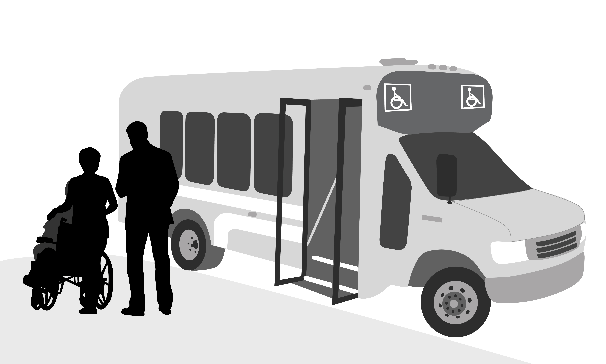

The Transport Standards stipulate that all new transport services must comply with minimum accessibility requirements, facilities that were already in operation prior to 2002 were given between five and thirty years to comply with the standards.

### Viewing activity

|  |  |
| --- | --- |
| This icon indicates a viewing activity | **Video:** ‘[Access for all](https://www.humanrights.gov.au/twentystories/video-access-for-all.html)’  **Source:** Australian Human Rights Commission,  **Duration:** 4 minutes 56 seconds |

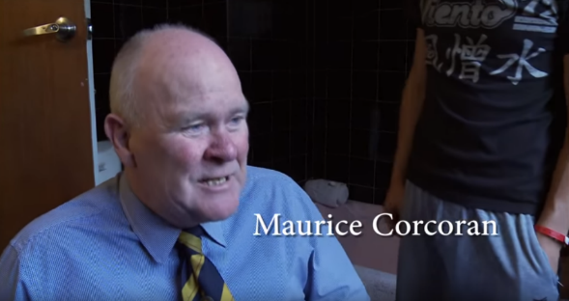

**Summary:** Riding the bus is something most of us take for granted. For Maurice Corcoran, it’s only been possible since 1994 and only because of his complaint. Prior to 1994, Maurice, who has quadriplegia had no choice but to get accessible taxis to work but wanted to be able to access public transport with other people in the community. His case started in South Australia but the case went national and achieved significant change in infrastructure, resulting in the introduction of the *Disability Standards for Accessible Public Transport 2002*.

**Instructions:**

1. Play the video, ‘Access for all.’
2. Ask learners if they have any questions or comments about the video before moving on.

### The Disability Standards for Education 2005

In 1999, the parents of Scarlett Finney, a child with spina bifida, applied to enrol her in kindergarten at Hills Grammar School. On the application, they provided the details of her disability which requires her to use a wheelchair, and outlined her particular needs. However, Scarlett was refused enrolment on the basis of her disability.

The Australian Human Rights Commission found that Scarlett had been discriminated against and the Hills Grammar School was ordered to pay $42,628 in damages.

This case was instrumental in paving the way for the development of the *Disability Standards for Education 2005* (the Education Standards).

The Education Standards are about more than just ensuring school grounds are wheelchair accessible. They state that all students with disability, regardless of their condition or impairment, should be provided with the same educational opportunities as children without disability as long as they meet the entry requirements of a particular educational institution.[7]

### Viewing activity

|  |  |
| --- | --- |
| This icon indicates a viewing activity | **Video:** ‘[A school in the bush](https://www.humanrights.gov.au/twentystories/video-school-in-the-bush.html)’  **Source**: Australian Human Rights Commission  **Duration:** 5 Minutes 45 seconds |

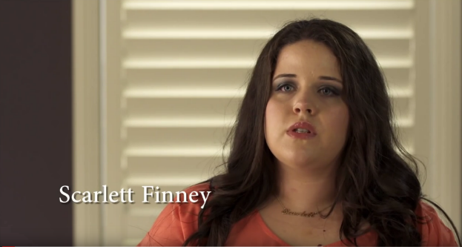

**Summary:** This video tells the story of Scarlett Finney. Now an adult, Scarlett Finney was refused enrolment to Hills Grammar School at age 7 on the grounds of her disability. The Finney’s took the case all the way to the Federal Court and won, setting a precedent for other students with disability.

**Instructions:**

1. Play the video, ‘A school in the bush’.
2. Ask students if they have any comments or questions about the video before moving on.

### The Access to Premises Standards 2010

Prior to 2010, the requirements of the Building Code of Australia were not consistent with accessibility provisions under the *Disability Discrimination Act*. This meant that a building could be constructed in accordance with the building code, but could still be subject to a complaint alleging disability discrimination as the building may not have included certain access features.

In response to complaints that had been lodged by a number of people with disability, a new set of standards were developed to ensure that the *Building Code of Australia* was consistent with the *Disability Discrimination Act*. The *Disability Standards for Access to Premises* (the Access to Premises Standards) came into effect in 2011, laying out requirements that are to be followed when undertaking the construction or refurbishment of a building or space that is open to the public.[8]

### Viewing activity

|  |  |
| --- | --- |
| This icon indicates a viewing activity | **Video:** ‘[Ramped up](https://www.humanrights.gov.au/twentystories/video-ramped-up.html)’  **Source:** Australian Human Rights Commission  **Duration:** 5 Minutes 34 seconds |

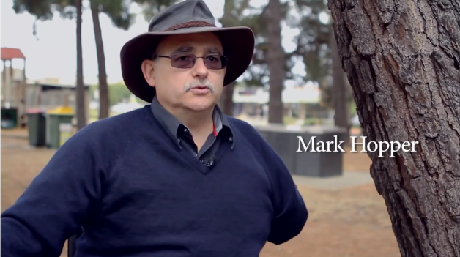

**Summary:** It started off with Mark Hopper attempting to cross the street to buy a cup of coffee. Mark simply couldn’t get his wheelchair onto the road safely, so he complained to the Australian Human Rights Commission and won. Mark went on toscrutinise every building, every footpath, and every access point in his home town in Victoria to test them against the standards which had been in place since the inception of the *Disability Discrimination Act*.

**Instructions:**

1. Play the video, ‘Ramped up’.
2. Ask learners if they have any comments or questions about the video before moving on.

**Below are examples of good and bad accessibility practices that have been implemented on public transport and in premises.**

These examples have been included on page 48 of the Learner Guide.

|  |  |  |  |  |  |
| --- | --- | --- | --- | --- | --- |
| **The Good** | | | **The Bad** | **The Ugly** | |
| **Paralympian and PWD NSW member Mr Alan Sargent boards an accessible bus** | | | **Examples of good and bad accessibility practices that have been implemented on public transport and in premises. A man who uses a wheelchair looking up a flight of stairs with no ramp.** | **Toilet used as closet and rail installed upside down** | |
| **A low desk accessible for people who use wheelchairs and for people of short stature** | | | **A counter that is too high** | **A ramp that is not accessible for people in wheelchairs** | |
| This icon indicates a discussion question | **Discussion question:**  Looking at each of these images, can you spot what makes them good, bad or ‘ugly’ (i.e. very bad) examples of accessibility practices? | | |

**Points to inform discussion:**

* **The Good:** The images here show someone using a wheelchair easily boarding a public bus, and a reception desk with a lowered section to allow ease of access for someone approaching the desk from a lower height (e.g. someone using a wheelchair or a person with Dwarfism)
* **The Bad:** These images show a wheel-chair user who is unable to access a building because it can only be entered via stairs, and a service area without a lowered section.
* **The Ugly:** The top image shows an accessible toilet that has been used inappropriately as a storage facility, making it inaccessible to anyone with disability who wishes to use it (the support railing to the right of the toilet has also been installed incorrectly), and the concrete ramp only extends partially up the flight of stairs.

### Activity: Check your knowledge

|  |  |
| --- | --- |
| This icon indicates an activity for a group or class discussion | **Activity type:** Small group activity  **Duration:** 25 minutes  **Equipment needed:** Learner Guide (pages 42, 49) |

**Purpose:** To encourage learners to think about the parts of domestic law that apply to a particular set of circumstances.

**Instructions:**

1. Organise learners into groups of three or four people.
2. Ask learners to turn to the activity on page 49 of their Learner Guide and read out the activity instructions, as they appear below:

|  |  |
| --- | --- |
| This icon indicates a suggested section to read out | * Khaira is experiencing difficulty accessing her university as she is a wheelchair user and a number of her lectures have been scheduled on the second floor of an older building that does not have lift access. * Use the overview of the *Disability Discrimination Act* on page 42 of your Learner Guide to outline the sections that you think might apply to Khaira’s case. * Also consider the *Access to Premises Standards* and the *Disability Standards for Education*. |

1. Inform groups that they will have 15 minutes to complete the task and ask them to begin.
2. After 15 minutes, ask each group to share their findings with the rest of the class.

## 2.3. Direct and indirect discrimination

**Approximate duration:** 20 minutes

Back in Topic 1, we talked about the fact that discrimination generally involves a person, or a group of people being treated less favourably on the grounds of a specific attribute, such as disability. The *Disability Discrimination Act* recognises two forms of discrimination, both of which are considered unlawful under the definition of the Act; these are:

* Direct discrimination
* Indirect discrimination

### Direct discrimination

Direct discrimination includes more overt forms of discrimination where a person is treated less favourably, because of his or her disability, than a person without that disability would be treated in the same or similar circumstances. [9]

For example, if a man was refused entry to a café because of his assistance animal.

The following case conciliated by the Australian Human Rights Commission is an example of direct discrimination:

A woman had been offered employment at her local supermarket and was asked to attend a pre-employment medical assessment. During the medical assessment, she disclosed that she had depression. The supermarket Manager responded by withdrawing the offer of employment.

|  |  |
| --- | --- |
| This icon indicates a trainer’s note | **Trainer’s note:** Ask if there are any comments or questions about the above case study before moving on. |

### Indirect discrimination

Indirect discrimination is less obvious. It occurs when:

* A particular condition applies to everyone, but because of their disability the person is not able to comply or, although able to comply, would suffer a serious disadvantage by doing so, and
* The requirement or condition disadvantages a person because of their disability, and
* It is unreasonable in all of the circumstances.[10]

**Examples of indirect discrimination:**

* A woman who has a disability complained that her access to online services from a Commonwealth Government service provision agency had been locked because she had disclosed her password to her husband so he could assist her.
* A man who has a mental illness complained that he had been discriminated against in being required to confirm each fortnight his continuing eligibility to benefit from a Commonwealth program, which his illness made it difficult for him to do.

|  |  |
| --- | --- |
| This icon indicates a discussion question | **Discussion question:** Can you think of an example of a condition or requirement that might indirectly discriminate against people with disability? |

**Points to inform discussion:**

Some examples of indirect discrimination include:

* Requiring an employee who is deaf to attend meetings where no Auslan interpreter is provided to enable them to understand what is being said. Although they could still attend the meeting without an interpreter, they would suffer a serious disadvantage as they would have difficulty participating in the meeting.
* A television advertisement directing viewers to call the number on the screen, but not verbalising this number for those who cannot see the screen.
* The example of Khaira, who featured in the previous scenario (see page 49 of the Learner Guide). Khaira needed to be able to access the stairs in order to attend her classes, which she was unable to do.

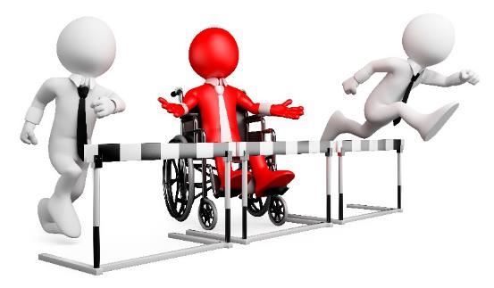

## 2.4. Reasonable adjustment and inherent requirements

**Approximate duration:** 40 minutes

Reasonable adjustment refers to the administrative, environmental, or procedural alterations required to enable a person with disability to participate in an activity on an equal basis with others. The adjustment must be considered ‘reasonable’ in all of the circumstances, and must not impose an undue burden on others.[11]

The *Disability Discrimination Act* requires that, wherever possible, reasonable adjustments be put in place to meet the needs of people with disability.

**An example of reasonable adjustment**

The complainant who is a prisoner, has a mobility disability and uses a wheelchair. He claimed he was moved from a prison with a wheelchair accessible cell and facilities to one with limited wheelchair access. In particular, he claimed the bench seat in the shower was too low and the lifting bar above his bed was inaccessible.

The government department said it relocated the complainant to a lower security unit designed for elderly prisoners and indicated a willingness to make modifications to the complainant's new cell to make it more accessible.

The complaint was resolved after the department provided the requested modifications to the complainant's cell.[12]

This case study demonstrates how adjustments can be made to increase the accessibility of existing services or facilities.

Reasonable adjustment is often also referred to in the context of employment and education. It is a way of modifying the way that a student might meet the requirements of a certain course, or an employee might perform the inherent requirements of a work role.

It does not mean that the essential requirements of the course or job change in any way, but simply provides flexibility about how these requirements are met.

### Reasonable adjustment in education

The following are two examples of cases previously conciliated by the Australian Human Rights Commission where reasonable adjustments were made.

|  |  |
| --- | --- |
| This icon indicates a trainer’s note | **Trainer’s note:** Instruct learners to turn to pages 52-53 of their Learner Guide and ask someone to read out the reasonable adjustment case studies as they appear below. |

|  |  |
| --- | --- |
| This icon indicates a suggested section to read out | **Example 1**  A woman complained that her son had been discriminated against on the basis of dyslexia and Attention Deficit Disorder when her request for a reading/writing assistant for an exam was refused. The complaint was settled when the education authority agreed to permit an assistant for the exam.[13]  **Example 2**  A school student who has a hand tremor because of a disability complained that he had not been granted adequate adjustments for undertaking his upcoming final exams. The complaint was resolved with the education authority agreeing to provide the student with an extra 10 minutes per 30 minutes exam time to be used to write, dictate or rest as he chose.[14] |



|  |  |
| --- | --- |
| This icon indicates a discussion question | **Discussion question:** Consider Khaira’s situation again (see page 49 of the Learner Guide). Is there a reasonable adjustment the university could make to allow her to attend her classes? |

**Points to inform discussion:**

* The timetable could be changed so that Khaira’s classes are held on the ground floor of the building, rather than one of the upper levels, or in another building that does have lift access.

### **Viewing activity**

|  |  |
| --- | --- |
| This icon indicates a viewing activity | **Video: ‘**[Jacob’s story](https://www.humanrights.gov.au/twentystories/video-jacobs-story.html)’  **Source:** Australian Human Rights Commission  **Duration:** 6 minutes 4 seconds |

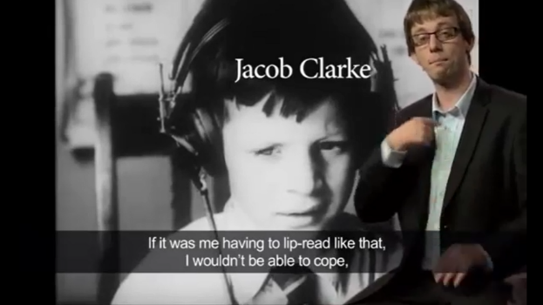

**Summary:** Jacob Clarke wanted to go to the same high school as his friends. But he needed something his friends didn’t: an interpreter. Jacob is deaf, so this was essential, but the school didn’t think so. Buddy systems and note-takers weren’t going to give Jacob the education he was entitled to. It ended up in court as a landmark case for Deaf rights.

**Instructions:**

1. Play the video, ‘Jacob’s story’.
2. Ask learners if they have any comments or questions about the video before moving on.

### Reasonable adjustment in employment

In regards to employment, employers are required to provide reasonable adjustments to enable a person with disability to perform the inherent requirements of a work role.

The inherent requirements of a job will vary depending on what the job is. They may include:

* The ability to perform tasks that are essential to perform a job productively and to the required quality
* The ability to work effectively in a team or other organisation
* The ability to work safely.[15]

|  |  |  |  |
| --- | --- | --- | --- |
| This icon indicates a trainer’s note | **Trainer’s note:** Instruct learners to turn to the case study on page 55 of their Learner Guide and read out the case study, as it appears below: | | |
| This icon indicates a suggested section to read out | | A person with a prosthetic foot was dismissed from their position at a funeral parlour because they could not carry coffins as smoothly as other employees. Carrying coffins was an inherent requirement of the job. However, with a small amount of training, the employee could have carried out this requirement to the appropriate standard. The dismissal was found to be disability discrimination.[16] |

An assessment of whether a person with disability is able to meet the inherent requirements of a particular role must not be based on assumptions about what a person is or is not capable of, but actual evidence.

|  |  |
| --- | --- |
| This icon indicates a discussion question | **Discussion scenario:**  Jesse is completely blind. He sees an advertisement for a job as an outreach community worker, which would require him to visit service users’ homes on a regular basis. The advertisement states that the preferred applicant must have a current driver’s license. Jesse believes that he is being discriminated against because he cannot legally hold one. Is this discrimination? |

**Points to inform discussion:**

* The position that Jesse is interested in is an outreach position and requires Jesse to be able to drive a company car.
* Driving is an essential component, or inherent requirement of the role.
* No two cases are the same and there are many factors that need to be considered, however generally speaking, it would not be possible to provide an adjustment to enable Jesse to meet this requirement. The advertisement is therefore not necessarily discriminatory.
* If the advertisement was for an office job, for example, that did not include outreach work and the employer specified that a driver’s license was required, this may amount to discrimination.

### **Viewing activity**

|  |  |
| --- | --- |
| This icon indicates a viewing activity | Video: ‘[Works for me](https://www.humanrights.gov.au/twentystories/video-works-for-me.html)’  **Source:** Australian Human Rights Commission  **Duration:** 4 minutes 31 seconds |



**Summary:** Jake Briggs was a qualified carpenter when an accident caused his disability. Carving out his new life in a wheelchair was challenging, but his employer retrained him and created a new role that has given Jake the chance to maintain a career.

**Instructions:**

1. Play the video, ‘Works for me’.
2. Ask learners if they have any comments or questions about the video before moving on.

## Topic 2: Endnotes

1. Australian Human Rights Commission, *Timeline: 20 Years of Disability Discrimination Act* (2012)

   < <https://www.humanrights.gov.au/twentystories/timeline.html>>.
2. Australian Human Rights Commission, *Timeline: 20 Years of Disability Discrimination Act* (2012) <<https://www.humanrights.gov.au/twentystories/timeline.html>>.
3. Australian Human Rights Commission, *A brief guide to the D.D.A*, ‘Who does the D.D.A protect?’ (2015) <<https://www.humanrights.gov.au/dda-guide-who-does-dda-protect>>.
4. Australian Human Rights Commission, *Annual Report 2013-2014* (2014).
5. Australian Human Rights Commission, *A quick guide to Australian discrimination laws*, ‘State and territory laws’ (2015)

   <<https://www.humanrights.gov.au/employers/good-practice-good-business-factsheets/quick-guide-australian-discrimination-laws>>.
6. Australian Human Rights Commission, *Timeline: 20 Years of Disability Discrimination Act* (2012)

   < <https://www.humanrights.gov.au/twentystories/timeline.html>>.
7. Australian Human Rights Commission, *Timeline: 20 Years of Disability Discrimination Act* (2012)

   <<https://www.humanrights.gov.au/twentystories/timeline.html>>.
8. Australian Human Rights Commission, *Timeline: 20 Years of Disability Discrimination Act* (2012) <<https://www.humanrights.gov.au/twentystories/timeline.html>>.
9. Australian Human Rights Commission, *Good Practice Good Business fact sheet – Disability discrimination* (2015)

   <<https://www.humanrights.gov.au/employers/good-practice-good-business-factsheets/disability-discrimination>>.
10. Australian Human Rights Commission, *Good Practice Good Business fact sheet – Disability discrimination* (2015) < <https://www.humanrights.gov.au/employers/good-practice-good-business-factsheets/disability-discrimination>>.
11. Australian Human Rights Commission, *Good Practice Good Business fact sheet – Disability discrimination* (2015) <<https://www.humanrights.gov.au/employers/good-practice-good-business-factsheets/disability-discrimination>>.
12. Australian Human Rights Commission, *2029842FC* (2012)

    <<https://www.humanrights.gov.au/2029842fc>>.
13. Australian Human Rights Commission, *Don't judge what I can do by what you think I can't: Ten years of achievements using Australia's Disability Discrimination Act*, 3.4 Education (2003). <<https://www.humanrights.gov.au/publications/dont-judg#education>>.
14. Australian Human Rights Commission, *DDA conciliation: education* (2009)

    < <https://www.humanrights.gov.au/dda-conciliation-education>>.
15. Australian Human Rights Commission, *Inherent Requirements*, (2015)

    <<https://www.humanrights.gov.au/quick-guide/12052>>.
16. Australian Human Rights commission, *Inherent Requirements* (2015) <<https://www.humanrights.gov.au/quick-guide/12052>>.