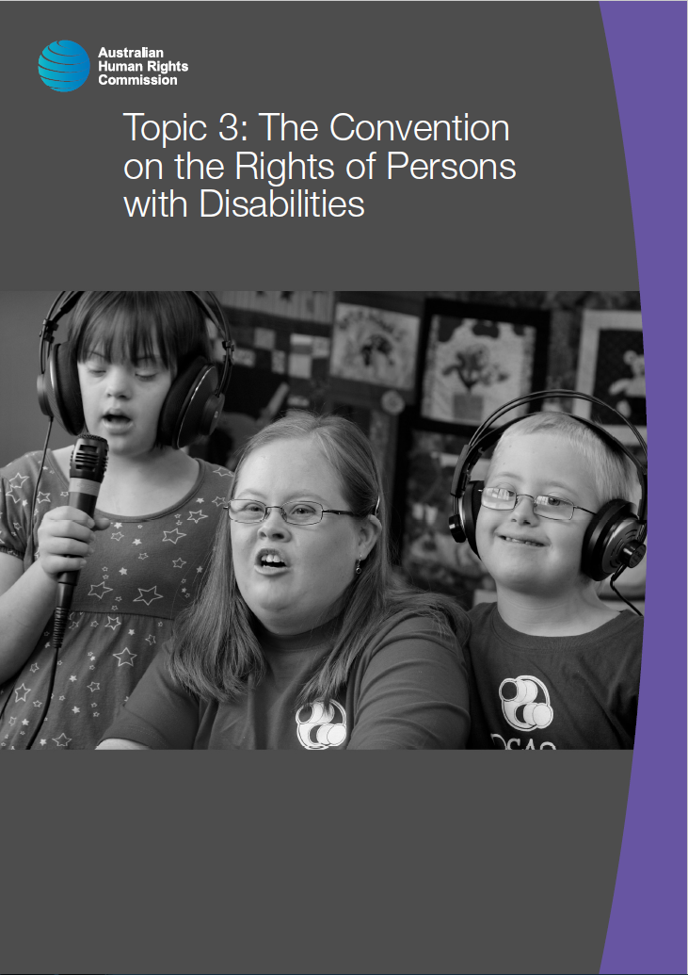

© Australian Human Rights Commission 2016.

The Australian Human Rights Commission encourages the dissemination and exchange of information presented in this publication and endorses the use of the **Australian Governments Open Access and Licensing Framework** (AusGOAL).



All material presented in this publication is licensed under the **Creative Commons Attribution 4.0 International Licence**, with the exception of:

• photographs and images;

• the Commission’s logo, any branding or trademarks;

• where otherwise indicated.

To view a copy of this licence, visit [**http://creativecommons.org/licenses/by/4.0/legalcode**](http://creativecommons.org/licenses/by/4.0/legalcode).

In essence, you are free to copy, communicate and adapt the publication, as long as you attribute the Australian Human Rights Commission and abide by the other licence terms.

**Please give attribution to:** © Australian Human Rights Commission 2016.

**Disability Rights: Facilitating the empowerment of people with disability** • CHCDIS007 • Trainer’s Manual • 2016

**Acknowledgments**

The ‘Disability Rights: Facilitating the empowerment of people with disability’ Trainer’s Manual and Learner Guide were drafted by Lauren Henley, Annie Pettit, Rebecca Rolls, Alexandra Walker and Siobhan Tierney.

This publication can be found in electronic format on the Australian Human Rights Commission’s website at **http://www.humanrights.gov.au/about/publications/**.

For further information about the Australian Human Rights Commission or copyright in this publication, please contact:

Education and Innovation Team

Australian Human Rights Commission

GPO Box 5218

SYDNEY NSW 2001

Telephone: (02) 9284 9600

Email: **communications@humanrights.gov.au**

**Design and layout** Dancingirl Designs

**Cover photography** Renate Hottmann-Schaefer

# Topic 3: The Convention on the Rights of Persons with Disabilities

**Approximate duration:** 1 hour 40 minutes

**Topic sequence:**

3.1. About the Convention (60 minutes)

3.2. Implementation and monitoring (20 minutes)

3.3. Progressive realisation (20 minutes)

**Equipment needed:**

* Audio-visual equipment with internet connection
* Learner Guide (pages 57-70)
* Butchers paper
* Coloured markers
* Disability Convention Bingo cards (see back of Trainer’s Manual)

## 3.1. About the Disability Convention

**Approximate duration:** 60 minutes

### The international human rights system

In 1948, the United Nations General Assembly adopted the *Universal Declaration of Human Rights* (UDHR).

In its opening sentence, the UDHR recognises that ‘the inherent dignity of all members of the human family is the foundation of freedom, justice and peace in the world’.[1]

The rights included in this important document include civil and political rights (such as the right to life, liberty, free speech and privacy), and economic, social and cultural rights (such as the right to health, education and social security).

The UDHR is not a treaty, which means it does not create binding obligations for countries. However, it is a fundamental statement of principle that forms the basis of international human rights law.

It has been argued that because countries have consistently invoked the UDHR for over 60 years, it has become binding as part of customary international law.

|  |  |
| --- | --- |
| This icon indicates a discussion question | **Discussion question:** How would you define ‘human rights’? |

**Points to inform discussion:**

Human rights can be defined as:

* The recognition and respect of people’s dignity
* A set of moral and legal guidelines that promote and protect recognition of our values, our identity and ability to ensure an adequate standard of living
* The basic standards by which we can identify and measure inequality and fairness
* Those rights associated with the Universal Declaration of Human Rights.

### Development of the Convention on the Rights of Persons with Disability

In the 1970s, disability rights movements started to gain greater momentum, leading to greater efforts being made at the international level to address the inequalities faced by people with disability.

Over a period of several decades, the United Nations implemented a number of measures which aimed to promote the rights of people with disability.

For example:

* In 1975, the United Nations General Assembly passed the *Declaration on the Rights of Disabled Persons*, which outlined a number of social, economic, civil and political rights for people with disability.
* The United Nations declared 1981 to be the International Year of Disabled Persons. This year called for a plan of action which would allow people with disability to have equal opportunity and to participate fully in society.
* In 1982, the United Nations General Assembly adopted the World Programme of Action Concerning Disabled Persons. This programme outlined a global disability strategy aimed at realising the full participation of people with disability in society.
* To implement the World Programme of Action Concerning Disabled Persons, the United Nations proclaimed a Decade of Disabled Persons which ran from 1983 to 1992.
* In 1992, the General Assembly proclaimed December 3rd the annual International Day of Disabled Persons.
* In 1993, the United Nations General Assembly adopted the Standard Rules on the Equalization of Opportunities for Persons with Disabilities.[2]

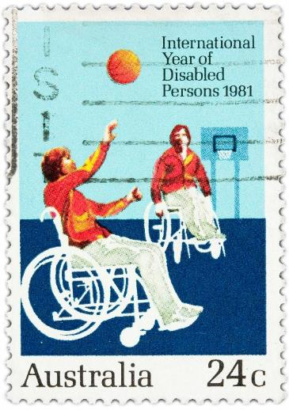

While these initiatives all played a role in advancing the rights of people with disability in some way, it was eventually recognised that a more substantive instrument was needed to articulate and strengthen the rights of people with disability.

To this end, a new international treaty, the *Convention on the Rights of Persons with Disabilities* (the Disability Convention), was drafted to ‘promote, protect and ensure the full enjoyment of all human rights and freedoms by all persons with disability.’[3]

The Disability Convention was adopted by the United Nations General Assembly in 2006 and entered into force on 3 May 2008.[4]

The Disability Convention features eight general principles which underpin all the rights contained within the Disability Convention. They are:

* Respect for inherent dignity, individual autonomy - including the freedom to make one's own choices - and independence of persons
* Non-discrimination
* Full and effective participation and inclusion in society
* Respect for difference and acceptance of persons with disabilities as part of human diversity and humanity
* Equality of opportunity
* Accessibility
* Equality between men and women
* Respect for the evolving capacities of children with disabilities and respect for the right of children with disabilities to preserve their identities.[5]

### Australia and the Convention on the Rights of Persons with Disabilities

The Australian Government was one of the first countries to sign and ratify the *Convention on the Rights of Persons with Disabilities* in 2008.

As a signatory to the Disability Convention, the Australian Government must ensure that its legislation, policies and practices are consistent with the obligations contained in the convention. On top of this, the Australian Government must take proactive steps to uphold, promote and protect the rights of people with disability in all areas of public life.

### Activity: Applying the general principles of the Disability Convention

|  |  |
| --- | --- |
| This icon indicates an activity for a group or class discussion | **Activity type:** Small group activity  **Duration:** 25 minutes  **Equipment needed:** Butchers paper, coloured markers |

**Purpose:** To encourage learners to think about the practical application of the general principles of the Disability Convention.

**Instructions:**

1. Organise learners around desks in groups of three or four people.
2. Provide each group with a large sheet of butcher’s paper and coloured markers.
3. Allocate one of the eight general principles to each group and ask them to draw a situation where this principle is being upheld, or their representation of a community where this principle is respected.
4. Inform groups that they will have 10 minutes to complete the task and instruct them to begin.
5. After 10 minutes, ask groups to stop drawing and nominate a spokesperson for their group.
6. Ask each group to come to the front of the room with their sheet of butcher’s paper and explain their project to the rest of the class.



### Activity: Disability Rights BINGO!

|  |  |
| --- | --- |
| This icon indicates an activity for a group or class discussion | **Activity type:** Group activity  **Duration:** 15 minutes  **Equipment needed:** Disability Convention Bingo Sheets (located at the end of this Trainer’s Manual), Learner Guide (pages 61-63) |

**Purpose:** To familiarise learners with the articles of the Disability Convention

**Instructions:**

1. Ask learners to partner up with another person to complete the activity and provide each pair with a Disability Convention Bingo Sheet (there are 15 in total).
2. Instruct learners to call out ‘Bingo’ when they have crossed off five boxes in a row (this can be horizontally, vertically or diagonally).
3. Read out descriptions of various articles of the Disability Convention using the ‘Overview of the Disability Convention’ on the following pages. Focus on articles 5-30 only.
4. Learners should refer to the ‘Overview of the Disability Convention’ reference sheet (on pages 61-63 of their Learner Guide), identify the article number and – if it’s on their Bingo Sheet – cross it off.

|  |  |
| --- | --- |
| This icon indicates a trainer’s note | **Trainer’s note:** You can make the game easier for learners by simply reading out the name of a particular article (for example, ‘the right to health’, referring to Article 25). Alternatively, you can make the game more challenging by describing aspects of an article (for example, ‘this article refers to the right of people with disability to give and receive information and ideas through accessible means of communication’, referring to Article 21). |



|  |  |
| --- | --- |
| This icon is used to highlight further reading and important information | **Further reading:**  People with Disability Australia, [*History of the Human Rights Movement in Australia*](http://www.pwd.org.au/student-section/history-of-disability-rights-movement-in-australia.html) (2015).  UN Enable, [United Nations Convention on the Rights of Persons with Disabilities](http://www.un.org/disabilities/default.asp?id=259). |

### Overview of the Disability Convention

**Articles 1-4** are foundational articles that articulate the purpose, definitions and general principles of the Disability Convention and establish general obligations for States party to the Convention.

**Article 5: Equality and non-discrimination**

Everyone is entitled to the equal protection and benefit of the law without discrimination.

**Article 6: Women with disabilities**

Countries must take all appropriate measures to ensure that women with disability are able to fully enjoy the rights and freedoms set out in the Disability Convention.

**Article 7: Children with disabilities**

The best interests of the child must be a primary consideration in all actions concerning children with disability.

**Article 8: Awareness-raising**

Countries must raise awareness of the rights, capabilities and contributions of people with disability.

**Article 9: Accessibility**

People with disability have the right to access all aspects of society on an equal basis with others including the physical environment, transportation, information and communications, and other facilities and services provided to the public.

**Article 10: Right to life**

People with disability have the right to life. Countries must take all necessary measures to ensure that people with disability are able to effectively enjoy this right on an equal basis with others.

**Article 11: Situations of risk and humanitarian emergencies**

Countries must take all necessary measures to ensure the protection and safety of all persons with disability in situations of risk, including armed conflict, humanitarian emergencies and natural disasters.

**Article 12: Equal recognition before the law**

People with disability have the right to recognition as persons before the law. People with disability have legal capacity on an equal basis with others in all aspects of life. Countries must take appropriate measures to provide support to people with disability so that they can effectively exercise their legal capacity.

**Article 13: Access to justice**

People with disability have the right to effective access to justice on an equal basis with others, including through the provision of appropriate accommodations.

**Article 14: Liberty and security of person**

People with disability have the right to liberty and security of person on an equal basis with others.

**Article 15: Freedom from torture or cruel, inhuman or degrading treatment or** punishment.

People with disability have the right to be free from torture and from cruel, inhuman or degrading treatment or punishment.

**Article 16: Freedom from exploitation, violence and abuse**

People with disability have the right to be protected from all forms of exploitation, violence and abuse, including their gender based aspects, within and outside the home.

**Article 17: Protecting the integrity of the person**

Every person with disability has a right to respect for his or her physical and mental integrity on an equal basis with others.

**Article 18: Liberty of movement and nationality**

People with disability have the right to a nationality.

**Article 19: Living independently and being included in the community**

People with disability have the right to live independently in the community.

**Article 20: Personal mobility**

Countries must take effective and appropriate measures to ensure personal mobility for people with disability in the manner and time of their choice, and at affordable cost.

**Article 21: Freedom of expression and opinion, and access to information**

People with disability have the right to express themselves, including the freedom to give and receive information and ideas through all forms of communication, including through accessible formats and technologies, sign languages, Braille, augmentative and alternative communication, mass media and all other accessible means of communication.

**Article 22: Respect for privacy**

People with disability have the right to privacy. Information about people with disability, including personal information and information about their health should be protected.

**Article 23: Respect for home and the family**

People with disability have the right to marry and to found a family. Countries must provide effective and appropriate support to people with disability in bringing up children, and provide alternative care to children with disability where the immediate family is unable to care for them.

**Article 24: Education**

People with disability have a right to education without discrimination. Countries must provide reasonable accommodation and individualised support to maximise academic and social development.

**Article 25: Health**

People with disability have the right to the enjoyment of the highest attainable standard of health without discrimination.

**Article 26: Habilitation and rehabilitation**

Countries must take effective and appropriate measures to enable people with disability to develop, attain and maintain maximum ability, independence and participation through the provision of habilitation and rehabilitation services and programmes.

**Article 27: Work and employment**

People with disability have the right to work, including the right to work in an environment that is open, inclusive and accessible.

**Article 28: Adequate standard of living and social protection**

People with disability have the right to an adequate standard of living including food, water, clothing and housing, and to effective social protection including poverty reduction and public housing programmes.

**Article 29: Participation in political and public life**

People with disability have the right to participate in politics and in public affairs, as well as to vote and to be elected.

**Article 30: Participation in cultural life, recreation, leisure and sport**

People with disability have the right to take part in cultural life on an equal basis with others, including access to cultural materials, performances and services, and to recreational, leisure and sporting activities.

**Article 31: Statistics and data collection**

Countries must collect information about people with disability, with the active involvement of people with disability, so that they can better understand the barriers they experience and make the Disability Convention rights real.

**Articles 32-50: Implementation and monitoring**

These articles explain how governments, the United Nations and other international organisations will work together to ensure the rights of people with disability are protected.

## 3.2. Implementation and monitoring

**Approximate duration:** 20 minutes

Article 33 of the Disability Convention outlines the obligations on governments to implement and monitor the rights set out in the Disability Convention.[6]

There are a number of mechanisms in place in Australia that contribute towards implementing and monitoring the Disability Convention, some of which have been outlined below:

* The Australian Government provides funding to a number of non-government organisations representing people with disability to enable them to provide input on public policy, and to undertake systemic advocacy to address barriers to the full and equal participation of people with disability.[7]
* At a legislative level, all new federal legislation and amendment bills that are introduced into Parliament are required to include a statement of compatibility with human rights. This statement includes information explaining how the Bill complies with Australia’s obligations under international instruments, including the *Convention on the Rights of Persons with Disabilities*. The Parliamentary Joint Committee on Human Rights then examines bills for compatibility and reports to both houses of Parliament as appropriate.[8]
* Through the Australian Human Rights Commission, Australia’s federal Disability Discrimination Commissioner works towards the implementation and monitoring of the Disability Convention. The Commissioner undertakes work on systemic issues affecting the full and equal participation of people with disability at a national level. The Australian Human Rights Commission also has the power to investigate complaints alleging a breach of the Disability Convention.[9]
* The Australian Government has developed a ten-year strategy for the progressive implementation of the Disability Convention,[10] which will be explored further in the next section.

### International monitoring: The Committee on the Rights of Persons with Disabilities

All countries that are signatories to the Disability Convention are required to submit a report to a committee of independent experts called the Committee on the Rights of Persons with Disabilities. Signatories are required to submit a report two years after the Disability Convention comes into force in their country and every four years thereafter.[11]

These reports must demonstrate the steps that have been taken to implement the Disability Convention during that reporting period.

The Australian Government made its first appearance before the Committee on 3 September 2013. At this appearance, the Committee made a number of concluding observations recognising positive achievements and highlighting where further work needed to be undertaken.[12] These concluding observations are referred to throughout this unit.

|  |  |
| --- | --- |
| This icon is used to highlight further reading and important information | **Further reading:**  Australian Government, [*Australia’s Initial Report under the Convention on the Rights of Persons with Disabilities*](http://www.ag.gov.au/RightsAndProtections/HumanRights/United-Nations-Human-Rights-Reporting/Pages/Treaty-Body-Reporting.aspx) (2013).  Committee on the Rights of Persons with Disabilities, [*Concluding Observations on the Initial Report of Australia*](http://www.ag.gov.au/RightsAndProtections/HumanRights/United-Nations-Human-Rights-Reporting/Pages/Treaty-Body-Reporting.aspx)(2013) < >.  NGO CRPD Shadow Report Project Group, [*Australian Civil Society Report to the United Nations CRPD*](http://www.pwd.org.au/issues/crpd-civil-society-shadow-report-group.html) (2013). |

## 3.3. Progressive realisation

**Approximate duration:** 20 minutes

International human rights law recognises that the full implementation of the rights set out in the Disability Convention cannot be achieved immediately, due to resourcing and other constraints. Governments are therefore encouraged to demonstrate how implementation will be progressed over a period of time. This is known as **‘progressive realisation’.**

The Disability Standards for Accessible Public Transport, which were explored in Topic 2, are a good example of progressive realisation.

The standards stipulate that all public transport operators established after the standards came into effect must meet minimum accessibility requirements. However, facilities that were already in operation prior to 2002 were given between five and thirty years to comply with the standards.

In 2010, the Council of Australian Governments endorsed a whole-of-government strategy for the progressive realisation of the rights set out in the *Convention on the Rights of Persons with Disabilities*.

This plan is known as the *National Disability Strategy 2010-2020* (NDS).

The *National Disability Strategy* includes six core outcome areas. Each of these outcome areas includes a number of policy directives to guide the work of governments in meeting these outcomes.

|  |  |
| --- | --- |
| This icon indicates a trainer’s note | **Trainer’s note:** A summary of the National Disability Strategy and the six core outcome areas have been provided on pages 67-68.  Each state and territory has a state-wide plan in place to articulate how the *National Disability Strategy* will be implemented across their jurisdiction. Determine what policy measures are in place in your own state or territory and adapt the content for this section accordingly. |

In its concluding observations on the initial report of Australia (handed down in 2013), the United Nations Committee on the Rights of Persons with Disabilities stated:

The Committee commends the State Party for the adoption of the National Disability Strategy 2010-2020 to implement the Disability Convention across all jurisdictions.[13]

|  |  |
| --- | --- |
| This icon is used to highlight further reading and important information | **Further reading:**  National People with Disabilities and Carer Council, [*SHUT OUT: The Experience of People with Disabilities and their Families in Australia*](https://www.dss.gov.au/our-responsibilities/disability-and-carers/publications-articles/policy-research/shut-out-the-experience-of-people-with-disabilities-and-their-families-in-australia) (2009).  Council of Australian Governments, [*National Disability Strategy 2010-2020*](https://www.dss.gov.au/our-responsibilities/disability-and-carers/program-services/government-international/national-disability-strategy) (2010). |

### Overview of the National Disability Strategy 2010-2020

**Outcome area 1- Inclusive and accessible communities**

* Increased participation of people with disability, their families and carers in the social, cultural, religious, recreational and sporting life of the community.
* Improved accessibility of the built and natural environment through planning and regulatory systems, maximising the participation and inclusion of every member of the community.
* Improved provision of accessible and well-designed housing with choice for people with disability about where they live.
* A public, private and community transport system that is accessible for the whole community.
* Communication and information systems that are accessible, reliable and responsive to the needs of people with disability, their families and carers.

**Outcome area 2 - Rights protection, justice and legislation**

* Increase awareness and acceptance of the rights of people with disability.
* Remove societal barriers preventing people with disability from participating as equal citizens.
* People with disability have access to justice.
* People with disability to be safe from violence, exploitation and neglect.
* More effective responses from the criminal justice system to people with disability who have complex needs or heightened vulnerabilities.

**Outcome area 3 - Economic security**

* Increase access to employment opportunities as a key to improving economic security and personal wellbeing for people with disability, their families and carers.
* Income support and tax systems to provide an adequate standard of living for people with disability, their families and carers; while fostering personal financial independence and employment.
* Improve access to housing options that are affordable and provide security of tenure.

**Outcome area 4 - Personal and community support**

* A sustainable disability support system which is person-centred and self-directed, maximising opportunities for independence and participation in the economic, social and cultural life of the community.
* A disability support system which is responsive to the particular needs and circumstances of people with complex and high needs for support.
* Universal personal and community support services are available to meet the needs of people with disability, their families and carers.
* The role of families and carers is acknowledged and supported.

**Outcome area 5- Learning and skills**

* Strengthen the capability of all education providers to deliver inclusive high quality educational programs for people with all abilities from early childhood through adulthood.
* Focus on reducing the disparity in educational outcomes for people with a disability and others.
* Ensure that government reforms and initiatives for early childhood, education, training and skill development are responsive to the needs of people with disability.
* Improve pathways for students with disability from school to further education, employment and lifelong learning.

**Outcome area 6 - Health and wellbeing**

* All health service providers (including hospitals, general practices, specialist services, allied health, dental health, mental health, population health programs and ambulance services) have the capabilities to meet the needs of people with disability.
* Timely, comprehensive and effective prevention and early intervention health services for people with disability.
* Universal health reforms and initiatives address the needs of people with disability, their families and carers.
* Factors fundamental to wellbeing and health status such as choice and control, social participation and relationships, to be supported in government policy and program design.

### Optional homework task: Progress towards implementing the Disability Convention

|  |  |
| --- | --- |
| This icon indicates an activity for individuals | **Purpose:** This task encourages learners to think about what further steps need to be taken to implement the Convention on the Rights of Persons with Disabilities. |

**Instructions for learners:**

1. Download a copy of the Committee on the Rights of Persons with Disabilities’ [Concluding Observations on Australia’s initial report](http://tbinternet.ohchr.org/_layouts/treatybodyexternal/TBSearch.aspx?TreatyID=4&DocTypeID=5).
2. Select three concluding observations from this document. Use these as headings and under each one, report on what Australia has done to address the observations since 2013, as well as what needs to be done in the future to work towards this goal.

## Topic 3: Endnotes

1. Universal Declaration of Human Rights, GA Res 217A (III), UN GAOR, 3rd sess, 183rd plen mtg UN Doc A/810 (10 December 1948) preamble para 1.
2. Australian Human Rights Commission, *Timeline: 20 Years of Disability Discrimination Act* (2012) <<https://www.humanrights.gov.au/twentystories/timeline.html>>.
3. Convention of the Rights of Persons with Disabilities, opened for signature 13 December 2006, 2515 UNTS 3 (entered into force 3 May 2008) Art. 1.
4. Convention of the Rights of Persons with Disabilities, opened for signature 13 December 2006, 2515 UNTS 3 (entered into force 3 May 2008).
5. Convention of the Rights of Persons with Disabilities, opened for signature 13 December 2006, 2515 UNTS 3 (entered into force 3 May 2008) Art. 3.
6. Convention of the Rights of Persons with Disabilities, opened for signature 13 December 2006, 2515 UNTS 3 (entered into force 3 May 2008) Art. 33.
7. Department of Social Services, *National Disability Peak Bodies* (2015) <<https://www.dss.gov.au/our-responsibilities/disability-and-carers/program-services/consultation-and-advocacy/national-disability-peak-bodies>>.
8. Australian Human Rights Commission, *Parliamentary Joint Committee on Human Rights* (2015) <<https://www.humanrights.gov.au/parliamentary-joint-committee-human-rights>>.
9. Australian Human Rights Commission, *National Human Rights Institutions and National implementation and monitoring of the Convention on the Rights of Persons with Disabilities* (2015) <<https://www.humanrights.gov.au/national-human-rights-institutions-and-national-implementation-and-monitoring-convention-rights>>.
10. Australian Human Rights Commission, ‘National Disability Strategies as tools for implementing the Convention on the Rights of Persons with Disabilities’, 2010 (Commissioner Graeme Innes) <<https://www.humanrights.gov.au/news/speeches/national-disability-strategies-tools-implementing-convention-rights-persons>>.
11. International Justice Resource Centre, *Committee on the Rights of Persons with Disabilities* (2015). <<http://www.ijrcenter.org/un-treaty-bodies/committee-on-the-rights-of-persons-with-disabilities/>>.
12. Attorney-General’s Department, *Human rights treaty body reporting* (2015)

    <<https://www.ag.gov.au/RightsAndProtections/HumanRights/United-Nations-Human-Rights-Reporting/Pages/Treaty-Body-Reporting.aspx>>.
13. Committee on the Rights of Persons with Disabilities, *Concluding observations on the initial report of Australia*, 10th sess, UN Doc CRPD/C/AUS/CO1 (21 October 2013).