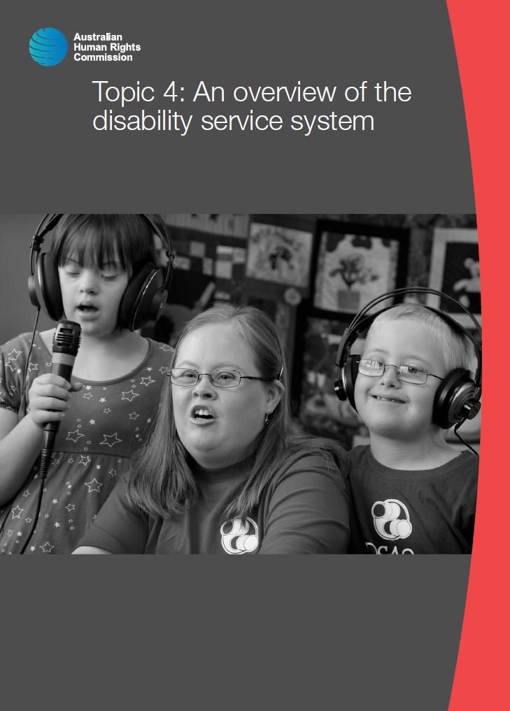

© Australian Human Rights Commission 2016.

The Australian Human Rights Commission encourages the dissemination and exchange of information presented in this publication and endorses the use of the **Australian Governments Open Access and Licensing Framework** (AusGOAL).



All material presented in this publication is licensed under the **Creative Commons Attribution 4.0 International Licence**, with the exception of:

• photographs and images;

• the Commission’s logo, any branding or trademarks;

• where otherwise indicated.

To view a copy of this licence, visit [**http://creativecommons.org/licenses/by/4.0/legalcode**](http://creativecommons.org/licenses/by/4.0/legalcode).

In essence, you are free to copy, communicate and adapt the publication, as long as you attribute the Australian Human Rights Commission and abide by the other licence terms.

**Please give attribution to:** © Australian Human Rights Commission 2016.

**Disability Rights: Facilitating the empowerment of people with disability** • CHCDIS007 • Trainer’s Manual • 2016

**Acknowledgments**

The ‘Disability Rights: Facilitating the empowerment of people with disability’ Trainer’s Manual and Learner Guide were drafted by Lauren Henley, Annie Pettit, Rebecca Rolls, Alexandra Walker and Siobhan Tierney.

This publication can be found in electronic format on the Australian Human Rights Commission’s website at **http://www.humanrights.gov.au/about/publications/**.

For further information about the Australian Human Rights Commission or copyright in this publication, please contact:

Education and Innovation Team

Australian Human Rights Commission

GPO Box 5218

SYDNEY NSW 2001

Telephone: (02) 9284 9600

Email: **communications@humanrights.gov.au**

**Design and layout** Dancingirl Designs

**Cover photography** Renate Hottmann-Schaefer

# Topic 4: An overview of the disability service system

**Approximate duration:** 1 hour 45 minutes

**Topic sequence:**

4.1. About disability services (15 minutes)

4.2. The National Disability Insurance Scheme (30 minutes)

4.3. My Aged Care (20 minutes)

4.4. The National Standards for Disability Services (40 minutes)

**Equipment needed:**

* Audio-visual equipment with internet connection
* Learner Guide (pages 70-86)
* Butchers paper
* Coloured markers

## 4.1. About disability services

**Approximate duration:** 15 minutes

|  |  |
| --- | --- |
| This icon indicates a trainer’s note | **Trainer’s note:** Consider inviting a person with disability, or an adaptive technology distributor to come and talk to the class about aids and equipment and other forms of support during this section of the training. |

Article 19 of the *Convention on the Rights of Persons with Disabilities* talks about the right of people with disability to live independently and be included in the community.

It refers to two types of support: personal support and community support.[1]

**Community support** acknowledges the extent to which the participation of people with disability is limited by societal barriers. As such, it articulates the need for mainstream services to be accessible to people with disability in order to facilitate their full and equal participation in the community.

Community supports could include things like structural modifications, provision of sign language interpreters and other forms of live assistance, braille and easy read versions of information and accessible bathrooms and entrances.

**Personal support**, on the other hand, refers to those individualised services or supports that a person with disability may require to overcome functional limitations with mobility, communication, daily living or self-care

Personal supports can include:

* + **Attendant care support** - for example, one-on-one assistance with toileting, showering, feeding etc.
  + **Home and community support** - for example, assistance with cooking, cleaning, shopping or garden maintenance.
  + **Assistive or adaptive technology** - for example, a communication device with speech output for someone who cannot speak, or text-to-speech software to enable someone who is blind to use a computer. Adaptive technology is any system or device that allows a person with disability to do something that they would otherwise be unable to do. Technological advancements have created many new opportunities for adaptive technology to assist people with disability and there are more solutions available now than ever before. We’ll explore technology further in Topic 5, when we look at augmentative communication.
  + **Mobility aids** - for example, a wheelchair, a motorised scooter or a guide dog.

Historically, these personal services and supports were provided to people with disability by a number of key service providers who received funding from federal and/or state governments.

Informal supports or natural supports such as family, friends and carers also played, and continue to play, an important role in the care and support of many people with disability.

In 2012, there were around 2.7 million carers in Australia providing support to friends or family with disability or ill health.[2]

Of those 2.7 million people, just under a third were primary carers. The *Disability Services Act 1986* (Cth) defines a primary carer as:

1. Someone providing care and support to the person because of his or her sense of responsibility as a relative of, or someone close to, the person; or
2. if the person does not have anyone providing care and support as mentioned in paragraph (a) – someone most closely involved in the treatment or care of, or support to, the person.[3]

In 2010, the National People with Disabilities and Carer Council published a report entitled, *SHUT OUT: The Experience of People with Disabilities and their Families in Australia*. It was this report that informed the direction and focus of the *National Disability Strategy 2010-20* which we explored in Topic 3.

Importantly, the report was informed through extensive consultation with people with disability by the National People with Disabilities and Carer Council. Over 750 submissions from Australians with disability and their families and carers were received.

The report recognised that the system of care and support in place at that time was inadequate and that a major shift was needed. The following passage has been taken from this report:

The chronic underfunding that has characterised the disability service sector for decades has had many consequences. The extraordinary level of unmet need has forced many people with disabilities and their families to purchase services and support privately, contributing to the high cost of living with a disability and trapping many people and their families in a desperate cycle of poverty. It has also resulted in a demand-management approach to service delivery, with greater attention paid to rationing services than meeting individual need. Resource constraints also contribute to a one-size-fits-all approach. Most importantly, the system clearly fails to ensure people with disabilities have the support they require to live as independent a life as possible, and enjoy a quality of life others in the community take for granted.

Many submissions argued that the service system is so fundamentally flawed as to be beyond bandaid solutions, requiring a complete overhaul to deliver lasting change. And many saw the creation of a lifetime care and support scheme (sometimes known as a national disability insurance scheme) as the paradigm change required.

Despite recent commitments to an increase in resources, submissions argued that the system is clearly unable to meet current need and has limited capacity to meet anticipated increases in demand. They also spoke of a pressing need to address inequities in the system, which result in people with disabilities receiving different levels of support depending on how their disability was acquired*.****[4]***

|  |  |
| --- | --- |
| This icon is used to highlight further reading and important information | **Further reading:**  National People with Disabilities and Carer Council, [*SHUT OUT: The Experience of People with Disabilities and their Families in Australia*](https://www.dss.gov.au/our-responsibilities/disability-and-carers/publications-articles/policy-research/shut-out-the-experience-of-people-with-disabilities-and-their-families-in-australia) (2009).  Productivity Commission, [*Disability Care and Support: Inquiry report on the proposed National Disability Insurance Scheme*](http://www.pc.gov.au/inquiries/completed/disability-support/report) (2011). |

## 4.2. The National Disability Insurance Scheme

**Approximate duration:** 30 minutes

### Viewing activity

|  |  |
| --- | --- |
| This icon indicates a viewing activity | **Video:** ‘[The time has come for the NDIS](https://www.youtube.com/watch?v=R4_W9NlD8BQ)’  **Source:** Every Australian Counts,  **Duration:** 1 minute 42 seconds |

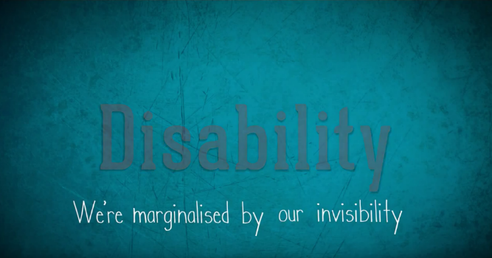

**Summary:**

The audio from this video is from Kurt Fearnley's Australia Day address on the 22nd of January 2013. The presentation outlines the importance of a National Disability Insurance Scheme (NDIS) and illustrates why it is such a monumental step forward for Australians with disability.

**Instructions:**

1. Play the video, ‘The time has come for the NDIS.’
2. Ask learners if they have any comments or questions about the video before moving on.

Outcome Area 4 of the *National Disability Strategy* (Personal and community support), which was informed by Article 19 of the *Convention on the Rights of Persons with Disabilities* (Living independently and being included in the community) includes the following policy directives for Australian governments:

* A sustainable disability support system which is person-centred and self-directed, maximising opportunities for independence and participation in the economic, social and cultural life of the community.
* A disability support system which is responsive to the particular needs and circumstances of people with complex and high needs for support.
* Universal personal and community support services are available to meet the needs of people with disability, their families and carers.
* The role of families and carers is acknowledged and supported.

The introduction of the *National Disability Insurance Scheme* (NDIS), a scheme of lifetime care and support for people with disability, was a crucial step in meeting these policy directives.

In its Concluding Observations on the Initial Report of Australia, the Committee on the Rights of Persons with Disabilities commended the Australian Government for implementing the scheme, recognising it as a major milestone in Australia’s implementation of the *Convention on the Rights of Persons with Disabilities*.[5]

The NDIS commenced rollout across several launch sites from July 2013, administered by a statutory authority called the National Disability Insurance Agency.

|  |  |
| --- | --- |
| This icon indicates a trainer’s note | **Trainer’s note:** Determine whether or not there have been any new developments with the rollout of the NDIS to help inform this section of the training. You should also aim to make this section of the training as relevant as possible to the state or territory where the training is being held. |

The NDIS is very different from the previous system of disability care and support, as the scheme:

* provides lifetime care and support to anyone with disability up to the age of 65, regardless of where or how they acquired their disability.
* introduced a nationally coordinated approach to service delivery, meaning that people will not receive different levels of support based on their geographic location.
* as an insurance scheme, provides assurance to anyone who might acquire a disability in the future that their disability-related needs will be met.
* puts funding for disability services in the hands of people with disability rather than service providers, placing them at the centre of the decision-making process and granting greater choice and control over the services they receive.
* allows for a personal planning process, where scheme participants identify their goals and aspirations and supports are put in place to allow them to work towards these goals.
* is able to fully fund aids and equipment that are needed by a person with disability, as long as these aids are considered reasonable and necessary.

### Viewing activity

|  |  |
| --- | --- |
| This icon indicates a viewing activity | **Video:** ‘[Living my plan, NDIS at work’](https://www.youtube.com/watch?v=T_HWADP5Uas)  **Source:** National Disability Insurance Scheme,  **Duration:** 7 minutes 27 |



**Summary:** Teens and adults explain how the NDIS has improved their lives as they receive support and equipment to live more independently and regain family relationships.

**Instructions:**

1. Play the video, ‘Living my plan, NDIS at work’.
2. Ask learners if they have any comments or questions about the video before moving on.

|  |  |
| --- | --- |
| This icon indicates a discussion question | **Discussion question:**  Do you think that providing supports through the new model of person-centred practice could provide benefits for people in caring roles, as well as for people with disability? If so, how? |

### Enabling independence through the NDIS

Person-centred practice is at the heart of the NDIS. This means that through the scheme people with disability will have access to the services and supports they need, when they need them.

The following case study, taken from the National People with Disabilities and Carer Council’s *SHUT OUT* report, illustrates how a lack of available supports can impede the independence and empowerment of a person with disability.

A child we will call S is 8-years-old and lives in a small rural community with her mother and siblings. S has cerebral palsy and uses a wheelchair permanently. She is unable to use verbal communication and uses a speech activated computer and has a manual wheelchair and attends public school.

Her mother has applied for and been waiting several years for an electric wheelchair for S, which would enable her to be more active at school with her friends and be more independent than she is. This would also free up her mother from having to push S everywhere as she is unable to use a manual wheelchair herself.[6]

Increased access to services and supports under the NDIS has the potential to reduce a person with disability’s reliance on informal supports such as friends and family.

As well as enhancing an individual’s independence this can also have significant ramifications for the wellbeing of personal relationships.

For example, an individual who had been involved in a 2-year trial of individualised funding prior to the introduction of the NDIS wrote:

I am extremely conscious of creating a life for myself so that I am not reliant on family and friends. I want to keep them just as that—family and friends—not as carers.[7]

In another study, an individual caring for a child with disability wrote:

I think people also often misunderstand what is needed and assume that we all need a break from our children. This is not the case. What is often needed is help with the endless chores so that we have the time and energy to enjoy being with our children.[8]

|  |  |
| --- | --- |
| This icon is used to highlight further reading and important information | **Further reading:**  National Disability Insurance Agency, [*Planning and Assessment – Assessment of Participants’ Needs*](http://www.ndis.gov.au/planning-and-assessment-assessment) (16 January 2014).  National Disability Insurance Agency, [*Planning and Assessment – Facilitating the Participant’s Statements of Goals and Aspirations*](http://www.ndis.gov.au/planning-and-assessment-facilitating-t) (16 January 2014).  National Disability Insurance Agency, [*Planning and Assessment – The Planning Conversation*](http://www.ndis.gov.au/planning-and-assessment-planning-c) (16 January 2014).  National Disability Insurance Agency, [*Planning and Assessment – Supports in the Plan*](http://www.ndis.gov.au/planning-and-assessment-supports-th) (1 September January 2014).  National Disability Insurance Agency, [*Planning and Assessment – Risk and Safeguards*](http://www.ndis.gov.au/planning-and-assessment-risk-and-safeg) (16 January 2014).  National Disability Insurance Agency, [*Planning and Assessment fact sheet – The Plan Management Decision*](http://www.ndis.gov.au/planning-and-assessment-plan-manag) (16 January 2014).  Carers Australia, [*NDIS and Carers*](http://www.carersaustralia.com.au/ndis-and-carers/) (26 June 2015). |

## 4.3. My Aged Care

**Approximate duration:** 20 minutes

If an individual has acquired their disability before the age of 65 and is already a registered participant of the *National* *Disability Insurance Scheme*, they will have the option of continuing to receive supports under the NDIS or transferring to the federal aged care scheme (*My Aged Care*) once they have turned 65. Any individual who acquires their disability over the age of 65, or who is over the age of 65 when the NDIS rolls out in their area, will not be eligible to receive supports through the NDIS.[9]

The aged care system has undergone major reforms over the past few years to bring it in line with the principles of person-centeredness that underpin the *National Disability Insurance Scheme*.

|  |  |
| --- | --- |
| This icon indicates a trainer’s note | **Trainer’s note:** Determine whether there have been any new developments with the reforms taking place in the aged care sector to help inform this section of the training. You should also aim to ensure this section of the training is as relevant as possible to your own state or territory. |

There are varying types of support available under *My Aged Care*, including home care packages to allow older people with disability to remain living in their own homes for as long as possible. Home Care Packages are flexible and tailored to meet the needs of the individual. Home Care Packages may include supports such as:

* Assistance with transport
* Assistance with shopping
* Assistance with household tasks such as cooking and cleaning
* Assistance with showering, toileting, feeding etc.
* Home modification
* Aids and equipment/adaptive technology.[10]



Home care packages are now delivered under a model called ‘consumer-directed care’, or ‘CDC’. Under this model, the package is allocated to the person with disability, placing them at the centre of decision-making and giving them greater choice and control over the supports and services they receive.

The home care package also stays with the individual if they decide to move, which was not possible under previous arrangements.[11]

People who require home care will receive a different level of assistance depending on their individual circumstances. There are four options available to address varying levels of need. These are:

* Home Care Level 1 – to support people with basic care needs
* Home Care Level 2 – to support people with low-level care needs
* Home Care Level 3 – to support people with intermediate care needs
* Home Care Level 4 – to support people with high-level care needs

The key shift that has taken place in both the disability sector and the aged care sector involves the adoption of a person-centred approach to service delivery, although this is referred to as ‘consumer-directed care’ under the *My Aged Care* scheme.

### Activity: Mind mapping person-centeredness

|  |  |
| --- | --- |
| This icon indicates an activity for a group or class discussion | **Activity type:** Whole class activity  **Duration:** 10 minutes  **Equipment needed:** Butchers paper and markers, or smart board |

**Purpose:** to encourage learners to think about the key elements that make up a person-centred approach.

**Instructions:**

1. In the middle of the smart board, or your sheet of butcher’s paper, draw a stick figure.
2. Explain to learners that this stick figure represents a person with disability who may require disability services.
3. Ask learners what factors might help to ensure that this person is at the centre of the services they receive and write these words or phrases around the stick figure.

|  |  |
| --- | --- |
| This icon indicates a trainer’s note | **Trainer’s note:** A person-centred approach puts people and their right to self-determination at the centre of professional practice. Dignity, respect and rights-based ideals are at the core of person-centred approaches, which focuses on the service user’s experiences and insight. By employing a person-centred practice, workers aim to be empathetic and demonstrate that service users can make free choices and exercise agency over their own lives.[12] |



|  |  |
| --- | --- |
| This icon is used to highlight further reading and important information | **Further reading:**  Department of Social Services, [*My Aged Care*](https://www.dss.gov.au/our-responsibilities/ageing-and-aged-care/programs-services/my-aged-care) (21 October 2015). |



## 4.4. The National Standards for Disability Services

**Approximate duration:** 40 minutes

Standards play an important role in regulating service delivery by determining the parameters under which service providers are to operate.

Prior to the introduction of the NDIS, service providers receiving funding from the Australian Government operated under the Disability Service Standards set out in the *Disability Services Act 1986 (Cth).* Agencies receiving funding from state governments were subject to the standards set out in state-based legislation.

The establishment of the NDIS meant that the Disability Service Standards needed to be reviewed to ensure they were consistent with the person-centred principles in the NDIS.

After extensive consultation with people with disability, their families and carers, the Standing Council on Disability Reform endorsed the revised standards at the end of 2013.

The revised set of standards include six core standards, as well as a number of performance indicators to help guide the work of service providers in meeting these standards.

The new *National Standards for Disability Services* ensure a nationally consistent approach to service quality across the disability sector.

The new *National Standards for Disability Services* have been summarised on the following pages.

|  |  |
| --- | --- |
| This icon indicates a trainer’s note | **Trainer’s note:** Research how the *National Standards for Disability Services* have been implemented in your own state or territory and adapt the training content for this section accordingly. If teaching this unit as part of an aged care qualification, you might also like to refer to the provisions outlined in schedule 1 of the *Aged Care Act 1977* (Cth), ‘User Rights Principles’, and particularly the Charter of Care and Recipients’ Rights and Responsibilities – Residential Care. |

### Overview of the National Standards for Disability Services

Note: The ‘indicators of practice’ describe what service providers need to do to meet each standard.

**Standard 1: Rights**

*Indicators of Practice*

1:1 The service, its staff and its volunteers treat individuals with dignity and respect.

1:2 The service, its staff and its volunteers recognise and promote individual freedom of expression.

1:3 The service supports active decision-making and individual choice including the timely provision of information in appropriate formats to support individuals, families, friends and carers to make informed decisions and understand their rights and responsibilities.

1:4 The service provides support strategies that are based on the minimal restrictive options and are contemporary, evidence-based, transparent and capable of review.

1:5 The service has preventative measures in place to ensure that individuals are free from discrimination, exploitation, abuse, harm, neglect and violence.

1:6 The service addresses any breach of rights promptly and systemically to ensure opportunities for improvement are captured.

1:7 The service supports individuals with information and, if needed, access to legal advice and/or advocacy.

1:8 The service recognises the role of families, friends, carers and advocates in safeguarding and upholding the rights of people with disability.

1:9 The service keeps personal information confidential and private.

**Standard 2: Participation and inclusion**

*Indicators of Practice*

2:1 The service actively promotes a valued role for people with disability, of their own choosing.

2:2 The service works together with individuals to connect to family, friends and their chosen communities.

2:3 Staff understand, respect and facilitate individual interests and preferences, in relation to work, learning, social activities and community connection over time.

2:4 Where appropriate, the service works with an individual’s family, friends, carer or advocate to promote community connection, inclusion and participation.

2:5 The service works in partnership with other organisations and community members to support individuals to actively participate in their community.

2:6 The service uses strategies that promote community and cultural connection for Aboriginal and Torres Strait Islander people.

**Standard 3: Individual outcomes**

*Indicators of Practice*

3:1 The service works together with an individual and, with consent, their family, friends, carer or advocate to identify their strengths, needs and life goals.

3:2 Service planning, provision and review is based on individual choice and is undertaken together with an individual and, with consent, their family, friends, carer or advocate.

3:3 The service plans, delivers and regularly reviews services or supports against measurable life outcomes.

3:4 Service planning and delivery is responsive to diversity including disability, age, gender, culture, heritage, language, faith, sexual identity, relationship status, and other relevant factors.

3:5 The service collaborates with other service providers in planning service delivery and to support internal capacity to respond to diverse needs.

**Standard 4: Feedback and complaints**

*Indicators of Practice*

4:1 Individuals, families, friends, carers and advocates are actively supported to provide feedback, make a complaint or resolve a dispute without fear of adverse consequences.

4:2 Feedback mechanisms including complaints resolution, and how to access independent support, advice and representation are clearly communicated to individuals, families, friends, carers and advocates.

4:3 Complaints are resolved together with the individual, family, friends, carer or advocate in a proactive and timely manner.

4:4 The service seeks and, in conjunction with individuals, families, friends, carers and advocates, reviews feedback on service provision and supports on a regular basis as part of continuous improvement.

4:5 The service develops a culture of continuous improvement using compliments, feedback and complaints to plan, deliver and review services for individuals and the community.

4:6 The service effectively manages disputes.

**Standard 5: Service access**

*Indicators of Practice*

5:1 The service systematically seeks and uses input from people with disability, their families, friends and carers to ensure access is fair, equal and transparent.

5:2 The service provides accessible information in a range of formats about the types and quality of services available.

5:3 The service develops, applies, reviews and communicates commencement and leaving a service processes.

5:4 The service develops, applies and reviews policies and practices related to eligibility criteria, priority of access and waiting lists.

5:5 The service monitors and addresses potential barriers to access.

5:6 The service provides clear explanations when a service is not available along with information and referral support for alternative access.

5:7 The service collaborates with other relevant organisations and community members to establish and maintain a referral network.

**Standard 6: Service management**

*Indicators of Practice*

6:1 Frontline staff, management and governing bodies are suitably qualified, skilled and supported.

6:2 Practice is based on evidence and minimal restrictive options and complies with legislative, regulatory and contractual requirements.

6:3 The service documents, monitors and effectively uses management systems including Work Health Safety, human resource management and financial management.

6:4 The service has monitoring feedback, learning and reflection processes which support continuous improvement.

6:5 The service has a clearly communicated organisational vision, mission and values which are consistent with contemporary practice.

6:6 The service has systems to strengthen and maintain organisational capabilities to directly support the achievement of individual goals and outcomes.

6:7 The service uses person-centred approaches including the active involvement of people with disability, families, friends, carers and advocates to review policies, practices, procedures and service provision.

### Activity: Standards in practice

|  |  |
| --- | --- |
| This icon indicates an activity for a group or class discussion | **Activity type**: Small group Activity  **Duration:** 25 minutes  **Equipment needed:** Learner Guide (page 85) |

**Purpose:** To encourage learners to think about what the *National Standards for Disability Services* mean in practice.

**Instructions:**

1. Organise learners into groups of three or four people.
2. Ask learners to turn to the case study on page 85 of their Learner Guide and read through the case study:

|  |  |
| --- | --- |
| This icon indicates a suggested section to read out | Kylie is 21 and lives in a major city. She has an intellectual disability. After she finishes school, she isn’t too sure what to do. She works for a while in the local supermarket but finds the customer focus challenging, as she doesn’t enjoy talking with people she doesn’t know. After talking with her family, Kylie decides to study painting and design at the local TAFE, however finds that she doesn’t meet the eligibility criteria.  The course coordinator refers Kylie to a training course that the TAFE has developed with a disability employment service. It includes painting, woodwork and ceramics. It also includes teamwork, time management and public speaking. The intention is to prepare students for further study or training or employment, and support community participation.  Kylie discusses study options with disability employment service staff, as well as her goals for the future and her learning preferences. She then enrols in the course with staff support. A highlight of the course for Kylie is the end of course exhibition, which was held at the TAFE jointly with a number of other arts and design courses. She develops a folio of work, and gains confidence with public speaking, which assists with her interview for a visual arts TAFE course.  The TAFE and the disability employment service built their partnership over several years, to develop more pathways for people with disability into the TAFE system, as well as to improve disability awareness within the TAFE.[13] |

1. Ask groups to refer back to their overview of the *National Standards for Disability Services* on pages 82-84 of their Learner Guide and try to identify the indicators of practice that might apply in this scenario. The answers have been provided below.

|  |  |
| --- | --- |
| **National Standards for Disability Services** | **Indicators of Practice** |
| **Standard 2: Participation and Inclusion** | 2:3 Staff understand, respect and facilitate individual interests and preferences, in relation to work, learning, social activities and community connection over time.  2:5 The service works in partnership with other organisations and community members to support individuals to actively participate in their community.  2:1 The service actively promotes a valued role for people with disability, of their own choosing. |

|  |  |
| --- | --- |
| This icon is used to highlight further reading and important information | **Further reading:**  Department of Social Services, [*National Standards for Disability Services*](https://www.dss.gov.au/our-responsibilities/disability-and-carers/standards-and-quality-assurance/national-standards-for-disability-services) (30 June 2015).  *(Webpage includes additional supporting resources)* |

## Topic 4: Endnotes

1. Convention of the Rights of Persons with Disabilities, opened for signature 13 December 2006, 2515 UNTS 3 (entered into force 3 May 2008) Art. 19.
2. Australian Bureau of Statistics, *4430.0 - Disability, Ageing and Carers, Australia: Summary of Findings* (2012) <<http://www.abs.gov.au/ausstats/abs@.nsf/mf/4430.0>>.
3. Commonwealth of Australia, *Disability Services Act*, ‘Section 7 – Meaning of primary carer’ (1986) <<http://www5.austlii.edu.au/au/legis/nt/consol_act/dsa213/s7.html>>.
4. National People with Disabilities and Carer Council, *SHUT OUT: The Experience of People With Disabilities And Their Families In Australia* (2009) 29.
5. Committee on the Rights of Persons with Disabilities, *Concluding observations on the initial report of Australia*, 10th sess, UN Doc CRPD/C/AUS/CO1 (21 October 2013).
6. National People with Disabilities and Carer Council, *SHUT OUT: The Experience of People With Disabilities And Their Families In Australia* (2009) 20.
7. National People with Disabilities and Carer Council, *SHUT OUT: The Experience of People With Disabilities And Their Families In Australia* (2009)18.
8. Kate Holland, *Carers' perspectives on caring: A qualitative analysis of open-ended responses to the Carer Health and Wellbeing Index survey*, ‘3.2 Carers need access to quality respite’, ID 2407, carer of autistic son, in (University of Canberra and Carers Australia, 2008) 19.
9. National Disability Insurance Scheme, *Continuity of support* (2015) < <http://www.ndis.gov.au/people-disability/continuity-support>>.
10. My Aged Care, *Caring for someone with a disability*, (2015) <<http://www.myagedcare.gov.au/caring-someone-particular-need/caring-someone-disability>>.
11. My Aged Care, *Consumer Directed Care (CDC)* (2015) <<http://www.myagedcare.gov.au/aged-care-services/home-care-packages/consumer-directed-care-cdc>>.
12. NSW Department of Ageing, Disability and Home Care, *Exploring And Implementing Person Centred Approaches* (2009) <<http://www.adhc.nsw.gov.au/search_results?q=exploring%20and%20implementing%20person%20centred%20approaches>>.
13. Department of Social Services, *National Standards for Disabilities – Stories* (2013) <<https://www.dss.gov.au/our-responsibilities/disability-and-carers/standards-and-quality-assurance/national-standards-for-disability-services>>.