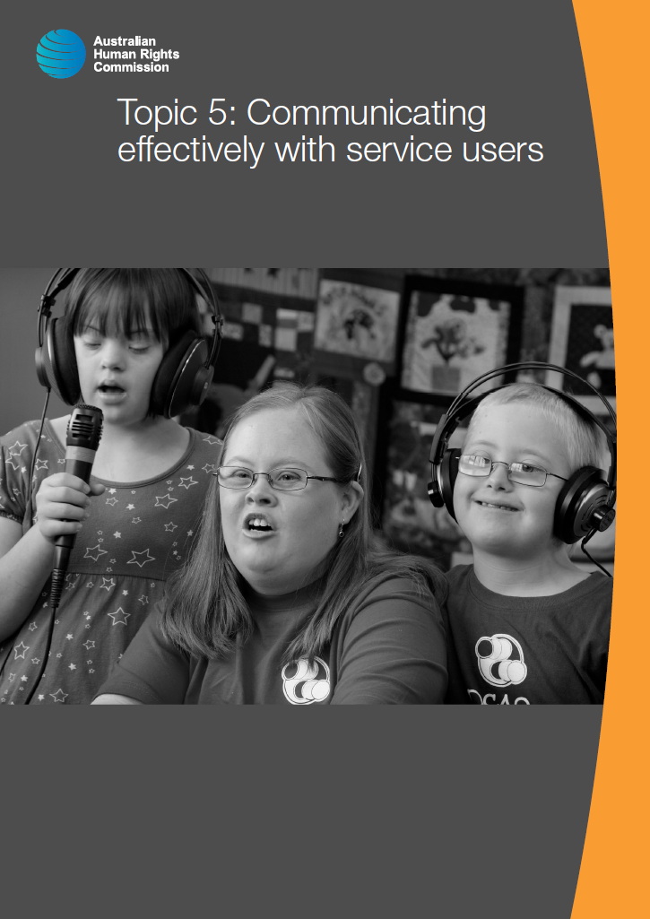

© Australian Human Rights Commission 2016.

The Australian Human Rights Commission encourages the dissemination and exchange of information presented in this publication and endorses the use of the **Australian Governments Open Access and Licensing Framework** (AusGOAL).



All material presented in this publication is licensed under the **Creative Commons Attribution 4.0 International Licence**, with the exception of:

• photographs and images;

• the Commission’s logo, any branding or trademarks;

• where otherwise indicated.

To view a copy of this licence, visit [**http://creativecommons.org/licenses/by/4.0/legalcode**](http://creativecommons.org/licenses/by/4.0/legalcode).

In essence, you are free to copy, communicate and adapt the publication, as long as you attribute the Australian Human Rights Commission and abide by the other licence terms.

**Please give attribution to:** © Australian Human Rights Commission 2016.

**Disability Rights: Facilitating the empowerment of people with disability** • CHCDIS007 • Trainer’s Manual • 2016

**Acknowledgments**

The ‘Disability Rights: Facilitating the empowerment of people with disability’ Trainer’s Manual and Learner Guide were drafted by Lauren Henley, Annie Pettit, Rebecca Rolls, Alexandra Walker and Siobhan Tierney.

This publication can be found in electronic format on the Australian Human Rights Commission’s website at **http://www.humanrights.gov.au/about/publications/**.

For further information about the Australian Human Rights Commission or copyright in this publication, please contact:

Education and Innovation Team

Australian Human Rights Commission

GPO Box 5218

SYDNEY NSW 2001

Telephone: (02) 9284 9600

Email: **communications@humanrights.gov.au**

**Design and layout** Dancingirl Designs

**Cover photography** Renate Hottmann-Schaefer

# Topic 5: Communicating effectively with service users

**Approximate duration:** 2 hours

**Topic sequence:**

5.1. Augmentative and alternative communication (40 minutes)

5.2. Easy English (30 minutes)

5.3. Translation and interpreting services (30 minutes)

5.4. Alternative accessible formats (20 minutes)

**Equipment needed:**

* Audio/visual equipment with internet connection
* Learner Guide (pages 87-100)
* Charades action cards and scoresheet

## 5.1. Augmentative and alternative communication

**Approximate duration:** 40 minutes

### Access to information

Access to information is one of the fundamental cornerstones of participation.

The right to seek and receive information in various formats is articulated in Article 21 of the *Convention on the Rights of Persons with Disabilities* (Freedom of expression and opinion, and access to information). It states that:

People with disability have the right to express themselves, including the freedom to give and receive information and ideas through all forms of communication, including through accessible formats and technologies, sign languages, Braille, augmentative and alternative communication, mass media and all other accessible means of communication.[1]

Being able to communicate with service users in a way that is appropriate to their needs is also a core component of the *National Standards for Disability Services*.

|  |  |
| --- | --- |
| **National Standards for Disability Services** | **Indicators of Practice** |
| **Standard 1: Rights** | 1:2 The service, its staff and its volunteers recognise and promote individual freedom of expression.  1:3 The service supports active decision-making and individual choice including the timely provision of information in appropriate formats to support individuals, families, friends and carers to make informed decisions and understand their rights and responsibilities. |
| **Standard 4: Feedback and Complaints** | 4:2 Feedback mechanisms including complaints resolution, and how to access independent support, advice and representation are clearly communicated to individuals, families, friends, carers and advocates. |
| **Standard 5: Service Access** | 5:2 The service provides accessible information in a range of formats about the types and quality of services available. |

### Optional activity: Charades

|  |  |
| --- | --- |
| This icon indicates an activity for a group or class discussion | **Activity type:** Group/class activity  **Duration:** 15 minutes  **Equipment needed:** Action cards, score sheet, prizes (optional) |

**Purpose:** To demonstrate that it is possible for people to convey information in a range of ways other than speech.

**Instructions:**

1. Organise learners into groups of three or four people and provide each group with a team number. Write the numbers down on a piece of paper so that you can keep score.
2. Inform groups that you will be playing charades and that all of the phrases will be action phrases, for example ‘Kicking a ball.’
3. Starting with the first group, ask for a volunteer from the group to act out the first phrase. Provide them with their action card and inform them that they have one minute.
4. Note which team has scored the point each time someone guesses the correct answer and then ask someone from the next group to take a turn at acting out the next phrase, until there are no phrases left. You should only allow one minute for each phrase and if nobody has guessed the correct answer, move on to the next one.
5. At the end of the activity, announce the winning team. An additional option may be to provide learners from the winning team with a small prize, such as a fun-size chocolate bar.
6. Conclude the activity by informing learners that this activity demonstrated that it is still possible to communicate thoughts and actions without using speech. This will help to introduce the topic of augmentative and alternative communication.

|  |  |
| --- | --- |
| This icon indicates a trainer’s note | **Trainer’s note:** The action cards for this activity have been included below. |

|  |  |
| --- | --- |
| Making a cup of tea | Mowing a lawn |
| Building a sandcastle | Playing baseball |
| Flying a kite | Milking a cow |
| Building a campfire | Going bowling |
| Flipping pancakes | Playing chess |

### Augmentative and alternative communication

Augmentative and alternative communication, or AAC, is a term used to refer to methods of communication that do not involve human speech. AAC can either be aided or unaided.

Acting out words or phrases is an example of unaided communication. Unaided communication is simply any form of communication that requires only the use of the body.

|  |  |
| --- | --- |
| This icon indicates a discussion question | **Discussion question:** Can anyone think of any other forms of unaided communication? |

**Points to inform discussion:**

Examples of unaided communication

* Blinking
* Nodding
* Waving
* Sign language

Australian sign language, or Auslan, is an alternative form of communication that is widely used by Australians who are deaf or hard of hearing. But there is no ‘one size fits all’ approach. Some people who are deaf may only use finger-spelling (which involves spelling out words using hand signs for each letter), while others may use some form of aided communication devices.

Remember that it is your role to facilitate communication with the service user in a way that is most appropriate to their needs.

If the person is an Auslan user, this will mean ensuring that they have access to an interpreter to facilitate their full and equal participation in conversations around service delivery.

You might also like to consider learning how to finger-spell as it is relatively easy to learn and may allow you to communicate directly with the service user in the event that the interpreter is running late, or there is some other change that needs to be communicated. A quick tutorial on how to spell the alphabet in Auslan is included in the following viewing activity.

### Viewing activity

|  |  |
| --- | --- |
| This icon indicates a viewing activity | **Video:** ‘[Fingerspelling A-Z in Auslan](https://www.youtube.com/watch?v=ONohx6mBAR8)’  **Source:** Lisa Mills - Honeybee Creations  **Duration:** 7 minutes 4seconds |

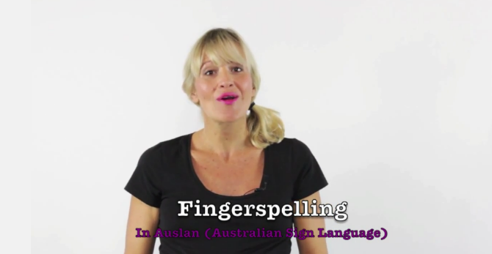

**Summary:** This quick video tutorial explains how to finger-spell the letters A-Z in Auslan.

**Instructions:**

* 1. Play the video, ‘Fingerspelling A-Z in Auslan.’
  2. Ask learners if they have any comments or questions about the video before moving on.

**Aided communication systems utilise other tools in addition to the user’s body. They can be high tech or low tech, ranging from flash cards, communication boards and a pencil and paper, to electronic communication devices that produce images or speech output.**

Many people who are deaf or hard of hearing, or otherwise have difficulty communicating via speech utilise a free Australia-wide telephone service called the National Relay Service. The National Relay Service is an example of an aided communication system. When someone makes a call through the NRS there will be a person in the middle of the call known as a ‘relay officer’. Relay officers relay exactly what is said by both parties, without interfering with what is being said. This service is available 24 hours each day. Depending on the user’s needs, they can use one of eight different call options, which include a telephone, mobile telephone, computer, tablet or smartphone. Another option is a TTY (teletypewriter) which is a phone with a small keyboard and screen that allows the user to type a message and read what is being said in reply.[2]

### Viewing activity

|  |  |
| --- | --- |
| This icon indicates a viewing activity | **Video**: ‘[AAC Lamp Words for Life iPad App Speech](https://www.youtube.com/watch?v=cHmnaXPJk_Q)’  **Source:** McKenna Powell,  **Duration:** 5 minutes40 seconds |

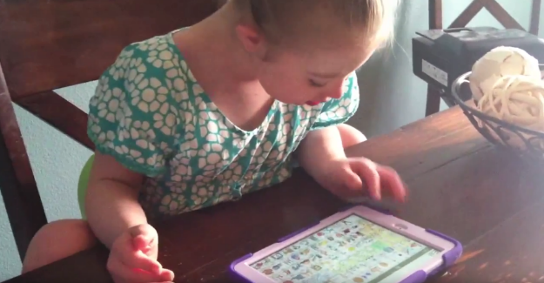

**Summary:** This video shows a mother teaching her daughter how to use her new communication device to say a range of different words.

**Instructions:**

1. Play the video ‘AAC Lamp Words for Life iPad App Speech.’
2. Ask learners if they have any comments or questions about the video before moving on.

As you would have heard, the little girl that features in this video is able to form some words. Some children will only require an augmentative communication system for a period of time, until they are able to further develop their speech. Others will develop augmentative communication strategies that will be life-long.

Technology has created many new opportunities for people to communicate. There are a wide variety of applications available for this purpose, as well as additional applications that will allow you to search for the app that might best meet the needs of the person you are working with.

### Optional homework task: Searching the App Store

|  |  |
| --- | --- |
| This icon indicates an activity for individuals | **Purpose:** To encourage learners to review some of the AAC applications that are available on their tablet or smart phone and share what they have learned with the rest of the class. |

**Instructions:**

1. Tell learners that if they have a tablet or a smart phone, they might like to have a look at the App Store on their device and see if they can find any apps for augmentative communication.
2. Encourage learners to download and install a free app if they can find one, and take a look at how it works.

## 5.2. Easy English

**Approximate duration:** 30 minutes

|  |  |  |
| --- | --- | --- |
| This icon indicates facts and statistics | According to the Australian Bureau of Statistics, almost half of the Australian population (46%) lack the literacy skills to deal with everyday life.[3] | |
| This icon indicates a discussion question | | **Discussion question:** What are some of the factors that may make it difficult for someone to understand verbal or written information? | |

**Points to inform discussion:**

* Coming from a non-English speaking background
* Acquired brain injury
* Intellectual disability
* Low levels of English literacy

Without realising it, we often use acronyms or complex words and phrases that other people might not understand.

When communicating, use language that will help you convey information to the widest range of people possible.

|  |  |
| --- | --- |
| This icon indicates a discussion question | **Discussion question:** What are some of the techniques you could use to keep language simple when speaking to service users? |

**Points to inform discussion:**

* use common, everyday words
* use short words, short sentences & short paragraphs
* try not to use jargon, acronyms or slang
* use the active voice e.g. ‘Sally opened the door’ rather than ‘the door had been opened by John’
* explain technical or complex terms.[4]

Another option is providing written information in Easy English. Easy English is used to create simplified versions of documents for people who, for a range of different reasons, might find it difficult to read, interpret or understand written information. Easy English is also sometimes referred to as ‘Easy Read.’

|  |  |
| --- | --- |
| This icon indicates a trainer’s note | **Trainer’s note:** Instruct learners to turn back to the overview of the *National Standards for Disability Services* on pages 82-84 of their Learner Guide, then distribute copies of the [Easy English version of the *National Standards*](https://www.dss.gov.au/our-responsibilities/disability-and-carers/standards-and-quality-assurance/new-national-standards-for-disability-services/national-standards-for-disability-services-easy-english-version) from the Department of Social Services.  This is a large document, so you only need to provide a couple of copies for reference. Ask learners to comment on the main differences between the two versions of the National Standards. |

The key features of Easy English, or ‘Easy Read’, documents are:

* Simplified language and grammar
* Minimal punctuation
* Simplified font, layout and design
* Images that illustrate headings and key messages.[5]

### Activity: Writing in Easy English

|  |  |
| --- | --- |
| This icon indicates an activity for a group or class discussion | **Activity type:** Partner/small group activity  **Duration:** 25 minutes  **Equipment needed:** Learner Guide (pages 61-63), Butchers paper, coloured markers, Easy English version of the Convention on the Rights of Persons with Disabilities[6] |

**Purpose:** To encourage learners to think about how they can explain information to service users in a non-complicated manner.

**Instructions:**

1. Organise learners into pairs or groups of three people and provide each pair or group with a set of coloured markers and a sheet of butcher’s paper.
2. Ask learners to turn back to the ‘Overview of the Disability Convention’ reference sheet on pages 61-63 of their Learner Guide.
3. Allocate two articles from the ‘Overview of the Disability Convention’ reference sheet to each pair or group and ask them to rewrite this information using the key features of Easy English:

* Simplified language and grammar
* Minimal punctuation
* Simplified font, layout and design
* Images that illustrate headings and key messages.[7]

1. Inform learners that they will have around 15 minutes to complete the activity.
2. After 15 minutes, ask a spokesperson from each pair or group to read out their allocated articles of the Disability Convention and then read out their Easy English version of the articles. Groups should explain any images they have chosen to include.
3. When all groups have presented their article, provide learners with a copy of the Easy English version of the Convention on the Rights of Persons with Disabilities, located on page 21 of the UK Equality and Human Rights Commission's resources '[The United Nations Convention on the Rights of People with Disabilities: What does it mean for you? (Easy Read)](http://www.equalityhumanrights.com/uploaded_files/publications/uncrpd_guide_easyread.pdf)'. Allow learners a few minutes to read over it.
4. Ask if there are any questions or comments, or if anyone would have changed anything about their Easy English versions of the articles after reading through the handout.

|  |  |
| --- | --- |
| This icon is used to highlight further reading and important information | **Activity resources:**  Equality and Human Rights Commission (UK), [*The United Nations Convention on the Rights of People with Disabilities: What does it mean for you? (Easy Read)*](http://www.equalityhumanrights.com/uploaded_files/publications/uncrpd_guide_easyread.pdf)(2010).  Department of Social Services, [*National Standards for Disability Services (Easy English version)*](https://www.dss.gov.au/our-responsibilities/disability-and-carers/standards-and-quality-assurance/new-national-standards-for-disability-services/national-standards-for-disability-services-easy-english-version) (16 July 2015). |

## 5.3. Translation and interpreting services

**Approximate duration:** 30 minutes

|  |  |
| --- | --- |
| This icon indicates a trainer’s note | **Trainer’s note:** For this section you might like to source a copy of the multilingual poster from the Western Australian Government Department of Health to show learners during this section of the training. The poster is available in the ‘More Information’ section of the WA Health webpage [‘Using the Interpreter Symbol and promoting language services’](http://ww2.health.wa.gov.au/Improving-WA-Health/Multicultural-health/Working-with-interpreters-and-translators/Using-the-Interpreter-Symbol-and-promoting-language-services).  You should also find out whether your state or territory has its own interpreting services for Aboriginal and Torres Strait Islander dialects and include this information in the training. |

Although speaking in plain English can be useful for some people whose first language is not English, this will not always be the case.

Nearly 20% of Australians speak a language other than English at home.[8]

In 2011, the most widely spoken languages other than English were Mandarin (1.7%), Italian (1.5%), Arabic (1.4%), Cantonese (1.3%) and Greek (1.3%).[9]

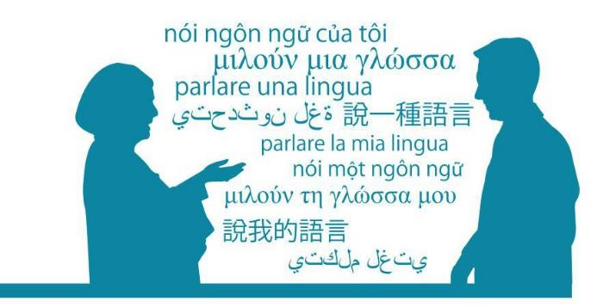

There are also a wide range of dialects spoken within Aboriginal and Torres Strait Islander communities throughout Australia.

Article 30 of the *Convention on the Rights of Persons with Disabilities* sets out the right to participation in cultural life, recreation, leisure and sport, stating that:

Persons with disabilities shall be entitled, on an equal basis with others, to recognition and support of their specific cultural and linguistic identity[10]

This means providing access to a language interpreter where necessary. To identify the language needed, you can either ask the service user or use a visual list that identifies languages and ask the service user to identify their preferred language.

It is important to understand that if a service user requires an interpreter to enable them to access a service and the service does not accommodate this request, the individual may seek to pursue the matter under anti-discrimination law.

The Australian Government, through the Department of Social Services, provides a free interpreting service for people who do not speak English. This service is called TIS National (TIS – translating and interpreting service). TIS is only available to approved community organisations and service providers. The TIS National website states that:

Incorporated, not-for-profit, non-government, community-based organisations can apply for the Free Interpreting Service through TIS National to support the delivery of casework and emergency services (which do not receive substantial government funding).[11]

Interpreting can take place face-to-face, via telephone and via video conference.

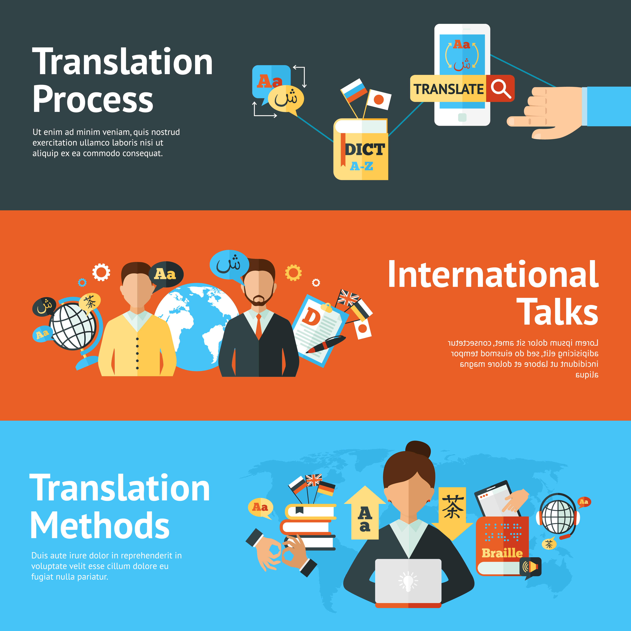

While service users might sometimes have a family member or friend who is willing to translate information for them, this will rarely be an appropriate option. Friends and family may not be impartial and are not bound by the same standards of conduct as accredited interpreters.

Allowing a friend or family member to interpret may also raise issues in regards to privacy and confidentiality, as there may be sensitive issues that need to be discussed.

Remember that many of the same considerations that apply to people who speak a foreign language may also apply to people who are deaf or hearing impaired who require an Auslan interpreter. You never know when a service user might require an interpreter, so you should undertake research to familiarise yourself with the process of hiring an interpreter in advance. Below are a few guiding questions to assist with your research:

* Does your workplace have a policy relating to the use of interpreters?
* Does your workplace have a preferred interpreting provider?
* If you are accompanying a service user to a meeting (especially with a Government Department), do they have access to an interpreter for this meeting?

|  |  |
| --- | --- |
| This icon indicates a discussion question | **Discussion question:** What other factors might you need to consider when **choosing** an interpreter? |

**Points to inform discussion:**

* How long will you require the interpreter for? For example if the service user will be attending a meeting, have you allowed extra time for interpreting in case the meeting runs overtime?
* The specific language or dialect that is required. Some foreign languages have several different dialects. Similarly, Auslan symbols may differ slightly in each state and territory.
* The personal preferences of the service user. Are they more comfortable with an interpreter of a certain gender? Or is there a particular interpreter that they have worked with before and feel comfortable with? It may not always be possible to accommodate personal preferences, but you should attempt to satisfy them wherever possible.
* Is the service user comfortable with the interpreter that has been chosen? In small community groups, for example, it is possible that the service user may already know the interpreter that has been chosen.

|  |  |
| --- | --- |
| This icon indicates a discussion question | **Discussion question:** What do you think are some of the factors you might need to consider when you are **using** an interpreter? |

**Points to inform discussion:**

* Ask the interpreter to only interpret what is being said (not to add anything else).
* Make sure you tell the interpreter what the service is about and tell them if it may be upsetting.
* Speak directly to the service user and keep eye contact with them, rather than the interpreter.
* Be clear about the need for confidentiality and ensure the interpreter is bound by these standards.
* Do not have separate conversations with the interpreter.
* Use first person language when speaking to the service user, e.g. when do you want to pick up the documents?
* If you are asking questions, ask one question at a time
* Speak in simple English, use short sentences and pause regularly so that the interpreter can interpret regularly. For example, do not use acronyms.
* Debrief with the interpreter to check how the session went.

|  |  |
| --- | --- |
| This icon is used to highlight further reading and important information | **Further reading:**  Multilingual poster, available from Western Australian Department of Health, [Using the Interpreter Symbol and promoting language services](http://ww2.health.wa.gov.au/Improving-WA-Health/Multicultural-health/Working-with-interpreters-and-translators/Using-the-Interpreter-Symbol-and-promoting-language-services).  *(The poster is available in the ‘More Information’ section of the WA Health webpage)*  My Aged Care, [*Other languages*](http://www.myagedcare.gov.au/other-languages) (I July 2015). |

## Alternative accessible formats

**Approximate duration:** 20 minutes

In addition to engaging directly with service users in a way that is respectful of their needs, you will often be required to provide written information tailored to the needs of service users.

In these situations, it is important to remember that printed information will not meet the needs of all service users and you may need to source information in alternative formats.

We’ve already explored how providing information in Easy English and translating information into foreign languages are ways of providing information to people with diverse needs. However, ‘alternative formats’ also includes other forms of communication such as Braille, large print and audio.



Braille is used by many people who are blind, vision impaired or deaf blind. However, it is important to remember that not all people with these disabilities will know or use Braille. Information can be reproduced in Braille using a machine called a Braille Embosser.

There are several companies in Australia who can translate written information into Braille. A directory of these companies can be found on the ‘[Directory](http://brailleaustralia.org/finding-braille/directory/)’ page of the Braille Australia website.

Some people now also access Braille via an electronic Braille display, or electronic note taker. These devices feature a display made up of tiny pins which rise up to produce words in Braille, allowing the user to access electronic documents, internet content etc. These devices are extremely cost prohibitive and still out of reach for many people with disability, although it is hoped that this may be addressed through the implementation of the National Disability Insurance Scheme.

Large print can also be useful for a number of service users with vision impairments, including older service users with diminishing vision.

The most commonly used font size for large print is 18pt, but the text may sometimes be larger. Other factors to consider when producing large print documents include the choice of font, line spacing and margins and the use of bold and underline. Italics should generally be avoided as it distorts the text and can make it difficult to read.

Audio versions of information can be useful for a wide range of people with disability including people who are blind or vision impaired, people with dyslexia, people with acquired brain injury and people with intellectual disability. Again, this is not a hard and fast rule and not all people with these conditions or impairments will need or want to use audio.

Specialised software is available that produces audio versions of print documents using synthesised speech. There are also several companies that reproduce information into an audio format for a fee.

**Web Content Accessibility Guidelines**

As we move into a digital world, electronic information is presenting a range of new opportunities for people with disability to be able to access information. But there are a few guidelines that need to be followed to ensure that information can be accessed by the widest range of people possible.

The Web Content Accessibility Guidelines 2.0, developed by the World Wide Web Consortium, establish an internationally recognised benchmark for web accessibility.[12]

Below are a few key points covered by the guidelines:

* Video content should not start playing automatically when you enter a website, as this can prevent people who use screen readings software from being able to navigate the page.
* Video content should be captioned for people who are deaf or hard of hearing, and audio described for people who are blind or vision impaired. An accompanying transcript of the video should also be provided.
* The use of Graphical CAPTCHAS on websites should be avoided, as these are not accessible to people with a print disability (a person who cannot effectively read print because of a visual, physical, perceptual, developmental, cognitive, or learning disability). CAPTCHAS are a security test that only a human operator can bypass. They usually involve having the user retype the text that appears in an image on the screen.
* Web links should be tagged with meaningful names so that the nature of the link is clear to people who use screen-reading software.
* Graphics or images should include meaningful Alt text describing the images for people who are blind or vision impaired. Alt Text is used in HTML coding to allow a person who is using screen reader software to interact with visual elements of webpages such as images or tables.
* Many pdf files are not accessible to people who use screen reading software, so if in doubt, you should ensure that a Microsoft Word or rtf version is provided as an alternative. Documents should also be made available in large print, Easy English and in other community languages wherever possible.

|  |  |
| --- | --- |
| This icon is used to highlight further reading and important information | **Further reading:**  Media Access Australia, [Service Providers’ Accessibility Guide](http://www.mediaaccess.org.au/research-policy/guides/disabilitycare-service-providers-accessibility-guide).  World Wide Web Consortium, [*Web Content Accessibility Guidelines 2.0*](http://www.w3.org/TR/WCAG20/) (2008). |

## Topic 5: Endnotes

1. United Nations, *Convention on the Rights of Persons with Disabilities*, ‘Article 21 - Freedom of expression and opinion, and access to information’ (2006) <<http://www.un.org/disabilities/default.asp?id=281>>.
2. National Relay Service, *An introduction to the NRS* (2015) <<http://relayservice.gov.au/resources/>>.
3. Australian Bureau of Statistics, *1301.0 - Year Book Australia,* ‘The National Year of Reading: Libraries helping to make Australia a nation of readers’ (2012)

   <<http://www.abs.gov.au/ausstats/abs%40.nsf/Lookup/by%20Subject/1301.0~2012~Main%20Features~The%20National%20Year%20of%20Reading:%20libraries%20helping%20to%20make%20Australia%20a%20nation%20of%20readers~206>>
4. The Plain Language Action and Information Network, *Plain Language: What is Plain Language*? (2015) <<http://www.plainlanguage.gov/whatisPL/>>.
5. Scope Vic, *Accessible Information* (2015) <<http://www.scopevic.org.au/service/accessible-information/>>.
6. Equality and Human Rights Commission (UK), *The United Nations Convention on the Rights of People with Disabilities: What does it mean for you? (Easy Read)* (2010) 21 <<http://www.equalityhumanrights.com/uploaded_files/publications/uncrpd_guide_easyread.pdf>>.
7. Scope Vic, *Accessible Information* (2015) <<http://www.scopevic.org.au/service/accessible-information/>>.
8. Australian Bureau of Statistics, *Australian Social Trends,* *2013* (4102.0 9 April 2013) <<http://www.abs.gov.au/AUSSTATS/abs@.nsf/allprimarymainfeatures/244402E7BB2A27E2CA257BB200141ADB?opendocument>>.
9. Australian Bureau of Statistics, 2012-2013, *Reflecting a Nation: Stories from 2011 Census* (2071.0 16 April 2013)

   <<http://www.abs.gov.au/ausstats/abs@.nsf/lookup/2071.0main+features902012-2013>>.
10. Convention of the Rights of Persons with Disabilities, opened for signature 13 December 2006, 2515 UNTS 3 (entered into force 3 May 2008) Art. 30.
11. Department of Social Services, *Free Interpreting Service* (10 July 2015) <<https://www.dss.gov.au/our-responsibilities/settlement-and-multicultural-affairs/programs-policy/settle-in-australia/help-with-english/free-interpreting-service>>.
12. Web Content Accessibility Guidelines (WCAG) 2.0, *W3C Recommendation* *11 December 2008* (11 December 2008) <<http://www.w3.org/TR/WCAG20/>>.