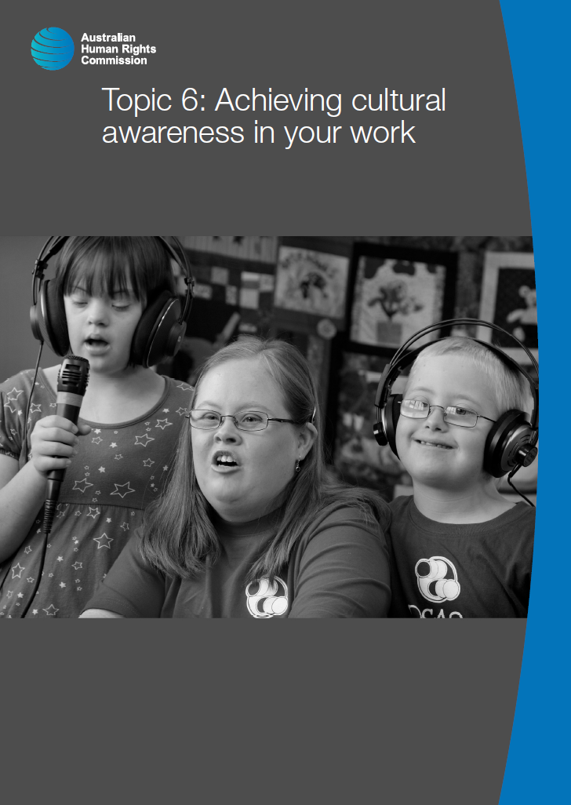

© Australian Human Rights Commission 2016.

The Australian Human Rights Commission encourages the dissemination and exchange of information presented in this publication and endorses the use of the **Australian Governments Open Access and Licensing Framework** (AusGOAL).



All material presented in this publication is licensed under the **Creative Commons Attribution 4.0 International Licence**, with the exception of:

• photographs and images;

• the Commission’s logo, any branding or trademarks;

• where otherwise indicated.

To view a copy of this licence, visit [**http://creativecommons.org/licenses/by/4.0/legalcode**](http://creativecommons.org/licenses/by/4.0/legalcode).

In essence, you are free to copy, communicate and adapt the publication, as long as you attribute the Australian Human Rights Commission and abide by the other licence terms.

**Please give attribution to:** © Australian Human Rights Commission 2016.

**Disability Rights: Facilitating the empowerment of people with disability** • CHCDIS007 • Trainer’s Manual • 2016

**Acknowledgments**

The ‘Disability Rights: Facilitating the empowerment of people with disability’ Trainer’s Manual and Learner Guide were drafted by Lauren Henley, Annie Pettit, Rebecca Rolls, Alexandra Walker and Siobhan Tierney.

This publication can be found in electronic format on the Australian Human Rights Commission’s website at **http://www.humanrights.gov.au/about/publications/**.

For further information about the Australian Human Rights Commission or copyright in this publication, please contact:

Education and Innovation Team

Australian Human Rights Commission

GPO Box 5218

SYDNEY NSW 2001

Telephone: (02) 9284 9600

Email: **communications@humanrights.gov.au**

**Design and layout** Dancingirl Designs

**Cover photography** Renate Hottmann-Schaefer

# Topic 6: Achieving cultural awareness in your work

**Approximate duration:** 2 hours 40 minutes

**Topic sequence:**

6.1. Culturally and linguistically diverse communities (60 minutes)

6.2. Aboriginal and Torres Strait Islander peoples (60 minutes)

6.3. Unconscious bias and casual racism (40 minutes)

**Equipment needed:**

* Audio-visual equipment with internet connection
* Learner Guide (pages 101-119)

## 6.1. Culturally and linguistically diverse communities

**Approximate duration:** 60 minutes

|  |  |
| --- | --- |
| This icon indicates a trainer’s note | **Trainer’s note:** For this section, undertake your own research to see whether your state and/or local government has a policy framework in place to determine how the needs of people from culturally and linguistically diverse backgrounds will be met. You could also consider approaching a few service providers to see if they have a specific set of policies or procedures in place to establish the parameters for accommodating the needs of service users from culturally and linguistically diverse backgrounds. |

When we talked about intersectional discrimination earlier in the training (see Learner Guide page 18), we saw that people with disability who belong to vulnerable groups in Australia experience heightened levels of disadvantage.

This means that the experiences of Aboriginal and Torres Strait Islander peoples with disability and people with disability from culturally and linguistically diverse backgrounds will differ greatly from those of the general population of people with disability in Australia.

The *Convention on the Rights of Persons with Disabilities* requires that the nationality and cultural identity of persons with disability must be respected at all times. [1]

In the previous topic, we explored the importance of providing translation and interpreting services to service users from linguistically diverse backgrounds.

This topic will consider ways of understanding and respecting the customs, beliefs and practices of service users from diverse backgrounds, and strategies for reflecting on your own professional practice to improve cultural awareness and cultural competency.

### Cultural diversity in Australia

Today, Australia is one of the most ethnically diverse countries in the world.

At the time of the 2011 Census, over one quarter of the Australian population (26%) had been born overseas, and 46% of the population had at least one parent who was born overseas.[2]

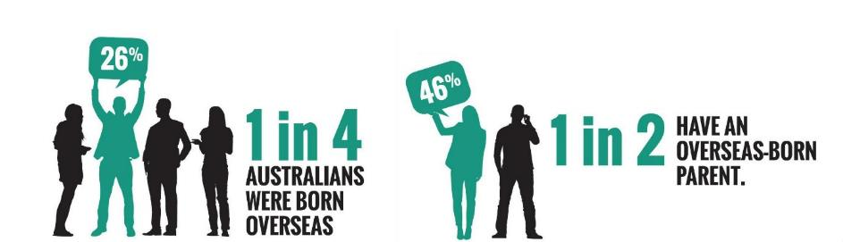

The following illustration shows the top 10 countries of birth for Australia’s overseas-born population.[3]

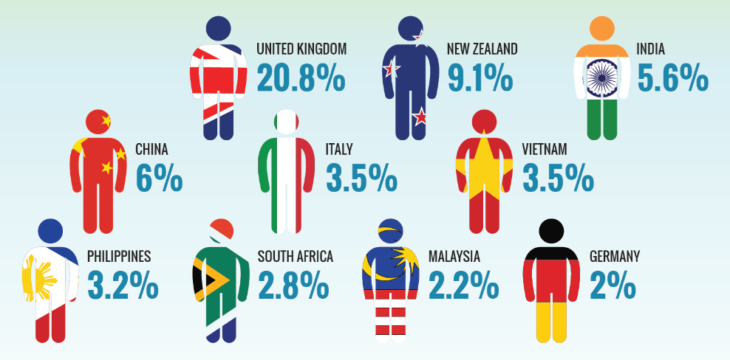

In 2013, overseas migration made up 60% of Australia’s population growth.[4]

While it may not be possible to be aware of the cultural norms and practices of every cultural group, it is important to be aware that the use of body language, eye contact and titles of address may differ for service users from culturally and linguistically diverse backgrounds.

Where possible, familiarise yourself with the cultural norms and practices of service users in order to understand how these may impact on service delivery.

### Activity: Exploring community profiles

|  |  |
| --- | --- |
| This icon indicates an activity for a group or class discussion | **Activity type:** Partner activity  **Duration**: 20 minutes  **Equipment needed:** ‘[Community Profiles for Health Care Providers](https://www.health.qld.gov.au/multicultural/health_workers/profiles-complete.pdf)’, Queensland Government, Learner Guide (page 104) |

**Purpose:** To familiarise learners with the norms and practices of other cultures.

**Instructions:**

1. Inform learners that they will be working in pairs for this activity.
2. Instruct learners to turn to the ‘Responding to cultural diversity’ checklist on page 104 of their Learner Guide.
3. Provide each pair with a different ‘Community Profile’ from Queensland Health’s Community Profiles for Health Care Providers resource (there are 18 in total).
4. Ask each pair to work through the profile, and try to answer as many of the questions from the checklist as possible. The questions have been included below for your reference:

* Does the service user require a language interpreter?
* Is it appropriate to use eye contact when working with the service user?
* Is there any body language I should avoid?
* What language should I use to address the service user?
* Is the service user uncomfortable with working with staff of a certain gender?
* Are there any religious practices that need to be accommodated when working with the service user?
* What role does the family play in the service user’s culture?
* How is disability typically viewed within the service user’s culture?

1. Inform learners that they have 10 minutes to complete the task and ask them to begin.
2. After 10 minutes, ask one person from each pair to outline the culture they have researched and summarise their findings.

When working with any service user whose cultural identity differs from your own, it is important to remember that you may need to alter the way in which you approach service delivery in order to demonstrate respect for that person’s beliefs, traditions and cultural identity. Developing cultural awareness is the first step in this process.

### Activity: Moving from awareness to practice

|  |  |
| --- | --- |
| This icon indicates an activity for a group or class discussion | **Activity type:** Small group activity  **Duration:** 40 minutes  **Equipment needed:** Learner Guide (page 106), computer with internet access |

**Purpose:** To encourage learners to think of ways to apply cultural awareness to a work context to improve the experiences culturally and linguistically diverse service users.

**Instructions:**

1. Organise learners into groups of three people.
2. Instruct learners to turn to the case study activity on page 106 of their Learner Guide.
3. Read out the case study, as it appears below:

|  |  |
| --- | --- |
| This icon indicates a suggested section to read out | You are a man, working for a disability service provider where it is your role to assist service users to develop their personalised support plans. You have just received a referral for a service user who is seeking support after a stroke left her with extensive frontal lobe damage.  The service user has recently immigrated to Australia from rural India. You are aware from her file that she and her family are Hindu. The stroke has impacted her ability to verbally communicate and her first language is not English.  Using the questions below, outline how you will ensure that this service user’s cultural needs are met. |

1. Inform learners that they have 25 minutes to use the internet to answer the questions in the Learner Guide and ask them to begin.
2. After 25 minutes, ask one person from each group to explain their group’s answers to the rest of the class.

|  |  |
| --- | --- |
| This icon indicates a discussion question | **Questions:**   * In this scenario, the service user is a Hindu woman who has recently immigrated to Australia from rural India. How might the service user’s cultural background impact on your planning and service delivery? * What cultural considerations should you take into account, as a man working with this service user? * From who and where is information about this service user’s culture best sourced? * How will you translate your awareness of the service user’s cultural needs into practice? What actions will you take? |

Although it is useful to build an awareness of service users’ cultural norms and practices, it is important to remember that regardless of ethnicity, no two service users are the same. For this reason, you should be guided by the preferences of the individual when establishing a foundation for respectful communication.

|  |  |
| --- | --- |
| This icon is used to highlight further reading and important information | **Further reading:**  Queensland Council of Social Service and AMPARO Advocacy, [*Multicultural Resource Book for Disability Service Providers*](https://www.qcoss.org.au/multicultural-resource-book-disability-service-providers) (2014).  NSW Department of Community Services, [*Working with Aboriginal people and communities: a practice resource*](http://www.community.nsw.gov.au/__data/assets/pdf_file/0017/321308/working_with_aboriginal.pdf) (2009).  Australian Human Rights Commission, [*Good Practice Good Business fact sheet – Racial Discrimination*](https://www.humanrights.gov.au/employers/good-practice-good-business-factsheets/racial-discrimination) (2015).  Australian Human Rights Commission, *Racism.* [*It Stops With Me – Clearinghouse*](https://itstopswithme.humanrights.gov.au/resources/clearinghouse). |

## 6.2. Aboriginal and Torres Strait Islander peoples

**Approximate duration:** 60 – 90 minutes

|  |  |
| --- | --- |
| This icon indicates a trainer’s note | **Trainer’s note:** For this section, undertake your own research to see whether your state and/or local government has a policy framework in place to determine how the needs of Aboriginal and Torres Strait Islander peoples will be met, for example through a Reconciliation Action Plan.  You could also consider approaching a few service providers to see if they have a specific set of policies or procedures in place to establish the parameters for accommodating the needs of Aboriginal and Torres Strait Islander service users. It would also be advisable to approach the [First Peoples Disability Network](http://www.fpdn.org.au/) Australia for further advice on how to deliver this section of the training. |

Aboriginal and Torres Strait Islander peoples are the first peoples of Australia and as such hold a unique place in Australia’s history and culture.[5]

Over time, the following definition has been agreed on by the community and Australian Government to identify when someone is an Aboriginal and/or Torres Strait Islander person. The person:

* is of Aboriginal and/or Torres Strait Islander descent
* identifies as an Aboriginal and/or Torres Strait Islander person, and
* is accepted as an Aboriginal and/or Torres Strait Islander person by the community in which he or she lives.[6]

Around 50% of Aboriginal and Torres Strait Islander people have a disability or long-term health condition, while the rate of disability for the general population is less than 20%.[7]

Aboriginal and Torres Strait Islander people are also twice as likely to experience a psycho-social disability or mental illness.[8]

There are many factors that contribute to the high rate of disability in Aboriginal and Torres Strait Islander communities, including:

* Intergenerational trauma resulting from the impact of colonisation and the stolen generations
* Cultural disconnection and loss of cultural identity
* Social disadvantage and poverty, and
* Racism and discrimination.[9]

While we know that the rate of disability is higher for Aboriginal and Torres Strait Islander peoples than it is for the rest of the population, the above figures may still be an under-representation. According to the First Peoples Disability Network:

The vast majority of Aboriginal people with disability do not self-identify as people with disability. This occurs for a range of reasons including the fact that in traditional language there was no comparable word for disability. Also that many Aboriginal people with disability are reluctant to take on the label of disability particularly if they may already experience discrimination based on their Aboriginality.[10]

Despite experiencing higher rates of disability, Aboriginal and Torres Strait Islander peoples continue to face barriers to accessing appropriate services and supports for reasons such as:

* Differing cultural attitudes towards disability.
* Social marginalisation.
* Mistrust of community workers.
* A lack of services that meet the cultural needs of Aboriginal and Torres Strait Islander peoples.[11]

The need to provide services that meet the cultural needs of Aboriginal and Torres Strait Islander service users is explicitly stated in the *National Standards for Disability Services.*

|  |  |
| --- | --- |
| **National Standards for Disability Services** | **Indicators of Practice** |
| **Standard 2: Participation and Inclusion** | 2:6 The service uses strategies that promote community and cultural connection for Aboriginal and Torres Strait Islander people. |

|  |  |
| --- | --- |
| This icon indicates a trainer’s note | **Trainer’s note:** The e-learning module in the activity below takes approximately 1-1.5 hours to complete. You may therefore decide to have learners complete the module as a homework task, or select only key elements of the module for learners to complete in-class. |

### Activity: Find out about Aboriginal Kinship

|  |  |
| --- | --- |
| This icon indicates an activity for individuals | **Activity type:** E-learning module  **Duration:** 30 – 90 minutes |

**Purpose:** To broaden learners’ awareness and understanding of Aboriginal cultures and communities.

By undertaking the module, learners will gain a greater understanding of and insight into:

* experience of Aboriginal Kinship systems and how they operate
* Aboriginal social structures and how these differ from Western societies
* how cultural assessment assists in understanding these impacts
* potential conflict in working with people from differing cultural backgrounds.

**Instructions**

1. Ask learners to log on to a computer and find the University of Sydney’s ‘[Aboriginal Kinship](http://sydney.edu.au/kinship-module/)’ module.
2. Specify which parts of the module you would like learners to complete and ask them to begin the online module.

### Aboriginal and Torres Strait Islander cultures and histories

It is important to remember that Aboriginal peoples and Torres Strait Islander peoples have distinct cultures.

Aboriginal peoples are comprised of many different language and/or tribal groups, while Torres Strait Islanders are from the Torres Strait Islands region.

Some Torres Strait Islander peoples have moved to mainland Australia either through forced removal or for employment and education. Aboriginal and Torres Strait Islander peoples retain their cultural identities whether they live in urban, regional or remote areas of Australia.

Because there is such a great diversity of cultures, languages, kinship structures and ways of life among Aboriginal and Torres Strait Islander peoples across Australia,[12] there is no one set of protocols that will meet the needs of every community.

One of the most important aspects of working with Aboriginal and Torres Strait Islander peoples is the need to work with the community and gain a better understanding of their traditions, customs, practices and preferences.[13]

Below are a few general tips to keep in mind when working with Aboriginal and Torres Strait Islander service users:

* Some Aboriginal and Torres Strait Islander people may still have a high level of mistrust towards community workers due to the entrenched trauma of historical events. Building trust and respect with the service user is therefore paramount to developing a strong working relationship.[14]
* Many Aboriginal and Torres Strait Islander communities still operate according to the principles of men’s business and women’s business, whereby specific traditions and customs are performed separately by men and women. When working with Aboriginal and Torres Strait Islander communities, you should enquire as to whether or not the topic of conversation is appropriate for everyone or if the rules of men’s and women’s business will apply.[15]
* Family kinship structures are very important in Aboriginal and Torres Strait Islander cultures and there may be times when non-Indigenous people are asked to leave the room so that matters can be discussed in private. You should be respectful of these boundaries and allow service users and their families (where appropriate) the opportunity to discuss matters in private.
* Especially in circumstances where trust has not already been established, it is preferable for men to speak to men, and women to speak to women.[16]
* After an individual has passed away, many Aboriginal and Torres Strait Islander communities will observe traditional grieving customs known as ‘sorry business’ for several weeks. You should generally avoid initiating contact with service users during times of sorry business.[17]
* Within Aboriginal and Torres Strait Islander communities, elders are generally referred to as ‘Aunty’ or ‘Uncle’ as a sign of respect. However, it may not be appropriate for a non-Indigenous person to use these titles if they have not already established a relationship of trust and respect with the elder in question.[18]

|  |  |
| --- | --- |
| This icon is used to highlight further reading and important information | **Further Reading:**  Australian Indigenous HealthInfoNet, [*Disability within the Indigenous Community*](http://www.healthinfonet.ecu.edu.au/related-issues/disability/reviews/disability-within-the-indigenous-community) (20 October 2015).  Australian Indigenous HealthInfoNet, [*National Aboriginal and Torres Strait Islander flexible aged care program*](http://www.healthinfonet.ecu.edu.au/key-resources/programs-projects?pid=1605) (27 September 2012). |

## 6.3. Unconscious bias and casual racism

**Approximate duration:** 40 minutes

Unconscious bias, also commonly referred to as ‘implicit bias’ or ‘hidden bias’ is something that we have all been influenced by at some point in our lives. We’ll explore the meaning of this term in the next viewing activity.

### Viewing activity

|  |  |
| --- | --- |
| This icon indicates a viewing activity | **Video:** ‘[Unconscious bias: the theory behind “Implicitly”](https://www.youtube.com/watch?v=c-f2VJM4dps)’  **Source:** Hogrefe Ltd,  **Duration:** 5 minutes 26seconds |



**Summary:** This video exploresthe theory behind Hogrefe’s ‘Implicitly’ test. ‘Implicitly’ is a collection of tests which can be used to help uncover our unconscious biases and their likely impact on behaviour.

**Instructions:**

1. Play the video ‘Unconscious bias: the theory behind “implicitly”’.
2. Use the following questions to encourage discussion about the video:

* What did you think of the video?
* What do you think is meant by the term ‘unconscious bias’?
* What are some biases we might have that we may not always be aware of?

|  |  |
| --- | --- |
| This icon indicates an activity for individuals | **Activity type:** Individual exercise  **Duration:** 5 minutes  **Equipment needed:** Learner Guide (page 113) |

### Activity: Check your bias

**Purpose:** To encourage learners to reflect on their level of unconscious bias towards people whose cultural identity may differ from their own.

**Instructions:**

1. Ask learners to turn to the ‘Check your bias’ activity on page 113 of their Learner Guide.
2. Inform learners that they will have 5 minutes to respond to the three questions listed on the page. Explain that this is a reflective task only and learners will not be required to share their responses with the rest of the class if they are not comfortable with doing so.
3. Encourage a group discussion about what some of the answers mean. Ensure learners feel safe and understand that they are not being judged for their responses. The questions for this activity have been provided below:

|  |  |
| --- | --- |
| This icon indicates a discussion question | **Questions:**   * How often do you specify someone’s race when it is not necessarily relevant (for instance an Asian doctor or Indian lawyer?) * Have you ever assumed that someone is good or bad at an activity (like athletics, mathematics, driving, or cooking) because of their race? * Have you ever asked a person ‘Where are you really from?’ * How might doing any of these things involve a form of bias or prejudice? |

### Unconscious bias

What we call unconscious bias is unavoidable. People naturally categorise information, which means we routinely sort objects and people into groups to help us make decisions. It is a product of biology and the way our brains work.

Consequently, we associate people who may look or sound a particular way with certain things, whether good or bad. These are associations that are activated without us being aware. As social psychologists have demonstrated, we all make implicit assumptions – including about ethnic or racial groups – even if we consciously think that we reject a group stereotype.[19]

Studies demonstrate there are often massive discrepancies between our conscious and unconscious biases. For example, in 2010, economists at the Australian National University found substantial racial discrimination in hiring by Australian employers.

The researchers sent over 4,000 fake job applications for entry-level jobs. The applications contained the same qualifications but with different names, distinguished by their ethnic origin.

In order to get the same number of interviews as an applicant with an Anglo-Saxon name, someone with a Chinese name needed to submit 68% more applications. Those with a Middle Eastern name would need 64% more, while those with an Italian name needed to put in 12% more applications.[20]

These figures may, in part, be the result of overt forms of racism such as a belief in racial superiority or deliberate acts of discrimination. However, it is likely that decisions about whether or not to hire an individual with a non-Anglo-Saxon name are sometimes made unconsciously, based on negative prejudices or stereotypes concerning race.

### Casual racism

|  |  |
| --- | --- |
| This icon indicates a discussion question | **Discussion question:** What do you think is meant by the term, ‘casual racism’? |

**Points to inform discussion:**

* Casual racism refers to conduct involving negative stereotypes or prejudices about people on the basis of race, colour or ethnicity.
* Examples include making offensive jokes and off-hand comments, and excluding people from social situations on the basis of their race.
* Unlike overt and intentional acts of racism, casual racism often isn’t intended to cause offence or harm.[21]

### Viewing activity

|  |  |
| --- | --- |
| This icon indicates a viewing activity | **Video:** ‘[Casual Racism: Robbie's Story’](https://www.youtube.com/watch?v=ICrPkfwbMAc)  **Source:** Studio 10,  **Duration:** 6 minutes 35 seconds |

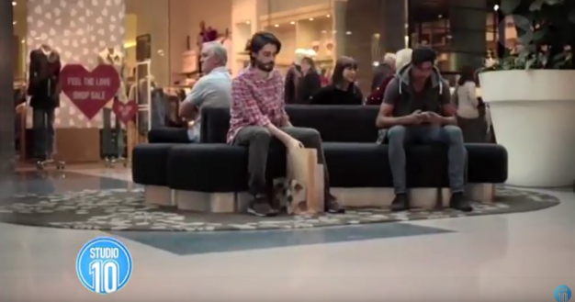

**Summary:** Not all racism is crude & shocking. There's also casual racism, it’s subtle & sometimes not even intended, but can have devastating effects.

**Instructions:**

1. Play the video, ‘Casual Racism: Robbie's Story’.
2. Ask learners if they have any comments or questions about the video before moving on.

Like other forms of racism, casual racism can marginalise, denigrate or humiliate those who experience it. Research demonstrates that racism can have adverse effects on people's physical and mental health, causing anxiety, depression, low self-esteem and high blood pressure.[22]

Casual racism, such as jokes and slurs, can also exclude the target from wider society by sending a message that they aren’t welcome, reinforcing social barriers and attacking the dignity of the victim as an equal member of society.[23]

Being aware of casual racism involves recognising that we are all accountable for the things we say or do. Joking about matters of race, culture or ethnicity not only has negative consequences for the victims of such jokes, but may also result in service users developing unfavourable impressions of you.

The *National Standards for Disability Services* require you to foster a work environment that respects cultural diversity and makes service users feel safe and welcome. Sometimes, this might require you to go beyond just reflecting on your own practice and taking a stand against instances of casual racism that occur in the workplace.

The case study below is a positive example of such an intervention:

Pradeepta is 28 and lives in a major city. She has lived in supported accommodation for several years. The accommodation organisation has recently merged with another service which means that Pradeepta has a number of new workers working with her.

One of these workers, Kerri, makes negative comments about the religious objects in Pradeepta’s room and her food, and pressures Pradeepta to change her haircut.

A manager, Diane, overhears this and explains to Kerri that Pradeepta is free to practice her culture and her religion. Diane tells Kerri she is not to make negative comments about Pradeepta. Kerri replies that she was ‘just teasing’.

Diane identifies that Kerri has a very low understanding of anti-discrimination and equal opportunity laws, and becomes worried about broader staff practice. She puts in place extra supervision for Kerri, to help her to reflect on how she engages with clients and the impact of her practice.

With Pradeepta’s consent, Diane speaks with Pradeepta and her family to make it clear that Kerri’s actions are not acceptable, and what changes are needed so it doesn’t happen again.

Diane organises compulsory cultural competency training for staff, run by a multicultural advocacy service. She uses an existing representative group with family members, carers and advocates deciding which issues and situations to include. The group also recommends the service update its Cultural Diversity Action Plan. Diane runs a specific session for residents about rights and how they should be supported and protected. Diane works with the Human Resources team to update recruitment processes, including advertising, interview questions and reference checking, to make sure there is a clear focus on cultural respect and anti-discrimination.

This scenario has been adapted from a case study from the *National Standards for Disability Services – Stories* publication, provided by the Department of Social Services. [24]

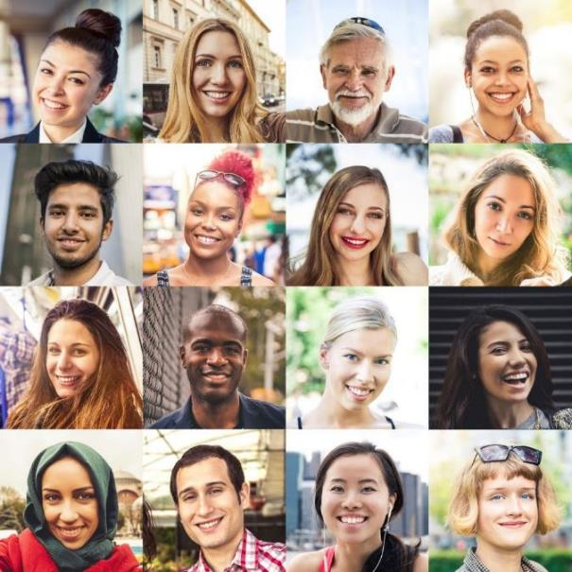

### Activity: Responding to casual racism in the workplace

|  |  |
| --- | --- |
| This icon indicates an activity for a group or class discussion | **Activity type:** Small group activity  **Duration:** 10 minutes  **Equipment needed:** Learner Guide (page 117) |

**Purpose:** To encourage learners to think about the steps they might take to combat casual racism in the workplace.

**Instructions:**

1. Organise learners into groups of three or four people
2. Ask learners to turn to the activity on page 117 of their Learner Guide and read out the scenario for this activity, as it appears below:

|  |  |
| --- | --- |
| This icon indicates a suggested section to read out | You are assisting to coordinate a peer support group for a number of people with disability. One of the men in the group is a refugee from Sudan. You overhear one of the other group members making offensive comments about people from Africa. What immediate and short to long term steps would you take to deal with this situation? |

1. Inform groups that they have five minutes to write their response and ask them to begin.
2. After five minutes, ask groups to briefly share their thoughts with the rest of the class.

A change in social attitudes is necessary for combatting casual racism. Everyone can contribute to this change through speaking up against racism when they encounter it.

You could start a conversation with a friend, family member, colleague or teammate. For example, this could involve pulling them aside to ask them what they mean by their comment or prompting them to think how they would feel if they were subjected to stereotypes.

|  |  |
| --- | --- |
| This icon indicates a discussion question | **Discussion questions:**   * How do you think unconscious bias and casual racism might impact on your work with people from diverse backgrounds? * What are some of the things you can do to identify and address unconscious bias when working with Aboriginal and Torres Strait Islander service users and service users from culturally and linguistically diverse backgrounds? * To what extent do you think unconscious bias might influence the way you think about other groups of people, such as people with disability, older people or people who are gay, lesbian, bisexual, transgender or intersex? |

**Examples:**

* There is a common misconception that older people cannot use technology.
* It is common for men to be asked if they have a wife or girlfriend and for women to be asked if they have a husband or boyfriend. This assumes that people are heterosexual and can make people who are gay, lesbian or bisexual feel like they might be treated differently because of their sexual orientation.

|  |  |
| --- | --- |
| This icon is used to highlight further reading and important information | **Further reading:**  Australian Human Rights Commission, [*Casual racism FAQs*](https://www.humanrights.gov.au/our-work/race-discrimination/projects/casual-racism-faqs) (9 July 2014).  Harvard University, [*Project Implicit*](https://implicit.harvard.edu/implicit/australia/). |

## Topic 6: Endnotes

1. Convention of the Rights of Persons with Disabilities, opened for signature 13 December 2006, 2515 UNTS 3 (entered into force 3 May 2008) Art. 18.
2. Australian Bureau of Statistics, *Australian Social Trends 2013* (4102.0-9 August 2013)

   <<http://www.abs.gov.au/AUSSTATS/abs@.nsf/allprimarymainfeatures/244402E7BB2A27E2CA257BB200141ADB?opendocument>>.
3. Australian Bureau of Statistics, *Reflecting a Nation: Stories from the 2011 Census 2012–2013* (2071.0 16 April 2013).

   <<http://www.abs.gov.au/ausstats/abs@.nsf/Lookup/2071.0main+features902012-2013>>.
4. Australian Bureau of Statistics, *Australian Demographic Statistics 2013-2014* (3101.026 March2014) <<http://www.abs.gov.au/AUSSTATS/abs@.nsf/allprimarymainfeatures/54A5E977BB10644CCA257E1300775B9B?opendocument>>.
5. The Australian Human Rights Commission understands the importance of using appropriate terminology when referring to Aboriginal and Torres Strait Islander peoples. The Commission recognises there is strong support for the use of Aboriginal and Torres Strait Islander peoples, First Nations and First Peoples. The word ‘peoples’ recognises that Aborigines and Torres Strait Islanders have a collective, as well as an individual dimension to their lives. This is affirmed in the *United Nations Declaration on the Rights of Indigenous Peoples,* GA Res 61/295, UN GAOR, 61st sess, 107th plen mtg, Supp No 49, UN Doc A/RES/61/295 (13 September 2007).
6. Department of Aboriginal Affairs, *Report on a Review of the Administration of the Working Definition of Aboriginal and Torres Strait Islanders*, in John Gardiner-Garden, *The Definition Of Aboriginality* (Dept. of Parliamentary Library, 2000).
7. Australian Bureau of Statistics, *The Health and Welfare of Australia's Aboriginal and Torres Strait Islander Peoples*, *October 2010* (4704.0 19 December 2010).

   <<http://www.abs.gov.au/ausstats/abs@.nsf/mediareleasesbytitle/3C18155D35250456CA2574390029C0E5?OpenDocument>>.
8. Australian Bureau of Statistics, *The Health and Welfare of Australia's Aboriginal and Torres Strait Islander Peoples*, *October 2010* (*4704.0 19 December* 2010 )

   <<http://www.abs.gov.au/ausstats/abs@.nsf/mediareleasesbytitle/3C18155D35250456CA2574390029C0E5?OpenDocument>>
9. The Royal Australian College of General Practitioners, *An introduction to Aboriginal and Torres Strait Islander health cultural protocols and perspectives*, ‘Core principles for working with Aboriginal and Torres Strait Islander people’ (2012) 23.
10. First Peoples Disability Network *Ten-point plan for the implementation of the NDIS in Aboriginal communities* (2015) < <http://www.fpdn.org.au/10-point-plan-ndis>>
11. Australian Indigenous Health InfoNet, *Disability within the Indigenous community* (2015) <<http://www.healthinfonet.ecu.edu.au/related-issues/disability/reviews/disability-within-the-indigenous-community>>.
12. Australian Human Rights Commission, *Face the Facts*, (2012) <<https://www.humanrights.gov.au/publications/face-facts-2012/2012-face-facts-chapter-1#fn2>>.
13. The Royal Australian College of General Practitioners, *An introduction to Aboriginal and Torres Strait Islander health cultural protocols and perspectives*, ‘Core principles for working with Aboriginal and Torres Strait Islander people’ (2012) 20.
14. The Royal Australian College of General Practitioners, *An introduction to Aboriginal and Torres Strait Islander health cultural protocols and perspectives*, ‘Core principles for working with Aboriginal and Torres Strait Islander people’ (2012) 22.
15. NSW Department of Community Services, *Aboriginal People and Communities: A Practice Resource*, ‘Men’s and Women’s Business’ (2009) 16.
16. NSW Department of Community Services, *Aboriginal People and Communities: A Practice Resource*, ‘Men’s and Women’s Business’ (2009) 16.
17. NSW Department of Community Services, *Aboriginal People and Communities: A Practice Resource*, ‘Grief and loss (Sorry Business)’ (2009) 6.
18. NSW Department of Community Services, *Aboriginal People and Communities: A Practice Resource*, ‘Communication’ (2009) 18.
19. Dr Tim Soutphommasane, ‘Unconscious bias and the bamboo ceiling’ (2014) (Speech delivered at the Asian Australian Lawyers Association, 10 June 2014) <<https://www.humanrights.gov.au/news/speeches/unconscious-bias-and-bamboo-ceiling1>>.
20. A Booth, A Leigh and E Varganova, ‘Does Racial and Ethnic Discrimination Vary Across Minority Groups? Evidence from a Field Experiment’, July 2010, CEPR Discussion Paper No. DP7913 (July 2010) <<http://ssrn.com/abstract=1640989>>.
21. Australian Human Rights Commission, *Casual racism FAQs* (2014) <<https://www.humanrights.gov.au/our-work/race-discrimination/projects/casual-racism-faqs>>.
22. Australian Human Rights Commission, *Casual racism FAQs* (2014) <<https://www.humanrights.gov.au/our-work/race-discrimination/projects/casual-racism-faqs>>.
23. Australian Human Rights Commission, *Casual racism FAQs* (2014) <<https://www.humanrights.gov.au/our-work/race-discrimination/projects/casual-racism-faqs>>.
24. Department of Social Services, *National Standards for Disability Services - Stories* (2013) <<https://www.dss.gov.au/our-responsibilities/disability-and-carers/standards-and-quality-assurance/national-standards-for-disability-services>>.