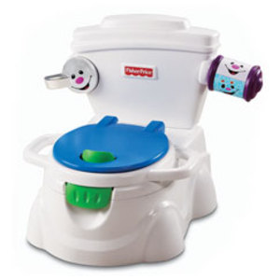
Potty training
Susan is the mother of twin girls, Lala and Meg, who are now three years old.
Susan uses Facebook on the internet and writes her own blog.
The twin girls, Lala and Meg, are in the middle of potty training. Susan takes a cute shot of the girls naked side by side on potties.
Susan posts these on her Facebook site.
Key Questions
What privacy issues does this story bring up?

Are there any problems with posting these photos?

Did Susan break any privacy rules?

Should Lala and Meg have a right to privacy?

What things could Susan have done differently?

The Family Tree
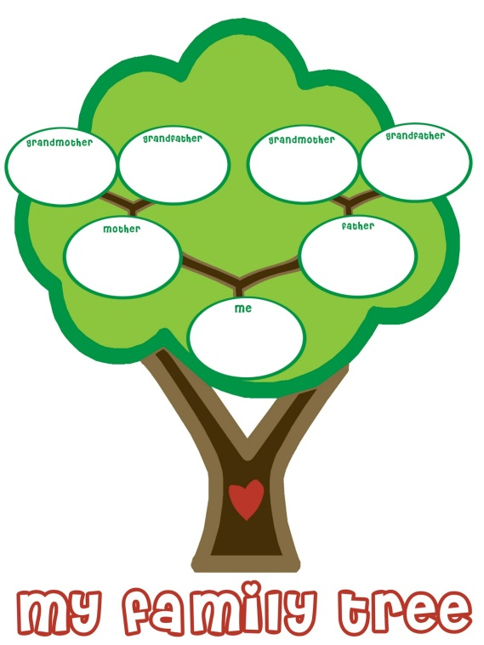
Mohammad is 9 years old and lives with foster parents.
One day at school the teacher asks all the children about their family tree. The teacher tells the class that Mohammad has foster parents. All the other children want to know why.
Mohammad feels a bit worried and angry. He kicks the desk and runs out of the class. Mohammad is then suspended for bad behaviour.
Key Questions
What privacy issues does this story bring up?

Did the teacher break privacy rules?

Should Mohammad have a right to privacy?

What could the teacher have done differently?

At the photocopier
Zali is 13 years old and is helping a teacher to photocopy some material for class.
She notices a file left in the photocopy room about another student, Jess, who she doesn’t get on with.
Jess has been bullying Zali online and in the playground. Zali can’t help but open the file and have a look.
Zali is surprised to read the file and see that Jess has trouble reading in class and is getting special help to improve her reading. Zali photocopies Jess’ file shares it with other students at lunch, hoping this will stop Jess bullying her.
Key Questions
What are the privacy issues here?

Did Zali break privacy rules by sharing Jess’ file with other students?

What should happen to Zali?

How can Jess keep her privacy safe?

Keep out!
Loki is 10 years old and is helping his mum make the dinner for a big family gathering later in the evening.
When Loki’s uncle, Steve, comes over for dinner, he goes into Loki’s bedroom without asking first.
Steve gave Loki a model aeroplane last Christmas and he went into Loki’s bedroom to see if Loki had put the plane together.
Loki doesn’t mind sharing toys with his siblings but he doesn’t like people going through his stuff without permission.
When Loki saw Steve leave his bedroom, Loki asked Steve what he was doing. Steve said that he was just looking around and that Loki shouldn’t be upset that he didn’t ask permission.
Key Questions
What are the privacy issues here?

Did Steve break privacy rules by entering Loki’s bedroom without asking for permission?

Should Loki have a right to privacy in his bedroom?

