The Family Doctor
Tom, 16, goes to the family doctor to get help with an alcohol and drug problem. He tells the doctor that his parents do not know about his problem.
The next week the doctor bumps into Tom’s dad at the shops and tells him that Tom had visited him.
Tom’s dad confronts Tom about the visit and asks him what it was about. Tom says it’s none of his business. Tom’s dad says it is, because Tom is under age and that Tom is his son.
Key Questions
What privacy issues does this story bring up?

Is this a serious breach of Tom’s privacy? Why/why not?

Do you think any laws have been broken?

Should Tom have a legal right to privacy?

What action should Tom be able to take?

What things could Tom, the doctor and Tom’s Dad have done differently?

The Party
Mia is 15, and so is her best friend Amani. One day at school Amani tells Mia that there is a picture of Mia from a recent party looking pretty wasted on another student’s Facebook. Mia says she didn’t even know that any photos were taken at the party.
Soon Mia gets a bunch of anonymous texts paying her out, calling her a slag and a waste of time. This goes on for several weeks and Mia is getting increasingly depressed. She thinks she knows who is doing it at the school but she’s not sure.
Amani wants Mia to tell the school counsellor or someone else, but Mia says no, that will only make it worse.
Key Questions
What privacy issues does this story bring up?

Is this breach of privacy? Why/Why not?

Do you think any laws have been broken?

Should Mia have a legal right to privacy?

What would help Mia and Amani in this situation?

My personal space
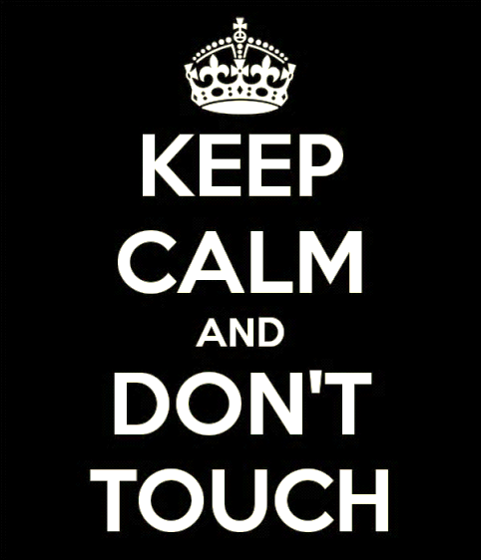
Ty is 17 and is in a juvenile detention centre charged with stealing a car.
At the detention centre he has a small room where he sleeps, a desk to study and a cupboard.
He has a few clothes and some personal items like magazines, books and photos in the room.
When he comes in from a metal work class one day and goes to his room, he notices things have been moved around. He asks the youth worker on shift if anyone had been into his room. The youth worker says that they thought he might have a prohibited item in the room, so they searched it while he was away. The youth worker said he didn’t find anything this time.
Ty says he has a right to privacy and wants to make a complaint. The worker says that Ty doesn’t have that right anymore because Ty has broken the law.
Key Questions
What privacy issues does this story bring up?

Is this a serious breach of privacy? Why/Why not?

Do you think any laws have been broken?

Should Ty have a right to privacy?

What should Ty be able to do about breaches of his privacy?

What could the youth worker have done differently?
Birthday girl
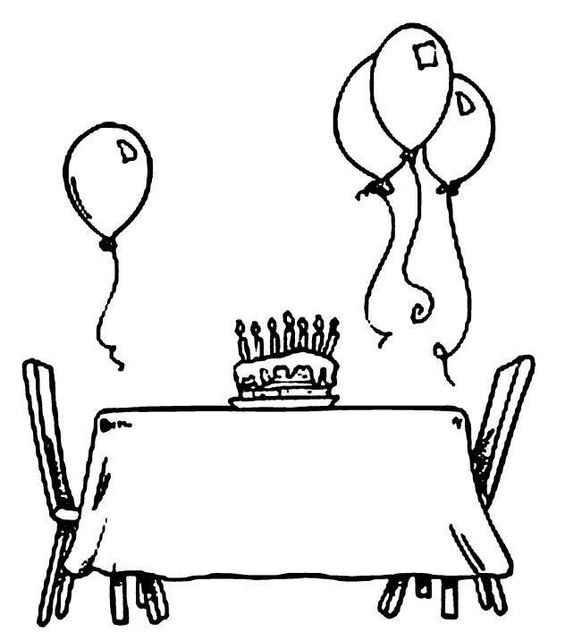
Brad is 23 and works in Student Administration and Janet is 17 and is a student at the high school. They live in the same street.
Occasionally they see each other at neighbourhood events and church, and their two families know each other.
Brad knows that Janet’s birthday is coming up because Janet happened to mention that she’ll be another year older very soon. Brad decides to access the student information system to find out Janet’s date of birth. A few weeks later Janet receives a birthday card from Brad sent to her home address.
Key Questions
What are the privacy issues here?

Is this a serious breach of privacy? Why/Why not?

Do you think any laws have been broken?

Should the law protect Janet’s privacy in this situation?

Should Janet be able to take any action? What might that look like?
The School Counsellor
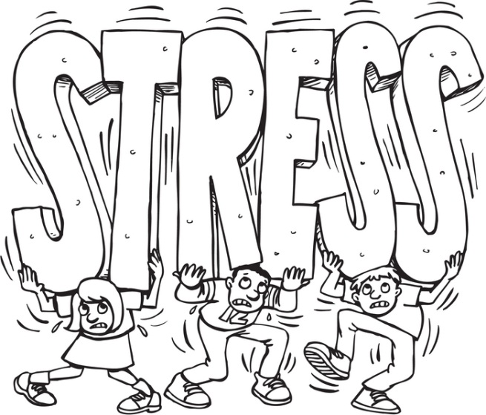
Braith is 14 and tells his friend Jono that he is feeling stressed by all the homework at school. Braith can’t keep up and things are bad at home. Braith even says he is thinking suicidal thoughts, but makes Jono swear not to tell anyone.
Braith is sent to School Counsellor, Myra, after being sent out of class for bad behaviour. He tells Myra how he is feeling.
After the meeting Myra telephones Braith at home about attending a follow up meeting. Braith is not at home, but his mother, Christine, answers the phone. She says she knows all about Braith’s problems but asks for more information.
When pressed, Myra provides further details. Myra feels comfortable about providing this information to Christine because she is the student’s mother and she has already told her that she knows all about what is going on.
Key Questions
Is there anything wrong with Myra giving Christine this information?

How can Jono handle the situation?

Do you think any laws have been broken?

Should there be a law to protect Braith’s privacy in this situation?

What action should Braith be able to take?
The Loan
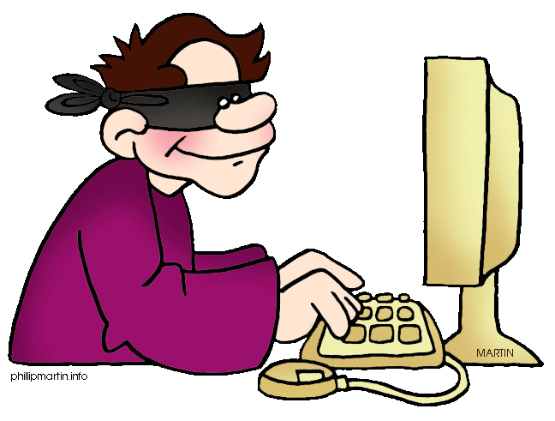
Mitch is 17 and is an apprentice electrician. He plays in a band on the weekends with his mates. He has his own Facebook page, with about 100 followers. He posts about once a week, mostly about the band and how their gigs went.
Having passed his driving test a couple of months ago, Mitch is keen to buy a ute. However, he needs a loan to do this. When Mitch approaches the bank he is denied a loan due to his poor credit history. Mitch says he can’t have a bad credit history because he has never had a loan before.
The bank looks into it, and is able to show him that he applied for and defaulted on a loan earlier in the year, and owes the bank $5000, plus interest. On further investigation it looks like Mitch has been a victim of identity fraud. The person who took out the loan knew his address, date of birth, credit card details, driver’s license number, and was able to forge his signature.
Key Questions
What privacy issues does this bring up?

How can Mitch handle the situation?

Do you think any laws have been broken?

Should there be a law to protect Mitch in this situation?

What action should Mitch be able to take?

What steps should Mitch take to protect his personal information in future?
The Inappropriate Photo
Kate is 15 and sends a photograph of herself in a bikini to her boyfriend Mark. Mark is also 15.
A few weeks later, Kate and Mark end their relationship. Kate starts seeing another guy who happens to be a friend of Mark’s.
Mark is angry and so to get back at Kate he forwards the message he has containing the photo of Kate in a bikini to the list of contacts in his mobile phone.
Key Questions
Do you think any laws have been broken?

What should Kate do?

What should happen to Mark?

Should what Mark did be against the law?

