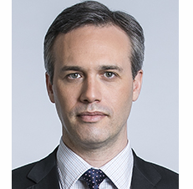 | Edward Santow  Human Rights Commissioner  FIFTH YEAR OF TERM | ‘The touchstone of human rights is dignity. The human rights framework provides practical tools to protect the dignity of all members of our community.’

TERM GOALS
Improved human rights protections for people including:  - refugees and asylum seekers  - lesbian, gay, bisexual, transgender and intersex people  - people in all forms of detention | Improved Australia’s protection of human rights in difficult contexts including:  - development and use of new technologies  - migration and refugee law and policy  - implementation of anti-terrorism and national security law and policy

STRATEGIES  - Developing partnerships and collaborations to address common goals.  - Public advocacy supported by research and evidence.  - Fostering public debate on human rights via strategic public engagement.  - Engaging stakeholders and ensuring inclusive consultation with diverse groups.  - Providing policy and law reform advice to improve human rights protection for vulnerable groups.  - Developing innovative solutions to protect and promote rights and freedoms. | 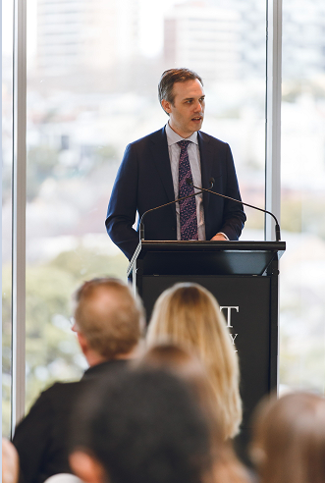  Commissioner Santow, on World Refugee Day, speaking at ‘The Sweetest Memory” event, Sydney, June 2019 (photo: Macquarie University, Widening Participation Unit).

KEY ACTVITITES/ 2020–21 WORKPLAN
Human rights and technology project | - This project was prompted by unprecedented technological development, and especially the increasing use of artificial intelligence in ways that can engage our human rights. The aim is to identify the challenges and opportunities that new technologies bring to the protection and promotion of human rights in Australia, and to address the risks of harm.  - In 2019, following national consultations, the Commission released a discussion paper setting out a draft template for reform. In 2020, a second phase of public consultation will be conducted. The final project report will be released in late 2020. Work with public and private sector stakeholders to implement the recommendations will follow.
Asylum seeker and immigration detention program | - This work aims to improve human rights protection in Australia’s immigration system. Projects include inspections of Australia’s immigration detention facilities to identify human rights problems and best practices; and research and reporting on the human rights implications of policies affecting asylum seekers, refugees and other migrants, including those in the Australian community.
Freedom of religion program | - This ongoing program is establishing a sustainable mechanism to communicate and work constructively with religious organisations, and the broader faith community, on how to protect freedom of religion in Australia. Through a combination of better data, community dialogue and education, it aims to increase understanding of the threats to religious freedom and to focus on combatting serious harms faced by religious communities in Australia.
Implementation of the Optional Protocol to the Convention against Torture (OPCAT) program | - Following publication of the final outcomes of our OPCAT public consultation and advice in mid-2020, this work will continue to pursue opportunities to advocate and educate in relation to the implementation of OPCAT in Australia.
SOGII program | - This work aims to improve human rights protection of lesbian, gay, bisexual, transgender and intersex people. The focus of this work will be advocating for implementation of recommendations in the report resulting from our work examining the human rights of people born with variations in sex characteristics in the context of medical interventions, and accessible trans and gender-diverse healthcare.

