Headshot photo - Commissioner Jenkins

Kate Jenkins

Sex Discrimination Commissioner

SEVENTH YEAR OF TERM

‘After many years of advocacy and building evidence, Australia is now at a turning point on sexual harassment, sexual assault, gender based violence and gender equality. Our community is demanding change and I am proud of the Commission’s work in workplaces, parliament, sport and education to guide the practical steps needed to achieve that change.’

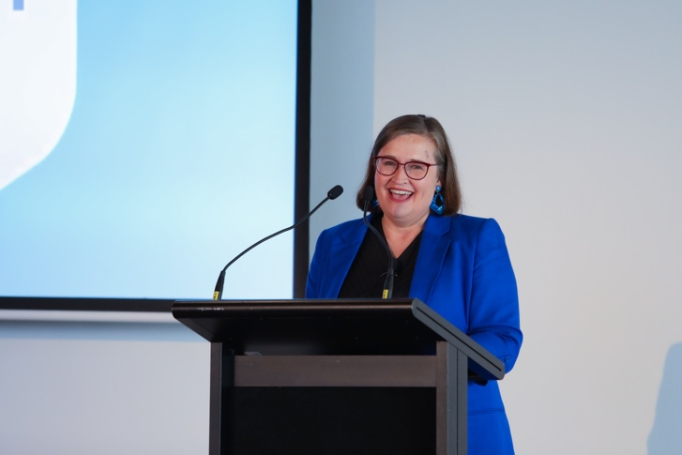

Commissioner Jenkins providing opening remarks at the Respect@Work Council Forum, Sydney July 2022

TERM GOALS

* **Reduce** violence against women.
* **Increase** diversity in leadership.
* **Improve** women’s economic security and empowerment.
* **Protect and promote** the rights of LGBTIQ+ communities.

PRINCIPLES / APPROACH

* Challenging violence against women and LGBTIQ+ communities in all parts of life: at work, on the street, at home, in education, in sport and online.
* Promoting broader social equality and cultural reform and addressing structural discrimination and intersectional disadvantage.
* Promoting women’s economic security through challenging the structural and attitudinal barriers affecting working parents, including parental leave, superannuation, flexible work, childcare, and sharing of unpaid work.
* Promoting the benefits of reducing gender-segregated paid and unpaid work.
* Advocating for improved representation of women and girls and LGBTIQ+ communities in political, corporate, sporting and organisational leadership roles.
* Promoting and facilitating opportunities for women and girls and LGBTIQ+ communities to have their voices heard at a local, national and international level.
* Taking a settings-based approach, focusing on the workplace, education, sport and parliament.

KEY ACTIVITES: 2022–23 WORKPLAN

|  |  |
| --- | --- |
| Workplaces | * Supporting Government in implementation of the recommendations of Respect@Work, Australia’s first National Inquiry into sexual harassment in Australian workplaces, including partnering with others to implement workplace recommendations. * Chairing the Respect@Work Council, comprising a core membership from the Fair Work Commission and Fair Work Ombudsman, Safe Work Australia and the Heads of Workplace Safety Authorities, the Heads of Workers’ Compensation Authorities, and the Australian Council of Human Rights Authorities. * Ongoing implementation of specific recommendations from Respect@Work, including: * Conducting and reporting on the fifth national survey on sexual harassment in Australian workplaces (Rec 2). * Developing a data collection and information sharing framework for agencies that handle workplace sexual harassment matters (Rec 3). * Developing and sharing education materials: * on workplace rights education for young people (Rec 9) * for the Fair Work Ombudsman and Fair Work Commission (Rec 34) * for Safe Work Australia and WHS regulators (Rec 36) * for workers’ compensation bodies (Rec 37) * for Judicial officers (Rec 40). * Developing and launching the Respect@Work portal (Rec 48). * Developing materials to be made available to ensure people affected by workplace sexual harassment understand their rights, including the options and supports available to them (Rec 52). * Promotion, advice, advocacy and engagement on workplace and community initiatives that promote gender equality and inclusion, including domestic and family violence leave, parental leave, discrimination against working parents, discrimination on the basis of sexual orientation, gender identity or intersex status, gender pay gap, flexible work, impacts of COVID19 and the implementation of Respect@Work especially by industry. |
| Parliament | * Supporting Government in the implementation of the recommendations of Set the Standard, the Independent Review into Commonwealth Parliamentary Workplaces, which aims to ensure that the people who work in parliamentary workplaces are treated with dignity and respect which apply best practice approaches to prevent and address bullying, sexual harassment and sexual assault. * Promoting and educating other workplaces, industries and parliaments on the lessons from Set the Standard. |
| Education | * With the National Children’s Commissioner lead the National Secondary Schools survey of the experience of sexual harassment and consent education in schools. * Continue to advocate to eliminate violence including sexual harassment and sexual assault of students and staff in Universities. |
| Sport | * Projects in this setting include promoting equal opportunity, anti-discrimination and inclusion in sport, especially in regard to women and girls, including: * Appointment as a Legacy ’23 Ambassador for the FIFA Women’s World Cup 2023. Through this appointment, Commissioner Jenkins is committed to helping Football Australia become the first sport to reach 50:50 gender participation whilst simultaneously building capacity in women’s leadership across the football ecosystem. * Promotion, advice, advocacy and education on implementation of other Commission guidance and resources, including Guidelines on Gender Equality in Golf, Guidelines for Inclusion of Transgender People in Sport; implementation of Change the Coursereport on the Independent Review of Gymnastics in Australia. |
| Defence Cultural Reform Collaboration | * This Collaboration engages the three Services and the Department of Defence to support and improve Defence cultural reform priorities. * Projects include: Indigenous inclusivity in Defence; attraction and recruitment of women in Defence; developing a centralised definition and framework for Defence’s work with at risk cohorts. * Key activities for the 2022–23 period include developing a ‘Respect@Work’ framework tailored to the Defence context; monitoring and evaluating Commission recommendations; and understanding, addressing and responding to sexual misconduct in the Navy. |
| Australian Federal Police – Commission partnership | * The AFP-Commission Partnership is a five-year collaboration which operates to support the AFP’s efforts to promote cultural health, specifically through promoting diversity, inclusion and a healthy culture which ensures that staff feel safe, respected, connected, contributing, and progressing. Key activities for the 2022–23 period include the delivery of portfolio reports including gender pay gaps and equity reporting and identifying promising practice, and updating policies and procedures to align with the Respect@Work recommendations. |
| Australian  Border Force collaboration | * A new five year partnership commencing 1 July 2022, the purpose of which is to support the ABF to promote a safe, inclusive, equitable and diverse culture. This will enhance ABF performance by ensuring that within its workforce ABF people contribute freely, feel respected, and are engaged with their work. The Commission will work with the ABF to deepen the connection between evidence and action for the ABF leadership. |