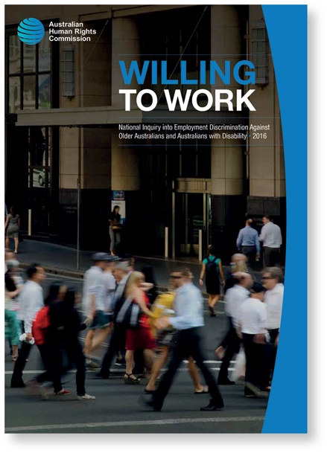
The full report is available on the Australian Human Rights Commission website.
In 2015, the Australian Human Rights Commission undertook a National Inquiry into Employment Discrimination against Older Australians and Australians with Disability. The final report Willing to Work, was published in 2016.
Employers, businesses and the organisations that represent them, play a critical role in recruiting, retaining and training older people. However, often employers lack the knowledge, awareness and skills necessary for developing inclusive workplaces which support older employees.
Through its six recommendations for employers, the Willing to Work report provides a range of strategies for employers to increase the recruitment and retention of older people.
____________________________________________________________________________________
Visit our online resource hub to access free resources for employers and employees at www.humanrights.gov.au/olderworkers.

Recommendation 1:

Leadership commitment
CEOs and organisational leaders should commit to an inclusive and diverse workplace and communicate this commitment to all staff. This should be supported by an organisational strategy which outlines the business case for a diverse workforce and could include goals such as: meeting voluntary targets for employment of older people; monitoring and reporting on performance against these targets; and ensuring inclusive practices in relation to recruitment, networking and mentoring opportunities.

Recommendation 2:

Ensure non-discriminatory recruitment and retention practices
Businesses should ensure that their recruitment and retention policies do not discriminate against older people. This could include reviewing recruitment processes to ensure that they are accessible and making promotion and training opportunities equally available to all employees, including older people.

Recommendation 3:

Build workplace flexibility
Businesses should seek to normalise flexible work by making job design, work location and hours flexible for all, as far as the demands of the role allow.

Recommendation 4:

Facilitate transitions
Employers should support older employees who wish to transition to other industries, roles or occupations by providing skills training and identifying transferable skills. Transitions should also be facilitated for employees who may be returning to work after a period away due to illness, injury or caring responsibilities.

Recommendation 5:

Provide targeted education and training in the workplace
In order to build inclusive, respectful workplaces, employers should provide staff with support and training about their rights and responsibilities at work, internal grievance processes, flexible leave options, any employee-driven networks and the nature and impact of discrimination.
Employers should support managers and supervisors in creating and managing diverse teams and flexible workplaces by: assisting with job redesign; building skills to manage employees flexibly; and providing training on the nature and impact of discrimination.

Recommendation 6:

Build healthy workplaces
Businesses should invest in health and wellbeing programs for staff. Implementing healthy work practices can be key to preventing chronic conditions and promoting good health. This could involve training staff and managers on issues such as health and wellbeing, implementing ergonomic assessments and subsidising gym memberships.

