Migration between Africa and Australia: a demographic perspective
…………………………
Background paper for African Australians: A review of human rights and social inclusion issues
Professor Graeme Hugo
December 2009
This background paper was commissioned by the Australian Human Rights Commission, however this paper is an independent piece of research and reflects the views of the individual author only.
Table of Contents
1 List of tables 4
2 List of figures 6
3 Introduction 7
4 Some data considerations 8
5 Migration from Africa 10
6 Stocks of African migrants in Australia 15
7 Flows of African migrants to Australia 24
8 Non-permanent migration 34
9 Movement from Australia to Africa 42
10 Australia’s South African community 46
11 Patterns of Settlement in Australia 56
12 Conclusion 60
13 Appendix A: Australia: Africa-born population, 1996, 2001 and 2006 61
14 Appendix B: Australia: Migration to and from Sub-Saharan Africa by country of birth, 1994-95 to 2007-08* 62
15 References 63

About the author
Graeme Hugo is a University Professorial Research Fellow, Professor of Geography and Director of the National Centre for Social Applications of Geographical Information Systems at the University of Adelaide. He is the author of over two hundred books, articles in scholarly journals and chapters in books, as well as a large number of conference papers and reports. In 2002 he secured a $1.125 million ARC Federation Fellowship over five years for his research project, "The new paradigm of international migration to and from Australia: dimensions, causes and implications".

List of tables
Table 1: Immigration and ethnicity-related topics included in Australian Population Censuses, 1911-2006 9
Table 2: Stocks of Africa-born persons in OECD nations around 2000 11
Table 3: African countries: Size of diaspora in OECD nations, 2000 12
Table 4: Africa-born persons in Australia, 1861-2006 15
Table 5: Change in the composition of the Australian population by place of birth, 1947-2006 17
Table 6: Australia: Growth of the Sub-Saharan population of Australia, 1981-2006 18
Table 7: Australia: Number of persons born in Southern and Eastern African nations, 1986 to 2008 19
Table 8: Australia, Sub-Saharan Africa-born: Ancestry groups, 2001-06 21
Table 9: Multiple ancestry response by English/other language spoken at home, 2006 22
Table 10: Australia: Estimated resident population, 1996-2008 23
Table 11: Australian Africa-born population: Ten fastest growing and ten slowest growing birthplace groups, 2001-06 23
Table 12: Program Management Structure (2005-06) Migration (non-Humanitarian) Program 24
Table 13: Settler arrivals born in Sub-Saharan Africa compared with total intake according to eligibility category, 2007-08 28
Table 14: Australia: Arrivals and departures of skilled health workers, 1993-2007 29
Table 15: Australia: Offshore settler arrivals from Africa under the Refugee-Humanitarian Program, 1992-93 to 2007-08 30
Table 16: Australia: Africa-born settler arrivals, 1997-98 to 2007-08 31
Table 17: Australia: Students present by region of birth, 30 June 2005 37
Table 18: Australia: Origins of the Australian foreign-born total and temporary resident populations, 2008 39
Table 19: Australia: Long-term movement to and from Africa and Australia, 1994-2008 39
Table 20: Australia: Short-term movement to and from Africa and Australia, 1994-2008 41
Table 21: Australia: Settlers and long-term migration, 1987-2007 43
Table 22 Australia: Birthplace of permanent arrivals and departures, 2008-09 44
Table 23: Australia: Permanent movement by financial years, 1991-2009 45
Table 24: Permanent and long-term out-movement of Australia-born departures to Africa, 1994-95 to 2007-08 45
Table 25: Australia: Africa-born birthplace groups, sex ratio, 2006 51
Table 26: Australia: Settler arrivals, birthplace Africa, sex ratios, 1993-94 to 2007-08 52
Table 27: Australia: Australia-born and Sub-Saharan Africa-born: Selected occupational and educational characteristics, 2006 53
Table 28: Longitudinal Survey of Immigrants to Australia: Employment experience 54
Table 29: Australia: Australia-born and Sub-Saharan Africa-born: Selected socio-economic indicators, 2006 54
Table 30: Australia: Australia-born and Sub-Saharan Africa-Born: Spatial distribution, 2006 57
Table 31: Settlement locations of migrants from Ethiopia, Eritrea and Congo, 2000-05 59

List of figures
Figure 1: Distribution of South Africa-born, Nigeria-born, Congo Democratic Republic-born and Angola-born expatriates in OECD Nations, 2000 13
Figure 2: Australia: Africa-born population, 1861 to 2006 16
Figure 3: Australia: Migration Program outcomes by stream, 1976-77 to 2008-09 25
Figure 4: Australia: Immigrants from Africa, 1945-2009 27
Figure 5: Immigrants from Africa as a percentage of total immigrants, 1945-2009 27
Figure 6: Distribution of birthplace of settlers to Australia, 1970 32
Figure 7: Distribution of birthplace of settlers to Australia, 2007-08 32
Figure 8: Africa: Birthplace of settler arrivals, 1993-2008 33
Figure 9: Australia: Onshore residence visa grants, 1989-90 to 2007-08 34
Figure 10: Temporary Migration to Australia by Category, 1986 to 2009 36
Figure 11: Australia: Temporary resident arrivals, 2005 38
Figure 12: Africa: Country of birth of long-term arrivals to Australia, 1994-2008 40
Figure 13: Africa: Birthplace of short-term moves to Australia, 1994-2008 42
Figure 14: Australia: Permanent departures of Australia-born and overseas-born persons from Australia, 1959-60 to 2008-09 43
Figure 15: Africa: Birthplace of permanent departures from Australia to Africa, 1994-2008 46
Figure 16: Australia: Age-sex structure of the Sub-Saharan Africa-born and Australia-born populations, 2006 47
Figure 17: Australia: Age structure of South Africa-born population, 2006 48
Figure 18: Age-sex distribution of the Africa-born permanent and long-term arrivals 1994-95 to 2006-07 and the total Australian population in 2006 48
Figure 19: Age of entrants to Australia from Liberia, Ethiopia and Eritrea, 2000-05 49
Figure 20: Australia: Sex ratios of settler arrivals, 1959-2009 50
Figure 21: Selected African group arrivals in Australia, 2000-05, by self-reported English proficiency 55
Figure 22: Australia: Distribution of the Sub-Saharan Africa-born population, 2006 58

Introduction
One of the fastest growing and most important types of African population mobility is that directed out of the continent toward so-called ‘north’ countries. However, it is neglected by many examinations of African migration and little is known of its nature and impact. Yet unlike the situation with respect to much migration within Africa, there is high quality data available to examine the migration collected at the destination. This paper demonstrates that the high quality of both flow and stock international migration data, as well as a national longitudinal survey in Australia, provide an excellent opportunity to examine in depth the nature of ‘south-north’ migration from Africa and also the ‘north-south’ movement from Australia to Africa. Moreover, the highly developed Australian international migration data system provides some useful lessons for the enhancement of such systems in African nations.
International migration between Africa and Australia has a long history. However, it has accelerated in recent years and now incorporates a number of components. These are analysed here in some detail since, to some extent, they exemplify the diverse types of south-north migration which are assuming increasing significance in Africa. In addition the paper demonstrates the potential of high-quality stock and flow data on international migration, together with a national longitudinal survey, to shed light on patterns of migration and inform the development of effective and timely migration and settlement policy. A number of different types of African migrants moving to Australia are identified, their movements analysed and the implications for origin and destination countries discussed.
The largest and most long-standing flow is from South Africa, although this has undergone some change following the abolition of apartheid. In recent years an increasing numbers of refugee and humanitarian settlers have come to Australia from Africa, especially Ethiopia and Sudan. Their experiences are examined and some of the implications discussed. Another recent and significant flow has involved medical professionals; this is examined and some implications explored. Flows of other high-skill groups from Africa to Australia are examined in the context of increased global movement of professional and managerial people and discussion of a ‘brain drain’. On the other side, some doctors in Australia have expressed concern about the numbers of doctors from African countries coming to Australia.
Data from the Longitudinal Survey of Immigrants in Australia are analysed to examine the causes of African migration to Australia. Moreover, this source allows some exploration of the patterns of settlement and adjustment to the labour market among groups of migrants from Africa. It also allows for consideration of the linkages that migrants have maintained with their countries of origin to be made, as well as some examination of the applicability of diaspora ideas in this context. In particular, the argument that the diaspora can have positive developmental effects in origin countries is discussed.
Australia’s international migration has undergone a transformation in the last decade, which has seen non-permanent migration increase in significance (Hugo 1999). Australian migration flow data allows a detailed analysis to be made of the complex two-way flows of long-term and short-term movers between Australia and African countries. The implications of this mobility, both for the African countries of origin and Australia, are discussed. One of the key features of the Australian international migration data system is that it provides accurate information on movement out of and into Australia. Accordingly, a short section of this paper will analyse movement from Australia to Africa and its implications.

Some data considerations
Australian data on both stocks and flows of movement between Australia and Africa are used here. These are comprehensive and of high quality by international standards. In relation to flows, the source employed is the Movements Data Base (MDB) maintained by the Department of Immigration and Citizenship (DIAC). Each person entering or leaving Australia is required to complete arrival or departure cards containing questions on citizenship, birthplace, birth date, gender, occupation, marital status, type of movement, origin/destination, reason for move (for short-term movers only) and location in Australia. This information forms the basis of the MDB, which is one of the few in the world to contain comprehensive information on both immigrants and emigrants. People leaving or coming to Australia are classified into three types of categories according to their intended length of their stay in Australia or overseas:
- Permanent movements
  - Immigrants are persons arriving with the intention of settling permanently in Australia.
  - Emigrants are Australian residents (including former settlers) departing with the stated intention of staying abroad permanently.
- Long-term movements
  - Overseas arrivals of visitors with an intended or actual length of stay in Australia of 12 months or more.
  - Departures of Australian residents with an intended or actual length of stay abroad of 12 months or more.
- Short-term movements
  - Travellers with an intended or actual stay in Australia or abroad of less than 12 months.
Clearly there are problems associated with the use of ‘intentions’ as a key element in the definitions of the different types of movement. It is apparent that there are no guarantees that intentions will become reality and a significant amount of category-jumping does occur (Hugo 1994, Chapter Three). Zlotnik (1987, 933-934) has also been critical of the concept of ‘residence’ used in these definitions, describing it as a ‘fertile breeding ground for confusion’. Nevertheless the MDB provides a valuable source of information on flows of people into and out of Australia, which has few equals globally in terms of accuracy and comprehensiveness.
Turning to information about the stocks of migrants, this paper draws on the quinquennial national censuses of population and housing. Table 1 shows the immigration-related questions asked at Australian censuses. It indicates that a comprehensive range of questions has been asked, especially in post-war censuses. Of particular interest was the introduction in 1971 of a ‘birthplace of parents’ question (which has been in each subsequent census) and the experiment with an ancestry question in 1986, 2001 and 2006. The latter has been excluded from several censuses because, although it produced a great deal of new insight into the diversity of Australia’s population, it generally failed in its objective to identify third-generation and older generations of immigrants (Khoo 1989). Censuses have been conducted in Australia every five years since 1961 and have a low rate of under-enumeration (less than two per cent).
Table 1: Immigration and ethnicity-related topics included in Australian Population Censuses, 1911-2006
Source: Paice 1990; ABS, 2006a
 | Topics - Persons | 1911 |  | 1921 |  | 1933 |  | 1947 |  | 1954 |  | 1961 |  | 1966 |  | 1971 |  | 1976 |  | 1981 |  | 1986 |  | 1991 |  | 1996 |  | 2001 |  | 2006
Birthplace |  |  | * |  | * |  | * |  | * |  | * |  | * |  | * |  | * |  | * |  | * |  | * |  | * |  | * |  | * |  | *
Birthplace of parents |  |  |  |  | * |  |  |  |  |  |  |  |  |  |  |  | * |  | * |  | * |  | * |  | * |  | * |  | *(1) |  | *
Year of arrival |  |  | * |  | * |  | * |  | * |  | * |  | * |  | * |  | * |  | * |  | * |  | * |  | * |  | * |  | * |  | *
(Period of residence in Australia)
Citizenship |  |  | * |  | * |  | * |  | * |  | * |  | * |  | * |  | * |  | *(2) |  | *(2) |  | *(3) |  | * |  | * |  | * |  | *
Aboriginal/TSI origin |  |  | * |  | * |  | * |  | * |  | * |  | * |  | *(4) |  | *(5) |  | *(5) |  | * |  | * |  | * |  | * |  | * |  | *
(Race)
Ethnic origin |  |  |  |  |  |  |  |  |  |  |  |  |  |  |  |  |  |  |  |  |  |  | *(6) |  |  |  |  |  | * |  | *
Number of overseas |  |  |  |  |  |  |  |  |  |  |  |  |  |  |  |  | * |  | * |  | * |  | * |  | * |  | * |  | * |  | *
residents or visitors
Language use |  |  |  |  | *(7) |  | *(8) |  |  |  |  |  |  |  |  |  |  |  | *(9) |  | *(10) |  | *(11) |  | * |  | * |  | * |  | *
Religion |  |  | * |  | * |  | * |  | * |  | * |  | * |  | * |  | * |  | * |  | * |  | * |  | * |  | * |  | * |  | *
Notes:
(1) In 2001 and each subsequent census the ‘country of birth of parents’ questions were replaced by questions asking whether a person’s parents were born in Australia or overseas.
(2) Prior to 1976 ‘nationality’, rather than ‘citizenship’, was asked.
(3) Since 1986 a person has been asked whether or not they are an Australian citizen.
(4) In all censuses prior to 1971 a person was required to state their race and, where race was mixed, to specify the proportion of each.
(5) In the 1971 and 1976 censuses a question with response categories of ‘European’, ‘Aboriginal’, ‘Torres Strait Islander’ and ‘other’ was included.
(6) A question on a person’s ancestry was asked for the first time in 1986.
(7) Question asked whether a person could read and write.
(8) Question asked whether a person could read and write a foreign language if unable to read and write English.
(9) The 1976 census asked for ‘all languages regularly used’.
(10) In 1981 ‘ability to speak English’ was asked.
(11) Since 1986 two separate questions have been asked: ‘language used’ and ‘ability to speak English’.
The census allows us to identify, with a high degree of accuracy, first-generation migrants and their Australia-born children and a number of their characteristics. However, the census does not provide information on former residents who have emigrated out of Australia. With respect to people travelling out of Australia on a temporary basis, some information can be obtained if they left households who could report their absence in a question relating to usual residents who are absent on the night of the census. Visitors to Australia who happen to be in the country on the night of the census are counted in the de-facto enumeration but excluded from most census tabulations.
The Longitudinal Survey of Immigrants in Australia (LSIA) is a major source of information which has been used extensively in the development of Australian immigration policy. It involved interviewing a sample of 5,912 settler arrivals arriving between September 1993 and August 1995 soon after arrival, a year later and a further two years later. A second cohort of 3,000 people who arrived in 1999 and 2000 were interviewed soon after arrival and again 18 months later. LSIA 3 involved a sample of 9,800 migrants arriving between December 2004 and March 2005, with follow-up interviews after six and 18 months. The LSIA has been used extensively in fine-tuning and developing Australian immigration and settlement policy (Hugo 2004a).

Migration from Africa
One approach to measure diasporas is to use the censuses of destination nations to compile a picture of the numbers of expatriates residing in those nations. This is facilitated by the synchronisation of national censuses, recommended by the United Nations to occur around the beginning of each decade and followed by most countries. However such approaches will often underestimate the size of expatriate populations because:
- some countries do not conduct censuses or have appropriate registration systems
- censuses may seek to exclude persons who are not citizens and/or permanent residents, which will exclude some expatriates
- in some cases, expatriates do not have full working rights and avoid being counted in an official census
- some expatriates avoid being counted because they perceive that it is not relevant to them
- the census may only include a question on birthplace, which doesn’t necessarily identify expatriates, or it may only have a question on citizenship which has similar problems
- it excludes second and later generations
- some censuses do not include birthplace or citizenship questions.
For example, the 2001 census of the United Kingdom counted the number of Australians as 107,817 but other estimates place the number closer to 300,000 (MacGregor 2003).
Despite this, much can be gained from bringing together census data of countries with immigration questions in their censuses to build up origin/destination matrices of migration. One important initiative in this area has been undertaken by the OECD, which launched a project in July 2003 to collect data from all OECD National Statistics Officers (NSO) on the stocks of foreign-born populations in order ‘to obtain by aggregating across receiving OECD countries, data on expatriates by country of origin’ (Dumont and Lemaitre 2005, 9). This data set makes it possible to obtain the numbers of Africa-born persons living in OECD nations.
The OECD study (Dumont and Lemaitre 2005, 31) found that the stock of Africa- born people in OECD nations was 7.1 million around the turn of the century, compared with 16.8 million from Asia, 15.6 million from Latin America and 5.3 million from the Caribbean. The estimates provided in Table 2 show that the largest stocks are in France, which accounts for 40% of Africans in OECD countries. Clearly this is a function of the long-standing colonial and cultural ties between Francophone African countries and France. There are almost a million in the United States and the United Kingdom, with large numbers in Spain, Canada, Belgium, Portugal and the Netherlands. Colonial ties, as well as proximity in the case of the Mediterranean nations, are important factors. The fact that the OECD data does not include Italy is unfortunate since there is a substantial African population in that country. Table 2 also shows that North African countries account for almost half of the south-north migrants (45.1%), with the bulk of the North African flow to France (72%), Spain (10.8%), Netherlands (5.1%) and Belgium (4.4%), which together account for 92% of the total. Australia is home to 191,501 Africa-born persons, although only 1.3% are from the north.
Table 2: Stocks of Africa-born persons in OECD nations around 2000
Source: Dumont and Lemaitre 2005, 31
Country | Africa-Born
Country | Number | Number from North African Countries | Percentage
Australia | 191,501 | 2,573 | 1.3
Austria | 19,934 | 3,560 | 17.9
Belgium | 247,515 | 139,799 | 56.5
Canada | 323,580 | 52,485 | 16.2
Switzerland | 68,801 | 21,153 | 30.7
Czech Republic | 2,374 | 588 | 24.8
Germany | 175,665 | 51,230 | 29.2
Denmark | 31,875 | 6,520 | 20.5
Spain | 423,082 | 343,819 | 81.3
Finland | 9,713 | 1,783 | 18.4
France | 2,862,569 | 2,296,979 | 80.2
Great Britain | 838,459 | 26,088 | 3.1
Greece | 58,275 | 1,416 | 2.4
Hungary | 2,687 | 517 | 19.2
Ireland | 26,650 | 1,238 | 4.6
Japan | 5,742 | 421 | 7.3
Luxembourg | 5,692 | 1,134 | 19.9
Mexico | 1,214 | 262 | 21.6
Netherlands | 280,007 | 163,658 | 58.4
Norway | 31,278 | 5,665 | 18.1
New Zealand | 39,351 | 273 | 0.7
Poland | 2,962 | 741 | 25.0
Portugal | 349,859 | 1,596 | 0.5
Slovak Republic | 404 | 50 | 12.4
Sweden | 78,039 | 9,962 | 12.8
Turkey | 12,686 | 1,627 | 12.8
USA | 988,253 | 58,530 | 5.9
Total | 7,078,167 | 3,193,667 | 45.1

Table 3: African countries: Size of diaspora in OECD nations, 2000
Source: OECD database on immigrants and expatriates
Country of Birth | Number Residing in OECD Country
South Africa | 405,434
Nigeria | 278,446
Kenya | 213,164
Angola | 211,823
Africa | 195,388
Somalia | 174,483
Ghana | 171,991
Ethiopia | 132,682
Congo, Dem. Rep. Of | 113,509
Senegal | 111,789
Cape Verde | 103,137
Mauritius | 88,413
Mozambique | 86,775
Zimbabwe | 86,585
Madagascar | 80,028
Congo | 75,266
United Republic of Tanzania | 73,434
Cameroon | 63,332
Côte d'Ivoire | 62,427
Liberia | 48,843
Mali | 48,225
Sierra Leone | 46,347
Zambia | 38,003
Eritrea | 37,953
Guinea-Bissau | 32,750
Gambia | 22,691
Guinea | 22,584
Togo | 20,079
Comoros | 19,876
Rwanda | 19,387
Mauritania | 16,670
Malawi | 16,095
Benin | 14,910
Equatorial Guinea | 14,015
Sao Tome and Principe | 13,177
Gabon | 12,552
Burundi | 12,482
Central African Republic | 11,119
Seychelles | 8,043
Djibouti | 7,157
Burkina Faso | 6,984
Chad | 6,337
Niger | 5,453
Botswana | 5,386
Namibia | 4,057
Saint Helena | 2,570
Swaziland | 2,500
Lesotho | 1,263
Western Sahara | 132

Figure 1: Distribution of South Africa-born, Nigeria-born, Congo Democratic Republic-born and Angola-born expatriates in OECD Nations, 2000
Source: OECD database on immigrants and expatriates

South African-born
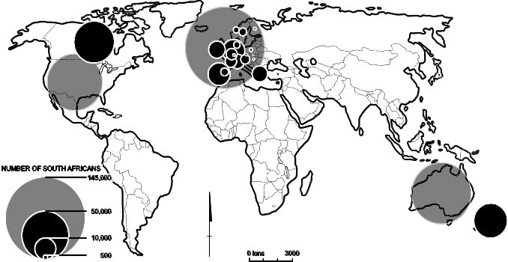

Nigeria-born
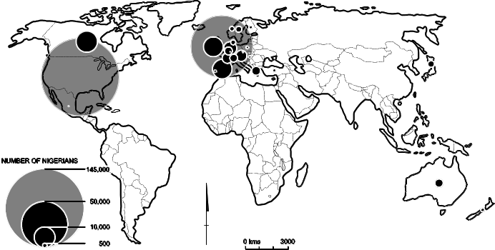

Congo Democratic Republic-born
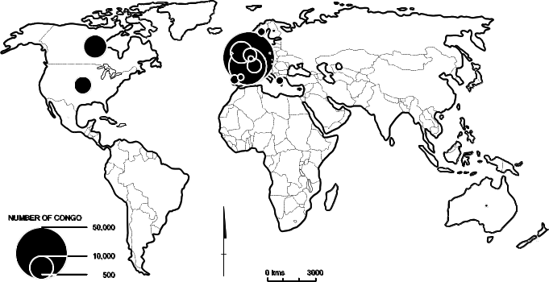

Angola-born
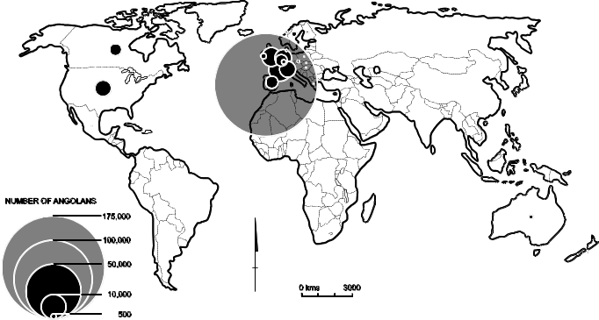
Putting together census data from OECD nations, shows the number of persons born in African countries living in those nations around 2000. These substantially understate the size of the diaspora in each country but do give some important indications. South Africa has the largest community of expatriates in OECD nations, while another 10 countries have more than 100,000 people living in ‘north’ nations. This represents substantial potential for development of linkages, remittances and the like (Hugo 2003a).
The OECD nation censuses allow a substantial level of analysis to be made of African diaspora. It is interesting in Figure 1, for example, to look at the distribution of four African birthplace groups in OECD nations. The largest diaspora is from South Africa; formerly a part of the British Empire, its colonial connections are evident in the concentration of its diaspora in the United Kingdom, Australia, Canada and New Zealand. This is also apparent in Nigeria’s expatriate community, although its largest single concentration (140,235 persons) is in the United States and reflects the increasingly significant West African flow to that country. The significance of colonial connections is strongly apparent in the diaspora of Angola, with 82.2% of the 211,823 Angolans in OECD nations living in Portugal. In addition, almost half of the Congo’s expatriates are in Belgium (43.9%). The two overwhelming south-north flows are clearly along colonial lines on the one hand and to North America, especially the United States, on the other. It is also possible to examine the characteristics of the expatriate community and Dumont and Lemaitre (2005) have shown how these movements are very selective of highly educated groups.

Stocks of African migrants in Australia
There is a long history of population movement between Africa and Australia but the data needs to be carefully interpreted. This is because many Africa-born people moving to Australia, especially in the period prior to 1991, were not of African ethnicity; rather they were the children of European-origin parents from South Africa and Zimbabwe who subsequently moved to Australia. Clearly, the fact that Australia’s states and South Africa, Zimbabwe, Kenya, etc ,were colonies of England and part of the British Empire (and later the British Commonwealth) meant they shared more linkages than Australia had with African countries that were not British colonies. Nevertheless, Table 4 indicates that in 1861 there were only 1,590 Africa-born persons in Australia. The mix between people from Northern Africa, South Africa and other Sub-Saharan Africa countries in the stocks of Africa-born in Australia has changed over the last century (see ). Prior to World War Two, South Africa was the dominant origin of the Africa-born population in Australia. In 1861 they made up 56.6% of all Africa-born people in Australia and that proportion remained steady until Federation in 1901, when the total Africa-born population had increased to only 2,840. Indeed it had declined from 2,923 in 1890 due to the effects of economic depression. One of the earliest initiatives of the new Australian Government was the introduction of a ‘White Australia’ policy which effectively prevented the settlement of Africans and others of non-European origin in Australia. Accordingly, in 1947 there were only 75,506 Africa-born people in Australia and 78.3% of these were South African. Hence, in the period before World War Two, there were only small numbers of Africa-born persons and they were overwhelmingly the children of colonial functionaries and Anglo Saxons from Southern Africa.
Table 4: Africa-born persons in Australia, 1861-2006
Source: Australian censuses
Census | Percentage  South Africa-born | Africa-born  population | Intercensal percentage  Per annum growth
1861 | 56.6 | 1,590
1871 | 55.3 | 1,767 | 1.1
1881 | 47.5 | 1,986 | 1.2
1891 | 47.2 | 3,044 | 4.4
1901 | 53.0 | 2,869 | -0.6
1911 | 79.3 | 4,958 | 5.6
1921 | 80.5 | 6,775 | 3.2
1933 | 79.5 | 7,821 | 1.2
1947 | 78.3 | 7,537 | -0.3
1954 | 37.9 | 15,826 | 11.2
1961 | 27.7 | 28,559 | 8.8
1966 | 23.3 | 41,605 | 7.8
1971 | 20.4 | 61,935 | 8.3
1976 | 22.1 | 70,510 | 2.6
1981 | 29.9 | 90,237 | 5.1
1986 | 34.1 | 108,547 | 3.8
1991 | 37.2 | 132,548 | 4.1
1996 | 37.7 | 147,876 | 2.2
2001 | 43.1 | 184,180 | 4.5
2006 | 41.9 | 248,699 | 7.0

Figure 2: Australia: Africa-born population, 1861 to 2006
Source: Australian censuses
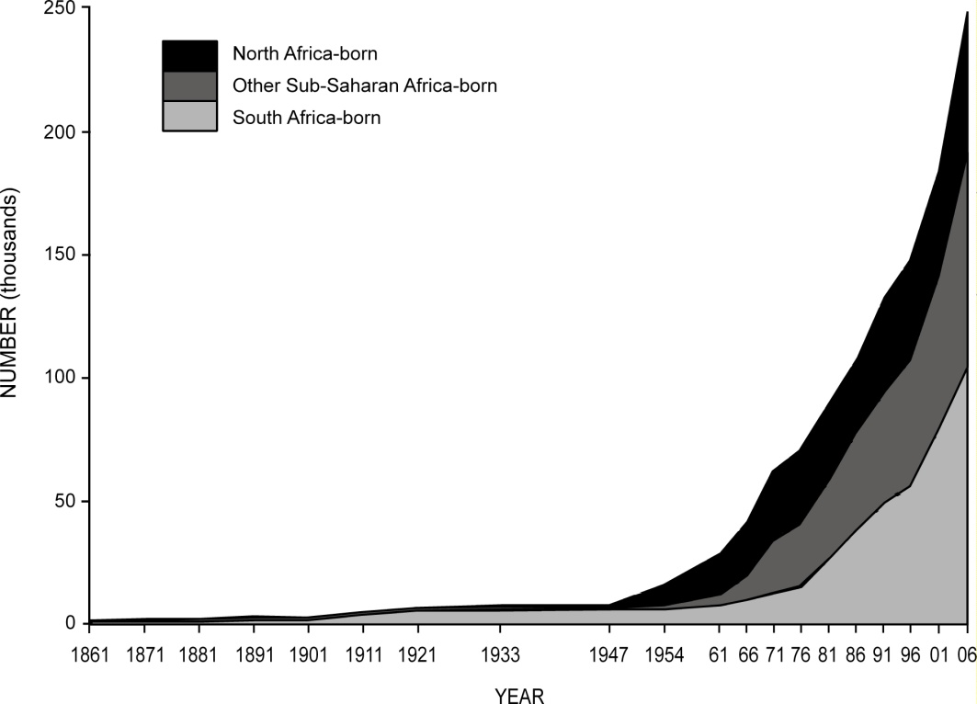
shows that African migration to Australia has increased with each intercensal period following World War Two. The first post-war intercensal period (1947-54) saw the Africa-born population in Australia double but virtually the entire increase was from North Africa, with the Egypt-born population in Australia increasing from 803 in 1947 to 8,150. The number of Africans in Australia doubled again between 1954 and 1961, and then again between 1961 and 1971 to reach 61,936. Once again the growth in this period was mainly driven by a substantial immigration of Egyptians (numbering 28,226 in 1971), who were predominantly Coptic Christians (Ham 2001, 274). There was also an increase in migration during this period by Anglo-Saxon-origin people from South African and other former British colonies in Africa – a result of the decolonisation process taking place in that continent and in Asia. There was also a significant movement of East Africans of European origin during this period. Adler (2001, 273) writes:
The effects of the Mau Mau uprising (1953-60), the Africanisation of land, particularly in the ‘White Highlands’ of Kenya, restrictions on the employment of non citizens and uncertainties about the future for themselves and their families caused them to emigrate. Similar facts affected all of the East African countries.
With the final dissolution of the White Australia policy in the 1960s and early 1970s, Australian immigration underwent a massive change as discrimination on the basis of race was removed. However, the change in composition of migration in the 1970s and 1980s was much more marked for the flows from Asia than the flows from Africa (Hugo 2003b). The proportion of South Africans in the flow, which had fallen from 78.3% in 1947 to 20.4% in 1971, began to increase again. shows that after 1971 the numbers arriving from North Africa (mainly Egyptians) stabilised, while numbers from Sub-Saharan Africa (both South Africans and other groups) began to grow.
Increasing African immigration has been part of the post-war transformation of Australia from an overwhelmingly British-dominated population to a multicultural society. Table 5 indicates this, showing that the proportion of the population born in dominantly non-English speaking nations declined from 98.1% to 86% between 1947 and 2006. During the same period, the proportion of people born in South Africa increased from 0.1% to 0.5% and from elsewhere in Africa it rose from less than 0.1% to 0.7%. It is clear that South Africa has dominated Sub-Saharan African migration to Australia. shows that the South Africa-born population doubled in the 1980s to 49,421 in 1991, more than doubling again in the next 15 years to reach 104,132 in 2006. Its share of the intake from Sub-Saharan African rose from 45.2% to 56.1% in 2001 but fell back to 54.3% in 2006. Much of this migration has involved South Africans of European decent. In the exodus of European-origin South Africans over the last two decades to other predominantly English-speaking countries, Australia has been the second most significant destination after the United Kingdom (Khoo and Lucas 2004; Van Rooyen 2000; Kalule Sabiti et al. 2003). In the 1980s and the early

Table 5: Change in the composition of the Australian population by place of birth, 1947-2006
Source: ABS, 1947 and 2006 Censuses
 | 1947 |  |  | 2006
 | Number of Persons | Percentage |  | Number of Persons |  | Percentage
English speaking origin | 7,438,892 |  | 98.1 |  | 15,748,287 |  | 85.2
Australia | 6,835,171 |  | 90.2 |  | 14,072,937 |  | 76.2
United Kingdom and Ireland | 543,829 |  | 7.2 |  | 1,088,421 |  | 5.9
New Zealand | 43,619 |  | 0.6 |  | 389,467 |  | 2.1
United States and Canada | 10,304 |  | 0.1 |  | 93,330 |  | 0.5
South Africa | 5,969 |  | 0.1 |  | 104,132 |  | 0.6
Non-English speaking origin | 140,466 |  | 1.9 |  | 2,730,042 |  | 14.8
Other Europe | 109,586 |  | 1.4 |  | 989,498 |  | 5.4
Asia* | 23,293 |  | 0.3 |  | 1,402,395 |  | 7.6
Other Africa | 1,531 | 0.0 |  | 144,567 |  | 0.8
Other America | 1,323 | 0.0 |  | 86,663 |  | 0.5
Other Oceania | 4,733 | 0.1 |  | 106,919 |  | 0.6
Total | 7,579,358 | 100.0 |  | 18,478,329 |  | 100.0
* Includes Middle East
Note: Excludes country of birth not stated, ‘Inadequately described’, ‘At sea’ and ‘Not elsewhere classified’.

Table 6: Australia: Growth of the Sub-Saharan population of Australia, 1981-2006
Source: ABS Population Censuses
Year | South Africa-born | Zimbabwe-born | Other Sub-Saharan Africa-born | Total Sub-Saharan Africa-born | South Africa-born as % of Total Sub-Saharan Africa-born | Zimbabwe-born as % of Total Sub-Saharan Africa-born | Other Sub-Saharan Africa-born as % of Total Sub-Saharan Africa-born
1981 | 26,965 | 4,110 | 28,517 | 59,592 | 45.2 | 6.9 | 47.9
1986 | 37,061 | 6,479 | 34,374 | 77,914 | 47.6 | 8.3 | 44.1
1991 | 49,421 | 8,352 | 36,657 | 94,430 | 52.3 | 8.8 | 38.8
1996 | 55,755 | 8,957 | 42,705 | 107,417 | 51.9 | 8.3 | 39.8
2001 | 79,425 | 11,733 | 50,538 | 141,696 | 56.1 | 8.3 | 35.7
2006 | 104,132 | 20,155 | 67,540 | 191,827 | 54.3 | 10.5 | 35.2
1990s the outflow was overwhelmingly of South Africans of English-speaking European descent, although Van Rooyen (2000, 36) argues that by 1999 the split was around half English-origin and half Afrikaan. The dominance of the English-origin South Africans is evident in the fact that, at the 2001 population census when an ancestry question was asked of the 79,421 South Africa-born people in Australia, 36,029 (45%) gave South Africa as their ancestry; 25,605 (32%) as English; 2,694 as Indian (three per cent); and 1,838 as Dutch (two per cent) (Khoo and Lucas 2004, 42). While there is no data collected on the ethnic background of immigrants arriving in Australia, it would seem that there are more African-origin immigrants among the South African arrivals.
There has, however, been an increase in the diversity of the Sub-Saharan African migration to Australia in the last decade; Table 7 shows the growth of the largest Africa-born populations in Australia over the 1986-2006 period. The large number of South Africans is evident, as are substantial groups from Zimbabwe and Mauritius, who are in many ways similar to the South Africans in the pre-dominance of European-origin groups. Those born in the groups from Kenya, Zambia, Tanzania and Uganda also include significant numbers of European-origin migrants, although most recent immigrants have been of African origin. It is noticeable, however, that there have been significant increases in the numbers from some countries where the immigrants are of African origin – most notably Ethiopia, Eritrea, Sudan and Somalia. Many of these immigrants have arrived in Australia under the refugee-humanitarian migration category. The most spectacular increase has been in the Sudan-born population, which increased from 4,900 in 2001 to 24,796 in 2008 and reflects the fact that they were an important group in refugee arrivals throughout the 2000s. However, there have also been substantial increases in a large number of smaller African birthplace groups, many of which include a large proportion of refugee-humanitarian arrivals, such as Burundi, Congo, Democratic Republic of Congo, Guinea, Liberia and Sierra Leone.
Table 7: Australia: Number of persons born in Southern and Eastern African nations, 1986 to 2008
Source: ABS Population Censuses 1986 to 2006 and ABS 2008 Estimated Resident Population data
Birthplace | 1986 | 1991 | 1996 | 2001 | 2006 | 2008 | % Overseas-born 2006 | Rank 2006
Angola | - | 328 | 344 | 353 | 396 | na | 0.01 | 144
Benin | - | 7 | 12 | 24 | 20 | na | 0.00 | 210
Botswana | - | 159 | 225 | 706 | 865 | na | 0.02 | 120
Burkina Faso | - | 0 | 10 | 23 | 27 | na | 0.00 | 201
Burundi | - | 16 | 23 | 25 | 753 | na | 0.02 | 124
Cameroon | - | 14 | 35 | 66 | 125 | na | 0.00 | 176
Cape Verde | - |  |  | 22 | 22 | na | 0.00 | 209
Central African Republic | - | 6 | 14 | 3 | 8 | na | 0.00 | 229
Chad | - | 15 | 21 | 36 | 30 | na | 0.00 | 200
Comoros | - | 3 | 6 | 18 | 13 | na | 0.00 | 218
Congo | - | 9 | 22 | 135 | 521 | na | 0.01 | 136
Congo, Democratic Republic of | - |  |  | 267 | 620 | na | 0.01 | 134
Cote d'Ivoire | - | 36 | 52 | 69 | 253 | na | 0.01 | 157
Djibouti | - | 31 | 75 | 68 | 97 | na | 0.00 | 180
Equatorial Guinea | - | 0 | 3 | 6 | 11 | na | 0.00 | 222
Eritrea | - |  | 1,161 | 1,599 | 2,017 | na | 0.05 | 99
Ethiopia | - | 1,341 | 2,353 | 3,544 | 5,635 | na | 0.13 | 78
Gabon | - | 11 | 19 | 19 | 26 | na | 0.00 | 203
Gambia | - | 23 | 26 | 53 | 130 | na | 0.00 | 174
Ghana | - | 998 | 1,495 | 2,040 | 2,769 | na | 0.06 | 92
Guinea | - | 18 | 19 | 28 | 333 | na | 0.01 | 153
Guinea-Bissau | - | 6 | 10 | 15 | 9 | na | 0.00 | 225
Kenya | 4,170 | 4,724 | 5,333 | 6,869 | 9,935 | na | 0.22 | 62
Lesotho | - | 43 | 58 | 54 | 80 | na | 0.00 | 183
Liberia | - | 64 | 84 | 125 | 1,525 | na | 0.03 | 108
Madagascar | - | 148 | 137 | 156 | 189 | na | 0.00 | 169
Malawi | - | 364 | 423 | 485 | 685 | na | 0.02 | 129
Mali | - | 13 | 15 | 29 | 47 | na | 0.00 | 192
Mauritania | - |  |  | 16 | 14 | na | 0.00 | 215
Mauritius | 13,086 | 16,882 | 17,083 | 16,962 | 18,174 | 23,379 | 0.41 | 47
Mozambique | - | 391 | 428 | 551 | 634 | na | 0.01 | 133
Namibia | - | 264 | 303 | 437 | 703 | na | 0.02 | 125
Niger | - | 12 | 10 | 14 | 15 | na | 0.00 | 213
Nigeria | - | 966 | 1,260 | 1,738 | 2,498 | na | 0.06 | 96
Reunion | - | 62 | 64 | 71 | 127 | na | 0.00 | 175
Rwanda | - | 12 | 22 | 46 | 201 | na | 0.00 | 164
Sao Tome and Principe | - | 6 | 12 | 11 | 9 | na | 0.00 | 225
Senegal | - | 149 | 170 | 185 | 196 | na | 0.00 | 167
Seychelles | - | 2,610 | 2,561 | 2,448 | 2,508 | na | 0.06 | 95
Sierra Leone | - | 118 | 164 | 363 | 1,811 | na | 0.04 | 104
Somalia | - | 357 | 2,058 | 3,713 | 4,315 | na | 0.10 | 83
South Africa | 37,058 | 49,383 | 55,756 | 79,425 | 104,128 | 136,201 | 2.36 | 12
St Helena | - | 34 | 25 | 25 | 38 | na | 0.00 | 196
Sudan | - | 1,259 | 2,417 | 4,900 | 19,050 | 24,796 | 0.43 | 45
Swaziland | - | 120 | 145 | 202 | 232 | na | 0.01 | 159
Tanzania | - | 1,432 | 1,561 | 1,714 | 2,298 | na | 0.05 | 98
Togo | - | 6 | 9 | 16 | 35 | na | 0.00 | 198
Uganda | - | 930 | 1,178 | 1,217 | 1,710 | na | 0.04 | 106
Zambia | - | 2,333 | 2,565 | 3,072 | 4,079 | na | 0.09 | 84
Zimbabwe | 6,479 | 8,352 | 8,957 | 11,733 | 20,155 | 27,369 | 0.46 | 43
The post-war outflow of Southern Africans to Australia gathered momentum with events such as the Sharpeville shootings in 1960, the 1976 Soweto riots and the general increase in tension and violence in the 1980s (Kennedy 2001a). Lucas (2001, 689) points out that “[p]rior to the 1990s some South Africans left because they could not tolerate apartheid. Others were worried about the political uncertainty in South Africa epitomised by the indefinite state of emergency declared in July 1985.”
The second largest group of countries of origin of Africans in Australia include Sudan, Eritrea, Ethiopia and Somalia in the Horn of Africa, with arrivals coming predominantly as refugees since the 1980s. Some earlier arrivals born in Eritrea and Ethiopia are of Italian origin, while more recent settlers are of African background (Pateman 2001). Most Ethiopians arrived after 1990 and were predominantly refugees (Gow 2001). There were only 359 Somali-born persons in Australia in 1991 but this increased to 2,057 in 1996 and 3,713 in 2001, following the settlement of a substantial community of refugees (Kennedy 2001b, 688) especially between 1994 and 1998. The Sudanese community has also increased substantially due to the influx of refugees since 1992 and especially since 2006; it is now the third largest African birthplace group in Australia.
There number of West Africans living in Australia is relatively small by comparison. Their immigration began in the mid-1960s with the arrival of students under the Special Commonwealth African Assistance Plan, mostly from Ghana and Nigeria (Okai 2001). The removal of the last vestiges of the White Australia policy saw small numbers of skilled African-origin immigrants but there also has been an inflow of refugees. In 1996 there were only 3,077 West Africans – increasing to 5,641 in 2001 – with Nigeria and Ghana the main countries of origin. However, by 2006 their numbers had expanded to 11,255, with most coming under the skilled or family streams of the migration program.
There are larger communities of people from East Africa in Australia but, as indicated earlier, much of this movement involved European-origin descendents of former colonial functionaries. The largest community is from Kenya, which numbered 6,869 in 2001, and recent migration has been dominated by people of African origin (Njuki 2003). Moreover, the period between 2001and 2006 saw a substantial inflow from East Africa, with numbers increasing by 35.6% to 74,228.
Table 8: Australia, Sub-Saharan Africa-born: Ancestry groups, 2001-06
Source: Khoo and Lucas 2004; ABS Table Builder 2006
Ancestry Group | 2001 |  | 2006 |  | Percentage Change 2001-06
Ancestry Group | No. | Percentage | No. | Percentage | Percentage Change 2001-06
Sub-Saharan African | 68,204 | 41.8 | 95,717 | 41.2 | 40.3
English | 40,210 | 24.7 | 50,207 | 21.6 | 24.9
Other UK | 10,547 | 6.5 | 18,927 | 8.2 | 79.5
Other European | 27,336 | 16.8 | 28,282 | 12.2 | 3.5
Indian | 6,888 | 4.2 | 10,672 | 4.6 | 54.9
The Australian censuses of 1986, 2001 and 2006 included questions on ancestry, which shed some light on the ethnic origin of African migrants to Australia. The ‘ancestry’ responses of Sub-Saharan Africa-born people (summarised in Table 8) indicate the importance of non-African heritage among Africa-born migrants to Australia, even after the substantial increase in numbers of Sub-Saharan African migrants between 2001 and 2006. The main Sub-Saharan African ancestries mentioned by the Africa-born in 2006, according to whether they spoke English or another language at home, are included in Table 9. Among the large groups in Australia, only 5.1% of Sudanese spoke English compared with 85.8% of South Africans.
It is clear that the stock of African immigrants has increased substantially in Australia since the 2006 census. This is evident in the estimates of birthplace groups produced by the Australian Bureau of Statistics (ABS 2006b). Unfortunately African birthplaces are not available as a group. However Table 10 shows that there has been very rapid growth of the African population, especially since the turn of the century. The growth of the Sudanese population is especially marked, with the population increasing by almost six times between 2000 and 2005.
Table 9: Multiple ancestry response by English/other language spoken at home, 2006
Source: ABS Table Builder 2006
Ancestry Multi Response | Language
Ancestry Multi Response | English | Other | Number | % Speaking English
Sub-Saharan African, nfd | 41 | 31 | 72 | 56.9
Central and West African, nfd | 100 | 71 | 171 | 58.5
Akan | 48 | 101 | 149 | 32.2
Ghanaian | 1030 | 1402 | 2432 | 42.4
Nigerian | 1144 | 719 | 1863 | 61.4
Yoruba | 43 | 121 | 164 | 26.2
Ivorean | 32 | 69 | 101 | 31.7
Liberian | 471 | 373 | 844 | 55.8
Sierra Leonean | 167 | 508 | 675 | 24.7
Central and West African, nec (includes Fang, Fulani, Kongo) | 832 | 1652 | 2484 | 33.5
Central and West African | 3867 | 5016 | 8883 | 43.5
Southern and East African, nfd | 303 | 84 | 387 | 78.3
Afrikaner | 1584 | 1403 | 2987 | 53.0
Angolan | 54 | 83 | 137 | 39.4
Eritrean | 274 | 2240 | 2514 | 10.9
Ethiopian | 1136 | 4169 | 5305 | 21.4
Kenyan | 993 | 1130 | 2123 | 46.8
Malawian | 69 | 106 | 175 | 39.4
Mauritian | 12767 | 7134 | 19901 | 64.2
Mozambican | 30 | 96 | 126 | 23.8
Oromo | 45 | 457 | 502 | 9.0
Seychellois | 1961 | 202 | 2163 | 90.7
Somali | 616 | 5512 | 6128 | 10.1
South African | 67647 | 11180 | 78827 | 85.8
Tanzanian | 171 | 193 | 364 | 47.0
Ugandan | 342 | 194 | 536 | 63.8
Zambian | 603 | 309 | 912 | 66.1
Zimbabwean | 5433 | 2117 | 7550 | 72.0
Amhara | 14 | 120 | 134 | 10.4
Batswana | 77 | 362 | 439 | 17.5
Dinka | 42 | 1205 | 1247 | 3.4
Hutu | 3 | 11 | 14 | 21.4
Masai | 26 | 10 | 36 | 72.2
Nuer | 14 | 270 | 284 | 4.9
Tigrayan | 10 | 82 | 92 | 10.9
Tigre | 5 | 20 | 25 | 20.0
Zulu | 136 | 126 | 262 | 51.9
Southern and East African, nec (includes Afar, Namibian, Tutsi) | 591 | 2123 | 2714 | 21.8
Southern and East African | 94946 | 40938 | 135884 | 69.9
Algerian | 301 | 565 | 866 | 34.8
Egyptian | 10685 | 20699 | 31384 | 34.0
Coptic | 271 | 1594 | 1865 | 14.5
Sudanese | 861 | 16003 | 16864 | 5.1
Table 10: Australia: Estimated resident population, 1996-2008
Source: ABS 2006b, 39-40; ABS 2009, 31-32
Region/Country | 1996 | 2000 | 2005 | 2008 | Percentage Change
 |  |  |  |  | 2007-08 | 1996-2008 (average annual)
North Africa/Middle East | 211,824 | 231,741 | 284,998 | 315,524 | 3.0 | 3.4
Sub-Saharan Africa | 118,405 | 145,867 | 204,955 | 245,139 | 4.6 | 6.3
South Africa | 61,749 | 80,718 | 113,783 | 136,201 | 7.9 | 6.8
Egypt | 37,875 | 36,948 | 38,102 | 39,940 | 1.8 | 0.4
Sudan | 2,637 | 4,199 | 23,787 | 24,796 | 7.3 | 20.5
Zimbabwe | 9,960 | 11,702 | 19,655 | 27,369 | 11.0 | 8.8
Mauritius | 18,949 | 18,503 | 19,149 | 23,379 | 7.4 | 1.8
Kenya | 5,924 | 7,037 | 10,574 | 12,361 | 7.3 | 6.9
Ethiopia | 2,662 | 3,703 | 6,925 | 6,981 | 7.9 | 9.2
Somalia | 2,305 | 4,069 | 5,431 | 5,286 | 5.5 | 7.8
Zambia | 2,855 | 3,315 | 3,886 | 4,970 | 5.2 | 5.2
Note: 2008 data is not available for Kenya, Ethiopia, Somalia and Zambia; 2007 data is shown.
Percentage change/growth is shown to 2006-07/1996-2007.
Table 11: Australian Africa-born population: Ten fastest growing and ten slowest growing birthplace groups, 2001-06
Source: ABS 2001 and 2006 Population of Census and Housing
Ten fastest growing |  |  | Ten slowest growing
Country | Growth Rate |  | Country | Growth Rate
Burundi | 97.6 |  | Guinea-Bissau | -11.8
Liberia | 64.9 |  | Comoros | -7.8
Guinea | 64.2 |  | Chad | -5.6
Sierra Leone | 37.9 |  | Niger | -4.7
Rwanda | 34.4 |  | Benin | -4.6
Sudan | 31.2 |  | Sao Tome and Principe | -3.9
Congo | 31.0 |  | Cape Verde | 0.0
Cote d'Ivoire | 29.9 |  | Mauritania | 0.0
C. African Republic | 27.2 |  | Mayotte | 0.0
Gambia | 19.7 |  | Egypt | 0.0
Recent changes in African birthplace groups are evident in Table 11, which shows the ten fastest growing and ten slowest growing groups over the 2001-06 intercensal period. It will be noticed that, of the largest groups in Australia, only Sudan appears in the ‘fastest growing’ category. Refugee-humanitarian groups are especially represented among the fastest growing groups, while many of the slowest growing groups are relatively small in number, except for the Egyptian community.

Flows of African migrants to Australia
Thus far we have examined African immigration to Australia using census stock data. It is also possible to analyse flow data, which is collected as migrants pass through Australia’s borders. Immigration to Australia is a highly planned and controlled process. In the first three post-war decades, the imperatives of Australian immigration policy were both economic and demographic. On the one hand, there were massive labour shortages in the post-war boom period and labour – skilled, semi-skilled and unskilled – was needed for the massive growth in manufacturing. There was also the ‘populate or perish’ argument, which followed the near invasion of the country by Japanese forces during World War Two. With the end of the ‘long boom’ in the 1970s, the reduction in manufacturing employment and increases in unemployment, immigration policy was redefined to involve a planned numerical intake made up of a number of policy components:
- refugee and humanitarian movement, to support the resettlement of refugees
- family migration, to enable family members to join earlier generations of immigrants
- economic migration, to recruit people with skills in short supply in the economy
- special categories, mainly involving New Zealanders, people with special talents, etc.
Over the years there has been a fluctuation in the significance of the various components of immigration. In the most recent period there has been a deliberate policy to increase the proportion of skilled workers in the immigration intake.
Table 12: Program Management Structure (2005-06) Migration (non-Humanitarian) Program
Source: DIMIA 2006, 19
Skill | Family | Special Eligibility
Business Skills, ENS and Distinguished Talent | Spouses and Dependent Children | Can be capped
Demand Driven | Demand Driven
State-Specific and Regional Migration | Exempt from capping
Demand Driven
Skilled Independent and Skilled | Fiancés and Interdependents
Australian Sponsored | Can be capped subject to demand for
Generally points tested | spouse and dependent child places
Planning level adjusted subject to demand in Business Skills, ENS and State-Specific and Regional Migration Categories | Parents and Preferential/Other Family
 | Can be capped subject to demand in
 | all other Family categories
Australia’s current migration program operates within set planning levels and is made up of humanitarian and non-humanitarian components. The Skilled Migration Program forms part of the latter and its various elements are summarised in Table 12. Within the program some components (ie Business Skills, Employer Nominated Scheme, Distinguished Talents, Spouses and Dependent Children) are demand-driven and not subject to capping. There are three main eligibility migration categories in the Migration Program – Family, Skill and Special Eligibility. Family migration consists of a number of categories under which the potential migrant can be sponsored by a relative who is an Australian citizen or permanent resident of Australia. In recent years there has been a significant shift away from the family category toward the skilled category, as shown in Figure 3.
The Skilled Migration Program consists of a number of categories of prospective migrants, where there is a demand for particular occupational skills, outstanding talents or business skills. These categories are:
- Independent migrants: not sponsored by an employer or relative in Australia, they must pass a points test which includes skills, age and English language ability (44,594 arrivals in 2008-09).
- Skilled-Australian Linked: commencing on 1 July 1997 (replacing the Concessional Family Category), applicants must pass a points test on skills, age and English language ability and receive additional points for sponsorship by relatives in Australia (10,504 arrivals in 2008-09) (also includes Regional Linked for applicants sponsored by relatives in regional areas; not points tested).
Figure 3: Australia: Migration Program outcomes by stream, 1976-77 to 2008-09
Source: DIAC Population Flows: Immigration Aspects, various issues and DIAC 2009
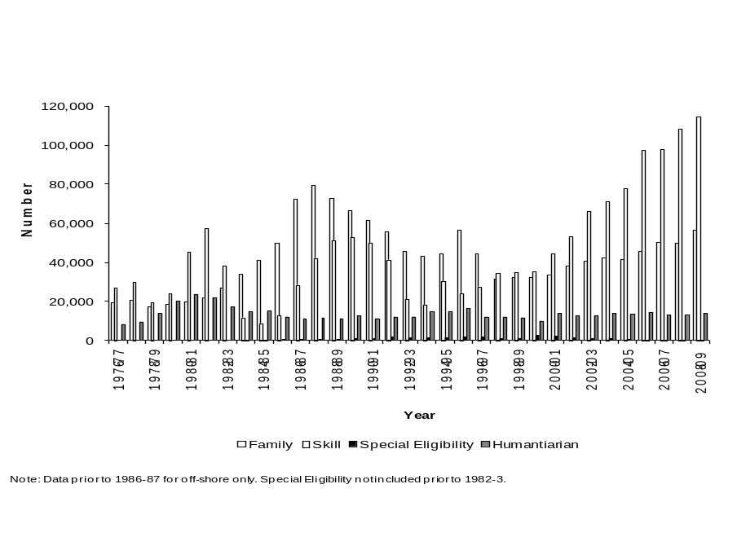

- Employer-sponsored: employers may nominate (or ‘sponsor’) personnel from overseas through the Employer Nomination Scheme (ENS), Regional Sponsored Migration Scheme (RSMS) and Labour Agreements. These visas enable Australian employers to fill skilled permanent vacancies with overseas personnel if they cannot find suitably qualified workers in Australia (38,030 arrivals in 2008-09)
- Business skills migration: encourages successful business people to settle permanently in Australia and develop new business opportunities (7,397 arrivals in 2008-09)
- Distinguished talent: for distinguished individuals with special or unique talents of benefit to Australia (200 arrivals in 2008-09).
In recent times there has been greater government intervention to shape the content of the intake of immigrants to better contribute to Australia’s development goals. This has seen greater emphasis placed on skills in migrant selection, as well as the development of business migration programs to attract entrepreneurs with substantial capital to invest in the country. Australia, like Canada, has micro-managed the qualifications of its migrant intake since the 1970s with the introduction of points assessment schemes.
The Skill Stream of the Australia’s migration program aims to attract people with qualifications and relevant work experience to address specific skill shortages in Australia and enhance the size, skill level and productivity of the Australian labour force. In 2007-08 a total of 108,540 people were granted visas under this category, increasing to 114,777 in 2008-09. In 2001-02 22.6% were ‘onshore’ applicants, compared with 42.7% in 2007-08. India accounted for 22% of all 2008-09 Skill Stream visa grants. Other major source countries included the United Kingdom (18%), China (ten per cent), South Africa (seven per cent) and Sri Lanka (seven per cent).
The annual flows of arrivals of Africa-born immigrants since World War Two are set out in Figure 4. There has been a steady growth, with peaks around 1970, 1982 and 1987; however the highest levels have been recorded in recent years. There was an increase from 9,988 in 2000-01 to 11,814 in 2003-04, followed by a record 15,781 in 2004-05, which then fell back to 11,841 in 2005-06. The African migration intake has increased numerically and also as a proportion of all immigrants. People born in Africa made up only two per cent of immigrants in 1950s but, as Figure 5 shows, reached an unprecedented 12.8% in 2004-05.
Figure 4: Australia: Immigrants from Africa, 1945-2009
Source: CBCS Demography; DIMIA Australian Immigration Consolidated Statistics and DIAC Immigration Update, various issues; DIAC unpublished data
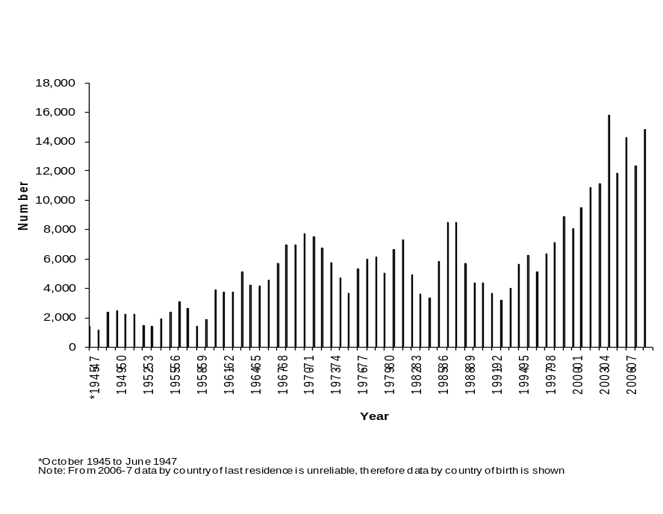

Figure 5: Immigrants from Africa as a percentage of total immigrants, 1945-2009
Source: CBCS Demography; DIMIA Australian Immigration Consolidated Statistics and DIAC Immigration Update, various issues; DIAC unpublished data
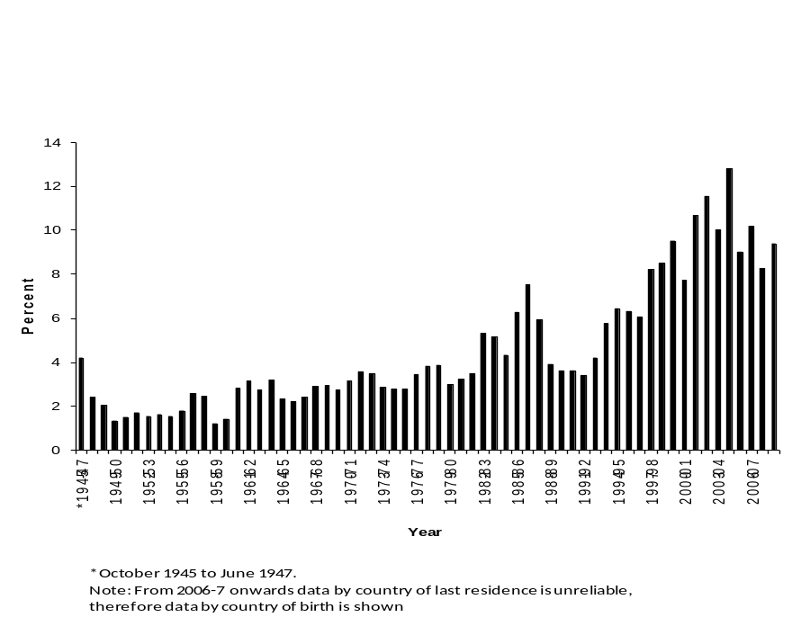
Table 13: Settler arrivals born in Sub-Saharan Africa compared with total intake according to eligibility category, 2007-08
Source: DIAC 2008, 21
Eligibility category | Sub-Saharan Africa  Number | Total  Number | Percentage of total from Sub-Saharan Africa
Family | 1,984 | 38,404 | 5.2
Skill
Sponsored | 968 | 11,330 | 8.5
ENS | 588 | 4,263 | 13.8
Business | 296 | 5,370 | 5.5
Independent | 3,319 | 44,441 | 7.5
Special Eligibility | - | 131 | 0.0
Humanitarian Program | 2,444 | 9,507 | 25.7
Non-Program Migration
NZ Citizen | 966 | 34,491 | 2.8
Other | 38 | 1,428 | 2.7
Total | 10,603 | 149,365 | 7.1
Table 13 shows that in 2007-08 Sub-Saharan Africa, in which South Africans are the dominant group, was over-represented in the following areas of immigration eligibility to Australia: the ‘Independent’ and ‘Employer-sponsored’ categories and the ‘Humanitarian’ group. Whereas some 29.8% of all settlers that year were independent migrants who entered Australia via the points test, this applied to 31.3% from Sub-Saharan Africa. The growth of refugee migration in recent years has seen a considerable dilution in the proportion of African migrants in the skill categories. In 2007-08, 48.8% of all migrants from Sub-Saharan Africa were accepted through the skill categories. This reflects the substantial migration from South Africa, along with the small, highly skilled outflow from other nations such as Kenya and Nigeria, which raises the spectre of ‘brain drain’. For example, Table 14 shows the substantial net flow of doctors and nurses from Africa, especially South Africa, to Australia. Many of them go to rural and remote areas of Australia, where there is an overall shortage of medical personnel (Australian Institute of Health and Welfare 2004). This has led to a debate in Australia about the ethics of such mobility and raises issues such as:
- developing a code of conduct for ethical recruitment
- possible reimbursement of the sending country for costs incurred in training personnel
- the need for more training of health workers in Australia
- selectively limiting proactive recruitment of skilled health professionals
- better supporting health care training systems in less developed countries
- encouraging the return of these doctors to their countries of origin after they complete a period in Australia.
(Reid 2002; Scott et al. 2004)
Table 14: Australia: Arrivals and departures of skilled health workers, 1993-2007
Source: DIAC unpublished data
 | Other Africa |  | South Africa
 | Doctors | Nurses | Doctors | Nurses
Permanent Arrivals | 58 | 314 | 316 | 696
Permanent Departures | 15 | 37 | 22 | 63
Net | +43 | +277 | +294 | +633
Long Term Arrivals | 633 | 1686 | 1461 | 1624
Long Term Departures | 305 | 781 | 587 | 495
Net | +268 | +905 | +874 | +1129
At the 2006 population census 3.6% of the Australian medical workforce was born in Africa or the Middle East (12,241 persons) and 10.4% in Asia (35,551 persons) (AIHW 2003; ABS 2006 Census). It has been argued by some doctors in Australia that a more ethical approach to recruitment of health workers should be adopted (Scott et al. 2004). However Australia, like other OECD nations, has through its contemporary immigration policies, encouraged the flow of skilled personnel from less developed nations, including many of those in Africa. Under the Colombo Plan and other later programs to train students from Asia and Africa in Australia, students were compelled to return to their homeland for at least two years following completion of their studies. This is no longer the case; indeed, in recent years, Australia has facilitated completing students in some skill areas to gain permanent residence in Australia without returning home. Moreover, the increased skill focus in Australia’s migration program has encouraged the outflow of skilled workers from less developed nations.
The other major area of concentration is in the refugee-humanitarian area. Table 13 shows that while 6.4% of all settlers were accepted under this category in 2007-08, a total of 23.1% of this group were from Sub-Saharan Africa. There has been a shift in the origin of refugee-humanitarian settlers toward the Horn of Africa. shows that in 1997 only eight per cent of Australia’s offshore refugees came from Africa, the number had increased to 70.6% in 2003-04 and 34.5% in 2007-08. In 2004 the Minister of Immigration announced that Australia would substantially increase its refugee intake from Africa, especially Sudan (Vanstone 2004). This resulted in a considerable increase in the number of refugee-humanitarian settlers from Africa. Table 14 shows that there was almost a doubling between 2003 and 2004 and the share of Africans of the total refugee intake also doubled to 70.6 percent. However, the last Immigration Minister of the Howard Government reduced the African intake of refugees because of concerns regarding their ability to adjust to Australian society (see ) and their numbers reduced somewhat after 2004-05. The growth of these groups presents challenges for their successful settlement since they are culturally very different to the host community; they often lack English language, may have a history of broken or limited education and have large families which can sometimes lead to difficulties in finding suitable housing. This group of migrants also experience considerable problems in entering the Australian labour market.
The trends in permanent settler arrivals from Africa over the last decade are shown in Table 16. It indicates that of more than a million permanent arrivals between 1998 and 2009, some 11% (132,000 people) came from Africa. The trend is of particular interest as it increased from six per cent of the total intake in 1993-94 to 14.4% in 2003-04, before declining to 11.2% in 2005-06 and to 11% in 2007-08. The dominance of arrivals from South Africa is evident, accounting for 41.4% of the total. The flow has been consistent over the period but increased substantially in 1997-98. The dominance of South Africa in immigration stocks from Africa has reduced significantly since the turn of the century. In the period between 1993 and 2000 South Africans made up 55.8% of all African settler arrivals. However, from 2001-06 it dropped to 33% and fell again in 2005-07 to 26.8%, before recovering in 2007-08 to 41.8%. In 2004-05 there were more settler arrivals from Sudan (5,654) than from South Africa (4,594). In subsequent years, however, South Africans were again the largest group of African settler arrivals. The outflow from Zimbabwe increased sharply in 2001-02, following the increased pressure on European-origin Zimbabweans from the Mugabe regime. The number of Kenya-born arrivals has also increased in recent years, however this probably includes some children born to Sudanese or Ethiopian parents in UNHCR refugee camps in that country.

Table 15: Australia: Offshore settler arrivals from Africa under the Refugee-Humanitarian Program, 1992-93 to 2007-08
Source: DIAC, Population Flows: Immigration Aspects, various issues and Immigration Update, various issues
Year | Europe | Asia⁽³⁾ |  | America | Africa | Middle East⁽¹⁾⁽²⁾ | Total | % Africa
1992-93 | 4,875 | 3,207 |  | 393 | 742 | 1,690 | 10,907 | 6.8
1994-95 | 6,258 | 3,204 |  | 164 | 845 | 3,163 | 13,364 | 6.2
1995-96 | 6,843 | 2,392 |  | 234 | 940 | 3,415 | 13,824 | 6.8
1996-97 | 4,131 | 2,084 |  | 88 | 772 | 2,577 | 9,652 | 8.0
1997-98 | 5,307 | 649 |  | 83 | 1,476 | 2,952 | 10,467 | 14.1
1998-99 | 4,724 | 1,038 |  | 30 | 1,457 | 2,267 | 9,526 | 15.3
1999-2000 | 3,421 | 113 |  | 30 | 1,733 | 2,205 | 7,502 | 23.1
2000-01 | 3,437 |  | 399 |  | 1,998 | 2,158 | 7,992 | 25.0
2001-02 | 2,707 |  | 422 |  | 2,622 | 2,707 | 8,458 | 31.0
2002-03 | 1,166 |  | 699 |  | 5,478 | 4,313 | 11,656 | 47.0
2003-04 | 354 |  | 236 |  | 8,332 | 2,880 | 11,802 | 70.6
2004-05 | 21 |  | 416 |  | 8,435 | 3,174 | 12,096 | 30.2
2005-06 | 51 |  | 1,263 |  | 7,106 | 4,338 | 12,758 | 55.7
2006-07 | 58 |  | 3,586 |  | 6,473 | 2,123 | 12,240 | 52.9
2007-08 | 54 |  | 4,011 |  | 3,279 | 2,147 | 9,491 | 34.5

(1) Includes North Africa in 1992-93 until 1998-99
(2) Includes South Asia in 1999-2000 to 2004-05
(3) Excludes South Asia in 1999-2000 to 2004-05
The most striking pattern in Table 16 has been the increasing flow of refugee-humanitarian settlers, especially those from Sudan, which was the second largest birthplace group in the flow from Africa over the last decade. However, more than three quarters (78.4%) of the 21,433 arrivals from Sudan between 1996 and 2006 arrived in the last four years. The reduction in the refugee intake from Africa is shown in the decline after that time, from 5,654 in 2004-05 to 1,018 in 2007-08. The flow from Ethiopia and Somalia, while smaller, has also increased in recent years. However, declines in each of the source countries of refugees have been evident since 2004-05.
Table 16: Australia: Africa-born settler arrivals, 1997-98 to 2007-08
Source: DIAC unpublished data
Country of Birth | Year ending June 30
Country of Birth | 1998 | 1999 | 2000 | 2001 | 2002 | 2003 | 2004 | 2005 | 2006 | 2007 | 2008 | Total
ALGERIA | 35 | 32 | 25 | 59 | 34 | 36 | 29 | 28 | 27 | 16 | 24 | 345
ANGOLA | 1 | 3 | 5 | 2 | 10 | 3 | 1 | 3 | 3 | 12 | 4 | 47
BENIN | 1 |  |  |  |  |  |  | 2 | 1 | 11 | 23 | 38
BOTSWANA | 70 | 12 | 10 | 19 | 16 | 26 | 27 | 29 | 24 | 36 | 21 | 290
BURKINA FASO |  |  |  |  | 3 | 1 | 1 |  |  | 1 | 2 | 8
BURUNDI |  | 1 | 1 | 5 | 5 | 8 | 51 | 259 | 442 | 440 | 228 | 1,440
CAMEROON | 1 | 1 | 2 |  | 4 | 9 | 4 | 4 | 5 | 11 | 29 | 70
CAPE VERDE |  |  |  |  |  |  |  |  | 1 | 1 | 2 | 4
CENTRAL AFRICAN REPUBLIC |  |  |  |  |  |  |  | 1 |  | 1 | 13 | 15
CENTRAL AND WEST AFRICA, NFD |  |  |  |  |  |  |  |  |  |  |  | 0
CHAD |  |  |  |  |  |  |  | 1 | 2 | 4 | 4 | 11
COMOROS |  |  |  | 3 |  | 1 |  |  |  | 3 |  | 7
CONGO |  | 3 | 3 | 20 | 8 | 23 | 137 | 276 | 91 | 103 | 32 | 696
CONGO, DEM. REP OF | 4 | 7 | 3 | 4 | 8 | 8 | 26 | 21 | 155 | 569 | 474 | 1,279
COTE D IVOIRE | 3 | 2 | 1 | 2 |  | 5 | 2 | 111 | 55 | 83 | 77 | 341
DJIBOUTI | 1 | 9 | 5 | 7 | 6 | 6 | 2 | 9 | 1 | 6 | 3 | 55
EQUATORIAL GUINEA |  |  |  |  |  |  |  |  |  |  |  | 0
EGYPT | 310 | 358 | 360 | 423 | 354 | 551 | 736 | 857 | 812 | 756 | 627 | 6,144
ERITREA | 67 | 187 | 142 | 137 | 133 | 109 | 148 | 125 | 168 | 138 | 128 | 1,482
ETHIOPIA | 280 | 371 | 357 | 397 | 396 | 570 | 718 | 586 | 429 | 575 | 466 | 5,145
GABON |  |  |  | 1 | 1 |  |  | 2 | 1 |  | 1 | 6
GAMBIA | 2 | 4 |  |  | 1 | 3 |  | 2 | 4 | 6 | 3 | 25
GHANA | 87 | 137 | 94 | 84 | 76 | 95 | 137 | 143 | 217 | 245 | 180 | 1,495
GUINEA | 1 | 1 | 1 | 4 | 8 | 25 | 16 | 152 | 101 | 147 | 87 | 543
GUINEA-BISSAU |  |  |  |  | 3 | 1 |  |  | 1 |  |  | 5
KENYA | 165 | 297 | 231 | 256 | 413 | 574 | 617 | 806 | 648 | 701 | 459 | 5,167
LESOTHO |  |  |  | 2 | 7 | 3 | 1 | 8 | 2 | 4 |  | 27
LIBERIA | 4 | 2 |  | 18 | 113 | 145 | 114 | 851 | 564 | 539 | 255 | 2,605
LIBYA | 15 | 8 | 12 | 18 | 9 | 19 | 24 | 18 | 20 | 19 | 24 | 186
MADAGASCAR |  | 7 | 4 | 4 | 5 | 8 | 3 | 1 | 4 | 6 | 5 | 47
MALAWI | 3 | 15 | 9 | 14 | 32 | 19 | 32 | 40 | 17 | 35 | 39 | 255
MALI |  |  | 1 |  |  | 1 | 1 | 1 | 1 |  | 1 | 6
MAURITANIA |  | 1 |  |  |  |  |  | 1 | 3 | 3 | 42 | 50
MAURITIUS | 84 | 64 | 118 | 138 | 153 | 170 | 238 | 227 | 260 | 308 | 388 | 2,148
MAYOTTE |  |  |  |  |  |  |  |  |  |  |  | 0
MOROCCO | 24 | 25 | 31 | 18 | 24 | 41 | 39 | 41 | 45 | 49 | 53 | 390
MOZAMBIQUE | 17 | 10 | 7 | 14 | 18 | 21 | 20 | 15 | 8 | 13 | 18 | 161
NAMIBIA | 17 | 27 | 27 | 37 | 39 | 48 | 23 | 53 | 39 | 36 | 28 | 374
NIGER | 15 | 1 | 7 | 7 | 6 | 1 | 1 | 2 | 9 | 6 | 3 | 58
NIGERIA | 43 | 82 | 56 | 86 | 126 | 89 | 102 | 111 | 160 | 187 | 185 | 1,227
R'EUNION |  | 5 | 5 |  | 2 |  | 2 | 1 | 3 | 1 | 1 | 20
RWANDA |  | 1 | 2 | 1 | 3 | 14 | 44 | 47 | 68 | 93 | 54 | 327
SAO TOME & PRINCIPE |  |  |  |  |  |  |  |  |  |  |  | 0
SENEGAL | 8 | 2 | 6 | 2 | 11 | 6 | 4 | 7 | 12 | 6 | 54 | 118
SEYCHELLES | 6 | 17 | 19 | 1 | 32 | 20 | 36 | 25 | 27 | 36 | 18 | 237
SIERRA LEONE | 5 | 6 | 61 | 127 | 328 | 174 | 132 | 642 | 532 | 519 | 276 | 2,802
SOMALIA | 688 | 507 | 284 | 319 | 359 | 203 | 221 | 246 | 264 | 296 | 156 | 3,543
SOUHERN AND EAST AFRICA, NFD | 2 |  | 1 | 1 |  | 1 | 1 |  |  |  | 1 | 7
SOUTH AFRICA | 4,281 | 5,024 | 5,691 | 5,754 | 5,714 | 4,603 | 5,849 | 4,594 | 3,953 | 3,996 | 5,166 | 54,625
SUDAN | 430 | 566 | 594 | 1,145 | 1,078 | 2,775 | 4,591 | 5,654 | 3,783 | 2,513 | 1,018 | 24,147
ST HELENA |  |  |  |  |  | 1 |  | 1 | 1 |  |  | 3
SWAZILAND | 7 | 12 | 8 | 8 | 6 | 6 | 11 | 3 | 10 | 6 | 4 | 81
TANZANIA | 27 | 20 | 16 | 13 | 26 | 24 | 55 | 176 | 405 | 344 | 291 | 1,397
TOGO |  |  |  | 3 | 1 | 1 | 2 | 8 | 3 | 49 | 99 | 166
TUNISIA | 11 | 11 | 5 | 9 | 6 | 22 | 5 | 4 | 9 | 10 | 10 | 102
UGANDA | 14 | 15 | 17 | 22 | 48 | 71 | 98 | 185 | 161 | 277 | 155 | 1,063
ZAMBIA | 79 | 72 | 90 | 84 | 123 | 77 | 129 | 98 | 93 | 127 | 109 | 1,081
ZIMBABWE | 273 | 322 | 573 | 720 | 1,068 | 1,197 | 1,620 | 1,258 | 1,104 | 935 | 1,019 | 10,089
Total Africa | 7,081 | 8,247 | 8,884 | 9,988 | 10,816 | 11,814 | 16,050 | 17,735 | 14,748 | 14,278 | 12,359 | 132,000
Total Settler Arrivals | 77,327 | 84,143 | 92,272 | 107,366 | 88,900 | 93,914 | 111,590 | 123,424 | 131,593 | 140,148 | 149,365 | 1,200,042
% of Total | 9.2 | 9.8 | 9.6 | 9.3 | 12.2 | 12.6 | 14.4 | 14.4 | 11.2 | 10.2 | 8.3 | 11.0
REGION OF BIRTH | 1997-98 | 1998-99 | 1999-00 | 2000-01 | 2001-02 | 2002-03 | 2003-04 | 2004-05 | 2005-06 | 2006-07 | 2007-08 | Total
North Africa | 825 | 1,000 | 1,027 | 1,672 | 1,505 | 3,444 | 5,424 | 6,602 | 4,696 | 3,363 | 1,756 | 31,314
Central & West Africa | 174 | 249 | 235 | 358 | 697 | 587 | 679 | 2,338 | 1,918 | 2,491 | 1,842 | 11,568
Southern & East Africa | 6,082 | 6,998 | 7,622 | 7,958 | 8,614 | 7,783 | 9,947 | 8,795 | 8,134 | 8,424 | 8,761 | 89,118
Total Africa | 7,081 | 8,247 | 8,884 | 9,988 | 10,816 | 11,814 | 16,050 | 17,735 | 14,748 | 14,278 | 12,359 | 132,000
Figure 6: Distribution of birthplace of settlers to Australia, 1970
Source: Department of Immigration 1972
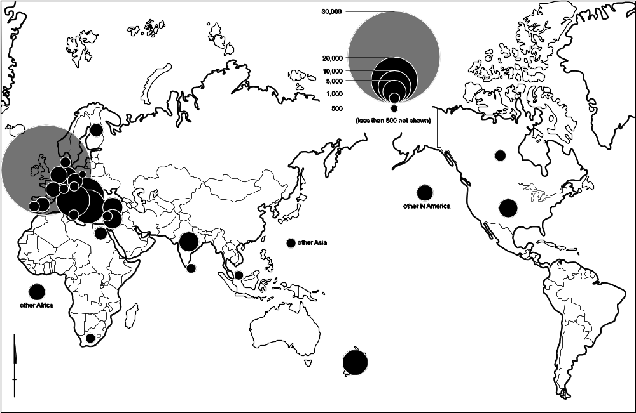

Figure 7: Distribution of birthplace of settlers to Australia, 2007-08
Source: DIAC unpublished data
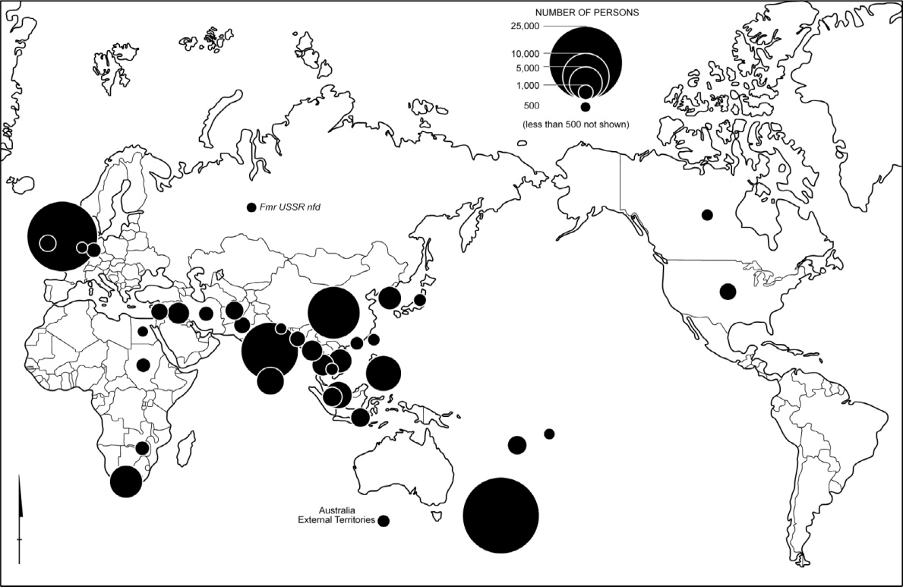

The shift in the origin of settlers coming to Australia in the last three decades is demonstrated in Error: Reference source not found and . The former shows that in 1970 the dominant countries of origin were European, although early flows from Asia were evident and small numbers came from Egypt and South Africa. On the other hand, , which shows the 2007-08 pattern, presents a quite different pattern; Asia provides the majority of settlers and the beginnings of larger scale movement from Africa is also apparent. Figure 8 shows that, over the last decade, most settlers to Australia from Africa came from South Africa, with Horn of Africa and East Africa countries also providing significant numbers and West Africa gaining in importance.
Figure 8: Africa: Birthplace of settler arrivals, 1993-2008
Source: DIAC unpublished data
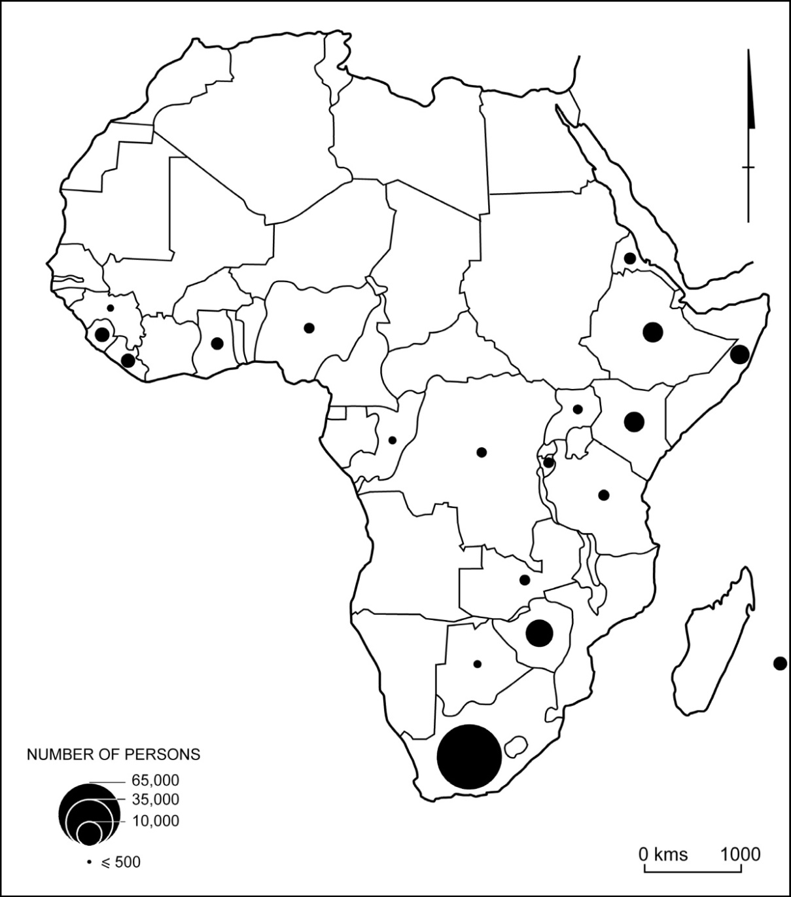
As explained in the following section, Australia made a major change in its immigration policy in the mid-1990s with the introduction of a range of temporary migration policies. This has facilitated the large-scale, non-permanent entry of skilled workers to the country (Khoo et al. 2003). One corollary of this has been the increasing proportion of Australia’s permanent immigration intake comprising ‘onshore settlers’ – persons who had entered Australia with a temporary residence or visitor visa who subsequently applied for, and received, permanent residence. Hence, Figure 9 shows a significant increase in the numbers of these onshore migrants in recent years, rising from 31,948 (19.1% of the total intake) in 2002-03 to 43,895 (26.2%) in 2004-05 and 56,575 (27.5%) in 2007-08. The proportion of African permanent additions made up by onshore settlers also increased from 18.1% (2,621 persons) to 27.5% (4,690 persons) over this period; however, it is mainly migrants from South Africa, Zimbabwe and Kenya who make the transition from temporary to permanent residence. In fact, in 2007-08 some 35.6% of all migrants from these countries were onshore arrivals, accounting for 78.3 percent of all onshore migrants from Africa but only 53.8 percent of ‘offshore’ migrants.
Figure 9: Australia: Onshore residence visa grants, 1989-90 to 2007-08
Source: DIAC Population Flows: Immigration Aspects, various issues

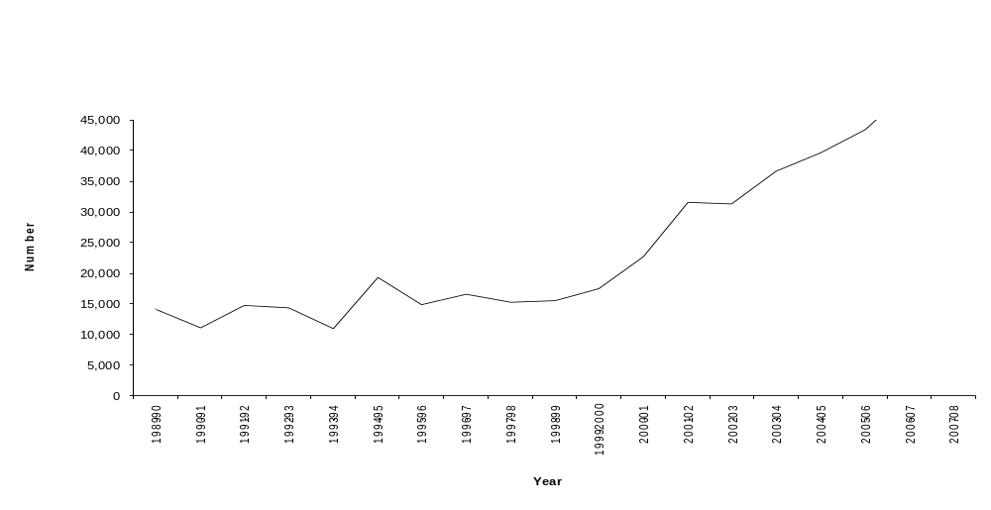

Non-permanent migration
An increasing proportion of Australia’s skilled migrant workers come from ‘onshore’ approval, with people entering Australia under some other visa category and then applying to settle in the country. This process has been made easier in recent times for some groups. For example, overseas students who graduate from Australian universities can readily gain entry to the country with their qualifications not having to be assessed. The assessment of migrants’ professional qualifications is an issue of concern and debate in Australia. The degree to which there is a necessity to have qualifications formally assessed varies with the profession and qualifications of the immigrant. In some skill areas (eg information technology) there is little professional regulation, while in others (eg doctors) there is a high level of professional assessment and regulation.
In post-war Australia there has been bipartisan agreement that permanent settlement of a significant number of migrants is desirable. Accordingly, each post-war government has had an active immigration program while, in some other OECD nations, non-permanent labour migration has been strongly opposed. There has been no serious challenge to the broad support for permanent settlement that has dominated Australian policy on international migration. However, there has, in recent times, been a change in focus (Hugo 1999). In response to significant structural changes in the Australian economy, internationalisation of labour markets and globalisation forces more generally, there has been a broad shift in policy which has allowed large numbers of people to enter and work in Australia on a non-permanent basis. Error: Reference source not found depicts recent trends in the major non-settlement categories. It is argued elsewhere that this represents a major change in Australian immigration policy (Hugo 1999). It should be noted that this visa class has not been extended to unskilled and low skilled areas; it is only available to people with skills in demand and entrepreneurs.
The Temporary Business Visa category was introduced in 1996 and as DIMA (2000, 48) explained at the time:
Figure 10: Temporary Migration to Australia by Category, 1986 to 2009
Source: DIAC Population Flows: Immigration Aspects, various issues
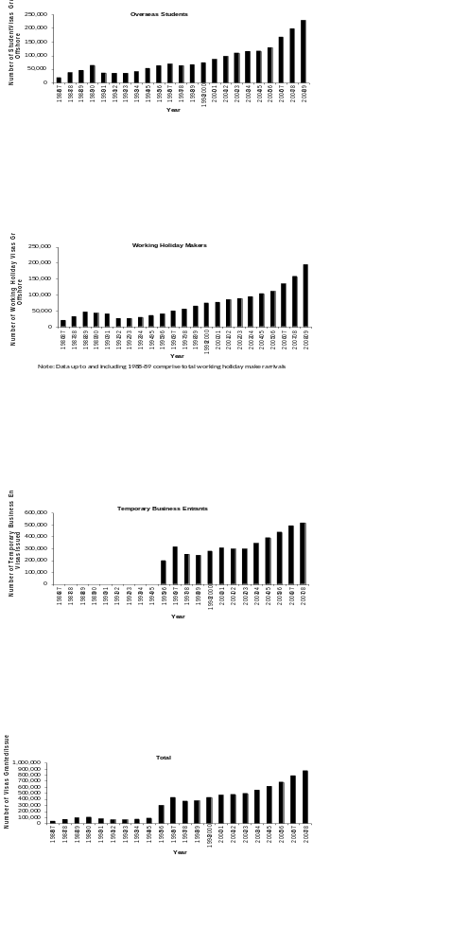
The employer sponsored temporary business visas allow employers to fill skill shortages from overseas and assess new ideas, skills and technology. The visa holders tend to be highly skilled and have relatively high income levels and therefore able to contribute to economic growth through improved productivity and increased demand for goods and services. The entry of managers and skilled specialists under these categories can also enhance Australia’s ability to compete in international markets.
One of the distinguishing features of the exponential increase in non-permanent migration to Australia is that the origin countries of this group are quite different to those of permanent settlers. Students are an important new temporary entry group to the country. Australia has a greater ratio of overseas-to-local students in its tertiary education institutions than any other OECD nation (Abella 2005). However, Table 17 shows that Sub-Saharan Africa only accounts for three per cent of overseas students and North Africa and the Middle East only 2.4%. Nevertheless the numbers of the former group increased from 4,889 in 2003-04 to 5,743 in 2004-05 and the latter grew from 3,433 to 4,524. The OECD (2004) has found that Africans make up 10.9% of all foreign students in the world, which means they are substantially under-represented in Australia.
Table 17: Australia: Students present by region of birth, 30 June 2005
Source: DIMIA 2005, 36
Region of Birth | Students Present
Region of Birth | No. | %
Oceania | 2,463 | 1.28
Europe | 13,613 | 7.06
North Africa and the Middle East | 4,524 | 2.35
Southeast Asia | 39,989 | 20.74
Northeast Asia | 77,664 | 40.29
Southern and Central Asia | 26,762 | 13.88
Northern America | 5,735 | 2.97
South and Central America and the Caribbean | 5,096 | 2.64
Sub-Saharan Africa | 5,743 | 2.98
Not Stated | 11,186 | 5.80
Total | 192,775 | 100.00

Figure 11: Australia: Temporary resident arrivals, 2005
Source: Drawn from data in DIMIA 2005
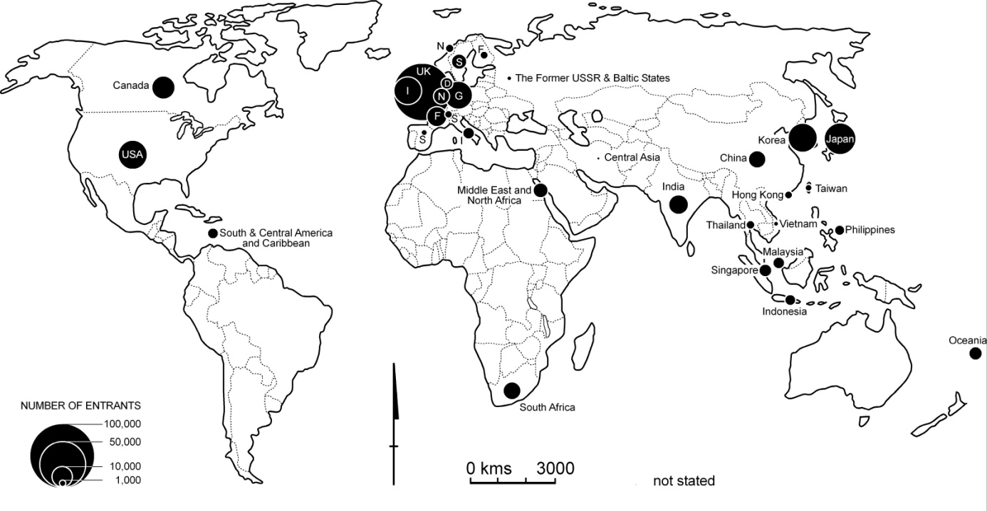
The origin of temporary resident arrivals – which includes long-stay business travellers, working holiday makers and occupational trainees, but excludes students and visitors – is depicted in Error: Reference source not found. It is clear that the African contribution of such arrivals comes almost totally from South Africa, which is an important source of business travellers and skilled temporary resident workers (Visa Categories 456 and 457). Table 18 shows that, in fact, there is a higher proportion of temporary residents to Australia who originate from Sub-Saharan Africa than permanent settlers, which largely reflects the movement from South Africa.
It is apparent that Africa, especially South Africa, has participated in the substantial expansion of temporary migration to Australia. Moreover, Table 19 shows that there has been a major increase in the number of Africa-born persons visiting Australia on a long-term basis. The numbers doubled between 1994-95 and 1998-99, doubled again by 2005 and subsequently doubled again. This reflects the strong involvement of Africans, especially South Africans, in the influx of skilled temporary workers to Australia, especially in the health and information technology sectors. The table also shows that the numbers of temporary entrants arriving in Australia is greater than the out-movement, which means the net gain of ‘temporary’ migrants has increased. This has been a feature of Australia’s population change in recent years. Net migration has accounted for around half of the national population increase, however half of that net gain has been in temporary movement. It remains to be seen how much of the temporary migration will lead to applications for permanent settlement. There are some strong indications of this increasingly occurring, with over a quarter of Australian permanent ‘settlers’ now being ‘onshore’ – in other words, people who are already in Australia usually on a temporary residence visa (Hugo 2005). The dominance of South Africa in African temporary migration to Australia is readily apparent in Error: Reference source not found, which shows the country of origin of long-term arrivals from Africa over the last decade.
Table 18: Australia: Origins of the Australian foreign-born total and temporary resident populations, 2008
Source: ABS 2009 and DIAC 2008
 | Total Overseas-Born,  2008 |  | Temporary Resident  Overseas-Born, 2008
 | Total | Percent | Total | Percent
Oceania | 625,026 | 11.4 | 3,997 | 1.7
Europe | 2,391,656 | 43.7 | 98,439 | 41.3
Middle East and North Africa | 315,524 | 5.8 | 4,163 | 1.7
Southeast Asia | 700,033 | 12.8 | 22,363 | 9.4
Northeast Asia | 562,074 | 10.3 | 53,643 | 22.5
Southern and Central Asia | 404,772 | 7.4 | 18,381 | 7.7
Northern America | 122,179 | 2.2 | 15,737 | 6.6
Southern America | 109,719 | 2.0 | 5,148 | 2.2
Sub-Saharan Africa | 245,142 | 4.5 | 16,657 | 7.0
Total | 5,476,125 | 100.0 | 238,528 | 100.0
* Excludes 6,196 Temporary Residents who did not state their birthplace
Table 19: Australia: Long-term movement to and from Africa and Australia, 1994-2008
Source: DIAC unpublished data
 | Long Term Resident |  | Long Term Visitor |  | Total Long Term
 | In | Out | In | Out | Net Migration
1994-95 | 1,520 | 1,528 | 1,256 | 832 | +416
1996-96 | 1,556 | 1,440 | 1,497 | 922 | +691
1996-97 | 1,798 | 1,460 | 2,045 | 951 | +1,432
1997-98 | 1,710 | 1,517 | 2,867 | 1,414 | +1,646
1998-99 | 1,650 | 1,427 | 4,159 | 1,221 | +3,161
1999-2000 | 1,829 | 1,468 | 4,546 | 1,748 | +3,159
2000-01 | 2,075 | 1,488 | 5,616 | 1,800 | +4,403
2001-02 | 2,036 | 1,429 | 5,939 | 1,866 | +4,680
2002-03 | 2,016 | 1,336 | 6,502 | 2,556 | +4,626
2003-04 | 2,045 | 1,427 | 6,683 | 2,939 | +4,362
2004-05 | 1,981 | 1,428 | 7,443 | 2,833 | +5,163
2005-06 | 2,132 | 1,529 | 9,981 | 2,926 | +7,658
2006-07 | 2,211 | 1,516 | 11,602 | 3,408 | +8,888
2007-08 | 2,440 | 1,626 | 15,415 | 4,050 | +12,179

Figure 12: Africa: Country of birth of long-term arrivals to Australia, 1994-2008
Source: DIAC unpublished data
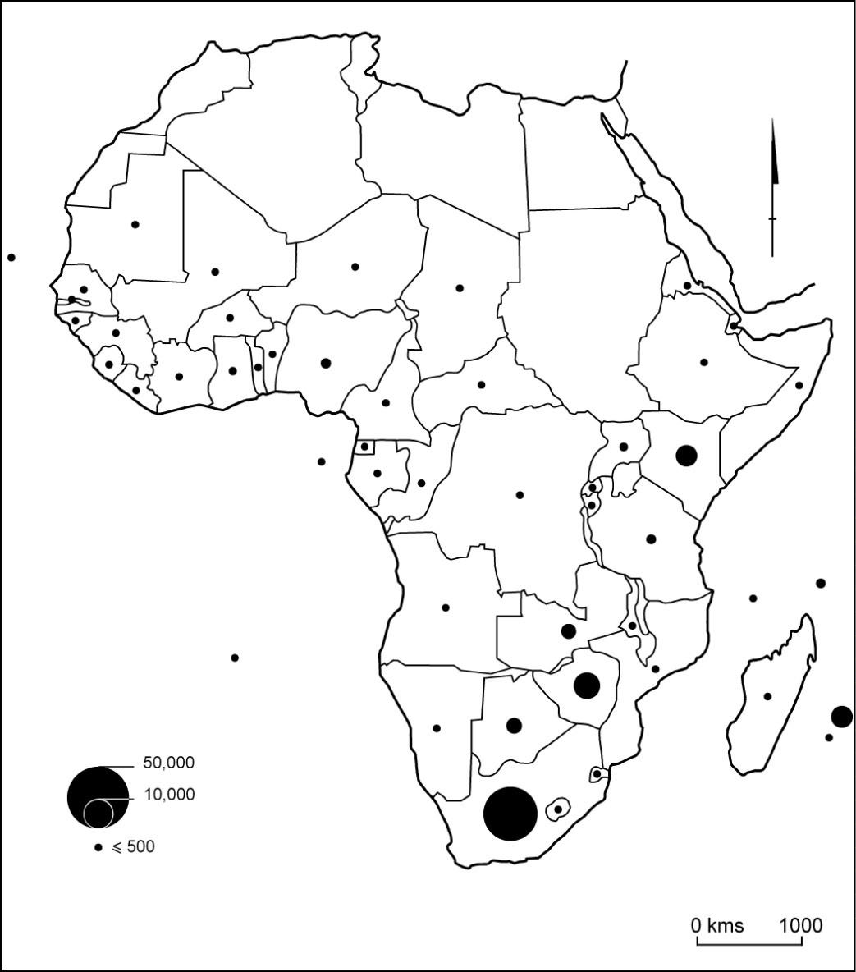
It is also interesting to note the shifts in short-term movement in recent years. Error: Reference source not found shows that there has been an increase in both Australian movement to Africa and also in the opposite direction. In particular, African short-term movement (involving primarily tourists and short-term business visitors) to Australia has increased substantially, almost doubling between 1994-95 and 1998-99. There was a downturn following the ‘September 11’ incidents and the heightened security concerns of travellers, but this recovered to reach record levels in 2007-08. For most years the number of short-term visitors going to Africa has been larger than the movement in the other direction. This may indicate that short-term movers from Australia go to Africa and then subsequently travel on to other foreign destinations like Europe. Error: Reference source not found shows that South Africa is the main origin of short-term arrivals to Australia, although a significant number of arrivals also come from East Africa.
Table 20: Australia: Short-term movement to and from Africa and Australia, 1994-2008
Source: DIAC unpublished data
 | Short-term resident |  | Short-term visitor
 | In | Out | In | Out
1994-95 | 35,749 | 35,495 | 41,986 | 43,562
1996-96 | 42,623 | 46,858 | 39,689 | 45,714
1996-97 | 45,666 | 54,553 | 55,985 | 55,151
1997-98 | 46,404 | 51,008 | 58,325 | 57,374
1998-99 | 51,498 | 50,428 | 77,828 | 78,458
1999-2000 | 50,677 | 57,595 | 71,868 | 75,405
2000-01 | 47,893 | 52,770 | 73,144 | 85,542
2001-02*
2002-03 | 60,051 | 63,148 | 62,709 | 65,421
2003-04 | 68,212 | 71,261 | 72,443 | 76,987
2004-05 | 77,705 | 79,033 | 66,887 | 70,628
2005-06 | 84,817 | 86,385 | 74,013 | 75,017
2006-07 | 94,510 | 97,799 | 80,673 | 82,113
2007-08 | 10,550 | 106,487 | 88,091 | 90,853
* Short-term movement not available

Figure 13: Africa: Birthplace of short-term moves to Australia, 1994-2008
Source: DIAC unpublished data
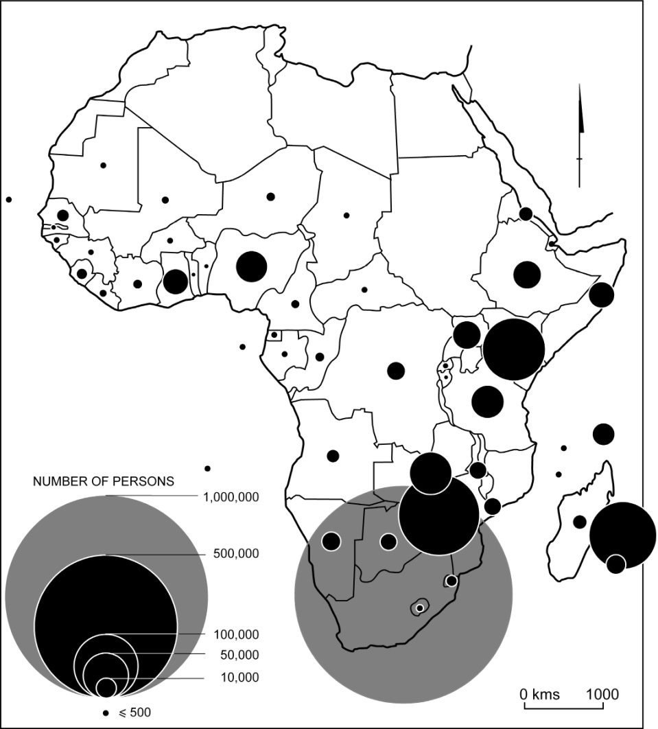

Movement from Australia to Africa
There is a tendency for Australia to be categorised as a purely immigration country but, in fact, it also is a country of significant emigration. Table 21 shows that, in recent years, departures on a long-term or permanent basis have been very substantial compared to the immigration intake. Former settlers have formed a major part of the outflow, as indicates. In 2008-09 permanent and long-term departures (326,175) reached unprecedented levels. The proportion of Australian-born people among the permanent departures reached its highest-ever level of 41,249 in 2008-09 (50.9%).
Table 21: Australia: Settlers and long-term migration, 1987-2007
Source: DIAC, Immigration Update, various issues and unpublished data

 | Year
 | 1987-88 | 1991-92 | 1995-96 | 1999-2000 | 2003-04 | 2004-05 | 2005-06 | 2006-07
Permanent Migration
Arrivals | 143,480 | 107,391 | 99,139 | 92,272 | 111,590 | 123,420 | 131,593 | 140,148
Departures | 20,470 | 29,122 | 28,670 | 41,078 | 59,078 | 62,606 | 67,850 | 72,103
Net | 123,010 | 78,269 | 70,469 | 51,194 | 52,512 | 60,818 | 63,743 | 68,045
Long-term Migration
Arrivals | 98,780 | 126,781 | 163,578 | 212,849 | 289,727 | 303,496 | 325,820 | 373,337
Departures | 78,570 | 115,162 | 124,386 | 156,768 | 177,618 | 186,342 | 190,290 | 203,101
Net | 20,210 | 11,619 | 39,192 | 56,081 | 112,109 | 117,154 | 135,530 | 170,236
Total Permanent and Long-term Net Gain | 143,220 | 89,888 | 109,661 | 107,275 | 164,621 | 177,972 | 199,273 | 238,281
% Net Migration from Long-term Movement | 14.1 | 12.9 | 35.7 | 52.3 | 68.1 | 65.8 | 68.0 | 71.4

Figure 14: Australia: Permanent departures of Australia-born and overseas-born persons from Australia, 1959-60 to 2008-09
Source: DIMIA, Australian Immigration Consolidated Statistics; DIAC, Immigration Update, various issues
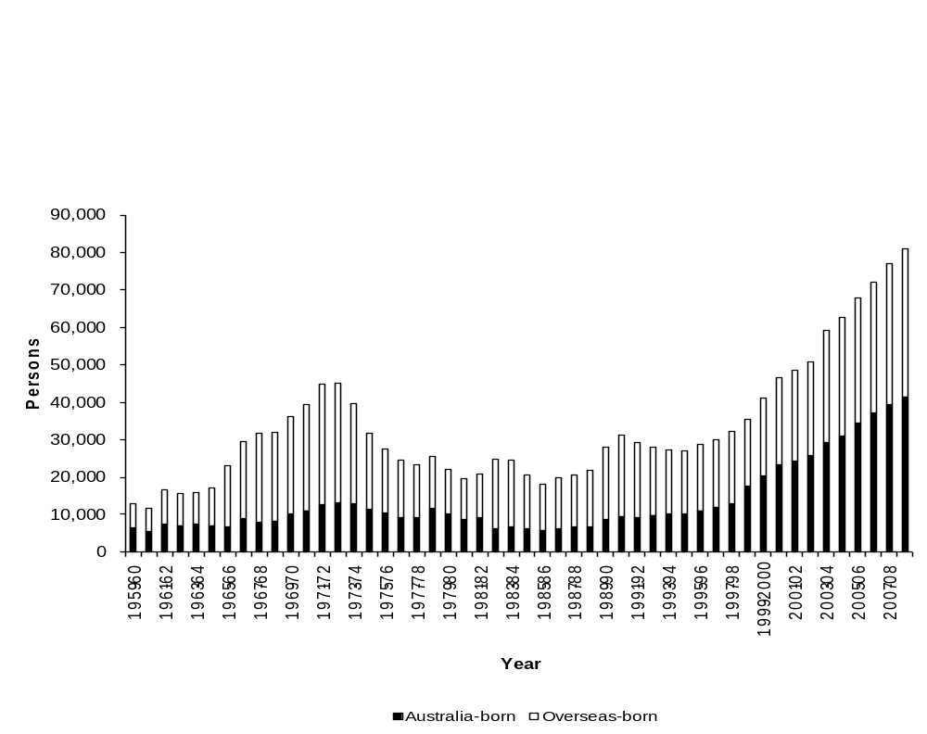
Settler loss has been an important feature of the post-war Australian migration scene, with around a fifth of all settlers subsequently emigrating from Australia and most returning to their home nation. There has been concern about settler loss among policy makers (Hugo 1994), however it has a number of components including migrants who never intended to settle permanently in Australia, people who are influenced by family changes and those who are not able to adjust to life in Australia. The pattern of settler loss, while it varies between birthplace groups (eg it is high among New Zealanders but low among Vietnamese), has tended to remain a relatively consistent feature of the post-war migration scene in Australia and fluctuations in numbers are very much related to earlier levels of immigration. With the recent increase in the skill profile of migrants it can be expected that there will also be an increase in settler loss, since skilled migrants have a greater chance of re-migrating than family migrants.
Table 22 Australia: Birthplace of permanent arrivals and departures, 2008-09
Source: DIAC, unpublished data
Country of Birth | Settler Arrival |  | Resident Permanent Departure |  | Ratio
Country of Birth | Number | Percentage | Number | Percentage | In:Out
Australia | 833 | 0.5 | 41,249 | 50.9 | 0.02
Other Oceania and Antarctica | 29,177 | 18.5 | 9,163 | 11.3 | 3.18
Europe | 29,294 | 18.5 | 10,147 | 12.5 | 2.89
North Africa and the Middle East | 11,143 | 7.1 | 2,010 | 2.5 | 5.54
South East Asia | 21,008 | 13.3 | 4,644 | 5.7 | 4.52
North East Asia | 20,977 | 13.3 | 9,302 | 11.5 | 2.26
Southern Asia | 25,900 | 16.4 | 1,093 | 1.3 | 23.70
Central Asia | 1,731 | 1.1 | 104 | 0.1 | 16.64
Northern America | 2,254 | 1.4 | 1,665 | 2.1 | 1.35
S America, C America and the Caribbean | 1,979 | 1.3 | 519 | 0.6 | 3.81
Sub - Saharan Africa | 13,025 | 8.2 | 1,083 | 1.3 | 12.03
Supplementary Country Codes | 671 | 0.4 | 33 | 0.0 | 20.33
Not Stated/NEI | 29 | 0.0 | 6 | 0.0 | 4.83
Grand Total | 158,021 | 100.0 | 81,018 | 100.0 | 1.95
A rough indication of contemporary patterns of settler loss can be derived by comparing the birthplace of permanent arrivals and departures to and from Australia. These data are presented in Table 22. It indicates that there are relatively high rates of return among settlers from more developed countries of origin, including New Zealand, Europe and North America. There are also high rates of return to parts of North East Asia, especially Japan (ABS 2001). Moreover, there is every indication of a low rate of settler return among African permanent settlers. This is a particular characteristic of refugee-humanitarian settlers (Hugo 1994).
Table 23: Australia: Permanent movement by financial years, 1991-2009
Sources: DIMIA Australian Immigration Consolidated Statistics; DIAC, Immigration Update, various issues; DIAC, unpublished data
Year | Former Settlers | Australia-Born | Total
1991-92 | 19,944 | 9,178 | 29,122
1992-93 | 18,102 | 9,803 | 27,905
1993-94 | 17,353 | 9,927 | 27,280
1994-95 | 16,856 | 10,092 | 26,948
1995-96 | 17,665 | 11,005 | 28,670
1996-97 | 18,159 | 11,698 | 29,857
1997-98 | 19,214 | 12,771 | 31,985
1998-99 | 17,931 | 17,250 | 35,181
1999-2000 | 20,844 | 20,234 | 41,078
2000-01 | 23,440 | 23,081 | 46,521
2001-02 | 24,095 | 24,146 | 48,241
2002-03 | 24,885 | 25,578 | 50,463
2003-04 | 29,977 | 29,101 | 59,078
2004-05 | 31,579 | 31,027 | 62,606
2005-06 | 33,569 | 34,284 | 67,853
2006-07 | 35,221 | 36,882 | 72,103
2007-08 | 37,779 | 39,144 | 76,923
2008-09 | 39,769 | 41,249 | 81,018
Table 23 reveals that more than half of permanent departures from Australia in 2001-02 were of Australia-born persons. While a small number were the Australia-born children of former settlers, the data indicates that the numbers of Australia-born persons leaving the country on a permanent basis is increasing especially quickly, doubling between 1997-98 and 2004-05 and increasing by half again by 2006-07. Focusing on the Australia-born movement to Africa, Table 24 shows that there has been a stable flow of around 1,000 per annum over the last decade, although there has been an increase in recent years. However, Africa is clearly not a significant destination for Australian expatriates. In Australia there is increasing concern about a ‘brain drain’ of skilled workers to other countries, despite the fact that there has been a substantial net gain of skilled migrants (Wood (ed.) 2004). The destinations of permanent departures to Africa is shown in Error: Reference source not found and it is interesting that, although the numbers are small, there is not the concentration in South Africa as there is for other types of movements.
Table 24: Permanent and long-term out-movement of Australia-born departures to Africa, 1994-95 to 2007-08
Sources: DIAC Movements Data Base
Year | Total | Percent
1994-95 | 860 | 1.7
1995-96 | 877 | 1.6
1996-97 | 912 | 1.6
1997-98 | 910 | 1.4
1998-99 | 973 | 1.3
1999-2000 | 968 | 1.2
2000-01 | 1,000 | 1.1
2001-02 | 1,516 | 1.2
2002-03 | 917 | 1.0
2003-04 | 1,024 | 1.1
2004-05 | 988 | 1.0
2005-06 | 1,092 | 1.1
2006-07 | 1,136 | 1.0
2007-08 | 1,238 | 1.1

Figure 15: Africa: Birthplace of permanent departures from Australia to Africa, 1994-2008
Source: DIAC unpublished data
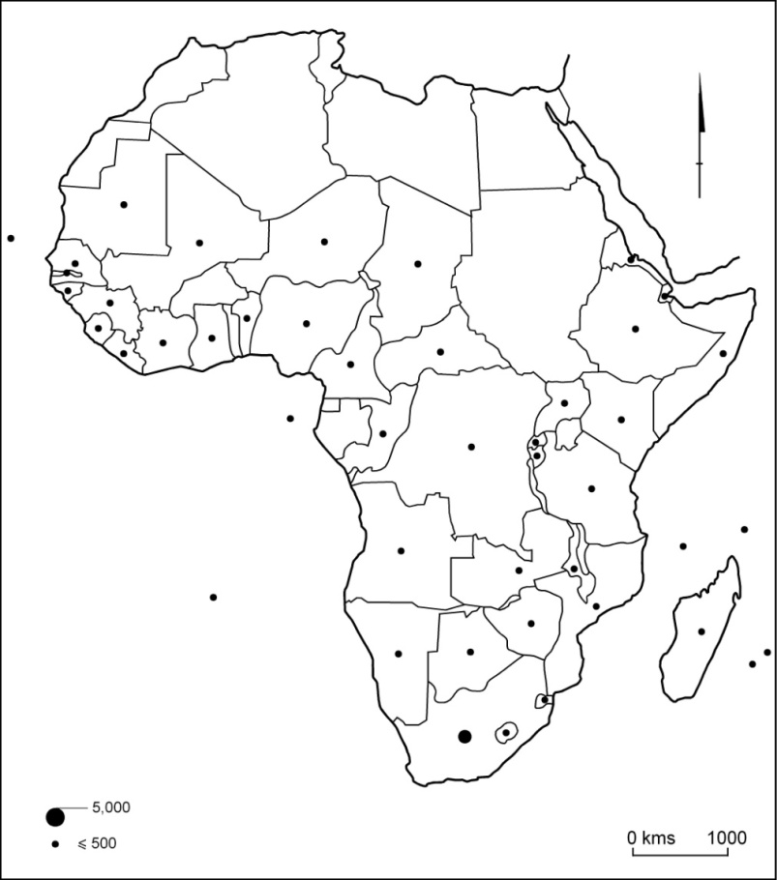

Australia’s South African community
The impact of any migration stream on a destination society goes far beyond the demographic addition of new residents. Migrants always have a different socio-economic and demographic profile from the broader society in their origin and destination countries and they inevitably change those populations through their presence or absence. Moreover, migrants often provide new channels for the flow of information, goods and capital, which bring about other changes in those countries of origin and destination. It is important, therefore, to examine the characteristics of Africans living in Australia. Here we are heavily reliant on data from the 2006 Australian Census of Population and Housing. As indicated earlier, however, there has been a substantial expansion of the African-origin population in Australia since then and this impact will be revealed when the results of the next census, to be held in August 2011, are released. In the meantime some data from other sources can be used to provide additional details about new immigrants to Australia from Africa.
One of the universal features of migration streams is that they tend to be selective of particular age groups, especially young adults. This is also the case for African migration to Australia – evident in Figure 16, which overlays the age-sex distributions of the Africa-born and total populations at the 2006 Australian Census. These reveal quite different age distributions for different birthplace groups. The long history of South African migration is evident in the relatively mature age of the population in Australia (see Error: Reference source not found). On the other hand, the recent flow of refugees means that groups born in Horn of Africa countries are substantially younger. As a result, the overall Africa-born population is over-represented in the 15-44 age group, which accounts for 51.4% of the Africa-born population but only 42.2% of the total Australian population. On the other hand, some 7.8% are aged over 65 compared with 11.1%of the Australian population.
The Australian immigration selection mechanism is highly selective by age. This is partly due to a strong focus on strengthening the national labour market and also growing concern about Australia’s ageing population (Costello 2002). Figure 18 overlays the age composition of the permanent and long-term arrivals from Africa over the last decade; the dominance of young adults and young families is readily apparent. Age is also an important component of the Points Assessment Test applied to potential migrants attempting to enter Australia under the various skilled migration categories. It is not, however, applied in the refugee-humanitarian program, under which the bulk of African migrants from outside South Africa have come to Australia in recent years. Figure 19 shows the age distribution of entrants from these nations and, while there is some variation, they are clearly very young populations.
Figure 16: Australia: Age-sex structure of the Sub-Saharan Africa-born and Australia-born populations, 2006
Source: ABS 2006 Census
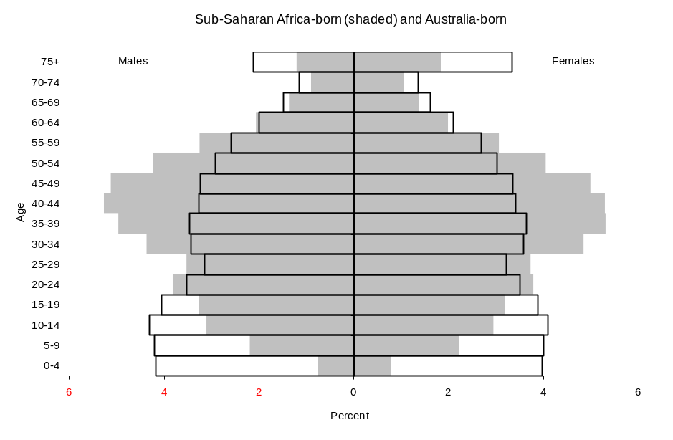
Figure 17: Australia: Age structure of South Africa-born population, 2006
Source: ABS 2006 Census

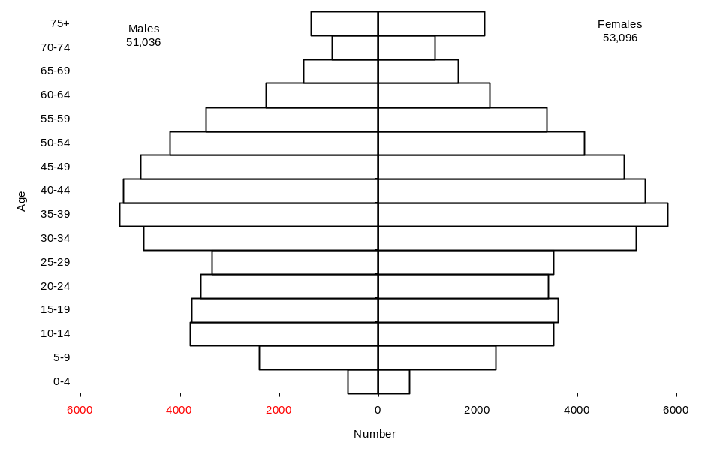
Figure 18: Age-sex distribution of the Africa-born permanent and long-term arrivals 1994-95 to 2006-07 and the total Australian population in 2006
Source: ABS 2006 Census; DIAC, unpublished data
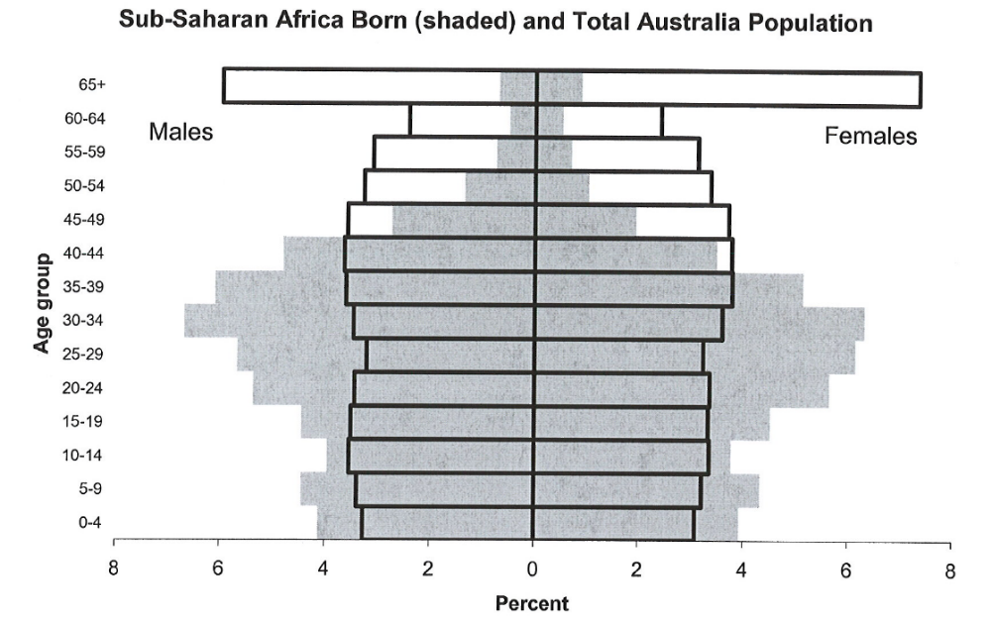

One of the most significant demographic events that occurred in Australia during the 1980s was that, for the first time in the nation’s post-European history, females outnumbered males. Despite the fact that women outlive men in Australia to a greater extent than most countries (Hugo, 1986), the dominance of males has, until recently, more than counter-balanced the effect of longevity. However, as shown in Figure 20, the last two decades has seen a feminisation of settlement in Australia. For example, in 2002-02 there were 93.7 males for every 100 females arriving in Australia. Females outnumber males in the stream from Africa but the sex ratio of this group (98.75) is higher than for all migrants (98.6). Nevertheless, males outnumber females among the majority of African birthplace groups (see Error: Reference source not found), although females dominate in some of the largest birthplace groups, particularly South Africa. This partly reflects the mature age structure of that community, as well as the fact that the streams of migrants are more varied than is the case for smaller country flows. Males tend to be dominant in the major flows of skilled migrants.
Figure 19: Age of entrants to Australia from Liberia, Ethiopia and Eritrea, 2000-05
Source: DIMA 2006a, b, c
Liberia
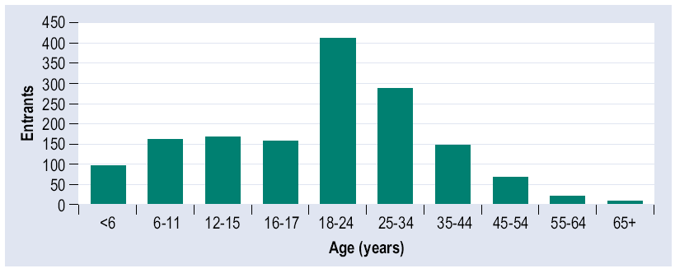
Ethiopia
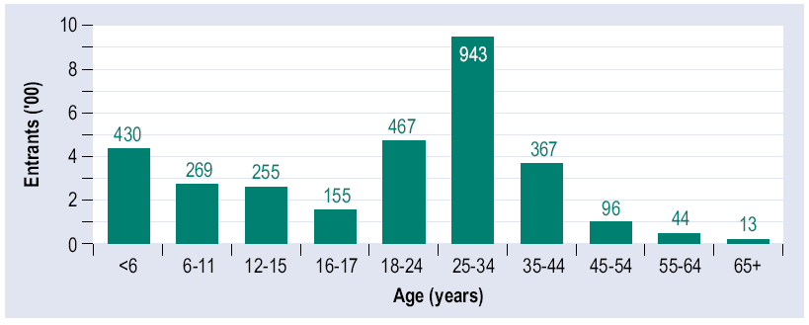

Eritrea
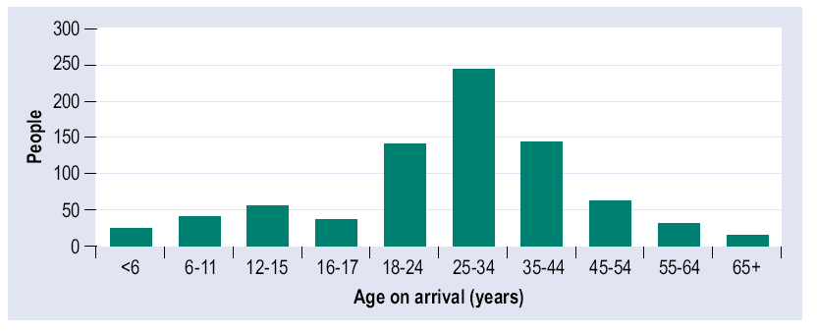

Figure 20: Australia: Sex ratios of settler arrivals, 1959-2009
Source: DIAC, unpublished data
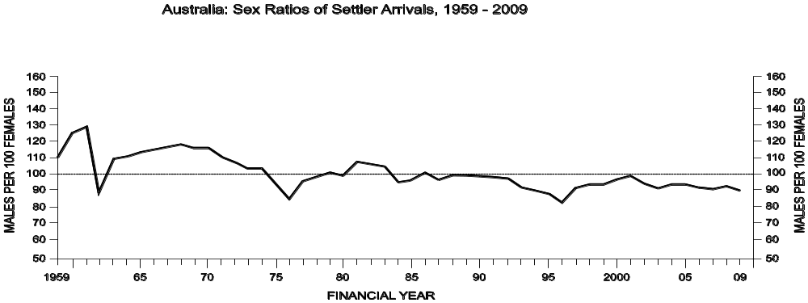
Table 25: Australia: Africa-born birthplace groups, sex ratio, 2006
Source: ABS Table Builder 2006
Birthplace | Sex Ratio |  | Birthplace | Sex Ratio
Algeria | 156.4 |  | Mali | 176.5
Angola | 101.5 |  | Mauritania | 87.5
Benin | 171.4 |  | Mauritius | 94.2
Botswana | 143.0 |  | Mayotte | na
Burkina Faso | 125.0 |  | Morocco | 142.5
Burundi | 110.3 |  | Mozambique | 105.5
Cameroon | 148.0 |  | Namibia | 95.8
Cape Verde | 450.0 |  | Niger | 140.0
Central African Republic | 150.0 |  | Nigeria | 145.7
Central and West Africa, nfd | 73.9 |  | North Africa, nec | 109.1
Chad | 160.0 |  | North Africa, nfd | 88.9
Comoros | 50.0 |  | Réunion | 82.9
Congo | 120.8 |  | Rwanda | 74.8
Congo, Democratic Republic of | 108.8 |  | Sao Tomé and Principe | 100.0
Côte d'Ivoire | 117.1 |  | Senegal | 153.8
Djibouti | 75.0 |  | Seychelles | 84.8
Egypt | 104.2 |  | Sierra Leone | 100.9
Equatorial Guinea | 266.7 |  | Somalia | 92.5
Eritrea | 96.4 |  | South Africa | 96.1
Ethiopia | 100.2 |  | Southern and East Africa, nec | 200.0
Gabon | 225.0 |  | Southern and East Africa, nfd | 71.6
Gambia | 124.1 |  | St Helena | 44.0
Ghana | 114.6 |  | Sudan | 118.2
Guinea | 109.4 |  | Swaziland | 96.6
Guinea-Bissau | na |  | Tanzania | 126.3
Kenya | 103.6 |  | Togo | 133.3
Lesotho | 105.1 |  | Tunisia | 144.8
Liberia | 87.2 |  | Uganda | 103.7
Libya | 114.7 |  | Western Sahara | 114.3
Madagascar | 75.0 |  | Zambia | 96.1
Malawi | 93.8 |  | Zimbabwe | 97.8

Table 26: Australia: Settler arrivals, birthplace Africa, sex ratios,
1993-94 to 2007-08
Source: DIAC unpublished data
COUNTRY OF BIRTH | Males | Females | Sex Ratio
Angola | 32 | 27 | 118.5
Benin | 24 | 17 | 141.2
Botswana | 332 | 329 | 100.9
Burkina Faso | 3 | 6 | 50.0
Burundi | 739 | 703 | 105.1
Cameroon | 44 | 29 | 151.7
Cape Verde | 3 | 1 | 300.0
Central African Republic | 8 | 8 | 100.0
Chad | 7 | 5 | 140.0
Comoros Excl Mayotte | 5 | 5 | 100.0
Congo | 372 | 326 | 114.1
Congo, Dem Rep | 586 | 612 | 95.8
Cote D’Ivoire | 159 | 186 | 85.5
Djibouti | 30 | 39 | 76.9
Eritrea | 885 | 913 | 96.9
Ethiopia | 2919 | 2979 | 98.0
Former Ethiopia | 574 | 537 | 106.9
Gabon | 4 | 3 | 133.3
Gambia | 21 | 11 | 190.9
Ghana | 906 | 1005 | 90.1
Guinea | 267 | 276 | 96.7
Guinea-Bissau | 3 | 3 | 100.0
Kenya | 2989 | 2865 | 104.3
Lesotho | 18 | 17 | 105.9
Liberia | 1178 | 1428 | 82.5
Madagascar | 21 | 31 | 67.7
Malawi | 138 | 143 | 96.5
Mali | 5 | 2 | 250.0
Mauritania | 27 | 21 | 128.6
Mauritius | 1223 | 1329 | 92.0
Mozambique | 98 | 92 | 106.5
Namibia | 225 | 188 | 119.7
Niger | 57 | 53 | 107.5
Nigeria | 804 | 605 | 132.9
Reunion Island | 10 | 15 | 66.7
Rwanda | 151 | 184 | 82.1
Senegal | 81 | 54 | 150.0
Seychelles | 134 | 167 | 80.2
Sierra Leone | 1431 | 1397 | 102.4
Somalia | 2543 | 2688 | 94.6
South Africa | 32985 | 32487 | 101.5
St Helena | 1 | 0
Sth and East Africa NFD | 32 | 39 | 82.1
Swaziland | 42 | 52 | 80.8
Tanzania | 790 | 717 | 110.2
Togo | 79 | 89 | 88.8
Uganda | 601 | 567 | 106.0
Zaire | 40 | 32 | 125.0
Zambia | 694 | 639 | 108.6
Zimbabwe | 5581 | 5378 | 103.8
Total Sub-Saharan Africa | 59901 | 59299 | 101.0
Algeria | 200 | 236 | 84.7
Egypt | 4413 | 3774 | 116.9
Libya | 143 | 102 | 140.2
Morocco | 304 | 212 | 143.4
Sudan | 14025 | 11640 | 120.5
Tunisia | 78 | 56 | 139.3
Western Sahara | 5 | 4 | 125.0
Total North Africa | 19168 | 16024 | 119.6
Total Africa | 79069 | 75323 | 105.0
In examining flows of migrants from Africa to Australia between 2000 and 2005, Table 25 shows there is considerable variation in the balance of male and females from the different countries. It is interesting that, overall, males outnumbered females, with 108 males moving to Australia for every 100 females during the period. It is particularly noticeable that males outnumber females in each of the largest flows, including South Africa (101.5), Sudan (120.5), Zimbabwe (103.8), Egypt (116.5) and Kenya (104.5). Ethiopia had a sex ratio of 108.2 among arrivals from 2000-05, however recent inflows of women have resulted in a relatively balanced ratio over the last 15 years (98).
Migration is often selective of more adventurous, entrepreneurial, better trained and risk-taking populations. Moreover, this is exacerbated by highly-planned immigration programs, such as Australia’s, which has increasingly focused on selecting settlers on the basis of skill (Richardson, Robertson and Ilsley 2001). This is reflected in the characteristics of the Africa-born population in Australia. Table 27 shows that the African population in Australia has a higher proportion in the manager, administrative and professional occupation categories than the total workforce and almost three times as many with a degree. The distribution is dominated by migrants from South Africa.
Table 27: Australia: Australia-born and Sub-Saharan Africa-born: Selected occupational and educational characteristics, 2006
Source: ABS Table Builder 2006
 | Birthplace
 | Australia | Sub-Saharan | Total Overseas | Total Population
Occupation
Managers and Administrators | 9.4 | 10.9 | 8.6 | 9.2
Professionals | 18.7 | 30.6 | 22.0 | 19.6
Associate Professionals | 12.2 | 11.8 | 12.1 | 12.2
Tradespersons and Related Workers | 12.7 | 8.8 | 11.4 | 12.3
Advanced Clerical and Service Workers | 3.3 | 3.6 | 2.9 | 3.2
Intermediate Clerical, Sales and Service W | 17.5 | 16.5 | 16.3 | 17.2
Intermediate Production and Transport W | 8.1 | 5.1 | 8.7 | 8.2
Elementary Clerical, Sales and Service W | 10.1 | 7.0 | 8.3 | 9.6
Labourers and Related Workers | 8.1 | 5.7 | 9.6 | 8.5
Percentage Unemployed | 4.9 | 5.5 | 6.1 | 5.2
Highest Qualification
Degree or higher | 11.1 | 25.5 | 16.0 | 12.5
Diploma/Certificate | 19.5 | 24.2 | 18.0 | 19.1
It is apparent that the recent refugee arrivals from the Horn of Africa have encountered difficulties entering the labour market, experiencing high levels of unemployment and low levels of workforce participation. South Africans are one of the most advantaged birthplace groups in the Australian population, while some of the recently-arrived refugee groups are among the least advantaged. Table 28 shows results from the Longitudinal Survey of Immigrants to Australia and indicates that African immigrants had very high rates of unemployment in the first six months of their arrival but that these improved substantially with length of residence. The high socio-economic status of the South Africa-born population, with high incomes and high rates of home ownership, is reflected in the Africa-born population as a whole (Table 29).
Table 28: Longitudinal Survey of Immigrants to Australia: Employment experience
 | No. Employed | No. Unemployed | Unemployment Rate
Cohort One
First Wave
Arrived 1993-98 | 158 | 88 | 35.8
Second Wave
1 year later | 184 | 40 | 17.9
Third Wave
3 years later | 171 | 32 | 15.8
Cohort Two
First Wave
Arrived 1999-2001 | 116 | 24 | 17.1
Second Wave
2 years later | 123 | 11 | 8.2
Cohort Three
First Wave (N=475)
Arrived Dec 2005-March 2006 | 339 | 59 | 14.8
Second Wave (N=291)
12 months later | 243 | 17 | 6.5

Table 29: Australia: Australia-born and Sub-Saharan Africa-born: Selected socio-economic indicators, 2006
Source: ABS Table Builder 2006
 | Birthplace |  | Total Overseas | Total Population
 | Australia | Sub-Saharan | Total Overseas | Total Population
Nature of Occupancy
Owner/Purchaser | 73.1 | 60.0 | 69.1 | 71.9
Tenant | 25.1 | 38.6 | 29.4 | 26.3
Other | 1.8 | 1.4 | 1.6 | 1.8
Income
Less than $400 per week | 43.5 | 37.5 | 48.6 | 45.0
$1,600 per week or more | 6.5 | 13.0 | 6.6 | 6.5

Figure 21: Selected African group arrivals in Australia, 2000-05, by self-reported English proficiency
Source: DIMA 2006a, b, c, d
Liberia
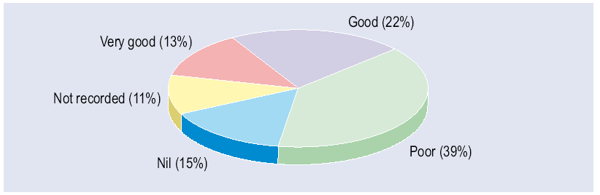

Congo
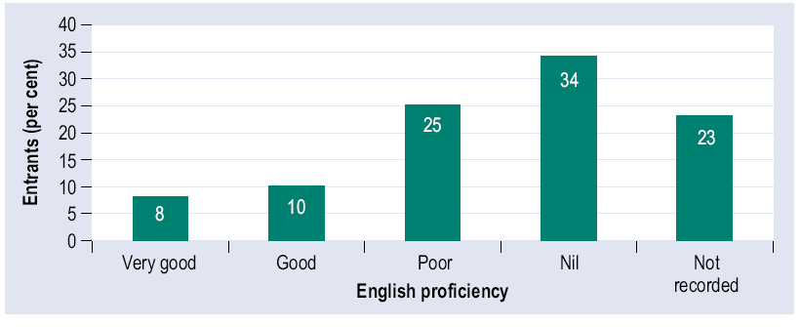
Eritrea
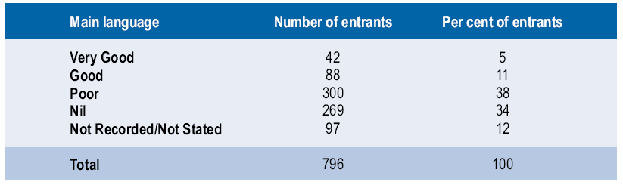
Ethiopia
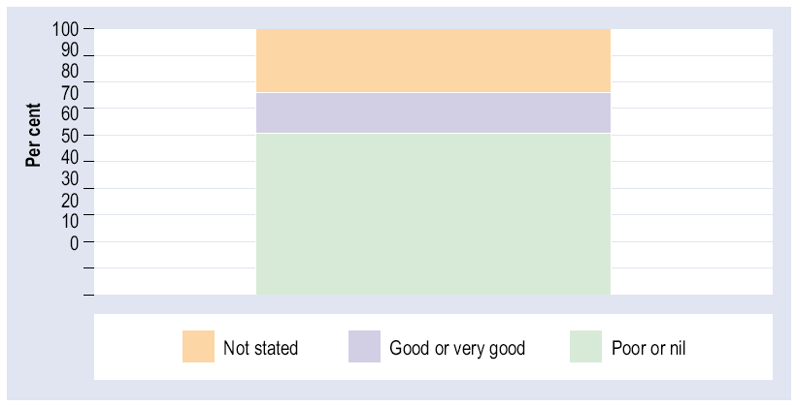
The problems experienced by refugee-humanitarian arrivals in entering the Australian labour market can be gauged from , which shows the self-reported English language ability among four groups of arrivals in 2000-05. It is evident that there is a very significant proportion with no English language ability or with poor proficiency. This represents a major barrier to success in the labour market. Nevertheless they have settled in Australia at a time of record low levels of unemployment, which will have assisted their possibility of finding work. A related issue is the large family size of some of the refugee-humanitarian groups, which can greatly reduce the housing options open to them.

Patterns of Settlement in Australia
Most immigrant groups in Australia have a quite different spatial distribution than the Australia-born population, reflecting the pattern of job opportunities prevailing at their time of arrival in Australia and the existence of communities of prior arrivals. Where immigrants settle can have a major impact on their level of satisfaction with life in their new country. African groups have had a quite distinctive pattern of settlement in Australia. This is reflected at a macro level in Table 30; in 2006 81.5% of Australian
Table 30: Australia: Australia-born and Sub-Saharan Africa-Born: Spatial distribution, 2006
Source: ABS Table Builder 2006

 | % Australia-Born | % Sub-Saharan Africa-Born | % Total Overseas-Born | % Total Population
Urban/Rural Distribution
Capital City | 58.3 | 81.5 | 80.6 | 63.7
Rest of State | 41.7 | 18.5 | 19.4 | 36.3
Interstate Distribution
NSW | 32.1 | 28.2 | 35.2 | 33.0
Victoria | 24.4 | 23.4 | 26.6 | 24.8
QLD | 20.9 | 19.0 | 15.8 | 19.7
SA | 8.0 | 4.7 | 7.0 | 7.6
WA | 9.1 | 21.4 | 12.0 | 9.9
Tas | 2.8 | 1.2 | 1.1 | 2.4
NT | 1.1 | 0.7 | 0.6 | 1.0
ACT | 1.7 | 1.3 | 1.6 | 1.6
Africans lived in the eight capital cities compared with 58.3% of the Australia-born population. It is interesting that this represented a decrease from 84.7% in 2001, indicating that more Africans are now settling outside the large cities. Nevertheless there is a strong concentration in metropolitan areas, as is the case with other migrant groups (Hugo, forthcoming), although there have been some attempts to encourage recently-arrived refugees to settle in regional areas. The metropolitan concentration of Africa-born immigrants is also apparent in Error: Reference source not found, which shows their distribution across the nation at the 2006 census. It is apparent that they are strongly concentrated in the capital cities of Sydney, Melbourne,

Figure 22: Australia: Distribution of the Sub-Saharan Africa-born population, 2006
Source: ABS, Table Builder 2006
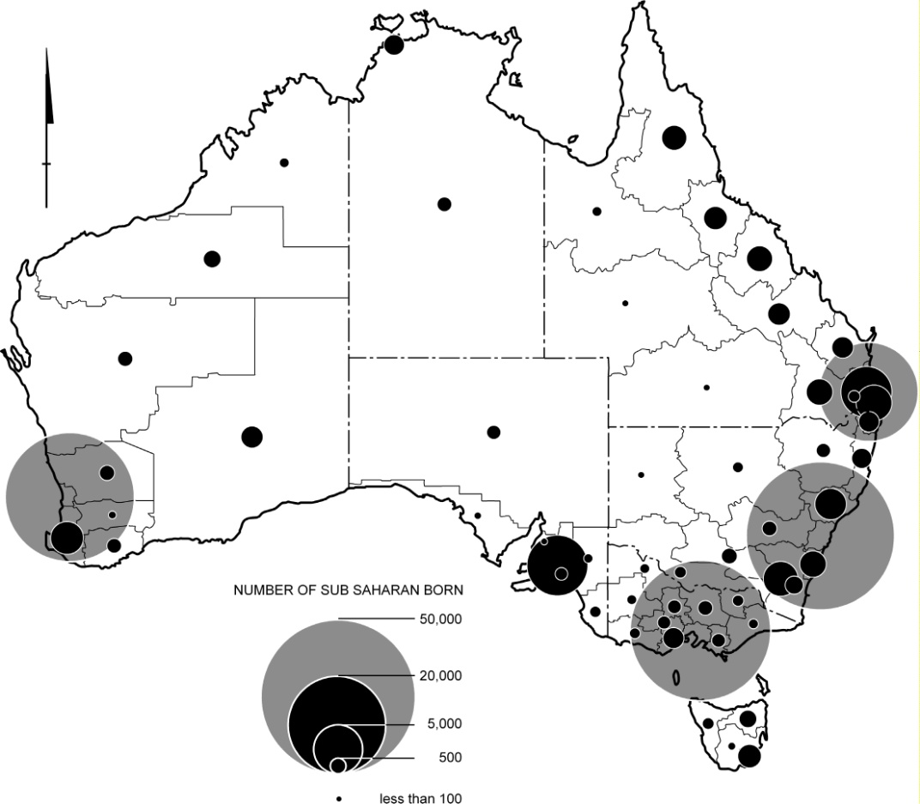

Brisbane, Perth and Adelaide. Sydney (39,535 persons) is home to 24% of the nation’s Africa-born. Although this is significantly higher than the proportion of the Australia-born living in Sydney (17.7%), it is lower than for most recently-arrived groups (Hugo 2004b). Moreover the large numbers in Sydney include many of the temporary migrants referred to earlier in the paper, as it is the main focus of business travellers and temporary business migrants. Figure 22 highlights that the numbers in Melbourne (41,310 persons) are similar to those in Sydney, although Melbourne’s total population is somewhat lower (3,592,590 persons compared with 4,119,191 persons). This is due in part to the fact that Melbourne has become the main location of settlement for the Ethiopia refugee groups from the Horn of Africa (Gow 2001, 693), especially in the suburb of Footscray in Melbourne’s western suburbs. The rapidly growing Sudanese refugee group is particularly concentrated in Sydney.
The third largest concentration is in Perth, which traditionally has been a major focus of settlement of groups from Sub-Saharan Africa, especially those from South Africa and Zimbabwe. Indeed its Africa-born community (24,843 persons) is almost as large as those in Sydney and Melbourne, which both have total populations roughly three times that of Perth. Table 30 indicates that there is a disproportionate concentration of Sub-Saharan Africa-born persons in Western Australia. One of the most distinctive features of the historical settlement of Africans in Australia has been what Hugo (1996) has described as an ‘Indian Ocean Connection’. He showed how data from the 1991 census indicated that the ring of nations around the Indian Ocean have a disproportionately large share of their Australian-based populations living in Western Australia. In 1981 Western Australia had 16.9% of the Australian Africa-born population – double that state’s share of the national total population. This is obviously partly a factor of greater proximity to the Indian Ocean region than any other Australian state and the fact that Perth was the first port of call of early visitors and settlers from South Africa; the establishment of a substantial South African community in Perth served as an anchor for later settlement. By 2006 the proportion of Australian Africans living in Western Australia had risen to 21.4%, more than double that state’s share of the total Australian population (9.9%).
The data on settlement patterns referred to so far are 2006 census data but, as indicated earlier, there has been a substantial increase in the inflow from Africa, along with a change in its composition, in the last four years. Moreover in recent years there have been increased efforts by federal, state and local governments to encourage immigrants to settle in particular parts of Australia and facilitate regional development. Accordingly 20.9% of settlers in 2005-06 came under the State Specific and Regional Migration (SSRM) scheme, which only allows people to settle outside of major metropolitan destinations on Australia’s east and south west coasts. The SSRM scheme only applies to a range of skill and family migration visa categories and not to refugee-humanitarian migrants. Nevertheless efforts are made to settle refugee-humanitarian migrants in the SSRM areas, where the necessary support is available to assist them (see Table 31). While NSW is Australia’s largest state and takes a larger share of migrants than any other state or territory, it is apparent that it has taken less Ethiopian, Eritrean and Congolese migrants (509) than Victoria (2,051) and Western Australia (749). In addition, South Australia (with only 7.5% of the national population) is home to 464 (10.4%) of this group of migrants.
Table 31: Settlement locations of migrants from Ethiopia, Eritrea and Congo, 2000-05
Source: DIMA 2006a, b, c
 | Ethiopia | Eritrea | Congo
New South Wales | 318 | 84 | 107
Victoria | 1,546 | 426 | 79
Queensland | 239 | 61 | 63
South Australia | 249 | 62 | 153
Western Australia | 425 | 117 | 207
Tasmania | 162 | 32 | -
Australian Capital Territory | 51 |  | -
Northern Territory | 30 | 314 | 24
Total | 3,020 | 796 | 633

Conclusion
Any comprehensive consideration of international migration in Africa must include consideration of the movement out of the continent. This paper has demonstrated that this can be studied to a substantial extent using data from destination nations and not be reliant upon data collected in Africa. This approach of using destination data is an under-utilised approach in African migration study. Nevertheless the development of effective international migration data systems is an essential pre-requisite to the development of effective migration policies and programmes. Nations cannot hope to manage migration, or have policies which are able to maximise benefits to their country and minimise its negative effects, if there is not a sound knowledge of the dynamics of that movement and an understanding of its main drivers and effects. The international migration data collection systems utilised here have been developed in Australia over a long period. The important issue is that the expense involved in these systems is not massive. Indeed developments in information technology have greatly improved the timeliness, effectiveness and cost efficiency in collecting information on migration flows. With the increasing significance of ‘south-north’ migration, as well as intra-African movement, the need to improve these data collection systems is pressing.
The exchange of people between Africa and Australia has undergone substantial changes over the post-war period. However, the consequences of this movement for Africa and for Australia, as well as for the immigrants, are little understood. There is a pressing need for this to be addressed. In considering the future of international migration between Africa and Australia it can be confidently predicted that the level and complexity of the interaction will increase over the next decade. The upsurge in settlement of Africans in Australia in recent years, and the increased diversity of the groups arriving, has led to an increase in the strength and spread of the social networks linking the two nations. Moreover, the immigration industry in both continents is strengthening and will continue to encourage and facilitate this movement, although it is likely that it will continue to be greater from Africa to Australia than in the opposite direction. However, as the economies of the countries become more closely linked, it can be expected that there will be some increase in movement of skilled Australians to work and live in African countries, as has been the case in some Asian nations.
Africa has a large reservoir of people who readily fit the criteria currently adopted by the Australian Government for selection of settlers and for those to enter the country as temporary workers. Consequently, these flows are likely to increase in the future. As a result, there is a need to investigate in more detail the implications and impacts of this movement; not only on those who move, but also on their communities and countries of origin and destination. Only then will there be a sound basis for policy development which maximises the benefits of this movement and minimises its negative effects.

Appendix A: Australia: Africa-born population, 1996, 2001 and 2006
Source: ABS 1996, 2001 and 2006 Censuses, Enumeration
 | Number of Persons |  |  | Average Annual Growth Rate (%)  2001-06
 | 1996 | 2001 | 2006 | Average Annual Growth Rate (%)  2001-06
Algeria | 753 | 980 | 1,004 | 0.5
Angola | 344 | 353 | 396 | 2.3
Benin | 12 | 24 | 19 | -4.6
Botswana | 225 | 706 | 865 | 4.1
Burkina Faso | 10 | 23 | 26 | 2.5
Burundi | 23 | 25 | 753 | 97.6
Cameroon | 35 | 66 | 125 | 13.6
Cape Verde | 24 | 22 | 22 | 0.0
Central African Republic | 14 | 3 | 10 | 27.2
Chad | 21 | 36 | 27 | -5.6
Comoros | 6 | 18 | 12 | -7.8
Congo | 22 | 135 | 520 | 31.0
Congo, Dem Republic of | 321 | 267 | 618 | 18.3
Cote d'Ivoire | 52 | 69 | 255 | 29.9
Djibouti | 75 | 68 | 97 | 7.4
Egypt | 34,158 | 33,432 | 33,496 | 0.0
Equatorial Guinea | 3 | 6 | 9 | 8.4
Eritrea | 1,161 | 1,599 | 2,015 | 4.7
Ethiopia | 2,353 | 3,544 | 5,634 | 9.7
Gabon | 19 | 19 | 25 | 5.6
Gambia | 26 | 53 | 130 | 19.7
Ghana | 1,495 | 2,040 | 2,769 | 6.3
Guinea | 19 | 28 | 334 | 64.2
Guinea-Bissau | 10 | 15 | 8 | -11.8
Kenya | 5,333 | 6,869 | 9,935 | 7.7
Lesotho | 58 | 54 | 78 | 7.6
Liberia | 84 | 125 | 1,523 | 64.9
Libya | 1,277 | 1,439 | 1,518 | 1.1
Madagascar | 137 | 156 | 188 | 3.8
Malawi | 423 | 485 | 685 | 7.1
Mali | 15 | 29 | 47 | 10.1
Mauritania | 3 | 16 | 16 | 0.0
Mauritius | 17,083 | 16,962 | 18,173 | 1.4
Mayotte | 0 | 0 | 0 | 0.0
Morocco | 1,100 | 1,170 | 1,293 | 2.0
Mozambique | 428 | 551 | 631 | 2.7
Namibia | 303 | 437 | 703 | 10.0
Niger | 10 | 14 | 11 | -4.7
Nigeria | 1,260 | 1,738 | 2,501 | 7.6
Reunion | 64 | 71 | 126 | 12.2
Rwanda | 22 | 46 | 202 | 34.4
Sao Tome and Principe | 12 | 11 | 9 | -3.9
Senegal | 170 | 185 | 199 | 1.5
Seychelles | 2,561 | 2,448 | 2,508 | 0.5
Sierra Leone | 164 | 363 | 1,809 | 37.9
Somalia | 2,058 | 3,713 | 4,314 | 3.0
South Africa | 55,756 | 79,425 | 104,132 | 5.6
St Helena | 25 | 25 | 37 | 8.2
Sudan | 2,417 | 4,900 | 19,049 | 31.2
Swaziland | 145 | 202 | 233 | 2.9
Tanzania | 1,561 | 1,714 | 2,300 | 6.1
Togo | 9 | 16 | 34 | 16.3
Tunisia | 450 | 422 | 444 | 1.0
Uganda | 1,178 | 1,217 | 1,712 | 7.1
Zambia | 2,565 | 3,072 | 4,078 | 5.8
Zimbabwe | 8,957 | 11,733 | 20,155 | 11.4

Appendix B: Australia: Migration to and from Sub-Saharan Africa by country of birth, 1994-95 to 2007-08*
Source: DIAC unpublished data
COUNTRY BIRTH | Settler Arrivals | Long Term Arrivals | Short Term Arrivals | Permanent Departures | Long Term Departures | Short Term Departures
ANGOLA | 58 | 135 | 4,600 | 38 | 103 | 4,680
BENIN | 41 | 28 | 698 | 4 | 9 | 862
BOTSWANA | 628 | 3,650 | 6,972 | 22 | 1,811 | 7,429
BURKINA FASO | 9 | 24 | 405 | 0 | 14 | 471
BURUNDI | 1,441 | 30 | 623 | 1 | 12 | 690
CAMEROON | 71 | 134 | 2,151 | 8 | 82 | 1,919
CAPE VERDE | 4 | 8 | 211 | 1 | 3 | 108
CENTRAL AFRICAN REPUBLIC | 16 | 6 | 134 | 1 | 3 | 238
CENTRAL & WEST AFRICA, NFD | 0 | 0 | 30 | 0 | 0 | 36
CHAD | 12 | 23 | 340 | 4 | 11 | 315
COMOROS | 10 | 2 | 221 | 1 | 0 | 284
CONGO | 697 | 98 | 2,400 | 5 | 65 | 2,266
CONGO, DEM. REP. OF | 1,313 | 259 | 8,741 | 35 | 159 | 8,570
COTE D IVOIRE | 343 | 114 | 2,475 | 9 | 57 | 2,471
DJIBOUTI | 64 | 11 | 419 | 3 | 6 | 492
EQUATORIAL GUINEA | 0 | 11 | 63 | 1 | 2 | 62
ERITREA | 1,798 | 274 | 5,239 | 69 | 202 | 5,798
ETHIOPIA | 6,487 | 681 | 20,312 | 151 | 645 | 19,498
GABON | 7 | 22 | 380 | 2 | 13 | 894
GAMBIA | 32 | 19 | 774 | 2 | 23 | 711
GHANA | 1,850 | 1,029 | 16,770 | 95 | 841 | 16,325
GUINEA | 543 | 41 | 1,174 | 3 | 20 | 1,308
GUINEA-BISSAU | 6 | 2 | 321 | 6 | 5 | 292
KENYA | 5,744 | 8,426 | 96,897 | 458 | 4,585 | 97,020
LESOTHO | 33 | 115 | 1,218 | 5 | 82 | 1,438
LIBERIA | 2,606 | 71 | 1,653 | 5 | 65 | 1,536
MADAGASCAR | 52 | 196 | 5,380 | 9 | 83 | 5,564
MALAWI | 278 | 693 | 7,752 | 43 | 457 | 7,745
MALI | 6 | 45 | 1,632 | 3 | 32 | 1,583
MAURITANIA | 49 | 11 | 351 | 1 | 6 | 586
MAURITIUS | 2,444 | 10,791 | 112,501 | 356 | 3,769 | 121,012
MAYOTTE | 0 | 3 | 99 | 0 | 0 | 302
MOZAMBIQUE | 184 | 653 | 7,816 | 44 | 399 | 8,346
NAMIBIA | 405 | 577 | 8,946 | 41 | 301 | 9,844
NIGER | 98 | 131 | 2,252 | 1 | 122 | 1,765
NIGERIA | 1,367 | 1,816 | 25,314 | 109 | 1,389 | 23,961
R'EUNION | 24 | 203 | 9,347 | 11 | 66 | 10,049
RWANDA | 334 | 74 | 1,020 | 1 | 33 | 871
SAO TOME & PRINCIPE | 0 | 3 | 27 | 1 | 2 | 7
SENEGAL | 135 | 131 | 4,052 | 13 | 84 | 3,743
SEYCHELLES | 285 | 1,406 | 12,946 | 96 | 623 | 12,230
SIERRA LEONE | 2,826 | 129 | 3,214 | 20 | 96 | 2,914
SOMALIA | 4,881 | 719 | 17,224 | 167 | 437 | 16,745
S & E AFRICA, NFD | 7 | 6 | 133 | 0 | 3 | 310
SOUTH AFRICA | 63,818 | 63,609 | 1,297,606 | 4,170 | 27,329 | 1,317,252
ST HELENA | 3 | 4 | 335 | 2 | 4 | 242
SWAZILAND | 89 | 222 | 3,068 | 21 | 122 | 3,873
TANZANIA | 1,491 | 1,411 | 26,879 | 98 | 921 | 25,943
TOGO | 168 | 22 | 644 | 0 | 15 | 563
UGANDA | 1,138 | 989 | 20,141 | 82 | 723 | 18,208
ZAMBIA | 1,289 | 4,039 | 44,107 | 255 | 2,042 | 41,771
ZIMBABWE | 10,816 | 16,224 | 161,016 | 714 | 6,467 | 161,139
Grand Total | 116,000 | 119,320 | 1,949,024 | 7,187 | 54,343 | 1,972,279
* Short Term in 2001-02 not included

References
M I Abella, Global Competition for Skilled Workers and their Consequences (Paper presented at Conference on Competing for Global Talent, Singapore Management University, Singapore, 13-14 January 2005).

R Adler, 2001. ‘East Africans of European Descent’, in J Jupp (ed.), The Australian People (2001), p273.

Australian Bureau of Statistics (ABS), Australian Social Trends 2001, Catalogue No. 4102.0, (2001).

Australian Bureau of Statistics (ABS), How Australia Takes a Census, Catalogue No. 2903.0, ABS, (2006a).

Australian Bureau of Statistics (ABS), Migration Australia, Catalogue No. 3412.0, ABS, (2006b).

Australian Bureau of Statistics (ABS), Migration Australia 2007-08, Catalogue No. 3412.0, (2009).

Australian Institute of Health and Welfare, Health and Community Services Labour Force 2001, National Health Labour Force Series No. 27, (2003).

Australian Institute of Health and Welfare, Medical Labour Force 2002, (2004).

Commonwealth Bureau of Census and Statistics (CBCS), Demography, various issues.

P Costello, Intergenerational Report 2002-03, 2002-03 Budget Paper No. 5, (2002).

Department of Immigration, Australian Immigration: Consolidated Statistics, (1972).

Department of Immigration and Citizenship (DIAC), Population Flows: Immigration Aspects, various issues.

Department of Immigration and Citizenship (DIAC), Immigration Update, various issues.

Department of Immigration and Citizenship (DIAC), Immigration Update 2007-2008, (2008).

Department of Immigration and Citizenship (DIAC), Annual Report 2008-09, (2009).

Department of Immigration and Multicultural Affairs (DIMA), Population Flows: Immigration Aspects, 2000 Edition, (2000).

Department of Immigration and Multicultural Affairs (DIMA), Ethiopian Community Profile, (2006a).

Department of Immigration and Multicultural Affairs (DIMA), Eritrean Community Profile, (2006b).

Department of Immigration and Multicultural Affairs (DIMA), Liberian Community Profile, (2006c).

Department of Immigration and Multicultural Affairs (DIMA), Congolese Community Profile, (2006d).

Department of Immigration and Multicultural and Indigenous Affairs (DIMIA). Australian Immigration Consolidated Statistics, various issues.

Department of Immigration and Multicultural and Indigenous Affairs (DIMIA), Immigration Update 2004-05, (2005).

Department of Immigration and Multicultural and Indigenous Affairs (DIMIA), Population Flows: Immigration Aspects, 2004-05, (2006).

J Dumont and G Lemaitre, Counting Immigrants and Expatriates in OECD Countries: A New Perspective (Conference on Competing for Global Talent, Singapore Management University, Singapore, 13-14 January 2005).

G Gow, ‘Ethiopians’, in J. Jupp (ed.) The Australian People: An Encyclopedia of the Nation, Its People and Their Origins (2001), p347-348.

A Ham, ‘Egyptians’, in J. Jupp (ed.) The Australian People: An Encyclopedia of the Nation, Its People and Their Origins (2001), p274-275.

G J Hugo, The Economic Implications of Emigration from Australia, (1994).

G J Hugo, Atlas of the Australian People – 1991 Census, Western Australia, (1996).

G J Hugo, ‘A New Paradigm of International Migration in Australia’, (1999) 25(1-2), New Zealand Population Review, p1-39.

G J Hugo, ‘Migration and Development: A Perspective from Asia’, IOM Migration Research Series, 14 (2003a).

G J Hugo, ‘Asian Migration to Australia: Changing Trends and Implications’, (2003b) 119(3) Scottish Geography Magazine, p247-264.

G J Hugo, The Longitudinal Survey of Immigrants to Australia (LSIA). (Paper prepared for IRSS Workshop on Longitudinal Surveys and Cross Cultural Survey Design, Home Office, London, 11-12 May 2004a).

G J Hugo, Australia’s Most Recent Immigrants 2001, Australian Census Analytic Program, Catalogue Number 2053.0, (2004b).

G J Hugo, (forthcoming), ‘Changing Spatial Patterns and Immigrant Settlement’, Prepared for Academy of Social Sciences in Australia, Learned Academies Special Project on Integration and Multiculturalism: A Harmonious Combination.

I Kalule-Sabiti, D Lucas, Y and Amoateng, ‘Stripping South Africa of its Human Capital’, (2003) 62, Development Bulletin, p126-128.

B Kennedy, ‘South Africa Immigration in the Nineteenth and Twentieth Centuries’ in J. Jupp (ed.) The Australian People: An Encyclopedia of the Nation, Its People and Their Origins, (2001a) p688-689.

B Kennedy, ‘Somalis’ in J. Jupp (ed.), The Australian People: An Encyclopedia of the Nation, Its People and Their Origins, (2001b) p688.

S E Khoo, Census 86: Data Quality - Ancestry, Australian Bureau of Statistics, (1989).

S Khoo, C Voight-Graf, G Hugo, and P McDonald, ‘Temporary Skilled Migration to Australia: The 457 Visa Sub-Class’ (2003) 11(4) People and Place, p27-40.

S E Khoo, and D Lucas, Australians’ Ancestries 2001, Australian Census Analytic Program, Catalogue No. 2054.0, (2004).

D Lucas, ‘South Africans in Australia in the 1990s’ in J. Jupp (ed.), The Australian People: An Encyclopedia of the Nation, Its People and Their Origins, (2001) p689-690.

P Njuki, Kenyan Migration to Australia, Unpublished M.A. Thesis, Department of Geographical and Environmental Studies, The University of Adelaide, (2003).

B Okai, ‘West Africa’ in J. Jupp (ed.), The Australian People: An Encyclopedia of the Nation, Its People and Their Origins, (2001) p. 745.

Organization for Economic Co-operation and Development (OECD), Education at a Glance: OECD Indicators 2004, (2004).

J Paice, The 1990s – Is the Australian Census of Population and Housing Relevant? (Paper presented at the Australian Population Association Conference, Melbourne, November 1990).

R Pateman, ‘Eritreans’, in J. Jupp (ed.), The Australian People: An Encyclopedia of the Nation, Its People and Their Origins, (2001) p344-345.

S Reid, Health Professional Migration: A Call to Action (Paper presented at ARRWAG National Conference, Adelaide, 24 April 2002).

S Richardson, F Robertson, and D Ilsley, The Labour Force Experience of New Migrants, (2001).

M L Scott, A Whelan, J Dewdney, and A B Zwi, ‘‘Brian Drain’ or Ethical Recruitment? Solving Health Workforce Shortages with Professionals from Developing Countries’, (2004) 180 Medical Journal of Australia, p174-176.

J Van Rooyen, The Great New Trek, (2000).

A Vanstone, ‘Refugee and Humanitarian Program – Helping Those Most in Need’ (Media Release, 2004, VPS 88/2004)

F Wood,(ed.), 2004. ‘Beyond Brain Drain’ Mobility, Competitiveness and Scientific Excellence, (2004).

H Zlotnik, ‘The Concept of International Migration as Reflected in Data Collection Systems’, (1987) Special Issue, Vol. 21, International Migration Review.

And 2008 estimates for the largest birthplace groups.

