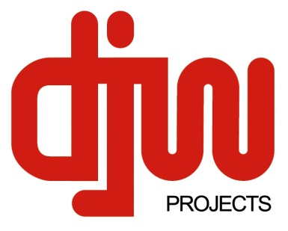
Audio Visual Sales Hire Installation & Service ▪ Energy Management & Turnkey Systems Integration Solutions ▪ Acoustic Analysis & Treatment ▪ Preventative Maintenance ▪ Outside Broadcast ▪ Event Technical Production

AMX Silver Systems Integrator ▪ Dynalite Dimension Dealer & Integrator ▪ Symetrix Preferred Integrator ▪ Smaart Certified ▪ Winner of the 2009 NECA Environmental and Energy Efficiency Award

www.djwprojects.com.au 17/1 Regent St Redfern 2016 Australia

FB: DJW Projects phone +612-9114 9993 fax +612-9699 3526

Disability Action Plan

DJW Projects is a turnkey systems integrator specialising in design and installation of automated or user controlled systems. Our proven strengths in energy management and power mitigation are in demand as power prices continue to rise and many clients seeing real savings.

We sell a wide range of equipment and consumables; operate a 24/7 onsite and workshop service department; have a large sound, lighting and AV stock in our hire department available for short or long term rental; and we provide design and fabrication services for venues. We design and install equipment into commercial and residential premises.

In conjunction with our EEO policy, this action plan is a joint management and staff effort designed to address both internal and external objectives.

The business appreciates that to conduct itself as a good corporate citizen it must promote stewardship to those affected with disabilities and put in place a company plan to address these issues.

Area | Strategy | Time frame | Outcome
General written communications | - Adopt a minimum font size of 12 point  - Address overall design – is it easy to read?  - Send documents in pdf format to allow easier zooming by end users | Sept 2010 | Done
Website | - Posting full articles on the site so they can be accessed and viewed in various sizes  - Be aware of design issues which might impede the visually impaired  - Inclusion of international symbols on web and print information sources | Feb 2011 | In process
Staff attitudes | - All staff members are made aware of issues of accessibility for people with disabilities  - All staff members are encouraged to contribute concepts, ideas and solutions to enhance our active works to assist people with disabilities | ongoing
Internal | - Fabricate a timber ramp to enable wheelchair access off the street directly to the front office  - Rework access to the toilets for ease of wheelchair access  - Install a grab rail in the toilet | Jan 2011 | Done
External | - Communicate with our external stakeholders and gauge their compliance with the legislation as well as looking at methods they use and plans they have  - Look at non stakeholders such as councils, government departments and the like to gauge their compliance with the legislation as well as looking at methods they use and plans they have  - Suggest to our entertainment clients that they install hearing induction loops | ongoing

