Change the
course:
NATIONAL REPORT ON SEXUAL ASSAULT AND SEXUAL HARASSMENT AT AUSTRALIAN UNIVERSITIES • 2017

© Australian Human Rights Commission 2017.
The Australian Human Rights Commission encourages the dissemination and exchange of information presented in this publication and endorses the use of the Australian Governments Open Access and Licensing Framework (AusGOAL).
All material presented in this publication is licensed under the Creative Commons Attribution 4.0 International Licence, with the exception of:
- photographs and images
- the Commission’s logo, any branding or trademarks
- where otherwise indicated.
To view a copy of this licence, visit http://creativecommons.org/licenses/by/4.0/legalcode.
In essence, you are free to copy, communicate and adapt the publication, as long as you attribute the Australian Human Rights Commission and abide by the other licence terms.
Please give attribution to:
© Australian Human Rights Commission 2017.
Change the course: National report on sexual assault and sexual harassment at Australian universities • August 2017 ISBN 978-1-921449-86-4
Acknowledgments
The Australian Human Rights Commission thanks the following organisations for their assistance with this work:
- Universities Australia for providing $950,000 to the Commission to complete the National Survey and submissions process.
- The Hunting Ground Australia Project for providing $150,000 in seed funding for the National Survey.
- A full list of acknowledgments is contained at Appendix 1.
The Change the course: National report on sexual assault and sexual harassment at Australian universities was drafted by Camilla Gebicki, Romana Pomering, Georgia Flynn, Noleen Grogan, Emma Hunt, Jessica Bell, Kishor Napier Raman and Alexandra Meagher.
The Sex Discrimination Commissioner thanks the following staff of the Australian Human Rights Commission: Matt Hall, Padma Raman, Darren Dick, Michelle Lindley, Adrian Flood, Natasha de Silva, Angela Zaballa, Liz Drakopoulos, Laura Sweeney, Anastasia Krivenkova and Mala Wadhera.

This publication can be found in electronic format on the Australian Human Rights Commission’s website at http://www.humanrights.gov.au/about/publications/.
For further information about the Australian Human Rights Commission or copyright in this publication, please contact: Australian Human Rights Commission
GPO Box 5218
SYDNEY NSW 2001
Telephone: (02) 9284 9600
Email: communications@humanrights.gov.au

Design and layout Dancingirl Designs
Printing Growing Positive Solutions
Cover image and internal photography iStock

Change the course:
National report on sexual assault and sexual harassment at Australian universities

Australian Human Rights Commission 2017

Warning: This report contains detailed accounts of sexual assault and sexual harassment, including personal accounts from survivors, which some readers may find distressing.

If anything in this report has affected or distressed you, you can contact the following support services:

  - 1800RESPECT (Ph: 1800 737 732) – National Sexual Assault, Domestic Family Violence Counselling Service
  - Lifeline (Ph: 13 11 14) – 24-hour crisis support and suicide prevention
  - Beyondblue (Ph: 1300 224 636) – Mental health support
  - Suicide Call Back Service (Ph: 1300 659 467)

If you have experienced sexual assault or sexual harassment and feel you would like to speak to someone for support or information, 1800RESPECT (Ph: 1800 737 732) can provide counselling 24-hours a day, 7 days a week.
If you have experienced sexual harassment, you can also make a complaint to the Australian Human Rights Commission by calling our Infoline on 1300 656 419 (local call).
You can also contact the sexual assault support service in your state.

Australian Capital Territory
Canberra Rape Crisis Centre Crisis Line: (02) 6247 2525 Email: crcc@rapecrisis.org.au www.crcc.org.au

New South Wales
NSW Rape Crisis Centre (02) 9819 6565
1800 424 017 (outside Sydney) www.nswrapecrisis.com.au
NSW Health Sexual Assault Services www.health.nsw.gov.au/kidsfamilies/protection/Pages/ health-sas-services.aspx

Northern Territory
Sexual Assault Referral Services (SARC) Alice Springs: (08) 8955 4500
Darwin: (08) 8922 6472
Katherine: (08) 8973 8524
Tennant Creek: (08) 8962 4100

Queensland
Brisbane Rape & Incest Survivors Support Centre (07) 3391 0004
www.brissc.org.au
Sexual Assault Help Line 1800 010 120

South Australia
Yarrow Place Rape & Sexual Assault Service Free call: 1800 817 421
After hours and emergency: (08) 8226 8787

Tasmania
Sexual Assault Support Service 24 hour crisis line: 1800 697 877
Ph: 03 6231 1811
Email: admin@sass.org.au
Laurel House Launceston Ph: (03) 6334 2740
Ph (After hours): 1800 697 877 www.laurelhouse.org.au
Laurel House North West Ph: (03) 6431 9711
Ph (After hours): 1800 697 877 www.laurelhouse.org.au

Victoria
Sexual Assault Crisis Line Free call: 1800 806 292
Email: ahcasa@thewomens.org.au

Western Australia
Sexual Assault Resource Centre (SARC) Crisis 24 hour: (08) 9340 1828
Country areas (free call): 1800 199 888

If you are feeling unsafe right now, call 000.

Contents
Commissioner’s foreword 7
Executive summary 10
- Introduction 31
  - Sexual assault and sexual harassment in Australia: An overview 37
  - Australian law and sexual assault and sexual harassment 38
  - International law and sexual assault and sexual harassment 41
- Sexual assault and sexual harassment at university 46
  - Prevalence of sexual harassment 48
  - Nature of sexual harassment 50
  - Who experiences sexual harassment at university? 52
  - Who are the perpetrators of sexual harassment at university? 58
  - Prevalence of sexual assault 64
  - Who experiences sexual assault at university? 64
  - Who are the perpetrators of sexual assault at university? 68
- Settings in which sexual assault and sexual harassment occur at university 76
  - Survey findings 77
  - Submissions 86
- Impact of sexual assault and sexual harassment 123
  - Mental health impacts 124
  - Impact on studies and career 125
  - Impact on social life 126
- Bystander responses to sexual assault and sexual harassment 131
  - Survey results 132
  - Submissions 140
- Reporting and seeking support following sexual assault or sexual harassment 146
  - Survey results 147
  - Submissions 168
- Attitudes which contribute to sexual assault and sexual harassment at university 196
  - Attitudes towards women 197
  - Attitudes towards sex 199
  - Attitudes towards sexual assault and sexual harassment 200
- Recommendations for change 208
  - Leadership and governance 210
  - Changing attitudes and behaviours 214
  - University responses to sexual assault and sexual harassment 221
  - Monitoring and evaluation 231
  - Residential colleges and university residences 234
Appendices 242
Appendix 1: Acknowledgments 243
Appendix 2: Survey instrument 245
Appendix 3: National survey methodology 281
Appendix 4: Submissions about sexual assault and sexual harassment at university 286

Commissioner’s foreword
Sex Discrimination Commissioner, Kate Jenkins

The Australian Human Rights Commission’s National Report on Sexual Assault and Sexual Harassment at Australian Universities outlines the Commission’s findings on the prevalence and nature of sexual assault and sexual harassment at all Australian universities. It is based on analysis of the data collected through a national survey and a separate submissions process conducted over the second half of 2016.
All 39 universities in Australia, through their peak body Universities Australia, have committed to this work. We appreciate the assistance of Vice-Chancellors, Universities Australia and other university staff who delivered the national survey to their student bodies. We also thank The Hunting Ground Australia Project, whose advocacy has provided a platform for this project and who provided seed funding to the Commission, for their contribution.
This report would not have been possible without the assistance of students who completed the survey or made a submission. On behalf of the Commission, I would like to acknowledge the contribution of those who have shared their experiences. For those who have experienced sexual assault or sexual harassment, it is not easy to relive your experiences. I thank you for your courage and for the guidance and knowledge that you have provided by doing so.
Many other people deserve acknowledgement for their contribution to this project. I wish to thank in particular: Karen Willis, Dr Damian Powell, Professor Andrea Durbach, Allison Henry, Mary McRae, Sharna Bremner, Heidi La Paglia, Nina Funnell, Anna Hush and Abby Stapleton.
A range of organisations provided assistance and advice to the Commission throughout the project. In particular, I acknowledge the contribution made by End Rape on Campus, the Hunting Ground Australia Project, the Australian Human Rights Centre at the University of New South Wales and the National Union of Students.
This report comes after years of advocacy by survivors of sexual assault, student representatives and other organisations to raise public awareness of the issue of sexual assault and sexual harassment at Australian universities.
Sexual assault and sexual harassment have a devastating impact on individuals – physically, emotionally and psychologically. The fact that this behaviour is occurring at universities is of serious concern. The implications are far-reaching for students, due to their vulnerability at this stage of their life cycle where they are maturing into adults and may be away from home for the first time. There are often severe consequences for how they access education and the completion of their studies, which in turn can impact their future careers.

The prevalence of sexual assault and sexual harassment at universities has received considerable focus in a number of countries over recent years, most notably in the United States and United Kingdom. In Australia, there has been a desire to understand the extent to which sexual assault and sexual harassment affects our students and ensure best practice responses, based on comprehensive data.
The information contained in this report paints a disturbing picture of the prevalence rates of these behaviours at Australian universities. Importantly, it also explores how universities have responded to disclosures and reports of incidents of sexual assault and sexual harassment.
There are three unavoidable conclusions of this report:
- sexual assault and sexual harassment are far too prevalent in university settings as they are in the broader community
- there is significant underreporting of sexual assault and sexual harassment to the university, and
- universities need to do more to prevent such abuse from occurring in the first place, to build a culture of respect and to respond appropriately by supporting victims of abuse and sanctioning perpetrators.
The results of the prevalence survey are a reflection of the unacceptably high levels of sexual violence in the broader Australian community. We know from existing research that young people, especially young women between the ages of 18 and 24, are at an increased risk of experiencing sexual violence.
The rates of violence experienced by young people are a call to action for Australian universities. Every young person who is contemplating a university education is entitled to expect that they will be able to study in an environment that is safe and promotes their well- being.
Swift and deliberate action with clear accountability is required by universities to improve their response to sexual violence.
Australia is the first country where an independent human rights agency has been engaged to gather comprehensive national data and share this transparently.
This is a strong indication that Vice-Chancellors in this country intend to act on the findings of this report.
The report contains a series of recommendations to assist universities to deal with the challenges that currently exist. I encourage them to move swiftly to indicate what they will do as a result of this report. And I encourage universities to do so in an inclusive manner that involves robust dialogue with students and staff alike, and responds in a fully integrated way across the full life and community of the university.
The benefits of addressing these issues head on extends beyond the individual reputations of universities and safety of their students. It is critical in informing general attitudes toward women and community safety among the next generation of leaders in Australia.

Implementation of the recommendations in this report can therefore contribute to changing the national culture to one that does not tolerate sexual assault or sexual harassment in any form.
I am committed to assisting universities in this process however I can, and to ensuring that survivors receive the support they need.
This report is the starting point for a new conversation, focused on ensuring that all students can access education in environments that are safe and which enable them to achieve their full potential.

Kate Jenkins

Sex Discrimination Commissioner
July 2017

Executive summary
At the request of Australia’s 39 universities, the Australian Human Rights Commission has conducted a national, independent survey of university students to gain greater insight into the nature, prevalence and reporting of sexual assault and sexual harassment at Australian universities.
The National university student survey on sexual assault and sexual harassment (the National Survey) also examined the effectiveness of university services and policies that address sexual assault and sexual harassment on campus.
The request to conduct this survey follows decades of advocacy on the topic of sexual assault and sexual harassment at universities both within Australia and overseas. The National Survey is the first of its kind and the first attempt to examine in detail the scale and the nature of the problem in Australia.
This work builds on the Commission’s extensive experience leading projects of this nature, including the Review into the Treatment of Women in the Australian Defence Force and conducting national workplace sexual harassment surveys for the past 12 years.
The National Survey measured the experiences of over 30,000 students across all 39 universities and collected information about:
- prevalence of sexual assault and sexual harassment among Australian university students in 2015 and 2016
- characteristics of people who experienced sexual assault and sexual harassment
- characteristics of perpetrators of sexual assault and sexual harassment
- settings where students experienced sexual assault and sexual harassment at university
- reporting of sexual assault and sexual harassment, and
- students’ recommendations for change.
In addition to the quantitative data gathered via the National Survey, a vast amount of qualitative data was gathered through written submissions. The Commission accepted written submissions from 23 August 2016 to 2 December 2016 and received 1849 submissions in total.
This report outlines the findings of the National Survey, provides an analysis of the qualitative information received through the submissions, and makes recommendations for areas of action and reform.

Prevalence of sexual assault and sexual harassment

Overall, the survey results paint a concerning picture of the nature and prevalence of sexual assault and sexual harassment experienced by Australian university students.

Around half of all university students (51%) were sexually harassed on at least one occasion in 2016, and 6.9% of students were sexually assaulted on at least one occasion in 2015 or 2016. A significant proportion of the sexual harassment experienced by students in 2015 and 2016 occurred in university settings.
For the purposes of the National Survey, incidents which occurred in ‘university settings’ included sexual assault and sexual harassment that occurred:
- on the university campus
- while travelling to or from university
- at an off-campus event organised by or endorsed by the university, and
- at university employment.
Experiences of technology-based harassment were included where some or all of the perpetrators were students, teachers or other people associated with the university.
In total, 26% of students were sexually harassed in a university setting in 2016. As described above, ‘university settings’ include incidents that occurred while travelling to or from university. Although travel to or from university is not strictly within the control of universities, it is nonetheless an important part of students’ university experience.
When incidents of sexual harassment which occurred while travelling to or from university are excluded, the Commission found that 21% of students were sexually harassed in a university setting in 2016.
  - % of students reported being sexually assaulted in a university setting (including while travelling to or from university) in 2015 or 2016.1
It is clear from the survey that women experience sexual assault and sexual harassment at disproportionately higher rates than men: they were almost twice as likely to be harassed in 2016 and more than three times as likely to be sexually assaulted in 2015 or 2016.
Overwhelmingly, men were the perpetrators of both sexual assault and sexual harassment reported in the survey. A significant proportion of students who were sexually assaulted or sexually harassed knew the perpetrator, who was most likely to be a fellow student from their university. Postgraduate students were almost twice as likely as undergraduate students to have been sexually harassed by a lecturer or tutor from their university.
The National Survey results add to the body of evidence that highlights the disturbing levels of sexual violence and violence against women in Australia.
Although no directly comparable data is available, the prevalence and nature of sexual assault and sexual harassment in a university setting largely corresponds with what is already known about the prevalence and nature of sexual violence in the broader Australian community.
Existing research indicates that women aged between 18 and 24 experience sexual assault and sexual harassment at disproportionate rates. Since the age of 15, one in five women, and one in 22 men in Australia have experienced sexual violence.2 Young women aged between 18 and 24 – the age group of a significant cohort of university students – experience sexual violence at over twice the national rate.3 18 to 24 year old women are also more likely than men in this age group to have experienced sexual harassment in the workplace.4

Sexual assault and sexual harassment in university settings

The results of the National Survey provide a detailed understanding of where sexual assault and sexual harassment is likely to occur in a university setting.
The National Survey results indicate that sexual assault and sexual harassment are occurring to varying degrees across most areas of university life. Almost a third of the incidents of sexual harassment reported in the survey as happening in a university setting occurred on university grounds or in teaching spaces, while one in five of those who were sexually assaulted said that this occurred at a university or residence social event. Colleges were a particular area
of concern, with women four times as likely as men to have been sexually assaulted in this setting.
The findings are supported by students’ first hand experiences of sexual assault and sexual harassment the Commission received in the submissions process. This information
provides an evidence base for prioritising university responses to sexual assault and sexual harassment, and the Commission’s recommendations for action and reform contained in this report.

Responses to sexual assault and sexual harassment

Our research also revealed that a vast majority of students who were sexually assaulted or sexually harassed in 2015 and 2016 did not make a formal report or complaint to their university.
Common reasons for this were that students who were sexually assaulted or sexually harassed did not believe their experience was serious enough to warrant making a report or that they
did not know how or where to make a report. Students were also unlikely to seek support or advice in relation to their experience of sexual assault or harassment, either from within their university or from external support sources.
It is clear from the results of the survey that students face a range of barriers, both structural and attitudinal, to reporting or seeking support following sexual assault or sexual harassment. In addition, students who did report were often unsatisfied with the response of their university.
The survey results indicated that only 6% of students thought that their university was currently doing enough to provide and promote clear and accessible information on sexual harassment procedures, policies and support services, and only 4% thought this was the case in relation to sexual assault.
These results are a cause for concern for a number of reasons. Firstly, the underreporting of sexual assault and sexual harassment makes it difficult for universities to shape appropriate responses. Secondly, it suggests that universities do not have clear pathways and policies for reporting sexual assault and sexual harassment, and do not foster an environment where reporting is encouraged.
The National Survey demonstrates that more work is needed to not only improve universities’ response to sexual assault and sexual harassment when it occurs, but also to increase the students’ awareness of available responses.

This report recommends the commissioning of an independent, systematic review of universities’ policies in responding to sexual assault and sexual harassment to assess their effectiveness.

Contributing factors to sexual assault and sexual harassment

The qualitative information received through submissions highlighted a number of recurring themes in incidents of sexual assault and sexual harassment that occurred in university settings.
    - Attitudes towards women: The submissions were indicative of some of the underlying attitudes towards women, gender roles, relationships and sex which contribute to sexual assault and sexual harassment at university.
    - Alcohol: Alcohol was often identified as a factor that contributed to people’s experiences of sexual assault and sexual harassment. The Commission received a number of submissions that reported sexual assault while the person being assaulted was unconscious or severely impaired due to the influence of alcohol.
    - Perpetrator abusing a position of power: A common theme was perpetrators abusing their position of power to create situations where they were able to sexually assault or sexually harass. Staff engaging in this behaviour towards students is an obvious area of concern, however submissions also identified instances of senior students in leadership positions sexually assaulting or sexually harassing other students in clubs and societies, at Uni Games, on orientation camps and within residential colleges.
    - Residential settings: Easy access to bedrooms, whether in a residential college, private home, on a university camp or overseas trip, provides perpetrators with a space in which to commit sexual assault or sexual harassment.

Recommendations

Australian universities provide education, pastoral care, recreational opportunities and employment to a cohort of students at increased risk of experiencing sexual assault and sexual harassment. This means that universities are in a unique position to prevent and respond to sexual assault and sexual harassment.
The results of the National Survey provide insight into the areas of university life where sexual assault and sexual harassment are more prevalent, the contributing factors to these behaviours, and the effectiveness of current responses to sexual assault and sexual harassment.
The information contained in this report is a call to action for universities to address these factors and ensure that they are providing students with a safe, supportive learning environment that does not tolerate sexual assault or sexual harassment. It is also an
opportunity for universities to create an institution-wide culture based on inclusiveness, gender equality, respectful behaviour and accountability.

Our findings and recommendations provide a clear pathway to ensuring that the fundamental rights of every student to access and enjoy their education free from the fear of sexual assault or sexual harassment are upheld and protected.
The Commission has made a total of nine recommendations, eight of which are directed to universities and one aimed at university colleges. These recommendations focus on five areas of action:
- Leadership and governance: A strong and visible commitment to action from university leaders, accompanied by clear and transparent implementation of these recommendations.
- Changing attitudes and behaviours: Development of measures aimed at preventing sexual assault and sexual harassment.
- University responses to sexual assault and sexual harassment: An independent, systematic review of university responses to sexual assault and sexual harassment and their effectiveness and the implementation of effective processes for responding to sexual assault and sexual harassment.
- Monitoring and evaluation: Ensuring that steps taken to prevent and respond to sexual assault and sexual harassment are evidence-based and that improvements are made over time.
- Residential colleges and university residences: A review to further examine issues and solutions to address sexual assault and sexual harassment within residential colleges and university residences.

Key findings

Prevalence of sexual harassment

The results of the National Survey reveal that students’ gender, sexual orientation, culturally and linguistically diverse backgrounds, Aboriginal and Torres Strait Islander status, disability status and age may impact on their experience of sexual harassment.
The results of the National Survey reflect existing research about the prevalence of sexual harassment in Australia more broadly, which indicates that women aged 18 to 24 experience higher rates of sexual harassment in the workplace than any other age group.5
The National Survey shows:
      - 51% of students were sexually harassed on at least one occasion in 2016.
      - 21% of students were sexually harassed in one of the following university settings: on campus, at an off-campus event organised by or endorsed by the university, at university employment or, for technology-based harassment, where some or all of the perpetrators were students, teachers or other people associated with the university.

- 26% of students were sexually harassed in one of the above university settings and/or while travelling to or from university in 2016.
- Women were almost twice as likely as men to have been sexually harassed in a university setting in 2016.
- 44% of students who identified as bisexual and 38% of students who identified as gay, lesbian or homosexual were sexually harassed in a university setting in 2016, compared with 23% of students who identified as heterosexual.
- Trans and gender diverse students (45%) were more likely to have been sexually harassed in a university setting in 2016 than women and men.
- Domestic students (27%) were slightly more likely than international students (22%) to have been sexually harassed in a university setting in 2016.
- Though sample sizes were small, Aboriginal and Torres Strait Islander students and students with disability were more likely to have been sexually harassed in 2016 than non-Indigenous students and students without disability.
- Undergraduate students (28%) were more likely than postgraduates (19%) to have been sexually harassed in a university setting in 2016.

Prevalence of sexual assault

Overall, the prevalence of sexual assault among university students is concerning and reflects existing research about rates of sexual assault in the Australian community more broadly, where young women between the age of 18 and 24 experience sexual assault at twice the national rate.
As with sexual harassment, gender and other characteristics such as sexual orientation, gender, culturally and linguistically diverse backgrounds, Aboriginal and Torres Strait Islander status, disability status and age can impact on an individual’s experiences of sexual assault at university.
- Overall, 6.9% of students were sexually assaulted on at least one occasion in 2015 or 2016, with 1.6% reporting that the sexual assault occurred in a university setting.
- Women (10%) were more than three times as likely as men (2.9%) to have been sexually assaulted in 2015 or 2016.
- Women were also more likely than men to have been sexually assaulted in a university setting in 2015 or 2016 (2.3% compared with 0.7% for men).
- Students who identified as bisexual (3.8%) were also more likely than those who identified as heterosexual (1.5%) or gay/lesbian/homosexual (1.4%) to have been sexually assaulted in a university setting in 2015 or 2016.
- Though sample sizes were small, Aboriginal and Torres Strait Islander students and students with disability were more likely to have been sexually assaulted in 2015 or 2016 than non-Indigenous students and students without disability.

The perpetrators of sexual assault and sexual harassment

The majority of perpetrators of most recent incidents of sexual assault or sexual harassment in a university setting were male, and in approximately half of these incidents, were known to the victim.
The National Survey results indicate that university students may be at greater risk of being sexually assaulted or sexually harassed by a person not previously known to them than the broader Australian community.6
However, a significant proportion of both sexual assault and sexual harassment was perpetrated by a person known to the victim. This highlights the need for universities to take measures to prevent sexual assault and sexual harassment and to ensure they respond appropriately to support victims and hold perpetrators accountable in situations where both are associated with the same university and are likely to attend the same campus, classes, or social events.
  - Almost half (45%) of students who were sexually harassed in a university setting knew some or all of the perpetrators of the most recent incident.
  - The majority (51%) of students who were sexually assaulted in a university setting knew some or all of the perpetrators of the most recent incident.
  - The majority of students who were sexually assaulted or sexually harassed in a university setting in 2015 or 2016 said that the perpetrator of the most recent incident was male (71% for sexual harassment and 83% for sexual assault).
  - Among those who had been sexually harassed in a university setting by someone they knew, more than two thirds (68%) said that the perpetrator(s) of the most recent incident was a student from their university.
  - Among those who had been sexually assaulted in a university setting by someone they knew, over half (57%) said that the perpetrator(s) of the most recent incident was a student from their university.

Settings in which sexual harassment occurred

The most common setting in which most recent incidents of sexual harassment occurred in 2015 or 2016 was on public transport to or from university. One in five students also
experienced technology-based sexual harassment in 2016, although not necessarily in a way connected with their university.
While both public transport and the use of technology such as email and social media by students and staff are beyond universities’ direct control, these findings highlight the
importance of prevention activities by universities, especially where the perpetrator of sexual harassment is another university student or staff member.

- Students who were sexually harassed in a university setting in 2015 or 2016 were most likely to have experienced the most recent incident of sexual harassment on public transport on the way to or from university (22%), on university grounds (14%) or in a university teaching space (13%).
- Of most recent incidents of sexual harassment which occurred on public transport, 57% of perpetrators were students from their university. Men were most commonly sexually harassed in university teaching spaces (17%). In relation to the most recent incident, women (25%) were more likely than men (13%) to have been sexually harassed on public transport to or from the university.
- More than one in five (22%) students experienced technology-based sexual harassment in 2016, including repeated or inappropriate advances on email, social networking websites and internet chat rooms and sexually explicit emails or SMS messages.

Settings in which sexual assault occurred

Most recent incidents of sexual assault in a university setting most commonly occurred at a university or residence social event. While men were more likely to be sexually assaulted at a university or residence social event, women were significantly more likely to have experienced sexual assault at a residential college or university residence.
These findings, coupled with the information received from the submissions process, provide a more detailed understanding of the university settings that carry an increased risk of sexual assault, and the underpinning factors which contribute to these behaviours. Further work recommended by the Commission will assist in shaping prevention and response activities within universities and residential colleges.
- Students who were sexually assaulted in a university setting in 2015 or 2016 were most likely to have experienced the most recent incident at a university or residence social event (21%), on public transport to or from university (15%), on university grounds (10%) or at a residential college or university residence (10%).
- Men (29%) were more likely than women (20%) to have experienced the most recent incident of sexual assault at a university or residence social event.
- Women (12%) were significantly more likely than men (3%) to have been sexually assaulted at a residential college or university residence in the most recent incident.

Bystander responses to sexual assault and sexual harassment

A majority of students who had witnessed an incident of sexual assault or sexual harassment failed to take any action in response. This highlights the need for universities to provide appropriate bystander education to equip students to take appropriate action when witnessing an incident of sexual assault or sexual harassment.
- One in four (25%) students witnessed another student being sexually harassed in a university setting in 2016.

  - 1.1% of students witnessed another student being sexually assaulted in a university setting in 2016.
  - Students who witnessed other students being sexually assaulted or sexually harassed in a university setting usually did not take any action in response.
» 21% of people who saw another student being sexually harassed in 2016 took action in response to the incident.
» 37% of people who saw another student being sexually assaulted in 2016 took action in response to the incident.
  - The most common reasons bystanders did not take any action were that they did not think it was serious enough to intervene or that they did not know what to do.

Reporting and seeking support following sexual assault or sexual harassment

An overwhelming majority of students who were sexually assaulted or sexually harassed in a university setting did not report the most recent incident to their university or seek support or assistance from their university. The reasons for not reporting were varied, and ranged from the victims not considering the incident serious enough to report, to not knowing where to formally report an incident.
Creating a safe, supportive environment that encourages the reporting of sexual assault and sexual harassment is the first step to ensuring appropriate processes are in place for victim support and perpetrator accountability. An environment that encourages reporting and provides clear and accessible information on available support services forms a part of an organisational culture that does not tolerate sexual assault and sexual harassment.
  - Of students who were sexually harassed in a university setting, 94% did not make a formal report or complaint to anyone at the university and 92% did not seek support or assistance from their university in relation to the most recent incident.
  - Of students who were sexually assaulted in a university setting, 87% did not make a formal report or complaint to anyone at the university and 79% did not seek support or assistance from their university following the most recent incident.
  - 18% of students who were sexually harassed and 36% of students who were sexually assaulted sought support from outside the university in relation to the most recent incident.
  - 68% of students who experienced sexual harassment in a university setting did not make a formal report or complaint about the most recent incident because they did not think their experience was serious enough, while 53% did not think they needed help.
  - 40% of students who experienced sexual assault in a university setting did not report the most recent incident because they did not think it was serious enough, while another 40% felt they did not need any help.

- The majority of students had little or no knowledge about where they could go to formally report or make a complaint about an experience of sexual harassment (60% of students) or sexual assault (62%).

Recommendations

In response to the National Survey results and the qualitative information received from submissions, the Commission has made nine recommendations for reform and further work to improve the prevention of and response to sexual assault and sexual harassment in Australian universities.
The recommendations focus on five areas of action: leadership and governance; changing attitudes and behaviours; university responses to sexual assault and sexual harassment; monitoring and evaluation; and residential colleges and university residences.

Leadership and governance

This report identifies that sexual assault and sexual harassment, while more prevalent in certain settings, are occurring to some degree in most areas of university life.
It is evident that improved measures for preventing and responding to sexual assault and sexual harassment are necessary, and the recommendations detailed below are designed to assist universities’ to address prevention and response.
As with the implementation of any significant reform, leadership and organisational support play a crucial role. The Commission’s first recommendation therefore, focuses on establishing the required governance structures and ensuring the leadership of Vice-Chancellors for a timely and comprehensive implementation of these recommendations.
There are core principles which should underpin universities’ approach to addressing sexual assault and sexual harassment. It is important that action:
- is led by Vice-Chancellors
- engages all levels of the university (including students)
- is transparent, and
- is based on evidence and expertise.

Recommendation 1
Vice-Chancellors should take direct responsibility for the implementation of these recommendations, including decision-making and monitoring and evaluation of actions taken.
To assist and advise them in this respect, Vice-Chancellors should have an advisory body within their institution which has responsibility for guiding the implementation of the recommendations made in this report.
The advisory body should report directly to the Vice-Chancellor of each university and include representatives from:
- the university’s senior leadership
- the student body
- academic staff
- residential colleges affiliated with the university
- student services, such as: counselling services, medical services and campus security, and
- frontline sexual assault services.
The advisory body should be responsible for developing an action plan for the implementation of these recommendations.
The development of an action plan should involve broad and extensive consultation with all relevant stakeholders from the university community and, where relevant, the wider community. The advisory body should also seek independent expertise where relevant and draw on existing research and best practice.
The advisory body should assess and publicly report on the university’s progress towards implementation of these recommendations within 18 months of the release of this report. From then on, public reporting on progress should occur on an annual basis.

Changing attitudes and behaviours

Women experience disproportionately high rates of sexual assault and sexual harassment. Research indicates that sexual assault and sexual harassment are often driven by deeply held norms and attitudes about women, their role in society and relationships between men and women.
Universities have an opportunity to prevent sexual assault and sexual harassment from occurring by addressing their underlying causes. Actions addressing attitudes and norms about gender roles and relationships are integral to preventing sexual assault and sexual harassment, and reducing the prevalence of these behaviours over the long term.

Recommendation 2
Universities develop a plan for addressing the drivers of sexual assault and sexual harassment that:
- provides students and staff with education about: behaviours that constitute sexual assault and sexual harassment, consent and respectful relationships, ‘violence supportive attitudes’ and bystander intervention, and
- identifies existing resources and communications campaigns that reinforce key messages of education programs for dissemination to staff and students.
Education programs and communications should:
- target all levels of the organisation – current and future students, staff, residential colleges, public transport to/from university, sports clubs, student societies and student unions
- be based on best practice and research
- be developed and delivered by individuals and/or organisations with expertise in sexual violence prevention
- be developed in consultation with university students, and
- include measures for evaluating and refining the actions taken.

University responses to sexual assault and sexual harassment

The National Survey indicates that very few students who experienced sexual assault or sexual harassment in a university setting reported the incident either externally or to their university. Only 2% of students who experienced sexual harassment and 9% of students who experienced sexual assault in a university setting in 2015 or 2016 said that they had made a formal report or complaint to the university.
A greater number of people had disclosed the incident or sought support and assistance from family, friends or a university staff member, however the overwhelming majority did not seek any form of formal or professional support or advice from their university or externally.
The National Survey also highlighted that the majority of students had little or no knowledge about where they could go to formally report or make a complaint about an experience
of sexual harassment. It is critical that students and staff are aware of the university’s reporting policies and processes and available support services. Therefore, the Commission recommends that universities take action to ensure information about reporting avenues and support services is widely disseminated and easily accessible.

Recommendation 3
In order to ensure students and staff know about support services and reporting processes for sexual assault or sexual harassment, universities should:
- widely disseminate information about university reporting avenues to staff and students
- widely disseminate information about internal and external services to staff and students, including: university counselling and medical services, campus security, local sexual assault services, police, medical centres, hospitals, counselling services and anti-discrimination agencies
- ensure that information about internal and external reporting procedures and support services is displayed clearly, in a logical place(s) on the university website
- ensure that information about internal and external reporting procedures and support services is provided to students as part of their orientation into university and to new staff as part of their human resources induction/on-boarding
- ensure that information about internal and external reporting procedures and support services is accessible to all students and staff, including: people with disability, people from CALD backgrounds, and
- develop relationships with external services (local sexual assault service, local hospital) to enable referral of students to these services where necessary.
Universities should evaluate the activities undertaken to increase awareness of support services and reporting processes to ensure that these measures have been effective in increasing awareness among staff and students.

University policies and procedures for responding to reports and disclosures of sexual assault and sexual harassment should be supportive of the person who has experienced the sexual assault or sexual harassment, respect their rights and those of the perpetrator, and ensure
a trauma-informed, fair process and perpetrator accountability. An appropriate response is critically important, particularly in cases where both are students at the same university and may attend the same campus, classes or social events.
The Commission recommends further work is required to gain a comprehensive understanding of the way in which universities respond to sexual assault and sexual harassment and the effectiveness of those responses.
In addition, universities must take steps to ensure that students who experience sexual assault or sexual harassment have access to specialist support, from a service provider with the required expertise and training in this area.

Recommendation 4
In order to ensure that actions taken by universities to prevent and respond to sexual assault and sexual harassment are appropriate, within a year of the release of this report, universities should commission an independent, expert-led review of existing university policies and response pathways in relation to sexual assault and sexual harassment. This review should assess the effectiveness of existing university policies and pathways and make specific recommendations to universities about best practice responses to sexual assault and sexual harassment.
In the interim, and at an institutional level, universities should draw on sexual violence counselling expertise to develop and review processes for responding to sexual assault and sexual harassment of students to ensure that they:
- secure the immediate safety and wellbeing of the individual who has experienced the sexual assault or sexual harassment
- are clear and accessible
- provide individuals with control over what happens to their report
- have the flexibility to suit individual circumstances
- provide students with support to continue with their studies
- provide specialist support, from someone who has specialist expertise and training in sexual assault, sexual harassment and trauma counselling of sexual assault survivors, and
- accommodate the needs of students from a diverse range of backgrounds.

A fundamental element of an effective response to sexual violence is ensuring that those receiving reports and disclosures of sexual assault and sexual harassment are appropriately trained and know how to respond.
In submissions, students who did report or seek support from their university in relation to sexual assault or sexual harassment often identified a lack of training among university staff and students in dealing with disclosures of sexual violence.
The information received by the Commission also indicated that many students disclosed their experiences to a trusted member of staff, such as a lecturer, or a student representative, such as their university women’s officer. These individuals are often not trained to provide support to victims of sexual assault and sexual harassment, and may experience vicarious trauma as a result of being exposed to the traumatic experiences of others.

Training is therefore important to ensure that those individuals who are likely to receive disclosures of sexual assault and sexual harassment are able to respond in an effective, supportive way and to recognise and take appropriate action in response to vicarious trauma. This training should be provided by an external service provider with expertise in the areas of sexual assault and sexual harassment.

Recommendation 5
Universities should conduct an assessment to identify staff members and student representatives within their institution most likely to receive disclosures of sexual assault and sexual harassment.
Universities should ensure that these staff members and student representatives receive training in responding to disclosures of sexual assault and sexual harassment, delivered by an organisation with specialist expertise in this area.

Monitoring and evaluation

The actions universities take to prevent and respond to sexual assault and sexual harassment should be evidence-based and evaluated.
It is recommended that universities collect their own data about reports and disclosures of sexual assault and sexual harassment, in order to track the effectiveness and appropriateness of their responses to sexual assault and sexual harassment over time.
Universities should also continue to obtain independent data about rates of sexual assault and sexual harassment at their institution. Collecting this information periodically will enable universities to measure the effectiveness of the steps they take to address these behaviours.
A commitment to obtaining independent data about sexual assault and sexual harassment may also improve public confidence in universities’ commitment to positive change. Maintaining and increasing public confidence in universities as safe and supportive learning environments and communities is important and may encourage those who experience sexual assault and sexual harassment to come forward and report to, or seek support from, their institution.

Recommendation 6
Universities should ensure that information about individual disclosures and reports of sexual assault and sexual harassment is collected and stored confidentially and used for continuous improvement of processes, including:
- details of the complaint/incident
- steps taken to respond to the complaint/incident, i.e.: whether the individual reported to police, whether the perpetrator was moved to a different lecture/tutorial
- support or assistance received, i.e.: whether the person received counselling from university services, whether they reported to police, whether they received support from an external sexual assault service
- time taken to respond to the report and/or refer the person to support services, and
- any feedback provided by the complainant/respondent in relation to the process.
Access to this information should be limited to staff members with responsibility for responding to disclosures and reports and those responsible for improving university responses to disclosures and reports.
On a regular basis – at least every six months – Vice-Chancellors should be provided with de-identified reports of this data, including any trends or identifiable concerns which arise, along with recommendations for any necessary improvements to processes.

Recommendation 7
Within six months of this report, but as soon as possible, universities should conduct an audit of university counselling services to assess:
- the capacity of university counselling services to respond to students’ requests for counselling in an appropriately timely manner, and
- how many university counselling staff have received training in working with sexual assault survivors.
As part of this audit, universities should collect data on:
- the average length of time students are required to wait to see a university counsellor, and
- the number of urgent/crisis requests for counselling received.
This data should be assessed to determine whether additional counselling services are required to meet the urgent needs of students who have experienced sexual assault or harassment.
If additional counselling services are required, universities should ensure that these additional resources are in place as soon as practicable.

Recommendation 8
Universities should engage an independent body to conduct the National university student survey of sexual assault and sexual harassment at three yearly intervals to track progress in reducing the prevalence of these incidents at a sector-wide level.

Residential colleges and university residences

While the style and mode of social and academic life vary considerably within and between universities, residential colleges play a significant role in shaping the university experience, as well as the attitudes and behaviours, of the students who reside there. University-affiliated residential halls and colleges present a unique environment in which young people, generally aged between 17 and 24, live, work, study and socialise within close proximity to each other and away from parents and family, typically for the first time.
Colleges and university residences have a duty of care to their students, and students have a reasonable expectation that their college will provide them with a safe and supportive environment.

The results of the National Survey, which indicate a relatively high prevalence rate of sexual assault and sexual harassment within residential colleges and university residences, suggest that more needs to be done to provide the safest possible environment for students living in residential colleges and university residences.
A large number of submissions received by the Commission also related to residential colleges and university residences, providing rich qualitative information on many aspects of residential college and university residence culture and practice which are cause for concern, and in the Commission’s view, warrant further investigation.

Recommendation 9
In addition to considering the implementation of the university recommendations made in this report, residential colleges and university residences should commission an
independent, expert-led review of the factors which contribute to sexual assault and sexual harassment in their settings.
This review should consider:
- appropriate responses by a college or university residence to reports of sexual assault and sexual harassment
- a trauma-informed and rights-based approach in a situation in which an allegation of sexual assault has been made
- the ways that hazing practices and college ‘traditions’ facilitate a culture which may increase the likelihood of sexual violence
- the role of alcohol in facilitating a culture which may increase the likelihood of sexual violence
- the level and nature of supervision in a twenty-four hour residential setting in which large numbers of young people are living away from home, and
- the level and adequacy of training required to equip residential advisors to serve as first responders or in response to matters of sexual assault and harassment.

Executive summary: Endnotes

- There is no comparable data from the National Survey which provides a prevalence rate for sexual assault which occurred in university settings excluding incidents which occurred while travelling to or from university.
- Peta Cox, Violence against women: Additional analysis of the Australian Bureau of Statistics’ Personal Safety Survey, 2012 (2015) Australia’s National Research Organisation for Women’s Safety. At http://media.aomx. com/anrows.org.au/s3fs-public/151022%20Horizons%201.1%20PSS.pdf (viewed 3 February 2017).
- Peta Cox, Violence against women: Additional analysis of the Australian Bureau of Statistics’ Personal Safety Survey, 2012 (2015) Australia’s National Research Organisation for Women’s Safety. At http://media.aomx. com/anrows.org.au/s3fs-public/151022%20Horizons%201.1%20PSS.pdf (viewed 3 February 2017).
- Australian Human Rights Commission, Working without fear: Results of the Sexual Harassment National Telephone Survey (2012) 28. At https://www.humanrights.gov.au/our-work/sex-discrimination/publications/ working-without-fear-results-sexual-harassment-national (viewed 3 February 2017).
- Australian Human Rights Commission, Working without fear: Results of the Sexual Harassment National Telephone Survey (2012) 4. At https://www.humanrights.gov.au/our-work/sex-discrimination/publications/ working-without-fear-results-sexual-harassment-national (viewed 3 February 2017).
- Australian Human Rights Commission, Working without fear: Results of the Sexual Harassment National Telephone Survey (2012) 36. At https://www.humanrights.gov.au/our-work/sex-discrimination/publications/ working-without-fear-results-sexual-harassment-national (viewed 3 February 2017). Australian Bureau of Statistics, 2012 Personal Safety Survey – Tables 4, 5, 35-37, cat no. 4906.0 (2013). At http://www.abs.gov.au/ AUSSTATS/abs@.nsf/DetailsPage/4906.02012?OpenDocument (viewed 24 March 2017).

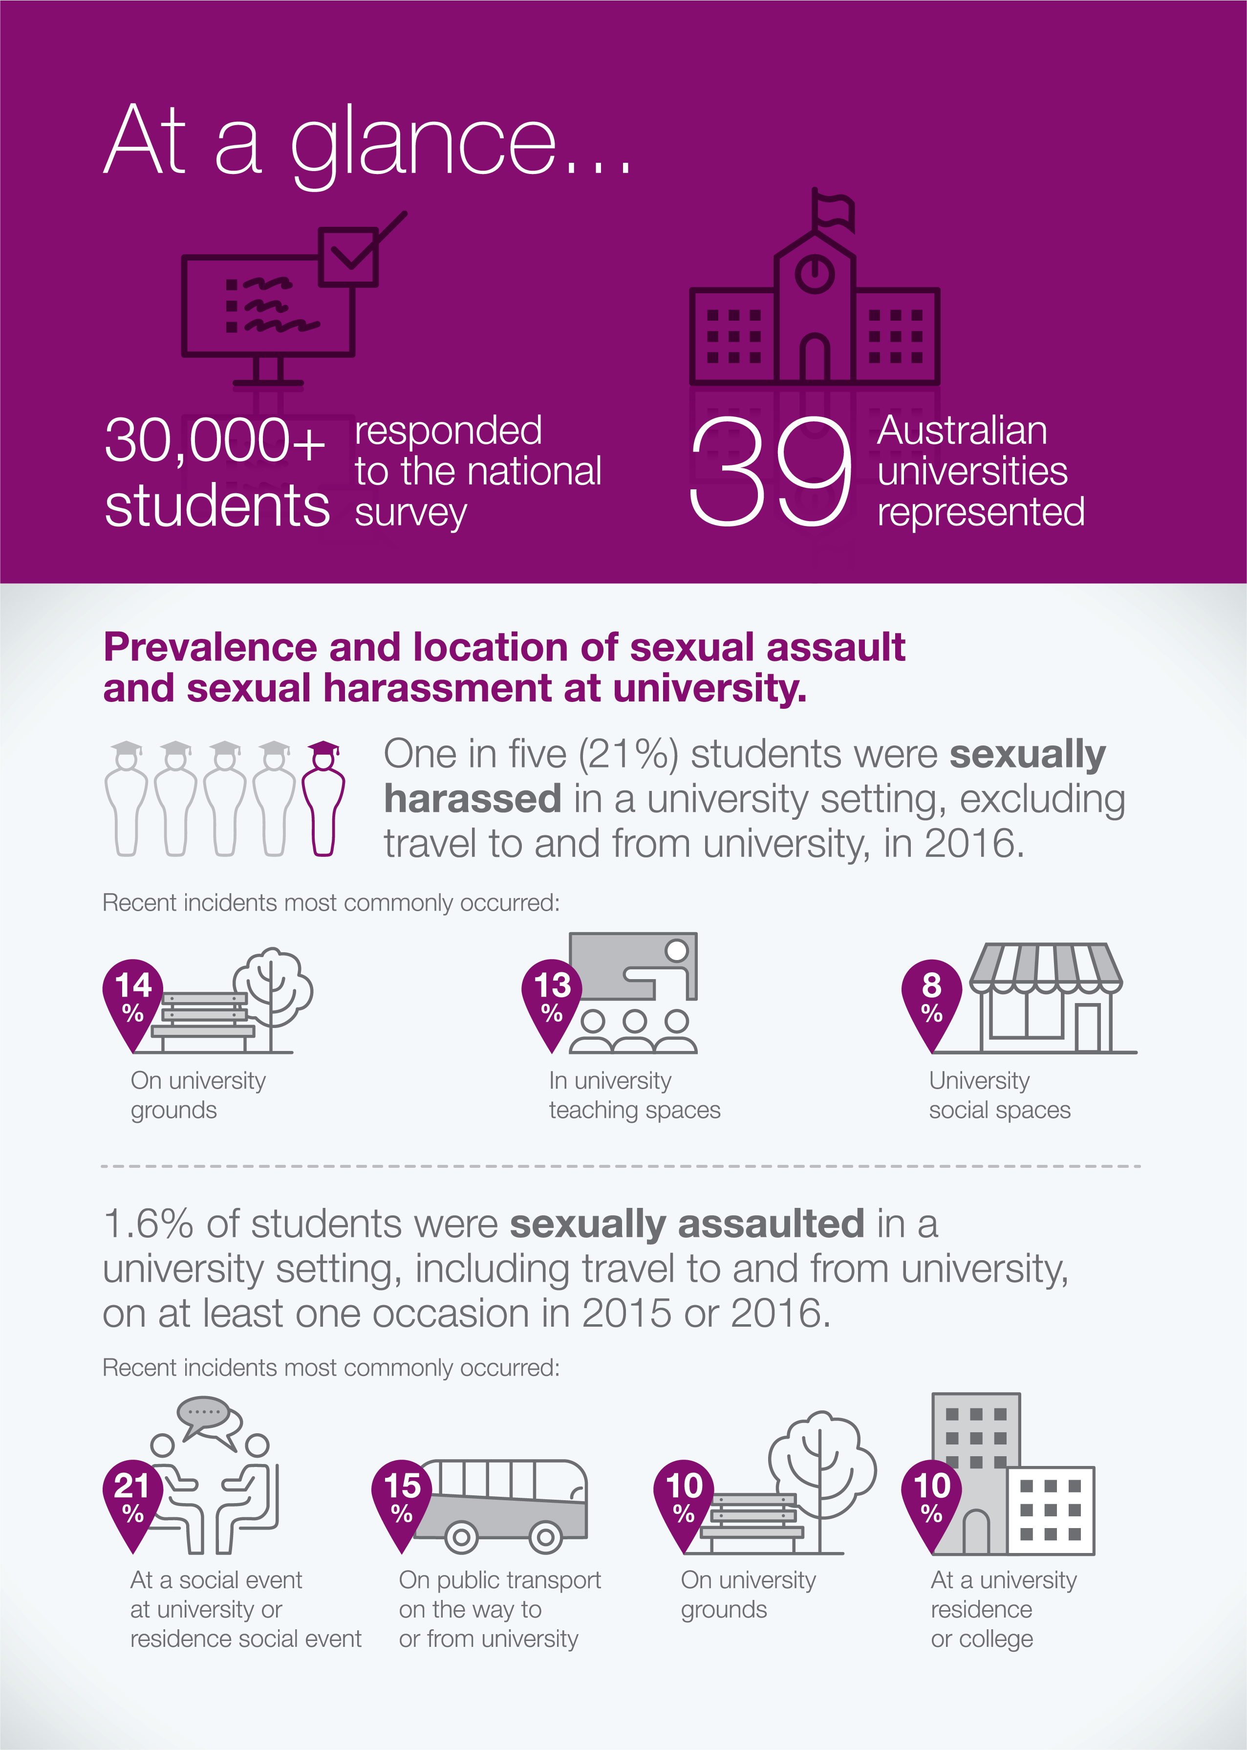

1 Introduction
More than one million students are currently enrolled at Australia’s universities.1
A university education is a crucial milestone in the lives of many young people. Higher education provides the opportunity for students to gain qualifications and skills that will make them competitive in the labour market. University is a time when many students turn their minds to their future careers and continue the transition towards increased independence.
The impact that university has on a person’s life extends beyond the classroom and lecture theatre. University is a place where students broaden their social and future professional networks. It is often their first time living away from home, at a time when they are maturing into adulthood. Many students live on campus at residential colleges and halls or in shared accommodation with fellow students during their studies.
The information set out in this report outlines a university experience shared by far too many Australian university students. Sexual assault and sexual harassment, whether they occur on a university campus or in another setting, can have a devastating impact on students’ lives.
Institutional failures to respond appropriately to these incidents can also be damaging for individuals, often compounding existing trauma.
The issue of sexual assault and sexual harassment within Australian universities is not new. There is extensive anecdotal evidence suggesting that this is an area of concern, including numerous media reports of incidents of sexual assault and sexual harassment, particularly at residential colleges.2
Advocates and survivors have also raised awareness of the issue, making it clear that concrete action is needed. The experiences of the higher education sectors overseas, particularly in the United States and United Kingdom, suggests that Australia is not alone in grappling with sexual assault and sexual harassment at universities.3
The prevalence of these behaviours and how they are dealt with has not previously been explored in detail. This report is the first attempt to examine in detail the scale and nature of the problem.
Experience from other, similar work, within the Australian Defence Forces and Victoria Police indicates that independent data and information is the first step in a longer journey towards positive change.
This report marks an important milestone in terms of universities confronting sexual assault and sexual harassment within their institutions. All 39 universities are to be commended for engaging the Commission to undertake this work, so that they can understand the nature of the challenges they face.
It is also a testament to the conviction and dedication of survivors and advocates, who have been tireless in bringing these issues to national attention. Their efforts have been instrumental in reaching this point.

Methodology

The findings and recommendations in this report are based on an independent assessment of the prevalence, nature and consequences of sexual assault and sexual harassment at universities. This assessment includes a detailed examination and analysis of both quantitative and qualitative research.

Quantitative data

The Commission engaged Roy Morgan Research to conduct the National university student survey on sexual assault and sexual harassment (the National Survey).
The National Survey received ethics approval from the Human Research Ethics Committee at the University of New South Wales on 4 August 2016.
A range of organisations with expertise in survey design and methodology were consulted in the development of the survey, including:
- Roy Morgan Research
- Australian Bureau of Statistics
- Department of Defence
- Rape and Domestic Violence Services Australia
- National Sexual Assault, Domestic Family violence Counselling Service (1800RESPECT), and
- Australian Human Rights Centre at the University of New South Wales.
The National Survey measured the experiences of over 30,000 students across all 39 Australian universities. The survey was distributed online, to a stratified sample of 319,252 students. A total of 30,930 responses were received, representing an overall response rate of 9.7% of the issued sample.
The National Survey provides the first nationally representative data on students’ experiences of sexual assault and sexual harassment at university, and collected information about:
- whether students had experienced sexual assault or sexual harassment in university settings in 2015 and/or 2016
- where students experienced sexual assault and sexual harassment in university settings

- the perpetrators of sexual assault and sexual harassment
- reporting of sexual assault and sexual harassment, and
- students’ recommendations for change.
The National Survey focussed on sexual assault and sexual harassment which occurred ‘in a university setting’, including incidents which occurred on the university campus, while travelling to and from university, at an off-campus event organised by or endorsed by the university, at university employment, or, for technology-based harassment, where some or all of the perpetrators were students, teachers or other people associated with the university.
Although the Commission acknowledges that some locations, in particular public transport to and from university, are not within the control of universities, this information has been included because travel to and from university was considered an important part of students’ university experience.

Notes on reading the prevalence data

Given the small sample sizes of respondents with a disability and Aboriginal and Torres Strait Islander respondents, the findings for these groups should be regarded as indicative only and care should be taken when extrapolating these findings to the general population.
The survey data has been derived from a sample of the target population who were motivated to respond, and who made an autonomous decision to do so. It may not necessarily be representative of the entire university student population.
An independent analysis of the data was conducted in order to assess whether any ‘response bias’ existed in relation to the survey, by examining the relationship between university response rates and the extent to which people said they had experienced or witnessed sexual assault or sexual harassment.
‘Response bias’ can occur where people who had been sexually assaulted or sexually harassed are more likely to respond to the survey than those who had not. Conversely, ‘non-response bias’ can occur where people who had been sexually assaulted or sexually harassed choose not to respond to the survey because they felt it would be too difficult or traumatic. Either of these can impact on the accuracy of the results.

This analysis found that universities with a higher proportion of survey respondents who said they had witnessed sexual harassment at university in 2016 had higher response rates. This indicates that survey respondents who witnessed sexual harassment in 2016 may have been more likely to respond to the National Survey.
An examination of the responses from men and women revealed that for men, there was a positive association between response rates and experiencing or witnessing sexual assault or sexual harassment.
This indicates that men who had experienced or witnessed sexual assault or sexual harassment may have been more likely to complete the survey. Therefore, caution must be taken in relation to our results which are projected to the population of male students. These may be an overestimation of the rates of sexual assault and sexual harassment experienced by male university students.
No such ‘response bias’ was identified in relation to women and we are therefore more confident in projecting these results to the population of female university students.
All results are rounded to the nearest whole number, except those results that relate to the prevalence of sexual assault. These have been rounded to the nearest decimal place to ensure greater accuracy, due to the smaller sample sizes of people who have been sexually assaulted at university.

Qualitative data

A large amount of qualitative information was received through written submissions, to inform this report and our recommendations. Although this report refers to alleged sexual assault and sexual harassment, it should be noted that the scope of this work did not extend to investigating or making findings or determinations with regard to any specific incidents. The qualitative information is used to inform the analysis of the quantitative data and to provide illustrative examples of students’ experiences of sexual assault and sexual harassment.
A call for submissions was disseminated via the Australian Human Rights Commission’s website and on the Commission’s social media platforms. Universities, student groups and other organisations also promoted the submissions process through their social media channels.

The Commission accepted written submissions from 23 August 2016 to 2 December 2016.
While the National Survey data relates to 2015 and/or 2016, the submission process was not restricted to the same time period and the majority of submissions received did not specify the timing of the incident(s) reported. Therefore, no direct correlation can be drawn between the survey data and the information received through submissions. The qualitative information is used to inform the analysis of the quantitative data and to provide illustrative examples of students’ experiences of sexual harassment and sexual assault.
It should also be noted that an open call for submissions presents some limitations. The first is that people self-selected to make submissions. This means that their experiences are not necessarily representative of the Australian university student population as a whole. Additionally, the quotes and case studies from submissions are a reflection of the personal experiences of the individual who made the submission.
Notwithstanding this, many of the experiences and themes detailed in submissions are confirmed by previously published empirical research.
A total of 1849 submissions were received, 1846 of which were confidential and from individuals. The Commission also received submissions from three organisations.
The submissions were analysed by Commission staff to identify emerging themes. The information from submissions, although anecdotal in nature, illustrates the issues identified by the quantitative data in this report through quotes and case studies.
In all quotes and case studies used in this report, names and/or particularly distinctive details have been changed or omitted to ensure no individual can be identified. As a further precaution, no associated demographic information that could be used to identify individuals has been reported.

Principles underpinning our methodology

Evidence based

The Commission based its findings and suggested areas for action and reform on the extensive quantitative data and qualitative information gathered through the survey and submissions, as well as on existing academic and social policy research.

Consultative and inclusive

The Commission aimed to give every current university student, as well as past students and other interested parties, the opportunity to contribute to the findings in this report.
The Commission took measures to promote the call for submissions and survey as widely as possible.

Voluntary

Involvement of participants in the National university student survey on sexual assault and sexual harassment (the National Survey) and the submissions process was voluntary.

Confidential

The survey information was gathered anonymously, and information received through submissions has been de-identified and confidentiality has been strictly maintained.
In addition, the Commission ensured that individuals who shared their experiences of sexual assault and sexual harassment were informed of the support services available nationally and in their state or territory.

Sexual assault and sexual harassment in Australia: An overview
There is no existing data on the prevalence of sexual assault and sexual harassment within Australian universities, however national data on sexual assault and sexual harassment in Australia does provide some context.
Current data indicates that sexual assault and sexual harassment are experienced by a significant proportion of the Australian population and that women are disproportionately affected by these behaviours.
In 2012, the Australian Bureau of Statistics estimated that 17% of women and 4% of men aged 18 years and over have been sexually assaulted since the age of 15.4
Research by the Australian Human Rights Commission in the 2012 Working Without Fear: National Telephone Survey, found that 33% of women and 9% of men have been sexually harassed since the age of 15.5
This prevalence study also found that:
    - Approximately one in five (21%) people aged 15 years and older has experienced sexual harassment in the workplace in the past five years.
    - Women (25%) were much more likely than men (16%) to be sexually harassed in the workplace during this period.
    - Both men and women are more likely to be sexually assaulted and sexually harassed by a man.
Very few people who experience sexual assault and sexual harassment report their experience. In 2012, only 17% of women who had been sexually assaulted in the last
12 months had contacted the police.6 78% of women and 83% of men who had been sexually harassed in the workplace said that they did not make a report or complaint.7
There is also evidence to suggest that particular groups, such as young people, Aboriginal and Torres Strait Islander people, lesbian, gay, bisexual and trans (LGBT) people, people from culturally and linguistically diverse (CALD) backgrounds and people with a disability may experience higher rates of sexual assault and sexual harassment than the general Australian population.
The Commission’s Working Without Fear: National Telephone Survey found that young people are at greater risk of sexual harassment in the workplace. In 2012, 18 to 24 year olds were most likely to experience sexual harassment in the workplace, representing 21% of those who were sexually harassed in the past 5 years.8
Similarly, the 2012 ABS Personal Safety Survey found that young people aged between 18 and 24 are the group most likely to have experienced some form of violence.9 Women in this age group are four times more likely to experience sexual assault than young men.10 Women aged 18 to 24 also experience sexual assault at twice the rate of women nationally and ten times the rate of women over the age of 55.11

The National LGBTI Health Alliance reports that ‘regardless of their actual identity, a young person whose sexual orientation, sex or gender identity is perceived to be non-conforming is frequently the target of verbal and physical violence’.12 In its 2014 From Blues to Rainbows report, the Alliance found that 66% of young LGBTI people reported experiencing verbal abuse because of their gender identity and expression.13
Regarding people who identify as trans or gender diverse, the Tranznation report on health and wellbeing of trans people in Australia and New Zealand found that 10% of respondents had experienced sexual assault and/or rape.14
There is very little existing data on the prevalence of sexual assault and sexual harassment within CALD communities in Australia.15 However, research produced by the Australian Institute of Family Studies indicates that women from CALD backgrounds may be at higher risk of experiencing sexual assault and may experience additional barriers to reporting their experiences.16
Recent surveys and statistics estimate that Aboriginal and Torres Strait Islander women are between three and three and a half times more likely than non-Indigenous women to be victims of sexual violence.17 While research indicates that sexual violence against Aboriginal and Torres Strait Islander women is most prevalent in remote and regional areas, there are also reports of significant rates of sexual violence perpetrated against Aboriginal and Torres Strait Islander women in rural and metropolitan areas.18
Nearly one in five Australians live with a disability.19 People living with a disability experience a variety of impairments that can affect their lives, including ‘medical and/or health conditions, and/or sensory, physical, cognitive and psychosocial impairments, singly or in combination’.20 Further research is required to better understand the nature of sexual assault and sexual harassment experienced by people with disabilities. There is no national data in relation to the prevalence of sexual assault or sexual harassment against people with disability in Australia.

Australian law and sexual assault and sexual harassment
Sexual assault and sexual harassment are prohibited in Australia under both anti-discrimination laws and criminal laws.

Anti-discrimination laws
Under the Sex Discrimination Act 1984 (Cth), sexual harassment is defined as ‘an unwelcome sexual advance’, ‘an unwelcome request for sexual favours’ or ‘other unwelcome conduct of a sexual nature’.21
To be unlawful, this behaviour must have taken place in ‘circumstances in which a reasonable person, having regard to all the circumstances, would have anticipated the possibility that the person harassed would be offended, humiliated or intimidated’.22

Sexual harassment can take many forms, both physical and non-physical. Sexual harassment may include:
  - staring or leering
  - unnecessary familiarity, such as deliberately brushing up against you or unwelcome touching
  - suggestive comments or jokes
  - insults or taunts of a sexual nature
  - intrusive questions or statements about someone’s private life
  - displaying posters, magazines or screen savers of a sexual nature
  - sending sexually explicit emails or text messages
  - inappropriate advances on social networking sites
  - accessing sexually explicit internet sites
  - requests for sex or repeated unwanted requests to go out on dates, and
  - behaviour that may also be considered to be an offence under criminal law, such as physical assault, indecent exposure, sexual assault, stalking or obscene communications.
The term ‘conduct of a sexual nature’ has been interpreted broadly by the courts. For example:
  - In Johanson v Blackledge the sale of a dog bone shaped so as to resemble a penis was found to be conduct of a sexual nature.23
  - In the case of Aleksovski v Australia Asia Aerospace Pty Ltd, the Court found that the conduct of a co-worker of the applicant constituted unwelcome conduct of a sexual nature. This conduct included: his declaration of love for the applicant; his suggestion that they discuss matters at his home; his reference to the applicant’s relationship with her partner and repeating all of these things the following day; and becoming angry and agitated when the applicant refused to do as he wished.24
Certain conduct which may not on its own amount to conduct of a sexual nature may still be classified as such where it forms part of a broader pattern of inappropriate sexual conduct.25 In Shiels v James the court found that incidents relating to the flicking of elastic bands at the
applicant were of a sexual nature as they formed part of a broader pattern of sexual conduct.26
The Sex Discrimination Act 1984 (Cth) makes sexual harassment unlawful in some circumstances, including in an educational institution or workplace.27
All states and territories have equivalent anti-discrimination or human rights legislation that also prohibit sexual harassment.28
Other behaviours which can constitute sexual harassment are also criminalised in some jurisdictions. For example, all Australian states and territories currently criminalise stalking.29

Criminal laws
Sexual assault has a specific meaning when used to describe particular criminal sexual offences, however it also has a broader, more general meaning when used in everyday conversation.
In the community, the terms ‘sexual assault’, ‘sexual abuse’ and ‘rape’ are often used interchangeably.30 The NSW Department of Justice has defined the following terms commonly used to describe sexual assault in the community:
  - ‘Rape is a term used in the community which describes the forced penetration of the vagina or anus of any person with any part of the body of another person, or any object, against their will or consent. It also includes oral sex’.31
  - ‘Indecent assault is unwanted touching of a person’s body by another person. For example it can include kissing or inappropriate touching of a person’s breasts, bottom or genitals’.32
Each Australian jurisdiction has criminalised sexual assault, although specific legal definitions differ slightly between jurisdictions. Sexual assault is the legal term for sexual intercourse without consent in New South Wales.33 However, the same offence is variously described as: ‘rape’ in Victoria,34 Queensland,35 South Australia36 and Tasmania;37 ‘sexual intercourse without consent’ in the Australian Capital Territory38 and Northern Territory;39 and ‘sexual penetration without consent’ in Western Australia.40
In addition to using differing terminology, jurisdictions vary slightly in their classifications of the types of behaviours which constitute sexual assault. However, there is generally a requirement for sexual intercourse or sexual penetration without consent to have occurred in order for there to have been a sexual assault.41
The definition of ‘sexual intercourse’ or ‘sexual penetration’ can include:
  - penetration of the vagina or anus of one person by another person with any body part
  - penetration of the vagina or anus of one person by another person with any object
  - oral sexual contact, including: insertion of the penis of one person into the mouth of another person, performingoral sex on a person (cunnilingus or fellatio), and
  - forced self-manipulation of the vagina or anus of a person.42
All Australian jurisdictions also have an offence of indecent assault which covers sexual acts other than a penetrative sexual offence.43 Similar to sexual assault, the legal terminology used differs in some jurisdictions. However, indecent assault can be defined as an assault that has a sexual connotation, which is offensive to the ordinary modesty of an average person.44

International law and sexual assault and sexual harassment
Sexual assault and sexual harassment are also violations of the fundamental human rights to personal security, freedom from violence and non-discrimination. The fact that the behaviour described in this report occured in an educational environment means that it may also lead to violations of the right to education.
Australia has ratified, and therefore has obligations under, a number of international treaties and conventions which enshrine these rights, including the:
    - International Covenant on Civil and Political Rights
    - Convention on the Elimination of All Forms of Discrimination Against Women, and
    - International Covenant on Economic, Social and Cultural Rights.
Under the International Covenant on Civil and Political Rights, ‘everyone has the right to life, liberty and security of person’.45
The Convention on the Elimination of All Forms of Discrimination Against Women, requires states to take appropriate measures to eliminate discrimination against women in a range of settings, including in educational settings.46 The Committee on the Elimination of Discrimination Against Women has interpreted the term ‘discrimination’ to include gender-based violence
– that is, ‘violence that is directed against a woman because she is a woman or that affects women disproportionately.’47
Sexual assault and sexual harassment are forms of violence against women. The Beijing Platform for Action, adopted at the Fourth World Conference on Women in 1995, defines violence against women as ‘any act of gender-based violence that results in, or is likely to result in, physical, sexual or psychological harm or suffering to women’.48 The Beijing Platform for Action specifically recognises sexual harassment in work or education institutions as a form of violence against women and as a form of discrimination.49 It calls for governments to enact and enforce laws on sexual harassment in ‘education institutions, workplaces and elsewhere’.50
Sexual assault and sexual harassment at university prevents students, and in particular women, from participating equally in higher education. The International Covenant on Economic, Social and Cultural Rights states that higher education will be made ‘equally accessible to all’.51 Under the Convention on the Elimination of All Forms of Discrimination Against Women, States are obliged to take all appropriate measures to eliminate discrimination against women to ensure that they enjoy ‘equal rights with men in the field of education’.52

Chapter 1: Endnotes

- Department of Education and Training, Selected Higher Education Statistics – 2016 Student Data (2016). At https://www.education.gov.au/selected-higher-education-statistics-2016-student-data (viewed 31 March 2017).
- Annie Dawson, ‘I graduated from university. A rape victim with a bachelor’s degree’, MamaMia (online), 8 April 2014. At http://www.mamamia.com.au/sexual-assault-on-college-campuses/ (viewed 31 March 2017); Nina Funnell, ‘Sexual assault: What is your university doing to prevent it?’, ABC News (online), 25 February 2017. At http://www.abc.net.au/news/2017-02-25/what-is-your-university-doing-to-prevent-sexual-assault/8295604 (viewed 20 March 2017); Eryk Bagshaw, ‘Why University of Sydney vice-chancellor Michael Spence had
to act’, Sydney Morning Herald (online), 20 May 2016. At http://www.smh.com.au/national/education/why- university-of-sydney-vicechancellor-michael-spence-had-to-act-20160519-goz1ie.html (viewed 20 March 2017).
- Universities UK, Changing the Culture: Report of the Universities UK Taskforce examining violence against women, harassment and hate crime affecting university students (2016). At http://www.universitiesuk.ac.uk/ policy-and-analysis/reports/Pages/changing-the-culture-final-report.aspx (viewed 24 April 2017); White House Task Force to Protect Students from Sexual Assault, January 2017, Preventing and Addressing Campus Sexual Misconduct: A Guide for University and College Presidents Chancellors and Administrators (2017). At https://www.whitehouse.gov/sites/whitehouse.gov/files/images/Documents/1.4.17.VAW%20Event.Guide%20 for%20College%20Presidents.PDF (viewed 25 June 2016).
- Australian Bureau of Statistics, 2012 Personal Safety Survey – Table 1, cat no. 4906.0 (2013). At http://www. abs.gov.au/AUSSTATS/abs@.nsf/DetailsPage/4906.02012?OpenDocument (viewed 24 March 2017).
- Australian Human Rights Commission, Working without fear: Results of the Sexual Harassment National Telephone Survey (2012) 4. At https://www.humanrights.gov.au/our-work/sex-discrimination/publications/ working-without-fear-results-sexual-harassment-national (viewed 3 February 2017).
- Australian Bureau of Statistics, 2012 Personal Safety Survey – Table 17, cat no. 4906.0 (2013). At http://www. abs.gov.au/AUSSTATS/abs@.nsf/DetailsPage/4906.02012?OpenDocument (viewed 10 March 2017).
- Australian Human Rights Commission, Working without fear: Results of the Sexual Harassment National Telephone Survey (2012) 40. At https://www.humanrights.gov.au/our-work/sex-discrimination/publications/ working-without-fear-results-sexual-harassment-national (viewed 3 February 2017).
- Australian Human Rights Commission, Working without fear: Results of the Sexual Harassment National Telephone Survey (2012) 28. At https://www.humanrights.gov.au/our-work/sex-discrimination/publications/ working-without-fear-results-sexual-harassment-national (viewed 3 February 2017).
- Australian Bureau of Statistics, ‘Australia’s 18 to 24 year-olds most at risk of violence’ (media release, 225/2013, 11 December 2013). At http://www.abs.gov.au/ausstats/abs@.nsf/Latestproducts/4906.0Media%20 Release12012? (viewed 3 February 2017).
- Australian Bureau of Statistics, ‘Australia’s 18 to 24 year-olds most at risk of violence’ (media release, 225/2013, 11 December 2013). At http://www.abs.gov.au/ausstats/abs@.nsf/Latestproducts/4906.0Media%20 Release12012? (viewed 3 February 2017).
- Violence against women: Additional analysis of the Australian Bureau of Statistics’ Personal Safety Survey, 2012 / Peta Cox. Sydney: ANROWS, c2016, p 50.
- National LGBT Health Alliance, Submission No 32 to the House Standing Committee on Family, Community, Housing and Youth, Parliament of Australia, Inquiry into the Impact of Violence on Young Australians, October 2009, 2.
- Elizabeth Smith, et al., ‘From Blues to Rainbows – the mental health and well-being of gender diverse and transgender young people in Australia’ (September 2014) Australian Research Centre in Sex, Health and Society, 59. At https://www.beyondblue.org.au/about-us/research-projects/research-projects/from-blues-to- rainbows-the-mental-health-needs-of-young-people-with-diverse-gender (viewed 3 February 2017).
- Murray Couch, et al., Tranzanation – A report on the health and wellbeing of transgender people in Australia and New Zealand (2007) 60. At http://arrow.latrobe.edu.au:8080/vital/access/manager/Repository/ latrobe:23974 (viewed 25 January 2017).
- Jenny Mouzos and Toni Makkai, Women’s experiences of male violence: findings from the Australian component of the International Violence Against Women Survey (IVAWS), Australia Institute of Criminology (January 2004) 64-65. At http://www.aic.gov.au/publications/current%20series/rpp/41-60/rpp56.html (viewed 29 March 2017).

- Annabelle Allimant and Beata Ostapiej-Piatkowski, Supporting women from CALD backgrounds who are victims/survivors of sexual violence, Australian Centre for the Study of Sexual Assault, Australia Institute of Family Studies (February 2011). At https://aifs.gov.au/publications/supporting-women-cald-backgrounds-who- are-victimsurvivors-sexual-violen (viewed 6 March 2017).
- Australian Law Reform Commission, Family Violence – A National Legal Response, Report No 114, (2010) vol 1, 1104 [24.27].
- Jenny Mouzos and Toni Makkai, Women’s experiences of male violence: findings from the Australian component of the International Violence Against Women Survey (IVAWS), Australia Institute of Criminology (January 2004) 57. At http://www.aic.gov.au/publications/current%20series/rpp/41-60/rpp56.html (viewed 29 March 2017).
- Australian Bureau of Statistics, 2011, Disability, Australia, 2009, cat no. 4446.0. At http://www.abs.gov.au/ ausstats/abs@.nsf/Lookup/4446.0main+features42009 (viewed 30 January 2017).
- Carolyn Frohmader, Leanne Dowse, Aminath Didi, Preventing Violence against Women and Girls with Disabilities: Integrating a Human Rights Perspective Women with Disabilities Australia (2015), 11. At http:// wwda.org.au/papers/confpaps/confpaps2011/ (viewed 30 January 2017).
- Sex Discrimination Act 1984 (Cth), s 28A(1).
- Sex Discrimination Act 1984 (Cth), s 28A(1).
- [2001] FMCA 6, [84] in Australian Human Rights Commission, Federal Discrimination Law, 2016, p 139.
- [2002] FMCA 81, [81]-[85] in Australian Human Rights Commission, Federal Discrimination Law, 2016, p 140
- See, for example, Harwin v Pateluch [1995] HREOCA 23 (extract at (1995) EOC 92-770) in Australian Human Rights Commission, Federal Discrimination Law, 2016, p 140.
- [2000] FMCA 2, [72] in Australian Human Rights Commission, Federal Discrimination Law, 2016, 140.
- Sex Discrimination Act 1984 (Cth), s 28F and s 28B.
- Anti-Discrimination Act 1977 (NSW) Pt 2A; Equal Opportunity Act 2010 (Vic) Pt 6; Anti-Discrimination Act 1991 (Qld) Ch 3; Equal Opportunity Act 1984 (WA) Div 4; Equal Opportunity Act 1985 (SA) s 87; Anti- Discrimination Act 1998 (Tas) s 17; Discrimination Act 1991 (ACT) Pt 5; Anti-Discrimination Act (NT) s 22.
- Crimes (Domestic and Personal Violence) Act 2007 (NSW) s 13; Crimes Act 1958 (Vic) s 21A; Criminal Code Act 1899 (Qld) s 359B; Criminal Law Consolidation Act 1935 (SA) s 19AA; Crimes Act 1900 (ACT) s 35; Criminal Code Act Compilation Act 1913 (WA) s 338E; Criminal Code Act 1924 (Tas) s 192; Domestic and Family Violence Act 2007 (NT) s 7; Criminal Code Act 1983 (NT) s 189.
- NSW Department of Justice, What is sexual assault?. At http://www.victimsservices.justice.nsw.gov.au/ sexualassault/Pages/sexual_assault_victims.aspx (viewed 14 March 2017).
- NSW Department of Justice, What is sexual assault?. At http://www.victimsservices.justice.nsw.gov.au/ sexualassault/Pages/sexual_assault_victims.aspx (viewed 14 March 2017).
- NSW Department of Justice, What is sexual assault?. At http://www.victimsservices.justice.nsw.gov.au/ sexualassault/Pages/sexual_assault_victims.aspx (viewed 14 March 2017).
- Crimes Act 1900 (NSW) s 61I.
- Crimes Act 1958 (Vic) s 38.
- Criminal Code 1899 (Qld) s 349.
- Criminal Law Consolidation Act 1935 (SA) s 48.
- Criminal Code Act 1924 (Tas) s 185.
- Crimes Act 1900 (ACT) s 54.
- Criminal Code (NT) s 192.
- Criminal Code (WA) s 325.
- Australian Institute of Family Studies, Appendix A: legislation table: Elements of the laws surrounding sexual assault, by jurisdiction. At https://aifs.gov.au/appendix-legislation-table-elements-laws-surrounding-sexual- assault-jurisdiction (viewed 13 March 2017).
- Australian Institute of Family Studies, Appendix A: legislation table: Elements of the laws surrounding sexual assault, by jurisdiction. At https://aifs.gov.au/appendix-legislation-table-elements-laws-surrounding-sexual- assault-jurisdiction (viewed 13 March 2017).
- Crimes Act 1900 (NSW) s 61L; Crimes Act 1958 (Vic) s 40; Criminal Code (Qld) s 352; Criminal Code (WA) s 323; Criminal Law Consolidation Act 1935 (SA) s 56; Criminal Code (Tas) s 127; Criminal Code (NT) s 192; Crimes Act 1900 (ACT) s 60.
- Crimes Act 1900 (NSW) s 61I.
- International Covenant on Civil and Political Rights opened for signature 16 December 1966, 999 UNTS 171 (entered into force 23 March 1976), at 9.

- Convention on the Elimination of All Forms of Discrimination against Women, opened for signature 18 December 1979, 1249 UNTS 13 (entered into force 3 September 1981), at 10.
- UN Committee on the Elimination of Discrimination Against Women (CEDAW), CEDAW General Recommendation No. 19: Violence against women, 1992. At http://www.un.org/womenwatch/daw/cedaw/ recommendations/recomm.htm (viewed 31 March 2017).
- United Nations, Beijing Declaration and Platform for Action, adopted at the Fourth World Conference on Women, 27 October 1995. At http://www.un.org/womenwatch/daw/beijing/platform/violence.htm (viewed 31 March 2017).
- United Nations, Beijing Declaration and Platform for Action, adopted at the Fourth World Conference on Women, 27 October 1995. At http://www.un.org/womenwatch/daw/beijing/platform/violence.htm (viewed 31 March 2017).
- United Nations, Beijing Declaration and Platform for Action, adopted at the Fourth World Conference on Women, 27 October 1995. At http://www.un.org/womenwatch/daw/beijing/platform/violence.htm (viewed 31 March 2017).
- International Covenant on Economic, Social and Cultural Rights opened for signature 16 December 1966, 993 UNTS 3 (entered into force 3 January 1976), at 13.
- Convention on the Elimination of All Forms of Discrimination against Women opened for signature 18 December 1979, 1249 UNTS 13 (entered into force 3 September 1981), at 10.

“Catcalling, leering and inappropriate comments just seem like daily and sometimes unavoidable experiences for most young women.”

Submission No. 165 to the Australian Human Rights Commission, University sexual assault and sexual harassment project.

2 Sexual assault and sexual harassment at university

Key findings:
- 1 in 5 (21%) students was sexually harassed in one of the following university settings in 2016: on campus, at an off-campus event organised by or endorsed by the university, at university employment or, for technology-based harassment, where some or all of the perpetrators were students, teachers or other people associated with the university.
- 1 in 4 (26%) students was sexually harassed in one of the above university settings and/or while travelling to or from university in 2016.
- 1.6% of students were sexually assaulted in a university setting in 2015 and/or 2016.
- Women were almost twice as likely as men to have been sexually harassed in a university setting in 2016, and three times as likely to have been sexually assaulted in a university setting in 2015 and/or 2016.
- Trans and gender diverse students were more likely to have been sexually harassed (45%) at university in 2016 than women and men.
- Students who identify as bisexual were more likely than those who identify as heterosexual to have been sexually assaulted or sexually harassed at university.
- 45% of students who were sexually harassed and 51% of students who were sexually assaulted knew some or all of the perpetrators of the most recent incident.
- 68% of students who were sexually harassed at university by someone they knew and 57% of students who were sexually assaulted at university by someone they knew said that the perpetrator(s) of the most recent incident was a student from their university.
- The majority of students who were sexually assaulted (83%) or sexually harassed (71%) said that the perpetrator was male.

This section of the report sets out findings in relation to:
- the prevalence of sexual assault and sexual harassment among Australian university students

the characteristics of people who experience sexual assault and sexual harassment, and
- the characteristics of perpetrators of sexual assault and sexual harassment.

The prevalence data captures students’ experiences of sexual assault and sexual harassment both at university and in the broader community. It should be noted that the survey results reflect students’ individual experiences of sexual assault and sexual harassment. These experiences may not necessarily constitute a criminal offence or a breach of discrimination legislation, which can only be determined by a court. The survey results indicate the prevalence of behaviours which could meet the legal definition(s) of sexual assault and sexual harassment.
For the purposes of our reporting, we have classified incidents that occurred in ‘university settings’ as follows:
- incidents which occurred on the university campus
- while travelling to or from university
- at an off-campus event organised by or endorsed by the university
- at university employment, or
- for technology-based harassment, where some or all of the perpetrators were students, teachers or other people associated with the university.
The Commission recognises that travel to and from university and the way in which university students and staff use technology such as mobile phones, social media accounts and email are not within the direct control of universities.
However, travel to and from university and the use of technology are an integral part of students’ university experience. An understanding of the prevalence of sexual harassment and assault in these environments is important – especially where the perpetrators(s) are affiliated with the same university – and will assist in shaping universities’ prevention and response activities.
We have, however, provided information about prevalence rates of sexual harassment, excluding incidents which occurred while travelling to and from university, in this section. Comparable data from the National Survey for sexual assault, excluding incidents which occurred while travelling to or from university, is not available.
It is important to note that the prevalence figures for sexual assault and sexual harassment are not directly comparable, as the survey instrument asked for different information about students’ experiences of these behaviours.
The prevalence rates of sexual assault and sexual harassment were measured as follows:
- The prevalence of sexual harassment was determined by providing respondents with a list of fourteen behaviours likely to constitute unlawful sexual harassment1 and asking them to disclose whether they had experienced any of these behaviours in a way that was unwelcome at any time in 2015 and/or 2016. In relation to the prevalence of sexual harassment, the reported figures relate to incidents that occurred in 2016, as these figures were deemed to be more reliable survey data.
- The prevalence of sexual assault was measured by providing respondents with a definition of sexual assault2 and asking whether the respondent had been sexually assaulted in 2015 and/or 2016. In relation to the prevalence of sexual assault, the reported figures relate to incidents that occurred in 2015 or 2016.

This Chapter also reports on the characteristics of people who experience sexual assault and sexual harassment and the characteristics of perpetrators of sexual assault and harassment:
  - In relation to the characteristics of people who experience sexual harassment, the reported figures relate to incidents which occurred in 2016.
  - The reported figures on characteristics of people who experience sexual assault
relate to experiences from 2015 or 2016.
  - In relation to the characteristics of perpetrators of sexual assault or sexual harassment, the reported figures relate to most recent incidents experienced in 2015 or 2016.
The survey was designed to capture the specific experiences of particular demographic groups. Some of the socio-demographic characteristics which were collected through the survey questionnaire include data in relation to the respondents’:
  - age
  - gender identity
  - sexual orientation
  - disability
  - Aboriginal and Torres Strait Islander status, and
  - cultural and linguistic background.

Further information about reading the data contained in this report can be found in the ‘Methodology’ section contained in Chapter 1.

Prevalence of sexual harassment

One in two students was sexually harassed on at least one occasion in 2016.

One in four students was sexually harassed in a ‘university setting’ on at least one occasion in 2016.
For the purposes of the National Survey, incidents which occurred in ‘university settings’ included sexual assault and sexual harassment that occurred:
    - on the university campus
    - while travelling to or from university
    - at an off-campus event organised by or endorsed by the university, and
    - at university employment.
Experiences of technology-based harassment were included where some or all of the perpetrators were students, teachers or other people associated with the university.
In total, 26% of students were sexually harassed in a university setting in 2016. As described above, ‘university settings’ include incidents that occurred while travelling to or from university. Although travel to or from university is not an area strictly within the control of universities, it is nonetheless an important part of students’ university experience.

When incidents of sexual harassment which occurred while travelling to or from university are excluded, the Commission found that 21% of students were sexually harassed in a university setting in 2016.

Chart 1: Sexual harassment by gender identity
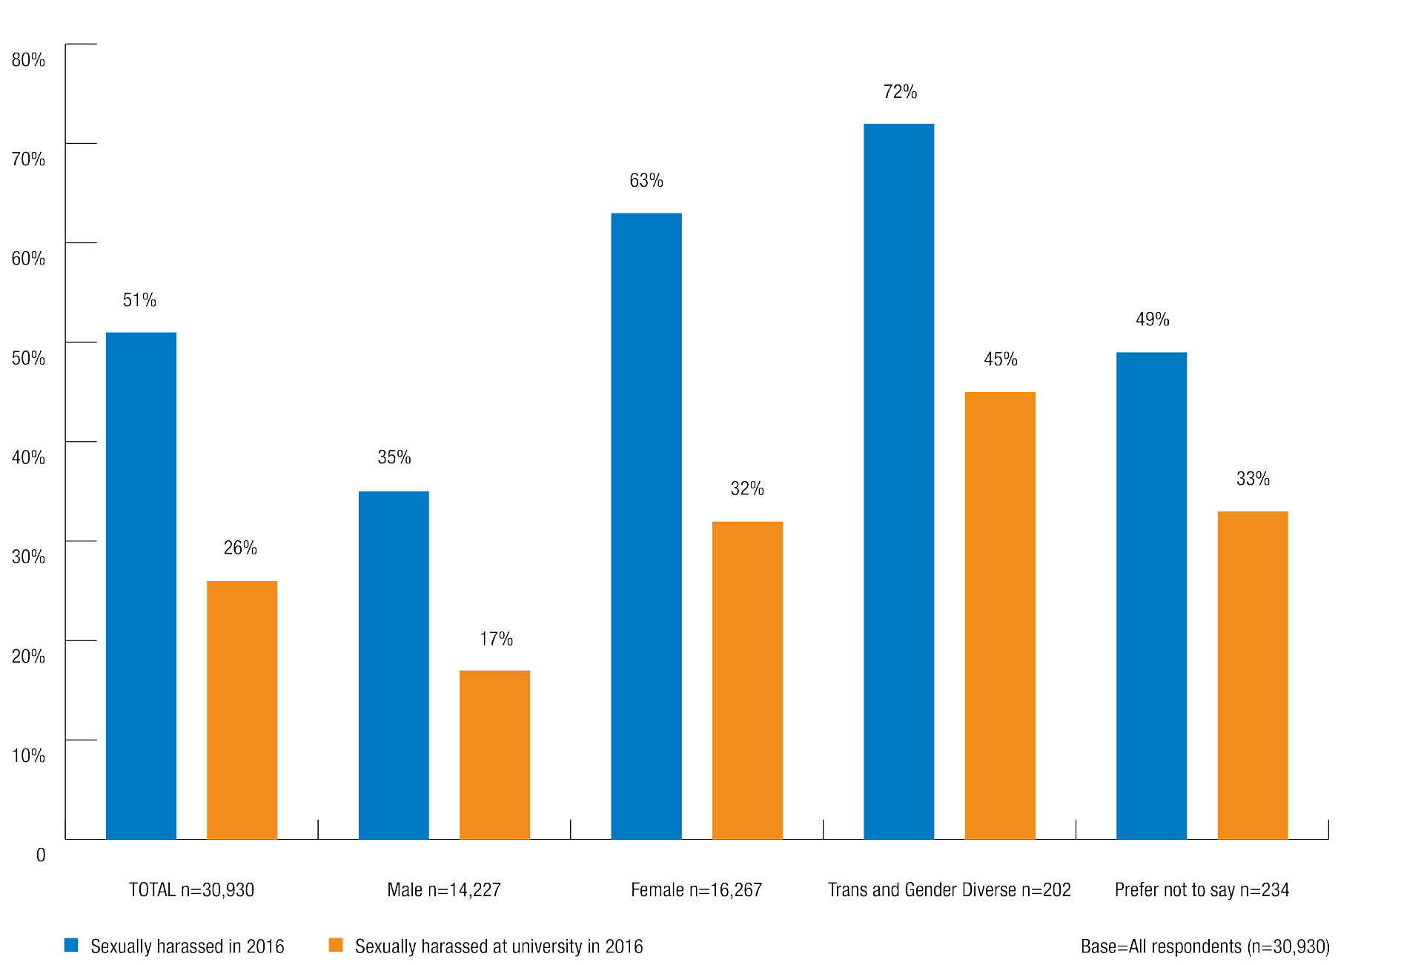

Nature of sexual harassment
The most common forms of sexual harassment experienced in a university setting in 2016 were:
    - inappropriate staring or leering (14%)
    - sexually suggestive comments or jokes (11%), and
    - intrusive questions about an individual’s private life or physical appearance (9%).

The types of harassment most commonly experienced differed based on the student’s gender.
    - Women (20%) were substantially more likely than men (5%) to have experienced inappropriate staring or leering at university in 2016.
    - Women were also more likely than men to have experienced sexually suggestive comments or jokes and intrusive questions about their private life or physical appearance.
Trans and gender diverse students were more likely than men or women to report:
    - intrusive questions about their private life or physical appearance (29%)
    - inappropriate staring or leering (25%), and
    - sexually suggestive comments or jokes (24%).

Chart 2: Types of sexual harassment experienced at university on at least one occasion in 2015 and/or 2016 by gender identity
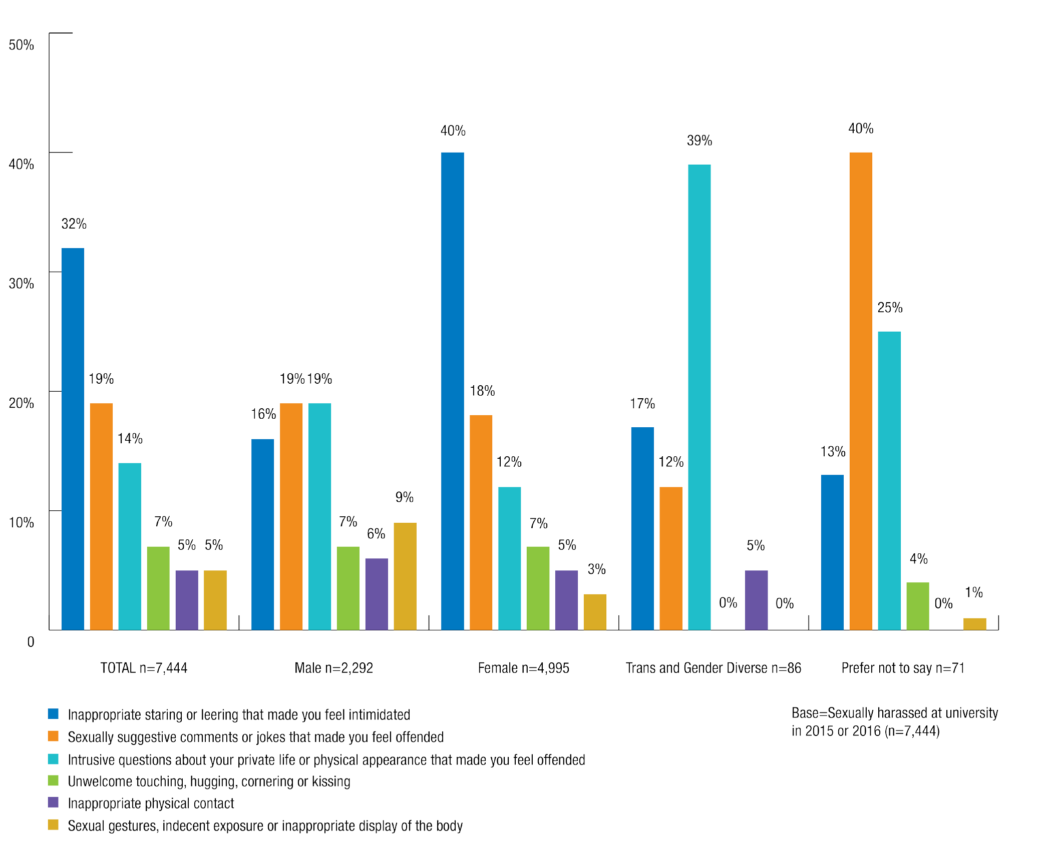

Who experiences sexual harassment at university?
Our research indicates that people may experience sexual harassment differently due to characteristics such as gender identity, sexual orientation, culturally and linguistically diverse backgrounds, Aboriginal and Torres Strait Islander status, disability status and age.
This report has aimed to capture, as far as possible, information that reflects the diversity of experiences of university students across Australia.

Gender identity

Women were almost twice as likely as men to have been sexually harassed.
In 2016, 63% of women were sexually harassed on at least one occasion, compared with 35% of men. 32% of women and 17% of men experienced sexual harassment in a university setting.

Chart 3: Sexual harassment by gender identity

When incidents of sexual harassment that occurred while travelling to or from university are excluded, 25% of women and 15% of men experienced sexual harassment in a university setting in 2016.
The National Survey allowed people to describe their gender in their preferred way. In this report, we refer to the gender of those who did not describe their gender as either male or female as ‘trans and gender diverse’.3
People who are trans and gender diverse do not identify with the gender identity they were assigned at birth.4 Some trans and gender diverse individuals may identify as male or female, however this is not the case for every individual – some people do not identify as either male or female.

The results of the National Survey indicate that trans and gender diverse students were more likely to have been sexually harassed than women or men.
While sample sizes were small, trans and gender diverse studentswere more likely to have been sexually harassed (72%) and more likely to have been sexually harassed in a university setting (45%) in 2016 than women or men.
Excluding incidents which occurred while travelling to or from university, 42% of trans and gender diverse students were sexually harassed in a university setting in 2016.

Sexual orientation
Sexual orientation can impact on an individual’s experiences of sexual harassment at university.

Students who identified as bisexual or gay, lesbian or homosexual were more likely than students who identified as heterosexual to have been sexually harassed in 2016.
44% of those who identified as bisexual and 38% of those who identified as gay, lesbian or homosexual were sexually harassed at university in 2016, compared with 23% of those who identified as heterosexual.

Chart 4: Sexual harassment by sexual orientation
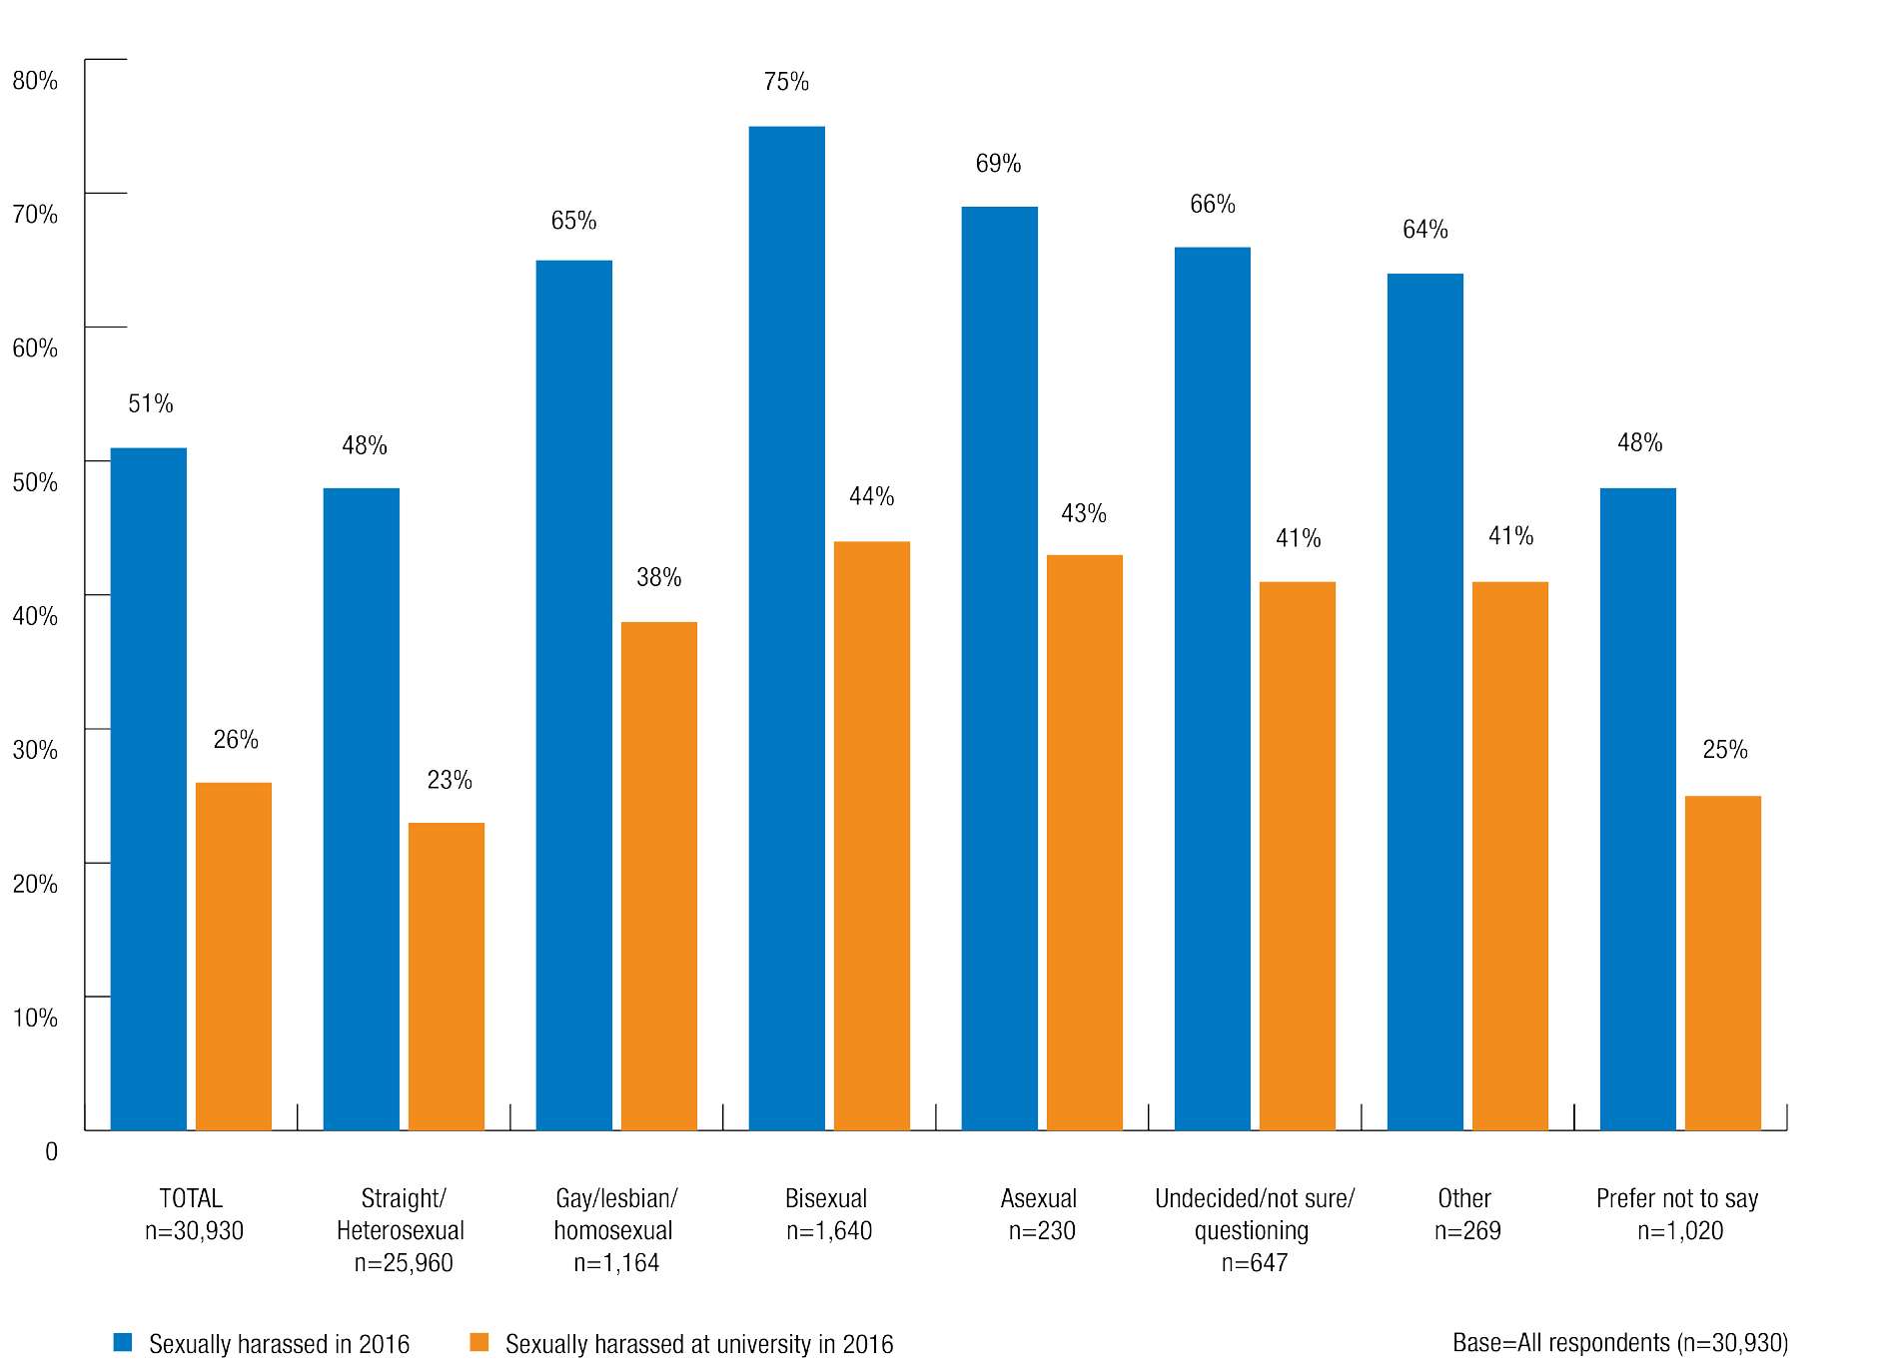

When incidents occurring while travelling to or from university are excluded:
  - 19% of students who identified as straight/heterosexual
  - 34% of students who identified as gay/lesbian/homosexual
  - 36% of students who identified as bisexual
  - 38% of students who identified as asexual, and
  - 36% of students who identified as undecided/not sure/questioning. were sexually harassed in a university setting in 2016.

Students from culturally and linguistically diverse (CALD) backgrounds and international students
This section describes the National Survey results received from domestic students who mainly speak a language other than English at home and from international students.

Students who mainly spoke English at home were more likely than those who mainly spoke a language other than English to have been sexually harassed in 2016.

In 2016:
  - 53% of students who mainly spoke English at home were sexually harassed, compared with 45% of students who spoke a language other than English.
  - 27% of students who mainly spoke English at home were sexually harassed in a university setting, compared with 22% of students who spoke a language other than English.
When incidents that occurred while travelling to or from university are excluded, 22% of students who mainly spoke English at home were sexually harassed in a university setting, compared with 17% of students who spoke a language other than English.

International students were less likely to experience sexual harassment than domestic students.
Over one in four (27%) domestic students had been sexually harassed at university in 2016 compared to one in five (22%) international students.
Excluding incidents that occurred while traveling to or from university, 22% of domestic students and 18% of international students were sexually harassed in a university setting in 2016.

Aboriginal and Torres Strait Islander students
There was limited data available through the survey about incidents of sexual harassment experienced by Aboriginal and Torres Strait Islander students due to small sample sizes.
On the whole, Aboriginal and Torres Strait Islander people are underrepresented in higher education. Despite making up 2.5% of the Australian population overall, in 2012 only 1.4% of total student enrolments at university identified as Aboriginal and Torres Strait Islander.5

Students who identified as Aboriginal and Torres Strait Islander were more likely to have been sexually harassed in 2016.
62% of students who identified as Aboriginal and Torres Strait Islander were sexually harassed in 2016, compared with 51% of students who did not identify as Aboriginal or Torres Strait Islander.
In university settings in 2016, 36% of students who identified as Aboriginal and Torres Strait Islander were sexually harassed, compared with 26% of those who did not identify as Aboriginal and Torres Strait Islander.
When incidents that occurred while traveling to or from university are excluded, 32% of students who identified as Aboriginal and Torres Strait Islander were sexually harassed in a university setting in 2016 compared with 21% of those who did not.
Women who identified as Aboriginal and Torres Strait Islander were more likely than women who did not identify as Aboriginal or Torres Strait Islander to have been sexually harassed in 2016 (72% and 63% respectively), and more likely to have been sexually harassed in a university setting in 2016 (43% and 32%).

Men who identified as Aboriginal and Torres Strait Islander were more likely than men who did not identify as Aboriginal or Torres Strait Islander to have been sexually harassed in 2016 (46% and 35% respectively), and almost twice as likely to have been sexually harassed in a university setting in 2016 (31% and 16% respectively).

Disability
Nearly one in five Australians live with a disability.6 People living with a disability experience
a variety of impairments that can affect their lives, including ‘medical and/or health conditions, and/or sensory, physical, cognitive and psychosocial impairments, singly or in combination’.7
There was limited data available through the survey about incidents of sexual harassment experienced by students with a disability due to small sample sizes.
People with disability are significantly underrepresented in higher education in Australia. In 2015, the Survey of Disability, Ageing and Carers found that only 4% of people with disability aged 15 to 64 years had obtained a bachelor degree or higher.8 In contrast, 59% of the general Australian population aged 15 to 74 years have obtained a bachelor degree or higher.9

Students with a disability were more likely to have been sexually harassed in 2016 than those without a disability.
In 2016:
  - 63% of students with a disability compared to 50% of students without a disability were sexually harassed on at least one occasion.
  - 34% of students with a disability compared to 25% of students without a disability were sexually harassed in a university setting.
Excluding incidents that occurred while travelling to or from university, 30% of students with a disability and 21% of students without a disability were sexually harassed in a university setting in 2016.
Men with a disability were more likely than men without a disability to have been sexually harassed in 2016 (50% and 35% respectively) and more likely to have been sexually harassed in a university setting in 2016 (24% and 16% respectively).
The same pattern was evident among women with a disability, though it was less pronounced. 69% of females with a disability were sexually harassed in 2016 (compared with 62% of females without a disability) and 39% of females with a disability were sexually harassed in
a university setting (compared with 32% of females without a disability).

Age
Age can impact on students’ experience of sexual harassment at university.
The likelihood of being sexually harassed in 2016 tended to be relatively constant for students aged up to their early to mid-twenties, then progressively declined.

Chart 5: Sexual harassment by age

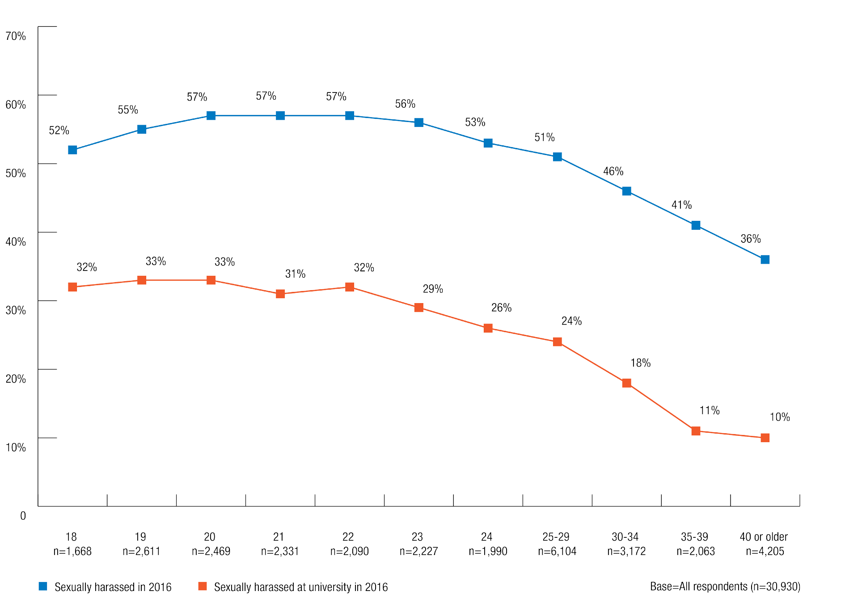

First year and continuing students
Students’ status as a first year or continuing student affects their experience of sexual harassment.

Continuing students were more likely than commencing students to have been sexually harassed and to have experienced this in a university setting.
Continuing students (52%) were marginally more likely than commencing students (49%) to have been sexually harassed in 2016, and were also more likely to have experienced this in a university setting in 2016 (27% and 24% respectively).
When sexual harassment that occurred while traveling to or from university is excluded, 22% of continuing students and 19% of commencing students were sexually harassed in a university setting in 2016.

Postgraduate and undergraduate students

Undergraduates were more likely than postgraduates to experience sexual harassment in general and in a university setting.
Undergraduate students (53%) were more likely than postgraduates (45%) to have been sexually harassed in 2016, and more likely to have experienced this in a university setting (28% and 19% respectively).

Chart 6: Sexual harassment by level of study
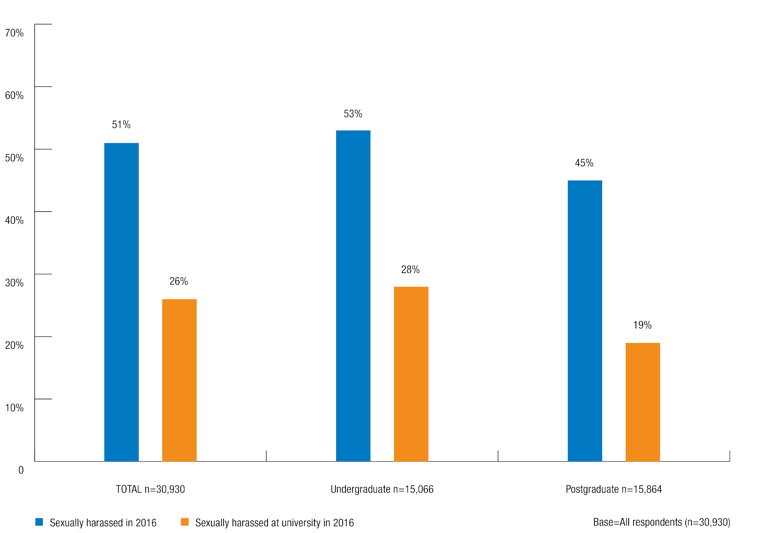

When sexual harassment that occurred while travelling to or from university is excluded, 23% of undergraduates and 15% of postgraduates experienced sexual harassment in a university setting in 2016.

Who are the perpetrators of sexual harassment at university?
Survey respondents who had experienced sexual harassment in a university setting in 2015 or 2016 were asked how many perpetrators were involved in the most recent incident. They were also asked about the identity and gender of the perpetrator(s).

Number of perpetrators

48% of students who were sexually harassed in a university setting in 2015 or 2016 indicated that in the most recent incident, they were sexually harassed by a single perpetrator.

Chart 7: Number of perpetrators directly involved in most recent incident of sexual harassment in a university setting by gender identity
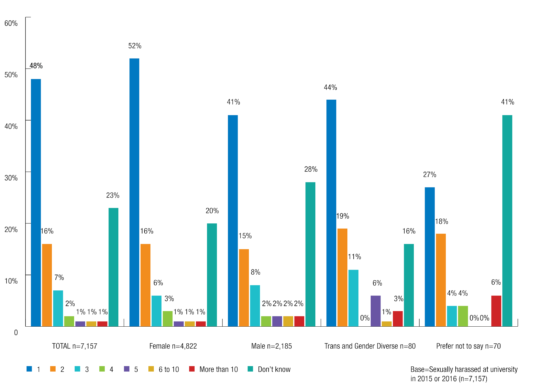

52% of women who were sexually harassed in a university setting were harassed by a single perpetrator in the most recent incident, compared with 41% of men.
Domestic students (50%) were more likely than international students (38%) to have been sexually harassed by a single perpetrator in the most recent incident.
Of students who were sexually harassed:
  - 16% said that there were two perpetrators.
  - 7% said that there were three perpetrators.
  - 5% said that there were four or more perpetrators.

Men reported more commonly than women that there were multiple perpetrators involved in the most recent incidents of ‘sexual gestures, indecent exposure or inappropriate display of body’ (7% compared to 3%) and ‘intrusive questions’ (24% compared to 13%).

Number of perpetrators known to the victim

Almost half (45%) of students who were sexually harassed in a university setting in 2015 or 2016 knew some or all of the perpetrators of the most recent incident.
  - 10% knew some of the perpetrators involved in the most recent incident
  - 35% knew all of the perpetrators involved in the most recent incident.
  - 50% of students did not know any of the perpetrators involved in the most recent incident.

Chart 8: Number of perpetrators known to victim in most recent incident of sexual harassment in a university setting by respondent gender identity
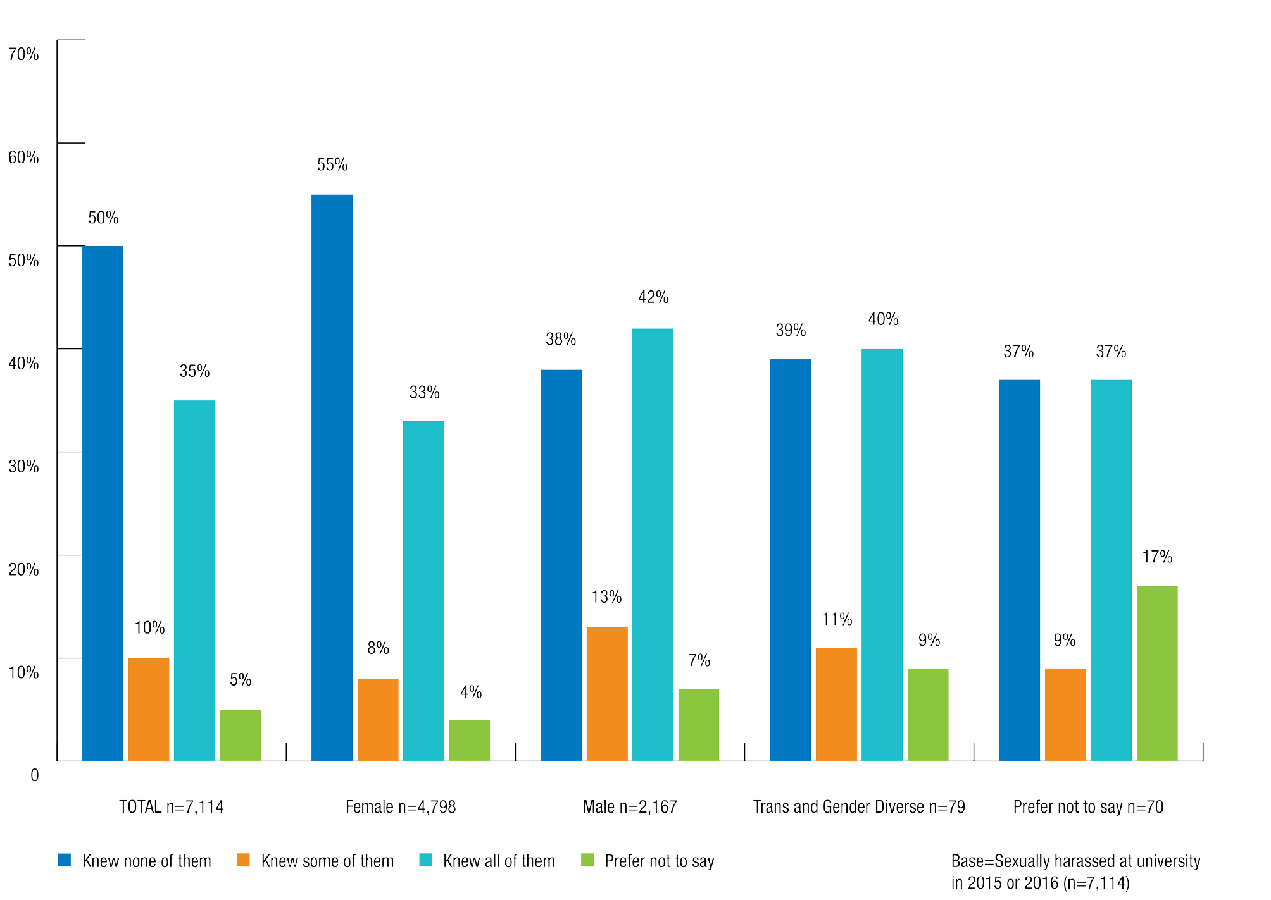

In relation to sexual harassment at university in 2015 or 2016:
- Women (55%) were more likely than men (38%) to be sexually harassed by someone they did not know.
- Men were more likely than women to know all of the perpetrators (42% compared with 33% for women) of the sexual harassment.
- Domestic students (37%) were more likely than international students (28%) to know all of the people involved.

Gender of perpetrators

The majority of students who were sexually harassed said that the perpetrator was male.
In relation to sexual harassment in a university setting in 2015 or 2016:
  - 71% of students said that the most recent incident involved only male perpetrators.
  - 11% involved only female perpetrators.
  - 11% involved both male and female perpetrators.
Women were overwhelmingly more likely to have been sexually harassed by men only (86%) in the most recent incident. Men were also more likely to have been sexually harassed by men only (37%), however some also reported experiencing sexual harassment by women only (30%) or by both men and women (22%).
Though sample sizes were small, trans and gender diverse students were also more likely to have been harassed by men only (49%) than by women only (5%).

Chart 9: Gender of sexual harassment perpetrator(s) by respondent gender identity
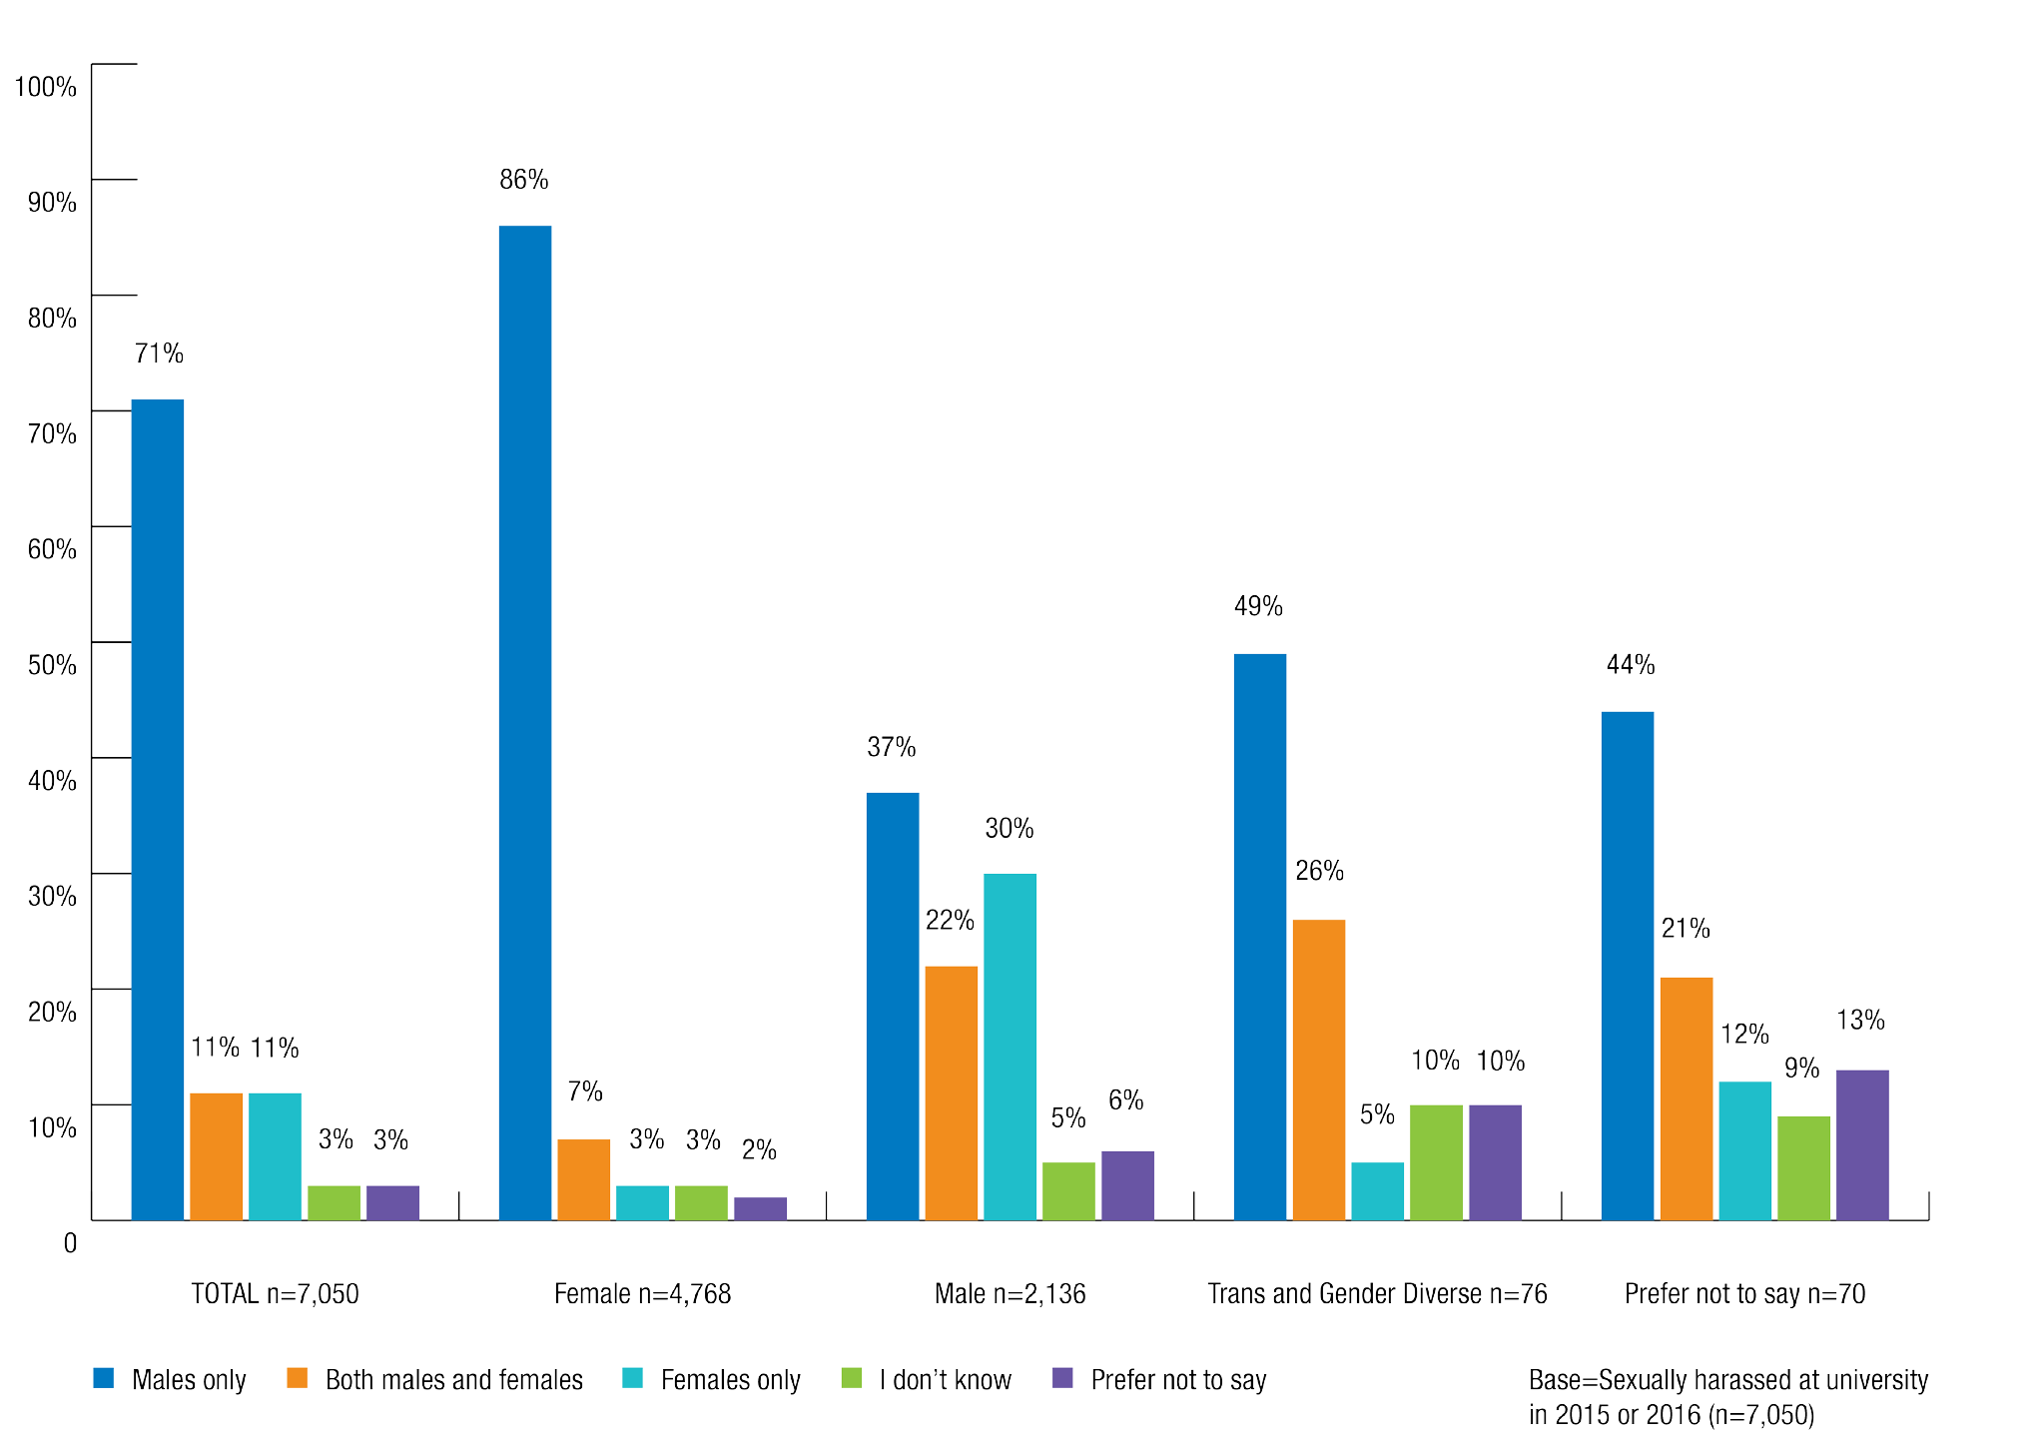

Identity of perpetrators

Among those who had been sexually harassed in a university setting by someone they knew, more than two thirds (68%) said that the perpetrator(s) of the most recent incident was a student from their university.
Undergraduate students (70%) were more likely than postgraduate students (58%) to have been sexually harassed by a student from their university in 2015 or 2016.

Chart 10: Identity of sexual harassment perpetrator(s) by respondent level of study
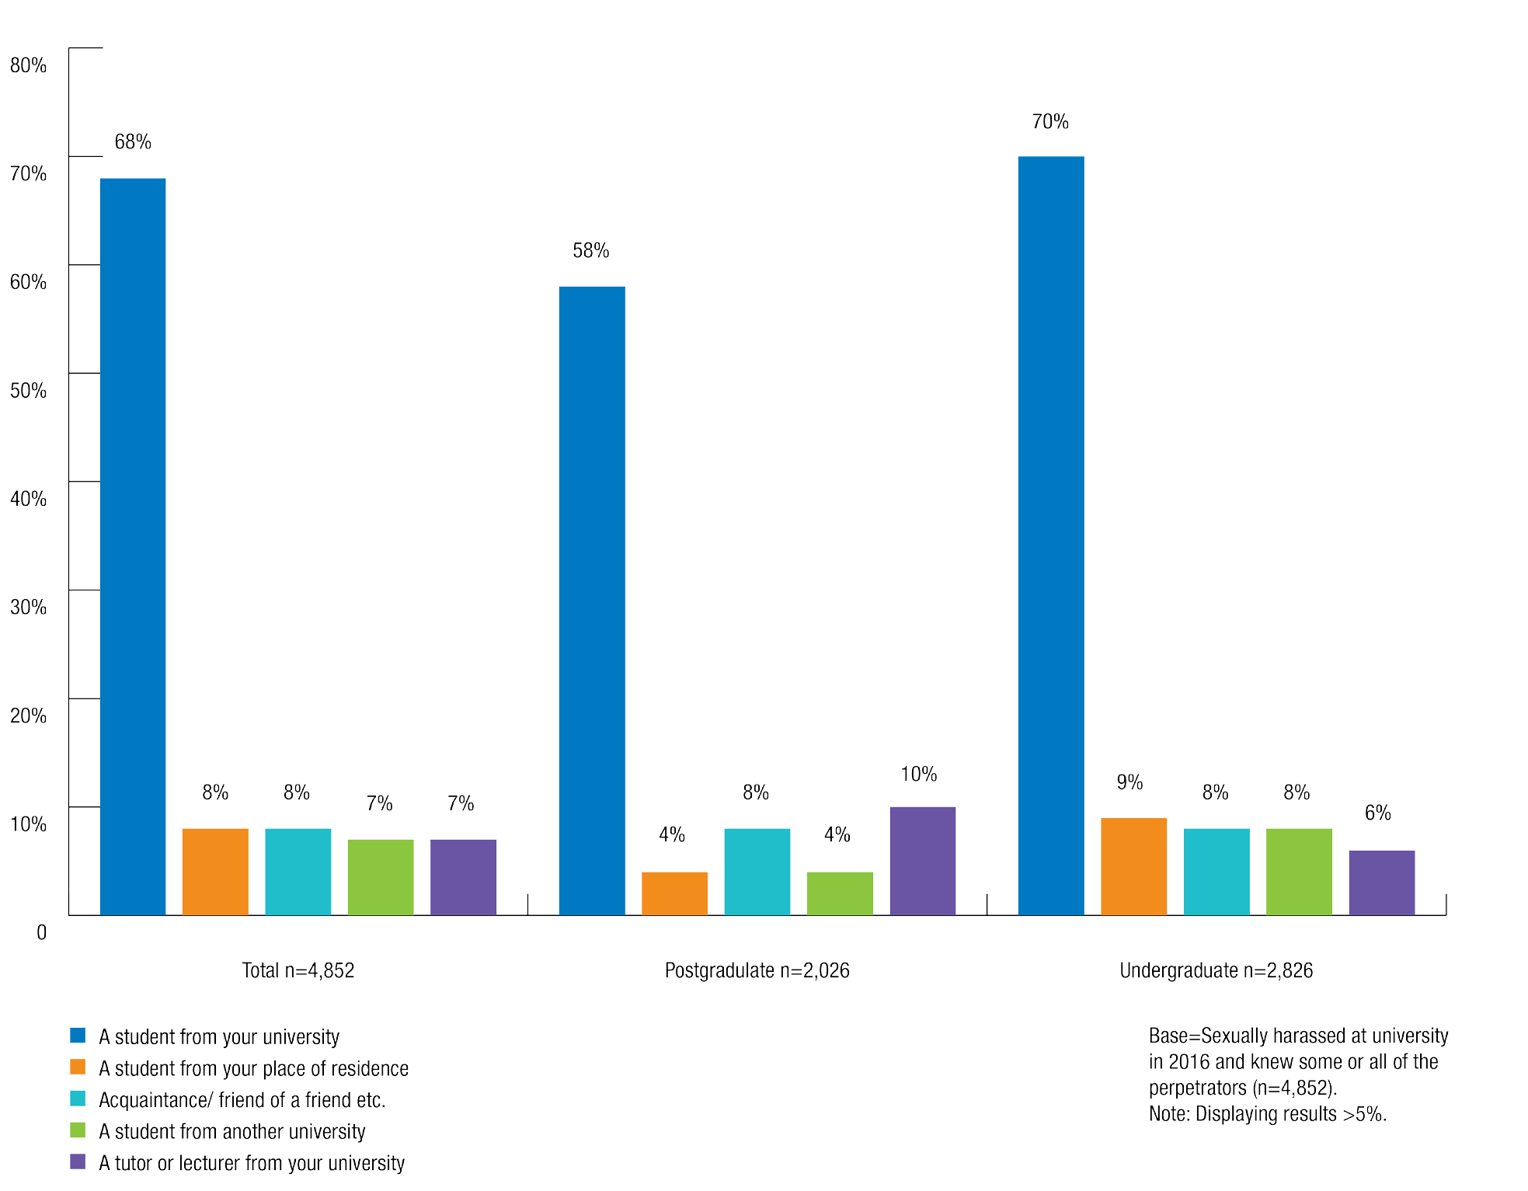

Postgraduate students were more likely than undergraduate students to have been sexually harassed by a university staff member in the most recent incident.
Sexual harassment of postgraduates was more likely to have involved a tutor or lecturer (10%, compared with 6% for undergraduates) or non-academic staff member (5%, compared with 2% for undergraduates).
Postgraduates were also more likely than undergraduates to have been sexually harassed by a fellow worker in their university employment (4% and 1% respectively) or by a supervisor/ boss as part of a work placement (3% and 1% respectively).

Prevalence of sexual assault

More than one in 20 students were sexually assaulted on at least one occasion in 2015 and/or 2016.
Overall, 6.9% of students were sexually assaulted on at least one occasion in 2015 and/or 2016, with 1.6% reporting that the sexual assault occurred in a university setting.
As previously stated, for the purposes of the National Survey, sexual assault which occurred in ‘university settings’ included incidents that occurred:
    - on the university campus
    - while travelling to or from university
    - at an off-campus event organised by or endorsed by the university, and
    - at university employment.

Who experiences sexual assault at university?

Gender identity
Women (10%) were more than three times as likely as men (2.9%) to have been sexually assaulted in 2015 and/or 2016. They were also more likely to have been sexually assaulted in a university setting in 2015 and/or 2016 (2.3% of women compared with 0.7% of men).

Chart 11: Sexual assault by gender identity
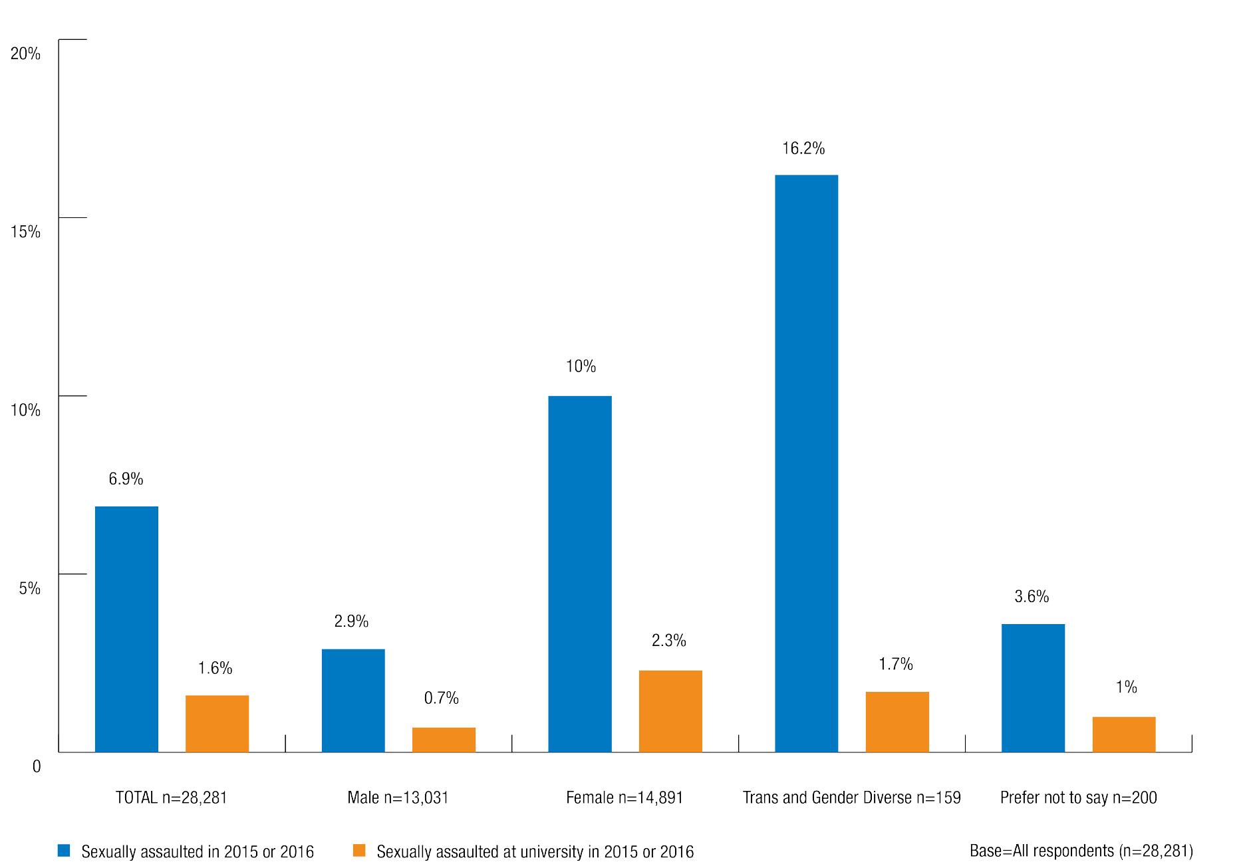

The National Survey allowed people to describe their gender in their preferred way. In this report, we refer to the gender of those who did not identify their as male or female as ‘trans and gender diverse’.
People who are trans and gender diverse do not identify with the gender identity they were assigned at birth.10 Some trans and gender diverse individuals may identify as male or female, however this is not the case for every individual – some people do not identify as either male or female.
While sample sizes were again small, trans and gender diverse students were also more likely than women or men to have been sexually assaulted (16.2%) in 2015 and/or 2016.
However, trans and gender diverse students were less likely than women, but more likely than men, to have been sexually assaulted in a university setting (1.7%).

Sexual orientation
Students who identified as bisexual or asexual were the most likely to have been sexually assaulted in 2015 and/or 2016.
Students who identified as bisexual (18%) or asexual (15%) were more likely than students who identified as gay/lesbian/homosexual (8%) or heterosexual (6%) to have been sexually assaulted in 2015 and/or 2016.
Those who identified as bisexual (3.8%) were also more likely than those who identified as heterosexual (1.5%) or gay/lesbian/homosexual (1.4%) to have been sexually assaulted in a university setting in 2015 and/or 2016.

Chart 12: Sexual assault by sexual orientation
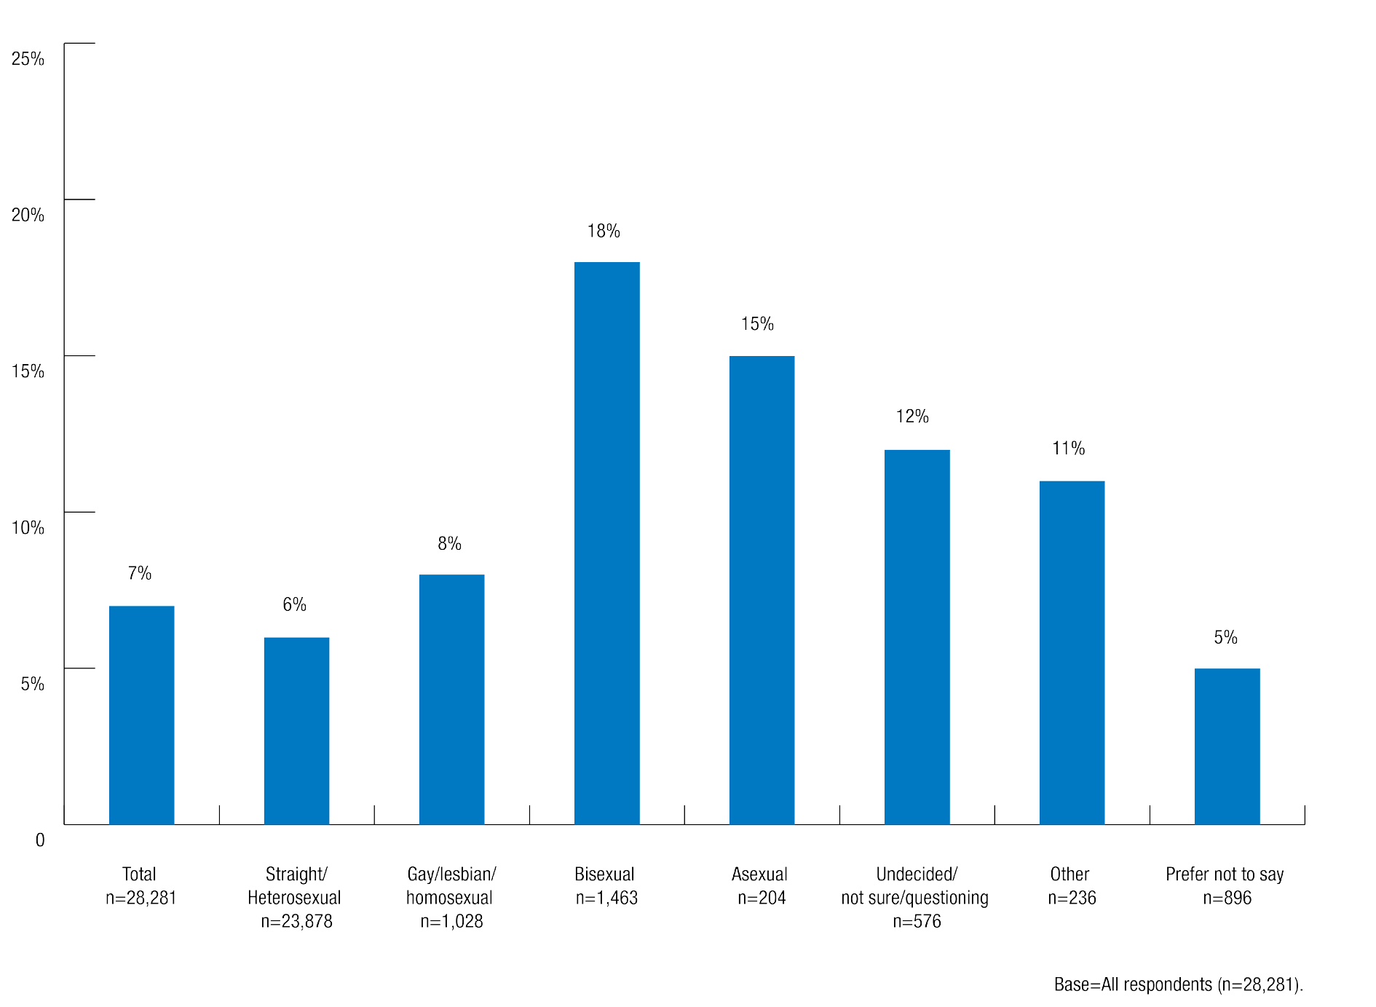

Students from culturally and linguistically diverse (CALD) backgrounds and international students
There were no substantial differences between the rates of sexual assault experienced by students who mainly speak English at home and those who speak a language other than English.

International students were less likely to experience sexual assault than domestic students.
  - 5.1% of international students were sexually assaulted in 2015 and/or 2016, and 1.4% experienced this in a university setting.
  - 7.4% of domestic students were sexually assaulted in 2015 and/or 2016, and 1.7% experienced this in a university setting.

Aboriginal and Torres Strait Islander students
There was limited data available through the survey about incidents of sexual assault experienced by Aboriginal and Torres Strait Islander students due to small sample sizes.
On the whole, Aboriginal and Torres Strait Islander people are underrepresented in higher education. Despite making up 2.5% of the Australian population overall, in 2012 only 1.4% of total student enrolments at university identified as Aboriginal and Torres Strait Islander.11

Students who identified as Aboriginal and Torres Strait Islander were more likely to have been sexually assaulted in 2015 and/or 2016, and to have experienced this in a university setting.
  - 10% of students who identified as Aboriginal and Torres Strait Islander compared to 7% of those who did not were sexually assaulted in 2015 and/or 2016.
  - 3.3% of students who identified as Aboriginal and Torres Strait Islander compared to 1.6% of those who did not were sexually assaulted in a university setting in 2015 and/or 2016.

Disability
Nearly one in five Australians live with a disability.12 People living with a disability experience a variety of impairments that can affect their lives, including ‘medical and/or health conditions, and/or sensory, physical, cognitive and psychosocial impairments, singly or in combination’.13
There was limited data available through the survey about incidents of sexual assault experienced by students with a disability due to small sample sizes.
People with disability are significantly underrepresented in higher education in Australia. In 2015, the Survey of Disability, Ageing and Carers found that only 4% of people with disability aged 15 to 64 years had obtained a bachelor degree or higher.14 In contrast, 59% of the general Australian population aged 15 to 74 years have obtained a bachelor degree or higher.15

Students with a disability were more likely to have been sexually assaulted than those without a disability.
  - 14% of students with a disability compared with 7% of those without a disability were sexually assaulted in 2015 and/or 2016.
  - 3.9% of students with a disability compared with 1.5% of those without a disability were sexually assaulted in a university setting in 2015 and/or 2016.

Age
Age can impact on students’ experience of sexual assault at university.
While sample sizes are too small to draw firm conclusions in relation to sexual assault, like sexual harassment, the prevalence rate of sexual assault declined with age.

First year and continuing students
Students’ status as a first year or continuing student affects their experience of sexual assault.

Continuing students were more likely than commencing students to have been sexually assaulted and to have experienced this in a university setting.
Continuing students were slightly more likely than commencing students to have been sexually assaulted in 2015 and/or 2016 (7.9% and 5.4% respectively) or sexually assaulted in a university setting in 2015 and/or 2016 (2.0% and 1.1% respectively).

Postgraduate and undergraduate students

Undergraduates were more likely than postgraduates to experience sexual assault in general and in a university setting.
Undergraduates were also more likely to have been sexually assaulted in 2015 and/or 2016 (8% compared with 5% for postgraduates), and 1.9% of undergraduate students reported being sexually assaulted in a university setting in 2015 and/or 2016, compared with 0.8% of postgraduates.

Who are the perpetrators of sexual assault at university?
Survey respondents who had experienced sexual assault in a university setting in 2015 or 2016 were asked how many perpetrators were involved in the most recent incident. They were also asked about the identity and gender of the perpetrator(s).

Number of perpetrators

64% of students who were sexually assaulted in a university setting in 2015 or 2016 indicated that in the most recent incident, they were sexually assaulted by a single perpetrator.

68% of women who were sexually assaulted were assaulted by a single perpetrator, compared with 47% of men.
Domestic students (66%) were also more likely than international students (55%) to have been sexually assaulted by a single perpetrator.
Of students who were sexually assaulted:
  - 8% said that there were two perpetrators.
  - 3% said that there were three perpetrators.
  - 4% said that there were four or more perpetrators.

Chart 13: Number of perpetrators directly involved in most recent incident of sexual assault in a university setting by respondent gender identity
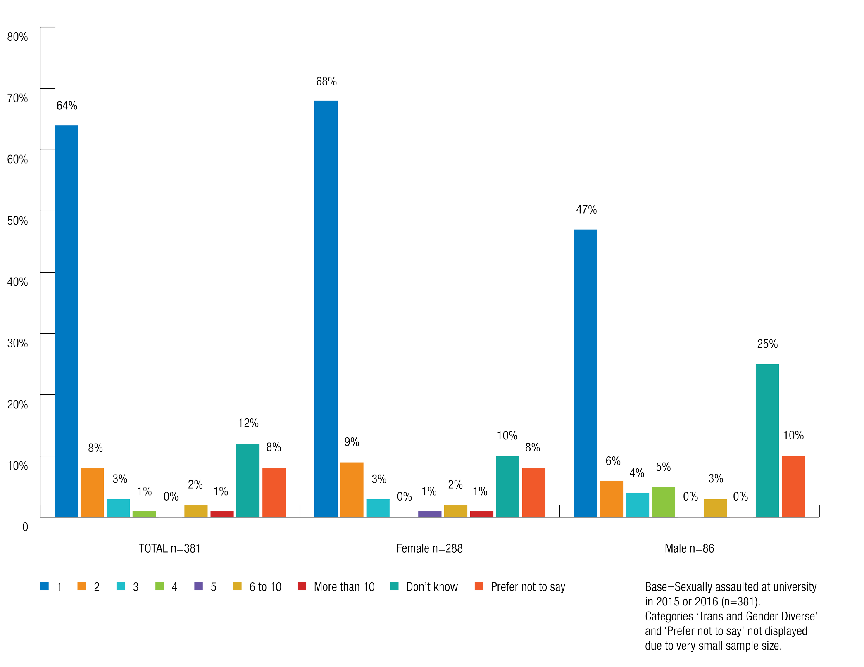

Number of perpetrators known to the victim

The majority of students sexually assaulted at university in 2015 or 2016 knew some or all of the perpetrators of the most recent incident.
  - 51% of students knew all of the perpetrators involved in the most recent incident.
  - 38% did not know any of them.
  - 6% knew some of them.

Chart 14: Number of perpetrators known to victim in most recent incident of sexual assault in a university setting by respondent gender identity
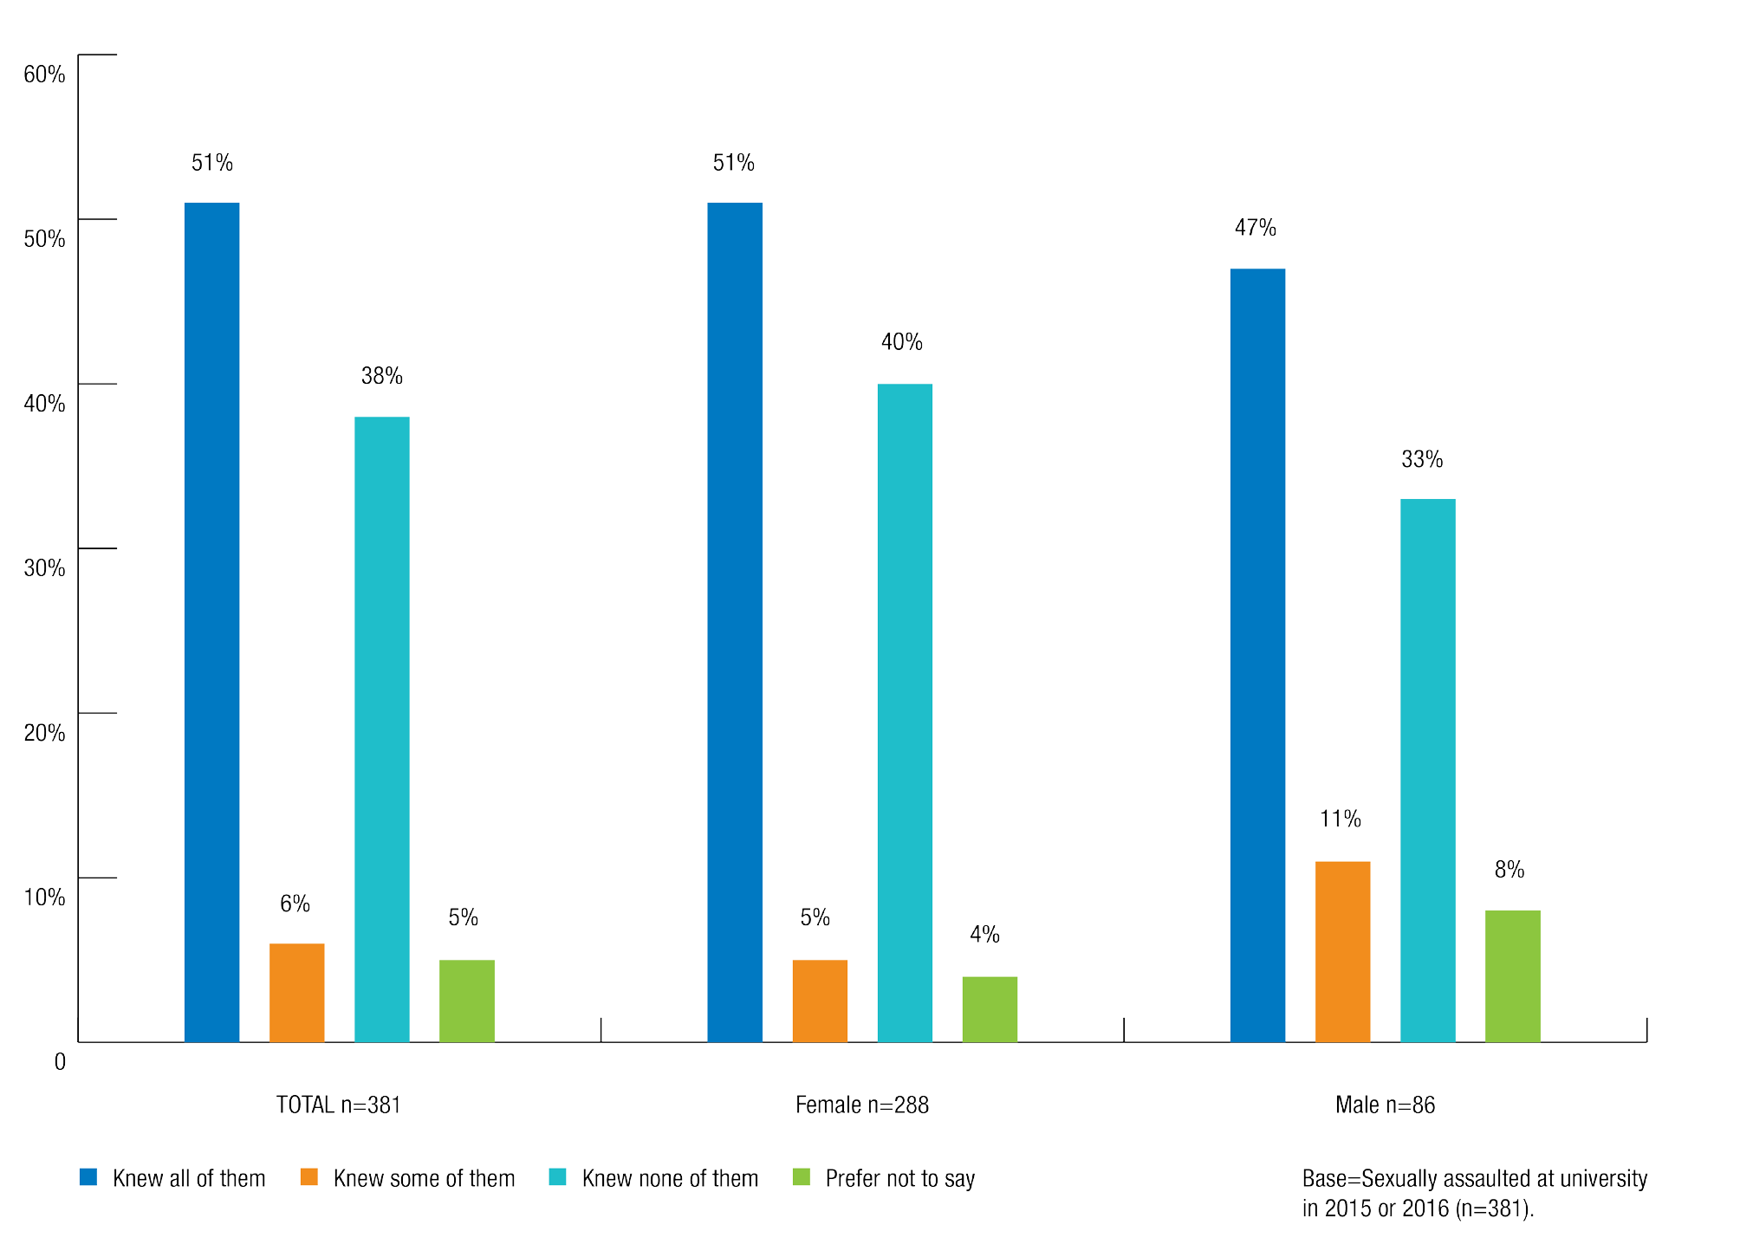

In relation to the most recent incident of sexual assault at university in 2015 or 2016:
- Over half of all women (51%) who were sexually assaulted said they knew all of the perpetrators compared to 47% of men.
- International students were more likely than other students to say they knew some of the perpetrators involved (14%), and postgraduates were the most likely to not know any of the people involved (45%).
- Undergraduates (53%) were more likely than postgraduate students (34%) to know all of the perpetrators. This was also the case for domestic students (53% knew all the perpetrators, compared with 38% of international students).

Gender of Perpetrators

The majority of students who were sexually assaulted said that the perpetrator was male.
In relation to sexual assault at university in 2015 or 2016:
  - 83% of students said that the most recent incident involved men only.
  - 6% involved women only.
  - 6% involved both men and women.
Overwhelmingly, women were more likely to report that the perpetrators of the most recent incident of sexual assault were men only (92%).
Men were most likely to have been sexually assaulted by men only (41%), and also reported incidents of sexual assault by women only (26%) or by both men and women (24%).

Chart 15: Gender of sexual assault perpetrator(s) by respondent gender identity
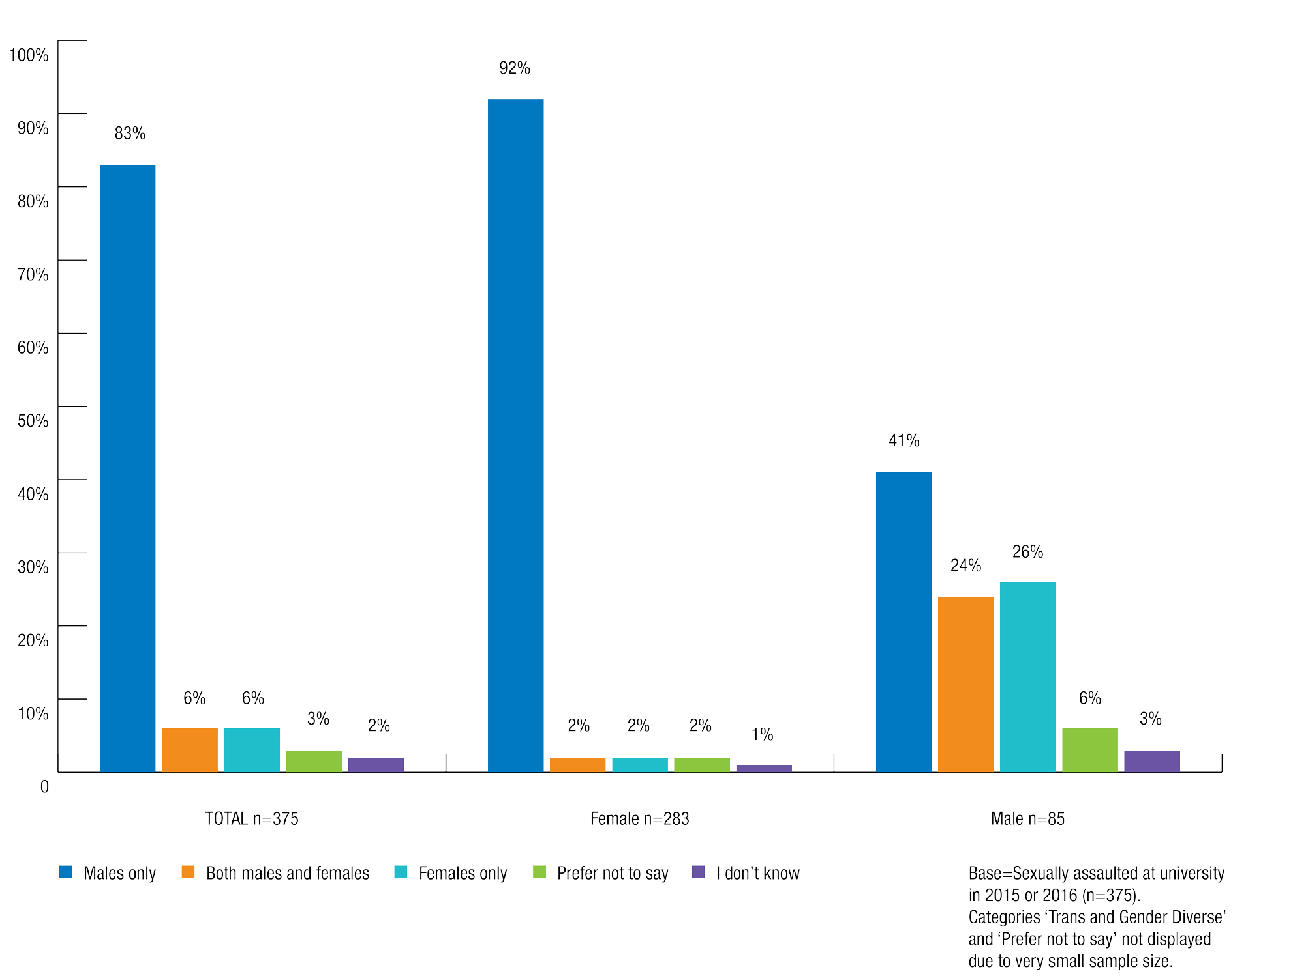

Identity of perpetrators

Among those who had been sexually assaulted in a university setting by someone they knew, over half said that in the most recent incident the perpetrator(s) was a student from their university.
A stranger was involved in 30% of the most recent incidents of sexual assault, with 18% involving a student from the victim’s place of residence.
Undergraduate students (59%) were more likely than postgraduate students (37%) to
have been sexually assaulted by a student from their university in the most recent incident. Postgraduate students were more likely to have been sexually assaulted by a stranger (38% compared with 29% for undergraduate students).

Chart 16: Identity of sexual assault perpetrator(s) by respondent level of study
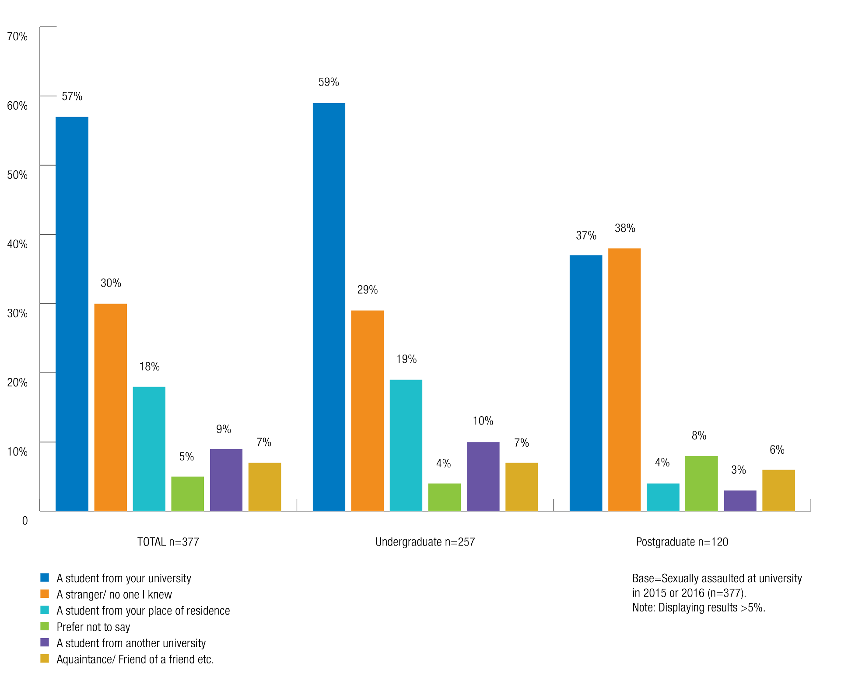

Chapter 2: Endnotes

- The 14 behaviours include: Unwelcome touching, hugging, cornering or kissing; Inappropriate staring or leering that made you feel intimidated; Sexual gestures, indecent exposure or inappropriate display of the body; Sexually suggestive comments or jokes that made you feel offended; Sexually explicit pictures, posters or gifts that made you feel offended; Repeated or inappropriate invitations to go out on dates; Intrusive questions about your private life or physical appearance that made you feel offended; Inappropriate physical contact; Requests or pressure for sex, or other sexual acts; Other unwelcome conduct of a sexual nature (excluding online); Sexually explicit emails or SMS messages; Repeated or inappropriate advances on email, social networking websites or internet chat rooms; Inappropriate commentary, images or film of you distributed on some form of social media without your consent; Other unwelcome conduct of a sexual nature that occurred online.
- The definition of sexual assault used was: ‘Sexual assault includes a range of behaviours, all of which are unacceptable and constitute a crime. Sexual assault occurs when a person is forced, coerced or tricked into sexual acts against their will or without their consent, including when they have withdrawn their consent.’
- Incorporating the survey response categories ‘Indeterminate or unspecified’, ‘Transgender’ and ‘Other’, but excluding ‘Prefer not to say’.
- Transgender Victoria, Definitions (2013) http://www.transgendervictoria.com/about/definitions.
- Larissa Behrendt, et al., Review of Higher Education Access and Outcomes for Aboriginal and Torres Strait Islander People: Final Report Department of Education and Training (2012) 7-9. At https://www.education. gov.au/review-higher-education-access-and-outcomes-aboriginal-and-torres-strait-islander-people (viewed 29 March 2017).
- Australian Bureau of Statistics, 2011, Disability, Australia, 2009, cat no. 4446.0. At http://www.abs.gov.au/ ausstats/abs@.nsf/Lookup/4446.0main+features42009 (viewed 30 January 2017).
- Carolyn Frohmader, Leanne Dowse, Aminath Didi, Preventing Violence against Women and Girls with Disabilities: Integrating a Human Rights Perspective Women with Disabilities Australia (2015), 11. At http:// wwda.org.au/papers/confpaps/confpaps2011/ (viewed 30 January 2017).
- Australian Bureau of Statistics, 2015, Disability, Ageing and Carers, Australia: Summary of Findings, 2015, cat no. 4430.0. At http://www.abs.gov.au/ausstats/abs@.nsf/mf/4430.0 (viewed 14 March 2017).
- Australian Bureau of Statistics, 2016, Education and Work, Australia, May 2016, cat no. 6227.0. At http:// www.abs.gov.au/AUSSTATS/abs@.nsf/allprimarymainfeatures/556A439CD3D7E8A8CA257242007B3F32?o pendocument (viewed 14 March 2017).
- Transgender Victoria, Definitions (2013) http://www.transgendervictoria.com/about/definitions.
- Larissa Behrendt, et al., Review of Higher Education Access and Outcomes for Aboriginal and Torres Strait Islander People: Final Report Department of Education and Training (2012) 7-9. At https://www.education. gov.au/review-higher-education-access-and-outcomes-aboriginal-and-torres-strait-islander-people (viewed 29 March 2017).
- Australian Bureau of Statistics, 2011, Disability, Australia, 2009, cat no. 4446.0. At http://www.abs.gov.au/ ausstats/abs@.nsf/Lookup/4446.0main+features42009 (viewed 30 January 2017).
- Carolyn Frohmader, Leanne Dowse, Aminath Didi, Preventing Violence against Women and Girls with Disabilities: Integrating a Human Rights Perspective Women with Disabilities Australia (2015), 11. At http:// wwda.org.au/papers/confpaps/confpaps2011/ (viewed 30 January 2017).
- Australian Bureau of Statistics, 2015, Disability, Ageing and Carers, Australia: Summary of Findings, 2015, cat no. 4430.0. At http://www.abs.gov.au/ausstats/abs@.nsf/mf/4430.0 (viewed 14 March 2017).
- Australian Bureau of Statistics, 2016, Education and Work, Australia, May 2016, cat no. 6227.0. At http:// www.abs.gov.au/AUSSTATS/abs@.nsf/allprimarymainfeatures/556A439CD3D7E8A8CA257242007B3F32?o pendocument (viewed 14 March 2017).

“We should not have to feel unsafe on our campus.”

Submission No. 157 to the Australian Human Rights Commission, University sexual assault and sexual harassment project.

3 Settings in which sexual assault and sexual harassment occur at university

Key findings:
- Common locations where students experienced sexual harassment at university in 2015 and 2016 were: university grounds (14%), university teaching spaces (14%) and university social spaces (8%).
- More than one in five (22%) students experienced technology-based sexual harassment in 2016, including repeated or inappropriate advances on email, social networking websites and internet chat rooms, and sexually explicit emails or SMS messages.
- In relation to sexual assault, 21% of students reported that the most recent incident in 2015 or 2016 occurred at a university or college residence social event, 10% said it occurred on university grounds, and 10% said it occurred at a residential college or university residence.
- Public transport to and from university was also a common location where students reported experiencing sexual harassment (22%) and sexual assault (15%).
- Although only 7% of students who completed the survey were living at university owned or affiliated accommodation, 34% of those who were sexually assaulted and 17% of those who were sexually harassed were living in university owned or affiliated accommodation at the time of the most recent incident.

Universities are large and complex institutions. In addition to their core functions of providing research and education, universities also support a range of social, cultural and sporting activities for their students. A university campus offers teaching and office space, residential accommodation, recreational facilities, licensed venues and commercial outlets.
In addition to the variety of settings located on campus, many students also undertake university-related activities off campus. For example, they might undertake professional placements, field trips or study tours as part of their university studies, or attend university events or parties at off campus venues.
This chapter considers the range of university settings where sexual assault and sexual harassment occurred. Due to the complex nature of universities, the definition of ‘university setting’ used in this report is broad and covers a range of different locations.1

Although not all of these locations are within the physical bounds of the university campus, we have treated them all as ‘university settings’ in order to reflect the full extent of the student experience of university. This broad definition also reflects the fact that sexual assault and sexual harassment that occurs off campus can nonetheless have a profound impact on a student’s daily life at university. For example, if the perpetrator is a fellow student or a staff member at the university, the student risks encountering them in class or elsewhere on campus.
The National Survey data contained in this chapter relates to settings in which students experienced their most recent incident of sexual assault or sexual harassment in 2015 or 2016. We have also reported on information gathered through submissions, to illustrate the issues identified by the quantitative data.

For notes on reading the data and submissions contained in this report, please see the methodology section contained in Chapter 1.
The findings of the survey and information gathered through submissions indicate that sexual assault and sexual harassment are prevalent across a range of university settings. It is also clear that there is a strong correlation between the location in which sexual assault and sexual harassment occurs and the nature of the experience.

Survey findings

Students were most likely to have experienced the most recent incident of sexual harassment in a university setting on public transport to or from university, on university grounds or in university teaching spaces.
Students who were sexually harassed in a university setting in 2015 or 2016 were most likely to have experienced the most recent incident of sexual harassment in the following locations:
    - on public transport on the way to or from university (22%)
    - on university grounds (14%), or
    - in a university teaching space (13%).
Women (25%) were most likely to have been sexually harassed on public transport to or from the university, while university teaching spaces were the most common locations where men were sexually harassed (17%).

Chart 17: Location of most recent sexual harassment incident by gender identity
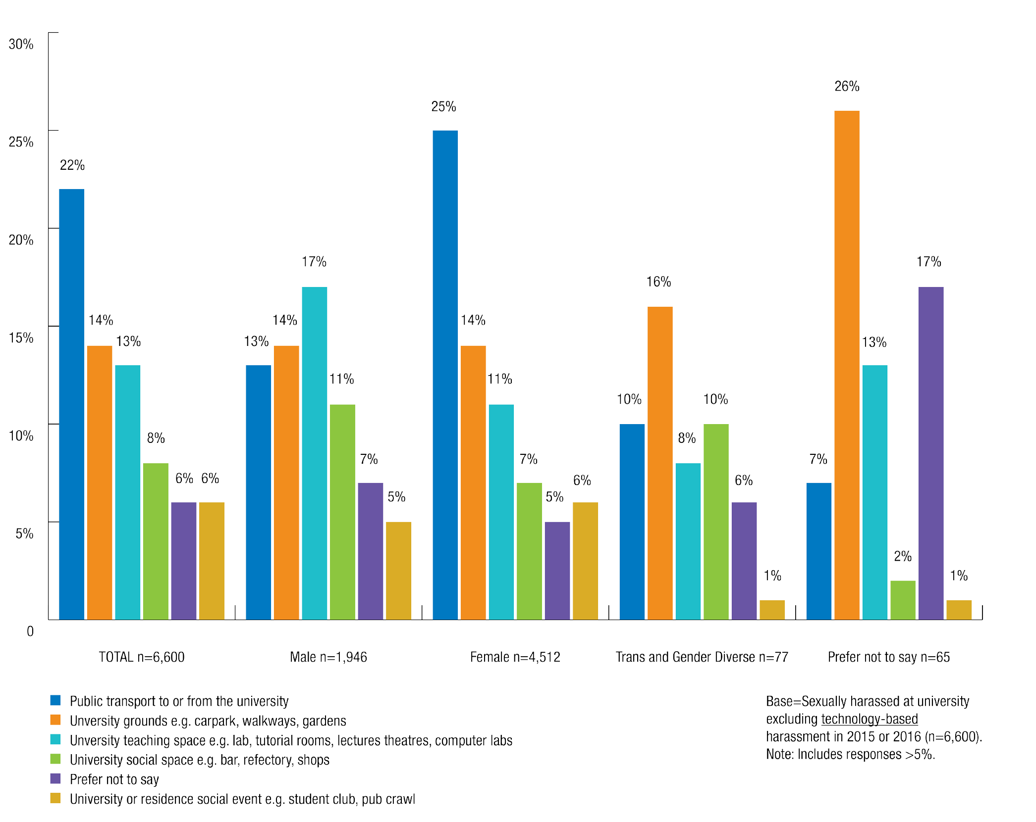

Students were most likely to have been sexually assaulted at a university or residence social event.
Students who were sexually assaulted in a university setting in 2015 or 2016 were most likely to have been sexually assaulted in the following locations:
      - 21% were assaulted at a university or residence social event.
      - 15% were assaulted on public transport to or from university.
      - 10% were assaulted on university grounds.
      - 10% were assaulted at a university residence or college.

Chart 18: Location of most recent sexual assault incident
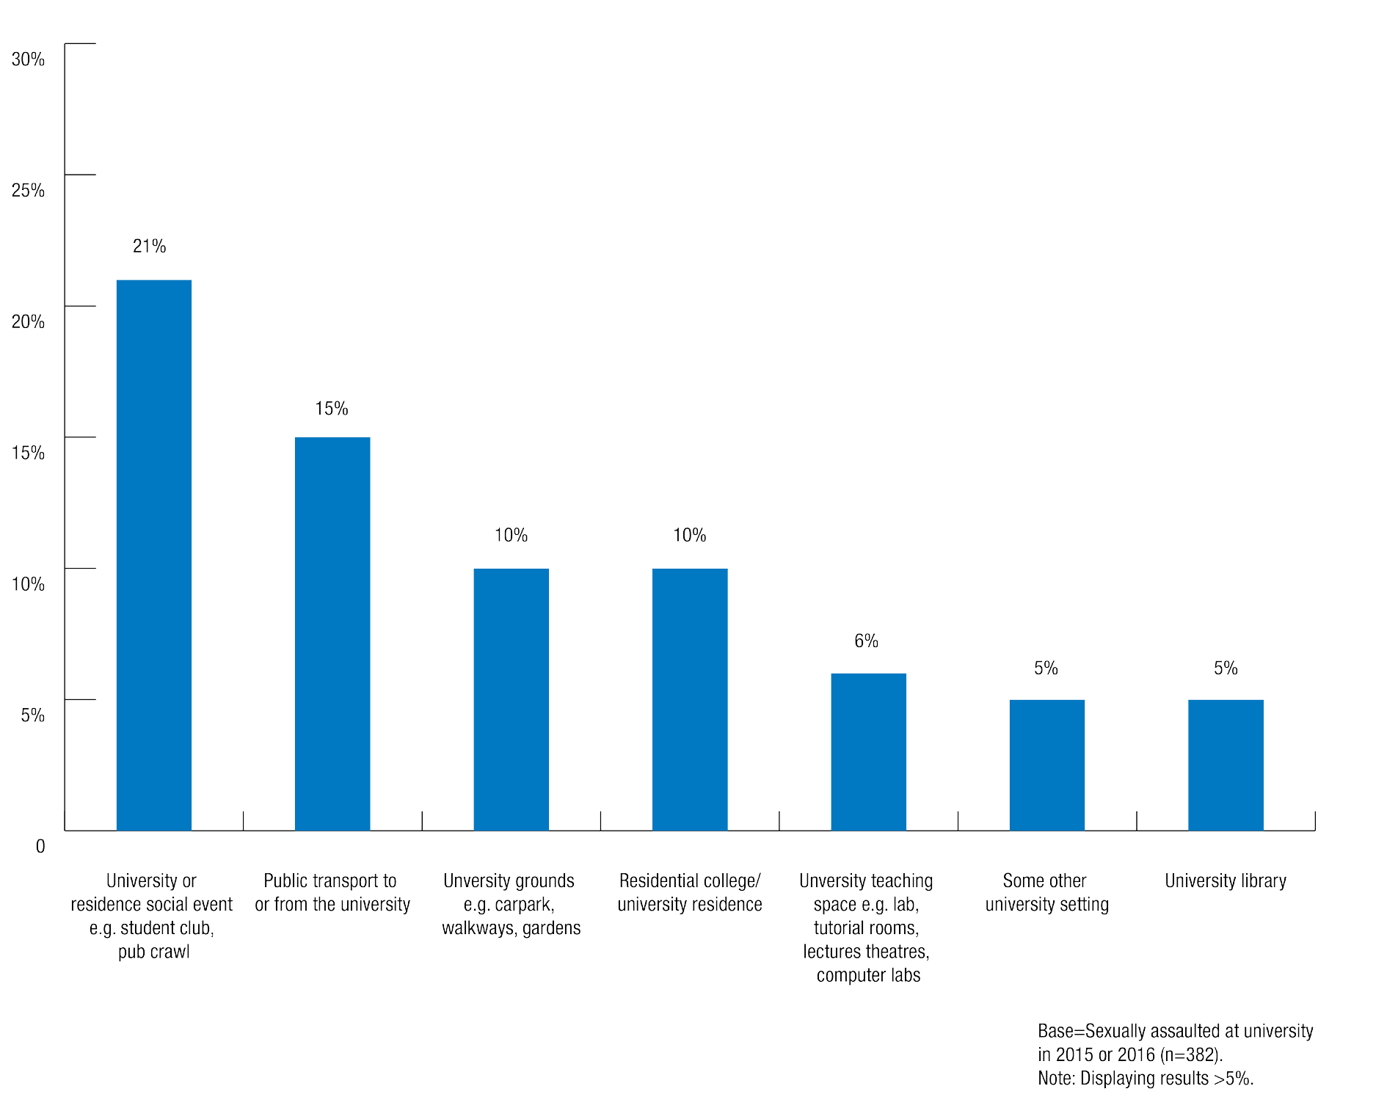

As with sexual harassment, there was variation in where students experienced sexual assault based on their gender. For both men and women, a university or residence social event was the most likely place where they would be sexually assaulted, though this was higher for men (29%) than women (20%).
The link between specific locations and the nature of sexual assault and sexual harassment is explored in further detail below.

Chart 19: Location of most recent sexual assault incident by gender identity
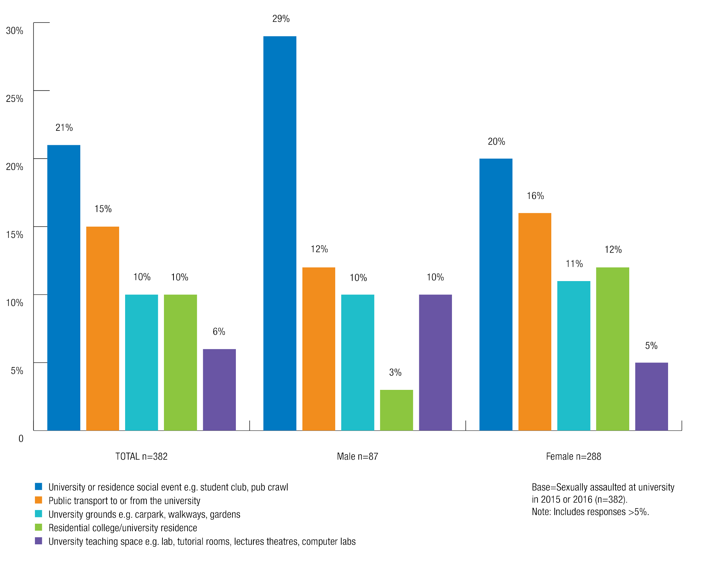

Public transport to or from university

Public transport to or from university was the most common location where students were sexually harassed in the most recent incident in 2015 or 2016.
The results of the National Survey indicate that the perpetrators of sexual assault and sexual harassment on public transport to or from university were often a student or other person affiliated with the university.
22% of students who were sexually harassed in 2015 or 2016 said that the most recent incident occurred on public transport.
Of these cases, 57% of perpetrators were a student from their university, 11% were a student from another university, 7% were an acquaintance or friend of a friend, 4% were a student from their place of residence, 3% were a non-academic staff member or a stranger, and 24% of survey respondents preferred not to say.

Women who were sexually harassed in 2015 or 2016 were more likely to have experienced this on public transport (25%, compared with 13% of men and 10% of trans and gender diverse students).
Domestic and international students were equally likely to have experienced sexual harassment on public transport in 2015 or 2016.

Public transport was also the second most common location were students experienced most recent incidents of sexual assault in 2015 or 2016.
15% of students who were sexually assaulted in 2015 or 2016 said that the most recent incident occurred on public transport to or from university.
Sexual assault on public transport to or from university was more likely for women (16%) than men (12%).
In contrast with sexual harassment, sexual assaults which occurred on public transport were more commonly perpetrated by a stranger. Of sexual assaults which occurred on public transport, 87% were perpetrated by a stranger, 8% were a student from their university, 7% were a fellow worker from their paid employment at university, 4% were a student from another university, and 3% were an acquaintance or friend of a friend.

International and postgraduate students were substantially more likely than domestic and undergraduate students to have been sexually assaulted on public transport.
27% of international students who were sexually assaulted in 2015 or 2016 said that the most recent incident occurred on public transport, compared with 13% of domestic students.
25% of postgraduate students who were sexually assaulted in 2015 or 2016 said that the most recent incident occurred on public transport, compared with 14% of undergraduate students.

Campus grounds
Campus grounds include a range of public areas located on the university campus, such as in university buildings, walkways and parks.

University campus grounds were the second most common university location where students experienced the most recent incidents of sexual harassment in 2015 or 2016.
Among students sexually harassed at university in 2015 or 2016, 14% said that the most recent incident occurred on campus grounds.
The group most likely to have experienced their most recent incident of sexual harassment in this setting were students who preferred not to specify a gender.
In relation to most recent incidents of sexual harassment:
  - 14% of women and 14% of men said this occurred on campus grounds.
  - 16% of trans and gender diverse students said this occurred on campus grounds.
  - 26% of students who preferred not to specify a gender said this occurred on campus grounds.

In addition to campus grounds as described above, 8% of students who were sexually harassed experienced the most recent incident in a university social space, such as a bar, cafeteria or shop.
Men (11%) and trans and gender diverse students (10%) were slightly more likely to have experienced the most recent incident of sexual harassment in university social spaces than women (7%).

Campus grounds were the third most common location where students were sexually assaulted in the most recent incident.
Among students who were sexually assaulted at university in 2015 or 2016, 10% said that the most recent incident occurred on campus grounds.

Teaching spaces

Teaching spaces were the third most common university setting where students experienced sexual harassment in the most recent incident 2015 or 2016.
Teaching spaces include: laboratories, tutorial rooms, lecture theatres and computer rooms.
Overall, 13% of students who were sexually harassed said that the most recent incident occurred in a university teaching space.
  - 17% of men who were sexually harassed said the most recent incident occurred in a university teaching space, compared to 11% of women and 8% of trans and gender diverse students.
  - 13% of domestic students who were sexually harassed said the most recent incident occurred in a university teaching space, compared to 9% of international students.
  - 15% of postgraduate students who were sexually harassed said the most recent incident occurred in a university teaching space, compared to 12% of undergraduate students.

Men were more likely than women to have been sexually assaulted in a university teaching space.
Overall, 6% of students who had been sexually assaulted in a university setting in 2015 or 2016 reported that the most recent incident occurred in a university teaching space.
Men who were sexually assaulted (10%) were more likely than women (5%) to have experienced the most recent incident in a university teaching space.

University social events

University and residence social events were the most common locations where students who were sexually assaulted experienced the most recent incident in 2015 or 2016.

21% of students who were sexually assaulted at university reported that a social event, such as a student club party or pub crawl, was the location in which they experienced the most recent incident of sexual assault.
  - Men (29%) who were sexually assaulted were more likely than women (20%) to have experienced the most recent incident at a university or residence social event.
  - Domestic students (23%) who were sexually assaulted were more likely than international students (12%) to have experienced the most recent incident at a university or residence social event.
6% of students who said they had experienced sexual harassment at university in 2015 or 2016 said the most recent incident occurred at a university or residence social event.

Residential colleges, university residences and other university accommodation
There are a number of accommodation options for university students in Australia.
Most students live off-campus in private or shared residences, however a number also reside in accommodation specifically targeted at university students.

Students who lived in university owned or affiliated residential accommodation were more likely than other students to have been sexually assaulted or sexually harassed.
There are a number of different types of university student accommodation, however for the purposes of the National Survey, the Commission distinguished between:
  - university owned or affiliated residential accommodation such as a college, hall, dorm or house, and
  - commercially owned or operated residences such as UniLodge, Student Housing Australia or Urbanest.
Overall, 7% of students who completed the survey were living at university owned or affiliated accommodation and 2% lived in commercially owned or operated housing.
However, of those who were sexually assaulted in a university setting, 34% were living in university owned or affiliated residential accommodation at the time of the most recent incident.
14% of those who had been sexually harassed in a university setting were living at university owned or affiliated accommodation at the time of the most recent incident.
Although these incidents did not necessarily occur at this accommodation, it does suggest that students living in university residential colleges or halls may be at a higher risk of sexual assault and sexual harassment than students living in other types of accommodation.

Chart 20: Living arrangements at time of most recent incident of sexual assault and sexual harassment
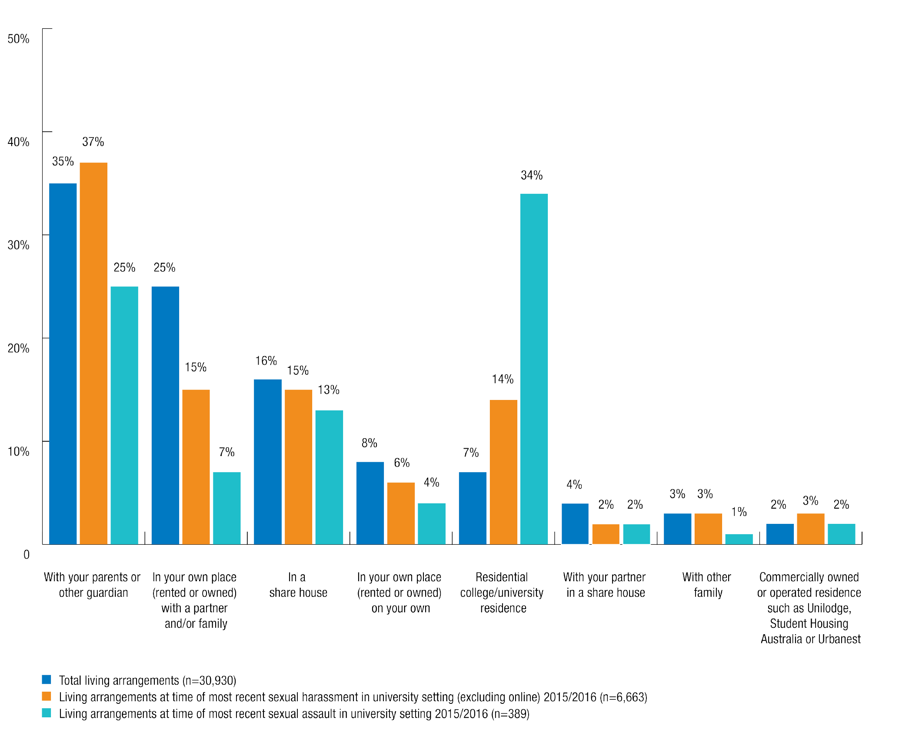

3% of people who were sexually harassed at university in 2015 or 2016 said that the most recent incident occurred at their residential college or university residence.
10% of students who were sexually assaulted at university in 2015 or 2016 said that the most recent incident occurred at a residential college or university residence.

Women were more likely than men to be sexually assaulted at a residential college or university residence.
    - 12% of women who were sexually assaulted at university in 2015 or 2016 said that the most recent incident occurred at a residential college or university residence, compared with 3% of men.

Although the survey did not distinguish between college and university social events, these events were the most common setting where students experienced sexual assault:
  - 21% of students who were sexually assaulted at university in 2015 or 2016 said that the most recent incident occurred at a university or residence social event.
In addition, 6% of students who were sexually harassed at university in 2015 or 2016 said the most recent incident occurred at a university or residence social event.

Professional settings
Among those who had been sexually harassed in a university setting in 2015 or 2016, 2% said the most recent incident had occurred in a workplace as part of university studies (professional placement) and 2% said it had occurred in their workplace at university.
Among those who had been sexually assaulted in a university setting in 2015 or 2016, 2% said that the most recent incident had occurred in a workplace as part of university studies (professional placement).

Technology

More than 1 in 5 students experienced technology-based sexual harassment in 2016.
  - 22% of students had experienced technology-based sexual harassment on at least one occasion in 2016.
  - 5% of students experienced technology-based sexual harassment in 2016 in a university setting.
This behaviour included repeated or inappropriate advances on email, social networking websites and internet chat rooms, sexually explicit emails or SMS messages, or any other unwelcome conduct of a sexual nature that occurred online.
Women (3.2%) were more than twice as likely as men (1.4%) to have been sexually harassed in a university setting in the form of repeated or inappropriate advances on email, social networking websites or internet chat rooms.
Trans and gender diverse students were more likely than women or men to report sexual harassment at university in 2016 in the form of:
  - repeated or inappropriate advances on email, social networking websites or internet chat rooms (5.4% of trans and gender diverse students, 3.2% of women and 1.4% of men)
  - other unwelcome conduct of a sexual nature that occurred online (5.5% trans and gender diverse students, 2.0% women and 1.4% men).

Chart 21: Types of sexual harassment experienced via technology perpetrated by people associated with the university on at least one occasion in 2016

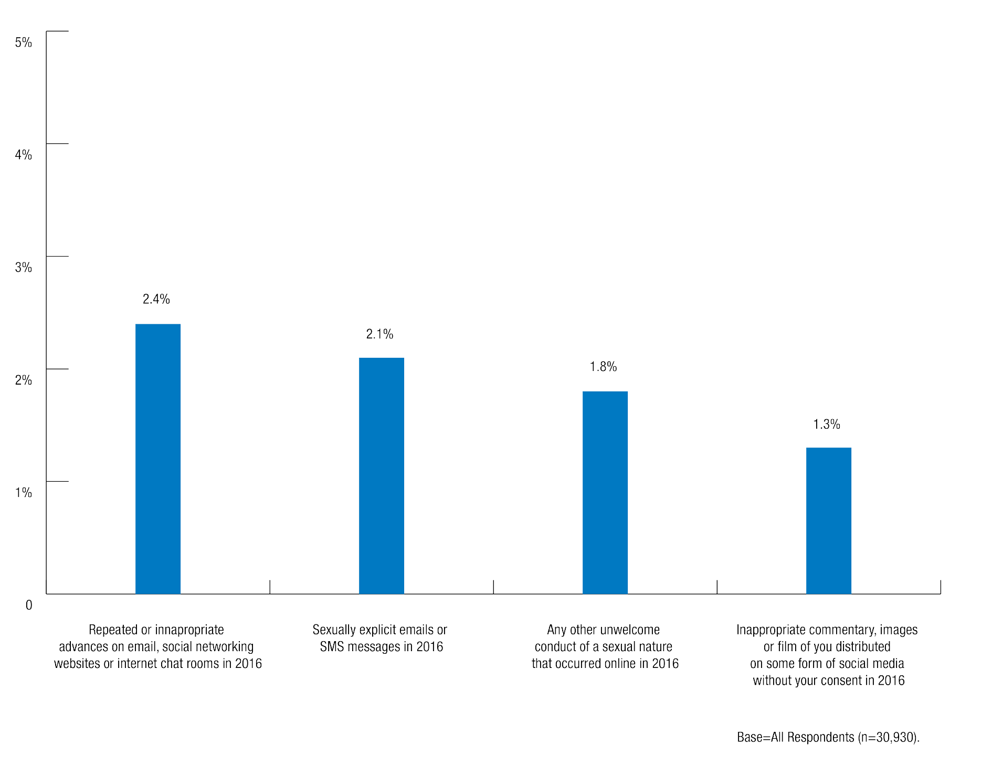

Submissions
A significant number of the submissions received by the Commission described experiences of sexual assault and sexual harassment which correspond with the survey results. The submissions provide a more nuanced understanding of the types of situations in which sexual assault and sexual harassment occurs, and the organisational cultures and practices that tolerate sexual violence or violence-supportive attitudes.
As previously stated, the submissions received by the Commission reflect individuals’ personal experiences of sexual assault and sexual harassment. As the submission process was not restricted to the same period as the National Survey and the majority of submissions received did not specify the timing of the incident(s) reported, no direct correlation can be drawn between the survey data and the information received through submissions.

Notes on reading the submissions contained in this report can be found in the ‘Methodology’ section contained in Chapter 1.

Illustrative quotes and case studies derived from the submissions have been grouped thematically below.

Public transport
Of the 1849 submissions the Commission received, 40 described an experience of sexual assault or sexual harassment on public transport.
Submissions described a range of sexual harassment experienced on public transport, including staring, leering, unwanted physical contact, and offensive comments of a sexual nature.
Often people of the opposite sex will sit very close, attempt to speak to me or interact or will just stare at me the entire duration of the bus ride. It happens around once every two weeks to once a month.2
As I was waiting to scan my [ticket] to exit the train station, a man came up behind me and slapped my bottom without my consent or permission. I did not know the man who slapped me personally, however I did recognise him as being a student because I have seen him around the campus before.3

Amanda rode the bus to university with a university professor. The professor would sit next to Amanda or gesture at her to sit next to him. During the bus rides, the professor stared at her and complimented her appearance. This behaviour made Amanda feel uncomfortable. They usually walked together from the bus to campus, but one day Amanda told the professor that she was going shopping. As she walked away he put his arm around her and kissed her on the cheek. From that day, Amanda arranged
for her sister to call and stay on the phone throughout her 20 minute bus ride to avoid interaction with the professor.4

Campus grounds
The Commission received 137 submissions describing sexual assault or sexual harassment occurring on university campus grounds. A wide variety of inappropriate sexual behaviour was described as occurring on campus grounds, including verbal harassment, unwanted staring and inappropriate physical contact.

Verbal harassment
Verbal harassment on campus grounds was commonly described in submissions. Verbal harassment includes a range of behaviours, such as cat-calling, derogatory comments and repeated requests for dates. Students who experienced verbal harassment in this setting were often unable to identify the perpetrator or determine whether they were a fellow student or member of the general public.
The Commission received submissions where the purpose of the verbal harassment appeared to be to intimidate individuals.
I was walking through campus in the morning and had my headphones in. A male student I didn’t know appeared next to me, getting closer than is acceptable and told me to take my headphones out of my ears and proceeded to ask me if I’d ‘suck him off’ before laughing and walking away.5

Abbey was leaving the library after dark one night. As she walked to her car, she noticed a male was following from close behind. He approached her and told her she was too pretty to be walking around at night alone and that she should be careful. Abbey tried
to walk faster but he kept close behind her while making sexual comments. Abbey turned towards the well-lit carpark where there were other students around and the male disappeared.6

Female students described incidents of being verbally harassed by groups of men while walking alone on campus.7

Martha was in the library, when a group of men came up behind her and started making sexual comments about her appearance. One of the students said ‘she’s really working it for us isn’t she boys?’. When one of them asked her to join them in a group study room, she felt uneasy and ran away.8

Sexist comments were a means of attacking and demeaning female students in competitive situations, such as sporting competitions9 and student elections.10
At the Interhall Female Soccer grand final, a number of extremely inappropriate, transphobic, and raping comments were yelled at my team members from the sidelines of the opposing team. A number of girls were incredibly upset by specific calls saying ‘you’re asking for it in those shorts’.11

Stalking
A number of students were followed and stalked on campus, particularly when they were alone.12 These incidents were sometimes accompanied by other inappropriate behaviours, such as staring or verbal harassment.13
From the beginning of the semester I began being harassed and stalked by a postgraduate student. He would follow me everywhere, tell me that I was ‘his’, grab me and intimidate me and belittle me.14

Philippa is an undergraduate student. Philippa was walking around the campus between her classes one day, when she noticed a young male student walking behind her.
Philippa walked to a lot of different places on campus – from the cafes and shops to the gardens. The male student kept following her. Philippa started to get concerned. She walked into her faculty building and made an excuse to pop into one of her lecturer’s offices for a chat. Finally, the male student stopped following her.15

Imogen is a postgraduate student. She was repeatedly harassed by a co-worker who also studied at her university. He would repeatedly ask her on dates and call her.
When Imogen told him she was not interested he began following her around campus whenever she was alone.16

One student related her experience of discovering a note left on her vehicle that implied someone had been stalking her for some time.
When I was an undergraduate at [university], somebody left an anonymous note under the windscreen wiper of my car. It told me the author had been watching me, was
very (scarily) attracted to me, and described me in detail. It also said the author would continue to watch me, with a huge eyeball drawn onto the page. My car was parked on campus...It was a 5 to 10 minute walk from my classes to my car, and on many occasions I would do this walk at night.17

Indecent exposure
The Commission received a number of submissions describing instances of indecent exposure on campus. These incidents usually involved men touching their genitals inappropriately in the presence of female students.18

Breanna was studying late at night in the library, when a male student approached her, pulled down his trousers to expose his erect penis, and asked her to ‘suck his dick’.
Breanna hid in the female bathrooms for 45 minutes, until another girl came in and helped her leave safely. Since then, Breanna has felt uncomfortable using the libraries and bathrooms at university on her own.19

Sexual assault and inappropriate physical contact
The Commission received a number of submissions involving unwanted physical contact which occurred on campus grounds. These incidents often occurred when individuals were walking alone in isolated areas of campus.20
I’ve also had strangers repeatedly touch my behind when walking behind me if I am in a tight skirt. This has happened a number of times and these people are all strangers and men.21

Erica was returning home from the gym one afternoon when a man started following her. He eventually approached her to ask for directions, and then repeatedly hassled her about taking a photo with him. Erica finally agreed to taking a photo of the man hoping he would leave, but he grabbed her by the wrist and groped her breast. Erica managed to escape by slapping him across the face and running back to her college.22

In addition to unwanted touching, submissions described instances of sexual assault which took place on university campuses.
I was sexually assaulted while on the uni campus. I was in a common room with my boyfriend at the time. He was the one who assaulted me.23

Teaching spaces
The Commission received 171 submissions from individuals who reported experiencing some form of sexual assault or sexual harassment in a university teaching space, usually perpetrated by a fellow student or a university staff member.

Sexual harassment in class by fellow students
Submissions described instances of sexual harassment perpetrated by fellow students in their classes. This behaviour included unwanted touching, stalking, inappropriate sexual comments or other unwelcome sexual attention.
One woman reported that a male classmate commented to her that ‘he could put her tongue to better use than her boyfriend could’.24 Another said that her classmate would make comments such as ‘I wish you had no clothes on’ and talked about sexual acts he wanted to perform on her.25
People reported fellow students making inappropriate comments during class or using class as an opportunity to make sexual advances. Students found this behaviour difficult to escape as they regularly saw the perpetrator in classes.

Wendy has faced ongoing harassment from a classmate throughout her undergraduate studies. He is aware that she has a partner, but continuously asks her on dates and tries to touch her inappropriately when they are in class.26

Dominique met another student in her degree in one of her first classes. They subsequently had many classes together. The student would constantly refer to Dominique’s figure and clothing in class. He repeatedly asked her out on dates, though she always declined. Dominique began feeling more and more uncomfortable in her classes and would sometimes miss them to avoid the student. When he would pass her by on campus, he would call out to her and shout sexually explicit remarks.27

Incidents of unwanted physical contact also occurred in lecture theatres.28 Students reported that the perpetrator would sit next to them in a lecture and use the opportunity to touch or grope them in a way that was unwanted.
…A man who was in my class sat next to me in a lecture, half sitting in my seat with me (even though there was numerous seats around the place) and then when we left the lecture walked half a step behind me.29
In class (the one class I had where I had no friends so was often by myself) he’d sit next to me and when I’d move to another seat he’d follow and stroke my thighs and in between my legs even after I and others told him to stop.30
One female student described a situation where her classmate would expose his genitals to her during tutorials.31 Another described a situation where sexual harassment occurring in class escalated to more serious behaviour.

Juliette experienced ongoing harassment from her classmate, Drew. When Juliette met Drew in first-year, they were enrolled in most subjects together. Drew would often make inappropriate comments to Juliette about her body, as well as touch her hair or her lower back when he was sitting next to her in class. The next semester, Drew started following Juliette after class and finding her wherever she was on campus. He would try to persuade Juliette to go somewhere quiet and secluded with him. On one occasion, he grabbed her by the arm and tried to pull her into an empty classroom. One day, Juliette was walking to her car when Drew suddenly appeared. He grabbed Juliette and asked her to kiss him. She refused and Drew pushed her against her car and began kissing her against her will. When he put his hand in between Juliette’s legs, she screamed to attract the attention of passing students.32

Sexual harassment of women in male-dominated fields
A number of women studying in male-dominated science, technology, engineering and mathematics (STEM) fields reported being sexually harassed in class. These submissions described a ‘culture’ of discriminatory attitudes towards women and a perception that women are unwelcome and not well suited to STEM professions.33
This behaviour was perpetrated by both staff and students. Women studying STEM at university described the isolating nature of being one of only a handful of female students enrolled in STEM subjects.34
As a female in engineering I am surrounded by men with the ratio being 35 to one, with me being the one.35
By the start of third year I was the only female student in a class of about 20.36
One individual noted that her experience studying computer sciences at university was an ‘ominous induction into the amount of sexual harassment [she] was to experience later on working as a female in an IT company.’37

Iman is a female, undergraduate student studying engineering. Iman’s classmates often suggest that she should have sex with her tutor in return for good grades on a group assignment. She often overhears male students discussing her appearance and her sexuality in class. Another classmate once took photos of her without her knowledge and drew sexual comments and images on them before showing other classmates. She has also experienced groping from classmates, both in class and when studying together or having breaks.38

Another submission described an incident of sexual harassment experienced in the classroom.
A fellow student came up behind me during an anatomy practical and continuously rubbed himself against my rear while students around us were preoccupied with the anatomy demonstrator. At first, I thought he was trying to get a better view of the specimens, however when I took an obvious step forward to make room, he followed me and continued to rub closely behind me.39
The specialised nature of these degrees also meant that the target of sexual harassment could not easily avoid the perpetrator because they have to see them in class every day.

Sexual harassment by staff
The Commission received submissions describing sexual harassment perpetrated by staff members in teaching spaces. Similarly to the examples already described, this behaviour included offensive sexual comments, unwanted sexual attention, stalking or inappropriate touching and groping.
A tutor at the university would leer at the female students during practicals, come up close to check our work and often approach us in a way that was like hitting on us.40
[A professor] once told me that he had scaled up my marks on an essay because I ‘had a pretty face’.41
Consulting with my…tutor about an assignment, he sat on the edge of my chair, stroked my hair, kissed the top of my head and said he’d like to run away and drink cheap red wine with me.42
I was alone with my supervisor after having just found out I had passed my first year PhD confirmation. He congratulated me and gave me a hug. When I went to pull away, he didn’t let go and whispered in my ear that he thought I was ‘so beautiful’ before kissing me on the mouth.43
This Assoc Prof would constantly take photos of all the undergraduate female students in his class including myself…We all felt his behaviour was creepy and unprofessional but no one kept tabs on his behaviour. He developed obsessions with many female students.44
Some students reported that a staff member had asked intrusive questions or made unwanted sexual advances.
…My teacher asked inappropriate questions about my relationships that made me feel uncomfortable while we were in the room alone together.45

Katie was packing up her things after a tutorial when her tutor approached her and asked her to come back to his house and have sex with him. Katie was scared as the tutor also marked all her assignments and she didn’t want to upset him and fail her course.46

Ana experienced sexual harassment from a tutor in her course, who stared at her inappropriately one day in class when she was wearing a dress, and asked her whether she was looking for a boyfriend.47

A theme that emerged from these submissions was the power disparity between students and teaching staff, which made students vulnerable to sexual harassment.
I believe that I was sexually harassed by my supervisor as he took advantage of the power imbalance and saw my situation as a new mother, and me being a young naive woman who looked up to him, as an advantage or a vulnerability. Perhaps lecturers at universities feel that they are in position of power with their students and some take advantage of this.48
I didn’t know what to do, I didn’t want to be rude because he was a professor.49

Sexual harassment of postgraduate students attending conferences
In addition to students reporting behaviours occurring in lectures and tutorials, the Commission heard in submissions from postgraduate students who were sexually harassed by academics while attending conferences. We have treated this location as a teaching space because these students attended the conferences as part of their studies or academic development.
These submissions predominantly spoke of unwanted sexual advances. The incidents were generally isolated events, although some submissions indicated that this type of behaviour was common at conferences.
As a postgraduate student, I have experienced a number of incidents of sexual harassment at conferences by persons in positions of power in my academic discipline within and outside of [my university].50

Diana attended a conference run by her faculty at her university. During one of the social events, a male colleague groped her.51

In some cases, the perpetrator was a prominent academic working in the target’s field who may have influence over their career.52

University social events
The Commission received 115 submissions relating to incidents that occurred at university social events. These include Orientation Week activities, university parties held on and off campus and events held by clubs and societies. A number of students described alcohol being used by the perpetrator to commit sexual assault or sexual harassment.

Orientation week
Orientation Week or ‘O-Week’ occurs at the start of the university semester, before the first week of classes. It is a time when students are encouraged to engage in the social aspects of university life through sports, clubs and societies, and when many different parties and events are held both on and off campus.
As with other university social events, the submissions relating to O-Week described incidents that ranged from sexual harassment to sexual assault.
The first time was during O week in my first year of uni when a group of boys surrounded a group of my girlfriends on the dance floor and hassled each of us individually trying to kiss us. We eventually had to leave the dance floor as none of them would take no for an answer.53
[A]s I didn’t know anyone well, no one noticed when I disappeared with another student that was much older than me…I’m not sure if I drank too much or if I was given a date rape drug, but I woke up naked, in his bed, in his house in a far away suburb, and when I realised what had happened I grabbed my clothes and ran away and walked back to my accommodation in the middle of the night in a city I didn’t know.54

Louisa was at an O-Week party with her friends. When she went to the bar, a male student approached her and asked if he could buy her a drink. She said no but he quickly became aggravated and pressured her to accept. She returned to her friends but later on that night, the same student approached her on the dance floor. He grabbed
her and began to grope her, pulling her against him and trying to dance with her. He was holding her so tightly that Louisa had to physically struggle against him to get away.55

University parties and social events
In addition to parties during O-week, the Commission received a number of submissions describing incidents that occurred at university parties or social events more broadly.
The behaviour reported in these submissions included unwanted touching or sexual advances and attempted coercion into sexual acts. Some of the incidents occurred at events on campus, and some at off-campus venues such as nightclubs and bars. Although some of these incidents occurred off-campus, the event was affiliated with the university and the perpetrator was often a classmate or acquaintance of the person subject to the sexual assault or sexual harassment.
The use of alcohol by perpetrators was a key factor in many submissions. Some students described a sense of pressure to participate in the culture of excessive drinking.
Lots of pressure to drink and tell people about your hook up experience. Drinking and ‘letting go’ is highly encouraged.56
The culture at Uni is that you have to go to the parties to be social and you have to drink to fit in. There is a culture that the girls have to drink more and party harder to prove that they are ‘cool’57
University parties or social events were described as environments where behaviours including unwanted touching and verbal harassment were regular occurrences. According to one student, groping in university bars ‘occurs so commonly among my friends that it’s almost considered one of those annoying ‘norms’’.58
I cannot count the number of times we have been drinking or dancing by ourselves in groups and guys would try to pick us off and corner us, grope us, make lewd comments, etc…This type of thing would occur every single time we went out on campus, by several different men on each night.59
During nights out drinking I have experienced unwanted sexual attention. This has involved sexist comments, inappropriate touching and groping [and] invading personal space.60
Individuals reported being sexually assaulted during or after university parties or social events, sometimes while under the influence of alcohol.

Mira is an undergraduate student. One night, she attended a university party with her friends. After having a few drinks she decided to leave the party and accepted an offer from a male friend to walk her home. Mira remembers waking up with her friend sexually assaulting her. She urged him to stop and tried to push him off but he continued to sexually assault her.61

Lily was at a party organised by her university. At the party, a man tried to take her home with him. When she refused to leave with him, the bouncer kicked her out of the venue. The man then took her to the car park and forced her to get on her knees and perform oral sex on him. Lily was crying and telling him to stop, but he continued, and eventually left her in the car park.62

Clubs and societies
Incidents of sexual assault and sexual harassment sometimes occurred at events organised by student-led clubs and societies. Students described the high levels of alcohol consumption at club and society events, the close-knit nature of university clubs and societies, and hierarchical leadership structures as contributing factors to incidents of sexual assault and sexual harassment in this particular setting.
My university especially has a series of clubs dedicated to drinking and partying, trying to emulate the American ‘frat boy’ experience. These parties and the groups of people who attend them perpetuate a predatory culture, where often the aim of the party is… to get drunk and get laid.63
Although these clubs outwardly state that they don’t condone sexism, misogyny or sexual harassment amongst members and students, so much has occurred in my time as a student…No one is taught how to drink safely but to keep drinking beyond their limit, and when that limit is reached or passed, no one looks after them.64
These clubs and societies are usually led by senior students, and some submissions described incidents where these leaders took advantage of their position of power to sexually assault or sexually harass younger club or society members.65
Executive committee members of clubs have an attitude of ‘I get who I want, when I want’ when it comes to social events.66
I am involved in various clubs at university and there is often a power play that goes on. There have been incidences where the President of the club … has sexually harassed me, but I didn’t feel like there was anything I could do about it because he was my ‘boss’.67

Alexandra attended an inter-university sports tournament with her team during the first year of her undergraduate degree. First-years were expected to participate in certain ‘rituals’ by the more senior members of the team. This included being subject to sexual harassment and unwanted sexual advances. There was an expectation that first-year team members would ‘hook up’ with more senior members. Alexandra is aware of sexual assaults that occurred during these rituals.68

Residential colleges
The Commission received 203 submissions describing experiences of sexual assault and sexual harassment occurring in residential colleges.
Students living in residential colleges reported experiencing a broad range of behaviours constituting sexual assault and sexual harassment, from inappropriate comments, to unwanted physical contact and rape.
Although many of these experiences are similar to those occurring in other university settings, the submissions received also highlight some factors unique to colleges which were identified as contributing to sexual assault and sexual harassment in this setting.
The Commission heard about hazing practices and other college traditions involving elements of sexual assault and sexual harassment. Submissions described hazing and traditions being used to initiate new residents into the college community. People reported feeling pressure to participate in these practices, which often entail excessive alcohol consumption and humiliating and degrading acts.
The residential setting of colleges was identified as providing opportunities for sexual assault and sexual harassment to occur. People described being sexually assaulted in private bedrooms in residential colleges. Another issue reported was women being filmed in showers or bathrooms within their college. The residential setting also contributes to a lack of privacy in relation to residents’ personal lives; there is a sense that sexual relationships in particular are considered ‘public knowledge’.
People described a culture of excessive alcohol consumption and social pressure to drink at college parties and social events.
Related to this, a particularly large number of submissions identified alcohol as a factor contributing to sexual assault and sexual harassment that occurred in colleges.
- 151 submissions described alcohol or drink spiking being a factor in sexual assault or sexual harassment. Of these submissions, 83 described incidents which occurred in residential colleges.
- 55 people made submissions that described being unconscious at the time of a sexual assault, and of these submissions, 31 described incidents which occurred in residential colleges.
These incidents were similar to those reported in other settings, with people being sexually assaulted while unconscious or incapacitated due to the influence of alcohol. Some people also reported perpetrators encouraging or forcing them to consume alcohol prior to sexually assaulting them or ‘spiking’ their drinks before sexually assaulting them. These assaults often occurred in a college bedroom after a night out drinking with friends.
Many colleges employ older students as Residential Advisors (RAs) to provide pastoral assistance to younger students. Some submissions reported RAs abusing their role, for example by using their master key to enter bedrooms of other residents without permission. In submissions, the Commission also heard of instances of sexual assault and sexual harassment perpetrated by RAs.

Hazing practices
A number of students described the practice of ‘hazing’ first-year students in colleges.
Hazing has previously been examined in relation to the Australian Defence Forces, by the Defence Abuse Response Taskforce. In that context, hazing has been defined as the
‘inappropriate humiliation and degradation of others to produce a stressful environment’69 and which includes behaviours such as ‘harassment, bullying, physical abuse, degradation, forced alcohol consumption and sleep deprivation’.70 The 2014 Report on abuse at the Australian Defence Force Academy noted that hazing practices which have ‘a sexual element, target the genital area or are otherwise sexually degrading’71 may constitute sexual assault or sexual harassment.
Submissions described hazing practices which align with these definitions, often involving excessive alcohol consumption, performing humiliating or degrading acts, and in many cases the sexual assault and sexual harassment, usually of female residents. People reported feeling pressure to participate in hazing in order to ‘fit in’ with their peers.
The aim is to get the freshers as drunk as possible. Maybe a secondary aim is to make them look as ridiculous and embarrassing as possible, giving them costumes, props, and even sometimes smearing food all over them.72
You had to participate, there was nothing you could do about it. The administration knew about this and they condoned this. The students had no power whatsoever, you couldn’t say anything.73
Examples of hazing practices described in submissions include:
  - One female student described a hazing practice for new female students called the ‘run the gauntlet’ challenge. Female students were required to run down a corridor lined with male residents. The male residents had cask wine sacks in their trousers with the nozzles hanging out of their fly. Female students were required to kneel before each male resident and ‘drink from his sack’.74
  - Another former resident reported that first-year female residents were given ratings on how ‘f**kable’ they were and invited to a party for male residents where they were told to wear ‘as little as possible’.75
  - A first year college resident described a ‘culture of hazing’ at her college, which included being made to sing inappropriate sexual songs in public and stripping naked and jumping into a river.76
  - An all-male college organised annual O-Week trips for first-years. As part of the trip, first- year residents were woken up early to march past the all-female college while singing songs describing sexual assault. Some songs identified female college residents by their name.77
  - One residential college student described a practice at college parties where first-year female students were pressured to take their tops off when a certain song is played. The male residents of the college would then form a circle around the female students and prevent them from leaving the dance floor without removing their tops.78

    - A college held an annual event called ‘feral women’s night’ where first-year female residents were force fed alcohol, told to remove their tops and serve drinks to older male college residents while being subjected to derogatory comments and chants.79

College traditions
In addition to the hazing practices targeted at first-year students, other college ‘traditions’ which occur throughout the year also involve sexual assault or sexual harassment of residents. Some of these traditions were similar to the hazing rituals and involved alcohol consumption and performing humiliating or degrading acts, while others were centred around publicising the private lives and sexual relationships of college residents. Some college traditions involving male residents singing songs or chants that encouraged sexual assault and sexual violence against women.80
As with hazing, people were pressured, sometimes by senior residents, to take part in these traditions.81
I was told I was ‘letting my team down’ as we would not get my ‘points’ for the day for not getting naked. I was made to feel extremely excluded and humiliated, all because I didn’t want to take my clothes off.82
Whenever someone starts chanting ‘win-on’ and making a chopping motion with their hand in the direction of a male and a female, everyone normally follows along, and this means that those two people have to kiss. Again, of course you can always say no, but this looks so bad in the eyes of your peers that most just do it.83
One person reported that her college held ‘stag nights’, or male only parties, where male residents sang songs referring to female residents as ‘pigs to bend over backwards and f**k when they get home’.84
A female student described a tradition in her college which takes place in the first week of semester and involves drinking games and going to nightclubs with fellow college residents. She was sexually assaulted by a fellow college resident after one of these nights out.85
People described college traditions which involved publicising the private lives and sexual relationships of college residents. Women were often shamed on the basis of their sex lives while male residents were glorified or praised for having slept with the highest number of women.
Conquests of guys getting girls from other colleges were broadcasted weekly in this gossip session the whole college had, where you would submit your experiences to an executive, and on weeknights we would gather and hear about everyone’s conquests that week…women were described as objects or trophies.86
Students were required to pay a weekly ‘fine’ for actions ranging from ‘seen kissing another student’ to ‘spit roasting’. Any action seen as worthy of notoriety was re-enacted at the next college dinner in front of 200 plus student body.87

At the end of the year, everyone voted for awards like ‘worst (car) parker ‘ and that sort of thing, and everyone voted for who they thought had had sex with the most people. It was called the ‘Casanova’ award for boys and ‘Lady Luck’ for girls. The spirit of it was that the boy who received the award was a champion, whereas the girl who received it should be ashamed.88
One student was sexually assaulted and had the experience broadcast over the college’s PA system as a ‘hook up’.89
Another person described a tradition at her college known as a ‘morality court’. Awards were given for ‘best arse’, ‘top root’, and the ‘largest number of sexual partners during a week’.90
Some submissions detailed college traditions which involved having their sexual relationships published online or in a college yearbook or newsletter.
There was also a section at the back of the magazine where there were riddles and things, which gossiped about students, and these often talked about students losing their virginity and certain students’ sex lives.91
I’ve also been put in an online ‘web’ called the college-spit chain, where boys (often lying) link up all the girls names they have kissed or had relations with.92
We had an internal server where everyone’s hookups were listed and people were ranked according to how many people they’d slept with. If I did sleep with someone, everyone knew about it before the next morning. Their friends would make comments and harass you.93

Residential setting
Submissions often described the residential setting of colleges as providing opportunities for sexual assault and sexual harassment to occur. These behaviours occurred in private bedrooms and shared bathrooms in colleges.
In addition, people also reported that the private lives and sexual relationships of college residents are considered to be ‘public knowledge’, and that women are sometimes sexually harassed on the basis of rumours about their sexual relationships.
Where people did experience sexual assault or sexual harassment by a fellow college
resident, the impacts were exacerbated by the fact that they had to live in close proximity to the perpetrator and see them on a regular basis.

Ongoing sexual assault and sexual harassment by fellow residents
Experiences of sexual assault and sexual harassment in residential colleges and other residential accommodation sometimes occurred over a period of several weeks or months. In these cases, the behaviour was compounded by the fact that the perpetrator was living in the same residential college.

One former college resident reported that her friend experienced ongoing sexual harassment from another male college resident. He would aggressively pursue her friend and refused
to take no for an answer. He also entered her room without permission to ask about her friend, and revealed that he watched them when they were together and knew about their movements.94
A fellow student that used to live at my [residential accommodation], invited me repeatedly to go to his room or to his office at inappropriate times and most of the times promising to give me alcoholic beverages. When I got tired of his invitations, I told him
I was already dating someone else and he behaved angry and aggressive through his messages.95

Stella lived in a residential college. Within a few weeks of living at the college, a postgraduate student who was also a resident of the college began to harass and stalk Stella. He would follow her around campus, grab her and hold her against her will and would tell her how much he wanted to be with her, despite Stella telling him that she was not interested in him. He began telling people that Stella was his girlfriend and told Stella she did not ‘appreciate how much he wanted her’. One night, Stella woke up to the resident raping and physically assaulting her. The resident told her that if she told anyone else what had happened, he would kill her.96

Lack of privacy regarding sexual relationships at residential colleges
The Commission heard in submissions that it is common within residential colleges for residents’ private lives to be considered public knowledge. This builds on what the Commission heard about college traditions which involve the details of sexual relationships being published in college magazines or on websites. In some instances, people – usually women – reported being shamed by their fellow residents on the basis of rumours about their sexual relationships.
…students weren’t free to have sex or explore their sexuality in a private way, everything was made public and everyone was judged.97
One woman reported being asked ‘how many guys [she] had fucked today?’ by a fellow resident at college. People also called her a ‘slut’, told her they were surprised she wasn’t pregnant or ‘hadn’t died of AIDS yet’ and implied she had a sexually transmitted disease.98

Grace lives in a residential college. One night at a party, her friend Jack pressured her to have sex with him but Grace refused. The next day Jack started spreading rumours that they had slept together and that Grace was a ‘slut’. Other males at the college joined in the harassment and Grace would often overhear derogatory comments directed at her in the common areas and hallways of the college.99

Some individuals noted that while women were shamed by their fellow residents for having sexual relationships, male residents who were known or thought to have had a large number of sexual partners were praised for this.
At college there are very distinctive gender roles. For women, you are most desirable if you are in your first year and physically attractive. For men, you are most desirable if
you are in a later year and are funny and popular. For men, having sex with a ‘hot’ first- year girl is a major achievement, one which you will tell all your friends to boost your popularity.100
Single-sex colleges are particularly problematic in that men’s colleges encourage masculinity and having relations with as many women as possible. This can lead to women being taken advantage of in an attempt to appear masculine and popular at male colleges.101

Women being filmed without their knowledge or consent
Submissions described instances of women being filmed without their knowledge or consent. A number of individuals reported being filmed in mixed-gender and female only showers or bathrooms at their residential college.102

Priyanka was showering in a unisex shower stall at college when she noticed a mobile phone hovering over the stall. She confronted the perpetrator and he denied doing anything.103

The Commission received submissions describing incidents where college residents watched or filmed consensual sex without one partner’s knowledge.
A large group of guys had a pact where they would go out looking for drunk girls to hook up with, and when one of them succeeded they would message the group and the rest of the guys would get back to the college room first and all pile in the closet (which had a huge gap you could see out of) waiting until the guy got back to the room with the girl and the group of guys would watch/film the couple have sex without the girl having any knowledge of what was happening.104
I am a staff member…and have worked within student residences for 26 years…I am also finding a growth in photos and vision, of consensual sex acts being shown to friends of one of the partners without their permission. Particularly males, taking photos and vision of a female partner, when both are usually heavily affected by alcohol or an illicit substance.105

Sexual assault and sexual harassment in college bedrooms
Some students living in residential colleges raised concerns about the lack of privacy and security resulting from living in close quarters with other students at college. People described how residential settings provide opportunities for sexual assault and sexual harassment to occur.
The final issue that I believe leads to high rates of sexual assault at college is the fact that everyone lives together. This means that it is easy for someone to take advantage of someone else by going to their room uninvited.106
One submission described a practice at their college known as ‘rockspidering’ where people knock on the doors of female residents with the intention of having sex with them. If the door is answered, this is considered consent to have sexual intercourse.107
The Commission received submissions from women who had had their rooms broken into by male college residents.
One night I had forgotten to lock my door, and an intoxicated male, one of the more senior students…came into my room and tried to convince me to have sex with him. Thankfully he eventually left without anything happening, but nevertheless. It was the sort of thing that could/would have happened much more frequently had I not locked my door every night.108
I had my door unlocked because I was waiting for my boyfriend to come home from town but I woke up to find another boy from my college in my bed touching me.109

Rachel was a first-year student living at a residential college. She was raped during O-Week by a male student who entered her dorm room without permission.110

Some individuals also reported being sexually assaulted in a college bedroom during a party held in the common living areas of the college.
In one scenario, a female student reported being sexually assaulted by a male resident during a college party. The assault took place in her college bedroom. After the assault, the male resident left and returned to the party as if nothing had happened.111

Mariana lived in a residential college during her first year of university. One night, there was a party in the college and Mariana attended with her friends. One of her male friends offered to get her more alcohol from his room. When they got his room, he suddenly kissed Mariana. He began undressing her and Mariana remembers being confused and scared. He then raped her while she kept trying to push him off.112

People also reported being sexually assaulted in their college bedroom by a friend or acquaintance who had offered to help them back to their room after a night out drinking.
At college…A common occurrence was for a later year boy to offer to ‘help’ a drunk younger girl to get home after being out and then to take advantage of her.113

Bianca had attended a party at the university bar and decided to go home. Two of her male friends offered to walk her home. Bianca accepted but on the way they said they had to stop off at their college for something. Once inside of the students’ room, they locked the door and took turns raping Bianca.114

Alcohol as a factor in sexual assault and sexual harassment occurring in colleges
In addition to being part of the hazing practices and college traditions described earlier in this chapter, excessive alcohol consumption was described as being a major feature of college life more broadly. Alcohol was also frequently reported as being a factor in instances of sexual assault and sexual harassment which occurred in college settings.
People described an environment in colleges where ‘binge drinking’ is common, alcohol is readily available and residents are sometimes pressured by their peers to drink.
…the ‘binge drinking’ culture has been part of [residential college] for years…Each Thursday we would drink and then go to the local pub, as first-years and within the first two weeks we would drink excessive amounts to fit into the ‘norm’.115
…binge drinking is rampant and encouraged. Many college events revolve around drinking games.116
…chalk on footpath advertising a college party: ‘Beer $2, bitches free’.117
Students reported that it is acceptable in colleges to have sex with someone who is heavily intoxicated.
I think the ‘lad culture’ and boys club mentality of the college helped to cultivate scenarios where taking advantage of intoxicated people was accepted and commonplace.118
It’s because there was no education at any time during college about respect or consent. Instead, it is encouraged and highly regarded to ‘bag’ as many people as possible… Among my peers in my immediate vicinity at the time, it was so common for people to be very drunk and have sex.119
The Commission received a number of submissions which reported sexual assault by a fellow college resident while the person being assaulted was unconscious or severely impaired due to the influence of alcohol.

Girls were encouraged, almost forced to drink and I saw so many times unconscious girls carried to their bed by guys and I was too scared to do anything, but I always wondered what happened behind closed doors.120
I have not experienced sexual assault myself, but being in a college environment hear of multiple accounts of girls waking up after a night of drinking and being unsure of what has happened, or knowing that they have been pressured into sex or even raped when they were unconscious or just barely conscious.121
One resident who had been drinking with friends in the room of a fellow resident said she had been drinking heavily and fell asleep on the bed while her friends were still talking, but woke up to a friend having sex with her.122

Allison attended a party in her first year living at a residential college. She participated in drinking games and consumed a lot of alcohol so she would fit in. At one point in the night, a large group of older residents grouped around Allison and a male college
resident she had been talking to and chanted at them to kiss. After this, Allison had very few memories of the night. Her friends who walked her home told her she was slipping in and out of consciousness as they walked her back to college. The next morning, Allison woke up in the room of the student she had kissed at the party. He was having sex with her. Allison went into shock and did not know what to do. She was very upset but pretended that she was okay so she could collect her things and get back to her own room.123

The Commission also heard of instances of women being sexually assaulted after being ‘fed’ drinks or encouraged to drink by the perpetrator of the assault.
One individual reported that on a date with a fellow resident, he told her to ‘drink more wine’ after she refused to have sex with him. He then pinned her to the bed and sexually assaulted her.124

Veronica was a first-year student living in college who was sexually assaulted by a friend, Paul, who was also a fellow student. She and Paul had been working on a group assignment with some other male students in Paul’s dorm room at a residential college. Paul and his friends encouraged Veronica to drink alcohol and continually topped up her glass. Veronica became faint and lay down on Paul’s bed. When the other male students left, Paul kissed Veronica and digitally penetrated her.125

Estelle went out drinking one night with friends from her residential college. One of her friends, Freddy, insisted on buying her shots of alcohol all evening. Estelle felt very intoxicated and Freddy offered to take her back to her room at college. When they arrived, Freddy instead took Estelle to his room where she passed out. When Estelle regained consciousness, she was in pain and Freddy was sexually assaulting her.126

Some submissions reported that they had been sexually assaulted after having their drink spiked at a college party or event.127

Cordelia’s drink was spiked by a college resident at the end of semester college ball. He had been trying to dance with Cordelia all night and kept offering to buy her drinks. He then gave one of her friends a drink at the bar and asked them to give it to Cordelia. She took the drink and he later raped her in her room at college.128

Residential advisors
A feature unique to residential colleges is the employment of residential advisors. Residential assistants or advisors (RAs) are senior residents tasked with providing pastoral support to other college residents. RAs may also assist in organising college social events, and are tasked with looking after other residents’ safety after hours.
In some colleges, RAs are given master keys that provide them with access to the rooms of other residents. Students reported that RAs in their college used their master keys inappropriately.
I am not satisfied the college did enough to ensure the safety of its students i.e. RA having easy access to a students private bedroom and often lending the master key to others to perform pranks etc.129
A certain member of staff who has a master key to all of our rooms always comes into my room without an invite to question my personal decisions… This usually goes on for hours. They then attempt to get with me, which is not wanted.130
Students also reported incidents of RAs sexually assaulting other college residents.

Lea, an international student, spent a night staying at her friend’s residential unit. She was offered a mattress on the floor by the RA who said she would be safe. However, during the night the RA groped Lea and tried to pressure her into having sex.131

Tara was in her first year of university and living at a residential college. Early on in the semester, there was a big party at the college. Tara was drinking and she started to get upset. The senior resident who had been employed to look after Tara’s floor saw this and took her away to calm her down. Tara was too upset to realise that the senior
resident had taken her back to his room. Once she had calmed down, Tara realised that the senior resident was rubbing his erect penis on her back. She tried to move away but the senior resident kept holding onto her and started to kiss her. At first, Tara felt that she had to stay as the resident had been nice in comforting her, but she then yelled at him to leave her alone and ran from the room.132

Professional settings
In total, 21 submissions described sexual assault or sexual harassment in professional settings.
Students described being sexually harassed in a workplace while on a professional placement as part of their degree. In addition, we received some submissions from university lecturers and tutors who were sexually harassed by students.
Although sexual harassment of staff members by students is not covered by the survey, the number of submissions received relating to this issue suggests that this is an area of concern and therefore the Commission has chosen to include it in this report.

Professional placements
Some students reported experiencing sexual harassment while completing a professional placement as part of their degree. Perpetrators included colleagues and clients at a workplace outside university.
Experiences of sexual harassment sometimes occurred on an ongoing basis and included behaviours such as intrusive questions, sexual jokes and unwelcome sexual advances.

Mina is an undergraduate student currently completing a professional placement. An older male staff member at her placement often asked intrusive questions about her private life and would touch her on her shoulder and waist whenever he was close to her. This made her feel uncomfortable. He also found her mobile number on the staff list and constantly sent her text messages outside of work hours. On one occasion he sent a suggestive photo of himself and asked her to save it to her phone.133

Kristian is completing a professional placement at a private organisation. Staff members at this organisation regularly ask him questions about his sex life, sexuality and relationships in the staff room. One staff member explicitly suggested that he and his supervisor were romantically involved. All the staff members at the organisation openly discussed sexual encounters within the organisation. This behaviour made Kristian very uncomfortable.134

Sexual harassment of staff by students
Postgraduate students and other staff employed by the university as tutors or lecturers experienced sexual harassment by their students, or witnessed sexual harassment in this context. The incidents occurred primarily in tutorials and lectures and were experienced by women in teaching roles.
I was tutoring in a centre specifically for first-year engineering students, and one of the students made a sexually suggestive comment saying I should share his bed with him.135
I witnessed a male student taking ‘upskirt’ photos of a female tutor.136
The anonymity provided by student surveys, combined with the now widespread nature of internet trolling, has led in recent years to students writing comments that have
little to do with the teaching of female academics and which instead constitute highly personal attacks on everything ranging from their appearance to their competence. The comments are often of such nastiness that female colleagues report shaking when opening survey results, report high levels of stress, anxiety, and depression, and report fear of teaching again.137

Celeste is completing a postgraduate research course and also working part-time as a tutor for the undergraduate courses in her faculty. In some of her first-year tutorials,
Celeste overheard some of the younger students make inappropriate sexual comments about her physical appearance. On one occasion, Celeste discovered that a student had posted a picture of her taken in her classroom to a social media page for the faculty’s students, along with sexual comments about her body and attire. Celeste feels that this incident has had an impact on how she teaches her classes and how she engages with her students, as she is afraid of encouraging more sexual harassment.138

Technology-based sexual harassment
The Commission received 93 submissions which reported conduct of a sexual nature perpetrated via technology. These behaviours can be grouped into two broad categories:
- sexual harassment including inappropriate pictures and comments of a sexual nature sent via technology, and
- image based abuse – intimate or sexual photos or videos being shared online without consent, either to humiliate or shame someone, or for the ‘entertainment’ of others.

Sexual harassment via technology
The Commission heard in submissions that a variety of technology mediums were used by perpetrators to sexually harass students. These mediums included social networking platforms such as Facebook, emails, phone calls and text messages. The forms of sexual harassment experienced by students varied from repeated requests for dates, receiving inappropriate pictures of a sexual nature, to threats of a sexual assault.
This sexual harassment was perpetrated by both students and university staff members. Submissions often described this kind of sexual harassment as taking place over a long period of time.
At one stage the boys [from a residential college] even had a massive group chat on Facebook with about 70 members, explicitly for the purpose of commenting and making sexual remarks about the girls.139

Teresa is the president of a student society on campus. One of the students in the society continuously messaged Teresa and other female students on social media asking sexually suggestive and intrusive questions and asking them out on dates.140

Anna’s friend told her that he wanted to be romantically involved with her. Anna told him that she was only interested in him as a friend. He initially accepted Anna’s wishes but his behaviour began to change. One day he sent Anne a picture of his penis. She told him immediately that this was inappropriate and that she didn’t want to speak to him anymore.141

In Daria’s first semester, her tutor approached her after class and complimented her on her appearance. Daria thought he was just being nice but then he started complimenting her every class. One day she received a sexually explicit email from the tutor detailing fantasies he had had about her.142

Louisa was stalked through Facebook by another student who made repeated threats to sexually assault her and commented about her sexual past.143

Image-based abuse
The Commission also received submissions describing image-based abuse. The Office of the Children’s eSafety Commissioner defines image-based abuse as ‘when intimate or sexual photos or videos are shared online without consent, either to humiliate or shame someone, or for the ‘entertainment’ of others.’144 Images can be obtained with or without consent, by a participant in sexual activity or a third party.145
The Commission heard of a number of instances where photos and videos of female students were shared online without the subject’s consent.
I’ve had someone take pictures of me at college events and zoom in on my chest and send it around in the ‘boys’ Facebook group…146

Leanna was studying in one of her faculty’s laboratories one afternoon. When she got up to leave, she noticed that the male student next to her was acting strangely. She immediately informed the campus security who apprehended the man. He had been filming up Leanna’s dress while she was studying.147

Jenna noticed male engineering students taking photographs of her on campus or from her Facebook profile. The images were later photo-shopped and posted online.148

One student reported that images of people kissing at university parties were taken without consent and shared online.149
In an extreme case, one student reported that they were sexually assaulted and that this was filmed. The footage was then uploaded to the internet and distributed to mutual friends.150

University affiliated camps and travel
University affiliated camps and travel were not listed as a location in the National Survey. However, the Commission received 49 submissions on sexual assault and sexual harassment that took place in these settings as discussed below.
University affiliated camps and travel include Uni Games, O-Week Camps, exchange, overseas trips and other inter-university events.

UniGames & inter-university events
The Commission received a number of submissions relating to inter-university events such as UniGames, debating competitions, and student conferences. These events bring together large groups of students from various states in one location for several days.
One woman reported that when she attended a university sporting event, she and her team mates were physically tied to their male teammates on a night out and were expected to ‘hook up’ with them. Her friend was raped by the teammate she was tied to: ‘This hazing goes on every year, as a first year you have to have an ‘L’ on your forehead to indicate ‘loser’ and you are open to sexual and any type of harassment.’151
In some instances, factors such as alcohol and the physical proximity of students staying in shared accommodation for the duration of the event provided the perpetrator with an opportunity to commit sexual assault.

Alison was a first-year undergraduate student who was sexually assaulted at a social event during Uni Games. While kissing Daniel, he suddenly put his hand up her dress and digitally penetrated her. Alison did not say anything to her friends who congratulated her for kissing someone. Later in the evening, Alison and a friend were grabbed on the bottom by a different male student.152

Anja attended Uni Games. After a night out with her team mates, Anja found her friend Scott upset outside his hotel room. Scott had recently broken up with his girlfriend and kept telling Anja that he wanted to have sex. Scott asked Anja to have sex with him but she told him that she didn’t want to and she considered him only as a friend. Anja was concerned about leaving Scott alone in case he left to go and drink more or assaulted someone else. Anja tried to get Scott into bed but he asked her if they could cuddle for a while. Scott suddenly digitally penetrated her. She told him to stop and tried to move away but he kept going. Scott then raped Anja. She was in shock and felt too scared to fight back in case he hurt her.153

Orientation camps
A number of the submissions related to incidents at orientation camps. These events are typically organised by faculty societies at the start of the year for new students.
Similar to the incidents described above, common factors which contributed to the sexual assault and sexual harassment described in these submissions were alcohol and physical proximity while staying in shared accommodation.
Orientation camps are usually supervised by senior students who, the Commission heard, sometimes encourage alcohol consumption and sexual activity on these camps.
There is excessive drinking and pressure to participate in drinking games. Females students are encouraged to become drunk and are often taken advantage of in these situations. They are encouraged to participate in sexual games, mimicking a girl giving a guy fellatio as an example, or stripping, they are encouraged to have sex or do sexual acts or kiss one another.154
A drinking competition was being run and one of the tasks was to ‘kiss a first year’. I was approached by a drunken, older student who [intruded] on my personal space and asked if he could kiss me. I politely declined and was then treated lesser by that student for the remainder of the camp. While it was not a serious harassment, I was disturbed that older students were being encouraged to approach first years, who are more vulnerable and ask for a kiss purely for the purpose of winning a drinking game.155

During her first year at university, Angela was allowed to attend an 18+ orientation camp run by the student faculty association even though she was still 17. The camp ran over a few nights and the older students encouraged heavy drinking. Women were only served food after they had ‘flashed’ their breasts to the student leaders. The organisers actively encouraged sexual activity and told students to use condoms and that they could provide them with the morning after pill.156

Students also experienced sexual assault during O-week camps, sometimes from camp leaders.

Valerie was raped by a senior student leader during her first year of university at an
O-Week camp. Valerie later heard that the perpetrator had raped other female students at previous camps and that no action had been taken by the event organisers.157

Ruth attended an orientation camp in her first year of university. One of the older male participants grabbed her, pulled down her pants, and pushed her against the wall when she resisted his unwanted advances.158

Exchange and overseas trips
Students reported experiences of sexual assault and sexual harassment perpetrated by other students while on exchange or during overseas university trips.
My major assault experience was on exchange. I didn’t contact my university; I wouldn’t know who to contact. I didn’t report it to the authorities, as I was in a foreign language country.159

Sofia was on an overseas study tour with her university and was asked to go out by her friend Derek. Derek and his friends encouraged Sofia to consume alcohol even when she told them she had had enough. When they returned to the hotel she wanted to go to bed, but Derek dragged her into his hotel room and sexually assaulted her. Sofia believes that Derek and his friends had planned the assault in advance. Sofia did not report the assault as she thought there was little the university could do because it had happened overseas.160

(i) Private residences
42 submissions described incidents of sexual assault and sexual harassment which took place at parties held and attended by university students in private residences.
While the behaviour described in submissions occurred entirely off-campus, the perpetrators in these submissions were generally classmates or acquaintances from university.
Similar to other locations described above, a number of students who were sexually assaulted in private residences were unconscious, due the influence of alcohol. Another consistent theme was close proximity to bedrooms in private residences, providing the opportunity for perpetrators to isolate their targets and commit sexual assault.

Bridget and her friends hosted a party at their house. One of the attendees was Mark
– a friend of a friend. Bridget and Mark started talking and he kept trying to get her to drink, encouraging her to play drinking games and take shots with him. Bridget became heavily intoxicated. Her next memory is waking up in pain in the morning to find Mark raping her. She had not been conscious when the rape began.161

Hayley made friends with another student, Leo, who took a number of classes with her. When Leo told her that he had developed romantic feelings towards her, Hayley told him that she wanted to remain friends. Although he said that he accepted her decision, he began touching Hayley inappropriately whenever they spent time together. A few weeks later, Hayley and her housemates hosted a party at their house, which Leo was invited to. Leo refused to leave when the rest of the guests left to go to a nightclub. Hayley thought she heard Leo leave, so she went to bed. She woke up a short time later to find that Leo was in her bed, kissing and digitally penetrating her. When she screamed at him to get out, her housemate ran into the room and forced Leo to leave.162

Chapter 3: Endnotes

- Incidents which occurred in ‘university settings’ were defined as including incidents which occurred on the university campus, while travelling to or from university, at an off-campus event organised by or endorsed by the university, at university employment, or, for technology-based harassment, where some or all of the perpetrators were students, teachers or other people associated with the university.
- Submission No. 1410 to the Australian Human Rights Commission, University sexual assault and sexual harassment project.
- Submission No. 88 to the Australian Human Rights Commission, University sexual assault and sexual harassment project.
- Submission No. 70 to the Australian Human Rights Commission, University sexual assault and sexual harassment project..
- Submission No. 1358 to the Australian Human Rights Commission, University sexual assault and sexual harassment project.
- Submission No. 1395 to the Australian Human Rights Commission, University sexual assault and sexual harassment project.
- Submission No. 1276, 810 and 1528 to the Australian Human Rights Commission, University sexual assault and sexual harassment project.
- Submission No. 1095 to the Australian Human Rights Commission, University sexual assault and sexual harassment project.
- Submission No. 865 to the Australian Human Rights Commission, University sexual assault and sexual harassment project.
- Submission No. 686 to the Australian Human Rights Commission, University sexual assault and sexual harassment project.
- Submission No. 533 to the Australian Human Rights Commission, University sexual assault and sexual harassment project.
- Submission No. 1656 and 131 to the Australian Human Rights Commission, University sexual assault and sexual harassment project.
- Submission No. 1663 to the Australian Human Rights Commission, University sexual assault and sexual harassment project.
- Submission No. 1623 to the Australian Human Rights Commission, University sexual assault and sexual harassment project.
- Submission No. 1663 to the Australian Human Rights Commission, University sexual assault and sexual harassment project.
- Submission No. 1656 to the Australian Human Rights Commission, University sexual assault and sexual harassment project.
- Submission No. 1166 to the Australian Human Rights Commission, University sexual assault and sexual harassment project.
- Submission No. 560, 531, 843, 1649 and 225 to the Australian Human Rights Commission, University sexual assault and sexual harassment project.
- Submission No. 527 to the Australian Human Rights Commission, University sexual assault and sexual harassment project.
- Submission No. 1657, 1591 and 1611 to the Australian Human Rights Commission, University sexual assault and sexual harassment project.
- Submission No. 478 to the Australian Human Rights Commission, University sexual assault and sexual harassment project.
- Submission No. 131 to the Australian Human Rights Commission, University sexual assault and sexual harassment project.
- Submission No. 1715 to the Australian Human Rights Commission, University sexual assault and sexual harassment project.
- Submission No. 844 to the Australian Human Rights Commission, University sexual assault and sexual harassment project.
- Submission No. 1361 to the Australian Human Rights Commission, University sexual assault and sexual harassment project.
- Submission No. 1334 to the Australian Human Rights Commission, University sexual assault and sexual harassment project.

- Submission No.1309 to the Australian Human Rights Commission, University sexual assault and sexual harassment project.
- Submission No. 436, 1249 and 1361 to the Australian Human Rights Commission, University sexual assault and sexual harassment project.
- Submission No. 436 to the Australian Human Rights Commission, University sexual assault and sexual harassment project.
- Submission No. 1361 to the Australian Human Rights Commission, University sexual assault and sexual harassment project.
- Submission No. 844 to the Australian Human Rights Commission, University sexual assault and sexual harassment project.
- Submission No. 1361 to the Australian Human Rights Commission, University sexual assault and sexual harassment project.
- Submission No. 103, 521 and 1494 to the Australian Human Rights Commission, University sexual assault and sexual harassment project.
- Submission No. 1232 to the Australian Human Rights Commission, University sexual assault and sexual harassment project.
- Submission No. 103 to the Australian Human Rights Commission, University sexual assault and sexual harassment project.
- Submission No. 1232 to the Australian Human Rights Commission, University sexual assault and sexual harassment project.
- Submission No. 1836 to the Australian Human Rights Commission, University sexual assault and sexual harassment project.
- Submission No. 375 to the Australian Human Rights Commission, University sexual assault and sexual harassment project.
- Submission No. 1666 to the Australian Human Rights Commission, University sexual assault and sexual harassment project.
- Submission No. 103 to the Australian Human Rights Commission, University sexual assault and sexual harassment project.
- Submission No. 125 to the Australian Human Rights Commission, University sexual assault and sexual harassment project.
- Submission No. 32 to the Australian Human Rights Commission, University sexual assault and sexual harassment project.
- Submission No. 12 to the Australian Human Rights Commission, University sexual assault and sexual harassment project.
- Submission No. 40 to the Australian Human Rights Commission, University sexual assault and sexual harassment project.
- Submission No. 1379 to the Australian Human Rights Commission, University sexual assault and sexual harassment project.
- Submission No. 255 to the Australian Human Rights Commission, University sexual assault and sexual harassment project.
- Submission No. 446 to the Australian Human Rights Commission, University sexual assault and sexual harassment project.
- Submission No. 114 to the Australian Human Rights Commission, University sexual assault and sexual harassment project.
- Submission No. 70 to the Australian Human Rights Commission, University sexual assault and sexual harassment project.
- Submission No. 1813 to the Australian Human Rights Commission, University sexual assault and sexual harassment project.
- Submission No. 915 to the Australian Human Rights Commission, University sexual assault and sexual harassment project.
- Submission No. 1103 to the Australian Human Rights Commission, University sexual assault and sexual harassment project.
- Submission No. 1314 to the Australian Human Rights Commission, University sexual assault and sexual harassment project.
- Submission No. 14 to the Australian Human Rights Commission, University sexual assault and sexual harassment project.

- Submission No. 1284 to the Australian Human Rights Commission, University sexual assault and sexual harassment project.
- Submission No. 132 to the Australian Human Rights Commission, University sexual assault and sexual harassment project.
- Submission No. 863 to the Australian Human Rights Commission, University sexual assault and sexual harassment project.
- Submission No. 1403 to the Australian Human Rights Commission, University sexual assault and sexual harassment project.
- Submission No. 157 to the Australian Human Rights Commission, University sexual assault and sexual harassment project.
- Submission No. 166 to the Australian Human Rights Commission, University sexual assault and sexual harassment project.
- Submission No. 1346 to the Australian Human Rights Commission, University sexual assault and sexual harassment project.
- Submission No. 192 to the Australian Human Rights Commission, University sexual assault and sexual harassment project.
- Submission No. 192 to the Australian Human Rights Commission, University sexual assault and sexual harassment project.
- Submission No. 118 to the Australian Human Rights Commission, University sexual assault and sexual harassment project.
- Submission No. 116 and 1647 to the Australian Human Rights Commission, University sexual assault and sexual harassment project.
- Submission No. 118 to the Australian Human Rights Commission, University sexual assault and sexual harassment project.
- Submission No. 1828 to the Australian Human Rights Commission, University sexual assault and sexual harassment project.
- Submission No. 1089 to the Australian Human Rights Commission, University sexual assault and sexual harassment project.
- Gary A Rumble, Melanie McKean & Dennis Pearce, Report of the Review of allegations of sexual and other abuse in Defence – Volume 1, (2012) 209. At http://www.defence.gov.au/pathwaytochange/docs/DLAPiper/ Background.asp (viewed 3 March 2017).
- Gary A Rumble, Melanie McKean & Dennis Pearce, Report of the Review of allegations of sexual and other abuse in Defence – Volume 1, (2012) 44. At http://www.defence.gov.au/pathwaytochange/docs/DLAPiper/ Background.asp (viewed 3 March 2017).
- Defence Abuse Response Taskforce, Report on abuse at the Australian Defence Force Academy, (2014) 24. At http://apo.org.au/node/42444 (viewed 3 March 2017).
- Submission No. 1819 to the Australian Human Rights Commission, University sexual assault and sexual harassment project.
- Submission No. 1202 to the Australian Human Rights Commission, University sexual assault and sexual harassment project.
- Submission No. 230 to the Australian Human Rights Commission, University sexual assault and sexual harassment project.
- Submission No. 42 to the Australian Human Rights Commission, University sexual assault and sexual harassment project.
- Submission No. 1669 to the Australian Human Rights Commission, University sexual assault and sexual harassment project.
- Submission No. 342 to the Australian Human Rights Commission, University sexual assault and sexual harassment project.
- Submission No. 705 to the Australian Human Rights Commission, University sexual assault and sexual harassment project.
- Submission No. 42 to the Australian Human Rights Commission, University sexual assault and sexual harassment project.
- Submission No. 42, 342, 866, 900, 1363 and 1699 to the Australian Human Rights Commission, University sexual assault and sexual harassment project.
- Submission No. 732 and 42 to the Australian Human Rights Commission, University sexual assault and sexual harassment project.

- Submission No. 1029 to the Australian Human Rights Commission, University sexual assault and sexual harassment project.
- Submission No. 1819 to the Australian Human Rights Commission, University sexual assault and sexual harassment project.
- Submission No. 1363 to the Australian Human Rights Commission, University sexual assault and sexual harassment project.
- Submission No. 1329 to the Australian Human Rights Commission, University sexual assault and sexual harassment project.
- Submission No. 732 to the Australian Human Rights Commission, University sexual assault and sexual harassment project.
- Submission No. 42 to the Australian Human Rights Commission, University sexual assault and sexual harassment project.
- Submission No. 175 to the Australian Human Rights Commission, University sexual assault and sexual harassment project.
- Submission No. 1819 to the Australian Human Rights Commission, University sexual assault and sexual harassment project.
- Submission No. 42 to the Australian Human Rights Commission, University sexual assault and sexual harassment project.
- Submission No. 175 to the Australian Human Rights Commission, University sexual assault and sexual harassment project.
- Submission No. 1184 to the Australian Human Rights Commission, University sexual assault and sexual harassment project.
- Submission No. 248 to the Australian Human Rights Commission, University sexual assault and sexual harassment project.
- Submission No. 848 to the Australian Human Rights Commission, University sexual assault and sexual harassment project.
- Submission No. 580 to the Australian Human Rights Commission, University sexual assault and sexual harassment project.
- Submission No. 1623 to the Australian Human Rights Commission, University sexual assault and sexual harassment project.
- Submission No. 175 to the Australian Human Rights Commission, University sexual assault and sexual harassment project.
- Submission No. 1312 to the Australian Human Rights Commission, University sexual assault and sexual harassment project.
- Submission No. 391 to the Australian Human Rights Commission, University sexual assault and sexual harassment project.
- Submission No. 1329 to the Australian Human Rights Commission, University sexual assault and sexual harassment project.
- Submission No. 550 to the Australian Human Rights Commission, University sexual assault and sexual harassment project.
- Submission No. 1101 and 1029 to the Australian Human Rights Commission, University sexual assault and sexual harassment project.
- Submission No. 446 to the Australian Human Rights Commission, University sexual assault and sexual harassment project.
- Submission No. 1147 to the Australian Human Rights Commission, University sexual assault and sexual harassment project.
- Submission No. 1128 to the Australian Human Rights Commission, University sexual assault and sexual harassment project.
- Submission No. 1329 to the Australian Human Rights Commission, University sexual assault and sexual harassment project.
- Submission No. 42 to the Australian Human Rights Commission, University sexual assault and sexual harassment project.
- Submission No. 1161 to the Australian Human Rights Commission, University sexual assault and sexual harassment project.
- Submission No. 4 to the Australian Human Rights Commission, University sexual assault and sexual harassment project.

- Submission No. 42 to the Australian Human Rights Commission, University sexual assault and sexual harassment project.
- Submission No. 1376 to the Australian Human Rights Commission, University sexual assault and sexual harassment project.
- Submission No. 1316 to the Australian Human Rights Commission, University sexual assault and sexual harassment project.
- Submission No. 1329 to the Australian Human Rights Commission, University sexual assault and sexual harassment project.
- Submission No. 1344 to the Australian Human Rights Commission, University sexual assault and sexual harassment project.
- Submission No. 1496 to the Australian Human Rights Commission, University sexual assault and sexual harassment project.
- Submission No. 1329 to the Australian Human Rights Commission, University sexual assault and sexual harassment project.
- Submission No. 440 to the Australian Human Rights Commission, University sexual assault and sexual harassment project.
- Submission No. 1794 to the Australian Human Rights Commission, University sexual assault and sexual harassment project.
- Submission No. 1819 to the Australian Human Rights Commission, University sexual assault and sexual harassment project.
- Submission No. 732 to the Australian Human Rights Commission, University sexual assault and sexual harassment project.
- Submission No. 1599 to the Australian Human Rights Commission, University sexual assault and sexual harassment project.
- Submission No. 252 to the Australian Human Rights Commission, University sexual assault and sexual harassment project.
- Submission No. 1819 to the Australian Human Rights Commission, University sexual assault and sexual harassment project.
- Submission No. 1140 to the Australian Human Rights Commission, University sexual assault and sexual harassment project.
- Submission No. 1771 to the Australian Human Rights Commission, University sexual assault and sexual harassment project.
- Submission No. 916 to the Australian Human Rights Commission, University sexual assault and sexual harassment project.
- Submission No. 15 to the Australian Human Rights Commission, University sexual assault and sexual harassment project.
- Submission No. 1691 to the Australian Human Rights Commission, University sexual assault and sexual harassment project.
- Submission No. 42 to the Australian Human Rights Commission, University sexual assault and sexual harassment project.
- Submission No. 209 to the Australian Human Rights Commission, University sexual assault and sexual harassment project.
- Submission No. 43 to the Australian Human Rights Commission, University sexual assault and sexual harassment project.
- Submission No. 1387 to the Australian Human Rights Commission, University sexual assault and sexual harassment project.
- Submission No. 1544 to the Australian Human Rights Commission, University sexual assault and sexual harassment project.
- Submission No. 1024 to the Australian Human Rights Commission, University sexual assault and sexual harassment project.
- Submission No. 1050 to the Australian Human Rights Commission, University sexual assault and sexual harassment project.
- Submission No. 1399 to the Australian Human Rights Commission, University sexual assault and sexual harassment project.
- Submission No. 1845 to the Australian Human Rights Commission, University sexual assault and sexual harassment project.

- Submission No. 206 to the Australian Human Rights Commission, University sexual assault and sexual harassment project.
- Submission No. 30 to the Australian Human Rights Commission, University sexual assault and sexual harassment project.
- Submission No. 517 to the Australian Human Rights Commission, University sexual assault and sexual harassment project.
- Submission No. 1697 to the Australian Human Rights Commission, University sexual assault and sexual harassment project.
- Submission No. 359 to the Australian Human Rights Commission, University sexual assault and sexual harassment project.
- Submission No. 1130 to the Australian Human Rights Commission, University sexual assault and sexual harassment project.
- Office of the Children’s eSafety Commissioner, Image-based abuse (2017). At https://www.esafety.gov.au/ esafety-information/esafety-issues/image-based-abuse (viewed 14 March 2017).
- Office of the Children’s eSafety Commissioner, Image-based abuse (2017). At https://www.esafety.gov.au/ esafety-information/esafety-issues/image-based-abuse (viewed 14 March 2017).
- Submission No. 1184 to the Australian Human Rights Commission, University sexual assault and sexual harassment project.
- Submission No. 1212 to the Australian Human Rights Commission, University sexual assault and sexual harassment project.
- Submission No. 804 to the Australian Human Rights Commission, University sexual assault and sexual harassment project.
- Submission No. 299 to the Australian Human Rights Commission, University sexual assault and sexual harassment project.
- Submission No. 445 to the Australian Human Rights Commission, University sexual assault and sexual harassment project.
- Submission No. 1089 to the Australian Human Rights Commission, University sexual assault and sexual harassment project.
- Submission No. 159 to the Australian Human Rights Commission, University sexual assault and sexual harassment project.
- Submission No. 266 to the Australian Human Rights Commission, University sexual assault and sexual harassment project.
- Submission No. 1244 to the Australian Human Rights Commission, University sexual assault and sexual harassment project.
- Submission No. 1275 to the Australian Human Rights Commission, University sexual assault and sexual harassment project.
- Submission No. 1344 to the Australian Human Rights Commission, University sexual assault and sexual harassment project.
- Submission No. 29 to the Australian Human Rights Commission, University sexual assault and sexual harassment project.
- Submission No. 1425 to the Australian Human Rights Commission, University sexual assault and sexual harassment project.
- Submission No. 918 to the Australian Human Rights Commission, University sexual assault and sexual harassment project.
- Submission No. 210 to the Australian Human Rights Commission, University sexual assault and sexual harassment project.
- Submission No. 1385 to the Australian Human Rights Commission, University sexual assault and sexual harassment project.
- Submission No. 1524 to the Australian Human Rights Commission, University sexual assault and sexual harassment project.

“I can still remember the whole thing, my inability to do anything, my embarrassment and shame.”

Submission No. 136 to the Australian Human Rights Commission, University sexual assault and sexual harassment project.

4 Impact of sexual assault and sexual harassment

Key findings:
- In submissions, people described the aftermath of being sexually assaulted or sexually harassed, and the impact this had on their lives, mental health, studies, career progression, social lives and relationships.
- Students reported that they experienced mental illness, including Post Traumatic Stress Disorder (PTSD) and depression as a result of being sexually assaulted or sexually harassed.
- Some individuals reported experiencing anxiety about attending classes or staying in their residential accommodation because they were afraid of encountering the person who had sexually assaulted or sexually harassed them.
- The Commission received submissions from people who were ostracised by friends or bullied after disclosing their experience of sexual assault.

This chapter considers the impacts of sexual assault and sexual harassment. Although the National Survey did not specifically ask respondents who had been sexually assaulted or sexually harassed about the impact of their experiences, in submissions people often
described the aftermath of being sexually assaulted or sexually harassed and how this affected their lives.1
The submissions received by the Commission reflect individuals’ personal experiences of sexual assault and sexual harassment. Sexual assault and sexual harassment were often reported as affecting people’s mental health, studies, career progression, social lives and relationships.
Existing research indicates that people who are subject to sexual violence, which includes sexual assault and sexual harassment, can suffer from ongoing physical, psychological, and other mental impairments and conditions.2

For notes on reading the submissions contained in this report, please see the ‘Methodology’ section contained in Chapter 1.

4.1 Mental health impacts
The Commission received a number of submissions from people whose mental health was negatively impacted by their experiences. The majority of these submissions related to experiences of sexual assault. Individuals described a range of mental health issues
experienced as a result of sexual assault and sexual harassment, including stress, anxiety, depression, drug and alcohol abuse and PTSD.3
After the incident, I feel hollow and empty inside. I hated myself, believed the incident was my fault, and was severely depressed.4
I ended up with PTSD and depression. Constant nightmares and flashbacks.5
Other people described the long-term effects that an experience of sexual assault had on their mental health.
Sexual assault and the emotional turbulence associated with it are life-changing, and there’s no easy or quick way to ever, ever escape that.6
When I was sexually assaulted…these events made me suffer tremendously.... I had to live with this trauma for a long time.7
While the majority of submissions received related to events that took place in recent years, the Commission did receive one submission from a woman who was sexually assaulted at a residential college over 20 years ago. She reported that she still suffers emotionally from the assaults and the response of her residential college.8
Some studies have suggested that people who are subject to sexual assault may be at increased risk of substance abuse.9 The Commission heard from individuals who experienced issues with drug and alcohol abuse after being sexually assaulted.
The first few months after it happened I was unable to sleep and I was abusing alcohol as well as smoking cannabis. This was both in order to get some sleep but also so that I would be able to not deal with what had happened.10
Following the assaults I struggled with drug and alcohol issues for approximately 15 years.11
Research has indicated that young people who experience sexual assault are also at particular risk of self-harm or suicidal thoughts.12 Some individuals began self-harming or contemplated suicide following their experience of sexual assault and sexual harassment.
My mental health has been terrible. I’ve had suicidal thoughts, lost friends and my place in the [club] community, and my self-confidence.13
I didn’t care anymore. I just wanted to die.14
One student who was gang raped in their residential college told the Commission they subsequently left the college after attempting to commit suicide.15

When Alice was an undergraduate student she lived in a residential college. In her first-year, a male resident that Alice had refused to have sex with, began a campaign of sexual harassment. He threatened to rape her and told other male residents in the college that Alice was a ‘slut’. Other male residents would make derogatory comments
to Alice when she passed them at college. This was deeply humiliating and traumatising for Alice, and she began to self-harm.16

Impact on studies and career
The Commission heard from people whose studies or career were affected by their experience of sexual assault and sexual harassment at university.
Some individuals reported experiencing anxiety about being on campus or attending classes, out of fear that they may encounter the perpetrator.
During this time he was allowed to continue studying at the university, I was mostly on prac at the time but it was very scary to go on campus when I had to attend workshops or lecture days.17
The stress of being in his vicinity during this course made me stressed to the point of nausea.18
I’ve only seen him once…I am sure I will see him again in the next 3 and a half years…
I get anxious each time I leave the College (i.e. when I go to class). It is horrible to be constantly on edge, and I don’t know when it will end.19
Some people were unable to continue with their university studies after being sexually assaulted or sexually harassed.
I left the course and tried studying by distance education but have now been so traumatised by ‘higher education’ institutions that I don’t feel able to set foot into study again.20
He delayed my education by a year and made me afraid to go to uni and at the time I truly didn’t see how bad the impact he was having on me, not even when I dropped out.21

Impact on social life
Research indicates that sexual assault and sexual harassment can impact the relationships and social lives of many of those who experience it.22
Some people changed their behaviour or avoided certain situations after being sexually assaulted.
It was really hard because he would always be at BBQs or any of the club social events, I felt like I could no longer hang out with that crowd so I stuck to my close friends and made other friends.23
I often will not got out and drink with my friends and other students (which is one of the main means of socialising) – largely because I want to avoid the [perpetrator].24
Upon realising that I could not really guarantee that I was ‘safe’ even when out surrounded by college friends and university students I made the option to ensure that
I really, really watched my alcohol intake, this isn’t the best case scenario but for me and many of my peers (I am sure) it has become a reality.25
Students in residential colleges sometimes had to continue to live in close proximity with the person who sexually assaulted them.
I avoided my rapist as much as possible, but it was difficult as he lived downstairs. I just ran away whenever I saw him.26
No effort was made to keep the attacker away from me, so I had to live with him for the next two weeks until my exams finished. Moving around the college and going to the dining hall three times a day became impossible without my friends beside me, because if I saw him, I had a panic attack.27
Research indicates that sexual assault can affect people’s ability to trust and feel safe in interpersonal relationships.28 The Commission heard from people who had problems with romantic relationships and intimacy after being sexually assaulted.
Although the assault was over 4 years ago it still impacts my life. I have trouble with relationships and sex.29
I have not been able to trust people in a long time, I struggle to make friends (which I didn’t before) and have not had an intimate relationship since.30

Lucy was sexually assaulted by an acquaintance after a night out with her friends. After the assault, Lucy started to suffer anxiety and distress when other males would touch her or try to flirt with her when she was out. She had difficulty being around men she did not know. She is worried about the impact this might have on future relationships.31

Some individuals were bullied after being sexually assaulted or sexually harassed. This was often instigated by the perpetrator or the perpetrator’s friends.
…when I confided in friends (both male and female), they supported him as he was an ‘alpha male’ in our friendship group. I was bullied and spent a period of six months alienated.32
It didn’t help that when some of the boy’s friends found out, they thought it was funny and teased me, and when I eventually got upset and told them what had actually happened, none of them wanted to hear it.33
I have a large group of guys who hate me with a passion, they made my life a living hell with rumours, harassment and bullying.34

Chapter 4: Endnotes

- As previously stated, while illustrative of students’ experiences of sexual assault and sexual harassment, the qualitative information collected from the submissions process is not necessarily representative of the experiences of the student population as a whole.
- Cameron Boyd, The impacts of sexual assault on women, Australian Centre for the Study of Sexual Assault, Australian Institute of Family Studies (2011). At https://aifs.gov.au/publications/impacts-sexual-assault-women (viewed 30 January 2017).
- The organisation Beyond Blue describes PTSD as follows: “A particular set of reactions that can develop in people who have been through a traumatic event which threatened their life or safety, or that of others around them…As a result, the person experiences feelings of intense fear, helplessness or horror”. Beyond Blue, PTSD, (2016). At https://www.beyondblue.org.au/the-facts/anxiety/types-of-anxiety/ptsd (viewed 21 February 2017).
- Submission No. 208 to the Australian Human Rights Commission, University sexual assault and sexual harassment project.
- Submission No. 1623 to the Australian Human Rights Commission, University sexual assault and sexual harassment project.
- Submission No. 182 to the Australian Human Rights Commission, University sexual assault and sexual harassment project.
- Submission No. 1269 to the Australian Human Rights Commission, University sexual assault and sexual harassment project.
- Submission No. 1202 to the Australian Human Rights Commission, University sexual assault and sexual harassment project.
- Jane Liebschutz et al., ‘The relationship between sexual and physical abuse and substance abuse consequences’ (2002) 22 Journal of Substance Abuse Treatment 121-128, 121.
- Submission No. 919 to the Australian Human Rights Commission, University sexual assault and sexual harassment project.
- Submission No. 990 to the Australian Human Rights Commission, University sexual assault and sexual harassment project.
- Cameron Boyd, The impacts of sexual assault on women, Australian Centre for the Study of Sexual Assault, Australian Institute of Family Studies (2011) 3. At https://aifs.gov.au/publications/impacts-sexual-assault- women (viewed 30 January 2017).
- Submission No. 116 to the Australian Human Rights Commission, University sexual assault and sexual harassment project.
- Submission No. 1623 to the Australian Human Rights Commission, University sexual assault and sexual harassment project.
- Submission No. 445 to the Australian Human Rights Commission, University sexual assault and sexual harassment project.
- Submission No. 391 to the Australian Human Rights Commission, University sexual assault and sexual harassment project.
- Submission No. 1476 to the Australian Human Rights Commission, University sexual assault and sexual harassment project.
- Submission No. 159 to the Australian Human Rights Commission, University sexual assault and sexual harassment project.
- Submission No. 316 to the Australian Human Rights Commission, University sexual assault and sexual harassment project.
- Submission No. 347 to the Australian Human Rights Commission, University sexual assault and sexual harassment project.
- Submission No. 1361 to the Australian Human Rights Commission, University sexual assault and sexual harassment project.
- Cameron Boyd, The impacts of sexual assault on women, Australian Centre for the Study of Sexual Assault, Australian Institute of Family Studies (2011) 5. At https://aifs.gov.au/publications/impacts-sexual-assault- women (viewed 30 January 2017).
- Submission No. 199 to the Australian Human Rights Commission, University sexual assault and sexual harassment project.

- Submission No. 1839 to the Australian Human Rights Commission, University sexual assault and sexual harassment project.
- Submission No. 172 to the Australian Human Rights Commission, University sexual assault and sexual harassment project.
- Submission No. 208 to the Australian Human Rights Commission, University sexual assault and sexual harassment project.
- Submission No. 371 to the Australian Human Rights Commission, University sexual assault and sexual harassment project.
- Cameron Boyd, The impacts of sexual assault on women, Australian Centre for the Study of Sexual Assault, Australian Institute of Family Studies (2011) 5. At https://aifs.gov.au/publications/impacts-sexual-assault- women (viewed 30 January 2017).
- Submission No. 1278 to the Australian Human Rights Commission, University sexual assault and sexual harassment project.
- Submission No. 430 to the Australian Human Rights Commission, University sexual assault and sexual harassment project.
- Submission No. 1080 to the Australian Human Rights Commission, University sexual assault and sexual harassment project.
- Submission No. 678 to the Australian Human Rights Commission, University sexual assault and sexual harassment project.
- Submission No. 1637 to the Australian Human Rights Commission, University sexual assault and sexual harassment project.
- Submission No. 1313 to the Australian Human Rights Commission, University sexual assault and sexual harassment project.

“A lot of the time, people see sexual harassment occurring but do not do anything to stop it.”

Submission No. 306 to the Australian Human Rights Commission, University sexual assault and sexual harassment project.

Bystander responses to sexual assault and sexual harassment

Key findings:
- In 2016, 1 in 4 (25%) students witnessed another student being sexually harassed at university and 1.1% of students witnessed another student being sexually assaulted at university.
- The majority of students who witnessed sexual assault or sexual harassment did not take any action in response: 21% of students who witnessed another student being sexually harassed and 37% of students who saw another student being sexually assaulted took action in response to the incident.
- The most common reasons that bystanders to sexual assault or sexual harassment at university did not take any action in response were that they did not think it was serious enough to intervene or that they did not know what to do.

This chapter discusses the role of bystanders who witnessed sexual assault and sexual harassment at university. In the More than ready: Bystander action to prevent violence against women in the Victorian Community report, VicHealth defines a bystander as:
A person or persons, not directly involved as a victim or perpetrator, who observes an act of violence, discrimination or other unacceptable or offensive behaviour.1
Bystanders have the potential to prevent sexual assault and sexual harassment by intervening in situations where these behaviours are occurring or are likely to occur, for example by confronting the perpetrator. They may also support individuals after they have experienced sexual assault and sexual harassment by calling the police or helping them access support services.
In this chapter, the reported figures from the National Survey relate to sexual assault and sexual harassment witnessed at university in 2016. We have also reported on information contained in submissions received by the Commission. This qualitative information illustrates the issues identified through the responses to the National Survey.

For notes on reading the data and submissions contained in this report, please see the ‘Methodology’ section contained in Chapter 1.
The findings of the survey indicate that while a significant number of people saw other students being sexually assaulted and sexually harassed at university 2016, they usually did not take any action in response.

Many of the common reasons people did not take action align with the reasons why individuals did not report sexual assault and sexual harassment, set out in Chapter 6, such as not thinking the incident was serious enough or not knowing what to do.
It is concerning that so few people took action when witnessing sexual assault and sexual harassment, however it is perhaps not surprising in light of the Commission’s findings in relation to the nature of sexual assault and sexual harassment at university, the barriers to reporting and, in particular, the attitudes underpinning these behaviours, which are discussed in Chapter 7.
Bystanders’ inclination to take action in response to sexual violence has been found to be influenced by factors such as whether they think their action will be effective, their own attitudes and their perceptions about the attitudes of others.2
In this chapter we have included information about sexual assault and sexual harassment witnessed while travelling to or from university. As previously stated, the Commission recognises that travel to and from university is not within the direct control of universities. However, travel to and from university is an integral part of students’ university experience and an understanding of the behaviours which occur in these environments is important and will assist universities’ in shaping their prevention and response activities.

Survey results

Witnessing sexual assault and sexual harassment

1 in 4 students witnessed another student being sexually harassed at university in 2016.
Respondents to the survey were asked whether they had witnessed sexual assault or sexual harassment of another student at any time in 2016.
- 25% of students had witnessed another student being sexually harassed.
- 1.1% of students had witnessed another student being sexually assaulted. The most common forms of sexual harassment witnessed at university in 2016 were:
- sexually suggestive comments or jokes
- inappropriate staring or leering, and
- intrusive questions about a person’s private life or appearance.
These were also the three most common forms of sexual harassment experienced by students at university in 2016 as reported in Chapter 2.

Chart 22: Nature of sexual harassment witnessed

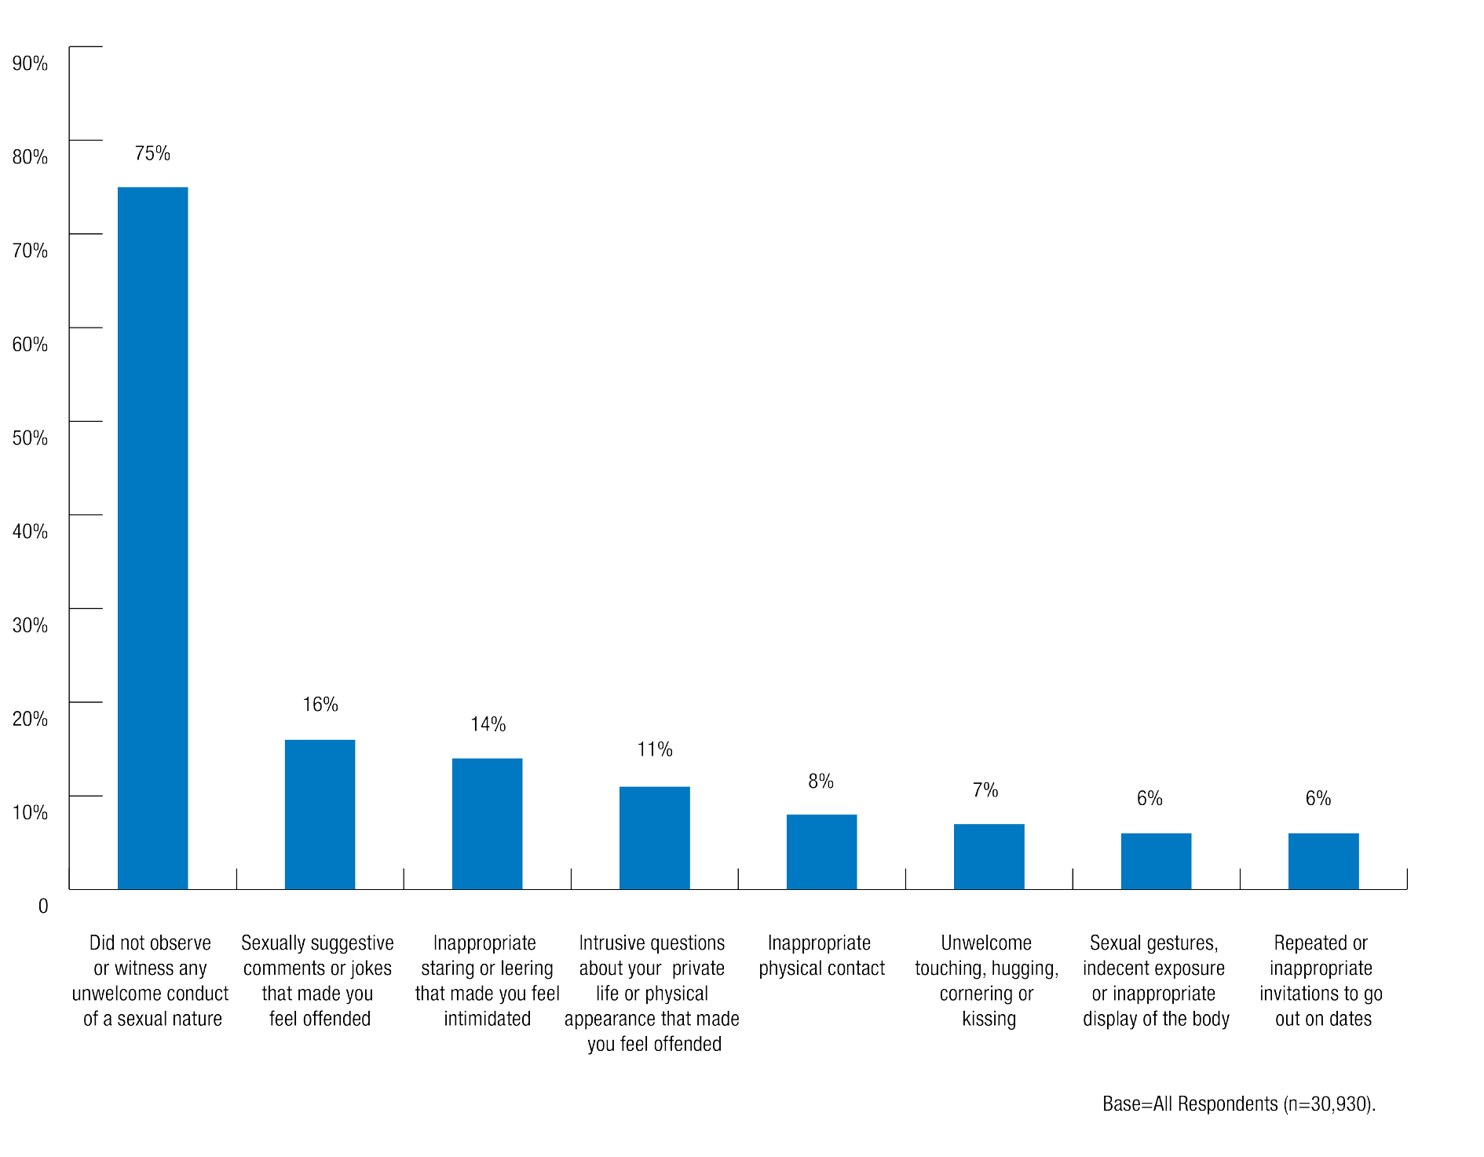

Trans and gender diverse students were more likely than women or men to have witnessed other students being sexually assaulted and sexually harassed at university in 2016.
- 43% of trans and gender diverse students had witnessed another student being sexually harassed at university in 2016, compared with 26% of women and 24% of men.
- 7% of trans and gender diverse students had witnessed another student being sexually assaulted at university in 2016, compared with 1.1% of men and 1.0% of women.

International students and postgraduate students were markedly less likely than other student cohorts to have witnessed another student being sexually harassed at university in 2016.
- 17% of international students had witnessed sexual harassment at university compared with 27% of domestic students.
- 18% of postgraduate students had witnessed sexual harassment at university compared with 28% of undergraduate students.

Chart 23: Where sexual harassment witnessed

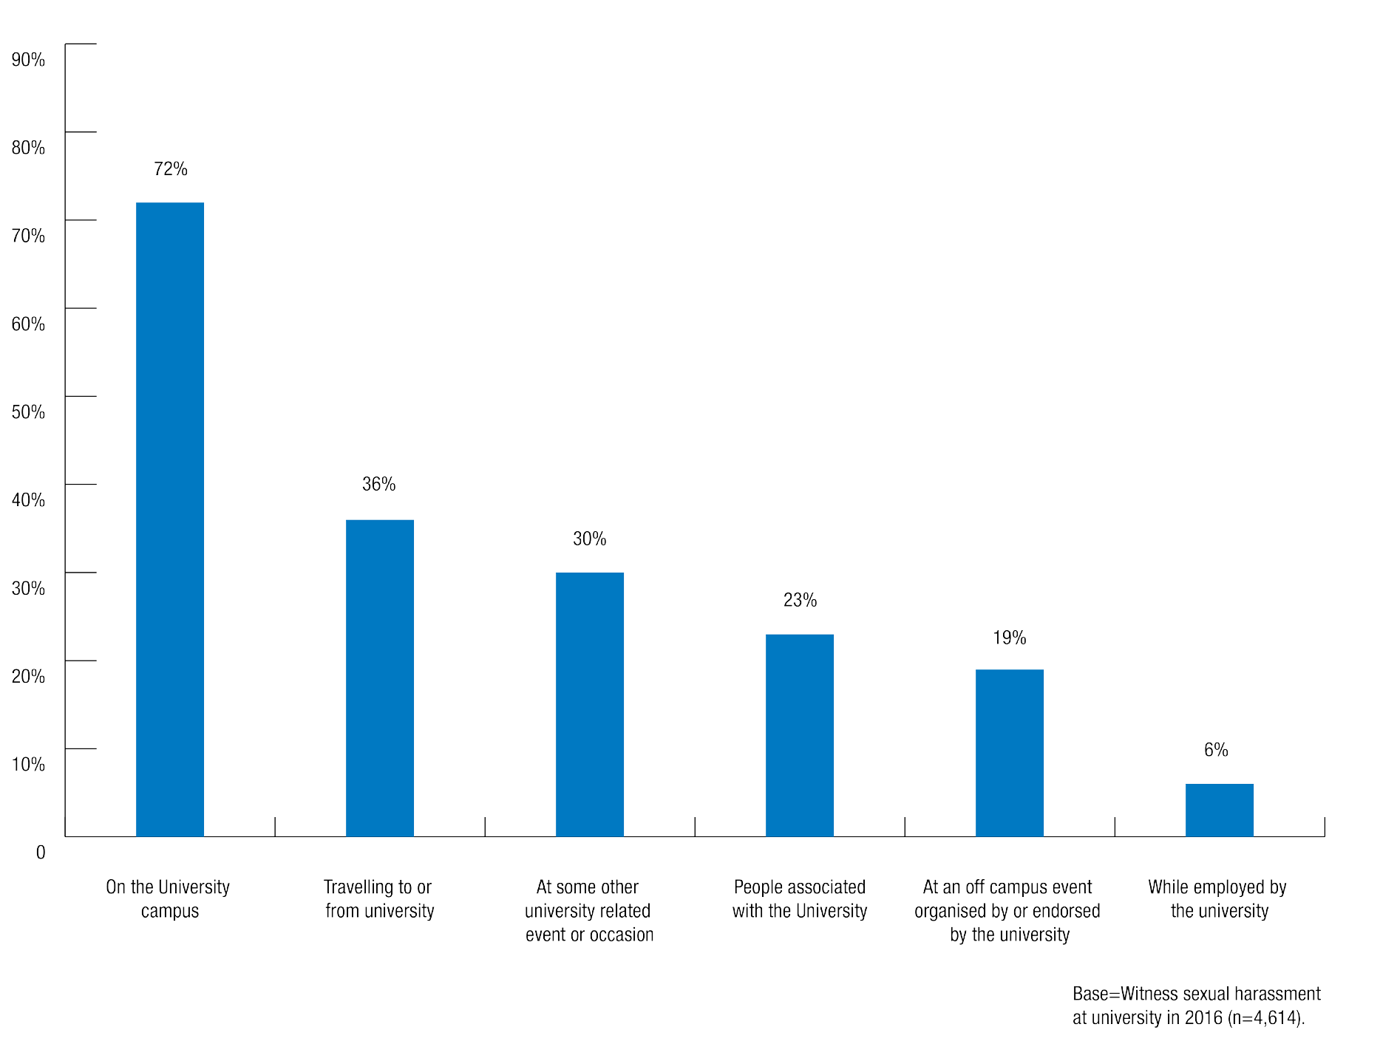

The majority of students who witnessed sexual harassment of another student in 2016 said that this happened on the university campus.
  - 72% of sexual harassment witnessed occurred on the university campus.
  - 36% of sexual harassment witnessed occurred when travelling to or from university.
  - 30% of sexual harassment witnessed occurred at some other university related event or occasion.

Intervening and assisting others

Students who witnessed other students being sexually assaulted or sexually harassed at university usually did not take any action in response.
  - 21% of students who saw another student being sexually harassed in 2016 took action in response to the incident.
  - 37% of students who saw another student being sexually assaulted in 2016 took action in response to the incident.

Trans and gender diverse students were more likely than men and women to have taken action after witnessing another student being sexually harassed.
30% of trans and gender diverse respondents took action after witnessing another student being sexually harassed, compared with 24% of men and 19% of women.

The most common actions taken by bystanders when they witnessed other students being sexually assaulted or sexually harassed were talking to the victim or to the offender.
In relation to witnessing sexual assault, 77% of those who took action spoke to the person who was sexually assaulted and 50% spoke to the offender.

Chart 24: Type of action taken after witnessing sexual assault by gender identity
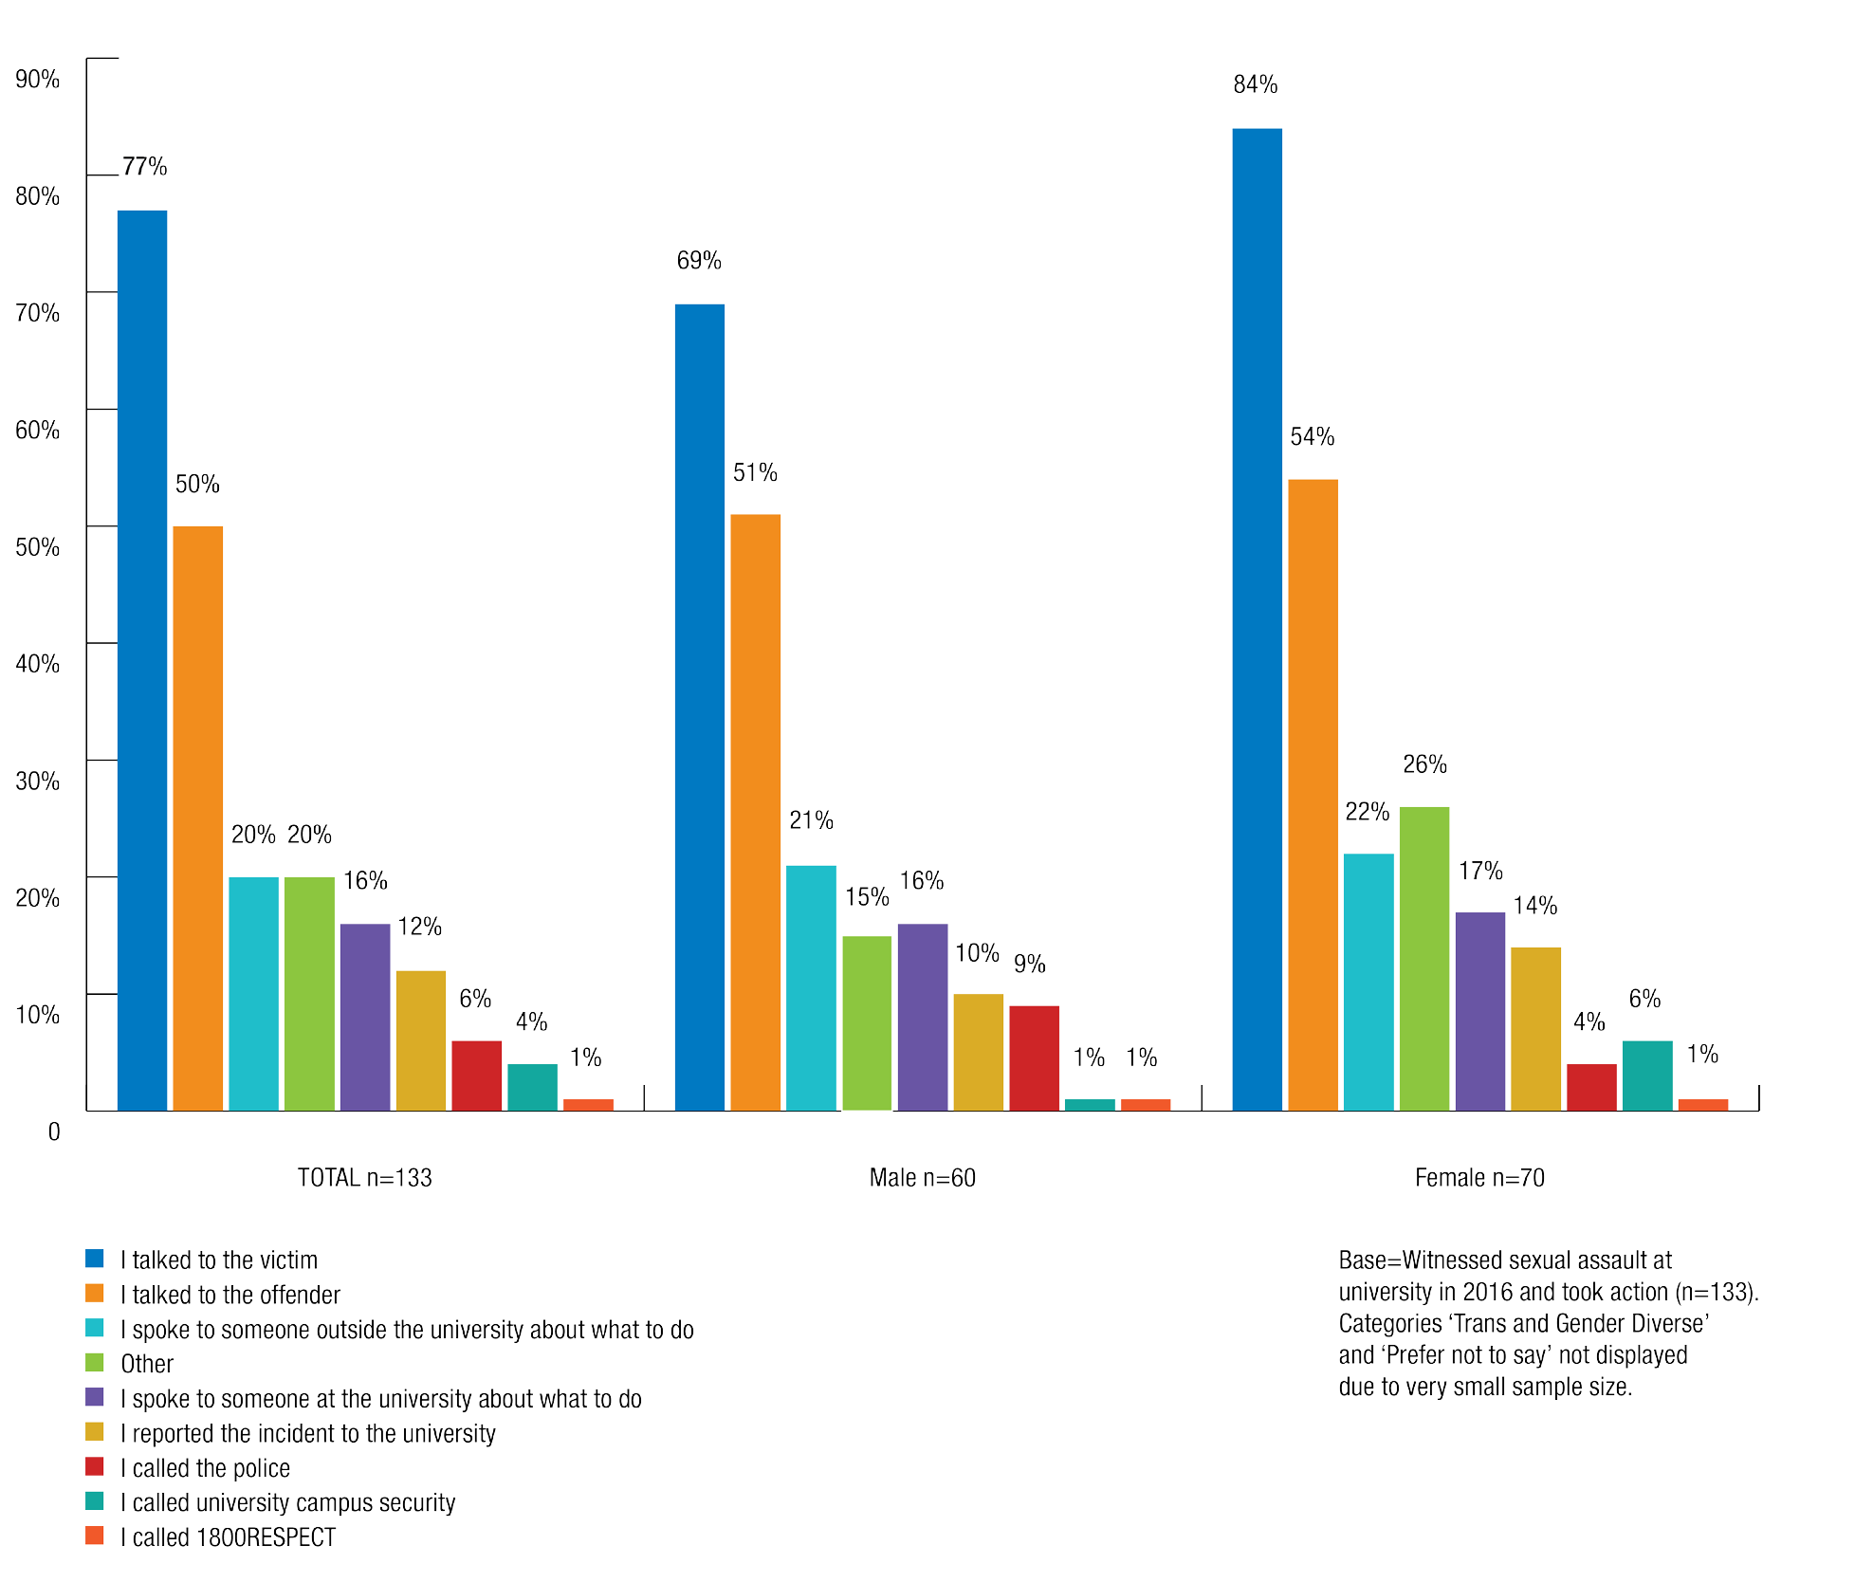

In relation to sexual harassment, 74% of those who took action spoke to the person who was sexually harassed and 42% said they spoke to the offender.

Chart 25: Type of action taken after witnessing sexual harassment by gender identity

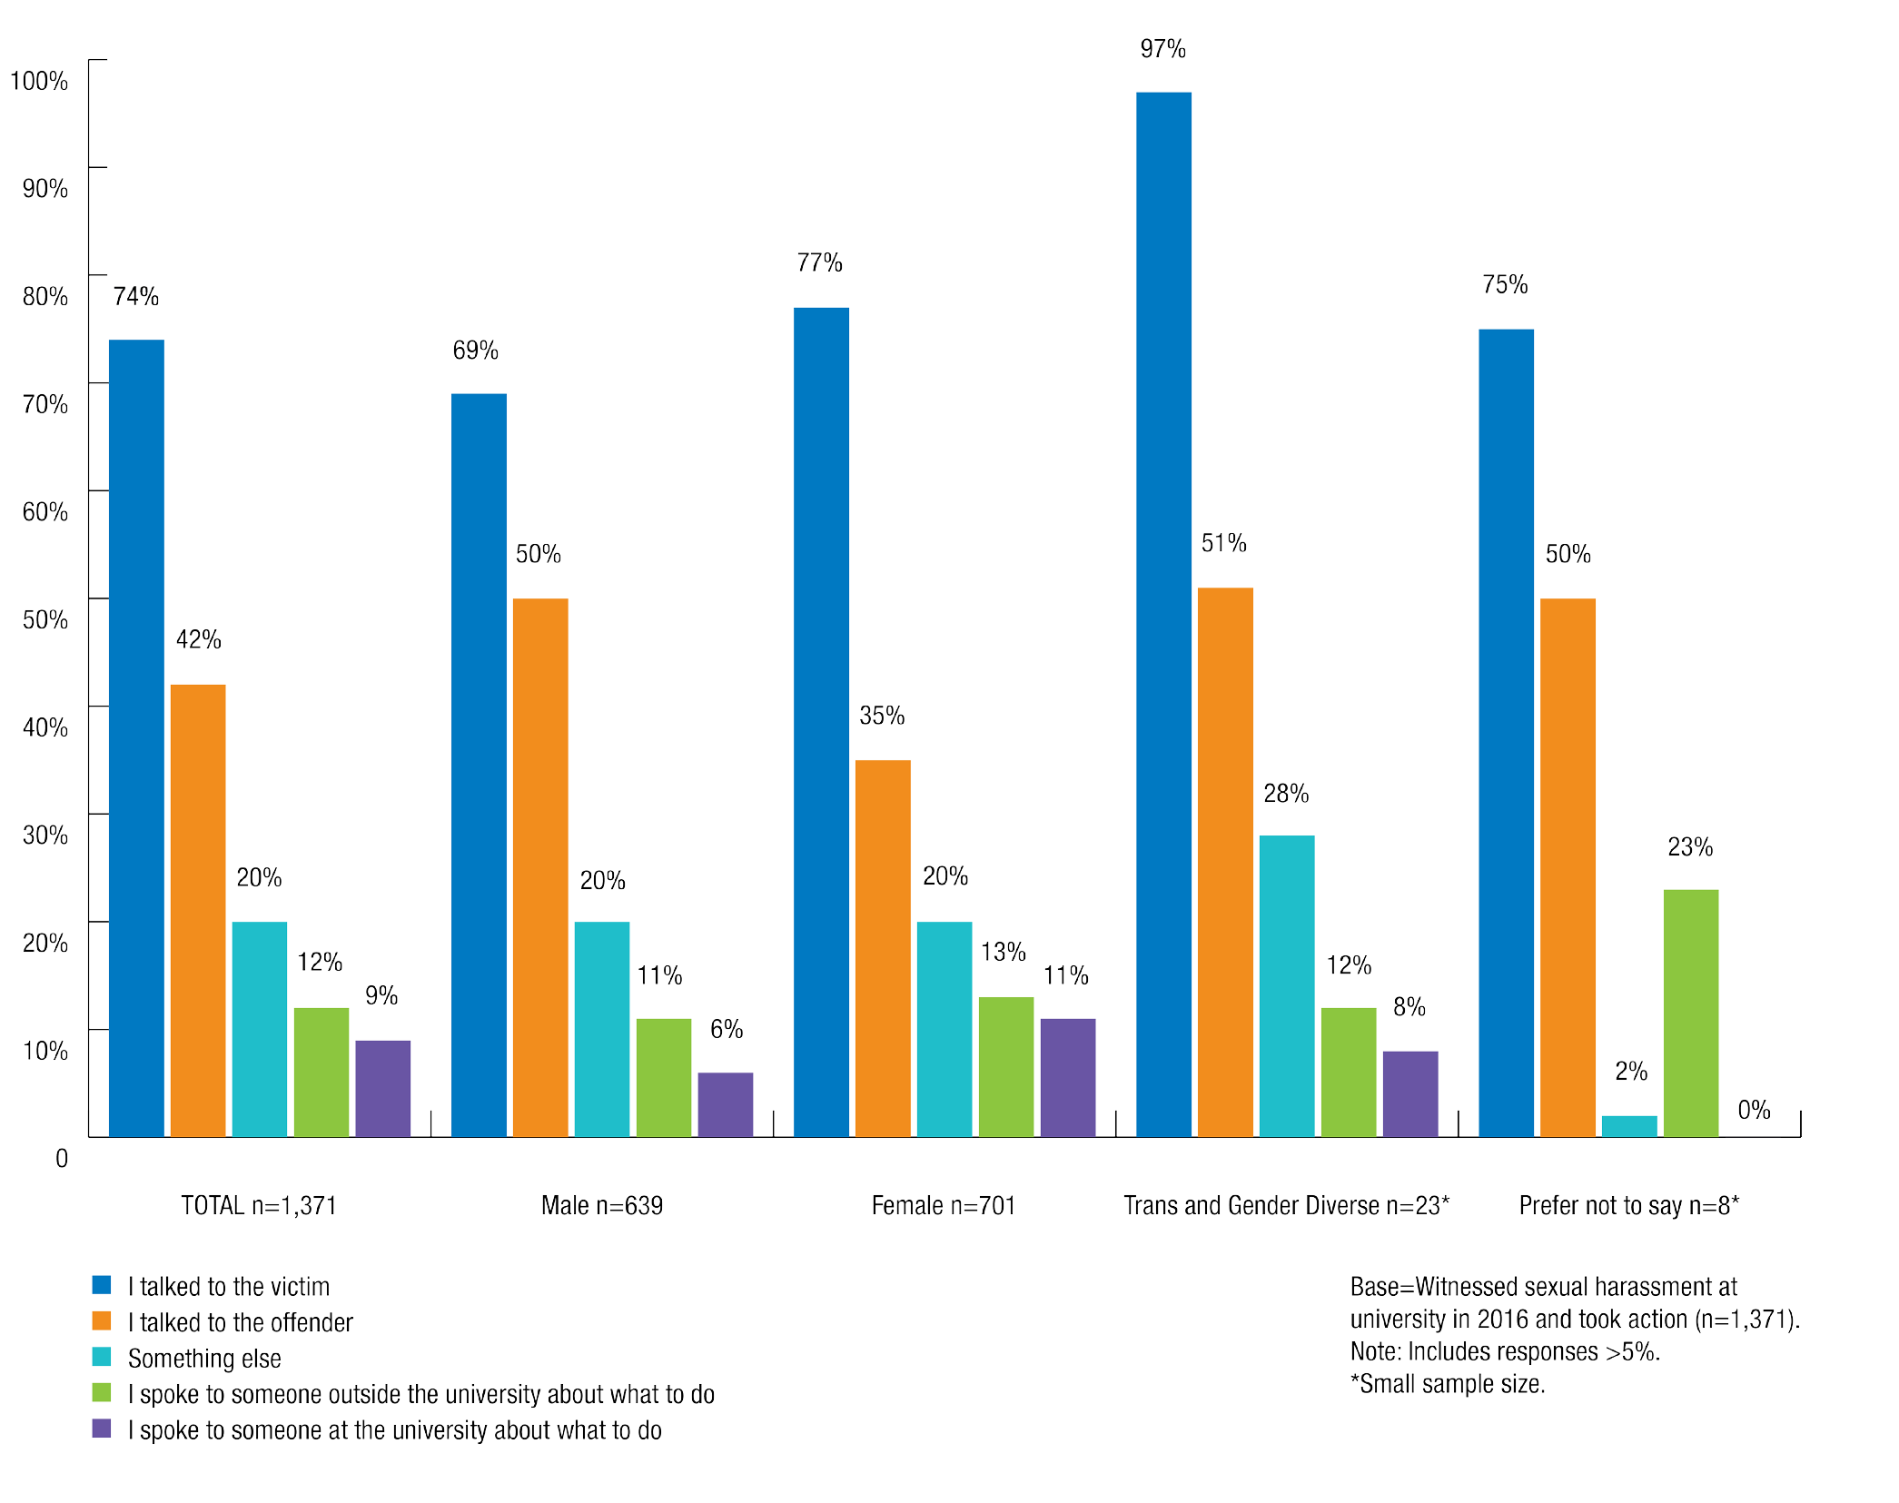

People who saw another student being sexually assaulted or sexually harassed and took action in response were unlikely to speak to someone at the university about the incident.
Only 9% of students who took action after witnessing another student being sexually harassed and 16% of students who took action after witnessing sexual assault spoke to someone at the university about it.

Reasons bystanders did not intervene in sexual assault or sexual harassment
The survey asked students who had not taken action after witnessing sexual assault or sexual harassment why they did not intervene.

The most common reason students did not take action after witnessing another student being sexually harassed was that they did not think it was serious enough to intervene.
Nearly half of the students (49%) who witnessed sexual harassment at university and took no action said this was because they did not think it was serious enough to intervene.
Men who witnessed another student being sexually harassed were more likely than women to think that the sexual harassment was not serious enough to warrant intervention (55% and 45% respectively). Women (32%) were more likely than men (20%) to say they did not know what to do.

Chart 26: Reason/s for not taking action after witnessing sexual harassment by gender identity
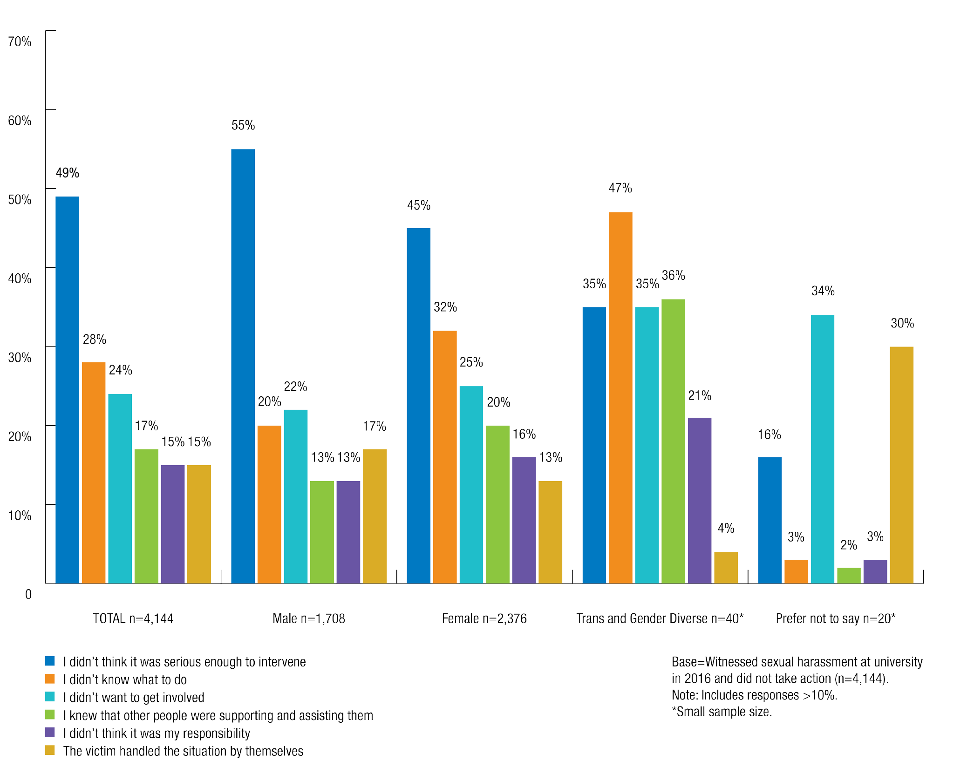

The most common reason students did not take action after witnessing another student being sexually assaulted was that they did not know what to do.
34% of students who witnessed sexual assault and did not take action said that they did not know what to do.
Other common reasons for not taking action were that the witness did not think it was serious enough to intervene (28%), the victim asked them not to take any action (27%) or that the witness knew that other people were supporting and assisting the victim (25%).
Men and women had different reasons for not taking action after witnessing sexual assault:
  - 31% of men said did not take action because they did not think the incident was serious enough for them to intervene, compared with 20% of women.
  - 24% of men said they did not take action because they did not want to get involved, compared with 9% of women.
  - 42% of women did not take action because they did not know what to do, compared to 16% of men.
  - 30% of women did not take action because they had been asked by the victim not to take action, compared to 19% of men.

Chart 27: Reason/s for not taking action after witnessing sexual assault by gender identity

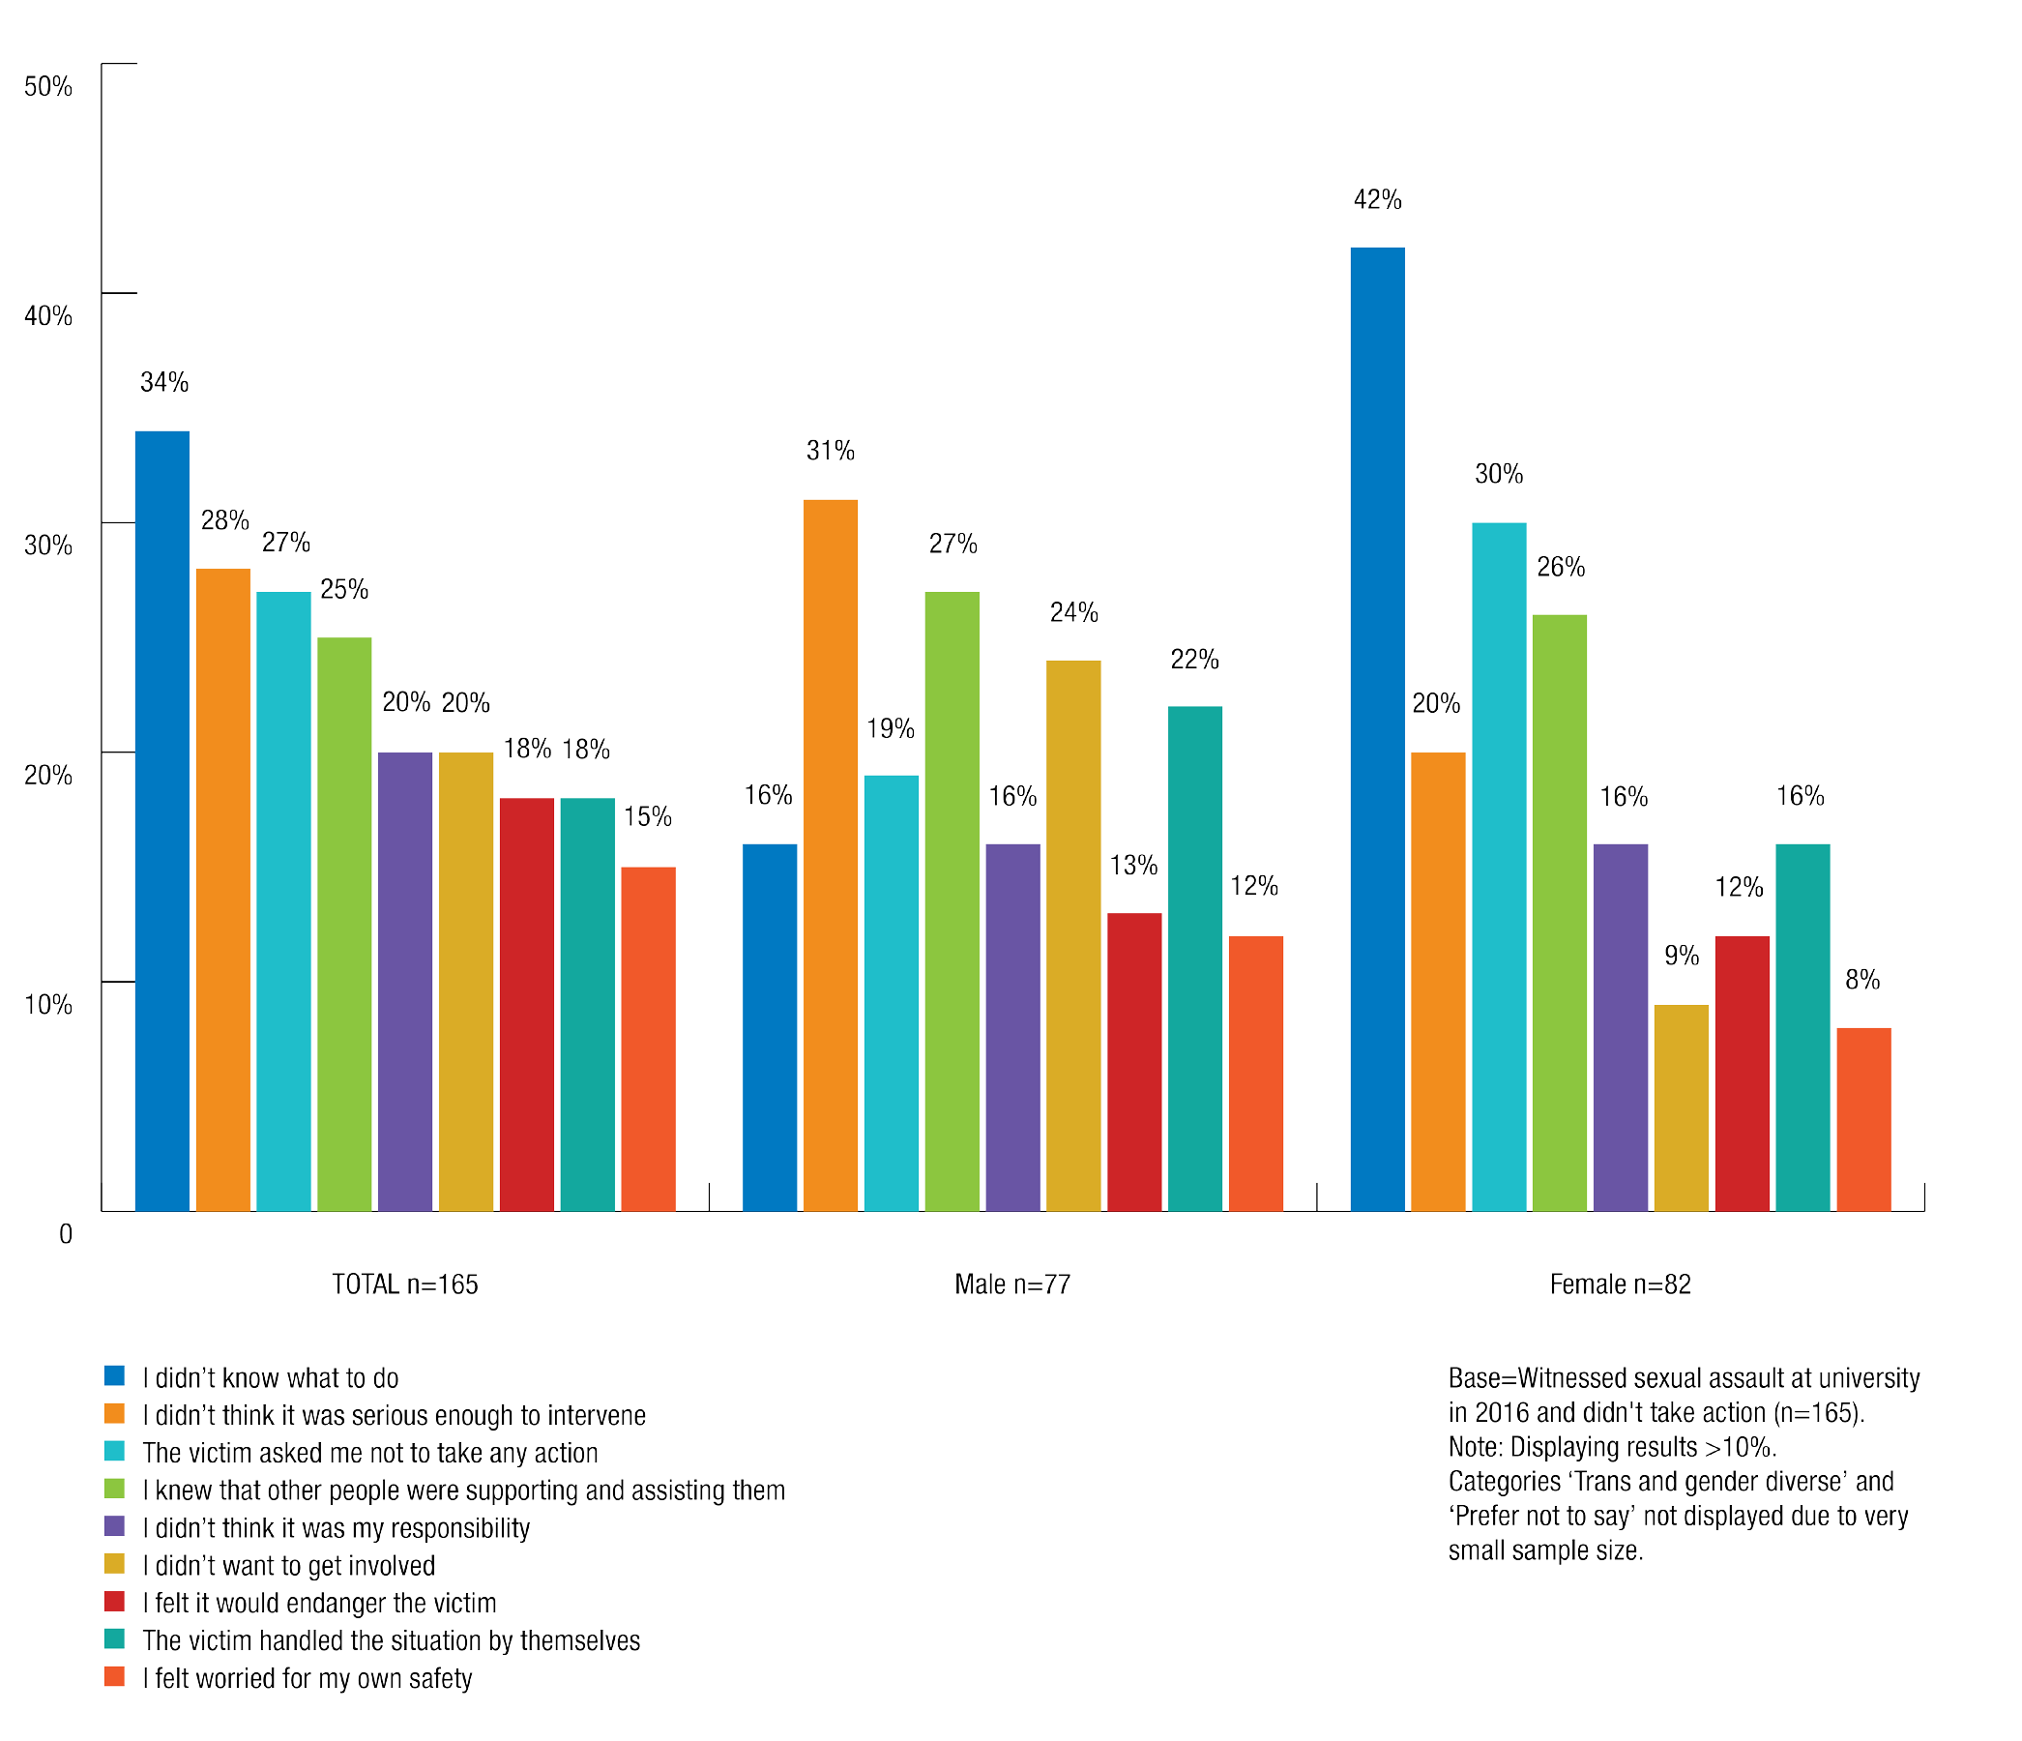

International students were substantially more likely than domestic students not to take action after witnessing sexual assault due to fears for their safety.
29% of international students compared with 11% of domestic students did not take action in relation to sexual assault they witnessed due to fears for their own safety.

Submissions
The Commission received a number of submissions describing individuals’ personal experiences of situations where there were bystanders to sexual assault and sexual harassment. In some instances, the submission was made by the bystander themselves, in other instances it was made by the person who was sexually assaulted or sexually harassed.

For notes on reading the submissions contained in this report, please see the ‘Methodology’ section contained in Chapter 1.

Bystanders taking action to stop sexual assault and sexual harassment
In submissions which described bystanders taking action in response to sexual assault and sexual harassment, it was often the case that a student took action because the person experiencing the assault or harassment was a friend.
When bystanders did take action they cited reasons such as:
  - they had noticed other student’s discomfort 3
  - they were assisting a younger student 4
  - they felt they had a responsibility to intervene,5 or
  - they knew someone who had had a similar previous experience.6
Students reported the Commission that other students helped them avoid contact with a perpetrator of sexual harassment by staying with them in class or escorting them across campus:
In class, older female students made sure to sit beside me and make sure that the man…could not approach me directly. They walked me between classes and made sure I reached my bus home without any contact with him.7

Throughout Bella’s undergraduate degree she has experienced sexual harassment from a fellow student and found it difficult to avoid him in classes. Whenever there is a practical activity in class, he makes sure to be partnered with Bella and uses the opportunity to touch her inappropriately. He asked Bella to go out on dates with him
repeatedly, despite Bella persistently declining. He has frequently described his sexual experiences to Bella or loudly to others when she is in the vicinity. Other students have noticed his behaviour and how uncomfortable it makes Bella. They make sure that someone is always with her when the other student is around. Recently, Bella also told her lecturer and he told her he would try to make sure she doesn’t get paired with him for partner work again.8

The Commission also heard about students intervening to prevent intrusive questions, comments and unwanted physical touching of a fellow student:
I felt comfortable telling the perpetrator that the woman he was asking sexualised inappropriate questions to, [to] stop and that she didn’t have to answer his questions.9

Cass was sitting by herself in her lecture theatre, when another student put his hand on her leg. Cass thought it might have been by accident so she leaned over and asked him to remove his hand, but he did not. Cass did not know what to do – he would not
move his hand and she could not move because there were no spare seats. The student seated in the row behind Cass also noticed. He leaned over and told the male student to remove his hand, which the male student finally did.10

Students also intervened to prevent other students from being sexually assaulted:

Heather is an undergraduate student. One day in class, she overheard a male student talking about his intention to take advantage of a female acquaintance at an upcoming university party. He said he would try to have sex with the woman when she was intoxicated. Heather confronted the male student about this conversation and told him that what he was planning was sexual assault. Heather also told the female student about what she had overheard.11

In another submission, a student physically intervened and prevented a female student at a residential college party, who was unconscious, from being taken to a private room by two male college residents. The student reported that no one else at the party thought to intervene or even that there was anything wrong with the situation. She said that when she intervened:
The guys jeered at me. And no one at all praised me at the time. Not even any of the girls around. I had very much annoyed my peers.12
There were also situations where students who were the subject of sexual assault and sexual harassment stated that bystander intervention prevented unwanted sexual conduct from occurring:
A male approached me, and began to wrap his arms around my body preventing me from moving. He then tried to kiss me, whilst I shook my head constantly. The harder I struggled to break free of his grasp the tighter he pulled. Two boys next to me ended up grabbing him to pull him away and tell him off.13
The male proceeded to put his hand up my skirt touching me inappropriately and whispering sexually suggestive comments in my ear despite me asking him to leave me alone. This continued for around 5 minutes…until a friend intervened and I managed to remove his hand from my skirt and leave with my friend.14
One student was at a weekend workshop on campus when she was followed into a bathroom by a male student who cornered her and demanded that she perform oral sex on him. The male student refused to let her leave until a third student, who had observed him following her into the bathroom entered and intervened to stop the assault.15

Bystanders supporting fellow students after sexual assault has occurred
The Commission also heard about situations where students helped a friend report sexual assault or reported on their friend’s behalf:
I was attending a university-run student ball when my drink was spiked by other students in my year level… My friend reported the incident to the university.16
I reported a sexual assault to our residential security team at [University] after I found a friend who had been shoved up against a wall and grabbed by a man.17
In another submission, an individual reported that she had helped a fellow college resident to seek medical help after she woke up naked in her dorm believing that she had been raped.18

Bystanders failing to take action in response to sexual assault and sexual harassment
The Commission received submissions outlining situations in which bystanders did not intervene to prevent sexual assault and sexual harassment that occurred both on and off campus and in the presence of university staff and fellow students. These submissions were made by individuals who experienced sexual assault and sexual harassment at university and were frustrated by the lack of action from bystanders to these incidents.

I had an abusive older boyfriend at the time….He would scream profanities (often sexual) at me in public, often in the uni bar…People don’t speak up when they see something that isn’t right.19
An extremely drunk student was wandering around the dance floor and very violently grinding against women. He was grabbing their breasts and wrapping his arms around them so they were unable to get away. Nobody intervened.20

Farah left class for the day and headed to the car park across the street from her university. A group of young male students were walking close by and started to follow her, calling out sexually derogatory comments, grabbing their crotches and gesturing towards her. Farah got to the crossing and was unable to get away from the group.
There were other people around who noticed the situation but no one intervened.21

A female student described being forced to perform oral sex on a man in a car park during a university party while several bystanders watched on and laughed.22

Chapter 5: Endnotes

- VicHealth, More than ready: Bystander action to prevent violence against women in the Victorian community (2012) 4. At https://www.vichealth.vic.gov.au/media-and-resources/publications/bystander-research-project (viewed 8 June 2017).
- VicHealth, More than ready: Bystander action to prevent violence against women in the Victorian community (2012) 24-38. At https://www.vichealth.vic.gov.au/media-and-resources/publications/bystander-research- project (viewed 8 June 2017).
- Submission No. 1295 to the Australian Human Rights Commission, University sexual assault and sexual harassment project.
- Submission No. 844 to the Australian Human Rights Commission, University sexual assault and sexual harassment project.
- Submission No. 910 and 1600 to the Australian Human Rights Commission, University sexual assault and sexual harassment project.
- Submission No. 1600 to the Australian Human Rights Commission, University sexual assault and sexual harassment project.
- Submission No. 844 to the Australian Human Rights Commission, University sexual assault and sexual harassment project.
- Submission No. 1295 to the Australian Human Rights Commission, University sexual assault and sexual harassment project.
- Submission No. 910 to the Australian Human Rights Commission, University sexual assault and sexual harassment project.
- Submission No. 1249 to the Australian Human Rights Commission, University sexual assault and sexual harassment project.
- Submission No. 1650 to the Australian Human Rights Commission, University sexual assault and sexual harassment project.
- Submission No. 1600 to the Australian Human Rights Commission, University sexual assault and sexual harassment project.
- Submission No. 533 to the Australian Human Rights Commission, University sexual assault and sexual harassment project.
- Submission No. 273 to the Australian Human Rights Commission, University sexual assault and sexual harassment project.
- Submission No. 153 to the Australian Human Rights Commission, University sexual assault and sexual harassment project.
- Submission No. 846 to the Australian Human Rights Commission, University sexual assault and sexual harassment project.
- Submission No. 1657 to the Australian Human Rights Commission, University sexual assault and sexual harassment project.
- Submission No. 15 to the Australian Human Rights Commission, University sexual assault and sexual harassment project.
- Submission No. 1587 to the Australian Human Rights Commission, University sexual assault and sexual harassment project.
- Submission No. 1263 to the Australian Human Rights Commission, University sexual assault and sexual harassment project.
- Submission No. 273 to the Australian Human Rights Commission, University sexual assault and sexual harassment project.
- Submission No. 192 to the Australian Human Rights Commission, University sexual assault and sexual harassment project.

“I did not report…I had no idea who to confide in
and I was made to feel like it was all my fault, that I deserved it.”

Submission No. 210 to the Australian Human Rights Commission, University sexual assault and sexual harassment project.

6 Reporting and seeking support following sexual assault or sexual harassment

Key findings:
- The results of the National Survey revealed that the majority of students who had experienced sexual assault or sexual harassment in 2015 or 2016 did not make a formal complaint or report to their university.
- 94% of students who were sexually harassed and 87% of students who were sexually assaulted did not make a report or complaint to their university.
- Students who were sexually assaulted or sexually harassed were also unlikely to seek support or assistance from their university or from external support services.
- Common reasons for not reporting sexual assault or sexual harassment were that students did not believe their experience was serious enough to warrant making a report, they did not know how or where to make a report or they thought it would be too hard to prove.
- Students who did make a formal report or complaint about sexual assault or sexual harassment were often dissatisfied with the response of their university.
- Only 6% of students thought that their university was currently doing enough to provide and promote clear and accessible information on sexual harassment procedures, policies and support services, and only 4% said they thought this was the case in relation to sexual assault.

This chapter explores students’ experiences of reporting and seeking support or assistance following an experience of sexual assault or sexual harassment. This includes students’ experiences of making a formal report or complaint to their university and seeking support or assistance, both from within their university and externally.
The National Survey data contained in this section relates to students’ experiences of reporting and seeking support or assistance in relation to their most recent experience of sexual assault or sexual harassment in 2015 or 2016. Once again, information received in submissions
is used to illustrate the issues identified by the National Survey results through quotes and case studies, however, it is not necessarily representative of the experiences of the student population as a whole.

For notes on reading the data and submissions contained in this report, please see the ‘Methodology’ section contained in Chapter 1.

Existing research indicates that few people who experience sexual assault and sexual harassment formally report their experience. For example, surveys conducted in 2012 found that:
- Only 17% of women who experienced sexual assault in the last 12 months reported that they had contacted the police.1
- 78% of women and 83% of men who said they had experienced sexual harassment in the workplace said that they did not make a report or complaint.2
These statistics are reflected in the results of the National Survey, which revealed that an overwhelming majority of students who were sexually assaulted or sexually harassed in 2015 or 2016 did not make a formal report. Students were also unlikely to seek support or advice, either from within their university or from external support sources.
It is clear that students face a range of barriers, both structural and attitudinal, to reporting or seeking support following sexual assault or sexual harassment. In addition, students who did report were often unsatisfied with the response of their university.
The underreporting of sexual assault and sexual harassment, as highlighted by the results of the National Survey, makes it difficult for universities to shape appropriate responses. It
also suggests that universities may not have clear pathways and policies for reporting sexual assault and sexual harassment, and do not foster an environment where reporting of these behaviours is encouraged.

Survey results

Reporting sexual assault and sexual harassment and seeking support

Making a formal report or complaint to the university

The majority of students who experienced sexual harassment did not make a formal report or complaint to anyone at their university in relation to the most recent incident.
Only 2% of students who experienced sexual harassment in a university setting in 2015 or 2016 said that they had made a formal report or complaint to the university in relation to the most recent incident.
  - 94% of students who experienced sexual harassment in a university setting did not make a formal report or complaint to anyone at the university in relation to the most recent incident.

Chart 28: Made a formal complaint to university about sexual harassment by gender identity
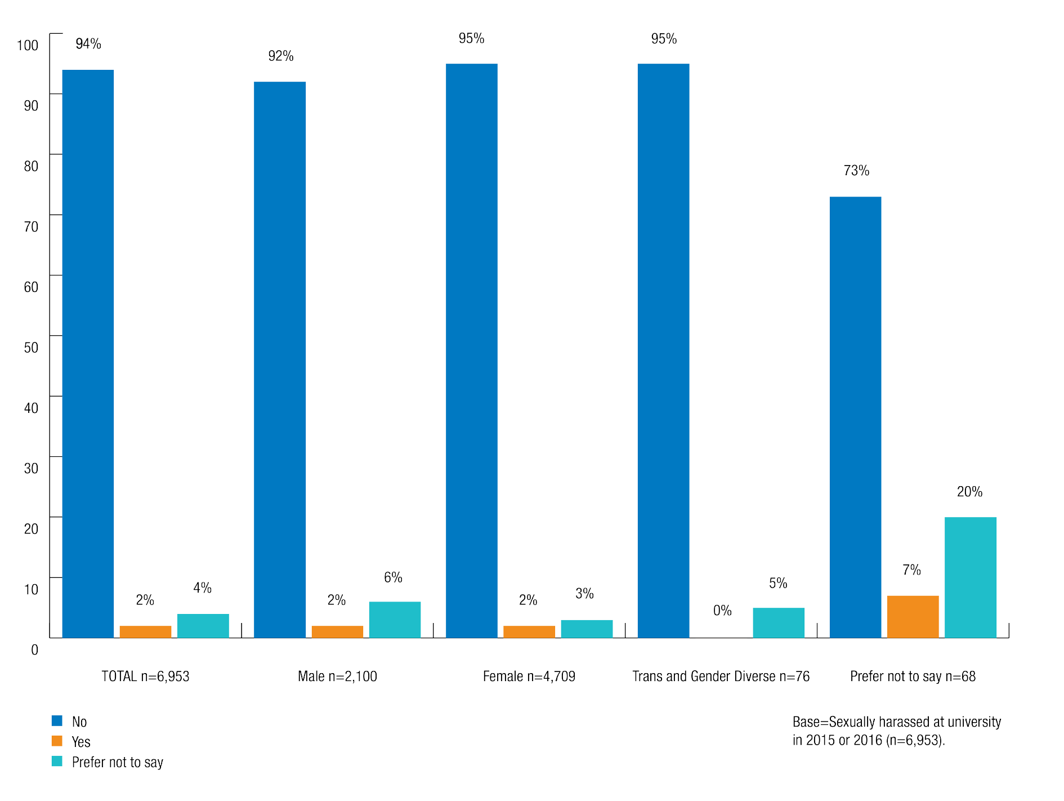

The majority of students who experienced sexual assault did not make a formal report or complaint to anyone at their university in relation to the most recent incident.
Only 9% of students who experienced sexual assault in a university setting in 2015 or 2016 said that they had made a formal report or complaint to the university in relation to the most recent incident.
    - 87% of students who experienced sexual assault did not make a formal report or complaint to anyone at the university in relation to the most recent incident.

Chart 29: Made a formal complaint about sexual assault to university by gender identity

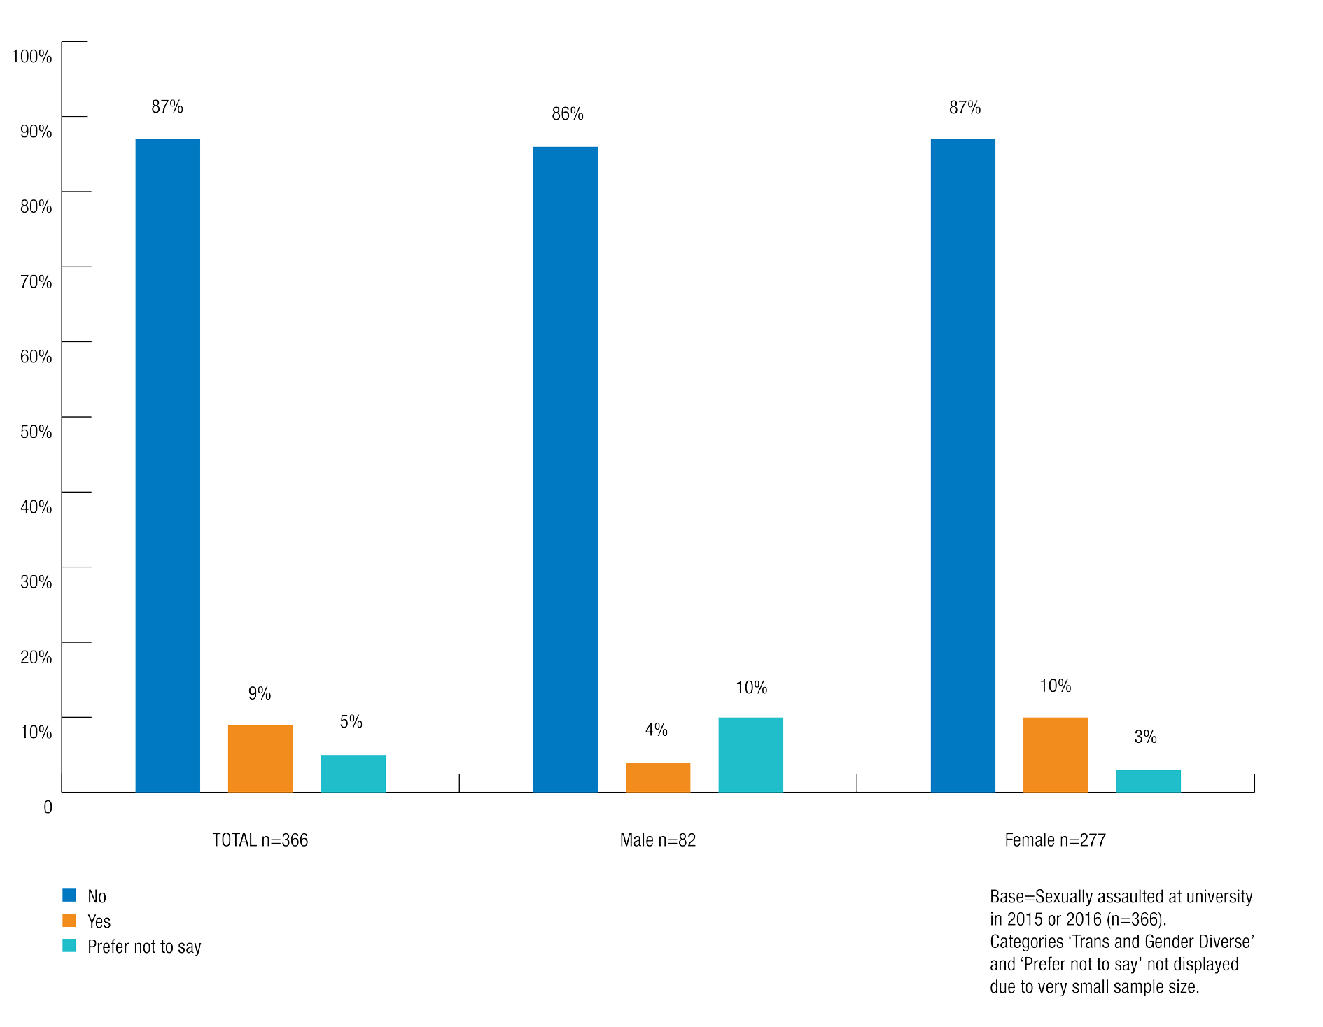

Seeking support from the university

Students were highly unlikely to seek support from their university after an experience of sexual assault or sexual harassment.
  - 92% of students who had been sexually harassed at university in 2015 or 2016 did not seek support or assistance from their university in relation to the most recent incident.
  - 79% of students who had been sexually assaulted at university in 2015 or 2016 did not seek support or assistance from their university in relation to the most recent incident.
Women (16%) were more likely than men (6%) to have sought support from their university in relation to the most recent sexual assault in a university setting, with 14% of men preferring not to say whether they had sought support.

International students were more likely than domestic students to seek support from their university after being sexually assaulted or sexually harassed.
    - 6% of international students who experienced sexual harassment sought support from the university in relation to the most recent incident, compared with 3% of domestic students.
    - 18% of international students who experienced sexual assault sought support from the university in relation to the most recent incident, compared with 13% of domestic students.
Commencing students (20%) were more likely than continuing students (12%) to seek support from the university after the most recent incident of sexual assault.
Students who had sought support from their university in relation to the most recent incident of sexual assault or sexual harassment were asked in the survey to identify the source of support from a list of seven options.

Chart 30: Types of support sought from university for sexual harassment by gender identity

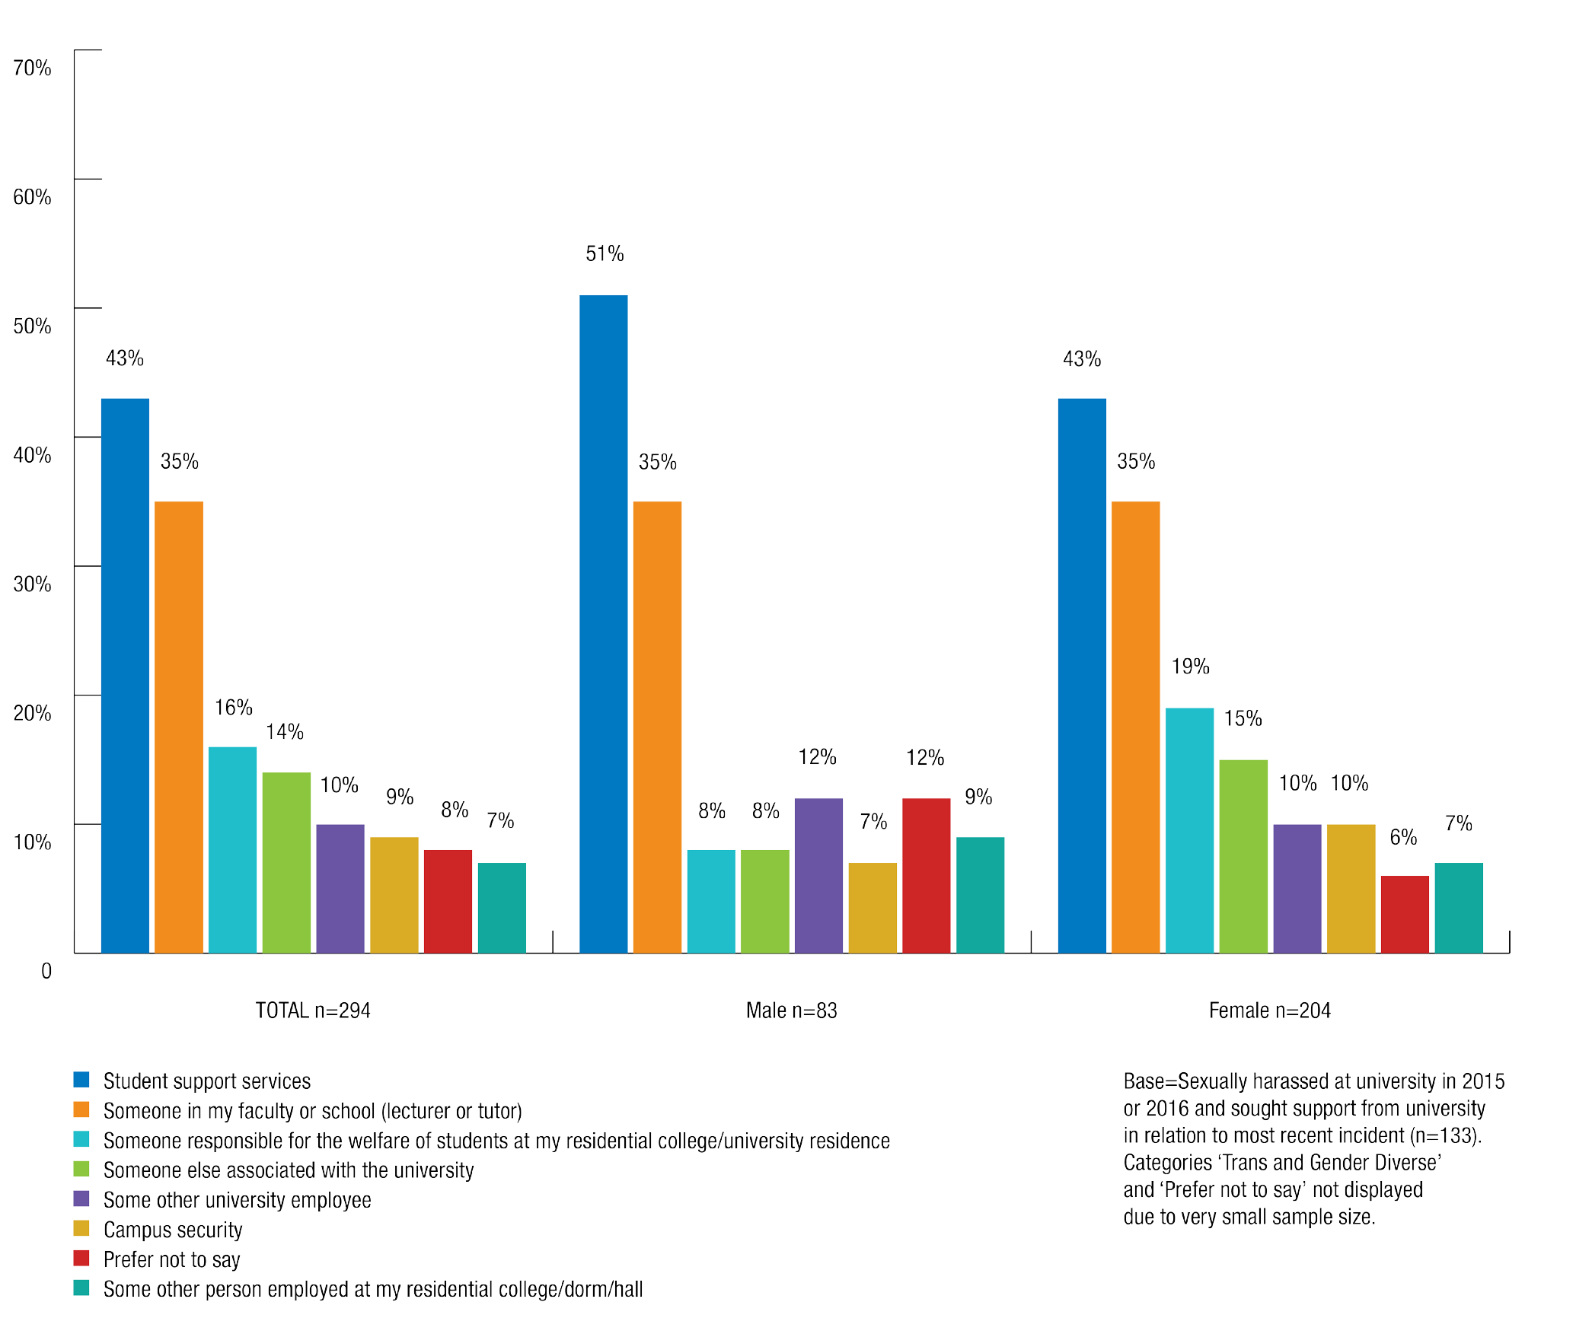

The survey results revealed that students who did seek support most commonly did so from university student services.
    - 43% of students who sought university support following the most recent incident of sexual harassment went to student services.
    - 56% of students who sought university support following the most recent incident of sexual assault went to student services.
Other common avenues for support included:
Lecturers and tutors: Of students who sought university support following the most recent incident, 35% of those who were sexually harassed and 18% of those who were sexually assaulted spoke to someone in their faculty or school.
Continuing students were almost twice as likely (42%) as commencing students (22%) to seek support from someone in their faculty or school, such as a lecturer or tutor, after the most recent incident of sexual harassment.
Domestic students (40%) who were sexually harassed were almost twice as likely as international students (21%) to seek support from someone in their faculty or school, such as a lecturer or tutor, after the most recent incident of sexual harassment.
Someone at their residential college: Of students who sought university support in relation to the most recent incident of sexual assault or sexual harassment, 16% of those who were sexually harassed and 48% of students who were sexually assaulted spoke to someone who is responsible for the welfare of students at their residential college, dorm or hall.
Campus security: Of students who sought university support in relation to the most recent incident of sexual assault or sexual harassment, 9% of those who were sexually harassed and 19% of those who were sexually assaulted said they spoke to campus security.
International students and postgraduates who sought university support after being sexually harassed were almost three times as likely as domestic students or undergraduates to
seek support from campus security in relation to the most recent incident (17% and 6% respectively).

Women and men made use of different university support services after experiencing sexual harassment.
For example:
- Student services: 51% of men who sought support following the most recent incident of sexual harassment went to student services, compared with 43% of women.
- Person responsible for the welfare of students at my residential college/dorm/ hall: 19% of women who sought support following the most recent incident of sexual harassment sought this type of support, compared with 8% of men.

Chart 31: Type of support sought for sexual assault from university
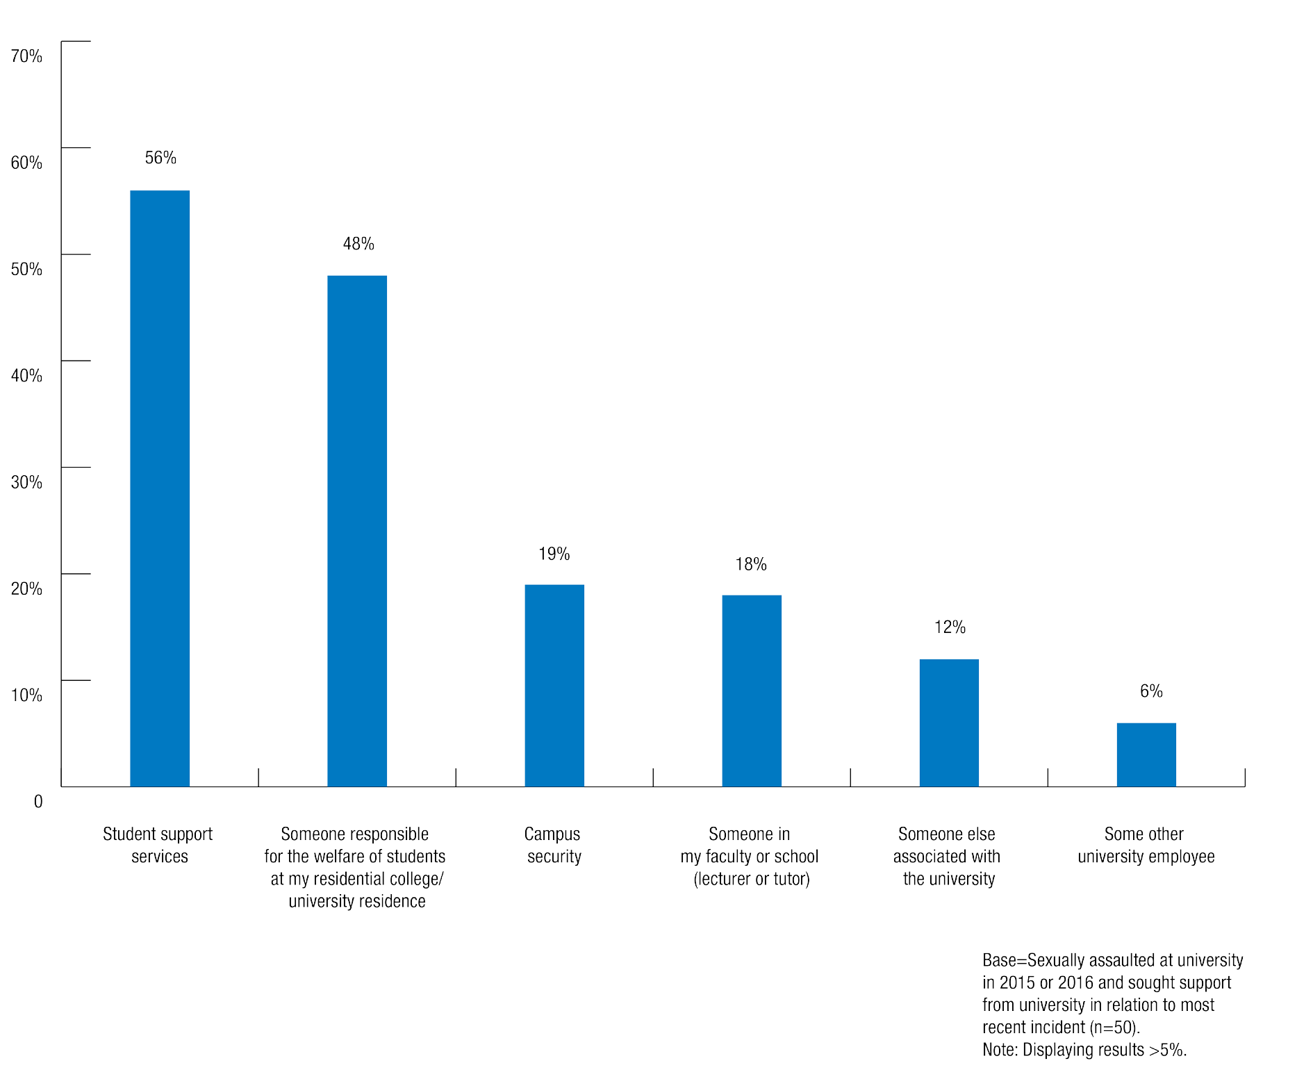

Seeking support from outside the university

Students who were sexually assaulted or sexually harassed were more likely to seek support from outside their university than from within their university.
  - Regarding the most recent incident of sexual harassment, 18% of students sought support from outside the university, compared to 4% who sought support from the university.
  - Regarding the most recent incident of sexual assault, 36% of students sought support from outside their university, compared to 14% who sought support from their university.

Women were more likely than men to seek support from outside of their university after being sexually assaulted or sexually harassed.

43% of trans and gender diverse students who were sexually harassed sought support from outside the university in relation to the most recent incident, compared with 20% of women and 12% of men.

Chart 32: Type of support sought for sexual harassment from outside university by gender identity
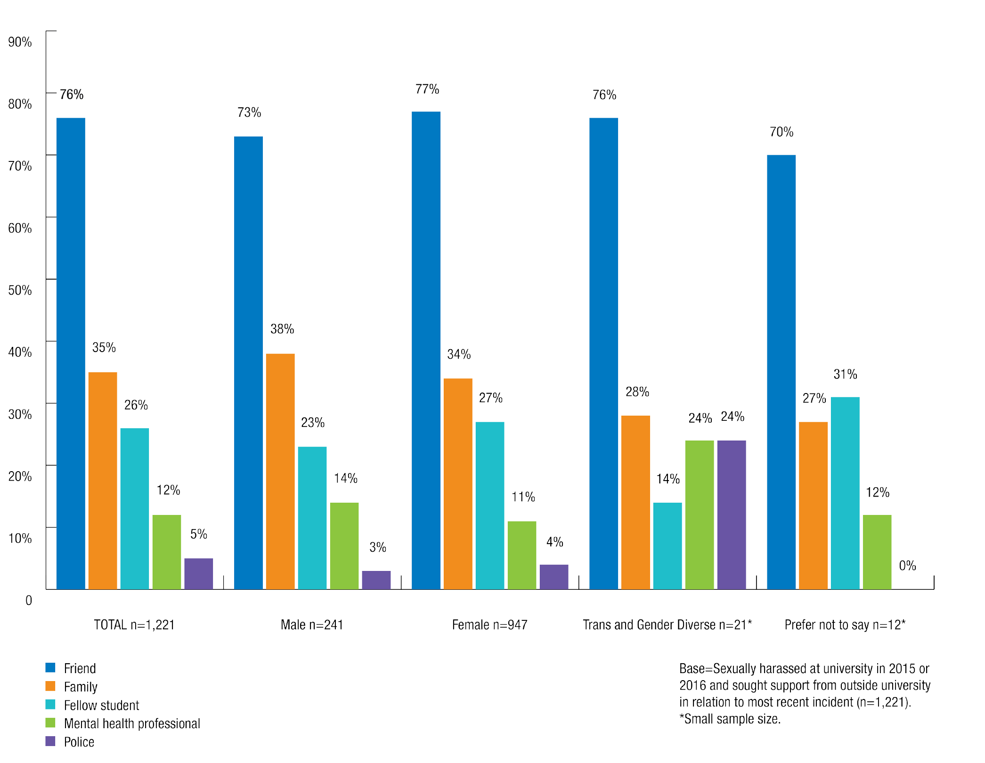

Women (39%) were more likely than men (23%) to have sought support from outside the university in relation to the most recent incident sexual assault.

Chart 33: Type of support sought for sexual assault from outside university by gender identity
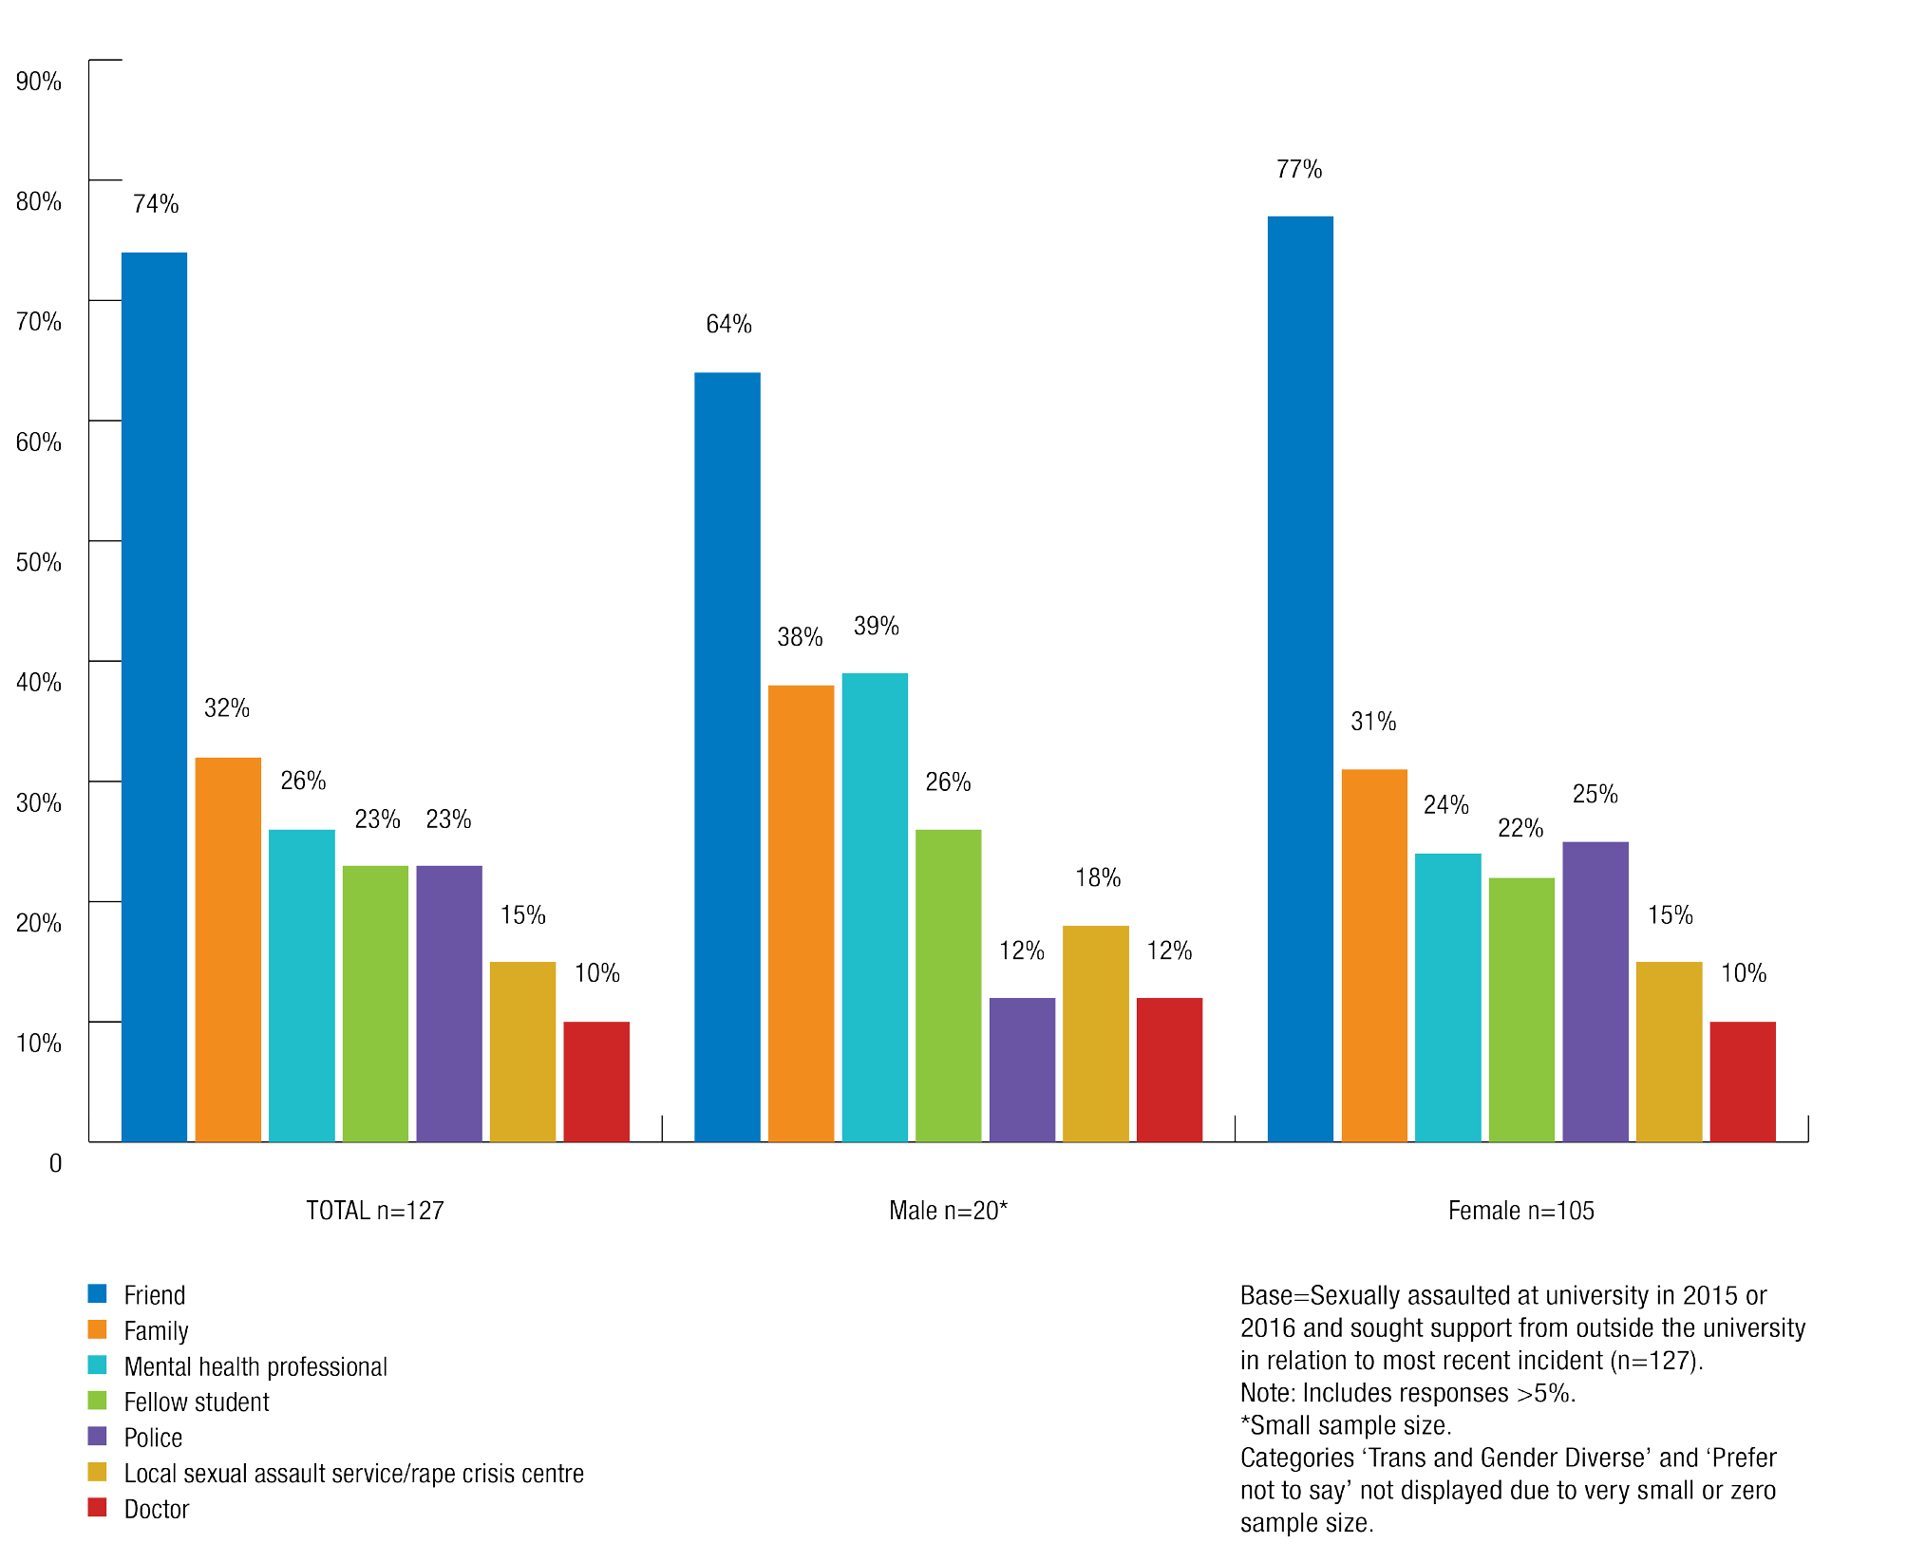

Friends and family were the most common forms of external support sought by students in relation to the most recent incidents of both sexual assault and sexual harassment. Students also sought support from their fellow students after experiencing sexual assault or sexual harassment.
Other avenues of external support pursued by students differed according to whether they experienced sexual assault or sexual harassment.
  - 26% of students who sought external help following the most recent incident of sexual assault said they spoke to a mental health professional.
  - 12% of students who sought external help following the most recent incident of sexual harassment spoke to a mental health professional.

Understandably, people who were sexually assaulted and sought external help were far more likely than those who were sexually harassed to have reported the most recent incident to police (23% and 5% respectively).
Women (25%) were also more than twice as likely as men (12%) to have sought support from the police after the most recent incident of sexual assault. One explanation for this may be stereotypes and beliefs around male sexual assault victims (discussed further below) that pose barriers to reporting for men.

Barriers to reporting and seeking support
Survey respondents were provided with a list of options to describe why they chose not to report or seek support from their university following an incident of sexual assault or sexual harassment (see survey instrument at Appendix 2). Respondents could also choose not to specify a reason or to enter their own reasons in response to this question.

Reasons for not reporting

For both sexual assault and sexual harassment, the most common reasons students cited for not making a report were that they did not think it was serious enough or that they did not think they needed help.
Regarding sexual harassment, 68% of students who did not report said that they did not think their experience was serious enough to report and 53% did not think they needed help. Other common reasons students cited for not reporting their experience included:
  - they did not know to whom to report (16%)
  - they did not know how to report (12%)
  - they thought that the incident would be too hard to prove (11%).
Of those who did not report, women (71%) and trans and gender diverse students (75%) were more likely than men (61%) to say that they did not think the sexual harassment was serious enough for them to make a report/complaint to the university.

Chart 34: Reasons for not reporting sexual harassment by gender identity
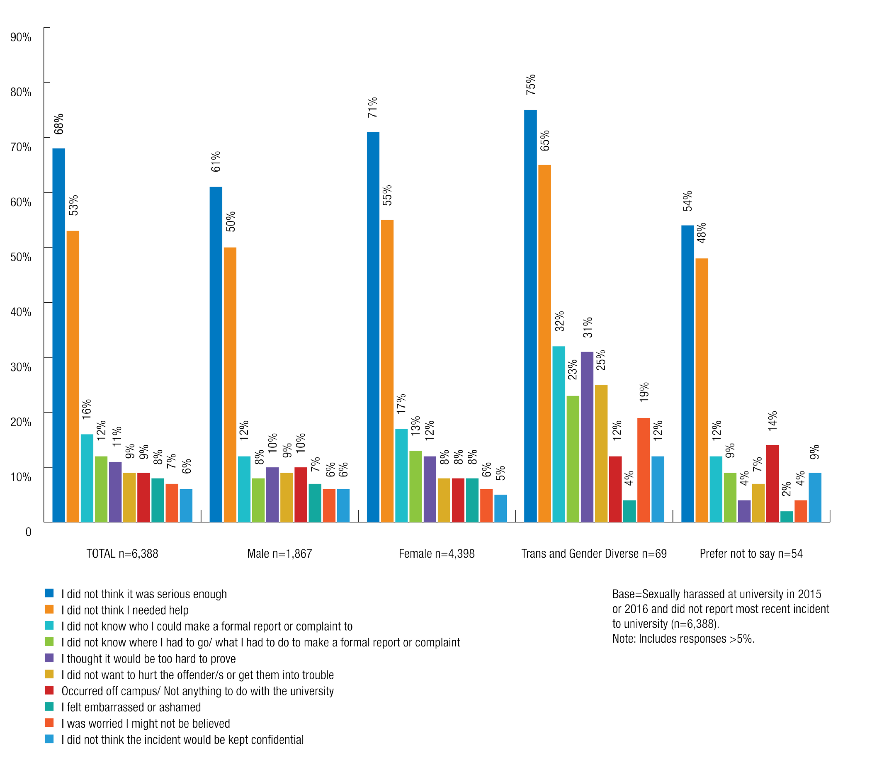

International students (20%) who were sexually harassed were more likely than domestic students (15%) to say that they didn’t know to whom to make a report, or to say that they felt embarrassed or ashamed (11% and 7% respectively).

Chart 35: Reasons for not reporting sexual harassment by residency
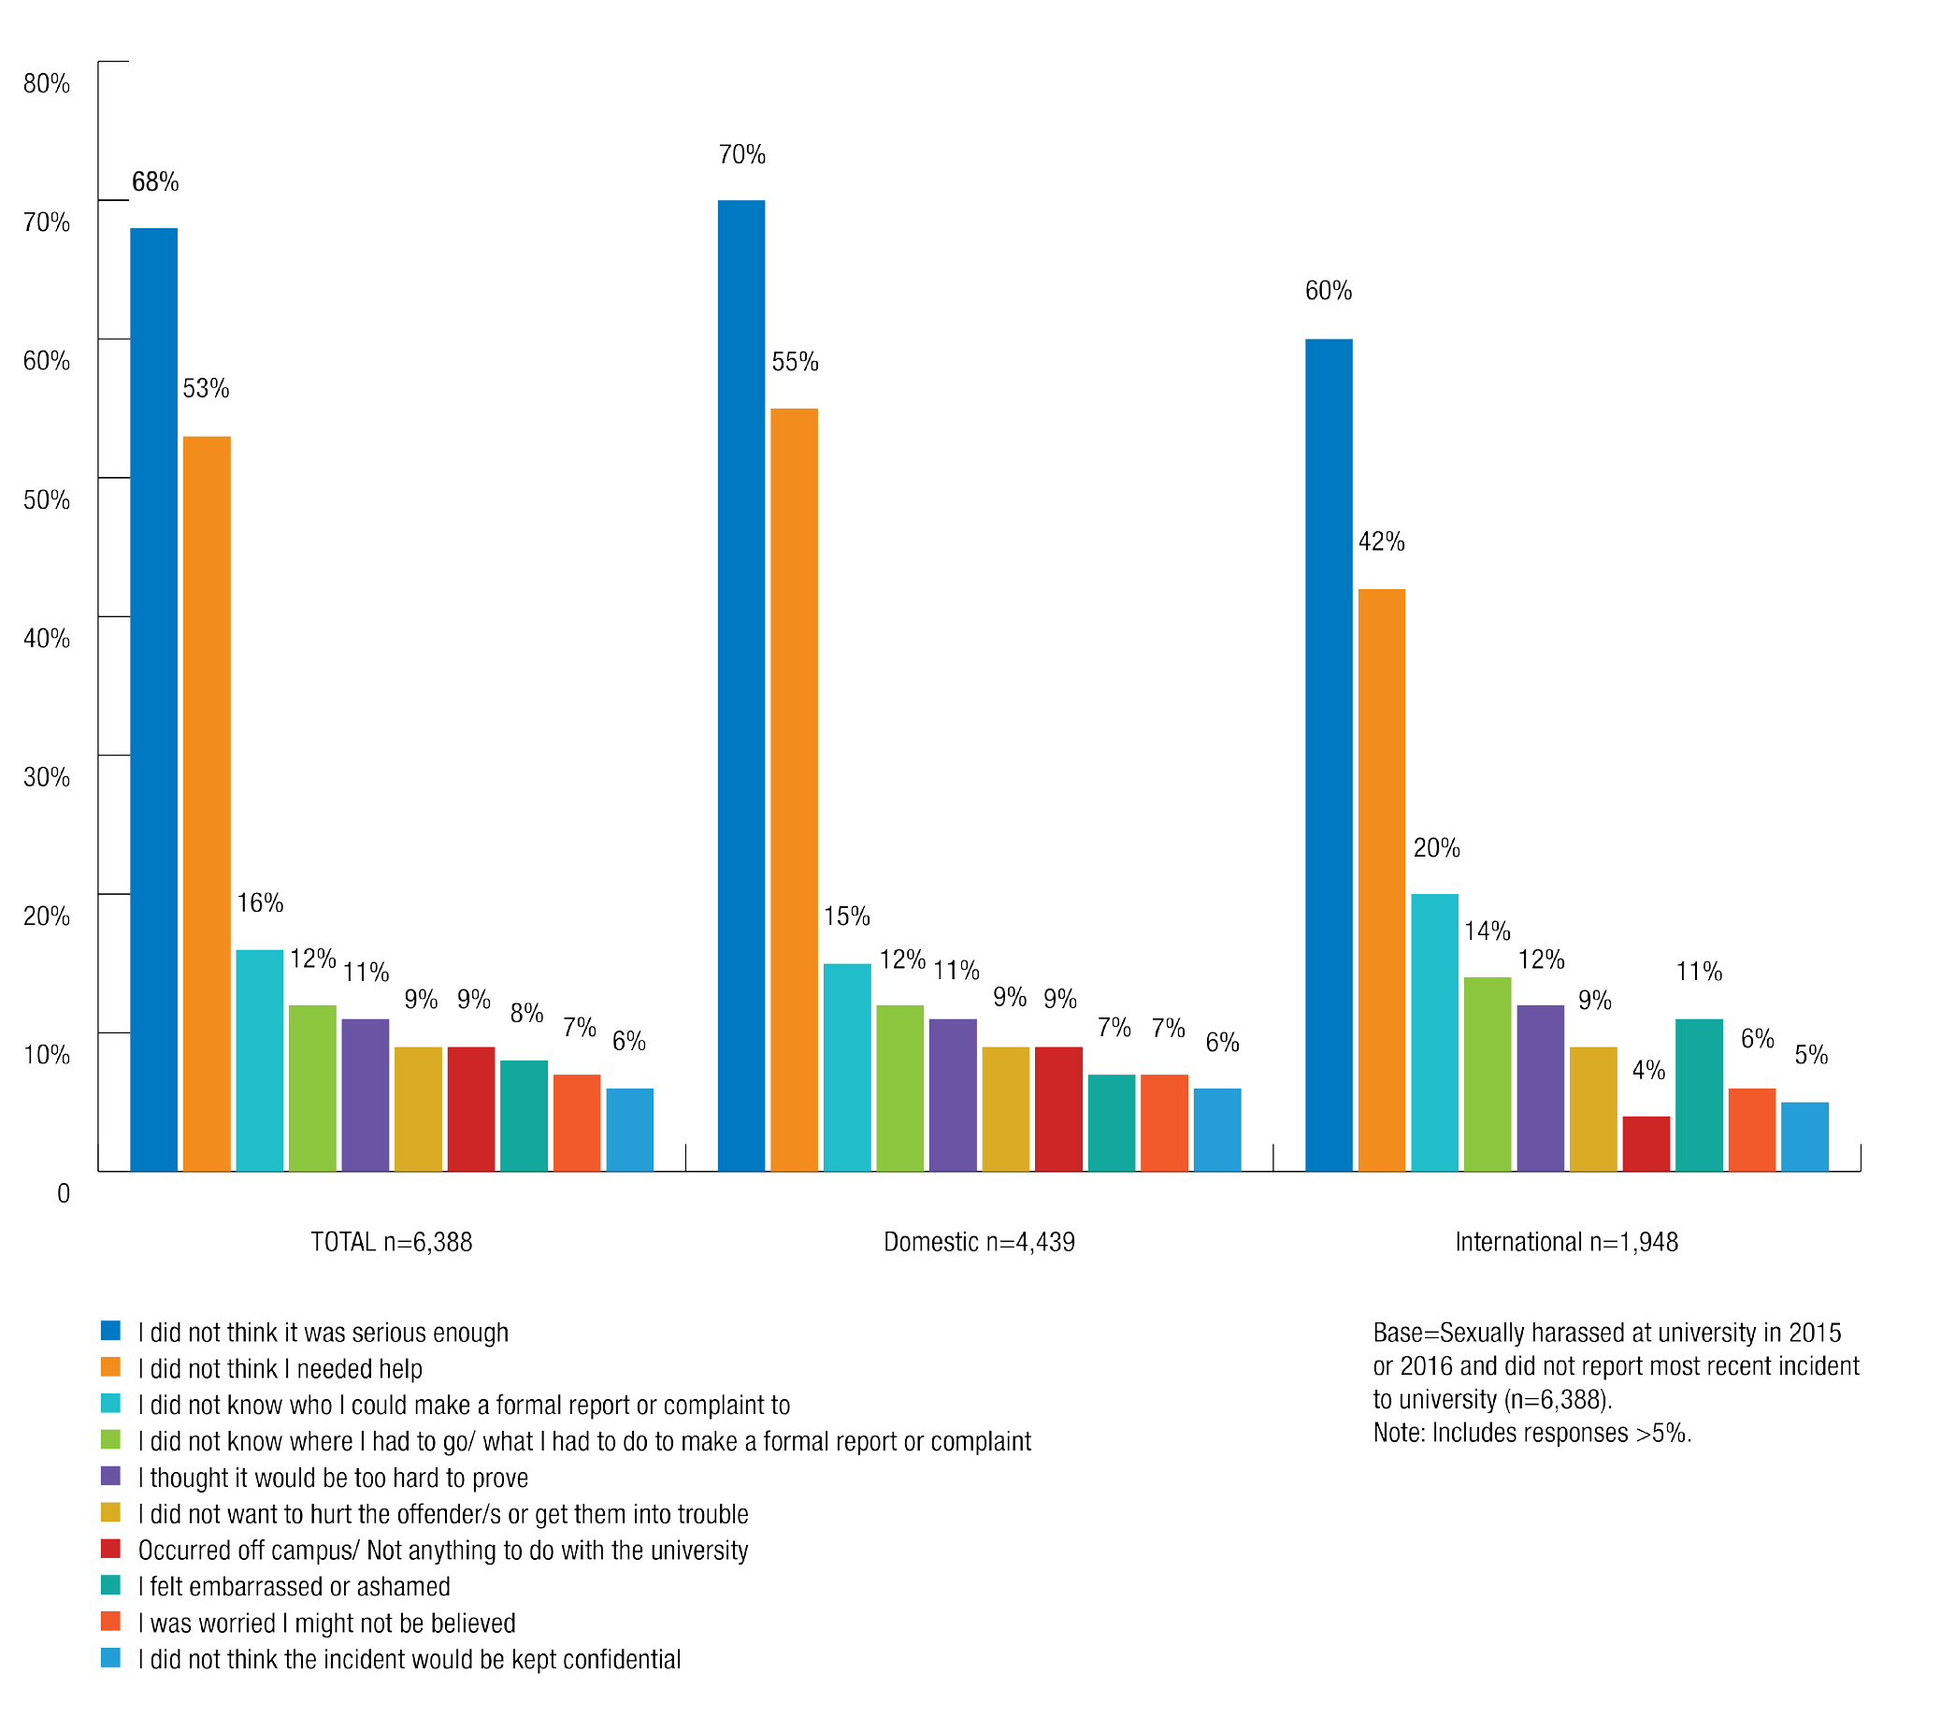

Regarding sexual assault, 40% of students who did not report their experience said this was because they did not think it was serious enough and 40% felt they did not need any help.
Other common reasons why students chose not to report their experience included:
  - they thought it would be too hard to prove (28%)
  - they did not know who to make the complaint to (25%)
  - they were worried they wouldn’t be believed (22%).

Women who did not report were more likely than men to say that their reason for not reporting the most recent sexual assault was that they did not think it was serious enough (44% and 22% respectively), that they lacked sufficient knowledge of who to make the report to (27% and 11% respectively) or where to go/what to do to make the report (24% and 8% respectively).

Chart 36: Reasons for not reporting sexual assault by gender identity
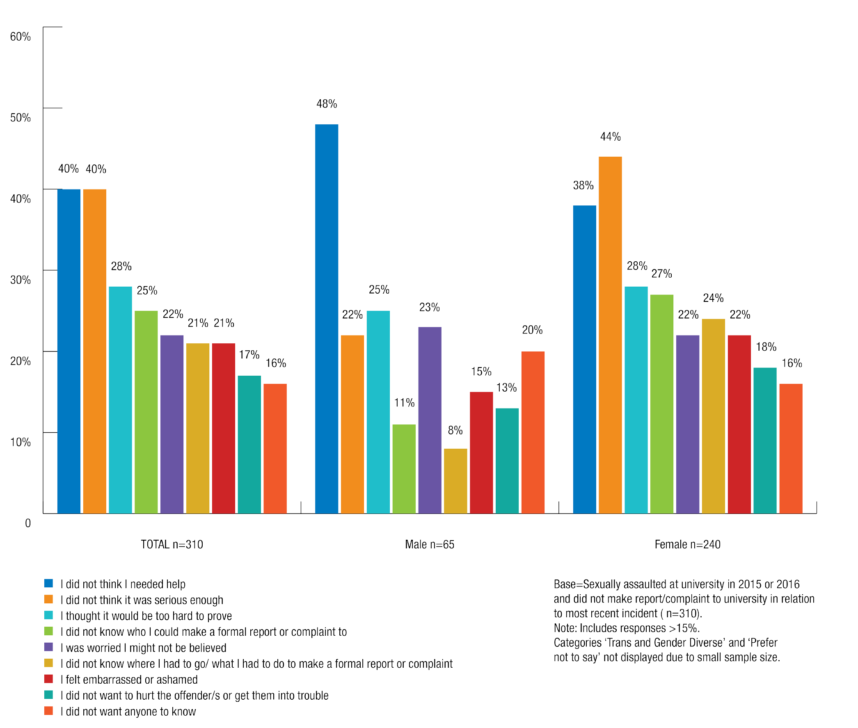

As with sexual harassment, international students who were sexually assaulted (31%) were more likely than domestic students (19%) to indicate that they felt too embarrassed or ashamed to report it. They were also more likely (33%) than domestic students (23%) to indicate they did not know who to report to.

Chart 37: Reasons for not reporting sexual assault by residence
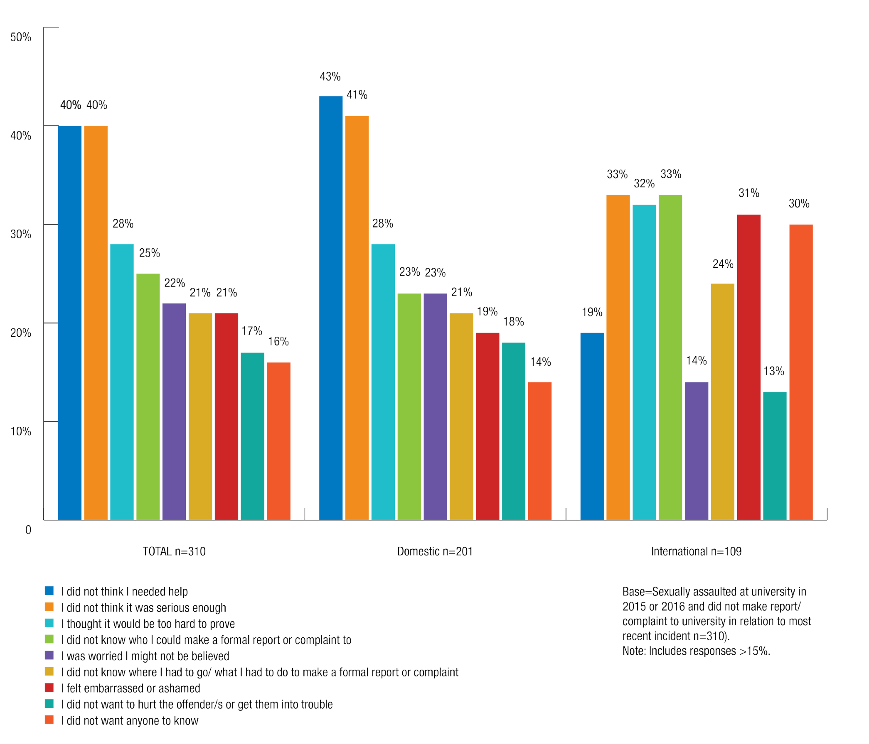

Reasons for not seeking support from university

Most students did not seek support from their university after an incident of sexual assault or sexual harassment because they did not think that the incident was serious enough.
  - 68% of students who were sexually harassed and 40% of students who were sexually assaulted identified this as the reason they did not seek support from their university.
  - 60% of students who were sexually harassed and 39% of students who were sexually assaulted said that they did not seek support from their university because they did not need help.

Women (72%) and those who were trans and gender diverse (73%) were more likely than men (57%) to indicate that they did not think the sexual harassment was serious enough for them to seek any support from the university.

Chart 38: Reasons support not sought from university for sexual harassment by gender identity
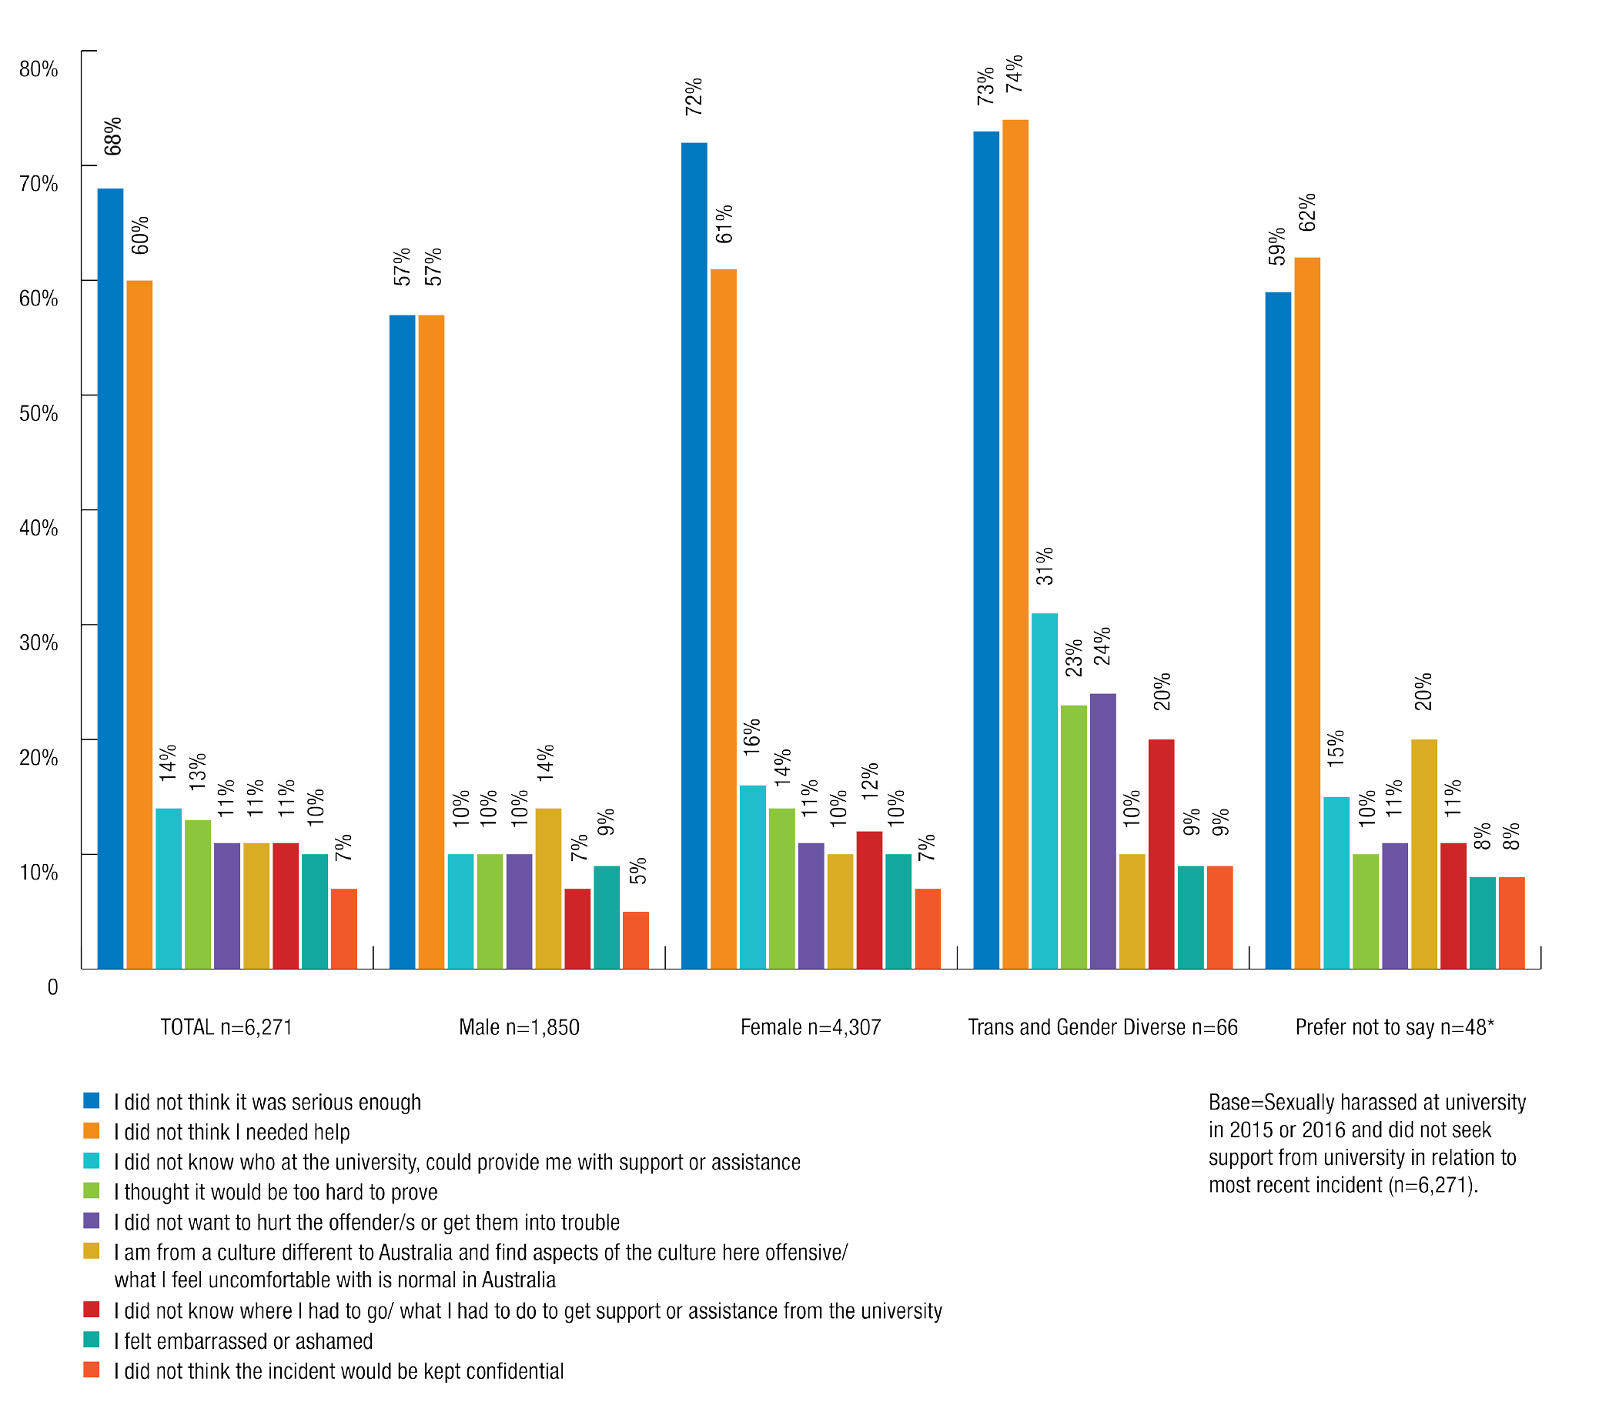

Similarly, in relation to sexual assault women (42%) were also more likely than men (31%) to indicate that they did not think that the sexual assault was serious enough for them to seek support from the university.

Chart 39: Reasons support not sought for sexual assault from university by gender identity
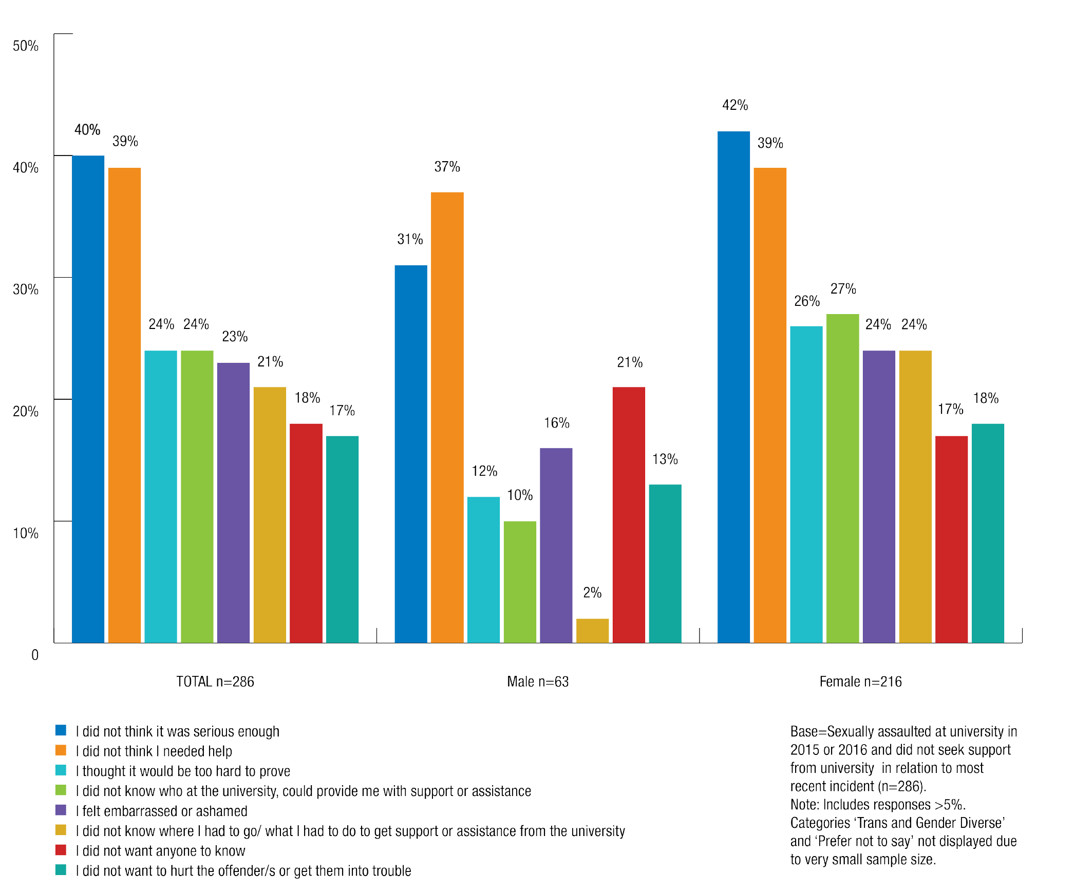

Knowledge of university policies, support services and reporting procedures
Students were asked how much they knew about university policies, reporting processes and support services in relation to sexual assault and sexual harassment.

The majority of students had little or no knowledge of where to seek support or assistance for sexual assault or sexual harassment within their university.
Two in five students (41%) indicated that they had some knowledge of where they can seek support or assistance in relation to sexual harassment.
A majority of students (57%) indicated that they had little or no knowledge about where they can seek support or assistance on sexual assault.

The majority of students had little or no knowledge of how to make a formal report or complaint of sexual assault or sexual harassment.
The majority of students (60%) had little or no knowledge about where they could go to formally report or make a complaint about an experience of sexual harassment.
Over three in five students (62%) had little or no knowledge about where they could go to formally report or make a complaint about an experience of sexual assault.

The majority of students had little or no knowledge of university policies on sexual assault and sexual harassment.
The majority of students (52%) had little or no knowledge about their university’s policy on sexual harassment.
Just over half of students (54%) had little or no knowledge about their university’s policy on sexual assault.

Chart 40: Knowledge about where to seek support or where to make a complaint about sexual harassment at university and university sexual harassment policy
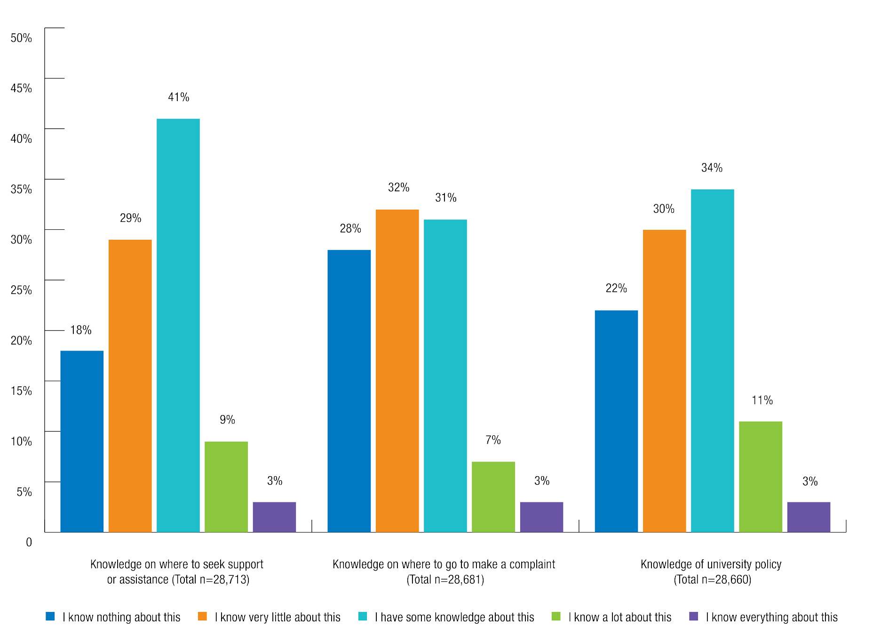

Chart 41: Knowledge about where to seek support or where to make a complaint about sexual assault at university and university sexual assault policy
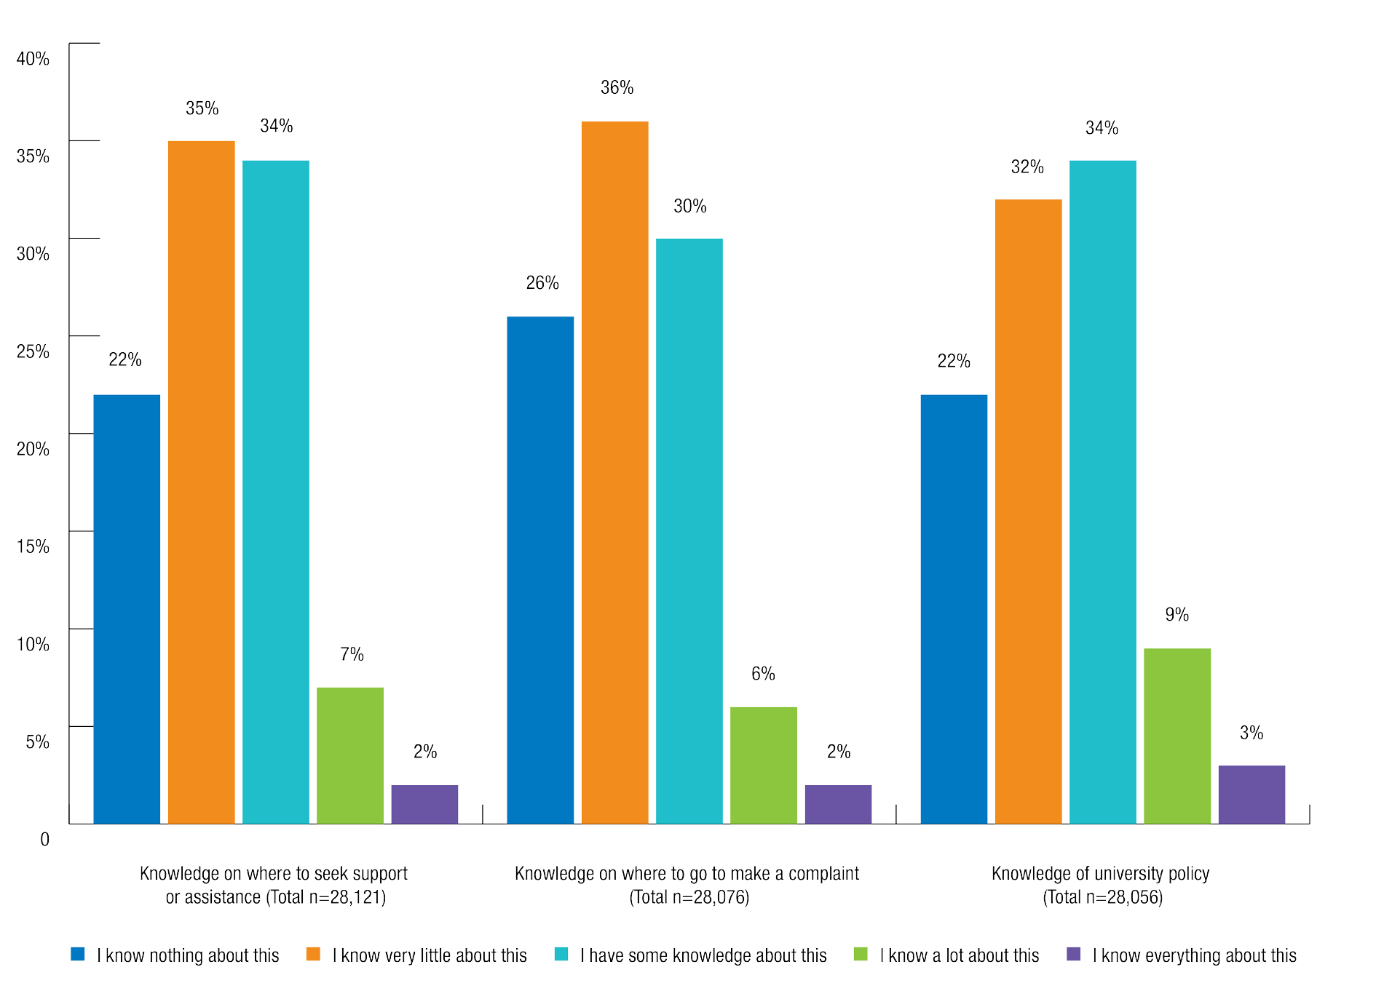

Experiences of reporting and seeking support
Although only a small number of students in the survey had reported their experience of sexual assault or sexual harassment or sought support from within the university, those that had reported were asked about their experience and whether or not they were satisfied.
Many respondents also made submissions of their experiences in reporting to someone in their university, their college, the police or an external service.

Made formal report or complaint to the university

Only 2% of people who had experienced sexual harassment in a university setting in 2015 or 2016 made a formal report or complaint to someone at their university.
Students with a disability (4%) were more likely than others to have reported the most recent incident to their university.
Men and women (both 2%) were equally likely to have made a formal report or complaint of sexual harassment to their university.
No students who identified as trans or gender diverse made a formal report to the university in relation to the most recent incident of sexual harassment in a university setting.

Only 9% of students who experienced sexual assault in a university setting in 2015 or 2016 made a formal report or complaint to anyone at their university.
Women (10%) were more likely than men (4%) to have made a formal report or complaint to the university in relation to sexual assault.
Domestic students (9%) were also slightly more likely than international students (5%) to have reported their experience of sexual assault to the university.

Satisfaction with university reporting process
Students who had made a formal report or complaint to their university in relation to the most recent incident of sexual assault or sexual harassment in a university setting were asked how satisfied they were with the process, taking into account issues such as the fairness, sensitivity and efficiency of the process.
In relation to sexual harassment, 18% of students who made a formal report or complaint were very satisfied, 23% satisfied, 21% dissatisfied, 15% very dissatisfied, and a further 23% neither satisfied nor dissatisfied with the process.
In relation to sexual assault, 23% of students who made a formal report or complaint to the university were very satisfied, 32% satisfied, 12% dissatisfied, 15% very dissatisfied, and a further 18% neither satisfied nor dissatisfied with the process.

Chart 42: Satisfaction with sexual harassment formal complaint process at university by gender identity
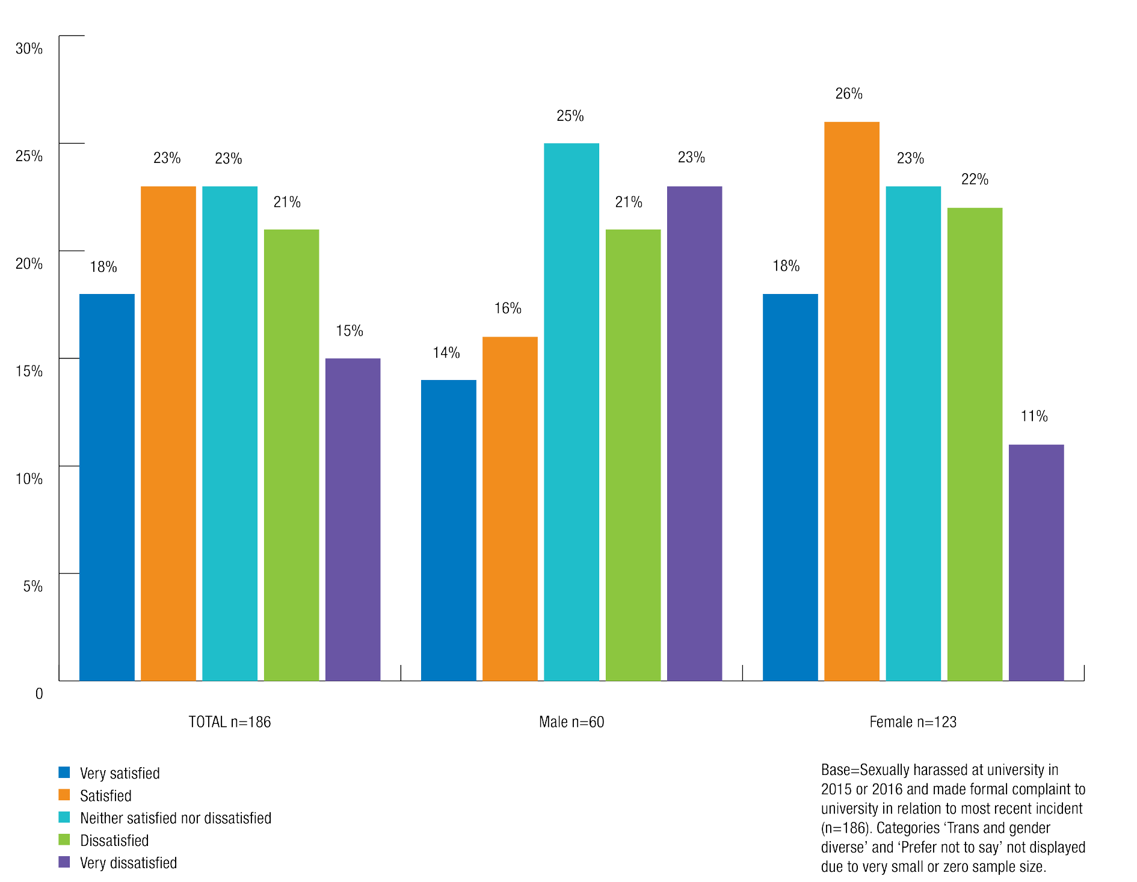

Satisfaction with support provided by university
Students who sought support from their university after being sexually harassed or sexually assaulted were asked about their satisfaction with the support provided.
In relation to sexual harassment, students were most satisfied with university support received from campus security (48% very satisfied, 17% satisfied) and student support services (22% very satisfied, 49% satisfied).

Chart 43: Satisfaction with support provided by university for sexual harassment
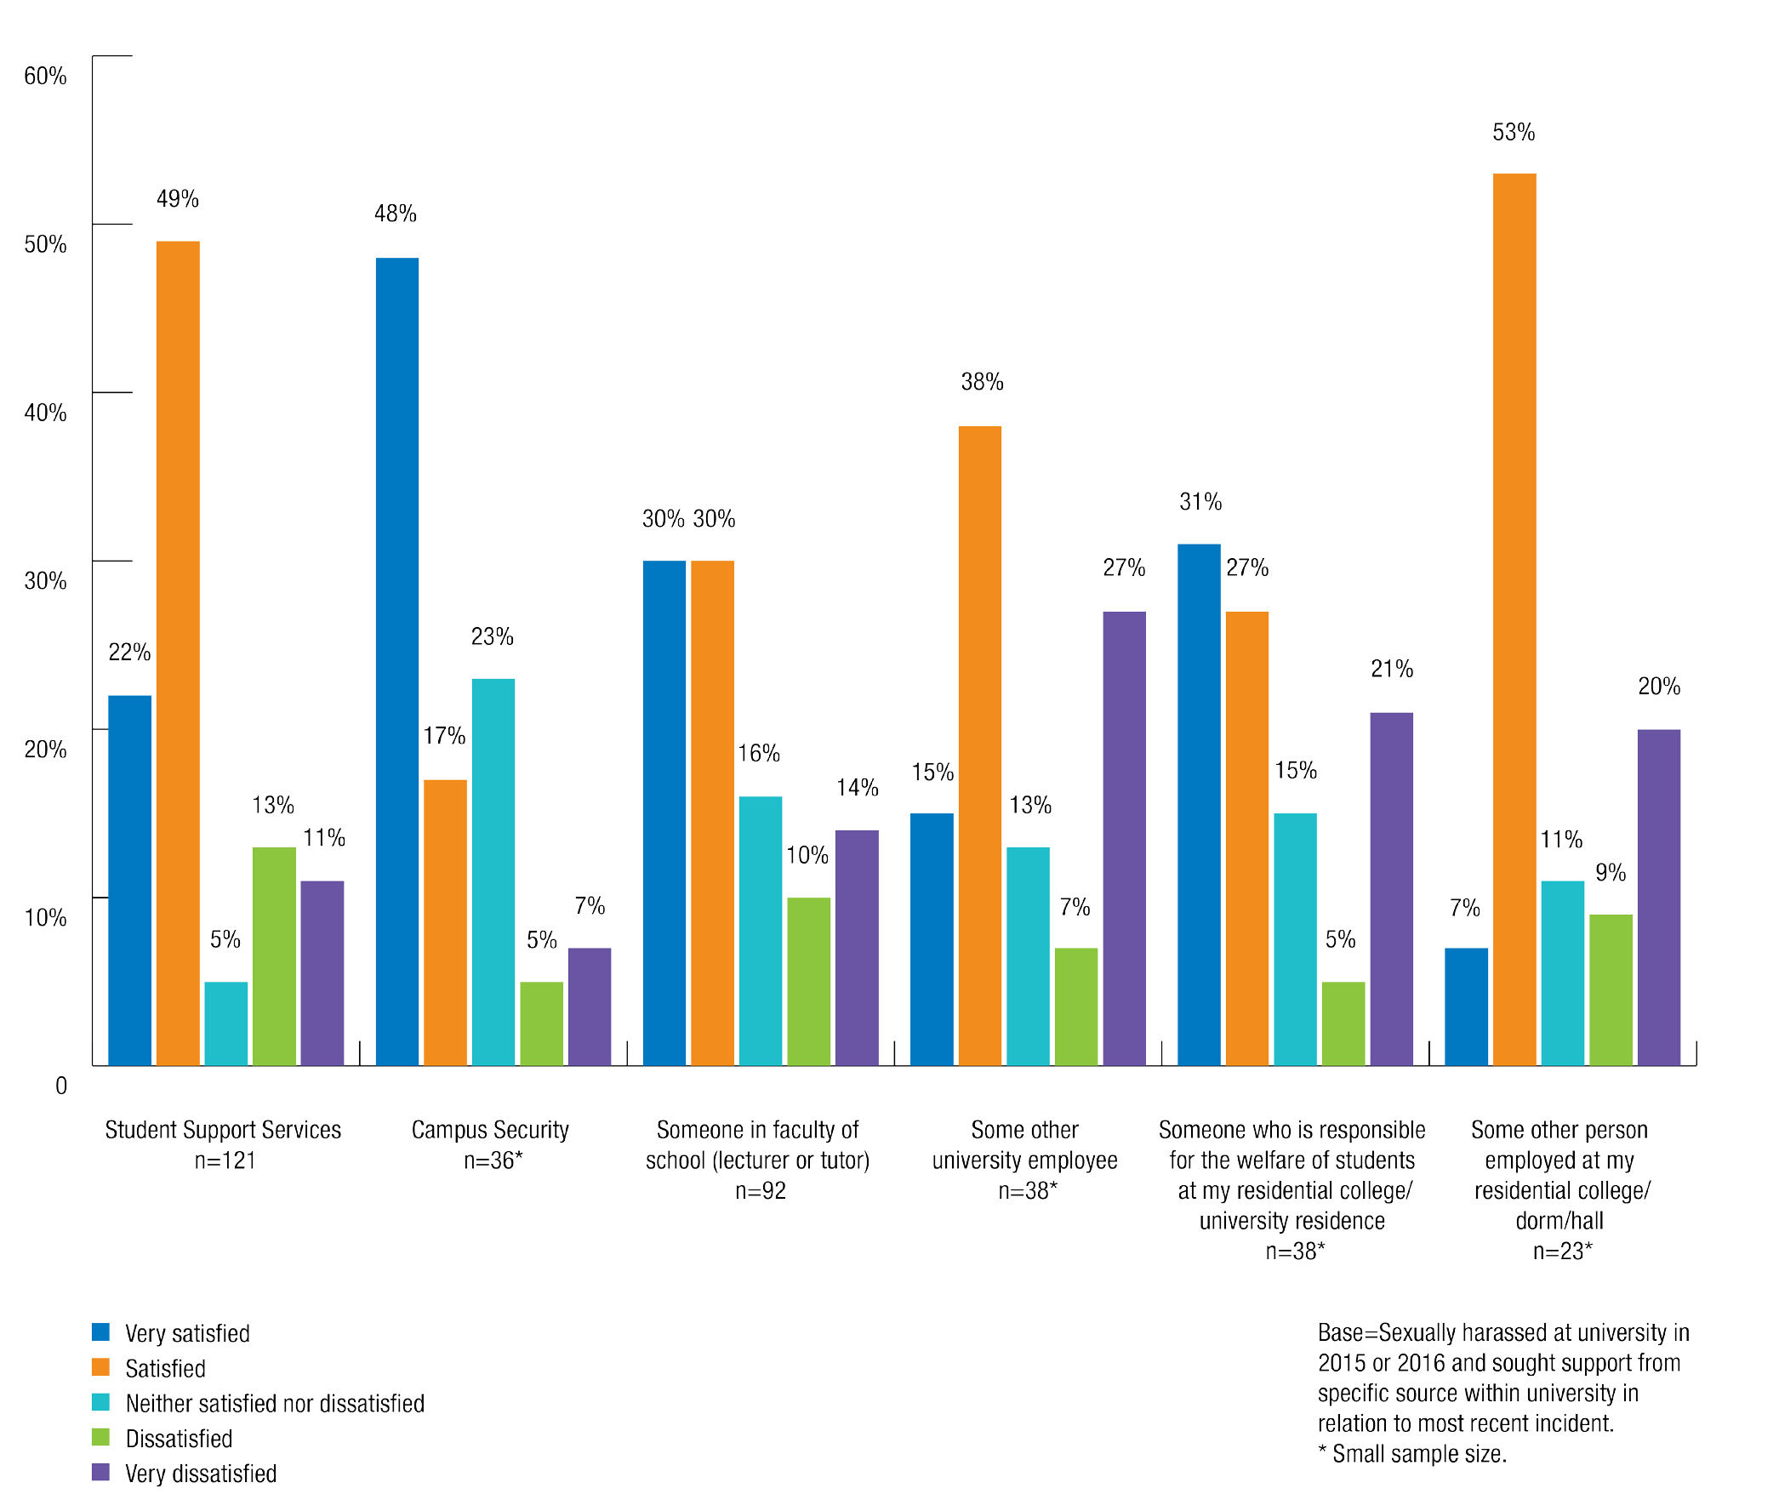

When examining sexual assault and associated levels of satisfaction with support, sample sizes were very small. For most listed sources of support, students who sought support were either satisfied or very satisfied with the support they had received. The exceptions to this were support sought from ‘someone from my faculty or school (lecturer or tutor)’ and ‘some other university employee’, where a clear majority of the (small number of) students involved were either dissatisfied or very dissatisfied with the support they received.

Incident reported to police
Students who had made a formal report or complaint about the most recent incident of sexual assault or sexual harassment to their university were asked whether the incident was reported to police.
  - Of those who were sexually harassed, 13% reported the incident to police, 66% did not report the incident to the police, 15% said they did not know and 6% said they preferred not to say.
  - Of the small number of people who were sexually assaulted and made a formal report or complaint to the university, the incident was reported to police in 43% of these cases,
with 41% saying that it was not reported to police, 16% saying they did not know and 1% preferring not to say.

University’s explanation of reporting process
Students who had made a formal report or complaint about an incident of sexual assault or sexual harassment to their university were asked whether the university had explained the complaint process, including any involvement with or processes for, reporting to the police.
  - 35% of students who had been sexually harassed and made a formal complaint said that the university had provided this explanation. 32% said that an explanation had not been provided, 22% were unsure and 10% preferred not to say.
  - 57% of the small number of students who had been sexually assaulted and made a complaint said that the university had provided this explanation, 32% said that an explanation had not been provided, and 11% said they did not know.

Submissions
The submissions received by the Commission reflect individuals’ personal experiences of sexual assault and sexual harassment. As the submission process was not restricted to the same period as the National Survey and the majority of submissions received did not specify the timing of the incident(s) reported, no direct correlation can be drawn between the survey data and the information received through submissions.

Reflecting the results of the National Survey, a small number of those who made submissions had made a formal report or sought support from their university regarding an incident of sexual assault or sexual harassment. However, a number of people did describe seeking advice or support about their experiences from friends, family or someone at their university.
Many of the submissions highlighted similar obstacles to reporting and seeking support for sexual assault and sexual harassment as those identified by survey respondents. However, the submissions also revealed additional reasons for not reporting or seeking support from the individual’s university, including:
    - misunderstanding the nature of sexual assault
    - fear of being victimised
    - self-blame
    - fears of negative impacts for their careers or studies, and
    - not believing that action would be taken.
Gender identity, sexual orientation and residency also had an impact on an individual’s experience of reporting an incident or seeking support.

For notes on reading the submissions contained in this report, please see the ‘Methodology’ section contained in Chapter 1.

Reasons for not reporting or seeking assistance and support

Not thinking what happened was serious enough to report or not feeling they needed help
Many students who made submissions did not think their experience of sexual harassment or sexual assault was serious enough or did not think that they needed help.
  - A woman was stalked by her male classmate, who made unwanted sexual advances towards her. She told the Commission: ‘I did not report. Although it bothered me, I felt like it would be treated as trivial’.3
  - A male student touched a woman inappropriately on public transport on the way to university. The woman said: ‘I was too scared to report the incident to the university for fear that they would ridicule me for reporting something that they might consider insignificant.’4
  - A female student kissed a male student during a party at UniGames. Without warning, he put his hand up her skirt and digitally penetrated her. Although she was upset, the woman did not make a report to her university: ‘I believed that it was insignificant in comparison to the reports of rape charges being laid at UniGames’.5

Julia experienced multiple instances of sexual harassment during her postgraduate studies. She was regularly subjected to sexist and derogatory comments by a professor teaching her course, who would make inappropriate sexual remarks. Julia was warned about the professor by other female students, however she was unsure if the behaviour was serious enough to report.6

The perception that an incident of sexual assault or sexual harassment was not serious enough or worth reporting was at times reinforced by the people that students confided in or sought help from.
Because my experiences have been downplayed by the people I have told, I never reported them because I thought I must have been overreacting and it wasn’t sexual harassment, even though…I have been distressed by what has happened.7

Fear of not being believed
Students who experienced sexual assault or sexual harassment often did not report the incident to their university because they were afraid that people would not believe them.
Men in particular indicated in their submissions that they feared people would not take their report seriously.
I was worried that nobody would believe me.8
I did not report this to my university, as it and our society in general refuse to believe that men can be victims of sexual harassment, assault or nearly any other crime.9
I do not feel that I would be taken seriously if I spoke out as a victim of non-consensual sexual activity if it was committed by a female.10
Some respondents who made submissions feared they would not be believed because the perpetrator was popular or known as a ‘nice person’ within the university or college community.
It was my word against his. He’s known as being a really nice friendly guy so I didn’t think a lot of people would believe me/care.11
…if someone is good looking and friendly, or friends with a lot of people, then no one wants to speak out against them. This sends victims and perpetrators alike the message that sexual assault and harassment are a-okay.12

Concerns about a lack of evidence
Concerns about their ability to ‘prove’ that the incident occurred, and a fear of having to meet a legal burden of proof emerged in submissions.

I didn’t report the incident…and because I had not done anything at the time I felt like there was nothing I could do…women carry the almost impossible burden of having to prove, in court, their allegation, usually in a he said-she said context.13
It would have been impossible to prove that I didn’t consent. I just wanted to forget about it.14
I would never want to report what happened because of the fear of being disbelieved or cross-examined on what happened. Imagine knowing clearly what happened to you, but being told by a court or university that it never happened or can’t be proven.15
This was a particular concern for people who could not identify the perpetrator(s).
I did not report the incident. I didn’t know any of the men...I did not tell the university that I had been groped at one of the parties they hosted because I don’t think anything would really come of it cause I don’t know who did it.16

Shame, embarrassment and blame
Some people who made submissions indicated that they felt ashamed or embarrassed for not having done more to prevent the sexual assault from occurring.
It all seemed too complex and I felt like I had been complicit somehow, because I hadn’t set firm enough boundaries or been vocal enough in my opposition to what he was doing. I felt ashamed of what had happened, and scared that no one would believe me or want to listen.17
I did not report the incident due to fear and guilt. I felt guilty because I thought I had not said ‘no’ enough or explicitly enough.18
To me, the idea that I had been raped is something that I really struggle to comprehend, I often find myself blaming myself for that night when truthfully I know I did nothing wrong.19

Annie returned to her college room with a group of friends after a night out. Her friends slept in her room because it was late and it was too far for them to go home. Annie woke up to her friend Jonah touching her genitals. Jonah then raped her. Annie was so shocked by what was happening she was unable to move. Annie was embarrassed and ashamed that she had not done anything to prevent the assault so she did not report it to anyone.20

In addition to a sense of personal shame, people expressed fear that other people would blame them for what occurred. Some individuals said they did not report their experience because they feared that they would be held responsible for the sexual assault or sexual harassment they had suffered.

It took me over a year to realise I wasn’t at fault and even so, I am still reluctant to tell people for fear of being blamed or told I’m overreacting.21
One student said in her submission that she did not report an incident of sexual assault as other people said she had flirted with the perpetrator before he assaulted her and therefore she had ‘asked for it’.22
This fear of being blamed was also a common concern in circumstances where alcohol was involved prior to an incident of sexual assault.
At the time I wanted to report him but felt too ashamed. I was sure I would be blamed for drinking, for smoking, and so I didn’t tell anyone.23
I didn’t report the incident…I felt that I was responsible for what had happened by being too drunk to look out for myself or remove myself from the situation effectively. Looking back on the situation now, I was far too drunk to be able to consent to any sexual activity. The guy should not have attempted to have sex with me, and the older residential advisers at the college should have intervened.24

Lola was raped by an acquaintance in her first semester of university. She had been drinking with friends, and the male student offered to walk her back to the residential college. He raped her in the grounds of the residential college. Lola was too afraid to report the rape to the college or the university because she was afraid that she would be blamed because she had been drinking beforehand. She was ashamed so she did not access any support services.25

Not wanting to get the perpetrator into trouble
A common barrier was not wanting to cause trouble, or having concern for the impact it might have on the perpetrator’s life and wellbeing. The information gathered from submissions indicates that this reluctance can exist even where an individual is aware that what the perpetrator has done is wrong.
I didn’t want to accuse and ruin my rapist’s life if I was too drunk to recall giving consent.26
I didn’t contact the university or residential college I was in at the time. From everything
I had heard about the boy, he was a nice guy, probably with a huge sense of entitlement, but didn’t deserve his life ruined.27
I was too afraid to take the matter much further because the guy was well liked...I also knew he had a girlfriend…and was terrified what would happen to everyone involved.28
Friends or peers that students disclosed to sometimes reinforced these fears. A woman who was raped by a friend said in her submission: ‘My friends begged me to not press charges or he’d kill himself’.29

One woman who was sexually assaulted on two separate occasions noted in her submission to the Commission:
Both times I consulted with my boyfriend and close friends, but never reported it to anyone. The reasons I didn’t was because I did not want to relive what had happened, nor ruin their lives. I believe both of them are just immature men that use the excuse of being under the influence to defend their behaviour.30
Some people feared causing trouble in their friendship group. Others wanted to fit in with their peers at their residential college. This was particularly the case for first-year residents (or ‘freshers’).
If he hadn’t been in my group of friends it would have been so much easier to be straight out and tell him off. I think because he is a friend I was wary that I’d have to see him all the time and what the impact of it on our friends would be.31
I didn’t report...because I was a fresher at college and didn’t want to cause trouble. I just wanted to fit in and I didn’t even know who to talk to.32
I never reported this as I was so young and didn’t know any better. I always thought this was part of normal university behaviour having to fend guys off…I also didn’t want to lose friends or be seen to be against college culture and traditions by disagreeing with any of the activities. It was a really difficult time for me trying to fit in and make friends.33

Too emotionally difficult to report
Concern about the emotional impact of making a formal report also emerged from submissions. Additionally, students were concerned that reporting procedures would be too onerous, or that the reporting process would be traumatic.
By and large, the complaints procedure seemed much more arduous and emotionally laborious for me as a complainant. It is a process that would affect me much more than it would affect him.34
I wanted to report the sexual assault but knew that as a trans woman reporting sexual assault by another queer woman would just be a humiliating and traumatising experience that would go nowhere.35
One submission also noted that by placing timeframes on reporting sexual assault and sexual harassment, university administration prevents students who might not be ready or able to report within the timeframe from reporting at all.
I never reported it officially. My university has a 40-day limit on when it can be reported to administration. There’s no way I was in the right place to be able to report it so soon after it happened. It took half a year before I felt like I needed to report it, and by then it was too late.36
In some instances, people did not report to their university because they did not want to involve the police.

I was also told that in order to expel him I would need to file a police report and that was something I was completely against and something that seriously scared me off.37

Fear of being victimised
A common reason for not reporting sexual assault or harassment identified in submissions was fear of bullying, by either the perpetrator or their friends. This is consistent with the survey data, which found that 12% of students who were sexually assaulted did not make a report to their university because they were ‘too scared or frightened’.
A fear of being victimised was particularly pronounced in submissions made by people who lived with their perpetrator at residential college at the time of the incident and saw them on a daily basis.
You get labelled a dyke, a man hater and a “tractor driver” if you make a complaint about sexual harassment – I have seen it force two other women to move out of the college.38
One woman who experienced sexual harassment from a Residential Adviser at college said she considered making a report. However, she decided not to report the incident because of the perpetrator’s ‘very active position within the community and fear of being ostracised’.39

Impact of reporting on studies and career
The survey indicated that some students did not formally report sexual assault or sexual harassment because they were concerned that because their perpetrator was a tutor, lecturer or supervisor, reporting would have a negative impact on their studies or career.
In some submissions, people told the Commission that they feared that reporting would have a negative impact on their grades.
I have not reported as I think it will impact on my results and I have no proof so will not be believed.40
I think there should be anonymous reporting. I didn’t report my experiences because I was worried about getting in trouble or having my marks affected.41
People also said they did not make a report because they were concerned about the potential impact on their future career. This concern was most commonly raised in situations where the perpetrator was a tutor, lecturer or academic in the relevant field.
I didn’t report the incident to anyone because the industry is very tight-knit, and causing a fuss or making trouble with a fellow student who could one day become a colleague in the industry could really ruin opportunities for me in the future. It happens a lot within the industry and so too within the course environment.42
I was too scared to make a complaint at the time because the lecturer had a big name in the industry I was trying to break into.43

…as a postgraduate hoping to be employed in academia it does not feel as I if have any options to reject this behaviour without damaging my future opportunities and severing networks.44

Not knowing whether what had occurred was sexual assault
Some people who made submissions told the Commission that they did not report their experience because they were unsure whether what they had experienced constituted sexual assault.
The college I stayed at had given us lots of information in O-week about sexual harassment and how it isn’t okay, but because we didn’t actually have sex I didn’t think it applied to me really.45
Some individuals were unsure about whether they could report because they were unsure whether sexual assault had occurred. Others were unsure about whether sexual assault had occurred because the initial behaviour had been consensual, but consent had then been withdrawn.
  - A woman who was inappropriately touched on her breasts and genitals by a friend while she slept reported to the Commission: ‘I had no idea that the reason I felt so crap was because it was sexual assault. I simply put it down to being uncomfortable but not bad enough to be assault.’46
  - Another woman said she felt pressured into going home with a man and having sexual intercourse: ‘I asked him to stop and eventually he did…I didn’t report anything because I didn’t know if what he’d done was wrong.47
  - A woman who was physically and sexually assaulted by a fellow student she was dating said that because they did not have sexual intercourse: ‘I did not report the incident to the university or police because I was not sure that it was assault and whether anything could be done.’48
Some individuals did not immediately recognise their experience as sexual assault because they knew their perpetrator or believed that sexual assault is perpetrated only by strangers.
Rape doesn’t always look like a dirty man holding you face down in an alleyway. It can be a nice guy, too much alcohol and a severe miscommunication that can never be erased.49
In my mind, rape occurred in dark alleys, not with people you knew.50
Too many people associate sexual assault with violent attacks by strangers, making it harder to identify and report sexual assault which is perpetrated by someone known to the victim or in a setting in which the coercion or lack of consent may be less overt.51

Fiona was sexually assaulted by a music teacher who touched her inappropriately while demonstrating something to her. She sensed that the behaviour was wrong and began to dread the lessons, but did not report because she was not sure that the behaviour was inappropriate. It was only later that she recognised what had happened as sexual assault.52

Some people did not understand that forced or coercive sex by an intimate partner constitutes sexual assault. This makes it difficult to recognise the experience as assault and creates an added barrier to reporting.
I did not report my rapist for many reasons…I didn’t know it was rape (because it wasn’t a stranger jumping at me from behind a bush) if it was my boyfriend.53

Tamara was an undergraduate student who experienced multiple sexual assaults perpetrated by her boyfriend. Tamara did not make a report as she did not understand that an intimate partner could be guilty of sexual assault and blamed herself.54

A woman who was sexually assaulted by a same-sex partner said she did not immediately recognise her experience as sexual assault. She noted that the lack of information about how these behaviours can manifest in non-heterosexual relationships created a barrier to reporting.
Maybe there should be some information about queer relationships and how they can still be inappropriate. Just because someone is queer, doesn’t mean that their boundaries shouldn’t be respected.55
Some individuals did not report because they saw or experienced sexual assault and sexual harassment so frequently that they considered these behaviours to be a normal part of the college or university experience.
I felt like I couldn’t say anything because ‘college is about having a fun time’. The phrase ‘we’re at college, this is what college is like!’ was used a lot.56

Lack of confidentiality
Over one in ten students said that they did not report to their university after being sexually assaulted because they worried the incident would not be kept confidential.
This was also cited as a reason why students did not report to, or seek support from, their university after being sexually harassed.

Many submissions indicated that the lack of anonymity in university reporting procedures discouraged people from reporting sexual assault or sexual harassment.
A particular concern identified in submissions was fearing that the perpetrator would find out about the report.
There are no mechanisms to make an official report anonymously and so the victim takes a big risk in reporting, with no guarantee of the outcome.57
I felt too scared to report these incidents. Our cohort for our course is incredibly small…I couldn’t have action taken against him because everyone would find out.58

A male student in Verity’s class groped her and rubbed his erection against her on two occasions during their tutorial. Verity tried to report him, but decided against it because she was told she would not be allowed to report anonymously.59

One woman told the Commission that she specifically insisted on a guarantee of anonymity before reporting her sexual assault to her university.
I contacted his university and…gave them his information making sure he would never know that I had reported him, since I’m acquainted with his friends at [university], and I didn’t want to face consequences from them, since they have no idea what their friend did and would more likely believe him over me.60
However, submissions to the Commission reported that some universities had specific policies requiring people who reported sexual assault or sexual harassment to attend a mediation
or another type of face-to-face meeting with the perpetrator. This proved to be a strong disincentive to making a report.
I was unsatisfied that it would be appropriately resolved. This was because a) one of the first steps of the complaints procedure is mediation, which forces an open confrontation between myself and [perpetrator], which I did not at all feel confident enough to pursue.61
One woman who was stalked by a classmate did not make a report because she was afraid that reporting would exacerbate the sexual harassment:
The process was incredibly difficult and lengthy, I became scared that he would find out it was me and provoke him... I still worry that because I did not report him, he may
continue his harassment and that if something happened to another student, it would be my fault, as I could have done something.62

Awareness of reporting procedures
A lack of knowledge among students about reporting mechanisms and procedures was identified as a significant barrier to reporting incidents of sexual assault and sexual harassment in both the survey and submissions.
As discussed in the survey section above, it is evident that most students know little to nothing about the reporting processes at their university.
It took me months to report the incident at my university, as I had no idea where to go, in spite of having studied there for six years.63
I had no clue that I could let institutions know that I was sexually assaulted without having to go to court and have to relive my assault constantly.64
I didn’t really know where to go on campus to complain. [They] don’t advertise those kinds of private services or complaint handling departments, so I didn’t know where to turn to when my assault occurred.65
International students in particular were not aware, or were less aware than domestic students, of the procedures that exist for formally reporting sexual assault or sexual harassment at their university.
I was not aware that I could contact an equity/counselling service because I was so new to [university] and Australia.66
Some individuals did not report because they were not sure whether their university could take any action, often because the incident occurred off-campus.
At an international conference I attended on university travel, one of the conference organisers inappropriately touched my bottom. This happened at a social event during the conference. I did not know who to complain to so I did nothing.67

Lack of confidence in action being taken
In submissions, people said that they did not make reports of sexual assault and sexual harassment because they doubted it would result in an end to the behaviour, or would not lead to action being taken against the perpetrator.
I didn’t report the incident…I was in a position to know of other allegations and also to know that the university did nothing about them.68
I didn’t report it because nothing would have been done, it would have been dismissed as him just not knowing he was making me uncomfortable and I was not prepared to deal with large amounts of paperwork to be told I was overreacting.69
I know some people who were sexually harassed by tutors or lecturers and felt powerless to report (especially if the lecturer was in a senior position, the student felt that nothing would be done because it’s very hard to dismiss someone that is senior).70

The university favours informal procedures rather than disciplinary action. I had no interest in entering into a process with the university, having to tell the university my story (and potentially losing control over it), having my experiences questioned, only to have the perpetrator apologise.71

Gender identity or sexual orientation
Some submissions revealed that people did not make a report of sexual assault or sexual harassment because they were afraid that the person they reported to might hold negative attitudes towards them based on their gender identity or sexual orientation.
I did not report it to anyone or tell anyone of this incident. There is already a social stigma against homosexuals in Australia, and I think my experience will just exacerbate it.72
The Commission also heard in submissions that people who had not ‘come out’ as gay or bisexual did not feel comfortable reporting sexual assault and sexual harassment.
I didn’t report the incident…because I wasn’t ready to come out to anyone.73

International students
The Commission received submissions from international students who did not know whether the behaviours they experience are sexual harassment or just a part of Australian culture.

Sukhon is an international PhD student and is new to Australia. In her first few meetings with her supervisor, he kissed on her the lips. Sukhon is unsure of whether this is a part of Australian culture or inappropriate of her supervisor.74

In addition, many international students may face unique barriers to reporting. Submissions reported that isolation from support networks can create a barrier to CALD and international students reporting sexual assault and sexual harassment.
I received an email from uni asking me about the situation which was sent to my email and my emergency contact’s email which caused them a lot of worry and I convinced them it was some administrative mistake because I didn’t want to give them anxiety or make them feel helpless as it was my first year at uni and they were far away.75
Concern around the impact of reporting on international students’ studies and visa status was also communicated to the Commission.
I didn’t report it to the police because I was scared this could affect my future visa conditions in this country.76

Experiences of reporting or seeking assistance and support
Only a small minority of students who experienced sexual assault or sexual harassment in a university setting in 2015 or 2016 made a formal report. However, the Commission received a number of submissions that discussed the experiences of students who had reported and sought support for an incident.
A large number of the submissions received by the Commission described negative experiences of reporting or support seeking at university, or negative impacts following an experience with the university.
Students also noted that there were inadequate support services at their university available to people who have experienced sexual assault and sexual harassment. Some students also identified a lack of specialised services for students who speak English as a second language or students with disabilities.
The submissions highlight some of the reasons why students were unhappy with the reporting procedure or policy at their university. The Commission heard that people were not believed, were shamed, or had their personal information compromised after making a report.
A significant number of those who did report also felt that the individual response of the person they reported to was inappropriate or inadequate in some way.
A negative response to someone reporting sexual assault or sexual harassment, or seeking support after an event can reinforce an individual’s feelings of self-blame or uncertainty about whether an incident was actually sexual assault or sexual harassment, and can deter a person from taking any further action.77
Research has indicated that certain responses to reporting can be re-traumatising for people who experience sexual assault:
When rape survivors are exposed to victim-blaming behaviours or attitudes, the experience may feel like a “second assault” or a “second rape”…Speaking out about
the assault may therefore have detrimental consequences for rape survivors as they are subjected to further trauma at the hands of the very people they turn to for help.78
According to one student, ‘the university’s response was incredibly traumatic and made things so much worse’.79 Another student reported to the Commission that ‘reporting my rape to the university was worse than being raped.’80

Positive experiences
The Commission received submissions from people who had reported sexual assault or sexual harassment to someone within their university or college and described their experience as positive, in terms of the support provided or the action taken.
Some key themes that emerged from the submissions describing positive experiences of seeking support were that students felt they were believed and that they had access to professional support services.

Students were more likely to have been satisfied with the process where they were able to rely on the support of friends, family or counsellors to assist them in some way with making a report. Some individuals also reported that it was helpful when the person they disclosed to had some kind of training in responding.
Although some individuals did not want to report formally, their university was able to provide them with flexible assistance that suited their specific needs.
I felt they [residential college manager] dealt with it really well. When I told them, they said we could take it to either the police and/or the University itself. They immediately moved me to another apartment, in a whole different building, in the same residential accommodation. They helped me to move quickly and discreetly…I decided to not take it to the police/ the University. However, they (management) also told me, that if I changed my mind in the future about this to just come straight back. I was more than satisfied with the sensitivity and practicality of the management in dealing with this problem.81
I did not report the incident to the university, but I did talk to my Senior Resident on my corridor of the residence. She had pastoral care training and let me cry to her and reminded me I wasn’t to blame and urged me to go to the university and the police.82
One woman who was sexually assaulted by a fellow college resident attended a committee hearing, run by the college, regarding the incident. She did not have any contact with the perpetrator during the hearing and after the hearing, she was told that he would not be returning to the college. She did not want to make a formal report, however her college said they would support her in reporting to the police if she changed her mind.83
Another woman who was raped by a fellow college resident reported to the university and was provided with support to ensure she could continue with her studies:
[The university] also has a service…for students with disabilities, and through them
I have…extra days per assignment without having to seek special consideration. [The university] have been helpful and ensured I was able to complete my undergraduate degree with grades good enough to get into masters. I really cannot ever thank them enough for this.84

Audrey was sexually assaulted on multiple occasions by Brian, a fellow student in her course. She disclosed the assaults to a counsellor at her university and her course coordinator. Although Audrey did not wish to make a formal report, her faculty was able to make changes to her study schedule, such as placing her in separate classes and exam rooms, to allow her to avoid seeing Brian on campus.85

Negative experiences
There were a number of key reasons why students had negative experiences of reporting and seeking support. Primarily, they were dissatisfied with a lack of action taken in response to their report; felt they were not believed or were blamed; a breach in confidentiality of the reporting procedures; an inappropriate response to their report; or a lack of support.
In many instances, negative experiences of reporting or seeking support had a significant impact on the student’s mental health or ability to pursue making a formal report or complaint.

Normalisation of sexual harassment
In both cases of formal reporting and seeking support, the Commission received submissions from students who said that the person they told did not consider the incident to be serious, or downplayed what had happened to them.
People who sought support from their friends were often told that their experience of sexual harassment was ‘not a big deal’ and that they should just let it go.
  - A woman who was repeatedly sexually harassed and sexually assaulted by a fellow college student told a friend about the incidents: ‘when I mentioned reporting the incident to a friend, she said I won’t be seeing him again so I wouldn’t bother.’86
  - Another woman who had been sexually harassed said: ‘I felt threatened and scared but my friend told me that it was no big deal and asked me to calm down because it was “nothing”’.87
  - A female student was sexually harassed over a semester by a male professor. He would make comments on her clothing or appearance, stare at her inappropriately and ask inappropriate questions about her personal life. She disclosed the behaviour to a friend who told her to just brush it off because he was joking and it didn’t matter.88
Individuals were also told by friends or university staff that they should take the sexual harassment ‘as a compliment’, or that it was just the person’s way of showing romantic interest in them.
A good friend of mine has been harassed, stalked and felt in danger by a colleague. The department were notified and she was treated like it was a shame she didn’t reciprocate his feelings!89
When I got to University, I told my friends that a man had slapped me on my bottom and their immediate response was “well, he might just fancy you”.90
One individual who was sexually harassed on multiple occasions said ‘I once told a tutor about an incident and was told to see it as a compliment and asked what I was wearing.’91
Students were also told by their friends that what had happened did not amount to sexual assault. This demonstrates a lack of understanding about behaviours that constitute sexual assault among university students.

One woman stated that when a female student told her friends she had been sexually assaulted, they said she had cheated on her boyfriend, rather than viewing the incident as an assault.92

Althea was an international student, living on campus, who was sexually assaulted when she stayed the night at a friend’s residential unit. She was offered a mattress on the floor by the Residential Adviser (RA). However, during the night the RA removed Althea’s clothes, groped her and tried to pressure her into having sex. Following the assault, Althea told her friends who said it was not assault as the RA had not raped her.93

Not believed
Many students said the person they reported their experience to or sought support from did not believe them.
A woman who was raped by a fellow college resident reported to staff members at her college. She told the Commission: ‘The next week was the worst week of my life, I went forward to…staff, only to find myself shamed and ignored. I felt like they didn’t believe me.’94

Nora is an undergraduate student who was sexually assaulted when she drove a fellow male student home after an off-campus event. She reported the assault to the police who told her that they could not do very much. The police told Nora that because she had not been raped it would be her word against the perpetrator. She felt like they did not believe her.95

Cindy was sexually harassed over a period of time by a Residential Adviser (RA) at her college. One night at a college party, she passed out and the RA took her back to her room. She woke up in the morning and realised he had sexually assaulted her while she was unconscious. Cindy later learned that other female residents had also been sexually assaulted by the RA. She and the other women reported him to the university. The university said they believed that the residents were lying and that they had damaged the RA’s reputation. The RA did not face any consequences and was allowed to keep his job.96

The Commission also heard from men, who had disclosed experiences of sexual assault or sexual harassment to friends, who felt that they were not believed because of their gender and stereotypes that men cannot be victims of sexual assault or sexual harassment.
A man who was raped by a female friend said that when he talked to his friends about what happened they laughed and called him a liar.97

Ben was sitting alone at the university bar waiting for his friends to arrive at the party. A couple of female students approached him and struck up a conversation. When one started touching Ben inappropriately, he asked them to leave him alone. The women then called him a ‘poofter’ and ‘faggot’. When Ben told his friends what had happened, some did not believe him and others laughed and told him he was ‘lucky’. In light of these reactions, Ben decided not to report the incident.98

Being blamed
Some students said that the person they reported to or sought support from implied that they were to blame for what happened. As discussed in the previous section, the prevalence of ‘victim-blaming’ attitudes prevents many individuals from reporting their experience in the first place.
A woman who was raped by a fellow college student said: ‘I told my boyfriend from home what had happened and he broke up with me for ‘cheating’ on him. This fed my worries that it was my fault and that I shouldn’t ruin the life of the person who raped me because I was to blame.’99
In many cases, students who were sexually assaulted told the Commission that their drinking habits were scrutinised by the person they reported to.100
A woman who was sexually assaulted in her bedroom by a male friend reported the incident to her university and was offered counselling for alcohol abuse.101
Another student was raped by a fellow college resident. She reported the incident to the college, who asked her about her drinking habits and ‘what [she] would be doing in the future to cut back on drinking to make sure “bad things like this don’t happen again”’.102

Odette is an undergraduate student who was raped in her residential college after attending a college party. She reported the rape to the head of the residential college who put Odette on a ‘drinking ban’ and advised her to focus on her studies.103

Lack of evidence
Some students reported to the Commission that universities, colleges and the police did not take their complaints seriously or take any action following their reports of sexual assault or sexual harassment because they didn’t think there was sufficient evidence.
One woman said that when she reported her assault to police, they told her they were unable to prosecute because of a lack of evidence.104
One individual who was sexually harassed at a university party was informed by her college that because there were no cameras, ‘no one could prove anything’.105
Another woman who was indecently assaulted by a friend went to police who advised her: ‘it would be hard to prosecute because he didn’t actually rape me.’106

Penny was at home with her friend Sean. She had been sleeping but woke up to find Sean raping her. Penny told the police, but they said it would be hard to prove it was rape as Penny had been drinking earlier in the evening.107

Breach of confidentiality
In some instances when students reported their experiences of sexual assault or sexual harassment, their university, college or peers breached their confidentiality.
This had significant negative consequences for victims, including being ostracised by their peers or bullied by the friends of the perpetrator.
The administration of my college repeatedly breached confidentiality about my case, as it was one of many cases that had been reported, by mistakenly informing other residents about the incidents, and failed to contact me or the other survivors when the perpetrator eventually was “encouraged to leave” the hall.108
The university broke confidentially by informing organisers of the camp (i.e. the rapist’s friends) what I’d done. People spread lies about me and I was ostracised from the club.109
As discussed in previous sections, it is common for residents living in colleges to be aware of intimate details of their peers’ private lives. Some individuals who had reported sexual assault to their college were subsequently bullied or ostracised by their peers.
It was not easy coming back to the College; he was a popular member of the community, and his friends were convinced that nothing wrong took place. This has been such a hard thing to battle with this year.110

A woman who was raped by a fellow student reported to her college and found that they were supportive. She was happy with the assistance provided. However, her peers were less supportive: ‘only a few of my friends at the time actively took my side. The others kept being
friends with him, which was extremely hurtful as that to me meant they were taking his side.’111

Requirement to attend mediation with the perpetrator
Students detailed instances where they were required by their college or university to undertake a face-to-face mediation process with the perpetrator.
People found this to be traumatic and were sometimes deterred from taking any further action in relation to the sexual assault or sexual harassment.
When I complained to the head of school I had a “mediation” session with the professor who was harassing me…At the end of the mediation session the professor stormed out and slammed the door. He wasn’t told to change his behaviour, the “mediation session” was all that was done.112

Jacinta was a postgraduate student who was sexually harassed on an ongoing basis by a senior academic. Jacinta made a report to the university, which led to a mediation process with the academic. She was shouted at by the academic during the session, and he did not adhere to the mediation agreement they both signed. No substantial action was taken and Jacinta later left the university.113

Personal ramifications
Some students told the Commission in submissions that reporting their experience to their college or university had negative ramifications for them personally.
For example, the Commission received submissions from some students who reported being punished by their university or college after reporting sexual assault or harassment. For example, one individual told the Commission that they were ‘banned from particular buildings to protect the rapist’.114
A female student who was sexually assaulted in on-campus housing reported this to her university and was not satisfied with the response she received.
The perpetrator escaped all punishment by claiming he was ‘too drunk to remember’ what had happened, and instead, the university seemed to go out of its way to punish me by claiming I was mentally unfit to continue studying. Why should I or any other victim be punished for the appalling actions of another student?115

Jenny was sexually harassed by her supervisor while on a professional placement. When Jenny reported her experience to her course coordinator, she was dismissive and did not believe her. Jenny later learned that the course coordinator and her placement supervisor had a close professional relationship. She sought help from the student union. While they offered assistance, she decided not to escalate her report because she needed the course coordinator to sign off on her assessments in order to graduate.116

Special consideration procedures
Students who made submissions about sexual assault and sexual harassment sometimes reported that their university refused to grant them special consideration or educational adjustments that would allow them to continue their education.
In particular, a number of students who struggled with their mental health following an assault said their lecturers denied them special consideration for assignments and exams.

Dimity is an undergraduate student who was sexually assaulted off-campus. She reported her assault to the university and sought support through counselling. In order to obtain academic consideration for her subjects and extensions for her assignments, she was told to contact each lecturer individually and provide letters from her counsellor and doctor. Dimity was not comfortable sending her personal counselling and health records by email, so she organised to have face-to-face meetings. Some of her teachers asked her very personal questions about her experience. She was not
comfortable approaching these teachers again and found the process to be lengthy and exhausting.117

No action taken
Some students said that after they had made a report of sexual assault or sexual harassment, there was no action taken by the university or college in response to their report.
A woman who was sexually assaulted on numerous occasions by her intimate partner, a fellow university student, tried to report to her university but was told the university had ‘no power to do anything, because none of it occurred on-campus’. She felt that the university should have taken action, because she was aware of the perpetrator sexually assaulting at least two other women at her university.118

In other instances, the university told people that they could not take any action in response to their report of sexual assault or sexual harassment unless they were willing to make a report to police.
Because I was not going through with a police investigation they said they couldn’t do anything about it.119
A tutor made a submission about her experience receiving a report of sexual assault from one of her students, who told her that she had been raped by a student at her residential college. The tutor reported that the ‘university did basically nothing to act, and said that they could not expel the male student because the female student did not wish to go
to the police.’ The tutor met with university administration to discuss the assault on her student’s behalf and it was only then that the student was able to be moved into alternative accommodation.120
The Commission also heard of people reporting sexual assault or sexual harassment to someone who was friends with the perpetrator and that subsequently no action was taken.
I reported the incidents to a Senior Resident at my university college who made the decision to not progress my concerns any further within the college…I believe that her decision not to report was due to her being friends with the perpetrator – she could not be objective about the situation as she wanted to protect him.121

University support services
In submissions, students described specific concerns about the support services provided by the university which are relied on by students who have experienced sexual assault or sexual harassment.
A common issue raised was that students did not know what support services actually existed at their university, or how they could access them.
I haven’t heard about anything to do with sexual assault/harassment at university. Perhaps it’s something that should be spoken about more so people know it’s not right, or so more people are aware there are services out there if they need support.122
I wanted to tell someone about the situation, but couldn’t find any channels to do so – not even for professional advice or emotional support. Being limited to six sessions on campus also made it uncomfortable for me to go see the campus counsellor because I felt like very little help could be achieved in that period of time.123
A number of students said in their submissions that they had to wait a long time in order to access the university support services, as these services were often understaffed and under- resourced.
One person stated that she did not seek assistance from support services as the waiting list to access mental health support services at her university was over two months long.124

When Elsie reported to the university, she was told to make an appointment with the counsellor. It took a month for Elsie to get an appointment. When she scheduled a second appointment, it was cancelled as the single counsellor employed at the
university could not work that day. Elsie has attempted to reschedule this appointment but has so far not been able to.125

A concern expressed in some submissions was that services are not appropriate for people who are trans and gender diverse, non-heterosexual or from different cultural backgrounds.
The Counselling Centre (and University administration in general) should publicise that their services are also for people that are international, queer, male-identifying, students of colour, ESL Students…My frustration for not talking with someone who could speak my same mother tongue made me have many ‘lost in translation’ misunderstandings with my counsellor.126

Chapter 6: Endnotes

- Australian Bureau of Statistics, 2012 Personal Safety Survey – Table 17, cat no. 4906.0 (2013). At http://www. abs.gov.au/AUSSTATS/abs@.nsf/DetailsPage/4906.02012?OpenDocument (viewed 10 March 2017).
- Australian Human Rights Commission, Working without fear: Results of the Sexual Harassment National Telephone Survey (2012) 40. At https://www.humanrights.gov.au/our-work/sex-discrimination/publications/ working-without-fear-results-sexual-harassment-national (viewed 3 February 2017).
- Submission No. 1656 to the Australian Human Rights Commission, University sexual assault and sexual harassment project.
- Submission No. 633 to the Australian Human Rights Commission, University sexual assault and sexual harassment project.
- Submission No. 159 to the Australian Human Rights Commission, University sexual assault and sexual harassment project.
- Submission No. 115 to the Australian Human Rights Commission, University sexual assault and sexual harassment project.
- Submission No. 594 to the Australian Human Rights Commission, University sexual assault and sexual harassment project.
- Submission No. 550 to the Australian Human Rights Commission, University sexual assault and sexual harassment project.
- Submission No. 50 to the Australian Human Rights Commission, University sexual assault and sexual harassment project.
- Submission No. 1743 to the Australian Human Rights Commission, University sexual assault and sexual harassment project.
- Submission No. 1520 to the Australian Human Rights Commission, University sexual assault and sexual harassment project.
- Submission No. 175 to the Australian Human Rights Commission, University sexual assault and sexual harassment project.
- Submission No. 136 to the Australian Human Rights Commission, University sexual assault and sexual harassment project.
- Submission No. 1080 to the Australian Human Rights Commission, University sexual assault and sexual harassment project.
- Submission No. 177 to the Australian Human Rights Commission, University sexual assault and sexual harassment project.
- Submission No. 1549 to the Australian Human Rights Commission, University sexual assault and sexual harassment project.
- Submission No. 1842 to the Australian Human Rights Commission, University sexual assault and sexual harassment project.
- Submission No. 1140 to the Australian Human Rights Commission, University sexual assault and sexual harassment project.
- Submission No. 1312 to the Australian Human Rights Commission, University sexual assault and sexual harassment project.
- Submission No. 136 to the Australian Human Rights Commission, University sexual assault and sexual harassment project.
- Submission No. 91 to the Australian Human Rights Commission, University sexual assault and sexual harassment project.
- Submission No. 1474 to the Australian Human Rights Commission, University sexual assault and sexual harassment project.
- Submission No. 333 to the Australian Human Rights Commission, University sexual assault and sexual harassment project.
- Submission No. 137 to the Australian Human Rights Commission, University sexual assault and sexual harassment project.
- Submission No. 1296 to the Australian Human Rights Commission, University sexual assault and sexual harassment project.
- Submission No. 550 to the Australian Human Rights Commission, University sexual assault and sexual harassment project.

- Submission No. 288 to the Australian Human Rights Commission, University sexual assault and sexual harassment project.
- Submission No. 138 to the Australian Human Rights Commission, University sexual assault and sexual harassment project.
- Submission No. 149 to the Australian Human Rights Commission, University sexual assault and sexual harassment project.
- Submission No. 1185 to the Australian Human Rights Commission, University sexual assault and sexual harassment project.
- Submission No. 179 to the Australian Human Rights Commission, University sexual assault and sexual harassment project.
- Submission No. 205 to the Australian Human Rights Commission, University sexual assault and sexual harassment project.
- Submission No. 903 to the Australian Human Rights Commission, University sexual assault and sexual harassment project.
- Submission No. 7 to the Australian Human Rights Commission, University sexual assault and sexual harassment project.
- Submission No. 1632 to the Australian Human Rights Commission, University sexual assault and sexual harassment project.
- Submission No. 563 to the Australian Human Rights Commission, University sexual assault and sexual harassment project.
- Submission No. 891 to the Australian Human Rights Commission, University sexual assault and sexual harassment project.
- Submission No. 230 to the Australian Human Rights Commission, University sexual assault and sexual harassment project.
- Submission No. 869 to the Australian Human Rights Commission, University sexual assault and sexual harassment project.
- Submission No. 1461 to the Australian Human Rights Commission, University sexual assault and sexual harassment project.
- Submission No. 70 to the Australian Human Rights Commission, University sexual assault and sexual harassment project.
- Submission No. 1242 to the Australian Human Rights Commission, University sexual assault and sexual harassment project.
- Submission No. 203 to the Australian Human Rights Commission, University sexual assault and sexual harassment project.
- Submission No. 1526 to the Australian Human Rights Commission, University sexual assault and sexual harassment project.
- Submission No. 1637 to the Australian Human Rights Commission, University sexual assault and sexual harassment project.
- Submission No. 179 to the Australian Human Rights Commission, University sexual assault and sexual harassment project.
- Submission No. 64 to the Australian Human Rights Commission, University sexual assault and sexual harassment project..
- Submission No. 1648 to the Australian Human Rights Commission, University sexual assault and sexual harassment project..
- Submission No. 1490 to the Australian Human Rights Commission, University sexual assault and sexual harassment project.
- Submission No. 266 to the Australian Human Rights Commission, University sexual assault and sexual harassment project.
- Submission No. 137 to the Australian Human Rights Commission, University sexual assault and sexual harassment project.
- Submission No. 32 to the Australian Human Rights Commission, University sexual assault and sexual harassment project.
- Submission No. 35 to the Australian Human Rights Commission, University sexual assault and sexual harassment project.
- Submission No. 34 to the Australian Human Rights Commission, University sexual assault and sexual harassment project.

- Submission No. 97 to the Australian Human Rights Commission, University sexual assault and sexual harassment project.
- Submission No. 175 to the Australian Human Rights Commission, University sexual assault and sexual harassment project.
- Submission No. 1813 to the Australian Human Rights Commission, University sexual assault and sexual harassment project.
- Submission No. 1334 to the Australian Human Rights Commission, University sexual assault and sexual harassment project.
- Submission No. 1666 to the Australian Human Rights Commission, University sexual assault and sexual harassment project.
- Submission No. 997 to the Australian Human Rights Commission, University sexual assault and sexual harassment project.
- Submission No. 7 to the Australian Human Rights Commission, University sexual assault and sexual harassment project.
- Submission No. 1309 to the Australian Human Rights Commission, University sexual assault and sexual harassment project.
- Submission No. 1103 to the Australian Human Rights Commission, University sexual assault and sexual harassment project.
- Submission No. 997 to the Australian Human Rights Commission, University sexual assault and sexual harassment project.
- Submission No. 1402 to the Australian Human Rights Commission, University sexual assault and sexual harassment project.
- Submission No. Sub 1633 to the Australian Human Rights Commission, University sexual assault and sexual harassment project.
- Submission No. 1628 to the Australian Human Rights Commission, University sexual assault and sexual harassment project.
- Submission No. 136 to the Australian Human Rights Commission, University sexual assault and sexual harassment project.
- Submission No. 436 to the Australian Human Rights Commission, University sexual assault and sexual harassment project.
- Submission No. 815 to the Australian Human Rights Commission, University sexual assault and sexual harassment project.
- Submission No. 266 to the Australian Human Rights Commission, University sexual assault and sexual harassment project.
- Submission No. 1289 to the Australian Human Rights Commission, University sexual assault and sexual harassment project.
- Submission No. 142 to the Australian Human Rights Commission, University sexual assault and sexual harassment project.
- Submission No. 585 to the Australian Human Rights Commission, University sexual assault and sexual harassment project.
- Submission No. 995 to the Australian Human Rights Commission, University sexual assault and sexual harassment project.
- Submission No. 1744 to the Australian Human Rights Commission, University sexual assault and sexual harassment project.
- Courtney Ahrens, ‘Being Silenced: The Impact of Negative Social Reactions on the Disclosure of Rape’ (2006) 38(3-4) American Journal of Community Psychology 263.
- Courtney Ahrens, ‘Being Silenced: The Impact of Negative Social Reactions on the Disclosure of Rape’ (2006) 38(3-4) American Journal of Community Psychology 263.
- Submission No. 321 to the Australian Human Rights Commission, University sexual assault and sexual harassment project.
- Submission No. 29 to the Australian Human Rights Commission, University sexual assault and sexual harassment project.
- Submission No. 38 to the Australian Human Rights Commission, University sexual assault and sexual harassment project.
- Submission No. 14 to the Australian Human Rights Commission, University sexual assault and sexual harassment project.

- Submission No. 1022 to the Australian Human Rights Commission, University sexual assault and sexual harassment project.
- Submission No. 919 to the Australian Human Rights Commission, University sexual assault and sexual harassment project.
- Submission no. 179 to the Australian Human Rights Commission, University sexual assault and sexual harassment project.
- Submission No. 1577 to the Australian Human Rights Commission, University sexual assault and sexual harassment project.
- Submission No. 1248 to the Australian Human Rights Commission, University sexual assault and sexual harassment project.
- Submission No. 125 to the Australian Human Rights Commission, University sexual assault and sexual harassment project.
- Submission No. 845 to the Australian Human Rights Commission, University sexual assault and sexual harassment project.
- Submission No. 88 to the Australian Human Rights Commission, University sexual assault and sexual harassment project.
- Submission No. 594 to the Australian Human Rights Commission, University sexual assault and sexual harassment project.
- Submission No. 1838 to the Australian Human Rights Commission, University sexual assault and sexual harassment project.
- Submission No. 43 to the Australian Human Rights Commission, University sexual assault and sexual harassment project.
- Submission No. 1313 to the Australian Human Rights Commission, University sexual assault and sexual harassment project.
- Submission No. 49 to the Australian Human Rights Commission, University sexual assault and sexual harassment project.
- Submission No. 1570 to the Australian Human Rights Commission, University sexual assault and sexual harassment project.
- Submission No. 871 to the Australian Human Rights Commission, University sexual assault and sexual harassment project.
- Submission No. 1179 to the Australian Human Rights Commission, University sexual assault and sexual harassment project.
- Submission No. 14 to the Australian Human Rights Commission, University sexual assault and sexual harassment project.
- Submission No. 1346 and 1479 to the Australian Human Rights Commission, University sexual assault and sexual harassment project.
- Submission No. 1346 to the Australian Human Rights Commission, University sexual assault and sexual harassment project.
- Submission No. 851 to the Australian Human Rights Commission, University sexual assault and sexual harassment project.
- Submission No. 53 to the Australian Human Rights Commission, University sexual assault and sexual harassment project.
- Submission No. 1407 to the Australian Human Rights Commission, University sexual assault and sexual harassment project.
- Submission No. 1184 to the Australian Human Rights Commission, University sexual assault and sexual harassment project.
- Submission No. 156 to the Australian Human Rights Commission, University sexual assault and sexual harassment project.
- Submission No. 149 to the Australian Human Rights Commission, University sexual assault and sexual harassment project.
- Submission no. 1750 to the Australian Human Rights Commission, University sexual assault and sexual harassment project.
- Submission No. 29 to the Australian Human Rights Commission, University sexual assault and sexual harassment project.
- Submission No. 316 to the Australian Human Rights Commission, University sexual assault and sexual harassment project.

- Submission No. 919 to the Australian Human Rights Commission, University sexual assault and sexual harassment project.
- Submission No. 412 to the Australian Human Rights Commission, University sexual assault and sexual harassment project.
- Submission No. 95 to the Australian Human Rights Commission, University sexual assault and sexual harassment project.
- Submission No. 992 to the Australian Human Rights Commission, University sexual assault and sexual harassment project.
- Submission No. 1433 to the Australian Human Rights Commission, University sexual assault and sexual harassment project.
- Submission No. 1804 to the Australian Human Rights Commission, University sexual assault and sexual harassment project.
- Submission No. 604 to the Australian Human Rights Commission, University sexual assault and sexual harassment project.
- Submission No. 1176 to the Australian Human Rights Commission, University sexual assault and sexual harassment project.
- Submission No. 1524 to the Australian Human Rights Commission, University sexual assault and sexual harassment project.
- Submission No. 401 to the Australian Human Rights Commission, University sexual assault and sexual harassment project.
- Submission No. 1504 to the Australian Human Rights Commission, University sexual assault and sexual harassment project.
- Submission No. 1436 to the Australian Human Rights Commission, University sexual assault and sexual harassment project.
- Submission No. 150 to the Australian Human Rights Commission, University sexual assault and sexual harassment project.
- Submission No. 1791 to the Australian Human Rights Commission, University sexual assault and sexual harassment project.
- Submission No. 1232 to the Australian Human Rights Commission, University sexual assault and sexual harassment project.
- Submission No. 1744 to the Australian Human Rights Commission, University sexual assault and sexual harassment project.

“We need to stop slut shaming, or saying that individuals are lying about being assaulted, or making them think they deserved it.”

Submission No. 408 to the Australian Human Rights Commission, University sexual assault and sexual harassment project.

7 Attitudes which contribute to sexual assault and sexual harassment at university

Key findings:
- The submissions received highlighted underlying attitudes about gender roles, relationships and sex, which contribute to the perpetration of sexual assault and sexual harassment.
- The Commission heard about negative attitudes towards women, which were expressed by both fellow students and university staff, particularly in male- dominated STEM fields.
- Other submissions highlighted a culture at university that normalises sexual assault and sexual harassment, and particularly in residential colleges.
- Some submissions highlighted attitudes held by people who believe that those who experience sexual assault and sexual harassment are somehow to blame, that women make false reports about sexual assault, and that statistics and reports of sexual assault and sexual harassment are overblown or exaggerated.

This chapter considers the underlying attitudes that contribute to the prevalence of sexual assault and sexual harassment. Although the National Survey did not specifically ask respondents about violence-supportive attitudes, the submissions received described attitudes and institutional cultures that are indicative of some of the underlying attitudes that contribute to these behaviours.
The submissions received by the Commission reflect individuals’ personal experiences of violence-supportive attitudes and culture that contributes to the prevalence of sexual assault and sexual harassment.
As with other sections of this report, the quotes and case studies used in this section are reflective of the attitudes of those who made submissions, and may not be representative of the university student population as a whole. The information received in submissions is not restricted to a particular time period and the majority of submissions received did not specify the timing of the incident(s) reported.

For notes on reading the submissions contained in this report, please see the ‘Methodology’ section contained in Chapter 1.
The Commission acknowledges that students of all genders are affected by sexual assault and sexual harassment at university. However at university, as in other areas of Australian society, women experience disproportionately high rates of sexual assault and sexual harassment, which is why in this chapter we focus on attitudes towards women.

The submissions highlighted how commonly held beliefs about gender roles, relationships and sex contribute to women’s experiences of sexual assault and sexual harassment at university.
Our findings are supported by existing research that has identified significant links between the attitudes and norms present in societies and the perpetration of violence against women:
Attitudes contribute to violence against women because they influence expectations of what is acceptable behaviour. Our understanding of these expectations has a strong influence on our behaviour.1
In addition to contributing to the perpetration of sexual assault and sexual harassment, attitudes and norms also influence the responses of those who experience it, as well as the responses of bystanders, communities and institutions.2
In the context of Australian universities, the Commission found that particular attitudes were evident in both the perpetration of, and responses to, sexual assault and sexual harassment in three key areas:
- attitudes towards women
- attitudes towards sex
- attitudes towards sexual assault and sexual harassment.

Attitudes towards women
Attitudes about gender roles and relationships have been found to be contributing factors in the perpetration of violence against women.3
Submissions to the Commission described negative attitudes towards women in a university context which were expressed by both students and university staff. Submissions also described situations which demonstrated attitudes about women’s capability and intelligence, and the sexual objectification of women.

Women are less intelligent or less capable than men
A commonly reported attitude was that women are less intelligent or less capable than their male counterparts. These views were expressed by both students and lecturers.
University lecturers are overwhelmingly male and tend to dismiss women, or talk down to them.4
I have a lecturer who…won’t even learn any of the girls’ names.5
One day I wrote down all the men I knew (reasonably well) from university, and crossed out the names of those that I had listened to make sexist statements/have sexist views against women. From a list of 35 I was left with three names uncrossed...I don’t know where one would go from that.6
While this type of behaviour is not confined to lecturers, tutors and students in these faculties, it was reported by students in STEM fields as being particularly pervasive.

During the second year of my PhD I was told by the head of my lab that the only reason I won a presentation award was because the judges wanted to sleep with me.7
[I remember] walking into a tutorial and students discussing which sexual position each female student would be best at.8
This kind of culture can be traced back right through to different lecturers who often get away with making sexist remarks…Having leaders who are overtly sexist is incredibly damaging to the women in engineering and creates a very damaging culture where this kind of behaviour is almost celebrated.9
The culture at med school is disgusting. There is a serious problem with the way that women are treated by the fellow students but also the doctors. I don’t know how to change it, but [if] it’s condoned by the doctors, then the students will keep doing it.10
It’s frustrating and it feels like all my degree is teaching me thus far is that girls are not welcome in engineering, equally at least, and that regardless of how well you do men will question it and your successes will not mean as much in their eyes.11

Sexualisation of women
Many students who made submissions perceived there to be a culture at their university of sexualising or objectifying women. The Commission received submissions from people who had witnessed these attitudes in social, educational and residential settings at university.
Perceptions need to change fast. Women are not pieces of meat. Women are human beings and want to be respected at University.12
On a bigger scale, we need to shift our cultural concept of women such that there is a lesser emphasis on their sexuality and appearance.13
University is simply a microcosm of a broader culture in which women are seen as a sexual objects and sexual harassment is commonplace. It is thus unsurprising that men would see me as a sexual object instead of (or perhaps in conjunction with) an intellectual and colleague.14
Attitudes and behaviours that sexualise and objectify women were particularly evident in submissions relating to colleges.
The main problem I have experienced is the misogynistic attitudes towards women held in the residential colleges. I think that this stems from the type of boys who have traditionally come to the college and the ritualisation of the sexism means that it is entrenched.15
The problem arises when this culture of objectification is allowed to manifest itself on college campuses. When first year boys see/take part in this behaviour in O-Week, they are taught that objectifying women in this manner is acceptable from the outset of their university careers.16

The culture that is allowed to develop in these residences is probably a root cause of campus sexual assault. Men are taught to sexualise women from the outset, and treat them as second class citizens.17

Attitudes towards sex
A number of people described pervasive attitudes towards sex at university, most commonly that men are entitled to expect sexual gratification from women.
Other submissions described a culture at university that normalises behaviours that are likely to constitute sexual assault or sexual harassment. For example, believing that sexual activity with a heavily intoxicated partner is normal and acceptable. The influence of these attitudes on behaviours is clear – as we described earlier in this report, a large number of people described being sexually assaulted while unconscious due to the influence of alcohol.

Entitlement to sex
Submissions from female students described a culture at universities where men feel ‘entitled’ to, or that they were ‘owed’, women’s bodies for sexual gratification. Individuals often felt that this was an important factor in sexual assault and sexual harassment perpetrated at university.
It seems as though the behaviours are just so deeply engrained in these boys, they don’t see a problem with it. They have this sense of entitlement to women and their bodies, to comment and touch – and an entitlement to sex.18
Boys that go to these colleges seem to have a very negative attitude about sex and seem to think it is their right to have sex with any woman they want.19
Male disrespect and entitlement are the factors that seem to impact my experience the most; their presumed right to be sexually satisfied by me, their presumption that I’ll
submit if they just work hard enough, their anger that I don’t want to see them, sleep with them, date them, without any other reason than I just don’t.20
I think it’s a societal change that needs to occur – particularly male entitlement. That was the sole reason for the attack I experienced, the offender felt he ‘deserved’ sex with me.21

Normalisation of behaviours which constitute sexual assault and sexual harassment
A number of submissions described attitudes in residential colleges that are seen as accepting sexual assault and sexual harassment as a ‘normal’ part of college life.
In colleges especially, there’s a real pack mentality and a bubble is created in which it feels like the rules of regular society don’t apply. So people often believe that they can get away with things in this bubble that they couldn’t normally get away with, like stealing, destruction of property, sexual harassment or assault.22

…women were frequently sexually objectified and often exposed to more sexism than occurs in the world outside of college. These occurrences happened so frequently, it is difficult to remember a single time as they kind of all ran together after a while.23
It seems normalised within the college system for the girls to get ‘preyed’ on... It was colloquial to talk about the ‘predators’ in college, and the older men to prey on the younger ‘freshers’. Hindsight it is creepy and gross, but when entirely engrossed in the system, it is much more normalised.24
A number of submissions specifically referred to commonly held attitudes around sex and alcohol consumption at college. Specifically, that it was ‘normal’ to have sex while intoxicated and for men to have sexual intercourse with women who were very intoxicated.
…among my peers in my immediate vicinity at the time, it was so common for people to be very drunk and have sex.25
Some students (especially male) who live on campus make regular remarks on their sexual exploits and frequently give graphic details of the events, which frequently seem to involve intoxicated females.26
There was a very strong culture of intoxication and a sexual pressure that, due to the impressionable and eager to “fit in” nature of young adults, was easily adopted by many of the residents.27
Things are done so uncritically, and to criticise them is to question ‘tradition’. This sets up the college culture for the rest of the year as revolving around intense consumption of alcohol and ‘getting’ sex. We are taught that to ‘score’ is the most important thing, and given almost no information about consent.28

Attitudes towards sexual assault and sexual harassment
A number of the submissions highlighted attitudes towards sexual assault and sexual harassment. Commonly held attitudes were that people who experience sexual assault or sexual harassment were somehow to blame for what happened to them, that people make false reports about sexual assault, and that statistics and reports of sexual assault and sexual harassment are overblown or exaggerated.
These views were highlighted in submissions we received from people who witnessed these attitudes, as well as from those who hold these beliefs.

Victim blaming
The submissions highlighted that victim blaming is a commonly held attitude among students at university. Victim blaming supports the idea that the victim could somehow have prevented sexual assault or sexual harassment from happening to them or are to blame for it happening.

The idea that the victim is partly responsible for what happened to them or that they were ‘asking for it’ has important consequences for sexual assault and sexual harassment. Victim blaming attitudes can be internalised by people who experience sexual assault and sexual harassment and can prevent them from disclosing or reporting other incidents.29 In Chapter 6, we described how many students who experienced sexual assault and sexual harassment at university did not report the incident or seek support because they were afraid they would be blamed.
A number of submissions described the prevalence of victim blaming in the wider university community, and misconceptions around sexual assault and sexual harassment more broadly.
I think girls are blamed – they were in an unsafe space, wearing the wrong clothes, drunk etc. and even in a University environment this view is still prevalent.30
The culture and attitude of staff and students need to shift. It is far too common to think that because someone was intoxicated, or dressed provocatively that they had it coming.31
…I know it was not my fault what happened but people still respond with ‘why were you not more clear about telling him no’ or ‘well you shouldn’t have slept with him in the first place’.32
Some people who made submissions told us that they thought that sexual assault and sexual harassment were caused by the behaviours of female students, or by the way they dressed, thereby shifting the blame from the perpetrator to the victim.
A specific factor that I think might contribute to the prevalence of these incidents at university may be misread signals... i.e. sometimes people are flirty and lead other people on.33
The reason why assaults happen to women especially in university is that they put themselves out there too much and generally just need to keep their modesty.34
Some women go around uni wearing very skimpy clothes; they should cover up as they label themselves as being “available” and even “slutty”. Surely, there should be a dress code enforced.35
It’s mostly females and it’s because they show off their bodies to great extents, well, at least at my university that’s the case. Males are wired in their brains to be attracted to things that look good and then something happens.36
…students should change their fashion style as some sexy styles may be a reason of sexual assault and sexual harassment.37
There are other ways in which the blame can be shifted from the perpetrator to the victim and these can take the form of more subtle victim blaming expressions. As outlined in Chapter 6, there are many reasons why people who have been sexually assaulted or sexually harassed may choose not to make a formal report.

However, this seemed to be poorly understood among a portion of the student population. A number of submissions suggested that students who experienced sexual assault were at fault if they did not immediately report to the police.
If you choose to not go to the police straight away, you’re an idiot. Report it if it happens and do it immediately.38
I think people need to go to the police following the incident and not whine.39
If someone is stating that they were raped or sexually assaulted, if they haven’t filed a police report on the incident have them charged with preventing the course of justice.40

Belief that people make false reports about sexual assault and sexual harassment
In some submissions students voiced a belief that a large number of reports of sexual assault at university were false.
I don’t think there is much sexual assault at universities. It seems people are so quick to label something…and get their name out there, and jump to a very serious accusation… It is absolutely ridiculous how quickly people jump to rape claims.41
I would like universities to be guided by actual crime statistics and not by anecdotal evidence from a television program or from militant Marxist ‘social science academics’.42
I believe that sexual assault and harassment are much less prevalent now than in previous generations but feminists and other political activists are creating rape culture to scare people into taking them seriously.43
While there are no definitive statistics on the prevalence of false reporting in the case of sexual assault, research has suggested that it is relatively low and in line with false reports for other crimes.44
The belief that a significant number of allegations of sexual assault are false can have a serious impact on reporting and disclosure, as people may be unwilling to come forward out of fear that they will not be believed.45 In Chapter 6, we highlighted our findings that many
students did not report or disclose their experience of sexual assault out of fear that they would not be believed.
In contrast, other submissions received asserted that reports of sexual assault made against men are unfailingly believed and men are not afforded a ‘fair trial’.
The accusations by women against men are often taken as gospel, with no evidence, and so no fair trial is given.46
The way it is now is that all men are basically assumed guilty until proven innocent.47
If the supposed victim cannot provide any physical evidence of the assault, their claims should merit some scepticism. In this day and age, it’s not difficult to hide a camera or microphone to document any recurring abuse.48

Belief that sexual assault and sexual harassment are ‘not a big deal’
The Commission received submissions that highlighted some individuals’ belief that sexual assault and sexual harassment are not serious, and that people who experience them are just overreacting or are too easily offended. This is contrary to our findings and other existing research, which demonstrate the serious impact that sexual assault and sexual harassment can have on the mental health, education and social lives of those who experience them.
Previous studies have found that when people believe that certain behaviours, such as sexual assault and sexual harassment, are not serious they are more likely to find instances of violence against women acceptable, and less likely to intervene when they see these behaviours taking place.49
A number of students stated that they believed there is no issue or problem with sexual assault and sexual harassment at Australian universities.50 These comments ranged from those who had never experienced or witnessed sexual assault or sexual harassment,51 to people who were openly sceptical that these behaviours happened at university at all.52
One submission stated that ‘[sexual assault and sexual harassment at universities] is just a trendy topic right now to excite a hysterical media’.53
Out of all the people I know in uni nobody has been sexually harassed with the exceptions of feminists who think that catcalls and men looking at them for more than two seconds is rape. It’s an absolute non-issue.54
Other students did not understand how things that they saw as minor could be considered sexual harassment.
Who cares if you get offended? Nothing happens when you get offended. Frankly it’s stupid.55
Bumping into someone accidentally demands no corrective action. Being looked at is a fact of life. And for an ill-considered joke, the lack of laughter is punishment enough.56
Easily offended people treat everything as sexual harassment, which devalues actual sexual harassment. We need to redefine our view of sexual harassment so that real victims of harassment such as groping aren’t seen to be the same as those who get offended at a poor joke.57
Probably, make every attempt possible not to be fooled by people who [mis]construe the definition of sexual assault and sexual harassment. It is a tragedy that such acts have been confused with simple staring, or jokes. Is political correctness becoming a thing now?58
Apparently checking out a girl is now eye rape. What a joke of a society we live in, where we can’t even look at someone without being accused of malicious intent. What happened to freedom of speech?59

Chapter 7: Endnotes

  - VicHealth, 2013 National Community Attitudes Towards Violence Against Women Survey – Research Summary (2014) 3. At https://www.vichealth.vic.gov.au/-/media/ProgramsandProjects/
DiscriminationandViolence/PreventingViolence/NCAS-Summary-Final.pdf?la=en&hash=470A0FC07695DA10 68400865AAAAD43E57D2F9ED (viewed 19 May 2017).
  - Michael Flood and Bob Pease, ‘Factors Influencing Attitudes to Violence Against Women’ (2009) 10 (2)
Trauma Violence Abuse 125, 126.
  - Michael Flood and Bob Pease, ‘Factors influencing attitudes to violence against women’ (2009) 10
(2) Trauma, violence & abuse 125, 126.
  - Submission No. 1461 to the Australian Human Rights Commission, University sexual assault and sexual harassment project.
  - Submission No. 44 to the Australian Human Rights Commission, University sexual assault and sexual harassment project.
  - Submission No. 1836 to the Australian Human Rights Commission, University sexual assault and sexual harassment project.
  - Submission No. 1494 to the Australian Human Rights Commission, University sexual assault and sexual harassment project.
  - Submission No. 61 to the Australian Human Rights Commission, University sexual assault and sexual harassment project.
  - Submission No. 375 to the Australian Human Rights Commission, University sexual assault and sexual harassment project.
  - Submission No. 153 to the Australian Human Rights Commission, University sexual assault and sexual harassment project.
  - Submission No. 103 to the Australian Human Rights Commission, University sexual assault and sexual harassment project.
  - Submission No. 88 to the Australian Human Rights Commission, University sexual assault and sexual harassment project.
  - Submission No. 765 to the Australian Human Rights Commission, University sexual assault and sexual harassment project.
  - Submission No. 1526 to the Australian Human Rights Commission, University sexual assault and sexual harassment project.
  - Submission No. 318 to the Australian Human Rights Commission, University sexual assault and sexual harassment project.
  - Submission No. 705 to the Australian Human Rights Commission, University sexual assault and sexual harassment project.
  - Submission No. 705 to the Australian Human Rights Commission, University sexual assault and sexual harassment project.
  - Submission No. 248 to the Australian Human Rights Commission, University sexual assault and sexual harassment project.
  - Submission No. 527 to the Australian Human Rights Commission, University sexual assault and sexual harassment project.
  - Submission No. 918 to the Australian Human Rights Commission, University sexual assault and sexual harassment project.
  - Submission No. 180 to the Australian Human Rights Commission, University sexual assault and sexual harassment project.
  - Submission No. 195 to the Australian Human Rights Commission, University sexual assault and sexual harassment project.
  - Submission No. 1794 to the Australian Human Rights Commission, University sexual assault and sexual harassment project.
  - Submission No. 96 to the Australian Human Rights Commission, University sexual assault and sexual harassment project.
  - Submission No. 1819 to the Australian Human Rights Commission, University sexual assault and sexual harassment project.
  - Submission No. 1690 to the Australian Human Rights Commission, University sexual assault and sexual harassment project.

  - Submission No. 900 to the Australian Human Rights Commission, University sexual assault and sexual harassment project.
  - Submission No. 371 to the Australian Human Rights Commission, University sexual assault and sexual harassment project.
  - Ann Burnett, et al., ‘Communicating/muting date rape: A co-cultural theoretical analysis of communication factors related to rape culture on a college campus’ (2009) 37 (4) Journal of Applied Communication Research 465, 480.
  - Submission No. 486 to the Australian Human Rights Commission, University sexual assault and sexual harassment project.
  - Submission No. 43 to the Australian Human Rights Commission, University sexual assault and sexual harassment project.
  - Submission No. 1581 to the Australian Human Rights Commission, University sexual assault and sexual harassment project.
  - Submission No. 874 to the Australian Human Rights Commission, University sexual assault and sexual harassment project.
  - Submission No. 1646 to the Australian Human Rights Commission, University sexual assault and sexual harassment project.
  - Submission No. 481 to the Australian Human Rights Commission, University sexual assault and sexual harassment project.
  - Submission No. 952 to the Australian Human Rights Commission, University sexual assault and sexual harassment project.
  - Submission No. 1167 to the Australian Human Rights Commission, University sexual assault and sexual harassment project.
  - Submission No. 1665 to the Australian Human Rights Commission, University sexual assault and sexual harassment project.
  - Submission No. 184 to the Australian Human Rights Commission, University sexual assault and sexual harassment project.
  - Submission No. 591 to the Australian Human Rights Commission, University sexual assault and sexual harassment project.
  - Submission No. 1394 to the Australian Human Rights Commission, University sexual assault and sexual harassment project.
  - Submission No. 1335 to the Australian Human Rights Commission, University sexual assault and sexual harassment project.
  - Submission No. 1368 to the Australian Human Rights Commission, University sexual assault and sexual harassment project.
  - Melanie Heenan & Suellen Murray, Study of reported rapes in Victoria, 2000-2003 (2006) 5. At https://www. rmit.edu.au/research/research-institutes-centres-and-groups/research-centres/centre-for-applied-social- research/publications/research-reports/study-of-reported-rapes-in-victoria-20002003 (viewed 18 May 2017); Liz Kelly, Jo Lovett & Linda Regan, (2005) A gap or chasm? Attrition in reported rape cases (Home Office Research Study 293) 53. At https://www.researchgate.net/publication/238713283_Home_Office_Research_ Study_293_A_gap_or_a_chasm_Attrition_in_reported_rape_cases (viewed 18 May 2017).
  - David Lisak, et al., ‘False allegations of sexual assault: an analysis of ten years of reported cases’ (2010) 16
(2) Violence Against Women 1318, 1331.
  - Submission No. 1076 to the Australian Human Rights Commission, University sexual assault and sexual harassment project.
  - Submission No. 1640 to the Australian Human Rights Commission, University sexual assault and sexual harassment project.
  - Submission No. 813 to the Australian Human Rights Commission, University sexual assault and sexual harassment project.
  - VicHealth, Australians’ attitudes to violence against women. Findings from the 2013 National Community Attitudes towards Violence Against Women Survey (NCAS) (2014) 59. At https://www.vichealth.vic.gov.au/-/ media/ResourceCentre/PublicationsandResources/PVAW/NCAS/NCAS-StakeholderReport_2014.pdf?la=en& hash=1DCE561AE158A40E8772136E27BD60E9B6FC121D (viewed 25 June 2017).
  - Submission No. 395 to the Australian Human Rights Commission, University sexual assault and sexual harassment project.

  - Submission No. 934, 935 and 1026 to the Australian Human Rights Commission, University sexual assault and sexual harassment project.
  - Submission No. 820, 1331 and 1333 to the Australian Human Rights Commission, University sexual assault and sexual harassment project.
  - Submission No. 515 to the Australian Human Rights Commission, University sexual assault and sexual harassment project.
  - Submission No. 607 to the Australian Human Rights Commission, University sexual assault and sexual harassment project.
  - Submission No. 55 to the Australian Human Rights Commission, University sexual assault and sexual harassment project.
  - Submission No. 640 to the Australian Human Rights Commission, University sexual assault and sexual harassment project.
  - Submission No. 1036 to the Australian Human Rights Commission, University sexual assault and sexual harassment project.
  - Submission No. 1217 to the Australian Human Rights Commission, University sexual assault and sexual harassment project.
  - Submission No. 1394 to the Australian Human Rights Commission, University sexual assault and sexual harassment project.

“Swift and deliberate action with clear accountability
is now required by universities to improve their response to sexual violence.
I am confident that universities are up to the challenge.”

Kate Jenkins

Sex Discrimination Commissioner

8 Recommendations for change

Summary:
- The case for addressing sexual assault and sexual harassment at Australian universities students is compelling. Swift and decisive action is required by universities to deal with the challenges that currently exist and to ensure that future students are guaranteed a learning environment that is safe and promotes their wellbeing.
- The Commission has made a total of nine recommendations, eight of which are directed at universities and one of which is aimed at residential colleges and university residences. These recommendations focus on five areas of action:
- Leadership and governance: The need for a strong and visible commitment to action from university leaders, accompanied by clear and transparent implementation of these recommendations.
- Changing attitudes and behaviours: Development of measures aimed at preventing sexual assault and sexual harassment.
- University responses to sexual assault and sexual harassment: Implementation of effective processes for responding to sexual assault and sexual harassment.
- Monitoring and evaluation: Ensuring that steps taken to prevent and respond to sexual assault and sexual harassment are evidence-based and that improvements to prevention and response mechanisms are made over time.
- Residential colleges and university residences: Specific steps to improve the culture within residential colleges and university residences, with a particular focus on risk management.

The findings in the report have made clear that there are aspects of university culture that enable sexual assault and sexual harassment to occur and that create barriers to the disclosure and reporting of these behaviours.

Universities must take decisive action to prevent sexual assault and sexual harassment and improve their responses to these behaviours, to ensure that they are providing students with a safe, supportive learning environment which does not tolerate sexual assault and sexual harassment.

Taking action to address sexual assault and sexual harassment will not only have a positive impact on the university community, but also has the potential to effect change in society more broadly. The Change the story framework developed by Our Watch identifies universities as a key setting for overcoming violence against women in Australia, noting that engaging groups in university settings may achieve wider shifts in community attitudes towards behaviours such as sexual assault and sexual harassment:
Activity in this setting can directly influence people during the critical transition from school to work, or career change… Effective gender equality programs in education institutions can also help reduce the gender segregation of the future workforce.1
This section makes recommendations for change to enhance both the prevention of, and response to, sexual assault and sexual harassment in university settings. These
recommendations are based on an analysis of the survey results, public submissions received, research and the Commission’s existing expertise in relation to gender equality, sexual harassment, prevalence surveys and violence against women.
The recommendations focus on five areas of action:
- Leadership and governance: A strong and visible commitment to action from university leaders, accompanied by a clear and transparent implementation of these recommendations.
- Changing attitudes and behaviours: Development of measures aimed at preventing sexual assault and sexual harassment.
- University responses to sexual assault and sexual harassment: Implementation of effective processes for responding to sexual assault and sexual harassment.
- Monitoring and evaluation: Ensuring that steps taken to prevent and respond to sexual assault and sexual harassment are evidence-based and that improvements to prevention and response mechanisms are made over time.
- Residential colleges: Specific steps to improve the culture within residential colleges and university residences, with a particular focus on risk management.
Each individual university will need to consider how these findings and recommendations relate to the trends emerging from their institutional-level data. While the Commission has made recommendations that are broadly applicable to all 39 Australian universities, each institution will need to tailor their response to meet the needs of their community.
The Commission recognises that a number of universities have already begun taking steps to improve their response to sexual assault and sexual harassment. We encourage those universities to ensure that these actions are in line with the recommendations made below.

Leadership and governance
This report identifies that sexual assault and sexual harassment, while more prevalent in certain settings, are occurring to some degree in most areas of university life.
It is evident that improved measures for preventing and responding to sexual assault and sexual harassment are necessary, and the recommendations detailed below are designed to assist universities to address prevention and response.
As with the implementation of any significant reform, leadership and organisational support play a crucial role. The Commission’s first recommendation therefore, focuses on the university governance structures and leadership of Vice-Chancellors required to ensure the timely and cohesive/comprehensive implementation of these recommendations.
There are core principles which should underpin universities’ approach to addressing sexual assault and sexual harassment. It is important that action:
    - is led by Vice-Chancellors
    - engages all levels of the university (including students)
    - is transparent, and
    - is based on evidence and expertise.

Leadership by Vice-Chancellors
The response to this report and recommendations should be led by Vice-Chancellors. Action from senior leadership is an essential part of achieving any organisational goals. The Leadership Shadow, published in 2014 by the Australian Human Rights Commission, states:
The path to lasting performance improvement on any priority—like gender balance— starts at the top. What we say; how we act; what we prioritise; and how we measure together determine what gets done (and what doesn’t).2
In submissions to the Commission, students often referred to the importance of university leadership and highlighted a number of perceived leadership failures to respond to these issues. Some key concerns were that:
  - University leaders do not call out sexual assault and sexual harassment.
  - University leaders do not acknowledge that there is a problem with sexual assault and sexual harassment.
  - University leaders do not hold perpetrators accountable for their behaviour.
  - University leaders do not take sexual assault and sexual harassment seriously enough.
  - University leaders don’t care about victims of sexual assault and sexual harassment. Student voices articulated a desire to see action from leadership within their universities:
Action and good role modelling has to come from the ‘top down’. There has to be an acknowledgement that harassment is going on.3
…the more that university leaders and staff speak up against inappropriate behaviours the more the rest of the university community absorbs and understands that these are unacceptable.4

The example set by Vice-Chancellors in responding to sexual assault and sexual harassment will set the tone for the whole organisation – both staff and students. The message conveyed should be that these behaviours will not be tolerated, that clear pathways for providing support to students who experience sexual assault and sexual harassment will be developed and that bystanders will be empowered to take action. Accordingly, clear and consistent messaging from the top will also likely increase students’ confidence in reporting sexual assault and sexual harassment to their university.
Many Vice-Chancellors will make a statement in response to this report which conveys these messages. It is important that these words are supported by action. In the context of this report, Vice-Chancellors should demonstrate a commitment to action by taking responsibility for implementing these recommendations within their institution.

Engagement from all levels of the university
Universities are complex organisations and both students and staff are affected by sexual assault and sexual harassment which occurs within this setting. Engagement and advice from all areas of the university will be crucial to implementing the Commission’s recommendations.
A ‘whole-of-organisation’ response to preventing violence against women, including sexual assault and sexual harassment, has been promoted by Our Watch in their guide Putting the prevention of violence against women into practice: How to Change the story.
A ‘whole-of’ approach to prevention means that your strategy aims to engage everyone in the population, community, organisation or other groups of people that you are working with. A ‘whole of’ approach recognises that change is complex and requires actions to embed prevention across all areas of an organisation, school or community.5
In relation to universities, Our Watch notes:
Prevention work in tertiary education institutions will ideally be part of a whole-of- organisation approach that involves students, academics/teachers, other staff, campus residential accommodation and the wider community. This includes assessing who holds leadership and support roles in the institution and examining the gendered norms, practices and structures of the organisation as a whole.6
In order to ensure that all areas of the university community are engaged in addressing sexual assault and sexual harassment, the Commission recommends that each university have an advisory group to guide the implementation of these recommendations which should include representatives of:
- the university’s senior leadership
- the student body
- academic staff
- residential colleges affiliated with the university
- student services, such as: counselling services, medical services and campus security, and
- frontline sexual assault services.

In addition, in developing a plan for the implementation of these recommendations, the advisory group should consult with all relevant stakeholders. In particular, there must be close consultation with the student body, and staff members working in student services and colleges.
This consultation should take into account the diversity of student experiences at university, for example speaking with international students, LGBTI students, Aboriginal and Torres Strait Islander students and students with disability. The Changing the Culture report produced
by Universities UK noted the critical importance of ‘regular and ongoing engagement with students’.7 That report also specifically recommended that universities implement systemic engagement with gender diverse students throughout the year, rather than simply during O-Week or Pride Week.8

Transparency and accountability
In submissions, students often raised concerns and expressed frustration about the lack of action and transparency from Vice-Chancellors in relation to sexual assault and sexual harassment.
Being transparent and accountable in the implementation of the Commission’s recommendations will assure the university community, students, parents and staff, that these issues are a priority. This is important because, as we have previously noted, students’
confidence in their university may encourage them to report and seek support following sexual assault and sexual harassment.
Universities should publicly and regularly report on their progress towards the implementation of these recommendations. The assessment of progress and reporting should be led by the advisory group.
Some other strategies to ensure transparency might include:
  - A standing agenda item in all meetings of governing authorities – particularly those concerned with student welfare and safety – to discuss the institutional response to this report.
  - A commitment from Vice-Chancellors to providing regular updates to university Chancellors about the institutional response to this report.

Expertise and evidence
Universities should consult appropriately qualified experts with experience in delivering frontline sexual assault services and learn from proven best practice in implementing these recommendations.

On 3 August 2016, the Australian Human Rights Centre at the University of New South Wales – one of the partners in this project – will release the findings of their research on good practice responses to sexual assault and sexual harassment at universities based on local and international experience. The Australian Human Rights Centre report, On Safe Ground: Strengthening Australian University Responses to Sexual Assault and Harassment (A Good Practice Guide for Australian Universities), builds on research by the National Union of Students and has a focus on the needs of women, LGBTQ students and international students. This work will be an important resource for universities in responding to these recommendations.9

Recommendation 1
Vice-Chancellors should take direct responsibility for the implementation of these recommendations, including decision-making and monitoring and evaluation of actions taken.
To assist and advise them in this respect, Vice-Chancellors should have an advisory body within their institution which has responsibility for guiding the implementation of the recommendations made in this report.
The advisory body should report directly to the Vice-Chancellor of each university and include representatives from:
- the university’s senior leadership
- the student body
- academic staff
- residential colleges affiliated with the university
- student services, such as: counselling services, medical services and campus security, and
- frontline sexual assault services.
The advisory body should be responsible for developing an action plan for the implementation of these recommendations.
The development of an action plan should involve broad and extensive consultation with all relevant stakeholders from the university community and, where relevant, the wider community. The advisory body should also seek independent expertise where relevant and draw on existing research and best practice.
The advisory body should assess and publicly report on the university’s progress towards implementation of these recommendations within 18 months of the release of this report. From then on, public reporting on progress should occur on an annual basis.

Changing attitudes and behaviours
Women at university, as in other areas of Australian society, experience disproportionately high rates of sexual assault and sexual harassment. This section details recommendations for universities aimed at preventing sexual assault and sexual harassment from occurring, by addressing the underlying drivers of these behaviours. It is evident from existing best practice
and research that actions addressing attitudes and norms about gender roles and relationships are integral to preventing sexual assault and sexual harassment.
Research indicates that sexual assault and sexual harassment are often driven by deeply held norms and attitudes about women, their role in society and relationships between men and women. VicHealth, in their 2013 National Community Attitudes Towards Violence Against Women Survey, stated that cultural and social norms are ‘the strongest influences on how people behave in a given situation’.10
In terms of the specific attitudes which contribute to violence against women, including sexual assault and sexual harassment, VicHealth has identified five key categories of ‘violence supportive attitudes’.11 These are attitudes that trivialise, excuse or justify violence against women – as well as attitudes that minimise the impact or shift blame from the perpetrator to the victim.

Violence supportive attitudes are attitudes which:
- justify violence against women, based on the notion that it is legitimate for a man to use violence, particularly against a woman with whom he is in an intimate relationship, in certain circumstances (e.g. the idea that partner violence is justified if a woman has sex with another man)
- excuse violence by attributing it to external factors (e.g. stress) or proposing that men cannot be held fully responsible for violent behaviour (e.g. ‘rape results from men not being able to control their need for sex’)
- trivialise the impact of violence, based on the view that the impacts of violence are not serious or are not sufficiently serious to warrant action by women themselves, the community or public agencies (e.g. ‘women who are sexually harassed should sort it out themselves rather than report it’)
- minimise violence by denying its seriousness, denying that it occurs or denying that certain behaviours are indeed violence at all (e.g. the idea that it’s only rape if the woman physically resisted), and
- shift blame for the violence from the perpetrator to the victim or hold women at least partially responsible for their victimisation or for preventing victimisation (e.g. the idea that women ask for rape).12

The Change the story framework developed by Our Watch has identified further factors which contribute to violence against women, including: rigid gender roles, stereotyped constructions of masculinity and femininity and male peer relations that emphasise aggression and disrespect towards women.13
It was clear from the submissions we received that these attitudes are present at Australian universities, and that they contribute not only to the perpetration of sexual assault and sexual harassment, but also to the responses of people who experience, witness or receive disclosures and reports of these behaviours. Attitudes most commonly mentioned included:
    - women are less intelligent or capable than men
    - men are entitled to expect sex from women
    - sexual assault and sexual harassment are ‘normal’ at university
    - people who experience sexual assault and sexual harassment are to blame for what happens to them
    - women make false reports of sexual assault and sexual harassment, and
    - sexual assault and sexual harassment are not a big deal.
Our findings are supported by existing research, which has identified that similar attitudes and norms are prevalent in Australian society more broadly. In 2013:
    - More than four in ten people agreed that rape results from men not being able to control their need for sex.
    - Nearly two in five believed that a lot of times women who say they were raped led the man on and later had regrets.
    - One in five people believed that if a woman is raped while she is drunk or affected by drugs, then she is at least partly responsible.
    - Almost one in two people believed that women often say ‘no’ when they mean ‘yes’.
    - More than one in ten people believed that if a woman goes to a room alone with a man at a party, it is her fault if she is raped.14
These attitudes and norms have been found to be of particular concern among young people in Australia, who constitute a significant proportion of the university student population. According to data from Our Watch, a quarter of young people aged 12 to 20 years old consider that a boy putting pressure on a girl to engage in sexual acts is ‘normal’.15
Another key finding of our research was that attitudes and stereotypes about gender and sexual orientation did not only affect women. Students who identify as trans and gender diverse and students who did not identify as heterosexual also reported higher rates of sexual assault and sexual harassment at university.

Education programs
Existing research suggests that addressing attitudes and norms, through ‘primary prevention’ approaches such as education and campaigns, is a key element of preventing sexual assault and sexual harassment.16 However, it is important to note that while prevention programs have shown success in changing behaviours, attitudinal change is not of itself a guarantee of behavioural change.17
Nonetheless, ‘education programs around gender relationships, sexual ethics and healthy and respectful relationships’ have been identified as effective primary prevention tools.18 The long- term goal of these initiatives should not simply be to improve knowledge or change attitudes, but ultimately to change behaviour.19

Developing and delivering targeted education programs aimed at preventing sexual assault and sexual harassment from occurring and empowering bystanders to take positive action in response to violence is a key initiative.20
There are a number of principles that should underpin education programs developed by universities.

Expertise and evidence-based
Universities should engage individuals and organisations with appropriate expertise to design and deliver education programs in relation to sexual assault and sexual harassment.
The National standards for the primary prevention of sexual assault through education note the importance of training which is based on best practice research from local and international sources and delivered by appropriately trained experts or peer educators.21
It is important, whether education programs are delivered face-to-face or online, that rigorous assessment should be applied to the suitability of these programs to achieve attitudinal and behavioural change.

Address the drivers of sexual assault and sexual harassment
Research has shown that education and intervention programs targeting violence against women or sexual violence ‘must address not only those attitudes that are overtly condoning of violence against women but also the wider clusters of attitudes related to gender and sexuality that normalise and justify this violence’.22
The National standards for the primary prevention of sexual assault through education note that some Australian academics also discuss ‘the benefits of promoting ethical sexualities, and positive gender norms as a prevention strategy’ which is a ‘significant shift away from the preventive strategy of focusing on risk avoidance or individualised safety management’.23

Ongoing
Research has shown that education programs which are one-off or which are just a ‘tick a box’ exercise are not effective.24 It is important that key messages are reinforced, for example through accompanying communications campaigns, as discussed in further detail below.

Target all levels of the university
Education programs should be provided to both staff and students. Delivering education to staff may improve responses to disclosures and reports and may also prevent staff from perpetrating sexual assault and sexual harassment.
Additionally, Our Watch note the importance of involving other stakeholders, such as colleges and student unions:
Working in partnership with associated organisations such as student unions and student accommodation/colleges can add value to initiatives and supports consistent prevention activities and messages being reinforced at multiple points.25

Evaluated
Education programs developed by universities should have appropriately resourced, regular and rigorous evaluation plans.
The National standards for the primary prevention of sexual assault through education state the importance of embedding evaluation and collecting adequate data to measure a program’s effectiveness. Where necessary, recommendations for refinement should be made on the basis of this evaluation.26
Evaluation should focus on behavioural change over time. In universities, a means of evaluation would be to obtain both internal and external data on rates of sexual assault and sexual harassment, as set out in recommendation 8. Universities can use this data to assess whether interventions are resulting in behavioural change in terms of a reduction in rates of sexual assault and sexual harassment within their student population.
An existing education program which has been offered in university settings is the Full Stop Foundation’s Sex, Safety and Respect Training.

Case study: Full Stop Foundation training programs
With the support of the Hunting Ground Australia Project, the Full Stop Foundation has developed a range of educational resources and training for university staff and students. The Sex, Safety and Respect programs were developed in consultation with Professor Moira Carmody,27 a national expert on sexual assault prevention education.
The programs are of varying length and delivered by specialist trauma trained social workers, psychologists and counsellors specifically educated to deliver sexual violence prevention education in universities.
Programs are based on best practice international research. Content includes, ethical consent in casual and ongoing relationships, verbal and non-verbal behaviour, dealing with alcohol and peer pressure, ethical use of social media, and skills in managing sexual assault disclosures.
In the last 12 months over 400 student leaders and staff in key positions have participated in the programs in universities across several states. Evaluation from the participants consistently ranks the programs very highly and the participants report increased confidence in their skills in assisting students who disclose sexual assault.

Communications strategies
Universities should consider additional strategies that may reinforce messages about respectful relationships and consent, address violence supportive attitudes and empower bystanders to intervene. Our Watch have highlighted the use of communications campaigns in preventing violence against women.
There is general acceptance that communication campaigns targeting attitudes and behaviours are ‘promising approaches for primary prevention of violence against women.’28
Social media is a particularly effective channel for engaging with young people, providing opportunities for interactivity and direct engagement.29
Social media campaigns should form part of broader efforts, including face-to-face or other activities encouraging individuals to take some action, such as visiting a website for further discussion on an issue.30
There are existing social marketing campaigns aimed at preventing sexual violence, illustrated in the case studies below. Universities should draw on such existing resources and disseminate these widely to staff and students as a means of reinforcing messages delivered through education programs about gender roles, relationships, and sexual assault and sexual harassment.

Case study: The Line
The Line is Australia’s national evidence-based, social marketing and behaviour change campaign for young people aged 12 to 20 years and their influencers, delivered by Our Watch. Now in its fifth year, The Line is an initiative under the National Plan to Reduce Violence against Women and their Children 2010 – 2022 and is funded by the Australian Government Department of Social Services.
The Line’s long-term goal is to prevent violence against women and their children by addressing the gendered drivers of violence. It does this by encouraging healthy and respectful relationships by challenging and changing attitudes and behaviour that excuse or condone violence, using integrated social marketing campaigns. The result is a multi-faceted campaign including advertising, direct engagement, ambassadors and partners, resources, public relations and advertising.
The campaign has an official website (www.theline.org.au), with a range of resources, articles and interactive quizzes, as well as video and educational content delivered
as part of the ‘You Can’t Undo Violence’ advertising campaign. The Line also communicates with a highly engaged social media community of over 155,000 young people who discuss topics relating to relationships, gender, dating, sex, bystander action, technology and communication.
The Line also delivered direct engagement activities with various universities as part of Orientation Week in 2016 and 2017. In 2016 The Line attended select university
  - eek activations in Queensland and Victoria and in 2017, Our Watch partnered with 13 universities across the country to distribute O-Week campaign content and materials.
The campaign is evaluated through ‘a mix of outcome, output and process evaluation, with a focus on regular tracking surveys that measure awareness, attitudes and behaviours in the target audiences.’31 Through survey data collected over five regular waves of activity, Our Watch have seen small but critical changes in attitudes of young people and their influencers. As findings from nation-wide surveys have demonstrated, shifts in young people’s attitudes towards violence against women, while incremental, are gradually improving over the course of decades.32 It is therefore reasonable to expect more significant shifts to take place over longer periods of time.

Case study: Violence against women. Let’s stop it at the start
Violence against women. Let’s stop it at the start is a national primary prevention campaign and joint initiative of the Australian, state and territory governments launched on 24 April 2016. The campaign is set to run until 2018.
The aim of the campaign is to break the cycle of violence by reaching out to adults (‘influencers’) who have influence and contact with children aged between 10 and 17.33 The campaign complements other state and national initiatives and programs targeting violence against women.
The campaign makes use of television, cinema, print, digital and outdoor advertising in addition to making available online tools and resources for ‘influencers’.
The campaign is jointly funded by the Australian, state and territory governments and builds on programs and work already in place set by government and non-government organisations.

It is recommended that universities develop a plan for the primary prevention of sexual assault and sexual harassment in accordance with best practice that:
    - engages with all layers of the organisation
    - seeks to address the underlying drivers of these behaviours, and
    - is evaluated over time.

Recommendation 2
Universities develop a plan for addressing the drivers of sexual assault and sexual harassment that:
- provides students and staff with education about: behaviours that constitute sexual assault and sexual harassment, consent and respectful relationships, ‘violence supportive attitudes’ and bystander intervention, and
- identifies existing resources and communications campaigns that reinforce key messages of education programs for dissemination to staff and students.
Education programs and communications should:
- target all levels of the organisation – current and future students, staff, residential colleges, sports clubs, student societies and student unions
- be based on best practice and research
- be developed and delivered by individuals and/or organisations with expertise in sexual violence prevention
- be developed in consultation with university students, and
- include measures for evaluating and refining the actions taken.

University responses to sexual assault and sexual harassment
The National Survey indicates that very few students who experienced sexual assault or sexual harassment in a university setting reported the incident either externally or to their university. Only 2% of students who experienced sexual harassment and 9% of students who experienced sexual assault in a university setting in 2015 or 2016 said that they had made a formal report or complaint to the university.
A greater number of people disclosed the incident or sought support and assistance from family, friends or a university staff member, however the overwhelming majority did not seek any form of formal or professional support or advice from their university or externally.
An appropriate response to both the victim and the perpetrator of violence is critically important, particularly in cases where both are students at the same university and may attend the same campus, classes or social events. Policies and procedures for responding to reports of sexual assault and sexual harassment should be supportive of a victim, respect the rights of both the victim and the perpetrator and ensure a trauma-informed, fair process and perpetrator accountability.

The National Survey highlighted that the majority of students had little or no knowledge about where they can go to formally report or make a complaint about an experience of sexual assault and sexual harassment. It is critical that students and staff are aware of the university’s reporting policies and processes and available support services. Therefore the Commission recommends that universities take action to ensure information about reporting avenues and support services is widely disseminated and easily accessible.
These findings are in line with existing research, which indicates that a minority of people in the broader Australian community make a report or seek assistance following sexual assault or sexual harassment.34
Universities are not only providers of education, they are also places where students socialise, work, live and engage in a range of extracurricular activities. In recognition of the broad role they play in the lives of their students, staff and communities, most universities provide a range of services, such as: on-campus gyms, counselling services, financial support and advice, medical clinics and childcare. Most, if not all, Australian universities also have some mechanism for students to report sexual assault and sexual harassment.
The role of a university in relation to sexual assault or sexual harassment of students, whether it occurs on or off-campus, is complex.
Universities have a responsibility to provide equal access to education to all students. They also have a legal duty of care to students. This includes ensuring that the educational environment is safe and free from discrimination, assault and harassment. Where a student is harassed or assaulted on campus, or the perpetrator is a fellow student or staff member, their access to education, as well as their personal safety, may be affected.
It is vital that students who experience sexual assault or sexual harassment are able to receive assistance in the period intermediately following the incident. In the case of people who have experienced sexual assault, they may have medical needs requiring
attention which relate to physical injuries sustained during the assault. People may also require assistance to ensure their safety by preventing future situations where they might come into contact with the perpetrator of the harassment or assault. Other important considerations are to ensure that students can access counselling support, assistance to report to police and obtain special consideration or other adjustments in relation to their studies. This should be done in a coordinated way, where possible, to avoid students having to repeat their story to multiple different people.
Sexual assault and sexual harassment can have a significant impact on student’s ability to continue with their studies. In submissions, students reported experiencing mental health issues following an incident of sexual assault or sexual harassment and subsequently dropped out of their studies, irrespective of where the sexual assault or sexual harassment occurred.
Ideally, universities would be able to support students in this situation to ensure that they can remain in their course of study.
Students will often disclose to a trusted lecturer, tutor or other member of university staff. Students spend a large proportion of their time at university and will often feel comfortable disclosing assault or harassment to a member of staff. This requires universities to ensure staff are aware of how to respond to these situations.

Reporting and disclosure of incidents may assist universities with prevention of sexual assault and sexual harassment. A secondary benefit of reporting and disclosure is that it alerts universities to issues so that steps can be taken to address any systemic problems which are contributing to sexual assault and sexual harassment.
This section outlines recommendations for the enhancement of university support services and reporting procedures to enable them to best respond to sexual assault and sexual harassment. These recommendations should be implemented as part of the review of sexual assault and sexual harassment policies recommended under ‘Leadership and governance’.
In relation to the reporting of sexual assault and sexual harassment, a ‘one stop’ or holistic approach has been identified as best practice, and this should be taken into account by universities when considering a response to these recommendations. In a 2013 Overview of the worldwide best practices for rape prevention and for assisting women victims of rape, the Policy Department of the European Parliament noted that:
Best practice health-led sexual violence services should be ‘one-stop shop’ units housed in hospitals providing health interventions, forensic evidence collection, and advocacy and counselling.35
The Australian Institute of Family Studies’ report on Current approaches to preventing and responding to sexual assault states that one of the ‘fundamental principles’ of responding to sexual violence is that:
Systems and service responses need to be co-ordinated or “joined up” pathways integrating agencies with specialist knowledge of the dynamics and impacts of sexual assault and abuse with other therapeutic and non-therapeutic providers.36
This has also been the approach recommended in recent reports in relation to the treatment of women in the Australian Defence Forces, the Australian Federal Police and Victoria Police.37

Awareness of support services and reporting avenues

It is crucial that people who experience sexual assault or sexual harassment know where to access support services and make a report, should they choose to do so.
The National Survey indicates that an overwhelming majority of students who were sexually assaulted or sexually harassed in a university setting in 2015 and 2016 did not make a report or seek support, and that a common reason for this was that they did not know how or where to do this.
In addition, the National Survey results show that:
  - only 6% of respondents thought their university is currently doing enough to provide and promote clear and accessible information on sexual harassment procedures, policies and support services.
  - only 4% of respondents thought their university is currently doing enough to provide and promote clear and accessible information on sexual assault procedures, policies and support services.

Accessibility and awareness among staff and students of university reporting avenues and support services is key to their effectiveness. Students should be aware of how and where to seek support, in the event that they are sexually assaulted or sexually harassed.
University staff also need to be aware of their university’s procedures for dealing with these behaviours. As noted above, students will often disclose sexual assault or harassment to a member of staff at university. It is therefore essential that staff members be aware of where to access information about reporting and support services to provide to students.
Previous reports in relation to sexual assault and sexual harassment at universities have noted similar issues in relation to student and staff awareness of how and where to obtain assistance and make a formal report.38
In relation to reporting procedures, the NSW Ombudsman’s Complaint Handling at Universities: Australian Best Practice Guidelines states that:
It is fundamental to the effective operation of any complaint handling system that there is widespread knowledge of the system and ready access to comprehensive information about the system and its processes.39
The university community is often spread out geographically, across multiple campuses, and many students and staff study or work remotely. In order to reach the entire staff and student body, universities will need to provide information about support services and reporting in a range of different ways. Universities should also look at a variety of other ways
of disseminating this material including: on their website, via social media, flyers in prominent locations on campus and by email.
The Australian Human Rights Commission’s guide for employers, Ending workplace sexual harassment: A resource for small, medium and large employers, sets out some steps workplaces can take to ensure that people are aware of their sexual harassment policy. These suggestions may translate to the university context:
    - officially launching the sexual harassment policy at a full staff meeting with endorsement from senior management
    - emailing copies of the policy to all staff members and clearly explaining any new responsibilities to staff members that are promoted to management positions, and
    - displaying the policy on the intranet, office noticeboards and in induction manuals for new staff members.40
Additionally, universities should ensure that information is accessible to all members of their community, including people from CALD backgrounds and people with disability. For example, universities with a large international student population may consider providing resources about reporting and support services in languages other than English.

It is also important to note that students may choose to report to, or seek support from, an external body such as a sexual assault service, the police or the Australian Human Rights Commission. In the United States, a report by the White House Task Force to Protect Students from Sexual Assault noted that ‘students may seek off-campus services for a variety of reasons, including a desire for privacy or a pre-existing relationship with off-campus providers’.41 In light of this, the task force recommended that universities:
Make information widely available to students about on-campus and off-campus resources. This may include web-accessible information, social media campaigns, printed fliers, and placing relevant information in campus rest rooms, in residence halls, on the back of student IDs, and other places, making it as easy as possible to access the information.42
Universities should ensure that they identify their local support services and establish contacts with these organisations. These details should be readily provided to students along with contact details of other key services, including:
  - local police
  - medical services
  - hospitals
  - sexual assault counselling services
  - community legal centres, and
  - anti-discrimination agencies (ie: Australian Human Rights Commission).

Recommendation 3
In order to ensure students and staff know about support services and reporting processes for sexual assault or sexual harassment, universities should:
- widely disseminate information about university reporting avenues to staff and students
- widely disseminate information about internal and external services to staff and students, including: university counselling and medical services, campus security, local sexual assault services, police, medical centres, hospitals, counselling services and anti-discrimination agencies
- ensure that information about internal and external reporting procedures and support services is displayed clearly, in a logical place(s) on the university website
- ensure that information about internal and external reporting procedures and support services is provided to students as part of their orientation into university and to new staff as part of their human resources induction/on-boarding
- ensure that information about internal and external reporting procedures and support services is accessible to all students and staff, including: people with disability, people from CALD backgrounds, and
- develop relationships with external services (local sexual assault service, local hospital) to enable referral of students to these services where necessary.
Universities should evaluate the activities undertaken to increase awareness of support services and reporting processes to ensure that these measures have been effective in increasing awareness among staff and students.

University processes for responding to sexual assault and sexual harassment

Students who experience sexual assault and sexual harassment require a flexible, trauma-informed response from their university.
Experiencing sexual assault and sexual harassment can have a significant impact on a student’s mental health and wellbeing, study and career progression, family life and relationships.
The Commission found that students who were sexually assaulted or sexually harassed at university often faced significant barriers, both attitudinal and structural, to reporting these behaviours or seeking other support or assistance. In addition, a considerable proportion of the small number of students who did report or seek support were not satisfied with the response from their university, for a variety of reasons.

The Commission recommends further work is required to gain a comprehensive understanding of the way in which universities respond to sexual assault and sexual harassment and the effectiveness of those responses.
Some of the attitudinal barriers to reporting and seeking assistance, such as victim blaming attitudes and fears about not being believed or taken seriously, need to be addressed through longer term primary prevention measures, as discussed in the previous section. However, addressing structural and procedural barriers to disclosing, reporting or accessing support is also essential to primary prevention:
Systems and services for responding to violence are the foundation for primary prevention activity, establishing perpetrator accountability, protecting women and their children from further violence, and sending a message that violence is unacceptable. Primary prevention activity can and should lead to increased numbers of women being able to identify, name and seek support for violence in their own lives, and so can increase levels of reporting to services and police.43
Ensuring robust and adequately funded response systems (including support services, police and justice systems) is therefore critical, to ensure that all disclosures receive an appropriate response.44
Through a review of existing research, the Australian Institute of Family Studies has identified the ‘clear needs’ of adults who experience sexual violence as:
- safety
- empathy, validation and non-judgement
- being heard/feeling listened to
- empowered choice and decision-making
- flexibility in accessing services
- responsivity to diversity, life circumstances, and
- practical, material forms of support and assistance.45
Based on information received through submissions and the survey, below are some key principles which should underpin universities’ response to sexual assault and sexual harassment.

Immediate safety and wellbeing
Any response to sexual assault and sexual harassment should first look at addressing the immediate safety and wellbeing concerns of the individual.
For example, ensuring they receive medical attention for any physical injuries sustained, or making sure they do not have to come into contact with the perpetrator. In the case of a
perpetrator who is a lecturer or fellow student, this may involve moving one or both individuals into different classes.

Universities should:
  - ensure that there is clear, confidential, regular communication and collaboration between university counselling, student support services, campus security, medical services and any other relevant internal departments
  - establish relationships with local sexual assault centres, hospitals and police, and
  - where necessary, undertake measures such as moving the individual and the perpetrator to different classes so that they do not come into contact.

Clear and accessible information
As discussed in the previous section, it is important that students are able to easily find information about how and where to report and seek support or assistance. This information should be clearly written, easy to read and be displayed in a logical, prominent place on the university website.

Flexibility and control
Existing research has highlighted the importance of individuals having control over what happens to their report and of processes being flexible to the needs of people who experience sexual assault or sexual harassment.
A frequent concern raised by students related to the confidentiality of the reporting process. In light of this, it is recommended that universities allow students who are concerned about this to make a ‘confidential disclosure’ as opposed to a formal report or complaint.
Reporting processes should:
  - provide students with clear information about what will happen after they report
  - allow students who do not wish to make a formal report to make a confidential disclosure
  - provide students with the choice about whether they wish to report the matter to police
  - not impose arbitrary or unreasonable timeframes on the reporting of sexual assault or sexual harassment to the university, noting that it may take some time for people who experience assault or sexual harassment to feel ready to report, and
  - not require students to attend mediation with the alleged perpetrator.

Support for studies
Universities must ensure that students who are sexually assaulted or sexually harassed, regardless of where it occurs, receive the support they need to continue with their studies.
The precise steps taken will depend on the particular circumstances of the individual, however, it is clear that universities need to better ensure that students who need special consideration following sexual assault or sexual harassment can obtain it in a way that:
- ensures that their information is kept confidential, and
- reduces the number of times and number of people to whom they are required to recount their experiences.

Specialist support
Students who have experienced sexual assault and sexual harassment must have access to specialist support, from someone who has specialist expertise and training in this area. Universities should:
- ensure that staff working in university counselling services have training in supporting a person who has been sexually assaulted or sexually harassed, and
- ensure students have access to external support, should they wish to access it, by establishing partnerships with local sexual assault services. This will also assist universities to provide the support students need where the university does not have the resources or expertise to provide the level or type of service required in-house.46
In addition, the Commission recommends that universities seek the input of someone with specialist expertise in sexual violence counselling in developing or reviewing their processes for responding to sexual assault and sexual harassment.

Diverse backgrounds
University support services and reporting procedures must address the diverse needs of students, including those from CALD backgrounds, Aboriginal and Torres Strait Islander students, students with disability, LGBT students.

Recommendation 4
In order to ensure that actions taken by universities to prevent and respond to sexual assault and sexual harassment are appropriate, within a year of the release of this report universities should commission an independent, expert-led review of existing university policies and response pathways in relation to sexual assault and sexual harassment.
This review should assess the effectiveness of existing university policies and pathways and make specific recommendations to universities about best practice responses to sexual assault and sexual harassment.
In the interim, and at an institutional level, universities should draw on sexual violence counselling expertise to develop and review processes for responding to sexual assault and sexual harassment of students to ensure that they:
- ensure the immediate safety and wellbeing of the individual who has experienced the sexual assault or sexual harassment
- are clear and accessible
- provide individuals with control over what happens to their report
- have the flexibility to suit individual circumstances
- provide students with support to continue with their studies
- provide specialist support, from someone who has specialist expertise and training in sexual assault, sexual harassment and trauma counselling of sexual assault survivors, and
- accommodate the needs of students from a diverse range of backgrounds.

Training for staff and students

A fundamental element of an effective response to sexual violence is ensuring that those receiving disclosures are appropriately trained and know how to respond.
In submissions, students who did report or seek support from their university in relation to sexual assault or sexual harassment identified a lack of training among university staff and students in dealing with disclosures of sexual violence. It is crucial that individuals who receive disclosures have an appropriate level of training.
The information received by the Commission indicates that students will often disclose their experiences to a trusted member of staff, such as a lecturer, or a student representative, such as their university women’s officer. These individuals are often not trained to provide support to victims of sexual assault and sexual harassment, and may experience vicarious trauma as a result of being exposed to the traumatic experiences of others.

This concern was raised in the Changing the Culture report in relation to universities in the UK:
Currently there is a high chance that students may disclose to a member of staff such as an academic, security staff or out-of-hours personnel, and a low chance that the staff member will know what to do or who to refer the student to internally.47
Training is therefore important to ensure that those individuals who are likely to receive disclosures of sexual assault and sexual harassment are able to respond in an effective, supportive way and to recognise and take appropriate action in response to vicarious trauma. This training should be provided by an external service provider with expertise in the areas of sexual assault and sexual harassment.
Universities will need to conduct their own assessments as to who, within their institution, are likely to receive these disclosures. This should be done through consultation with staff and student representatives across the university.

Recommendation 5
Universities should conduct an assessment to identify staff members and student representatives within their institution most likely to receive disclosures of sexual assault and sexual harassment.
Universities should ensure that these staff members and student representatives receive training in responding to disclosures of sexual assault and sexual harassment, delivered by an organisation with specialist expertise in this area.

Monitoring and evaluation

The actions universities take to prevent and respond to sexual assault and sexual harassment should be evidence-based and evaluated.
It is recommended that universities collect their own data about reports and disclosures of sexual assault and sexual harassment. They should also continue to obtain independent data on rates of sexual assault and sexual harassment at their institutions. This will enable universities to track the effectiveness and appropriateness of their response to sexual assault and sexual harassment over time.
In their guide to Complaint handling at universities, the NSW Ombudsman notes that having an up-to-date and well managed complaints database ‘can help to identify, assess and manage risks’.48
The Australian Defence Force Sexual Misconduct Prevention and Response Office (SeMPRO) is an example of an institution-wide centralised system which collects data and reports of incidents of sexual assault across the Australian Defence Force, tracking prevalence and trends with the aim of developing effective education and prevention strategies.49 SeMPRO has internal and external reporting requirements to the Chiefs of Service Committee and through its annual report.50

In collecting and reporting on this data, some key factors for universities to consider is the time taken to respond to the report and any feedback about their processes. Even where an individual does not choose to make a formal report, universities should collect some data as this information can be helpful in assessing improvements to policies and practices.
A key concern raised in submissions related to long waiting periods for counselling services for students who had been sexually assaulted or sexually harassed. In light of this, it is specifically recommended that universities collect data about the average amount of time students
are required to wait to see a counsellor. This will assist universities to determine adequate numbers of counselling staff required to be able to support students.

Recommendation 6
Universities should ensure that information about individual disclosures and reports of sexual assault and sexual harassment is collected and stored confidentially and used for continuous improvement of processes, including:
- details of the complaint/incident
- steps taken to respond to the complaint/incident, i.e.: whether the individual reported to police, whether the perpetrator was moved to a different lecture/tutorial
- support or assistance received, i.e.: whether the person received counselling from university services, whether they reported to police, whether they received support from an external sexual assault service
- time taken to respond to the report and/or refer the person to support services, and
- any feedback provided by the complainant/respondent in relation to the process.
Access to this information should be limited to staff members with responsibility for responding to disclosures and reports and those responsible for improving university responses to disclosures and reports.
On a regular basis – at least every six months – Vice-Chancellors should be provided with de-identified reports of this data, including any trends or identifiable concerns which arise, along with recommendations for any necessary improvements to processes.

Recommendation 7
Within six months of this report, but as soon as possible, universities should conduct an audit of university counselling services to assess:
- the capacity of university counselling services to respond to students’ requests for counselling in an appropriately timely manner, and
- how many university counselling staff have received training in working with sexual assault survivors.
As part of this audit, universities should collect data on:
- the average length of time students are required to wait to see a university counsellor, and
- the number of urgent/crisis requests for counselling received.
This data should be assessed to determine whether additional counselling services are required to meet the urgent needs of students who have experienced sexual assault or sexual harassment.
If additional counselling services are required, universities should ensure that these additional resources are in place as soon as practicable.

Universities should continue to obtain independent data about rates of sexual assault and sexual harassment at their institution. Collecting this information at regular intervals will enable universities to measure the effectiveness of the steps they take to address these behaviours.
The data contained in this report, as well as the institutional data provided to universities, provides a baseline for measuring progress towards reducing rates of sexual assault and sexual harassment at universities. Conducting this survey at regular three year intervals will help universities assess the progress they have made addressing these issues as a sector. It will also hold universities accountable to each other and may incentivise collaboration between institutions.
A commitment to obtaining independent data about sexual assault and sexual harassment will likely improve public confidence and reinforce the university’s commitment to positive change. As previously discussed, public confidence in universities is important and may encourage those who experience sexual assault and sexual harassment to come forward and report to, or seek support from, their institution.

Recommendation 8
Universities should engage an independent body to conduct the National university student survey of sexual assault and sexual harassment at three-yearly intervals to track progress in reducing the prevalence of these incidents at a sector-wide level.

Residential colleges and university residences
While the style and mode of social and academic life vary considerably within and between universities, residential colleges play a significant role in shaping the university experience, as well as attitudes and behaviours, of the students who reside there. University-affiliated residential halls and colleges present a unique environment in which young people, typically aged between 17 and 24, live, work, study and socialise within close proximity to each other and away from parents and family, typically for the first time.
Colleges and university residences have a duty of care to their students, and students have a reasonable expectation that their college will provide them with a safe and supportive environment.
The results of the National Survey suggest that more needs to be done to provide the safest possible environment for students within residential colleges and university residences. A significant number of submissions received by the Commission provided rich qualitative information on many aspects of residential college and university residence culture
and practice that are cause for concern, and in the Commission’s view, warrant further investigation.
Over the past decade several reports have highlighted the fact that, disturbingly, such residential settings may experience higher levels of sexual assault and sexual harassment:
    - In its 2007 report, Preventing violence before it occurs: A framework and background paper to guide the primary prevention of violence against women in Victoria, VicHealth noted that:
Attitudes and norms about gender roles and relations operate at both peer and organisational levels to increase the risk of violence against women, especially sexual violence. Organisational contexts found to be of particular concern in this regard are male sports clubs and facilities, male residential colleges on university campuses and the military.51
    - In the National Union of Student’s 2011 Safe Universities Blueprint: Talk About It Survey
– results and recommendations, colleges were noted as an area where women feel unsafe.52

- The Australian Human Rights Commission’s Report on the Review into the Treatment of Women at the Australian Defence Force Academy noted that ‘there is evidence that the challenges and problems surrounding unacceptable behaviour confronting ADFA also exist in other universities and residential colleges’.53
Through the National Survey results, the Commission has identified colleges as a location with a relatively high prevalence of sexual assault in particular, but also sexual harassment. 12%
of women and 3% of men who were sexually assaulted at university in 2015 and/or 2016 said that it occurred at a residential college or hall. Students who lived at college in 2015 or 2016 were also at higher risk than other university students of being sexually assaulted or sexually harassed.54
In submissions, the Commission also received detailed information that highlighted particular facets of college life that contribute to sexual assault and sexual harassment. The key issues identified were:
- hazing practices and other college traditions often involving excessive alcohol consumption, performing humiliating or degrading acts and, in many cases, sexual harassment and sexual assault
- the residential setting of colleges can enable the occurrence of sexual assault and sexual harassment
- alcohol plays a part in many instances of sexual assault and sexual harassment in colleges
- residential advisors are involved in perpetrating sexual assault and sexual harassment, and
- colleges have often failed to respond appropriately to incidents of sexual assault and sexual harassment.
Given the high rates of sexual assault and sexual harassment in these settings, the Commission considers that further work is needed as a priority.
It is therefore recommended that colleges and university residences engage an independent entity to conduct an examination of the culture, physical environment, governance structures and power relations that have a bearing on the elevated levels of sexual assault and sexual harassment. The Commission is aware that some colleges have already embarked on this work, and they are encouraged to take into account the findings of our report. While this section focuses on colleges and university residences, it is noted that many of the issues raised will also be relevant to ‘commercial’ providers of university student accommodation, who also have a similar duty of care to students.
On the basis of the information collected by the Commission, we recommend that any review conducted take into account the following key issues.

College responses to reports of sexual assault and sexual harassment:
In submissions, the Commission heard from students who were frustrated by their college’s lack of action in response to reports of sexual assault and sexual harassment. People also raised concerns that college staff were inadequately trained and, in many instances, incapable of responding appropriately to reports and disclosures of sexual assault.

It is important that colleges have thorough processes in place for receiving and responding to reports and disclosures, with particular attention to the importance of first response, and that staff (including residential advisers) who receive reports and disclosures have appropriate understanding and training in how to respond to these situations.

Situations in which a person who has experienced sexual assault or sexual harassment and the alleged perpetrator are simultaneously in residence:
The Commission received submissions from students who had to live in college with a person who had sexual assaulted or sexually harassed them. In some instances, this was the case even after a formal report had been made. Students reported that it was traumatic to have to live with the perpetrator in closely confined circumstances and to see them on a daily basis.

Hazing practices and college traditions:
This report has identified some specific behaviours and attitudes which contribute to sexual assault and sexual harassment in colleges, notably hazing practices and other college ‘traditions’ which were demeaning to women.
These practices need to be investigated as a part of a broader range of cultural practices that may contribute to a culture in which the safety of all students is compromised.

Alcohol:
While not unique to colleges, the role of alcohol in sexual assault and sexual harassment in residential colleges and university residences was particularly evident in submissions to the Commission. Peer pressure to drink and the ready availability of alcohol in colleges contributed to a troubling environment in which perpetrators used alcohol as a tool to commit sexual assault. A deeply concerning picture emerged about the role of alcohol in college and university residences.

Residential nature of colleges and university residences:
Submissions described how communal facilities lacking adequate and appropriate supervision, combined with the twenty-four hour a day nature of collegiate living, can provide opportunities for sexual assault and sexual harassment to occur. This may be particularly the case in colleges and university residences, where large numbers of young women and men are living together and away from home for the first time.

Residential advisors:
While some colleges employ professional staff as resident tutors, the typical model is for students to be employed as resident advisors, with significant daily oversight of the pastoral and social wellbeing of students who may often be of similar age. The Commission notes that residential advisors may not always have adequate training
to meet or understand their duty of care. In addition, these advisers may be put into a position in which they wittingly or unwittingly abuse their position of power and in some instances commit sexual assault and sexual harassment.
In considering the issues above, it is recommended that colleges and university residences refer to the recommendations made by the Australian Human Rights Commission in the 2011 Report on the Review into the Treatment of Women at the Australian Defence Force Academy. Colleges and university residences should also consider the recommendations made to universities in this report.

Recommendation 9
In addition to considering the implementation of the university recommendations made in this report, residential colleges and university residences should commission an
independent, expert-led review of the factors which contribute to sexual assault and sexual harassment in their settings.
This review should consider:
- appropriate responses by a college or university residence to reports of sexual assault and sexual harassment
- a trauma-informed and rights-based approach in a situation in which an allegation of sexual assault has been made
- the ways that hazing practices and college ‘traditions’ facilitate a culture which may increase the likelihood of sexual violence
- the role of alcohol in facilitating a culture which may increase the likelihood of sexual violence
- the level and nature of supervision in a twenty-four hour residential setting in which large numbers of young people are living away from home, and
- the level and adequacy of training required to equip residential advisors to serve as first responders or in response to matters of sexual assault and harassment.

Chapter 8: Endnotes

- Our Watch, Change the story: A shared framework for the primary prevention of violence (2015) 39. At https:// www.ourwatch.org.au/What-We-Do/National-Primary-Prevention-Framework (viewed 26 May 2017).
- Australian Human Rights Commission, It starts with us: The Leadership Shadow, (2014) 4. At https://www. humanrights.gov.au/sites/default/files/document/publication/MCC-LeadershipShadow_210314.pdf (viewed 24 April 2017).
- Submission No. 230 to the Australian Human Rights Commission, University sexual assault and sexual harassment project.
- Submission No. 1360 to the Australian Human Rights Commission, University sexual assault and sexual harassment project.
- Our Watch, Putting the prevention of violence against women into practice: How to change the story (2017)
81. At https://www.ourwatch.org.au/getmedia/a8d9dc3d-2291-48a6-82f8-68f1a955ce24/Putting-prevention- into-practice-AA-web.pdf.aspx (viewed 26 May 2017).
- Our Watch, Putting the prevention of violence against women into practice: How to change the story (2017)
83. At https://www.ourwatch.org.au/getmedia/a8d9dc3d-2291-48a6-82f8-68f1a955ce24/Putting-prevention- into-practice-AA-web.pdf.aspx (viewed 26 May 2017).
- Universities UK, Changing the Culture: Report of the Universities UK Taskforce examining violence against women, harassment and hate crime affecting university students (2016) 4. At http://www.universitiesuk.ac.uk/ policy-and-analysis/reports/Documents/2016/changing-the-culture.pdf (viewed 26 April 2017).
- Universities UK, Changing the Culture: Report of the Universities UK Taskforce examining violence against women, harassment and hate crime affecting university students (2016) 45. At http://www.universitiesuk. ac.uk/policy-and-analysis/reports/Documents/2016/changing-the-culture.pdf (viewed 26 April 2017).
- Australian Human Rights Centre, Strengthening Australian university responses to sexual assault and harassment (2016) University of New South Wales. At http://www.ahrcentre.org/topics/strengthening- australian-university-responses-sexual-assault-and-harassment (viewed 27 April 2017).
- Anita Harris, Nikki Honey, Kim Webster, Kirsten Diemer and Violeta Politoff, Young Australians’ attitudes to violence against women: Findings from the 2013 National Community Attitudes towards Violence Against Women Survey for respondents 16–24 years (2015) 37. At https://www.vichealth.vic.gov.au/media-and- resources/publications/2013-national-community-attitudes-towards-violence-against-women-survey (viewed 6 March 2017).
- VicHealth, Australians’ attitudes to violence against women: Findings from the 2013 National Community Attitudes towards Violence Against Women Survey (NCAS) (2014) 37. At https://www.vichealth.vic.gov.au/ media-and-resources/publications/2013-national-community-attitudes-towards-violence-against-women- survey (viewed 25 June 2017).
- VicHealth, Australians’ attitudes to violence against women: Findings from the 2013 National Community Attitudes towards Violence Against Women Survey (NCAS) (2014) 37. At https://www.vichealth.vic.gov.au/ media-and-resources/publications/2013-national-community-attitudes-towards-violence-against-women- survey (viewed 25 June 2017).
- Our Watch, Change the story: A shared framework for the primary prevention of violence (2015) 8. At https:// www.ourwatch.org.au/What-We-Do/National-Primary-Prevention-Framework (viewed 26 May 2017).
- Anita Harris, Nikki Honey, Kim Webster, Kirsten Diemer and Violeta Politoff, Young Australians’ attitudes to violence against women: Findings from the 2013 National Community Attitudes towards Violence Against Women Survey for respondents 16–24 years (2015) 37. At https://www.vichealth.vic.gov.au/media-and- resources/publications/2013-national-community-attitudes-towards-violence-against-women-survey (viewed 6 March 2017).
- Our Watch, ‘The Line’ Campaign Evaluation: Wave 1 – Report (2016) 3. At https://www.ourwatch.org.au/ News-media/Latest-news/Survey-indicates-1-in-5-young-women-are-being-put?feed=LatestNewsFeed (viewed 26 May 2017).
- VicHealth, Preventing violence before it occurs: A framework and background paper to guide the primary prevention of violence against women in Victoria (2007) 12. At https://www.vichealth.vic.gov.au/media-and- resources/publications/preventing-violence-before-it-occurs (viewed 23 March 2017).
- Michael Flood, ‘Changing Men: Best practice in sexual violence education’ (2005-2006) 18 Women Against Violence 26, 28.

- Australian Human Rights Commission, Report on the Review into the Treatment of Women at the Australian Defence Force Academy – Phase 1 of the Review into the Treatment of Women in the Australian Defence Force (2011) 96. At https://defencereview.humanrights.gov.au/report-review-treatment-women-australian- defence-force-academy (viewed 23 March 2017).
- Australian Centre for the Study of Sexual Assault, ‘Reflecting on primary prevention of violence against women: a public health approach’ ACSSA Issues (2014) 17. At https://aifs.gov.au/publications/reflecting- primary-prevention-violence-against-women (viewed 30 May 2017).
- Anastasia Powell, Bystander approaches (2014) Australian Centre for the Study of Sexual Assault At https:// aifs.gov.au/publications/bystander-approaches (viewed 6 March 2016).
- Moira Carmody et al., ‘Framing Best Practice: National standards for the primary prevention of sexual assault through education’ National Sexual Assault Prevention Education Project for NASASV (2009). At www. nasasv.org.au/PDFs/Standards_Full_Report.pdf (viewed 21 April 2017).
- Michael Flood and Bob Pease, ‘Factors Influencing Attitudes to Violence Against Women’ (2009) 10 Trauma Violence Abuse 125, 137.
- Moira Carmody et al., ‘Framing Best Practice: National standards for the primary prevention of sexual assault through education’ National Sexual Assault Prevention Education Project for NASASV (2009) 20. At www. nasasv.org.au/PDFs/Standards_Full_Report.pdf (viewed 21 April 2017).
- Michael Flood, ‘Changing Men: Best practice in sexual violence education’ (2005-2006) 18 Women Against Violence 26, 28.
- Our Watch, Putting the prevention of violence against women into practice: How to change the story (2017)
83. At https://www.ourwatch.org.au/getmedia/a8d9dc3d-2291-48a6-82f8-68f1a955ce24/Putting-prevention- into-practice-AA-web.pdf.aspx (viewed 26 May 2017).
- Moira Carmody et al., ‘Framing Best Practice: National standards for the primary prevention of sexual assault through education’ National Sexual Assault Prevention Education Project for NASASV (2009). At http://www. nasasv.org.au/PDFs/4_Page_Brochure.pdf (viewed 21 April 2017).
- Carmody, Moira (2015) Sex, Ethics and Young People, Macmillan Springer: New York.
- VicHealth, Preventing violence before it occurs: A framework and background paper to guide the primary prevention of violence against women in Victoria (2007) 48. At https://www.vichealth.vic.gov.au/media-and- resources/publications/preventing-violence-before-it-occurs (viewed at 23 March 2017).
- Australian Centre for the Study of Sexual Assault, ‘Reflecting on primary prevention of violence against women: a public health approach’ ACSSA Issues (2014) 13. At https://aifs.gov.au/publications/reflecting- primary-prevention-violence-against-women (viewed 30 May 2017).
- Australian Centre for the Study of Sexual Assault, ‘Reflecting on primary prevention of violence against women: a public health approach’ ACSSA Issues (2014) 13. At https://aifs.gov.au/publications/reflecting- primary-prevention-violence-against-women (viewed 30 May 2017).
- The Line and Kantar TNS, ‘Tracking Change: midterm snapshot evaluation findings for The Line campaign’
Our Watch (2016) 4. At https://www.ourwatch.org.au/Media-Resources?c=TheLine (viewed 30 May 2017).
- VicHealth, Australians’ attitudes to violence against women: Findings from the 2013 National Community Attitudes towards Violence Against Women Survey (NCAS) (2014). At https://www.vichealth.vic.gov.au/media- and-resources/publications/2013-national-community-attitudes-towards-violence-against-women-survey (viewed 25 June 2017).
- Australian Government, Violence against women. Let’s stop it at the start (2016). At https://www.respect.gov. au (viewed 19 April 2017).
- In 2012: Only 17% of women reported that they had contacted the police regarding a sexual assault occurring in the last 12 months. 78% of women and 83% of men who said they had experienced sexual harassment
in the workplace said that they did not make a report or complaint. Australian Bureau of Statistics, 2012 Personal Safety Survey – Table 17, cat no. 4906.0 (2013). At http://www.abs.gov.au/AUSSTATS/abs@.nsf/ DetailsPage/4906.02012?OpenDocument (viewed 10 March 2017). Australian Human Rights Commission, Working without fear: Results of the Sexual Harassment National Telephone Survey (2012) 40. At https:// www.humanrights.gov.au/our-work/sex-discrimination/publications/working-without-fear-results-sexual- harassment-national (viewed 3 February 2017).
- Sylvia Walby et al., ‘Overview of the worldwide best practices for rape prevention and for assisting women victims of rape’ European Parliament (2013) 54. At http://www.europarl.europa.eu/RegData/etudes/etudes/ join/2013/493025/IPOL-FEMM_ET(2013)493025_EN.pdf (viewed 26 May 2017).

- Australian Institute of Family Studies, Current approaches to preventing and responding to sexual assault: A Rapid Evidence Assessment (2016) 15. At https://www.women.nsw.gov.au/ data/assets/pdf_ file/0010/389134/rapid-review-sexual-assault.pdf (viewed 26 May 2017).
- Australian Human Rights Commission, Report on the Review into the Treatment of Women at the Australian Defence Force Academy – Phase 1 of the Review into the Treatment of Women in the Australian Defence Force (2011). At https://defencereview.humanrights.gov.au/report-review-treatment-women-australian- defence-force-academy (viewed 8 May 2017); Elizabeth Broderick & Co, Cultural Change: Gender Diversity and Inclusion in the Australian Federal Police (2016). At https://www.afp.gov.au/sites/default/files/PDF/ Reports/Cultural-Change-Report-2016.pdf (viewed 26 May 2017); Victoria Police, Independent Review
into sex discrimination and sexual harassment, including predatory behaviour in Victoria Police (2015). At https://www.humanrightscommission.vic.gov.au/component/k2/item/1336-independent-review-into- sex-discrimination-and-sexual-harassment-including-predatory-behaviour-in-victoria-police-phase-one- report-2015?Itemid=671 (viewed 16 May 2017).
- White House Task Force to Protect Students from Sexual Assault, January 2017, ‘Preventing and Addressing Campus Sexual Misconduct: A Guide for University and College Presidents Chancellors and Administrators’ (2017). At https://www.whitehouse.gov/sites/whitehouse.gov/files/images/Documents/1.4.17.VAW%20Event. TF%20Report.PDF (viewed 26 May 2017); Universities UK, Changing the Culture: Report of the Universities UK Taskforce examining violence against women, harassment and hate crime affecting university students (2016). At http://www.universitiesuk.ac.uk/policy-and-analysis/reports/Documents/2016/changing-the-culture. pdf (viewed 26 April 2017); Harvard University Task Force on the Prevention of Sexual Assault, ‘Final
Report of the Task Force on the Prevention of Sexual Assault’ Harvard University (7 March 2016). At https:// sexualassaulttaskforce.harvard.edu/Final-Report (viewed 8 May 2017); the University of Sydney, Creating a Safer Community for All: Sexual Harassment and Assault on Campus (2016). At http://sydney.edu.au/dam/ corporate/documents/campus-life/emergencies-and-personal-safety/safer-community-for-all-final-report.pdf (viewed 26 May 2017).
- Ombudsman New South Wales, Complaint handling at universities: Australian best practice guidelines (2015)
7. At https://www.ombo.nsw.gov.au/news-and-publications/publications/guidelines/universities/complaint- handling-at-universities-best-practice-guidelines (viewed 21 March 2017).
- Australian Human Rights Commission, Ending workplace harassment: A resource for small, medium and large employers, (2014). At https://www.humanrights.gov.au/our-work/sex-discrimination/publications/ending- workplace-sexual-harassment-resource-small-medium (viewed 24 April 2017).
- White House Task Force to Protect Students from Sexual Assault, January 2017, ‘Preventing and Addressing Campus Sexual Misconduct: A Guide for University and College Presidents Chancellors and Administrators’ (2017) 5. At https://www.whitehouse.gov/sites/whitehouse.gov/files/images/Documents/1.4.17.VAW%20 Event.TF%20Report.PDF (viewed 26 May 2017).
- White House Task Force to Protect Students from Sexual Assault, January 2017, ‘Preventing and Addressing Campus Sexual Misconduct: A Guide for University and College Presidents Chancellors and Administrators’ (2017). At https://www.whitehouse.gov/sites/whitehouse.gov/files/images/Documents/1.4.17.VAW%20Event. Guide%20for%20College%20Presidents.PDF (viewed 26 May 2017).
- Our Watch, Change the story: A shared framework for the primary prevention of violence (2015) 37. At https:// www.ourwatch.org.au/What-We-Do/National-Primary-Prevention-Framework (viewed 30 May 2017).
- Our Watch, Change the story: A shared framework for the primary prevention of violence (2015) 37. At https:// www.ourwatch.org.au/What-We-Do/National-Primary-Prevention-Framework (viewed 30 May 2017).
- Australian Institute of Family Studies, Current approaches to preventing and responding to sexual assault: A Rapid Evidence Assessment (2016) 19. At https://www.women.nsw.gov.au/ data/assets/pdf_ file/0010/389134/rapid-review-sexual-assault.pdf (viewed 26 May 2017).
- Campus Technical Assistance and Resource Project, Addressing Gender-Based Violence on College Campuses: Guide to a Comprehensive Model, 53. At http://changingourcampus.org/documents/FINAL-GBV- Comprehensive-Model-22117.pdf (viewed 26 May 2017).
- Universities UK, Changing the Culture: Report of the Universities UK Taskforce examining violence against women, harassment and hate crime affecting university students (2016). At http://www.universitiesuk.ac.uk/ policy-and-analysis/reports/Documents/2016/changing-the-culture.pdf (viewed 26 April 2017).
- Ombudsman New South Wales, Complaint handling at universities: Australian best practice guidelines (2015)
12. At https://www.ombo.nsw.gov.au/news-and-publications/publications/guidelines/universities/complaint- handling-at-universities-best-practice-guidelines (viewed 21 March 2017).

- Department of Defence, About SeMPRO. At http://www.defence.gov.au/sempro/about/default.asp (viewed 26 June 2017).
- Department of Defence, About SeMPRO. At http://www.defence.gov.au/sempro/about/default.asp (viewed 26 June 2017).
- National Union of Students, Safe Universities Blueprint: Talk About It Survey, Results and Recommendations
(2011), 10.
- National Union of Students, Safe Universities Blueprint: Talk About It Survey, Results and Recommendations
(2011), 10.
- Australian Human Rights Commission, Report on the Review into the Treatment of Women at the Australian Defence Force Academy – Phase 1 of the Review into the Treatment of Women in the Australian Defence Force (2011) 99. At https://defencereview.humanrights.gov.au/report-review-treatment-women-australian- defence-force-academy (viewed 23 March 2017).
- Overall, 7% of students who completed the survey were living at university owned or affiliated accommodation. However, 14% of those who were sexually harassed and 34% of those who were sexually assaulted were living in university owned or affiliated residential accommodation at the time.

Appendices

Appendix 1:

Acknowledgments

This report follows a long period of sustained advocacy from survivors, students and other organisations about sexual assault and sexual harassment at universities. We feel that it is important to note the contributions of these groups, whose efforts have significantly contributed to the publication of this report.
The National Union of Students (NUS), and university women’s officers in particular have continued to advocate for change in relation to sexual assault and sexual harassment. Since 2010, the NUS have conducted two surveys about the experiences of female university students. In 2015, 72.75% of respondents to this survey reported experiencing some form of sexual harassment or unwelcome sexual behaviour while enrolled at their current institution.
The advocacy organisation End Rape on Campus, in partnership with Nina Funnell, has produced a report, Connecting the dots: Understanding sexual assault in university
communities, based on their experience working with student survivors of sexual assault. This report was provided to the Commission as a submission for this report, and contains significant detail about the nature and reporting of sexual assault and sexual harassment at universities, as well as proposed recommendations.
In addition, the Commission has collaborated with both the Australian Human Rights Centre at the University of New South Wales and the Hunting Ground Australia Project on this work. Both of these organisations have been undertaking their own projects in relation to sexual assault and sexual harassment at Australian universities.
The Hunting Ground Australia Project was formed in 2015 and has facilitated:
  - campus screenings of the documentary, The Hunting Ground
  - the adaptation of sexual ethics, consent and bystander training for use in a university context
  - the funding and development of model policy frameworks for university responses to sexual violence by the Australian Human Rights Centre at the University of New South Wales, and
  - the development of and seed funding for an independent national survey to be conducted by the Australian Human Rights Commission.

The Australian Human Rights Centre at the University of New South Wales, Strengthening Australian University Responses to Sexual Assault and Harassment Project consists of the initial development with the Australian Human Rights Commission of the national student survey and the drafting of a report on good practice policies, procedures and practices for universities which combines the Commission’s analysis of the national student survey data and the online submissions and comparative international research. The Centre’s On Safe Ground: Strengthening Australian University Responses to Sexual Assault and Harassment (A Good Practice Guide for Australian Universities) report will be released in August 2017.
In addition, the Sex Discrimination Commissioner thanks the following people and organisations for their assistance in preparing this report:

Universities Australia

University Vice-Chancellors and staff National Union of Students

Karen Willis
Rape and Domestic Violence Services Australia

Andrea Durbach
Australian Human Rights Centre, University of New South Wales

Allison Henry
The Hunting Ground Australia Project

Mary Macrae
Shark Island Productions Pty Ltd

Ian Darling
Shark Island Productions Pty Ltd

Damian Powell
Janet Clarke Hall, University of Melbourne

Professor Paula McDonald
QUT

Professor Mark Western
University of Queensland

Rose Alwyn
University Colleges Australia

Our Watch

Victorian Equal Opportunity and Human Rights Commission

Department of Defence 1800RESPECT

Appendix 2:

Survey instrument

[OPENING SCREEN]
The Australian Human Rights Commission is undertaking a survey, on behalf of Universities Australia, of university students’ experience with, and opinions in regard to, issues around sexual harassment and sexual assault at university. We would like to invite you to complete a short questionnaire about your views and experiences – most people take 10 to 12 minutes to complete the survey.
The survey is being conducted for the Australian Human Rights Commission by Roy Morgan Research.
Roy Morgan Research is an independent market research company. They operate under the provisions of the Privacy Act and do not have access to your contact details. This survey is not compulsory and is completely anonymous – you will not be asked to provide your name, student number or other contact details at any stage. None of the information collected in the survey can be used to identify you. Your answers will remain strictly confidential and will be combined with the information from thousands of other university students across Australia.
The survey is being conducted under University of NSW Human Ethics Committee approval (HC Reference Number HC16136). If you wish to read a full Participant Information Statement prepared by the Australian Human Rights Commission click here.

If you experience any distress during or after participating in the survey, you can access support by calling 1800RESPECT.

The Ethics Approval process requires us to obtain your consent to do the survey by completing the table below before you start the survey. Please complete the Consent Form below and then start the survey by clicking on the NEXT button below.

Consent Form – Participant providing own consent Declaration by the participant
- I understand I am being asked to provide consent to participate in this research project;
- I have read the Participant Information Sheet or someone has read it to me in a language that I understand;
- I understand the purposes and risks of the research described in the project;
- I provide my consent for the information collected about me to be used for the purpose of this research study only;
- I have had an opportunity to ask questions and I am satisfied with the answers I have received;
- I freely agree to participate in this research study as described and understand that I am free to withdraw at any time during the project and withdrawal will not affect my relationship with any of the named organisations and/or research team members;
- I understand that I can download a copy of this consent form from (weblink).

PROGRAMMER NOTE: RESPONDENT MUST MARK ALL BOXES IN CONSENT FORM TO PROCEED.
To start the survey, please click HERE.

[SURVEY INTRODUCTION]
Thank you for your participation!
Tips for completing the survey:

To navigate through the survey, please use the buttons within the survey (example below)

Please DO NOT use the refresh, back or forward buttons on your browser.

PLEASE MAXIMISE THIS WINDOW BEFORE YOU CONTINUE

If you wish to leave the survey and complete it later or if you are experiencing technical difficulties, you may close your browser. When you want to return to the survey, click on the link provided in your email.
If you experience technical difficulties please email us or call 1800 337 332 for assistance.
Please remember to hit the OK button at the end of the survey to ensure your responses are submitted and points allocated.

[ASK ALL]
[SINGLE]
A1 | What was your age as at your last birthday?
[IF AGE =Under 18 terminate WITH TERMINATION 1 MESSAGE]
[IF AGED 18 OR OLDER CONTINUE]
[SINGLE]
A2 | At which Australian university are you currently enrolled? | Drop down list 1
[MULTIPLE]
A3 | Which university campus do you attend? Please select all campus you attend for the subjects you are currently studying. If you are studying online or are on professional placement and do not attend any classes on campus, please mark the box for the University’s main campus. | Drop down list 2
[SINGLE]
A4 | Are you currently enrolled as an undergraduate or postgraduate student? If you have concurrent enrolments, please select the highest level. | Undergraduate Postgraduate  Other | 1  2  3
[MULTIPLE]
A5 | What disciplines are you studying? Please select all that apply. | Agriculture, Environmental and  Related Studies Architecture and Building  Creative Arts Education  Engineering and Related Technologies Food, Hospitality and Personal Services  Health Information Technology Management and Commerce Mixed Field Programmes Natural and Physical Sciences  Society and Culture  Other
1
2
3
4
5
6
7
8
9
10
11
12
99
[SINGLE]
A6 | Are you a domestic or international student? | Domestic International | 1  2
[SINGLE]
A7 | In what year did you start your current degree? | 2016  2015  2014  2013  2012  Before 2012 | 1  2  3  4  5  6

[SINGLE]
A8 | In what month did you start your current | January | 1
 | degree? | February | 2
 |  | March | 3
 |  | April | 4
 |  | May | 5
 |  | June | 6
 |  | July | 7
 |  | August | 8
 |  | September | 9
 |  | October | 10
 |  | November | 11
 |  | December | 12
[SINGLE]
A9 | Are you currently studying on a full time or | Full time | 1
 | a part time basis? | Part time | 2
[SINGLE]
A10 | Where are you undertaking your current | All my classes are conducted on campus | 1
 | studies at this university? | All my classes are conducted online | 2
 |  | Some of my classes are on campus and some  online I am currently on professional placement and | 3  4
 |  | not attending campus  I am currently on professional placement but | 5
 |  | also attend some on campus classes I have some other arrangement | 6
[SINGLE]
A11 | Which of the following best describes your living arrangements during semester/ session? | University owned or affiliated residential accommodation such as a college, hall, dorm or  house | 1
 |  | Commercially owned or operated residence such as Unilodge, Student Housing Australia or  Urbanest | 2
 |  | With your partner in a share house | 3
 |  | In a share house | 4
 |  | With your parents or other guardian | 5
 |  | With other family | 6
 |  | In your own place (rented or owned) on your  own | 7
 |  | In your own place (rented or owned) with a  partner and/or family | 8
 |  | In a ‘home-stay’ arrangement | 9
 |  | Insecure accommodation e.g. couch surfing | 10
 |  | Other | 99

[IF LIVING IN UNIVERSITY OR COMMERCIAL OWNED/OPERATED STUDENT ACCOMMODATION (A11=1 OR 2) CONTINUE]
[IF NOT LIVING IN UNIVERSITY OR COMMERCIAL OWNED/OPERATED STUDENT ACCOMMODATION (A11=3 – 11) SKIP TO A13]

[SINGLE]
A12 | And is this accommodation for | Women only | 1
 |  | Men only | 2
 |  | Both men and women | 3

[ASK ALL]
[SINGLE]
A13 | What is your main language spoken at | English | 1
 | home? | Arabic | 2
 |  | Cantonese | 3
 |  | French | 4
 |  | German | 5
 |  | Greek | 6
 |  | Hindi | 7
 |  | Indonesian | 8
 |  | Italian | 9
 |  | Korean | 10
 |  | Macedonian | 11
 |  | Malay | 12
 |  | Mandarin | 13
 |  | Nepali | 14
 |  | Spanish | 15
 |  | Urdu | 16
 |  | Vietnamese | 17
 |  | Some other language | 18
[SINGLE]
A14 | Which best describes your gender? | Male | 1
 |  | Female | 2
 |  | Indeterminate or unspecified | 3
 |  | Transgender | 4
 |  | Other | 98
 |  | Prefer not to say | 99
[SINGLE]
A15 | Do you identify yourself as | Aboriginal | 1
 |  | Torres Strait Islander | 2
 |  | Aboriginal and Torres Strait Islander | 3
 |  | Neither Aboriginal nor Torres Strait Islander | 4
 |  | Prefer not to say | 5
[SINGLE]
A16 | Do you have a disability? | Yes | 1
 |  | No | 2
 |  | Prefer not to say | 3
[SINGLE]

A17 | Do you consider yourself to be | Straight/Heterosexual | 1
 |  | Gay/lesbian/homosexual | 2
 |  | Bisexual | 3
 |  | Asexual | 4
 |  | Undecided/not sure/questioning | 5
 |  | Other | 98
 |  | Prefer not to say | 99

[MULTIPLE] [GRID] RANDOMISE ROWS 1-9

B1 Which, if any, of the following have you experienced in a way that was unwelcome at any time in 2016? Please indicate if you have or have not experienced each of these and if you have, please indicate where it happened.
 | I have experienced this while |  |  |  |  |  |  | I have NOT experienced this in 2016
 | On the University campus | Travelling to or from university | At an off campus event organised by or endorsed by the university | Employed by the university | At some other university related event or occasion | At work (excluding University employment) or at a work related event | Somewhere else
Unwelcome touching, hugging, cornering or kissing | 1 | 2 | 3 | 4 | 5 | 6 | 7 | 8
Inappropriate staring or leering that made you feel intimidated | 1 | 2 | 3 | 4 | 5 | 6 | 7 | 8
Sexual gestures, indecent exposure or inappropriate display of the body | 1 | 2 | 3 | 4 | 5 | 6 | 7 | 8
Sexually suggestive comments or jokes that made you feel offended | 1 | 2 | 3 | 4 | 5 | 6 | 7 | 8
Sexually explicit pictures, posters or gifts that made you feel offended | 1 | 2 | 3 | 4 | 5 | 6 | 7 | 8
Repeated or inappropriate invitations to go out on dates | 1 | 2 | 3 | 4 | 5 | 6 | 7 | 8
Intrusive questions about your private life or  physical appearance that made you feel offended | 1 | 2 | 3 | 4 | 5 | 6 | 7 | 8
Inappropriate physical contact | 1 | 2 | 3 | 4 | 5 | 6 | 7 | 8
Requests or pressure for sex, or other sexual acts | 1 | 2 | 3 | 4 | 5 | 6 | 7 | 8
Other unwelcome conduct of a sexual nature (excluding online) | 1 | 2 | 3 | 4 | 5 | 6 | 7 | 8

[MULTIPLE] [GRID] RANDOMISE ROWS 1-3
B1a And which, if any, of the following have you experienced in a way that was unwelcome at any time in 2016?
Please indicate if you have or have not experienced each of these and, if you have, whether or not any of the people who did it were associated with your university.

 | I experienced this in 2016, and  Some or all of the people who did this were students, teachers or other people associated with the university | I experienced this in 2016, and  None of the people who did this were students, teachers or other people associated with the university | I have not experienced this in 2016
Sexually explicit emails or SMS messages | 1 | 2 | 3
Repeated or inappropriate advances on email, social networking websites or internet chat rooms | 1 | 2 | 3
Inappropriate commentary, images or film of you distributed on some form of social media without your consent | 1 | 2 | 3
Other unwelcome conduct of a sexual nature that occurred online | 1 | 2 | 3

[IF STARTED CURRENT DEGREE BEFORE JANUARY 2016 (A7= 2-6) CONTINUE]
[IF STARTED DEGREE IN 2016 (A7=1) AND MORE THAN ONE TYPE OF UNIVERSITY BASED HARASSMENT REPORTED IN TOTAL (B1=1 – 5 OR B1a =1 ON TWO OR MORE OCCASIONS SKIP TO B3]
[IF STARTED DEGREE IN 2016 (A7=1) AND ONLY ONE TYPE OF UNIVERSITY HARASSMENT IN TOTAL REPORTED AT B1 (B1=1 – 5 ON ONLY ONE OCCASION) AND NO HARASSMENT AT B1a (B1a=2-3 ON ALL OCCASIONS) SKIP TO C1]
[IF STARTED DEGREE IN 2016 (A7=1) AND ONLY ONE TYPE OF UNIVERSITY HARASSMENT IN TOTAL REPORTED AT B1A (B1=1 ON ONLY ONE OCCASION) AND NO HARASSMENT AT B1 (B1=6-8 ON ALL OCCASIONS) SKIP TO C4]
[IF STARTED DEGREE IN 2016 (A7=1) AND NO UNIVERSITY BASED HARASSMENT REPORTED AT B1 (B1= 6 – 8 ON ALL OCCASIONS) OR AT B1a (B1a = 2 – 3 ON ALL OCCASIONS) SKIP TO K1]

[MULTIPLE] [GRID] RANDOMISE ROWS 1-9

B2 Now thinking about 2015, have you experienced at any time in 2015 any of the following in a way that was unwelcome? Please indicate if you have or have not experienced each of these and if you did please indicate where it happened.
 | I have experienced this while |  |  |  |  |  |  | I have NOT experienced this in 2015
 | On the University campus | Travelling to or from university | At an off campus event organised by or endorsed by the university | Employed by the university | At some other university related event or occasion | At work (excluding University employment) or at a work related event | Somewhere else
Unwelcome touching, hugging, cornering or kissing | 1 | 2 | 3 | 4 | 5 | 6 | 7 | 8
Inappropriate staring or leering that made you feel intimidated | 1 | 2 | 3 | 4 | 5 | 6 | 7 | 8
Sexual gestures, indecent exposure or inappropriate display of the body | 1 | 2 | 3 | 4 | 5 | 6 | 7 | 8
Sexually suggestive comments or jokes that made you feel offended | 1 | 2 | 3 | 4 | 5 | 6 | 7 | 8
Sexually explicit pictures, posters or gifts that made you feel offended | 1 | 2 | 3 | 4 | 5 | 6 | 7 | 8
Repeated or inappropriate invitations to go out on dates | 1 | 2 | 3 | 4 | 5 | 6 | 7 | 8
Intrusive questions about your private life or  physical appearance that made you feel offended | 1 | 2 | 3 | 4 | 5 | 6 | 7 | 8
Inappropriate physical contact | 1 | 2 | 3 | 4 | 5 | 6 | 7 | 8
Requests or pressure for sex, or other sexual acts | 1 | 2 | 3 | 4 | 5 | 6 | 7 | 8
Other unwelcome conduct of a sexual nature (excluding online) | 1 | 2 | 3 | 4 | 5 | 6 | 7 | 8

[MULTIPLE] [GRID] RANDOMISE ROWS 1-3
B2a Now thinking about 2015, have you experienced at any time in 2015 any of the following in a way that was unwelcome?
Please indicate if you have or have not experienced each of these and, if you have, please indicate whether or not any of the people who did it were associated with your university.

 | I experienced this in 2015, and  Some or all of the people who did this were students, teachers or other people associated with the university | I experienced this in 2015, and  None of the people who did this were students, teachers or other people associated with the university | I have not experienced this in 2015
Sexually explicit emails or SMS messages | 1 | 2 | 3
Repeated or inappropriate advances on email, social networking websites or internet chat rooms | 1 | 2 | 3
Inappropriate commentary, images or film of you distributed on some form of social media without your consent | 1 | 2 | 3
Other unwelcome conduct of a sexual nature that occurred online | 1 | 2 | 3

[IF MORE THAN ONE TYPE OF UNIVERSITY BASED HARASSMENT REPORTED FOR 2016 (B1=1 – 5 OR B1a = 1 ON TWO OR MORE OCCASIONS) SKIP TO B3]
[IF ONLY ONE TYPE OF UNIVERSITY HARASSMENT REPORTED FOR 2016 AT B1 (B1=1 – 5 ON ONLY ONE OCCASION) AND NO UNIVERSITY HARASSMENT AT B1a (B1a=2-3 ON ALL OCCASIONS) SKIP TO C1]
[IF ONLY ONE TYPE OF UNIVERSITY HARASSMENT REPORTED FOR 2016 AT B1a (B1A=1 ON ONLY ONE OCCASION) AND NO UNIVERSITY HARASSMENT AT B1 (B1=6-8 ON ALL OCCASIONS) SKIP TO C4]
IF NO UNIVERSITY HARSSMENT REPORTED IN 2016 AT B1 AND B1a (B1=6-8 AND B1a-2-3 ON ALL OCCCASIONS) AND ONLY ONE TYPE OF UNIVERSITY HARASSMENT REPORTED FOR 2015 AT B2 (B2=1-5 ON ONLY ONE OCCASION) AND NO UNIVERSITY HARASSMENT AT B2a (B2a
=2-3 ON ALL OCCASIONS) SKIP TO C1]

IF NO UNIVERSITY HARSSMENT REPORTED IN 2016 AT B1 AND B1a (B1=6-8 AND B1a-2-3 ON ALL OCCCASIONS) AND ONLY ONE TYPE OF UNIVERSITY HARASSMENT REPORTED FOR 2015 AT B2A (B2A=1 ON ONLY ONE OCCASION) AND NO UNIVERSITY HARASSMENT AT B2 (B2
=6-8 ON ALL OCCASIONS) SKIP TO C4]
[IF NO UNIVERSITY BASED HARASSMENT REPORTED FOR 2016 OR 2015 (ALL RESPONSES TO B1 ARE 6-8 AND ALL RESPONSES AT B1a ARE 2-3 AND ALL RESPONSES AT B2 ARE 6-8 AND ALL RESPONSES AT B2a ARE 2-3) SKIP TO K1]

[SINGLE]
B3 Which of these incidents occurred most recently?
Drop down list all university harassment mentioned in B1 (codes 1-5) or at B1a (code 1)

[IF SELECTED A CODE FROM B1 AT B3 SKIP TO C1] [IF SELECTED A CODE FROM B1a AT B3 SKIP TO C4]

[SINGLE]
B4 Which of these incidents occurred most recently?
Drop down list all university harassment mentioned in B2 (codes 1-5) or at B2a (code 1)

[IF SELECTED A CODE FROM B2 AT B4 SKIP TO C1] [IF SELECTED A CODE FROM B2a AT B4 SKIP TO C4]

[SINGLE]
C1 Now thinking about this most recent incident involving [list most recent incident], which
of the following best describes your living arrangements when this most recent incident happened?
University owned or affiliated residential 1
accommodation such as a college, hall, dorm or
house Commercially owned or operated residence 2
such as Unilodge, Student Housing Australia or
Urbanest

With your partner in a share house 3
In a share house 4
With your parents or other guardian 5
With other family 6
In your own place (rented or owned) on your own 7
In your own place (rented or owned) with a 8
partner and/or family
In a ‘home-stay’ arrangement 9
Insecure accommodation e.g. couch surfing 10
Other (please specify) 99
[IF LIVING IN UNIVERSITY OR COMMERCIAL OWNED/OPERATED STUDENT ACCOMMODATION (C11=1 OR 2) CONTINUE]
[IF NOT LIVING IN UNIVERSITY OR COMMERCIAL OWNED/OPERATED STUDENT ACCOMMODATION (C1=3 – 11) SKIP TO C3]

[SINGLE]
C2 | And is this accommodation for | Women only | 1
 |  | Men only | 2
 |  | Both men and women | 3

[SINGLE]
C3 Where were you when the most recent incident occurred?
Please specify all that apply.
University library 1
University teaching space – e.g. lab, tutorial 2
rooms, lecture theatres, computer labs University social space – e.g. bar, refectory, 3
shops
University recreational space – 4
e.g. gym, sports fields, galleries University grounds – e.g. carpark, walkways, 5
gardens
University or residence social event – 6
e.g. student club, pub crawl
In a workplace as part of university studies 7
(professional placement) University online environment – e.g. tutorial, 8
university chatroom

Public transport to or from the university 9
In your workplace at university 10
At your home/residence 11
At someone’s else house/residence 12
On the internet or social media 13
Somewhere else (please specify) 98
Prefer not to say 99

[SINGLE]
[SAME FILTER AS C1]
C4 How many people were directly involved in subjecting you to this most recent incident of [list most recent incident]?

Don’t know 999

[SINGLE]
C5 How many of them were known to you? All of them 1
Some of them 2
None of them 3
Prefer not to say 4
[MULTIPLE]

C6 Was this person/Were any of these people Please select all that apply.
 |  | A student from another university | 3
 |  | A tutor or lecturer from your university | 4
 |  | A non-academic university staff member | 5
 |  | Your supervisor or boss at the university | 6
 |  | A supervisor or boss in a workplace where work  is part of university study (that is, professional  placement) | 7
 |  | A fellow worker in your paid employment at  University | 8
 |  | A supervisor or boss in your paid employment at university | 9
 |  | A partner or family member | 10
 |  | A stranger/no one I knew | 11
 |  | Someone else (Please specify) | 98
 |  | Prefer not to say | 99
[SINGLE]
C7 | Was this person/Were these people | Males only | 1
 |  | Females only | 2
 |  | Both males and females involved | 3
 |  | I don’t know | 4
 |  | Prefer not to say | 5
[SINGLE]
C8 | Did you seek support or assistance from the | Yes | 1
 | university in relation to the incident? | No | 2
 |  | Prefer not to say | 3

A student from your university 1
A student from your place of residence 2

[IF SOUGHT SUPPORT/ASSISTANCE FROM UNIVERSITY (C8=1) CONTINUE]
[IF DID NOT SEEK SUPPORT/ASSISTANCE FROM UNIVERSITY (C8=2) SKIP TO E1] [IF PREFERS NOT TO SAY (C8=3) SKIP TO F1]

[MULTIPLE]
D1 Who did you seek support or assistance from in the university?
Please select all that apply.
Student support services 1
Campus security 2
Someone in my faculty or school (lecturer or 3
tutor)

Some other university employee 4
Someone who is responsible for the welfare of 5
students at my residential college/dorm/hall Some other person employed at my residential 6
college/dorm/hall

[IF ONLY SOUGHT HELP FROM SOMEONE ELSE (D1 ONLY =7) SKIP TO F1] [IF SOUGHT HELP (D1=1 – 6] ASK D2
[IF PREFER NOT TO SAY (D1=8) SKIP TO F1]

[SINGLE] [GRID] [ONLY DISPLAY RESPONSES 1-6 IN D1 IF THEY ARE TICKED]
Someone else associated with the university 7
Prefer not to say 8

D2 | How satisfied were you with the support or  assistance provided to you by the university?

 | Very dissatisfied | Dissatisfied | Neither satisfied nor dissatisfied | Satisfied | Very satisfied
Student support services | 1 | 2 | 3 | 4 | 5
Campus security | 1 | 2 | 3 | 4 | 5
Someone in my faculty or school (lecturer or tutor) | 1 | 2 | 3 | 4 | 5
Some other university employee | 1 | 2 | 3 | 4 | 5
Someone who is responsible for the welfare of students at my residential college/dorm/hall | 1 | 2 | 3 | 4 | 5
Some other person employed at my residential college/dorm/hall | 1 | 2 | 3 | 4 | 5

[SINGLE]
D3 | Would you like to provide any comments on the | Yes | 1
 | support or assistance you received from the  university? | No | 2

[IF WANTS TO PROVIDE COMMENT (D3=1) CONTINUE]]
[IF DOES NOT WANT TO PROVIDE COMMENT(D3=2) SKIP TO F1]

D4 What would you like to say about the support or assistance you received from the university?

[IF WANTED TO PROVIDE COMMENT (D3=1) SKIP F1]

[MULTIPLE]
E1 People decide not to seek support or assistance for many different reasons. Which, if any of these were reasons you did not seek support or assistance from the university?
Please select all that apply.
I did not know who, at the university, could 1
provide me with support or assistance
I did not know where I had to go/what I had to do 2
to get support or assistance from the university
I felt embarrassed or ashamed 3
I thought it would be too emotionally difficult 4

I did not think the incident would be kept 5
confidential
I did not think I needed help 6
I did not think it was serious enough 7
I was worried I might not be believed 8
I did not want to hurt the offender/s or 9
get them into trouble
I thought it would be too hard to prove 10 I was too scared or frightened 11 I did not want anyone to know 12
I thought it could incriminate me/ 13 did not want to get into trouble
I did not want to involve the police 14 Other reasons (please specify) 98
Prefer not to say 99

[SINGLE]
F1 Did you seek support or assistance from
somewhere or someone outside the university? Yes 1
No 2
Prefer not to say 3

[IF OBTAINED SUPPORT/ASSISTANCE FROM SOMEWHERE OR SOMEONE OUTSIDE THE UNIVERSITY(F1=1) CONTINUE]
[IF DID NOT OBTAIN SUPPORT/ASSISTANCE FROM SOMEWHERE OR SOMEONE OUTSIDE THE UNIVERSITY (F1=2 – 3) SKIP TO H1] [MULTIPLE]

G1 | Who did you seek support or assistance from? |  | Friend | 1
Please select all that apply. Family |  |  |  | 2
 |  | Fellow student |  | 3
 |  | Support provided in the workplace |  | 4
 |  | Local sexual assault service/rape crisis centre |  | 5
 |  | 1800 RESPECT telephone counselling |  | 6
 |  | Lifeline |  | 7
 |  | Police |  | 8
 |  | Mental health professional |  | 9
 |  | Doctor |  | 10
 |  | Australian Human Rights Commission |  | 11
 |  | Someone else |  | 12
 |  | Prefer not to say |  | 13
[SINGLE]
H1 | Did you formally report or make a formal | Yes |  | 1
 | complaint about the incident to anyone at the | No |  | 2
 | university? | Prefer not to say |  | 3

[IF MADE A FORMAL REPORT (H1=1) CONTINUE]
[IF DID NOT MAKE A FORMAL REPORT (H1=2 ) SKIP TO J1] [IF PREFER NOT TO SAY (H1=30 SKIP TO K1]

[SINGLE]
I1 Did the university explain their formal reporting or complaint processes to you, including any involvement with or processes for reporting to the police?
Yes 1
No 2
Don’t know 3
Prefer not to say 4

[SINGLE]
I2 How satisfied were you with the university’s formal reporting or complaint process, taking into account issues such as the fairness, sensitivity and efficiency of the process?

Very Satisfied 1
Satisfied 2
Neither satisfied nor dissatisfied 3
Dissatisfied 4
Very dissatisfied 5

[SINGLE]
I3 Was the incident reported to the police? Yes 1
No 2
Don’t know 3
Prefer not to say 4

[SINGLE]
I4 Would you like to provide any comments on your experience of formally reporting or
making a complaint about the incident to your university?
Yes 1
No 2

IF WANTS TO PROVIDE COMMENT (I4=1) CONTINUE
IF DOES NOT WANT TO PROVIDE COMMENT (I4=2) SKIP TO K1

I4 What would you like to say about your experience or the support you received?

IF PROVIDE COMMENT (I4=1) SKIP TO K1 [MULTIPLE]

J1 | People decide not to formally report or make a complaint about an incident to their university for many different reasons. Which, if any, of these were reasons you decided not to formally report or make a complaint?  Please select all that apply. | I did not know who, I could make  a formal report or complaint to | 1
 |  | I did not know where the I had to go/what I had to do to make a formal report or complaint | 2
 |  | I felt embarrassed or ashamed | 3
 |  | I thought it would be too emotionally difficult | 4
 |  | I did not think the incident would be kept  confidential | 5
 |  | I did not think I needed help | 6
 |  | I did not think it was serious enough | 7
 |  | I was worried I might not be believed | 8
 |  | I did not want to hurt the offender/s or  get them into trouble | 9
 |  | I thought it would be too hard to prove | 10
 |  | I was too scared or frightened | 11
 |  | I did not want anyone to know | 12
 |  | I thought it could incriminate me/did not  want to get into trouble | 13
 |  | I did not want to involve the police | 14
 |  | Other reasons (please specify) | 98
 |  | Prefer not to say | 99

[MULTIPLE] [GRID] RANDOMISE ROWS 1-9

K1 Have you observed or witnessed at any time during 2016, another student experiencing any of the following in a way that was unwelcome in any of these university settings? Please indicate if you have or have not observed or witnessed each of these and if so you where it happened.
 | I have observed or witnessed another student experiencing this while |  |  |  |  | I have NOT observed or witnessed this in any of these University settings
 | On the University campus | Travelling to or from university | At an off campus event organised by or endorsed by the university | Employed by the university | At some other university related event or occasion
Unwelcome touching, hugging, cornering or kissing | 1 | 2 | 3 | 4 | 5 | 6
Inappropriate staring or leering that made you feel intimidated | 1 | 2 | 3 | 4 | 5 | 6
Sexual gestures, indecent exposure or inappropriate display of the body | 1 | 2 | 3 | 4 | 5 | 6
Sexually suggestive comments or jokes that made you feel offended | 1 | 2 | 3 | 4 | 5 | 6
Sexually explicit pictures, posters or gifts that made you feel offended | 1 | 2 | 3 | 4 | 5 | 6
Repeated or inappropriate invitations to go out on dates | 1 | 2 | 3 | 4 | 5 | 6
Intrusive questions about your private life or physical appearance that could be offensive | 1 | 2 | 3 | 4 | 5 | 6
Inappropriate physical contact | 1 | 2 | 3 | 4 | 5 | 6
Requests or pressure for sex, or other sexual acts | 1 | 2 | 3 | 4 | 5 | 6
Other unwelcome conduct of a sexual nature (excluding online) | 1 | 2 | 3 | 4 | 5 | 6

[MULTIPLE] [GRID] RANDOMISE ROWS 1-3
K1a Have you observed or witnessed at any time during 2016, another student experiencing any of the following in a way that was unwelcome?
Please indicate if you have or have not observed or witnessed each of these and, if you have, please indicate whether or not any of the people who did it were associated with your university.

 | II observed or witnessed this in 2016,  and  Some or all of the people who did this were students, teachers or other people associated with the university | I observed or witnessed this in 2016,  and  None of the people who did this were students, teachers or other people associated with the university | I have not observed or witnessed this in 2016
Sexually explicit emails or SMS messages | 1 | 2 | 3
Repeated or inappropriate advances on email, social networking websites or internet chat rooms | 1 | 2 | 3
Inappropriate commentary, images or film distributed on some form of social media without the person’s consent | 1 | 2 | 3
Other unwelcome conduct of a sexual nature that occurred online | 1 | 2 | 3

[IF WITNESSED ANY UNIVERSITY RELATED INCIDENT (K1=1-5 OR K1a=1 FOR ONE OR MORE EVENT) CONTINUE] [IF DID NOT WITNESS ANY UNIVERSITY RELATED INCIDENT (K1=6 OR K1a=2-3 FOR ALL EVENTS) SKIP TO O1]

[SINGLE]
L1 | Did you take any action when you became aware of this? | Yes | 1
 |  | No | 2
 |  | Prefer not to say | 3

[IF TOOK ACTION (L1=1) CONTINUE]
[IF DID NOT TAKE ANY ACTION (L1=2) SKIP TO N1] [IF PREFERS NOT TO SAY (L1=30 SKIP TO O1]

[MULTIPLE]
M1 What did you do?
Please select all that apply.
I talked to the victim 1
I talked to the offender 2

I reported the incident to the 3
university
I spoke to someone at the 4
university about what to do
I spoke to someone outside the 5
university about what to do
Called 1800 RESPECT 6
Called Lifeline 7
Called the police 8
Called university campus security 9
Something else 10
Prefer not to say 11
[IF TOOK ACTION (L1=1) SKIP TO O1]

[MULTIPLE]
N1 Which of these best describes why you did not take any action about the incident you witnessed?
Please select all that apply.
I felt it would endanger the victim 1
I felt worried for my own safety 2
I didn’t think it was serious enough 3
to intervene

I didn’t think it was my responsibility 4
I knew that other people were 5
supporting and assisting them
I didn’t know what to do 6
I didn’t want to get involved 7
The victim asked me not to take 8
any action
Other – please specify 98 Prefer not to say 99

[SINGLE]
O1 Sexual harassment is an unwelcome sexual advance, unwelcome request for sexual favours or other unwelcome conduct of a sexual nature which, in the circumstances, a reasonable person, aware of those circumstances, would anticipate the possibility that the person would feel offended, humiliated or intimidated. It can include any of the types of behaviour we have been asking you about. We would like
to know more about your understanding of your university’s support services, formal reporting/complaint processes and policies on sexual harassment.
How knowledgeable are you about where you can seek support or assistance within the university about an experience of sexual harassment?
I know nothing about this 1
I know very little about this 2
I have some knowledge about this 3
I know a lot about this 4
I know everything about this 5

[SINGLE]
O2 How knowledgeable are you about where you can go in your university to formally report, or make a complaint about, an experience of sexual harassment?

I know nothing about this 1
I know very little about this 2
I have some knowledge about this 3
I know a lot about this 4
I know everything about this 5

[SINGLE]
O3 How knowledgeable are you about your university’s policy on
sexual harassment?
I know nothing about this 1
I know very little about this 2
I have some knowledge about this 3
I know a lot about this 4
I know everything about this 5

O4 What do you think your university can do to ensure students know about the university’s policies, support services and reporting processes on sexual harassment?

[SINGLE]
P1 Sexual assault includes a range of behaviours, all of which are unacceptable and constitute a crime.
Sexual assault occurs when a person is forced, coerced or tricked into sexual acts against their will or without their
consent, including when they have withdrawn their consent.
Have you experienced, at any time during 2016 any incident of sexual assault, WHETHER AT UNIVERSITY OR ELSEWHERE?
Yes 1
No 2
Prefer not to say 3

[IF PREFERS NOT TO SAY (P1=3) SKIP TO Z1]
[IF STARTED CURRENT DEGREE BEFORE JANUARY 2016 (A7=2-6) CONTINUE]
[IF STARTED DEGREE IN 2016 (A7=1) AND HAS EXPERIENCED SEXUAL ASSAULT (P1=1) SKIP TO P3]
[IF STARTED DEGREE IN 2016 (A7=1) AND HAS NOT EXPERIENCED SEXUAL ASSAULT (P1=2) SKIP TO Y1]

[SINGLE]
P2 And have you experienced, at any time during 2015 any incident of sexual assault? Please select yes if this happened to you at any time or anywhere during 2015.
Yes 1
No 2
Prefer not to say 3

[IF PREFERS NOT TO SAY (P2=3) SKIP TO Z1]
[IF HAS NOT EXPERIENCED SEXUAL ASSAULT IN 2016 (P1=2) OR 2015 (P2=2) SKIP TO Y1] [IF EXPERIENCED SEXUAL ASSAULT IN 2016 (P1=1) AND 2015 (P2=1) SKIP TO P4]
[IF EXPERIENCED SEXUAL ASSAULT ONLY IN 2016 (P2=1and P2=2) CONTINUE] [IF EXPERIENCED SEXUAL ASSAULT ONLY IN 2015 (P2=2 and P2=1) CONTINUE]

[SINGLE]
VARIABLE TEXT – IF P1 = 1 and P2 = 2 or 3, display “in 2016” VARIABLE TEXT – IF P1 = 2 and P2 = 1 or 3, display “in 2015”

P3 Did this assault [in 2016/in 2015] occur in a university setting such as while you were on campus, while travelling to or from university, at an off campus event endorsed or organised by the university, while employed by the university or at some other university related event or occasion?
[IF ASSAULT OCCURRED IN A UNIVERSITY SETTING (P3=1) SKIP TO Q1]
[IF ASSAULT DID NOT OCCUR IN A UNIVERSITY SETTING (P3=2) SKIP TO Y1] [IF PREFERRED NOT TO SAY (P3=3) SKIP TO Y1]

[SINGLE]
P4 Did any of these assaults occur in a university setting such as while you were on campus, while travelling to or from university, at an off campus event endorsed or organised by the university, while employed by the university or at some other university related event or occasion?
Yes 1
No 2
Prefer not to say 3

Yes 1
No 2
Prefer not to say 3

[IF ASSAULT OCCURRED IN A UNIVERSITY SETTING (P4=1) CONTINUE]
[IF ASSAULT DID NOT OCCUR IN A UNIVERSITY SETTING (P4=2) SKIP TO Y1] [IF PREFERRED NOT TO SAY (P4=3) SKIP TO Y1]

[SINGLE]
Q1
Which of the following best describes your living arrangements when this sexual assault occurred?  If you have experienced more than one incident of sexual assault in a university setting please refer to the most recent incident. | University owned or affiliated residential accommodation such as a college, hall, dorm or  house | 1
 | Commercially owned or operated residence such as Unilodge, Student Housing Australia or  Urbanest | 2
 | With your partner in a share house | 3
 | In a share house | 4
 | With your parents or other guardian | 5
 | With other family | 6
 | In your own place (rented or owned) on your own | 7
 | In your own place (rented or owned) with  a partner and/or family | 8
 | In a ‘home-stay’ arrangement | 9
 | Insecure accommodation e.g. couch surfing | 10
 | Other (please specify) | 98
 | Prefer not to say | 99

[IF LIVING IN UNIVERSITY OR COMMERCIAL OWNED/OPERATED STUDENT ACCOMMODATION (Q1=1 or 2) CONTINUE]
[IF NOT LIVING IN UNIVERSITY OR COMMERCIAL OWNED/OPERATED STUDENT ACCOMMODATION (Q1=3-12) SKIP TO Q3] [SINGLE]
Q2 | And was this accommodation for | Women only | 1
 |  | Men only | 2
 |  | Both men and women | 3
[SINGLE]
Q3 | Where were you when this incident occurred? | University library | 1
 |  | University teaching space – e.g. lab, tutorial rooms, lecture theatres, computer labs | 2
 |  | University social space – e.g. bar, refectory,  shops | 3
 |  | University recreational space – e.g. gym,  sports fields, galleries | 4
 |  | University grounds – e.g. carpark, walkways,  gardens | 5
 |  | University or residence social event – e.g. student  club, pub crawl | 6
 |  | In a workplace as part of university studies  (professional placement) | 7
 |  | University online environment – e.g. tutorial,  university chatroom | 8
 |  | Public transport to or from the university | 9
 |  | Some other university setting (please specify) | 99
 |  | Prefer not to say | 11
[SINGLE]
Q4 | How many people were directly involved in
 | subjecting you to this incident? | Don’t Know | 98
 |  | Prefer not to say | 99
[SINGLE]
Q5s | How many of them were known to you? | All of them | 1
 |  | Some of them | 2
 |  | None of them | 3
 |  | Prefer not to say | 4

[MULTIPLE]

Q6 Was this person/Were any of these people Please select all that apply.
 |  | A student from another university | 3
 |  | A tutor or lecturer from your university | 4
 |  | A non-academic university staff member | 5
 |  | Your supervisor or boss at the university | 6
 |  | A supervisor or boss in a workplace where work is part of university study (that is, professional  placement) | 7
 |  | A fellow worker in your paid employment at  university | 8
 |  | A supervisor or boss in your paid employment at  university | 9
 |  | A partner or family member | 10
 |  | A stranger/no one I knew | 11
 |  | Someone else (please specify) | 98
 |  | Prefer not to say | 99
[SINGLE]
Q7 | Was this person/Were these people | Males only | 1
 |  | Females only | 2
 |  | Both males and females involved | 3
 |  | I don’t know | 4
 |  | Prefer not to say | 5
[SINGLE]
Q8 | Did you seek support or assistance from the | Yes | 1
 | university in relation to the sexual assault? | No | 2
 |  | Prefer not to say | 3

A student from your university 1
A student from your place of residence 2

[IF SOUGHT ASSISTANCE (Q8=1) CONTINUE]
[IF DID NOT SEEK ASSISTANCE (Q8=2) SKIP TO S1] [IF PREFERS NOT TO SAY (Q8=3) SKIP TO T1]

[MULTIPLE]
R1 Who did you seek support or assistance from in the university?
Please select all that apply.
Student support services 1
Campus security 2
Someone in my faculty or school (lecturer or tutor) 3
Some other university employee 4

Someone responsible for the welfare of students 5
at my residential college/dorm/hall Someone other person employed 6
at my residential college/dorm/hall
Someone else associated with the university 7
Prefer not to say 8
[IF ONLY SOUGHT HELP FROM SOMEONE ELSE (R1 ONLY =7) SKIP TO T1] [IF SOUGHT HELP (R1=1 – 6] ASK R2]
[IF PREFER NOT TO SAY (R1=8) SKIP TO T1]

[SINGLE] [GRID] [ONLY DISPLAY RESPONSES 1-6 IN R1 IF THEY ARE TICKED]

R2 How satisfied were you with the support or assistance provided to you by the university?

 | Very dissatisfied | Dissatisfied | Neither satisfied nor dissatisfied | Satisfied | Very satisfied
Student support services | 1 | 2 | 3 | 4 | 5
Campus security | 1 | 2 | 3 | 4 | 5
Someone in my faculty or school (lecturer or tutor) | 1 | 2 | 3 | 4 | 5
Some other university employee | 1 | 2 | 3 | 4 | 5
Someone who is responsible for the welfare of students at my residential college/dorm/hall | 1 | 2 | 3 | 4 | 5
Some other person employed at my residential college/dorm/hall | 1 | 2 | 3 | 4 | 5

[SINGLE]
R3 | Would you like to provide any comments on the | Yes | 1
 | support or assistance you received from the  university? | No | 2

[IF WANTS TO PROVIDE COMMENT (R3=1) CONTINUE]
[IF DID NOT WANT TO PROVIDE COMMENT (R3=2) SKIP TO T1]

R4 What would you like to say about the support or assistance you received from the university?

[IF WANTED TO PROVIDE COMMENT (R3=1) SKIP TO T1] [MULTIPLE]

S1 People decide not to seek support or assistance for many different reasons. Which, if any of these were reasons you did NOT seek support or assistance from the university?
Please select all that apply.
I did not know who, at the university, could 1
provide me with support or assistance
I did not know where I had to go/what I had to do 2
to get support or assistance from the university
I felt embarrassed or ashamed 3
I thought it would be too emotionally difficult 4

I did not think the incident would be kept 5
confidential
I did not think I needed help 6
I did not think it was serious enough 7
I was worried I might not be believed 8
I did not want to hurt the offender/s or 9
get them into trouble
I thought it would be too hard to prove 10 I was too scared or frightened 11 I did not want anyone to know 12
I thought it could incriminate me/did not 13
want to get into trouble
I did not want to involve the police 14 Other reasons (please specify) 99

[SINGLE]
T1 Did you seek support or assistance from somewhere or someone outside the university?

Yes 1
No 2
Prefer not to say 3

[IF SOUGHT SUPPORT (T1=1) CONTINUE]
[IF DID NOT SEEK SUPPORT (T1=2) SKIP TO V1] [IF PREFERS NOT TO SAY (T1=3) SKIP TO V1]

[MULTIPLE]

U1 Who did you seek support or assistance from?
Please select all that apply.
Friend 1
Family 2
Fellow student 3
Support provided in the workplace 4
Local sexual assault service/rape crisis centre 5
1800 RESPECT telephone counselling 6
Lifeline 7
Police 8
Mental health professional 9
Doctor 10
Australian Human Rights Commission 11
Other 12
None of these 13
Prefer not to say 14

[SINGLE]
V1 Did you formally report or make a formal complaint about the sexual assault to anyone at the university?

Yes 1
No 2
Prefer not to say 3

[IF FORMALLY REPORTED ASSAULT (V1=1) CONTINUE]
[IF DID NOT FORMALLY REPORT ASSAULT (V1=2) SKIP TO X1] [IF PREFERS NOT TO SAY (V1=3) SKIP TO Y1]

[SINGLE]
W1 Did the university explain their formal reporting or complaint processes to you, including any involvement with or processes for reporting to the police?
Yes 1
No 2
Don’t know 3
Prefer not to say 4

[SINGLE]
W2 How satisfied were you with the university’s formal reporting or complaint process, taking into account issues such as the fairness, sensitivity and efficiency of the process?

Very Satisfied 1
Satisfied 2
Neither satisfied nor dissatisfied 3
Dissatisfied 4
Very dissatisfied 5

[SINGLE]
W3 Was the incident reported to the police? Yes 1
No 2
Don’t know 3
Prefer not to say 4

[SINGLE]
W3 Would you like to provide any comments on your experience of formally reporting or
making a complaint about the incident to your university?
Yes 1
No 2

[IF WANTS TO PROVIDE COMMENT (W3=1) CONTINUE]
[IF DOES NOT WANT TO PROVIDE COMMENT (W3=2) SKIP TO Y1]

W4 What would you like to say about the support you received?

[IF PROVIDED COMMENT (W3=1) SKIP TO Y1]

[MULTIPLE]
X1 People decide not to formally report or make a complaint about an incident to their university for many different reasons. Which, if any, of these were reasons you decided not to formally report or make a complaint?
Please select all that apply.
I did not know who, I could make a 1
formal report or complaint to
I did not know where the I had to go/what I had 2
to do to make a formal report or complaint
I felt embarrassed or ashamed 3
I thought it would be too emotionally difficult 4

I did not think the incident would be kept 5
confidential
I did not think I needed help 6
I did not think it was serious enough 7
I was worried I might not be believed 8
I did not want to hurt the offender/s or 9
get them into trouble
I thought it would be too hard to prove 10 I was too scared or frightened 11 I did not want anyone to know 12
I thought it could incriminate me/did not 13
want to get into trouble
I did not want to involve the police 14 Other reasons (please specify) 98
Prefer not to say 99

[SINGLE]
Y1 Have you observed or witnessed, at any time in 2016, someone being sexually assaulted at university or elsewhere?

Yes 1
No 2
Prefer not to say 3

[IF HAS WITNESSED AN ASSAULT (Y1=1) CONTINUE]
[IF HAS NOT WITNESSED AN ASSAULT (Y1=2) SKIP TO Z1] [IF PREFERS NOT TO SAY (Y1=3) SKIP TO Z1]

[SINGLE]
Y2 Did the sexual assault you witnessed or observed occur in a university setting such as while you were on campus, while travelling
to or from university, at an off campus event endorsed or organised by the university, while employed by the university or at some other university related event or occasion?
Yes 1
No 2

[IF ASSAULT THAT WAS WITNESSED OCCURRED IN A UNIVERSITY SETTING (Y2=1) CONTINUE]
[IF ASSAULT THAT WAS WITNESSED DID NOT OCCUR IN A UNIVERSITY SETTING (Y2=2) SKIP TO Z1]

[SINGLE]

Y3 Did you take any action when you became aware of this sexual assault?
Yes 1
No 2
Prefer not to say 3

[IF TOOK ACTION (Y3=1) CONTINUE]
[IF DID NOT TAKE ANY ACTION (Y3=2) SKIP TO Y5] [IF PREFERRED NOT TO SAY (Y3=3) SKIP TO Z1]

[MULTIPLE]
Y4 What did you do?
Please select all that apply.
I talked to the victim 1
I talked to the offender 2
I reported the incident to the university 3

I spoke to someone at the university 4
about what to do
I spoke to someone outside the 5
university about what to do
Called 1800 RESPECT 6
Called Lifeline 7
Called the police 8
Called university campus security 9
Other 10
Prefer not to say 11
[IF TOOK ACTION (Y3=1) SKIP TO Z1]

[MULTIPLE]
Y5 Why didn’t you did take any action?
Please select all that apply.
I felt it would endanger the victim 1
I felt worried for my own safety 2
I didn’t think it was serious enough to intervene 3
I didn’t think it was my responsibility 4

I knew that other people were supporting and 5
assisting them
I didn’t know what to do 6
I didn’t want to get involved 7
The victim asked me not to take any action 8
Other (please specify) 98
Prefer not to say 99
[SINGLE]
Z1 We would like to know more about your understanding of your university’s support services, formal reporting/complaint processes and policies on sexual assault.

[SINGLE]
How knowledgeable are you about where you can seek support or assistance within the university about an experience of sexual assault?
I know nothing about this 1
I know very little about this 2
I have some knowledge about this 3
I know a lot about this 4
I know everything about this 5

Z2 How knowledgeable are you about where you can go in your university to formally report, or make a complaint about, an experience of sexual assault?
I know nothing about this 1
I know very little about this 2
I have some knowledge about this 3
I know a lot about this 4
I know everything about this 5

[SINGLE]
Z3 How knowledgeable are you about your university’s policy on sexual assault?
I know nothing about this 1
I know very little about this 2
I have some knowledge about this 3
I know a lot about this 4
I know everything about this 5

[SINGLE]
Z4 What do you think your university can do to ensure students know about the university’s policies, support services and reporting processes on sexual assault?

The interview is now finished. Thank you for your time and for your support. You made a valuable contribution to the success of this important study.
This research has been conducted by Roy Morgan Research in compliance with the Privacy Act and the information you provided will be used only for research purposes. None of the information collected in the survey can be used to identify you. Your answers will remain strictly confidential and will be combined with the information from thousands of other university students across Australia.
If you would like any more information about this project or Roy Morgan Research, you can phone us on 1800 337 332.
We are conducting this research on behalf of the Australian Human Rights Commission. If you would like to tell the Australian Human Rights Commission more about your opinion or experiences of sexual assault and sexual harassment at university they are providing an opportunity to do this on their web site. Please go to https://www. humanrights.gov.au/submissions-sexual-assault-and-sexual-harassment-university.
[IF EXPERIENCED SEXUAL HARASSMENT (B2 =1-7 AT LEAST ONCE OR B3 =1-7 AT LEAST ONCE) OR IF WITNESSED SOMEONE ELSE BEING SEXUALLY HARASSED (K1=1-5 AT LEAST ONCE) OR EXPERIENCED SEXUAL ASSAULT (P12 =1 OR P2 =1) OR IF WITNESSED SOMEONE ELSE BEING SEXUALLY ASSAULTED (Y1=1) DISPLAY MESSAGE 1]
Please note that your survey responses about any sexual harassment or assault you may have experienced or witnessed do not constitute a formal report of that sexual harassment or assault.
- If you would like to make a formal report of sexual harassment, you may do so by contacting the Australian Human Rights Commission, a state or territory anti-discrimination agency or your University.
- If you would like to make a formal report of sexual assault, you may do so by contacting the police or your University.
If this survey brings up issues for you, there are people you can talk to. If you would like to contact a support service for people who have been victims of sexual assault or sexual harassment or speak to someone who can give you advice about these issues you can call 1800RESPECT (1800 737 732). If you don’t want to talk to
someone you can access their website here. If you would like to see a list of other organisations that that may be able to help you click here [INSERT LINK TO HELP LIST 1]

[EXIT SURVEY]

END-OF-QUESTIONNAIRE

Termination 1 | We are sorry but the survey can only be completed by students who are at least 18 years old. Thank you for your interest in our study.  If you would like to tell the Australian Human Rights Commission about your opinion or experiences of sexual assault and sexual harassment at university they are also providing an opportunity to do this on their website. Please go to https://www.humanrights.gov.au/ submissions-sexual-assault-and-sexual-harassment-university.  If you would like to contact a support service for people who have been victims of sexual assault or sexual harassment or speak to someone who can give you advice about these issues you can call 1800 RESPECT (1800 737 732 ). If you don’t want to talk to someone you can access their website here. If you would like to see a list of other organisations that that may be able to help you click here [INSERT LINK TO HELP LIST 1].  [EXIT SURVEY]

[HELP LIST 1]

Sexual Abuse and Harassment Contacts

National Contacts

Australian Human Rights Commission General Enquiries | 1300 369 711
Australian Human Rights Commission Complaints Infoline | 1300 656 419
1800RESPECT National Sexual Assault, Domestic Family Violence Counselling Service | 1800 737 732
24 hour National Domestic Violence and Sexual Assault helpline | 1800 200 526
Callers who are deaf or have a hearing impairment can call through the National Relay Service | 1800 555 677 and quote 1800 200 526
Reachout.com | http://au.reachout.com/find/articles/sexual-assault

State and Territory Contacts

ACT | NSW
ACT Human Rights Commission: (02) 6205 2222  Women’s Legal Service: 1800 634 669  Domestic Violence: (02) 6280 0900  Sexual Assault: (02) 6247 2525  Relationships Australia: 1300 364 277  Mensline Australia: 1300 789 978 | NSW Anti-Discrimination Board: (02) 9268 5555  Law Access NSW: 1300 888 529  Domestic Violence (DoCS): 1800 656 463  Sexual Assault (Syd): (02) 9819 6565  Sexual Assault (Rural): 1800 424 017  Relationships Australia: 1300 364 277  Mensline Australia: 1300 789 978

Northern Territory | Queensland
Northern Territory Anti-Discrimination Commission: 1800 813 846  Working Women’s Centre: 1800 817 055  Domestic Violence: 1800 019 116  Sexual Assault (Darwin): (08) 8922 7156  Sexual Assault (Alice Springs): (08) 8951 5880  Relationships Australia: 1300 364 277  Mensline Australia: 1300 789 978 | Anti-Discrimination Commission Queensland: 1300 130 670  Working Women’s Centre: 1800 621 458  Domestic Violence: 1800 811 811  Sexual Assault: 1800 010 120  Relationships Australia: 1300 364 277  Mensline Australia: 1300 789 978

South Australia | Tasmania
Equal Opportunity Commission of South Australia: 1800 188 163  Domestic Violence: 1800 800 098  Sexual Assault: 1800 817 421  Relationships Australia: 1300 364 277  Mensline Australia: 1300 789 978 | Office of the Anti-Discrimination Commissioner (Tasmania): 1300 305 062  Launceston Community Legal Centre: (03) 6334  1577  Domestic Violence: 1800 633 937  Sexual Assault (Southern): (03) 6231 1811  Sexual Assault (Northern): (03) 6334 2740  Sexual Assault (Nth West): (03) 6431 9711  Relationships Australia: 1300 364 277  Mensline Australia: 1300 789 978

Victoria | Western Australia
Victorian Equal Opportunity and Human Rights Commission: 1300 891 848  Domestic Violence (Melbourne): (03) 9373 0123  Domestic Violence (Rural): 1800 015 188  Sexual Assault: 1800 806 292  Relationships Australia: 1300 364 277  Mensline Australia: 1300 789 978 | The Western Australian Equal Opportunity Commission: 1800 198 149  Women’s Law Centre (WA): 1800 625 122  Domestic Violence: 1800 007 339  Sexual Assault: 1800 199 888  Relationships Australia: 1300 364 277  Mensline Australia: 1300 789 978

[FULL PARTICIPANT INFORMATION STATEMENT PREPARED BY THE AUSTRALIAN HUMAN RIGHTS COMMISSION]

Appendix 3:

National survey methodology

The National university student survey on sexual assault and sexual harassment (the National Survey) was conducted online, with currently enrolled university students. The National Survey measured current university students’ experiences of sexual assault and sexual harassment in 2015 and 2016.

The survey instrument
The overall objective of the National Survey was to identify the prevalence, nature and reporting of sexual assault and sexual harassment of Australian university students.
The survey instrument was developed in collaboration with Roy Morgan Research and other experts working in this field in Australia. It also draws from similar surveys conducted in Australia. The survey instrument is included in Appendix 2.
Existing quantitative data and qualitative information about the nature of sexual harassment and sexual assault was drawn on to inform the content and structure of the survey instrument.
The National Survey focussed on sexual assault and sexual harassment which occurred ‘in a university setting’, including incidents which occurred on the university campus, while travelling to or from university, at an off-campus event organised by or endorsed by the university,
at university employment, or, for technology-based harassment, where some or all of the perpetrators were students, teachers or other people associated with the university.
Although the Commission acknowledges that some locations, in particular public transport to and from university, are not within the control of universities, this information has been included because travel to and from university were considered an important part of students’ university experience.
Cognitive testing of the survey instrument was undertaken by Roy Morgan Research in August 2016 with 15 university students.1 Upon completion of the survey, each respondent of the cognitive testing phase participated in an in-depth interview regarding their understanding and interpretation of the survey questions. Several key issues with the survey instrument were resolved through this process.

1 The students were recruited from Roy Morgan Research’s database of previous Roy Morgan Single Source participants who were known to be undertaking a university course of study. The Roy Morgan Research Single Source Survey is a face-to-face interview conducted 50 weeks a year with a weekly sample of approximately 1,000 people drawn from a national sample that is proportional to the Australian population in terms of age, gender and location. Respondents provide extensive detail on a broad range of demographic characteristics (including current and past attendance of university), social attitudes and values, their consumption of consumer goods, their finances and, media habits.

The National Survey did not ask detailed questions about the nature of sexual assault experienced. This was on advice from experts that the Commission should avoid asking detailed questions about sexual assault in an online survey, where there is no ability to assess whether respondents are becoming distressed by the questioning.
The Commission acknowledges that some stakeholders have expressed concern about the fact that these questions were not sufficiently detailed and may have resulted in underreporting.
However, an independent analysis of the Commission’s methodology and survey instrument found that the questionnaire design was suitable and appropriate for university students, while noting that it can never be known whether all of the most serious incidents of sexual assault or sexual harassment will be reported in a survey due to the possibility that reliving events may be traumatic for those involved.
The preparatory work for this project commenced in early 2016, with data collection occurring from September to December 2016.

Sample design and size
The population of interest for the survey was the Australian university student population aged 18 years and over. A total of 30,930 responses to the survey were received.
The sample was stratified to ensure that the survey responses were representative of the university student population in terms of: gender (male/female), year of study (commencing/ continuing), residency (domestic/international) and level of study (undergraduate/ postgraduate). This sample design ensured that each university strata was mutually exclusive (i.e. a student could only be selected in one stratum).
The selection of a student was based on a known and equal probability of selection, to be determined by the total population of students within each stratum at each university.
It was anticipated that response rate would be between 10 to 15 %. On that basis the sample drawn for each university was approximately 10,000 (1,500/0.15). For universities with smaller student enrolments, an equal sampling proportion of the university population was drawn.
Each university undertook the strict sampling of their student population and email invitation to the survey following set-up rules provided by Roy Morgan Research.
In total, survey invitations were sent to 319,959 students across the 39 universities via email from September 19, 2016. With a final response from 30,930 students, the overall response rate was 9.7% of issued sample.

Weighting
Weighting of data was undertaken to account for known biases in the drawn sample.
Weighting targets were based on enrolment data obtained from each of the 39 universities about the proportion of:
  - Male/female students
  - Commencing/continuing students
  - Domestic/International students
  - Undergraduate/postgraduate students
To statistically account for respondents that identified a gender other than male or female, their gender identity was statistically randomly allocated to either male or female (proportionally
to the male/female distribution of the student population) to an allocated weight and then re- allocated to the other gender category as a weighted population.
This randomised allocation of responses was done only for the purpose of allocating weighting factors. It affects the weighting factor allocated, not the answers provided. The effect on weighted-count estimates would thus be minimised and no student’s answers would be changed. Only the answers as given by the student have been used for reporting and analysis purposes.
The reason for this is that university enrolment data does not currently account for people who identify with a gender other than male or female.
The unweighted number of respondents (n) has been reported below each figure to indicate how many respondents answered the question.

Reading and interpreting the data

Rounded numbers
All numbers are rounded to the nearest whole number, except those results which relate to the prevalence of sexual assault. Given the small sample sizes for questions relating to sexual assault, one decimal place has been reported where the values are less than ten per cent to demonstrate the differences to the reader.

Statistical reliability of the results
The estimates derived for this study are based on information obtained from a sample survey and are therefore subject to sampling variability. That is, they may differ from results that would be obtained if all university students in Australia aged 18 years or older completed the survey or if the survey was repeated with a different sample of people.
One measure of the likelihood of any difference is the standard error (SE), which shows the extent to which an estimate might vary by chance because only a sample of people were interviewed. For example, and as discussed in more detail later in this report, in this survey the results estimate that 26% of students were sexually harassed at university in 2016.

Based on a sample of 30,930 respondents, the results of the survey have a standard error of
+/- 0.4% at a 95% confidence level. In other words, there is approximately a 95% chance (i.e. 19 chances in 20) that if the survey were repeated, the estimated number of respondents who were sexually harassed in a university setting would fall within the range of 25% and 27%.

Limitations
This report refers to ‘percentage of students’: our weighting of the results of this survey to project the results to the student population was able to adjust for known biases which may occur in the final sample such as age, gender, level of study and residency.
However, weighting cannot account for unknown biases such as the likelihood to respond to a survey about sexual harassment. In any survey there is a likelihood that response rates will be higher amongst people who are already engaged with the topic.
When reading the report, it is important to remember that the survey results, even though weighted appropriately as described, can only reflect the views of those who responded.

Caveats
The following caveats apply to the National Survey results reported in this report:
  - The survey data has been derived from a sample of the target population who were motivated to respond, and who made an autonomous decision to do so. It may not necessarily be representative of the entire university student population.
  - People who had been sexually assaulted and/or sexually harassed may have been more likely to respond to this survey than those who had not. This may in turn have impacted on the accuracy of the results.
  - People who had been sexually assaulted or sexually harassed may have chosen not to respond to the survey because they felt it would be too difficult or traumatic. This may also have impacted on the accuracy of the results.
An independent analysis of the data was conducted in order to assess whether any ‘response bias’ existed in relation to the survey, by examining the relationship between university response rates and the extent to which people said they had experienced or witnessed sexual assault or sexual harassment.
‘Response bias’ can occur where people who had been sexually assaulted or sexually harassed are more likely to respond to the survey than those who had not. Conversely, ‘non- response bias’ can occur where people who had been sexually assaulted or sexually harassed chose not to respond to the survey because they felt it would be too difficult or traumatic.
Either of these can impact on the accuracy of the results.
This analysis found that universities with a higher proportion of survey respondents who said they had witnessed sexual harassment at university in 2016 had higher response rates. This indicates that survey respondents who witnessed sexual harassment in 2016 may have been more likely to respond to the National Survey.

An examination of the responses from men and women revealed that for men, there was a positive association between response rates and experiencing or witnessing sexual assault or sexual harassment.
This indicates that men who had experienced or witnessed sexual assault or sexual harassment may have been more likely to complete the survey. Therefore, caution must be taken in relation to our results which are projected to the population of male students. These may be an overestimation of the rates of sexual assault and sexual harassment experienced by male university students.
No such ‘response bias’ was identified in relation to women and we are therefore more confident in projecting these results to the population of female university students.

Appendix 4:

Submissions about sexual assault and sexual harassment at university

Submissions received from individuals

Submission Number | Date received | Format | Gender |  | Submission Number | Date received | Format | Gender
1 | 23/08/2016 | Online form | Female |  | 30 | 23/08/2016 | Online form | Female
2 | 23/08/2016 | Online form | Female |  | 31 | 23/08/2016 | Online form | Female
3 | 23/08/2016 | Online form | Female |  | 32 | 23/08/2016 | Online form | Female
4 | 23/08/2016 | Online form | Female |  | 33 | 23/08/2016 | Online form | Female
5 | 23/08/2016 | Online form | Female |  | 34 | 23/08/2016 | Online form | Female
6 | 23/08/2016 | Online form | Female |  | 35 | 23/08/2016 | Online form | Female
7 | 23/08/2016 | Online form | Female |  | 36 | 23/08/2016 | Online form | Male
8 | 23/08/2016 | Online form | Female |  | 37 | 23/08/2016 | Online form | Male
9 | 23/08/2016 | Online form | Male |  | 38 | 23/08/2016 | Online form | Female
10 | 23/08/2016 | Online form | Female |  | 39 | 23/08/2016 | Online form | Female
11 | 23/08/2016 | Online form | Female |  | 40 | 23/08/2016 | Online form | Female
12 | 23/08/2016 | Online form | Female |  | 41 | 23/08/2016 | Online form | Female
13 | 23/08/2016 | Online form | Male |  | 42 | 23/08/2016 | Online form | Female
14 | 23/08/2016 | Online form | Female |  | 43 | 23/08/2016 | Online form | Female
15 | 23/08/2016 | Online form | Female |  | 44 | 23/08/2016 | Online form | Female
16 | 23/08/2016 | Online form | Female |  | 45 | 23/08/2016 | Online form | Female
17 | 23/08/2016 | Online form | Female |  | 46 | 23/08/2016 | Online form | Female
18 | 23/08/2016 | Online form | Female |  | 47 | 24/08/2016 | Online form | Female
19 | 23/08/2016 | Online form | Female |  | 48 | 24/08/2016 | Online form | Male
20 | 23/08/2016 | Online form | Female |  | 49 | 24/08/2016 | Online form | Female
21 | 23/08/2016 | Online form | Female |  | 50 | 24/08/2016 | Online form | Male
22 | 23/08/2016 | Online form | Female |  | 51 | 24/08/2016 | Online form | Male
23 | 23/08/2016 | Online form | Female |  | 52 | 24/08/2016 | Online form | Female
24 | 23/08/2016 | Online form | Female |  | 53 | 24/08/2016 | Online form | Female
25 | 23/08/2016 | Online form | Male |  | 54 | 24/08/2016 | Online form | Confidential
26 | 23/08/2016 | Online form | Female |  | 55 | 24/08/2016 | Online form | Male
27 | 23/08/2016 | Online form | Male |  | 56 | 24/08/2016 | Online form | Female
28 | 23/08/2016 | Online form | Female |  | 57 | 24/08/2016 | Online form | Female
29 | 23/08/2016 | Online form | Female |  | 58 | 24/08/2016 | Online form | Female

Submission Number | Date received | Format | Gender |  | Submission Number | Date received | Format | Gender
59 | 24/08/2016 | Online form | Male |  | 96 | 25/08/2016 | Online form | Female
60 | 24/08/2016 | Online form | Male |  | 97 | 25/08/2016 | Online form | Female
61 | 24/08/2016 | Online form | Female |  | 98 | 25/08/2016 | Online form | Female
62 | 24/08/2016 | Online form | Female |  | 99 | 25/08/2016 | Online form | Male
63 | 24/08/2016 | Online form | Female |  | 100 | 25/08/2016 | Online form | Female
64 | 24/08/2016 | Online form | Female |  | 101 | 25/08/2016 | Online form | Male
65 | 24/08/2016 | Online form | Male |  | 102 | 25/08/2016 | Online form | Female
66 | 24/08/2016 | Online form | Female |  | 103 | 25/08/2016 | Online form | Female
67 | 24/08/2016 | Online form | Female |  | 104 | 25/08/2016 | Online form | Female
68 | 24/08/2016 | Online form | Male |  | 105 | 25/08/2016 | Online form | Male
69 | 24/08/2016 | Online form | Male |  | 106 | 26/08/2016 | Online form | Female
70 | 24/08/2016 | Online form | Female |  | 107 | 26/08/2016 | Online form | Female
71 | 24/08/2016 | Online form | Female |  | 108 | 26/08/2016 | Online form | Male
72 | 24/08/2016 | Online form | Female |  | 109 | 26/08/2016 | Online form | Female
73 | 24/08/2016 | Online form | Female |  | 110 | 26/08/2016 | Online form | Female
74 | 24/08/2016 | Online form | Female |  | 111 | 26/08/2016 | Online form | Male
75 | 24/08/2016 | Online form | Female |  | 112 | 26/08/2016 | Online form | Female
76 | 24/08/2016 | Online form | Female |  | 113 | 26/08/2016 | Online form | Female
77 | 24/08/2016 | Online form | Male |  | 114 | 26/08/2016 | Online form | Female
78 | 24/08/2016 | Online form | Female |  | 115 | 26/08/2016 | Online form | Female
79 | 24/08/2016 | Online form | Female |  | 116 | 27/08/2016 | Online form | Female
80 | 24/08/2016 | Online form | Female |  | 117 | 27/08/2016 | Online form | Female
81 | 24/08/2016 | Online form | Female |  | 118 | 27/08/2016 | Online form | Female
82 | 24/08/2016 | Online form | Female |  | 119 | 28/08/2016 | Online form | Female
83 | 24/08/2016 | Online form | Female |  | 120 | 28/08/2016 | Online form | Female
84 | 24/08/2016 | Online form | Female |  | 121 | 28/08/2016 | Online form | Female
85 | 24/08/2016 | Online form | Female |  | 122 | 29/08/2016 | Online form | Female
86 | 24/08/2016 | Online form | Female |  | 123 | 29/08/2016 | Online form | Female
87 | 24/08/2016 | Online form | Female |  | 124 | 29/08/2016 | Online form | Female
88 | 24/08/2016 | Online form | Female |  | 125 | 29/08/2016 | Online form | Female
89 | 24/08/2016 | Online form | Female |  | 126 | 30/08/2016 | Online form | Female
90 | 24/08/2016 | Online form | Male |  | 127 | 30/08/2016 | Online form | Female
91 | 24/08/2016 | Online form | Female |  | 128 | 30/08/2016 | Online form | Female
92 | 25/08/2016 | Online form | Male |  | 129 | 30/08/2016 | Online form | Female
93 | 25/08/2016 | Online form | Female |  | 130 | 30/08/2016 | Online form | Female
94 | 25/08/2016 | Online form | Female |  | 131 | 30/08/2016 | Online form | Female
95 | 25/08/2016 | Online form | Female |  | 132 | 30/08/2016 | Online form | Female

Submission Number | Date received | Format | Gender |  | Submission Number | Date received | Format | Gender
133 | 30/08/2016 | Online form | Female |  | 170 | 31/08/2016 | Online form | Female
134 | 30/08/2016 | Online form | Female |  | 171 | 31/08/2016 | Online form | No response
135 | 30/08/2016 | Online form | Female |  | 172 | 31/08/2016 | Online form | Female
136 | 30/08/2016 | Online form | Female |  | 173 | 31/08/2016 | Online form | Female
137 | 30/08/2016 | Online form | Female |  | 174 | 31/08/2016 | Online form | Female
138 | 31/08/2016 | Online form | Female |  | 175 | 31/08/2016 | Online form | Female
139 | 31/08/2016 | Online form | Female |  | 176 | 31/08/2016 | Online form | Female
140 | 31/08/2016 | Online form | Female |  | 177 | 31/08/2016 | Online form | Female
141 | 31/08/2016 | Online form | Female |  | 178 | 31/08/2016 | Online form | Female
142 | 31/08/2016 | Online form | Male |  | 179 | 31/08/2016 | Online form | Female
143 | 31/08/2016 | Online form | Female |  | 180 | 31/08/2016 | Online form | Female
144 | 31/08/2016 | Online form | Male |  | 181 | 31/08/2016 | Online form | Female
145 | 31/08/2016 | Online form | Female |  | 182 | 31/08/2016 | Online form | Female
146 | 31/08/2016 | Online form | Female |  | 183 | 31/08/2016 | Online form | Female
147 | 31/08/2016 | Online form | Male |  | 184 | 31/08/2016 | Online form | Female
148 | 31/08/2016 | Online form | Female |  | 185 | 31/08/2016 | Online form | Female
149 | 31/08/2016 | Online form | Female |  | 186 | 31/08/2016 | Online form | Female
150 | 31/08/2016 | Online form | Female |  | 187 | 31/08/2016 | Online form | Female
151 | 31/08/2016 | Online form | Female |  | 188 | 31/08/2016 | Online form | Female
152 | 31/08/2016 | Online form | Female |  | 189 | 31/08/2016 | Online form | Female
153 | 31/08/2016 | Online form | Female |  | 190 | 31/08/2016 | Online form | Female
154 | 31/08/2016 | Online form | Female |  | 191 | 31/08/2016 | Online form | Female
155 | 31/08/2016 | Online form | Female |  | 192 | 31/08/2016 | Online form | Female
156 | 31/08/2016 | Online form | Female |  | 193 | 31/08/2016 | Online form | Female
157 | 31/08/2016 | Online form | Female |  | 194 | 31/08/2016 | Online form | Male
158 | 31/08/2016 | Online form | Female |  | 195 | 1/09/2016 | Online form | Female
159 | 31/08/2016 | Online form | Female |  | 196 | 1/09/2016 | Online form | Female
160 | 31/08/2016 | Online form | Female |  | 197 | 1/09/2016 | Online form | Female
161 | 31/08/2016 | Online form | Female |  | 198 | 1/09/2016 | Online form | Male
162 | 31/08/2016 | Online form | Female |  | 199 | 1/09/2016 | Online form | Female
163 | 31/08/2016 | Online form | Male |  | 200 | 1/09/2016 | Online form | Female
164 | 31/08/2016 | Online form | Female |  | 201 | 1/09/2016 | Online form | Trans non binary
165 | 31/08/2016 | Online form | Female
 |  |  |  |  | 202 | 1/09/2016 | Online form | Female
166 | 31/08/2016 | Online form | Female
 |  |  |  |  | 203 | 1/09/2016 | Online form | Female
167 | 31/08/2016 | Online form | Female
 |  |  |  |  | 204 | 1/09/2016 | Online form | Male
168 | 31/08/2016 | Online form | Female
 |  |  |  |  | 205 | 1/09/2016 | Online form | Female
169 | 31/08/2016 | Online form | Female

Submission Number | Date received | Format | Gender |  | Submission Number | Date received | Format | Gender
206 | 1/09/2016 | Online form | Female |  | 242 | 1/09/2016 | Online form | Female
207 | 1/09/2016 | Online form | Female |  | 243 | 1/09/2016 | Online form | No response
208 | 1/09/2016 | Online form | Female |  | 244 | 1/09/2016 | Online form | Female
209 | 1/09/2016 | Online form | Female |  | 245 | 1/09/2016 | Online form | Female
210 | 1/09/2016 | Online form | Female |  | 246 | 1/09/2016 | Online form | Male
211 | 1/09/2016 | Online form | Female |  | 247 | 1/09/2016 | Online form | Female
212 | 1/09/2016 | Online form | Female |  | 248 | 1/09/2016 | Online form | Female
213 | 1/09/2016 | Online form | Female |  | 249 | 1/09/2016 | Online form | Female
214 | 1/09/2016 | Online form | Female |  | 250 | 1/09/2016 | Online form | Male
215 | 1/09/2016 | Online form | Female |  | 251 | 1/09/2016 | Online form | Female
216 | 1/09/2016 | Online form | Female |  | 252 | 2/09/2016 | Online form | Female
217 | 1/09/2016 | Online form | Female |  | 253 | 2/09/2016 | Online form | Female
218 | 1/09/2016 | Online form | Female |  | 254 | 2/09/2016 | Online form | Male
219 | 1/09/2016 | Online form | Male |  | 255 | 2/09/2016 | Online form | Female
220 | 1/09/2016 | Online form | Female |  | 256 | 2/09/2016 | Online form | Female
221 | 1/09/2016 | Online form | Male |  | 257 | 2/09/2016 | Online form | Male
222 | 1/09/2016 | Online form | Male |  | 258 | 2/09/2016 | Online form | Female
223 | 23/08/2016 | Email | Male |  | 259 | 2/09/2016 | Online form | Male
224 | 23/08/2016 | Email | Female |  | 260 | 2/09/2016 | Online form | Female
225 | 24/08/2016 | Email | Male |  | 261 | 2/09/2016 | Online form | Female
226 | 31/08/2016 | Email | Male |  | 262 | 2/09/2016 | Online form | Female
227 | 31/08/2016 | Email | No response |  | 263 | 2/09/2016 | Online form | Male
228 | 1/09/2016 | Online form | Female |  | 264 | 2/09/2016 | Online form | Female
229 | 1/09/2016 | Online form | Gender queer |  | 265 | 2/09/2016 | Online form | Female
 |  |  |  |  | 266 | 2/09/2016 | Online form | Female
230 | 1/09/2016 | Online form | Female
 |  |  |  |  | 267 | 2/09/2016 | Online form | No response
231 | 1/09/2016 | Online form | Female
 |  |  |  |  | 268 | 2/09/2016 | Online form | Female
232 | 1/09/2016 | Online form | Female
 |  |  |  |  | 269 | 2/09/2016 | Online form | Male
233 | 1/09/2016 | Online form | Female
 |  |  |  |  | 270 | 2/09/2016 | Online form | Female
234 | 1/09/2016 | Online form | Female
 |  |  |  |  | 271 | 2/09/2016 | Online form | Female
235 | 1/09/2016 | Online form | Female
 |  |  |  |  | 272 | 2/09/2016 | Online form | Female
236 | 1/09/2016 | Online form | Female
 |  |  |  |  | 273 | 2/09/2016 | Online form | Female
237 | 1/09/2016 | Online form | Female
 |  |  |  |  | 274 | 2/09/2016 | Online form | Female
238 | 1/09/2016 | Online form | Female
 |  |  |  |  | 275 | 2/09/2016 | Online form | Female
239 | 1/09/2016 | Online form | Female
 |  |  |  |  | 276 | 2/09/2016 | Online form | Female
240 | 1/09/2016 | Online form | Female
 |  |  |  |  | 277 | 2/09/2016 | Online form | Female
241 | 1/09/2016 | Online form | Female
 |  |  |  |  | 278 | 2/09/2016 | Online form | Female

Submission Number | Date received | Format | Gender |  | Submission Number | Date received | Format | Gender
279 | 2/09/2016 | Online form | Female |  | 316 | 6/09/2016 | Online form | Female
280 | 3/09/2016 | Online form | Male |  | 317 | 6/09/2016 | Verbal | Female
281 | 3/09/2016 | Online form | Female |  | 318 | 6/09/2016 | Online form | Female
282 | 3/09/2016 | Online form | Male |  | 319 | 7/09/2016 | Online form | Female
283 | 3/09/2016 | Online form | Female |  | 320 | 7/09/2016 | Email | Female
284 | 3/09/2016 | Online form | Male |  | 321 | 8/09/2016 | Email | Female
285 | 3/09/2016 | Online form | Female |  | 323 | 8/09/2016 | Email | Female
286 | 4/09/2016 | Online form | Female |  | 324 | 7/09/2016 | Online form | Female
287 | 4/09/2016 | Online form | Female |  | 325 | 7/09/2016 | Online form | Female
288 | 4/09/2016 | Online form | Female |  | 326 | 7/09/2016 | Online form | Female
289 | 4/09/2016 | Online form | Female |  | 327 | 7/09/2016 | Online form | Female
290 | 4/09/2016 | Online form | Female |  | 328 | 7/09/2016 | Online form | Male
291 | 4/09/2016 | Online form | Female |  | 329 | 7/09/2016 | Online form | Female
292 | 4/09/2016 | Online form | Female |  | 330 | 7/09/2016 | Online form | Female
293 | 5/09/2016 | Online form | Male |  | 331 | 7/09/2016 | Online form | Male
294 | 5/09/2016 | Online form | Male |  | 332 | 7/09/2016 | Online form | Female
295 | 5/09/2016 | Online form | Male |  | 333 | 7/09/2016 | Online form | Female
296 | 5/09/2016 | Online form | Female |  | 334 | 7/09/2016 | Online form | Female
297 | 5/09/2016 | Online form | Female |  | 335 | 7/09/2016 | Online form | Male
298 | 5/09/2016 | Online form | Female |  | 336 | 8/09/2016 | Online form | Female
299 | 5/09/2016 | Online form | Female |  | 337 | 8/09/2016 | Online form | Female
300 | 5/09/2016 | Online form | Female |  | 338 | 8/09/2016 | Online form | Female
301 | 5/09/2016 | Online form | Female |  | 339 | 8/09/2016 | Online form | Female
302 | 5/09/2016 | Online form | Male |  | 340 | 8/09/2016 | Online form | Female
303 | 5/09/2016 | Online form | Male |  | 341 | 8/09/2016 | Online form | Female
304 | 5/09/2016 | Online form | Male |  | 342 | 9/09/2016 | Online form | Female
305 | 5/09/2016 | Online form | Male |  | 343 | 9/09/2016 | Online form | Male
306 | 5/09/2016 | Online form | Female |  | 344 | 10/09/2016 | Online form | Female
307 | 5/09/2016 | Online form | Female |  | 345 | 10/09/2016 | Online form | Female
308 | 5/09/2016 | Email | Female |  | 346 | 10/09/2016 | Online form | Female
309 | 5/09/2016 | Email | Male |  | 347 | 10/09/2016 | Online form | Female
310 | 5/09/2016 | Online form | Male |  | 348 | 11/09/2016 | Online form | Male
311 | 5/09/2016 | Online form | Female |  | 349 | 12/09/2016 | Online form | Female
312 | 6/09/2016 | Online form | Female |  | 350 | 11/09/2016 | Email | Female
313 | 6/09/2016 | Online form | Male |  | 351 | 12/09/2016 | Online form | Female
314 | 6/09/2016 | Online form | Male |  | 352 | 12/09/2016 | Online form | Male
315 | 6/09/2016 | Online form | Female |  | 353 | 12/09/2016 | Online form | Female

Submission Number | Date received | Format | Gender |  | Submission Number | Date received | Format | Gender
354 | 14/09/2016 | Email | Confidential |  | 390 | 15/09/2016 | Online form | Female
355 | 14/09/2016 | Email | Non-binary |  | 391 | 15/09/2016 | Online form | Female
356 | 13/09/2016 | Online form | Female |  | 392 | 15/09/2016 | Online form | Agender
357 | 13/09/2016 | Online form | Female |  | 393 | 15/09/2016 | Online form | Female
358 | 13/09/2016 | Online form | Female |  | 394 | 15/09/2016 | Online form | Female
359 | 13/09/2016 | Online form | Female |  | 395 | 15/09/2016 | Online form | Female
360 | 13/09/2016 | Online form | Female |  | 396 | 15/09/2016 | Online form | Female
361 | 13/09/2016 | Online form | Male |  | 397 | 15/09/2016 | Online form | Female
362 | 14/09/2016 | Online form | Male |  | 398 | 16/09/2016 | Online form | Male
363 | 14/09/2016 | Online form | Female |  | 399 | 16/09/2016 | Online form | Female
364 | 14/09/2016 | Online form | Female |  | 400 | 16/09/2016 | Online form | Female
365 | 14/09/2016 | Online form | Female |  | 401 | 16/09/2016 | Online form | Female
366 | 14/09/2016 | Online form | Male |  | 402 | 16/09/2016 | Online form | Male
367 | 14/09/2016 | Online form | Female |  | 403 | 16/09/2016 | Online form | Female
368 | 14/09/2016 | Online form | Female |  | 404 | 16/09/2016 | Online form | Female
369 | 14/09/2016 | Online form | Female |  | 405 | 16/09/2016 | Online form | Female
370 | 14/09/2016 | Online form | Male |  | 406 | 16/09/2016 | Email | Female
371 | 14/09/2016 | Online form | Female |  | 407 | 16/09/2016 | Email | Male
372 | 14/09/2016 | Online form | Male |  | 408 | 18/09/2016 | Email | Female
373 | 14/09/2016 | Online form | Male |  | 409 | 18/09/2016 | Email | Male
374 | 14/09/2016 | Online form | Female |  | 410 | 18/09/2016 | Email | Female
375 | 14/09/2016 | Online form | Female |  | 411 | 16/09/2016 | Online form | Female
376 | 14/09/2016 | Online form | Female |  | 412 | 17/09/2016 | Online form | Female
377 | 14/09/2016 | Online form | Female |  | 413 | 17/09/2016 | Online form | Male
378 | 14/09/2016 | Online form | Female |  | 414 | 17/09/2016 | Online form | Female
379 | 14/09/2016 | Online form | Female |  | 415 | 17/09/2016 | Online form | Female
380 | 14/09/2016 | Online form | Female/ Genderfluid |  | 416 | 17/09/2016 | Online form | Male
 |  |  |  |  | 417 | 18/09/2016 | Online form | Female
381 | 14/09/2016 | Online form | Male
 |  |  |  |  | 418 | 18/09/2016 | Online form | Female
382 | 15/09/2016 | Online form | Female
 |  |  |  |  | 419 | 18/09/2016 | Online form | Female
383 | 15/09/2016 | Online form | Female
 |  |  |  |  | 420 | 18/09/2016 | Online form | Female
384 | 15/09/2016 | Online form | Female
 |  |  |  |  | 421 | 18/09/2016 | Online form | Female
385 | 14/09/2016 | Email | Female
 |  |  |  |  | 422 | 18/09/2016 | Online form | Female
386 | 15/09/2016 | Online form | Female
 |  |  |  |  | 423 | 18/09/2016 | Online form | Male
387 | 15/09/2016 | Online form | Female
 |  |  |  |  | 424 | 18/09/2016 | Online form | Female
388 | 15/09/2016 | Online form | Male
 |  |  |  |  | 425 | 18/09/2016 | Online form | Female
389 | 15/09/2016 | Online form | Male
 |  |  |  |  | 426 | 19/09/2016 | Online form | Female

Submission Number | Date received | Format | Gender |  | Submission Number | Date received | Format | Gender
427 | 19/09/2016 | Online form | Female |  | 464 | 19/09/2016 | Online form | Female
428 | 19/09/2016 | Online form | Male |  | 465 | 19/09/2016 | Online form | Female
429 | 19/09/2016 | Online form | Female |  | 466 | 19/09/2016 | Online form | Female
430 | 19/09/2016 | Online form | Female |  | 467 | 19/09/2016 | Online form | Female
431 | 19/09/2016 | Online form | Female |  | 468 | 19/09/2016 | Online form | Female
432 | 19/09/2016 | Online form | Female |  | 469 | 19/09/2016 | Online form | Female
433 | 19/09/2016 | Online form | Female |  | 470 | 19/09/2016 | Online form | Female
434 | 19/09/2016 | Online form | Female |  | 471 | 19/09/2016 | Online form | Female
435 | 19/09/2016 | Online form | Female |  | 472 | 19/09/2016 | Online form | Female
436 | 19/09/2016 | Online form | Female |  | 473 | 19/09/2016 | Online form | Female
437 | 19/09/2016 | Online form | Male |  | 474 | 19/09/2016 | Online form | Female
438 | 19/09/2016 | Online form | Female |  | 475 | 19/09/2016 | Online form | Female
439 | 19/09/2016 | Online form | Male |  | 476 | 19/09/2016 | Online form | Female
440 | 19/09/2016 | Online form | Female |  | 477 | 19/09/2016 | Online form | Male
441 | 19/09/2016 | Online form | Female |  | 478 | 19/09/2016 | Online form | Female
442 | 19/09/2016 | Online form | Female |  | 479 | 19/09/2016 | Online form | Female
443 | 19/09/2016 | Online form | Female |  | 480 | 19/09/2016 | Online form | Female
444 | 19/09/2016 | Online form | Male |  | 481 | 19/09/2016 | Online form | Female
445 | 19/09/2016 | Online form | Male |  | 482 | 19/09/2016 | Online form | Female
446 | 19/09/2016 | Online form | Female |  | 483 | 19/09/2016 | Online form | Female
447 | 19/09/2016 | Online form | Male |  | 484 | 19/09/2016 | Online form | Male
448 | 19/09/2016 | Online form | Male |  | 485 | 19/09/2016 | Online form | Male
449 | 19/09/2016 | Online form | Female |  | 486 | 19/09/2016 | Online form | Female
450 | 19/09/2016 | Online form | Male |  | 487 | 19/09/2016 | Online form | Male
451 | 19/09/2016 | Online form | Female |  | 488 | 19/09/2016 | Online form | Female
452 | 19/09/2016 | Online form | Male |  | 489 | 19/09/2016 | Online form | Female
453 | 19/09/2016 | Online form | Male |  | 490 | 19/09/2016 | Online form | Female
454 | 19/09/2016 | Online form | Female |  | 491 | 19/09/2016 | Online form | Male
455 | 19/09/2016 | Online form | Male |  | 492 | 19/09/2016 | Online form | Female
456 | 19/09/2016 | Online form | Male |  | 493 | 19/09/2016 | Online form | Male
457 | 19/09/2016 | Online form | Female |  | 494 | 19/09/2016 | Online form | Female
458 | 19/09/2016 | Online form | Male |  | 495 | 19/09/2016 | Online form | Female
459 | 19/09/2016 | Online form | Female |  | 496 | 19/09/2016 | Online form | Female
460 | 19/09/2016 | Online form | Female |  | 497 | 19/09/2016 | Online form | Female
461 | 19/09/2016 | Online form | Male |  | 498 | 19/09/2016 | Online form | Female
462 | 19/09/2016 | Online form | Female |  | 499 | 19/09/2016 | Online form | Female
463 | 19/09/2016 | Online form | Female |  | 500 | 19/09/2016 | Online form | Female

Submission Number | Date received | Format | Gender |  | Submission Number | Date received | Format | Gender
501 | 19/09/2016 | Online form | Female |  | 538 | 19/09/2016 | Online form | Male
502 | 19/09/2016 | Online form | Male |  | 539 | 19/09/2016 | Online form | Female
503 | 19/09/2016 | Online form | Female |  | 540 | 19/09/2016 | Online form | Male
504 | 19/09/2016 | Online form | Male |  | 541 | 19/09/2016 | Online form | Female
505 | 19/09/2016 | Online form | Male |  | 542 | 19/09/2016 | Online form | Female
506 | 19/09/2016 | Online form | Female |  | 543 | 19/09/2016 | Online form | Male
507 | 19/09/2016 | Online form | Female |  | 544 | 19/09/2016 | Online form | Female
508 | 19/09/2016 | Online form | Male |  | 545 | 19/09/2016 | Online form | Male
509 | 19/09/2016 | Online form | Male |  | 546 | 19/09/2016 | Online form | Male
510 | 19/09/2016 | Online form | Female |  | 547 | 19/09/2016 | Online form | Female
511 | 19/09/2016 | Online form | Female |  | 548 | 19/09/2016 | Online form | Female
512 | 19/09/2016 | Online form | Female |  | 549 | 19/09/2016 | Online form | Female
513 | 19/09/2016 | Online form | Female |  | 550 | 19/09/2016 | Online form | Female
514 | 19/09/2016 | Online form | Female |  | 551 | 19/09/2016 | Online form | Female
515 | 19/09/2016 | Online form | Male |  | 552 | 19/09/2016 | Online form | Male
516 | 19/09/2016 | Online form | Male |  | 553 | 19/09/2016 | Online form | Female
517 | 19/09/2016 | Online form | Female |  | 554 | 19/09/2016 | Online form | Male
518 | 19/09/2016 | Online form | Male |  | 555 | 19/09/2016 | Online form | Female
519 | 19/09/2016 | Online form | Female |  | 556 | 19/09/2016 | Online form | Male
520 | 19/09/2016 | Online form | Female |  | 557 | 19/09/2016 | Online form | Female
521 | 19/09/2016 | Online form | Female |  | 558 | 19/09/2016 | Online form | Female
522 | 19/09/2016 | Online form | Male |  | 559 | 19/09/2016 | Online form | Female
523 | 19/09/2016 | Online form | Female |  | 560 | 19/09/2016 | Online form | Female
524 | 19/09/2016 | Online form | Male |  | 561 | 19/09/2016 | Online form | Female
525 | 19/09/2016 | Online form | Male |  | 562 | 19/09/2016 | Online form | Female
526 | 19/09/2016 | Online form | Male |  | 563 | 19/09/2016 | Online form | Female
527 | 19/09/2016 | Online form | Female |  | 564 | 19/09/2016 | Online form | Male
528 | 19/09/2016 | Online form | Male |  | 565 | 19/09/2016 | Online form | Female
529 | 19/09/2016 | Online form | Female |  | 566 | 19/09/2016 | Online form | Female
530 | 19/09/2016 | Online form | Female |  | 567 | 19/09/2016 | Online form | Female
531 | 19/09/2016 | Online form | Female |  | 568 | 19/09/2016 | Online form | Female
532 | 19/09/2016 | Online form | Male |  | 569 | 19/09/2016 | Online form | Male
533 | 19/09/2016 | Online form | Female |  | 570 | 19/09/2016 | Online form | Female
534 | 19/09/2016 | Online form | Female |  | 571 | 19/09/2016 | Online form | Female
535 | 19/09/2016 | Online form | Female |  | 572 | 19/09/2016 | Online form | Male
536 | 19/09/2016 | Online form | Female |  | 573 | 19/09/2016 | Online form | Female
537 | 19/09/2016 | Online form | Female |  | 574 | 19/09/2016 | Online form | Female

Submission Number | Date received | Format | Gender |  | Submission Number | Date received | Format | Gender
575 | 19/09/2016 | Online form | Female |  | 612 | 19/09/2016 | Online form | Female
576 | 19/09/2016 | Online form | Male |  | 613 | 19/09/2016 | Online form | Male
577 | 19/09/2016 | Online form | Male |  | 614 | 19/09/2016 | Online form | Female
578 | 19/09/2016 | Online form | Female |  | 615 | 19/09/2016 | Online form | Female
579 | 19/09/2016 | Online form | Female |  | 616 | 19/09/2016 | Online form | Female
580 | 19/09/2016 | Online form | Female |  | 617 | 19/09/2016 | Online form | Male
581 | 19/09/2016 | Online form | Male |  | 618 | 19/09/2016 | Online form | Female
582 | 19/09/2016 | Online form | Female |  | 619 | 19/09/2016 | Online form | Female
583 | 19/09/2016 | Online form | Female |  | 620 | 19/09/2016 | Online form | Female
584 | 19/09/2016 | Online form | Male |  | 621 | 19/09/2016 | Online form | Male
585 | 19/09/2016 | Online form | Female |  | 622 | 19/09/2016 | Online form | Female
586 | 19/09/2016 | Online form | Male |  | 623 | 19/09/2016 | Online form | Female
587 | 19/09/2016 | Online form | Female |  | 624 | 19/09/2016 | Online form | Female
588 | 19/09/2016 | Online form | Male |  | 625 | 19/09/2016 | Online form | Male
589 | 19/09/2016 | Online form | Female |  | 626 | 19/09/2016 | Online form | Female
590 | 19/09/2016 | Online form | Female |  | 627 | 19/09/2016 | Online form | Female
591 | 19/09/2016 | Online form | Female |  | 628 | 19/09/2016 | Online form | Male
592 | 19/09/2016 | Online form | Female |  | 629 | 19/09/2016 | Online form | Male
593 | 19/09/2016 | Online form | Female |  | 630 | 19/09/2016 | Online form | Female
594 | 19/09/2016 | Online form | Female |  | 631 | 19/09/2016 | Online form | Male
595 | 19/09/2016 | Online form | Male |  | 632 | 19/09/2016 | Online form | Male
596 | 19/09/2016 | Online form | Female |  | 633 | 19/09/2016 | Online form | Female
597 | 19/09/2016 | Online form | Male |  | 634 | 19/09/2016 | Online form | Female
598 | 19/09/2016 | Online form | Female |  | 635 | 19/09/2016 | Online form | Female
599 | 19/09/2016 | Online form | Female |  | 636 | 19/09/2016 | Online form | Female
600 | 19/09/2016 | Online form | Male |  | 637 | 19/09/2016 | Online form | Female
601 | 19/09/2016 | Online form | Male |  | 638 | 19/09/2016 | Online form | Female
602 | 19/09/2016 | Online form | Female |  | 639 | 19/09/2016 | Online form | Female
603 | 19/09/2016 | Online form | Female |  | 640 | 19/09/2016 | Online form | Male
604 | 19/09/2016 | Online form | Female |  | 641 | 19/09/2016 | Online form | Female
605 | 19/09/2016 | Online form | Male |  | 642 | 19/09/2016 | Online form | Female
606 | 19/09/2016 | Online form | Male |  | 643 | 19/09/2016 | Online form | Male
607 | 19/09/2016 | Online form | Male |  | 644 | 19/09/2016 | Online form | Male
608 | 19/09/2016 | Online form | Female |  | 645 | 19/09/2016 | Online form | Female
609 | 19/09/2016 | Online form | Female |  | 646 | 19/09/2016 | Online form | Female
610 | 19/09/2016 | Online form | Female |  | 647 | 19/09/2016 | Online form | Female
611 | 19/09/2016 | Online form | Male |  | 648 | 19/09/2016 | Online form | Male

Submission Number | Date received | Format | Gender |  | Submission Number | Date received | Format | Gender
649 | 19/09/2016 | Online form | Female |  | 686 | 19/09/2016 | Online form | Female
650 | 19/09/2016 | Online form | Female |  | 687 | 19/09/2016 | Online form | Male
651 | 19/09/2016 | Online form | Male |  | 688 | 19/09/2016 | Online form | Female
652 | 19/09/2016 | Online form | Female |  | 689 | 19/09/2016 | Online form | Female
653 | 19/09/2016 | Online form | Female |  | 690 | 19/09/2016 | Online form | Male
654 | 19/09/2016 | Online form | Female |  | 691 | 19/09/2016 | Online form | Female
655 | 19/09/2016 | Online form | Female |  | 692 | 19/09/2016 | Online form | Male
656 | 19/09/2016 | Online form | Male |  | 693 | 19/09/2016 | Online form | Male
657 | 19/09/2016 | Online form | Female |  | 694 | 19/09/2016 | Online form | Female
658 | 19/09/2016 | Online form | Female |  | 695 | 19/09/2016 | Online form | Male
659 | 19/09/2016 | Online form | Male |  | 696 | 19/09/2016 | Online form | Female
660 | 19/09/2016 | Online form | Male |  | 697 | 19/09/2016 | Online form | Female
661 | 19/09/2016 | Online form | Female |  | 698 | 19/09/2016 | Online form | Male
662 | 19/09/2016 | Online form | Male |  | 699 | 19/09/2016 | Online form | Female
663 | 19/09/2016 | Online form | Female |  | 700 | 19/09/2016 | Online form | Confidential
664 | 19/09/2016 | Online form | Female |  | 701 | 19/09/2016 | Online form | Genderfluid
665 | 19/09/2016 | Online form | Male |  | 702 | 19/09/2016 | Online form | Female
666 | 19/09/2016 | Online form | Female |  | 703 | 19/09/2016 | Online form | Female
667 | 19/09/2016 | Online form | Male |  | 704 | 19/09/2016 | Online form | Male
668 | 19/09/2016 | Online form | Female |  | 705 | 19/09/2016 | Online form | Female
669 | 19/09/2016 | Online form | Male |  | 706 | 19/09/2016 | Online form | Male
670 | 19/09/2016 | Online form | Male |  | 707 | 19/09/2016 | Online form | Female
671 | 19/09/2016 | Online form | Female |  | 708 | 19/09/2016 | Online form | Female
672 | 19/09/2016 | Online form | Female |  | 709 | 19/09/2016 | Online form | Male
673 | 19/09/2016 | Online form | Female |  | 710 | 19/09/2016 | Online form | Male
674 | 19/09/2016 | Online form | Female |  | 711 | 19/09/2016 | Online form | Female
675 | 19/09/2016 | Online form | Male |  | 712 | 20/09/2016 | Online form | Female
676 | 19/09/2016 | Online form | Male |  | 713 | 20/09/2016 | Online form | Female
677 | 19/09/2016 | Online form | Female |  | 714 | 20/09/2016 | Online form | Female
678 | 19/09/2016 | Online form | No response |  | 715 | 20/09/2016 | Online form | Male
679 | 19/09/2016 | Online form | Male |  | 716 | 20/09/2016 | Online form | Female
680 | 19/09/2016 | Online form | Female |  | 717 | 20/09/2016 | Online form | Female
681 | 19/09/2016 | Online form | Female |  | 718 | 20/09/2016 | Online form | Male
682 | 19/09/2016 | Online form | Female |  | 719 | 20/09/2016 | Online form | Female
683 | 19/09/2016 | Online form | Female |  | 720 | 20/09/2016 | Online form | Male
684 | 19/09/2016 | Online form | Male |  | 721 | 20/09/2016 | Online form | Female
685 | 19/09/2016 | Online form | Female |  | 722 | 20/09/2016 | Online form | Male

Submission Number | Date received | Format | Gender |  | Submission Number | Date received | Format | Gender
723 | 20/09/2016 | Online form | Female |  | 760 | 20/09/2016 | Online form | Female
724 | 20/09/2016 | Online form | Male |  | 761 | 20/09/2016 | Online form | Male
725 | 20/09/2016 | Online form | Male |  | 762 | 20/09/2016 | Online form | Female
726 | 20/09/2016 | Online form | Female |  | 763 | 20/09/2016 | Online form | Female
727 | 20/09/2016 | Online form | Female |  | 764 | 20/09/2016 | Online form | Female
728 | 20/09/2016 | Online form | Male |  | 765 | 20/09/2016 | Online form | Female
729 | 20/09/2016 | Online form | Female |  | 766 | 20/09/2016 | Online form | Male
730 | 20/09/2016 | Online form | Male |  | 767 | 20/09/2016 | Online form | Female
731 | 20/09/2016 | Online form | Female |  | 768 | 20/09/2016 | Online form | Male
732 | 20/09/2016 | Online form | Female |  | 769 | 20/09/2016 | Online form | Male
733 | 20/09/2016 | Online form | Female |  | 770 | 20/09/2016 | Online form | Male
734 | 20/09/2016 | Online form | Female |  | 771 | 20/09/2016 | Online form | Female
735 | 20/09/2016 | Online form | Male |  | 772 | 20/09/2016 | Online form | Male
736 | 20/09/2016 | Online form | Female |  | 773 | 20/09/2016 | Online form | Male
737 | 20/09/2016 | Online form | Female |  | 774 | 20/09/2016 | Online form | Male
738 | 20/09/2016 | Online form | Male |  | 775 | 20/09/2016 | Online form | Female
739 | 20/09/2016 | Online form | Female |  | 776 | 20/09/2016 | Online form | Female
740 | 20/09/2016 | Online form | Female |  | 777 | 20/09/2016 | Online form | Female
741 | 20/09/2016 | Online form | Male |  | 778 | 20/09/2016 | Online form | Male
742 | 20/09/2016 | Online form | Male |  | 779 | 20/09/2016 | Online form | Female
743 | 20/09/2016 | Online form | Female |  | 780 | 20/09/2016 | Online form | Female
744 | 20/09/2016 | Online form | Female |  | 781 | 20/09/2016 | Online form | Female
745 | 20/09/2016 | Online form | Male |  | 782 | 20/09/2016 | Online form | Female
746 | 20/09/2016 | Online form | Female |  | 783 | 20/09/2016 | Online form | Female
747 | 20/09/2016 | Online form | Female |  | 784 | 20/09/2016 | Online form | Male
748 | 20/09/2016 | Online form | Female |  | 785 | 20/09/2016 | Online form | Female
749 | 20/09/2016 | Online form | Male |  | 786 | 20/09/2016 | Online form | Female
750 | 20/09/2016 | Online form | Male |  | 787 | 20/09/2016 | Online form | Male
751 | 20/09/2016 | Online form | Female |  | 788 | 20/09/2016 | Online form | Female
752 | 20/09/2016 | Online form | Female |  | 789 | 20/09/2016 | Online form | Female
753 | 20/09/2016 | Online form | Female |  | 790 | 20/09/2016 | Online form | Female
754 | 20/09/2016 | Online form | Male |  | 791 | 20/09/2016 | Online form | Female
755 | 20/09/2016 | Online form | Female |  | 792 | 20/09/2016 | Online form | Female
756 | 20/09/2016 | Online form | Female |  | 793 | 20/09/2016 | Online form | Female
757 | 20/09/2016 | Online form | Female |  | 794 | 20/09/2016 | Online form | Female
758 | 20/09/2016 | Online form | Male |  | 795 | 20/09/2016 | Online form | Male
759 | 20/09/2016 | Online form | Female |  | 796 | 20/09/2016 | Online form | Female

Submission Number | Date received | Format | Gender |  | Submission Number | Date received | Format | Gender
797 | 20/09/2016 | Online form | Male |  | 834 | 20/09/2016 | Online form | No response
798 | 20/09/2016 | Online form | Female |  | 835 | 20/09/2016 | Online form | Female
799 | 20/09/2016 | Online form | Male |  | 836 | 20/09/2016 | Online form | Female
800 | 20/09/2016 | Online form | Female |  | 837 | 20/09/2016 | Online form | Female
801 | 20/09/2016 | Online form | Female |  | 838 | 20/09/2016 | Online form | Unsure
802 | 20/09/2016 | Online form | Male |  | 839 | 20/09/2016 | Online form | Female
803 | 20/09/2016 | Online form | Female |  | 840 | 20/09/2016 | Online form | Male
804 | 20/09/2016 | Online form | Female |  | 841 | 20/09/2016 | Online form | Female
805 | 20/09/2016 | Online form | Female |  | 842 | 20/09/2016 | Online form | Male
806 | 20/09/2016 | Online form | Male |  | 843 | 20/09/2016 | Online form | Female
807 | 20/09/2016 | Online form | Female |  | 844 | 20/09/2016 | Online form | Female
808 | 20/09/2016 | Online form | Male |  | 845 | 20/09/2016 | Online form | Female
809 | 20/09/2016 | Online form | Female |  | 846 | 20/09/2016 | Online form | Female
810 | 20/09/2016 | Online form | Female |  | 847 | 20/09/2016 | Online form | Male
811 | 20/09/2016 | Online form | Female |  | 848 | 20/09/2016 | Online form | Female
812 | 20/09/2016 | Online form | Female |  | 849 | 20/09/2016 | Online form | Female
813 | 20/09/2016 | Online form | Male |  | 850 | 20/09/2016 | Online form | Male
814 | 20/09/2016 | Online form | Male |  | 851 | 20/09/2016 | Online form | Female
815 | 20/09/2016 | Online form | Female |  | 852 | 20/09/2016 | Online form | Female
816 | 20/09/2016 | Online form | Female |  | 853 | 20/09/2016 | Online form | Female
817 | 20/09/2016 | Online form | Male |  | 854 | 20/09/2016 | Online form | Female
818 | 20/09/2016 | Online form | Female |  | 855 | 20/09/2016 | Online form | Female
819 | 20/09/2016 | Online form | Female |  | 856 | 20/09/2016 | Online form | Female
820 | 20/09/2016 | Online form | Male |  | 857 | 20/09/2016 | Online form | Female
821 | 20/09/2016 | Online form | Female |  | 858 | 20/09/2016 | Online form | Female
822 | 20/09/2016 | Online form | Male |  | 859 | 20/09/2016 | Online form | Female
823 | 20/09/2016 | Online form | Male |  | 860 | 20/09/2016 | Online form | Female
824 | 20/09/2016 | Online form | Male |  | 861 | 20/09/2016 | Online form | Female
825 | 20/09/2016 | Online form | Female |  | 862 | 20/09/2016 | Online form | Female
826 | 20/09/2016 | Online form | Male |  | 863 | 20/09/2016 | Online form | Female
827 | 20/09/2016 | Online form | Male |  | 864 | 20/09/2016 | Online form | Female
828 | 20/09/2016 | Online form | Female |  | 865 | 20/09/2016 | Online form | Female
829 | 20/09/2016 | Online form | Female |  | 866 | 20/09/2016 | Online form | Female
830 | 20/09/2016 | Online form | Male |  | 867 | 20/09/2016 | Online form | Female
831 | 20/09/2016 | Online form | Female |  | 868 | 20/09/2016 | Online form | Male
832 | 20/09/2016 | Online form | Female |  | 869 | 20/09/2016 | Online form | Female
833 | 20/09/2016 | Online form | Female |  | 870 | 20/09/2016 | Online form | Male

Submission Number | Date received | Format | Gender |  | Submission Number | Date received | Format | Gender
871 | 21/09/2016 | Online form | Male |  | 908 | 20/09/2016 | Email | Female
872 | 21/09/2016 | Online form | Male |  | 909 | 20/09/2016 | Email | Male
873 | 21/09/2016 | Online form | Female |  | 910 | 21/09/2016 | Email | Female
874 | 21/09/2016 | Online form | Female |  | 911 | 21/09/2016 | Email | Female
875 | 21/09/2016 | Online form | Male |  | 912 | 21/09/2016 | Email | Female
876 | 21/09/2016 | Online form | Male |  | 913 | 21/09/2016 | Email | Female
877 | 21/09/2016 | Online form | Female |  | 914 | 21/09/2016 | Email | Female
878 | 21/09/2016 | Online form | Male |  | 915 | 21/09/2016 | Email | Female
879 | 21/09/2016 | Online form | Male |  | 916 | 21/09/2016 | Email | Female
880 | 21/09/2016 | Online form | Female |  | 917 | 22/09/2016 | Email | Female
881 | 21/09/2016 | Online form | Female |  | 918 | 22/09/2016 | Email | Female
882 | 21/09/2016 | Online form | Male |  | 919 | 22/09/2016 | Email | Female
883 | 21/09/2016 | Online form | Female |  | 920 | 21/09/2016 | Online form | Female
884 | 21/09/2016 | Online form | Female |  | 921 | 21/09/2016 | Online form | Female
885 | 21/09/2016 | Online form | Male |  | 922 | 21/09/2016 | Online form | Male
886 | 21/09/2016 | Online form | Female |  | 923 | 21/09/2016 | Online form | Female
887 | 21/09/2016 | Online form | Male |  | 924 | 21/09/2016 | Online form | Female
888 | 21/09/2016 | Online form | Male |  | 925 | 21/09/2016 | Online form | Female
889 | 21/09/2016 | Online form | Female |  | 926 | 21/09/2016 | Online form | Male
890 | 21/09/2016 | Online form | Male |  | 927 | 21/09/2016 | Online form | Female
891 | 19/09/2016 | Email | Female |  | 928 | 21/09/2016 | Online form | Female
892 | 19/09/2016 | Email | Male |  | 929 | 21/09/2016 | Online form | Female
893 | 19/09/2016 | Email | Female |  | 930 | 21/09/2016 | Online form | Female
894 | 19/09/2016 | Email | Female |  | 931 | 21/09/2016 | Online form | Female
895 | 19/09/2016 | Email | Male |  | 932 | 21/09/2016 | Online form | Female
896 | 19/09/2016 | Email | Male |  | 933 | 21/09/2016 | Online form | Female
897 | 19/09/2016 | Email | Male |  | 934 | 21/09/2016 | Online form | Female
898 | 20/09/2016 | Email | Female |  | 935 | 21/09/2016 | Online form | Female
899 | 20/09/2016 | Email | Female |  | 936 | 21/09/2016 | Online form | Female
900 | 20/09/2016 | Email | Female |  | 937 | 21/09/2016 | Online form | Male
901 | 20/09/2016 | Email | Male |  | 938 | 21/09/2016 | Online form | Female
902 | 20/09/2016 | Email | Female |  | 939 | 21/09/2016 | Online form | Female
903 | 20/09/2016 | Email | Female |  | 940 | 21/09/2016 | Online form | Female
904 | 20/09/2016 | Email | Female |  | 941 | 21/09/2016 | Online form | Male
905 | 20/09/2016 | Email | Female |  | 942 | 21/09/2016 | Online form | Female
906 | 20/09/2016 | Email | Male |  | 943 | 21/09/2016 | Online form | Female
907 | 20/09/2016 | Email | Female |  | 944 | 21/09/2016 | Online form | Male

Submission Number | Date received | Format | Gender |  | Submission Number | Date received | Format | Gender
945 | 21/09/2016 | Online form | Female |  | 982 | 21/09/2016 | Online form | Female
946 | 21/09/2016 | Online form | Female |  | 983 | 21/09/2016 | Online form | Female
947 | 21/09/2016 | Online form | Female |  | 984 | 21/09/2016 | Online form | Female
948 | 21/09/2016 | Online form | Female |  | 985 | 21/09/2016 | Online form | Female
949 | 21/09/2016 | Online form | Female |  | 986 | 21/09/2016 | Online form | Male
950 | 21/09/2016 | Online form | Female |  | 987 | 21/09/2016 | Online form | Female
951 | 21/09/2016 | Online form | Female |  | 988 | 21/09/2016 | Online form | Female
952 | 21/09/2016 | Online form | Female |  | 989 | 21/09/2016 | Online form | Female
953 | 21/09/2016 | Online form | Female |  | 990 | 21/09/2016 | Online form | Female
954 | 21/09/2016 | Online form | Female |  | 991 | 21/09/2016 | Online form | Female
955 | 21/09/2016 | Online form | Female |  | 992 | 21/09/2016 | Online form | Female
956 | 21/09/2016 | Online form | Female |  | 993 | 21/09/2016 | Online form | Female
957 | 21/09/2016 | Online form | Female |  | 994 | 22/09/2016 | Online form | Male
958 | 21/09/2016 | Online form | Female |  | 995 | 22/09/2016 | Online form | Female
959 | 21/09/2016 | Online form | Female |  | 996 | 22/09/2016 | Online form | Female
960 | 21/09/2016 | Online form | Female |  | 997 | 22/09/2016 | Online form | Female
961 | 21/09/2016 | Online form | Male |  | 998 | 22/09/2016 | Online form | Male
962 | 21/09/2016 | Online form | Female |  | 999 | 22/09/2016 | Online form | Female
963 | 21/09/2016 | Online form | Female |  | 1000 | 22/09/2016 | Online form | Female
964 | 21/09/2016 | Online form | Female |  | 1001 | 22/09/2016 | Online form | Female
965 | 21/09/2016 | Online form | Female |  | 1002 | 22/09/2016 | Online form | Male
966 | 21/09/2016 | Online form | Female |  | 1003 | 22/09/2016 | Online form | Male
967 | 21/09/2016 | Online form | Female |  | 1004 | 22/09/2016 | Online form | Male
968 | 21/09/2016 | Online form | Male |  | 1005 | 22/09/2016 | Online form | Female
969 | 21/09/2016 | Online form | Female |  | 1006 | 22/09/2016 | Online form | Female
970 | 21/09/2016 | Online form | Female |  | 1007 | 22/09/2016 | Online form | Male
971 | 21/09/2016 | Online form | Male |  | 1008 | 22/09/2016 | Online form | Male
972 | 21/09/2016 | Online form | Female |  | 1009 | 22/09/2016 | Online form | Male
973 | 21/09/2016 | Online form | Female |  | 1010 | 22/09/2016 | Online form | Male
974 | 21/09/2016 | Online form | Female |  | 1011 | 22/09/2016 | Online form | Female
975 | 21/09/2016 | Online form | Male |  | 1012 | 22/09/2016 | Online form | Female
976 | 21/09/2016 | Online form | Male |  | 1013 | 22/09/2016 | Online form | Female
977 | 21/09/2016 | Online form | Female |  | 1014 | 22/09/2016 | Online form | Female
978 | 21/09/2016 | Online form | Female |  | 1015 | 22/09/2016 | Online form | Female
979 | 21/09/2016 | Online form | Female |  | 1016 | 22/09/2016 | Online form | Female
980 | 21/09/2016 | Online form | Female |  | 1017 | 22/09/2016 | Online form | Female
981 | 21/09/2016 | Online form | Female |  | 1018 | 22/09/2016 | Online form | Female

Submission Number | Date received | Format | Gender |  | Submission Number | Date received | Format | Gender
1019 | 22/09/2016 | Online form | Female |  | 1056 | 24/09/2016 | Online form | Male
1020 | 22/09/2016 | Online form | Female |  | 1057 | 24/09/2016 | Online form | Female
1021 | 22/09/2016 | Online form | Female |  | 1058 | 24/09/2016 | Online form | Female
1022 | 22/09/2016 | Online form | Female |  | 1059 | 24/09/2016 | Online form | Male
1023 | 22/09/2016 | Online form | Female |  | 1060 | 24/09/2016 | Online form | Female
1024 | 22/09/2016 | Online form | Male |  | 1061 | 24/09/2016 | Online form | Male
1025 | 22/09/2016 | Online form | Female |  | 1062 | 24/09/2016 | Online form | Male
1026 | 22/09/2016 | Online form | Female |  | 1063 | 24/09/2016 | Online form | Female
1027 | 22/09/2016 | Online form | Female |  | 1064 | 24/09/2016 | Online form | Female
1028 | 22/09/2016 | Online form | Male |  | 1065 | 24/09/2016 | Online form | Female
1029 | 22/09/2016 | Online form | Female |  | 1066 | 25/09/2016 | Online form | Female
1030 | 22/09/2016 | Online form | Female |  | 1067 | 25/09/2016 | Online form | Female
1031 | 22/09/2016 | Online form | Female |  | 1068 | 25/09/2016 | Online form | Male
1032 | 22/09/2016 | Online form | Female |  | 1069 | 25/09/2016 | Online form | Female
1033 | 22/09/2016 | Online form | Female |  | 1070 | 25/09/2016 | Online form | Male
1034 | 22/09/2016 | Online form | Female |  | 1071 | 25/09/2016 | Online form | Male
1035 | 22/09/2016 | Online form | Female |  | 1072 | 25/09/2016 | Online form | Female
1036 | 23/09/2016 | Online form | Male |  | 1073 | 26/09/2016 | Online form | Female
1037 | 23/09/2016 | Online form | Female |  | 1074 | 26/09/2016 | Online form | Female
1038 | 23/09/2016 | Online form | Male |  | 1075 | 26/09/2016 | Online form | Female
1039 | 23/09/2016 | Online form | Female |  | 1076 | 26/09/2016 | Online form | Male
1040 | 23/09/2016 | Online form | No response |  | 1077 | 26/09/2016 | Online form | Female
1041 | 23/09/2016 | Online form | Female |  | 1078 | 26/09/2016 | Online form | Male
1042 | 23/09/2016 | Online form | Female |  | 1079 | 26/09/2016 | Online form | Female
1043 | 23/09/2016 | Online form | Male |  | 1080 | 26/09/2016 | Online form | Female
1044 | 23/09/2016 | Online form | Female |  | 1081 | 26/09/2016 | Online form | Female
1045 | 23/09/2016 | Online form | Female |  | 1082 | 26/09/2016 | Online form | Male
1046 | 23/09/2016 | Online form | Female |  | 1083 | 26/09/2016 | Online form | Female
1047 | 23/09/2016 | Online form | Female |  | 1084 | 26/09/2016 | Online form | Female
1048 | 23/09/2016 | Online form | Female |  | 1085 | 26/09/2016 | Online form | Male
1049 | 23/09/2016 | Online form | Female |  | 1086 | 26/09/2016 | Online form | Female
1050 | 23/09/2016 | Online form | Female |  | 1087 | 26/09/2016 | Online form | Female
1051 | 23/09/2016 | Online form | Male |  | 1088 | 26/09/2016 | Online form | Male
1052 | 23/09/2016 | Online form | Female |  | 1089 | 26/09/2016 | Online form | Female
1053 | 23/09/2016 | Online form | Female |  | 1090 | 26/09/2016 | Online form | Female
1054 | 24/09/2016 | Online form | Female |  | 1091 | 26/09/2016 | Online form | Male
1055 | 24/09/2016 | Online form | Female |  | 1092 | 27/09/2016 | Online form | Female

Submission Number | Date received | Format | Gender |  | Submission Number | Date received | Format | Gender
1093 | 23/09/2016 | Email | Male |  | 1130 | 29/09/2016 | Email | Female
1094 | 23/09/2016 | Email | Female |  | 1131 | 4/10/2016 | Hard copy | Female
1095 | 25/09/2016 | Email | Female |  | 1132 | 29/09/2016 | Online form | Female
1096 | 28/09/2016 | Email | Female |  | 1133 | 29/09/2016 | Online form | No response
1097 | 28/09/2016 | Email | Female |  | 1134 | 29/09/2016 | Online form | Male
1098 | 27/06/2016 | Online form | Female |  | 1135 | 29/09/2016 | Online form | No response
1099 | 27/06/2016 | Online form | Female |  | 1136 | 29/09/2016 | Online form | Female
1100 | 27/06/2016 | Online form | Female |  | 1137 | 29/09/2016 | Online form | Female
1101 | 27/06/2016 | Online form | Female |  | 1138 | 29/09/2016 | Online form | Female
1102 | 27/06/2016 | Online form | Male |  | 1139 | 29/09/2016 | Online form | Female
1103 | 27/06/2016 | Online form | Female |  | 1140 | 29/09/2016 | Online form | Female
1104 | 27/06/2016 | Online form | Male |  | 1141 | 29/09/2016 | Online form | Female
1105 | 27/06/2016 | Online form | Female |  | 1142 | 29/09/2016 | Online form | Male
1106 | 27/06/2016 | Online form | Male |  | 1143 | 30/09/2016 | Online form | Female
1107 | 27/06/2016 | Online form | Female |  | 1144 | 30/09/2016 | Online form | Male
1108 | 27/06/2016 | Online form | Male |  | 1145 | 30/09/2016 | Online form | Female
1109 | 28/09/2016 | Online form | Male |  | 1146 | 30/09/2016 | Online form | Male
1110 | 28/09/2016 | Online form | Female |  | 1147 | 30/09/2016 | Online form | Female
1111 | 28/09/2016 | Verbal | No response |  | 1148 | 30/09/2016 | Online form | Female
1112 | 28/09/2016 | Online form | Male |  | 1149 | 30/09/2016 | Online form | Male
1113 | 28/09/2016 | Online form | Female |  | 1150 | 30/09/2016 | Online form | Female
1114 | 28/09/2016 | Online form | Male |  | 1151 | 30/09/2016 | Email | Female
1115 | 28/09/2016 | Online form | Male |  | 1152 | 30/09/2016 | Online form | Male
1116 | 28/09/2016 | Online form | Male |  | 1153 | 30/09/2016 | Online form | Male
1117 | 28/09/2016 | Online form | Male |  | 1154 | 30/09/2016 | Online form | Female
1118 | 28/09/2016 | Online form | Female |  | 1155 | 30/09/2016 | Online form | Fem-ish genderqueer
1119 | 28/09/2016 | Online form | Female
 |  |  |  |  | 1156 | 30/09/2016 | Online form | Female
1120 | 28/09/2016 | Online form | Male
 |  |  |  |  | 1157 | 1/10/2016 | Online form | Female
1121 | 28/09/2016 | Online form | Female
 |  |  |  |  | 1158 | 1/10/2016 | Online form | Male
1122 | 28/09/2016 | Online form | Female
 |  |  |  |  | 1159 | 1/10/2016 | Online form | Female
1123 | 28/09/2016 | Online form | Female
 |  |  |  |  | 1160 | 1/10/2016 | Online form | Male
1124 | 28/09/2016 | Online form | Female
 |  |  |  |  | 1161 | 1/10/2016 | Online form | No response
1125 | 28/09/2016 | Online form | Female
 |  |  |  |  | 1162 | 1/10/2016 | Online form | Female
1126 | 29/09/2016 | Online form | Male
 |  |  |  |  | 1163 | 1/10/2016 | Online form | Female
1127 | 29/09/2016 | Online form | Male
 |  |  |  |  | 1164 | 1/10/2016 | Online form | Female
1128 | 29/09/2016 | Email | Male
 |  |  |  |  | 1165 | 1/10/2016 | Online form | Female
1129 | 29/09/2016 | Email | Female

Submission Number | Date received | Format | Gender |  | Submission Number | Date received | Format | Gender
1166 | 1/10/2016 | Online form | Female |  | 1203 | 5/10/2016 | Online form | Male
1167 | 2/10/2016 | Online form | Male |  | 1204 | 5/10/2016 | Online form | Male
1168 | 2/10/2016 | Online form | Female |  | 1205 | 5/10/2016 | Online form | Female
1169 | 2/10/2016 | Online form | Male |  | 1206 | 5/10/2016 | Online form | Female
1170 | 2/10/2016 | Online form | Female |  | 1207 | 5/10/2016 | Online form | Male
1171 | 3/10/2016 | Online form | Female |  | 1208 | 5/10/2016 | Online form | Female
1172 | 3/10/2016 | Online form | Male |  | 1209 | 5/10/2016 | Online form | Female
1173 | 3/10/2016 | Online form | Female |  | 1210 | 5/10/2016 | Online form | Female
1174 | 3/10/2016 | Online form | Female |  | 1211 | 5/10/2016 | Online form | Female
1175 | 3/10/2016 | Online form | Female |  | 1212 | 5/10/2016 | Online form | Female
1176 | 3/10/2016 | Online form | Female |  | 1213 | 5/10/2016 | Online form | Female
1177 | 3/10/2016 | Online form | Female |  | 1214 | 5/10/2016 | Online form | Female
1178 | 3/10/2016 | Online form | Female |  | 1215 | 5/10/2016 | Online form | Female
1179 | 3/10/2016 | Online form | Male |  | 1216 | 6/10/2016 | Online form | Female
1180 | 3/10/2016 | Online form | Female |  | 1217 | 6/10/2016 | Online form | Male
1181 | 4/10/2016 | Online form | Female |  | 1218 | 6/10/2016 | Online form | Female
1182 | 4/10/2016 | Online form | Female |  | 1219 | 6/10/2016 | Online form | Female
1183 | 4/10/2016 | Online form | Female |  | 1220 | 6/10/2016 | Online form | Female
1184 | 4/10/2016 | Email | Female |  | 1221 | 6/10/2016 | Online form | Female
1185 | 4/10/2016 | Online form | Female |  | 1222 | 6/10/2016 | Online form | Male
1186 | 4/10/2016 | Online form | Female |  | 1223 | 6/10/2016 | Online form | Female/ Transgender MTF
1187 | 4/10/2016 | Online form | Female
1188 | 4/10/2016 | Online form | Female
 |  |  |  |  | 1224 | 6/10/2016 | Online form | Female
1189 | 4/10/2016 | Online form | Male
 |  |  |  |  | 1225 | 6/10/2016 | Online form | Female
1190 | 4/10/2016 | Online form | Female
 |  |  |  |  | 1226 | 6/10/2016 | Online form | Female
1191 | 4/10/2016 | Online form | Female
 |  |  |  |  | 1227 | 7/10/2016 | Email | Female
1192 | 4/10/2016 | Online form | Female
 |  |  |  |  | 1228 | 6/10/2016 | Online form | Male
1193 | 4/10/2016 | Online form | Female
 |  |  |  |  | 1229 | 6/10/2016 | Online form | Female
1194 | 4/10/2016 | Online form | Male
 |  |  |  |  | 1230 | 6/10/2016 | Online form | Female
1195 | 4/10/2016 | Online form | Female
 |  |  |  |  | 1231 | 6/10/2016 | Online form | Female
1196 | 4/10/2016 | Online form | Female
 |  |  |  |  | 1232 | 6/10/2016 | Online form | No response
1197 | 4/10/2016 | Online form | Female
 |  |  |  |  | 1233 | 6/10/2016 | Online form | Female
1198 | 4/10/2016 | Online form | Female
 |  |  |  |  | 1234 | 7/10/2016 | Online form | Female
1199 | 5/10/2016 | Online form | Female
 |  |  |  |  | 1235 | 7/10/2016 | Online form | Female
1200 | 5/10/2016 | Email | Female
 |  |  |  |  | 1236 | 7/10/2016 | Online form | Female
1201 | 5/10/2016 | Email | Female
 |  |  |  |  | 1237 | 7/10/2016 | Online form | Female
1202 | 5/10/2016 | Verbal | Female
 |  |  |  |  | 1238 | 7/10/2016 | Online form | Female

Submission Number | Date received | Format | Gender |  | Submission Number | Date received | Format | Gender
1239 | 7/10/2016 | Online form | Male |  | 1276 | 9/10/2016 | Online form | Female
1240 | 7/10/2016 | Online form | Female |  | 1277 | 9/10/2016 | Online form | Male
1241 | 7/10/2016 | Online form | Female |  | 1278 | 9/10/2016 | Online form | Female
1242 | 7/10/2016 | Online form | Female |  | 1279 | 9/10/2016 | Online form | Female
1243 | 7/10/2016 | Online form | Male |  | 1280 | 9/10/2016 | Online form | Female
1244 | 8/10/2016 | Online form | Female |  | 1281 | 9/10/2016 | Online form | Female
1245 | 8/10/2016 | Online form | Female |  | 1282 | 9/10/2016 | Online form | Male
1246 | 8/10/2016 | Online form | Female |  | 1283 | 9/10/2016 | Online form | Male
1247 | 8/10/2016 | Online form | Male |  | 1284 | 9/10/2016 | Online form | Female
1248 | 8/10/2016 | Online form | Female |  | 1285 | 9/10/2016 | Online form | Female
1249 | 8/10/2016 | Online form | Female |  | 1286 | 9/10/2016 | Online form | Female
1250 | 8/10/2016 | Online form | Male |  | 1287 | 9/10/2016 | Online form | Female
1251 | 9/10/2016 | Online form | Female |  | 1288 | 9/10/2016 | Online form | Female
1252 | 9/10/2016 | Online form | Female |  | 1289 | 9/10/2016 | Online form | Female
1253 | 9/10/2016 | Online form | Female |  | 1290 | 9/10/2016 | Online form | Female
1254 | 9/10/2016 | Online form | Female |  | 1291 | 9/10/2016 | Online form | Female
1255 | 9/10/2016 | Online form | Female |  | 1292 | 9/10/2016 | Online form | Female
1256 | 9/10/2016 | Online form | Female |  | 1293 | 9/10/2016 | Online form | Female
1257 | 9/10/2016 | Online form | Female |  | 1294 | 9/10/2016 | Online form | Female
1258 | 9/10/2016 | Online form | Male |  | 1295 | 9/10/2016 | Online form | Female
1259 | 9/10/2016 | Online form | Male |  | 1296 | 9/10/2016 | Online form | Female
1260 | 9/10/2016 | Online form | Female |  | 1297 | 10/10/2016 | Online form | Female
1261 | 9/10/2016 | Online form | Male |  | 1298 | 10/10/2016 | Online form | Male
1262 | 9/10/2016 | Online form | Female |  | 1299 | 10/10/2016 | Online form | Male
1263 | 9/10/2016 | Online form | Female |  | 1300 | 10/10/2016 | Online form | No response
1264 | 9/10/2016 | Online form | Female |  | 1301 | 10/10/2016 | Online form | Female
1265 | 9/10/2016 | Online form | Male |  | 1302 | 10/10/2016 | Online form | Male
1266 | 9/10/2016 | Online form | Female |  | 1303 | 10/10/2016 | Online form | Female
1267 | 9/10/2016 | Online form | Genderqueer |  | 1304 | 10/10/2016 | Online form | Female
1268 | 9/10/2016 | Online form | Female |  | 1305 | 10/10/2016 | Online form | Female
1269 | 9/10/2016 | Online form | Female |  | 1306 | 10/10/2016 | Online form | Female
1270 | 9/10/2016 | Online form | Male |  | 1307 | 10/10/2016 | Online form | Female
1271 | 9/10/2016 | Online form | Female |  | 1308 | 10/10/2016 | Online form | Male
1272 | 9/10/2016 | Online form | Female |  | 1309 | 9/10/2016 | Email | Female
1273 | 9/10/2016 | Online form | Female |  | 1310 | 9/10/2016 | Email | Female
1274 | 9/10/2016 | Online form | Female |  | 1311 | 10/10/2016 | Email | Female
1275 | 9/10/2016 | Online form | Female |  | 1312 | 10/10/2016 | Email | Female

Submission Number | Date received | Format | Gender |  | Submission Number | Date received | Format | Gender
1313 | 10/10/2016 | Email | Confidential |  | 1350 | 10/10/2016 | Online form | Female
1314 | 10/10/2016 | Email | Female |  | 1351 | 10/10/2016 | Online form | Female
1315 | 10/10/2016 | Email | Male |  | 1352 | 10/10/2016 | Online form | Female
1316 | 10/10/2016 | Email | Female |  | 1353 | 10/10/2016 | Online form | Female
1317 | 11/10/2016 | Email | Female |  | 1354 | 10/10/2016 | Online form | Female
1318 | 10/10/2016 | Email | Male |  | 1355 | 10/10/2016 | Online form | Female
1319 | 10/10/2016 | Online form | Male |  | 1356 | 10/10/2016 | Online form | Female
1320 | 10/10/2016 | Online form | Female |  | 1357 | 10/10/2016 | Online form | Female
1321 | 10/10/2016 | Online form | Male |  | 1358 | 10/10/2016 | Online form | Female
1322 | 10/10/2016 | Online form | Female |  | 1359 | 10/10/2016 | Online form | Female
1323 | 10/10/2016 | Online form | Female |  | 1360 | 10/10/2016 | Online form | Male
1324 | 10/10/2016 | Online form | Female |  | 1361 | 10/10/2016 | Online form | Female
1325 | 10/10/2016 | Online form | Female |  | 1362 | 10/10/2016 | Online form | Female
1326 | 10/10/2016 | Online form | Female |  | 1363 | 10/10/2016 | Online form | Female
1327 | 10/10/2016 | Online form | Male |  | 1364 | 10/10/2016 | Online form | Female
1328 | 10/10/2016 | Online form | Female |  | 1365 | 10/10/2016 | Online form | Female
1329 | 10/10/2016 | Online form | Female |  | 1366 | 11/10/2016 | Online form | Female
1330 | 10/10/2016 | Online form | Male |  | 1367 | 11/10/2016 | Online form | Female
1331 | 10/10/2016 | Online form | Male |  | 1368 | 11/10/2016 | Online form | Male
1332 | 10/10/2016 | Online form | Male |  | 1369 | 11/10/2016 | Online form | Female
1333 | 10/10/2016 | Online form | Male |  | 1370 | 11/10/2016 | Online form | Female
1334 | 10/10/2016 | Online form | Female |  | 1371 | 11/10/2016 | Online form | Female
1335 | 10/10/2016 | Online form | Male |  | 1372 | 11/10/2016 | Online form | Female
1336 | 10/10/2016 | Online form | No response |  | 1373 | 11/10/2016 | Online form | Female
1337 | 10/10/2016 | Online form | Female |  | 1374 | 11/10/2016 | Online form | Female
1338 | 10/10/2016 | Online form | Female |  | 1375 | 11/10/2016 | Online form | Female
1339 | 10/10/2016 | Online form | Female |  | 1376 | 11/10/2016 | Online form | Female
1340 | 10/10/2016 | Online form | Male |  | 1377 | 11/10/2016 | Online form | Male
1341 | 10/10/2016 | Online form | Female |  | 1378 | 11/10/2016 | Online form | Male
1342 | 10/10/2016 | Online form | Male |  | 1379 | 11/10/2016 | Online form | Female
1343 | 10/10/2016 | Online form | Female |  | 1380 | 11/10/2016 | Online form | Female
1344 | 10/10/2016 | Online form | Female |  | 1381 | 11/10/2016 | Online form | Female
1345 | 10/10/2016 | Online form | Female |  | 1382 | 11/10/2016 | Online form | Female
1346 | 10/10/2016 | Online form | Female |  | 1383 | 11/10/2016 | Online form | Female
1347 | 10/10/2016 | Online form | Female |  | 1384 | 11/10/2016 | Online form | Female
1348 | 10/10/2016 | Online form | Female |  | 1385 | 11/10/2016 | Online form | Female
1349 | 10/10/2016 | Online form | Female |  | 1386 | 11/10/2016 | Online form | Male

Submission Number | Date received | Format | Gender |  | Submission Number | Date received | Format | Gender
1387 | 11/10/2016 | Online form | Female |  | 1423 | 12/10/2016 | Online form | Female
1388 | 11/10/2016 | Online form | Female |  | 1424 | 12/10/2016 | Online form | Male
1389 | 11/10/2016 | Online form | Female |  | 1425 | 12/10/2016 | Online form | Female
1390 | 11/10/2016 | Online form | Male |  | 1426 | 12/10/2016 | Online form | Female
1391 | 11/10/2016 | Online form | Female |  | 1427 | 12/10/2016 | Online form | Female
1392 | 11/10/2016 | Online form | Female |  | 1428 | 12/10/2016 | Online form | Female
1393 | 11/10/2016 | Online form | Female |  | 1429 | 12/10/2016 | Online form | Female
1394 | 11/10/2016 | Online form | Male |  | 1430 | 12/10/2016 | Online form | Female
1395 | 11/10/2016 | Online form | Female |  | 1431 | 12/10/2016 | Email | Male
1396 | 11/10/2016 | Online form | Female |  | 1432 | 13/10/2016 | Verbal | Male
1397 | 11/10/2016 | Online form | Female |  | 1433 | 12/10/2016 | Online form | Female
1398 | 11/10/2016 | Online form | Male |  | 1434 | 12/10/2016 | Online form | Nonbinary
1399 | 11/10/2016 | Online form | Female |  | 1435 | 12/10/2016 | Online form | Female
1400 | 11/10/2016 | Online form | Female |  | 1436 | 12/10/2016 | Online form | Female
1401 | 11/10/2016 | Online form | Female |  | 1437 | 12/10/2016 | Online form | Male
1402 | 11/10/2016 | Online form | Female |  | 1438 | 12/10/2016 | Online form | Male
1403 | 11/10/2016 | Online form | Female |  | 1439 | 12/10/2016 | Online form | Male
1404 | 11/10/2016 | Online form | Male |  | 1440 | 13/10/2016 | Online form | Female
1405 | 11/10/2016 | Online form | Female |  | 1441 | 13/10/2016 | Online form | Female
1406 | 11/10/2016 | Online form | Female |  | 1442 | 13/10/2016 | Online form | Male
1407 | 11/10/2016 | Online form | Female |  | 1443 | 13/10/2016 | Online form | Female
1408 | 11/10/2016 | Online form | Male |  | 1444 | 13/10/2016 | Online form | Male
1409 | 11/10/2016 | Online form | Female |  | 1445 | 13/10/2016 | Online form | Female
1410 | 11/10/2016 | Online form | Female |  | 1446 | 13/10/2016 | Online form | Female
1411 | 11/10/2016 | Online form | Female/Non- binary |  | 1447 | 13/10/2016 | Online form | Male
 |  |  |  |  | 1448 | 13/10/2016 | Online form | Male
1412 | 11/10/2016 | Online form | Female
 |  |  |  |  | 1449 | 13/10/2016 | Online form | Female
1413 | 11/10/2016 | Online form | Female
 |  |  |  |  | 1450 | 13/10/2016 | Online form | Female
1414 | 11/10/2016 | Online form | Male
 |  |  |  |  | 1451 | 13/10/2016 | Online form | Female
1415 | 11/10/2016 | Online form | Male
 |  |  |  |  | 1452 | 13/10/2016 | Online form | Female
1416 | 11/10/2016 | Online form | Female
 |  |  |  |  | 1453 | 13/10/2016 | Online form | Female
1417 | 11/10/2016 | Online form | Male
 |  |  |  |  | 1454 | 13/10/2016 | Online form | Female
1418 | 11/10/2016 | Online form | Female
 |  |  |  |  | 1455 | 13/10/2016 | Online form | Female
1419 | 11/10/2016 | Online form | Female
 |  |  |  |  | 1456 | 13/10/2016 | Online form | Female
1420 | 11/10/2016 | Online form | Female
 |  |  |  |  | 1457 | 13/10/2016 | Online form | Female
1421 | 11/10/2016 | Online form | Female
 |  |  |  |  | 1458 | 13/10/2016 | Online form | Female
1422 | 11/10/2016 | Online form | Male
 |  |  |  |  | 1459 | 13/10/2016 | Online form | Female

Submission Number | Date received | Format | Gender |  | Submission Number | Date received | Format | Gender
1460 | 13/10/2016 | Online form | Female |  | 1497 | 18/10/2016 | Email | Female
1461 | 13/10/2016 | Online form | Female |  | 1498 | 17/10/2016 | Email | Female
1462 | 13/10/2016 | Online form | Female |  | 1499 | 17/10/2016 | Online form | Male
1463 | 14/10/2016 | Online form | Female |  | 1500 | 17/10/2016 | Online form | Female
1464 | 14/10/2016 | Online form | Female |  | 1501 | 17/10/2016 | Online form | Female
1465 | 14/10/2016 | Online form | Female |  | 1502 | 17/10/2016 | Online form | Male
1466 | 14/10/2016 | Online form | Female |  | 1503 | 17/10/2016 | Online form | Female
1467 | 14/10/2016 | Online form | Male |  | 1504 | 17/10/2016 | Online form | Female
1468 | 14/10/2016 | Email | Male |  | 1505 | 17/10/2016 | Online form | Female
1469 | 14/10/2016 | Online form | Female |  | 1506 | 17/10/2016 | Online form | Female
1470 | 14/10/2016 | Online form | Female |  | 1507 | 17/10/2016 | Online form | Female
1471 | 14/10/2016 | Online form | Female |  | 1508 | 17/10/2016 | Online form | Female
1472 | 14/10/2016 | Online form | Female |  | 1509 | 17/10/2016 | Online form | Male
1473 | 14/10/2016 | Online form | Female |  | 1510 | 17/10/2016 | Online form | Female
1474 | 14/10/2016 | Online form | Female |  | 1511 | 17/10/2016 | Online form | Female
1475 | 14/10/2016 | Online form | Male |  | 1512 | 17/10/2016 | Online form | Female
1476 | 14/10/2016 | Online form | Female |  | 1513 | 17/10/2016 | Online form | Male
1477 | 14/10/2016 | Online form | Female |  | 1514 | 18/10/2016 | Online form | Female
1478 | 15/10/2016 | Online form | Female |  | 1515 | 18/10/2016 | Online form | Female
1479 | 15/10/2016 | Online form | Female |  | 1516 | 18/10/2016 | Online form | Female
1480 | 15/10/2016 | Online form | Female |  | 1517 | 18/10/2016 | Online form | Female
1481 | 15/10/2016 | Online form | Male |  | 1518 | 18/10/2016 | Online form | Male
1482 | 15/10/2016 | Online form | Female |  | 1519 | 18/10/2016 | Online form | Male
1483 | 15/10/2016 | Online form | Female |  | 1520 | 18/10/2016 | Email | Female
1484 | 16/10/2016 | Online form | Male |  | 1521 | 18/10/2016 | Online form | Male
1485 | 16/10/2016 | Online form | Male |  | 1522 | 18/10/2016 | Online form | Female
1486 | 16/10/2016 | Online form | Male |  | 1523 | 18/10/2016 | Online form | Female
1487 | 16/10/2016 | Online form | Female |  | 1524 | 18/10/2016 | Online form | Female
1488 | 16/10/2016 | Online form | Female |  | 1525 | 18/10/2016 | Online form | Male
1489 | 16/10/2016 | Online form | Female |  | 1526 | 18/10/2016 | Online form | Female
1490 | 16/10/2016 | Online form | Female |  | 1527 | 18/10/2016 | Online form | Female
1491 | 17/10/2016 | Online form | Female |  | 1528 | 18/10/2016 | Online form | Female
1492 | 17/10/2016 | Online form | Female |  | 1529 | 18/10/2016 | Online form | Female
1493 | 17/10/2016 | Online form | Female |  | 1530 | 19/10/2016 | Online form | Female
1494 | 15/10/2016 | Email | Female |  | 1531 | 19/10/2016 | Online form | Female
1495 | 15/10/2016 | Email | Female |  | 1532 | 19/10/2016 | Online form | Female
1496 | 16/10/2016 | Email | Female |  | 1533 | 19/10/2016 | Online form | Female

Submission Number | Date received | Format | Gender |  | Submission Number | Date received | Format | Gender
1534 | 20/10/2016 | Email | Female |  | 1571 | 21/10/2016 | Online form | Female
1535 | 20/10/2016 | Hard copy | Female |  | 1572 | 21/10/2016 | Online form | Female
1536 | 19/10/2016 | Online form | Female |  | 1573 | 21/10/2016 | Online form | Female
1537 | 19/10/2016 | Online form | Male |  | 1574 | 21/10/2016 | Online form | Female
1538 | 19/10/2016 | Online form | Female |  | 1575 | 21/10/2016 | Online form | Agender
1539 | 19/10/2016 | Online form | Female |  | 1576 | 21/10/2016 | Online form | Female
1540 | 19/10/2016 | Online form | Female |  | 1577 | 21/10/2016 | Online form | Male
1541 | 19/10/2016 | Online form | Female |  | 1578 | 21/10/2016 | Online form | Female
1542 | 19/10/2016 | Online form | Female |  | 1579 | 21/10/2016 | Online form | Female
1543 | 19/10/2016 | Online form | Female |  | 1580 | 22/10/2016 | Online form | Female
1544 | 19/10/2016 | Online form | Female |  | 1581 | 22/10/2016 | Online form | Female
1545 | 19/10/2016 | Online form | Male |  | 1582 | 22/10/2016 | Online form | Female
1546 | 19/10/2016 | Online form | Female |  | 1583 | 22/10/2016 | Online form | Female
1547 | 19/10/2016 | Online form | Female |  | 1584 | 22/10/2016 | Online form | Male
1548 | 19/10/2016 | Online form | Female |  | 1585 | 25/10/2016 | Email | Female
1549 | 19/10/2016 | Online form | Female |  | 1586 | 25/10/2016 | Email | Female
1550 | 19/10/2016 | Online form | Female |  | 1587 | 25/10/2016 | Email | Female
1551 | 19/10/2016 | Online form | Male |  | 1588 | 25/10/2016 | Email | Female
1552 | 20/10/2016 | Email | Female |  | 1589 | 24/10/2016 | Online form | Female
1553 | 20/10/2016 | Email | Female |  | 1590 | 24/10/2016 | Online form | Female
1554 | 20/10/2016 | Online form | Male |  | 1591 | 24/10/2016 | Online form | Female
1555 | 20/10/2016 | Online form | Female |  | 1592 | 25/10/2016 | Online form | Female
1556 | 20/10/2016 | Online form | Male |  | 1593 | 25/10/2016 | Online form | Male
1557 | 20/10/2016 | Online form | Female |  | 1594 | 25/10/2016 | Online form | Male/Two Spirited
1558 | 20/10/2016 | Online form | Female
 |  |  |  |  | 1595 | 25/10/2016 | Online form | Male/Two Spirited
1559 | 20/10/2016 | Online form | Male
1560 | 20/10/2016 | Online form | Male
 |  |  |  |  | 1596 | 25/10/2016 | Online form | Female
1561 | 20/10/2016 | Online form | Female
 |  |  |  |  | 1597 | 25/10/2016 | Online form | Female
1562 | 20/10/2016 | Online form | Male
 |  |  |  |  | 1598 | 25/10/2016 | Online form | Female
1563 | 20/10/2016 | Online form | Female
 |  |  |  |  | 1599 | 25/10/2016 | Online form | Female
1564 | 20/10/2016 | Online form | Female
 |  |  |  |  | 1600 | 25/10/2016 | Online form | Female
1565 | 20/10/2016 | Online form | Female
 |  |  |  |  | 1601 | 25/10/2016 | Online form | Female
1566 | 20/10/2016 | Online form | Female
 |  |  |  |  | 1602 | 25/10/2016 | Online form | Female
1567 | 20/10/2016 | Online form | Male
 |  |  |  |  | 1603 | 25/10/2016 | Online form | Female
1568 | 20/10/2016 | Online form | Male
 |  |  |  |  | 1604 | 26/10/2016 | Online form | Female
1569 | 21/10/2016 | Online form | Female
 |  |  |  |  | 1605 | 26/10/2016 | Online form | Female
1570 | 21/10/2016 | Online form | Female
 |  |  |  |  | 1606 | 26/10/2016 | Online form | Female

Submission Number | Date received | Format | Gender |  | Submission Number | Date received | Format | Gender
1607 | 26/10/2016 | Online form | Male |  | 1644 | 28/10/2016 | Online form | Female
1608 | 26/10/2016 | Hard copy | Female |  | 1645 | 28/10/2016 | Online form | Female
1609 | 26/10/2016 | Online form | Female |  | 1646 | 29/10/2016 | Online form | Female
1610 | 26/10/2016 | Online form | Female |  | 1647 | 29/10/2016 | Online form | Female
1611 | 26/10/2016 | Online form | Female |  | 1648 | 29/10/2016 | Online form | Female
1612 | 26/10/2016 | Online form | Female |  | 1649 | 29/10/2016 | Online form | Female
1613 | 26/10/2016 | Online form | Female |  | 1650 | 29/10/2016 | Online form | Female
1614 | 26/10/2016 | Online form | Male |  | 1651 | 29/10/2016 | Online form | Female
1615 | 26/10/2016 | Online form | Male |  | 1652 | 30/10/2016 | Online form | Female
1616 | 26/10/2016 | Online form | Female |  | 1653 | 30/10/2016 | Online form | Female
1617 | 26/10/2016 | Online form | Female |  | 1654 | 30/10/2016 | Online form | Female
1618 | 26/10/2016 | Online form | Female |  | 1655 | 30/10/2016 | Online form | Male
1619 | 27/10/2016 | Online form | Female |  | 1656 | 30/10/2016 | Online form | Female
1620 | 27/10/2016 | Online form | Female |  | 1657 | 30/10/2016 | Online form | Male
1621 | 27/10/2016 | Online form | Female |  | 1658 | 30/10/2016 | Online form | Female
1622 | 27/10/2016 | Online form | Female |  | 1659 | 31/10/2016 | Online form | Female
1623 | 27/10/2016 | Email | Female |  | 1660 | 31/10/2016 | Online form | Female
1624 | 27/10/2016 | Email | Female |  | 1661 | 31/10/2016 | Online form | Male
1625 | 27/10/2016 | Online form | Female |  | 1662 | 31/10/2016 | Online form | Male
1626 | 27/10/2016 | Online form | Female |  | 1663 | 31/10/2016 | Email | Female
1627 | 27/10/2016 | Online form | Female |  | 1664 | 31/10/2016 | Online form | Male
1628 | 27/10/2016 | Online form | Female |  | 1665 | 31/10/2016 | Online form | Male
1629 | 27/10/2016 | Online form | Female |  | 1666 | 31/10/2016 | Online form | Female
1630 | 27/10/2016 | Online form | Female |  | 1667 | 31/10/2016 | Online form | Female
1631 | 27/10/2016 | Online form | Female |  | 1668 | 1/11/2016 | Online form | Male
1632 | 27/10/2016 | Online form | Female |  | 1669 | 1/11/2016 | Online form | Female
1633 | 27/10/2016 | Online form | Female |  | 1670 | 1/11/2016 | Online form | Male
1634 | 27/10/2016 | Online form | Female |  | 1671 | 1/11/2016 | Online form | Female
1635 | 27/10/2016 | Online form | Female |  | 1672 | 1/11/2016 | Online form | Female
1636 | 27/10/2016 | Online form | Female |  | 1673 | 2/11/2016 | Online form | Female
1637 | 27/10/2016 | Online form | Female |  | 1674 | 2/11/2016 | Online form | Other
1638 | 27/10/2016 | Online form | Male |  | 1675 | 2/11/2016 | Online form | Male
1639 | 27/10/2016 | Online form | Male |  | 1676 | 2/11/2016 | Online form | Male
1640 | 27/10/2016 | Online form | Other |  | 1677 | 2/11/2016 | Online form | Female
1641 | 28/10/2016 | Online form | Male |  | 1678 | 2/11/2016 | Online form | Male
1642 | 28/10/2016 | Online form | Female |  | 1679 | 2/11/2016 | Online form | Male
1643 | 28/10/2016 | Online form | Female |  | 1680 | 2/11/2016 | Online form | Female

Submission Number | Date received | Format | Gender |  | Submission Number | Date received | Format | Gender
1681 | 2/11/2016 | Online form | Male |  | 1718 | 5/11/2106 | Online form | Male
1682 | 2/11/2016 | Online form | Female |  | 1719 | 5/11/2106 | Online form | Female
1683 | 2/11/2016 | Online form | Female |  | 1720 | 5/11/2106 | Online form | Female
1684 | 3/11/2016 | Online form | Male |  | 1721 | 5/11/2106 | Online form | Male
1685 | 3/11/2016 | Online form | Male |  | 1722 | 5/11/2106 | Online form | No response
1686 | 3/11/2016 | Online form | Male |  | 1723 | 5/11/2106 | Online form | Female
1687 | 3/11/2016 | Online form | Female |  | 1724 | 5/11/2106 | Online form | Female
1688 | 3/11/2016 | Hard copy | No response |  | 1725 | 5/11/2106 | Online form | Female
1689 | 3/11/2016 | Hard copy | Female |  | 1726 | 5/11/2106 | Online form | Female
1690 | 3/11/2016 | Email | Male |  | 1727 | 6/11/2106 | Online form | Female
1691 | 3/11/2016 | Email | Female |  | 1728 | 6/11/2106 | Online form | Female
1692 | 7/11/2016 | Email | Female |  | 1729 | 6/11/2106 | Online form | Female
1693 | 6/11/2016 | Email | Male |  | 1730 | 6/11/2106 | Online form | Female
1694 | 5/11/2016 | Email | Male |  | 1731 | 6/11/2106 | Online form | Female
1695 | 3/11/2106 | Email | Male |  | 1732 | 6/11/2106 | Online form | Female
1696 | 3/11/2106 | Online form | Female |  | 1733 | 6/11/2106 | Online form | Female
1697 | 3/11/2106 | Online form | Female |  | 1734 | 6/11/2106 | Online form | Male
1698 | 3/11/2106 | Online form | Female |  | 1735 | 7/11/2106 | Online form | Female
1699 | 3/11/2106 | Online form | Female |  | 1736 | 7/11/2106 | Online form | Female
1700 | 3/11/2106 | Online form | Male |  | 1737 | 7/11/2106 | Online form | Male
1701 | 3/11/2106 | Online form | Female |  | 1738 | 7/11/2106 | Online form | Male
1702 | 3/11/2106 | Online form | Female |  | 1739 | 7/11/2106 | Online form | Male
1703 | 3/11/2106 | Online form | Female |  | 1740 | 7/11/2106 | Online form | Female
1704 | 3/11/2106 | Online form | Female |  | 1741 | 7/11/2106 | Online form | Female
1705 | 3/11/2106 | Online form | Female |  | 1742 | 7/11/2106 | Online form | Male
1706 | 3/11/2106 | Online form | Female |  | 1743 | 7/11/2106 | Online form | Male
1707 | 3/11/2106 | Online form | Male |  | 1744 | 7/11/2106 | Online form | Male/Non- binary
1708 | 4/11/2106 | Online form | Female
 |  |  |  |  | 1745 | 7/11/2106 | Online form | Female
1709 | 4/11/2106 | Online form | Male
 |  |  |  |  | 1746 | 7/11/2106 | Online form | Female
1710 | 4/11/2106 | Online form | Female
 |  |  |  |  | 1747 | 7/11/2106 | Online form | Male
1711 | 4/11/2106 | Online form | Female
 |  |  |  |  | 1748 | 7/11/2106 | Online form | Female
1712 | 4/11/2106 | Online form | Female
 |  |  |  |  | 1749 | 7/11/2106 | Online form | Male
1713 | 4/11/2106 | Online form | Female
 |  |  |  |  | 1750 | 7/11/2106 | Online form | Female
1714 | 4/11/2106 | Online form | Female
 |  |  |  |  | 1751 | 7/11/2106 | Online form | Female
1715 | 4/11/2106 | Online form | Female
 |  |  |  |  | 1752 | 7/11/2106 | Online form | Male
1716 | 5/11/2106 | Online form | Male
 |  |  |  |  | 1753 | 7/11/2106 | Online form | Female
1717 | 5/11/2106 | Online form | Female

Submission Number | Date received | Format | Gender |  | Submission Number | Date received | Format | Gender
1754 | 7/11/2106 | Online form | Male |  | 1791 | 15/11/2016 | Email | Female
1755 | 7/11/2106 | Online form | Female |  | 1792 | 12/11/2016 | Online form | Female
1756 | 7/11/2106 | Online form | Female |  | 1793 | 13/11/2016 | Online form | Female
1757 | 7/11/2106 | Online form | Female |  | 1794 | 13/11/2016 | Online form | Female
1758 | 7/11/2106 | Online form | Male |  | 1795 | 14/11/2016 | Online form | Female
1759 | 7/11/2106 | Online form | Female |  | 1796 | 14/11/2016 | Online form | Female
1760 | 7/11/2106 | Online form | Female |  | 1797 | 14/11/2016 | Online form | Male
1761 | 7/11/2106 | Online form | Female |  | 1798 | 14/11/2016 | Online form | Male
1762 | 7/11/2106 | Online form | Male |  | 1799 | 14/11/2016 | Online form | Female
1763 | 7/11/2106 | Online form | Female |  | 1800 | 15/11/2016 | Online form | Female
1764 | 7/11/2106 | Online form | Female |  | 1801 | 15/11/2016 | Online form | Male
1765 | 7/11/2106 | Online form | Female |  | 1802 | 15/11/2016 | Online form | Female
1766 | 7/11/2106 | Online form | Female |  | 1803 | 15/11/2016 | Online form | Female
1767 | 7/11/2106 | Online form | Male |  | 1804 | 18/11/2019 | Online form | Female
1768 | 7/11/2106 | Online form | Male |  | 1805 | 19/11/2019 | Online form | Female
1769 | 7/11/2106 | Email | Male |  | 1806 | 21/11/2016 | Online form | Male
1770 | 7/11/2106 | Email | Female |  | 1807 | 21/11/2016 | Online form | Female
1771 | 8/11/2016 | Online form | Female |  | 1808 | 21/11/2016 | Online form | Female
1772 | 8/11/2016 | Online form | Female |  | 1809 | 21/11/2016 | Online form | Male
1773 | 8/11/2016 | Online form | Male |  | 1810 | 21/11/2016 | Online form | Male
1774 | 8/11/2016 | Online form | Female |  | 1811 | 21/11/2016 | Online form | Male
1775 | 8/11/2016 | Online form | Male |  | 1812 | 22/11/2016 | Online form | Female
1776 | 8/11/2016 | Online form | Male |  | 1813 | 22/11/2016 | Online form | Female
1777 | 9/11/2016 | Online form | Male |  | 1814 | 22/11/2016 | Online form | Female
1778 | 9/11/2016 | Online form | Male |  | 1815 | 22/11/2016 | Online form | Female
1779 | 9/11/2016 | Online form | Female |  | 1816 | 23/11/2016 | Online form | Male
1780 | 9/11/2016 | Online form | Male |  | 1817 | 23/11/2016 | Online form | Female
1781 | 10/11/2016 | Online form | Female |  | 1818 | 30/11/2016 | Verbal | Female
1782 | 10/11/2016 | Online form | Male |  | 1819 | 30/11/2016 | Email | Female
1783 | 10/11/2016 | Online form | Male |  | 1820 | 1/12/2016 | Email | Female
1784 | 10/11/2016 | Online form | Male |  | 1821 | 30/11/2016 | Online form | Female
1785 | 10/11/2016 | Online form | Female |  | 1822 | 30/11/2016 | Online form | Male
1786 | 10/11/2016 | Online form | Male |  | 1823 | 30/11/2016 | Online form | Female
1787 | 10/11/2016 | Online form | Female |  | 1824 | 1/12/2016 | Online form | Female
1788 | 11/11/2016 | Online form | Female |  | 1825 | 1/12/2016 | Online form | Female
1789 | 11/11/2016 | Online form | Male |  | 1826 | 1/12/2016 | Online form | Male
1790 | 12/11/2016 | Email | Female |  | 1827 | 2/12/2016 | Online form | Female

Submission Number | Date received | Format | Gender
1828 | 2/12/2016 | Online form | Female
1829 | 2/12/2016 | Online form | Female
1830 | 10/12/2016 | Email | Female
1831 | 5/12/2016 | Online form | Male
1832 | 6/12/2016 | Online form | Male
1833 | 7/12/2016 | Online form | Male
1834 | 7/12/2016 | Online form | Female
1835 | 8/12/2016 | Online form | Male
1836 | 10/12/2016 | Online form | Female
1837 | 11/12/2016 | Online form | Female
1838 | 13/12/2016 | Online form | Female
1839 | 14/12/2016 | Email | Female
1840 | 20/12/2017 | Email | Female
1841 | 4/01/2017 | Email | Female
1842 | 7/01/2017 | Email | Female
1843 | 8/01/02017 | Email | Female
1845 | 12/01/2017 | Email | Female
1846 | 20/01/2017 | Email | Female
1847 | 1/03/2017 | Email | Male
1848 | 1/03/2017 | Hard copy | No response

Submissions received from organisations

Submission Number | Name | Date received | Individual or Organisation | Format
322 | University of Queensland Union | 8/09/2016 | Organisation | Email
1844 | End Rape on Campus Australia | 8/01/02017 | Organisation | Email
1849 | The Hunting Ground Australia Project | 8/03/2017 | Organisation | Email

