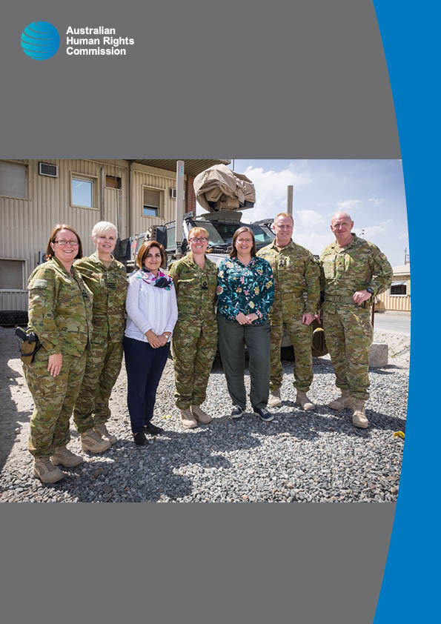

Conversations on
deployment
JUNE 2017

© Australian Human Rights Commission 2017.
The Australian Human Rights Commission encourages the dissemination and exchange of information presented in this publication and endorses the use of the Australian Governments Open Access and Licensing Framework (AusGOAL).

All material presented in this publication is licensed under the Creative Commons Attribution 4.0 International Licence, with the exception of:
- photographs and images
- the Commission’s logo, any branding or trademarks
- where otherwise indicated.
To view a copy of this licence, visit http://creativecommons.org/licenses/by/4.0/legalcode.
In essence, you are free to copy, communicate and adapt the publication, as long as you attribute the Australian Human Rights Commission and abide by the other licence terms.
Please give attribution to:
© Australian Human Rights Commission 2017.
Conversations on deployment • June 2017 ISBN 978-1-921449-85-7
Acknowledgments
The Australian Human Rights Commission thanks the organisations and individuals who participated in the consultation process for this report: Anastasia Krivenkova, Annalise Cincotta- Lee, Tiffany Scott, Emilie Priday, and Georgia Flynn.
This publication can be found in electronic format on the Australian Human Rights Commission’s website at http://www.humanrights.gov.au/about/publications/.
For further information about the Australian Human Rights Commission or copyright in this publication, please contact:
Australian Human Rights Commission GPO Box 5218
SYDNEY NSW 2001
Telephone: (02) 9284 9600
Email: communications@humanrights.gov.au
Design and layout Dancingirl Designs
Cover Image Courtesy of the Department of Defence

Reflections from Kate | 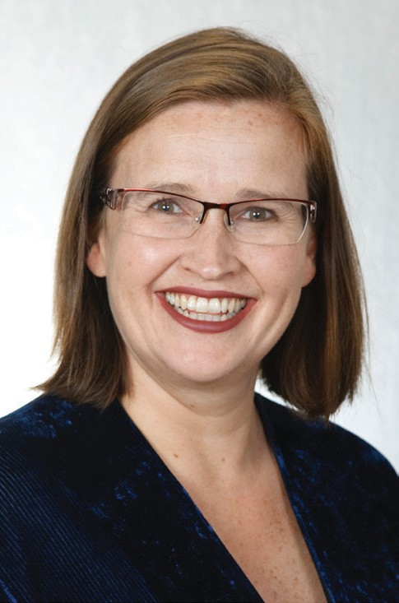
..........................................................
Kate Jenkins
...........................................................
Sex Discrimination Commissioner Australian Human Rights Commission

In early May 2017, I had the extraordinary privilege of visiting the Middle East region with the Australian Defence Forces (ADF). The Chief of the Defence Force, Air Chief Marshal Mark Binskin AC, extended an invitation so that I could learn more about the lived experience of deployment for ADF members and understand the contributions that the ADF is making in the region.
It is a rare opportunity for a civilian to experience such amazing access and insight into the deployed context. I met with a large number of ADF personnel in main operating and logistics bases in the region as well as Kabul, Afghanistan. From formal meetings, to conversations over a meal in the mess, to adrenalin raising training exercises, I now have a vivid picture of the rewards and challenges of deployment.
During my conversations and experiences, I was impressed by the professionalism of ADF personnel and the complexity of their work on deployment. I saw examples of diverse, capable teams committed to their mission.
I also saw evidence of the positive contribution that ADF is making to vital security and strategic outcomes in the region, particularly in Afghanistan. So many of the basic rights that we take for granted in Australia are hard won here in Afghanistan and the ADF have been part of this important fight. As Sex Discrimination Commissioner, I thank the ADF for their contribution to the lives of girls, women and their communities in the Middle East region to realise their human rights.
Life on deployment is not without its risks and challenges. I want to recognise and pay credit to the people who chose to serve their country through service with the ADF, leaving their loved ones often for many months on end.
During my conversations, I reflected on my own family members who have fought in wars. My 92-year-old father-in-law served in the United States Marines in World
War Two. When people see his “USS Yorktown” cap he is often stopped and thanked for his service. In Australia, I rarely hear of this gratitude for the service of our ADF members. Now more than ever, I appreciate the contribution of our current and past service ADF personnel and their family and friends who support them.

I extend my sincere thanks to the many people who made my visit possible, including Air Chief Marshal Mark Binskin, Vice Admiral David Johnston, Major General John Frewen, Brigadier Mick Prictor, Lieutenant Commander Donna Sill, Colonel Bronwyn Wheeler, Commodore Allison Norris, Wing Commander Llani Kennealy, Wing Commander Mike Barnsley, Major Greg Cranswick, Ms Andrea Samson, Ambassador Arthur Spyrou, Colonel Gerald Berson, Ambassador Richard Feakes, Colonel Grant Mason.
Most importantly, I wish to thank all the deployed personnel who welcomed me so warmly, showed me their workplace and home on deployment, and so candidly shared their experiences with me.
The experiences and information that I gathered will strengthen my work to help the ADF embed cultural reform across their organisation. I will also share these insights with other organisations striving to improve performance through diversity.

Kate Jenkins
Sex Discrimination Commissioner 1 June 2017

ADF collaboration with the Australian Human Rights Commission

The Australian Human Rights Commission (the Commission) has been working with the ADF since 2011 when the Minister for Defence asked then Sex Discrimination Commissioner Elizabeth Broderick to lead a review into the treatment of women at the Australian Defence Force Academy and across the ADF.
The Review made 21 recommendations calling for sweeping reforms to the recruitment and retention of women in the armed forces, their opportunities to rise to leadership positions, the prevention of sexual harassment, sexual abuse and improved responses to victims of abuse. The Chief of the Defence Force (CDF) and the three Service Chiefs accepted all 21 recommendations. The ADF has made significant progress towards cultural reform and participation of women.
Since July 2014, the Commission has been working collaboratively to assist the ADF embed cultural reform across the three services: Navy, Army and Air Force. Specifically, the Commission is engaged to examine issues around gender, race and diversity, sexual orientation and gender identity and the impact of alcohol and social media on the cultural reform process.
Since the collaboration started, the Commission has consulted with more than 2000 ADF members to develop strategies to enhance cultural reform and diversity. The projects have looked at nominated bases and units to observe the culture, as well as extended research projects. For example, we have looked at the culture in Army combat brigades; how to support women to become fast jet pilots in the Air Force; and how to increase diversity among marine technicians in the Navy.
The Commission also works collaboratively with the ADF in other ways. Chief of Army Lieutenant General Angus Campbell, DSC, AM and his predecessor Lieutenant General David Morrison AO are members of the Male Champions of Change initiative, and Sex Discrimination Commissioner Kate Jenkins is an independent member of the Chief of Defence Gender Equality Advisory Board.

ADF in the Middle East

There are more than 1700 Australian Defence Force personnel deployed on Operations ACCORDION, OKRA, HIGHROAD and MANITOU in the Middle East region, working to ensure the security and stability of the region.
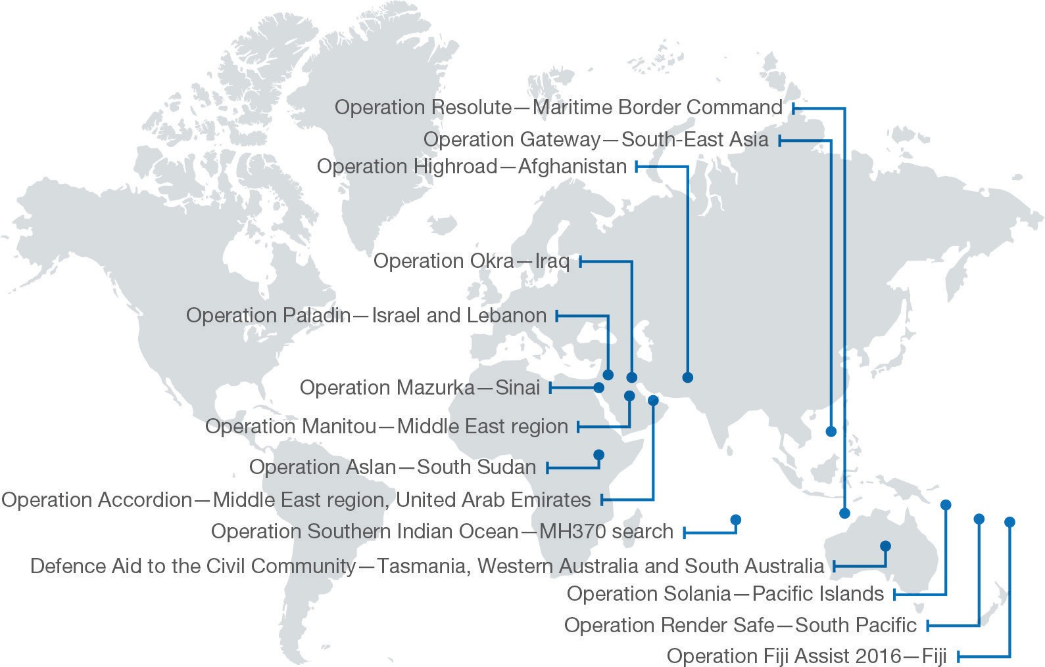

Source: Defence Force Annual Report 2015-16: http://www.defence.gov.au/AnnualReports/15-16/

Operation ACCORDION
Operation ACCORDION’s mission is to support the sustainment of ADF operations, enable contingency planning and enhance regional relationships in the Middle East region.
From Australia’s main logistics base in the Middle East region, around 400 ADF personnel provide support to Australian operations throughout the region, including Operations OKRA, HIGHROAD and MANITOU.

Operation OKRA
Operation OKRA is the ADF’s contribution to the international effort to combat the Daesh (also known as ISIL) terrorist threat in Iraq and
Syria. Australia’s contribution is being closely coordinated with the Iraqi government, Gulf nations and a broad coalition of international partners.
Around 780 ADF personnel have deployed to the Middle East in support of Operation OKRA.

Operation HIGHROAD
The ADF’s commitment to Afghanistan is known as Operation HIGHROAD and is fulfilled by personnel serving with the ADF’s Task Group in Afghanistan.
Task Group Afghanistan’s Headquarters is at Kabul’s Hamid Karzai International Airport and comprises a command element of about 45 ADF personnel, which coordinates administration, communications and logistics support for all ADF members deployed to Afghanistan.
Around 270 ADF members from the Royal Australian Navy, the Australian Army, the Royal Australian Air Force and Defence civilians are deployed in Afghanistan as part of Operation HIGHROAD.

Operation MANITOU
Operation MANITOU is the current name for the Australian Government’s contribution to support international efforts to promote maritime security, stability and prosperity in the Middle East region. An enhanced security environment ensures Australia’s safe and open access to the region while fostering trade and commerce.

Highlights of the Sex Discrimination Commissioner’s visit to the Middle East region

Kate Jenkins, Sex Discrimination Commissioner and Emilie Priday, AHRC Director of the AHRC/ADF Collaboration, visited the Middle East region with the ADF from 2-8 May 2017. Commodore Allison Norris, Director General Australian Defence Simulation and Training at Headquarters Joint Operations Command, and Wing Commander Llani Kennealy, Gender Adviser to the Chief of Air Force accompanied them.

We visited Australia’s main operating and logistics bases in the region, as well as Task Group Afghanistan elements in Kabul, to get a better understanding of how the ADF operates and what they are achieving in the Middle East region.
The ADF facilitated a range of high impact meetings, workshops, site tours and briefings. Just as valuable were the many informal one-on-one conversations with personnel about their own experiences in the ADF and on deployment.
Our experience in the Middle East went beyond talking and listening. The ADF provided an inside look at the Bushmaster Protected Mobility Vehicle, a F/A 18 Classic Hornet and a E-7A Wedgetail. We flew in a C-130J Hercules transport aircraft and a CH-47 Chinook helicopter. We even experienced a mock Improvised Explosive Device (IED) strike in the back of a Protected Mobility Vehicle Bushmaster and conducted battlefield first aid training.
Visiting operations in Afghanistan further enriched our understanding. We met a number of the Australian mentors and advisors working with various parts of the Afghan Security Forces and were inspired by the young Afghan women training at the Afghan National Army Officer Academy. We had the opportunity to learn deeply about the work of the ADF Senior Gender Advisor, Colonel Bronwyn Wheeler, and her inspiring and dedicated team.
Australian Ambassador to Afghanistan Richard Feakes and representatives from the Australian Embassy in Kabul, shared their work implementing Australia’s aid investment projects in Afghanistan, which are directed towards specific projects for women, projects in agriculture and humanitarian projects.
We were honoured to visit the Presidential Palace in Kabul, to meet with Her Excellency the First Lady of Afghanistan, Mrs Rula Ghani, who is an incredible advocate for gender equality in Afghanistan.

Motivated by the mission

Throughout the visit we had the opportunity to see many examples of cohesive, highly motivated teams, led by engaging and supportive leaders.
Over and again, we heard that deployment is a career highlight for members of the ADF because it gives individuals an opportunity to put their training into practice.
Many had waited years for the opportunity, while others had only recently finished their initial training. Everyone we spoke to understood how their role contributed to the mission and derived purpose and pride from a common goal.
Deployment is challenging and we ask a great deal of our serving members. Just from a brief experiential training exercise, I have a great respect for the physical and mental resilience necessary for combat situations.
Being away from family, friends and home routines also requires resilience.
I was moved by the stories of parents who are deeply missing their children and partners. I also empathised with others without children, for whom being away from partners, family and friends was also the biggest challenge of deployment. Their sense of service for their country, as well as strong support from home and ease of communication to home gave them strength to contribute at their best.
For mothers, deployment came with added guilt and the burden of gendered social expectations that they should remain at home with their children rather than deploy. I heard of women who were told that they would be damaging their children by deploying. They told me that concern from friends and family was often about how their partner would cope, rather than for their safety and wellbeing on deployment and that much of their pre-deployment preparation involved making care and domestic arrangements to cover their absence.
Despite these challenges, the women we spoke to wanted to challenge themselves and contribute.
I wanted to challenge myself. I wanted to show what women can do. My work with Army is my focus but there is stereotyping as a woman about what I should prioritise.

The support and care for individuals heartened me. We observed caring leaders but also great support from peers.

Diversity in action

The ADF’s cultural reform journey is driven by a capability imperative. We know that diversity is a force multiplier that increases the capability of the ADF. The ADF has made progress in strengthening capability through diversity. This was evident during our visit to the Middle East region.
We saw excellent practical examples of how a diverse ADF meets mission requirements and improves operations. Walking around the bases I noticed evidence of the diversity among deployed members. I met with numerous women and met with individuals from a broad range of cultural backgrounds. Despite women representing less than 10% of the deployed community,1 all of the members we spoke to felt valued and part of the team.
At the operating and logistical bases in the United Arab Emirates, many members remarked to me that working with members from different services was a positive experience. Many had never worked in a joint environment but felt enriched by different perspectives and service cultures. On forward operations, ADF personnel also valued working with service personnel from Allied countries.
Diversity not only builds high functioning teams but adds unique specialist capability. Female mentors and advisors in Afghanistan are making a critical contribution to strengthening the capacity of the Afghan Defence and Security Forces. Female mentors and advisors are able to work directly with their female mentees, in a way that would be inappropriate for male officers. Female mentees and advisors also serve as agents for change by showing the Afghan Defence and Security Forces the positive contribution that female officers can make and the respect they command.
Positive experiences of diversity create ripples beyond the deployed environment. One female mentor shared with us that although she had been somewhat ambivalent about the ADF’s drive for gender diversity, she now sees the positive impact that diversity brings and will go back home with a changed perspective.

1 Australian Defence Force, Women in the ADF Report (2015-16), Supplement to Defence Annual Report 2015-16, p. 107.

We also witnessed workshop conversations where challenging, but respectful discussions about diversity on deployment saw individuals shift their thinking on diversity and cultural reform. One workshop participant observed:
I now see the bigger picture. But others don’t. I’ll share what I’ve learned today but we need to get better at helping the workforce understand. We need to get more people involved in the discussion so they understand better why there is a focus on increased diversity.

Deployed members have a different lived experience of diversity. There are opportunities to share their positive insights broadly.

Contributing to a better future in Afghanistan

Visiting Afghanistan was a rare experience. During my short visit, I heard some of the most heart breaking stories and met some of the most inspiring individuals. I met individuals who face uncertainty and risk every day but maintain their resolve for a better future.
The ADF has been involved in Afghanistan since 2001. It is the longest running military operation in Australia’s history. The ADF’s contribution in Afghanistan has shifted from traditional security operations to capacity building. This involves training, advising and assisting the Afghan National Defence and Security Forces to bolster their capability. A strong Afghan military is critical to the stability and security of Afghanistan, the Middle East region and beyond.
A highlight was meeting the mentors and Afghan female recruits at the Afghan National Army Officer Academy (ANAOA). The female Afghan recruits were enthusiastic, bright and brave. Joining the Afghan Army is not like joining the Australian Army for these women. Some told us that they must keep their employment in the Army a secret as it could bring serious danger to themselves and their families. They are well supported by Australian and British mentors who train the ANAOA instructors.

NATO Resolute Support Mission – Gender Office

Australia actively supports United Nations Security Council Resolution 1325 on women, peace and security.

UNSC Resolution 1325 stresses the importance of women’s equal and full participation as active agents in the prevention and resolution of conflicts, peace-building and peacekeeping. It calls on member states to ensure women’s equal participation and full involvement in all efforts for the maintenance and promotion of peace and security, and urges all actors to increase the participation of women and incorporate gender perspective in all areas of peace building.

Colonel Bronwyn Wheeler is the Senior Advisor to NATO Resolute Support. Her role is to advise and assist Afghan security institutions to integrate UNSCR 1325 and a gender perspective in order promote women’s active and meaningful participation and integration within the Afghan security institutions.
Colonel Wheeler’s team connect with the Ministry of the Interior, Ministry of Defence, Afghan National Police, Afghan National Army, local women’s services, the Afghan Human Rights Commission, Minister for Women’s Affairs, the First Lady of Afghanistan, international ambassadors and Afghan women to advance change and improve the position of women in Afghanistan.
Some of their work includes:
- Supporting the Family Resource Units run by the Afghan Police to provide safe and appropriate responses to violence against women and children
- Working with the Afghan Department of Defence to provide opportunities for Afghan women to work in Defence
- Supporting the Gender Occupational Opportunity Development (GOOD) program, which provides women with literacy, computer, English language and office skills to increase their opportunities for work.
All of these programs contribute to the realisation of human rights for Afghan women and children. I was particularly impressed by the tenacity and determination of Colonel Wheeler and her team.
I love my job. Just seeing the small bits of progress and knowing that I have done something to empower and educate women. The news may never see this but we see it. I tell the women in the Afghan Police Force that I am inspired by their commitment to the job, to their country, for their bravery and commitment to help women. It is remarkable they come to work every day despite the dangers of doing so and without the proper tools to do their jobs.

Her Excellency the First Lady of Afghanistan

It was an honour to meet with Her Excellency the First Lady of Afghanistan, Mrs Rula Ghani, who is an incredible advocate for women and children in Afghanistan. During this meeting we discussed the continuing challenges and some recent causes for optimism on the road to gender equality in Afghanistan. I heard about wide-ranging improvements including better access to education for women, better access to appropriate maternal health care and the newly established Afghan Women’s Chamber of Commerce and Industry.
I learnt about Her Excellency’s approach to her position. While she told me she does not have an agenda, she is passionate about ‘opening doors’ for women so that they are ‘seen’ and part of the solution for Afghanistan. She stressed the importance of individual empowerment for women, starting in the family. But she also observed that as soon as anyone talks about women’s rights, there are questions raised about men’s rights. She aims to include men and works for sustainable solutions for the entire Afghan population. Her measured, wise approach struck a deep chord with me and my own vision for gender equality.

Afghan Independent Human Rights Commission (AIHRC)

Although we did not have the opportunity to meet with Dr Sima Samar, Chairperson of the AIHRC during this visit, I was privileged to meet her recently at the United Nations Conference for the Commission on the Status of Women. It is important
to highlight the extraordinary work undertaken by the Afghan Independent Human Rights Commission and Dr Samar in protecting and promoting the human rights of women and girls in Afghanistan. For example their investigation into honour killings of women established the basis for new criminal laws that made this practice illegal.
Dr Samar has received various international awards on women’s rights, human rights, democracy, and women for peace over the course of her career in advancing the rights of women and girls in Afghanistan. Dr Samar also served as the first Deputy Chair and Minister of Women’s Affairs in the Interim Administration of Afghanistan.
Dr Samar is also the Chair of the Asia Pacific Forum of National Human Rights Institutions, a coalition of 24 national independent human rights initiations. The Asia Pacific Forum is headquartered in Sydney at the Australian Human Rights Commission premises.

Concluding thoughts

The purpose of our visit was to listen and learn about the ADF’s deployed context. While I listened to the impressive individuals who contribute to the ADF’s work in the Middle East region, I also learnt that how they operate has broader significance for my work as Sex Discrimination Commissioner.
I saw first-hand how diversity is increasing the ADF’s capability and building effective teams. I also saw how a gender perspective, through UNSCR 1325 leads to better opportunities and outcomes for women. The integration of a gender perspective to promote the participation of women in the Afghan National Defence and Security Forces is leading to tangible change. There is still a long way to go but the human rights based approach in UNSCR 1325 sets a solid foundation. The stories of
the impact our female mentors and gender advisors are making are some of the examples I will share when I am asked why gender diversity is so important.
I learnt that serving as a military member can be immensely challenging, both mentally and physically. As I experienced during a short training exercise, it isn’t for everybody! But for those that are capable and committed it offers team work, lifelong friendships, unique experiences and knowing that your work contributes to a significant mission.
This experience has shown me the ADF at its best – an organisation with inclusive leaders, cohesive teams and capable individuals, all working for a common purpose. Reflecting on these strengths will contribute to the Commission’s work with the ADF on cultural reform to make the ADF an even better organisation.

