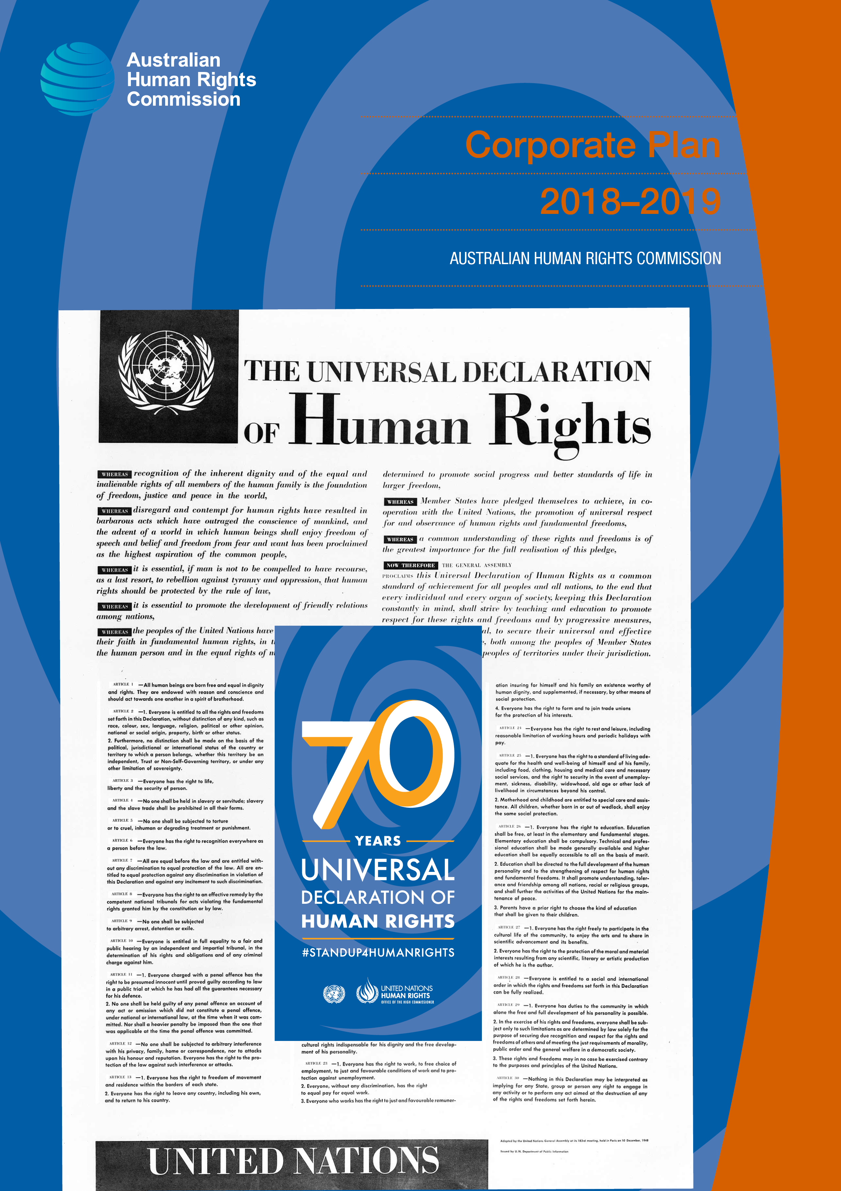

The Australian Human Rights Commission encourages the dissemination and exchange of information provided in this publication.
All material presented in this publication is provided under a Creative Commons Attribution 3.0 Australia, with the exception of:
- the Australian Human Rights Commission logo,
- photographs and images, and
- any content or material provided by third parties.
The details of the relevant licence conditions are available on the Creative Commons website, as is the full legal code for the CC BY 3.0 AU licence.
Attribution
Material obtained from this publication is to be attributed to the Australian Human Rights Commission with the following copyright notice:
Corporate Plan 2018–2019
ISSN 2206-8368 (Online)
Third party copyright
Wherever a third party holds copyright in material presented in this publication, the copyright remains with that party. Their permission may be required to use the material.
The Commission has made all reasonable efforts to:
clearly label material where the copyright is owned by a third party. Please note this does not include photos, images and video which are all regarded as third party material, and ensure that the copyright owner has consented to this material being presented on this website.
Graphic design Dancingirl Designs
Cover photo 1–The Universal Declaration of Human Rights 10 December 1948, United Nations Department of Public Information, Wikipedia Commons, Public Domain, 2–70 Years Universal Declaration of Human Rights logo, http://www.standup4humanrights.org/en/index.html.

Corporate Plan 2018–2019
Contents

1. Preface 4
2. Our purpose 5
2.1 Our leadership team 6
2.2 Performance framework 7
3. Operating context 12
4. Operationalising performance 18
4.1 Planning our work and the Commissioner terms 19
4.2 Key initiatives against performance outcomes 22
5. Evaluating our performance 24
6. Our organisational structure 26
7. 2018–19 Corporate Plan web page 27

1. Preface
The Australian Human Rights Commission is a small independent statutory agency that is part of the Attorney-General’s portfolio.
This Corporate Plan articulates how we implement our purpose and promote an Australian society where human rights are enjoyed by everyone, everywhere, everyday.
It has been prepared in accordance with s 35(1)(b) of the Public Governance, Performance and Accountability Act 2013 (Cth) and s 46AA of the Australian Human Rights Commission Act 1986 (Cth). It sets out the connection between our purpose, operating environment, and organisational impact over the next 4 years to 2021.
It also sets out the key activities that we anticipate will contribute to this impact over the 2018–19 financial year.
Additional materials that further detail our performance and evaluation frameworks and related matters are included on our Corporate Plan webpage at https://www.humanrights.gov.au/corporate-plan-2018-2019.

2. Our purpose
As Australia’s national human rights institution, our purpose is to fulfil our statutory functions so that Australians have access to effective, independent complaint handling and public inquiry processes on human rights and discrimination matters, and benefit from our human rights education, advocacy, monitoring and compliance activities.

The Australian Human Rights Commission was established in 1986 by the federal Parliament as an independent statutory organisation charged with protecting and promoting the human rights of all people in Australia.
The Commission is accredited as an ‘A status’ national human rights institution (NHRI). This accreditation is regularly reviewed through United Nations sanctioned processes by the Global Alliance of NHRIs. To be given ‘A status’, NHRIs must be established and operate in compliance with the United Nations Principles Relating to the Status of National Institutions for the Promotion and Protection of Human Rights—commonly known as the ‘Paris Principles’. The principles require us to operate in a robust, independent manner in order to provide accountability for human rights in Australia.
We have statutory obligations under the Australian Human Rights Commission Act 1986 (Cth) as well as the Age Discrimination Act 2004 (Cth), Disability Discrimination Act 1992 (Cth), Race Discrimination Act 1975 (Cth) and Sex Discrimination Act 1984 (Cth). The Commission also has specific responsibilities under the Fair Work Act 2009 (Cth) and Native Title Act 1993 (Cth).
Our vision is an Australian society where respect for human rights and freedoms is the cornerstone of a cohesive and peaceful society in which everyone can contribute and feel safe and included.

2.1 Our leadership team
The work of the Commission is led by a President and seven Commissioners.
Emeritus Professor Rosalind Croucher AM—President, August 2017
June Oscar AO—Aboriginal and Torres Strait Islander Social Justice Commissioner
The Hon Dr Kay Patterson AO—Age Discrimination Commissioner
Megan Mitchell—National Children’s Commissioner
Alastair McEwin—Disability Discrimination Commissioner
Edward Santow—Human Rights Commissioner
Dr Tim Soutphommasane—Race Discrimination Commissioner (term finishes 19 August 2018)
Kate Jenkins—Sex Discrimination Commissioner
Padma Raman—Chief Executive

2.2 Performance framework
This Corporate Plan sets out how the Commission meets its legislative mandate and the outcomes in our Portfolio Budget Statement. Figure 1 shows the line of sight between our purpose, programs and the day-to-day work of our staff.

Figure 1: Integrating our purpose into our day to day work
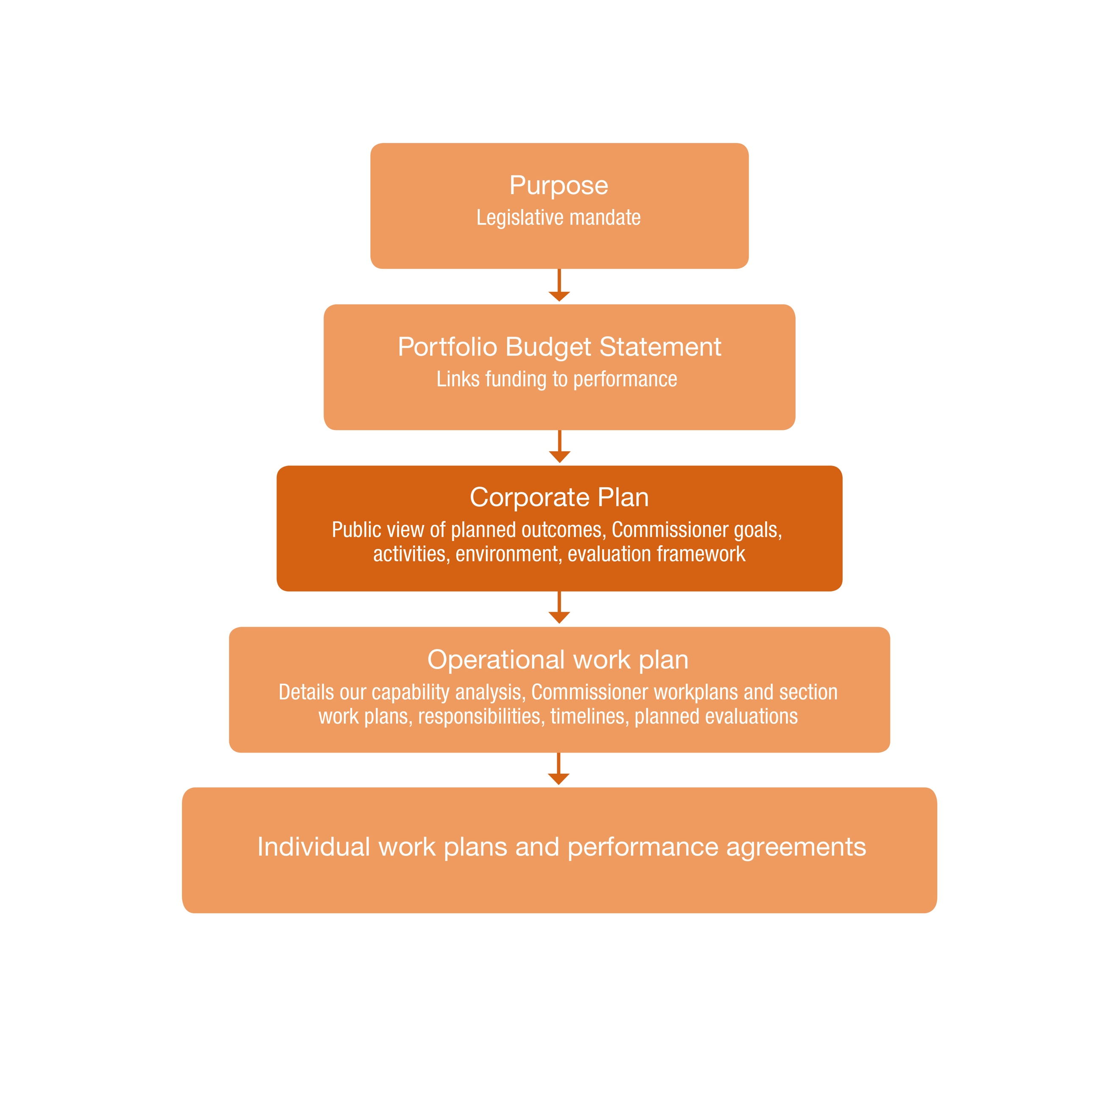

Figure 2 below, sets out our four performance outcomes and the indicators used to measure performance against these. The four outcomes correspond to the Performance Criteria in the Commission’s Portfolio Budget Statement (PBS). The indicators with an asterisk, correspond to the targets in our PBS. Under the Public Governance, Perfomance and Accountability Act 2013 (Cth), we report on our performance in our Annual Report.

Figure 2: Our performance outcomes and indicators framework
Our vision | Human rights—everyone, everywhere, everyday
Our purpose | As Australia’s national human rights institution our purpose is to fulfil our statutory functions so that Australians have access to effective, independent complaint handling and public inquiry processes on human rights and discrimination matters, and benefit from our human rights education, advocacy, monitoring and compliance activities.
Our functions | The Commission exercises functions under the Australian Human Rights Commission Act 1986 (Cth), federal discrimination laws (Age Discrimination Act 2004 (Cth), Disability Discrimination Act 1992 (Cth), Race Discrimination Act 1975 (Cth) and Sex Discrimination Act 1984 (Cth)) and the Fair Work Act 2009 (Cth) and achieves its purpose by:  - Promoting understanding, acceptance and public discussion of human rights in Australia (including through our specialist commissioners).  - Promoting compliance with human rights and federal discrimination law (including through the preparation of guidelines; developing and monitoring disability standards; and considering applications for exemptions under relevant discrimination laws).  - Undertaking research, educational and other programs for promoting human rights, including by reporting to Parliament on the status of enjoyment of human rights by children and Aboriginal and Torres Strait Islander peoples.  - Conducting inquiries into acts or practices that may be contrary to human rights; reporting on laws that Parliament should make, or actions that the Commonwealth should take, to meet Australia’s international human rights obligations; and examining laws and proposed laws for consistency with human rights.  - Inquiring into, and attempting to conciliate, complaints of unlawful discrimination, or breaches of human rights or discrimination in employment.
Our environment and capability | We operate in a complex social and political environment and multiple factors can affect how, and how well, we achieve our purpose. Our planning framework identifies key risks, challenges, and opportunities and aims to build our capability to address these.
Our performance | Outcomes
 | 1 Effective promotion of key human rights issues and engagement with governments, parliament, the courts, business and civil society builds increased awareness and understanding of actions required to comply with Australia’s human rights obligations. | 2 Effective and timely information assists government, business and the community to comply with discrimination and human rights law.  The efficient investigation and conciliation of complaints resolves disputes in a timely manner, impartially, and ensures access to justice. | 3 Expert and persuasive research, analysis, advocacy and reporting contribute to preventing human rights breaches and proactively improving compliance with international human rights obligations of laws, proposed laws and the acts or practices of the Commonwealth. | 4 Human rights education activities increase understanding and build capacity in individuals and organisations about human rights and freedoms.

Our performance | Indicators
 | 1a Leadership, promotion and advocacy that facilitates positive discourse, increases awareness of human rights issues and contributes to positive action by stakeholders and decision makers.  1b* Effective reach among identified audiences, through the provision of relevant and useful information about human rights with increased reach demonstrated by web and social media analytics that exceed the previous year’s benchmark by 5%.  1c* High rate of acceptance of applications to the courts for leave to appear demonstrates acknowledged expertise on human rights; and citation analysis of court judgements demonstrates that our submissions to the courts have contributed to human rights impacts being considered.  1d Increased capability among organisations and employers to be diverse, inclusive and respectful workplaces.  1e As a national human rights institution our engagement with United Nations processes contributes to the full implementation of human rights commitments by the government and Parliament. | 2a* Efficient and effective information and dispute resolution services meet performance indicators relating to timeliness, effectiveness and service user satisfaction. Including:  - 85% of complaints are finalised in under 12 months.  - 40% of complaints are resolved by conciliation.  - 85% of parties to complaints are satisfied with the service they receive.  2b* The terms on which disputes are resolved include systemic outcomes that accord with the objectives of the law.  2c Legal information, resources, guidelines and an effective exemption process help employers and organisations to comply with Australian discrimination and human rights law. | 3a* Parliamentary debates and committee inquiry reports cite and/or reference the work of the Commission, demonstrating that our analysis, submissions and recommendations have contributed to human rights issues being considered.  3b* Major reports and national inquiries are viewed as robust; lead to increased understanding of relevant human rights issues and impact; and increased motivation to take action to address human rights violations.  3c Stakeholders use our research, reports and other resources, increasing their capacity to advocate and strategically promote human rights issues. | 4a* Education and training programs demonstrate that:  New resources are engaging, of a satisfactory quality and relevant to target audiences.  Learning objectives have been met for the majority of participants.  The majority of participants are satisfied with the quality and relevance of the training.  4b Increased knowledge, attitudes and skills, within the school community and adult training participants, to apply human rights in school, in work and in everyday life.  4c* Participation in the investigation and conciliation process results in increased understanding of rights and responsibilities in the law.  4d International technical cooperation activities increase human rights capacity and advance national reform in partner states.
 | Commissioner term goals
 | Operational workplan — how we deliver these

3. Operating context
The Commission operates in a complex social and political environment with multiple factors that can affect how and how well we achieve our purpose. Each year we examine our operating context to assess the risks, challenges, opportunities and capability factors that may have an impact on our work.
Our risk management process complies with the Public Governance, Performance and Accountability Rule 2014 requirements for Commonwealth entities. Each year a process to review and oversee these risks is undertaken with our internal auditors and integrated into our planning processes. The framework covers three areas:
- Strategic risks: including reputation and public image, managing external relationships.
- Core business risks: including complaints management, community engagement, media and public awareness, organisational alignment.
- Administration and corporate service risk assessment: including financial management, asset management, fraud and corruption prevention, business continuity, regulatory compliance, procurement and contract management, human resources, information and communications technology management, Workplace Health and Safety management, project management and records management.
Figure 3 below summarises the challenges and opportunities that the Commission anticipates we will face this coming financial year as well as over the next four years. We note that we have varying degrees of control over these matters.
We also detail our internal capability relating to Workforce, Information and Communications Technology and Partnerships.
Further information about these challenges and opportunities, our level of control over them and our management strategy is set out in the appendices to this Corporate Plan on our website.

Figure 3: Key challenges and opportunities, 2018–19
EXTERNAL

Opportunities  - Release of significant reports that will inform human rights outcomes: Royal Commission on Institutional Abuse; ALRC elder abuse; ALRC indigenous incarceration; Religious freedoms panel.  - National and international focus on high profile violence/harassment issues provides momentum to utilise Commission’s functions to achieve positive change (e.g. sexual harassment, elder abuse, OPCAT, institutional abuse of children, people with a disability).  - Stronger focus on international engagement: Australia’s place on UN Human Rights Council and multiple treaty body appearances ahead and the global focus on Sustainable Development Goals are a timely agent for change.  - Promoting our distinct role as Australia's National Human Rights Institution provides a valuable perspective for our unique expertise to influence change. |  | Challenges and risk management  - Effective implementation of reforms to the Commission’s functions: public scrutiny and judicial clarity is likely to come in the next few years as new provisions for handling complaints are utilised and tested.  - Ongoing risk to reputation from high profile issues: continual scrutiny of the Commission is likely to continue.  - Constrained public service funding environment likely to continue limiting core funding and having an impact on our work program.  - Machinery of Government changes: including a federal election by May 2019 and potential shifts in whole-of-government policies on shared services.

INTERNAL

Opportunities, challenges and risks  - Building partnerships and financial support for our work: an increasing reliance on external funding to complete our program needs requires improved agility, strategic coordination and recognition that not all Commission functions or work areas can attract funding.  - ‘Living within our means’: ongoing need for realistic work planning.  - Ensuring national coverage of our work: addressing a Sydney/East Coast bias, and need for a rural and regional engagement lens.  - Building on the goodwill generated more recently to consolidate effective working relationships with Parliament and government. |  | Systems, Workforce, and Information and Communications Technology capability factors  - Greater mobility of staff, with higher staff turnover expected to continue within a climate in which there is a higher reliance on project specific funding.  - Meeting digital continuity 20/20 policy through upgrade of key IT and support systems.  - Upgrading of key internal finance and human resources technology, as well as key communication tools such as website and intranet.

Workforce Capability
As a micro-agency within the Commonwealth public service, we are subject to the same external factors as larger agencies. This includes Australian Public Service (APS) workforce directives and continuing reduced appropriations. In this coming year we expect to see a need to address:  - Continuing trends of workforce career ambitions, particularly among junior staff, that are challenging to foster within a small agency environment.  - Continuing requirements to resource externally funded projects with short lead times and parameters. | We will manage these along with other workforce demand and supply trends via:  - A continued commitment to building the capability of current and less experienced staff through professional development opportunities.  - Use of staffing feeder mechanisms such as talent pools, temporary project staff registers and short term contracts to maintain an agile and skilled workforce.  - Increasing in-house skills and reducing outsourcing by building in-house capacity around critical and emerging needs such as data analysis and design/graphics skills.

Information and Communications Technology Capability
Information and communications technology (ICT) has a crucial role in supporting the organisation’s communication and sharing of information both internally and externally.  Our ICT manages a complex network with a diverse range of supported platforms. To ensure the continuity and availability of ICT services, and a reliable and resilient network service requires increasing investment, which is challenging in our current fiscal environment. | Our ICT Strategic Plan for the coming four years focuses on continuity, security and efficiency in addition to exploring innovative ways to harness new communications technologies such as artificial intelligence. For example, this financial year we have commenced a trial with RecordPoint to implement new technology that is cloud-based and artificial intelligence driven for records management.

Partnership Capability
The Commission regularly works in partnership across government, business, the non-government sector and internationally. We are a source of expertise on human rights research, consultation and implementation design. We also have a track record of being trusted as providing a neutral, ‘safe’, meeting place for different sectors to come together to jointly address difficult human rights challenges.
Some of our partnerships involve fee for service arrangements that draw on our expertise and our networks to advance human rights awareness and protections. For example, we work across the federal government on projects like:
- Wiyi Yani U Thangani (Women’s Voices) with the Department of Prime Minister and Cabinet
(PM & C)
- Child Safe Organisations program, with the Department of Social Services
- Cultural reform program with the Australian Defence Force
- National Inquiry into Sexual harassment in the Workplace with the Office for Women (PM & C)
- Human rights technical cooperation programs in Laos and China, and activities in other countries, with the Department of Foreign Affairs and Trade
- We are also working with these Commonwealth entities: Australian Sports Commission, Attorney-General’s Department, Department of Education and Training, National Disability Insurance Agency, and the Digital Transformation Agency.
Other partnerships involve collaborations across different sectors on specific human rights projects of mutual benefit. These increase our capability and reach through shared resources and generating a collective ability to deliver outcomes greater than that of individual organisations acting alone. For example:
- A range of organisations across government, industry, the legal sector and NGOs are working with the Commission on issues relating to the impact of new technology on human rights protections.
- We host the secretariat for the Close the Gap Campaign and National Health Equality Forum, working with over 30 partners to achieve health equality for Aboriginal and Torres Strait Islander peoples within a generation.
- We are working with the Australian Building Codes Board and other stakeholders to support the development of a regulatory impact statement on universal housing design standards that will be of great benefit to people with a disability and older Australians.
We are working with the Australian Sports Commission and multiple sporting codes on guidance for the inclusion of intersex people in sport, as well as with Golf Australia to develop national guidelines for equal opportunity in golf.
- We are working across the business sector, including with the Australian Human Resources Institute on issues affecting employment of older Australians, the Global Compact Network Australia on an annual dialogue on business and human rights, as well as with universities and unions on a number of sexual harassment research projects.
The Commission also receives generous pro-bono support from the legal sector, consultancy firms, the medical and education sectors in our work. For example:
- We have strategic partnerships with a number of law firms for research and other support for the work of our Commissioners.
- Medical professionals provide assistance in our monitoring visits to immigration detention facilities, providing expertise on mental health, child health and related issues.
In this coming year, we will continue to build relationships and undertake partnerships where there is strategic benefit to the organisation. To do this requires agility, coordination and an attuned risk compass. Figure 4 identifies the range of our regular partners and collaborators.

Figure 4: Partner categories
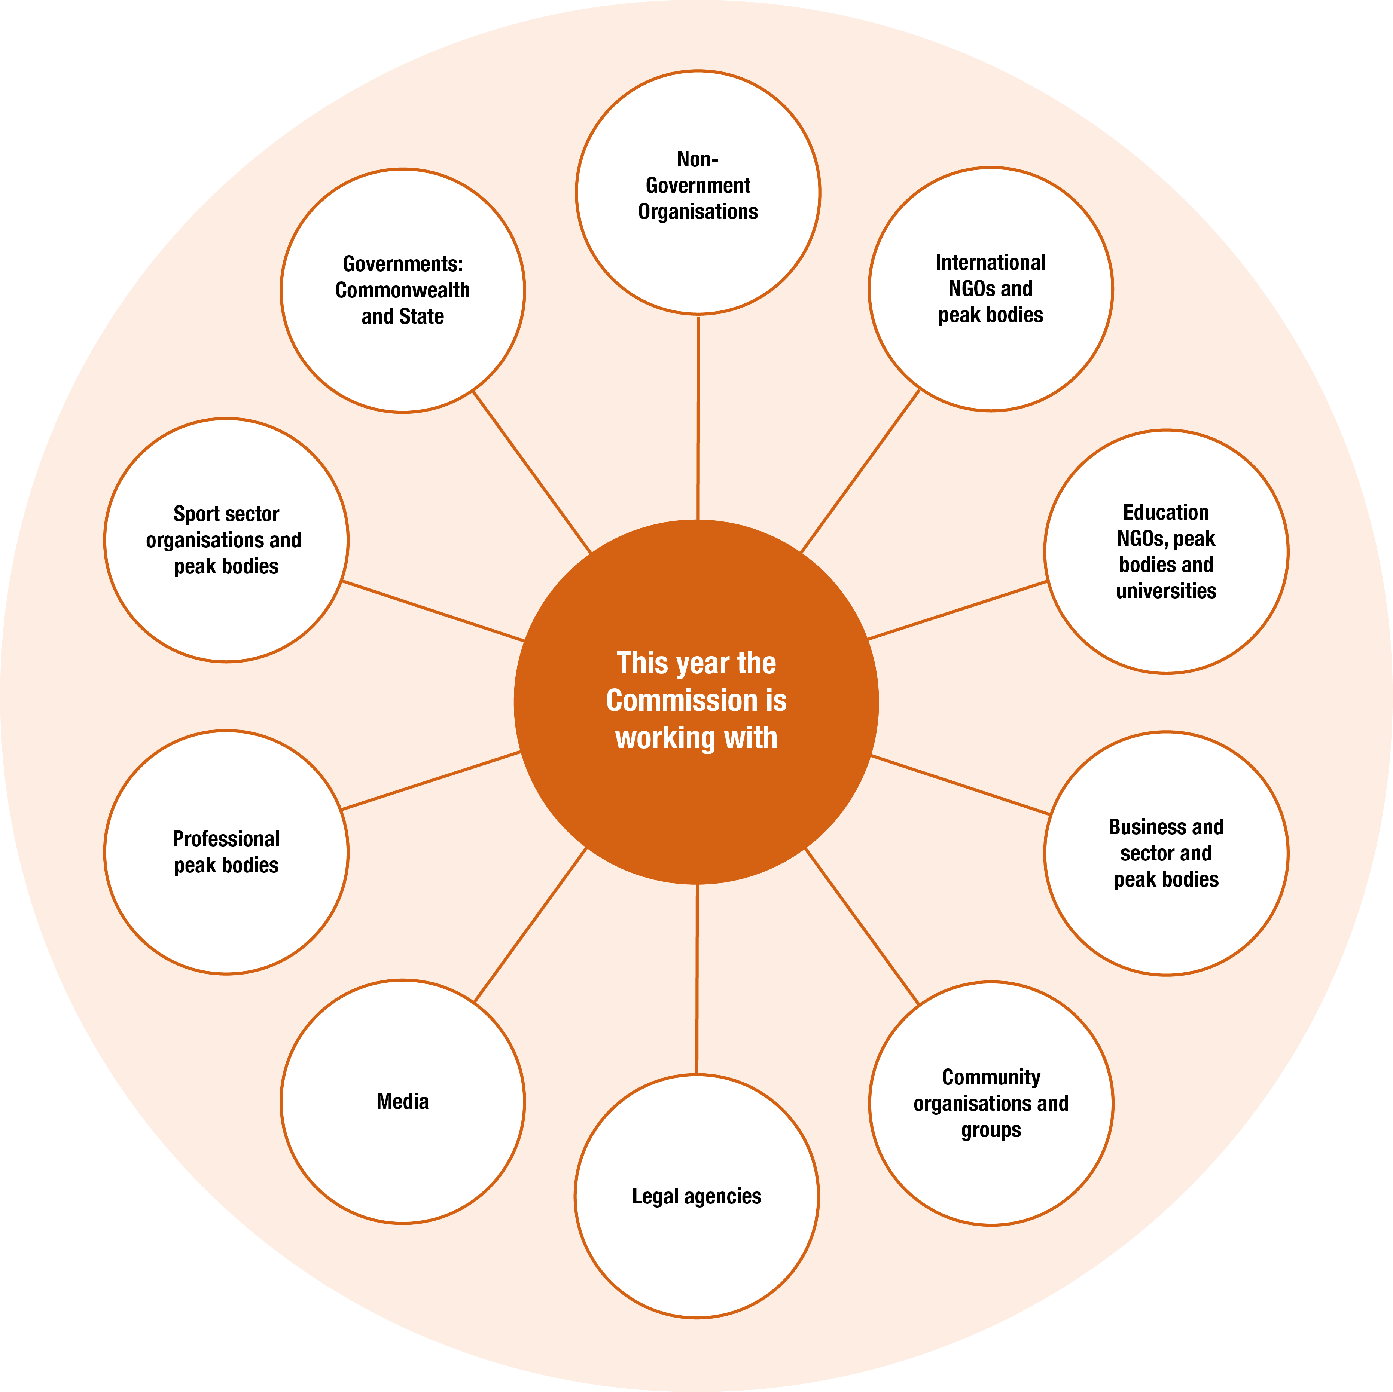

4. Operationalising performance
The Commission’s activities in 2018–19 and beyond advance the four outcome areas in this Corporate Plan.
Under Outcome 1 we focus on our functions to promote the implementation of human rights and freedoms in Australia. We do this using our profile and public presence to reach communities, raise public awareness and contribute to debate about human rights issues.
Our President and Commissioners play a key leadership role in this by promoting a positive discourse, facilitating cooperation and partnerships to implement human rights and in using our independent research as an evidence base to set and advance important human rights agendas.
We also intervene in court cases when it is important to make a human rights argument and appear as amicus curiae—or ‘friend of the court’—to provide specialist experience and advice in discrimination cases.
As a National Human Rights Institution (NHRI), we participate in global exchanges between Commissions through the Global Alliance of National Human Rights Institutions (GANHRI) and we have an important role to play in the United Nations system. We regularly provide independent reports, which describe how Australia is progressing in relation to meeting its human rights obligations.
Under Outcome 2 we provide an avenue for people to voice and resolve disputes about human rights in a manner that is accessible, timely and educative.
Like many NHRIs around the world, we deliver a National Information Service and a complaint Investigation and Conciliation Service. Conciliating complaints allows individuals to resolve their disputes quickly and effectively without recourse to litigation. Moreover, agreed outcomes through conciliation regularly include actions that have a systemic impact.
We also support and promote understanding and compliance with federal discrimination laws through legal information, resources and guides, as well as administration of a temporary exemption service to grant applicants the time to make adjustments in order to comply with discrimination law.
Under Outcome 3 we conduct research and report on the protection of human rights and freedoms. We have a particular responsibility to monitor situations involving groups of people who are especially vulnerable to discrimination, exclusion and unfair treatment.
We regularly consider the human rights impact of existing and proposed legislation and we undertake regular monitoring and reporting work on issues affecting Aboriginal and Torres Strait Islander communities and the status of the enjoyment of rights by children.
Outcome 4 captures our functions to promote human rights through educational activities. Our objective is to build ‘rights-mindedness’ across the community with better understanding and awareness of human rights and how to protect them. Our education programs aim to increase capacity to apply human rights in individuals and organisations. We do this by developing and promoting school resources for today’s teaching environment and delivering training programs (currently targeting the public service and helping government personnel to apply human rights in their day-to-day work).
Our human rights technical cooperation programs assist with human rights issues facing our regional partners. They use education and skill-building approaches with partner organisations and share experience and best practice in the application of rights based models and approaches to help operationalise local human rights related policies, regulations and legislation.

4.1 Planning our work and the Commissioner terms
The Commission’s workplan and outlook differs from many other agencies as the terms of our President and Commissioners do not always align with the standard four year outlook of the Commonwealth Corporate Plan cycle. Statutory appointments are made at differing times and usually for a period of five years. Figure 5 shows the current stage in their terms for our President and each Commissioner.

Figure 5: Commissioner Terms transect the multiyear outlook of the Corporate Plan
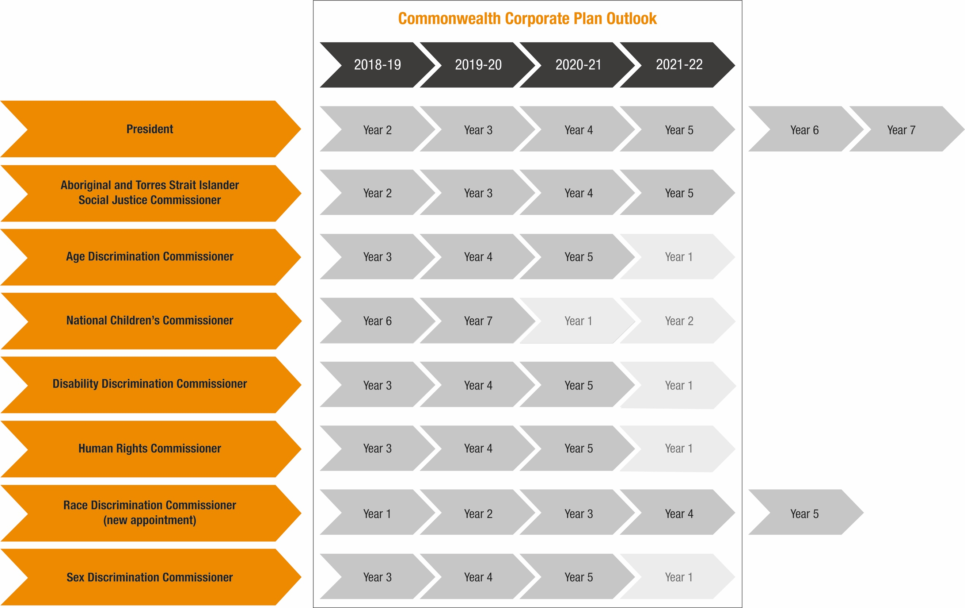

Our President and each Commissioner has a series of goals that they are seeking to achieve over their terms. Our Corporate Plan website provides the individual profiles that summarise the difference each aims to make during their term, their goals, the approaches they use and key initiatives they are leading in this year.
Click on the icons below for President and Commissioner profiles or visit our website at https://www.humanrights.gov.au/corporate-plan-2018-2019.
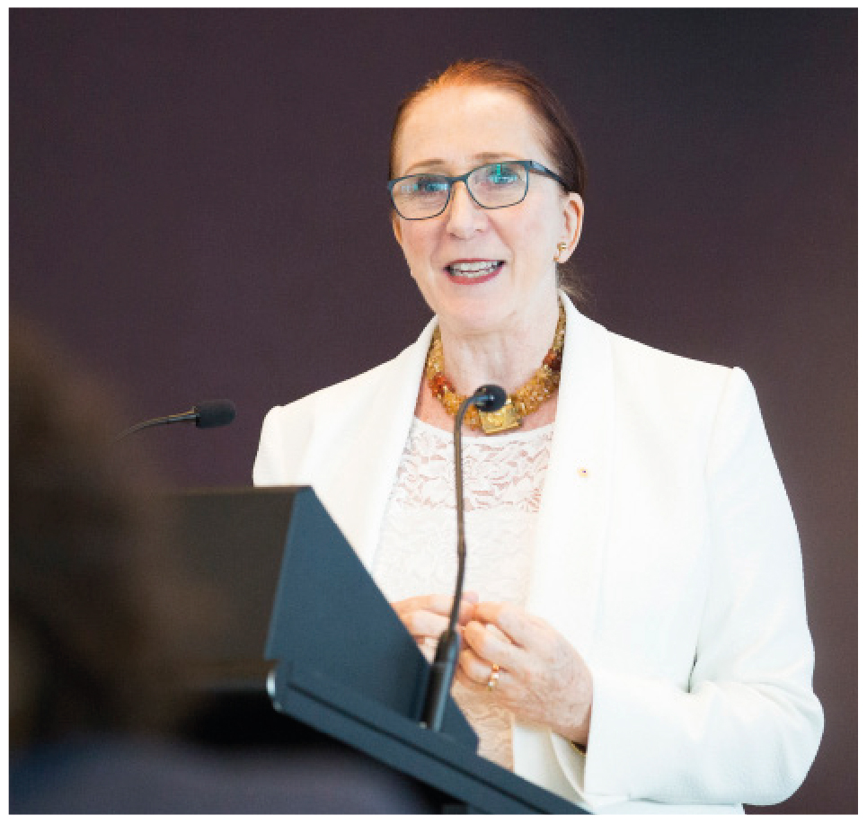  President  Emeritus Professor  Rosalind Croucher AM | 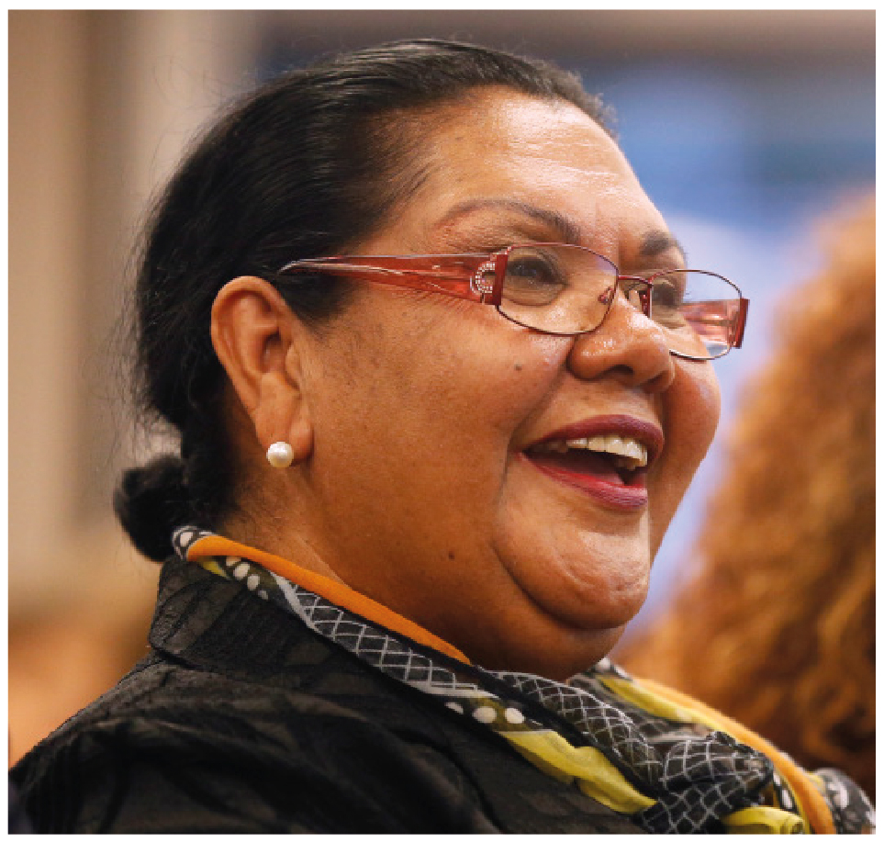  Aboriginal and Torres Strait Islander  Social Justice Commissioner  June Oscar AO | Age Discrimination Commissioner  The Hon Dr Kay Patterson AO
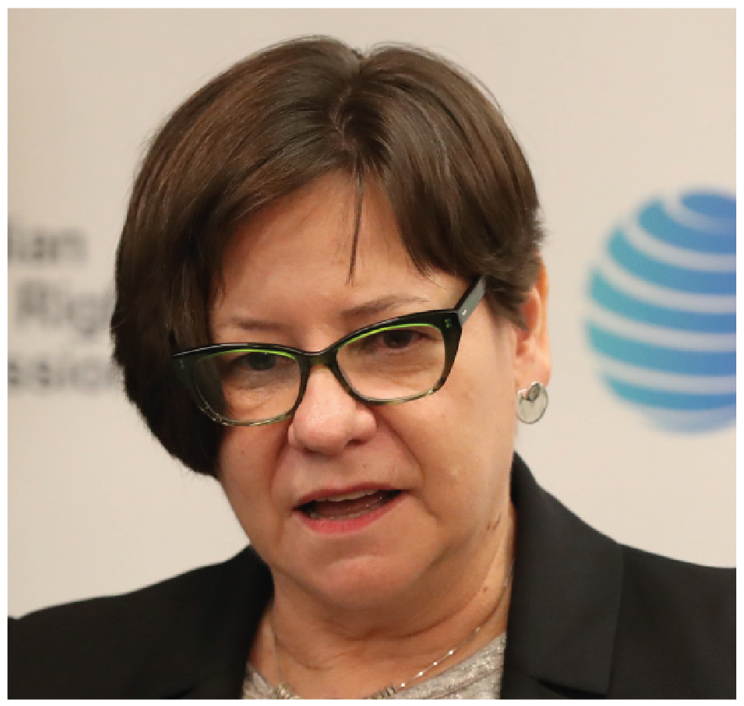  National Children’s Commissioner  Megan Mitchell | Disability Discrimination Commissioner  Alastair McEwin | Human Rights Commissioner  Edward Santow
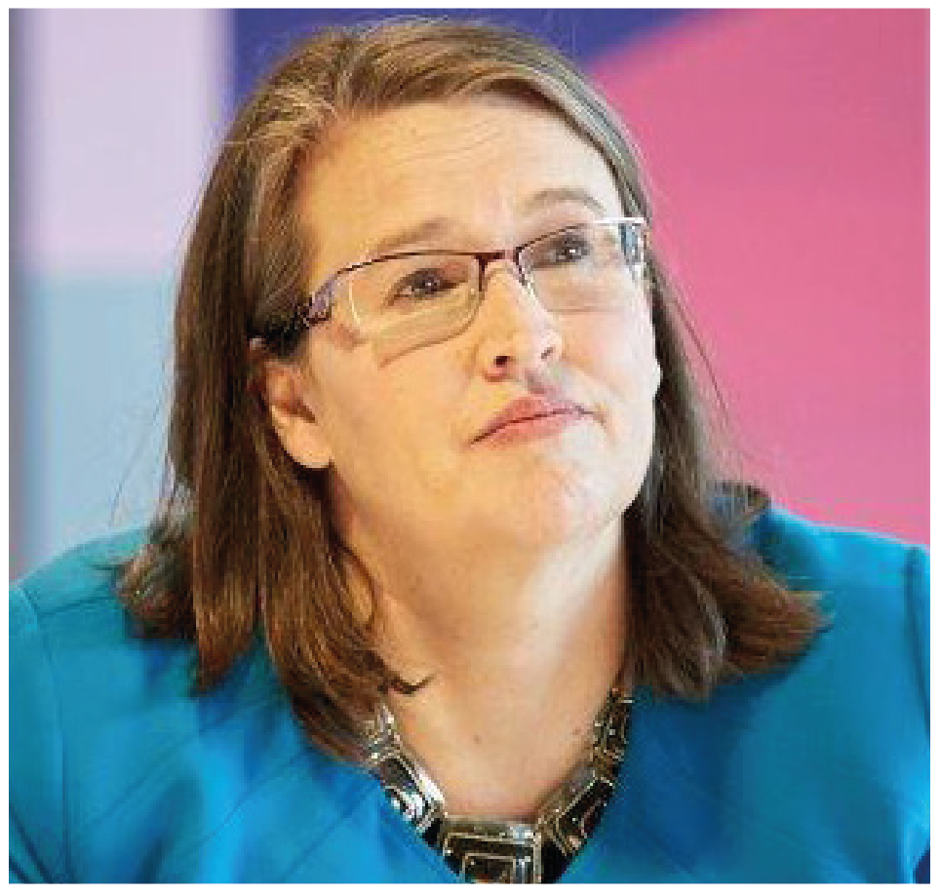
Sex Discrimination Commissioner
Kate Jenkins

4.2 Key initiatives against performance outcomes
The table below maps the Commission’s planned initiatives for the coming financial year, linked to the outcome and indicator that they predominantly contribute to. Many activities occur over multiple years, as reflected in the table.
Outcome, Indicator, and Initiative |  | Multiyear to:
1a | Human Rights and Technology Program | 2020–21
 | Older Women at Risk of Homelessness program | 2020–21
 | National Inquiry Sexual Harassment in the Workplace | 2018–19
 | Nothing about us, without us leadership and advocacy program | 2020–21
 | Wiyi Yani U Thangani (Women’s Voices) Aboriginal and Torres Strait Islander Women and Girls Program | 2019–20
 | Child Safe Organisations Program | 2019–20
1b* | Close the Gap Campaign and National Health Leadership Forum | 2021–22
 | Elder Abuse Awareness Program | 2020–21
 | Your Rights at Retirement resource series | 2018–19
 | National Anti-Racism Partnership Strategy and Racism. It Stops With Me. Campaign | 2021–22
 | Android RightsApp mobile application: guide to international human rights law | 2018–19
 | Annual Human Rights Day Awards/other major events and launches | Ongoing
 | Communication, digital and website services providing access to good information and resources | Ongoing
1c* | Legal interventions and amicus curiae in court proceedings | Ongoing
1d | Older Australians and Employment Program | 2020–21
 | AHRC-ADF Collaboration on Cultural Reform in the Australian Defence Force | 2019–20
 | Disability Employment Project | 2018–19
 | National Annual Dialogue on Business and Human Rights | 2018–19
1e | Report to the United Nations Committee on the Rights of the Child | 2018–19
 | Report to United Nations Committee on the Elimination of Discrimination Against Women and Girls | 2018–19
2a* | National Information Service | Ongoing
 | Investigation and Conciliation Service | Ongoing
2b* | Investigation and Conciliation Service | Ongoing
2c | Guidelines for the application of special measures under the Sex Discrimination Act 1984 to advance substantial equality between men and women. | 2018–19
 | Federal guidelines on the inclusion of trans and intersex people in sport | 2018–19
 | National Guidelines: Equal Opportunity in Golf | 2018–19
 | Management and reporting of complaints under the Australian Human Rights Commission Act 1986 (Cth) | Ongoing
3a* | Human Rights Scrutiny Program (Parliamentary Joint Committee on Human Rights) and submissions to parliamentary inquiries | Ongoing
3b* | 2018 Children’s Report | 2018–19
 | National Disability Insurance Scheme: a human rights charter | 2018–19
 | Implementation of the Change the Course report recommendations by Australian universities | 2018–19
 | Implementation of the Optional Protocol to the Convention against Torture project | 2018-19
 | Intersex Variations/Variations in Sex Characteristics in the Context of Medical Interventions project | 2018–19
3c | Asylum Seeker and Immigration Detention Program | Ongoing
 | Violence against people with disability in institutional settings report | 2018–19
 | Accessible housing project | 2019
4a* | The Story of our rights and freedoms resource | 2018–19
4b | Children’s Rights Digital Resource | Ongoing
 | Public Sector Training Program and training components within other programs | Ongoing
4c* | Investigation and Conciliation Service | Ongoing
4d | China-Australia Human Rights Technical Cooperation Program | 2020–21
 | Laos People's Democratic Republic-Australia Human Rights Technical Cooperation Program | 2020–21
 | Vietnam Human Rights Education Program | 2020–21

5. Evaluating our performance
We deliver our work program within a monitoring, evaluation, and learning framework, to assess how we are contributing to our outcomes and how we can improve this contribution.
Measuring the impact of our work is a complex task, as our efforts are often collaborative and linked to longer-term goals and incremental change, which cannot be attributed solely to our work. Our framework uses a program logic approach shown in Figure 6. This approach helps us to identify plausible outcomes and to design evaluations to measure results and capture our influence.

Figure 6: Program logic approach
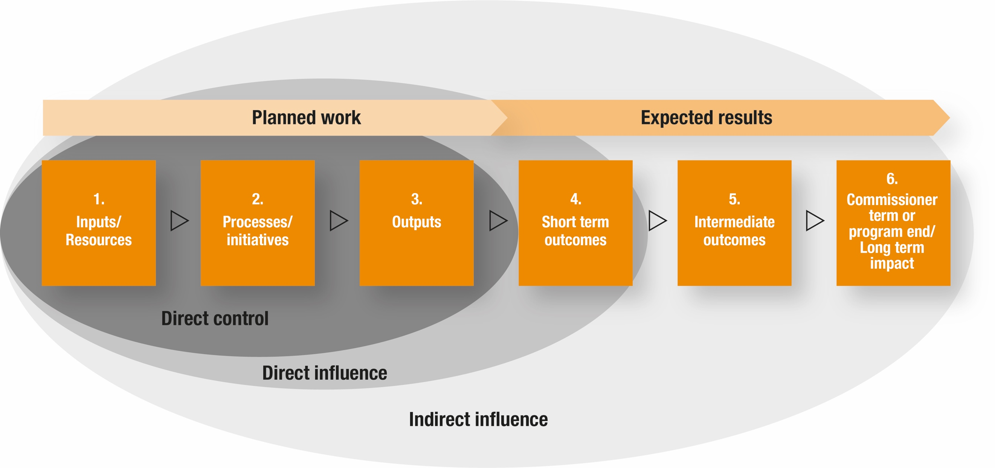

We have also built the evaluation capacity of our staff and developed systems to improve the monitoring and evaluation of our activities. The evaluations we undertake are proportional to our resources. If feasible, we collaborate with external evaluation experts, however, most of our evaluations are internally designed and led. All our evaluations aim to answer these questions:
Planned work | - How much did we do?  - How well did we do it?
Expected results | - What difference did we make?  - Who benefits and why?
Learning and improvement | Helping us to:  - Assess implementation methods and process.  - Guide program development.  - Assist decision-making.  - Add to existing knowledge and promote best practice.  - Identify gaps in knowledge and research.  - Meet our annual reporting obligations to government under the PGPA Act.

Our Corporate Plan website provides further information about the evaluation activities we intend to conduct this financial year.

6. Our organisational structure
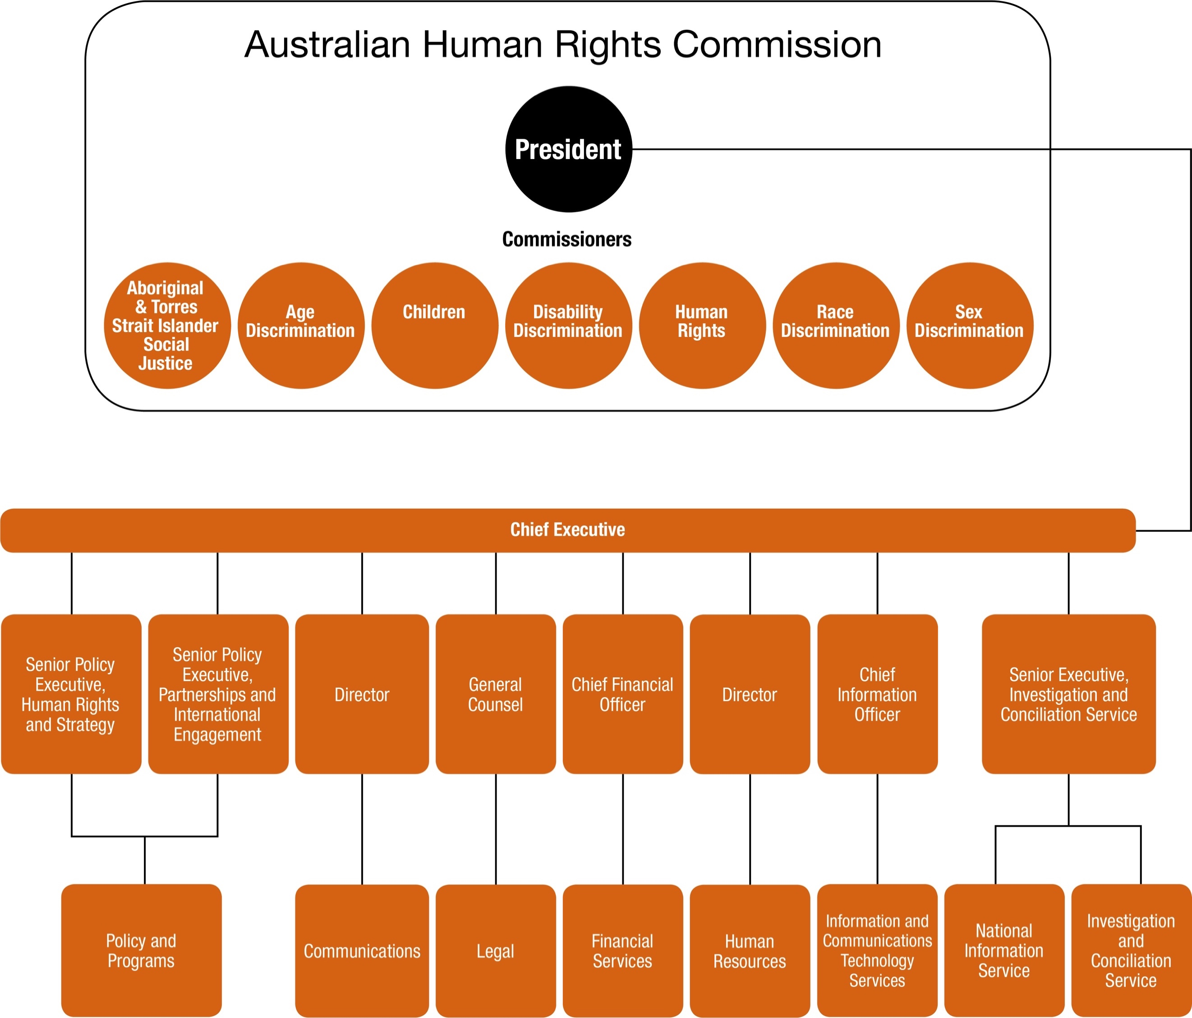

7. 2018–19 Corporate Plan web page
For brevity, the additional materials referred to in this document are located on our website. These include the President and Commissioner profiles and further detail on our risk management and evaluation framework. To access these click on the icons below or visit our website at https://www.humanrights.gov.au/corporate-plan-2018-2019.
2018–19 Evaluations by performance framework
2018–19 Challenges, risks and opportunities analysis
President and Commissioners Profiles

Further information: http://nhri.ohchr.org/EN/AboutUs/Pages/ParisPrinciples.aspx.
This is a general overview. See the specific legislation for exact wording, in particular s 11 of the Australian Human Rights Commission Act 1986 (Cth). Some functions are set out in other legislation.
Commissioners are statutory officeholders usually appointed for a term of five years.
The Commission is able to grant temporary exemptions from some parts of the Sex Discrimination Act, the Disability Discrimination Act and the Age Discrimination Act.
The President has been appointed for a seven year term and the five year term of the National Children’s Commissioner has been extended for a further two years.
At this time, there is no Race Discrimination Commissioner work plan due to the completion of the current Commissioner’s term (August 2013–18).

