# Disability Rights: Inclusion and Sport

**A unit of work for the Australian Curriculum: Health and Physical Education, Years 7 and 8**

Almost 4 million Australians live with disabilities. If we add families, friends and colleagues, the number of people affected by disability is larger still.

These lessons fit within the **Years 7-8 Health and Physical Education curriculum**. They are based on the Australian Human Rights Commission’s [*20 Years: 20 Stories film project*](http://www.humanrights.gov.au/twentystories/), which celebrates 20 years of Australia’s *Disability Discrimination Act 1992*. The Act provides protection from discrimination for people with disabilities.

These lessons address outcomes in the Health and Physical Education Curriculum across the personal, social and community health strand, and the movement and physical activity strand. They explore themes of health benefits of physical activity, mental health and wellbeing, relationships, and games and sports.

**Focus**

It’s a sport only for the ‘fast and furious’, but those two words haven’t meant much to Paul Gooda until recently. Since taking up wheelchair basketball, the former self-confessed book-worm hasn’t looked back.

This unit provides opportunities for students to explore the importance of team sports and physical activity for people with disabilities and issues around transitions and trauma, and coping with changes.

Students will explore the following inquiry questions:

* What are the benefits to individuals and communities of valuing diversity?
* What are the physical and mental health benefits, and social benefits of physical activity?
* How can young people who are experiencing transitions or trauma be supported?
* How can diversity and difference be respected through sport?

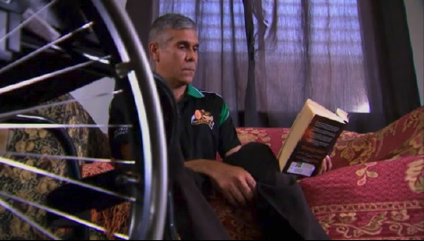

**Image caption:** Paul Gooda, Rockwheelers, 20 Years: 20 Stories Film Project, Australian Human Rights Commission.

**Teaching and Learning Activities**

These lessons can be taught as a unit or as individual lessons

*1* Introduction to disability rights

2 Inclusive sports (Modified, adapted and disability sports)

*3* *Rockwheelers* video: participation in sport

*4* Playing an inclusive sport

*5* Challenging stereotypes in sport

**Learning outcomes:**

**As a result of this unit students will:**

* Analyse the concept of disability rights and how to make sport inclusive.
* Explore the social and emotional benefits of participating in physical activity.
* Experience playing an inclusive sport, and practice modifying rules and removing barriers to make a sport more inclusive.
* Analyse stereotypes and prejudices against athletes with disabilities.
* Identify coping strategies to manage difficult situations that involve young people dealing with transitions or trauma.

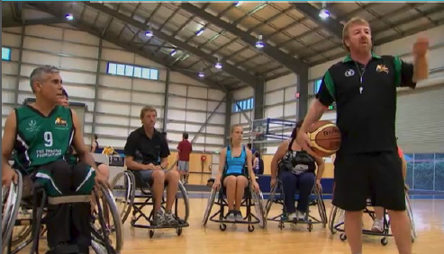

**Image caption:** Paul Gooda, Rockwheelers, 20 Years: 20 Stories Film Project, Australian Human Rights Commission.

Contents

Disability Rights: Inclusion and Sport 1

Australian Curriculum Links – Health and Physical Education 5

Unit description: 6

Resources: 6

Vocabulary: 6

Lesson 1 Introduction to disability rights 8

Lessons 2-3 Inclusive sport (Modified, adapted and disability sports) 10

Lesson 4 Rockwheelers video: participation in sports 11

Lesson 5 Playing a modified sport 12

Lesson 6 Challenging stereotypes in sport 13

Activity and Resource Sheets 14

**About this resource:**

The Australian Human Rights Commission encourages the dissemination and exchange of information provided in this publication.

All material presented in this publication is provided under Creative Commons Attribution 3.0 Australia, with the exception of:

* the Australian Human Rights Commission Logo
* photographs and images
* any content or material provided by third parties.

The details of the relevant licence conditions are available on the Creative Commons website, as is the full legal code for the CC BY 3.0 AU licence



**Attribution**

Material obtained from this publication is to be attributed to the Australian Human Rights Commission with the following copyright notice:

© Australian Human Rights Commission 2014.

**Electronic format**

This publication can be found in electronic format on the website of the Australian Human Rights Commission: [**www.humanrights.gov.au/publications/index.html**](http://www.humanrights.gov.au/publications/index.html).

**Contact details**

For further information about the Australian Human Rights Commission, please visit [**www.humanrights.gov.au**](http://www.humanrights.gov.au)or email [**communications@humanrights.gov.au**](mailto:communications@humanrights.gov.au)**.**

You can also write to:

Human Rights Education Team

Australian Human Rights Commission

GPO Box 5218

Sydney NSW 2001

# Australian Curriculum Links – Health and Physical Education

|  |  |
| --- | --- |
| **Content Description** | **Elaboration** |
| **Strand 1: Personal, Social and Community Health** | |
| ***Sub-strand 1 Being Healthy Safe and Active*** | |
| [ACPPS070](http://www.australiancurriculum.edu.au/healthandphysicaleducation/Curriculum/F-10) Investigate the impact of transition and change on identities | * *identifying feelings and emotions associated with transitions, and practising self-talk and help-seeking strategies to manage these transitions* |
| [ACPPS072](http://www.australiancurriculum.edu.au/healthandphysicaleducation/Curriculum/F-10) Practise and apply strategies to seek help for themselves or others | * *examining scenarios to highlight how emotions, dispositions and decision making can affect outcomes* |
| [ACPPS073](http://www.australiancurriculum.edu.au/healthandphysicaleducation/Curriculum/F-10) Investigate and select strategies to promote health, safety and wellbeing | * *researching opportunities in the local community to participate in regular physical activity and examining how accessible these opportunities are for students* |
| ***Sub-strand 2: Communicating and interacting for health and wellbeing*** | |
| [ACPPS075](http://www.australiancurriculum.edu.au/Curriculum/ContentDescription/ACPPS075) Analyse factors that influence emotions, and develop strategies to demonstrate empathy and sensitivity | * *investigating personal, social and cultural factors that influence the way individuals respond emotionally to different situations* |
| ***Sub-strand 3: Contributing to healthy and active communities*** | |
| [ACPPS079](http://www.australiancurriculum.edu.au/healthandphysicaleducation/Curriculum/F-10#level7-8) Examine the benefits to individuals and communities of valuing diversity and promoting inclusivity | * *examining* *values and beliefs about cultural and social issues such as disability, gender, race, sexuality and violence.* * *investigating how respecting diversity and challenging disability discrimination, racism, sexism and homophobia influence individual and community health and wellbeing* |
| **Strand 2: Movement and Physical Activity Strand** | |
| ***Sub-strand 1: Moving our body*** | |
| [ACPMP080](http://www.australiancurriculum.edu.au/healthandphysicaleducation/Curriculum/F-10#level7-8) Use feedback to improve body control and coordination when performing specialised movement skills | * *participating in activities without vision to demonstrate the importance of auditory feedback* |
| ***Sub-strand 3: Learning through movement*** | |
| [ACPMP088](http://www.australiancurriculum.edu.au/healthandphysicaleducation/Curriculum/F-10) Modify rules and scoring systems through changes to rules and scoring systems to allow for fair play, safety and inclusive participation | * *modifying rules, equipment or scoring systems to allow all participants to enjoy and succeed* |

**General Capabilities**

The general capabilities emphasised in this unit of work are [Ethical Understanding](http://www.australiancurriculum.edu.au/GeneralCapabilities/Ethical-understanding), [Personal and Social Capability](http://www.australiancurriculum.edu.au/GeneralCapabilities/Personal-and-social-capability), [Literacy](http://www.australiancurriculum.edu.au/GeneralCapabilities/Literacy/Introduction/Introduction) and [Information and Communication Technology (ICT) Capability](http://www.australiancurriculum.edu.au/GeneralCapabilities/Information-and-Communication-Technology-capability).

**Disability Rights: Inclusion and Sport**

|  |  |
| --- | --- |
| Unit description: | |
| These lessons address outcomes in the Health and Physical Education Curriculum across the personal, social and community health strand, and the movement and physical activity strand. They explore themes of health benefits of physical activity, mental health and wellbeing, relationships, and games and sports.  **Key inquiry questions:**   * What are the benefits to individuals and communities of valuing diversity? * What are the physical and mental health benefits, and social benefits of physical activity? * How can young people who are experiencing transitions or trauma be supported? * How can diversity and difference be respected through sport?   **Learning Outcomes:**   * Analyse the concept of disability rights and how to make sports inclusive. * Explore the social and emotional benefits of participating in physical activity. * Experience playing an inclusive sport, and practice modifying the rules of a sport to make it more inclusive. * Analyse stereotypes and prejudices against athletes with disabilities. * Identify coping strategies to manage difficult situations that involve young people dealing with transitions or trauma. | |
| Resources: | Vocabulary: |
| **Videos**  *Rockwheelers* ,*Twenty Years: Twenty Stories* video (4 min 37 sec) <http://www.youtube.com/watch?v=2m-lR7GHJxc>  **Activities**  Activity Sheet: Sport and people with disabilities - interactive crossword (across solutions and down solutions)  Activity Sheet: Sport and people with disabilities  Activity Sheet: Inclusive sports (Modified, adapted and disability sports)  Activity Sheet: Researching an adapted or modified sport  Activity Sheet: *Rockwheelers*-viewing questions  Activity Sheet: Rockwheelers – question cards  Activity Sheet: Op-ed template  **Resources**  Resource Sheet: Background information - Sport and people with disabilities  **Additional Resources**  Don’t dis my ability language guide <http://www.dontdismyability.com.au/tools_and_tips/language_guide>  Australian Sports Commission <http://www.ausport.gov.au/participating/coaches/tools/coaching_specific_groups/Inclusive> | Accessibility  Adapted sports  Disability  Disability Rights  Disability sports  Inclusive sports  Inclusion  Mainstream sports  Modified sports  Participation |

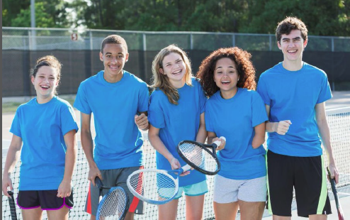

|  |  |
| --- | --- |
| Lesson 1 Introduction to disability rights | |
| **Australian Curriculum Links** | |
| [ACPPS079](http://www.australiancurriculum.edu.au/healthandphysicaleducation/Curriculum/F-10#level7-8) Examine the benefits to individuals and communities of valuing diversity and promoting inclusivity   * *examining* *values and beliefs about cultural and social issues such as disability, gender, race, sexuality and violence.* * *investigating how respecting diversity and challenging disability discrimination, racism, sexism and homophobia influence individual and community health and wellbeing* | |
| **Integrated Teaching Learning and Assessment** | **Resources** |
| ***Introduction***   * Explain to students this lesson and upcoming lessons will be focusing on disability rights and inclusive sports.   As a class, discuss the term ‘disability’, and discuss the different types of disability e.g. intellectual, physical and sensory, physcosocial   * Introduce the concept of disability rights. As a class or in small groups, students brainstorm the rights of people with disabilities. After the brainstorm, facilitate a class discussion to ensure students understand that **people with disabilities have the same rights as people without disabilities**, including the right to participate in sporting and recreational activities. Through this activity, introduce and discuss the terms ‘equal opportunity’, ‘accessibility’, ‘inclusion’ and ‘participation’. * As a class discuss the importance of using respectful language, which is an important part of human rights. Get students to draw up two columns in their book titled ‘HOT’ and ‘NOT’. Give each student a HOT card and NOT card. Use the vocabulary and phrases from the *Don’t dis my ability: what’s hot, what’s not* language guide and get students to raise their sign on whether they think the word is ‘hot’ or ‘not’. Students then write the terms down under the correct column in their books. * *Literacy activity:* The interactive crossword information gap activity is a pre-vocabulary exercise that will help students become more familiar with the key vocabulary used in the *Resource sheet: Background information – sport and people with disabilities* and throughout the unit.   Divide students into pairs to conduct an interactive crossword information gap activity. Each student in the pair will get either the across solutions or the down solutions. They must not show each other the solutions. Instead students need to ask questions e.g. ‘what is one across’ and the other person has to answer by explaining the definition, which the first person matches to their word bank. It is important to note students should not mention the ‘solution’ in their explanations/definitions. Depending upon the students, you may like to provide a general word bank of the words included in the crossword puzzle.  Alternatively, this activity can be conducted as a whole class interactive activity e.g. the teacher has the ‘across’ solutions while students have the ‘down’ solutions.  The list of words included in the crossword activity are: ‘disability’, ‘public life’, ‘unlawful’, ‘equal access’, ‘treaty’, ‘take action’, ‘discrimination’, ‘equal basis’, ‘mainstream’, ‘provision’, ‘recreational’, ‘tourism’, ‘venues’, ‘leisure’, ‘services, ‘inclusion’ and ‘participation’. The words included in the crossword activity are primarily sourced from the *Resource sheet: Background information – sports and people with disabilities.*  **Teacher’s Note:** Where the answer is more than one word, a space has been left on the crossword grid between the words.   * Following up the interactive crossword activity, as a class, students go through and discuss the *Resource sheet: Background information – sports and people with disabilities.*   As a class or in small groups, students brainstorm the physical, mental and emotional benefits of participating in sport for individuals and the broader community. This exercise will help consolidate the notion that accessible sport is important.   * In pairs or as individuals, students complete the *Activity sheet: Sport and people with disabilities.*  Prior to the completion of the worksheets, the terms ‘mainstream sport’ and ‘disability specific sport’ may need to be defined and discussed. Be sure to encourage students to consider a broad range of disabilities, such as physical, sensory, psychosocial and intellectual.   Facilitate a short classroom discussion to go through student responses. | Resource sheet: Background information - Sports and people with a disability  Activity sheet: Sports and people with disabilities - interactive crossword (across solutions and down solutions)  Activity sheet: Sports and people with a disability  Don’t dis my ability language guide: what’s hot, what’s not <http://www.dontdismyability.com.au/tools_and_tips/language_guide> |

|  |  |  |  |
| --- | --- | --- | --- |
| Lessons 2-3 Inclusive sport (Modified, adapted and disability sports) | | | |
| **Australian Curriculum Links** | | | |
| [ACPPS073](http://www.australiancurriculum.edu.au/healthandphysicaleducation/Curriculum/F-10) Investigate and select strategies to promote health, safety and wellbeing   * *researching opportunities in the local community to participate in regular physical activity and examining how accessible these opportunities are for students* | | | |
| **Integrated Teaching Learning and Assessment** | | | **Resources** |
| ***Pre-viewing/Scaffolding Activities***  **Teacher’s Note:** In the Disability Convention it is recognised that disability is an evolving concept and no fixed definition of disability is provided. This is illustrated by the fact that the Convention’s use of the terms ‘disability sports’, ‘mainstream sport’ and ‘disability specific sport’ are now considered somewhat outdated. ‘Inclusive sport’ is the preferred overarching term used here, however in order to be consistent with the language of the Convention, references to Convention terms are included in this resource.   * Introduce the following terminology: modified sports, adapted sports and disability sports. * *Modified sports* – sports that have been modified from regular versions of the sport, to meet the needs of players’ ages, size, abilities, skills and experiences e.g. touch football.   As a class, students could discuss the similarities and differences between the mainstream and modified versions of touch football. This information could be represented using a Venn diagram. This will help students better understand the term ‘modified sport’.   * *Adapted sports* – sports that have been adapted to meet the needs of people with disabilities, e.g. wheelchair basketball. The term ‘able-bodied’ will need to be explained to students.   As a class, students could discuss the similarities and differences between the mainstream and adapted versions of wheelchair basketball. This information could be represented using a Venn diagram. This will help students better understand the term ‘adapted sport’.   * *Disability sports* – (also disabled sports or parasports) sports that are played by people with physical and/or intellectual disabilities. Could be adapted sports, or disability-specific sports. There may need to a discussion about the differences between physical and intellectual disabilities. * In groups, pairs or as individuals, students research an adapted or modified sport. Provide students with the *Activity sheet: Researching adapted or modified sports* to scaffold the research. Students could either generally research about an adapted or modified sport, or research about an adapted or modified sport in their local area. This information could be presented as a report using Microsoft Word.   Alternatively, students could collaboratively use Google sites to create a class website about adapted and modified sports. Divide students into small groups. Each group researches a different adapted or modified sport. Provide students with a copy of the *Activity sheet* to scaffold the research. Students create a webpage on the class website to present information about their researched sport. | | | Activity sheet: Researching an adapted or modified sport  Microsoft Word / Google sites |
| Lesson 4 Rockwheelers video: participation in sports | | | |
| **Australian Curriculum Links** | | | |
| [ACPPS075](http://www.australiancurriculum.edu.au/Curriculum/ContentDescription/ACPPS075) Analyse factors that influence emotions, and develop strategies to demonstrate empathy and sensitivity   * *investigating personal, social and cultural factors that influence the way individuals respond emotionally to different situations*   [ACPPS079](http://www.australiancurriculum.edu.au/healthandphysicaleducation/Curriculum/F-10#level7-8) Examine the benefits to individuals and communities of valuing diversity and promoting inclusivity   * *examining* *values and beliefs about cultural and social issues such as disability, gender, race, sexuality and violence.*   *investigating how respecting diversity and challenging disability discrimination, racism, sexism and homophobia influence individual and community health and wellbeing*  [ACPPS070](http://www.australiancurriculum.edu.au/healthandphysicaleducation/Curriculum/F-10) Investigate the impact of transition and change on identities   * *identifying feelings and emotions associated with transitions, and practising self-talk and help-seeking strategies to manage these transitions* | | | |
| **Integrated Teaching Learning and Assessment** | | **Resources** | |
| ***Viewing Activities***   * Introduce the *Rockwheelers* video. Explain that it is about Paul Gooda and his experience of becoming involved in wheelchair basketball. It explores how this helped him become more socially connected to his community. Watch the *Rockwheelers* video(5 min 32 sec)   Watch the video a second time. In pairs or small groups, students answer the viewing questions in the *Activity Sheet: Rockwheelers – viewing questions* to scaffold students’ comprehension of the video. Then facilitate a short classroom discussion to check meaning and discuss any other issues raised by the video.  ***Post-viewing Activities***   * Divide students into groups. Conduct a jigsaw activity using the *Activity sheet: Rockwheelers – question cards* to consolidate students’ understanding of the issues raised in the video. (For more information about jigsaw activities view the [Jigsaw Classroom website](http://www.jigsaw.org/steps.htm))   Prior to conducting the jigsaw activity, the terms ‘emotional’ and ‘psychological’ factors need to be discussed.  The questions discussed through this activity are:   * What might stop a person with disabilities from participating in sport? * What are some of the benefits of participating in team sport? * Why might participation in a team sport be especially beneficial for people with disabilities? * Why might an person without disabilities participate in inclusive sport * What were some of the issues that Paul faced when learning to live as a person with disabilities? * What impact did his accident have on him? What strategies helped him make this transition?   Following up the jigsaw activity, facilitate a brief classroom discussion to conclude discussion about the video *Rockwheelers.* | | *Rockwheelers* video (4mins 37 secs)  <http://youtu.be/2m-lR7GHJxc>  or <http://www.humanrights.gov.au/twentystories/video-rockwheelers.html>  Activity sheet: *Rockwheelers-* viewing questions  Activity sheet: *Rockwheelers* - question cards | |
| Lesson 5 Playing a modified sport | | | | |
| **Australian Curriculum Links** | | | | |
| [ACPMP080](http://www.australiancurriculum.edu.au/healthandphysicaleducation/Curriculum/F-10#level7-8) Use feedback to improve body control and coordination when performing specialised movement skills   * *participating in activities without vision to demonstrate the importance of auditory feedback*   [ACPMP088](http://www.australiancurriculum.edu.au/healthandphysicaleducation/Curriculum/F-10) Modify rules and scoring systems to allow for fair play, safety and inclusive participation   * *modifying rules, equipment or scoring systems to allow all participants to enjoy and succeed* | | | | |
| **Integrated Teaching Learning and Assessment** | | **Resources** | | |
| ***Movement and Physical Activities***   * As a class, students design an inclusive sport (e.g. modified basketball, football, goalball) by altering the rules and the scoring system of the sport. For instance, students could play on their knees using kneepads, play using only one hand, play blindfolded, or play without hearing etc.   Ensure there is time at the end of the game to provide students the opportunity to debrief about their experience. The following questions could be used to guide the discussion:   * How did your rules or scoring system work? * How did removing barriers to the sport through adapting rules and the scoring system contribute to fair play? * Do you think it made the game more inclusive? * How did removing barriers to the game change your body control and coordination? * Do you think the inclusive version of the sport is as challenging? | | Regular sports equipment  Wheelchairs for wheelchair basketball  See organisations :  Wheelchair sports NSW <http://wsnsw.org.au/roadshow/school-road-show/>  Australian Sports Commission <http://www.ausport.gov.au/participating/coaches/tools/coaching_specific_groups/Inclusive> | | |

|  |  |
| --- | --- |
| Lesson 6 Challenging stereotypes in sport | |
| **Australian Curriculum Links** | |
| [ACPPS079](http://www.australiancurriculum.edu.au/healthandphysicaleducation/Curriculum/F-10#level7-8) *Examine the benefits to individuals and communities of valuing diversity and promoting inclusivity*   * *examining values and beliefs about cultural and social issues such as disability, gender, race, sexuality and violence.* * *investigating how respecting diversity and challenging disability discrimination, racism, sexism and homophobia influence individual and community health and wellbeing* | |
| **Integrated Teaching Learning and Assessment** | **Resources** |
| * In pairs or small groups, students write an op-ed piece for a newspaper to challenge the perception that inclusive sports (such as modified, adapted or disability sports) are not as challenging as mainstream sports. Students need to also refer to how respecting diversity and promoting inclusivity in sport has broader health and wellbeing benefits for the community.   This task needs to be scaffolded carefully. Suggestions include:   * Explain what an op-ed is, who writes it, and why an op-ed is written. Inform students that the purpose of an op-ed is to introduce different perspectives to the readers. It aims to stimulate discussion in the community and o can be used as an advocacy tool. * Provide students with an example of an op-ed. In small groups or pairs, students identify the language features and structure of this text type using the provided op-ed example.   Alternatively, *s*tudents could also be provided with examples of well written and poorly written op-eds. The task for students then is to compare the op-ed pieces to identify the appropriate language features and structure of a well written example of this text type.  Some features of an op-ed include: use of active voice in sentences; concise sentences; short paragraphs; persuasive language; absence of jargon; use third person (can use first person); use of anecdotes; opinions are supported by facts, statistics and/or examples; acknowledgement of different viewpoint that is then refuted by facts; use of linking words to give examples, show reasons and give another argument ; usually uses informal language   * In small groups, students brainstorm arguments and evidence to challenge the perception that inclusive sports (such as modified, adapted or disabled sports) are not as challenging as mainstream sports. For instance, students could refer to their own experience of playing a modified sport. Students should also refer to local, national and international athletes with disabilities, and relevant programs and competitions to support their argument. Students could also discuss the benefits of inclusive sport for individuals and the broader community.   To guide the brainstorm, provide students with the *Activity sheet: Op-ed template.* | Activity sheet: Op-ed template  Resources: Examples of op-eds can be found on the following websites:   * <http://www.publicanthropology.org/Yanomami/General/Criteria-Examples.htm> * <http://www.washingtontrio.org/index.php/get-involved/ResourcesEducation/Op-EdExamples/> * <http://www.advocatesforyouth.org/topics-issues/organizational-development/246?task=view> * <http://www.nytimes.com/pages/opinion/> |

# Activity and Resource Sheets

**Rights Ed Activity Sheet: Sports and people with disabilities – interactive crossword**

***Across solutions***



**Rights Ed Activity Sheet: Sports and people with disabilities – interactive crossword**

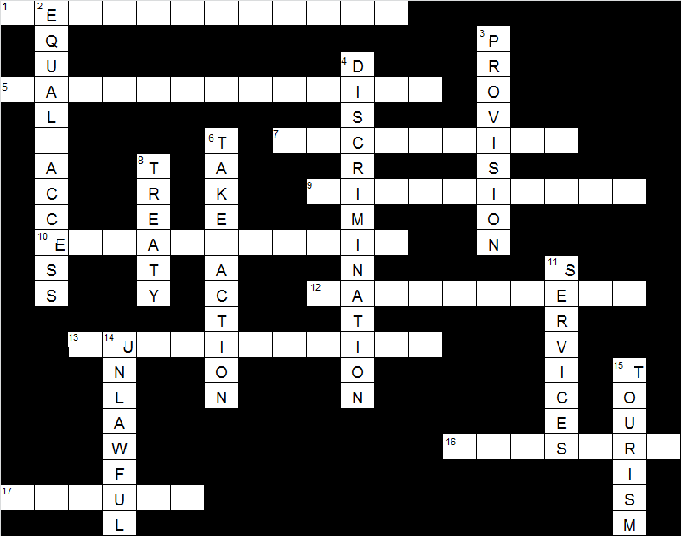***Down solutions***

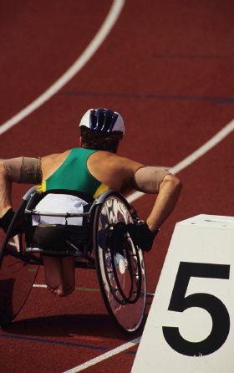

**Rights Ed Resource Sheet: Background information - Sport and people with disabilities**

All people have the right to participate in recreation, leisure and sporting activities.

Australia has a law called the **Disability Discrimination Act** (DDA) that protects individuals from unfair treatment in many parts of public life including in sport. The DDA makes disability discrimination unlawful, and promotes equal rights, equal opportunity and equal access for people with disabilities.

Australia has also signed an important international treaty called the Convention on the Rights of Persons with Disabilities or the Disability Convention for short.

The ***Disability Convention*** identifies how to take action to allow people with disabilities to participate on an equal basis with others in recreational, leisure and sporting activities:

1. To ***encourage and promote the participation***, to the fullest extent possible, of people with disabilities ***in mainstream sporting activities*** at all levels
2. To ***ensure that people with disabilities have an opportunity to organise, develop and participate in disability-specific sporting*** and recreational activities and, to this end, encourage the provision, on an equal basis with others, of appropriate instruction, training and resources
3. To ***ensure that people with disabilities have access to*** sporting, recreational and tourism ***venues***
4. To ***ensure that children with disabilities have equal access with other children to participation in*** play, recreation and leisure and sporting activities, including those activities in ***the school system***
5. To ***ensure that people with disabilities have access to services from those involved in the organisation of recreational, tourism, leisure and sporting activities***

**Rights Ed Activity Sheet: Sport and people with disabilities**

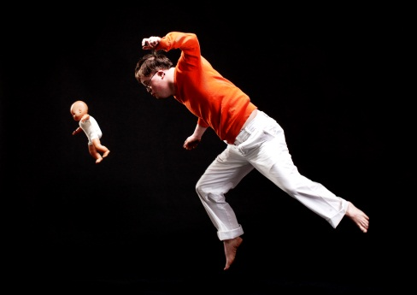

**Image Caption:** “Restless Dancer” by Katie Pashley, Australian Human Rights Commission Photography Competition winner

|  |
| --- |
| 1. *How do you think you can encourage and promote the participation of people with disabilities in sports? In your answer, try to consider a broad range of disabilities* |
|  |
| 1. *Can you think of examples where people with disabilities organise, develop and participate in sport without barriers? This could be a local, national or an international event. Hint: Do you remember what happened in London in 2012?* |
|  |
| 1. *Do you know if people with disabilities have access to sporting venues in your local area? Can you think of an example of this occurring? If you can’t, why do you think this is?* |
|  |
| 1. *Do you think students with disabilities have equal access as other students and young people to sporting and recreational opportunities in school? Do you think this could be improved? If yes, how do you think this could be improved?* |
|  |

**Rights Ed Activity: Researching an adapted or modified sport**

*Instructions:*Research an adapted or modified sport and write a brief report on the sport.

|  |
| --- |
| **Name of sport** |
| **What are the rules?** |
| **What is the history of the sport?** |
| **Who is it played by?** |
| **Is it included in any major organised sport competitions?** |

**Adapted or modified sport in your local area**

*Instructions:* Research an adapted sport or sport program which has had barriers to participation removed and is offered in the local area. Discuss how accessible these programs are for students with and without disabilities.

|  |
| --- |
| **Name of sport** |
| **What are the rules?** |
| **What is the history of the sport in your local area?** |
| **How accessible is this sport program to students with and without disabilities.?** |

**Rights Ed Activity Sheet: *Rockwheelers -* viewing questions**

Watch the *Rockwheelers* video <http://youtu.be/2m-lR7GHJxc>

|  |  |
| --- | --- |
| **Question** | **Answer** |
| 1. Who are the Rockwheelers? |  |
| 1. When did the wheelchair basketball program begin? |  |
| 1. How long has Paul been playing wheelchair basketball? |  |
| 1. How did Paul feel after his accident? |  |
| 1. What unites players on the court? |  |
| 1. Why does Daniel enjoy being in the Rockwheelers? |  |
| 1. What do you think has contributed to Paul’s sense of wellbeing since he joined the Rockwheelers? |  |

**Rights Ed Activity: *Rockwheelers* – question cards**

|  |  |
| --- | --- |
| **Question 1** | **Question 2** |
| **What might stop a person with disabilities from participating in a sport?**  Refer specifically to issues raised in the video, as well as other possible factors. Aside from issues arising directly from disabilities, discuss emotional and psychological factors. | **What are some of the benefits of participating in team sports?**  Refer specifically to benefits highlighted in the video, as well as other possible benefits. |
| **Question 3** | **Question 4** |
| **Why might participation in a team sport be especially beneficial for people with disabilities?**  Refer specifically to benefits highlighted in thevideo, as well as other possible benefits. | **Why might a person without disabilities participate in inclusive sports?**  Refer specifically to the reasons discussed in the video, as well as other possible reasons. |
| **Question 5** | **Question 6** |
| **What were some of the issues that Paul faced when making the transition to having disabilities?** | **What impact did his accident have on him? What strategies helped him make this transition to having disabilities?** |

**Rights Ed Activity Sheet: Op-ed template**

***Title*** *[the title needs to be catchy]****:***

***Author/s:***

***Introduction:*** What is your opinion on the level of difficulty and challenge of modified or inclusive sports compared with sports which are not accessible to those with disabilities? Provide a brief overview of your arguments. The introduction needs to be interesting to grab the audience’s attention.

***Argument 1:*** Develop an argument to support your opinion e.g. use your personal experiences of playing inclusive sport to support your view.

***Conclusion:*** Re-state your opinion and provide a brief summary of your arguments.

***Argument 2:*** Develop an argument to support your opinion e.g. refer to local, national and international athletes with disabilities, and relevant programs and competitions.

***Argument 3:*** Develop an argument to support your opinion e.g. how are inclusive sports beneficial for individuals participating in them and the whole community?