Take a stand against racism

Introduction
This unit of work is designed to equip young people to take a stand against racism in their community, by valuing diversity and encouraging others to do the same. The unit is linked to the Australian Curriculum: Health and Physical Education.
Students explore issues of racism and its impact on people from diverse backgrounds. They also consider the ways in which we can value diversity within the community and celebrate the different cultures represented within schools and the wider community.
Students are challenged to take action on behalf of people who have experienced racial discrimination or harassment. The overall message of the unit is that we are never too young to take a stand against bullying and harassment.
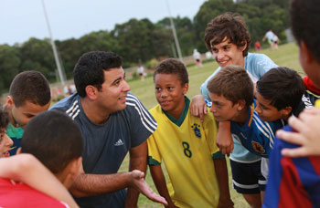
Photo by Australian Human Rights Commission

Table of Contents

Introduction 1
Links to the Australian Curriculum 4
Focus 7
Teaching and learning activities 7
Teacher support 8
Achievement, learning and assessment 10
Sequence 1—Understanding identity 11
Sequence 2 — Walking in another person’s shoes 22
Sequence 3—Taking action 31
Sequence 4—Stand up against racism 37
Resources for ‘Take a stand against racism’ 43
Worksheets 46

About this resource:

The Australian Human Rights Commission encourages the dissemination and exchange of information provided in this publication.
All material presented in this publication is provided under Creative Commons Attribution 3.0 Australia, with the exception of:
- the Australian Human Rights Commission Logo
- photographs and images
- any content or material provided by third parties.
The details of the relevant licence conditions are available on the Creative Commons website, as is the full legal code for the CC BY 3.0 AU licence

Attribution
Material obtained from this publication is to be attributed to the Australian Human Rights Commission with the following copyright notice:
© Australian Human Rights Commission 2014.

Electronic format
This publication can be found in electronic format on the website of the Australian Human Rights Commission: www.humanrights.gov.au/publications/index.html.
Contact details
For further information about the Australian Human Rights Commission, please visit www.humanrights.gov.au or email communications@humanrights.gov.au.

You can also write to:
Human Rights Education Team
Australian Human Rights Commission
GPO Box 5218
Sydney NSW 2001

Links to the Australian Curriculum
Years 5 and 6: Personal, Social and Community Health
Content
The content in this unit relates to the Australian Curriculum: Health and Physical Education for Years 5 and 6, covering the strand of Personal, Social and Community Health.
General Capabilities
The general capabilities emphasised in this unit of work are Intercultural understanding, Ethical understanding, Literacy, Personal and social capability, Critical and creative thinking and Information and communication technology (ICT) capability.

Curriculum content descriptions
Content description | Elaborations
Being healthy, safe and active
ACPPS051 — Explore personal and cultural identities and how they change and adapt to different contexts and situations | - identifying how personal qualities contribute to identities and inform world views (MH)  - exploring how personal and cultural identities change over time (MH, RS)  - investigating how personal and cultural identities are influenced by the groups and communities to which we belong and the places to which we feel connected (RS)  - exploring how family, peers and the media influence how individuals interact in given situations (RS)
Communicating and interacting for health and wellbeing
ACPPS055 — Practice skills to establish and manage relationships | - proposing strategies for managing the changing nature of relationships, including dealing with bullying and harassment and building new friendships (S, RS)
ACPPS056 — Examine the influence of emotional responses on behaviour and relationships | - analysing situations in which emotions can influence decision making, including in peer-group, family and movement situations (CA, GS, RS, MH)  - discussing how inappropriate emotional responses impact relationships (MH, RS)
ACPPS057 — Recognise how media and important people in the community influence personal attitudes, beliefs, decisions and behaviours | - examining how media and public identities influence the way people act and the choices they make (MH, HBPA, FN, S, AD, RS)  - sharing how important people in their life influence them to act or behave in a healthy or safe way (MH, RS, S, FN, AD, HBPA)
Contributing to healthy and active communities
ACPPS058 — Investigate the role of preventive health in promoting and maintaining health, safety and wellbeing for individuals and their communities | - understanding the importance of social support and a sense of belonging in promoting mental health and wellbeing (MH, RS)
ACPPS060 — Investigate and reflect on how valuing diversity positively influences the wellbeing of the community | - exploring initiatives sporting and community groups use to counter discrimination and support the wellbeing of their communities (RS, MH, HBPA)  - discussing how the actions of bystanders, friends and family can prevent and/or stop bullying and other forms of discrimination and harassment (RS, MH)  - proposing strategies to help others understand points of view that differ from their own and to encourage further discussion about individual and cultural similarities and differences in order to tackle racism (RS)  - exploring and celebrating how cultures differ in behaviours, beliefs and values (RS, MH, FN)

Key (Health and Physical Education focus areas)
AD — alcohol and other drugs
CA — challenge and adventure activities
FN — food and nutrition
HBPA — health benefits of physical activity
MH — mental health and wellbeing
RS — relationships and sexuality
S — safety

Focus
This unit provides opportunities to understand the nature of racism and its effects on children and young people. Students will explore measures to address racism and how to take action against bullying and harassment based on race, culture or ethnicity.
Teaching and learning activities have been designed to challenge and empower students to take a stand.
Each sequence of activities can be taught independently or as a comprehensive program.

Teaching and learning activities
- Understanding identity
- Walking in another person’s shoes
- Taking action
- Stand up against racism

Sequence 1 begins by having students consider how their history and family background influence who they are.
Sequence 2 asks the students to answer the question: what does bullying look like, sound like and feel like?
Sequence 3 is designed to challenge students to be part of the solution, and begins by exploring programs designed to address racism.
Sequence 4 uses the experiences of Adam Goodes to encourage students to think about what they can do to address racism.

Teacher support
Please be aware that a number of the activities in this unit raise issues that may be sensitive or controversial and should be addressed with care.
When confronted with sensitive or controversial issues, young people are likely to express a wide range of responses based on their different experiences, learning styles and emotional intelligence levels. It is important to handle these issues without reinforcing stereotypes, increasing confusion or raising tension between students.
Some strategies for introducing controversial topics and managing responses can be found in the guide Dos and don’ts when teaching about cultural differences, from Civics and Citizenship Education.
Other strategies and techniques include:
- Splitting the class into smaller groups. This will ensure that greater confidentiality exists and enables less confident students to express their opinions in a less-pressured environment.
- Frame discussions around controversial issues in ways that are as open-ended and inclusive as possible and challenge students to consider issues from a variety of perspectives and sources.
- Encourage all students to develop and maintain a sense of pride in their language, their lived culture, their experiences, their families, and their communities.
As further reading, the report The Impact of Racism upon the Health and Wellbeing of Young Australians includes examples of how racism is experienced by young people and can provide some background in supporting teacher understanding.
Resources:
Dos and don’ts when teaching about cultural differences, Civics and Citizenship Education.
The Impact of Racism upon the Health and Wellbeing of Young Australians, the Foundation for Young Australians

Getting Help
In cases where students require counselling or support refer them to assistance from the school counsellor or from one of the following organisations:
Kids Helpline
Kids Helpline is a counselling service for Australian children and young people aged between 5 and 25 years.
Website: http://www.kidshelp.com.au/
Phone: 1800 551 800
Headspace
The National Youth Mental Health Foundation provides information and advice for young people going through difficulties through their Headspace centres, online and through telephone support services
Website: https://www.eheadspace.org.au/
Phone: 1800 650 890
Lifeline
Lifeline provides 24 hour crisis support and suicide prevention services.
Website: https://www.lifeline.org.au/Home
Phone: 13 11 14

Achievement, learning and assessment
There are two summative assessment tasks for this unit. They are included at the end of Sequence 2 and Sequence 4.
As a result of this unit of study students will:
• develop a thorough understanding of racism and its impact
• analyse the effects of racism on children and young people from different cultures and backgrounds living in Australia, including Aboriginal and Torres Strait Islander peoples
• discuss actions that we can take in order to value diversity and positively influence the wellbeing of the community
• demonstrate how our actions can prevent or stop bullying and harassment in relation to race, culture and language.

This will be evident when students:
• discuss what racism looks like, sounds like and feels like
• clearly define the terms harassment and discrimination — particularly in relation to racism
• discuss, with a degree of understanding, the effects of racism on children and young people
• contribute to group research to present an anti-racism campaign within their community or school
• develop an action plan for preventing racially related bulling and harassment.

Resources
Resources used in this unit are listed at the end of each teaching and learning activity. Alternatively, find the full list of resources at the back of this document.

Sequence 1—Understanding identity
Understanding culture and identity

‘Culture’ refers to the ideas, customs, and behaviours of a group of people or a society. A culture can be defined by everything from values, beliefs and traditions to food, music, arts and social practices.

Focus for class discussion
- What is ‘Australian culture’? What are our values, beliefs and traditions? What other things do we consider part of Australian culture? (e.g. foods, particular social practices)
- What other cultures are represented in Australia?
- What values, beliefs and traditions are important to your families? Do they have a link to your family’s history?

For many people, their cultural heritage is linked to their racial background or ethnicity. The traditions, values and beliefs have been passed down through generations and are very important because they are a link to their ancestors, their country of origin and their history.
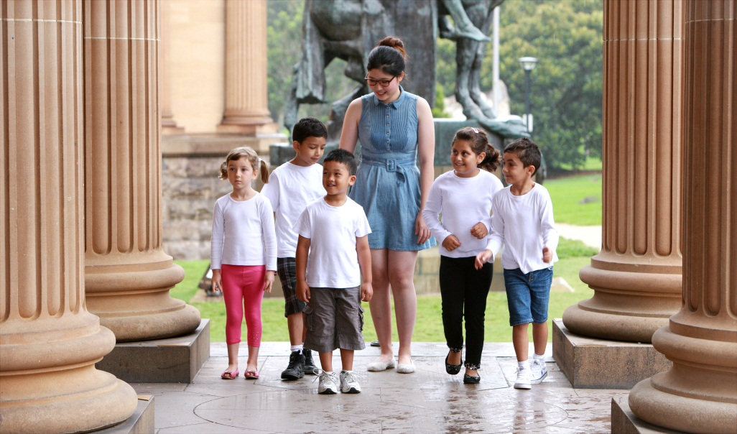
Photo by Australian Human Rights Commission

Student activity—your identity
Ask students to think about their own timeline. What kind of events have made up our history? Students may list their ideas together on the board or in their workbooks.
Using a piece of blank paper instruct students to draw a timeline from their birth until their age right now. Along the timeline ask students to mark down the key life events that have happened to them. For example:
- the birth of a sibling
- when they lost their first tooth
- when they began primary school
- their first memorable holiday
- major celebrations
- festivals they have attended
- moving house
- family breakdown.

Ask students to think about how these experiences have shaped our identity and find those that have particular cultural importance. Students may be asked to highlight or underline these from their work above.
Hand out the Your Identity, Your Heritage worksheet to continue the discussion. Students can work in pairs to complete the worksheet. This worksheet has been designed for teacher-directed use. If providing to students, please provide direction as needed for each section.

Resources:
Your Identity, Your Heritage worksheet

Teacher’s note: This activity has been adapted from Your Identity, Your Heritage on the Racism. No Way website. See this page for other related activities

Student activity— identifying stereotypes
This activity aims to assist students to gain an understanding of stereotypes and how some groups can be negatively stereotyped. For this activity you will need to provide students with a range of newspapers and magazines.
Begin this activity by writing on the board examples of different categories of people (for example, girl, boy, old person, a person with disability) and ask students to suggest descriptive words which define these groups. Take note of student suggestions on the board.
As a class discuss whether the attributes mentioned for the people in each category are positive, negative or neutral. Explain to students the difference between a generalisation (a general statement or idea that is formed by looking a few specific examples) and a stereotype (a widely held but oversimplified idea about a particular type of person or thing). Explain that stereotypes can be positive, negative or neutral in nature.
Pose the following question to students:
- Where do you think you got these views? From your own experience, or from the media, or from family and friends?
Divide students into groups and provide each group with a selection of newspapers and magazines. Ask students to go through the materials and look for stereotypical representations of certain groups - both in the text and in the pictures. These groups could be the ones used at the start of the activity or other groups which experience discrimination.
As an example, you may wish to refer to the case of stereotypes applied to Irish people evident in the police investigation described in the Sydney Morning Herald article Missing Irishman found seriously injured five days after morning drinking session.
Ask students to present their findings to the class. Ask the class as a whole to answer the following questions:
- What similarities did you find between the groups that were positively stereotyped?
- What about those that were negatively stereotyped?
Explain to students that stereotypes about particular groups are often not based on actual, personal contact with the group. This lack of personal understanding can mean that these stereotypes become negative prejudices.
Conclude the activity by asking students:
- What are the sources of these stereotypes? (e.g. negative stereotypes can be based emotions of fear or envy)
- What conclusions can be drawn from this activity about generalizations and stereotypes? (e.g. stereotypes are found in many parts of our society, such as in the media and in the opinions of friends and family)
As a follow-up task, you may wish to ask students to write a one page reflective essay about an occasion when they felt that they were stereotyped in either a positive or negative way. Ask students to reflect on how this made them feel.
Teacher’s note: be aware of the need to handle discussions about stereotypes with care. Ensure class discussion is respectful and does not single out particular students or groups within the class. Emphasise to students that the discussion should be about particular perception of groups, not offensive comments or language.
The activity has been adapted from How to design your own human rights teaching activities by Amnesty International.

Resources:
Missing Irishman found seriously injured five days after morning drinking session, Sydney Morning Herald
How to design your own human rights teaching activities, Amnesty International

Take home task on family and heritage

Part 1
Begin this task with a discussion of the term ‘heritage’ in class and ask students to think about their own heritage. You may wish to show this ‘Cultural Heritage’ video from Department of Social Services as a discussion starter.
Distribute the family history worksheet My Family. My Heritage and instruct students to ask their parents, relatives or caregivers about their family heritage.

Part 2
Ask students to create a family tree depicting all the people in their family. Include the information that they have discovered from the ‘My Family. My Heritage’ activity above.
There are several options for the completion of this activity depending on the age and ability level of your class.
Option 1: Use a blank family tree pro-forma and ask students to fill in the people within their family that they know about. Allow students time to take home their family tree and discuss it with other family members before bringing it back to display in the classroom.
Option 2: Use an online family tree maker such as that at the My Heritage website which allows students to create a free account and add the people in their family to an online map. They will need their school email address to use this site. There are also additional options for sharing this map with other family members and adding images to the map.
Option 3: Ask students to use the following Australian websites to create their own version of a family tree, to be displayed in a format of their own choosing. Each website can assist students to find out more about their own family. The teacher may need to provide direction to get students started — for instance, they may begin with the Option 1 pro-forma as a starting point.
- The National Library of Australia offers information about family history and finding out about your heritage.
- The Australian Heritage Council offers information about general history and heritage within Australia.

As an optional concluding task, ask students to sketch their own representation of the parts of their history that have influenced the people they are today.
Resources:
My Family. My Heritage worksheet
My Heritage website
National Library of Australia website
Australian Heritage Council website
Cultural Heritage video, Department of Social Services

Our class history
In concluding the above activities ask students to share either:
a) the My Family. My Heritage worksheet above, or
b) their family tree.
Discuss as a class the different cultures and backgrounds reflected within the class. Pose the following questions:
- How many people in our class have relatives or ancestors from the United Kingdom?
- How many people in our class have ancestors who are Aboriginal or Torres Strait Islander people?
- How many people in our class have ancestors or relatives from Europe, Asia (South and South East), North or South America, the Middle East, or Africa?
- What do you find most interesting about the backgrounds of other people in the class?
- In what ways are we all similar? In what ways are we all different?

You may choose to introduce a visual representation of this work by placing the family trees around the room or placing a large map on the wall and marking all the places where class members and their families have come from.
The class could also celebrate the multiculturalism within the class by holding one of the following events:
- A celebration for Harmony Day on March 21
- An international food fair
- A special dress day where students wear a national costume from a different country
- A storytelling day where relatives or elders from other cultural groups are invited to share their stories

Resources:
My Family. My Heritage worksheet

Extension activity – Research task
Use the ABC Splash resource Choose Your Own Statistics to introduce this research task. This website contains a topic on ‘Country of Birth’ which will form the starting point for this exercise.
Begin by exploring as a class the ‘Country of Birth’ infographic. This infographic contains statistical information about migrants living in Australia.
Draw students’ attention to the breakdown of the Top 10 countries of birth of Australia’s overseas born population, shown below.
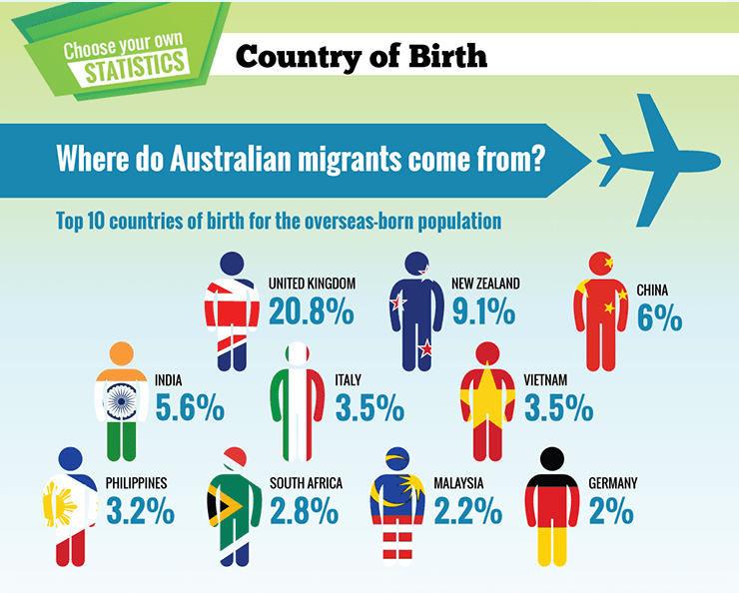
Excerpt from the ‘Country of Birth’ infographic from Choose Your Own Statistics, ABC Splash
Divided students into groups and allocate one of the Top 10 countries to each group. Then, using the computer room, laptops or the library, ask each group to research their assigned country, using the Communities in Australia worksheet to prompt and structure their investigation. Students should then use the worksheet to present a summary of their findings to the class.
As a class, discuss how traditions and cultures vary between the different countries researched. Ask students about their own experiences of different countries and people.
Make a mind map on the board of what each culture has brought to Australia as students share information about their allocatd country.
For a focus on visual learning, ask students to create a poster which reflects the many ways in which the diverse cultures in Australia have influenced our country. For example, students could depict the different types of foods, festivals and art forms present in our society.
Resources:
Communities in Australia worksheet
‘Country of Birth’ infographic, Choose Your Own Statistics, ABC Splash

Class survey
Students design and conduct a survey of students in the school to find out where their ancestors are from.
Compare the results of the class to statistics for the rest of the Australian population. Where have people in Australia come from?
Students can use the following resources to compare the statistics:
- Australia's population by country of birth, Australian Bureau of Statistics
- Australia’s racial diversity — teaching resource from Racism. No Way
- ‘Country of Birth’ interactive graphs, Choose Your Own Statistics

Action activity—acceptance and rejection
This activity aims to help students become more aware of the effects of acceptance and rejection.
You can find the instructions for the ‘Acceptance and Rejection’ activity on page 5 of the Mix It Up Activity Booklet.
After conducting the activity, discuss in either small or large groups some of the responses to the activity, using the following prompts:
- If you tried to join more than one group, compare the two or three experiences.
- Each group had different rules for accepting or rejecting new members. Did you react differently to each group’s set of rules?
- Consider the rules your group had for including or excluding new members. How would you describe these rules? (Were they unfair or fair? Welcoming or unwelcoming?)
- Can you justify your group’s practice for accepting or rejecting members? Explain.
- Can you think of real life social groups that might behave using similar rules to the ones used by your group?
- Have you ever been in a situation where you experienced behaviour similar to what you saw or experienced in this activity? What did you do in that situation?

Conclude the activity by asking students to imagine that the secret handshakes and combinations were actually like languages and customs, and the means by which we understood how to buy things in shops or wait in line.
Pose the question: how would it feel to leave your own country, where you know the language and customs, and have to join new groups in a new country, where you don’t know the secret rules?
Resources:
‘Acceptance and Rejection’, Mix It Up Activity Booklet.

Research Task—Migrant Stories
Use one of the following websites to find a story about a young person or family who has had to leave their country and come to Australia.
- Success stories of Australian Immigration
- Journey of the Hong Hai
- Stories from the National Maritime Museum
- Immigration Place
Describe how these young people feel about who they meet and the ways they try to join in. Write a story about meeting this person. What would you like to find out about their lives?

Resources:
Success stories of Australian Immigration, a series of personal histories compiled by the Department of Immigration and Border Protection
Journey of the Hong Hai, an interactive resource exploring the journey of Vietnamese refugees to Australia by boat (requires an Abobe Flash player)
Stories from our collection, National Maritime Museum
Immigration Place – an interactive not-for-profit website documenting migrant stories

Resources for Sequence 1
Find a summary of all the resources used in this sequence in the ‘Resources’ section at the end of this document.

Sequence 2 — Walking in another person’s shoes

Introduction
In Sequence 1, students thought about their history and culture and how these things make us who we are. In this section they will begin to think about how racism looks, sounds and feels. For many, it may be the first time they think about how it feels to be judged by someone else simply because of the colour of their skin, the language they speak, or the country where there parents were born.
The activities in this sequence help students to think about how racism specifically affects children and young people. The activities encourage students to place themselves in someone else’s shoes and think about how life would be different if they were born to a different family or in different circumstances. Often racism occurs because we fear people who are different from ourselves. It is important to remember that our similarities as human beings far outnumber our differences.

Class Investigation — What is racism?
Initiate a class discussion about what racism is and what it means to treat others unfairly because of their race or cultural heritage.
Explain to students that racism isn’t a new thing. In some ways it has always existed in Australia and throughout the world.
When people are racist they think, act, talk or behave in a way that demonstrates that they think they are more important than someone else, just because of their background. Racism is an ugly part of our history and many communities throughout Australia still struggle with racist behaviours, attitudes and language.
Teacher’s note: In preparation for this class investigation you may wish to refer to this useful guide from Civics and Citizenship Education which outlines some useful “do’s and don’t’s” for conducting constructive conversations about race and racism.
As a class explore the What You Say Matters website. What You Say Matters is a website designed to engage young people with the issues of racism. It is part of the Racism. It Stops With Me website by the Australian Human Rights Commission.
Provide students with some age-appropriate examples of racism.
For example:

- making jokes or negative comments about a particular ethnic group
- calling others racist names or verbally abusing them
- writing racist graffiti in public places
- making offensive comments online
- bullying, hassling or intimidating others because of their race.
- excluding people from groups because they’re ‘different’ or ‘don’t belong’
- physically abusing someone because of their race.

Ask students to make a list of the behaviours and actions that are racist and ask them how often they think these things happen in their school and their community. Discuss how racism can be particularly hard for children and young people.
Screenshot from the What You Say Matters video, Australian Human Rights Commission

Resources:
Dos and don’ts when teaching about cultural differences, from Civics and Citizenship Education
What You Say Matters, Australian Human Rights Commission.

Role Play Activity—playing the game
Involve the entire class in the learning based game called ‘playing the game’ from the Racism. No Way website.
Begin the activity by watching the video on the website, which depicts racial conflict taking place in a high school basketball game.
Form students into groups of 4 or 5 and ask students to think about why the characters in the video acted the way they did and what students would do in their place. Use the ‘playing the game’ focus notes as a starting point to guide student reflection.
Then asks students to discuss in their groups some of the following questions

Discussion questions:
- What are some of the causes of racism shown in the video?
- What are the consequences of the racist remarks made by Glen and Arturo?
- How did Glen feel when he was being called names? How did Arturo feel when he was being called names?
- Did Glen and Arturo know that their name calling was racist behaviour? Why/why not?
- When and why is name calling acceptable/not acceptable?
- How could Glen and Arturo be helped to understand racism?
- What choices did the girls have as spectators?
- Do you think the boys solved their problem? If so, how?
- What do you think will happen next? What do you think should happen next?
Teacher’s note: More discussion questions can be found in the ‘Playing the game’ discussion starters worksheet

To conclude the activity, ask each group to make a short presentation to the class about what they learnt from the video and their discussion.

Teacher’s note: If you feel the content of the video is too mature for Year 5-6 students consider using a similar story told verbally to students about an incident of racial conflict in your school. See the The Soccer Game resource sheet as an example.

Resources:
‘Playing the game’ focus notes, Racism. No Way website
‘Playing the game’ video, Racism. No Way website
‘Playing the game’ discussion starters, Racism. No Way website
The Soccer Game resource sheet

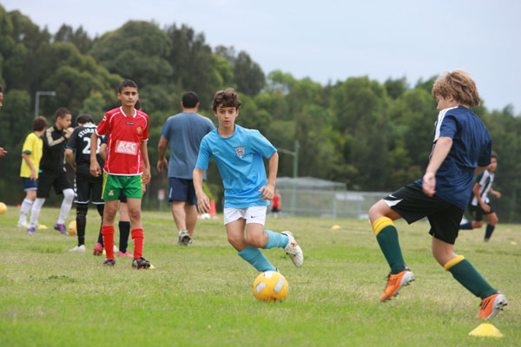
Above: The Soccer Game. Photo by Australian Human Rights Commission
Walking in another’s shoes
As a class activity, discuss how it would feel to be the odd one out in a situation. Pose the following questions to the class:
- How do you think racism could affect you?
- How does it feel to be judged based on how you look?
- How does it feel to be left out?

Teacher’s note: In order to assist students to develop a greater understanding of how racism may feel, the next section in this sequence will introduce the more familiar concept of bullying. Due to effective school policies and media campaigns, many students have a clear understanding of what constitutes bullying. Students may require a revision of the definition of bullying and this is best achieved by using your own school policy in relation to the topic.

Bullying
Lead the class in discussion with the question: What would we call the behaviour displayed by the students from the stories in the previous activities?
Answer: Yes, it is bullying.
Next, pose the question: What is bullying? Does bullying happen in our school?

Y-chart activity
Distribute the Y-chart activity sheet to students, either individually or in small groups (2–3 students). Ask students to fill in the ‘Looks like’, ‘Sounds like’ and ‘Feels like’ sections of the chart with the things they know about bullying. Encourage students to use the ideas discussed in the ‘playing the game’ activity to add to their answers.
You may also wish to use the following video ‘Kids Talk About Bullying’, from the KidsHealth website, as a stimulus to assists students to complete the activity.
Resources:
Y-chart activity sheet
‘Kids Talk About Bullying’, KidsHealth website

Student online activity
Go to the Take a Stand Together website and select one of the interactive videos from the video menu (the ‘video menu’ button is located in the bottom left corner of the homepage). Choose the ending for your video which best reflects someone taking a stand against bullying.
Next, build an avatar and share it with your friends by clicking on the ‘Build your own avatar’ button at the bottom of the avatar gallery.
You can select your own anti-bullying message and send it with your avatar to the online gallery at Bullying. No Way!
Resources:
Take a Stand Together, Bullying. No Way!

Discussion—How is racism a type of bullying?
People can be bullied for many different reasons and we don't always know why bullies choose to behave in the way they do. When people bully others because of their skin colour, culture, language or family background, this is called racism.
In the same way that bullying makes each of us feel sad, upset and embarrassed, people who experience racism feel similar emotions.
Racism, however, is a much bigger problem than people just calling others names in the playground. Racist behaviour can also involve people being refused services, eliminated from selection for jobs or treated differently by law enforcement officers — just because of the colour of their skin or their cultural background.

Class talk-show
Ask for volunteers to be part of a class talk-show and ask them similar questions about bullying and racist behaviour. Other students in the class can be the audience and offer their own questions.
Some example questions about bullying include:
- What is a bully?
- Have you ever seen bullying (please don't use specific examples)?
- How do you think it feels to be bullied?

Some example questions about racism include:
- Why are people racist?
- Who experiences racism?
- Why is racism a problem?

Conclude the discussion by combining the concepts of bullying and racism and asking students why someone might be bullied because of their skin colour, culture, nationality or ethnic origin.

Effects of racism
Part 1 — Brainstorming
Have students divide into groups of three or four with a large sheet of butchers’ paper. One person in the group lies down on the paper and the others in the group draw an outline of their body shape. The person can then get up and the group uses the body outline to write all the ways that racism could affect a person — remember to include how it could feel to be treated in a racist way, what it would look like and how it may sound.
Part 2 — Viewing Activity
Watch the video ‘Racism in Australia’ from All Together Now.
Pose the following questions to the class:
- How is racism described in the video?
- Who suffers from racism?
- Why do you think racism occurs?

Have students add any new ideas that come out of the class discussion onto their group’s piece of paper.
Resources:
Racism in Australia, All Together Now

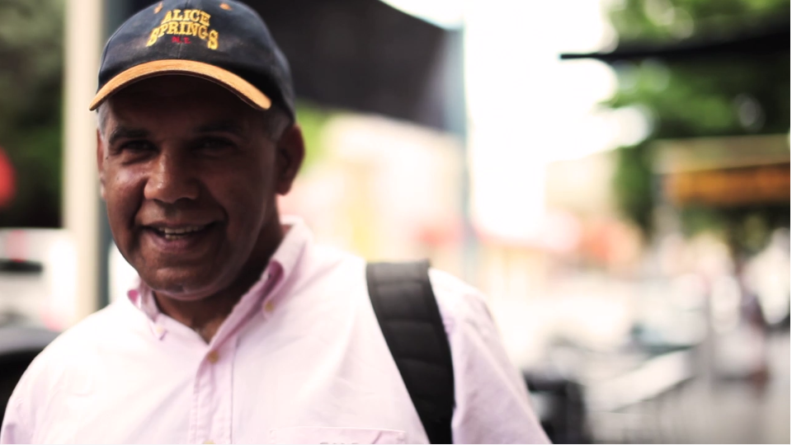
Screenshot from Racism in Australia from All Together Now

Group Activity
Divide students into 5–6 groups. Give each group a starting statement from the following list:
- I don't speak English very well
- I don't understand the customs in Australia
- My skin is a different colour to all the other kids in my school
- I celebrate different occasions
- I speak with an accent
- I attend temple while other kids are out playing

Ask the students to imagine that they are the person making the statement they have been given. Ask the group to list under the statement the ways in which this person may experience unfair treatment or bullying.
Bring the class back together again and ask them to share about their discussion. Ask students to identify which experiences of unfair treatment or bullying were common across several groups and which ones were different or specific to a particular group.

Summative assessment task for Sequences 1 and 2

Task: Take a stand, be informed
Prepare a poster or other visual presentation which features the following concepts that we have studied throughout this unit of work:
- What is racism?
- How does racism affect others?
- A slogan against racism.
On your poster make sure you feature one piece of information related to each of the above concepts. The overall purpose of the poster should be to inform and challenge the people in your school to take a stand against racism.

Achievement Standards
Students should be assessed on their ability to:
- prepare a visually appealing poster which informs and challenges people to take a stand against racism
- demonstrate an understanding of racism
- discuss the ways in which racism can affect other people
- provide details of actions students and community members can take to challenge racism and support those who are victims of racism.

Resources for Sequence 2
Find a summary of all the resources used in this sequence in the ‘Resources’ section at the end of this document.

Sequence 3—Taking action

Introduction
This sequence seeks to teach more about racism, aiming also to move students to a point of action — where they understand that every single person can be part of the solution.
The activities below encourage students to do just that, by exploring the types of campaigns and actions that are already taking place as a lead in to Sequence 4, which empowers students to take a stand against racism.

Campaigns against racism
Many people rightly feel that racism, like bullying, is a very ugly aspect of our society. Governments, organisations and individuals work hard in a range of different areas to teach people about racism and encourage people to be part of the solution. In this sequence students will explore a range of exemplary campaigns, activities and resources which encourage people to speak out against racism and to encourage others to do the same.

Student Web Quest
Teacher’s note: The student Web Quest activity focuses on the Racism. It Stops With Me campaign by the Australian Human Rights Commission. By way of background, Racism. It Stops With Me is an awareness campaign that aims to encourage people to be part of a national movement to prevent racism. Various aspects of the campaign are carefully crafted to address racist behaviours and actions within different areas of Australian society.
The ‘What You Say Matters’ resources are directed specifically toward teenagers and young people. They may not be suitable for all Year 5 and 6 students.

Explore the Racism. It Stops With Me website as a class and discuss the purpose of the campaign. Consider also the area of the website for young people called What You Say Matters (explored earlier, in Sequence 1).
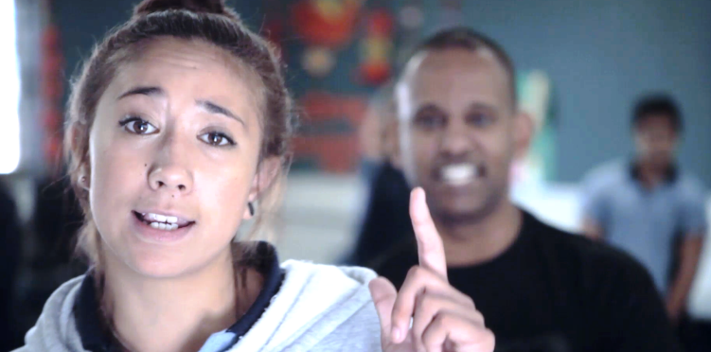
Screenshot from the What You Say Matters video, Australian Human Rights Commission
Ask students to think about both the campaign slogan and the specific youth slogan. Pose the following questions:
- What is the slogan about?
- What do you think it means?
- How can we all be part of the solution for racism in Australia?

Ask students to complete the Web Quest worksheet on the Racism. It Stops With Me website and campaign.
As a class, watch the following advertisement from the campaign.
Follow with a discussion of racism in sport. Pose the following questions:
- Does racism happen in every sport? Does it happen more in some sports than others?
- Have you ever seen anything racist happen during sport?
- Why would racism happen more regularly in sport than other settings?
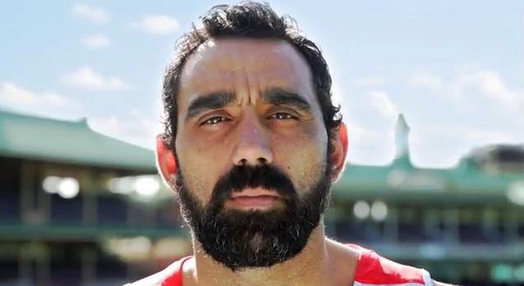
Screenshot from Racism. It Stops With Me. TV commercial featuring Adam Goodes, Australian Human Rights Commission.

Resources:
Web Quest worksheet
Racism. It Stops With Me website, Australian Human Rights Commission
What You Say Matters website, Australian Human Rights Commission
Racism. It Stops With Me. TV commercial featuring Adam Goodes video, Australian Human Rights Commission

Actions against racist bullying

Student research task
Teacher’s note: Prior to commencing the student research task, you may need to research appropriate campaigns for students to use. Consider creating a list for students to choose from. Suggestions have been given in the resources list.
In this activity, students will research actions or campaigns against racism and racist bullying. This should include a focus on actions or campaigns that have been designed to assist students and young people to combat racist bullying.
Begin by asking students to think about campaigns they may have heard about which address racism or bullying. Discuss as a class each suggestion and talk about how these examples may help to combat racism in our society.
Next, divide students into groups of 2 or 3 and then, using the computer room, laptops or the library, ask each group to research a different campaign designed to address racism. (Note that anti-bullying campaigns are only suitable for this task if they contain a specific component designed to address racial bullying.)
Ask students to use the Student research task worksheet to document their findings. When students have completed their research they should complete the ‘What, Where, When, Why’ chart at the bottom of the worksheet.
Students should then use this chart as the basis for a short presentation to the class on the campaign that they have researched. This can be presented in either PowerPoint or Prezi.

Resources:
Student research task worksheet
Prezi, an online tool for creating presentations

Suggested Campaigns
Racism in sport toolkit from Play By the Rules
Racism. No Way, NSW Department of Education and Communities
‘Stop.Think. Respect’ awareness campaign from Beyond Blue
Talk about racism from All Together Now

Taking action—one example
The Close the Gap campaign is a good example of an action which is designed to address racial inequalities within Australia.
The campaign calls for the closing of the gap between Indigenous and non-Indigenous Australians in terms of health status, levels of education, economic status and quality of life.
Teacher’s note: please ensure you have a thorough understanding of this campaign and the related issues before teaching. You can find links to more information about the Close the Gap campaign in the resource list.
Additionally, please watch the video indicated below before showing it to your students. If you feel the content of the video is too mature for your students consider using the Close the Gap video below which was created for younger audiences.
What could 2030 look like?, Close the Gap video from Oxfam
If suitable for your group of students, discuss the inequalities between groups within Australia and watch the following video together.
After viewing, ask students the following questions:
- How does the Close the Gap initiative take a stand against unfair difficulties experienced by Aboriginal and Torres Strait Islanders?
- How might this campaign assist people who are being harassed or bullied because of their race?

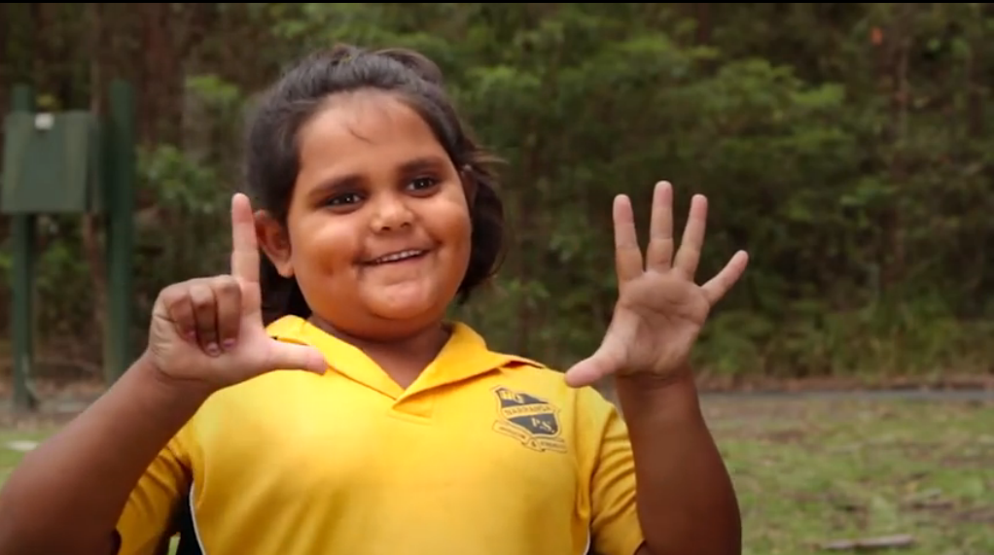
Screenshot from Ending health inequality in a generation video from Oxfam Australia 2014
Resources”
Ending health inequality in a generation, Close the Gap video from Oxfam Australia
What could 2030 look like?, Close the Gap video from Oxfam Australia
Close the Gap: Indigenous Health Campaign, Australian Human Rights Commission
Closing the Gap, Australian Indigenous HealthInfoNet

What could we do?—discussion points
As a class, begin a conversation about the kinds of actions and initiatives students might join, in order to stop racism in school, the broader community or Australia-wide. Students may have ideas based on the campaigns they have researched, or they may suggest other things that they could all be a part of.
Use a short video from All Together Now’s campaign ‘Talk About Racism’ as either an introduction or conclusion to this discussion.
Resources:
Talk About Racism - What can we all do to prevent racism happening?, All Together Now

Resources for Sequence 3
Find a summary of all the resources used in this sequence in the ‘Resources’ section at the end of this document.

Sequence 4—Stand up against racism

Introduction
This sequence looks at ways to allow students to develop their own actions against racist bullying and harassment within their school and community.
The activities in this sequence encourage students to build on what they have learnt in the previous three sequences. With a firm understanding of racism and its effects on individuals within the community students are asked to take a stand against racism and do something about it.
This sequence is closely related to the assessment activities and it is suggested that the assessment tasks be worked into the teaching of this sequence.
Begin by asking students to share the posters they have completed as a summative assessment task for Sequences 1 and 2. Discuss the different ideas that people in the class had in relation to standing up against racism.
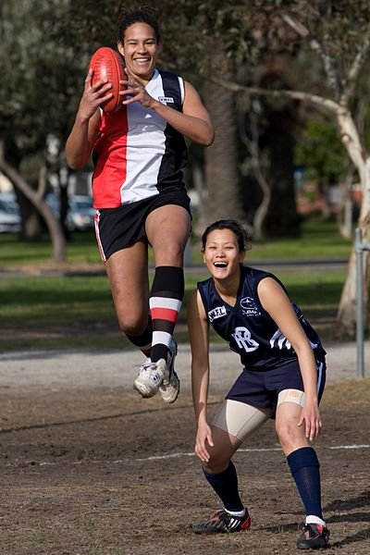
Football players Avril Chow, Phoebe McWilliams and Rachael Achampong, Faces of Australia: DIBP Images on Flickr

Building the story
Ask the class if anyone heard about the racism displayed by fans in the Australian Football League (AFL) in 2013.
As a class, view After Adam pointed the finger, a video produced by The Age, which explores the incident of a young girl shouting a racial slur at AFL player Adam Goodes during a game at the MCG in May 2013.
You may also wish to show the class the following videos to provide context:
- Adam Goodes' response to the racism incident, a video from the Sydney Swans in which Adam Goodes explains his reaction to the racial abuse
- Racial taunt mars Swans' win, a Channel 7 news report which contains footage of the incident.
After viewing, use the following questions for a discussion.
- How do you think hearing those racial slurs felt?
- How did Adam Goodes respond to the slurs? What do you think of his response?
- What can be done about racism and bullying?
- What could be done in school to take actions against racism and bullying? What changes create positive change school?
- How would we get others to follow our example?
- How can standing up for others make a difference?

Resources:
After Adam pointed the finger, The Age, Faifax Media
Adam Goodes' response to the racism incident, SwansTV
Racial taunt mars Swans' win, 7NEWS
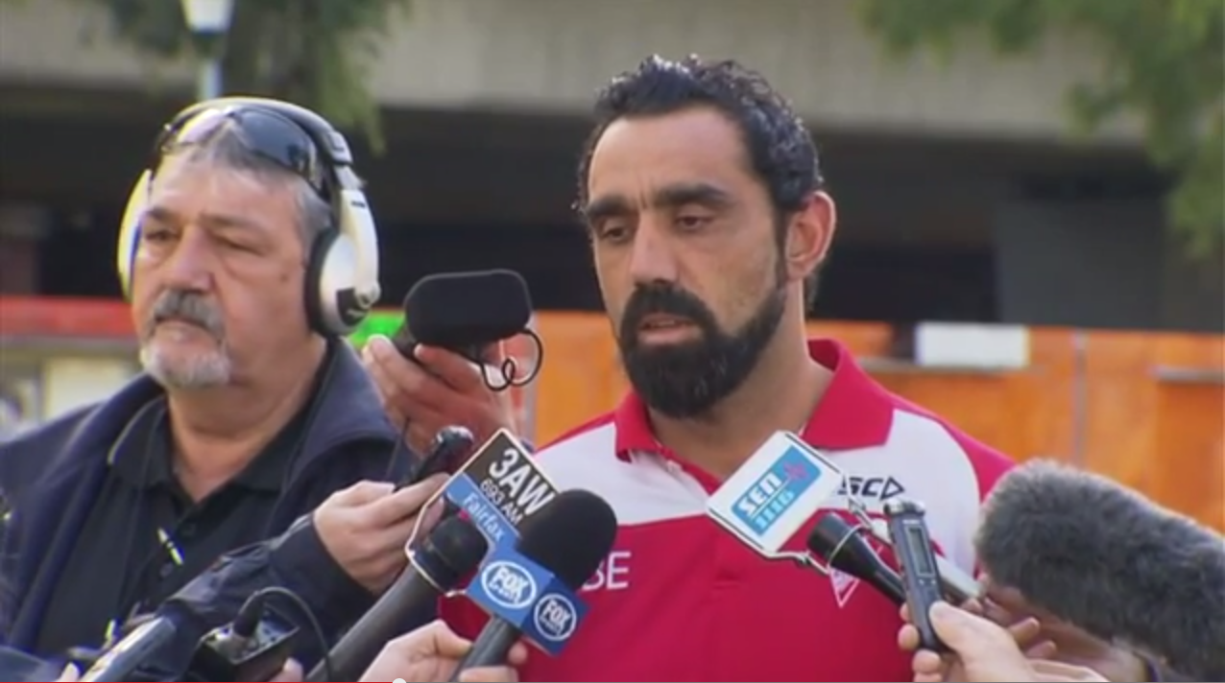
Screenshot from Adam Goodes' response to the racism incident, by SwansTV

Cartoon activity
To begin this activity, explore the ‘Speaking up against Racism’ page on the All Together Now website as a class and discuss ideas and strategies for how students could help others to have a better understanding of the true effects of racism.
Teacher’s note: Please review the content of the All Together Now page before sharing with the class. The information provided is valuable in contributing to student understanding, however, some content may not be appropriate for Years 5 and 6 students.
Next, ask students to design a cartoon depicting a student standing up for someone who is being bullied or harassed about their race. Students should include in their cartoon a conversation with the person who is doing the bullying.
Students can use Bitstrip, an online resource for creating comic strips, or other similar program to turn their ideas into a digital cartoon.
To conclude the activity, discuss why it can be difficult to express opposition to racist beliefs or attitudes, especially against those who are bigger and stronger.
Resources:
Bitstrip, an online resource for creating comic strips
‘Speaking up against Racism’ page on the All Together Now website

Final Assessment Task
(Summative assessment task for Sequences 3 and 4)
We can all take a stand against racism within our school, our community and our country. On our own, we might feel powerless to make a difference to a problem so huge and so historically entrenched, but together we can create change.
The final assessment task for this unit of work requires students to create a campaign which takes a stand against racism. Students can present their task in any format.
As an introduction to this assessment task, have students consider The new campaign to tackle racism in schools video, from ABC News, which looks at the schools campaigns, What You Say Matters and Together For Humanity
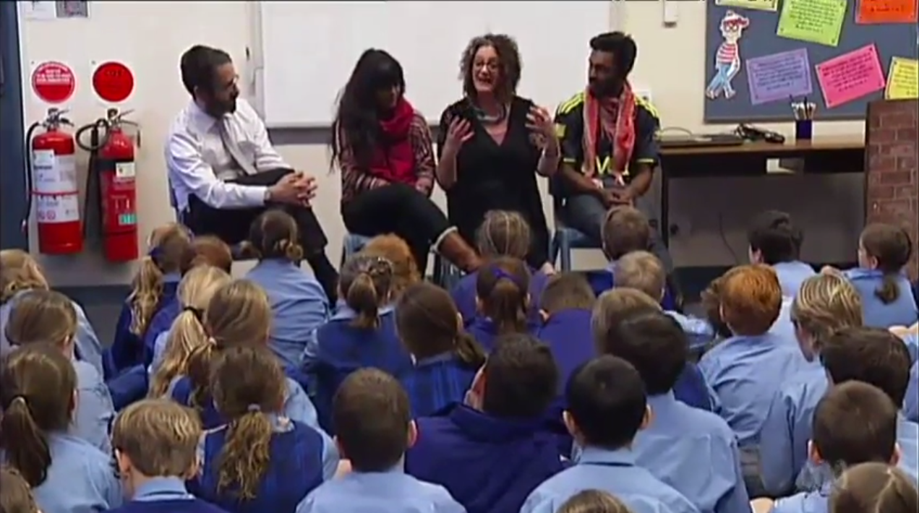
Screenshot from The new campaign to tackle racism in schools, from ABC News

Task: Take a stand — Design a campaign against racism
This task needs to be completed in groups of 3–4 students.
Design a campaign to prevent or stop racism. Your campaign should encourage people in your school to take actions to stop bullying and harassment toward people from different racial, ethnic and cultural backgrounds.
The finished product can be presented in any electronic method including a video, a cartoon or another audiovisual program.
Students can be encouraged to work together to design their own action against racism and if possible this assessment could continue in the weeks following the unit of work.

Achievement Standards
Students should be assessed on their ability to:
- work cooperatively with the other members of their group to achieve the outcomes of the assignment
- design a campaign to prevent or stop racism in their own school.
- demonstrate an understanding of the actions that people can take in order to address racism
- demonstrate proficiency in using information computer technologies in order to present a campaign.

Resources
The new campaign to tackle racism in schools, from ABC News
What You Say Matters website
Together For Humanity website

Resources for Sequence 4
Find a summary of all the resources used in this sequence in the ‘Resources’ section at the end of this document.

Resources for ‘Take a stand against racism’

Introduction
Dos and don’ts when teaching about cultural differences, Civics and Citizenship Education.
The Impact of Racism upon the Health and Wellbeing of Young Australians, the Foundation for Young Australians

Sequence 1 — Understanding identity
- What You Say Matters website, Australian Human Rights Commission
- Missing Irishman found seriously injured five days after morning drinking session, Sydney Morning Herald
- How to design your own human rights teaching activities, Amnesty International
- Your Identity, Your Heritage worksheet
- My Family. My Heritage worksheet
- My Heritage website
- National Library of Australia website
- Australian Heritage Council website
- Cultural Heritage video, Department of Social Services
- Communities in Australia worksheet
- ‘Country of Birth’ infographic, Choose Your Own Statistics, ABC Splash
- Australia's population by country of birth, Australian Bureau of Statistics
- Australia’s racial diversity — teaching resource from Racism. No Way
- ‘Country of Birth’ interactive graphs, Choose Your Own Statistics
- ‘Acceptance and Rejection’, Mix It Up Activity Booklet.
- Success stories of Australian Immigration, Department of Immigration and Border Protection
- Journey of the Hong Hai, National Museum Australia
- Stories from our collection, National Maritime Museum
- Immigration Place website
- Dos and don’ts when teaching about cultural differences, Civics and Citizenship Education

Additional resources for Sequence 1
- Your Identity, Your Heritage lesson ideas from Racism. No Way website
- The United Nations Convention on the Rights of the Child
- Cartoons for children's rights at United Nations Children’s Fund

Sequence 2 — Walking in another person’s shoes
- ‘Playing the game’ focus notes, Racism. No Way website
- ‘Playing the game’ video, Racism. No Way website
- ‘Playing the game’ discussion starters, Racism. No Way website
- The Soccer Game resource sheet
- Y-chart activity sheet
- ‘Kids Talk About Bullying’, KidsHealth website
- Take a Stand Together, Bullying. No Way!
- Racism in Australia, All Together Now

Additional resources for Sequence 2
- Teachers may include the UK-based Brit Kid website and ask students to make their own town with characters from different backgrounds.

Sequence 3 — Taking action
- Web Quest worksheet
- Racism. It Stops With Me website, Australian Human Rights Commission
- What You Say Matters website, Australian Human Rights Commission
- Racism. It Stops With Me. TV commercial featuring Adam GoodesStudent research task worksheet
- Prezi, an online tool for creating presentations
- Ending health inequality in a generation, Close the Gap video from Oxfam Australia
- What could 2030 look like?, Close the Gap video from Oxfam Australia
- Talk About Racism - What can we all do to prevent racism happening?, All Together Now

Additional resources for Sequence 3
- Racism in sport toolkit from Play By the Rules
- Racism. No Way, NSW Deparment of Education and Communities
- ‘Stop.Think. Respect’ awareness campaign from Beyond Blue
- Talk about racism from All Together Now
- Close the Gap: Indigenous Health Campaign, Australian Human Rights Commission
- Closing the Gap, Australian Indigenous HealthInfoNet

Sequence 4 — Stand up against racism
- After Adam pointed the finger, The Age, Faifax Media
- Adam Goodes' response to the racism incident, SwansTV
- Racial taunt mars Swans' win, 7NEWS
- Bitstrip, an online resource for creating comic strips
- Speaking up against Racism page on the All Together Now website
- The new campaign to tackle racism in schools, from ABC News for Australia Network

Additional resources Sequence 4
- Together For Humanity website
- Take a Stand Together ‘Someone I know is being bullied’ page
- Pacer Center’s Kids Against Bullying website (United States)

Worksheets

Sequence 1 Worksheet: Your Identity, Your Heritage
Required equipment: large sheets of paper and pens.
1. In groups of four, list the cultural events that you and your families have participated in.

Identity—Who we are often changes with whom we are with
2. In your group discuss how your behavior, language, presentation (for example: clothes, makeup, jewelry, choice of music) may change depending on the people you are with.
Consider the following people:
- your closest friend(s)
- parents
- grandparents
- the people you admire or look up to at school
- community group (church, sports, dance or music, neighbours)
- your school principal or teachers
3. Discuss: Why do we put on a different hat for different people?

Writing activity
4. On a separate piece of paper, in two or three paragraphs write a description of who you are when you are alone? Do not include your name.
5. Now try writing another description of yourself from someone else’s point of view. Select one person from the list above. Do not include your name.
Place these descriptions into the centre and take it in turns to read some one else’s paragraphs. Is it clear who the person being described is?
Sometimes we think other people have expectations of us that we have to live up to. Sometimes this can be challenging if we do not feel that this expectation is who we really are. This can often cause conflict between family members and within yourself.
6. Think of some examples where you have felt uncomfortable? It may be with a friend who you look up to; it may be with a grandparent or another family member.
At times we are asked to participate in cultural events that may seem insignificant or irrelevant, but there are expectations that you will participate. How do we cope in these situations? Discuss the ideas above as a class.
Discussion topic:
‘Often the less we understand about something the more irrelevant it seems to us.’

The content for this worksheet comes from the Your Identity, Your Heritage lesson on the Racism. No Way! website

Sequence 1 Worksheet: My Family, My Heritage

Draw your family in the space above.

Ask your parents if you can ask them some questions about your family history and heritage. If you don’t live with your parents, ask someone else from your family or someone that you consider family to you.

1. Has our family always lived in Australia? (If yes go to Question 4)

2. If no, when did our family move here and what country did they come from?

3. Why did we (or our ancestors) immigrate? What were the circumstances?

4. If yes to Question 1: Where did our family come from in Australia? Did we come with the settlers or did we always live here? If we were here, which area did we come from and what is the name of our people?

5. Do we have any heritage from other countries?

6. What traditions and celebrations are important in our family? When did they begin?

7. Do we speak another language? Can any of our relatives speak other languages?

Sequence 1 Worksheet: Communities in Australia
1. Country of birth (Which country of birth has your group been given to research?)

2. How many immigrants have moved to Australia from this country?

3. What areas do they live in?

4. What are some significant historical events that have taken place in their country of origin?

5. How have these historical events impacted on immigration from these countries to Australia? (For instance, war or natural disasters)

6. List the celebrations and traditions observed by this community

7. What languages do people from this country speak?

8. List some examples of food that people from this country eat.

Describe some of the ways this community has contributed to Australian culture. (For instance with food, or celebrations or music)

Did you find out any other interesting things about this group of people?

Sequence 2 Resource sheet: The Soccer Game
The Soccer Game. Photo by Australian Human Rights Commission

It was a hot day in early March and as the lunch time bell sounded it triggered an excited explosion of primary school students into the expansive playgrounds. The boys headed quickly for the back oval seeking out Dave. Dave was the boy with the ball, which granted him the highest position in the current school pecking order. The ball was nothing special. Dirty and marked but retaining its tell tale black and white hexagons.
Teams were chosen. Names were called. While the popular students were quickly assigned teams the quieter boys shuffled from foot to foot waiting for their chance to play.
At that moment Shabbir and Asim arrived. They were hot and sweaty from running down the hill from their classroom. Shabbir had once again been kept back for working so slowly in English. Today his temper had gotten the better of him and he had called out strange words in the classroom. The teacher sounded very angry when she asked him to remain behind to discuss the incident.
As the boys eagerly looked around for a team to play on, Dave, the boy with all the power, wandered over. He was accompanied by two of his friends Alex and Ned.
‘You guys can't play today’ said Dave, with an air of authority, then called time to the others. As the game began Asim shrugged at Shabbir and decided to pursue the matter. He called out loudly down the field, ‘Why not eh?’
Dave didn't even break from running before he shouted back ‘Your type are always angry and shouting. We don’t even know what you're saying.’ He looked like he had finished, but then turned to add, ‘Why don't you go and play with people like you?’ The other boys continued playing while some echoed their agreement.
Shabbir’s shoulders dropped and his brow furrowed. He was angry and hurt. He didn’t understand why the other boys were being so mean. Asim understood how hard he found the English words in class, but it didn't seem like anyone else got it.

Discussion questions:
- In this story, how has Shabbir and Asim’s cultural and ethnic background affected how they are treated?
- Is the way they are treated fair/unfair? Why?
- How would you feel if you were excluded because of the language you spoke or where you are from?
- What assumptions have Dave and his friends made about Shabbir and Assim?
- How could Dave, Alex and Ned be helped to understand how their actions made others feel?
- What do you think will happen next? What do you think should happen next?
- What could other students who were watching this conversation do to help Shabbir and Assim?

Sequence 2 Worksheet: Y-chart

Bullying

Looks like

Feels like
Sounds like

Sequence 3 Worksheet: Web Quest

Racism. It Stops With Me

Go to https://itstopswithme.humanrights.gov.au/
- What do you think the ‘Racism. It Stops With Me’ campaign is about?

Go to the ‘What You Say Matters’ section (you will find it in the ‘Resources’ menu). Watch the video on the ‘What You Say Matters’ homepage.
- Describe the different situations shown in the video. What is happening in these siutations?

- How do the people being picked on respond?

- What is the message of the video?

Use the red ‘Find Out More’ menu on the left hand side of the web page to find the answers to the following questions.
- Where does racism occur?

- Why are people racist?

- Why is racism a problem?

End by exploring the ‘What you can do?’ section.

Design the front and back of a bookmark with a clear slogan discouraging racism in your school, using the space below. If there is time your teacher may ask you to create a final version using cardboard for a keepsake.
FRONT BACK

Sequence 3 Worksheet: Student research task

Campaigns addressing racism
As a group find some examples of campaigns which exist to address racism in our society or around the world.
Try to choose those campaigns which have relevance for us in Australia, even if they were made in another country like Canada or New Zealand.
Campaigns found (list all the websites and campaigns you have found)

Now, narrow down your list to one campaign you wish to explore in more detail
Campaign Name:

Complete the following questions using the campaign website or information.

1. What is the slogan for the campaign?

2. What does the slogan mean?

3. Does the campaign encourage people to take action? If so, what action?

4. Does the campaign address a specific kind of racism? If so, what kind?

5. In which areas does the campaign take place?

6. What do you like about the campaign?

Once you have finished your research, complete the ‘Ws Chart’ below to prepare for your PowerPoint presentation to the class.

What | When
Where | Why

