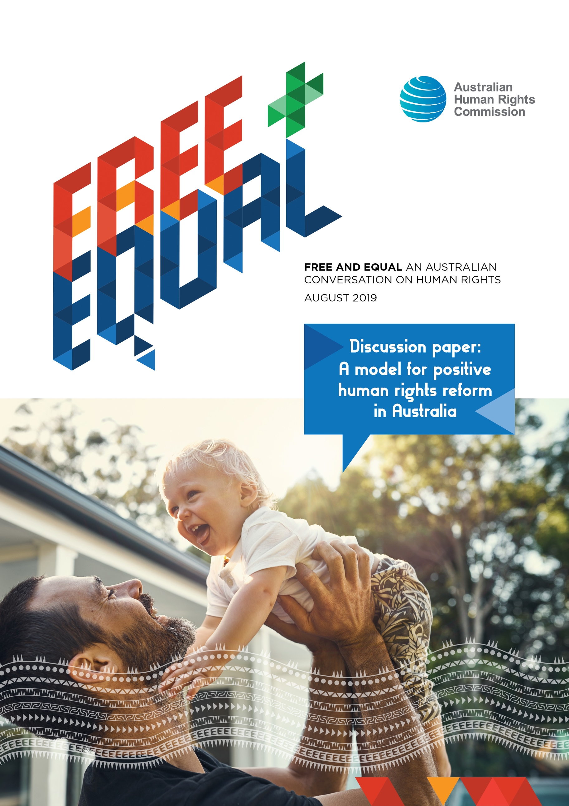
© Australian Human Rights Commission 2019
The Australian Human Rights Commission encourages the dissemination and exchange of information provided in this publication.
All material presented in this publication is provided under a Creative Commons Attribution 3.0 Australia, with the exception of:
- photographs and images;
- the Commission’s logo, any branding or trademarks;
- content or material provided by third parties; and
- where otherwise indicated.
To view a copy of this licence, visit http://creativecommons.org/licenses/by/4.0/legalcode.
In essence, you are free to copy, communicate and adapt the publication, as long as you attribute the Australian Human Rights Commission and abide by the other licence terms.
Please give attribution to: © Australian Human Rights Commission 2019.
FREE AND EQUAL An Australian conversation on human rights 2019
ISBN 978-1-925917-13-0
This publication can be found in electronic format on the Australian Human Rights Commission’s website at: https://www.humanrights.gov.au/our-work/publications/
For further information about the Australian Human Rights Commission or copyright in this publication, please contact:
Australian Human Rights Commission
GPO Box 5218
SYDNEY NSW 2001
Telephone: (02) 9284 9600
Email: communications@humanrights.gov.au
Website: www.humanrights.gov.au
Design and layout Dancingirl Designs
Graphics We Are 27 Creative
Photography iStock

Contents
What are the options for reform? 6
Join the conversation 7
What current human rights protections exist? 8
The Constitution 8
Federal discrimination laws 8
Common law 9
State and territory human rights protections 10
Parliamentary scrutiny of human rights 11
Australian Human Rights Commission 12
International law 13
A federal Human Rights Act 15
Why is it needed? 15
What would it achieve? 15
What model could work? 17
What are the main objections? 20
Additional or alternative protections 22
Introducing human rights obligations for policy and law makers 23
Incorporating human rights into administrative law 24
Developing a human rights culture in the public service 24
Incorporating human rights into statutory interpretation 25
Reforming tort law 26
Enhancing the Commission’s human rights functions 26
Indigenous recognition, representation and reconciliation 27
Enhancing parliamentary review and oversight mechanisms 27
Establishing an obligation for business to conduct human rights due diligence 28
Enhancing engagement with international human rights processes 28
Recognising economic, social and cultural rights in practice 29
Enhancing public education and human rights resources 29
Strengthening the operation of federal discrimination laws 30

This year, the Australian Human Rights Commission is undertaking a major project: ‘Free and Equal: An Australian conversation on human rights’ (the National Conversation). Through the National Conversation, the Commission is working to identify what principles and key elements would make up an effective system of human rights protections for 21st Century Australia. Its findings will inform a comprehensive reform agenda to modernise human rights protection for all.
Australian Governments have ratified human rights treaties on behalf of Australia, and therefore have an obligation to respect, protect and fulfil the human rights of all people in Australia. While some of our international human rights commitments have been enshrined in domestic law, many implementation gaps remain.
In our current system, governments are not always required to make decisions that uphold human rights. Political or economic justifications can easily override human rights, without being tested. There are also minimal protections in place to ensure that the government considers our human rights as part of everyday law and policy making, and takes steps to prevent breaches before they occur. There are limited avenues to seek review of government decisions or actions that violate a person’s human rights.
Often, existing legislative protections frame human rights in the negative rather than the positive. That is, the law narrowly sets out what the government or others cannot do. There is no holistic recognition of our human rights, no positive duty to consider human rights when making decisions, and no process by which to do so. There is also no guidance provided when decision-makers have to balance different human rights.
As a result, our fundamental rights and freedoms are not fully protected or realised. At times, this has led to unfair, unjust or unequal treatment without appropriate recourse or consequences.
Recent public discussions about how far government and private action should be able to limit freedom of speech, freedom of religion, the right to equality and a person’s privacy, are examples of areas where there is no legal framework to resolve complex tensions between fundamental rights and freedoms.
For example, there are very limited grounds to challenge the validity of intrusive police raids conducted on the home and offices of journalists. A right to freedom of speech and a right to privacy would help ensure that national security measures are legitimate, proportionate and limit our free press to the least restrictive degree.

Closing the fundamental gaps in our protection of human rights would enhance dignity, freedom and equality for all members of the Australian community. Reformed protections would work alongside our strong traditions of liberal democracy including the rule of law, separation of powers and free press. They would complement or bolster existing protections in federal discrimination laws, the common law and our Constitution. They would equip the community with tools to challenge government decisions that adversely affect their rights. There are a number of options that Australia has to better protect our fundamental rights and freedoms.
The strongest legal protection would be through a constitutional bill of rights. Another option, supported by the Commission, is a principled, comprehensive and enforceable federal Human Rights Act. Other possible measures include reforming existing laws, policies, decision-making frameworks and other processes, to strengthen human rights consideration and scrutiny.
This paper outlines what our current system of human rights protections looks like, how it is and isn’t effective in ensuring that government respects, protects and fulfils our human rights, why reforming the current system is critical, and options for reform. The case studies throughout show how more fair and equal outcomes can be reached when human rights are protected by law, or instances where there are currently gaps in protection. It provides a basis for members of the public, business sector, NGOs, the legal community and others to submit their views on the proposals contained in this paper, or on other ways to better protect human rights in Australia.

What are the options for reform?
There are a range of views about the best way to protect and promote human rights in Australia. These include through a constitutionally entrenched bill of rights, a new form of statutory protection or other legislative reform. There is no one option for reform that is a panacea.
What is clear is that the status quo is inadequate. Australia has an inadequate legal patchwork of human rights protection that does not fully implement international obligations agreed to by our government. Individuals cannot access enforceable remedies when their rights have been breached and rights and freedoms are too easily ignored or dismissed.
A variety of improvements can be made to our laws, policies, governance systems, decision-making frameworks and public service culture, that would strengthen human rights protection in Australia.
The Commission has long considered that strengthened statutory human rights protection through a Human Rights Act is the most appropriate model for Australia, with considerable support from other human rights experts and the public.
For example, in 2009 the Federal Government appoint a committee, led by Father Frank Brennan, to conduct a nation-wide human rights consultation. This was the largest public consultation in Australian history, receiving 35,000 written submissions and holding 66 public roundtables across the country. The consultation concluded that a federal Human Rights Act was the best model of human rights protection for Australia.
Notably, human rights are best protected by a mutually enforcing system of laws, policies and institutions. Building a strong culture of human rights is also essential, both within and outside the government, to ensure that our rights are valued and realised in practice.

Join the conversation
The Commission seeks input on the options provided in this paper for building a culture and legal framework that proactively protects human rights at the national level.

DISCUSSION QUESTIONS
Please provide any comments on the options identified in this paper for better protecting human rights at the national level. For example:
- Do you consider the options proposed are the most important reforms that could be undertaken to better protect human rights?
- Do you have comments about how the options identified might work in practice?
- Are there other options not identified in the paper?

You can make a submission to the Commission on this paper through the online submissions form on our website.
Everyone is invited to take part. We want to hear your vision for the future. We want to hear about how to better respect, protect and fulfil human rights in Australia, to make our lives better and our communities stronger.
The deadline for receiving submissions on this paper is 5pm on 15 November.

What current human rights protections exist?
Our domestic law is far from comprehensive in its implementation of Australia’s human rights commitments. This has led to a situation where domestic law and policy can clash with international human rights obligations.
The Australian Constitution, the common law, federal and many state laws offer limited protection. While there has been some forward movement, legal change has not been cogent, cohesive, or timely enough to properly protect our fundamental rights and freedoms. Many gaps remain.

The Constitution
The Australian Constitution dates back to 1900. It was drafted in the 1890s, before the time of international human rights treaties that recognised the rights of all people equally. Its concerns were largely about the relationship between the Commonwealth and the States. Fundamental human rights were considered best left to the protection of the common law and Parliament. While intended to be a living document, the Constitution does not always keep pace with changes to Australian society.
The protections in our Constitution operate to invalidate any law that prevents the enjoyment of certain, limited rights. These include:
- the free exercise of religion
- a trial by jury for indictable federal offences
- the implied right to freedom of political communication
- the implied right to vote
- a prohibition against discrimination because of the state in which a person lives
- a prohibition against not providing compensation on just terms for the compulsory acquisition of property by the Commonwealth.

Federal discrimination laws
Federal discrimination laws make discrimination on the grounds of race, sex, disability, age, and sexual orientation, gender identity and intersex status unlawful. The laws prohibit direct and indirect discrimination, which includes where a condition or requirement has an unfair effect on people with such protected attributes.
It is unlawful to discriminate on the basis of race in all areas of public life. Discrimination on the basis of sex, disability and age is only unlawful in prescribed areas such as employment, education, access to premises, the provision of goods and services, and the administration of Commonwealth laws and programs.
Complaints of unlawful discrimination can be brought to the Australian Human Rights Commission, which will investigate and attempt to seek a resolution through conciliation. If a complaint cannot be resolved in this way, a person may be able to bring their matter to court. A court can award remedies including damages in cases of unlawful discrimination.

EQUALITY FOR SAME-SEX FAMILIES
Sometimes our laws do not keep pace with human rights and social change, permitting unfair treatment and hardship. Only since 2013 has federal law made it unlawful to discriminate against a person on the basis of their sexual orientation, gender identity or intersex status. However, this law still allowed the prevention of same-sex marriage, which only became legal in 2017. Until Parliament decided to change the law, many Australians could not marry the person they loved. They may have also faced different legal, financial and other treatment with no avenue for challenge. Prior to the amendments, a legal right to equality and non-discrimination would have provided stronger protections for same-sex couples and families.

Common law
The common law recognises a limited number of rights and freedoms. Some key common law rights and protections include:
- fair trial rights, including:
  - the right to legal representation
  - the privilege against self-incrimination
  - a presumption of innocence in criminal trials
  - a presumption that the standard of proof in criminal cases is beyond reasonable doubt
- freedom of movement
- prohibitions on trespass (which partially protect the right to privacy)
- the right to sue in tort (for example for false imprisonment)
- a presumption against retrospective laws
- the rules of natural justice.
However, these rights can be overridden by statute at any time and without adequate consideration and justification as long as the Parliament is clear about it. Their evolution also depends on cases being brought to court.
Some general rules of common law and principles of statutory interpretation are protective of human rights. For example, the High Court has held that statutory interpretation must ‘favour construction [of a statute] which is in conformity and not in conflict with Australia’s international obligations’.
The principle of legality also presumes that Parliament ‘does not intend to interfere with common law rights and freedoms except by clear and unequivocal language’ and that ‘statutes be construed … to avoid or minimise their encroachment upon rights and freedoms at common law.

Independence and dignity in aged care
In the UK, some aged care homes placed all their residents in ‘tilt-back’ chairs, to reduce the risk of falls. However, these chairs also prevented many residents who were otherwise mobile from getting out of the chair and moving freely. Rather, they had to wait for staff to assist them to leave the chair, limiting their dignity and independence. A human rights organisation raised with the aged care home that use of the chairs risked violating residents’ rights to private life, and not to be subject to inhuman or degrading treatment. Both these rights are protected under UK law. The homes reformed their blanket policy on using tilt-back chairs, to no longer place mobile residents in such chairs and encourage the use of walking aids around the home. Without the UK Human Rights Act, this potentially degrading treatment might have continued. In Australia, there are no equivalent legal protections in federal law.

State and territory human rights protections
Human Rights Acts have been passed in Victoria, the Australian Capital Territory and most recently Queensland. These acts bind the relevant state and territory public authorities, including government departments, statutory authorities and public servants.
Common features of state and territory Human Rights Acts, such as the Charter of Human Rights and Responsibilities Act 2006 (Vic), include that:
- public authorities must act compatibly with human rights and properly consider human rights in decision-making
- before passing a law, Parliament must consider how proposed legislation will affect human rights
- courts must interpret legislation consistently with human rights
- a person can make an application to a court seeking remedies where their human rights have been breached, except for damages.

Safety and wellbeing of children
In Anyar v Commissioner for Social Housing (2017), the Australian Capital Territory (ACT) Civil and Administrative Tribunal found that a family’s human rights, in particular the protection of a young child with special needs, were unreasonably interfered with by a decision to remove them from the High Needs Housing list. These were rights expressly protected by the ACT Human Rights Act.
Ms Anyar was a single mother relying on Centrelink benefits, caring for four children. Her daughter suffered from dermatitis and eczema which was being made worse by the carpet in their current social housing. Ms Anyar was initially on the High Needs Housing list but rejected two offers of alternative accommodation as they were not suitable for her daughter’s medical condition. As a result, she was removed from the list. The Tribunal found that only properties without carpet should be considered valid housing offers to Ms Anyar. It directed that her name be returned to the list. It also recommended that the Department adjust its policies, to ensure consideration of human rights as a routine part of decision making.

Parliamentary scrutiny of human rights
Since 2011, new Bills and certain legislative instruments must be assessed for their compatibility with human rights. A member of Parliament who introduces a Bill must prepare a Statement of Compatibility, justifying any limitations on individual rights and freedoms.
This is an important mechanism which helps Parliament consider the human rights impacts of a law before it is passed. However, these statements are largely educative. They can inadequately justify a breach of human rights. They cannot be challenged and do not bind a court or tribunal. They do not affect the validity, operation or enforcement of a Bill.

The Commonwealth Parliamentary Joint Committee on Human Rights (PJCHR) is also empowered to examine Bills and legislative instruments for compatibility with human rights. It can also examine current laws and inquire into any matter referred to it by the Attorney-General. In exercising these functions, the PJCHR must report its findings to both Houses of Parliament.
The PJCHR process can assist Parliament to consider the human rights impact of a Bill in more depth. Statements and reports of the PJCHR may also assist a court in interpreting legislation, where the meaning of a provision is ambiguous. However, the PJCHR cannot compel Parliament to alter or abandon a Bill, law or policy even if it is incompatible with human rights.
The Commission has expressed the concern that the findings of the PJCHR are rarely taken into account by Parliament. In many instances, bills are voted upon prior to the PJCHR tabling its views meaning that identified human rights concerns are not brought to the attention of parliamentarians until it is too late to consider the implications of this.

Australian Human Rights Commission
In 1986, the Federal Parliament established on a permanent footing what is now the Australian Human Rights Commission. The Commission was established at the same time that an Australian Bill of Rights Act was introduced into Parliament and was intended to be the body that administered this law. Together, these steps were supposed to domestically implement Australia’s obligations under the ICCPR.
Australia is a signatory to seven core international human rights treaties, including the International Covenant on Civil and Political Rights (ICCPR). Under these human rights treaties, governments are obliged to respect, protect and fulfil human rights.
However, a Bill of Rights was not ultimately adopted, leaving a gap in the architecture and work of the Commission.
Presently, the Commission can inquire into and attempt to conciliate individual complaints of unlawful discrimination, equal opportunity in employment (the ILO 111 jurisdiction) and other breaches of human rights. It can also hold public inquiries and consultations, including to address systemic human rights or discrimination issues of national importance. It can undertake research and education to promote human rights.

The Commission may report to the Minister on laws that should be made or action the government should take on human rights or compliance with Australia’s international human rights obligations. In legal cases involving human rights issues, the Commission has a power to intervene and make submissions with the leave of the court.
However, the Commission’s ability to resolve human rights complaints can be very limited. Unlike complaints alleging unlawful discrimination, if the Commission cannot conciliate a human rights or ILO 111 discrimination complaint, the person cannot then bring court proceedings. Rather, if the Commission finds a breach of human rights it can report to the Attorney-General. Any recommendations made by the Commission are non-binding and are not enforceable by the courts.
In effect, human rights complainants can be left at the end of a pathway with nowhere to go. While they have been able to make a complaint to the Commission, the result is a non-binding report which in many cases is ineffective in achieving true justice or reform.

International law
The obligation to respect human rights requires that governments, through their own actions, do not breach human rights and ensure remedies are available for breaches by governments and public officials. The obligation to protect human rights requires governments to take actions to prevent others from breaching human rights and ensure accessible and effective remedies are available if rights are breached. The obligation to fulfil human rights requires governments to take positive actions to fully realise the equal enjoyment of human rights.
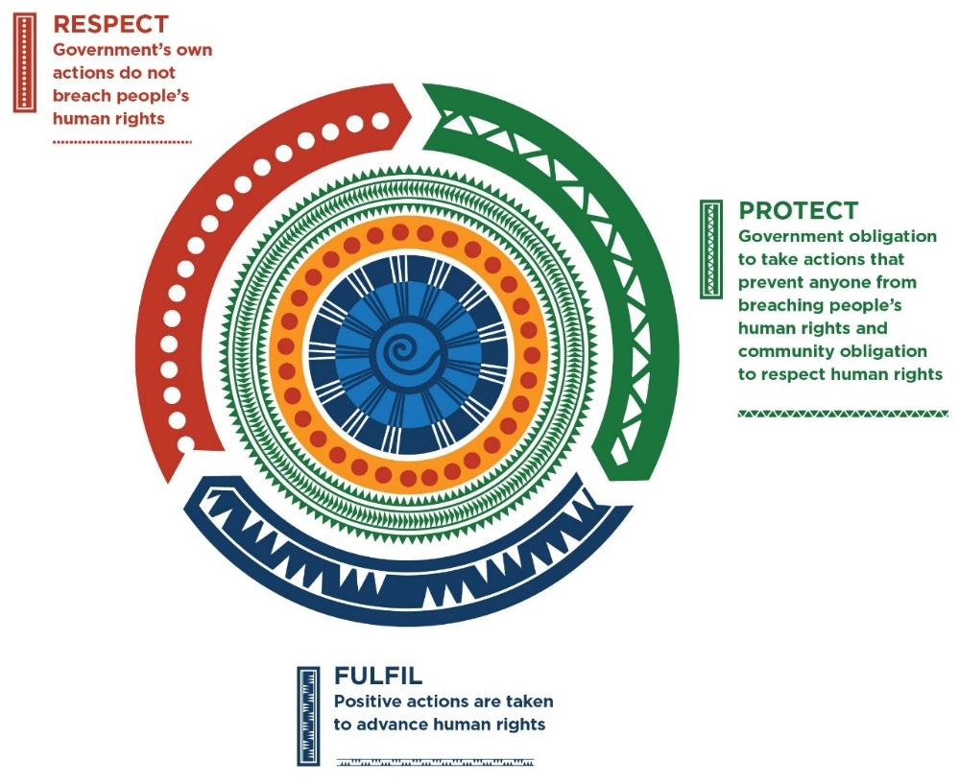

However, Australia is the only common law legal system in the world without a constitutional Bill of Rights or a national Human Rights Act by way of domestic implementation of these voluntary commitments.
This means Australians are unable to legally enforce the obligations assumed by our government under these treaties, needing to rely on complaints to the Commission, as a precursor to complaining to certain international bodies if the Commission cannot resolve the complaint. For example, the United Nations Human Rights Committee can hear individual communications relating to breaches of the ICCPR. However, the decisions of such bodies are not binding on Australia and can and have be ignored.
Other international processes also offer little recourse for victims of human rights violations by Australia. Recommendations made by United Nations special rapporteurs and resolutions passed by the United Nations Human Rights Council are also unenforceable.

A federal Human Rights Act

Why is it needed?
An Australian Human Rights Act would help fix the incomplete human rights architecture in our legal system. It would close many current gaps in protection in a consistent, principled and comprehensive way. For example, human rights protection should not depend on where you live. A federal Human Rights Act could harmonise protection for all Australians by reference to one law.
It would complement our existing yet inadequate human rights protections in law and policy, by requiring that decision-makers consider and act in accordance with human rights. It would provide accountability mechanisms where this has not occurred. It would frame human rights protections in the positive rather than the negative, and help meet our international human rights commitments.

Harmful treatment of vulnerable parents
ParentsNext is a compulsory program that affects certain families relying on the Parenting Payment. Under the program, parenting payments can be automatically and immediately cut off if a parent does not attend prescribed activities. As a result, children and their parents have been left without adequate money for food, shelter and other necessities. Single mothers and Indigenous Australians have been the most detrimentally impacted. This program is inconsistent with a person’s right to social security, the right to equality and non-discrimination and children’s rights. It risks exacerbating poverty and unemployment for vulnerable families. However, without a Human Rights Act there is no avenue to challenge its operation on these grounds.

What would it achieve?
A Human Rights Act would improve law and policy development by requiring proactive, upfront consideration of human rights impacts at an early stage. This would help ensure that the human rights impacts of decisions are properly considered, improve the quality and transparency of decision-making. Human rights breaches could be prevented in advance, ahead of any dispute. There would be a reduced need for people to apply to make a complaint to the Commission or apply to a court to enforce their rights.
A Human Rights Act would enhance the design and delivery of public services. It would support decision-makers to consider human rights in a way that is more appropriate to individual circumstances, rather than taking a blanket approach when making a decision that affects a person’s rights and freedoms. For example, a person’s religious practices would need to be considered when delivering aged care. It would help make public services more accessible and fairer for all.
A Human Rights Act would provide a framework for decision-makers to balance human rights when they are in conflict. It would set out a proportionality test to govern when a limitation on human rights is permitted. For example, it is appropriate to limit freedom of expression if one person is racially vilifying another. The test would take into account all the relevant circumstances, including whether there are other less rights-intrusive measures available to achieve the intended purpose of the law or policy.
A Human Rights Act would help embed a fair, respectful and inclusive culture of human rights in government. It would require decision-makers and public servants at all levels to be aware of their human rights obligations and how to comply. It would make rights protection a core part of government business, not just an afterthought.

Consent to medical treatment
In PBU & NJE v Mental Health Tribunal (2018) the Victorian Supreme Court found that electroconvulsive treatment (ECT) ordered against patients’ wishes is a breach of human rights. Two patients who suffered from schizophrenia had been ordered by authorized psychiatrists to receive involuntary ECT. The court held that the test of informed consent in the Mental Health Act 2014 (Vic) must be interpreted and applied in a way that is compatible with human rights, specifically the right to self-determination, to be free of non-consensual medical treatment and to personal inviolability. The non-consensual orders for ECT were overturned for both patients.

A Human Rights Act would give effect to Australia’s voluntarily adopted human rights commitments under international law. Australians would be able to turn to domestic institutions for the protection of their fundamental rights and freedoms. It would improve our standing, credibility and regional leadership on human rights in the Asia Pacific and international stage.

A Human Rights Act could reduce social and other costs, providing economic benefits for Australians. Social policies that are compliant with human rights can improve equality of access, for example to health services and social security, in turn reducing longer-term costs. Improved access to education and employment can aid workforce participation and economic growth. By considering the human rights impacts of a proposed law or policy upfront, there is also a reduced likelihood that decisions will breach human rights and therefore the risk and costs of court action.

What model could work?
There are many models and options for a Human Rights Act, noting that Australia is the only Western liberal democracy without some form of comprehensive legal protection of human rights. Appendix 1 sets out how some other jurisdictions have approached their legal protections for human rights.
Based on existing models in comparative jurisdictions, some key elements of an effective ‘dialogue model’ Human Rights Act would include a set of protected rights, a test for limiting human rights, obligations on public authorities, obligations on courts, consequences for incompatible laws, a cause of action, and effective remedies. A dialogue model means that courts could not strike down laws that are incompatible with human rights, only refer them back to Parliament for review. Parliamentary supremacy is assured.
A Human Rights Act would set out a list of protected rights. These could be based on rights already recognised in our common law and international commitments, for example the ICCPR.
A Human Rights Act would set out a proportionality test for when a human right can be limited. International law recognises that most human rights are not absolute. That is, many human rights can be limited if the limitation is lawful, reasonable, proportionate and demonstrably justified by government. This allows for consideration of competing interests such as public health and safety.

The right to family in aged care
Dora and Simon had been married for 59 years. Dora was blind and had recently developed Alzheimer’s disease. She and Simon were injured in a fall at home, and he was no longer able to care for her. During this time, Dora was moved into a local publicly funded nursing home. It became clear that Dora would have to stay in a nursing home, but Simon visited her every day. However, their relationship was threatened when the local authority decided to move Dora into a home that was too far away for Simon and their children to visit. Simon challenged the decision to move Dora on the basis that their right to family life under article 8 of the UK Human Rights Act was threatened. This helped Simon persuade social services to allow Dora to remain in the nursing home close to her family and to Simon.

A Human Rights Act would require the government to give proper consideration to human rights and act compatibly with human rights. This obligation would apply to Ministers, public servants and bodies charged with delivering public services.
A Human Rights Act would require courts to interpret and apply legislation consistently with human rights. It would help our law develop consistently with human rights, and ensure that court proceedings are conducted in a way that is compatible with human rights.

Access to justice
In Matsoukatidou v Yarra Ranges Council (2017), the Supreme Court of Victoria found that a court or tribunal must assist a self-represented party with a disability to effectively participate in a hearing. The applicant had attempted to appeal a decision of the local council about her home. The applicant suffered from a learning disability. She misunderstood the nature of the proceedings, the applicable legal test, and was not given an adequate opportunity to make her submissions. As a result, her appeal was struck-out. The Court found that the right to equality under the Charter applied to the practice and procedure of courts, positively obliging judges to make reasonable adjustments and accommodations to ensure equal access to justice. The appeal was sent back to the County Court to be reheard.

A Human Rights Act would require Parliament to pass laws that are compatible with human rights, or otherwise issue an ‘override declaration’. An override declaration would be required to provide strong justification as to why human rights protections should be displaced in the proposed law, and be subject to parliamentary and public scrutiny.
A Human Rights Act should allow a person to make a human rights complaint to the Commission, as is currently possible for a breach of ICCPR rights, but by reference to the human rights protected in the Act. In many cases the Commission’s investigation and conciliation service could assist to successfully resolve a dispute without going to court.
A Human Rights Act should also provide a cause of action to a court. While conciliation is effective and useful, it is also critical that there are legal avenues for individuals to challenge laws and government action that are not consistent with their human rights and freedoms. In this way, a person can seek different and enforceable outcomes when their rights have been breached. Judicial oversight will enhance accountability and quality of decision-making. The most rights protective option would be a stand-alone cause of action, allowing a person whose rights have been breached to apply directly to a court or tribunal. Alternatively, a restricted cause of action could be available when attached to a separate, existing legal claim.
A Human Rights Act should provide a range of enforceable remedies where a public body has breached human rights. Australia is required under the human rights treaties it has signed to provide effective remedies for a breach of human rights, including appropriate compensation. Such remedies could include compensation, guarantees of non-repetition, an apology or orders that certain action be taken, such as training.
A Human Rights Act should protect all human rights. Full implementation of Australia’s international commitments requires not only the protection of civil and political rights, but also the progressive realisation of economic, social and cultural rights to the maximum of Australia’s available resources. Enforcement mechanisms for these rights could ensure that appropriate discretion is left to the government to allow decision-making about resource allocation, and would be subject to any constitutional limitations.

Protecting Aboriginal cultural rights
In Cemino v Cannan (2018), the Victorian Supreme Court found that a magistrate was required to take into account a person’s right to equality and cultural rights, in particular the right held by Aboriginal persons to their identity and culture, in considering where to hold a sentencing hearing. A 22-year-old Yorta Yorta man had requested that his matter be heard in the Koori Court, a culturally-sensitive forum where local elders help determine an appropriate punishment. The magistrate’s decision to refuse to transfer the case to the Koori Court was quashed. The Court ordered that the transfer application be reheard, in accordance with the Charter.

What are the main objections?
Over time, many arguments have been made against a Human Rights Act. These include that: our current protections are adequate, parliamentary supremacy will be undermined, power will be transferred to judges, there will be more litigation and that certain rights will be undermined, such as freedom of religion and belief. The Commission considers that none of these objections are necessarily correct or compelling.
It is true that many people in Australia already enjoy a relatively high standard of living. However, history shows that our current system has not always been effective or adequate, especially for vulnerable and marginalised members of the community. In addition, any one of us could move from a situation where our rights are currently well protected to one where we are more vulnerable—for example through sudden illness, accident or unemployment. New human rights challenges will also continue to emerge, for example in relation to technological change, Australia’s ageing population, and the effects of climate change. We should strive for, and lay the foundations of, a fairer and more inclusive future Australia for all.

Human rights and new technologies
Unprecedented and rapid technological change has already significantly affected our human rights. This change presents significant challenges for the government and wider community, and our laws have struggled to keep pace. For example, the use of algorithms to target jobs ads on the basis of age, or other exclusionary criteria, may mean that older people are excluded from employment opportunities. Such examples highlight the potentially unfair outcomes of AI-informed decision-making. Submissions made to the Commission’s current Human Rights and Technology Project have identified the need for a principles-based, technologically-neutral human rights legislation as part of a regulatory framework.

A Human Rights Act would be an ordinary and democratic Act of Parliament passed by our elected representatives through usual parliamentary process. It would not be a higher law that sits above all else. Under a dialogue model, judges would not have the power to invalidate non-compliant laws. Rather, Parliament would be required to reconsider the problematic aspects. Under a Human Rights Act, courts would be doing the kind of work they always do—interpreting legislation and balancing competing interests in applying the law.
By embedding human rights considerations into government decision-making, the Act could prevent human rights problems from arising in the first place. In turn, this could reduce the risk of litigation. The Commission would also act as a forum for resolving complaints through conciliation, without going to court. Comparable jurisdictions such as the United Kingdom have not seen a substantial increase in litigation since its Human Rights Act.
A Human Rights Act would protect all included human rights, including the right to equality and the right to freedom of religion and belief. It would provide a framework to help balance the interests of LGBTIQ and religious communities in Australia, through setting out a test for when human rights limitations are permitted. Further, by way of exception, similar to federal anti-discrimination laws, some public authorities could be prevented from making decisions that would impede a religious body from acting in conformity with its religious doctrines, beliefs or principles.

Additional or alternative protections
While the passage of a Human Rights Act would afford the strongest protection, many other complementary or alternate measures can be taken to enhance human rights protection in Australia. These can be achieved through reform of our existing law, policy or non-legislative processes. The Commission invites comment on the below options for reform, and any other ideas to better strengthen the protection of human rights in Australia.
Notably, the nature of human rights obligations means that there is often no one single action that can fully protect human rights or remedy a breach of human rights. This often requires a variety of actions ranging from legal protections, complaint and compensatory procedures, education, community-based programs and social services, for example. Because human rights aim to protect people’s essential dignity and ensure fairness of treatment, it is especially important to ensure that there is a strong focus on prevention of breaches of human rights from occurring in the first place.
The table below provides examples of how different measures can be adopted and work together, to respect, protect and fulfil human rights.
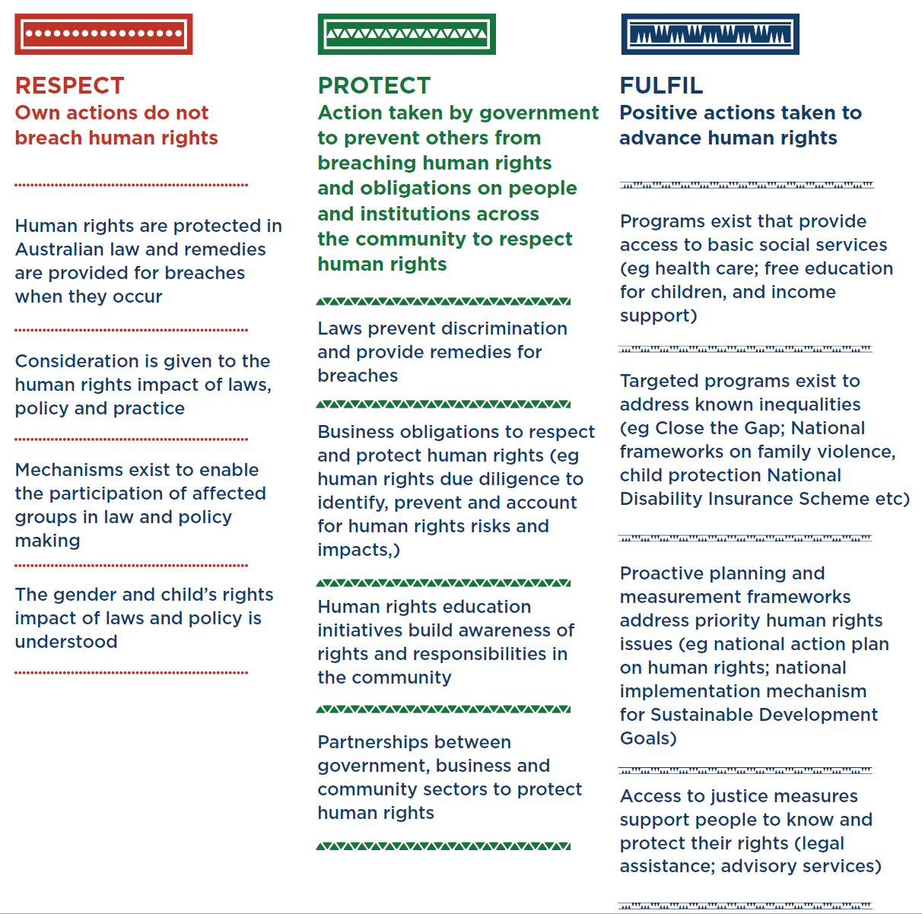
Figure: Government obligations to respect, protect and fulfil human rights

Introducing human rights obligations for policy and law makers
Public authorities, including Ministers and public servants, could be required to properly consider Australia’s international human rights obligations when making decisions, and to act consistently with these obligations. This requirement could be incorporated into existing governance frameworks for the public service, for example the Public Service Act 1999 (Cth), Australian Public Service (APS) values or the APS Code of Conduct. Such a requirement would help government decision-making become more consistent with Australia’s human rights obligations.

Incorporating human rights into administrative law
The Administrative Decisions (Judicial Review) Act 1977 (Cth) (ADJR Act) could be amended to specify that Australia’s human rights obligations are a relevant consideration that must be taken into account by government decision-makers when exercising a power. In the alternative or in addition, the ADJR Act could be amended to make a breach of human rights a ground for review of an administrative decision. This would allow a person to seek judicial review of a decision that breaches their human rights. It would also encourage the decision-maker to observe the rules of natural justice, including an opportunity for the affected person to be heard, and to provide reasons, where a decision limits human rights.
Further legislative and other amendments could be made to apply or highlight human rights to specific public authorities, administrative systems and decision-makers who may not otherwise be subject to the ADJR Act. For example, sentencing courts, as well as prison and parole authorities, could be required to have regard to Australia’s human rights obligations when making sentencing and custodial decisions. This is a matter that could be incorporated into Part IB of the Crimes Act 1914 (Cth).
In the alternate or in addition, the ability for independent oversight mechanisms to review administrative action for human rights compliance could be strengthened, such as the powers of the Commonwealth Ombudsman. Further, the functions and processes of the Ombudsman and other administrative review mechanisms could be reviewed to better incorporate human rights standards.

Developing a human rights culture in the public service
In addition to legislative change, development of a human rights culture in the public service can be supported by reform of day-to-day processes and practice. Existing law and policy making processes could be reviewed to more effectively incorporate human rights. For example, when making submissions for Ministerial approval, public servants could be required to identify and analyse how Australia’s human rights obligations are met (or not met) when recommending a particular decision or policy proposal.

Public servants should receive education and training on how human rights are relevant to their roles, and how to best protect human rights. This could be general or more specific depending on a person’s role, such front-end incorporation of human rights into policy development or how to draft a Statement of Compatibility. Public authorities could be required to develop human rights action plans, to conduct or comply with annual human rights audits, and to prepare annual reports on human rights compliance.

Respect for private life of LGBT persons
The UK Human Rights Act has been used as a tool by advocates to achieve positive social change outside of a courtroom. For example, Robert, a disabled gay man receiving community support, asked his support worker to accompany him to a gay pub where he could socialise. Robert’s request was denied, despite other, heterosexual service users receiving such support. After receiving human rights training, Robert’s advocate challenged this decision by the local authority. He argued that Robert’s right to respect for private life, and to not be discriminated against on the grounds of sexual orientation, were being denied. The relevant local authority changed their policy giving Robert equal opportunity to enjoy his social and leisure activities.

Incorporating human rights into statutory interpretation
The Acts Interpretation Act 1901 (Cth) could be amended to require that federal legislation be interpreted consistently with human rights as far as it is possible to do so consistent with the purpose of the particular law. This would allow courts to have regard to Australia’s human rights obligations when interpreting Commonwealth legislation. As in Victoria, Queensland and the ACT, courts could be permitted to consider international law when interpreting human rights, such as treaties and general comments that expand on the content of rights including those of at-risk groups, like people with a disability and Indigenous peoples.

Reforming tort law
In tort law, there is already some measure of protection against human rights violations. For example, the tort of false imprisonment may provide recourse for an individual arbitrarily detained by the police. A victim of police brutality could sue for assault or battery to protect their right not to be subject to cruel, inhuman or degrading treatment. A person subjected to malicious prosecution could sue in tort to compensate for a violation of their right to a fair trial.
However, our tort law could be strengthened as a means of enhancing human rights protections, by giving Australians a cause of action where their rights have been breached. Such reform would also help fulfil Australia’s obligation to provide an effective remedy for violations of human rights.
Options include introducing legislation to extend the scope of existing torts, so that they cover protections guaranteed in international human rights law. For example, extending the tort of negligence to cover the failure of a public authority to adequately fund medical services in rural areas, where such shortfall led to foreseeable deaths of patients. Another option is for specific new torts to be created, such as a tort of invasion of privacy. Alternatively, a new, more general tort providing a right to sue for violation of a recognised human right would provide clearer protection of human rights in Australia.

Enhancing the Commission’s human rights functions
The Australian Human Rights Commission Act 1986 (Cth) (AHRC Act) could be amended to allow a person to have recourse to a court if their human rights or ILO 111 discrimination complaint cannot be conciliated by the Commission, in the same way that complaints are currently treated under federal discrimination laws. For example, a new provision modelled on current s 46PO of the AHRC Act could be introduced, to allow a person to apply to the court if a human rights complaint is terminated by the Commission.
The AHRC Act could also be amended to empower the Commission, or other representative organisations with a legitimate interest in a particular subject matter, to bring a court case where government action has breached human rights on a systemic level.
The Commission requires adequate funding and resources to carry out its functions or expanded functions, to ensure better protection and promotion of human rights.

Indigenous recognition, representation and reconciliation
Our Constitution should be reformed to recognise Indigenous Australians, remove racially discriminatory provisions and include constitutional protections of equal treatment and non-discrimination.
Our Parliament should ensure the full participation of Aboriginal and Torres Strait Islander peoples in decision-making that affects their interests, including through a constitutionally enshrined representative voice. There should be effective parliamentary oversight for outcomes on indicators of well-being for Aboriginal and Torres Strait Islander peoples.
An agreement or framework for negotiations with Indigenous Australians should be developed, to recognise and address the structural inequalities brought about by colonisation and the consequences of past and ongoing injustices, through truth and reconciliation processes.

Enhancing parliamentary review and oversight mechanisms
Human rights protections could be strengthened through improved parliamentary scrutiny processes. Parliamentary Standing Orders, policies and procedures could be reformed to improve the human rights compliance of Bills before they are passed, for example through requiring that:
- adequate time and resources be given to parliamentary committees to consider the human rights implications of Bills and proposed legislative instruments before Bills are considered further by parliament
- there be an opportunity for parliamentary debate about the content of parliamentary committee reports that raise human rights concerns
- the government table a response to parliamentary committee reports that raise human rights concerns about specific Bills or legislative instruments, included PJCHR reports, before passing the relevant law
- all parliamentary committees have regard to the human rights implications of a Bill or inquiry that comes before it.
Further, more resources could be given to the PJCHR to provide routine general and tailored guidance and assistance to policy makers in the policy development and legislative drafting stages to ensure human rights compliance informs decision making.

Establishing an obligation for business to conduct human rights due diligence
Australian businesses should be required to conduct human rights due diligence, to identify, prevent, mitigate and account for any adverse human rights impacts. Passing legislation to implement these obligations would align with the United Nations Guiding Principles on Business and Human Rights (UNGPs). The UNGPS were unanimously endorsed and adopted by the United Nations Human Rights Council in 2011. They provide that:
- the government has a duty to protect against human rights abuses by third parties within its territory and/or jurisdiction, including abuses by business enterprises
- businesses have a responsibility to respect human rights, including by conducting human rights due diligence
- victims of business-related human rights abuse must be given access to an effective remedy.
The Australian Government co-sponsored the UNGPs and has committed to domestic implementation. While the Modern Slavery Act 2018 (Cth) was recently passed, this legislation only imposes a reporting requirement on businesses and is limited to modern slavery risks and impacts.

Enhancing engagement with international human rights processes
Australia could deepen its engagement with international human rights mechanisms and processes, to ensure that human rights concerns identified by the international community are adequately addressed and that future similar violations are prevented. For example, improvements could be made to:
- consideration of any communications, views and reports transmitted by United Nations human rights mechanisms, by providing more timely and public responses to adverse findings
- the implementation of Universal Periodic Review (UPR) recommendations, such as through public evaluation, adoption of independent oversight mechanisms, and funding commitments including to support civil society organisations to participate in the UPR
- identifying and adopting voluntary UPR commitments.

Recognising economic, social and cultural rights in practice
The human rights issues faced by Australians increasingly regard economic and social challenges, such as access to affordable housing, childcare and health services. Much more could be done to meet Australia’s commitments under the International Covenant on Economic and Social and Cultural Rights (ICESCR) through our laws, policies and procedures.
The progressive realisation obligation requires that the government take all necessary steps, to the maximum of its available resources, to realise economic, social and cultural rights. It includes that governments should duly observe human rights when making decisions about resource allocation, spend efficiently and effectively to improve the enjoyment of human rights, and ensure that the realisation rights is advanced over time without regression.
For example, the provision and delivery of welfare should take account of a person’s right to an adequate standard of living, to social security and to health, as well as the rights of persons with disabilities.
The AHRC Act could also be amended to allow individuals to make a complaint to the Commission, should their economic, social or cultural rights be breached.

Enhancing public education and human rights resources
Education for all Australians about their human rights and the obligations of public authorities should be a priority. This would empower individuals to take appropriate action when their human rights have been breached, and reduce the likelihood of violations occurring in the first place.
Much more can be done to develop and embed a national program of human rights education, in education, workplace and other contexts. This could include greater inclusion in school curricula, and a requirement that relevant employers educate their employees about human rights.
Increased funding and support for advocacy, community and legal organisations that work to protect and promote human rights would help support public understanding of human rights.

Equal access to public restrooms
In the UK, a transgender man was not permitted to use the male bathroom during his stay in a public hospital, causing him much distress. The man’s advocate discussed with the hospital a person’s right not to be discriminated against on the basis of gender identity under the UK Human Rights Act. The hospital changed its practice. In Australia, we have only had federal legal protections to prevent such discrimination since 2013. Before that time, a person would not have enjoyed the protection of the law to challenge such practices. Prior to the change in Australian law, a legal right to be free from discrimination on the basis of gender identity, as in the UK, would have provided more effective protection.

Strengthening the operation of federal discrimination laws
To strengthen our human rights system, we must also consider how to enhance the protections we already have. Our existing discrimination laws play an important role in fulfilling some of our international obligations, but require improvement.
As part of the National Conversation, the Commission has identified key priority areas for federal discrimination law reform. These include simplifying and improving the consistency of legislative definitions, addressing limitations in the coverage of protected attributes, reviewing existing permanent exemptions in the four federal discrimination acts and providing further clarity to business, organisations and individuals regarding their obligations under federal discrimination laws.

Appendix 1: Legislative human rights protections in other jurisdictions
Jurisdiction | Model | Obligations on branches of government |  | Protected rights | Cause of action | Remedies
Queensland  Since 2009 | Legislative  Human Rights Act 2019 (Qld) | Executive | Public entities must properly consider human rights in decision-making and act compatibly with human rights | - Civil and political rights  - Cultural rights (general and indigenous)  - Some economic and social rights (education, health) | - Cause of action must attach to a legal claim that exists independently (‘piggyback’)  - Can lodge a complaint with the Human Rights Commission | - Court can award same remedies as available for other/piggybacked claim, except damages  - Court can make declaration of incompatibility, and Minister must respond (no effect on validity; flags that reconsideration by government needed)
 |  | Parliament | Parliamentary Committee must scrutinise and report on the compatibility of all Bills
 |  | Courts | - Interpret laws in a manner compatible with rights to the extent consistent with purpose  - Courts are public authorities when acting in an administrative (rather than judicial capacity)
ACT  Since 2004 | Legislative  Human Rights Act 2004 (ACT) | Executive | - Public authorities must properly consider human rights in decision-making and act compatibly with human rights  - Statements of compatibility must accompany every Bill | - Civil and political rights  - Cultural rights (indigenous)  - Right to education | - Standalone, direct cause of action  - Can rely on human rights in other legal actions | - Court can award any remedy including damages
 |  | Parliament | Parliamentary Committee must scrutinise and report on the compatibility of all Bills
 |  | Courts | - Interpret laws in a manner compatible with rights to the extent consistent with purpose  - Courts are public authorities when acting in an administrative (rather than judicial capacity)
Victoria  Since 2006 | Legislative  Charter of Human Rights and Responsibilities Act 2006 (Vic) | Executive | - Public authorities must properly consider human rights in decision-making and act compatibly with human rights  - Statements of compatibility must accompany every Bill | - Civil and political rights  - Cultural rights | - Cause of action must attach to a legal claim that exists independently (‘piggyback’) | - Court can award same remedies as available for other/piggybacked claim, except damages  - Court can make declaration of incompatibility, and Minister must respond (no effect on validity; flags that reconsideration by government needed)
 |  | Parliament | Parliamentary Committee must scrutinise and report on the compatibility of all Bills
 |  | Courts | - Interpret laws in a manner compatible with rights to the extent consistent with purpose  - Courts are public authorities when acting in an administrative (rather than judicial capacity)
United Kingdom  Since 1998 | Legislative  Human Rights Act 1998 (UK); European Convention on Human Rights | Executive | Unlawful for public authority to act incompatibly with human rights | - Civil and political rights  - Some economic and social rights (right to marry and family, education, peaceful enjoyment of property)  - By reference to the European Convention | - Standalone, direct cause of action  - Ability to use human rights in other legal actions  - Breach of human rights may provide a ground of judicial review  - Ability to apply to the European Court of Human Rights, if all domestic avenues are exhausted | - Court can award any remedy including damages  - Court can make declaration of incompatibility (no effect on validity; flags that reconsideration by government needed)  - European Court of Human Rights can award any remedies, including damages
 |  | Parliament | Statements of compatibility must accompany every Bill
 |  | Courts | - Must read legislation in a way compatible with human rights  - Courts must act compatibility with human rights
New Zealand  Since 1990 | Legislative  New Zealand Bill of Rights Act 1990 (NZ) | Executive | Attorney-General must bring to the attention of Parliament any provision of a Bill that is inconsistent with human rights | Limited civil and political rights, based on the ICCPR | No express legislative cause of action, but developed in common law | - No express legislative remedies, but courts have awarded common-law based remedies including damages  - Court can make declaration of inconsistency (no effect on validity; flags that reconsideration by government needed)
 |  | Parliament | No legislative requirement for scrutiny of Bills
 |  | Courts | Interpretation of legislation consistent with human rights to be preferred
Canada  Since 1960 | Constitutional and legislative  Canadian Human Rights Act 1985; Canadian Charter of Rights and Freedoms in the Constitution Act 1982; Canadian Bill of Rights 1960 | Executive | - No express obligations, but cause of action permits anyone whose rights have been infringed or denied to apply to a court for a remedy  - Justice Minister must examine every Bill and instrument and report any inconsistency with human rights to Parliament | - Civil and political rights  - Some economic, social and cultural rights (minority language educational rights, language rights) | Standalone, direct cause of action | - Courts can award any remedy, including damages  - Court can invalidate law that is inconsistent with the Charter, unless Parliament has expressly overruled in advance
 |  | Parliament | No legislative requirement for scrutiny of Bills
 |  | Courts | - Must read legislation in a way compatible with human rights
United States  Since 1787 | Constitutional  United States Constitution | Executive | Cannot pass unconstitutional laws | Limited civil and political rights | A person can challenge the constitutionality of any law | - A court can award damages as a remedy for the enforcement of constitutional guarantees  - A court can invalidate unconstitutional legislation and executive action
 |  | Parliament | No legislative requirement for scrutiny of Bills
 |  | Courts | No explicit obligations

Endnotes

Our Constitution can only be changed by referendum—a difficult, costly and historically unsuccessful path. A Human Rights Act would be a more incremental, pragmatic, democratic, approach that preserves parliamentary supremacy.
See Commonwealth of Australia, National Human Rights Consultation (Report, September 2009).
For example, two provisions of the Australian Constitution as originally drafted were highly discriminatory against Indigenous Australians. Section 51(xxvi) of the Constitution as made gave the Commonwealth power to make laws with respect to ‘people of any race, other than the Aboriginal race in any state, for whom it was deemed necessary to make special laws.’ Section 127 of the Constitution as made excluded Indigenous Australians from the census count. These provisions were not amended to remove discriminatory aspects until the referendum in 1967.
See the Hon Sir Anthony Mason, ‘The Role of a Constitutional Court in a Federation: A Comparison of the Australia and the United States Experience’ (1986) 16 Federal Law Review 8: ‘Because the founders accepted, in conformity with prevailing English legal thinking, that the citizen’s rights are best left to the protection of the common law and because they were not concerned to protect the individual from oppression by majority will, the Constitution contains very little in the way of provisions guaranteeing new rights. The founders did not share the American framers’ lack of faith in parliamentary supremacy and their belief that it was necessary to protect minority rights against majority oppression’. His Honour echoed these comments in Australian Capital Television v Commonwealth (1992) 177 CLR 106 at [31].
Section 116 of the Constitution provides: ‘The Commonwealth shall not make any law for establishing any religion, or for imposing any religious observance, or for prohibiting the free exercise of any religion, and no religious test shall be required as a qualification for any office or public trust under the Commonwealth’.
Section 80 of the Constitution provides: ‘The trial on indictment of any offence against any law of the Commonwealth shall be by jury, and every such trial shall be held in the State where the offence was committed, and if the offence was not committed within any State the trial shall be held at such place or places as the Parliament prescribes’.
First recognised by the High Court of Australia in Australian Capital Television Pty Ltd v Commonwealth (1992) 177 CLR 106.
Recognised by the High Court of Australia in ss 7, 24, taken together, of the Constitution: see Roach v Electoral Commissioner (2007) 233 CLR 162 and Rowe v Electoral Commissioner (2010) 243 CLR 1.
Australian Constitution, s 117.
The Commonwealth may only acquire property on ‘just terms’ as a consequence of s 51(xxxi). For a detailed discussion of this provision, see Australian Law Reform Commission, Traditional Rights and Freedoms – Encroachments by Commonwealth Laws (ALRC Report 129, 2015) 477-85.
In 1975 with the Sex Discrimination Act 1984 (Cth).
In 1984 with the Sex Discrimination Act 1984 (Cth).
In 1992 with the Disability Discrimination Act 1992 (Cth).
In 2004 with the Age Discrimination Act 2004 (Cth).
In 2013 amendments were made to the Sex Discrimination Act 1984 (Cth) by the Sex Discrimination Amendment (Sexual Orientation, Gender Identity and Intersex Status) Act 2013 (Cth). The amendments replaced discrimination based on ‘marital status’ throughout the Sex Discrimination Act 1984 (Cth) with discrimination on the basis of ‘sexual orientation, gender identity, intersex status, marital or relationship status’: Sex Discrimination Amendment (Sexual Orientation, Gender Identity and Intersex Status) Act 2013 (Cth) Sch 1, Pt 1.
Racial Discrimination Act 1975 (Cth), s 9.
Racial Discrimination Act 1975 (Cth), s 26.
Racial Discrimination Act 1975 (Cth), s 29.
There are other protections against unlawful discrimination in federal workplace laws, such as the Fair Work Act 2009 (Cth) that entitles the Fair Work Ombudsman to take enforcement action against employers who unlawfully discriminates against an employee or prospective employee based on certain attributes, including race, colour, sex, sexual orientation, age, disability, marital status, religion, pregnancy and political opinion.
Australian Human Rights Commission 1986 (Cth), s 46P.
Australian Human Rights Commission 1986 (Cth), s 46PO(1).
Australian Human Rights Commission 1986 (Cth), s 46PO(4).
See, inter alia, Re Minister for Immigration and Multicultural Affairs; ex parte Lam (2003) 195 ALR 502 per McHugh and Gummow JJ at [100]; Plaintiff M70/2011 v Minister for Immigration and Citizenship (2011) 244 CLR 144 per Kiefel K at [247].
Momcilovic v The Queen (2011) 245 CLR 1 per French CJ at [43].
British Institute of Human Rights, The Human Rights Act – Changing Lives (2nd ed, 2008) 15.
Charter of Human Rights and Responsibilities Act 2006 (Vic).
Human Rights Act 2004 (ACT).
Human Rights Act 2019 (Qld).
Anyar v Commissioner for Social Housing (2017) ACAT 33.
Human Rights (Parliamentary Scrutiny) Act 2011 (Cth) ss 8, 9(1); Legislation Act 2003 (Cth), s 15J(2)(f).
Human Rights (Parliamentary Scrutiny) Act 2011 (Cth), ss 8(4), 9(3).
Human Rights (Parliamentary Scrutiny) Act 2011 (Cth), ss 8(5), 9(4).
Human Rights (Parliamentary Scrutiny) Act 2011 (Cth), s 7(a).
Human Rights (Parliamentary Scrutiny) Act 2011 (Cth), s 7(b).
Human Rights (Parliamentary Scrutiny) Act 2011 (Cth), s 7(c).
Human Rights (Parliamentary Scrutiny) Act 2011 (Cth), ss 7(a), (b), (c).
See description of the Committee’s work in Australian Law Reform Commission, Traditional Rights and Freedoms – Encroachments by Commonwealth Laws (ALRC Report 129, 2015) 41–43.
Acts Interpretation Act 1901 (Cth), ss 15AB(2)(c), (e).
Acts Interpretation Act 1901 (Cth), s 15AB(1).
The legal history of the Australian Human Rights Commission and its complaint handling functions are discussed in detail in: Emeritus Professor Rosalind Croucher AM, ‘”Seeking Equal Dignity without Discrimination” — The Australian Human Rights Commission and the Handling of Complaints’ (2019) 93 Australian Law Journal 571.
International Covenant on Civil and Political Rights, opened for signature 19 December 1966, 999 UNTS 171 (entered into force 23 March 1976).
Australian Human Rights Commission Act 1986 (Cth), ss 11(a) and (aa). Such claims arise under Australia’s anti-discrimination legislation, which includes the Racial Discrimination Act 1975 (Cth), the Sex Discrimination Act 1984 (Cth), the Disability Discrimination Act 1992 (Cth) and the Age Discrimination Act 2004 (Cth).
Australian Human Rights Commission Act 1986 (Cth), s 11(f)(i).
Australian Human Rights Commission Act 1986 (Cth), s 11(1)(j).
Australian Human Rights Commission Act 1986 (Cth), s 11(1)(k).
Australian Human Rights Commission Act 1986 (Cth), s 29.
Robert French AC, ‘Human Rights Protection in Australia and the United Kingdom: Contrasts and Comparisons’, Anglo-Australasian Lawyers Society and Constitutional and Administrative Law Bar Association (5 July 2012).
Sometimes, the government has responded to decisions made by international bodies. In 1994, the Human Rights Committee found that a Tasmanian law criminalising homosexual sex violated the right to privacy guaranteed by article 17 of the ICCPR. The federal government responded by passing the Human Rights (Sexual Conduct) Act 1994 (Cth) that legalised sexual activity between consenting adults throughout Australia, undoing the effect of Tasmania’s law. This Committee decision had a positive impact on the legal landscape in Australia, but is in the minority in that regard, and still required action by the federal Parliament.
PBU & NJE v Mental Health Tribunal [2018] VSC 564.
See ‘Human rights and equality in the voluntary sector: Report of a pilot project by the British Institute of Human Rights and the Equality and Diversity Forum’, Equality and Human Rights Commission (10 December 2010) 11.
Matsoukatidou v Yarra Ranges Council [2017] VSC 61.
Given the urgent and serious nature of some human rights matters, such as where a person is facing deportation and there is risk of refoulement, it is important that conciliation be an option but not prevent a person from pursuing a time-sensitive claim in court.
For example, see article 2(3) of the International Covenant on Economic, Social and Cultural Rights, opened for signature 16 December 1966, 993 UNTS 3 (entered into force 3 January 1976).
UN Human Rights Committee, General Comment No 31, The nature of the general legal obligation imposed on States Parties to the Covenant, 26 May 2004, para 16; UN Committee on the Elimination of Racial Discrimination, General Recommendation No 26, General recommendation XXVI on Article 6 of the Convention, 24 March 2000, para 2.
International Covenant on Economic, Social and Cultural Rights, opened for signature 16 December 1966, 993 UNTS 3 (entered into force 3 January 1976).
Cemino v Cannan [2018] VSC 535.
See further Australian Human Rights Commission, Human Rights and Technology Issues Paper (2018).
British Institute of Human Rights, The Human Rights Act – Changing Lives (2nd ed, 2008) 9.
The Australian Law Reform Commission has recommended a statutory cause of action for serious invasion of privacy. See Australian Law Reform Commission, For Your Information: Australian Privacy Law and Practice (ALRC Report 108, 2006) [74].
See discussion of issues impeding the effective resolution of ILO 111 complaints made to the Commission in Australian Human Rights Commission, ‘Discussion paper: Priorities for federal discrimination law reform’, Free and Equal: An Australian conversation on human rights 2019 (2019) 10–11.
See similar conclusions reached and recommendations made in Australian Law Reform Commission, Traditional Rights and Freedoms – Encroachments by Commonwealth Laws (ALRC Report 129, 2015) [3.95].
As the Australian Law Reform Commission has noted: ‘Parliamentary debate is the ultimate forum for the scrutiny of, and judgments about, encroachments on rights’: Australian Law Reform Commission, Traditional Rights and Freedoms – Encroachments by Commonwealth Laws (ALRC Report 129, 2015).
Australian Law Reform Commission, Traditional Rights and Freedoms – Encroachments by Commonwealth Laws (ALRC Report 129, 2015) [3.95].
The business and human rights agenda has evolved significantly in recent years. Several countries are developing or implementing legislation, for example the Corporate Duty of Vigilance Law in France, the Child Labour Due Diligence Law in the Netherlands and the Responsible Business Initiative in Switzerland.
See Australian Government Department of Foreign Affairs and Trade, Business and Human Rights available at https://dfat.gov.au/international-relations/themes/human-rights/business/Pages/default.aspx.
British Institute of Human Rights, Protect, Care and Support: A Human Rights Approach to Advocacy.
See Australian Human Rights Commission, ‘Discussion paper: Priorities for federal discrimination law reform’, Free and Equal: An Australian conversation on human rights 2019 (2019) 10–11.

