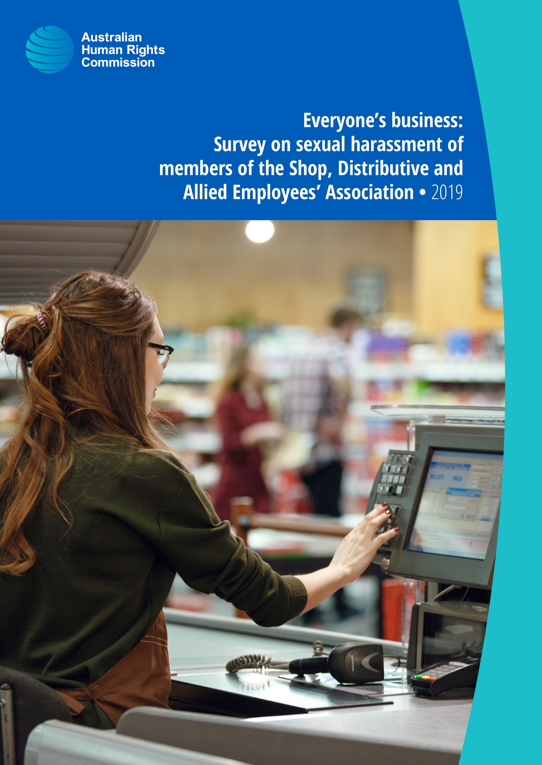

© Australian Human Rights Commission 2019.
The Australian Human Rights Commission encourages the dissemination and exchange of information presented in this publication.
All material presented in this publication is licensed under the Creative Commons Attribution 4.0 International Licence, with the exception of:
- photographs and images;
- the Commission’s logo, any branding or trademarks;
- content or material provided by third parties; and
- where otherwise indicated.
To view a copy of this licence, visit http://creativecommons.org/licenses/by/4.0/legalcode.
In essence, you are free to copy, communicate and adapt the publication, as long as you attribute the Australian Human Rights Commission and abide by the other licence terms.
Please give attribution to: © Australian Human Rights Commission 2019.
Everyone’s business: Survey on sexual harassment of members of the Shop, Distributive and Allied Employees’ Association
ISBN 978-1-925917-11-6
This publication can be found in electronic format on the Australian Human Rights Commission’s website at https://www.humanrights.gov.au/our-work/publications.
For further information about the Australian Human Rights Commission or copyright in this publication, please contact:
Australian Human Rights Commission
GPO Box 5218
SYDNEY NSW 2001
Telephone: (02) 9284 9600
Email: communications@humanrights.gov.au
Design and layout Dancingirl Designs
Printing Bright Printing Groups
Cover photo Adobe Stock

Contents
Commissioner’s foreword 5
Executive Summary 7
Key findings 9
Chapter 1: Introduction 20
1.1 Background 20
1.2 Objectives 21
1.3 Methodology 21
1.4 Reading and interpreting the data 26
Chapter 2: Lifetime sexual harassment experienced by SDA members 34
2.1 Measuring the prevalence of lifetime sexual harassment 35
2.2 Prevalence of lifetime sexual harassment 36
2.3 Types of lifetime sexual harassment 37
2.4 Who experiences lifetime sexual harassment? 41
2.5 Awareness of sexual harassment 44
Chapter 3: Workplace sexual harassment 48
3.1 Prevalence of workplace sexual harassment 53
3.2 Nature of workplace sexual harassment 60
3.3 SDA members who had experienced workplace sexual harassment 84
3.4 Harassers 91
3.5 Impact of workplace sexual harassment 103
Chapter 4: Sexual harassment by customers 116
4.1 Prevalence of sexual harassment by customers 117
4.2 Frequency of sexual harassment by customers 118
4.3 Time elapsed since last sexually harassed by a customer 122
4.4 Was the harasser known to the SDA member? 124
4.5 Repeat harassers 125
4.6 Reporting sexual harassment by a customer to an employer 125
Chapter 5: Inappropriate campaigns or clothing and sexual harassment 129
5.1 Inappropriate campaigns or clothing 129
5.2 Inappropriate campaigns or clothing leading to sexual harassment 129
Chapter 6: Reporting and seeking support in relation to workplace sexual harassment 132
6.1 Reporting of workplace sexual harassment 133
6.2 Seeking support and advice 155
6.3 Reasons for not reporting, making a complaint, or seeking support or advice 159
6.4 Seeking information about workplace sexual harassment 160
Chapter 7: Bystanders—witnessing and hearing about workplace sexual harassment 165
7.1 Prevalence of bystander experience 166
7.2 Action taken by bystanders 168
7.3 Consequences of bystanders taking action 170
7.4 Reasons bystanders did not take action 172
Chapter 8: Workplace policies, procedures and training 176
8.1 Existing measures in the workplace to address sexual harassment 177
8.2 Sexual harassment prevention training 180
8.3 Knowledge of where to find sexual harassment policies and procedures 184
8.4 Prevalence of workplace sexual harassment when policies, procedures and training are in place 185
Appendix: Shop, Distributive and Allied Employees’ Association workplace sexual harassment survey 188

Commissioner’s foreword
Workplace sexual harassment remains a reality for too many working Australians.
In 2018 the Australian Human Rights Commission (the Commission) published its fourth national report on the prevalence, nature and reporting of workplace sexual harassment in Australia (2018 National Survey). In early 2020 the Commission will publish the findings of its National Inquiry into Sexual Harassment in Australian Workplaces (the National Inquiry).
The time for breakthrough leadership on workplace sexual harassment is now.
The 2018 National Survey report identified that one in three (33%) working Australians had experienced sexual harassment at work in the last five years. A number of industries reported workplace sexual harassment prevalence rates higher than the national rate (33%) including:
- retail trade (42%)
- accommodation and food services (39%).
In response to these concerning results the Shop, Distributive and Allied Employees’ Association (the SDA), approached the Commission to conduct a comprehensive survey of its members, who are employed in these industries. The survey (2019 Member Survey) conducted earlier this year was based on the instrument and methodology adopted in the 2018 National Survey.
The SDA has long been an advocate for workplaces that are free from all forms of discrimination and harassment. With the majority of its members (60%) identifying as women, the SDA has a particular interest in addressing sexual harassment. Most recently the SDA has demonstrated leadership in developing solutions through commissioning the 2019 Member Survey and making a submission to the National Inquiry earlier this year. In October 2019, the SDA launched ‘No One Deserves a Serve’ campaign, focusing on workplace safety, a further example of SDA’s advocacy and leadership to ensuring safe workplaces.
SDA members are primarily employed in the retail, fast food, and warehouse sectors and often work in environments with direct and daily contact with customers. By publishing the results of the 2019 Member Survey, the SDA is again showing leadership by empowering not only SDA representatives and members, but also all employers and workers in the retail, fast food, and warehousing sectors with valuable information about the specific challenges and opportunities for change.
The results of the 2019 Member Survey reflect those of the 2018 National Survey, in terms of the prevalence of workplace sexual harassment, the gendered nature of these experiences and the low reporting rates. The 2019 Member Survey has allowed the Commission to provide the SDA with a comprehensive picture of the workplace sexual harassment experienced by its members, including valuable new information about the role of customers in workplace sexual harassment, both as harassers and bystanders.
This report is an important step in addressing both the systemic drivers which underpin workplace sexual harassment in the working population, as well as factors which are unique to the workplaces of SDA members. I commend the SDA for its commitment to eliminating workplace sexual harassment.
I also encourage other industries, employers and employee organisations to reflect on the discussion in this report and consider how they too can learn, collaborate and take further steps to ensure that all workplaces are free from sexual harassment.
Kate Jenkins
Sex Discrimination Commissioner
October 2019

Executive Summary
The Shop, Distributive and Allied Employees’ Association (the SDA) commissioned the Australian Human Rights Commission (the Commission) to conduct a National Workplace Sexual Harassment Survey of its members (2019 Member Survey), between March and April 2019.
The purpose of the 2019 Member Survey was to investigate the prevalence, nature and reporting of sexual harassment of SDA members in their workplaces and in the community more broadly. The format and methodology of the 2019 Member Survey are based on to the Commission’s National Workplace Sexual Harassment Survey, conducted in 2003, 2008, 2012 and 2018.
The 2019 Member Survey was conducted online and examined:
- the prevalence and nature of sexual harassment experienced by SDA members aged 15 years and older across their lifetime (at any time or anywhere) and in the workplace, with a particular focus on workplace sexual harassment committed by customers
- the characteristics of harassers of workplace sexual harassment
- the characteristics of workplaces where sexual harassment occurs
- the reporting of workplace sexual harassment and the outcomes of complaints
- the impacts of workplace sexual harassment on those who experience it
- the responses of people who witnessed or heard about sexual harassment in their workplaces
- the prevalence and implementation of workplace training on sexual harassment
- the prevalence and awareness of workplace sexual harassment policies and procedures
- SDA members’ awareness of where they can access information about sexual harassment.
Throughout this report the results of the 2019 Member Survey have been compared to the results of the 2018 National Survey, where a direct comparison is possible.
The data contained in this report captures what SDA members’ have said about their experiences of sexual harassment both in the workplace and, more broadly, in their lifetime. It should be noted that the 2019 Member Survey results reflect people’s experiences of sexual harassment as reported through the survey process. These experiences may not necessarily constitute a criminal offence or a breach of discrimination legislation, which can only be determined by a court.

Key findings

Lifetime sexual harassment
The results of the 2019 Member Survey indicate that the majority of SDA members have experienced sexual harassment at some point in their lifetime.
- Two thirds (65%) of SDA members said they had experienced sexual harassment at some point in their lifetime, compared to 73% of those in the working population.
- Nearly three in four (73%) female SDA members and just over half (52%) of male SDA members said they had been sexually harassed at some point in their lifetime.
- Female SDA members indicated that they experienced all types of sexual harassment at rates higher than their male colleagues.
- The most common types of sexual harassment that SDA members said that they had experienced in their lifetime were:
  - sexually suggestive comments or offensive jokes (43%) (over half (52%) of female SDA members and more than a quarter (28%) of male SDA members)
  - intrusive questions about a person’s private life or physical appearance that made them feel offended (40%) (almost half (47%) of female SDA members and almost a third (29%) of male SDA members)
  - inappropriate staring or leering (38%) (half (50%) of female SDA members and almost one fifth (19%) of male SDA members)
  - inappropriate physical contact (35%) (more than two fifths (42%) of female SDA members and more than one fifth (23%) of male SDA members)
  - unwelcome touching, hugging, cornering or kissing (34%) (more than two fifths (42%) of female SDA members and more than a fifth (21%) of male SDA members).
- One in seven (14%) female SDA members said that they had experienced actual or attempted rape or sexual assault at some point in their lifetime.
- Nearly a quarter (24%) of female SDA members said that they had experienced unwelcome requests or pressure for sex or other sexual acts.
- The 2019 Member Survey indicates that there are differences in SDA members’ experiences of sexual harassment over the course of their lifetime, based on their demographic profile:
  - rates of sexual harassment were highest among SDA members aged 18–29 years, with 70% having experienced sexual harassment over the course of their lifetime
  - the prevalence of sexual harassment was higher among SDA members who identified as gay, lesbian, bisexual, pansexual, queer, asexual or aromantic, undecided, not sure, questioning or other (81%), compared to 63% of SDA members who identified as heterosexual
  - Aboriginal and Torres Strait Islander members of the SDA (67%), were relatively more likely to have experienced lifetime sexual harassment than SDA members who were not of Aboriginal and Torres Strait Islander descent (65%)
  - SDA members with disability (74%) were more likely than those without disability (64%) to have been sexually harassed in their lifetime.

Prevalence of workplace sexual harassment in the last five years
The results of the 2019 Member Survey indicate that the rate of workplace sexual harassment experienced by SDA members in the last five years is higher than in the working population (39% and 33%, respectively).
When examining workplace sexual harassment experienced by SDA members and the working population in the last five years:
- female SDA members were more likely to have been sexually harassed in the workplace than male SDA members (46% and 29%, respectively)
- the most commonly experienced type of sexual harassment behaviour for both SDA members (24%) and those in the working population (19%) was sexually suggestive comments or offensive jokes
- over half (54%) of SDA members, and 51% of those in the working population, had been exposed to workplace sexual harassment in the last five years, either by experiencing it personally, as a bystander, or both
- the highest prevalence of workplace sexual harassment was reported in the fast food (37%), retail (39%), and ‘other’ (47%) SDA sectors
- SDA members working in the warehousing sector were less likely than those in other sectors to have experienced workplace sexual harassment (26%).

The most recent incident of workplace sexual harassment
The results of the 2019 Member Survey indicate that, based on the most recent incident of workplace sexual harassment experienced in the last five years:
- the two most common types of workplace sexual harassment experienced by female SDA members were sexually suggestive comments or offensive jokes (26%) and inappropriate staring of leering that made you feel intimidated (20%)
- more than half (57%) of SDA members said they had experienced the same (or a similar) type of workplace sexual harassment on more than one occasion, compared to 49% of the working population
- for 53% of SDA members who had experienced repeated workplace sexual harassment in their workplace, the harassment was experienced over a period of seven months or more
- three quarters (75%) of the most recent incidents of workplace sexual harassment experienced by SDA members took place at the individual’s workstation or the area where they worked, compared to 52% for the working population
- just over a quarter (26%) of SDA members said the most recent incident of workplace sexual harassment was witnessed by one or more bystanders, while the rate was 40% for the working population.

SDA members who had experienced workplace sexual harassment
As with lifetime sexual harassment, the results of the 2019 Member Survey indicate that SDA members’ experience of workplace sexual harassment differs according to their demographic profile:
- female SDA members were more likely than male SDA members to have experienced sexual harassment in the workplace in the last five years (46% and 29%, respectively). A similar pattern is present within the working population, where women (39%) also experience workplace sexual harassment at higher rates than men (26%)
- SDA members aged 18–29 years were more likely than those in other age groups to have experienced workplace sexual harassment in the last five years (46%). Workplace sexual harassment was also most prevalent among this age group in the working population (45%)
- the prevalence of workplace sexual harassment was higher among SDA members who are gay, lesbian, bisexual, pansexual, queer, asexual or aromantic, undecided, not sure, questioning or other (58%), compared to 37% of SDA members who identified as heterosexual. This is also the case for the working population (52% and 31%, respectively)
- Aboriginal and Torres Strait Islander members of the SDA (43%) were relatively more likely to have experienced workplace sexual harassment than those not of Aboriginal or Torres Strait Islander descent. This is similar to the working population (53% and 32%, respectively)
- SDA members with disability (45%) were more likely than those without disability (39%) to indicate that have been sexually harassed in the workplace. A similar trend was present in the working population (44% and 32%, respectively).

Harassers
The results of the 2019 Member Survey indicate that the majority of harassers in cases of workplace sexual harassment experienced by SDA members in the last five years were men. The data suggests that this was the case for both male and female SDA members.
The results indicate that based on the most recent incident of workplace sexual harassment experienced in the last five years:
- both SDA members (82%) and the working population (79%) said that the majority of harassers in cases of workplace sexual harassment were men
- SDA members said that one in three (36%) incidents of workplace sexual harassment involved harassment by a customer or client, with women (42%) more likely than men (22%) to say this
- thirty-six per cent of SDA members and 28% of the working population said that they were harassed by a harasser (both single and multiple harassers) aged 30 years and under
- both SDA members and those in the working population said that the majority of workplace sexual harassment incidents were carried out by a single harasser (57% and 64%, respectively).

Impact of workplace sexual harassment
The 2019 Member Survey results indicate that workplace sexual harassment caused either short or long-term negative consequences for many SDA members. The negative consequences most commonly identified by SDA members who had experienced workplace sexual harassment were:
- a ‘negative impact on mental health, or caused stress’ (44%, compared to 36% for the working population)
- a ‘negative impact on self-esteem and confidence’ (35%, compared to 33% for the working population)
- a ‘negative impact on employment, career or work’ (23%, compared to 25% for the working population).

Sexual harassment by customers
In the 2019 Member Survey, SDA members in the retail and fast food sectors were asked about their experiences of workplace sexual harassment by customers.
- One in five (21%) SDA members said they had been sexually harassed by a customer in their current job, with female SDA members more likely to have had this experience (28%) than male SDA members (11%).
- One in three incidents (36%) of workplace sexual harassment experienced by SDA members in the last five years involved a customer as one of the harassers.
- SDA members aged 18–29 years said that they had been sexually harassed by a customer in their current job an average of 7.2 times in the last 12 months, compared to 4.1 times for SDA members aged 30 years or more.
- Over half (54%) of SDA members who said they had been sexually harassed by a customer in their current job had been sexually harassed in the previous six months.
- Eighty-one per cent of SDA members who said they had been sexually harassed by a customer in their current job in the last 12 months did not know the person who had sexually harassed them in the most recent incident.
- More than half (56%) of SDA members who said they had been sexually harassed by a customer in their current job did not know whether their employer had a mechanism for reporting such harassment.
- One in four (25%) SDA members who said they were sexually harassed by a customer in their current job indicated they had reported the sexual harassment to their employer.
- Of those SDA members who said they had made a formal report or complaint, 63% said the incident had not been investigated by their employer, with only 23% confirming that it had.

Inappropriate campaigns or clothing and sexual harassment
In the 2019 Member Survey, SDA members in the retail and fast food sectors were asked about their experiences of workplace sexual harassment in connection with inappropriate campaigns or clothing.
Four per cent of SDA members in the workforce in the last five years indicated that their employer had conducted a marketing or advertising campaign or some other form of promotion that they felt was inappropriate. The same proportion of SDA members indicated they had been required to wear inappropriate clothing or a uniform that they felt was inappropriate or made them feel uncomfortable.
One in five (19%) of these SDA members said that this had led to them being sexually harassed at work, with this more likely to have been experienced by female SDA members than male SDA members (24% and 11%, respectively).

Reporting and seeking support in relation to workplace sexual harassment
In the 2019 Member Survey the majority of SDA members indicated that they had not made a formal report or complaint in relation to the most recent incident of workplace sexual harassment, with many believing that reporting would be viewed as an overreaction, or that it was easier to stay quiet.
- Only around one in eight (13%) SDA members, and 17% of the working population, made a formal report or complaint in relation to the most recent incident of workplace sexual harassment.
- The most common person to receive a formal report or complaint of workplace sexual harassment from a SDA member (71%) and the working population (55%) was a direct manager or supervisor.
- SDA members were more likely than those in the working population to make a formal report or complaint to a union or employee representative (18% and 6%, respectively).
- Of formal reports or complaints that were finalised, the majority (74%) were finalised within the month after the incident.
- Almost two thirds (61%) of SDA members who made a formal report or complaint said that no changes occurred at their organisation as a result.
- The most common reason for not reporting workplace sexual harassment was that other people would think they were overreacting (48%).
- Only one in eight (13%) SDA members, and 18% of the working population, who had experienced workplace sexual harassment sought support or advice in relation to the incident.
- Where advice or support was sought, most commonly it was from friends or family (SDA:65%, and working population: 61%).
- Nine per cent of SDA members had sought support or advice from their union or employee representative, compared to 7% of those in the working population.
- The most common sources of information about workplace sexual harassment for SDA members were a direct manager or supervisor at work (45%) or friends and family (44%).
- SDA members (36%) were more likely than the working population (24%) to seek information about workplace sexual harassment from their union or employee representative.

Bystanders—witnessing and hearing about workplace sexual harassment
In the 2019 Member Survey SDA members were asked about their experiences as bystanders to workplace sexual harassment.
- More than one in three (35%) SDA members had witnessed or heard about the sexual harassment of another person at their workplace in the last five years. This was similar to the working population (37%).
- Only one in three (35%) SDA members who witnessed or heard about sexual harassment of someone else in their workplace, took action in relation to the most recent incident they had witnessed or heard. This was the same for the working population (35%).
- When SDA members who were bystanders did take action, the most common response was to talk with or listen to the person who had been sexually harassed about the incident (74%). In just over half (55%) of cases where action was taken, the bystander, reported the harassment to their employer, compared to 47% in the working population.
- For a large proportion of SDA members (42%) who took action there were no consequences for them as a result. The experience of bystanders who took action in the working population was different, where the most common consequence was that the sexual harassment stopped (45%).
- The most common reason for bystanders not taking action was knowing that other people were supporting and assisting the person who experienced workplace sexual harassment (31%). Within the working population this was also the most common reason (41%).

Workplace policies, procedures and training
In the 2019 Member Survey SDA members were asked about the measures that their current employer has in place to prevent or address sexual harassment.
- Most SDA members (59%) said their current employer had either policies, procedures or training in place to prevent workplace sexual harassment.
- Almost half of SDA members (48%) indicated that their current employer had a written workplace sexual harassment policy, while a third (30%) said there was training in place.
- Most (77%) SDA members said they had received sexual harassment training, with 60% indicating this had been within the last 12 months.
- Three quarters (76%) of SDA members who had received sexual harassment prevention training at their current employer indicated that this training had been delivered online.
- Three in five (62%) SDA members who said that their current employer had either policies or procedures in place, indicated that they knew where to find the relevant policies and procedures.

‘My harasser sits outside my work in the food court and watches me as I work. If I notice him he averts his eyes but not for long. He also does his grocery shopping in my store and on the last occasion brought his wife with him. He has also started parking his vehicle closer to mine so I see it when I leave work.’

Introduction
Chapter 1 provides a brief introduction to the 2019 Member Survey and an overview of the methodology adopted to conduct the survey and prepare this report.

Background
The SDA is one of Australia’s largest trade unions with over 215,000 members. Approximately 60%, or 131,000 SDA members, are women.
The SDA engaged the Commission to conduct a survey of its members (SDA members), between March and April 2019, to investigate the prevalence, nature and reporting of sexual harassment.
The instrument used (2019 Member Survey) and the methodology adopted to survey SDA members were based on the National Workplace Sexual Harassment Survey (2018 National Survey).
SDA members are primarily employed in the retail, fast food, and warehouse sectors and as such their work environment differs from the broader Australian workforce as a large proportion of SDA members have direct and daily contact with customers.
To address the specific nature of the work of SDA members a number of additional questions were included in the 2019 Member Survey. These additional questions focused on customers; campaigns and clothing; and workplace policies, procedures and training.
As compared to the Australian workforce (hereafter, working population) SDA membership is characterised by:
- a larger proportion of women (60%, compared to 49% in the working population)
- a larger proportion of younger workers (the mean age of SDA members is 32 years compared to 44 years in the working population).

Objectives
The 2019 Member Survey was designed to collect data from SDA members about the following:
- the prevalence of lifetime sexual harassment
- the types of sexual harassment behaviours experienced in a lifetime
- the prevalence of workplace sexual harassment
- the types of workplace sexual harassment behaviours experienced
- the nature of workplace sexual harassment, including characteristics of:
  - those who experience sexual harassment
  - the harassers
  - the workplaces where sexual harassment occurs
- the reporting of, and outcomes of reporting, workplace sexual harassment
- the extent to which others are aware of sexual harassment in their workplace and how they have responded
- the level of awareness about where someone would go if they needed information about, or support or advice on, workplace sexual harassment
- the extent of workplace policies, procedures and training designed to prevent or address workplace sexual harassment
- the nature and scale of sexual harassment by customers
- the extent to which employers have:
  - conducted a marketing or advertising campaign or promotion that was inappropriate or made employees feel uncomfortable, or
  - required or expected employees to wear a uniform or clothing they felt was inappropriate or made them uncomfortable.

Methodology
The 2019 Member Survey was conducted online. For privacy reasons the SDA coordinated the distribution of the survey through its branches. Each branch was provided with sampling guidance to assist in the dissemination of the 2019 Member Survey to, and the collection of data from, a representative group of SDA members. Of the SDA members invited to participate in the 2019 Member Survey, 4,274 responded representing a response rate of 9.1%. However, 861 respondents reported that they had not participated in the workforce in the last 5 years. As the 2019 Member Survey was directed at the workplace experience of SDA members in the previous five years these 861 individuals were excluded from the survey analysis resulting in a sample of 3,413.
The 2019 Member Survey measured SDA members’ experiences of sexual harassment over the course of their lifetime. Anyone who had been in the workforce at any time in the last five years was also asked about their experience of sexual harassment in the workforce, both within the last five years and within the previous 12 months. SDA members were also asked about their experience of sexual harassment by customers.
As an incentive to participate in the 2019 Member Survey, SDA members were offered the opportunity to participate in a prize draw (1 prize of a $500 gift card, and two prizes of $250 gift cards).
The 2019 Member Survey instrument and the methodology used to conduct the 2019 Member Survey received approval from the Human Research Ethics Committee at Charles Sturt University.

Measuring the prevalence of sexual harassment
The 2019 Member Survey measured the prevalence of sexual harassment in two ways:
- by providing respondents with a simplified legal definition of sexual harassment and asking them whether they have ever been sexually harassed (legal definition)
- by providing respondents with a list of behaviours likely to constitute sexual harassment and asking them whether they had experienced these behaviours (behavioural definition)
The majority of the results referred to in this report are based on the behavioural definition, an approach that measures the prevalence of sexual harassment more accurately than the legal definition.
Existing research has found that using questions based on a specific definition of sexual harassment to measure prevalence may lead to underreporting of this behaviour. Asking a respondent whether they have experienced sexual harassment based on the legal definition of sexual harassment can be daunting, as it requires the respondent to make a judgement about the kinds of behaviours that a lawyer or court would regard as constituting sexual harassment.
People’s understanding of what constitutes sexual harassment may also differ from what the researcher believes they are measuring or may be inconsistent with other respondents’ understanding of sexual harassment. In contrast, questions that specify the types of behaviours that constitute sexual harassment (behavioural definition) rely less on the respondent’s own understanding of sexual harassment and are therefore more likely to result in a more accurate measure of prevalence.
The behavioural approach with respect to sexual harassment is also the approach adopted by the Australian Bureau of Statistics in the Personal Safety Survey, which is conducted every five years and measures, among other things, the lifetime experiences of sexual harassment of Australian adults since the age of 15.
The Commission’s own research, conducted over four separate workplace sexual harassment surveys since 2003, follows this approach to questioning respondents about their experiences of sexual harassment. These surveys have consistently found that a significant number of people who say they have not been sexually harassed based on the legal definition go on to report experiencing behaviours that are likely to constitute sexual harassment.
The list of behaviours provided to respondents to the 2018 National Survey were also provided to respondents to the 2019 Member Survey:
- unwelcome touching, hugging, cornering or kissing
- inappropriate staring or leering that made you feel intimidated
- sexual gestures, indecent exposure or inappropriate display of the body
- sexually explicit pictures, posters or gifts that made you feel offended
- repeated or inappropriate invitations to go out on dates
- intrusive questions about your private life or physical appearance that made you feel offended
- sexually explicit comments made in emails, SMS messages or on social media
- inappropriate physical contact
- repeated or inappropriate advances on email, social networking websites or internet chat rooms
- being followed, watched or someone loitering nearby
- sexually suggestive comments or jokes that made you feel offended
- sharing or threatening to share intimate images or film of you without your consent
- indecent phone calls, including someone leaving a sexually explicit message on voicemail or an answering machine
- requests or pressure for sex or other sexual acts
actual or attempted rape or sexual assault, and
- any other unwelcome conduct of a sexual nature.
This list captures a broad spectrum of behaviours, ranging from inappropriate staring and leering to actual or attempted rape or sexual assault. Respondents were asked whether they had ever experienced these behaviours in a way that was unwelcome. All the behaviours listed, if experienced in a way which was unwelcome, are likely to constitute sexual harassment under the Sex Discrimination Act 1984 (Cth) (Sex Discrimination Act), which defines sexual harassment as follows:
A person sexually harasses another person (the person harassed) if:
- the person makes an unwelcome sexual advance, or an unwelcome request for sexual favours, to the person harassed; or
- engages in other unwelcome conduct of a sexual nature in relation to the person harassed;
in circumstances in which a reasonable person, having regard to all the circumstances, would have anticipated the possibility that the person harassed would be offended, humiliated or intimidated.
The Sex Discrimination Act proscribes sexual harassment in various areas of public life, including in employment, education, the provision of goods, service or facilities, accommodation, and in clubs.
As the 2019 Member Survey also asked people about their lifetime experience of sexual harassment at any time or anywhere, not all incidents of sexual harassment reported in the survey would be unlawful under the Sex Discrimination Act.

The survey instrument
The 2019 Member Survey was conducted using a modified version of the 2018 National Survey instrument with the final wording structured to meet the requirements of a Computer Assisted Telephone Interview (CATI) questioning and the inclusion of additional questions focused on customers; campaigns and clothing; and workplace policies, procedures and training.
The 2019 Member Survey also asked respondents who indicated that they had been sexually harassed in the workplace to identify their employer. Employer-specific data was not provided to the Commission nor is it reported on in this report. This data was provided by Roy Morgan directly to the SDA.
Sexual harassment is a highly sensitive topic. Taking part in an interview could have exposed a respondent to potentially distressing situations, and careful planning was undertaken to ensure the research process was respectful of the rights and dignity of respondents. The key priority was to ensure the emotional wellbeing of all individuals involved in the 2019 Member Survey.
To ensure the safety of all participants, respondents were provided with all relevant information on the research project and its purpose, to enable them to make an informed decision about participating in the 2019 Member Survey. Additionally, respondents were provided with contact details for support and counselling services in the event that completion of the 2019 Member Survey raised issues or caused distress.
A copy of the 2019 Member Survey instrument can be found in the Appendix.

Sample design and size
The results for the 2019 Member Survey are based on the weighted responses from a sample of 3,413 members selected from a quota sample drawn from the membership records of each branch.
A quota sample was used to achieve a proportionally representative sample of the SDA membership in terms of age (15 years and older), gender (male or female) and SDA branch (New South Wales, Newcastle, Victoria, Queensland, South Australia, Western Australia, Tasmania).
While the sample quota specification was designed to achieve a representative coverage of the SDA membership, the final data was weighted to reflect the composition of the SDA membership from which the sample was drawn. Unless otherwise indicated all of the data expressed as a percentage refers to the entire SDA membership, not just the SDA members who participated as respondents. Where the data refers to respondents only, this is made clear by referring to ‘respondents’. References to respondents are included where the sample size does not allow for the findings to be extrapolated to the broader SDA membership. See more on the weighting of data in section 1.4.

Participants under the age of 18
The 2019 Member Survey sample included young people aged 15–17 years. People who were under the age of 18 were interviewed only if a parent or guardian granted them permission to participate in the survey.
Parents who had granted permission were then sent an email specifying that their child had participated in the survey after stating that they had parental permission. If this was not the case, or the parent changed their mind, they were given an option to have their child’s answers withdrawn from the survey.
At the direct request of a parent, one response was removed from the data.

Reading and interpreting the data
As noted above, the data contained in this report captures what SDA members have said about their experiences of sexual harassment both in the workplace and, more broadly, in their lifetime. It should be noted that the 2019 Member Survey results reflect SDA members’ experiences of sexual harassment as reported through the survey process. These experiences may not necessarily constitute a criminal offence or a breach of discrimination legislation, which can only be determined by a court.

Rounded numbers
All numbers in this report are rounded to the nearest whole number (except for numbers between 0% and 1%). Consequently, it should be noted that:
- percentages may not add up to 100% in some figures due to rounding
- in other cases, numbers in the text that are cumulated totals, may differ from the total of individual numbers shown in a figure because of rounding of decimals
- similarly, the largest single rounded numbers in pie charts may be adjusted to add to a total of 100%—in such cases the number reported in the text may differ from the number in the pie chart because of this adjustment.

Statistical reliability of the results
The estimates outlined in this report are based on information obtained from the 2019 Member Survey, which is a sample survey and is therefore subject to sampling variability. That is, they may differ from results that would be obtained if all people in Australia aged 15 years or older completed the survey or if the survey was repeated with a different sample of people.
One measure of the likelihood of any difference is the standard error (SE) which shows the extent to which an estimate might vary by chance because only a sample of people were interviewed.
For example, the results of the 2019 Member Survey estimate that 35% of SDA members aged 15 years or older who have worked at some time in the last 5 years have witnessed or heard about sexual harassment in their workplace. This estimate, based on a sample of 3,413 respondents, has a standard error of +/- 1.6% at a 95% confidence level. In other words, there is approximately a 95% chance (i.e. 19 chances in 20) that if the 2019 Member Survey was repeated the estimated rate would fall within the range of 33.4% and 36.6%.

Weighted Data
As mentioned in section 1.3 above, the responses to the 2019 Member Survey have been weighted so that the results can be extrapolated to the entire SDA membership population aged 15 and older. This was done by assigning a weight to each respondent that was inverse to their probability of being selected. These weighting factors were calculated based on the SDA’s membership estimates for sex by age by SDA branch as at February 2019.
This weighting re-distributed 2019 Member Survey estimates to represent the actual membership distribution by age, gender and branch, rather than the distribution of the respondents.
The estimates provided by the SDA for the purpose of weighting were only classified as either male or female and did not include estimates for people who identified as a gender other than male or female. In the 2019 Member Survey respondents were given the option of describing their gender as “Male” or “Female” or “Non-Binary” or “Other” or they could indicate that they “preferred not to say”.
Any respondents who identified their gender as “Non-Binary”, “Other” or “Prefer not to say” were alternatively assigned a “weighting gender” of either male or female, which was reflective of the proportional male/female distribution of the SDA membership records aged 15 years and older.
This enabled them to be assigned a weighting which captured gender, age and branch membership. This weighting was then applied on the basis of their self-determined gender, thereby allowing an inferred population-estimate to be applied without affecting their answers.
The weighting of the 2019 Member Survey results also offset any non-response and sampling error that may have otherwise caused over- or underrepresentation of particular populations by sex, age or area.

Comparison data
This report contains comparisons between the data gathered through the 2019 Member Survey and the 2018 National Survey.
Where comparisons between the lifetime sexual harassment experiences of SDA members and the working population are included in chapter 2, the working population data is based on a subset of data collected for the 2018 National Survey report. This subset of data only refers to those who were in the workforce and is not separately published in the 2018 National Survey report because of its broader focus on the lifetime experiences of the general Australian population.
This narrower subset of data has been used for comparative purposes in this report to allow for a more meaningful comparison of the broader lifetime sexual harassment experiences of those in the workforce in the last five years, as between SDA members and the working population.
In addition, in some cases the comparison figures used within this report are based on the data collected as part of the 2018 National Survey but were not separately reported in that report. In those cases no direct reference to the 2018 National Survey report is provided.

Terminology
This section outlines the terminology used in this report.

Bystander
Bystander is used in this report to describe a person who witnesses or observes workplace sexual harassment firsthand or hears about it subsequently.
In chapter 3 (workplace sexual harassment) the reported data relates to SDA members who have experienced workplace sexual harassment reporting on whether another person (bystander) witnessed their experience.
In chapter 7 (bystanders-witnessing and hearing about workplace sexual harassment) the reported data relates to SDA members reporting on whether they themselves have been a bystander to workplace sexual harassment.

Gender
As outlined earlier, respondents to the 2019 Member Survey were asked to nominate their gender as either ‘female’, ‘male’, ‘non-binary’, ‘other’ or ‘prefer not to say’.
The terms ‘female’ and ‘male’ are generally considered to refer to ‘sex’, in contrast to ‘woman’ and ‘man’ which refer to ‘gender’.
Throughout this report the terms ‘female’, ‘women’ and ‘woman’, and ‘male’, ‘men’ and ‘man’, are used interchangeably to refer to gender.

Non-heterosexual
Non-heterosexual refers to individuals who in response to the question in the 2019 Member Survey regarding sexual orientation indicated that they were gay, lesbian, bisexual, pansexual, queer, asexual or aromantic, undecided, not sure or questioning.

Harasser
Harasser is used in this report to describe the person who is alleged to have sexually harassed another person.

Person who experienced workplace sexual harassment
Person who experienced workplace sexual harassment is used to describe a person who reported experiencing sexual harassment in the workplace.
The term ‘victim’ is often used in place of this phrase for brevity.

SDA sector
SDA sector refers to the different industries that SDA members work in. SDA members were asked to choose from the following sectors:
- fast food
- retail
- warehousing
- some other industry
- prefer not to say
- don’t know.

Sexual harassment behaviours
Sexual harassment behaviours refers to the following 16 behaviours:
- unwelcome touching, hugging, cornering or kissing
- inappropriate staring or leering that made you feel intimidated
- sexual gestures, indecent exposure or inappropriate display of the body
- sexually explicit pictures, posters or gifts that made you feel offended
- repeated or inappropriate invitations to go out on dates
- intrusive questions about your private life or physical appearance that made you feel offended
- sexually explicit comments made in emails, SMS messages or on social media
- inappropriate physical contact
- repeated or inappropriate advances on email, social networking websites or internet chat rooms
- being followed, watched or someone loitering nearby
- sexually suggestive comments or jokes that made you feel offended
- sharing or threatening to share intimate images or film of you without your consent
- indecent phone calls, including someone leaving a sexually explicit message on voicemail or an answering machine
- requests or pressure for sex or other sexual acts
- actual or attempted rape or sexual assault, and
- any other unwelcome conduct of a sexual nature.

Working population
Working population is used to describe the population from the 2018 National Survey report who were in the workforce in the five years preceding that survey.

Workplace sexual harassment
Workplace sexual harassment refers to the experience of any of the 16 sexual harassment behaviours at work, a work-related event or while looking for work.

‘It's a really big problem, especially for young women and teenagers. It makes me so sad to think of all my co-workers (especially teenagers) that have been sexually harassed at work, by other co-workers or customers or both. I believe there should be mandatory training or information given out that employees need to know. I think it's difficult because a lot of the bosses are older heterosexual men at the store I work at and they don't know what it's like to be sexually harassed as a young female or someone part of the LGBTQ community.’

Lifetime sexual harassment experienced by SDA members
Chapter summary
This chapter examines sexual harassment experienced by SDA members throughout their lifetime, including beyond the workplace.
The majority of SDA members (65%) said that they had experienced sexual harassment at some point in their lifetime, but at a rate lower than the working population (73%). The prevalence of lifetime sexual harassment was higher amongst female SDA members (73%) compared to male SDA members (52%).
Of SDA members who said they had experienced sexual harassment in their lifetime, 57% had experienced multiple types of sexually harassing behaviour, with female SDA members more likely (67%) than male SDA members (41%) to provide this response.
Female SDA members indicated that they experienced all types of sexual harassment at rates higher than their male colleagues.
Half of female SDA members had experienced sexually suggestive comments or jokes that made them feel offended (52%), and inappropriate leering or staring that made them feel intimidated (50%).
While the types of lifetime sexual harassment experienced by SDA members and the working population were broadly similar, SDA members experienced most types of lifetime sexual harassment at slightly lower levels.
Lifetime sexual harassment was highest among SDA members aged 18–29, with 70% having experienced sexual harassment over the course of their lifetime. Sexual harassment was also most prevalent among this age group in the working population (77%).
SDA members’ experience of lifetime sexual harassment also differed according to their demographic profile:
- SDA members who were non-heterosexual (81%) were more likely to experience lifetime sexual harassment than SDA members who were heterosexual (63%)
- Aboriginal and Torres Strait Islander members of the SDA (67%) were relatively more likely to have experienced lifetime sexual harassment than those not of Aboriginal or Torres Strait Islander descent (65%)
- SDA members with disability (74%) were more likely than those without disability (64%) to have been sexually harassed in their lifetime
- SDA members who speak mainly English at home were more likely to have experienced lifetime sexual harassment (66%) than those who mainly speak a language other than English at home (56%)
- the prevalence of lifetime sexual harassment was broadly similar across most household income bands. However, it was higher among households earning $25,000 to $34,999 per year (75%) and $150,000 to $199,999 (73%).
SDA members were also more likely (65%) to identify lifetime sexual harassment when asked about sexual harassment behaviours than when asked about the legal definition of ‘sexual harassment’ (44%).

Measuring the prevalence of lifetime sexual harassment
The prevalence of lifetime sexual harassment was determined by providing all respondents with a simplified legal definition of sexual harassment (see section 1.3(a)) and asking them if they had personally experienced sexual harassment, at any time or anywhere.
Respondents were also provided with the following list of 16 behaviours likely to constitute sexual harassment. However, these behaviours would only constitute unlawful sexual harassment if they occurred in one of the areas of public life protected under the Sex Discrimination Act, and found to be unlawful by a court.
Respondents were then asked to disclose whether they had ever, any time or anywhere, experienced any of these behaviours in a way that was unwelcome:
- unwelcome touching, hugging, cornering or kissing
- inappropriate staring or leering that made you feel intimidated
- sexual gestures, indecent exposure or inappropriate display of the body
- sexually explicit pictures, posters or gifts that made you feel offended
- repeated or inappropriate invitations to go out on dates
- intrusive questions about your private life or physical appearance that made you feel offended
- sexually explicit comments made in emails, SMS messages or on social media
- inappropriate physical contact
- repeated or inappropriate advances on email, social networking websites or internet chat rooms
- being followed, watched or someone loitering nearby
- sexually suggestive comments or jokes that made you feel offended
- sharing or threatening to share intimate images or film of you without your consent
- indecent phone calls, including someone leaving a sexually explicit message on voicemail or an answering machine
- requests or pressure for sex or other sexual acts
- actual or attempted rape or sexual assault, and
- any other unwelcome conduct of a sexual nature.
Where someone indicated that they had experienced one or more of these behaviours they were included in the measurement of lifetime sexual harassment.

Prevalence of lifetime sexual harassment
The majority of SDA members said they had experienced sexual harassment at some point in their lifetime.
Two in three (65%) SDA members said they had experienced sexual harassment at some point in their lives. SDA members experienced lifetime sexual harassment at a rate lower than the working population (73%).
The median age for SDA members who said they had been sexually harassed (20–29 years) is younger than the median age for the working population (40–49 years). It appears that the higher prevalence for lifetime sexual harassment for the working population is due to their older age profile which would mean they have been exposed to more sexual harassment over time.
Female SDA members were significantly more likely than male SDA members to have been sexually harassed in their lifetime.
Nearly three in four female SDA members (73%) said they had been sexually harassed in their lifetime, compared to just over half (52%) of male SDA members.
Figure 1: Prevalence of lifetime sexual harassment
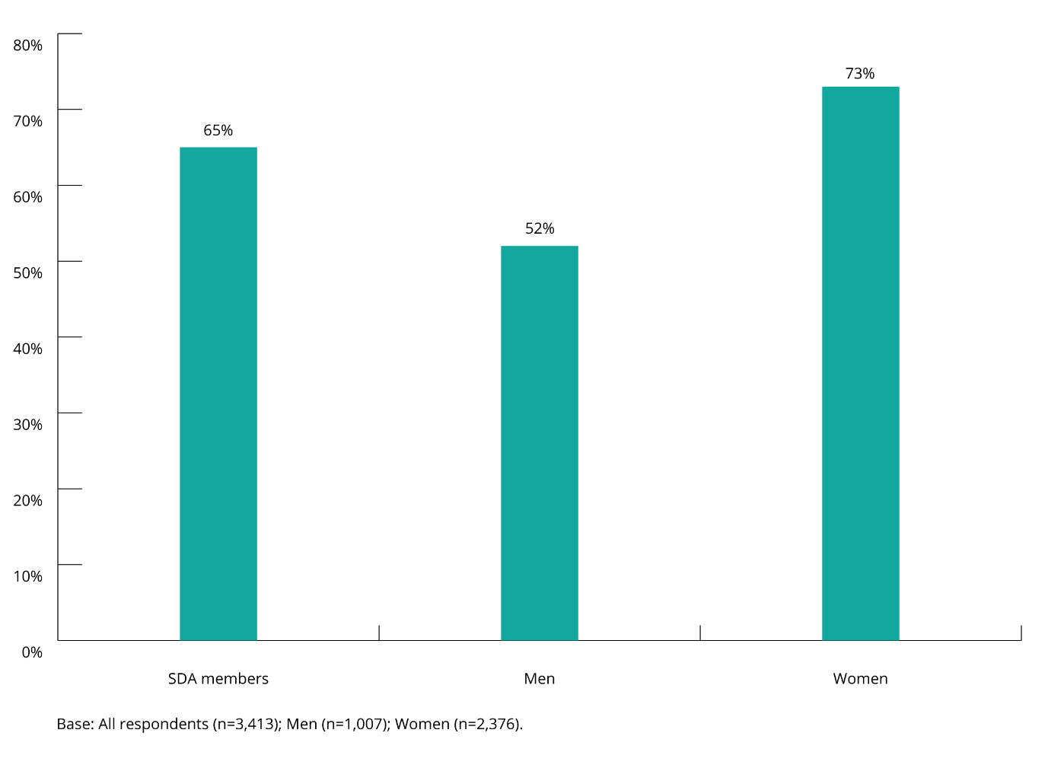

Types of lifetime sexual harassment
Over half of SDA members said they had experienced multiple types of sexual harassment in their lifetime.
Of the 65% of SDA members who said they had experienced lifetime sexual harassment, 57% had experienced multiple types of sexually harassing behaviour, while 8% had only experienced one type.
Female SDA members (67%) were more likely to experience multiple types of sexual harassment in their lifetime compared to male SDA members (41%).
Female SDA members said they had experienced each different type of sexual harassment at rates higher than male SDA members.
Half of female SDA members said they had experienced sexually suggestive comments or jokes that made them feel offended, and inappropriate leering or staring that made them feel intimidated.
The five most common types of sexual harassment that SDA members experienced in their lifetime overall were:
- sexually suggestive comments or offensive jokes (43%) (over half (52%) of female SDA members and more than a quarter (28%) of male SDA members)
- intrusive questions about the SDA member’s private life or physical appearance that made them feel offended (40%) (almost half (47%) of female SDA members and almost a third (29%) of male SDA members)
- inappropriate staring or leering (38%) (half (50%) of female SDA members and almost one fifth (19%) of male SDA members)
- inappropriate physical contact (35%) (more than two fifths (42%) of female SDA members and more than one fifth (23%) of male SDA members)
- unwelcome touching, hugging, cornering or kissing (34%) (more than two fifths (42%) of female SDA members and more than one fifth (21%) of male SDA members).
Nearly a quarter (24%) of all female SDA members said they had experienced requests or pressure for sex or other sexual acts on at least one occasion in their life. One in seven (14%) female SDA members said they had experienced attempted or actual rape or sexual assault on at least one occasion in their life.
While male SDA members were far less likely to have had these experiences, the rates of prevalence were still notable, with one in ten (10%) male SDA members indicating that they had experienced requests or pressure for sex or other sexual acts on at least one occasion in their life, and one in twenty (4%) saying they had experienced attempted or actual rape or physical assault on at least one occasion in their life.

Figure 2: Types of lifetime sexual harassment behaviours experienced (by gender)
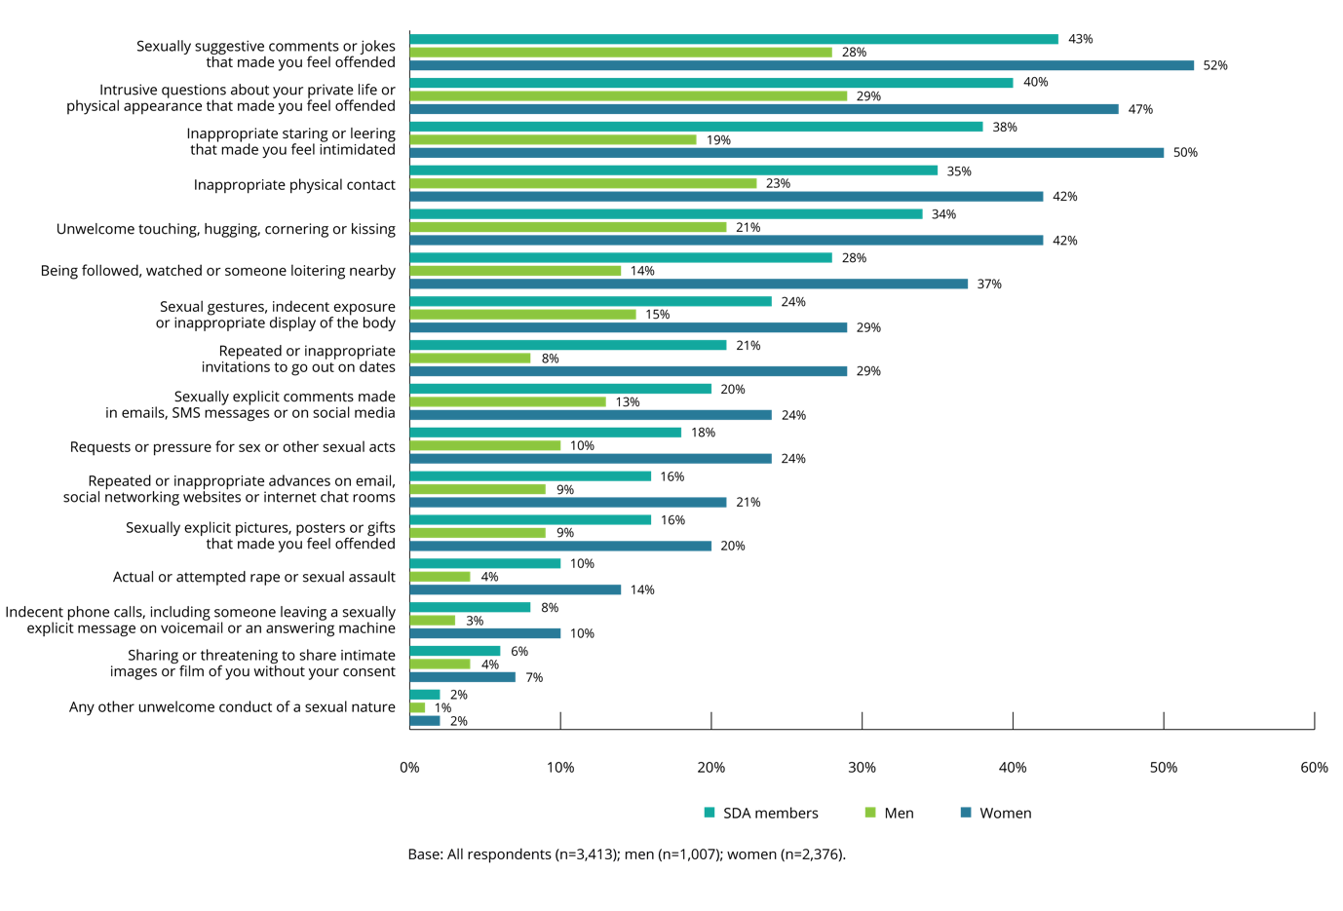
The types of lifetime sexual harassment experienced was broadly similar for SDA members and those in the working population.
However, SDA members indicated that they experienced sexual harassment behaviours at slightly lower rates in their lifetime than the working population.
In particular, those in the working population were more likely to experience the following types of sexual harassment:
- inappropriate physical contact (41%, compared to 35% of SDA members)
- unwelcome touching, hugging, cornering or kissing (38%, compared to 34% of SDA members)
- sexual gestures, indecent exposure of inappropriate display of the body (28%, compared to 24% of SDA members)
- indecent phone calls, including someone leaving a sexually explicit message on voicemail or answering machine (12%, compared to 8% of SDA members).
SDA members were slightly more likely than the working population to experience the following types of sexual harassment:
- intrusive questions about their private life or physical appearance that made them feel offended (40%, compared to 36% of the working population)
- inappropriate staring or leering that made the person feel intimidated (38%, compared to 34% of working population)
- being followed, watched or someone loitering nearby (28%, compared to 25% of the working population).
Figure 3: Lifetime sexual harassment behaviours experienced (SDA members vs the working population)
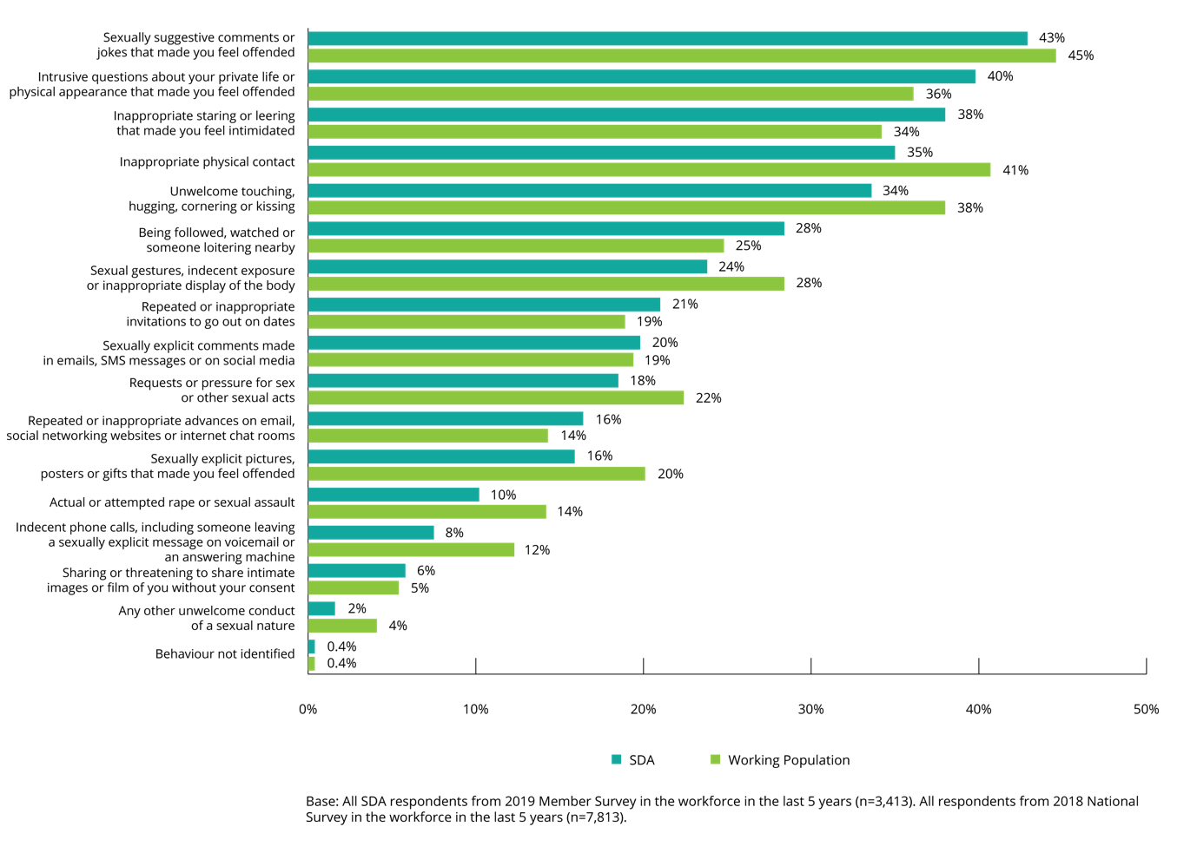

Who experiences lifetime sexual harassment?
The results of the 2019 Member Survey indicate that, over the course of their lifetime, SDA members’ experience of sexual harassment varies according to their demographic profile such as gender identity, age, sexual orientation, intersex status, Aboriginal and Torres Strait Islander status, disability status, and culturally and linguistically diverse backgrounds.

Gender identity
In the survey, respondents were provided with the option of identifying their gender as:
- female
- male
- non-binary
- other
- prefer not to say.
SDA members who indicated they were female (women) were more likely than those who indicated they were male (men) to have experienced sexual harassment in their lifetime (73% and 52%, respectively). A similar pattern is present within the working population, where women (88%) also experienced lifetime sexual harassment at higher rates than men (58%).
The number of respondents who selected an option other than ‘female’ or ‘male’ was too small to draw firm conclusions regarding the prevalence of their experiences of sexual harassment. However, the data does indicate that those who identify as either ‘non-binary’ or ‘other’ are likely to experience lifetime sexual harassment at a rate of 81%. This is higher than the rate of prevalence for SDA members overall (65%), female SDA members (73%) and male SDA members (52%).

Age
Lifetime sexual harassment was highest among SDA members aged 18–29 years, with 70% having experienced sexual harassment over the course of their lifetime. Sexual harassment was also most prevalent among this age group in the working population (77%).
SDA members aged 30 years or more experienced sexual harassment at a rate of 61%, with those aged 15–17 years being the least likely to have been sexually harassed in their lifetime (59%). The experience of lifetime sexual harassment is similar in the working population with those aged 30 or more experiencing sexual harassment at a rate of 72%, and those aged 15–17 years being the least likely to have experienced lifetime sexual harassment (63%).

Sexual orientation
The prevalence of sexual harassment was higher among SDA members who identified as gay, lesbian, bisexual, pansexual, queer, asexual or aromantic, undecided, not sure, questioning or other (hereafter, non-heterosexual) (81%, compared to 63% for heterosexual SDA members). This is also the case for the working population, with people who identify as non-heterosexual having experienced lifetime sexual harassment at a rate of 88%, compared to 72% who identify as heterosexual.
Female SDA members (91%) who identified as non-heterosexual were more likely than non-heterosexual male SDA members (69%) to have experienced sexual harassment in their lifetime.
While the prevalence of sexual harassment for non-heterosexual men was lower than for non-heterosexual women, it was still the case that non-heterosexual men (69%) experienced sexual harassment at a rate higher than heterosexual men (49%).

Intersex status
The sample size for this cohort was too small to conclusively report on experiences of sexual harassment. Therefore, these results should be considered as indicative only.
Four in five respondents (79%) with an intersex variation had been sexually harassed in their lifetime, higher than SDA members without an intersex variation (65%).

Aboriginal and Torres Strait Islander peoples
Aboriginal and Torres Strait Islander members of the SDA (67%) were relatively more likely to have experienced lifetime sexual harassment than those not of Aboriginal or Torres Strait Islander descent (65%). This was consistent with the rates in the working population (78% for Aboriginal and Torres Strait Islander workers, and 73% for those not of Aboriginal or Torres Strait Islander descent).

People with a disability
SDA members with disability (74%) were more likely than those without disability (64%) to have been sexually harassed in their lifetime. While the same prevalence trend was present in the working population the rates were higher (83% and 72%, respectively).
Four in five (82%) female SDA members with disability had experienced lifetime sexual assault compared to 66% of male SDA members with disability.

People from culturally and linguistically diverse backgrounds
SDA members who speak mainly English at home were more likely to have experienced lifetime sexual harassment (66%) than those who mainly speak a language other than English at home (56%).

Household income
The prevalence of lifetime sexual harassment was broadly similar across most household income bands. However, it was higher among households earning $25,000 to $34,999 per year (75%) and $150,000 to $199,999 (73%).

Awareness of sexual harassment
To gauge SDA members’ awareness about what constitutes ‘sexual harassment’ before being asked about their experiences of sexual harassment ‘behaviours’, all survey respondents were provided with the following simplified legal definition of sexual harassment and asked to indicate whether they had experienced such harassment at any time or anywhere:
Sexual harassment is an unwelcome sexual advance, unwelcome request for sexual favours or other unwelcome conduct of a sexual nature which, in the circumstances a reasonable person, aware of those circumstances would anticipate the possibility that the person would feel offended, humiliated or intimidated.
Respondents were then read a list of 16 sexual harassment behaviours (see section 1.3(a)) and asked if they had experienced any of the identified behaviours in a way that was unwelcome.
SDA members were more likely to identify lifetime sexual harassment when asked about sexual harassment behaviours than when asked about the legal definition of ‘sexual harassment’.
In total, 44% of SDA members indicated that they had been sexually harassed in their lifetime based on the legal definition. In contrast, 65% said they had experienced lifetime sexual harassment when presented with a list of 16 sexual harassment behaviours (see section 1.3(a)).
This gap in awareness was far higher for men than for women.
Over half of female SDA members (55%) indicated that they had been sexually harassed when asked in the context of the legal definition. This increased by 18%, to 73% when they were asked to report on their experiences based on the 16 sexual harassment behaviours outlined in the 2019 Member Survey (see section 1.3(a)).
In contrast, 26% of male SDA members reported that, based on the legal definition they had experienced lifetime sexual harassment. This doubled to 52% when measured in terms of the 16 sexual harassment behaviours outlined in the 2019 Member Survey.
The gap in awareness was higher for 15–17 year olds than for other age groups. One third (36%) of 15–17 year olds reported an experience of sexual harassment only after being showed a list of 16 sexual harassment behaviours, compared to 21% of 18–29 year olds and 21% of those 30 years and older.
It is notable that the increase in the proportion of male SDA members reporting an experience of sexual harassment more than doubles (99%), increasing from 26% to 52%, after seeing the list of 16 sexual harassment behaviours. In contrast, the increase in reporting for female SDA members was just over a third (34%) increasing from 55% to 73%. This is a consistent trend for male and female SDA members aged 18–29 years and 30 years and over, and for younger female SDA members aged 15–17 years.
While the numbers of young male SDA members aged 15–17 years reporting an experience of sexual harassment are insufficient to provide a statistically reliable estimate there is a strong indication that they are only likely to report experiencing sexual harassment when prompted with a list of 16 sexual harassment behaviours.

Figure 4: Gap in awareness and understanding of sexual harassment (legal vs behavioural definition) for all SDA members
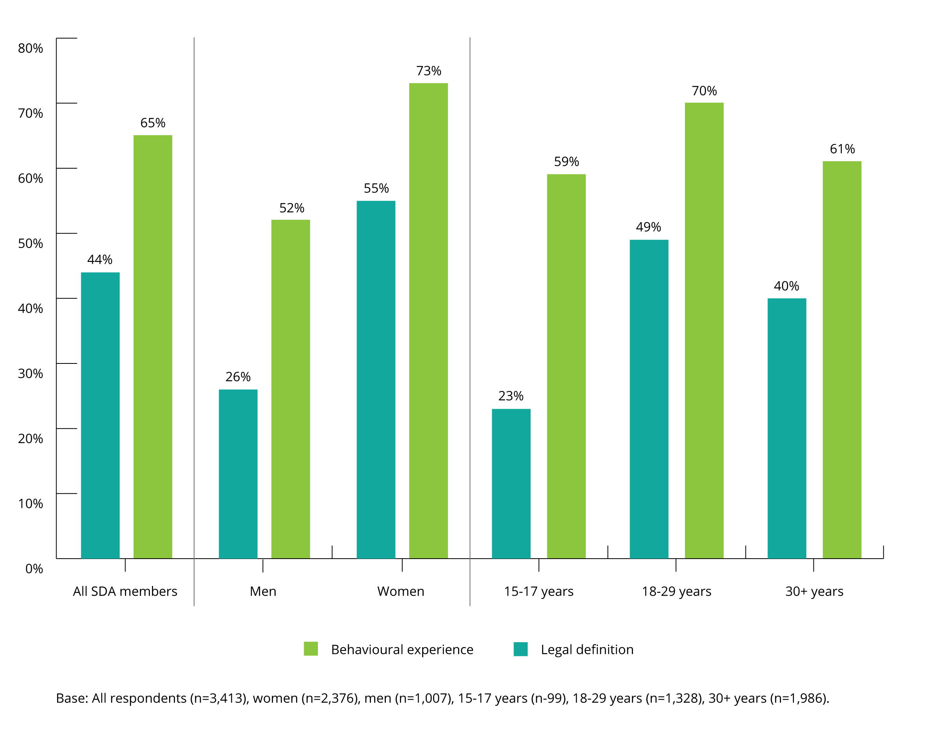

‘My team leader plays disgusting sexually explicit music while me and my colleagues are working for the whole shift. Our store manager walked past and asked the girls what they would rate the playlist out of 10. They scored it pretty low. Nothing was done about it though, just thought I’d mention it…’

Workplace sexual harassment

Chapter summary
This chapter examines SDA members’ experiences of workplace sexual harassment as reported through the 2019 Member Survey. Workplace sexual harassment refers to sexual harassment at work, a work-related event or while looking for work.
Prevalence of workplace sexual harassment in the last five years
Two in five (39%) SDA members said they had experienced workplace sexual harassment in the last five years. Female SDA members (46%) experienced workplace sexual harassment at higher rates than their male colleagues (29%).
SDA members (39%) experienced workplace sexual harassment at levels higher than the working population (33%) over the last five years. A third (30%) of SDA members had experienced multiple types of workplace sexual harassment.
Over half (54%) of SDA members, and 51% of the working population, had been exposed to workplace sexual harassment in the last five years, either by experiencing it personally, as a bystander, or both.
The highest prevalence of workplace sexual harassment was reported in the fast food (37%), retail (39%), and ‘other’ (47%) SDA sectors. SDA members working in the warehousing sector were less likely than those in other sectors to have experienced workplace sexual harassment (26%).
The most recent incident of workplace sexual harassment

Types of workplace sexual harassment
When asked about the most recent incident of workplace sexual harassment they had experienced, female SDA members indicated that the most common types of workplace sexual harassment that they had experienced were:
- sexually suggestive comments or offensive jokes (26%)
- inappropriate staring or leering that made you feel intimidated (20%).

Male SDA members indicated that the most common types of workplace sexual harassment they experienced were:
- intrusive questions about an individual’s private life or physical appearance that made them feel offended (27%)
- sexually suggestive comments or offensive jokes (26%).

Frequency of workplace sexual harassment
More than half (57%) of SDA members indicated that they had experienced the same type of workplace sexual harassment on more than one occasion in the same workplace. Female SDA members were more likely to say this (58%) than male SDA members (52%).
Of SDA members who had been sexually harassed in the workplace in the last five years, two thirds (62%) considered that this type of behaviour was either common or occurred sometimes in their workplace.

Duration of ongoing workplace sexual harassment
For a significant proportion of SDA members, workplace sexual harassment was an ongoing issue. Over half (53%) of SDA members who said they had experienced workplace sexual harassment in the last five years indicated that the sexual harassment had continued for a period of seven months or more. This included 23% of SDA members who had experienced workplace sexual harassment for a period of two years or longer.

Location of workplace sexual harassment
The most common location for the most recent incident of workplace sexual harassment to occur was an individual’s workstation or the area in which they worked (75%). Female SDA members (78%) were more likely than male SDA members (68%) to have been sexually harassed at their workstation or in the area in which they worked.

Gender balance of workplace where workplace sexual harassment occurred
When asked about the gender balance in their workplace at the time of the most recent incident of workplace sexual harassment, two-thirds (62%) of SDA members indicated that the gender balance in their workplace was roughly equal. The types of workplace sexual harassment experienced by SDA members varied based on the gender balance of the workplace.

Bystanders to the most recent incident of workplace sexual harassment
Just over a quarter (26%) of SDA members indicated that their most recent incident of workplace sexual harassment was witnessed by one or more bystanders, compared to 40% for the working population.
The most common types of workplace sexual harassment which went unwitnessed were:
- inappropriate staring or leering (76%)
- questions about an individual’s private life or physical appearance (75%)
- repeated or inappropriate invitations to go out on dates (75%)
- inappropriate physical contact (72%)
- unwelcome touching, cornering or kissing (71%).
The most commonly witnessed type of workplace sexual harassment was being followed, watched or loitering nearby (38%), followed by sexually suggestive comments or offensive jokes (31%).
When SDA members reported that their most recent experience of sexual harassment had been witnessed by a bystander, this was often by only one person (23%). The average number of bystanders to the most recent incident, as reported by the person who experienced workplace sexual harassment, was 2.6.
In 77% of cases, the bystander was a co-worker at the same level as the person who experienced workplace sexual harassment. In 16% of cases, the bystander was a customer or client. Intervention by a bystander was twice as likely to occur if the SDA member who was being sexually harassed was female (25%) compared to 12% for males.
In most incidents, bystanders did not intervene, with only 22% of bystanders taking action. Bystanders were more likely to intervene when the person experiencing sexual harassment was 15–17 years of age (45%), than when they were older (18–29 years: 17%; and 30 years or more: 23%).
SDA members who had experienced workplace sexual harassment
SDA members’ experience of workplace sexual harassment in the last five years differed according to their demographic profile:
- SDA members who were female (46%) were more likely to experience workplace sexual harassment than their male colleagues (29%)
- workplace sexual harassment was highest amongst SDA members aged 18–29 (46%)
- SDA members who identified as gay, lesbian, bisexual, pansexual, queer, asexual or aromantic, undecided, not sure, questioning or other experienced workplace harassment at a higher rate (58%) than those who identified as heterosexual (37%)
- Aboriginal and Torres Strait Islander members of the SDA (43%) were relatively more likely to have experienced workplace sexual harassment than those who were not of Aboriginal and Torres Strait Islander descent (38%)
- SDA members with disability (45%) were more likely to have experienced workplace sexual harassment compared to those without disability (39%)
- SDA members who speak mainly English at home (40%) were more likely to have experienced workplace sexual harassment compared to those who speak a language other than English at home (28%)
- SDA members who reported household incomes of between $25,000 and $34,999 (48%), and $150,000 and $199,999 (41%), were more likely to have experienced workplace sexual harassment than those in other income brackets.
Harassers

Gender of harassers
SDA members indicated that in the majority (82%) of workplace sexual harassment incidents experienced in the last five years the harasser was male. Female SDA members were even more likely to indicate that they had been sexually harassed by a male harasser in the workplace (91%).

Relationship of harassers to SDA member
SDA members said that in one in three incidents (36%) of workplace sexual harassment they experienced in the last five years, one or more of the harassers was a customer or client. This was more likely to have been the case for female SDA members (42%) than for male SDA members (22%).

Age of harasser
Just over a third (36%) of SDA members indicated that they were sexually harassed by a person aged 30 years or younger, with a further 27% indicating that the harasser was aged between 31 and 40 years of age.

Number of harassers
SDA members and the working population said that the majority of workplace sexual harassment incidents were carried out by a single harasser (57% and 64%, respectively). Female SDA members (61%) were more likely than male SDA members (46%) to have experienced workplace sexual harassment by a single harasser.

Impact of workplace sexual harassment on affected employees
The majority of SDA members who had experienced workplace sexual harassment reported some form of negative consequence. The most commonly identified consequence was a negative impact on the individual’s mental health or stress (44%).
When SDA members were asked about specific health and wellbeing consequences, anxiety (40%) and loss of self-esteem (23%) were the most often reported consequences. Female SDA members (42%) were more likely than male SDA members (33%) to have experienced anxiety as a result of the most recent incident.
When asked about the support sought when they experienced the most recent incident of workplace sexual harassment, SDA members were most likely to indicate sick/personal leave (14%) followed by seeing a medical practitioner (10%).

Degree of offence and intimidation experienced
Female SDA members indicated that they experienced higher levels of offence and intimidation as a result of workplace sexual harassment than male SDA members.
The more offended or intimidated SDA members were, the more likely they were to make a formal report or complaint about the incident. Three in five (58%) SDA members who had experienced workplace sexual harassment and who were extremely offended, and one in two (52%) SDA members who were extremely intimidated, made a formal complaint.

Prevalence of workplace sexual harassment

Workplace sexual harassment in the last five years
Workplace sexual harassment refers to the experience of any of the 16 sexual harassment behaviours at work, a work-related event or while looking for work (see section 1.3(a)).
Two in five SDA members said they were sexually harassed in the workplace in the last five years.
Thirty-nine per cent of SDA members in the workforce said that they had experienced workplace sexual harassment in the last five years.
The prevalence of workplace sexual harassment was significantly higher among female SDA members and younger SDA members.
The prevalence of workplace sexual harassment was higher among female SDA members (46%) than male SDA members (29%). Those aged 18–29 years (46%) were also more likely than those in other age groups to have been sexually harassed in the workplace in the last five years.

Figure 5: Prevalence of workplace sexual harassment in the last five years (by gender and age)
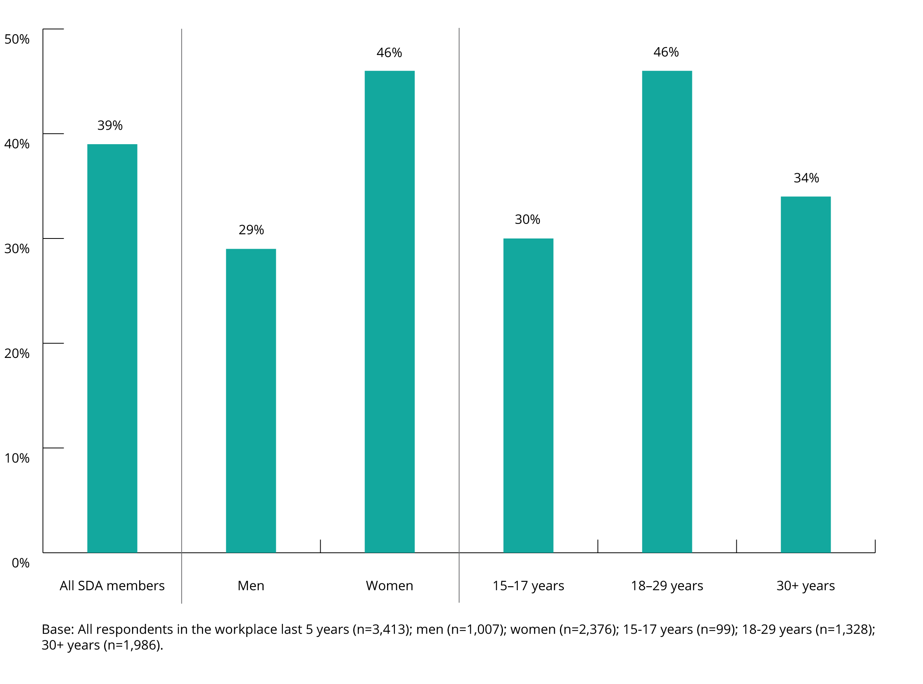
SDA members experienced workplace sexual harassment at a higher rate than the working population.
This is in contrast to lifetime sexual harassment where the prevalence was higher in the working population, which is related to the lower median age of SDA members (20–29 years, compared to 40–49 years in the working population) (see section 2.2).
While the prevalence of workplace sexual harassment among SDA members in the last 12 months was 28%, and 39% in the last five years, the working population experienced workplace sexual harassment at rates of 20% and 33%, respectively.

Figure 6: Prevalence of workplace sexual harassment—last 5 years, 12 months (SDA members vs the working population)
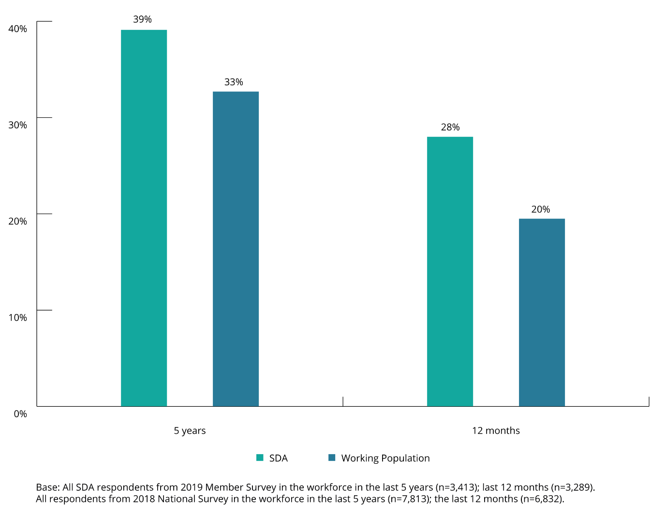
A third of SDA members said they had experienced multiple types of workplace sexual harassment.
Thirty per cent of SDA members had experienced multiple types of sexually harassing behaviour in the workplace in the last five years, and 9% had experienced one type.
Female SDA members (36%) were more likely to experience multiple types of workplace sexual harassment than male SDA members (20%). Female and male SDA members experienced one type of workplace sexual harassment at similar rates (10% and 9%, respectively).

Figure 7: How many types of workplace sexual harassment behaviours have been experienced
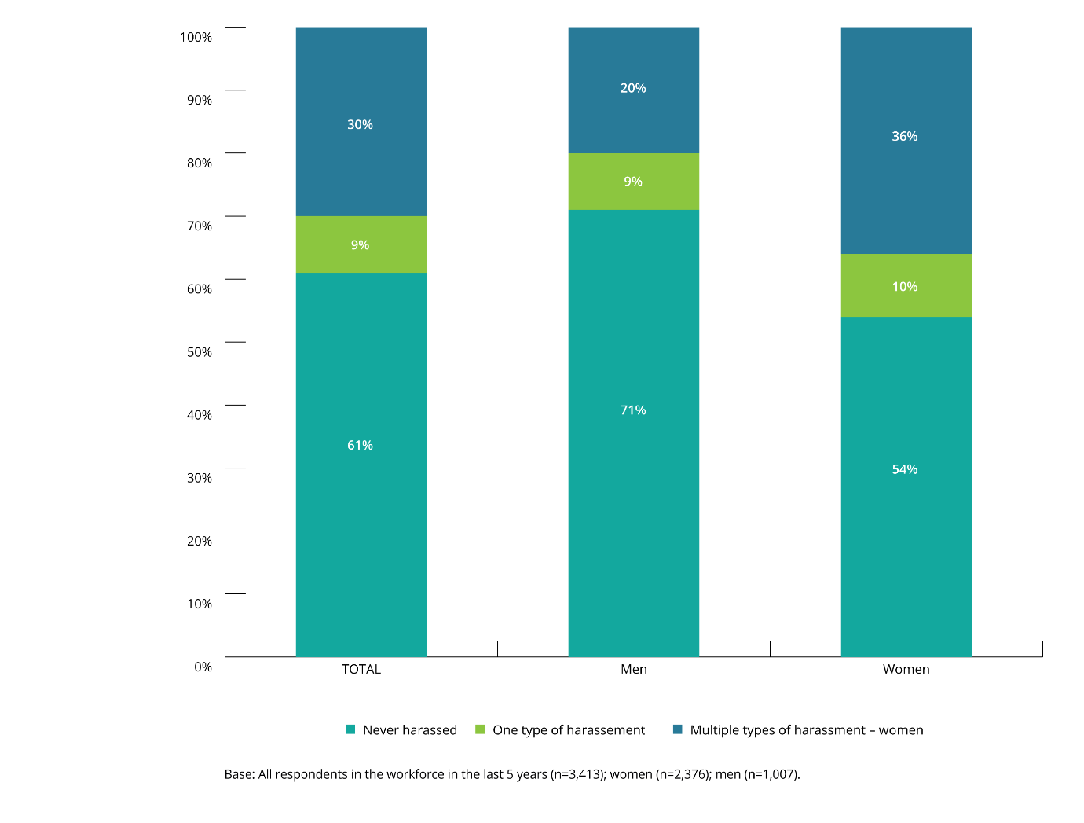

Types of workplace sexual harassment
While SDA members and the working population experienced similar types of workplace sexual harassment, the incidence was notably higher across most behaviours for SDA members.
For both groups, the three most commonly experienced behaviours were:
- sexually suggestive comments or offensive jokes (SDA: 24%, compared to 19% for the working population)
- intrusive questions about a person’s private life or physical appearance (SDA: 22%, compared to 14% of the working population)
- inappropriate staring or leering (SDA: 20%, compared to 11% of the working population).
Figure 8: Types of workplace sexual harassment behaviours experienced (SDA members vs the working population)
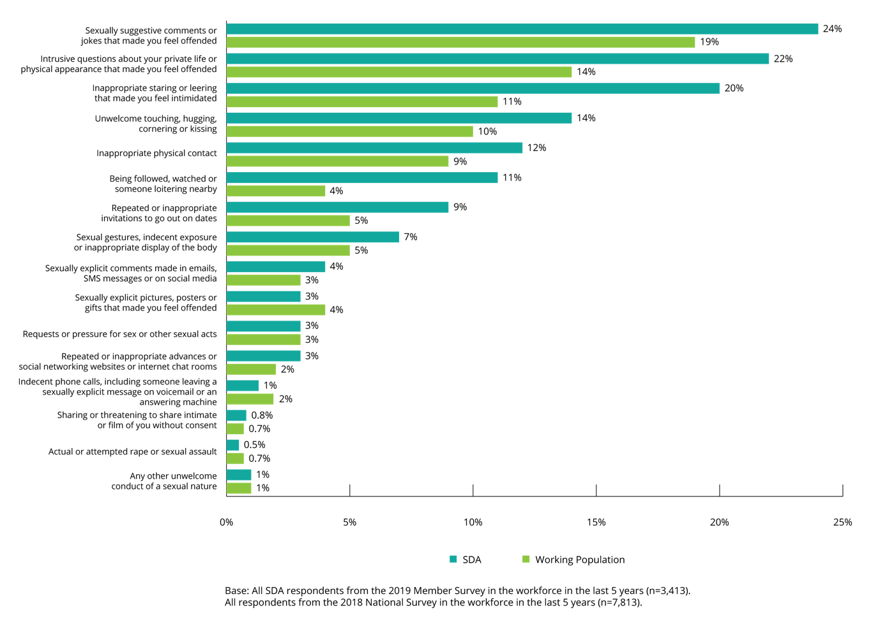

Scale of sexual harassment in the workplace
SDA members who had been in the workforce in the last five years were asked about their exposure to workplace sexual harassment, either as a person who had experienced workplace sexual harassment, as a bystander, or both.
More than half of SDA members indicated that they had either experienced workplace sexual harassment, had been a bystander to workplace sexual harassment, or both.
Just over half (54%) of SDA members who had been in the workforce in the last five years said they had been exposed to some type of workplace sexual harassment, either as someone who had experienced it, or as a bystander (someone who either witnessed or heard about the sexual harassment of another person in their workplace), or both.
Female and male SDA members reported a similar likelihood of exposure to workplace sexual harassment, with 56% of females and 56% of males either experiencing workplace sexual harassment, witnessing it as a bystander, or both, in the last five years.
Both SDA members and the working population had similar levels of exposure to workplace sexual harassment.
Like SDA members (54%), just over half (51%) of the working population said they had been exposed to workplace sexual harassment. However, SDA members were more likely than the working population to have experienced workplace sexual harassment themselves but not witnessed another person being harassed (19% and 14%, respectively).
In contrast, the working population were more likely than SDA members to have witnessed someone else being sexually harassed in the workplace but not have experienced it themselves (19% and 15%, respectively).

Workplace sexual harassment by SDA sector
The highest prevalence of workplace sexual harassment was reported in the fast food (37%), retail (39%), and ‘other’ (47%) industry sectors. SDA members working in the warehousing sector were less likely than those in other sectors to have experienced workplace sexual harassment in the last five years (26%).
While 47% of those working in ‘some other industry’ (that is, not fast food, retail or warehousing) had been sexually harassed in the workplace, there was no statistically significant difference between this and the overall level of workplace sexual harassment (39%).

Figure 9: Prevalence of workplace sexual harassment by SDA sector
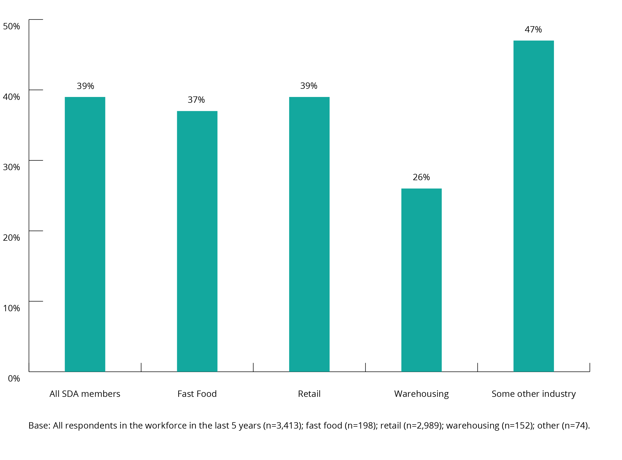
In most cases, there was a similar incidence of particular types of workplace sexual harassment across SDA sectors.
SDA members in the retail sector were more likely to have experienced inappropriate physical contact (17%, compared to the overall rate of 12%). SDA members in ‘some other industry’ were more likely to have experienced requests for pressure for sex or other sexual acts (12%, compared to an overall rate of 3%).
SDA members working in the warehousing sector were less likely than average to have experienced intrusive questions about their private life or physical appearance (11%, compared to an overall rate of 22%), and inappropriate staring or leering (11%, compared to an overall rate of 20%).

Nature of workplace sexual harassment
Survey respondents were asked questions about their experience of sexual harassment including:
- the type of behaviour experienced
- the frequency, duration, and location of workplace sexual harassment
- the gender balance at the workplace where they experienced sexual harassment
- whether there were bystanders who witnessed them being sexually harassed
- the impact of and the degree of offence or intimidation caused by workplace sexual harassment
- the harasser.
This section focuses on the most recent incident of workplace sexual harassment within the last five years, as reported in the 2019 Member Survey.

Types of workplace sexual harassment
The most common types of workplace sexual harassment experienced by female SDA members, during the most recent incident of workplace sexual harassment, were sexually suggestive comments or offensive jokes.
The two most common types of workplace sexual harassment experienced by female SDA members were sexually suggestive comments or offensive jokes (26%), and inappropriate staring or leering that made you feel intimidated (20%).
For male SDA members, the two most common types of workplace sexual harassment experienced in the last five years were intrusive questions about a person’s private life or physical appearance (27%), and sexually suggestive comments or offensive jokes (26%). Women reported experiencing sexually suggestive comments or offensive jokes at the same rate as men (26%) but reported intrusive questions at a lower rate (18%).

Figure 10: The most recently experienced types of workplace sexual harassment behaviours
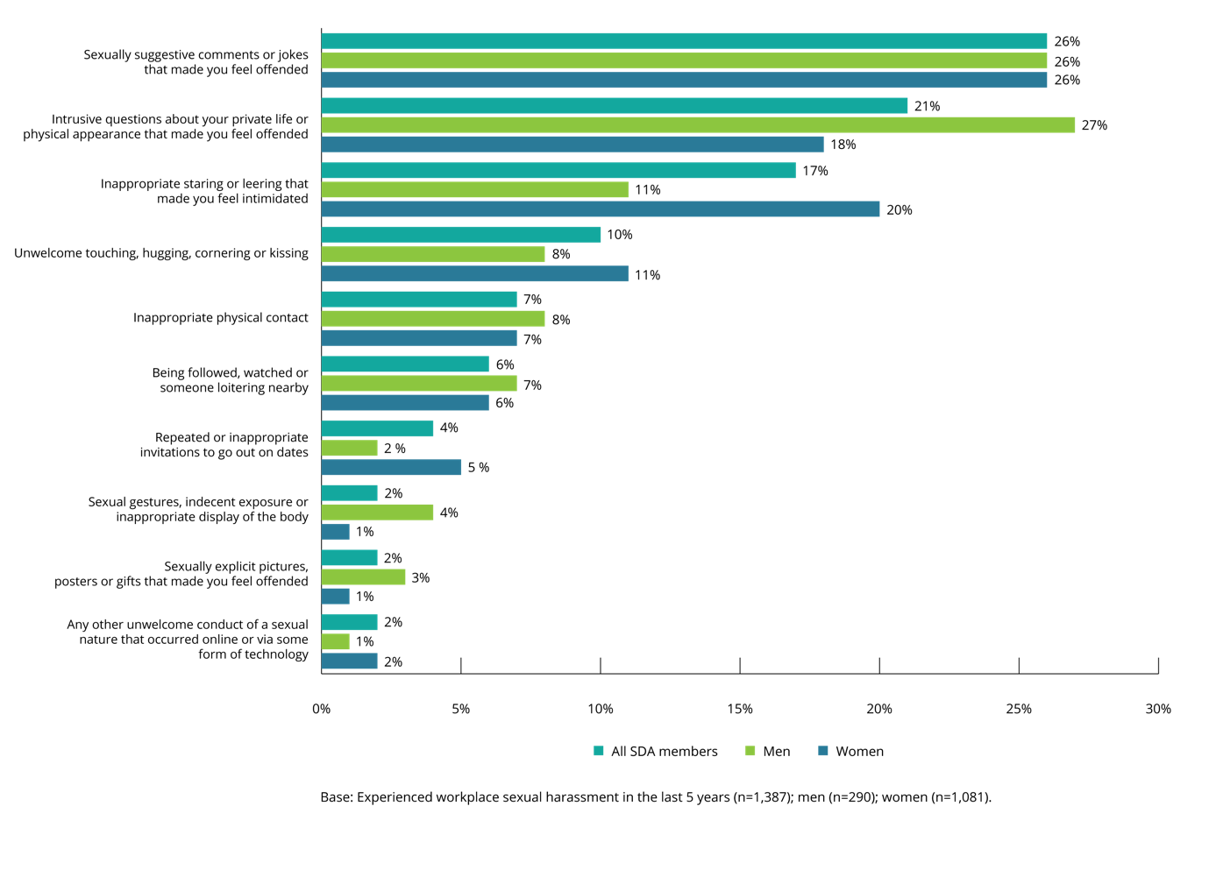

Frequency of workplace sexual harassment
SDA members who said they had experienced workplace sexual harassment in the last five years were asked, in relation to the most recent incident, whether this was a one-off event or if it they had experienced the same or similar behaviour previously in the same workplace.
More than half of SDA members indicated that they had experienced the same (or a similar) type of workplace sexual harassment on more than one occasion.
Overall, 43% of SDA members who indicated they had been sexually harassed at work in the last five years described the most recent incident as a one-off event, with the majority (57%) saying they had experienced workplace sexual harassment on more than one occasion in the workplace.
Women (58%) were more likely than men (52%) to have experienced workplace sexual harassment on more than one occasion.
Figure 11: Frequency of workplace sexual harassment (by gender)
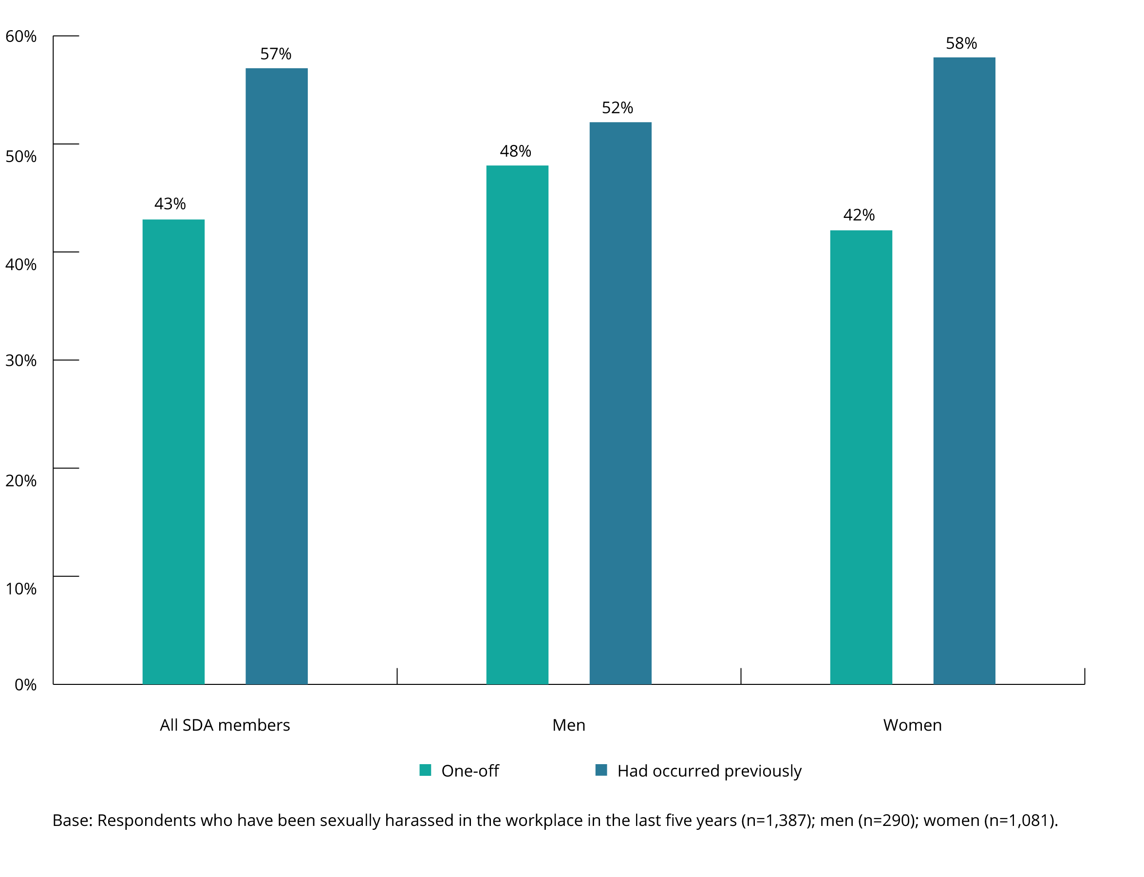
SDA members were more likely than the working population to have experienced workplace sexual harassment on more than one occasion.
SDA members experienced workplace sexual harassment on more than one occasion at a rate of 57%, compared to 49% for the working population.
When these experiences were broken down by gender, both a majority of female SDA members (58%) and male SDA members (52%) indicated that they had experienced workplace sexual harassment on more than one occasion. In contrast, within the working population, the majority of males described their experience as a one-off incident (57%), although females were still more likely to experience multiple incidents of workplace sexual harassment (54%).
While some workplace sexual harassment behaviours were more likely to be experienced as a one-off incident, others were more likely to occur repeatedly.
Amongst SDA members the likelihood that a particular type of workplace harassment was a one-off occurrence as opposed to a repeated behaviour was generally similar to the overall incidence of that type of sexual harassment, with three main exceptions:
- ‘sexually suggestive comments or jokes’ was more likely to have been a repeated behaviour with 67% of the reported occasions being a repeated occurrence and 33% a one-off event
- ‘repeated or inappropriate invitations to go out on dates’ was more likely to have been a repeated behaviour rather than a one-off event (68% repeated, compared to 32% one-off)
- ‘inappropriate physical contact’ was more likely to have been a one-off occurrence than a repeated behaviour (58% one-off occurrence compared to 42% repeated).

Figure 12: Types of workplace sexual harassment behaviours (one-off experience vs those that occurred previously)
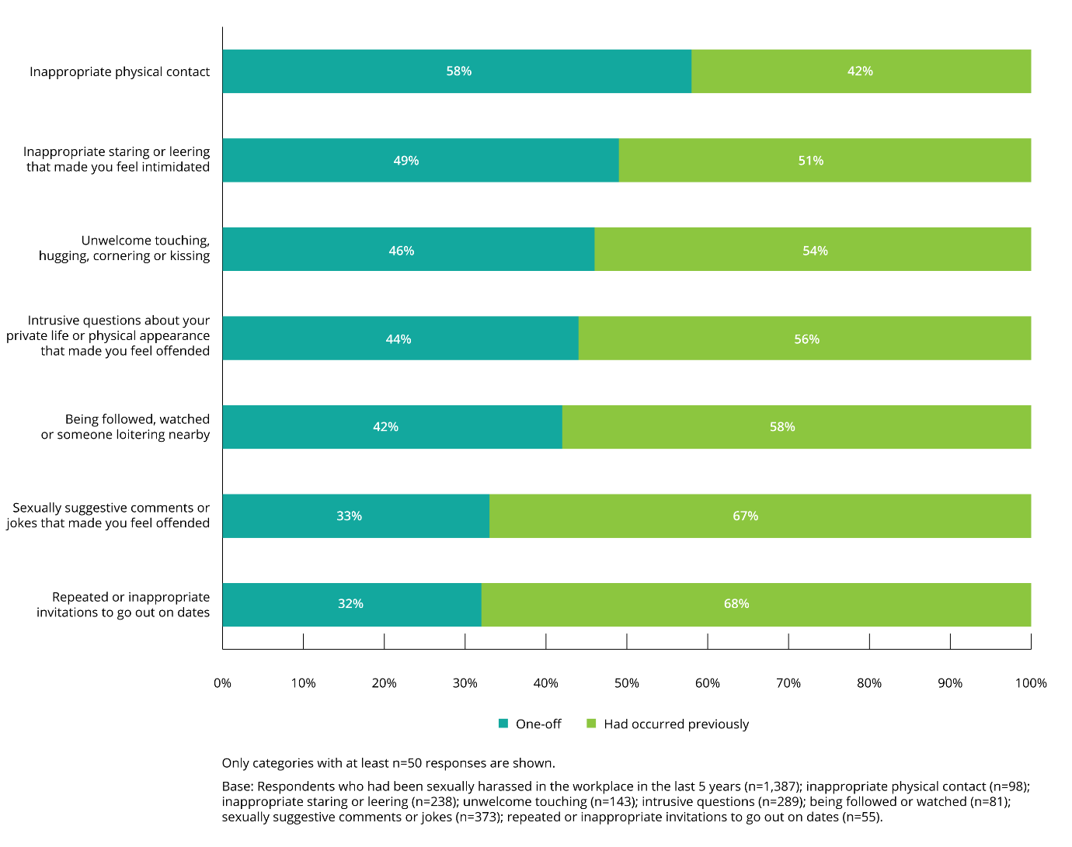
Two thirds (62%) of SDA members who said they had been sexually harassed in the workplace in the last five years considered the type of behaviour that they had experienced to be something that is either common or occurs sometimes in their workplace.
Nearly a quarter (23%) of SDA members who were sexually harassed at work reported that the type of behaviour that they had experienced was common in their workplace, and 39% reported that it occurred sometimes.
Women were more likely than men to indicate that workplace sexual harassment was common (25% and 16%, respectively), and men were more likely than women to say that workplace sexual harassment was rare (27% and 16%, respectively) or very rare (10% and 9%, respectively).
Figure 13: Assessment of how common workplace sexual harassment is (by gender)
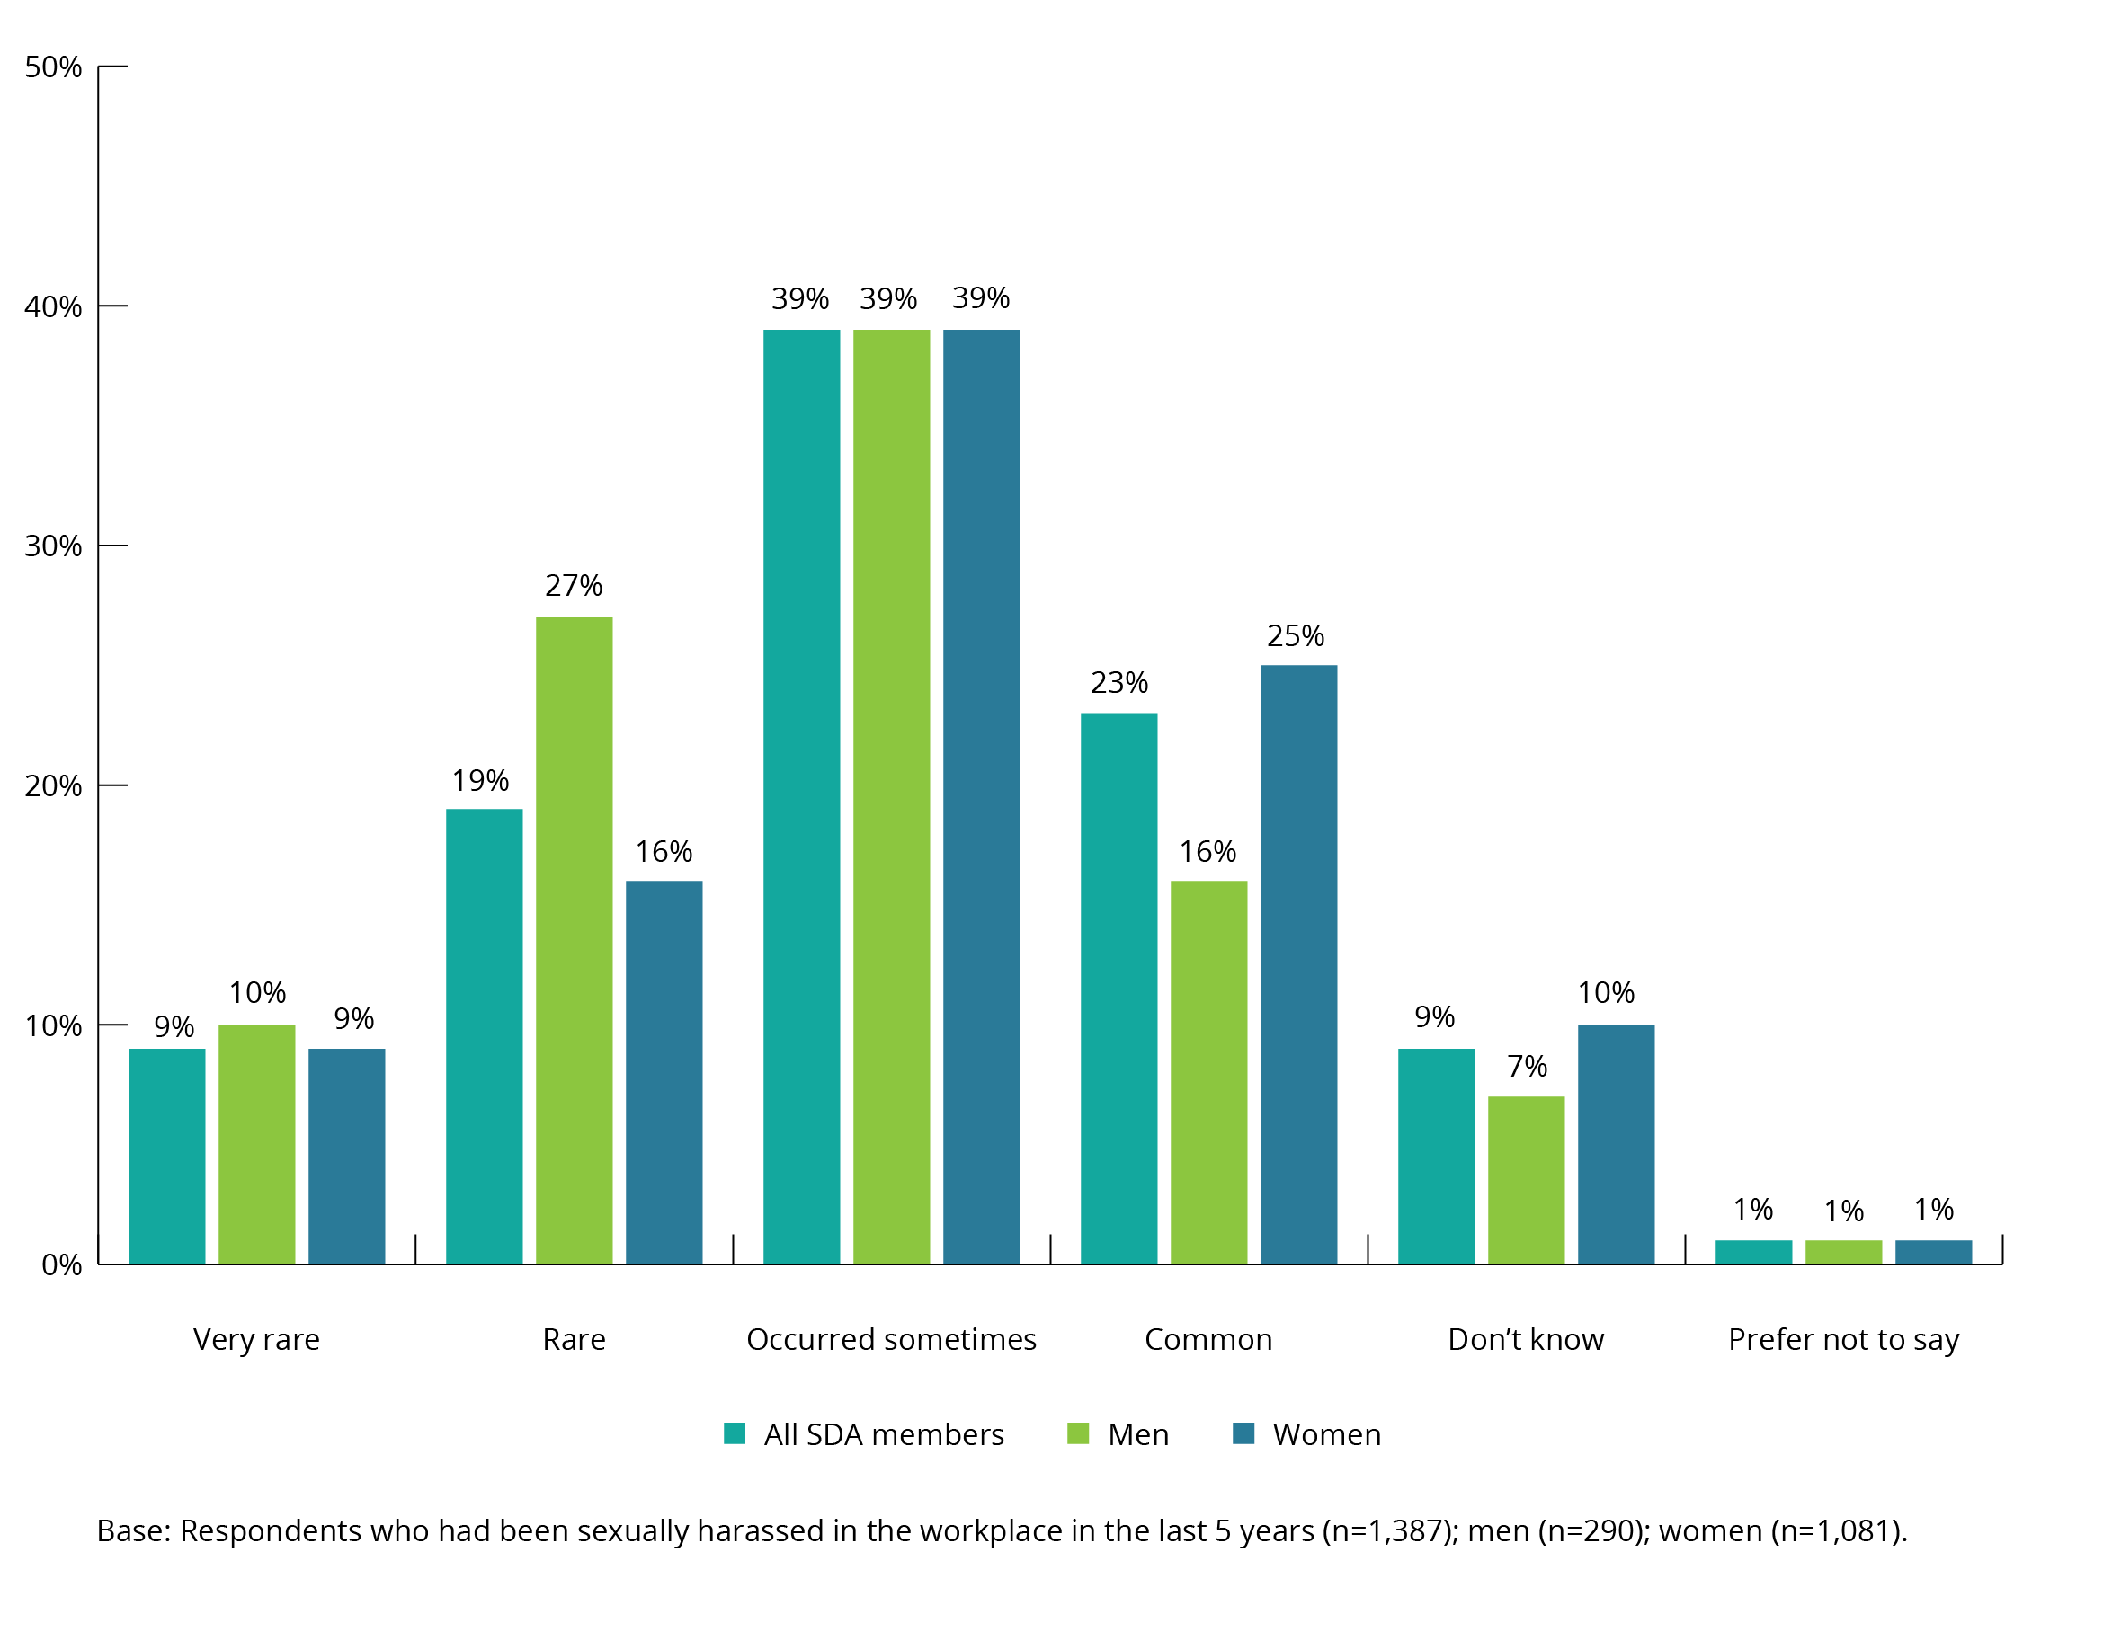
Nearly half of SDA members who had been sexually harassed in the workplace in the last five years were aware of someone else in their workplace who had also been sexually harassed in the same way.

Overall:
- 46% said they were aware that others in the workplace had experienced the same type of sexual harassment as them
- 8% were not aware of anyone else in the workplace who had been sexually harassed in the same way
- 45% said they did not know whether anyone else in the workplace had experienced the same type of sexual harassment as they had.
Female SDA members were more likely than male SDA members to say that this type of workplace sexual harassment had happened to others in the workplace (48% and 39%, respectively), while male SDA members were more likely than female SDA members to say that it had not occurred (11% and 6%, respectively).
Figure 14: Whether others in the workplace experienced the same type of sexual harassment (by gender)
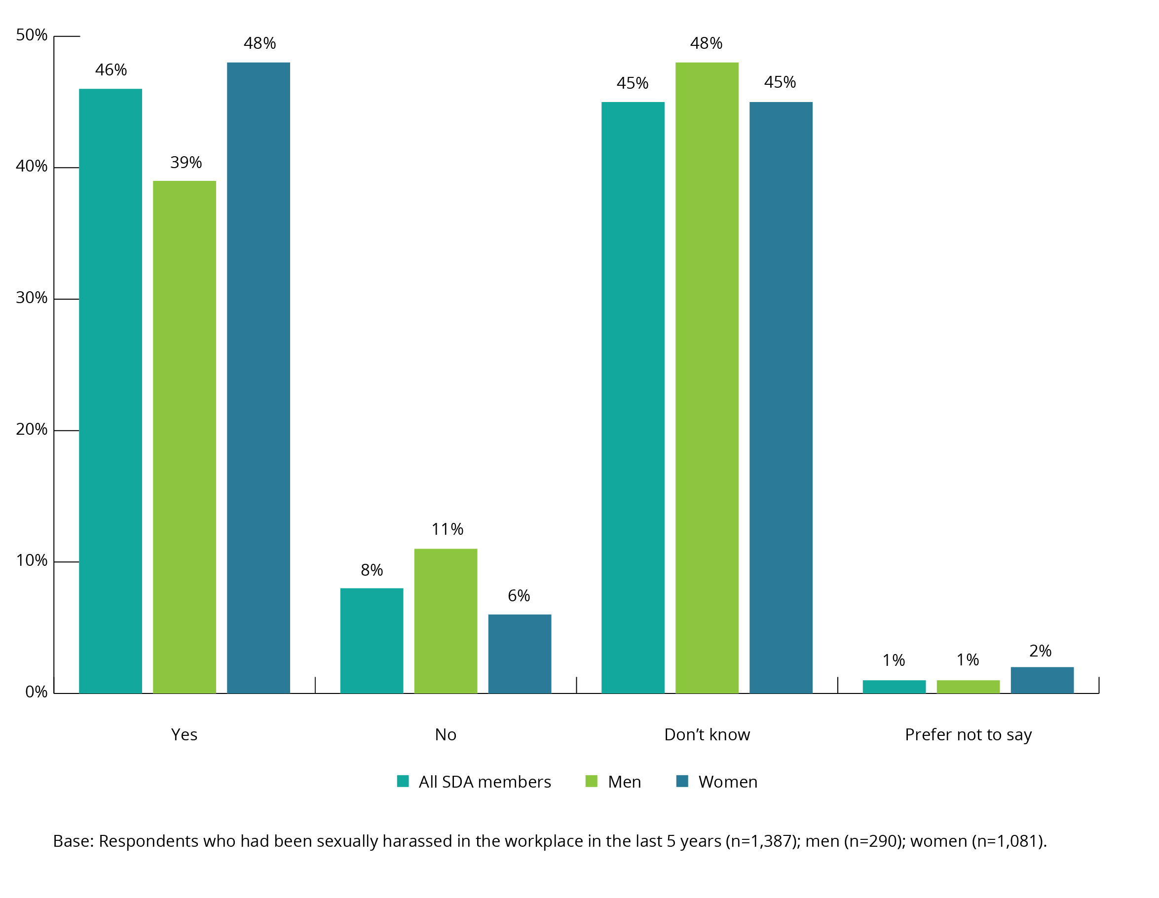
Sexually suggestive comments or jokes were the type of sexual harassment most likely to have been experienced by another person in the same workplace in the last five years.
The types of sexual harassment most likely to have also been experienced by others in the workplace where the most recent incident occurred were:
- sexually suggestive comments or jokes that made the person feel offended (54%)
- repeated or inappropriate invitations to go out on dates (48%)
- being followed, watched or someone loitering nearby (47%)
- intrusive questions about private life or physical appearance (46%)
- inappropriate staring or leering that made the person feel intimidated (44%)
- unwelcome touching, hugging, cornering or kissing (41%)
- inappropriate physical contact (37%).

Figure 15: Whether others in the workplace experienced the same type of sexual harassment (by type of behaviour)
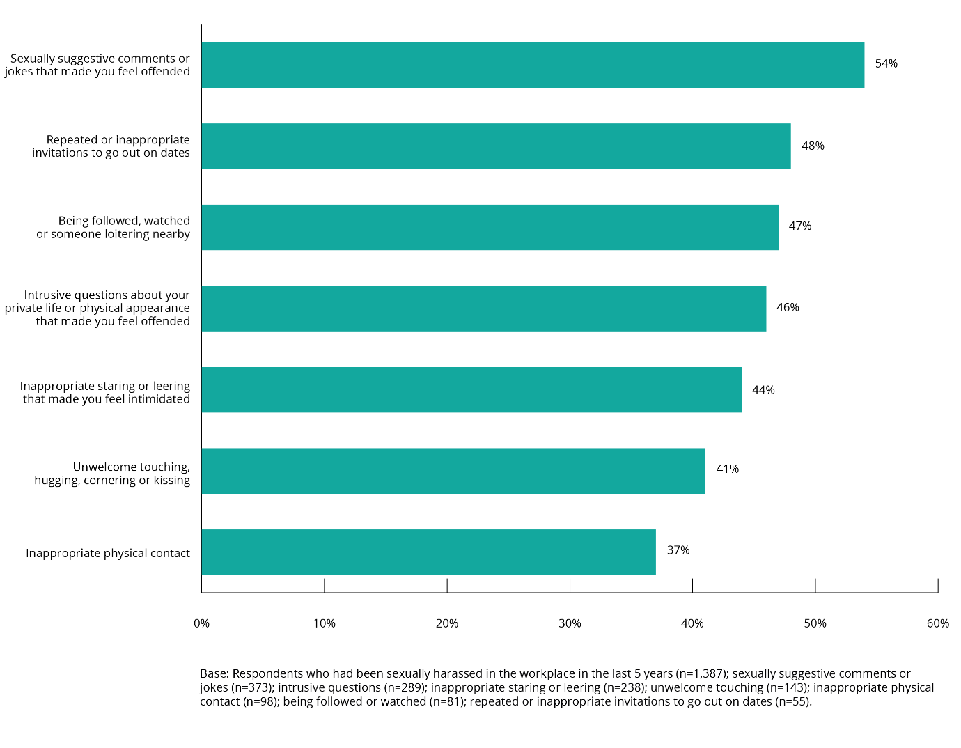

Duration of ongoing workplace sexual harassment
SDA members who said they had experienced workplace sexual harassment in the last five years, on more than one occasion in the same workplace, were asked how long they had been experiencing this behaviour at that workplace.
Workplace sexual harassment experienced in the last five years often took place over an extended period.
For 35% of SDA members who had experienced repeated sexual harassment in their workplace, the harassment was experienced over a period of six months or less.
However, for a significant proportion of SDA members workplace sexual harassment was a longer-term issue. Over half (53%) of SDA members experienced ongoing sexual harassment for a period of seven months or more. This included 23% of SDA members who had experienced ongoing workplace sexual harassment for a period of two years or more.
Figure 16: Duration of ongoing workplace sexual harassment (by gender)
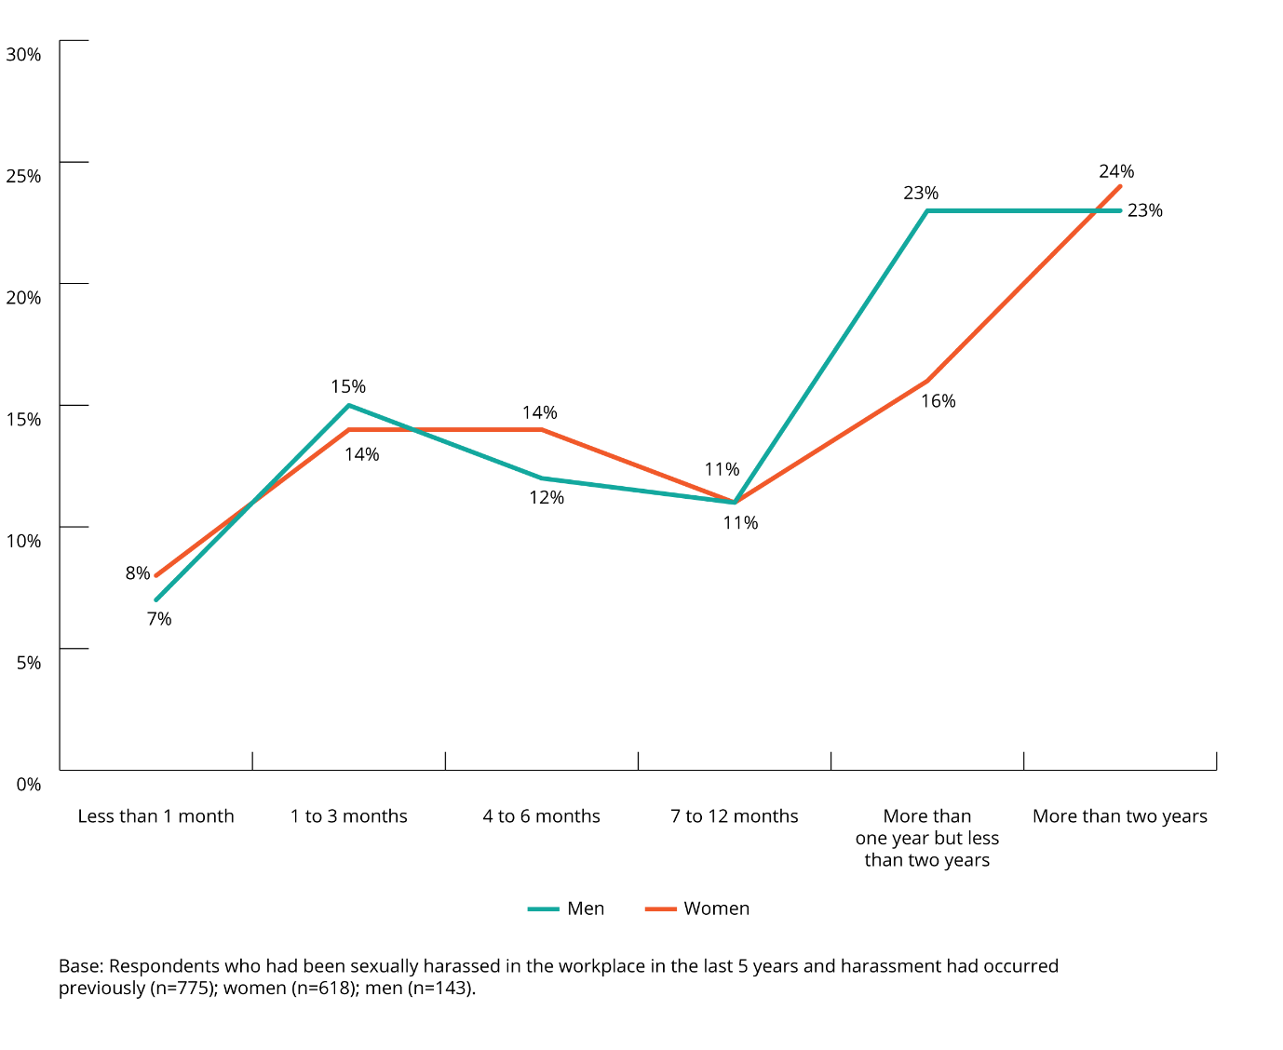
SDA members and the working population reported similar rates of experiencing workplace sexual harassment over a period of less than two years.
However, in situations where workplace sexual harassment lasted for more than two years, SDA members (23%) reported this at a lower rate than the working population (30%).
SDA members (8%) were more likely than the working population (5%) to indicate that they did not know, or preferred not to say (4% and 1%, respectively) how long their experience of ongoing workplace sexual harassment had been going.
The length of time that a SDA member said they experienced workplace sexual harassment varied based on the type of harassment.
Over half (53%) of cases of ongoing ‘sexually suggestive comments or jokes’ were experienced by SDA members for a period of more than twelve months (11% of SDA members who had experienced this type of harassment could not, or did not want to, recall how long the ongoing harassment lasted).
Sexual harassment behaviours that were more likely to be of a short duration (12 months or less) included:
- inappropriate staring or leering (55% of cases)
- intrusive questions about a person’s private life or physical appearance (52% of cases)
- unwelcome touching, hugging, cornering or kissing (50% of cases).

Location of workplace sexual harassment
SDA members who had been in the workforce in the last five years and had experienced workplace sexual harassment, were asked about the location of the most recent incident.
Workplace sexual harassment was most likely to occur at an individual’s workstation or the area where they worked.
Three quarters (75%) of the most recent incidents of workplace sexual harassment took place at the individual’s workstation or the area where they worked.
The next most common locations in which workplace sexual harassment occurred were:
- in a social area for employees (20%)
- at a work social event (6%).
Female SDA members (78%) were more likely than male SDA members (68%) to have been sexually harassed in the area where they were working.
Male SDA members (26%) were more likely than female SDA members (17%) to have been sexually harassed in a workplace social area, or at a work social function (8% and 5%, respectively).
Figure 17: Location of most recent incident of workplace sexual harassment (by gender)
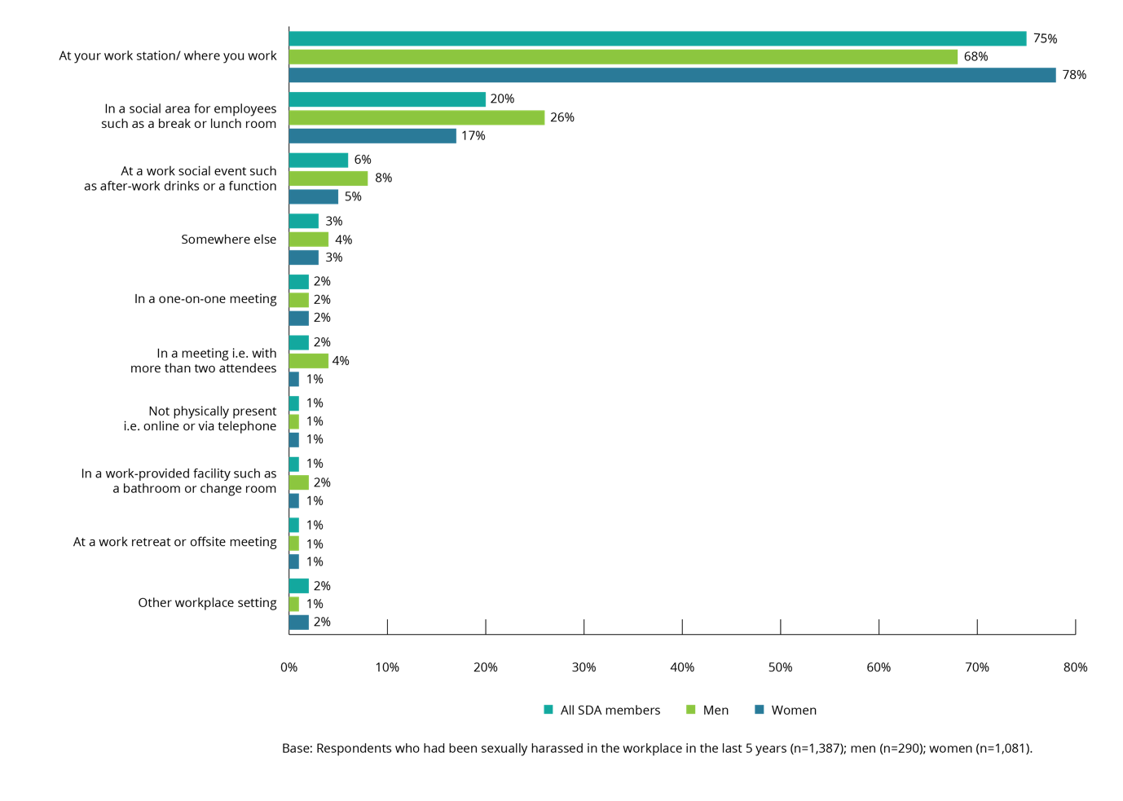
Like SDA members, those in the working population were most likely to experience their most recent incident of workplace sexual harassment at their workstation or the area where they worked.
While SDA members indicated that this was their experience in 75% of cases, the working population reported this experience in just over half of cases (52%).
The workplace sexual harassment experiences of SDA members were centred at fewer locations than that of the working population. For example, in addition to social areas for employees (26%) and social events (18%), the working population also had these experiences in one-on-one meetings (8%) and meetings in which there were two or more attendees (7%).
Figure 18: Location of most recent incident of workplace sexual harassment (SDA members vs the working population)
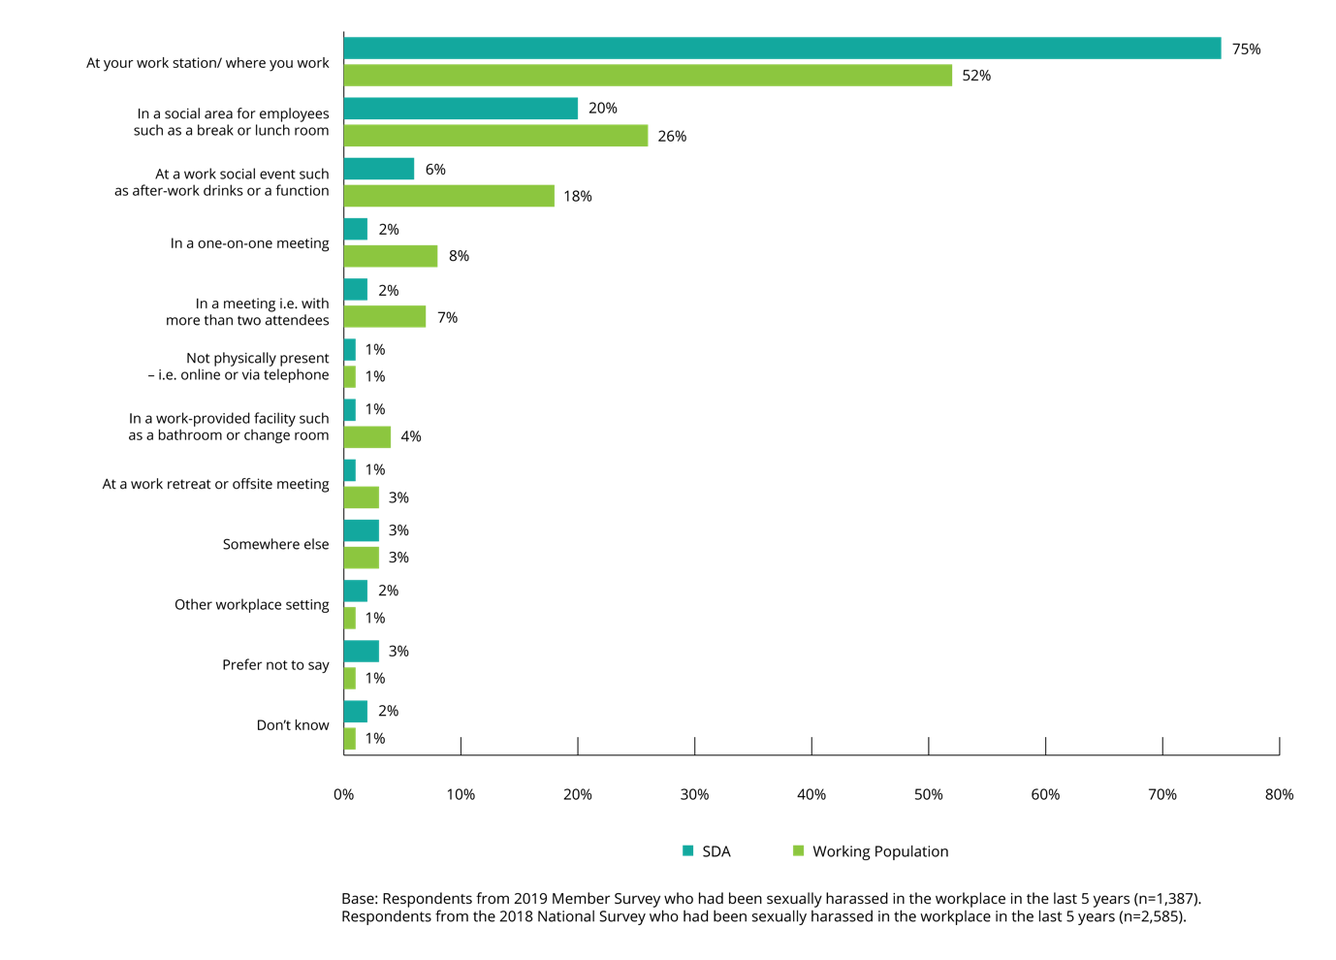

Gender balance in workplaces where workplace sexual harassment occurs
SDA members who said they had been sexually harassed in the workplace in the last five years were asked to describe the gender balance of their workplace at the time of the most recent incident of sexual harassment.
Two-thirds of SDA members indicated that the gender balance in their workplace was roughly equal at the time of their most recent experience of workplace sexual harassment.
Sixty-two per cent of SDA members indicated that the gender balance of their workplace was roughly equal.

Figure 19: Gender balance at workplace where most recent incident of sexual harassment occurred (by gender)
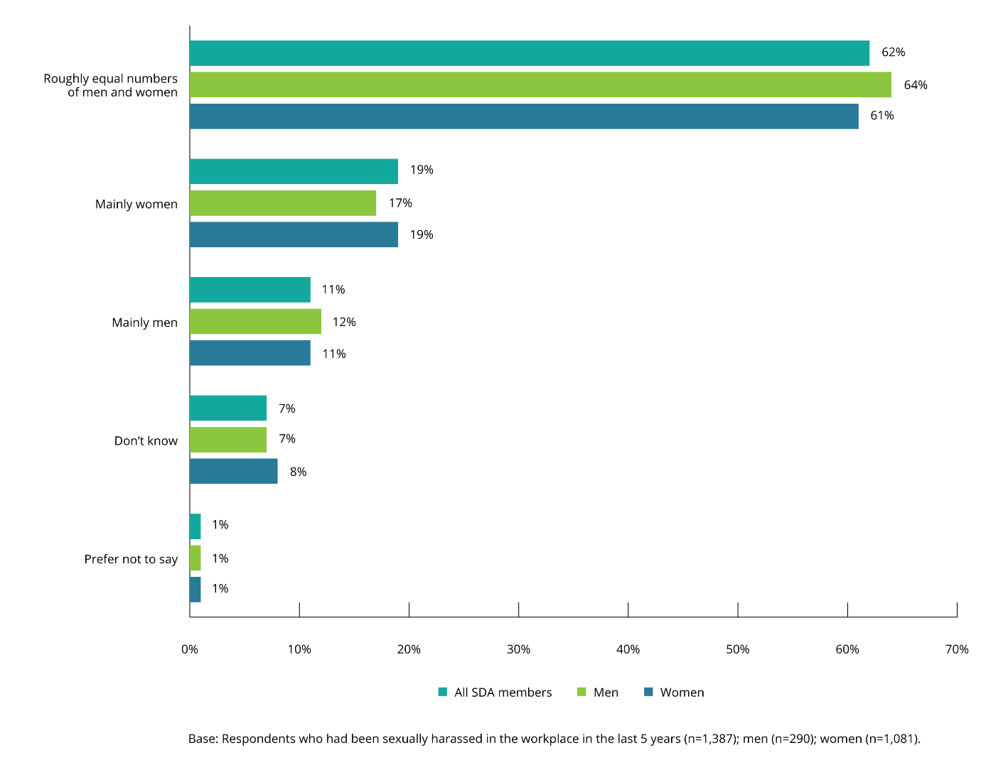
The types of sexual harassment behaviours most likely to be experienced varied based on the gender balance of workplaces.
In SDA workplaces with roughly equal numbers of men and women, the most recent experience was:
- relatively more likely to have been inappropriate physical contact (9%), compared to 7% for all workplaces
- relatively less likely to have involved repeated or inappropriate invitations to go out on dates (3%), compared to 4% for all workplaces.
In workplaces comprised mainly of men, the most recent experience of sexual harassment was relatively more likely to have been sexually suggestive comments or jokes (36%), compared to 26% for all workplaces.
In workplaces comprised mainly of women, the most recent experience of sexual harassment was:
- relatively more likely to have taken the form of being followed, watched or someone loitering nearby (10%), compared to 6% for all workplaces
- relatively less likely to have involved inappropriate physical contact (3%), compared to 7% for all workplaces.
Figure 20: Gender balance at workplace where most recent incident of sexual harassment occurred (by type of behaviour)
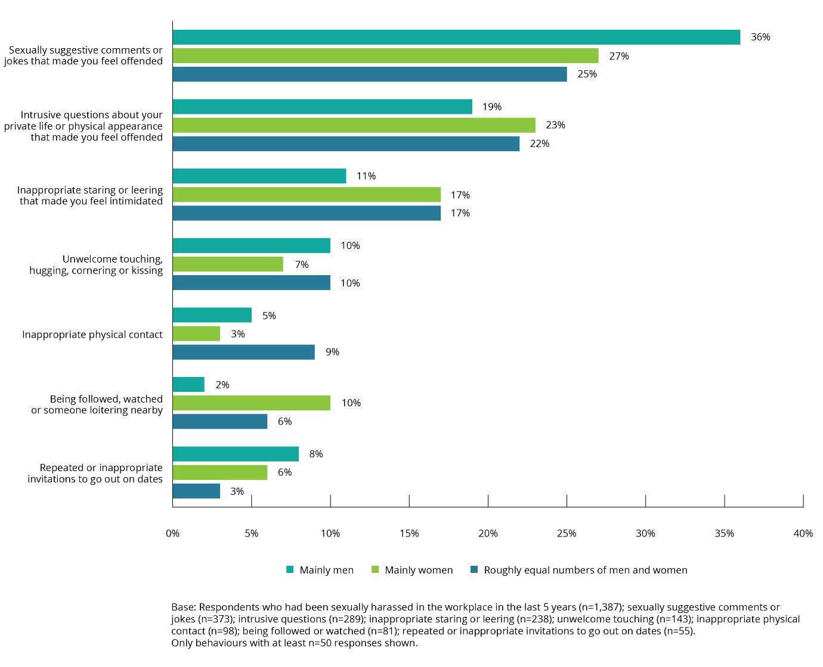

Bystanders to the most recent incident of workplace sexual harassment
The majority of incidents of workplace sexual harassment in the last five years were not witnessed.
SDA members who said they had been sexually harassed in the workplace in the last five years were asked whether their most recent incident of workplace sexual harassment was witnessed by a bystander.
Just over a quarter (26%) of SDA members said that the most recent incident of workplace sexual harassment was witnessed by one or more bystanders, while the rate was 40% for the working population.
The number of individuals who said there were no bystanders to the most recent incident of workplace sexual harassment was similar for both SDA members (41%) and the working population (44%). However, more SDA members said they did not know if anyone else had witnessed the most recent incident (30%), compared to 15% for the working population.
The sexual harassment of a female SDA member was more likely to have been witnessed by a bystander (27%) than the sexual harassment of a male SDA member (22%).

Figure 21: Whether the most recent incident of workplace sexual harassment was witnessed by a bystander (by gender of SDA member)
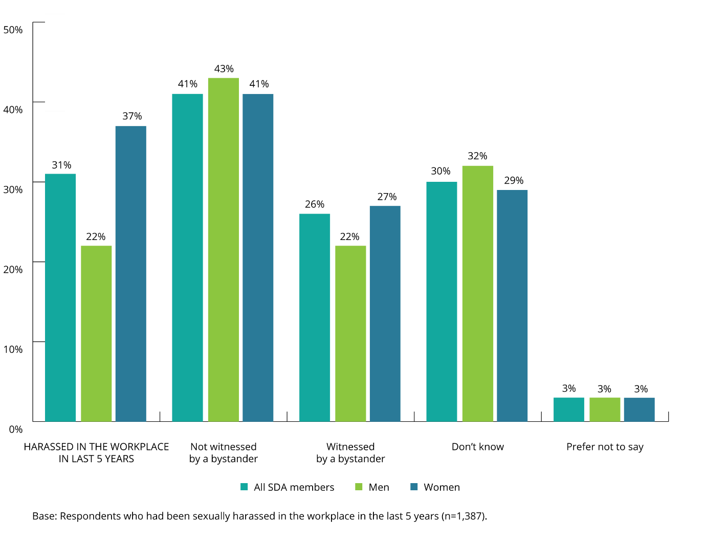

Types of behaviours witnessed
The type of behaviour where a SDA member was most likely to be isolated, and the workplace sexual harassment incident least likely to be witnessed, was inappropriate staring or leering.
The types of behaviours where a SDA member was most likely to be isolated and the incident least likely to be witnessed by a bystander were:
- inappropriate staring or leering, where 76% of SDA members who experienced this behaviour were isolated (in 44% of cases there was no witness, and in 32% of cases it was not known if there was a witness)
- questions about a person’s private life or physical appearance where 75% of SDA members who experienced this behaviour were isolated (in 43% of cases there was no witness, and in 32% of cases it was not known if there was a witness)
- repeated or inappropriate invitations to go out on dates, where 74% of SDA members who experienced this behaviour were isolated (in 49% of cases there was no witness and in 25% of cases it was not known if there was a witness)
- inappropriate physical contact, where 72% of SDA members who experienced this behaviour were isolated (in 46% of cases there was no witness, and in 26% of cases it was not known if there was a witness)
- unwelcome touching, cornering or kissing, where 71% of SDA members who experienced this behaviour were isolated (in 42% of cases there was no witness, and in 29% of cases it was not known if there was a witness).
The types of behaviour most likely to be witnessed were being followed, watched or loitering nearby.
The types of behaviours most likely to be witnessed were:
- being followed, watched or loitering nearby (38%)
- sexually suggestive comments or jokes (31%)
- unwelcome touching, hugging, cornering or kissing (28%)

Figure 22: Bystanders witnessed workplace sexual harassment (by type of behaviour)
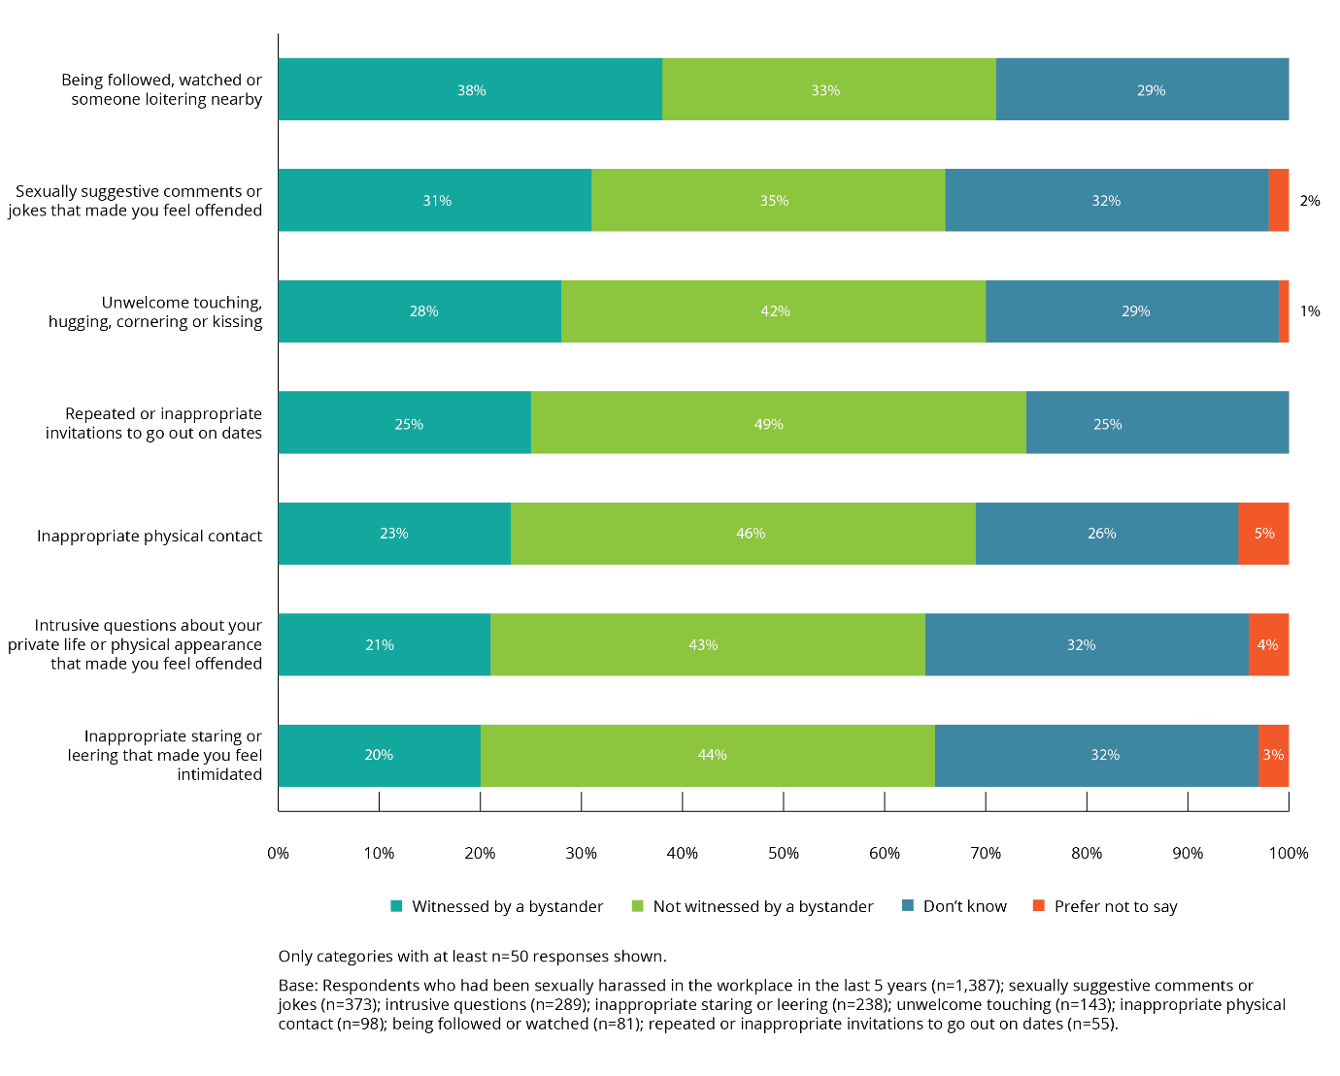

Number of bystanders
SDA members indicated that most incidents of workplace sexual harassment that took place in the last five years were not witnessed.
SDA members who said that the most recent incident of workplace sexual harassment had been witnessed by others were asked how many bystanders had witnessed the incident.
Overall, 23% of SDA members said the most recent incident of workplace sexual harassment had been witnessed by one bystander. The average number of bystanders who witnessed an incident was 2.6. The average number of bystanders was higher for the working population with 4.4 bystanders for a given incident.
Figure 23: Number of bystanders who witnessed most recent incident of workplace sexual harassment (by gender of SDA member)
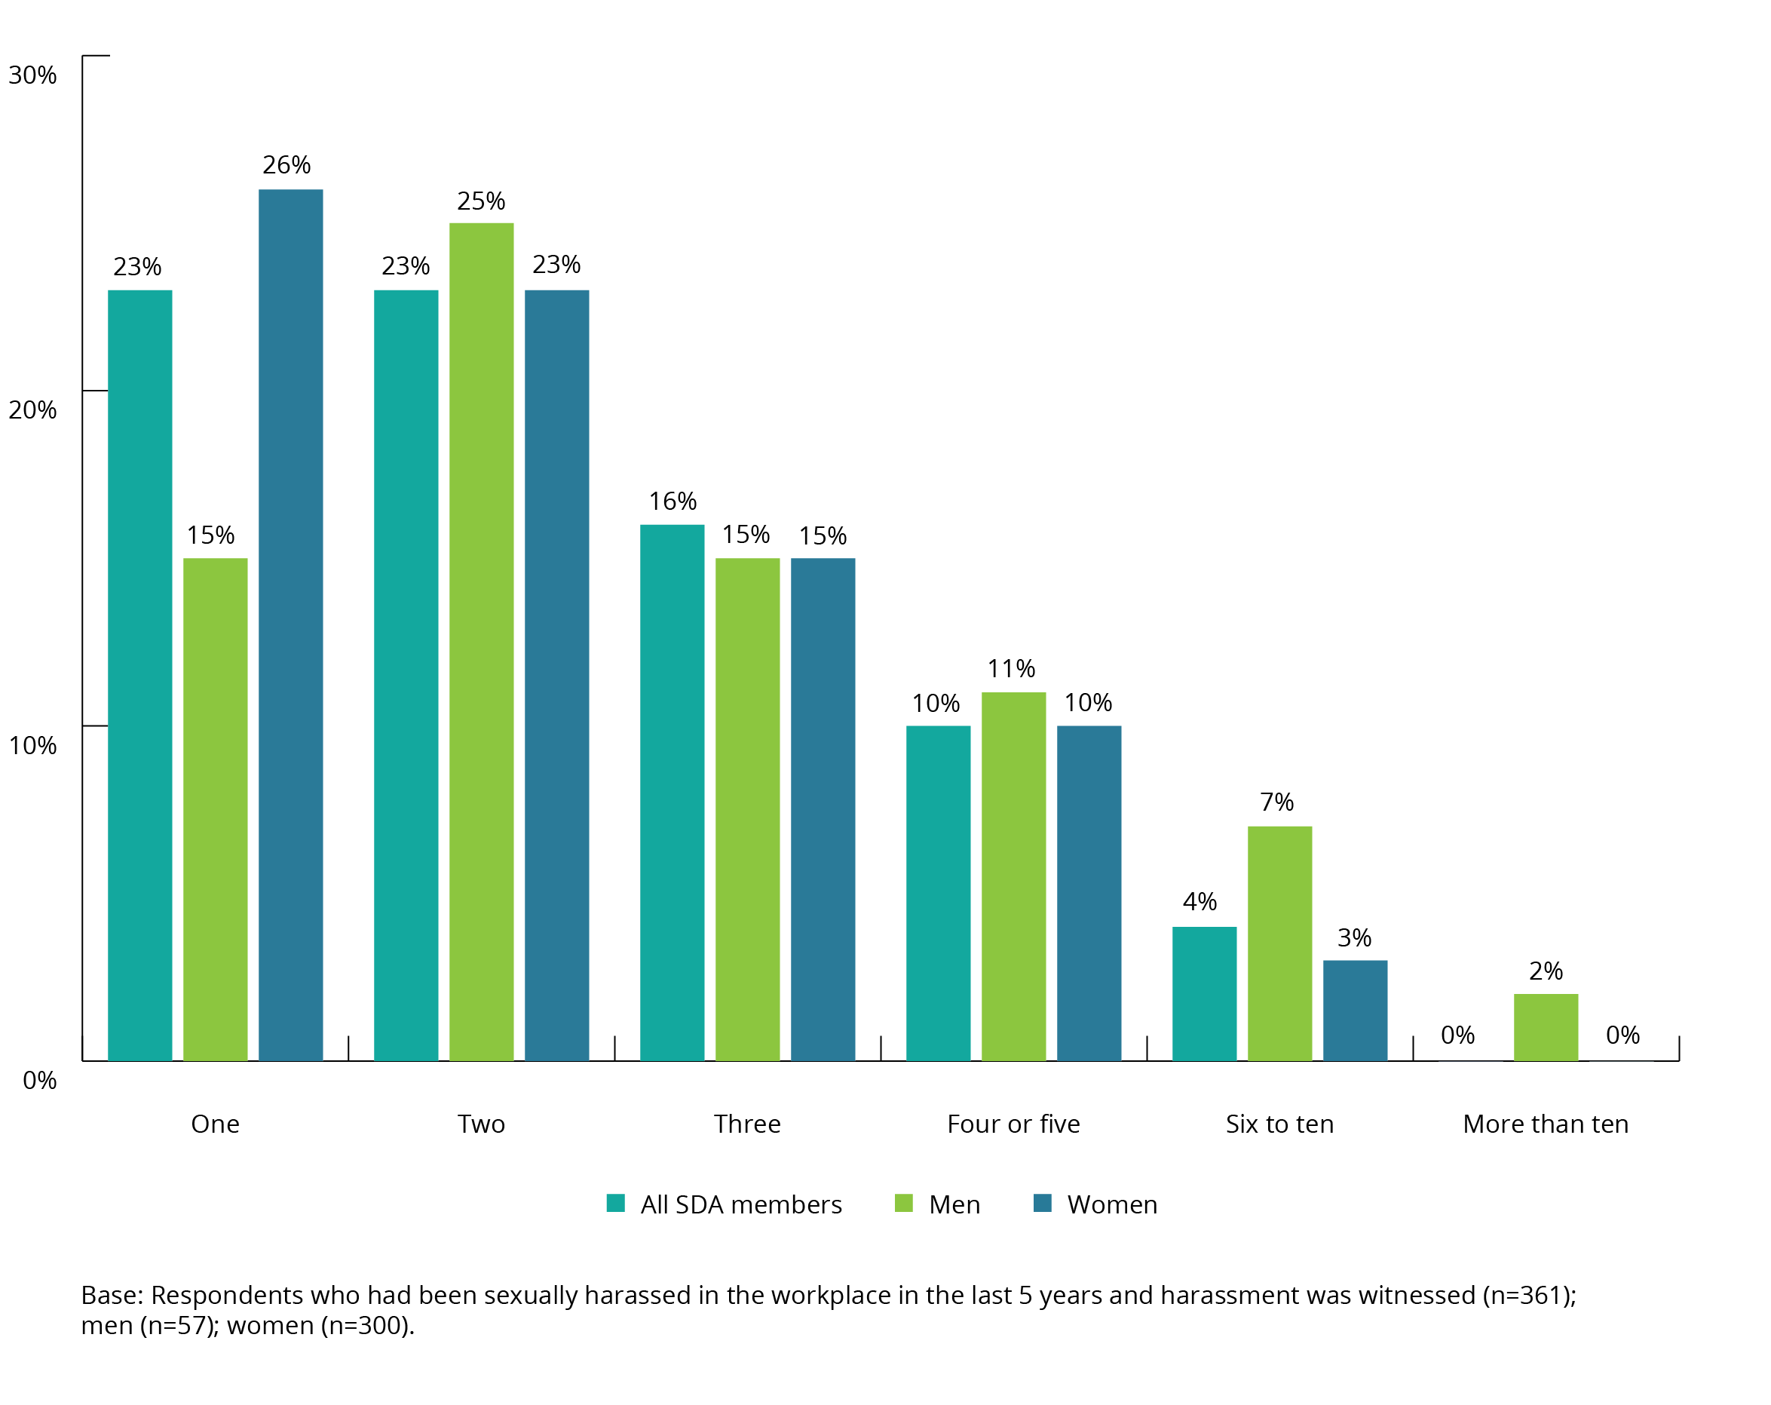

Relationship of bystander to a SDA member
Workplace sexual harassment was most often witnessed by a co-worker at the same level as the person who experience the sexual harassment.
In three of four incidents (77%) of workplace sexual harassment witnessed by a bystander, the bystander was a co-worker at the same level as the SDA member.
Approximately one in six incidents (16%) of workplace sexual harassment was witnessed by a customer or client.
Figure 24: Relationship of SDA member to bystander who witnessed workplace sexual harassment (by gender of SDA member)
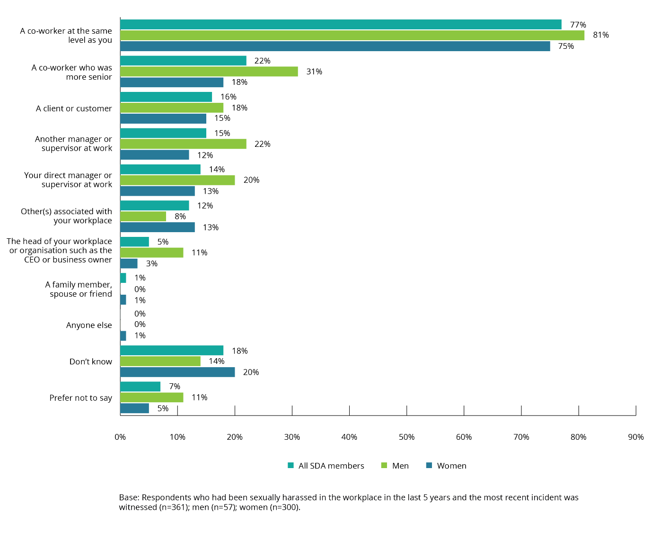

Response of bystanders to sexual harassment
Most bystanders who witnessed incidents of workplace sexual harassment did not take action to intervene.
A bystander intervened in workplace sexual harassment that they had witnessed in only one in five cases (22%). Intervention by a bystander was twice as likely to occur if the SDA member who said they had experienced workplace sexual harassment was female (25%) than if they were male (12%).
There was no clear pattern in terms of the age of SDA members who had experienced workplace sexual harassment and the propensity of a bystander to intervene. Bystanders intervened in around half (45%) of incidents involving a SDA member aged 15–17 years, but were also less likely to intervene where the SDA member was aged 18–29 years (17%), than if the SDA member was aged 30 years or older (23%).

Figure 25: Bystanders who intervened in the most recent incident of workplace sexual harassment (by age of SDA member)
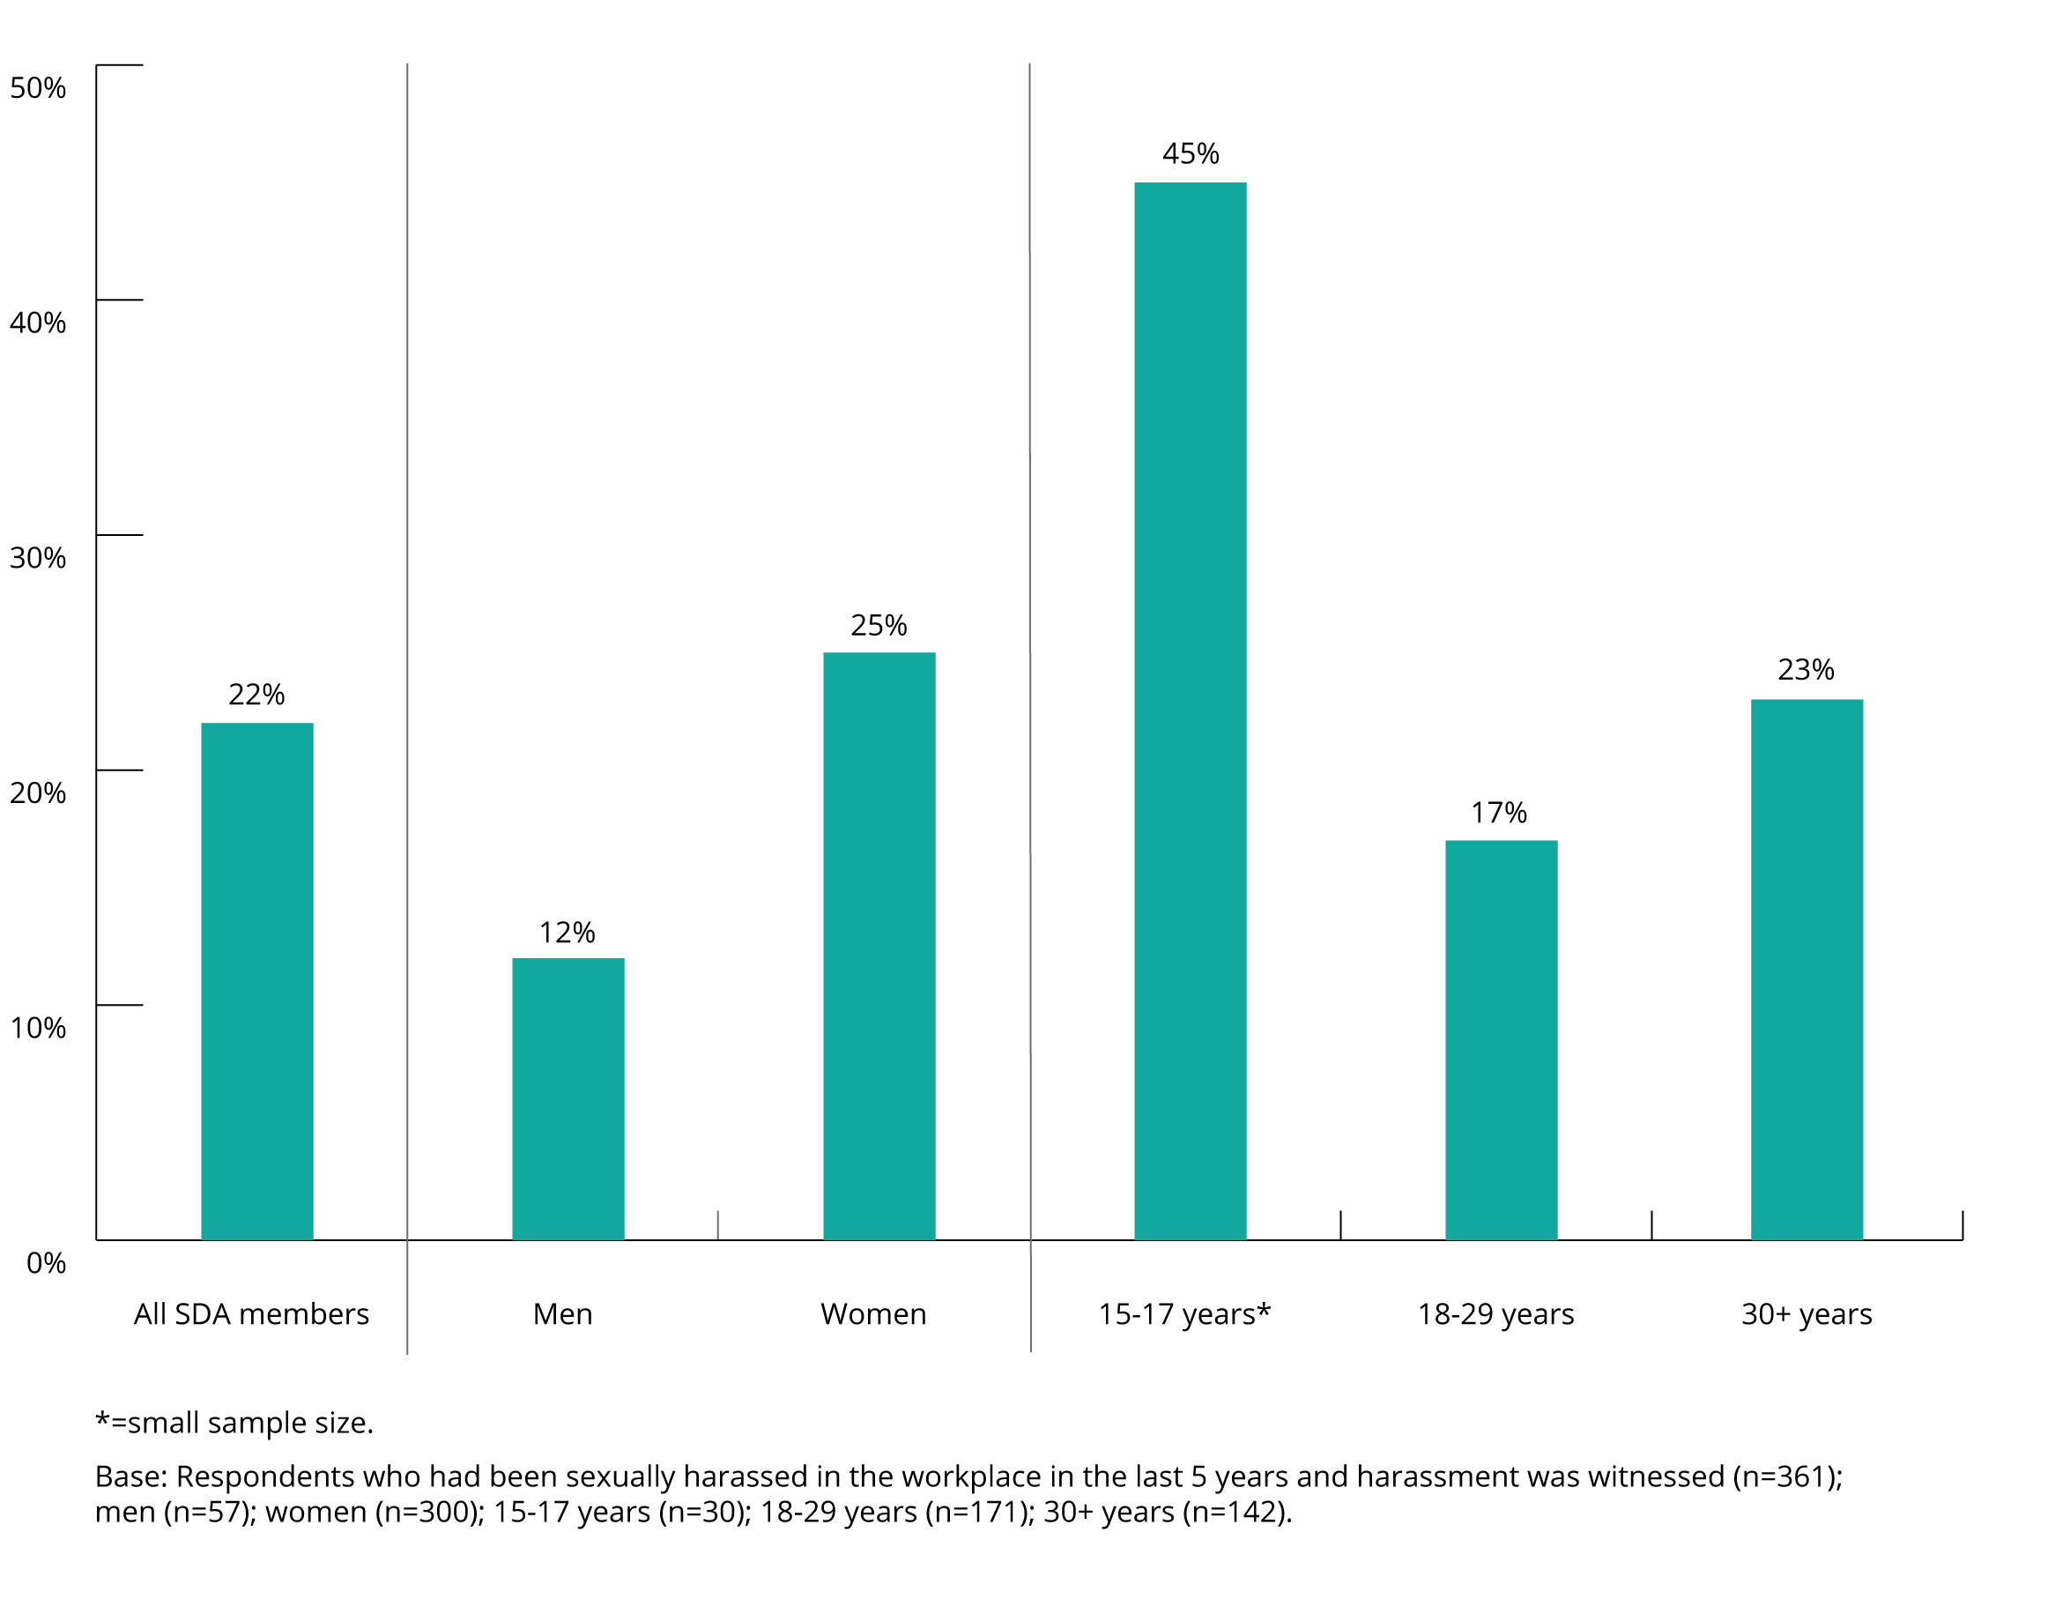

Action taken by bystanders
Where a bystander to workplace sexual harassment did act, the most common action taken was speaking about the incident to the SDA member who had experienced workplace sexual harassment (44%).
This was more likely to occur in the case of a female SDA member than a male SDA member (47% and 37%, respectively).

Other actions likely to have been taken by bystanders who witnessed workplace sexual harassment included:
- offering advice to the SDA member who had experienced workplace sexual harassment (19%)
- talking to the harasser about the incident (14%)
- reporting the workplace sexual harassment to the employer (11%).
Figure 26: Action taken by bystanders (by gender of SDA member who experienced workplace sexual harassment)
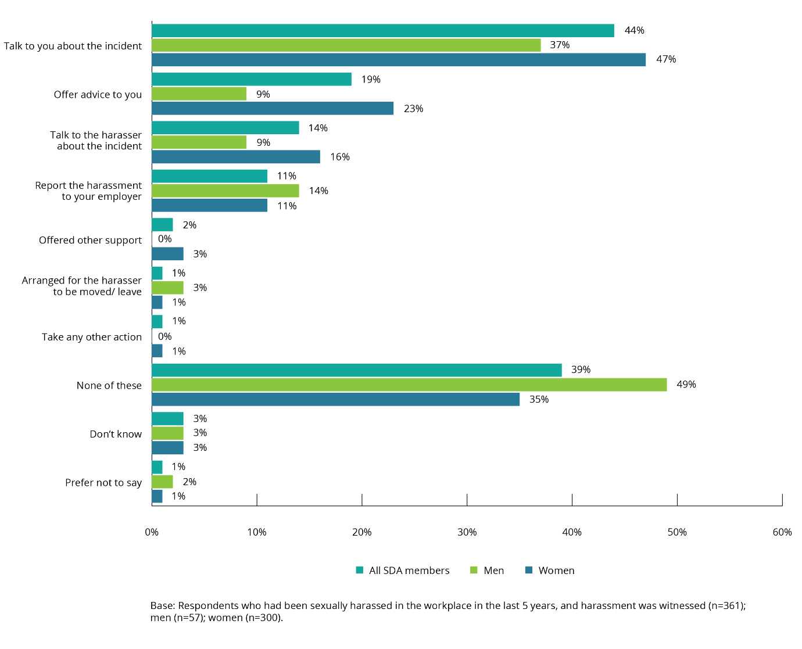

SDA members who had experienced workplace sexual harassment
The results of the 2019 Member Survey indicate that SDA members’ experience of workplace sexual harassment, like their lifetime experience, differs according to their demographic profile such as gender identity, sexual orientation, and culturally and linguistically diverse backgrounds.
For nearly all of the demographic groups listed below SDA members experienced more workplace sexual harassment than the working population.

Gender identity
In the survey, respondents were provided with the option of identifying their gender as:
- female
- male
- non-binary
- other
- prefer not to say.
SDA members who indicated they were female (women) were more likely than those who indicated they were male (men) to have experienced sexual harassment in the workplace in the last five years (46% and 29%, respectively). A similar pattern is present within the working population, where women (39%) also experience workplace sexual harassment at higher rates than men (26%).

Age
Workplace sexual harassment was highest among SDA members aged 18–29 years, with 46% indicating they had experienced workplace sexual harassment in the last five years. Sexual harassment was also most prevalent among this age group in the working population (45%).
Thirty-four per cent of SDA members aged 30 years or more said they had experienced workplace sexual harassment. This is higher than the working population rate of 29%.
Thirty per cent of SDA members aged 15–17 years said they had experienced workplace sexual harassment. This is higher than the working population rate of 20%.
When considering the age of SDA members who said they had experienced workplace sexual harassment, two-thirds (70%) were under the age of 40 years at the time of the most recent incident, slightly higher than the working population rate of 62%.
Younger female SDA members aged 15–17 years (51%) or 18–29 years (58%) were more likely than those aged 30 years or over (37%) to have had experienced workplace sexual harassment in the last five years.
For male SDA members, there was little difference in the rate of workplace sexual harassment of those aged 18–29 years (31%) and those aged 30 or older (28%).
The average age of female SDA members and male SDA members at the time of the most recent incident of workplace sexual harassment was similar (30.4 years for females and 27.7 years for males, respectively). This was slightly lower than the working population average age, 34.5 years for females and 35.5 years for males.

Figure 27: Age of SDA members who had experienced workplace sexual harassment at the time of the most recent incident (by gender)
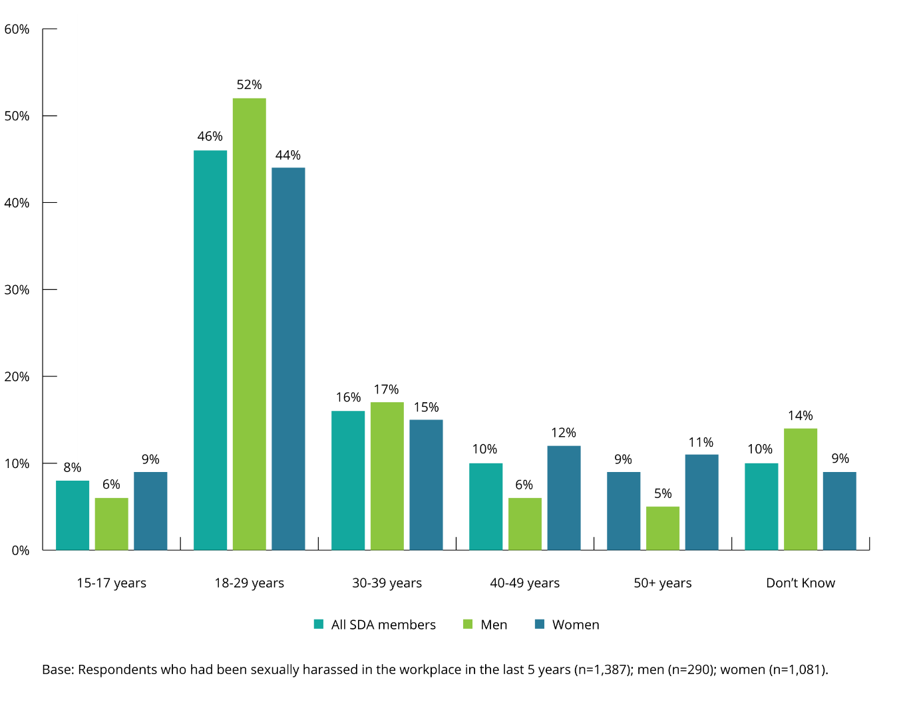
SDA members aged 15–17 years who said they had experienced sexual harassment in the workplace in the last five years were relatively more likely to have experienced inappropriate staring and leering (29%), than those aged 18–29 years (17%), or those aged 30 years or older (15%).
Moreover, SDA members aged 15–17 years who said they had experienced sexual harassment in the workplace in the last five years were relatively more likely to have experienced intrusive questions about their private life or physical appearance (27%) than those aged 18–29 years (23%) and those aged 30 years or older (19%).

Figure 28: Age of SDA members who had experienced workplace sexual harassment at the time of the most recent incident (by type of behaviour)
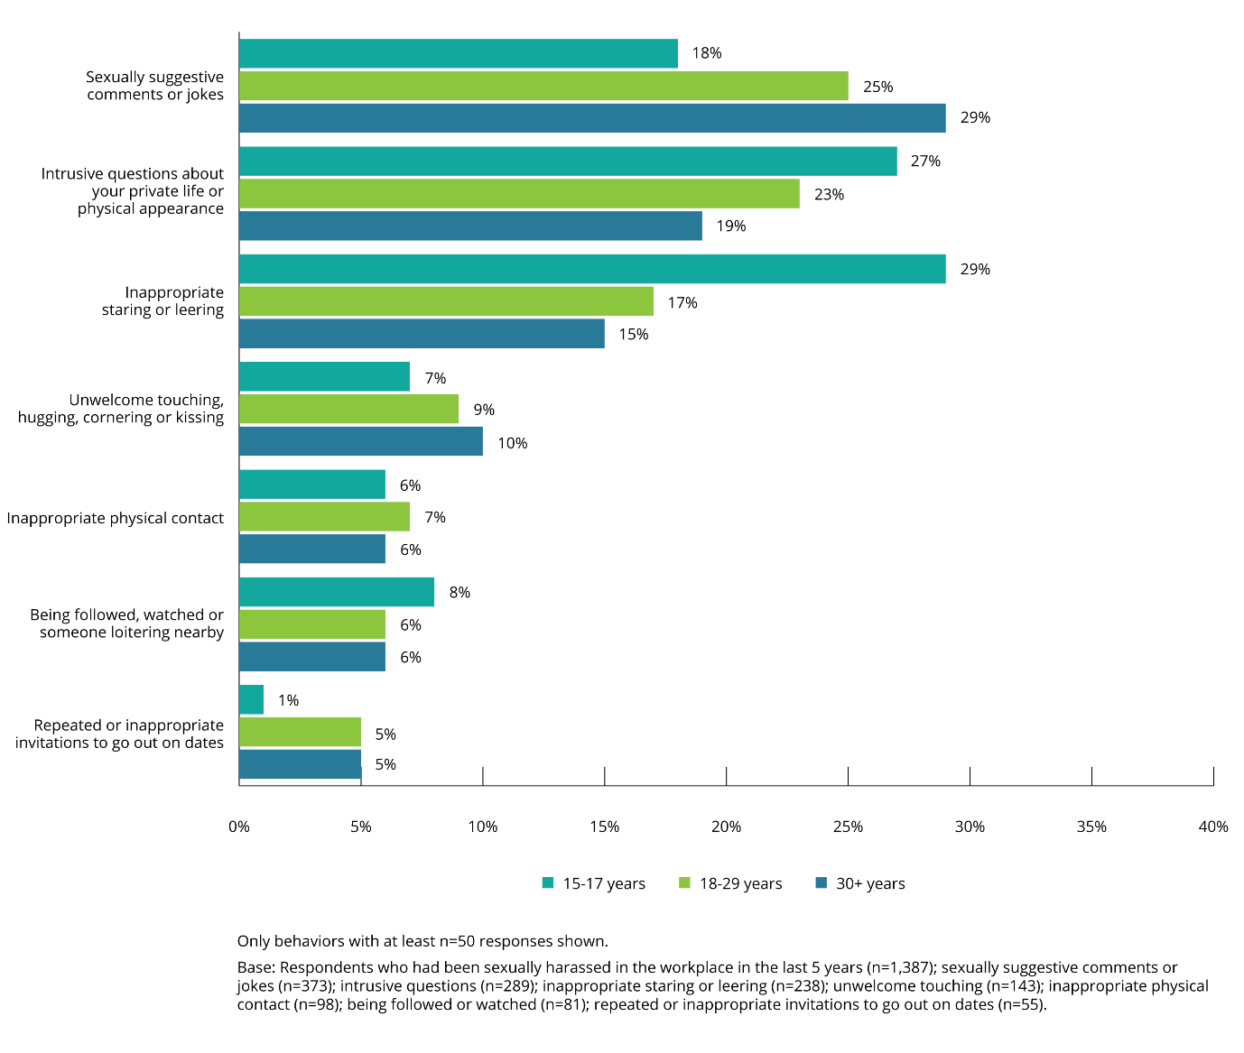

Sexual orientation
The prevalence of workplace sexual harassment was higher among SDA members who identified as gay, lesbian, bisexual, pansexual, queer, asexual or aromantic, undecided, not sure, questioning or other (hereafter, non-heterosexual) (58%, compared to 37% for heterosexual SDA members). This is also the case for the working population, with people who identify as non-heterosexual indicating that they experienced workplace sexual harassment at a rate of 52%, compared to 31% who identify as heterosexual.
Non-heterosexual female SDA members (68%) were more likely than non-heterosexual male SDA members (45%) to have experienced workplace sexual harassment in the last five years.

Intersex status
The sample size for this cohort was too small to conclusively report on experiences of workplace sexual harassment.
As noted in section 2.4(d), in relation to lifetime experience of sexual harassment, more individuals with an intersex variation reported being sexually harassed in their lifetime.

Aboriginal and Torres Strait Islander peoples
Aboriginal and Torres Strait Islander members of the SDA (43%) were relatively more likely to have experienced workplace sexual harassment than those not of Aboriginal or Torres Strait Islander descent (38%). This is similar to the working population (53% and 32%, respectively).
For female SDA members, there was little difference in the prevalence of workplace sexual harassment between those of Aboriginal and Torres Strait Islander descent and those who were not of Aboriginal and Torres Strait Islander descent (42% and 45%, respectively).
The sample size was too small to draw conclusions in relation to male SDA members who were of Aboriginal and Torres Strait Islander descent.

People with disability
SDA members with disability were more likely than those without disability to indicate that they had been sexually harassed in their workplace in the last five years (45% and 39%, respectively). A similar prevalence trend was present in the working population (44% and 32%, respectively).
Both male SDA members (35%) and female SDA members (54%) with disability were more likely than those without disability to have experienced workplace sexual harassment during this period. A similar trend was present in the working population (35% and 52%, respectively).

People from culturally and linguistically diverse backgrounds
SDA members who speak mainly English at home were more likely to indicate that they had experienced workplace sexual harassment in the last five years (40%) than those who mainly speak a language other than English at home (28%).

Household income
The prevalence of workplace sexual harassment was broadly similar across most household income bands. It was higher among households earning $25,000 to $34,999 per year (48%) and $150,000 to $199,999 (41%).

Employment status
At the time the 2019 Member Survey was conducted, two thirds (65%) of the Australian workforce was employed on a full-time basis, with just under one third (30%) working part-time and around one in twenty (5%) looking for work. Men were more likely to be employed on a full-time basis than women (77% men; 52% women) and conversely more women than men were working part-time (18% men; 43% women).
The employment status of SDA members who had experienced workplace sexual harassment was very different from the Australian workforce.
Three in five (61%) SDA members who said they had been sexually harassed in the workplace in the last five years were working part-time at the time of the most recent incident. Three in ten (28%) worked full time. A small group (1%) of people who experienced workplace sexual harassment were looking for work at the time.
Male SDA members were more likely than female SDA members to have been working full-time at the time of the most recent incident of workplace sexual harassment (35% and 25%, respectively). This is consistent with the working population where males were more likely than females to be working full-time (73% and 54%, respectively).

Figure 29: Employment status of SDA members who had experienced workplace sexual harassment (by gender)
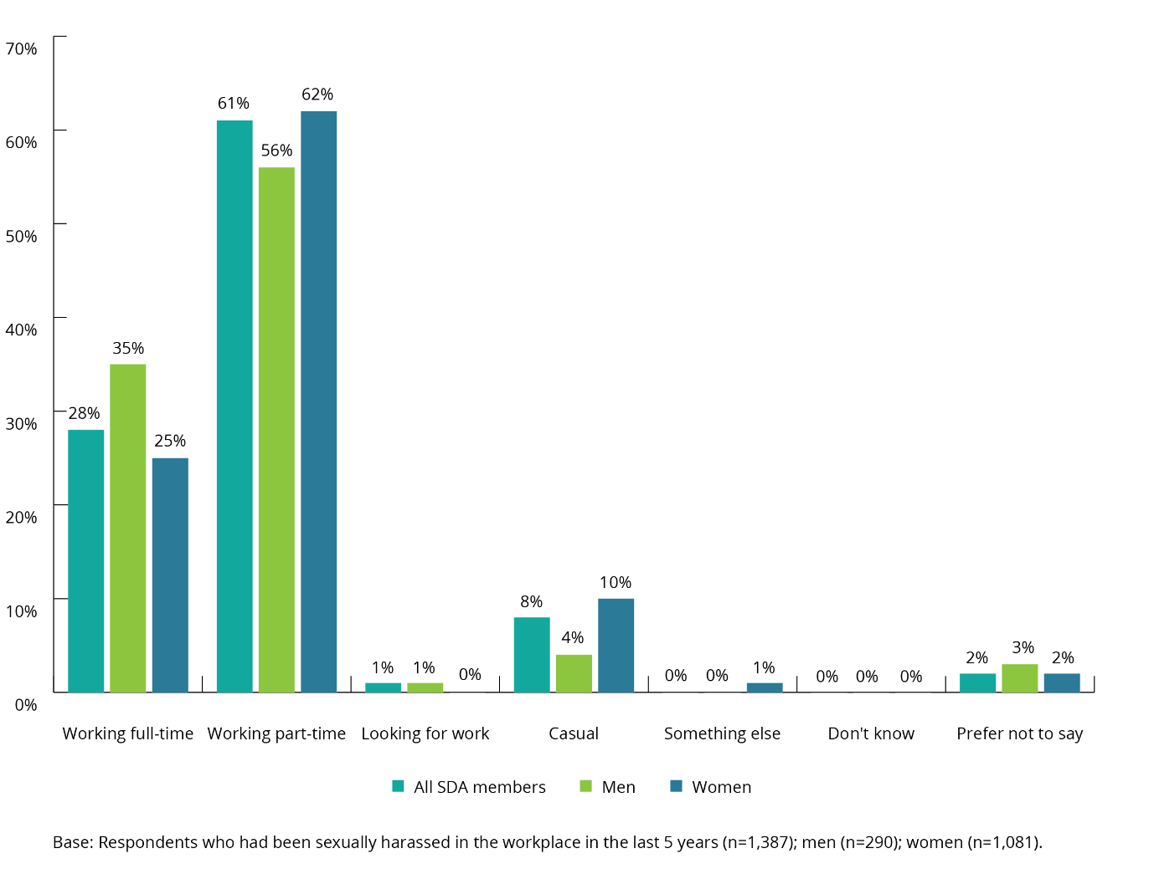

Employment type
The majority of SDA members (67%) and those in the working population (66%) who said they experienced workplace sexual harassment were permanent employees at the time of the most recent incident. More than a quarter of SDA members (27%) and slightly less than a quarter of the working population (23%) were employed on a casual basis. A small group of SDA members (1%) and the working population (5%) worked as temporary employees.
Male SDA members (71%) were more likely than female SDA members (66%) to have been a permanent employee at the time of the most recent incident, and women were more likely than men to have been a casual employee at that time (29% and 22%, respectively).

Figure 30: Employment type of SDA members who had experienced workplace sexual harassment (by gender)
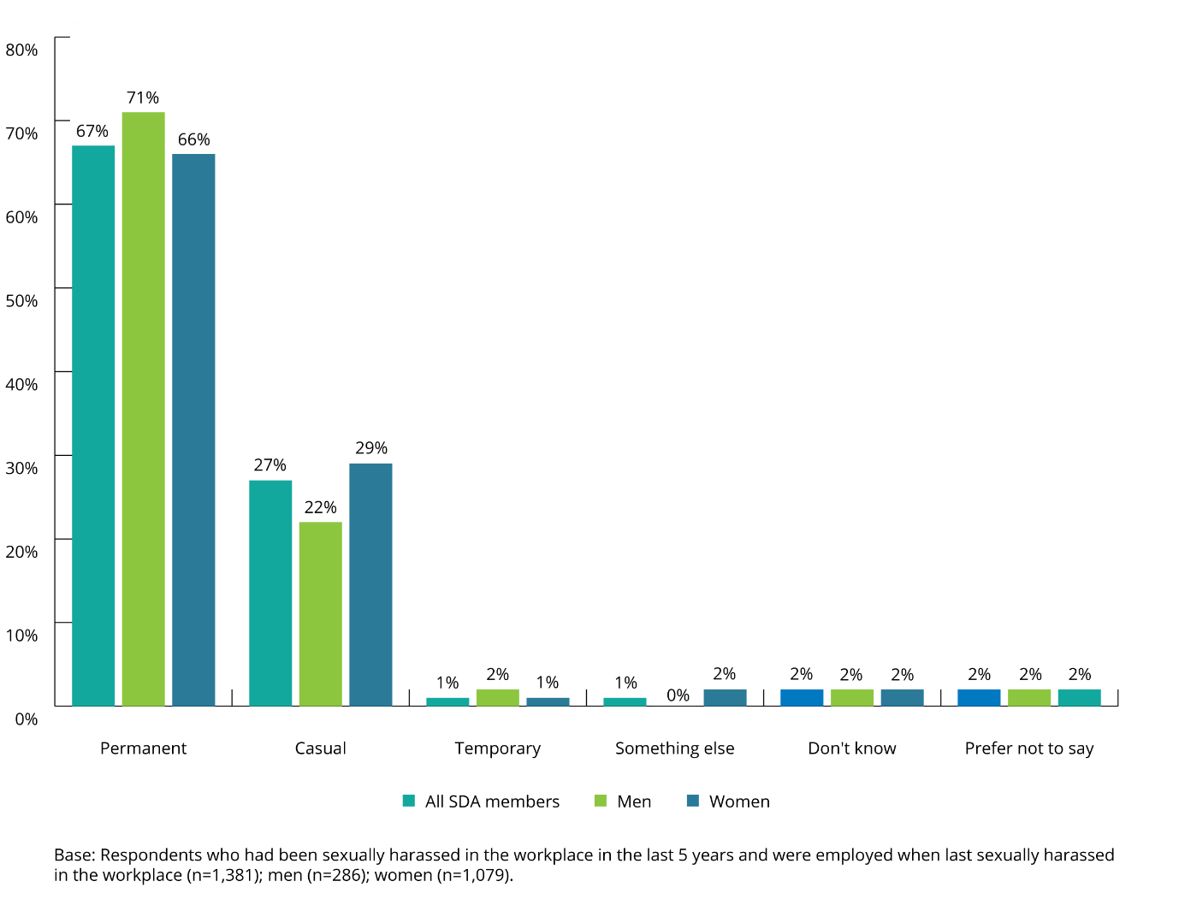

Harassers

Gender of harassers
SDA members indicated that in the majority of cases of workplace sexual harassment they experienced, in the last five years, the harasser was male.
The data suggests that this was the case for both male and female SDA members who said they had experienced workplace sexual harassment.
For both SDA members and those in the working population, in the majority of cases of workplace sexual harassment in the last five years the harasser was male (82% for SDA members compared to 79% for the working population, respectively).
Figure 31: Gender of harasser (SDA members vs the working population)
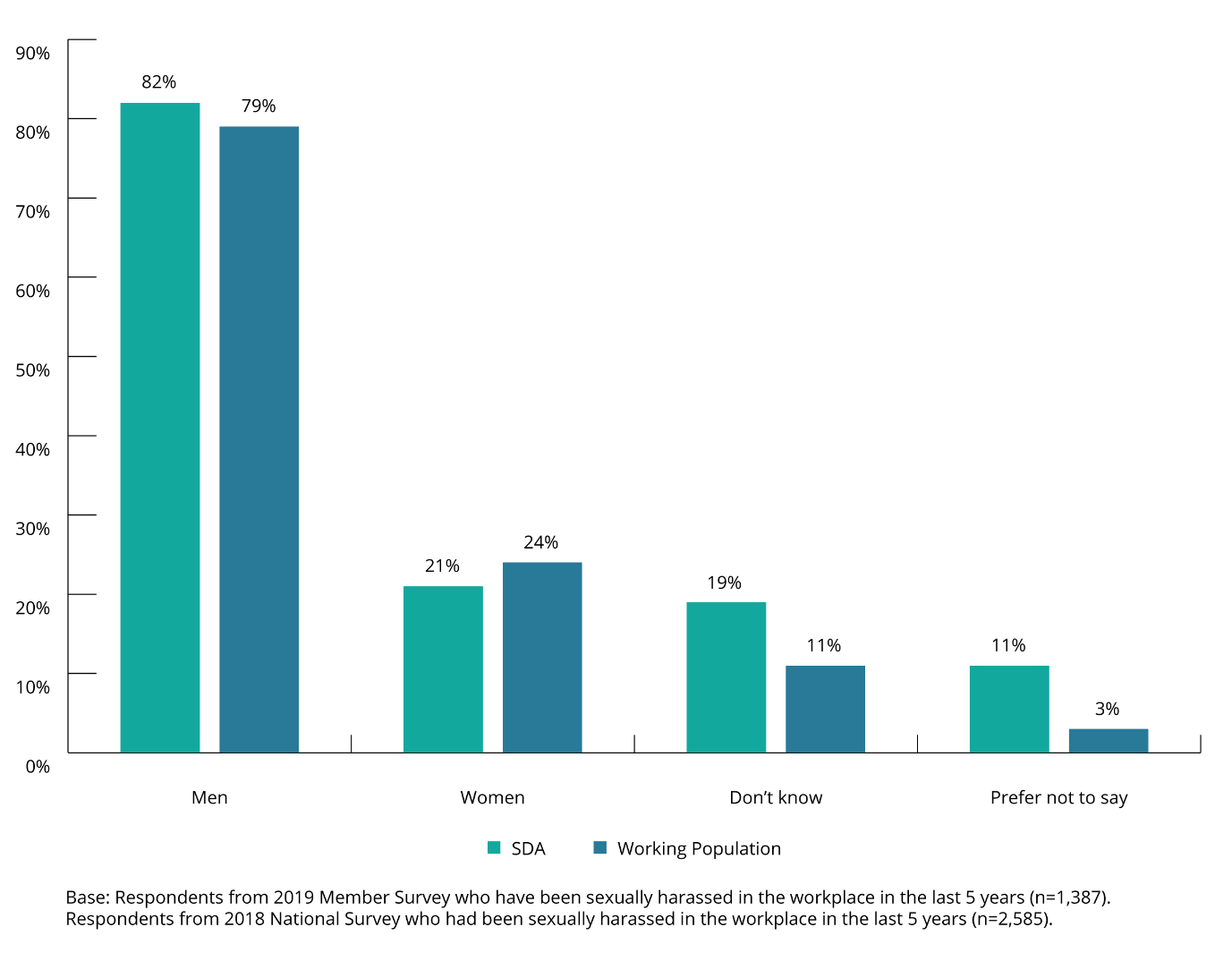

Figure 32: Gender of harasser (by gender of SDA member who had experienced workplace sexual harassment)
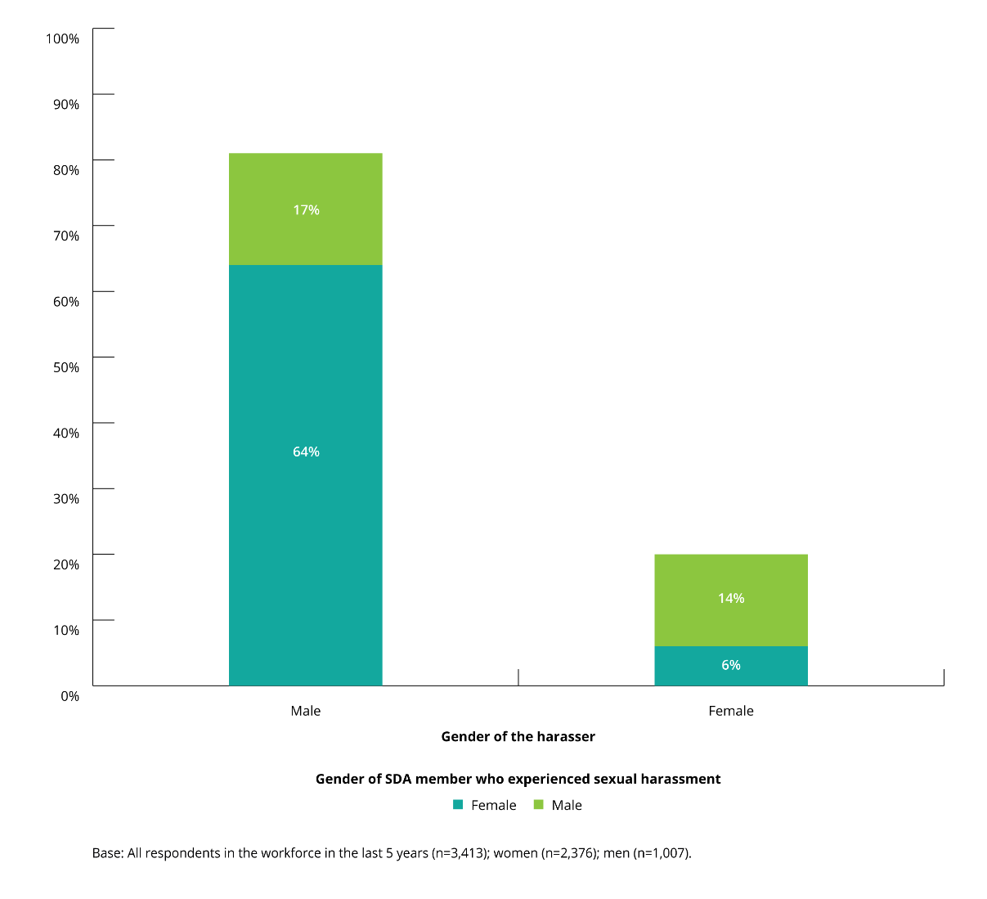
In incidents of workplace sexual harassment involving one or more harassers, and where the gender of the harasser was known, 81% of cases involved a male harasser and 19% of cases involved a female harasser.
In cases where a male harasser was involved, female SDA members experienced workplace sexual harassment in 64% of cases, compared to 17% for their male colleagues.
In cases where a female harasser was involved, male SDA members experienced workplace sexual harassment in 14% of cases, compared to 6% for female SDA members.

Relationship of harasser to SDA member who had experienced workplace sexual harassment
In one in three incidents of workplace sexual harassment experienced by SDA members in the last five years, one or more of the harassers was a client or customer.
SDA members who indicated that they had experienced workplace sexual harassment in the last five years were asked what their relationship to the harasser was.
When the results were examined for all harassers (both single and multiple harassers), one or more of the harassers was a customer or client in just over one in three (36%) incidents experienced by SDA members. This is compared to18% of incidents for those in the working population.
This was more likely to have been the case when the person who experienced workplace sexual harassment was female (42% for SDA members, and 21% for the working population) than when they were male (22% for SDA members, and 13% for the working population).
See Chapter 4 for further discussion about the role of customers in workplace sexual harassment.
Male SDA members were more likely than female SDA members to have been sexually harassed at work by a co-worker at the same level (34% and 24%, respectively).
Male SDA members were also more likely than female SDA members to have been sexually harassed at work by someone more senior to them, ranging from a co-worker to the head of the organisation (54% and 30%, respectively).

Figure 33: Relationship of harasser to SDA members who had experienced workplace sexual harassment (by gender of SDA member)
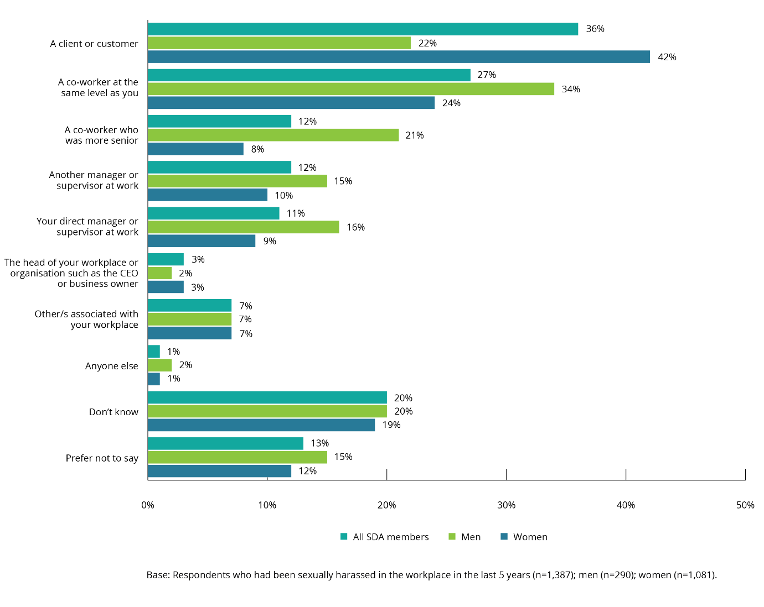
Both those in the working population and SDA members experienced similar levels of workplace sexual harassment by co-workers at the same level (27% and 30%, respectively). However, those in the working population were more likely to have been sexually harassed by:
- a co-worker who was more senior (19%, compared to 12% for SDA members)
- a direct manager or supervisor (14%, compared to 11% for SDA members)
- the head of the organisation or CEO (7%, compared to 3% for SDA members).
In comparison to the working population, the harasser tended to be a co-worker at the same level (30%) or more senior level (19%). The differences between SDA members and the working population may be due to the more customer-facing and customer-focused roles in which SDA members are employed.
Figure 34: Relationship of harassers to people who had experienced workplace sexual harassment (SDA members vs the working population)
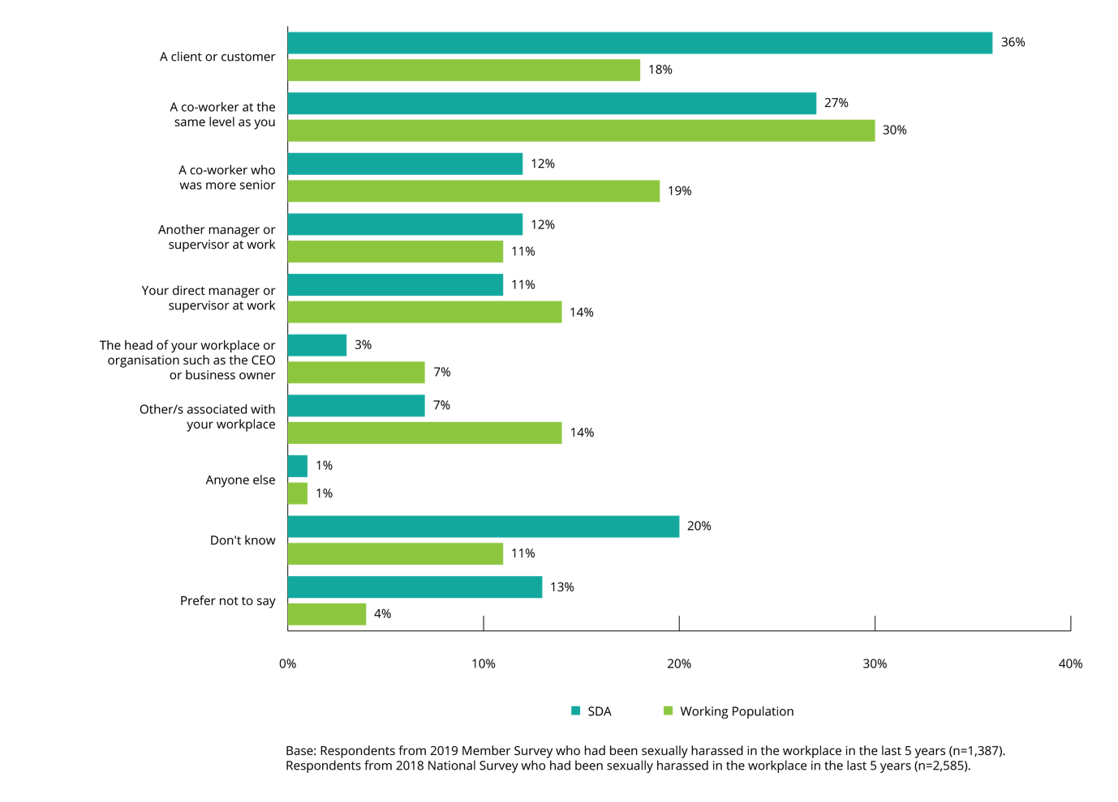

Age of harasser
SDA members were more likely to have been sexually harassed in the workplace by a younger harasser than those in the working population. Just over a third (36%) of SDA members were sexually harassed by a harasser (both single and multiple harassers) aged 30 years or less, compared to just over a quarter (28%) in the working population.
When the results are examined for all harassers (both single and multiple harassers) by age:
- one or more of the harassers was aged 21 to 30 years in 27% of the most recent incidents for SDA members, and 23% for the working population
- likewise, one or more of the harassers was aged 31 to 40 years in 27% of the most recent incidents for SDA members, and 29% for the working population
- one or more of the harassers was aged 41–50 years in 21% of the most recent incidents for SDA members, and 28% for the working population.
Male SDA members were more likely than female SDA members to say that one or more of their harassers was aged 15–20 years (12% and 8%, respectively), or 21–30 years (33% and 25%, respectively) or 31–40 years (30% and 26%, respectively). Female SDA members were more likely than male SDA members to say that one of their harassers was aged between 51–64 years (19% and 12%, respectively) or 65 years or older (8% and 3%, respectively).

Figure 35: Age of harassers (by gender of SDA members who had experienced workplace sexual harassment)
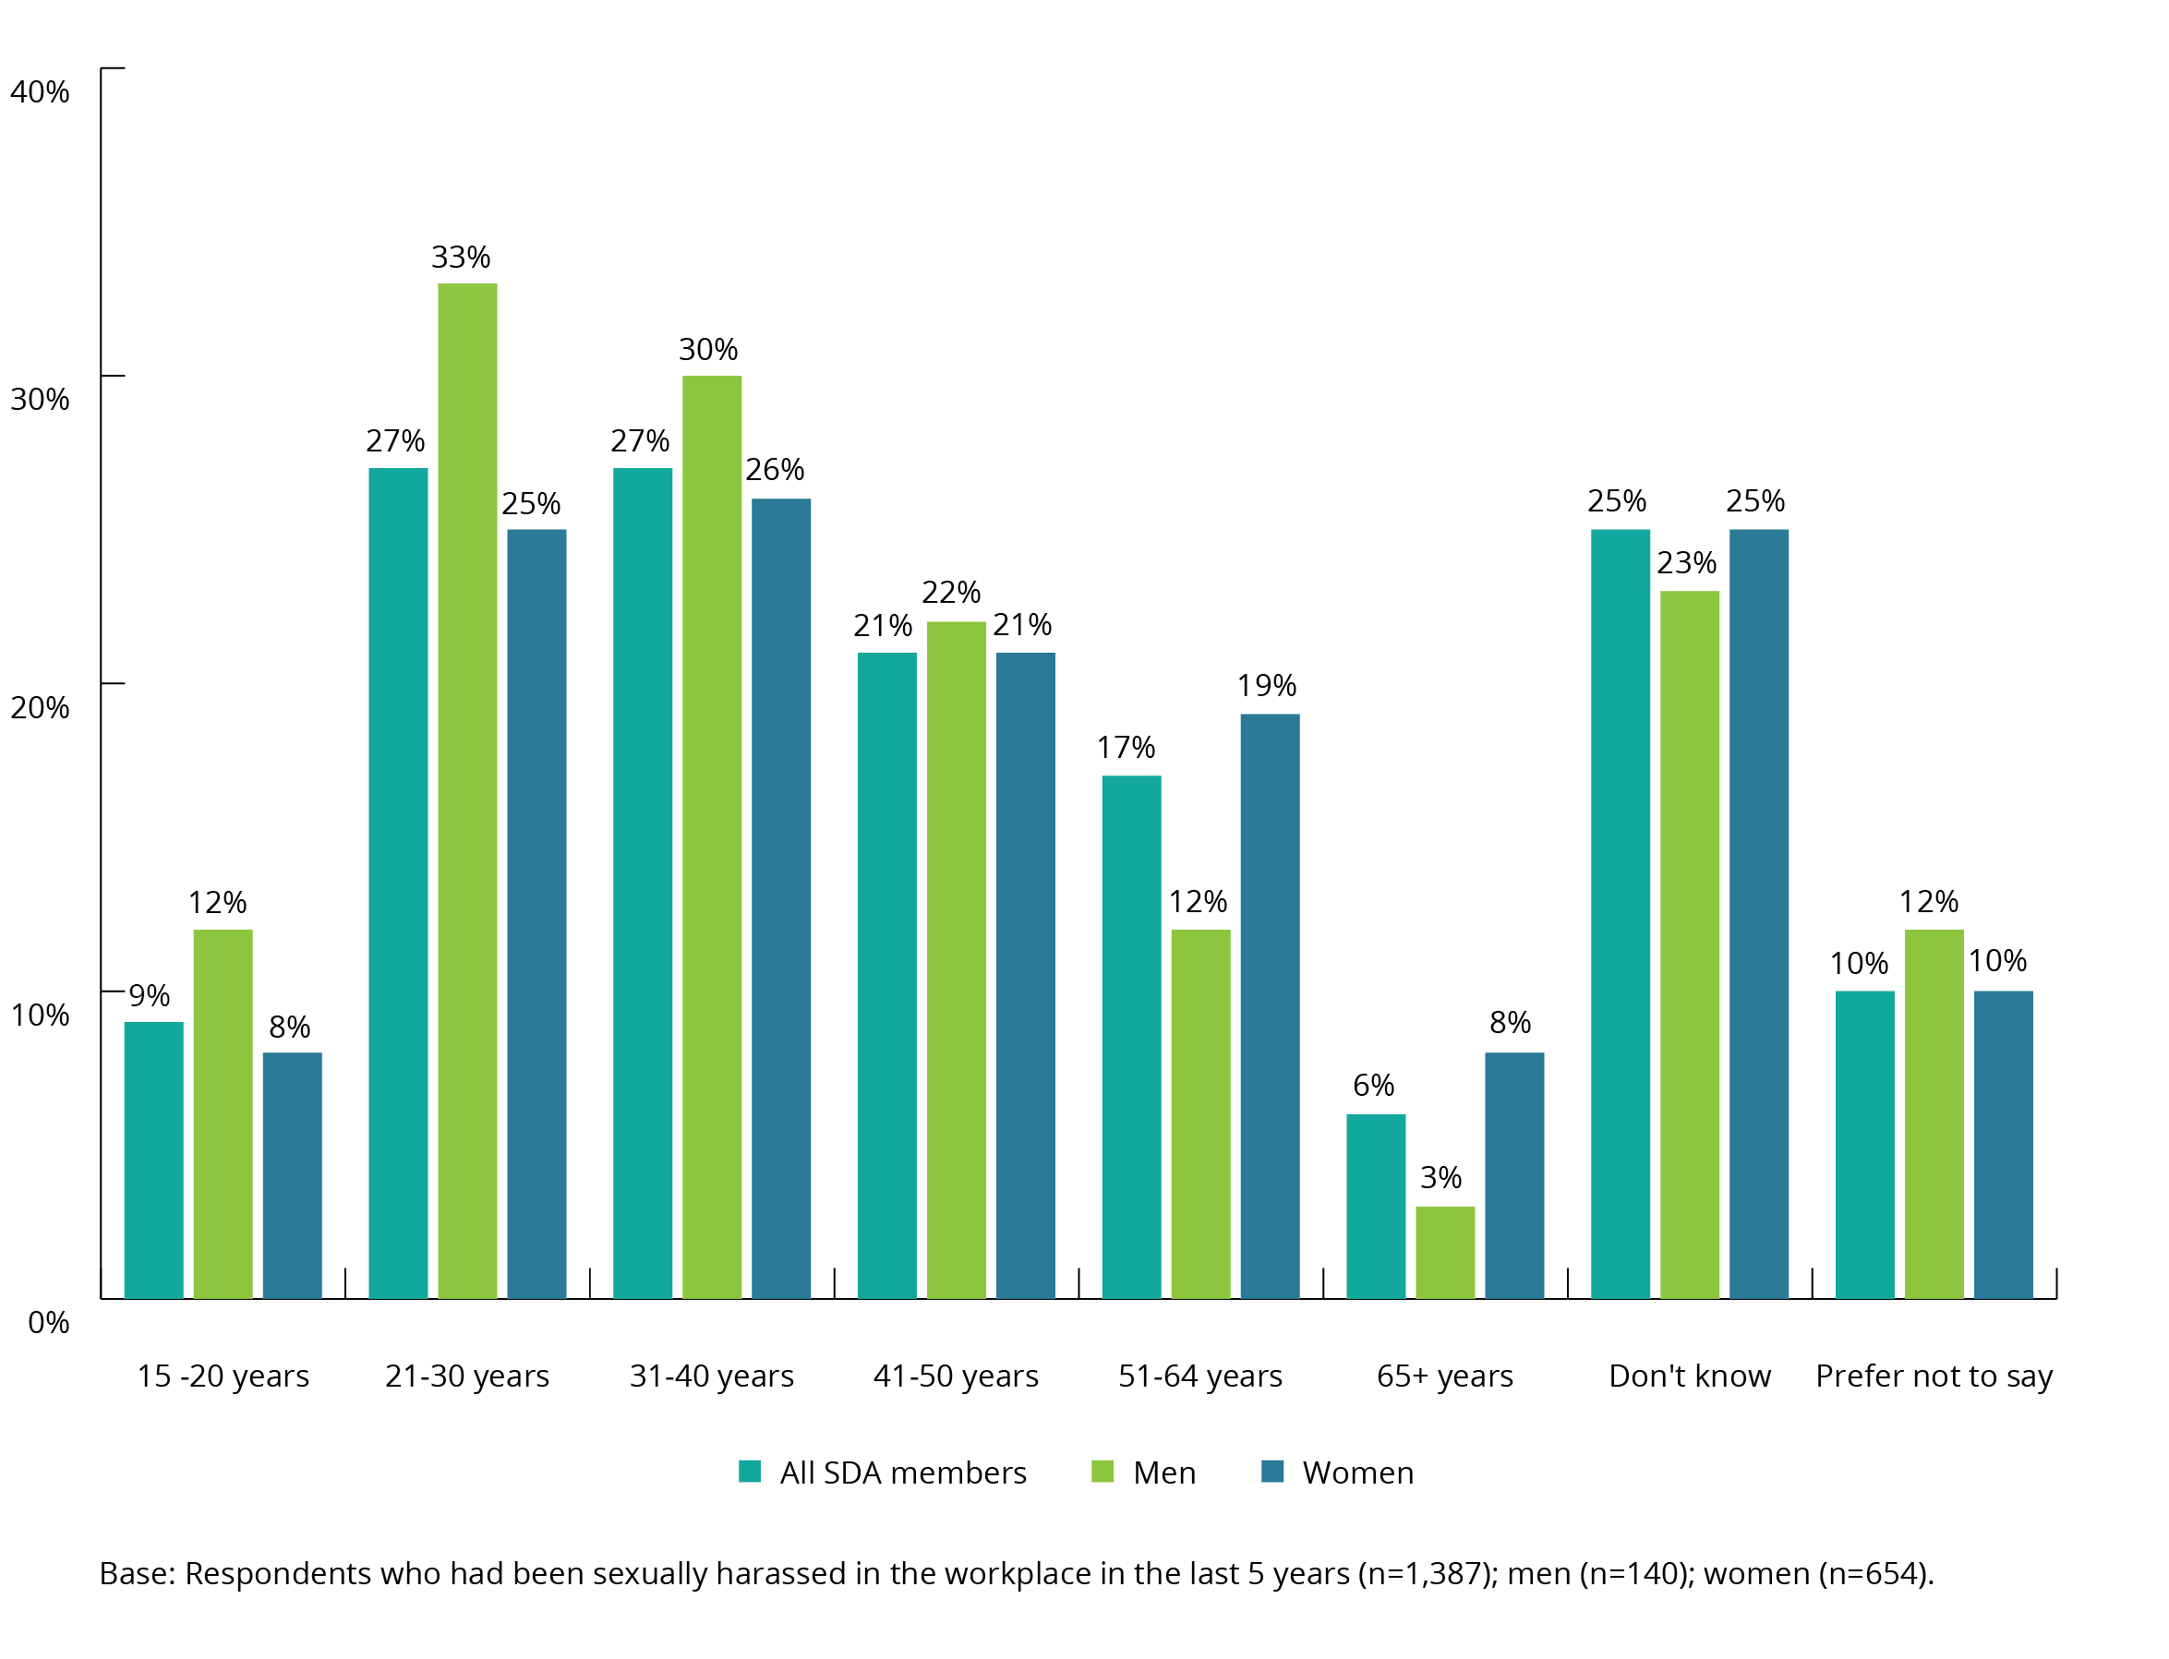
Some types of workplace sexual harassment behaviours were over-represented when examined by the age of the harasser:
- harassers aged 21–30 years were involved in 27% of the most recent incidents of workplace sexual harassment, but represented 34% of the cases of intrusive questions about a person’s private life or physical appearance
- similarly, harassers aged 31–40 years were involved in 27% of the most recent incidents of workplace sexual harassment, but represented 32% of the cases of inappropriate staring or leering and 31% of the cases of intrusive questions.

Figure 36: Type of most recent workplace sexual harassment behaviour (by age of harasser)
Type of most recent sexual harassment experienced in workplace
Age of Harasser/s | Total Harassed in Workplace Last 5 years | Unwelcome touching, hugging, cornering or kissing | Inappropriate staring or leering that made you feel intimidated | Sexually suggestive comments or jokes that made you feel offended | Repeated or inappropriate invitations to go out on dates | Intrusive questions about your private life or physical appearance that made you feel offended | Inappropriate physical contact | Being followed, watched or someone loitering nearby
n= | 1387 | 143 | 238 | 373 | 55 | 289 | 98 | 81
15 -20 years | 9% | 5% | 10% | 10% | 7% | 12% | 3% | 9%
21-30 years | 27% | 24% | 29% | 19% | 33% | 34% | 27% | 33%
31-40 years | 27% | 17% | 32% | 27% | 32% | 31% | 14% | 21%
41-50 years | 21% | 11% | 17% | 27% | 14% | 23% | 16% | 26%
51-64 years | 17% | 29% | 12% | 20% | 12% | 15% | 19% | 12%
65+ years | 6% | 6% | 3% | 8% | 6% | 6% | 11% | 4%
Don't know | 25% | 22% | 31% | 22% | 15% | 25% | 23% | 38%
Prefer not to say | 10% | 14% | 11% | 12% | 5% | 10% | 11% | 6%
Only behaviours with at least n=50 responses are shown.

Number of harassers
SDA members indicated that the majority of incidents of workplace sexual harassment in the last five years involved a single harasser.
The majority of workplace sexual harassment incidents in the SDA workforce and in the working population were carried out by a single harasser (57% and 64%, respectively).
Female SDA members (61%) were more likely than male SDA members (46%) to have experienced workplace sexual harassment by a single harasser. This is consistent with the findings in the working population where women (71%) were more likely than men (54%) to have experienced workplace sexual harassment by a single harasser.
The mean number of harassers reported by male SDA members who experienced workplace sexual harassment was 1.5, compared to 1.3 harassers for female SDA members.

Figure 37: Number of harassers involved in the most recent incident of workplace sexual harassment (by gender of SDA members who had experienced workplace sexual harassment)
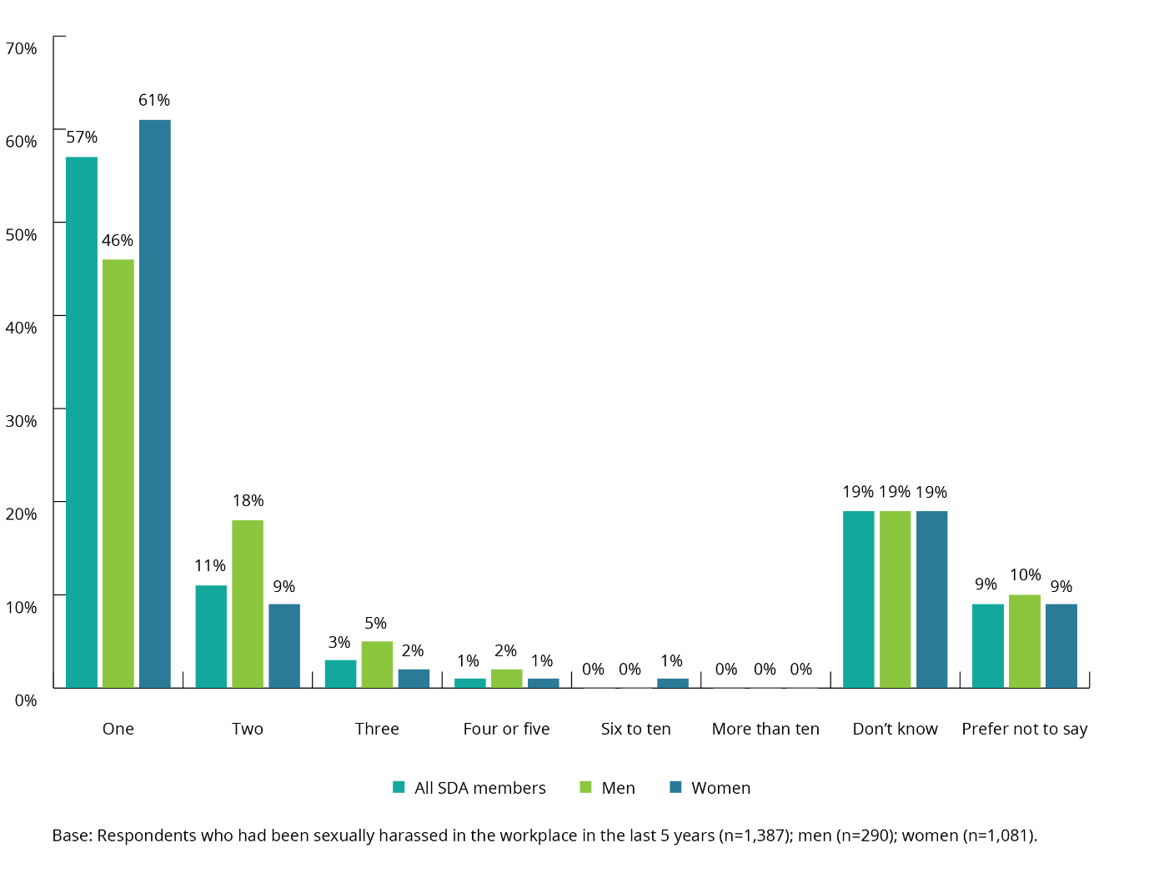
While almost three in five incidents (57%) of all workplace sexual harassment was carried out by a single harasser, this proportion was higher among behaviours such as inappropriate physical contact (69%), unwelcome touching, hugging, cornering or kissing (69%) and repeated or inappropriate invitations to go out on dates (73%).

Figure 38: Number of harassers involved in the most recent incident of workplace sexual harassment (by type of behaviour)
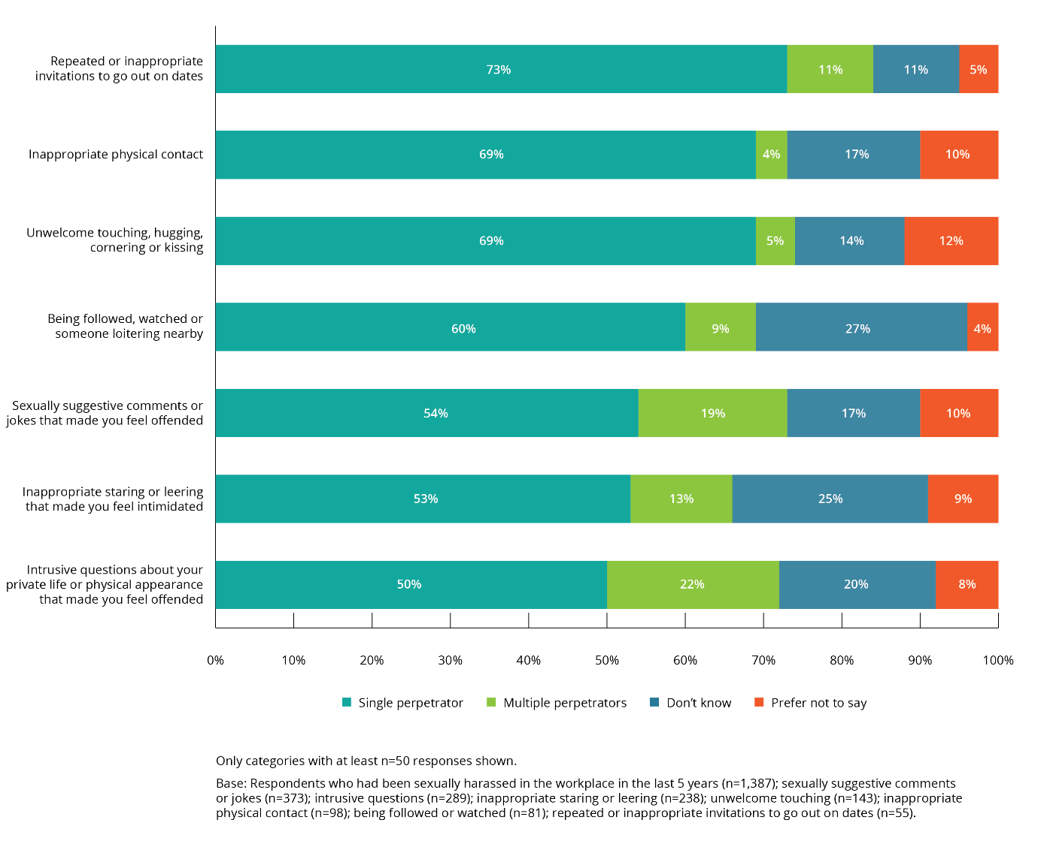

Impact of workplace sexual harassment

Impact of workplace sexual harassment
The 2019 Member Survey results indicate that workplace sexual harassment caused either short or long-term negative consequences for many SDA members.
SDA members who had been sexually harassed in the workplace in the last five years were asked to indicate what the consequences of the most recent incident had been for them.
The majority of SDA members reported either short or long-term negative consequences as a result of workplace sexual harassment. Only 33% of SDA members who had experienced workplace sexual harassment said there were no long-term consequences for them as a result of the workplace sexual harassment.
The negative consequences most commonly identified by SDA members who had experienced workplace sexual harassment were:
- a ‘negative impact on mental health, or caused stress’ (44% for SDA members, compared to 36% for the working population)
- a ‘negative impact on self-esteem and confidence’ (35% for SDA members, compared to 33% for the working population)
- a ‘negative impact on employment, career or work’ (23% for SDA members, compared to 25% for the working population).
More female SDA members than male SDA members said the most recent incident of workplace sexual harassment had impacted negatively on their mental health or caused them stress (45% and 40%, respectively).

Figure 39: Consequences of the most recent incident of workplace sexual harassment (by gender)
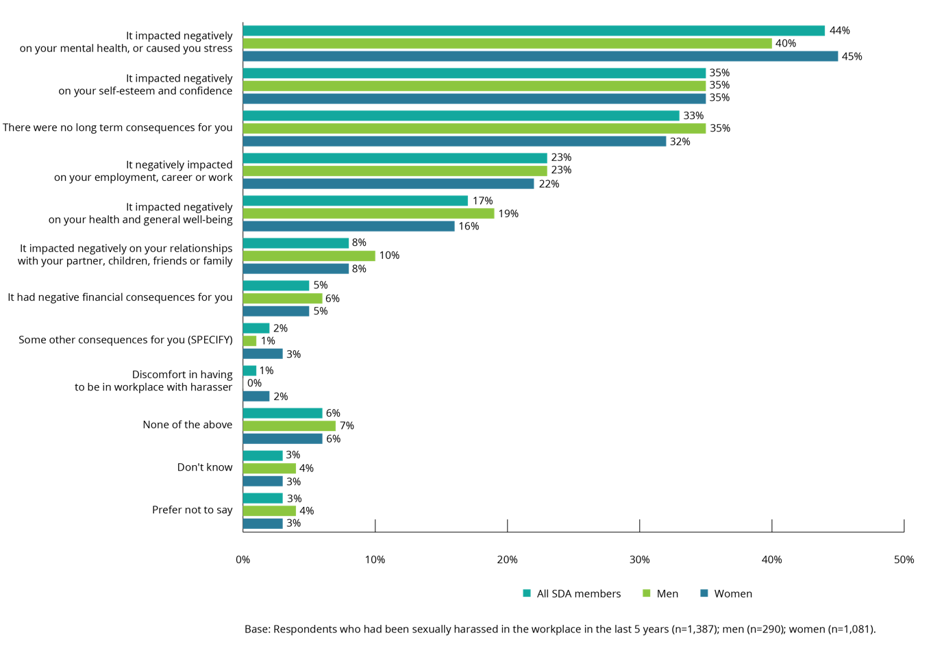
SDA members who had been sexually harassed in the workplace in the last five years were also asked to indicate which, if any, of a specified list of health and wellbeing consequences they had experienced as a direct result of the most recent incident of workplace sexual harassment.
The majority of SDA members who had experienced workplace sexual harassment reported one or more of the listed consequences. A further 37% of SDA members said that they had not experienced any of the listed consequences. The negative consequences most commonly identified by SDA members were:
- anxiety (40%)
- loss of self-esteem (23%)
- depression (18%)
- sense of helplessness (16%)
- sleeplessness (15%).
Suicidal thoughts (6%) and Post-Traumatic Stress Disorder (4%) were identified by a number of SDA members as negative, and potentially life-threatening, consequences of workplace sexual harassment.
Both male and female SDA members reported experiencing particular consequences at similar rates. The only statistically significant differences were that female SDA members (42%) were more likely than male SDA members (33%) to have experienced anxiety as a result of the most recent incident of workplace sexual harassment, and male SDA members were more likely than female SDA members to have experienced burn out (13% and 8%, respectively).
Figure 40: Health and wellbeing consequences for SDA members who had experienced workplace sexual harassment (by gender)
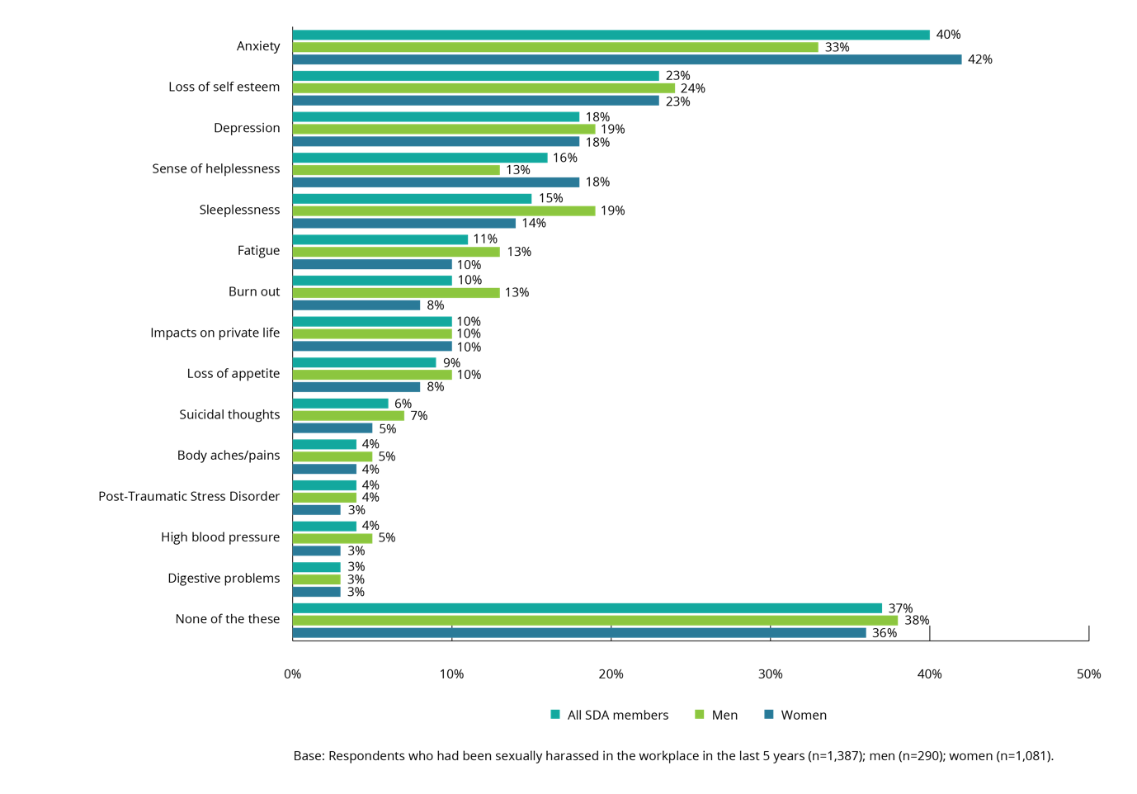

Forms of assistance utilised by SDA members who had experienced workplace sexual harassment
SDA members who said they had experienced workplace sexual harassment were most likely to utilise sick/personal leave as a source of support.
SDA members who had been sexually harassed in the workplace in the last five years were also asked to indicate whether they had sought assistance (from a defined list of potential sources of support) as a result of health problems directly associated with the most recent incident of workplace sexual harassment.
The sources of support most often utilised were sick/personal leave (14%), followed by seeing a medical practitioner (10%), counselling (9%), medication (9%), seeing a psychiatrist/psychologist (8%), annual leave (8%) or unpaid leave (8%).
Male SDA members were more likely than female SDA members to have taken sick/personal leave (19% and 13%, respectively) or unpaid leave (11% and 7%, respectively).
All other sources of assistance were utilised equally by both male and female SDA members.

Figure 41: Forms of assistance utilised by SDA members who had experienced workplace sexual harassment (by gender)
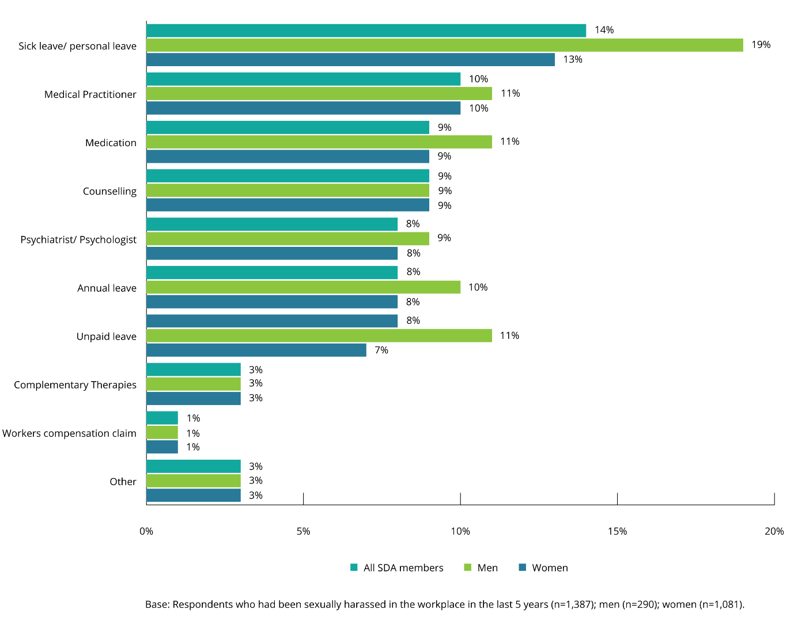

Degree of offence and intimidation experienced by SDA members who had experienced workplace sexual harassment
Overall, female SDA members said they experienced higher levels of offence and intimidation as a result of workplace sexual harassment than male SDA members.
SDA members who had been sexually harassed in the workplace in the last five years were asked to rate how offended and how intimidated the most recent incident had made them feel on a scale from one to five, where one was ‘not at all’ and five was ‘extremely’.
One in two (52%) female SDA members rated their level of offence as 4 or 5 on the scale, compared to one in three (36%) male SDA members.
Overall, experiencing workplace sexual harassment had caused some level of offence, with only 8% of male SDA members and 1% of female SDA members reporting they were ‘not at all’ offended.
Figure 42: Degree of offence felt by SDA members who had experienced workplace sexual harassment (by gender)
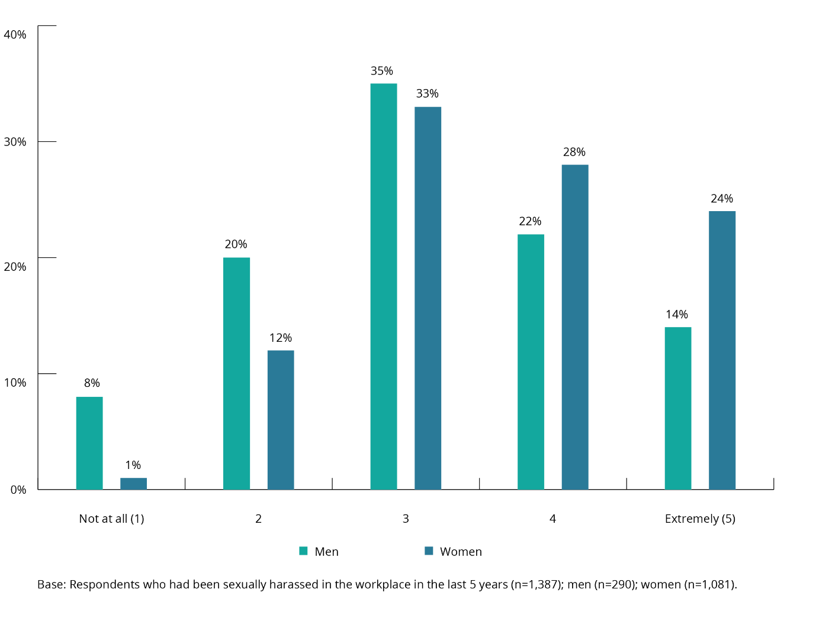
Almost half (47%) of female SDA members rated their level of intimidation as 4 or 5 on the scale, compared to 28% of male SDA members.
One in five (21%) male SDA members were ‘not at all’ intimidated by their experience, compared to fewer than one in ten (8%) female SDA members.

Figure 43: Degree of intimidation felt by SDA members who had experienced workplace sexual harassment (by gender)
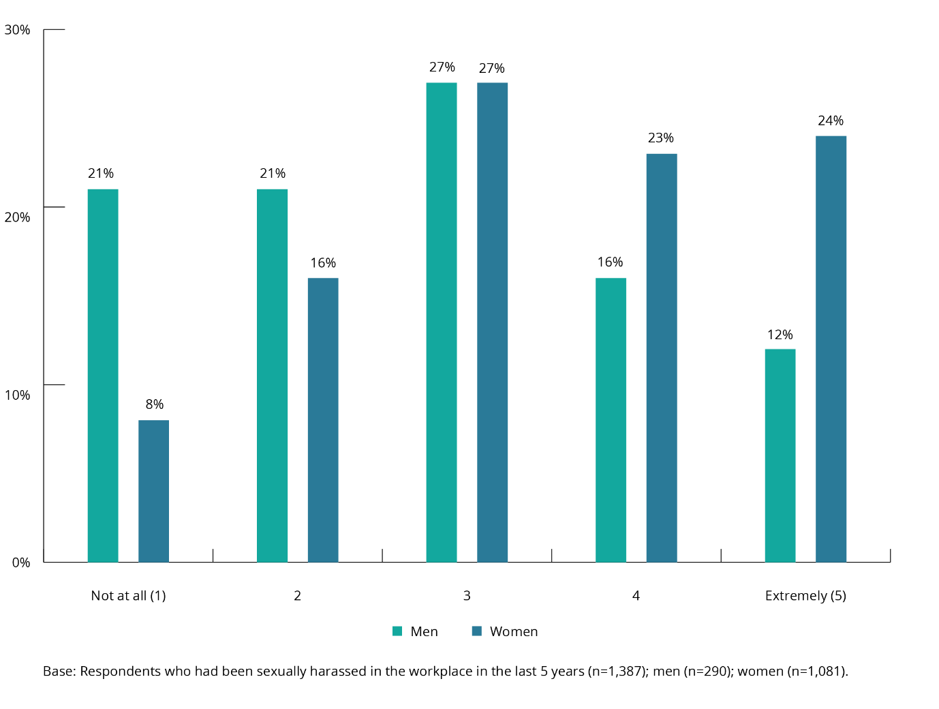
The level of intimidation felt about workplace sexual harassment was slightly higher among younger workers than older workers.
SDA members aged 15–17 years at the time of the most recent workplace sexual harassment incident were slightly more likely to have been intimidated by the experience than SDA members in other age groups.
In contrast, the age of the SDA member at the time of the most recent incident of workplace sexual harassment had no real impact on the level of offence they experienced.

Figure 44: Degree of intimidation or offence felt by SDA members who had experienced workplace sexual harassment (by age)
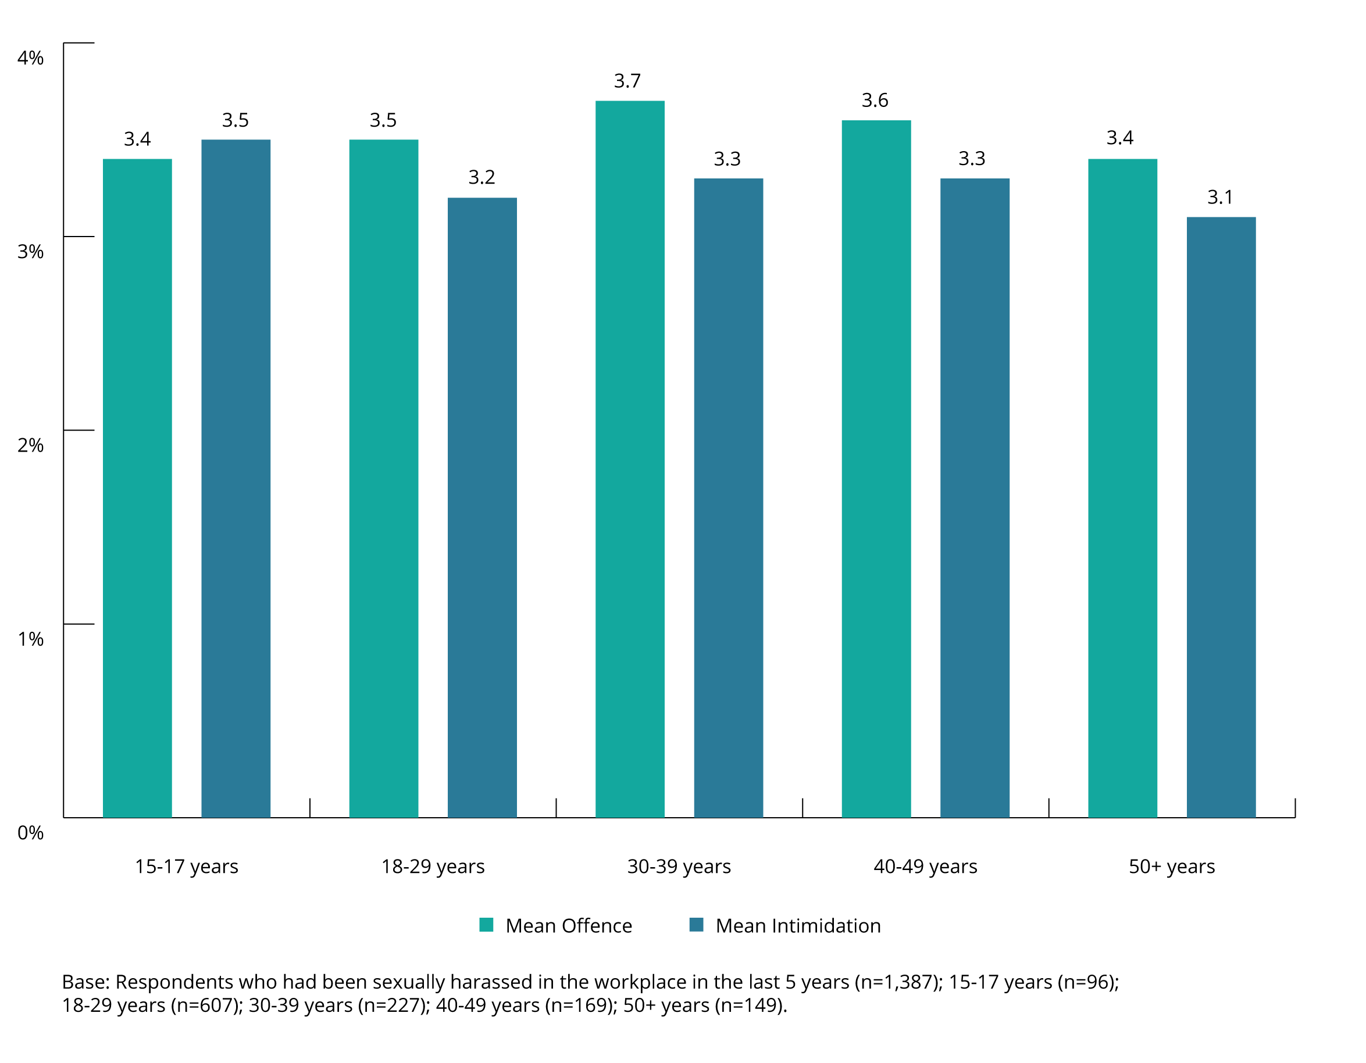
The more offended or intimidated SDA members were by their most recent experience of workplace sexual harassment, the more likely they were to make a formal report or complaint about the incident.
Three in five (58%) SDA members who had experienced workplace sexual harassment and were extremely offended, and one in two (52%) SDA members who were extremely intimidated, made a formal report or complaint.

Figure 45: SDA members who made a formal report or complaint by degree of offence and intimidation
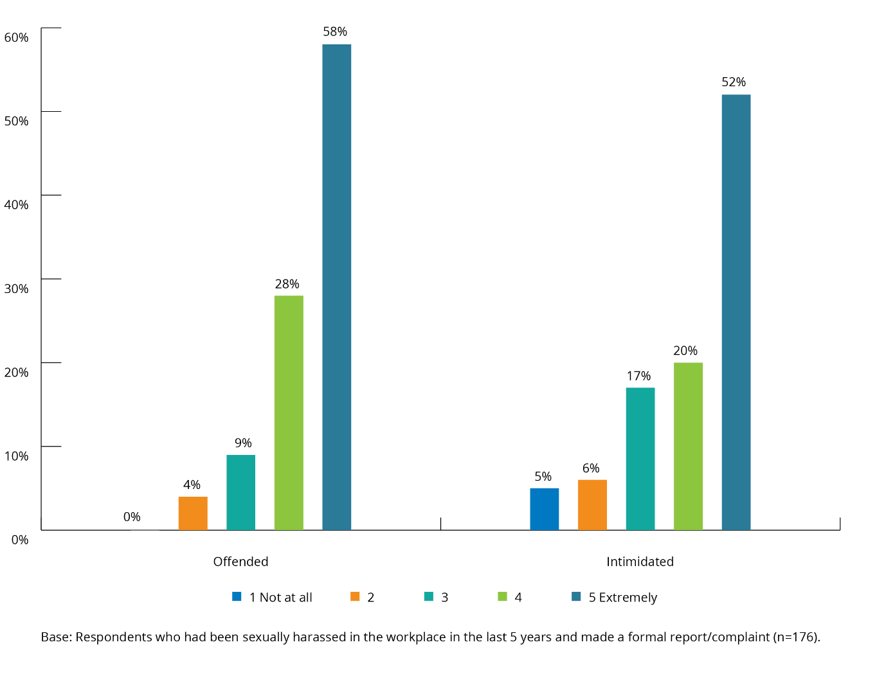
Three in five (60%) female SDA members who had been extremely offended made a formal report or complaint, while half (52%) of male SDA members who had been extremely offended made a formal report or complaint.

Figure 46: SDA members who made a formal report or complaint by degree of offence and intimidation (by gender)
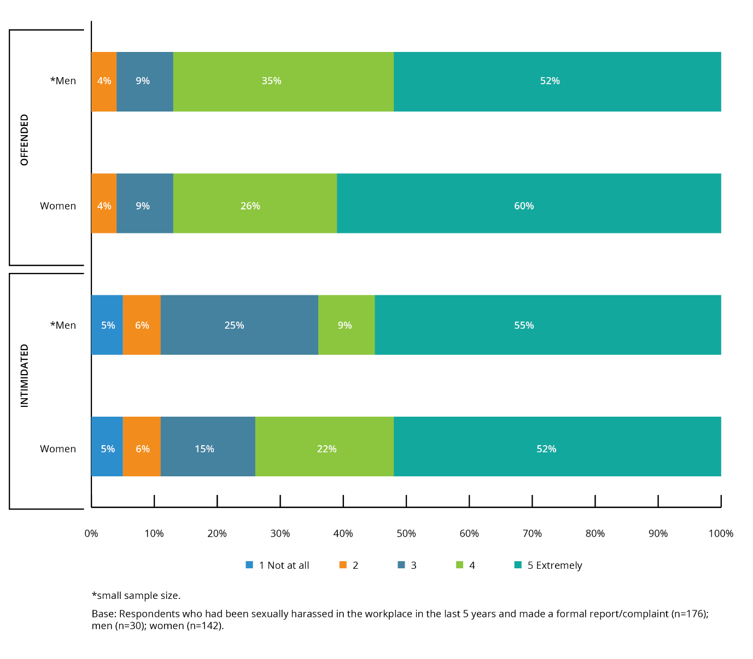

‘[Employers] need to implement training for managers and team members on sexual harassment AND mental health. My mental health has been affected greatly by the lack of support I received after being groped at work by another employee who was drunk. I was then bullied by my team members for having anxiety and self-harming, it was used to discredit myself as an employee and a human being. I have been harassed by customers, not just sexually but through intimidation and stalking. I refuse to wear a name badge because my safety is at risk when I leave work, I was followed for 300 metres in my shopping centre outside of work on my day off by a ‘regular’ who has been sexually inappropriate with myself and team member for years. We still will not ban this man from our store because of the money he spends. I’ve also enquired and requested if we can get a security guard in our store because not only do I not feel safe but the large majority of women who work at my store do not as well. I was told ‘if we don’t even have money for wages, we’re not [going to] have wages for a security guard.’ It’s quite heartbreaking to constantly be reminded that the customer and the customers money is valued more than your safety and general well-being.’

Sexual harassment by customers
Chapter summary
This chapter examines the prevalence and nature of sexual harassment by customers in the retail and fast food sectors
Questions regarding customers were specifically included in the 2019 Member Survey based on the customer-facing nature of the work undertaken by SDA members, and on findings from a survey about customer violence and abuse conducted by the SDA in 2016.
One in five (21%) SDA members said they had been sexually harassed by a customer in their current job. Of those SDA members, female SDA members (28%) were more likely than male SDA members (11%) to have experienced sexual harassment by a customer.
When asked about their experiences of workplace sexual harassment over the last five years, SDA members indicated that a customer was the harasser in 36% of cases. Again female SDA members (42%) were more likely to say this than male SDA members (22%).
SDA members aged 18–29 years indicated that they were sexually harassed by customers more frequently in their current job in the last 12 months than members aged 30 years or more, (7.2 times and 4.1 times, respectively).
Eighty-one per cent of SDA members who said they had been sexually harassed by a customer in their current job in the last 12 months did not know the person who had sexually harassed them in the most recent incident.
Only one in five SDA members who had been sexually harassed by a customer (20%) indicated that their employer had a reporting mechanism in place. Fifty-six per cent said they did not know.
Sixty-seven per cent of SDA members who said they had been sexually harassed by a customer in their current job indicated that they had not reported the incident to their employer.
Of the 25% of SDA members who said they had made a formal report or complaint, 63% said the incident had not been investigated by their employer, with only 23% confirming that it had.

Prevalence of sexual harassment by customers
One in five SDA members said they had been sexually harassed by a customer in their current job.
Of the 21% of SDA members who had been sexually harassed by a customer in their current job, female SDA members were more likely to have had this experience (28%) than male SDA members (11%).
SDA members aged 18–29 years (27%) were most likely to have been sexually harassed by a customer, when compared to other age groups.
There was no statistically significant difference between the experience of sexual harassment in the main customer facing SDA sectors, retail (22%) and fast food (18%).

Figure 47: Prevalence of sexual harassment by customers experienced by SDA members in their current job
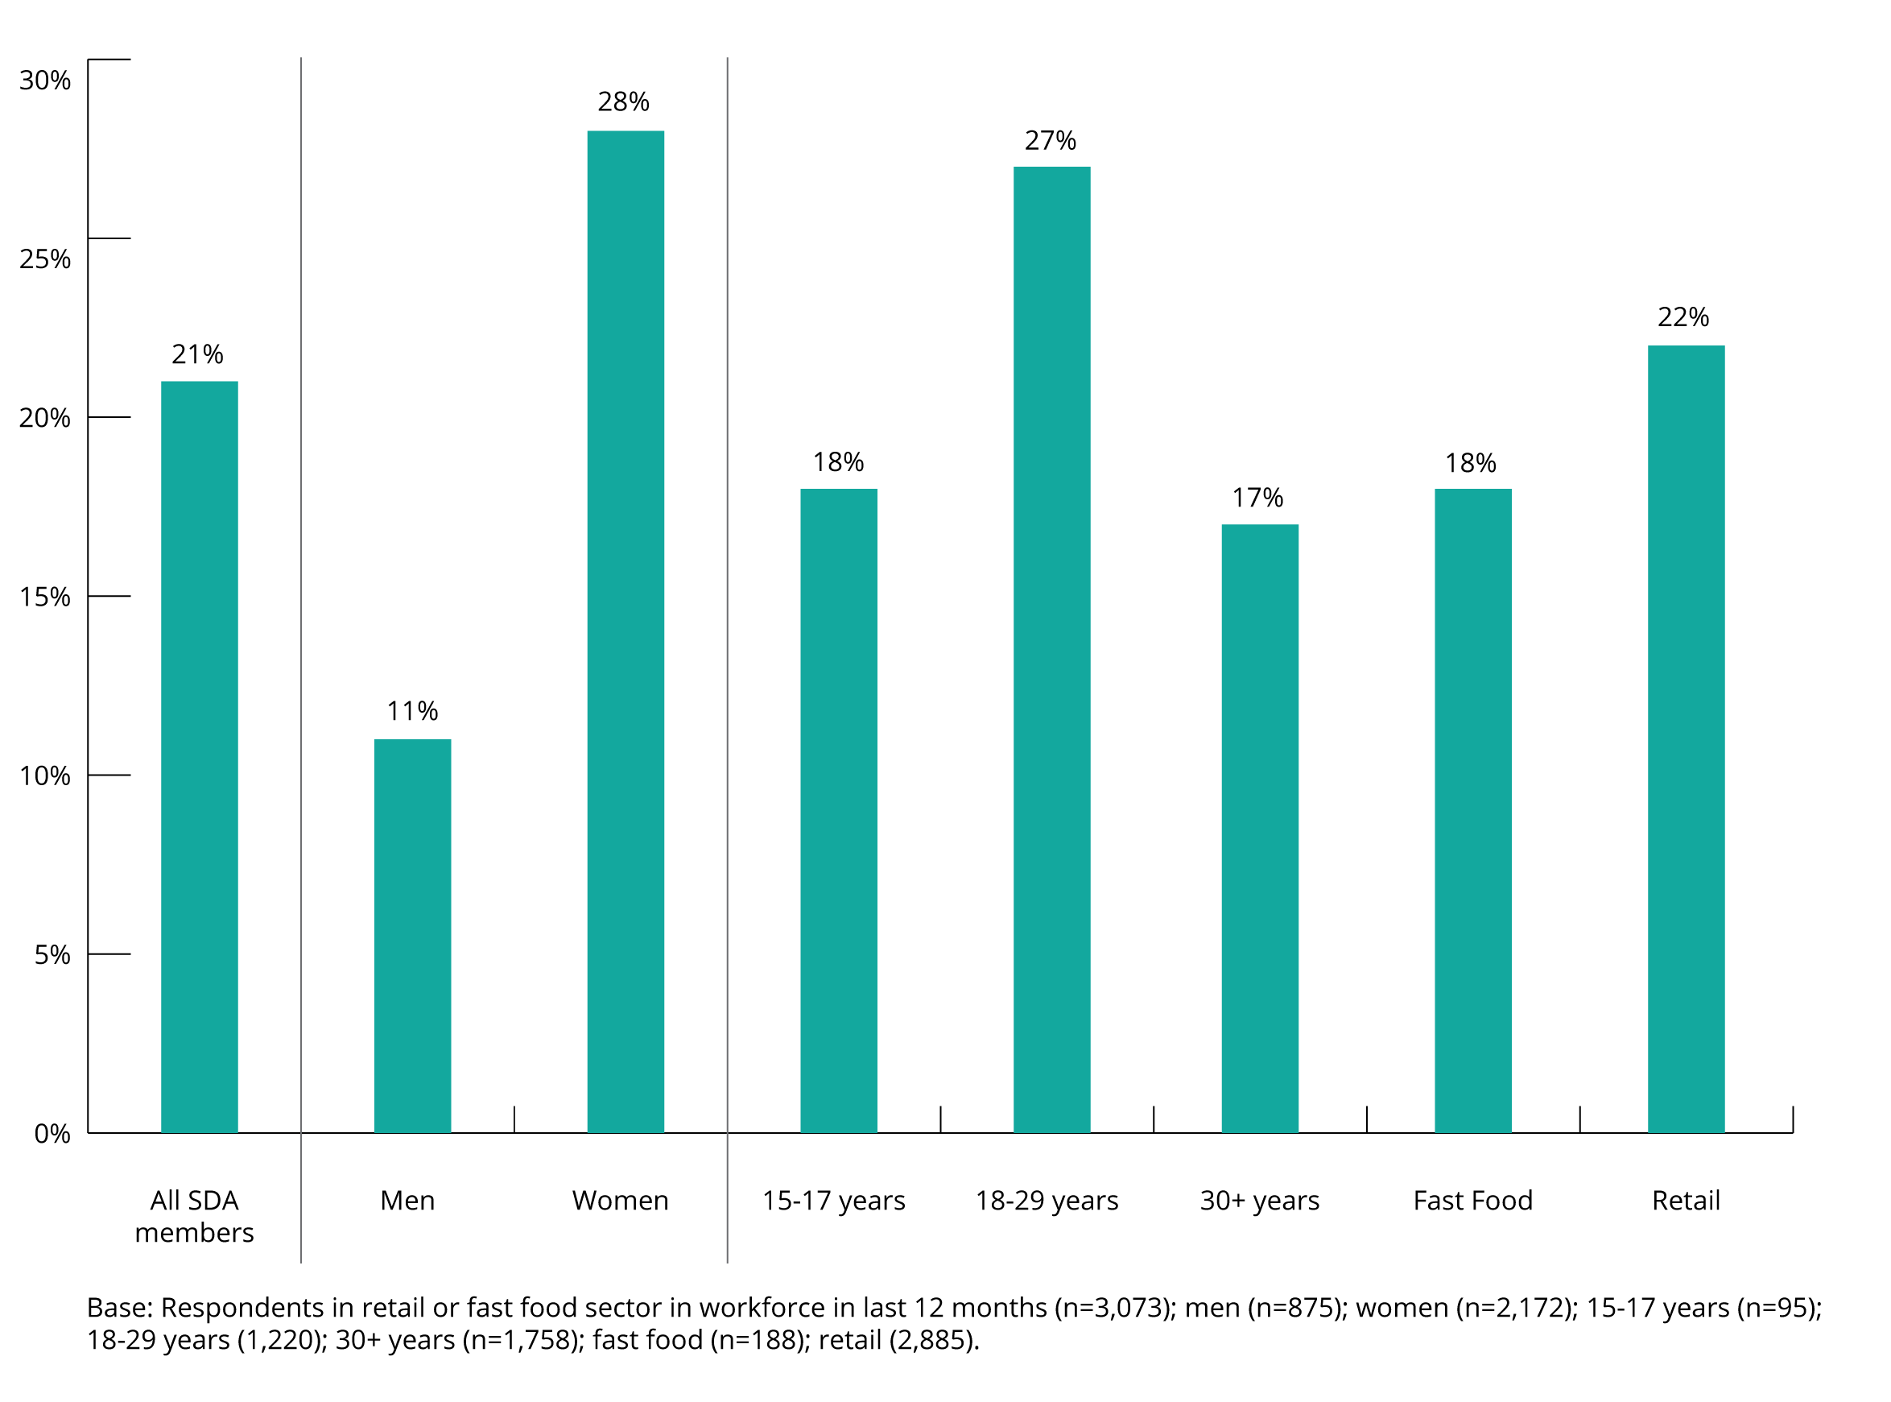
When the relationship between SDA members who experienced workplace sexual harassment in the last five years and their harassers were examined, in 36% of cases the harasser was a customer. Again female SDA members (42%) were more likely to say this than male SDA members (22%). See section 3.4(b) for more details.

Frequency of sexual harassment by customers
SDA members who had been sexually harassed by a customer in their current job in the last 12 months were asked how often they had been sexually harassed in the last 12 months.
Seventy–five per cent of SDA members had been sexually harassed by a customer more than once.
On average SDA members who provided a numerical response indicated that they had been sexually harassed by customers an average of 5.9 times in the last 12 months.
The frequency of incidents of sexual harassment by customers experienced by SDA members in their current job in the last 12 months was reported as follows:
- 25% of SDA members who indicated they had been sexually harassed said this had been a one-off occurrence
- 17% of SDA members who indicated they had been sexually harassed said this had occurred twice in the last 12 months
- 35% of SDA members who indicated they had been sexually harassed said this had occurred three to five times in the last 12 months
- 11% of SDA members who indicated they had been sexually harassed said this had occurred six to ten times in the last 12 months
- 12% of SDA members who indicated they had been sexually harassed said this had occurred more than ten times in the last 12 months.

Figure 48: Frequency of workplace sexual harassment by a customer in current job in the last 12 months (by gender)
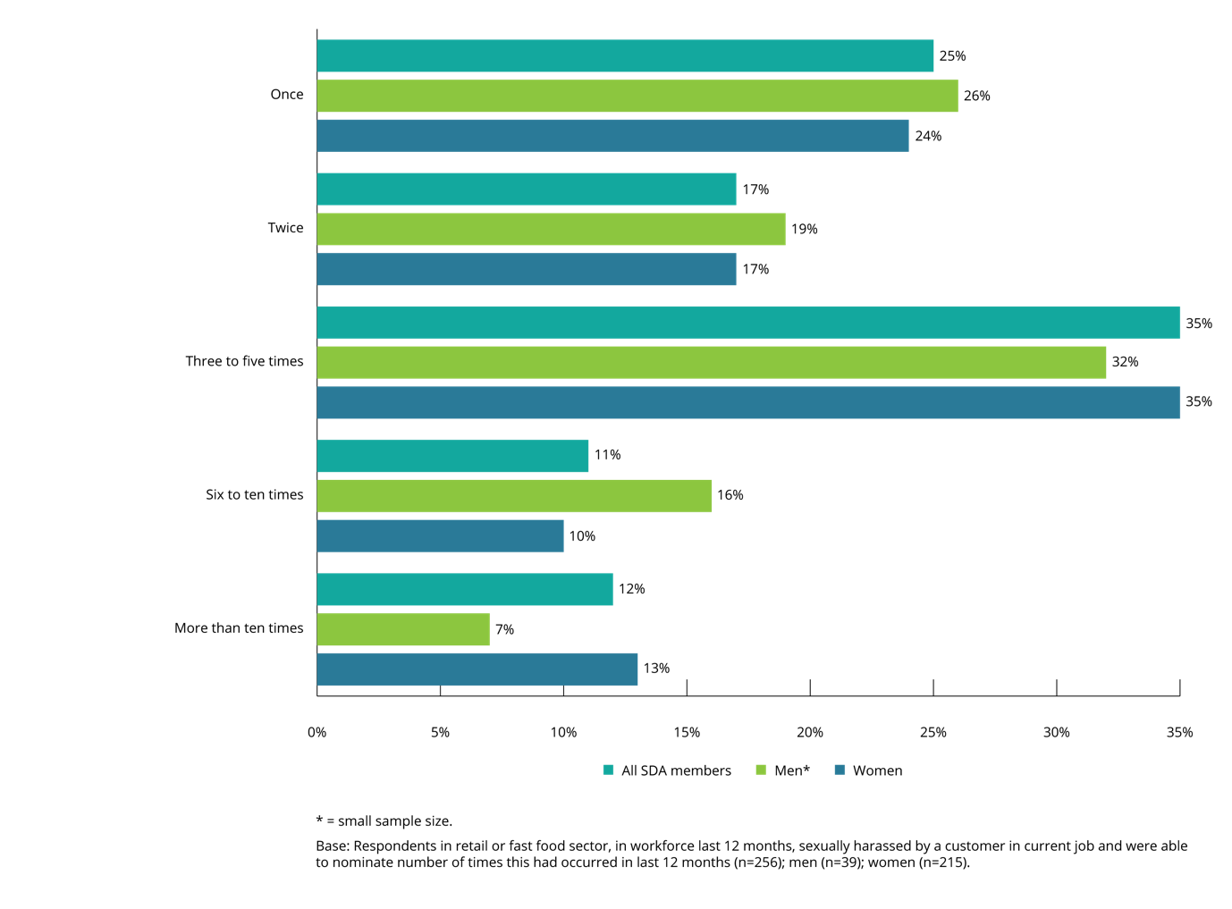
There was no statistically significant indication that either women or men were being sexually harassed by customers more often.
Younger SDA members said they were sexually harassed by customers more frequently than older SDA members.
On average, SDA members aged 18–29 years had been sexually harassed more often by customers in their current job in the last 12 months (7.2 times) compared to those aged 30 years or more (4.1 times).
SDA members aged 30 years or more were more likely to have been sexually harassed on only one occasion (38%) when compared to those aged 18–29 years old (17%).
SDA members aged 18–29 years old were also more likely to say that they had been sexually harassed by a customer more than ten times (15%) when compared to those aged 30 years and older (6%).
The sample size in the fast food sector (n=15) was too small to draw comparisons with the retail sector.
Figure 49: Frequency of workplace sexual harassment by a customer in current job in the last 12 months (by age)
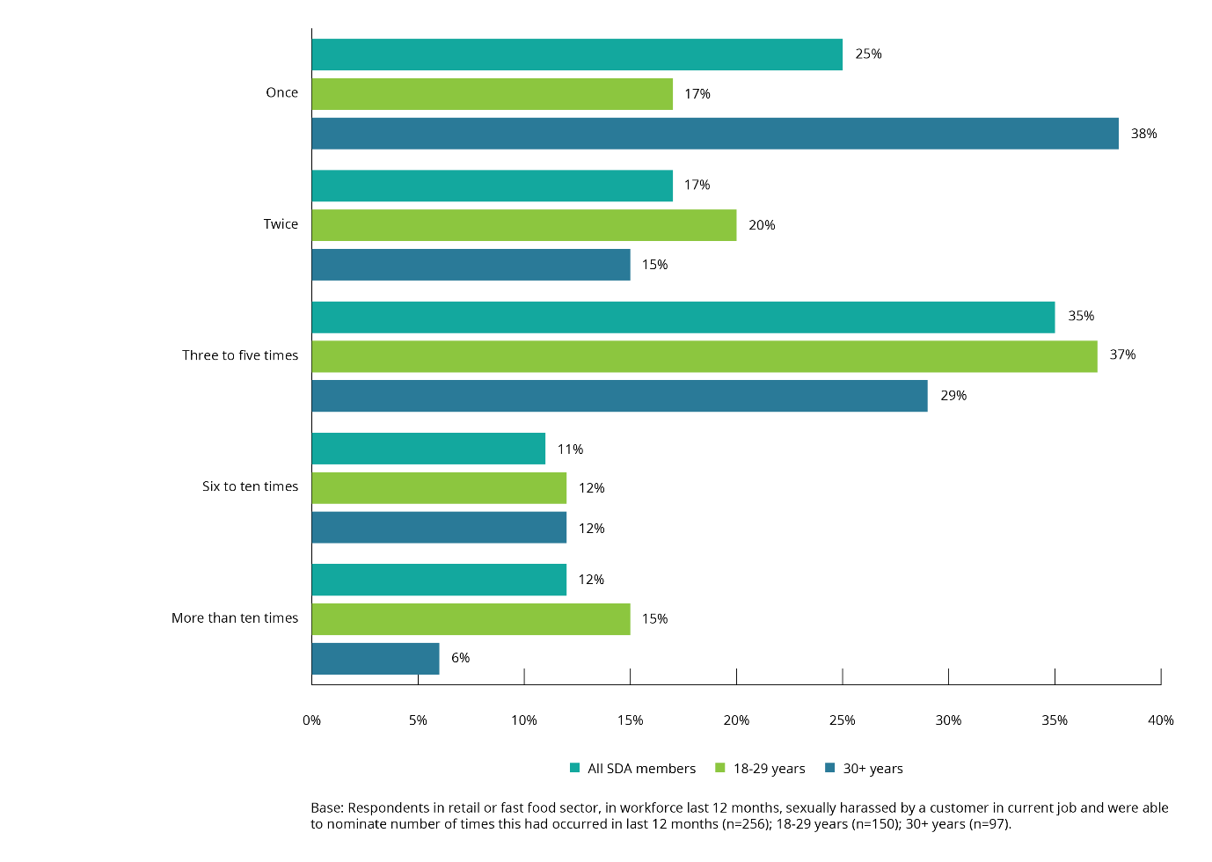

Time elapsed since last sexually harassed by a customer
Over half of SDA members who indicated that they had been sexually harassed by a customer in their current job had been sexually harassed in the previous six months.
Fifty-four per cent of SDA members who said they had been sexually harassed by a customer in their current job indicated that their most recent experience had occurred in the last six months. Female SDA members (56%) were more likely than male SDA members (42%) to say this. Male SDA members (40%) were twice as likely as female SDA members (20%) to indicate that their experience of being sexually harassed by a customer had occurred more than 12 months previously.
Figure 50: Time since last sexually harassed by a customer in current job in the last 12 months (by gender)
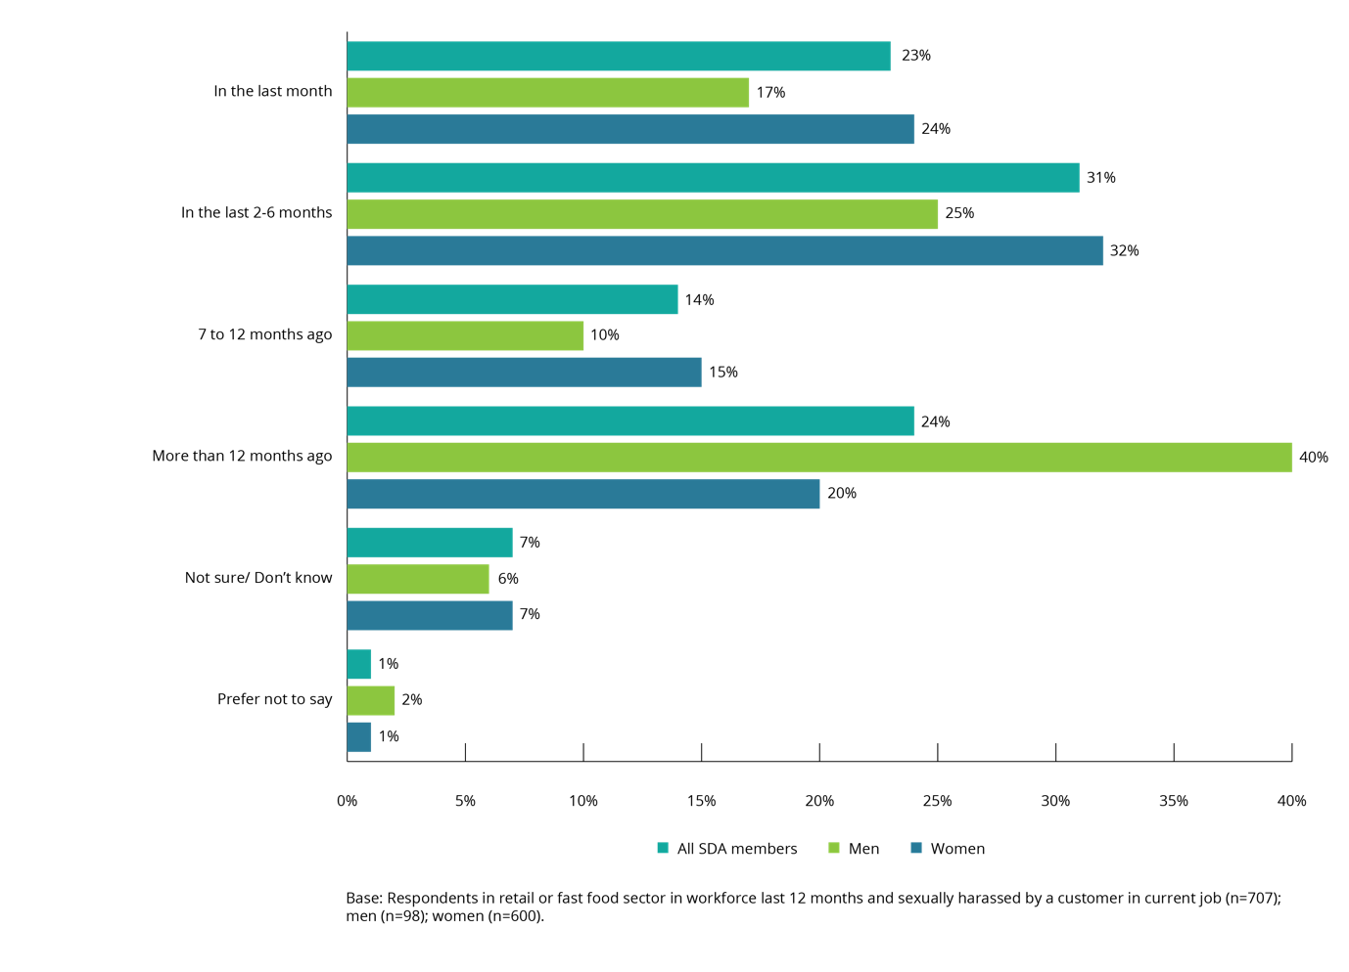

Younger SDA members were more likely to have experienced sexual harassment by a customer more recently.
Of SDA members aged 18–29 years, 28% indicated that their most recent experience of sexual harassment by a customer had occurred in the previous month, compared to 14% of those aged 30 years or older.
The same was true in relation to sexual harassment by a customer experienced in the previous 6 months, with 61% of SDA members aged 18–29 years saying they had been sexually harassed in this time period compared to 41% of those aged 30 years or older.
The sample size for those aged 15–17 years was too small to draw statistically significant findings, but the data does indicate that SDA members in this age group had been sexually harassed by customers more recently than older SDA members.
There were no statistically significant differences between SDA members in the retail and fast food sectors regarding the timing of their most recent experience of sexual harassment by customers.

Figure 51: Time since last sexually harassed by a customer in current job in the last 12 months (by age)
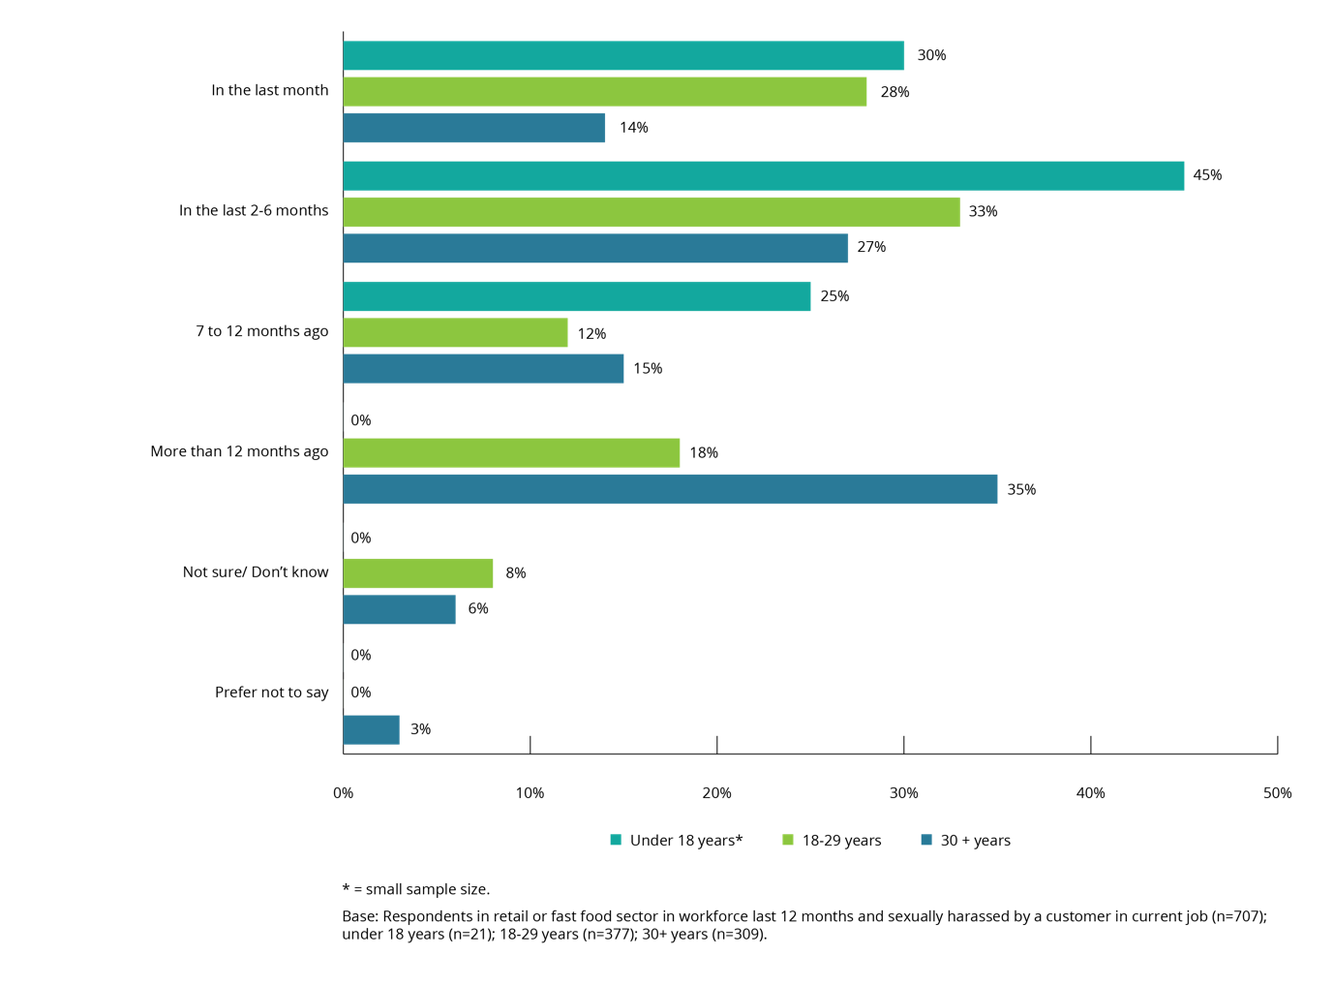

Was the harasser known to the SDA member?
SDA members who said they had been sexually harassed in their current job in the last 12 months by a customer were asked if they knew the person who had sexually harassed them in the most recent incident.
Eighty-one per cent of SDA members who indicated that they had been sexually harassed by a customer said they did not know the harasser.
Only 15% of SDA members who said they had been sexually harassed by a customer indicated that they knew the harasser.
While there was no statistically significant difference between genders or SDA sectors, SDA members aged 30 years or older (22%) were more likely than those aged 18–29 years (13%) to have known the harasser.

Repeat harassers
SDA members who said they had been sexually harassed in their current job in the last 12 months by a customer were asked if the customer who had harassed them in the most recent incident had harassed them previously.
One in three of these SDA members said they had been sexually harassed by the same customer multiple times.
Overall, 35% of SDA members who had been sexually harassed by a customer said that they had been harassed by the same customer on more than one occasion.
While there was no statistically significant difference between genders or SDA sectors, SDA members aged 30 years or older (42%) were more likely than those aged 18–29 years (33%) to say that the customer had sexually harassed them on a previous occasion.

Reporting sexual harassment by a customer to an employer

Reporting mechanism
SDA members who said they had been sexually harassed by a customer in their current job were asked about the mechanisms for reporting a customer to their employer.
One in five SDA members who had been sexually harassed by a customer (20%) indicated that their employer had a reporting mechanism in place, with a similar proportion (24%) stating that there was no such mechanism. The majority (56%) were not sure whether a reporting mechanism existed.
While there was no difference between men and women in this regard, those aged 30 years or more (27%) were more likely than those aged 18–29 years (15%) to say their employer had a reporting mechanism in place.

Outcome of reporting
SDA members who said they had been sexually harassed by a customer in their current job were asked if they had reported such an incident to their employer.
One in four SDA members who said they had been sexually harassed by a customer indicated that they had reported the sexual harassment to their employer.
While 25% of SDA members who had been sexually harassed by a customer indicated that they had reported the incident to their employer, 67% of SDA members indicated that they had not. There was no statistically significant difference by gender or age.
SDA members who had reported an incident of sexual harassment by a customer to their employer in their current job were asked if their report had been investigated.
Only one in four SDA members who reported sexual harassment by a customer in their current job to their employer indicated their report had been investigated.
While 23% of SDA members indicated that their report had been investigated, 63% said that it had not, and 14% were unsure what the outcome of their report was. There was no statistically significant difference by gender or age in relation to the outcome of reporting.
Due to the small sample size of SDA members whose reports of sexual harassment were investigated it is not possible to draw firm conclusions about employer action following an investigation. However, in all but one case where sexual harassment was investigated some action was taken against the harasser. Action included the customer being spoken to, the customer being banned from the workplace and the police being called.

‘Wearing a badge with our name on it makes customers and sexual predators feel comfortable enough to harass us under the guise of friendliness. It also allows them to think that because they know your name they are entitled to other personal information about you and to touch you. Wearing a name badge also makes it incredibly easy for those same predators to go home and look us up online and then harass us from the comfort of their homes too.’

Inappropriate campaigns or clothing and sexual harassment
Chapter summary
This chapter examines the experience of SDA members from the retail and fast food sectors in connection with inappropriate:
- marketing, advertising campaigns or other promotions
- uniforms or clothing that their employer required them to wear.
A small number of SDA members indicated that their employer had conducted a marketing or advertising campaign (4%) or required them to wear a uniform or clothing (4%) that they felt was inappropriate or made them feel uncomfortable. However, of those whose employer had conducted an inappropriate campaign or required them to wear inappropriate clothing, or both, one in five (19%) said that the inappropriate campaign or uniform or clothing resulted in them being sexually harassed.

Inappropriate campaigns or clothing
Four per cent of SDA members who were in the workforce in the last five years indicated that their employer had conducted a marketing or advertising campaign or some other form of promotion that they felt was inappropriate or made them feel uncomfortable. Four in five SDA members (81%) said that this had not occurred and 15% did not know or preferred not to say.
Similarly, four per cent of SDA members indicated that their employer had required or expected them to wear a uniform or clothing as part of their job that they felt was inappropriate or made them feel uncomfortable. Nine in ten SDA members (93%) said that this had not occurred.
There were no statistically significant differences based on age or gender.

Inappropriate campaigns or clothing leading to sexual harassment
SDA members who indicated that their employer had conducted an inappropriate campaign or expected or required them to wear an inappropriate uniform or clothing in the workplace were asked if either of these events had led to them being sexually harassed at work.
One in five of these SDA members said that they had been sexually harassed at work as a result of an inappropriate campaign or inappropriate clothing.
While 19% of SDA members whose employers had either conducted an inappropriate campaign or asked them to wear an inappropriate uniform or clothing said that this had led to them being sexually harassed, 70% said that it had not, and 11% did not know or preferred not say.
Female SDA members (24%) were more likely than male SDA members (11%) to have experienced sexual harassment in these circumstances.
There were no statistically significant differences in age for those who reported sexual harassment in these circumstances (excluding those aged 15–17 years due to the small sample size).
Figure 52: Prevalence of sexual harassment as a result of inappropriate campaigns or clothing
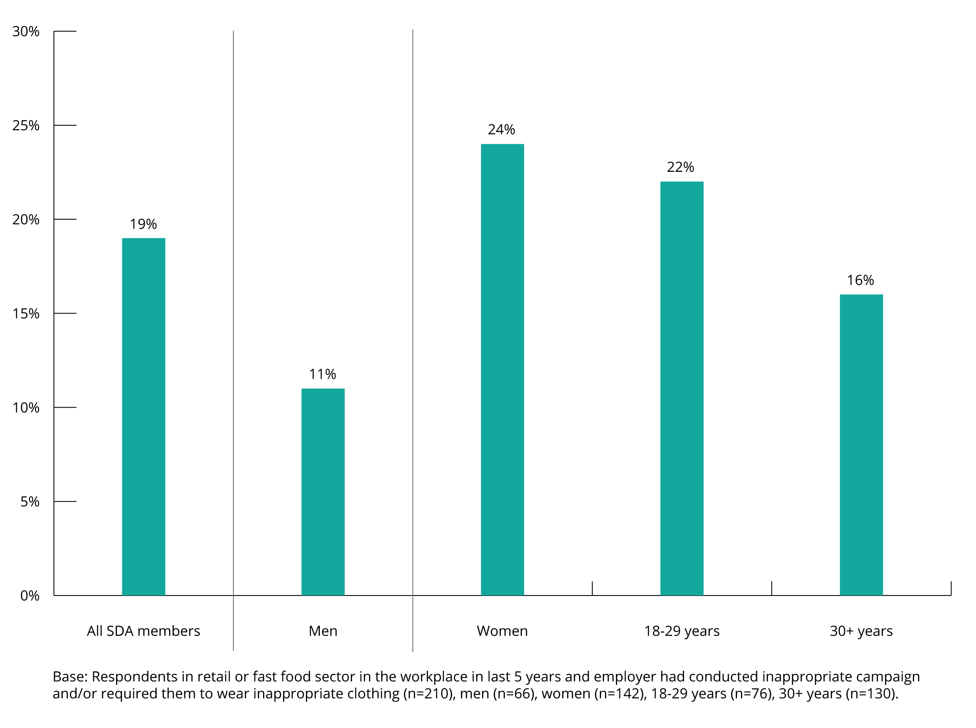

‘I would like store managers, department managers and duty managers to have a bit more training and knowledge to deal with these situations. In my case, I felt that the person I confided in was unsure how to respond to what I told them and too ready to brush off and dismiss what I had to say. It might not have been a big deal to them, but I was uneasy, anxious and a little scared. Now I keep doubting myself and feel like I was overreacting.’

Reporting and seeking support in relation to workplace sexual harassment
Chapter summary
This chapter examines the responses of workplaces and SDA members when workplace sexual harassment occurs.
Reporting of workplace sexual harassment
The vast majority of SDA members who had experienced workplace sexual harassment indicated that they had not made a formal report or complaint in relation to the most recent incident of workplace sexual harassment.
Although there were no overall differences between male and female SDA members in the reporting of sexual harassment, when analysed by specific types of behaviour there were some gender-based differences in reporting behaviour.
Female SDA members were more likely than male SDA members to formally report or make a complaint about incidents of unwelcome touching, hugging, cornering or kissing; and inappropriate physical contact. In contrast, male SDA members were more likely than female SDA members to report or complain about incidents that involved being followed, watched or someone loitering nearby.
Formal reports or complaints of workplace sexual harassment from a SDA member were mostly made to a direct manager or supervisor (71%). Of SDA members’ formal reports or complaints that were finalised, the majority (74%) were finalised in less than a month after the incident.
Almost two thirds (61%) of formal reports or complaints of workplace sexual harassment resulted in no changes in the workplace.
The most common reason for not making a formal report or complaint of workplace sexual harassment was that SDA members thought other people would think they were overreacting (48%).

Seeking support and advice
Only 13% of SDA members had sought support or advice in relation to the most recent incident of workplace sexual harassment. This support or advice was commonly sought from friends and family (65%).
Reasons for not reporting, making a complaint, or seeking support or advice
The data in relation to making a formal report or complaint, and seeking support or advice, was examined holistically. Most SDA members (71%) did not make a formal report or complaint about their most recent incident of workplace sexual harassment, or seek support or advice in relation to it.
The most common reason given for not taking action was a concern that others would think they were overreacting (47%).
Seeking information about workplace sexual harassment
The most commonly nominated sources of information about workplace sexual harassment were:
- direct manager or supervisor at work (45%)
- friends and family (44%).
In 36% of cases, SDA members also sought information from their union or employee representative.

Reporting of workplace sexual harassment
SDA members who indicated that they had experienced workplace sexual harassment in the last five years were asked if they had formally reported or made a complaint in relation to the most recent incident of workplace sexual harassment.
The majority of SDA members said that they had not made a formal report or complaint in relation to the most recent incident of workplace sexual harassment.
Only one in eight (13%) SDA members who had experienced workplace sexual harassment in the last five years made a formal report or complaint in relation to the most recent incident. Although female SDA members experienced workplace sexual harassment at a rate of 46% compared to 29% for male SDA members, there is no evidence that female SDA members were more likely to report their experience than their male colleagues. This is consistent with the working population.
By comparison, 17% of the working population who had experienced workplace sexual harassment in the last five years made a formal report or complaint. This finding is consistent across both genders.
Figure 53: Reporting of workplace sexual harassment (SDA members vs the working population) (by gender)
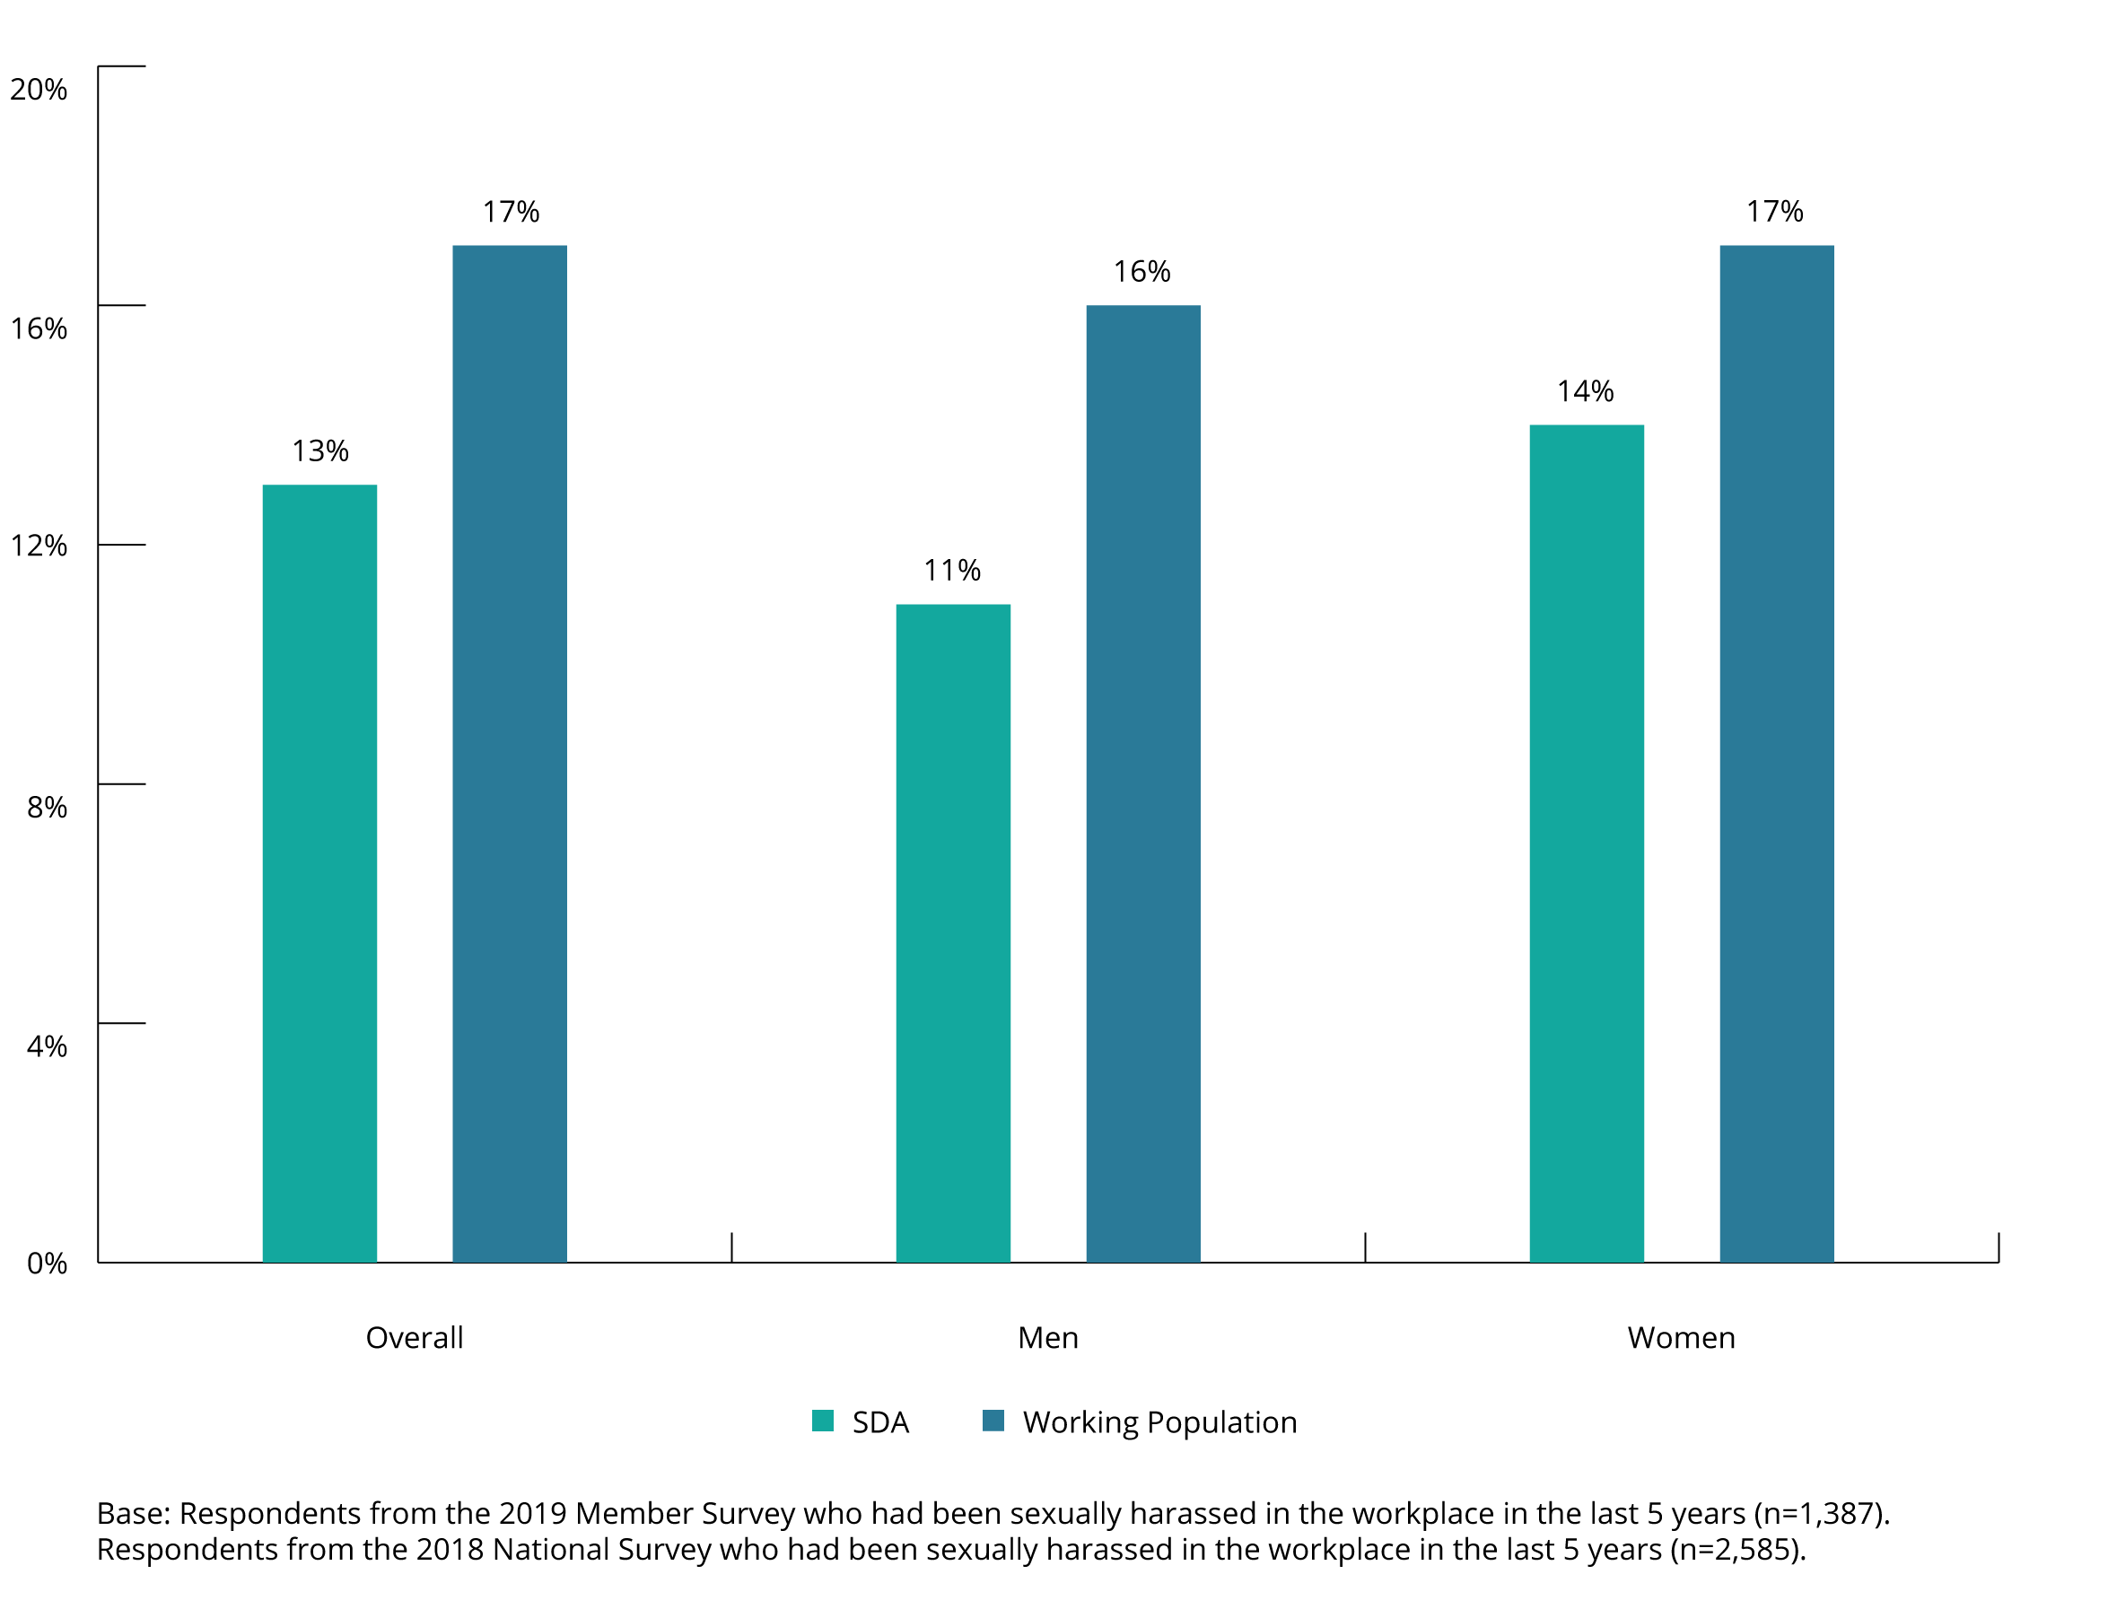

Types of workplace sexual harassment reported
The behaviours that were most often experienced in the workplace, tended to be the least likely to be reported by both SDA members and the working population.
- Sexually suggestive comments or jokes represented over a quarter (26%) of the most recent incidents of workplace sexual harassment for SDA members, but only 13% of these incidents were the subject of a formal report or complaint. In the working population, these figures were 31% and 10%, respectively.
- Intrusive questions about an individual’s private life, represented 21% of the most recent incidents of workplace sexual harassment for SDA members, but only 10% of these incidents were the subject of a formal report or complaint. In the working population, these figures were 18% and 13%, respectively.
Conversely, incidents with a low incidence had a very high level of reporting.
- Repeated or inappropriate invitations to go out on dates represented 4% of the most recent incidents of workplace sexual harassment for SDA members, but 21% of these incidents were the subject of a formal report or complaint. These figures match the experiences of the working population.
- Similarly, being followed or watched amounted to 6% of the most recent incidents of workplace sexual harassment for SDA members, but 23% of these incidents were the subject of a formal report or complaint. In the working population these figures were similar, 3% and 25% respectively.
- Sexually explicit pictures, posters or gifts represented 2% of the most recent incidents of workplace sexual harassment for SDA members, but 19% of these incidents were the subject of a formal report or complaint. In the working population, these figures were 3% and 19% respectively.

Figure 54: Workplace sexual harassment behaviours experienced vs behaviours reported
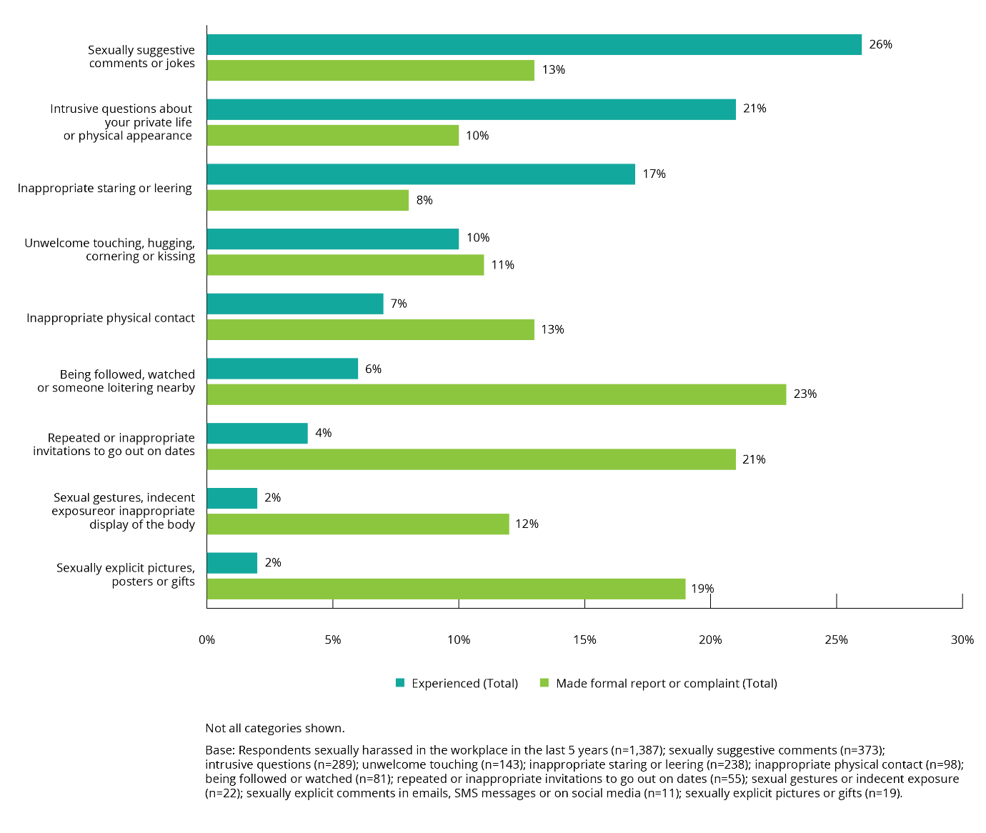

Figure 55: Types of workplace sexual harassment behaviour reported (SDA members vs the working population)
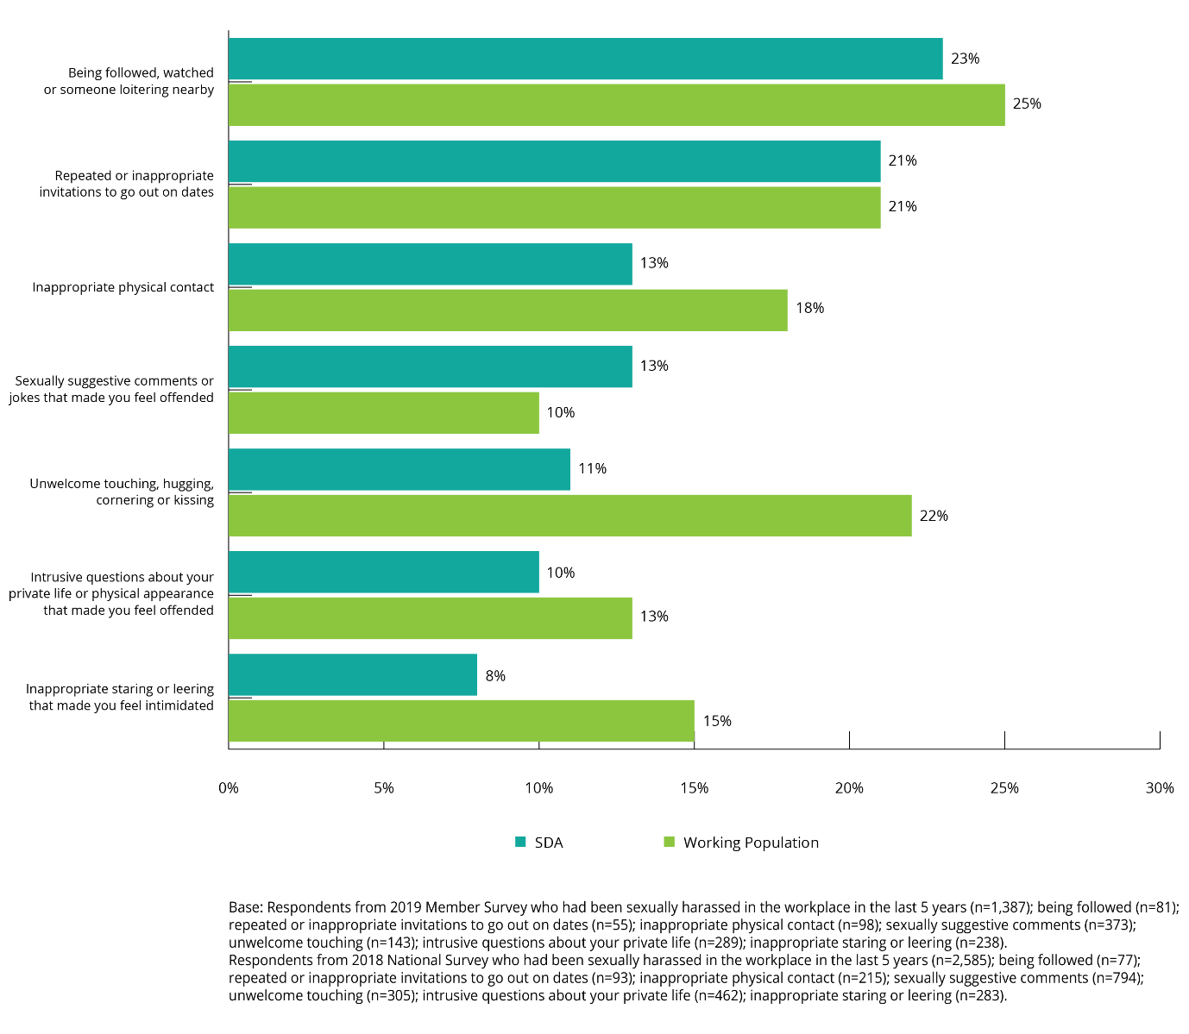

Although there were no differences overall between male and female SDA members in the reporting of sexual harassment, when analysed by specific types of behaviour there were some gender-based differences in reporting behaviour.
Female SDA members were more likely than male SDA members to report incidents of:
- unwelcome touching, hugging, cornering or kissing (11% of incidents, reported in 14% of cases by females, compared to 8% of incidents, reported in 4% of cases by males)
- inappropriate physical contact (7% of incidents, reported in 17% of cases by females, compared to 8% of incidents reported in 4% of cases by males).
In contrast, male SDA members were more likely than female SDA members to make a formal report or complaint about workplace sexual harassment incidents regarding being followed, watched or someone loitering nearby. Female SDA members experienced this type of behaviour in 6% of most recent incidents of workplace sexual harassment and reported on these in 20% of cases. Male SDA members experienced this type of behaviour in 7% of most recent incidents of workplace sexual harassment and reported on these in 28% of cases.
In the case of intrusive questions about an individual’s private life or physical appearance, this was the most recent type of workplace sexual harassment experienced by 27% of male SDA members and 18% of female SDA members, but the rate of formal reporting or complaining was 10% for both males and females.

The process of making a formal report or complaint of workplace sexual harassment
SDA members who made a formal report or complaint about the most recent incident of workplace sexual harassment were most likely to report to their direct manager or supervisor.
Both SDA members (71%) and the working population (55%) were most likely to make a formal report or complaint to a direct manager or supervisor. Females in the working population were more likely than males to take this action (60% and 47% respectively). While the sample size for men was small, the results show a similar pattern for SDA members, with 76% of female SDA members reporting to their direct manager or supervisor compared to 53% of male SDA members.
SDA members were more likely than the working population to make a report or complaint to another manager or supervisor (38% and 22%, respectively). SDA members were also more likely than the working population to make a report or complaint to a union or employee representative (18% and 6%, respectively).
In contrast, those in the working population were more likely than SDA members to report workplace sexual harassment to the head of the organisation or business owner (36% and 22%, respectively). The nature of SDA members’ employment is likely to mean that they are generally less likely to have an opportunity to contact the Chief Executive Officer (CEO) or the owner of the business they work in.
Although the sample size of male SDA members who made a formal report or complaint was too small to facilitate a specific gender-based comparison, the results suggest that female SDA members are more inclined to report their harassment to a union or employee representative.

Figure 56: Who formal reports or complaints were made to (by gender)
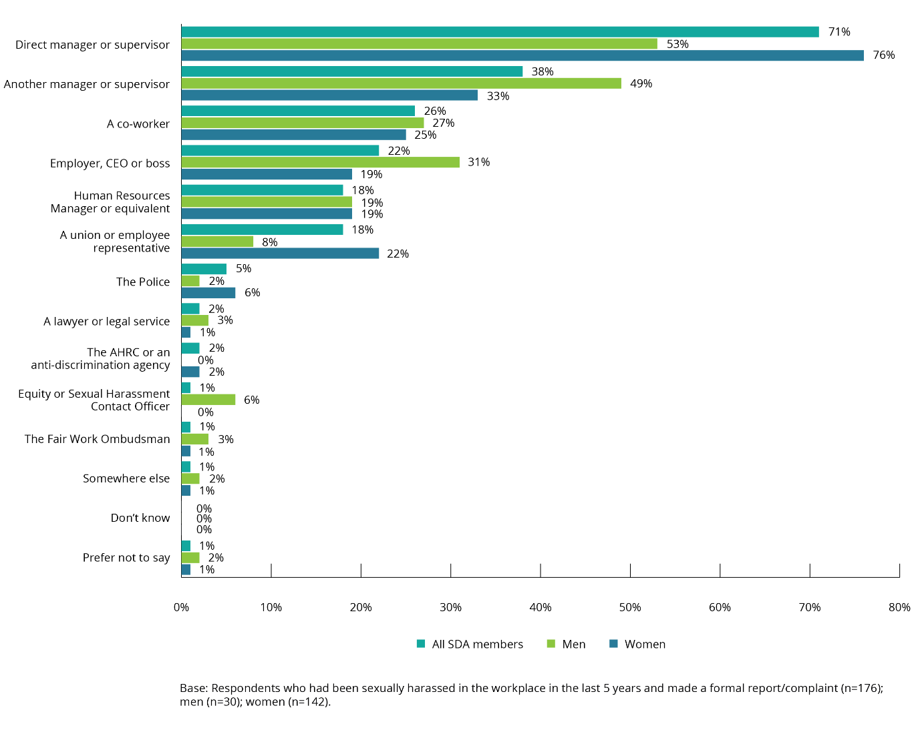

Time taken to make a report or complaint
Almost half of SDA members who made a formal report or complaint about the most recent incident of workplace sexual harassment did so immediately after the incident had occurred.
In nearly half of incidents (46%) of workplace sexual harassment, the formal report or complaint was made on the same day or on the next working day following the incident. This rate was the same for both SDA members and the working population. The formal report or complaint was made within the following month in a further 20% of cases for SDA members and 26% of cases for the working population.
Female SDA members were more likely than male SDA members to report harassment on the same or next working day. Half (51%) of female SDA members who formally reported or complained about workplace sexual harassment did so on the same or next day, whereas a quarter (28%) of male SDA members did so.
Figure 57: Elapsed time before a formal report or complaint was made (by gender)
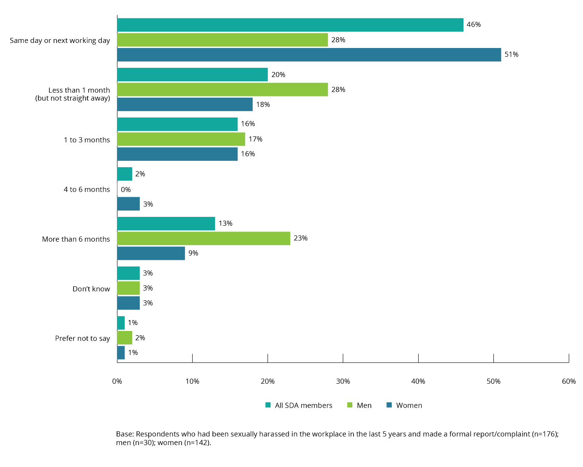

Finalised formal reports or complaints
Over half (64%) of SDA members who had made a formal report or complaint about the most recent incident of workplace sexual harassment had their formal report or complaint finalised.
Most formal reports or complaints were finalised between the SDA member who had experienced workplace sexual harassment and their direct manager or supervisor or the head of their organisation.
For both SDA members and the working population, their formal report or complaint of workplace sexual harassment was finalised with either their direct manager or supervisor (55% and 47%, respectively) or the head of the organisation (29% and 39%, respectively).
Although the overall sample size is small for both groups, results indicate that SDA members were more likely than those in the working population to have finalised their formal report or complaint with Human Resources (13% and 3%, respectively) or with the involvement of their union (15% and 9%, respectively).
Due to the small sample size for male SDA members, no gender comparison was conducted.

Figure 58: How a formal report or complaint was finalised (by gender)
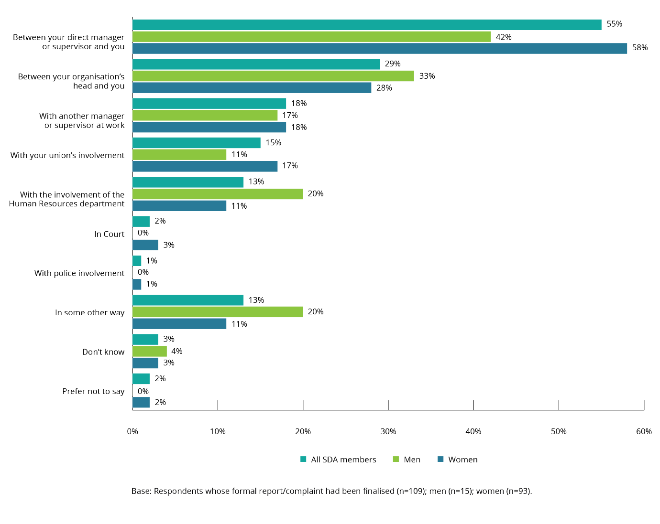
The majority of formal reports or complaints of workplace sexual harassment were finalised in less than one month after the incident.
A third (30%) of formal reports or complaints were finalised on the same day or the next working day following the incident of workplace sexual harassment, and another four in ten (44%) were finalised in the following month. All but 3% were finalised within six months.
This compares with the working population where formal reports or complaints were also finalised quickly with one third (33%) of formal reports or complaints finalised on the same day or next working day, and another third (38%) were finalised within the following month. Just 6% of formal reports or complaints took longer than six months to be finalised.

Figure 59: Time taken for a formal report or complaint to be finalised (by gender)
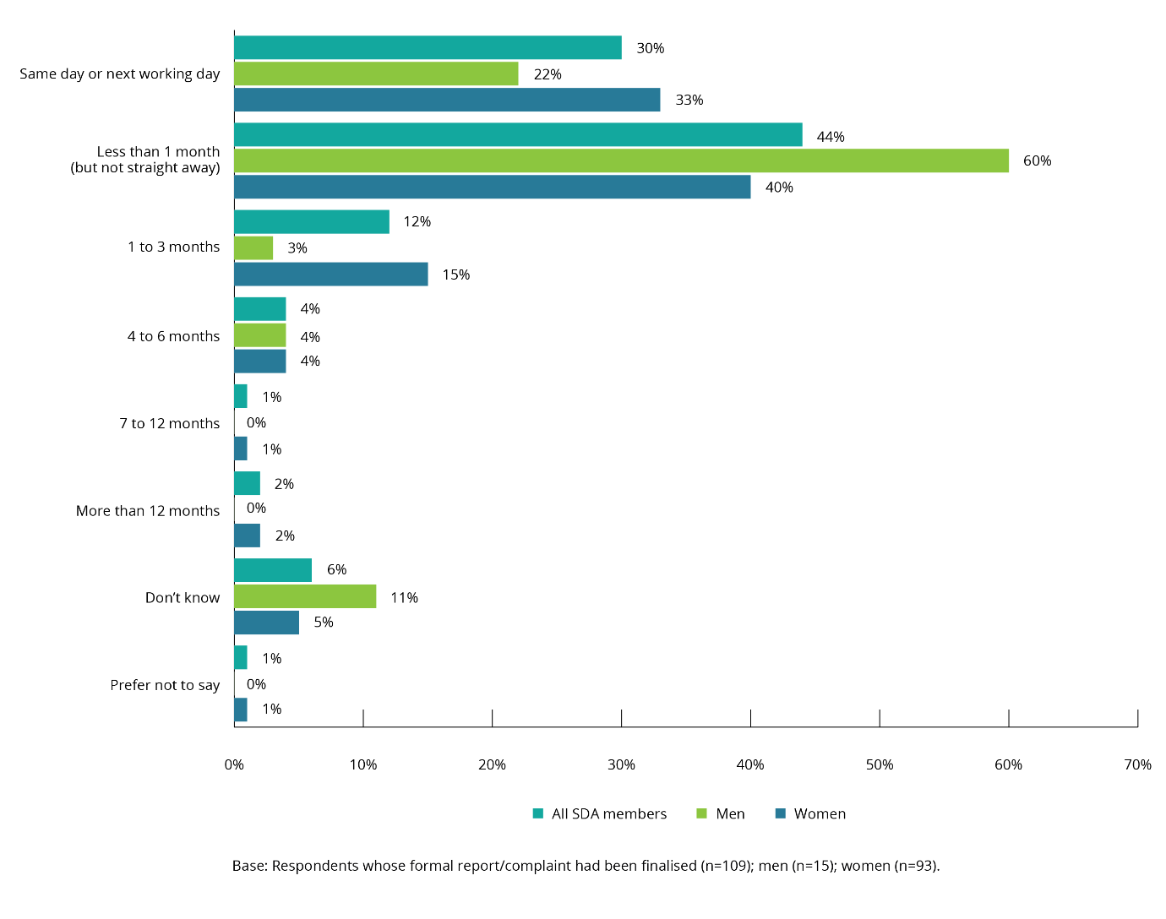

Outcome of report or complaint of workplace sexual harassment
SDA members who had made a formal report or complaint about the most recent incident of workplace sexual harassment were asked about the outcomes of their formal report or complaint in terms of:
- what happened to them
- what happened to the harasser
- any action that was taken by their workplace.
The sample size of male SDA members who made a formal report or complaint was too small to facilitate a gender-based analysis.

Outcomes for SDA members who had made a formal report or complaint
The most common outcome for SDA members who had made a formal report or complaint about their most recent experience of workplace sexual harassment was that there were no consequences—either positive or negative.
In 24% of cases, there were no consequences – either positive or negative—for SDA members who made a formal report or complaint about their most recent experience of workplace sexual harassment.
The outcomes for people who had made a formal report or complaint were more positive for the working population. When SDA members made a formal report or complaint, 20% said the workplace sexual harassment stopped, in comparison to 44% of the working population.
SDA members were also less likely than those in the working population to have received positive feedback for making a formal report or complaint (14% and 31%, respectively). Eleven per cent of SDA members and 20% of the working population received an apology from their managers.
Some SDA members reported experiencing a number of negative consequences in response to making a formal report or complaint including:
- being ostracised, victimised or ignored by colleagues (19%)
- having their shifts changed (15%)
- being labelled as a trouble-maker (15%)
- resigning (12%).

Figure 60: Outcome for SDA members who had experienced workplace sexual harassment after a formal report or complaint (by gender)
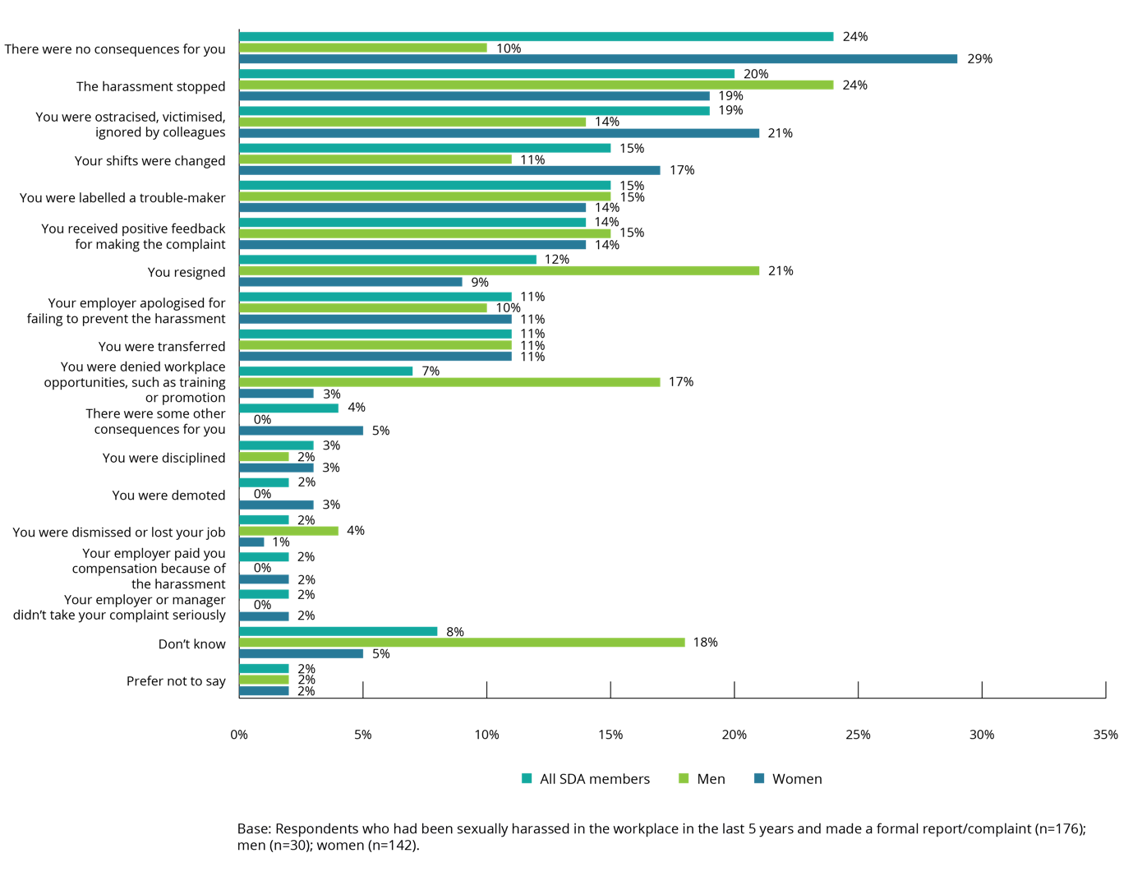

Outcomes for harassers
In more than a quarter of cases, there were no consequences for the harasser as a result of a formal report or complaint being made.
Twenty-eight per cent of SDA members who made a formal report or complaint of workplace sexual harassment said that there were no consequences for the harasser. In comparison, 19% of the working population who had made a formal report or complaint said there were no consequences for the harasser.
Those who harassed SDA members were less likely to be the subject of formal action than harassers within the working population.
These differences between the experiences of SDA members and the working population are reflected in the data regarding the type of action that was taken after a formal report or a complaint of workplace sexual harassment was made.
In the case of SDA members who experienced workplace sexual harassment, 20% of harassers were formally warned, compared to 30% for the working population. The harasser was more than twice as likely to be disciplined in the working population than the SDA workplace (22% and 9%, respectively). The harasser was also less likely to be transferred when the person who had experienced workplace sexual harassment was a SDA member (5% of cases) than a person in the working population (12% of cases).
The likelihood that the harasser would apologise to a SDA member was relatively low, with only 6% of harassers apologising for their behaviour. In contrast, 23% of harassers in the working population apologised for their behaviour.
In 7% of cases the person who had harassed a SDA member resigned. This is similar to the working population where the harasser resigning was the outcome in 11% of cases.
Seven per cent of SDA members who experienced workplace sexual harassment indicated that the harasser’s shifts were changed. In the working population, this was the outcome for 11% of harassers.

Figure 61: Outcome for harasser after a formal report or complaint (by gender of SDA members who had experienced workplace sexual harassment)
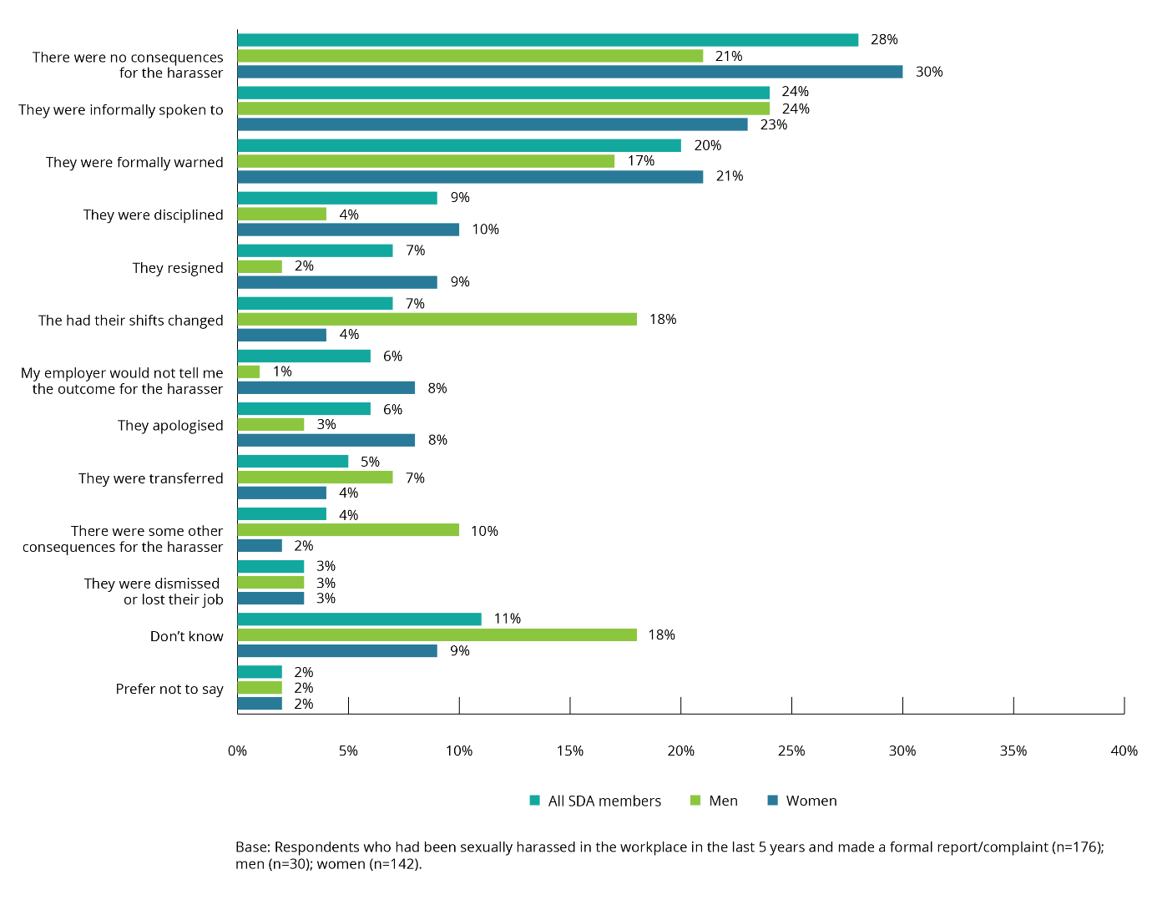

Outcomes in the organisation
In over half of cases where a formal report or complaint of sexual harassment was made there were no changes at the workplace as a result.
Workplace changes following a formal report or complaint about workplace sexual harassment were less likely at places where SDA members worked, than at the workplaces of the working population.

In 61% of cases where a formal report or complaint of workplace sexual harassment was made by a SDA member nothing changed at the workplace level following the complaint. In comparison, in the working population there was no change at the organisation level in 45% of cases.
Over a quarter (26%) of SDA members who made a formal report or complaint of workplace sexual harassment indicated that they did not know what had happened at their organisation following the formal report or complaint, in comparison to 12% for the working population.
The implementation of training or education as a result of a formal report or complaint of workplace sexual harassment was a positive organisational outcome for SDA members (7%) and the working population (22%).
Figure 62: Changes at organisation following a formal report or complaint (by gender)
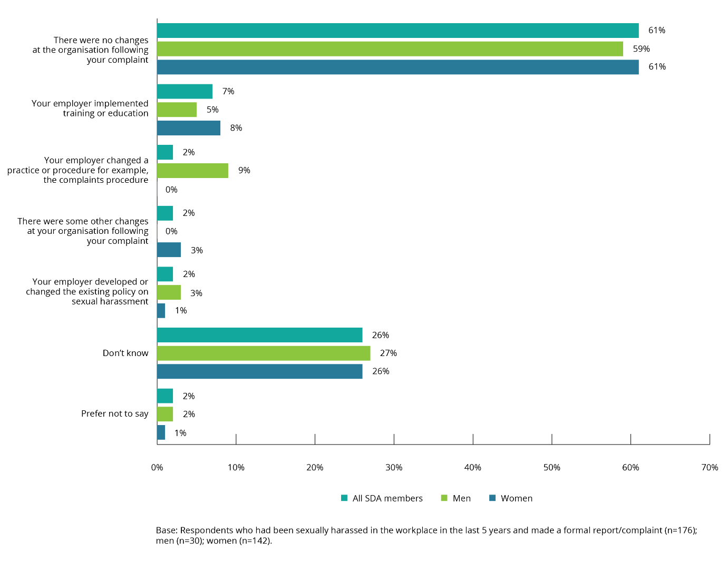

Satisfaction with formal report and complaint process
SDA members who made a formal report or complaint of workplace sexual harassment were asked to rate their satisfaction with the formal report and complaint process from 1 to 5, with 1 being ‘not at all satisfied’ and 5 being ‘extremely satisfied’.
Overall, SDA members were less likely than those in the working population to be satisfied with the formal report and complaints process. Twenty-three per cent of SDA members who made a formal report or complaint of workplace sexual harassment, were extremely satisfied with the process of dealing with the complaint, compared to 35% for the working population.
The mean satisfaction score for SDA members was 3.1. There were no statistically significant differences between male SDA members and female SDA members in any of the ratings provided.
Figure 63: Satisfaction with formal report or complaint process (by gender)
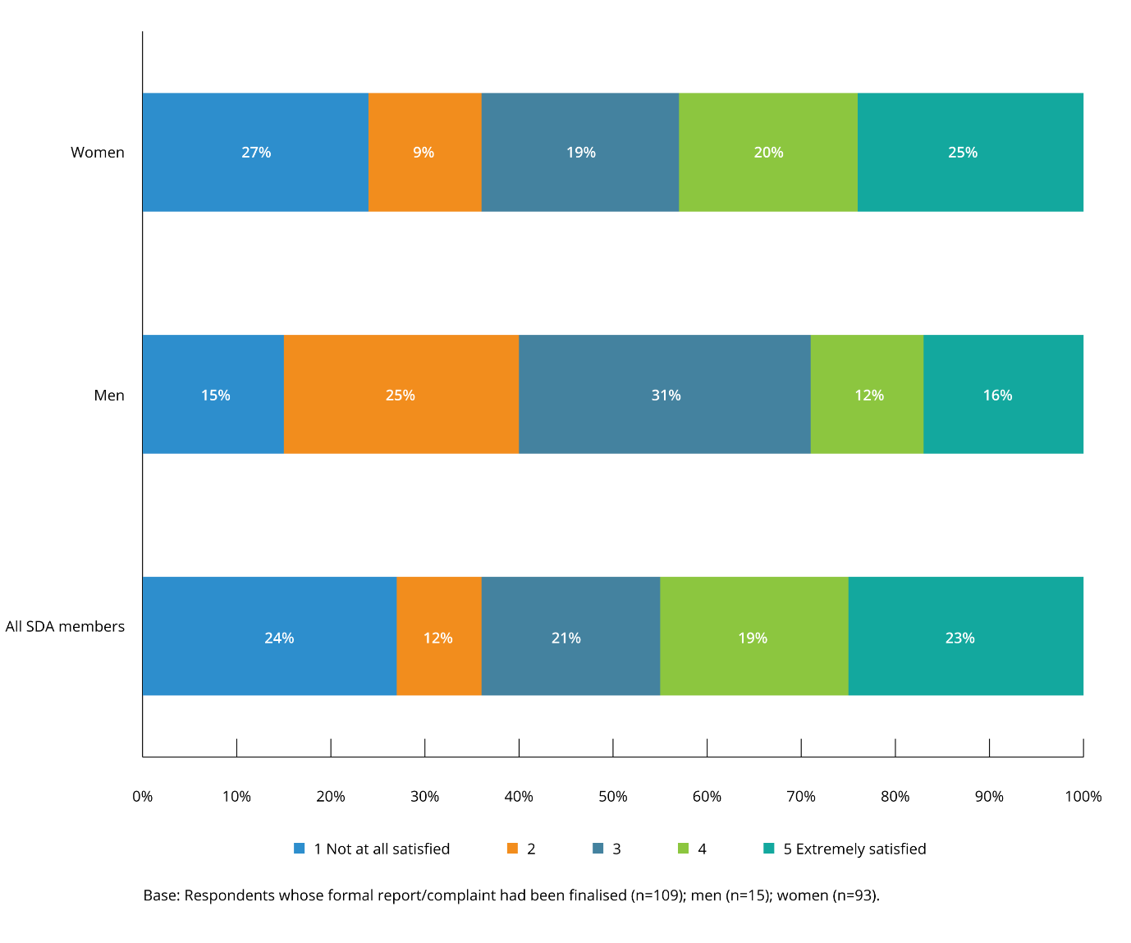

Reasons for not making a formal report or complaint of workplace sexual harassment
SDA members who had not made a formal report or complaint about the most recent incident of workplace sexual harassment were asked about the reasons for their decision.
The most common reason for not making a formal report or complaint of workplace sexual harassment was that SDA members thought other people would think they were overreacting.
SDA members identified the following reasons as the common reasons for not reporting workplace sexual harassment:
- people thinking that they were overreacting (48%)
- it was easier to keep quiet (41%)
- they thought it would not change things or that nothing would be done (40%)
- they did not think the incident was serious enough (28%).
There are differences between the reasons male and female SDA members did not report their harassment:
- female SDA members were more likely to say that they had not reported the workplace sexual harassment because they did not think reporting would change things or that nothing would be done (42% compared to 34% of male SDA members)
- male SDA members were more likely to say they had not reported because:
- the complaint process was embarrassing or difficult (30% compared to 23% of female SDA members)
- they thought they would not be believed (18% compared to 11% of female SDA members)
- they thought they would be blamed (13% compared to 8% of female SDA members)
- their career would be damaged (13% compared to 7% of female SDA members).

Figure 64: Reasons for not making a formal report or complaint of workplace sexual harassment (by gender)
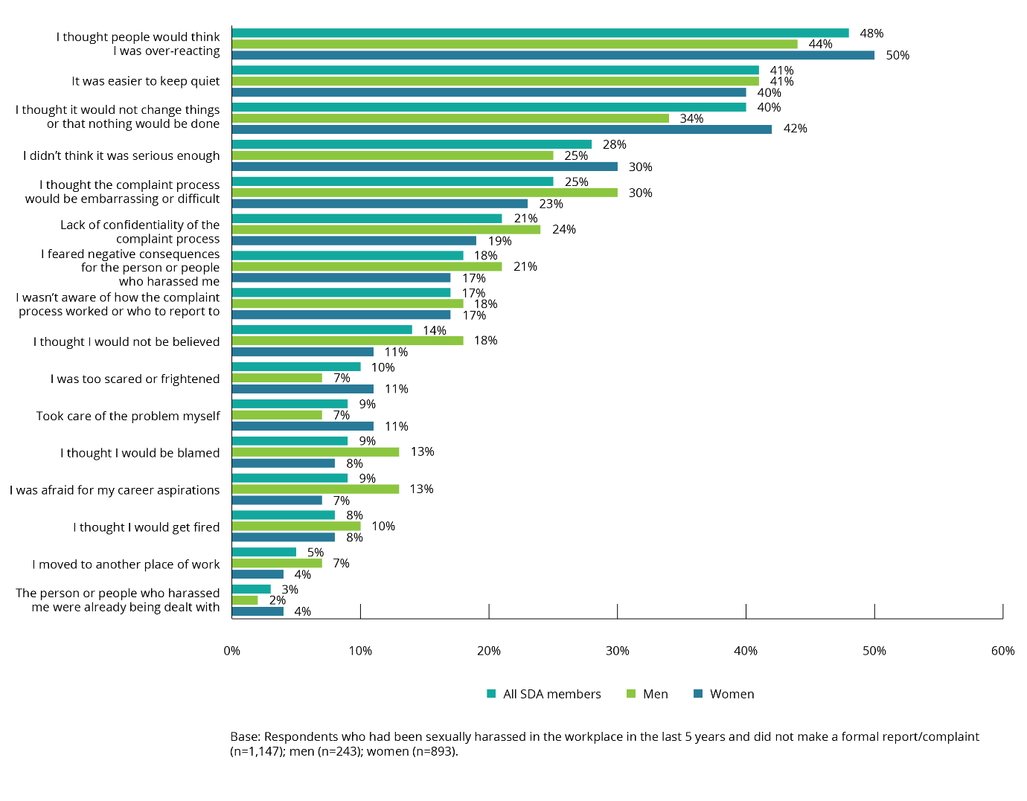
These responses are consistent with the responses for the working population, with half of people (49%) not making a formal report or complaint because they thought other people would think they were overreacting.
Another common reason SDA members provided for not reporting workplace sexual harassment was that they did not think it was serious enough.
Those who provided this answer were asked why they felt this way.
The most common response was that it was commonplace or an accepted part of their job or industry (19%). Although the sample sizes for male SDA members was small, the results suggest that female SDA members (23%) were more likely than their male colleagues (7%) to provide this reason. In contrast, male SDA members (33%) were more likely to say that the reason was that the incident was minor or not important.
Figure 65: Reasons for view that workplace sexual harassment was not serious enough to make a formal report or complain about (by gender)
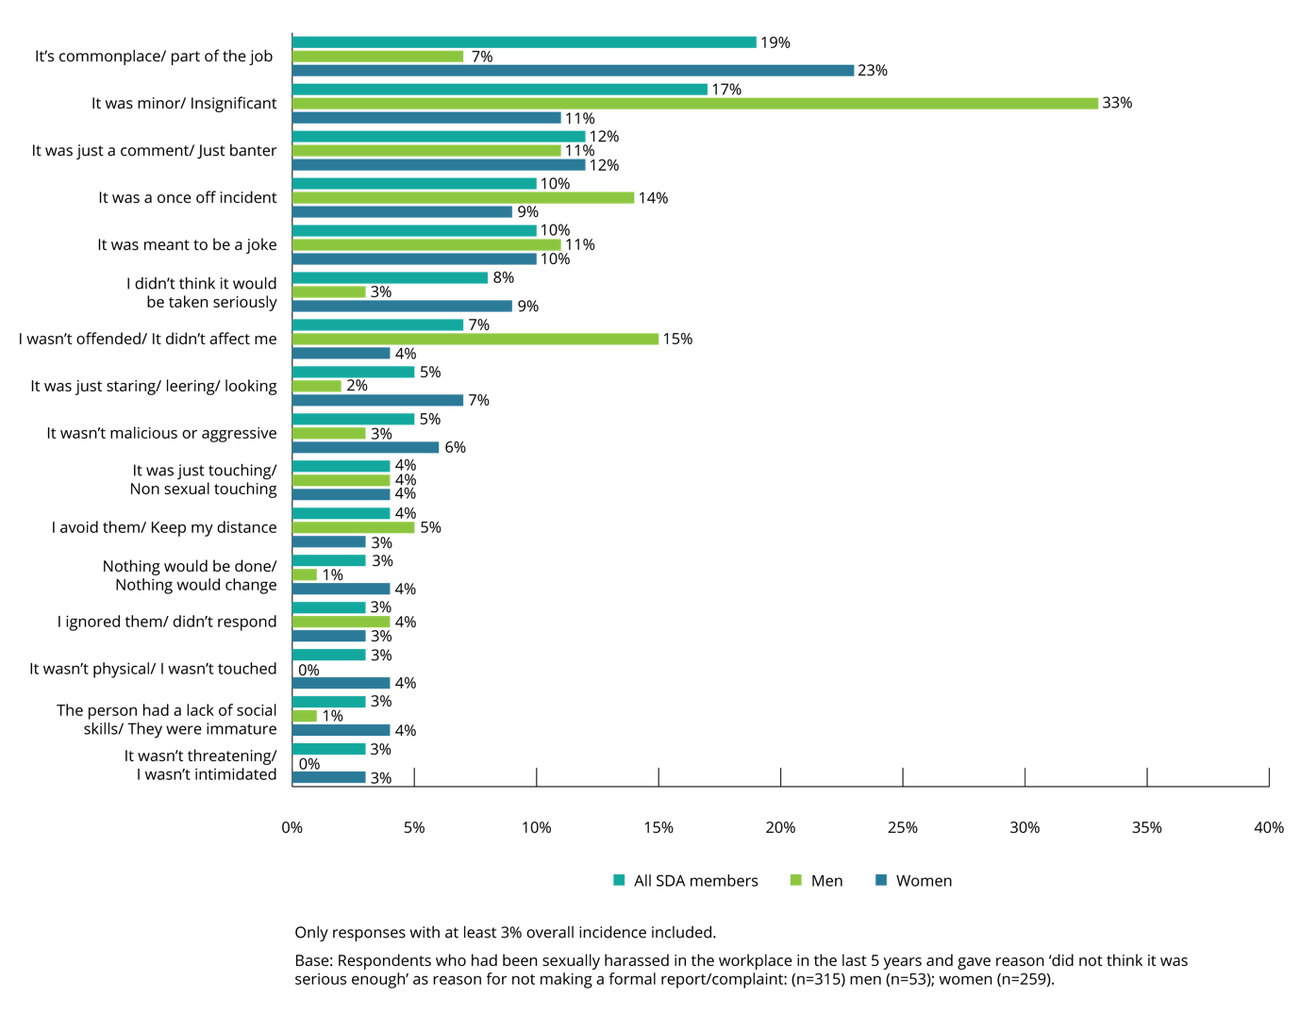
When the reasons for not reporting are analysed in relation to the nature of the workplace sexual harassment in the most recent incident a number of statistically significant differences can be noted.
SDA members whose most recent experience of workplace sexual harassment involved unwelcome touching, hugging, cornering or kissing were less likely (20%, compared to 28% overall) to say that they had not made a formal report or complaint because the incident was not serious enough.
SDA members whose most recent experience had been sexually suggestive comments or jokes were relatively more likely (25%, compared to 18% overall) to say that they feared negative consequences from the harasser, while only 13% of those whose most recent experience had been inappropriate staring or leering said this was a reason why they had not lodged a formal report or complaint.
One in ten SDA members indicated that they were too scared or frightened to make a complaint. However, this reason was more common amongst SDA members whose most recent experience had been inappropriate staring or leering (15%) and less common among those whose most recent experience had been unwelcome touching, hugging, cornering or kissing (6%) or being followed or watched (5%).
The majority of SDA members who said they ‘took care of the matter themselves’ did this by confronting the harasser at the time of the incident.
SDA members who said that they did not report the most recent incident of workplace sexual harassment because they had taken care of it themselves were asked to describe what action they had taken.
The most common responses were:
- I confronted them and told them off (68%)
- I avoid them/don’t have contact with them anymore (19%).
Due to the small sample size of male SDA members it was not possible to examine gender-based differences in reasons.

Figure 66: Actions taken by SDA members who took care of the matter themselves rather than make a formal report or complaint (by gender)
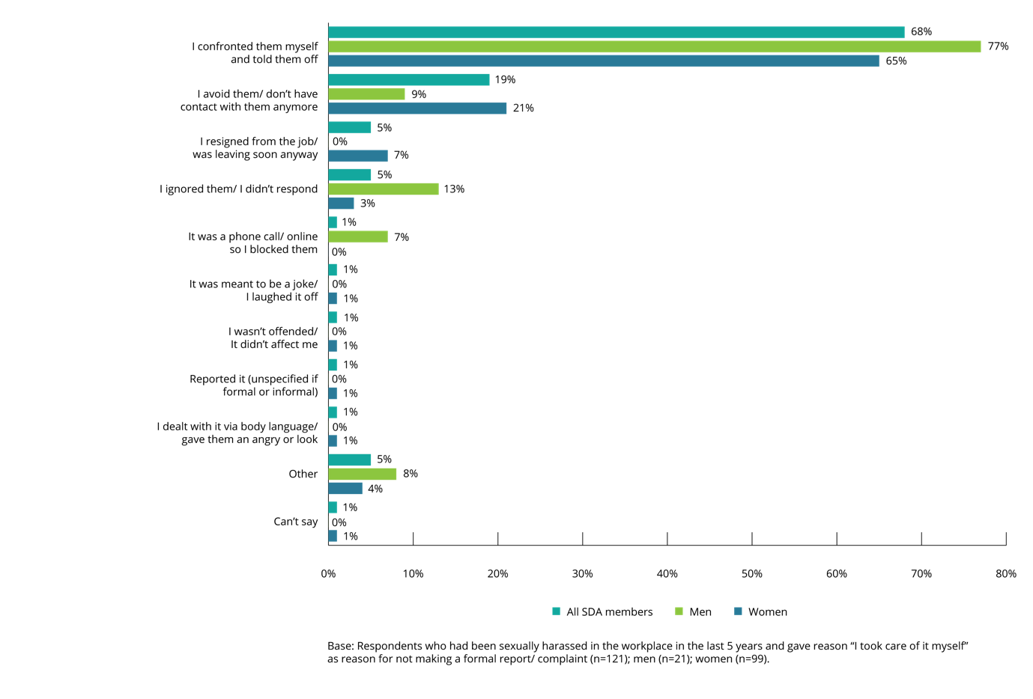

Seeking support and advice
SDA members who had been sexually harassed in the workplace in the last five years were asked whether they had sought support or advice in relation to the most recent incident, and who they had sought support or advice from.

When support or advice is sought
Only one in eight SDA members had sought support or advice in relation to the most recent incident of workplace sexual harassment.
Overall, SDA members (13%) were less likely than those in the working population (18%) to seek support or advice in relation to the most recent incident of workplace sexual harassment.
Female SDA members (16%) were twice as likely to seek support or advice as male SDA members (8%). This is in comparison to the working population, where females (20%) and males (17%) sought support or advice at similar rates.
Figure 67: Sought support or advice following workplace sexual harassment (by gender and age)
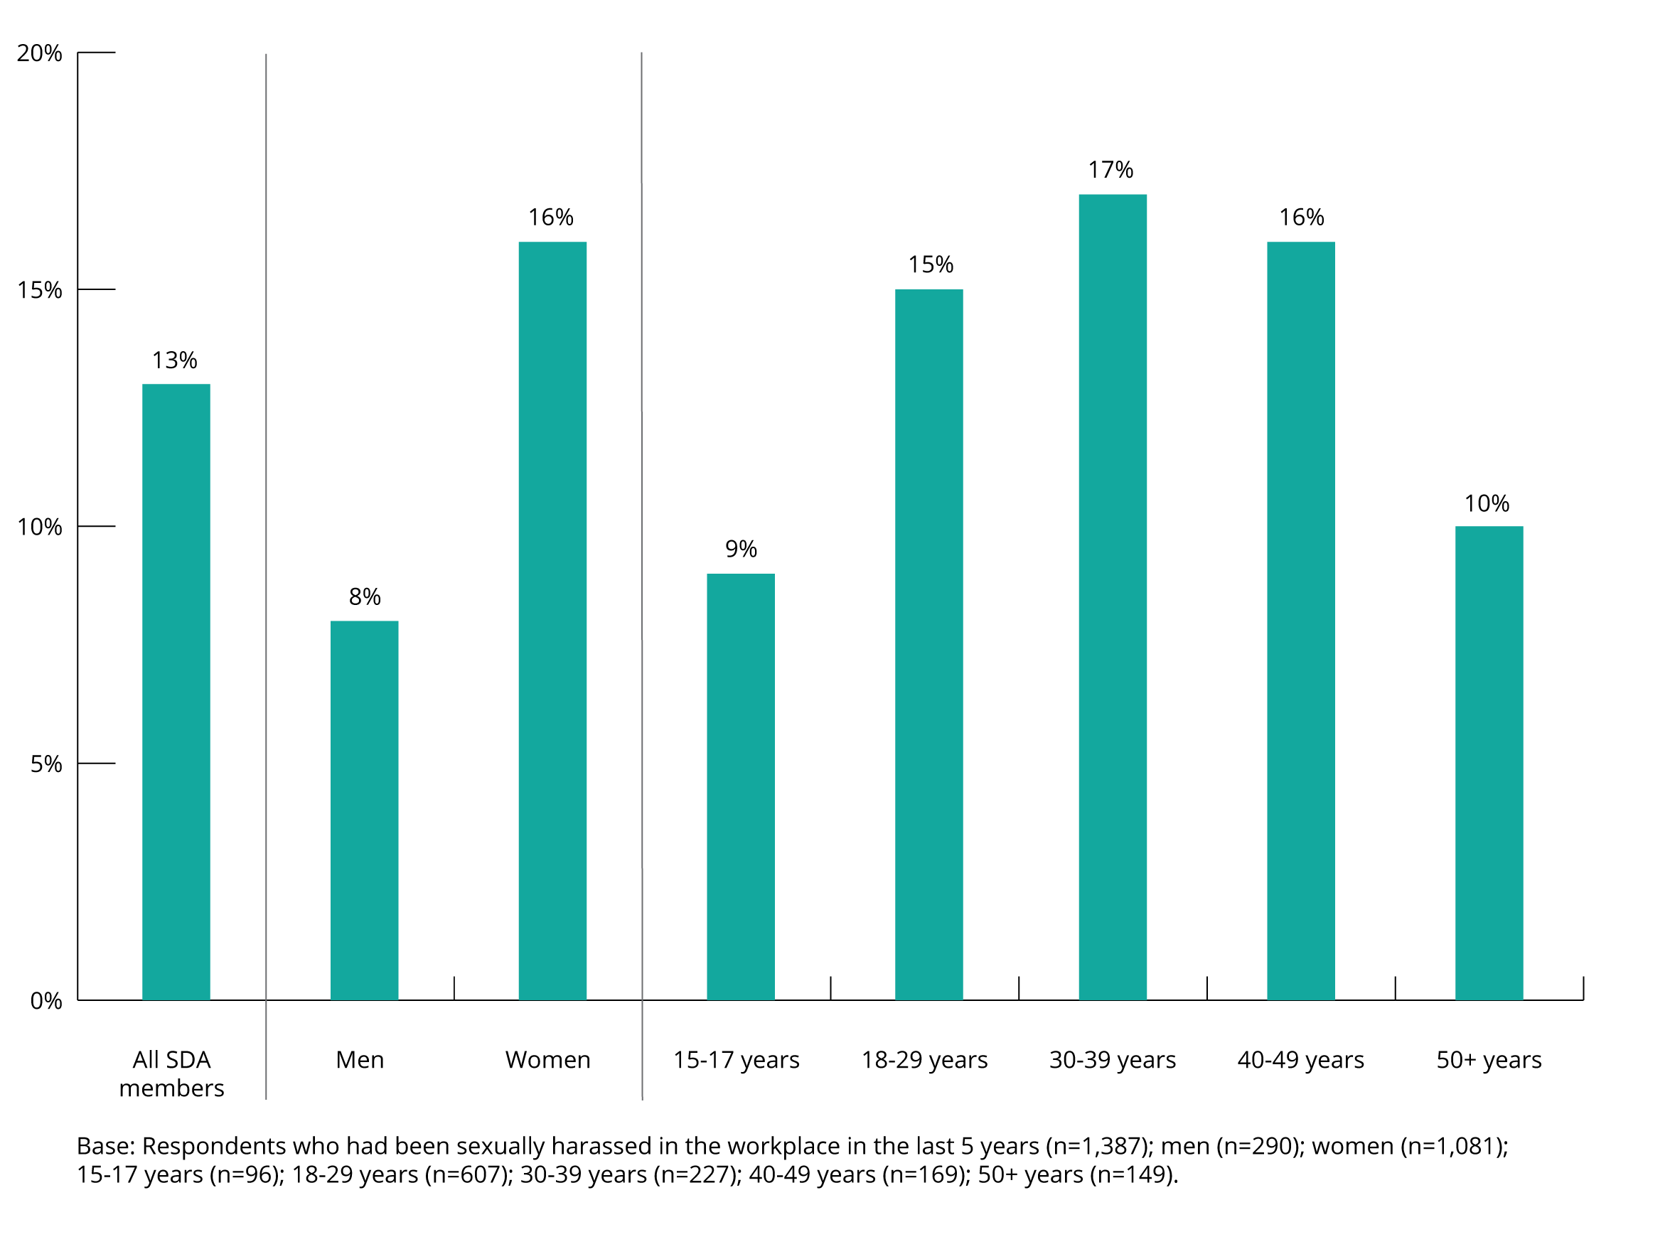
SDA members were less likely to seek support or advice for the most often experienced types of workplace sexual harassment behaviours. This pattern was also seen in relation to formal reporting and complaints (see section 6.1(a)).
Sexually suggestive comments or jokes that made a person feel offended represented 26% of incidents, but SDA members only sought support in 13% of cases.
Similarly, intrusive questions about private lives or physical appearances which made a person feel offended represented 21% of incidents, but support was only sought in 11% of cases.
In contrast, repeated or inappropriate invitations to go out on dates represented only 4% of incidents but support or advice was sought in 16% of cases. The same pattern was present in relation to:
- being followed watched or someone loitering nearby (6% of incidents, support or advice sought in 17% of cases)
- inappropriate physical contact (7% of incidents, support or advice sought in 12% of cases).
Figure 68: Workplace sexual harassment behaviours experienced vs behaviours for which support was sought
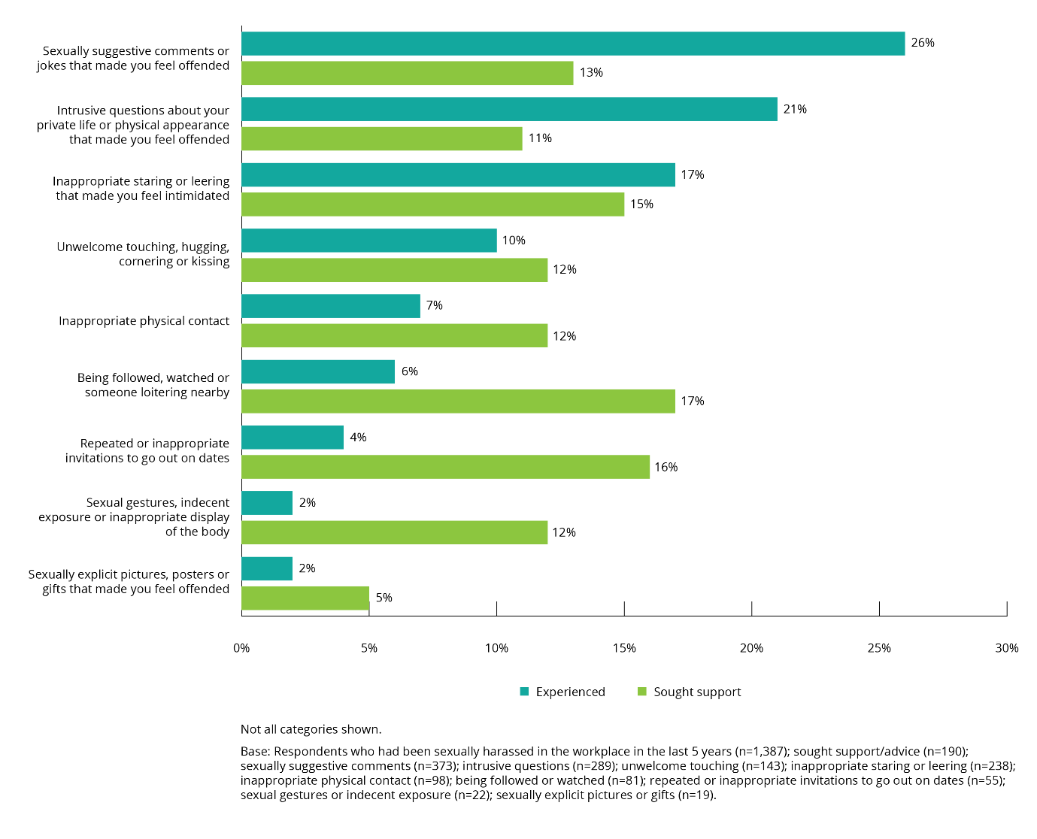

Sources of support or advice
People who had sought support or advice were most likely to have sought this from friends or family.
Overall, SDA members and the working population sought support or advice from similar sources.
Both SDA members (65%) and the working population (61%) were most likely to seek support or advice from friends or family.
SDA members (40%) were slightly more likely than those in the working population (31%) to consult a co-worker or peer at the same level.
SDA members (35%) were more likely than those in the working population (22%) to seek support or advice from a direct manager or supervisor.
One in ten (9%) SDA members had sought support or advice from their union or employee representative compared to 7% of people in the working population.
Due to the small sample size for male SDA members who had sought support or advice, it was not possible to conduct gender-based comparisons.
Figure 69: Individuals and organisations approached for support or advice by SDA members who had experienced workplace sexual harassment
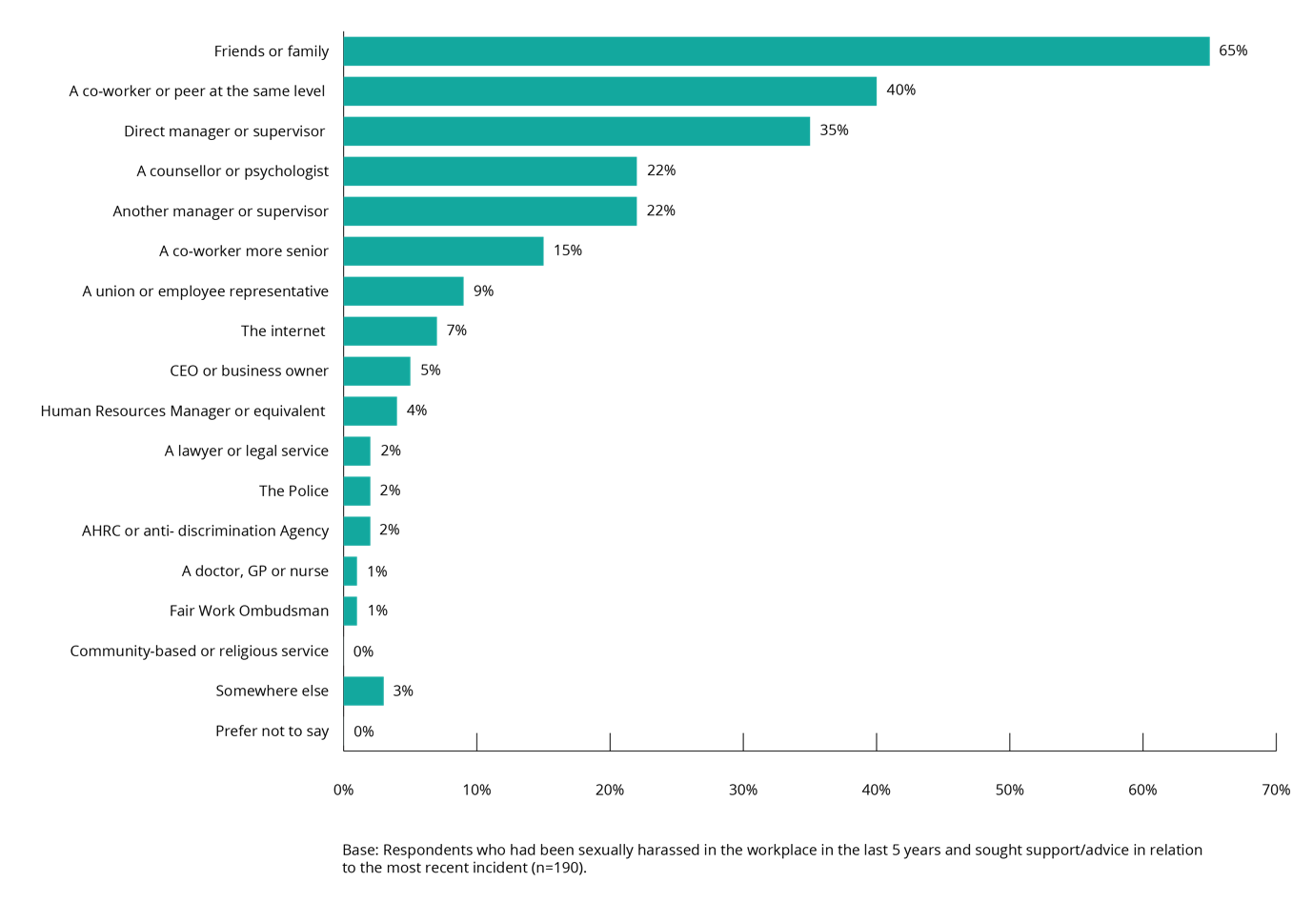

Reasons for not reporting, making a complaint, or seeking support or advice
The data in relation to making a formal report or complaint, and seeking support or advice, was examined holistically to better understand the relationship between these responses.
Most SDA members who said they had experienced workplace sexual harassment did not make a formal report or complaint, or seek support or advice in relation to their experience.
Overall, 71% of SDA members and 70% of the working population who had experienced workplace sexual harassment did not make a formal report or complaint about their most recent incident, or seek support or advice. Male SDA members (77%) were more likely to have not taken any action than female SDA members (69%).
The most common reasons SDA members provided for not reporting, making a complaint or seeking support or advice were:
- thinking that others would think they were overreacting (47%)
- thinking these actions would not change anything or that nothing would be done (41%)
- feeling that it was easier to keep quiet (40%).
Although for many of the listed reasons there was no significant difference between the responses provided by female SDA members and male SDA members, female SDA members (42%) were more likely than male SDA members (35%) to say that they did not report, complain or seek support or advice because it would not change anything or nothing would be done, or that they were frightened (11% of female SDA members, 7% of male SDA members).
In contrast, male SDA members were more likely to say that they thought the reporting and complaint process would be embarrassing or difficult (28%, compared to 20% of female SDA members), that they thought they would not be believed (19%, compared to 12% of female SDA members or they would be blamed (13% compared to 8% of female SDA members).
One in ten (10%) SDA members sought support or advice despite not making a formal report or complaint. Female SDA members (12%) were more likely than male SDA members (5%) to have taken this action. Similarly, 9% of SDA members made a formal report or complaint about the most recent incident of workplace sexual harassment but did not seek any support or advice. Female SDA members (10%) and male SDA members (8%) took this action at similar rates.

Seeking information about workplace sexual harassment
SDA members who had been in the workforce in the last five years were asked to nominate the sources they would use for information about sexual harassment.
The information sources most frequently nominated were:
- direct manager or supervisor at work (45%)
- friends and family (44%).
There was no significant difference in the responses provided by female and male SDA members for these sources.
Forty per cent of SDA members said they would use the internet, with male SDA members (45%) more likely than female SDA members (37%) to nominate this information source. A similar proportion (36%) said they would seek information from their union or employee representative with female SDA members (38%) more likely than male SDA members (34%) to do so.
Male SDA members were more likely than female SDA members to nominate the Human Resources Manager or equivalent as a likely information source (30% and 19%, respectively).
When information sources were analysed based on whether SDA members had experienced workplace sexual harassment, only one source (the internet) was more likely to have been nominated by those who had experienced workplace sexual harassment (46%) compared to those who had not (37%).
SDA members (36%) were more likely than the working population (24%) to seek information from their union or employee representative.

Figure 70: Sources SDA members used for information about workplace sexual harassment (by gender)
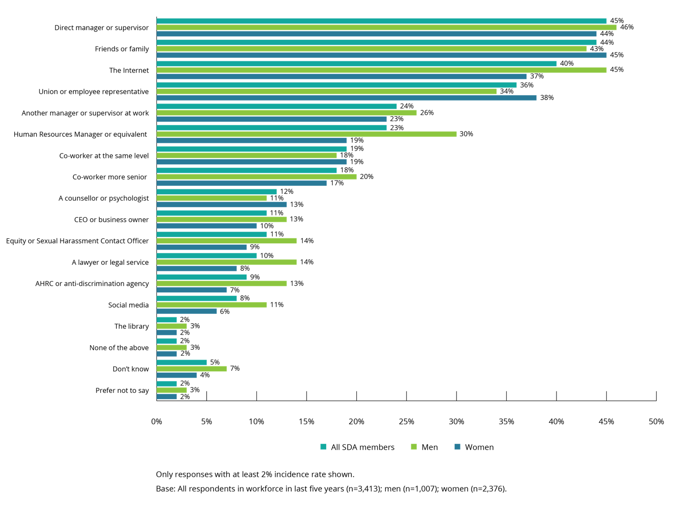

‘I have experienced this issue mostly from male customers. It is difficult to be assertive at work because I am supposed to be friendly and amenable to customers. I have read on social media that this is then misinterpreted as 'interest' and I agree. I wish there was a culture in my workplace/culture that supported women whom feel harassed this way at work. It unfortunately would be easier for me if someone else such as a manager were to step in and say 'this is not okay' because I feel very awkward saying it. It is like having two jobs trying to avoid particular customers. I have spoken to other men whom I work with about it to at least garner some understanding of why men think it is okay to make repeated sexual comments to retail assistants, and so someone else is aware it makes me uncomfortable in case I need help. The best option for me is to ask someone to call me out the back of the store if they see particular customers near me, which was my main incentive to let a manager and co-worker of mine know what was going on.’

Bystanders—witnessing and hearing about workplace sexual harassment

Chapter summary
This chapter examines the experience of SDA members who were bystanders to (witnessed or heard about) workplace sexual harassment.
More than one third of SDA members and the working population, said that they had been bystanders to workplace sexual harassment in the last five years (35% and 37%, respectively). Men were as likely as women to have been bystanders to workplace sexual harassment (15% and 13%, respectively).
Most SDA members (52%) who said they had experienced workplace sexual harassment in the last five years had also witnessed or heard it in their current workplace.
The majority of SDA members who were bystanders to workplace sexual harassment did not take any action in response. Only one in three (35%) SDA members who witnessed or heard about workplace sexual harassment in the last five years took any action in relation to the most recent incident they had witnessed or heard.
The most common form of action taken by SDA members who were bystanders was to talk with or listen to the person who had experienced it (74%).
The second most common form of action taken by SDA members was to report the incident to their employer (55%). This action was more common within the SDA than the working population (47%).
For a large proportion of SDA members who were bystanders (42%) there were no consequences as a result of taking action, although some were either labelled a trouble-maker (8%) or ostracised, victimised or ignored (7%) by their colleagues as a result.
The experience of bystanders who took action in the working population was different, with the most common consequence of their action being an end to the sexual harassment (45%).
Where SDA members indicated that they did not take any action in response to witnessing or hearing about workplace sexual harassment, the most common reason provided was that others were supporting or assisting the person who had experienced this behaviour (31%). This reason was provided more often by those in the working population (41%).

Prevalence of bystander experience
More than one third of SDA members indicated that they had witnessed or heard about workplace sexual harassment in their workplace in the last five years.
Thirty-five per cent of SDA members had been a bystander to the sexual harassment of another person in their workplace in the last five years.
Figure 71: Bystander exposure to sexual harassment of others in the workplace (by gender)
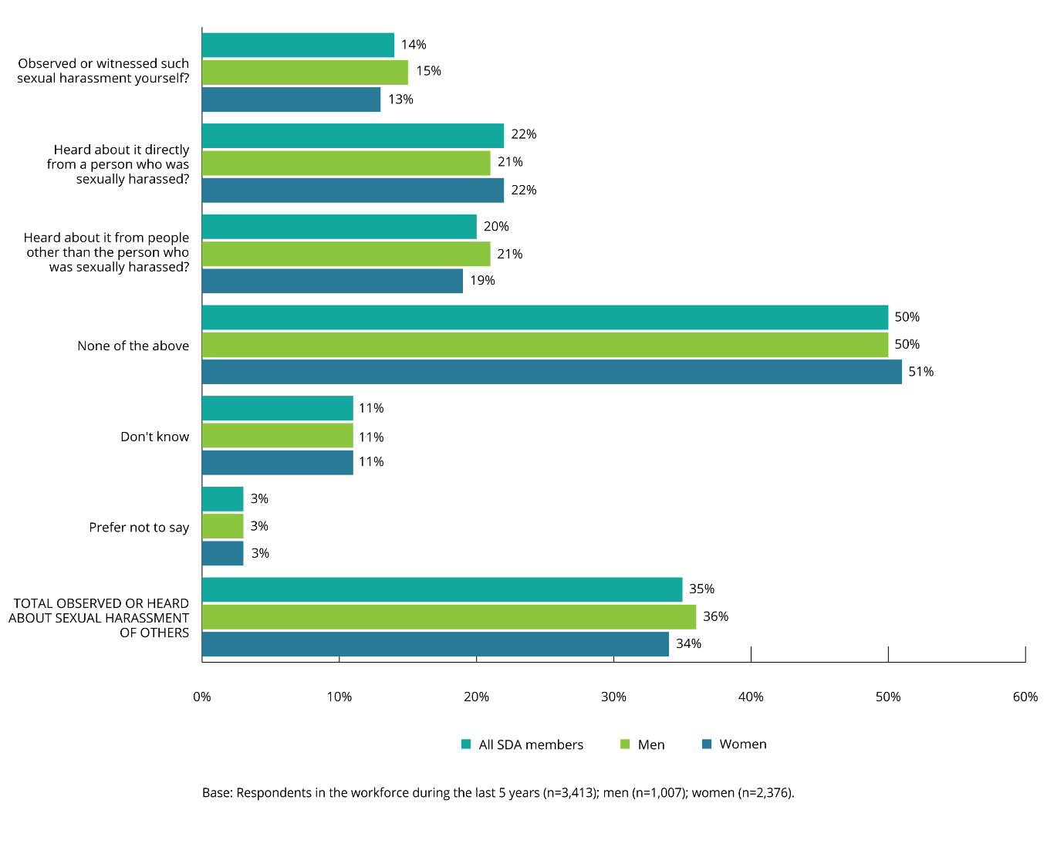
SDA members aged 18–29 years old (41%) were more likely to have been a bystander to workplace sexual harassment than those in any other age group.
SDA members working in the fast food sector (45%) or in some ‘other’ SDA sector (48%) were more likely to have been a bystander to workplace sexual harassment than those working in the retail (33%) or warehousing (35%) sectors.
The likelihood of a SDA member being a bystander to workplace sexual harassment was similar to that of the working population.
More than a third (37%) of the working population had either witnessed or heard about the sexual harassment of another person in their workplace, while 57% had not.
Overall, of SDA members who had witnessed or heard about workplace sexual harassment:
- 14% had witnessed or observed the workplace sexual harassment of another person, compared to 16% in the working population
- 22% had heard about it directly from the person who had experienced workplace sexual harassment, compared to 21% in the working population
- 20% had heard about it from a person other than the person who had experienced workplace sexual harassment, compared to 21% in the working population.
Most SDA members who had experienced workplace sexual harassment had also witnessed or heard about the workplace sexual harassment of others.
Fifty-two per cent of SDA members who had been sexually harassed at work in the last five years had also been a bystander to the workplace sexual harassment of others in their current workplace. This is compared to 24% of SDA members who had not experienced sexual harassment.
Overall, of SDA members who had experienced workplace sexual harassment in the last five years:
- 25% had witnessed or observed the sexual harassment of another person in the workplace
- 36% had heard about it from the person who experienced it
- 28% had heard about it from a person other than the person who experienced it.

Action taken by bystanders
The majority of SDA members who had been a bystander to the workplace sexual harassment of another person did not take any action in response.
Only one in three (35%) SDA members who had been a bystander to the workplace sexual harassment of another person in the last five years took any action to prevent or reduce the harm of the most recent incident they had witnessed or heard about. This figure is the same for the working population (35%).
There were no statistically significant differences in relation to gender or age.
SDA members were less likely than the working population to indicate that they had not taken action after being a bystander to workplace sexual harassment (56% and 62%, respectively).
Figure 72: SDA members who were bystanders to workplace sexual harassment and took some form of action
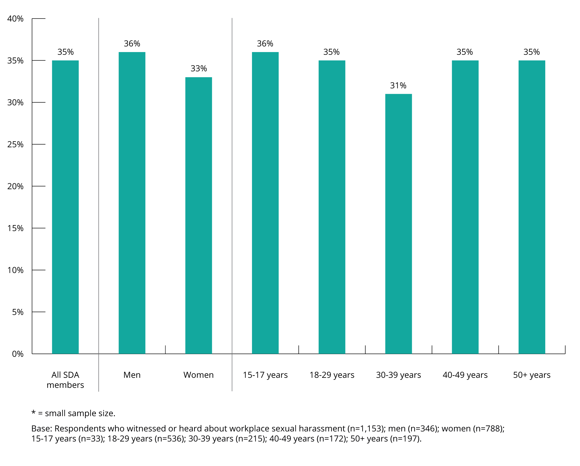
Where SDA members who were bystanders did take action, the most common action taken was to talk with or listen to the person who experienced workplace sexual harassment.
In 74% of cases where a SDA member did take action in relation to the most recent incident of workplace sexual harassment they had been a bystander to, they talked with or listened to the person who experienced it. This occurred at a similar rate in the working population (71%).
In just over half (55%) of cases, SDA members reported the behaviour they had witnessed or heard to their employer, with female SDA members (61%) more likely than male SDA members (46%) to have taken this action. This is a higher rate than the working population, where only 47% of bystanders reported the workplace sexual harassment they had witnessed or heard about to their employer.
In 53% of cases, the SDA member who witnessed or heard about the workplace sexual harassment offered advice to the person who experienced it. A similar rate of 54% was reported in the context of the working population.
In just over a quarter (27%) of cases, the SDA member who witnessed or heard about the incident spoke with the harasser, with male SDA members (43%) more likely than female SDA members (15%) to have taken this action. Those in the working population were much more likely to have spoken with the harasser (40%).

Figure 73: Actions taken by bystanders to workplace sexual harassment (by gender)
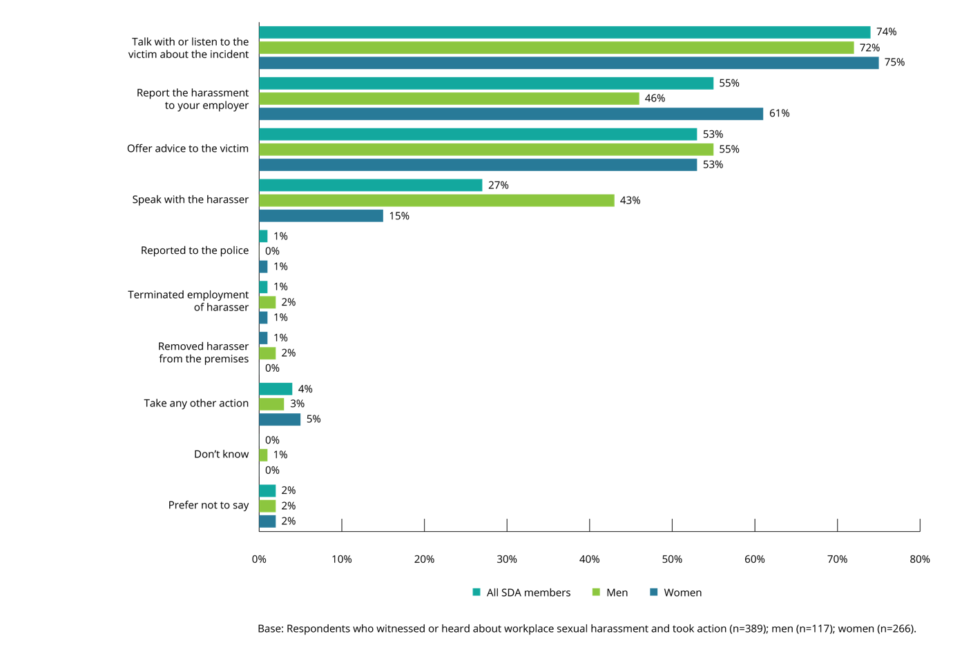

Consequences of bystanders taking action
A large proportion of SDA members who took action after witnessing or hearing about workplace sexual harassment said that there were no consequences for them.
Four in ten (42%) bystanders who took action in response to workplace sexual harassment that they had heard about or witnessed in the last five years said that there were no consequences for them, either positive or negative, as a result of their action, with female SDA members (47%) more likely than male SDA members (34%) to say this.
The consequences most often identified by bystanders who took action were:
- receiving positive feedback for making the complaint (23%), reported by 30% of male SDA members and 18% of female SDA members
- the sexual harassment stopped (22%), reported by 31% of male SDA members and 16% of female SDA members.
In 8% of cases, the SDA member who took action was labelled a troublemaker, and in 7% of cases they were ostracised, victimised or ignored by their colleagues. There were no statistically significant differences between male and female SDA members in relation to these reported consequences.
Figure 74: Consequences for bystanders who took action (by gender)
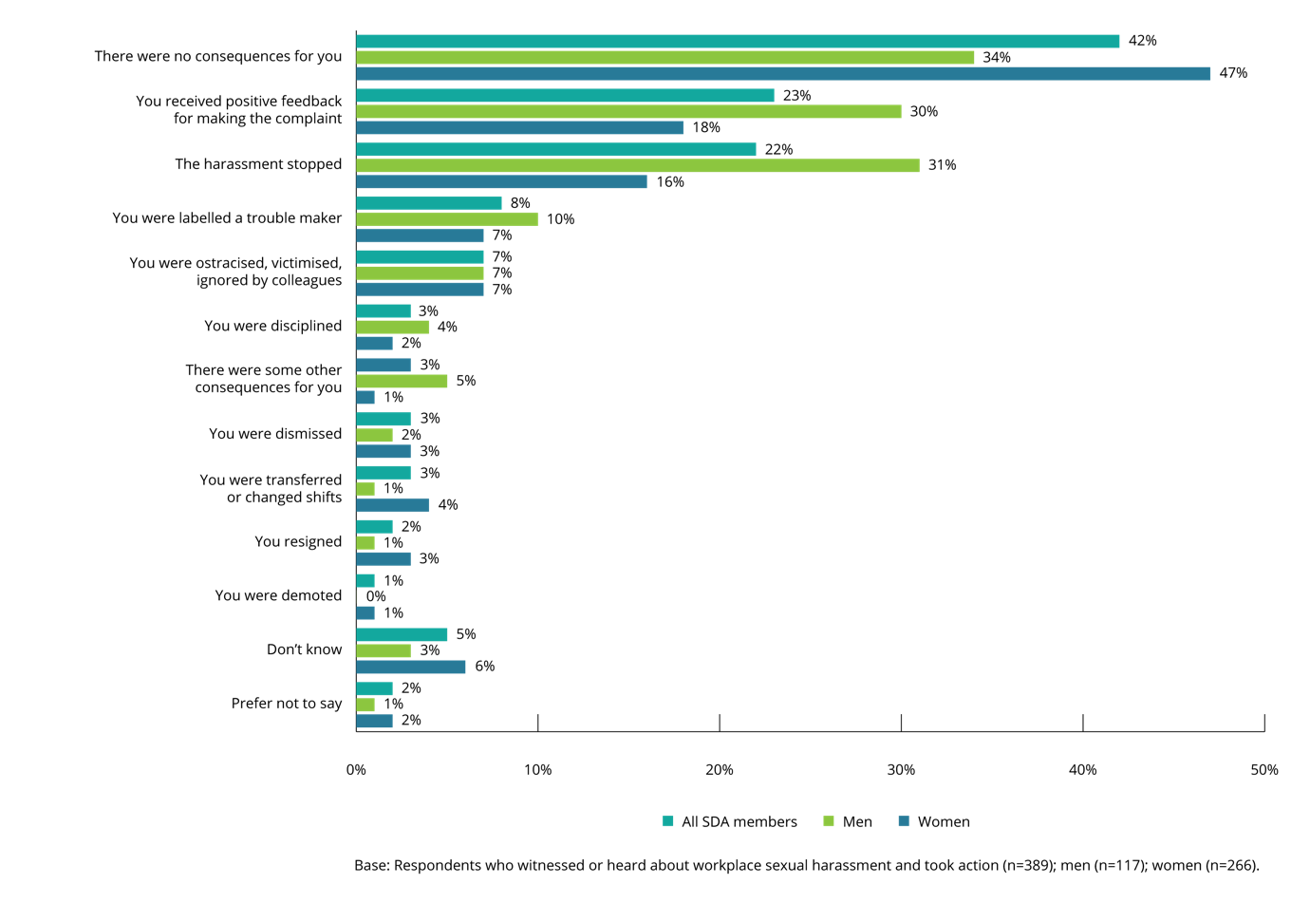
In contrast, within the working population, the most common consequence of bystander action was that the harassment stopped.
In the working population, the most commonly reported consequence of bystander action in response to workplace sexual harassment was that the harassment stopped (45%) (compared to 22% in the SDA), followed by receiving positive feedback for making a complaint (34%) (compared to 23% in the SDA).
The rates for being labelled a troublemaker (9%) and being ostracised, victimised or ignored by colleagues (10%) within the working population were similar to those reported within the SDA (8% and 7%, respectively).

Reasons bystanders did not take action
The most common reason provided by SDA members for not taking action was that other people were supporting and assisting the person who had experienced workplace sexual harassment.
One in three (31%) SDA members who witnessed or heard about workplace sexual harassment in the last five years and did not take action, indicated that this was their response because other people were supporting or assisting the person who had experienced workplace sexual harassment. Within the working population, 41% indicated that this was the reason they did not take action.
In one quarter (23%) of cases, SDA members who were bystanders did not take any action because they did not want to make things worse for the person who had experienced workplace sexual harassment. A similar proportion of the working population (25%) indicated this to be the reason why they did not take any action.
Other reasons provided included:
- not wanting to get involved (22%) (20% of female SDA members and 27% of male SDA members)
- being asked by the person who experienced workplace sexual harassment not to take any action (21%) (23% of female SDA members and 17% of male SDA members).
The working population provided similar responses, with 20% indicating they did not want to get involved and 21% responding that the person who experienced sexual harassment had asked them not to take any action.
However, those in the working population were more likely to say that the reason they had not taken action was that the harassment was not serious enough to intervene in (21% working population, 12% SDA) or that it was not their (the bystander’s) responsibility (17% working population, 10% SDA).

Figure 75: Reasons for not taking action after witnessing/hearing about workplace sexual harassment (by gender of bystander)
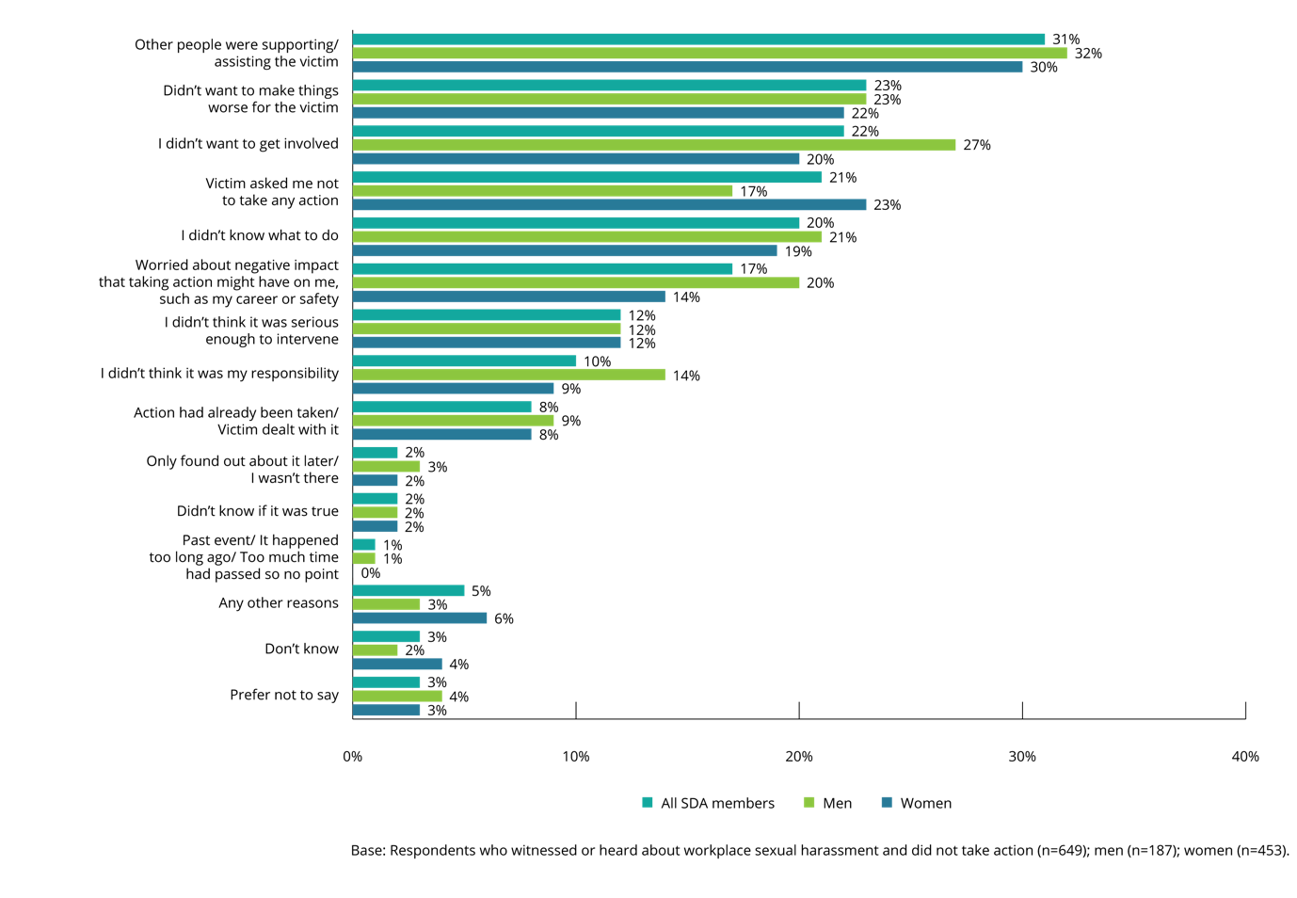

‘Procedures surrounding incidents of sexual harassment need to be clearer for employees. Also, all employees should be made to complete training, teaching what is classed as sexual harassment and that this 'It was just a joke' mentality will not be tolerated.’

Workplace policies, procedures and training
Chapter summary
This chapter provides information about the measures that workplaces have in place to prevent and address workplace sexual harassment, including policies, procedures and training. Most SDA members (59%), who had been in the workforce in the last 12 months, indicated that their current employer had either policies, procedures or training in place to prevent workplace sexual harassment. However, a third (31%) said they were not sure if there were policies, procedures or training in place.
Over three quarters (77%) of SDA members said that they had received sexual harassment prevention training at their current employer.
Those who said their current employer provided training were most likely to report that training was provided as part of an induction program for new employees (28%).
Of those who received training, this was most likely to have been delivered in the last 12 months (60%) and online (76%).
The majority of SDA members (62%) who said that their current employer had either a procedure for reporting sexual harassment, a written policy, or both, knew where to find these policies.
While only indicative, the data suggests that the proportion of SDA members who experienced workplace sexual harassment tended to be higher in workplaces where neither policies, procedures nor training were in place.

Existing measures in the workplace to address sexual harassment
SDA members who had been in the workforce in the last 12 months were asked whether their current employer had policies, procedures or training in place to prevent or address workplace sexual harassment.
Most SDA members indicated that their current employer had at least one of these measures in place.
Three in five (59%) SDA members said that their current employer had at least one of these measures in place to prevent or address workplace sexual harassment. Male SDA members (62%) were more likely than female SDA members (57%) to say this, as were members aged 30 years or older (66%, compared to 52% of those aged 18–29 years, and 45% for those aged 15–17 years). There were no significant differences between SDA sectors.
Almost half (48%) of SDA members indicated that their current workplace had a written workplace sexual harassment policy, while a third (30%) said there was training on sexual harassment in place. Only 18% of SDA members said that their workplace had one or more sexual harassment contact officers.
Only 8% of SDA members said that their current workplace did not have any sexual harassment policies, procedures or training in place.
A third of SDA members (31%) did not know whether their current workplace had any of these measures in place, with more female SDA members (34%) than male SDA members (27%) providing this response.

Figure 76: SDA members’ awareness of sexual harassment policies, procedures, and training in the workplace (by gender)
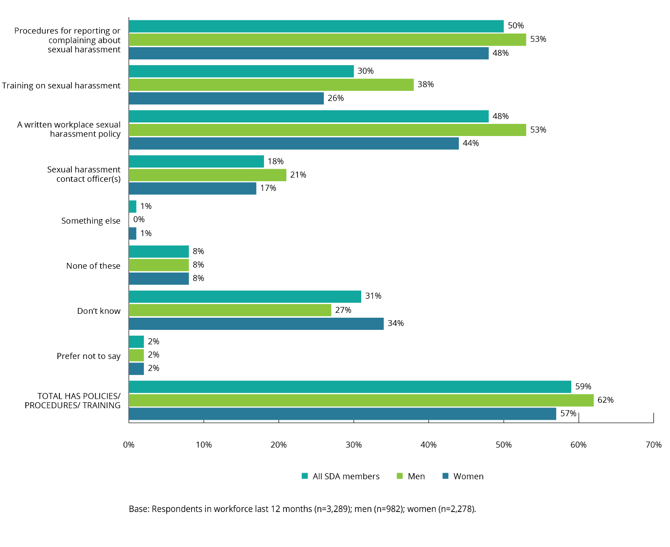

Figure 77: SDA members’ awareness of sexual harassment policies, procedures, and training in the workplace (by age)
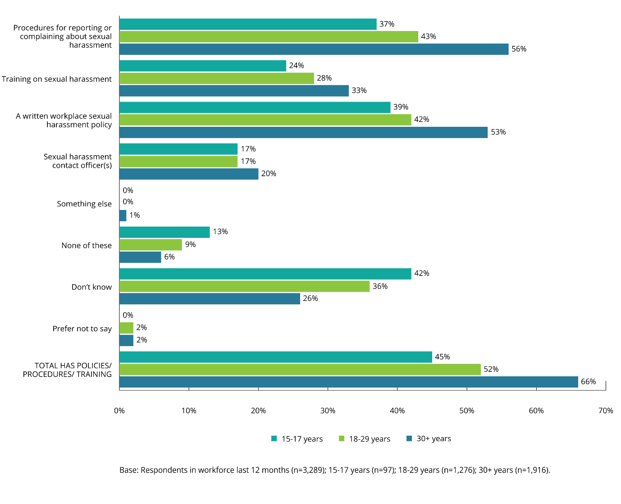

Sexual harassment prevention training
SDA members who indicated that their current employer provided sexual harassment prevention training were asked about the nature and frequency of this training.

Training at current employer
The majority of SDA members said that they had received sexual harassment prevention training while working at their current employer.
While 77% of SDA members said that they had received sexual harassment prevention training at their current employer,13% said they had not, and 10% were unsure.
There were no statistically significant differences by gender, age or SDA sector in this regard.

Frequency of training
SDA members who indicated that their current employer provided sexual harassment prevention training were asked how often the training was conducted.
The most common response was that sexual harassment prevention training was conducted as part of an induction program for new employees.
Overall, sexual harassment prevention training was provided:
- as part of an induction program for new employees (28%)
- at least once per year (21%)
- at a frequency that varies (i.e. no set time it varies) (13%)
- at least once every two years (2%).
There were no statistically significant differences by gender, age or SDA sector.

Figure 78: How often was sexual harassment prevention training conducted at your current workplace (by gender)
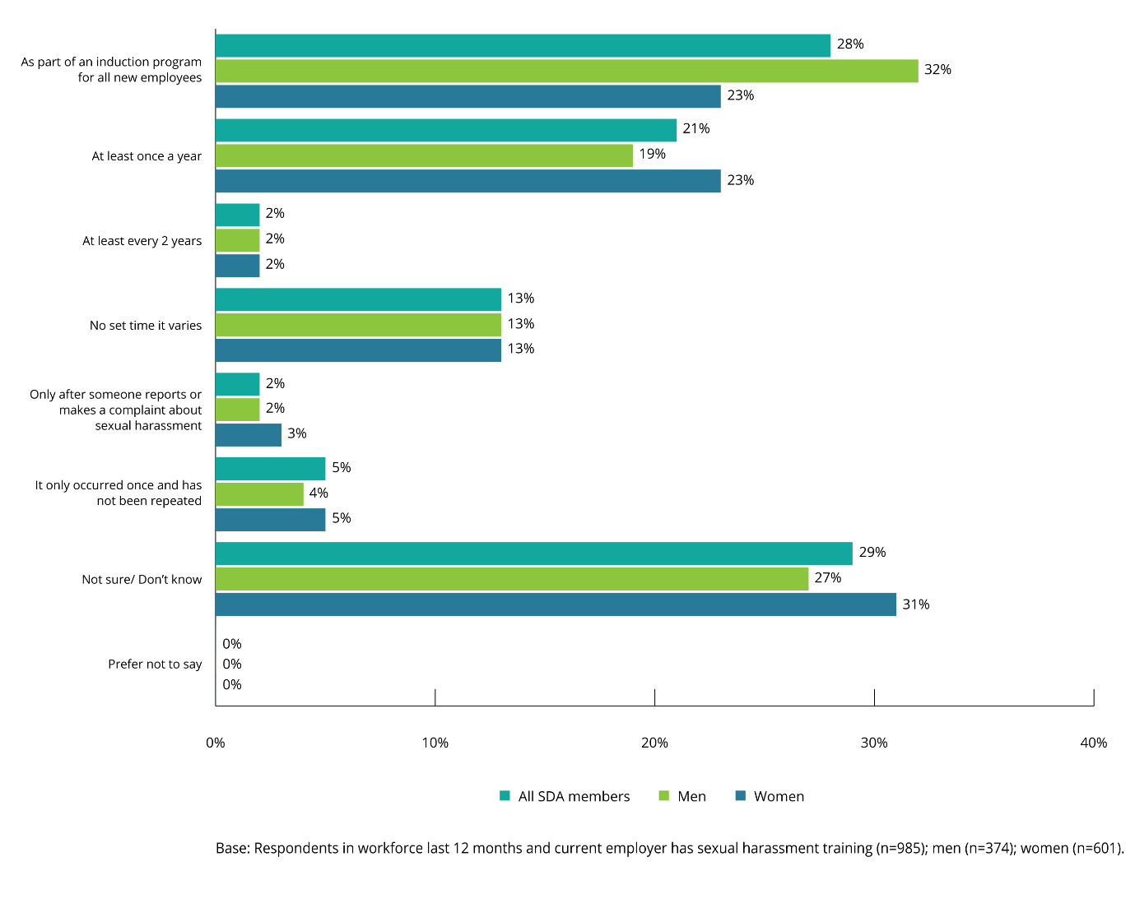

Time elapsed since most recent training
SDA members who had received sexual harassment training at their current employer were asked how long it had been since they received this training.
Most SDA members had received sexual harassment training within the last 12 months.
While 60% of SDA members had received this training within the last 12 months, one in four (25%) said it had been more than 12 months. One in seven (15%) did not know how long it had been.
There were no statistically significant differences by gender, age or SDA sector.

Figure 79: How long since sexual harassment prevention training was conducted at your current workplace (by gender)
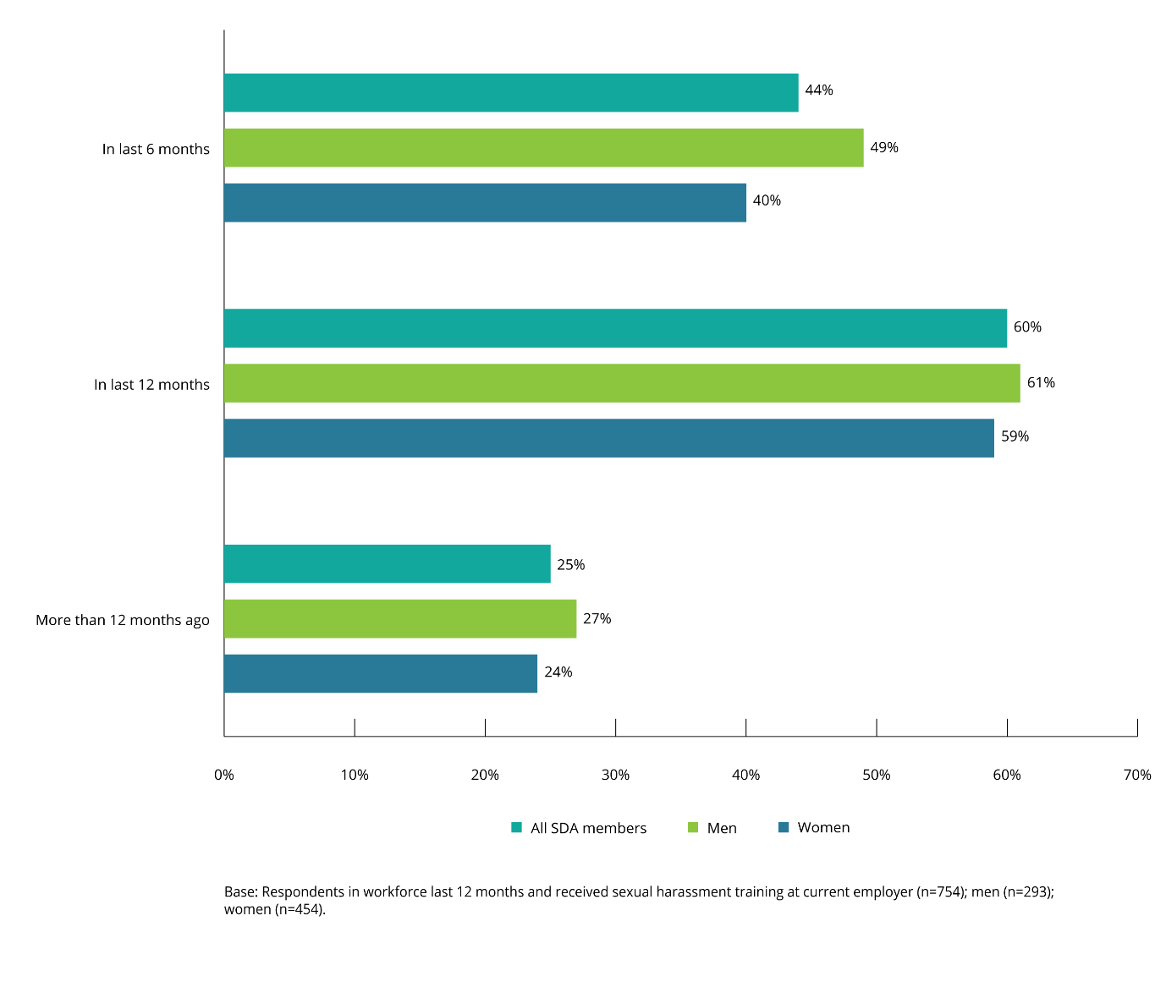

Method of training
SDA members who had received sexual harassment prevention training at their current employer were asked how the training was delivered.
The majority had engaged in online training.
Seventy-six per cent said that their last sexual harassment prevention training had involved online training.
There were no statistically significant differences by age or gender.

Of the other methods of delivery:
- 20% said that their training used written materials supplied to them
- 22% said that the training had been conducted face-to-face, by someone who worked at the organisation.
Male SDA members (27%) were more likely than female SDA members (17%) to have received face-to-face training.
Figure 80: Method of last sexual harassment prevention training at your current workplace (by gender)
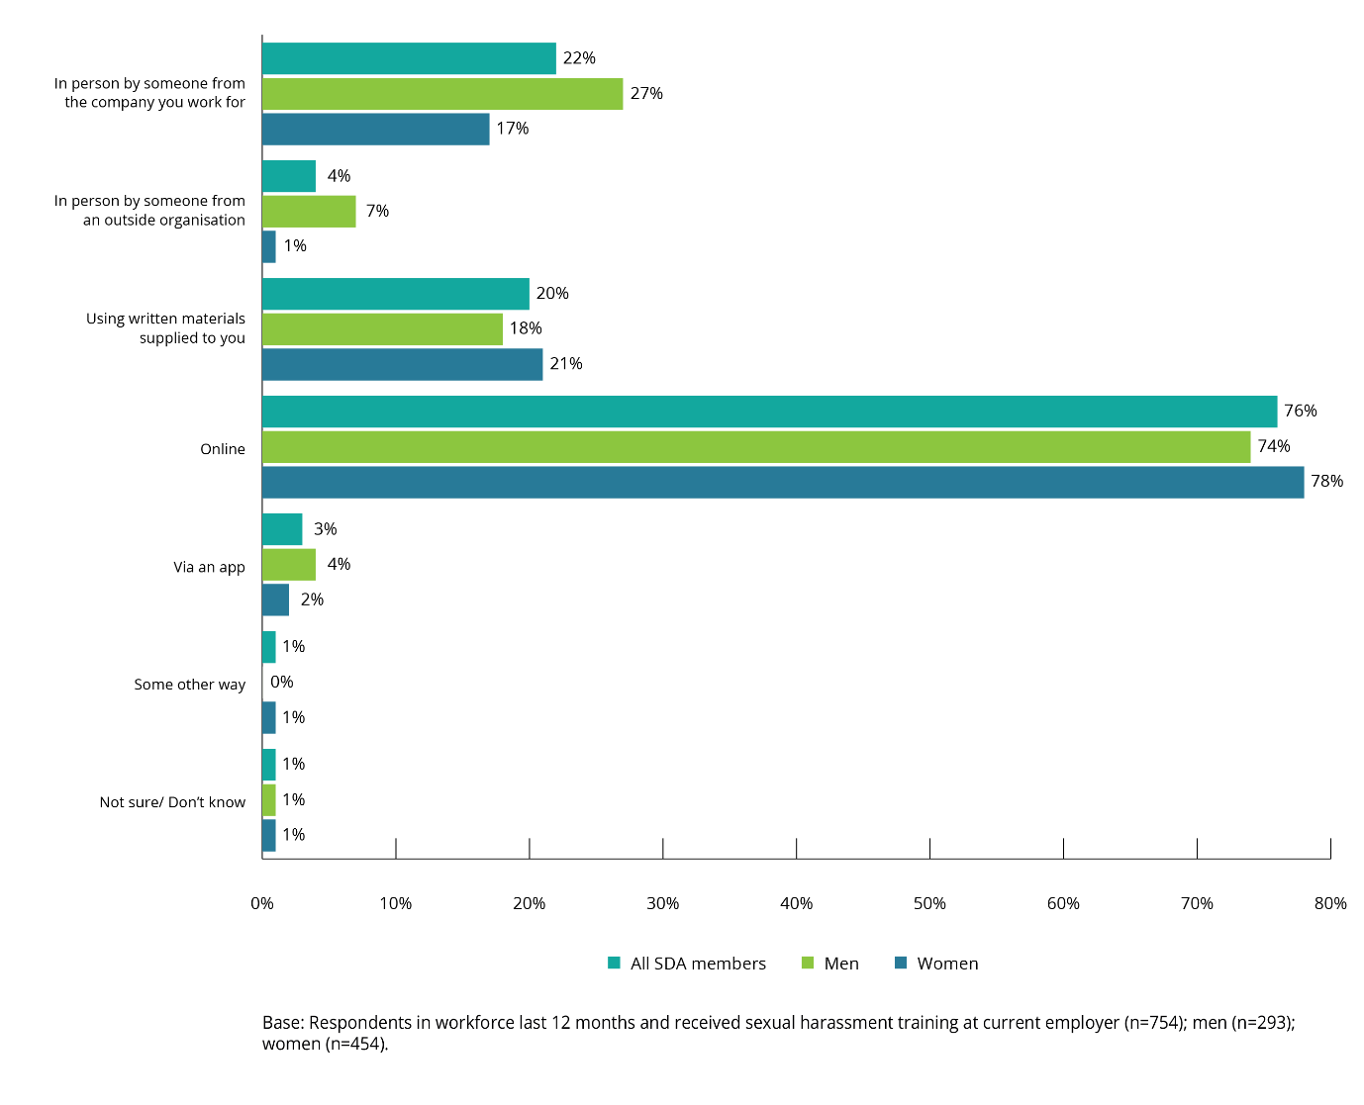

Knowledge of where to find sexual harassment policies and procedures
SDA members who said that their current employer had either procedures for reporting or complaining about sexual harassment, or a written sexual harassment policy, were asked whether they knew where to find these policies in their workplace.
Three in five SDA members indicated that they knew where to find the relevant sexual harassment policies and procedures.
Of the 62% of SDA members who said they knew where to find the relevant policies and procedures, men (67%) were more likely to provide this answer than women (58%).
Those working in the fast food sector (73%) were more likely than those in other SDA sectors to know where to find these policies and procedures.

Figure 81: Knowledge of where to find workplace sexual harassment policies/procedures
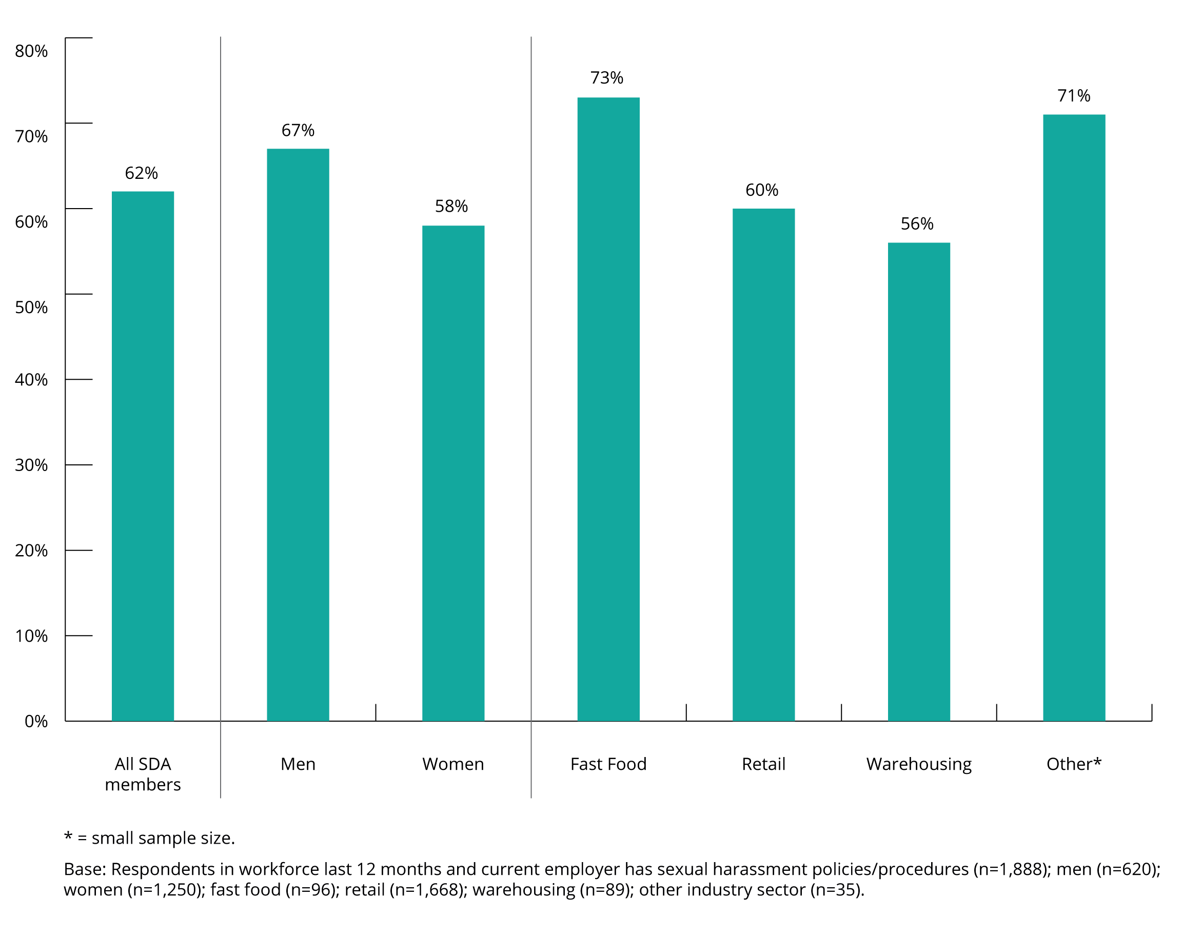

Prevalence of workplace sexual harassment when policies, procedures and training are in place
While it is not possible to directly compare SDA members who said they had experienced workplace sexual harassment to the existence of policies, procedures or training regarding sexual harassment in their current job, the data suggests that there is a relationship between the prevalence of workplace sexual harassment and workplace policies, procedures and training.
While only indicative, the data suggests that the proportion of SDA members experiencing some form of workplace sexual harassment appears to be higher when there are no procedures, policies or training in place, or the SDA member is not aware of any.
Figure 82: Prevalence of workplace sexual harassment with reference to policies, procedures, and training
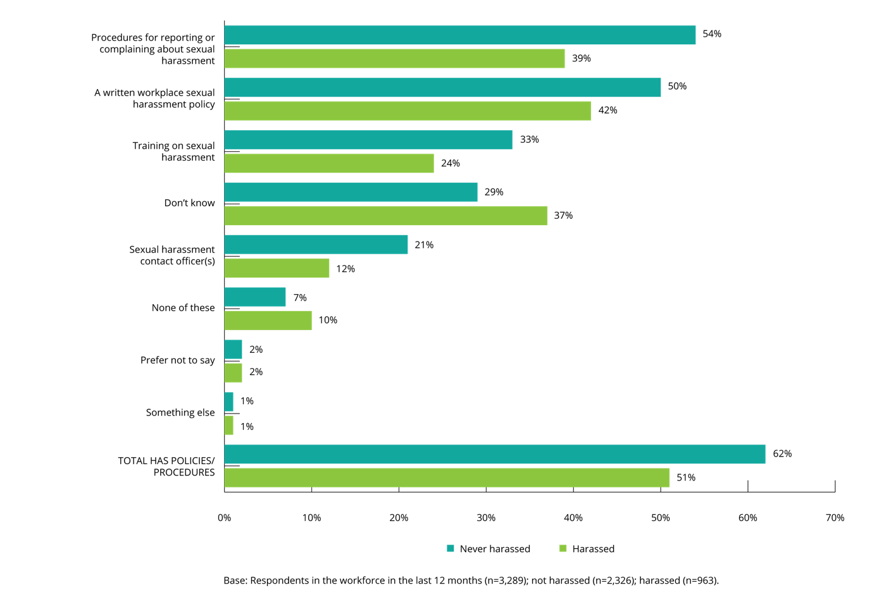
There is some indication that employees in larger organisations are less likely to be aware of the existence of an employer policy on sexual harassment or reporting procedures. In contrast, those working in smaller organisations are more likely to be aware that their employer has procedures in place, and a better understanding of the nature of those procedures and policies.

Figure 83: Size of employer and awareness of reporting and prevention measures
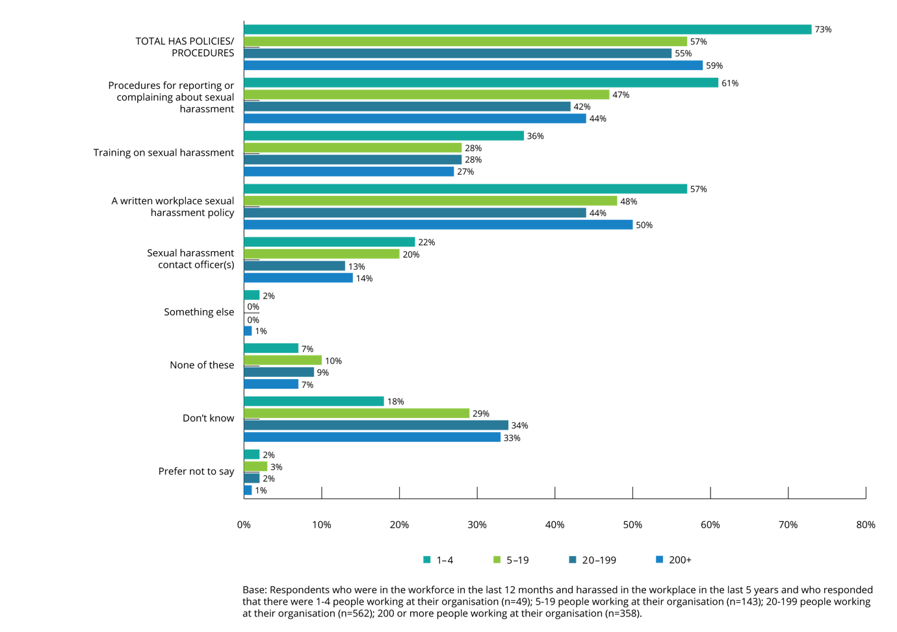

Appendix: Shop, Distributive and Allied Employees’ Association workplace sexual harassment survey

Introduction
The Australian Human Rights Commission is conducting a survey on sexual harassment in the workplace for the Shop, Distributive and Allied Employees’ Association (SDA).
We are inviting a sample of SDA members to tell us about their views and experiences with sexual harassment in the workplace.
It is important that the survey is representative of all SDA members’ opinions and experiences so please take the time to complete the survey.
Participation in this survey is completely voluntary, and you can stop or withdraw at any time. It will take most people about 15 minutes to complete.
The survey is being conducted for the Australian Human Rights Commission by Roy Morgan.
Roy Morgan is an independent market research company. They operate under the provisions of the Privacy Act and none of the information collected in the survey can be used to identify you. Your answers will remain strictly confidential and will be combined with the information from thousands of other SDA Members across Australia and will only be used for research purposes.
If you find any part of this survey distressing or upsetting, there are support services available that you can contact. Our Participant Information Statement contains a list of these support services with their contact details for your reference. In the event you have not retained a copy of this, you can access a copy of this here. We recommend you save a copy of this now for your future reference.

ASK ALL:
S1a. Is your gender…
SINGLE RESPONSE
1 | Male | CONTINUE
2 | Female | CONTINUE
3 | Non Binary | CONTINUE
4 | Other | CONTINUE
5 | Prefer not to say | CONTINUE

PROGRAMMER NOTE – FOR QUOTA PURPOSES, ALLOCATE ANY “OTHER” OR “NON-BINARY” OR “REFUSED” (Code 3, 4 or 5) RESPONSES ALTERNATIVELY AS FEMALE OR MALE
IF SEX QUOTA FULL, TERMINATE, SAY:
“Thank you for your time and assistance but we have interviewed enough people of your gender.”
S1b. What is your postcode?
SINGLE RESPONSE
_ _ _ _ CODE NUMERIC 1000-9999
99 Don’t know
IF CODE 99, TERMINATE, SAY:
"Thank you for your time and assistance but for this survey we need to know your postcode."

S1ba. Which industry sector do you work in?
1 | Fast Food | CONTINUE
2 | Retail | CONTINUE
3 | Warehousing | CONTINUE
4 | Some other industry | CONTINUE
5 | Prefer not to say | TERMINATE
6 | Don’t know | TERMINATE

TERMINATE if Code 5 or 6:
"Thank you for your time, but for this survey we need to know the industry sector in which you work."
ASK ALL:
S1c. What is your age?
1 | Record
99 | Prefer not to say

IF CODE 99 (REFUSED AGE) AT S1c, ASK
S1ca. To which of the following age groups do you belong?
1 | Under 15 years | TERMINATE
2 | 15-17 years | GO TO PARPER
3 | 18-19 years | CONTINUE
4 | 20-24 years | CONTINUE
5 | 25-29 years | CONTINUE
6 | 30-34 years | CONTINUE
7 | 40-54 | CONTINUE
8 | 55-64 | CONTINUE
9 | 65 years or older | CONTINUE
99 | Prefer not to say | TERMINATE

IF AGE QUOTA FULL, TERMINATE, SAY:
Thank you for your time and assistance but we have interviewed enough people in your age group.
IF CODE 99 AT S1ca – TERMINATE, SAY:
Thank you for your time and assistance but for this survey we need to know your approximate age.

IF AGE UNDER 15 AT S1c OR CODE 1 OR 2 AT S1ca – TERMINATE, SAY:
Thank you for your time and assistance but for this survey we need to interview people who are at least 15 years old.
IF AGE 15 TO 17 AT S1c OR CODE 2 AT S1ca – CONTINUE TO PARPER
OTHERWISE, GO TO Q1
PARPER
[SINGLE]
Because you are under 18, you will need permission from a parent or guardian to complete this survey. Please ask your parent or guardian to read the following information and complete the consent details. We will attempt to contact your parent/guardian by email, telephone and/or letter to confirm that they have given permission for you to participate.
TO THE PARENT OR GUARDIAN
We are conducting an important survey on behalf of the Australian Human Rights Commission and the Shop Distributive and Allied Employees’ Association (SDA). This study investigates the incidence and nature of sexual harassment both in and outside the workplace and in the process of looking for work. As the Commission and SDA are particularly interested in including the experience and attitude of younger people, we would like to ask your permission for your child to participate.
The survey will take approximately 15 minutes for most people and the information provided will be used for research purposes only. Your child’s answers will remain strictly confidential. They will not be able to be identified in any way in the results. Their answers will be combined with the responses from thousands of other participants from across Australia.
Participation in this survey is completely voluntary and your child can stop at any time if they do not wish to continue. If your child has experienced sexual harassment, we will ask them questions about this experience.
If your child’s responses to this survey disclose any current or past instances of child abuse or neglect, Roy Morgan Research may be legally obliged to report this to relevant government agencies.

Do you agree for your child to participate in this online survey?
1 I AGREE to my child participating in this online survey
2 I DO NOT AGREE to my child participating in this online survey
IF PARENT/GUARDIAN AGREES (CODE 1 ON PARPER) SAY:
Please provide your name, email address and contact telephone number so that we can contact you to verify your consent to your child’s participation.
(BOXES for name, email address and telephone number)
PROGRAMMER – MUST PROVIDE NAME AND ONE OR BOTH OF EMAIL AND TELEPHONE NUMBER. IF PROVIDES ONLY ONE OF EMAIL OR TELEPHONE NUMBER, PLEASE DISPLAY:
If you do not have {an email address/a contact telephone number}, please provide your postal address so we have another method of verifying your consent to your child’s participation.
(BOX for street address)
PROGRAMMER – ALLOW RESPONDENT TO PROCEED, EVEN IF NO RESPONSE AT ADDRESS BOX
IF CODE 1 AT PARPER, DISPLAY:
Thank you for allowing your child to participate. This survey covers important current issues in Australia. The views of your child are very important for this study. If you choose, you can be present while your child completes this survey, but as it is very important that your child is allowed to answer each question by himself/herself, please do not influence or suggest the answers.
Please press ‘Next’ to return to the survey to be completed by your child.
END
IF PARENT/GUARDIAN DOES NOT AGREE (CODE 2 ON PARPER) DISPLAY:
We respect and understand your reasons for deciding not to allow your child to take part in this survey. Thank you for your assistance.
ASK ALL:
This is an important study of the prevalence and impact of sexual harassment.
The definition of Sexual Harassment is provided below.
Sexual harassment is an unwelcome sexual advance, unwelcome request for sexual favours or other unwelcome conduct of a sexual nature which, in the circumstances, a reasonable person, aware of those circumstances, would anticipate the possibility that the person would feel offended, humiliated or intimidated.

Q1. Have you ever personally experienced sexual harassment? This could be at any time or anywhere – NOT just when you are at work.
SINGLE RESPONSE
1 | Yes | CONTINUE
2 | No | CONTINUE
3 | Don’t know | CONTINUE
4 | Prefer not to say | CONTINUE

Q3a. Listed below are some different forms of sexual harassment that some people have experienced.
At any time or anywhere, have you ever experienced any of the following behaviours in a way that was unwelcome? Please select one response in each row.

ROTATE – STATEMENT ‘K’ SHOULD ALWAYS BE THE FINAL STATEMENT ASKED, AND ALL OTHERS SHOULD BE ROTATED. HOWEVER, STATEMENT J SHOULD NEVER APPEAR FIRST.
 | Yes | No | Don’t know | Prefer not to say
- Unwelcome touching, hugging, cornering or kissing
- Inappropriate staring or leering that made you feel intimidated
- Sexual gestures, indecent exposure or inappropriate display of the body
- Sexually suggestive comments or jokes that made you feel offended
- Sexually explicit pictures, posters or gifts that made you feel offended
- Repeated or inappropriate invitations to go out on dates
- Intrusive questions about your private life or physical appearance that made you feel offended
- Inappropriate physical contact
- Being followed, watched or someone loitering nearby
- Requests or pressure for sex or other sexual acts
- Actual or attempted rape or sexual assault

Q3b. And have you ever experienced any of the following behaviours in a way that was unwelcome? Please select one response in each row.
ROTATE – STATEMENT ‘Q’ SHOULD ALWAYS BE THE FINAL STATEMENT ASKED, AND ALL OTHERS SHOULD BE ROTATED.
 | Yes | No | Don’t know | Prefer not to say
M. Indecent phone calls, including someone leaving a sexually explicit message on voicemail or an answering machine
N. Sexually explicit comments made in emails, SMS messages or on social media
O. Repeated or inappropriate advances on email, social networking websites or internet chat rooms
P. Sharing or threatening to share intimate images or film of you without your consent
Q. Any other unwelcome conduct of a sexual nature (PLEASE SPECIFY) ____________________

S1d. Have you been in the workforce at any time in the last 5 years? If you are unsure, please make your best guess.
SINGLE RESPONSE
1 | Yes
2 | No

IF IN WORKFORCE IN LAST 5 YEARS (CODE 1 AT S1d), ASK:
S1da. And have you been in the workforce in the last 12 months? If you are unsure, please make your best guess.
SINGLE RESPONSE
1 | Yes
2 | No

IF NOT IN WORKFORCE IN LAST 5 YEARS (CODE 2 AT S1d) GO TO Q25
IF IN WORKFORCE IN LAST 5 YEARS (Code 1 AT S1d) BUT NEVER EXPERIENCED SEXUAL HARASSMENT (NOT YES AT ANY OF ITEM A TO K AT Q3a OR ITEM M TO Q AT Q3b) GO TO Q21
IF IN WORKFORCE IN LAST 5 YEARS (Code 1 at S1d) AND HAS EXPERIENCED SEXUAL HARASSMENT (ANSWERED ‘YES’ FOR ANY OF ITEM A TO K AT Q3a AND/OR ANY OF ITEM M TO Q AT Q3b), CONTINUE TO Q4a
Q4a. Now we want to ask you about your experiences of work-related sexual harassment.
IF MORE THAN ONE TYPE OF SEXUAL HARASSMENT (MORE THAN ONE CODE 1 AT Q3a AND/OR Q3b) GO TO Q4a2
IF ONLY ONE TYPE OF SEXUAL HARASSMENT (ONLY ONE CODE 1 AT Q3a AND/OR Q3b) ASK Q4a1

Q4a1. Have you experienced {CASE IN Q3a OR 3b} at work, at a work-related event or while looking for work at any time in the last 5 years?
SINGLE RESPONSE
1 | Yes
2 | No
3 | Don’t know
4 | Prefer not to say

IF EXPERIENCED HARASSMENT IN WORKPLACE IN LAST 5 YEARS (CODE 1 IN Q4a1) BUT NOT IN THE WORKFORCE IN THE LAST 12 MONTHS (CODE 2 IN S1da) GO TO Q6b2
IF DID NOT EXPERIENCE HARASSMENT IN WORKPLACE IN LAST 5 YEARS, DOES NOT KNOW OR PREFERS NOT TO SAY (CODE 2 OR 3 OR 4 IN Q4a1) GO TO Q21
IF EXPERIENCED HARASSMENT IN WORKPLACE IN LAST 5 YEARS (CODE 1 IN Q4a1) AND IN THE WORKFORCE IN THE LAST 12 MONTHS (CODE 1 IN S1da) ASK Q4a1a
Q4a1a. And did this happen to you at work, at a work-related event or while looking for work at any time in the last 12 months?
SINGLE RESPONSE
1 | Yes
2 | No
3 | Don’t know
4 | Prefer not to say

IF EXPERIENCED WORKPLACE SEXUAL HARASSMENT IN LAST 12 MONTHS (CODE 1 IN Q4a1a) GO TO Q6b1
IF DID NOT EXPERIENCE WORKPLACE SEXUAL HARASSMENT IN LAST 12 MONTHS, DOES NOT KNOW OR PREFERS NOT TO SAY (CODE 2 OR 3 OR 4 IN Q4a1) GO TO Q6b2
ASK IF MORE THAN ONE TYPE OF SEXUAL HARASSMENT (MORE THAN ONE CODE 1 AT Q3a AND/OR Q3b
MULTI
DISPLAY ONLY THE CODES SELECTED AT Q3a OR Q3b

Q4a2. Which, if any, of the things you mentioned earlier happened to you at work, at a work-related event or while looking for work at in the last five years? (Mark all that apply)
Programmer use the following truncated descriptions of the behaviours here and at any later questions calling for this text to be brought forward to question text
A touching, hugging, cornering or kissing
B staring or leering
C sexual gestures, indecent exposure or display of the body
D sexually suggestive comments or jokes
E sexually explicit pictures, posters or gifts
F repeated or inappropriate invitations to go out on dates
G intrusive questions about your private life or physical appearance
H physical contact
I someone following, watching or loitering nearby
J requests or pressure for sex or other sexual acts
K actual or attempted rape or sexual assault
M indecent phone calls or voice messages
N sexually explicit comments in emails, SMS messages or on social media
O repeated or inappropriate advances on email, social networking websites or internet chat rooms
P sharing or threats to share intimate images or film of you
Q insert open text response from Q3b

97 | None of these
98 | Don’t know
99 | Prefer not to say

IF ONLY ONE TYPE OF WORKPLACE SEXUAL HARASSMENT (ONLY ONE CODE 1 AT Q4a2) AND NOT IN THE WORKFORCE IN LAST 12 MONTHS (CODE 2 AT S1da) GO TO Q6b2
IF MORE THAN ONE CASE OF WORKPLACE SEXUAL HARASSMENT IN LAST 5 YEARS (MORE THAN ONE CODE 1 AT Q4a2) AND IN THE WORKFORCE IN LAST 12 MONTHS (CODE 1 AT S1da) GO TO Q4b2
IF MORE THAN ONE CASE OF WORKPLACE SEXUAL HARASSMENT IN LAST 5 YEARS (MORE THAN ONE CODE 1 AT Q4a2) BUT NOT IN THE WORKFORCE IN LAST 12 MONTHS (CODE 2 AT S1da) GO TO Q5b
IF ONLY ONE TYPE OF WORKPLACE SEXUAL HARASSMENT (ONLY ONE CODE 1 AT Q4a2) AND IN THE WORKFORCE IN LAST 12 MONTHS (CODE 1 AT S1da) ASK Q4b1
Q4b1. You said that you had experienced {CASE IN Q4a2} at work, at a work-related event or while looking for work. Did this happen to you in the last 12 months?
SINGLE RESPONSE
1 | Yes
2 | No
3 | Don’t know
4 | Prefer not to say

IF EXPERIENCED WORKPLACE SEXUAL HARASSMENT IN LAST 12 MONTHS (CODE 1 IN Q4b1) GO TO Q6b1
IF DID NOT EXPERIENCE WORKPLACE SEXUAL HARASSMENT IN LAST 12 MONTHS OR DOES NOT KNOW OR PREFERS NOT TO SAY (2 OR 3 OR 4 IN Q4b1) GO TO Q6b2
ASK IF MORE THAN ONE CASE OF WORKPLACE SEXUAL HARASSMENT IN LAST 5 YEARS (MORE THAN ONE CODE 1 AT Q4a2) AND IN THE WORKFORCE IN LAST 12 MONTHS (CODE 1 AT S1da)
MULTI
Q4b2. And which, if any, of the things you mentioned earlier happened to you at work, at a work-related event or while looking for work in the last 12 months? (Mark all that apply)
PROGRAMMER – LIST ONLY THE WORKPLACE-RELATED ITEMS IDENTIFIED AT Q4a2
97 | None of these
98 | Don’t know
99 | Prefer not to say

IF EXPERIENCED ONLY ONE WORKPLACE SEXUAL HARASSMENT IN LAST 12 MONTHS (ONLY ONE CODE 1 IN Q4b2) GO TO Q6b1
IF DID NOT EXPERIENCE WORKPLACE SEXUAL HARASSMENT IN LAST 12 MONTHS OR DOES NOT KNOW OR PREFERS NOT TO SAY (97 OR 98 OR 99 IN Q4b2) GO TO Q5b
IF EXPERIENCED MORE THAN ONE WORKPLACE SEXUAL HARASSMENT IN LAST 12 MONTHS (MORE THAN ONE CODE 1 IN Q4b2) ASK Q5a

Q5a. You’ve mentioned that you experienced the following behaviours at work or at a work-related event or while looking for work in the last 12 months. Which of these happened to you most recently?
PROGRAMMER – LIST ONLY THE WORKPLACE-RELATED ITEMS IDENTIFIED (CODE 1) AT Q4b2
SINGLE RESPONSE
A | Unwelcome touching, hugging, cornering or kissing
B | Inappropriate staring or leering that made you feel intimidated
C | Sexual gestures, indecent exposure or inappropriate display of the body
D | Sexually suggestive comments or jokes that made you feel offended
E | Sexually explicit pictures, posters or gifts that made you feel offended
F | Repeated or inappropriate invitations to go out on dates
G | Intrusive questions about your private life or physical appearance that made you feel offended
H | Inappropriate physical contact
I | Being followed, watched or someone loitering nearby
J | Requests or pressure for sex or other sexual acts
K | Actual or attempted rape or sexual assault
M | Indecent phone calls, including someone leaving a sexually explicit message on voicemail or an answering machine
N | Sexually explicit comments made in emails, SMS messages or on social media
O | Repeated or inappropriate advances on email, social networking websites or internet chat rooms
P | Sharing or threatening to share intimate images or film of you without your consent
Q | Insert open text from Q3b

If SEXUALLY HARASSING BEHAVIOUR EXPERIENCED AT WORK IN LAST 12 MONTHS (ANY CODE IN Q5a) ASK Q6b1
ASK Q5b IF:

MORE THAN ONE CASE OF WORKPLACE SEXUAL HARASSMENT IN LAST 5 YEARS (MORE THAN ONE CODE 1 AT Q4a2) BUT NOT IN THE WORKFORCE IN LAST 12 MONTHS (CODE 2 AT S1da); OR

DID NOT EXPERIENCE WORKPLACE SEXUAL HARASSMENT IN LAST 12 MONTHS OR DOES NOT KNOW OR PREFERS NOT TO SAY (97 OR 98 OR 99 IN Q4b2)
MULTI
Q5b. You’ve mentioned that you experienced the following behaviours at work, at a work-related event or while looking for work during the last 5 years. Which of these happened to you most recently?
PROGRAMMER – LIST ONLY THE WORKPLACE-RELATED ITEMS IDENTIFIED (CODE 1) AT Q4a2

SINGLE RESPONSE
A | Unwelcome touching, hugging, cornering or kissing
B | Inappropriate staring or leering that made you feel intimidated
C | Sexual gestures, indecent exposure or inappropriate display of the body
D | Sexually suggestive comments or jokes that made you feel offended
E | Sexually explicit pictures, posters or gifts that made you feel offended
F | Repeated or inappropriate invitations to go out on dates
G | Intrusive questions about your private life or physical appearance that made you feel offended
H | Inappropriate physical contact
I | Being followed, watched or someone loitering nearby
J | Requests or pressure for sex or other sexual acts
K | Actual or attempted rape or sexual assault
M | Indecent phone calls, including someone leaving a sexually explicit message on voicemail or an answering machine
N | Sexually explicit comments made in emails, SMS messages or on social media
O | Repeated or inappropriate advances on email, social networking websites or internet chat rooms
P | Sharing or threatening to share intimate images or film of you without your consent
Q | Insert text from other-specify box at Q3b
IF ONLY ONE SEXUALLY HARASSING BEHAVIOUR EXPERIENCED AT WORK IN LAST 5 YEARS (ANY CODE IN Q5b) ASK Q6b2
ASK Q6b1 IF:

EXPERIENCED WORKPLACE SEXUAL HARASSMENT IN LAST 12 MONTHS (CODE 1 IN Q4a1a); OR

EXPERIENCED WORKPLACE SEXUAL HARASSMENT IN LAST 12 MONTHS (CODE 1 IN Q4b1); OR

EXPERIENCED ONLY ONE WORKPLACE SEXUAL HARASSMENT IN LAST 12 MONTHS (ONLY ONE CODE 1 IN Q4b2);

EXPERIENCED SEXUALLY HARASSING BEHAVIOUR WORK IN LAST 12 MONTHS (ANY CODE IN Q5a) ASK Q6b1.
Q6b1. You mentioned that you had experienced {behaviour} at work, at a work-related event or while looking for work at some time in the last 12 months.
Was this sexual harassment a one-off, or had it occurred previously at that same place of work?
PROGRAMMER – IF THE ONLY APPLICABLE BEHAVIOUR RELATES TO CODE Q, PLEASE INSERT THE TEXT FROM THE RELEVANT OTHER-SPECIFY BOX
PROGRAMMER DISPLAY TYPE OF BEHAVIOUR:

IF CODE 1 IN Q4a1a DISPLAY TYPE OF HARASSMENT IN Q3a OR Q3b

IF CODE 1 IN Q4b1 DISPLAY TYPE OF HARASSMENT IN Q4a2

IF ONLY 1 CODE SELECTED IN Q4b2 DISPLAY TYPE OF HARASSMENT IN Q4b2

IF ANY CODE IN Q5a DISPLAY TYPE OF HARASSMENT IN Q5a
SINGLE RESPONSE
1. One-off
2. Had occurred previously
IF ONE OFF (CODE 1 AT Q6b1) GO TO Q6e
IF OCCURRED PREVIOUSLY (CODE 2 AT Q6b1), GO TO Q6c

ASK Q6b2 IF:

DID NOT EXPERIENCE WORKPLACE SEXUAL HARASSMENT IN LAST 12 MONTHS, DOES NOT KNOW OR PREFERS NOT TO SAY (CODE 2 OR 3 OR 4 IN Q4a1)

ONLY ONE TYPE OF WORKPLACE SEXUAL HARASSMENT (ONLY ONE CODE 1 AT Q4a2) AND NOT IN THE WORKFORCE IN LAST 12 MONTHS (CODE 2 AT S1da)

DID NOT EXPERIENCE WORKPLACE SEXUAL HARASSMENT IN LAST 12 MONTHS OR DOES NOT KNOW OR PREFERS NOT TO SAY (2 OR 3 OR 4 IN Q4b1)

ONLY ONE SEXUALLY HARASSING BEHAVIOUR EXPERIENCED AT WORK IN LAST 5 YEARS (ANY CODE IN Q5b)
Q6b2. You mentioned that you had experienced {behaviour} at work, at a work-related event or while looking for work at some time in the last 5 years.
Was this sexual harassment a one-off, or had it occurred previously at that same place of work?
PROGRAMMER – IF THE ONLY APPLICABLE BEHAVIOUR RELATES TO CODE Q, PLEASE INSERT THE TEXT FROM THE RELEVANT OTHER-SPECIFY BOX. IF ONLY APPLICABLE BEHAVIOUR RELATES TO CODE K, SUPPRESS THE WORDS “…UNWELCOME AND WAS…” IN QUESTION TEXT
PROGRAMMER DISPLAY TYPE OF BEHAVIOUR EXPERIENCED:

IF CODE 2 OR 3 OR 4 IN Q4a1 DISPLAY TYPE OF HARASSMENT IN Q3a OR 3b

IF ONE CODE AT Q4a2 AND CODE 2 AT S1da DISPLAY TYPE OF HARASSMENT IN Q4a2

IF CODE 2 OR 3 OR 4 IN Q4b1 DISPLAY TYPE OF HARASSMENT IN Q4a2

IF ANY CODE IN Q5b DISPLAY TYPE OF HARASSMENT IN Q5b
SINGLE RESPONSE
1. One-off
2. Had occurred previously

IF OCCURRED PREVIOUSLY (CODE 2 AT Q6b1 or CODE 2 at Q6b2), ASK Q6c:
Q6c. For how long had you been experiencing this at this place of work? If you are unsure, please make your best guess.
SINGLE RESPONSE
1 | Less than 1 month
2 | 1 to 3 months
3 | 4 to 6 months
4 | 7 to 12 months
5 | More than one year but less than two years
6 | More than two years
98 | Don’t know
99 | Prefer not to say

IF EXPERIENCED ANY WORK-RELATED SEXUALLY HARASSING BEHAVIOUR IN LAST 5 YEARS (CODE 1 AT Q4a1), ASK Q6e:
Q6e. How old were you when you experienced the most recent incident of {Behaviour from Q6b1 or Q6b2}? If you are unsure, please make your best guess.
SINGLE RESPONSE
_ _ CODE NUMERIC 1-96
99 Don’t know

Q6f. At the time of the most-recent incident, were you working full-time, part-time, looking for work or something else?
SINGLE RESPONSE
1 | Working full-time | CONTINUE
2 | Working part-time | CONTINUE
3 | Looking for work | CONTINUE
4 | Something else (PLEASE SPECIFY) ____________________ | CONTINUE
5 | Don’t know | CONTINUE
6 | Prefer not to say | CONTINUE

ASK IF CODE 1, 2, 4, 5 or 6 AT Q6f:
Q6g. And was that as a permanent, casual or temporary employee, or something else?
SINGLE RESPONSE
1 | Permanent | CONTINUE
2 | Casual | CONTINUE
3 | Temporary | CONTINUE
4 | Something else (PLEASE SPECIFY) ____________________ | CONTINUE
5 | Don’t know | CONTINUE
6 | Prefer not to say | CONTINUE

(CODE 1 AT Q4a1)

Q7b. When the most recent incident occurred, were you…? (Mark all that apply)
MULTIPLE RESPONSE
1 | In a social area for employees – such as a break or lunch room
2 | At a work social event – such as after-work drinks or a function
3 | At your work station/where you work
4 | In a meeting – i.e. with more than two attendees
5 | In a one-on-one meeting
6 | At a work retreat or offsite meeting
7 | In a work-provided facility – such as a bathroom or change room
8 | Somewhere else (PLEASE SPECIFY) ____________________
98 | Don’t know
99 | Prefer not to say

Q7ca. How many people were directly involved in subjecting you to this most recent incident?
1 | Record
98 | Don’t know
99 | Prefer not to say

IF 2 OR MORE HARASSERS AT Q7ca, OR DON’T KNOW OR PREFER NOT TO SAY, GO TO Q8aa
IF ONE HARASSER AT Q7c, ASK
Q8a. Was the harasser male, female or another gender?
SINGLE RESPONSE
1 | Male | CONTINUE
2 | Female | CONTINUE
3 | Another gender | CONTINUE
98 | Don’t know | CONTINUE
99 | Prefer not to say | CONTINUE

Q8b. About how old was the harasser?
SINGLE RESPONSE
1 | 15 -20 years | CONTINUE
2 | 21-30 years | CONTINUE
3 | 31-40 years | CONTINUE
4 | 41-50 years | CONTINUE
5 | 51-64 years | CONTINUE
6 | 65+ years | CONTINUE
98 | Don’t know | CONTINUE
99 | Prefer not to say | CONTINUE

Q8c. What was the harasser’s relationship to you? Were they…
SINGLE RESPONSE
1 | The head of your workplace or organisation – such as the CEO, business owner or similar
2 | Your direct manager or supervisor at work
3 | Another manager or supervisor at work
4 | A co-worker who was more senior
5 | A co-worker at the same level as you
6 | A client or customer
7 | Someone else associated with your workplace
97 | Anyone else (PLEASE SPECIFY) ____________________
98 | Don’t know
99 | Prefer not to say

IF 2 OR MORE HARASSERS AT Q7ca, OR DON’T KNOW OR PREFER NOT TO SAY, ASK
Q8aa. Were any of the harassers…? (Mark all that apply)
MULTIPLE RESPONSE
1 | Males
2 | Females
3 | Another gender
98 | Don’t know (MULTI)
99 | Prefer not to say

Q8ba. Were any of the harassers in the following age groups? If unsure, please make your best guess. (Mark all that apply)
MULTIPLE RESPONSE
1 | 15-20 years | CONTINUE
2 | 21-30 years | CONTINUE
3 | 31-40 years | CONTINUE
4 | 41-50 years | CONTINUE
5 | 51-64 years | CONTINUE
6 | 65+ years | CONTINUE
98 | Don’t know (MULTI) | CONTINUE
99 | Prefer not to say | CONTINUE

Q8ca. What was the relationship of the various harassers to you? Were any of them… (Mark all that apply)
MULTIPLE RESPONSE
1 | The head of your workplace or organisation – such as the CEO or business owner
2 | Your direct manager or supervisor at work
3 | Another manager or supervisor at work
4 | A co-worker who was more senior
5 | A co-worker at the same level as you
6 | A client or customer
7 | Others associated with your workplace
97 | Anyone else (PLEASE SPECIFY) ____________________
98 | Don’t know (MULTI)
99 | Prefer not to say

ASK IF EXPERIENCED SEXUAL HARASSMENT AT WORK IN LAST 5 YEARS (CODE 1 AT Q4a1)
SINGLE RESPONSE
Q8d. Did anyone else see this most recent incident of harassment?
1 | Yes
2 | No
3 | Don’t know
4 | Prefer not to say

IF NO-ONE ELSE SAW THE INCIDENT OR THEY DON’T KNOW, PREFER NOT TO SAY OR REFUSED (CODES 2 OR 3 OR 4 IN Q8d) GO TO Q9a
ASK IF ANYONE ELSE SAW THIS INCIDENT (CODE 1 IN Q8d)

Q8d1. How many people would you say saw it happen?
1 | Specify
98 | Don’t know
99 | Prefer not to say

ASK IF 2 OR MORE WITNESS AT Q8d1 OR CODE 98 OR 99 AT Q8d1
Q8e. Who were the people who saw it happen? Were any of them… (Mark all that apply)
MULTIPLE RESPONSE
1 | The head of your workplace or organisation – such as the CEO or business owner
2 | Your direct manager or supervisor at work
3 | Another manager or supervisor at work
4 | A co-worker who was more senior
5 | A co-worker at the same level as you
6 | A client or customer
7 | Others associated with your workplace
97 | Anyone else (PLEASE SPECIFY) ____________________
98 | Don’t know (MULTI)
99 | Prefer not to say

ASK IF 1 WITNESS AT Q8d1
SINGLE
Q8e1. Who was the person who saw it happen? Was it…
1 | The head of your workplace or organisation – such as the CEO or business owner
2 | Your direct manager or supervisor at work
3 | Another manager or supervisor at work
4 | A co-worker who was more senior
5 | A co-worker at the same level as you
6 | A client or customer
7 | Another person associated with your workplace
97 | Anyone else (PLEASE SPECIFY) ____________________
98 | Don’t know
99 | Prefer not to say

ASK IF ANYONE ELSE SAW THIS INCIDENT (CODE 1 IN Q8d)

Q8f. Did anyone who saw you being harassed try and intervene?
SINGLE RESPONSE
1 | Yes
2 | No
3 | Don’t know
4 | Prefer not to say

Q8f1. Did anyone who saw the harassment do any of the following…? (Mark all that apply)
MULTIPLE RESPONSE
1 | Talk to the harasser about the incident
2 | Report the harassment to your employer
3 | Talk to you about the incident
4 | Offer advice to you
95 | Take any other action (PLEASE SPECIFY) ____________________
96 | None of these (SINGLE)
97 | Don’t know
98 | Prefer not to say

ASK IF EXPERIENCED SEXUAL HARASSMENT AT WORK IN LAST 5 YEARS (CODE 1 AT Q4a1)
Q9a. On a scale of 1 to 5, where 1 means not at all offended and 5 means extremely offended, overall how offended did the most recent incident of work-related harassment make you feel?
SINGLE RESPONSE
Not at all offended |  |  |  | Extremely offended | Don’t know
1 | 2 | 3 | 4 | 5 | 6

Q9b. On a scale of 1 to 5, where 1 means not at all intimidated and 5 means extremely intimidated, overall how intimidated did the most recent incident of work-related harassment make you feel?
SINGLE RESPONSE
Not at all intimidated |  |  |  | Extremely intimidated | Don’t know
1 | 2 | 3 | 4 | 5 | 6

Q9d. Thinking about the consequences of the most recent incident on you, would you say…. (Mark all that apply)
MULTIPLE RESPONSES
RANDOMISE ORDER OF ITEMS 1 TO 6
1 | It negatively impacted on your employment, career or work
2 | It had negative financial consequences for you
3 | It impacted negatively on your relationships with your partner, children, friends or family
4 | It impacted negatively on your self-esteem and confidence
5 | It impacted negatively on your health and general well-being
6 | It impacted negatively on your mental health, or caused you stress
7 | There were some other consequences from this harassment on you (PLEASE SPECIFY) ____________________
8 | There were no long-term consequences for you
9 | None of the above (SINGLE)
98 | Don’t know
99 | Prefer not to say

Q9e. Have you experienced any of the following health and wellbeing consequences as a direct result of your most recent experience of sexual harassment?
MULTIPLE RESPONSES
RANDOMISE ORDER OF ITEMS 1 TO 14
1 | Anxiety
2 | Burn out
3 | Depression
4 | Post-Traumatic Stress Disorder
5 | Loss of appetite
6 | Sense of helplessness
7 | Loss of self esteem
8 | Suicidal thoughts
9 | Fatigue
10 | High blood pressure
11 | Sleeplessness
12 | Digestive problems
13 | Body aches/pains
14 | Impacts on private life
97 | None of the above (SINGLE)
98 | Don’t know
99 | Prefer not to say

Q9f. Have you sought assistance to help you address health problems directly associated with your most recent experience of sexual harassment from any of the following?
MULTIPLE RESPONSES
RANDOMISE ORDER OF ITEMS 1 TO 14
 |  | Yes | No | Not Sure | Prefer not to say
1 | Medical practitioner
2 | Complementary therapies (Physiotherapy, Chiropractic, Osteopathy, Acupuncture)
3 | Counselling
4 | Psychiatrist/Psychologist
5 | Medication
6 | Sick leave/personal leave
7 | Annual leave
8 | Unpaid leave
9 | Workers compensation claim
10 | Other

Q10a. Has anyone else in that same place of work experienced {behaviour from Q6b1 or Q6b2} in a way that was unwelcome and associated with their employment?
PROGRAMMER – IF APPLICABLE BEHAVIOUR RELATES TO:

CODE K, SUPPRESS THE WORDS “…UNWELCOME AND” IN QUESTION TEXT

CODE P, CHANGE DISPLAYED BEHAVIOUR TEXT TO “SHARING OR THREATS TO SHARE IMAGES OR FILM OF THEM”

IF CODE G, DISPLAY “INTRUSIVE QUESTIONS ABOUT THEIR PRIVATE LIFE OR PHYSICAL APPEARANCE”
SINGLE RESPONSE
1 | Yes | CONTINUE
2 | No | GO TO 10c
3 | Don’t know | GO TO 10c
4 | Prefer not to say | GO TO 10c

IF CODE 1 ON Q10a AND ONLY ONE PERSON DIRECTLY INVOLVED IN HARASSING THE RESPONDENT TO THE MOST RECENT INCIDENT (AT Q7ca), ASK

Q10b. And was the person who had harassed you also involved in this other incident of {behaviour from Q6b1 or Q6b2}
SINGLE RESPONSE
PROGRAMMER – IF APPLICABLE BEHAVIOUR RELATES TO:

CODE K, SUPPRESS THE WORDS “…UNWELCOME AND” IN QUESTION TEXT

CODE P, CHANGE DISPLAYED BEHAVIOUR TEXT TO “SHARING OR THREATS TO SHARE IMAGES OR FILM”

IF CODE G, DISPLAY “INTRUSIVE QUESTIONS ABOUT THEIR PRIVATE LIFE OR PHYSICAL APPEARANCE”
1 | Yes | CONTINUE
2 | No | CONTINUE
3 | Don’t know | CONTINUE
4 | Prefer not to say | CONTINUE

IF CODE 1 ON Q10a AND THERE WAS MORE THAN ONE PERSON DIRECTLY INVOLVED IN HARASSING THE RESPONDENT TO THE MOST RECENT INCIDENT (AT Q7ca) OR NUMBER IS UNKNOWN OR PREFER NOT TO SAY (CODE 98 or 99 at Q7ca, ASK Q10b1
Q10b1. And were any of the people who had harassed you also involved in this other incident of {behaviour from Q6b1 or Q6b2}
SINGLE RESPONSE

PROGRAMMER – IF APPLICABLE BEHAVIOUR RELATES TO:

CODE K, SUPPRESS THE WORDS “…UNWELCOME AND” IN QUESTION TEXT

CODE P, CHANGE DISPLAYED BEHAVIOUR TEXT TO “SHARING OR THREATS TO SHARE IMAGES OR FILM”

IF CODE G, DISPLAY “INTRUSIVE QUESTIONS ABOUT PRIVATE LIFE OR PHYSICAL APPEARANCE”
1 | Yes | CONTINUE
2 | No | CONTINUE
3 | Don’t know | CONTINUE
4 | Prefer not to say | CONTINUE

ASK IF EXPERIENCED SEXUAL HARASSMENT AT WORK IN LAST 5 YEARS (CODE 1 AT Q4a1)
Q10c. Thinking about your workplace at the time of the most recent incident, would you say that this type of behaviour was very rare, rare, occurred sometimes or was common?
SINGLE RESPONSE
1 | Very rare | CONTINUE
2 | Rare | CONTINUE
3 | Occurred sometimes | CONTINUE
4 | Common | CONTINUE
98 | Don’t know | CONTINUE
99 | Prefer not to say | CONTINUE

Q11. Did you make a formal report or complaint about the most recent incident of sexual harassment?
SINGLE RESPONSE
1 | Yes | CONTINUE
2 | No | GO TO Q12
3 | Prefer not to say | GO TO Q12

IF MADE REPORT (CODE 1 ON Q11), ASK
Q11a. To which of the following did you report the incident to? (Mark all that apply)
MULTIPLE RESPONSE
1 | The head of your workplace organisation – CEO, business owner
2 | Your direct manager or supervisor at work
3 | Another manager or supervisor at work
4 | The Human Resources Manager or equivalent at work
5 | An Equity or Sexual Harassment Contact Officer at work
6 | A co-worker
7 | A union or employee representative
8 | A lawyer or legal service
9 | The Australian Human Rights Commission or to a state or territory anti-discrimination agency
10 | The Fair Work Ombudsman
11 | The Police
97 | Somewhere else (PLEASE SPECIFY) ____________________
98 | Don’t know
99 | Prefer not to say

Q11b. What was the time period between when the harassment began and when you first reported it?
SINGLE RESPONSE
1 | Same day or next working day | CONTINUE
2 | Less than 1 month (but not straight away) | CONTINUE
3 | 1 to 3 months | CONTINUE
4 | 4 to 6 months | CONTINUE
5 | More than 6 months | CONTINUE
98 | Don’t know | CONTINUE
99 | Prefer not to say | CONTINUE

Q11c. Has your complaint been finalised yet?
SINGLE RESPONSE
1 | Yes
2 | No
98 | Don't know
99 | Refused

IF FINALISED (CODE 1 AT Q11c), ASK
Q11ca. How was your complaint finalised? (Mark all that apply)
MULTIPLE RESPONSE
1 | Between your organisation’s head and you
2 | Between your direct manager or supervisor and you
3 | With another manager or supervisor at work
4 | With your union’s involvement
5 | With the involvement of the Australian Human Rights Commission or state or territory anti-discrimination agency
6 | By your legal representative/lawyer
7 | In Court
97 | In some other way (PLEASE SPECIFY) ____________________
98 | Don’t know (DO NOT READ)
99 | Prefer not to say (DO NOT READ)
Q11d. How long did it take to finalise your complaint? Was it…
SINGLE RESPONSE
1 | Same day or next working day | CONTINUE
2 | Less than 1 month (but not straight away) | CONTINUE
3 | 1 to 3 months | CONTINUE
4 | 4 to 6 months | CONTINUE
5 | 7 to 12 months | CONTINUE
6 | More than 12 months | CONTINUE
98 | Don’t know | CONTINUE
99 | Prefer not to say | CONTINUE

IF MADE REPORT (CODE 1 ON Q11), ASK
Q11e. Did any of the following things occur as a result your complaint?
MULTIPLE RESPONSES – DO NOT DISPLAY. DO NOT READ “THERE WERE NO CONSEQUENCES FOR YOU” IF SELECTED ANY OF CODES 1-14
RANDOMISE ORDER OF ITEMS 1 TO 13
1 | Your employer apologised for failing to prevent the harassment
2 | Your employer paid you compensation because of the harassment.
3 | The harassment stopped
4 | You received positive feedback for making the complaint
5 | Your shifts were changed
6 | You were transferred
7 | You resigned
8 | You were dismissed or lost your job
9 | You were demoted
10 | You were disciplined
11 | You were denied workplace opportunities, such as training or promotion
12 | You were ostracised, victimised, ignored by colleagues
13 | You were labelled a trouble-maker
14 | There were some other consequences for you (PLEASE SPECIFY) ____________________
15 | There were no consequences for you (SINGLE)
98 | Don’t know
99 | Prefer not to say

IF MADE REPORT (CODE 1 ON Q11), ASK
Q11f. Did any of the following things happen to your {harasser/harassers} following your complaint? (Mark all that apply)
PROGRAMMER – VARIABLE TEXT BASED ON RESPONSE AT Q7c
MULTIPLE RESPONSES
RANDOMISE ORDER OF ITEMS 1 TO 8
1 | They were disciplined
2 | They were formally warned
3 | They were informally spoken to
4 | They were transferred
5 | The had their shifts changed
6 | They resigned
7 | They apologised
8 | They paid you compensation
9 | There were some other consequences for the harasser (PLEASE SPECIFY) ____________________
10 | There were no consequences for the harasser (SINGLE)
11 | My employer would not tell me the outcome for the harasser (SINGLE)
98 | Don’t know
99 | Prefer not to say

IF MADE REPORT (CODE 1 ON Q11), ASK
Q11g. Did any of the following happen at your organisation as a result of your complaint?
MULTIPLE RESPONSES
1 | Your employer developed or changed the existing policy on sexual harassment
2 | Your employer changed a practice or procedure – for example, the complaints procedure
3 | Your employer implemented training or education
4 | There were some other changes at your organisation following your complaint (PLEASE SPECIFY) ____________________
5 | There were no changes at the organisation following your complaint (SINGLE)
98 | Don’t know
99 | Prefer not to say

IF COMPLAINT FINALISED (CODE 1 AT Q11c) ASK
Q11h. On a scale of 1 to 5, where 1 means not at all satisfied and 5 means extremely satisfied, how would you rate the overall process of dealing with your complaint?
SINGLE RESPONSE
Not at all satisfied |  |  |  | Extremely satisfied | Don’t know
1 | 2 | 3 | 4 | 5 | 6

IF EXPERIENCED ANY WORK-RELATED SEXUALLY HARASSING BEHAVIOUR IN LAST 5 YEARS (CODE 1 AT Q4a1), ASK
Q12. Did you seek any {other form of} support or advice about the most recent incident of sexual harassment?
PROGRAMMER NOTE – DISPLAY VARIABLE TEXT IF MADE COMPLAINT/REPORT (CODE 1 AT Q11)
SINGLE RESPONSE
1 | Yes
2 | No
3 | Prefer not to say

IF CODE 1 ON Q12, ASK
Q12a. Did you seek support or advice from any of the following? (Mark all that apply)
MULTIPLE RESPONSE
1 | Friends or family
2 | The head of your workplace or organisation – such as the CEO or business owner
3 | Your direct manager or supervisor at work
4 | Another manager or supervisor at work
5 | The Human Resources Manager or equivalent at work
6 | An Equity or Sexual Harassment Contact Officer at work
7 | A co-worker more senior than you
8 | A co-worker or peer at the same level as you
9 | A union or employee representative
10 | A lawyer or legal service
11 | Australian Human Rights Commission or a State or Territory anti-discrimination Agency
12 | A counsellor or psychologist
13 | The internet (including search engines such as Google and Yahoo)
14 | A community-based or religious service
15 | The Fair Work Ombudsman
16 | The Police
97 | Somewhere else (PLEASE SPECIFY) ____________________
98 | Don’t know
99 | Prefer not to say

IF DID NOT MAKE COMPLAINT (CODE 2 AT Q11) OR DID NOT SEEK SUPPORT (CODE 2 AT Q12) ASK Q12b
Q12b. People decide not to seek support or make a complaint for many different reasons.
Which of the following were reasons why you did not seek support or advice or make a report or complaint about the most recent incident of sexual harassment? (Mark all that apply) (CODE 2 ON Q11 AND CODE 2 ON Q12)
OR
Which of the following were reasons why you did not seek {any other form of} support or assistance about the most recent incident of sexual harassment? (Mark all that apply) (CODE 2 ON Q12 BUT NOT CODE 2 ON Q11) Programmer – insert variable question text if Code 2 on Q12 and Code 1 on Q11.
OR
Which of the following were reasons why you did not make a report or complaint about the most recent incident of sexual harassment? (Mark all that apply) (CODE 2 ON Q11 BUT NOT CODE 2 ON Q12)
MULTIPLE RESPONSE
PROGRAMMER NOTE – DO NOT DISPLAY CODES 1, 2, 5 and 7 IF MADE COMPLAINT (CODE 1 AT Q11)
1 | I wasn’t aware of how the complaint process worked or who to report to
2 | My family friends or co-workers advised me not to make a complaint
3 | It was easier to keep quiet
4 | I thought I would not be believed
5 | I thought the complaint process would be embarrassing or difficult
6 | I thought it would not change things or that nothing would be done
7 | Lack of confidentiality of the complaint process
8 | I was too scared or frightened
97 | None of these (SINGLE)
98 | Don’t know
99 | Prefer not to say

Q12b1. And which, if any, of the following are reasons why you did not {seek support or advice/seek support or advice or make a report or complaint/make a report or complaint} in relation to the most recent incident of sexual harassment? (Mark all that apply)
MULTIPLE RESPONSE
PROGRAMMER – INSERT VARIABLE TEXT AS FOLLOWS {if code 2 at Q12 and not code 2 at Q11/if code 2 at Q11 and code 2 at Q12/if code 2 at Q11 and not code 2 at Q12}
N | I thought I would be blamed
O | I thought people would think I was over-reacting
P | I thought I would get fired
Q | I was afraid for my career aspirations
S | I feared negative consequences for the person or people who harassed me
T | I moved to another place of work
U | The person or people who harassed me were already being dealt with
V | I didn’t think it was serious enough  Why did you think it was not serious enough? (PLEASE SPECIFY) _____________________
W | Took care of the problem myself  How did you take care of it? (PLEASE SPECIFY) _____________________
X | Any another reason (PLEASE SPECIFY) ____________________
Y | No other reasons (SINGLE) ____________________

IF EXPERIENCED ANY WORK-RELATED SEXUALLY HARASSING BEHAVIOUR IN LAST 5 YEARS (CODE 1 AT Q4a1), ASK
Thinking now specifically about your workplace when the most recent incident of sexual harassment took place.
Q15. How many people worked at your organisation at that time – in the total organisation, not just at your workplace? If you are unsure, please make your best guess.
SINGLE RESPONSE
1 | 1 to 4 | CONTINUE
2 | 5 to 19 | CONTINUE
3 | 20 to 199 | CONTINUE
4 | 200 or more | CONTINUE
98 | Don’t know | CONTINUE
99 | Prefer not to say | CONTINUE

Q20. Did your workplace at that time contain mainly men, mainly women or roughly equal number of each? If you are unsure, please make your best guess.
SINGLE RESPONSE
1 | Mainly men | CONTINUE
2 | Mainly women | CONTINUE
3 | Roughly equal numbers of men and women | CONTINUE
98 | Don’t know | CONTINUE
99 | Refused | CONTINUE

Q18a. In what industry did the most recent incident of sexual harassment take place?
SINGLE RESPONSE
1 | Agriculture, Forestry and Fishing | CONTINUE
2 | Mining | CONTINUE
3 | Manufacturing | CONTINUE
4 | Electricity, Gas, Water and Waste Services | CONTINUE
5 | Construction | CONTINUE
6 | Wholesale Trade | CONTINUE
7 | Retail Trade | CONTINUE
8 | Accommodation and Food Services | CONTINUE
9 | Transport, Postal and Warehousing | CONTINUE
10 | Information, Media and Telecommunications | CONTINUE
11 | Financial and Insurance Services | CONTINUE
12 | Rental, Hiring and Real Estate Services | CONTINUE
13 | Professional, Scientific and Technical Services | CONTINUE
14 | Administrative and Support Services | CONTINUE
15 | Public Administration and Safety | CONTINUE
16 | Education and Training | CONTINUE
17 | Health Care and Social Assistance | CONTINUE
18 | Arts and Recreation Services | CONTINUE
19 | Australian Defence Force | GO TO Q19
20 | Personal Services | GO TO Q19
21 | Other Services | GO TO Q19
97 | Other (PLEASE SPECIFY) ____________________ | GO TO Q19
98 | Don’t know | GO TO Q19
99 | Prefer not to say | GO TO Q19

IF INDUSTRY CODE 1-18 AT Q18a, ASK Q18b
PROGRAMMER – DISPLAY MAIN ACTIVITY FOR INDUSTRY IN Q18a AT Q18b, ALONG WITH ADDITIONAL CODES (FOR ANY INDUSTRY) FOR “OTHER”, “DON’T KNOW” and “PREFER NOT TO SAY”
18b. And which best describes the main activity at this location? Would it be…
Agriculture, Forestry and Fishing | 01 Agriculture  04 Fishing, Hunting and Trapping  05 Agriculture, Forestry and Fishing Support Services
Mining | 06 Coal Mining  07 Oil and Gas Extraction  08 Metal Ore Mining  09 Non-Metallic Mineral Mining and Quarrying  10 Exploration and Other Mining Support Services
Manufacturing | 11 Food Product Manufacturing  12 Beverage and Tobacco Product Manufacturing  13 Textile, Leather, Clothing and Footwear Manufacturing  14 Wood Product Manufacturing  15 Pulp, Paper and Converted Paper Product Manufacturing  16 Printing (including the Reproduction of Recorded Media)  17 Petroleum and Coal Product Manufacturing  18 Basic Chemical and Chemical Product Manufacturing  19 Polymer Product and Rubber Product Manufacturing  20 Non-Metallic Mineral Product Manufacturing  21 Primary Metal and Metal Product Manufacturing  22 Fabricated Metal Product Manufacturing  23 Transport Equipment Manufacturing  24 Machinery and Equipment Manufacturing  25 Furniture and Other Manufacturing
Electricity, Gas, Water and Waste Services | 26 Electricity Supply  27 Gas Supply  28 Water Supply, Sewerage and Drainage Services  29 Waste Collection, Treatment and Disposal Services
Construction | 30 Building Construction  31 Heavy and Civil Engineering Construction  32 Construction Services
Wholesale Trade | 33 Basic Material Wholesaling  34 Machinery and Equipment Wholesaling  35 Motor Vehicle and Motor Vehicle Parts Wholesaling  36 Grocery, Liquor and Tobacco Product Wholesaling  37 Other Goods Wholesaling  38 Commission-Based Wholesaling
Retail Trade | 391 Motor Vehicle retailing  392 Motor Vehicle Parts Retailing  400 Fuel Retailing  411 Supermarket and Grocery Stores  421 Furniture, Floor Coverings, Houseware and textile Goods Retailing  422 Electrical and Electronic Goods Retailing  423 Hardware, Building and Garden Supplies Retailing  424 Recreational Goods Retailing  425 Clothing, Footwear and Personal Accessory Retailing  426 Department Stores  427 Pharmaceutical and Other Store-Based Retailing  41 Non-Store Retailing (Direct Selling etc.)  432 Retail Commission-Based Buying and/or Selling
Accommodation and Food Services | 440 Accommodation  451 Cafes, Restaurants and Takeaway Food Services  452 Pubs, Taverns And Bars  453 Clubs (Hospitality)
Transport, Postal and Warehousing | 46 Road Transport  47 Rail Transport  48 Water Transport  49 Air and Space Transport  50 Other Transport  51 Postal and Courier Pick-Up and Delivery Services  52 Transport Support Services  53 Warehousing and Storage Services
Information Media and Telecommunications | 54 Publishing (except Internet and Music Publishing)  55 Motion Picture and Sound Recording Activities  56 Broadcasting (except Internet)  57 Internet Publishing and Broadcasting  58 Telecommunications Services  59 Internet Service Providers, Web Search Portals and Data Processing Services  60 Library and Other Information Services
Financial and Insurance Services | 62 Finance  63 Insurance and Superannuation Funds  64 Auxiliary Finance and Insurance Services
Rental, Hiring and Real Estate Services | 66 Rental and Hiring Services (except Real Estate)  67 Property Operators and Real Estate Services
Professional, Scientific and Technical Services | 69 Professional, Scientific and Technical Services (Except Computer System Design and Related Services)  70 Computer System Design and Related Services
Administrative and Support Services | 72 Administrative Services  73 Building Cleaning, Pest Control and Other Support Services
Public Administration and Safety | 75 Public Administration  76 Defence  77 Public Order, Safety and Regulatory Services
Education and Training | 80 Preschool and School Education  81 Tertiary Education  82 Adult, Community and Other Education
Health Care and Social Assistance | 84 Hospitals  85 Medical and Other Health Care Services  86 Residential Care Services  87 Social Assistance Services
Arts and Recreation Services | 89 Heritage Activities  90 Creative and Performing Arts Activities  91 Sports and Recreation Activities  92 Gambling Activities

97 | Other
98 | Don't know
99 | Prefer not to say

IF EXPERIENCED ANY WORK-RELATED SEXUALLY HARASSING BEHAVIOUR IN LAST 5 YEARS (CODE 1 AT Q4a1), ASK
Q19. What was your occupation at the time of the most recent incident of sexual harassment?
SINGLE RESPONSE
1 | Professional Worker – lawyer, doctor, scientist, teacher, engineer, nurse, accountant, investment banker, stock brokerage, marketing, musician | CONTINUE
2 | Manager, Executive or Official – in a business, government agency, or other organisation | CONTINUE
3 | Business Owner – such as a store, factory, plumbing contractor, etc | CONTINUE
4 | Clerical or Office Worker – in business, government agency, or other type of organisation – such as a typist, secretary, postal clerk, telephone operator, computer operator, data entry, bank clerk, etc. | CONTINUE
5 | Sales Worker – clerk in a store, door-to-door salesperson, sales associate | CONTINUE
6 | Manufacturer’s Representative – outside sales person, sales representative | CONTINUE
7 | Service Worker – policeman/woman, fireman, waiter or waitress, maid, nurse’s aide, attendant, barber or beautician, fast-food | CONTINUE
8 | Skilled Tradesman – printer, baker, tailor, electrician, machinist, linesman, railroad engineer, plumber, or does mechanical work such as garage mechanic, carpenter, etc | CONTINUE
9 | Semi-skilled Worker – operates a machine in a factory, is an assembly line worker in a factory, drives a truck, taxi cab, or bus, etc | CONTINUE
10 | Unskilled/Labourer/Elementary Occupations – plumber’s helper, construction labourer, longshoreman, sanitation worker, maintenance, housekeeping, or other physical work | CONTINUE
11 | Technology professional – web designer, network administrator, systems engineer, programmer, systems analyst, Internet, IT | CONTINUE
12 | Agriculture and Fishery Workers | CONTINUE
13 | Home Duties | CONTINUE
14 | Retired/Pensioner | CONTINUE
15 | Student | CONTINUE
97 | Other (PLEASE SPECIFY) ____________________ | CONTINUE
98 | Don’t know | CONTINUE
99 | Prefer not to say | CONTINUE

Q19b. Did the most recent incident of sexual harassment take place at any of these employers?
SINGLE RESPONSE
1 | Woolworths supermarket | CONTINUE
2 | Dan Murphys | CONTINUE
3 | Big W | CONTINUE
4 | BWS | CONTINUE
5 | Woolworths Petrol | CONTINUE
6 | Myer | CONTINUE
7 | David Jones | CONTINUE
8 | Priceline | CONTINUE
9 | The Reject Shop | CONTINUE
10 | McDonalds | CONTINUE
11 | Red Rooster | CONTINUE
12 | Oporto | CONTINUE
13 | Chicken Treat | CONTINUE
14 | Country Road | CONTINUE
15 | Witchery | CONTINUE
16 | MIMCO | CONTINUE
17 | Trenery | CONTINUE
18 | Politix | CONTINUE
97 | None of these | CONTINUE
98 | Don’t know | CONTINUE
99 | Prefer not to say | CONTINUE

ASK IF IN WORKPLACE IN LAST 5 YEARS (CODE 1 at S1d)
Q21. The next question is about any sexual harassment of another person that may have occurred at any of your workplaces over the last 5 years. Have you... (Mark all that apply)
MULTIPLE RESPONSE
1 | Observed or witnessed such sexual harassment yourself?
2 | Heard about it directly from a person who was sexually harassed?
3 | Heard about it from people other than the person who was sexually harassed?
4 | None of the above (SINGLE)
97 | Don’t know
98 | Prefer not to say

IF WITNESSED OR HEARD ABOUT HARASSMENT (CODE 1 – 3 AT Q21) ASK
Q22. Thinking now about the most recent incident of sexual harassment you witnessed or heard about at your workplace. Did you take any action in relation to the most recent incident of workplace sexual harassment that you witnessed or heard about?
SINGLE RESPONSE
1 | Yes
2 | No
99 | Prefer not to say

IF WITNESSED OR HEARD ABOUT SEXUAL HARASSMENT AND TOOK ACTION (CODE 1 AT Q22), ASK
Q22a. Which of the following actions did you take after witnessing or hearing about this most recent incident of sexual harassment? (Mark all that apply)
MULTIPLE RESPONSE
A | Speak with the harasser
B | Report the harassment to your employer
C | Talk with or listen to the victim about the incident
D | Offer advice to the victim
E | Take any other action (PLEASE SPECIFY) ____________________
G | Don’t know
H | Prefer not to say

Q23. Did any of the following things occur as a result you taking action in relation to this most recent incident of sexual harassment? (Mark all that apply)
MULTIPLE RESPONSE
RANDOMISE RESPONSE ITEMS 1 TO 9
1 | You received positive feedback for making the complaint
2 | You were disciplined
3 | You were transferred or changed shifts
4 | You resigned
5 | You were dismissed
6 | The harassment stopped
7 | You were demoted
8 | You were ostracised, victimised, ignored by colleagues
9 | You were labelled a trouble maker
10 | There were some other consequences for you (PLEASE SPECIFY) ____________________
11 | There were no consequences for you (SINGLE)
97 | Don’t know
98 | Prefer not to say

ASK IF WITNESSED OR HEARD ABOUT HARASSMENT BUT DID NOT TAKE ACTION (CODE 2 AT Q22)
Q24. People may decide not to take action after witnessing sexual harassment for many different reasons.
For each of the following, please indicate whether or not it was a reason why you decided not to take any action about the most recent incident of sexual harassment you witnessed? (Mark all that apply)
MULTIPLE RESPONSE
RANDOMISE RESPONSE ITEMS 1 TO 8
1 | I didn’t want to make things worse for the person who was being sexually harassed
2 | I was worried about the negative impact that taking action might have on me, such as my career or safety
3 | I didn’t think it was serious enough to intervene
4 | I didn’t think it was my responsibility
5 | I knew that other people were supporting and assisting the person
6 | I didn’t know what to do
7 | I didn’t want to get involved
8 | The person being sexually harassed asked me not to take any action
9 | Any other reasons (PLEASE SPECIFY) ____________________
98 | Don’t know
99 | Prefer not to say

ASK IF IN WORKFORCE IN THE LAST 12 MONTHS (CODE 1 AT S1da)
Now, just a few questions about your current work situation…
Q25a. Does your current employer have any of the following policies or procedures where you work? (Mark all that apply)
MULTIPLE RESPONSE
RANDOMISE RESPONSE ITEMS 1 TO 9
1 | Procedures for reporting or complaining about sexual harassment
2 | Training on sexual harassment
3 | A written workplace sexual harassment policy
4 | Sexual harassment contact officer(s)
5 | Something else (PLEASE SPECIFY) ____________________
6 | None of these (SINGLE)
98 | Don’t know
99 | Prefer not to say

ASK Q25b IF HAS TRAINING ON SEXUAL HARASSMENT (CODE 2 AT Q25a)
Q25b. How often does your employer conduct sexual harassment training?
1 | As part of an induction program for all new employees
2 | At least once a year
3 | At least every 2 years
4 | No set time it varies
5 | Only after someone reports or makes a complaint about sexual harassment
6 | It only occurred once and has not been repeated.
98 | Not sure/Don’t know
99 | Prefer not to say

Q25c. Have you received any training on sexual harassment while working for your current employer?
SINGLE RESPONSE
1 | Yes
2 | No
3 | Not sure/Don’t know
4 | Prefer not to say

ASK IF HAS RECEIVED TRAINING ON SEXUAL HARASSMENT (CODE 1 AT Q25c)
Q25d. How long is it since you last had this training on sexual harassment?
1 | Less than 1 month
2 | 1 to 3 months
3 | 4 to 6 months
4 | 7 to 12 months
5 | More than one year but less than two years
6 | More than two years
97 | Don’t know
98 | Prefer not to say

Q25e. How was this training conducted? (Mark all that apply)
1 | In person by someone from the company you work for
2 | In person by someone from an outside organisation
3 | Using written materials supplied to you
4 | Online
5 | Via an app
6 | Some other way (PLEASE SPECIFY) ____________________)
7 | Not sure/Don’t know

ASK IF HAS SEXUAL HARASSMENT POLICIES OR PROCEDURES (CODE 1 OR 3 AT Q25a)
Q25f. Do you know where to find the sexual harassment policies or procedures at your workplace?
1 | Yes
2 | No
98 | Not sure/Don’t know
99 | Prefer not to say

IF NOT RETAIL OR FAST FOOD SAMPLE (CODE 3, 4, 5 OR 6 AT S1ba) ASK Q25
ASK 25g or 25h IF SEXUALLY HARASSED IN THE WORKPLACE IN THE LAST 5 YEARS (CODE 1 AT Q4a1 OR ANY CODE A-Q AT Q4a2) AND IN WORKFORCE IN LAST 12 MONTHS (CODE 1 AT S1da) AND IF RETAIL OR FAST FOOD SAMPLE (CODE 1 OR 2 AT S1ba)
IF WAS SEXUALLY HARASSED BY A CUSTOMER (CODE 6 IN Q8c OR CODE 6 IN Q8ca) ASK Q25g
OTHERWISE ASK Q25h
Q25g. You mentioned earlier that you were sexually harassed by a customer, did this occur while you were in your current job?
1 | Yes
2 | No
98 | Not sure/Don’t know
99 | Prefer not to say

IF SEXUAL HARASSMENT BY CUSTOMER OCCURRED IN CURRENT JOB (CODE 1 IN Q25g) ASK Q25j
Q25h. Have you ever been sexually harassed by a customer while working in your current job?
1 | Yes
2 | No
98 | Not sure/Don’t know
99 | Prefer not to say

IF EVER BEEN SEXUAL HARASSMENT BY CUSTOMER IN CURRENT JOB (CODE 1 IN Q25g OR Q25h) ASK Q25ia
Q25ia. Does your employer have a mechanism for you to report an incident of sexual harassment by a customer?
1 | Yes
2 | No
98 | Not sure/Don’t know
99 | Prefer not to say

Q25ib. Have you ever reported an incident of sexual harassment by a customer to your employer?
1 | Yes
2 | No
98 | Not sure/Don’t know
99 | Prefer not to say

IF REPORTED AN INCIDENT OF SEXUAL HARASSMENT BY A CUSTOMER (CODE 1 IN Q25ib) ASK Q25ic
OTHERWISE ASK Q25ie
Q25ic. Was your report of being sexually harassed by a customer investigated by your employer?
1 | Yes
2 | No
98 | Not sure/Don’t know
99 | Prefer not to say

IF REPORTED INCIDENT OF SEXUAL HARASSMENT BY A CUSTOMER WAS INVESTIGATED (CODE 1 IN Q25ic) ASK Q25id
Q25id. What was the outcome of this investigation?
1 | Nothing Happened
2 | Customer was spoken to
3 | Customer was banned from store or your workplace
4 | The Police were called
5 | Something else (PLEASE SPECIFY) ____________________
6 | Not sure/Don’t know
7 | Prefer not to say

Q25ie. When was the last time you were sexually harassed by a customer at your current job? If you are not sure, please make your best estimate.
1 | In the last seven days
2 | 1 to 2 weeks ago
3 | 3 to 4 weeks ago
4 | 2 to 3 months ago
5 | 3 to 6 months ago
6 | 7 to 12 months ago
7 | More than 12 months ago
98 | Not sure/Don’t know
99 | Prefer not to say

IF SEXUAL HARASSMENT BY A CUSTOMER OCCURRED IN THE LAST 12 MONTHS (CODE 1, 2, 3, 4, 5 or 6 IN Q25ie) ASK Q25j
Q25j. How often in the last 12 months have you been sexually harassed by a customer in your current workplace?
1 | Record
98 | Don’t know
99 | Prefer not to say

IF ONLY ONE OCCASION OF SEXUAL HARASSMENT IN Q25j, ASK Q25k
IF MORE THAN ONE OCCASION OF SEXUAL HARASSMENT BY A CUSTOMER IN Q25j OR DON’T KNOW (CODE 98 IN Q25j) OR PREFER NOT TO SAY (CODE 99 IN Q25j) ASK Q25ka
Q25k. Did you know this customer who sexually harassed you?
1 | Yes
2 | No
98 | Not sure/Don’t know
99 | Prefer not to say

Q25ka. Thinking about the most recent occasion when a customer sexually harassed you, did you know this customer who sexually harassed you?
1 | Yes
2 | No
98 | Not sure/Don’t know
99 | Prefer not to say

Q25l. Has this customer sexually harassed you on more than one occasion?
1 | Yes they have harassed me on more than one occasion
2 | No this was the only occasion
98 | Not sure/Don’t know
99 | Prefer not to say

Q25m. Has your employer ever conducted a marketing or advertising campaign or some other form of promotion that you felt was inappropriate or made you feel uncomfortable?
1 | Yes
2 | No
98 | Not sure/Don’t know
99 | Prefer not to say

Q25n. Has your employer ever required or expected you to wear a uniform or clothing as part of your job that you felt was inappropriate or made you feel uncomfortable?
1 | Yes
2 | No
98 | Not sure/Don’t know
99 | Prefer not to say

[IF YES TO Q25m OR Q25n]
Q25o. And did this promotion or campaign or the uniform or clothing your employer required you to wear result in you being sexually harassed, either by a customer, co‑worker or someone else connected with your workplace?
1 | Yes
2 | No
98 | Not sure/Don’t know
99 | Prefer not to say

ASK ALL
Q25. If you needed any information about sexual harassment, which of the following would you be likely to go to? (Mark all that apply)
MULTIPLE RESPONSE
A | Friends or family
B | Social media
C | The Internet, including search engines such as Google or Yahoo
D | The head of your workplace or organisation
E | Your direct manager or supervisor at work
F | Another manager or supervisor at work
G | The Human Resources Manager or equivalent at work
H | The Equity or Sexual Harassment Contact Officer at work
I | A co-worker more senior than you
J | A co-worker or peer at the same level as you
K | A union or employee representative
L | A lawyer or legal service
M | The Australian Human Rights Commission or a state or territory anti-discrimination agency
N | The library
O | A counsellor or psychologist
P | Other (PLEASE SPECIFY) ____________________
Q | None of the above (Single)
R | Don’t know
S | Prefer not to say

Q27. What is your total annual HOUSEHOLD income from all sources before taxes?
SINGLE RESPONSE
1 | Less than $15,000 per year | CONTINUE
2 | $15,000 up to $24,999 per year | CONTINUE
3 | $25,000 up to $34,999 per year | CONTINUE
4 | $35,000 up to $44,999 per year | CONTINUE
5 | $45,000 up to $54,999 per year | CONTINUE
6 | $55,000 up to $74,999 per year | CONTINUE
7 | $75,000 up to $99,999 per year | CONTINUE
8 | $100,000 up to $149,999 per year | CONTINUE
9 | $150,000 up to $199,999 per year | CONTINUE
10 | $200,000 and over | CONTINUE
98 | Don’t know | CONTINUE
99 | Prefer not to say | CONTINUE

S1e. Are you of Aboriginal and/or Torres Strait Islander descent?
SINGLE RESPONSE
1 | Aboriginal | CONTINUE
2 | Torres Strait Islander | CONTINUE
3 | Both Aboriginal and Torres Strait Islander | CONTINUE
4 | No/neither | CONTINUE
98 | Don’t know | CONTINUE
99 | Prefer not to say | CONTINUE

Q27. What is the main language spoken at home?
SINGLE RESPONSE
1 | English | CONTINUE
2 | Italian | CONTINUE
3 | Greek | CONTINUE
4 | Cantonese | CONTINUE
5 | Mandarin | CONTINUE
6 | Arabic | CONTINUE
7 | Vietnamese | CONTINUE
8 | Hindi | CONTINUE
9 | Punjabi | CONTINUE
10 | Spanish | CONTINUE
11 | Urdu | CONTINUE
97 | Other (PLEASE SPECIFY) ____________________ | CONTINUE
98 | Don’t know | CONTINUE
99 | Prefer not to say | CONTINUE

Q28. Do you have a disability?
1 | Yes | CONTINUE
2 | No | CONTINUE
3 | Prefer not to say | CONTINUE

Q29. The next two questions are about your sexual orientation and intersex status.
If you are not comfortable responding to these questions, you can simply mark the response ‘prefer not to say’.
Any information you do provide here or elsewhere in the survey will be kept confidential and will not be used to identify you in any way.

S1a. Which of the following best describes your sexual orientation?
1 | Straight or heterosexual | CONTINUE
2 | Gay | CONTINUE
3 | Lesbian | CONTINUE
4 | Bisexual | CONTINUE
5 | Pansexual | CONTINUE
6 | Queer | CONTINUE
7 | Asexual or Aromantic | CONTINUE
8 | Undecided, not sure or questioning | CONTINUE
9 | Other (PLEASE SPECIFY) ____________________ | CONTINUE
10 | Prefer not to say | CONTINUE

Q30. Intersex is a term for people born with atypical sex characteristics. There are many different intersex traits or variations. Do you have an intersex variation?
1 | Yes | CONTINUE
2 | No | CONTINUE
3 | Don’t know | CONTINUE
4 | Prefer not to say | CONTINUE

ASK ALL
Q31. Would you like to make any additional comments about your experience with, or observations of, sexual harassment in the workplace or suggestions about what employers or the SDA could do to reduce sexual harassment in the workplace?
SINGLE RESPONSE
1 | Yes
2 | No

ASK IF WOULD LIKE TO MAKE ADDITIONAL COMMENTS (CODE 1 IN Q29)
Q32. What additional comments would you like to make?

ALL:
Thank you for your time and for your support. You made a valuable contribution to the success of this important study.
This research is carried out in compliance with the Privacy Act and Telecommunications and Research Calls Industry Standard, and the information you provided will be used only for research purposes.
We are conducting this research on behalf of the Australian Human Rights Commission.
IF EXPERIENCED SEXUAL HARASSMENT (CODE 1 ON Q1 or Q3a or Q3b), OR IF WITNESSED SOMEONE ELSE BEING SEXUALLY HARASSED (CODE 1 ON Q21), ALSO DISPLAY
PROGRAMMER – PLEASE DISPLAY ON SAME SCREEN AS PREVIOUS TEXT
Please note that your survey responses about any sexual harassment you may have experienced do not constitute a formal report of that sexual harassment. If you would like to make a formal report of sexual harassment, you may do so by contacting the police, the Australian Human Rights Commission, a state or territory anti-discrimination agency or Fair Work Australia.
S6 | If this survey brings up issues for you, there are people you can talk to. If you would like to contact a support service for people who have been victims of sexual assault or sexual harassment or speak to someone who can give you advice about these issues you can call 1800 RESPECT (1800 737 732).  If you don’t want to talk to someone you can access their website at www.1800respect.org.au.
S7  1  2 | We can also display a list of other organisations that can provide information and assistance with issues that may have been brought up by this survey. Would you like to see or this list?  Yes, please show me the list now  No

IF REQUESTS THAT LIST IS DISPLAYED (1 in S7) SHOW NATIONAL AND RELEVANT STATE LIST (from S1b/S1ba), AS S8
National List | Australian Human Rights Commission General Enquiries: 1300 369 711  Australian Human Rights Commission Complaints Infoline: 1300 656 419  1800RESPECT: 1800 737 732  Lifeline: 13 11 14  Beyondblue: 1300 22 4636  Relationships Australia: 1300 364 277  Mensline Australia: 1300 789 978  QLIFE (LGBTI counselling service): 1800 184 527
ACT | Human Rights Commission: (02) 6205 2222  Women’s Legal Service: 1800 634 669  Domestic Violence: (02) 6280 0900  Sexual Assault: (02) 6247 2525
NSW | NSW Anti-Discrimination Board: (02) 9268 5544  Law Access NSW: 1300 888 529  Domestic Violence (DoCS): 1800 656 463  Sexual Assault (Syd): (02) 9819 6565  Sexual Assault (Rural): 1800 424 017
VIC | Victorian Equal Opportunity and Human Rights Commission: 1300 891 848  Domestic Violence (Melb): (03) 9373 0123  Domestic Violence (Rural): 1800 015 188  Sexual Assault: 1800 806 292
SA | Equal Opportunity Commission of South Australia: 1800 188 163  Domestic Violence: 1800 800 098  Sexual Assault: 1800 817 421
NT | Northern Territory Anti-Discrimination Commission: 1800 813 846  NT Domestic Violence Hotline (Darwin): (08) 8945 2284  NT Domestic Violence Hotline (Alice Springs): (08) 8952 6075  Domestic Violence: 1800 019 116  Sexual Assault (Darwin): (08) 8922 6472  Sexual Assault (Alice Springs): (08) 8955 4500  Sexual Assault (Katherine): (08) 8973 8524  Sexual Assault (Tennant Creek): (08) 8962 4361
QLD | Anti-Discrimination Commission Queensland: 1300 130 670  Working Women’s Centre: 1800 621 458  Domestic Violence: 1800 811 811  Sexual Assault: 1800 010 120
WA | The Western Australian Equal Opportunity Commission: 1800 198 149  Women’s Law Centre (WA): 1800 625 122  Domestic Violence: 1800 007 339  Sexual Assault: 1800 199 888
TAS | Office of the Anti-Discrimination Commissioner (Tasmania): 1300 305 062  Hobart Community Legal Centre: (03) 6223 2500  Launceston Community Legal Centre: 1800 066 019  Domestic Violence: 1800 608 122  Sexual Assault: 1800 697 877

Australian Human Rights Commission
Level 3, 175 Pitt Street
SYDNEY NSW 2000
GPO Box 5218
SYDNEY NSW 2001
Telephone: (02) 9284 9600
Complaints Infoline: 1300 656 419
General enquiries and publications: 1300 369 711
TTY: 1800 620 241
Fax: (02) 9284 9611
Website: www.humanrights.gov.au
For detailed and up to date information about the Australian Human Rights Commission visit our website at www.humanrights.gov.au. To order more publications from the Australian Human Rights Commission, download a Publication Order Form at: www.humanrights.gov.au/about/publications/, call: (02) 9284 9600, fax: (02) 9284 9611 or email: publications@humanrights.gov.au
Acknowledgments
The Australian Human Rights Commission thanks the Shops, Distributive and Allied Employees Association for providing funding to conduct the Everyone’s business: survey on sexual harassment of members of the Shops, Distributive, and Allied Employees’ Association (SDA), and Julia Fox (National Assistant Secretary) and Katie Biddlestone (National Industrial & National Women’s Officer) for their leadership on this issue.
The Sex Discrimination Commissioner thanks the following staff of the Australian Human Rights Commission for their contributions: Afton Fife, Tyla Joubert, Natasha de Silva, Maria Twomey, Lauren Jones, Julie O’Brien, Rachel Holt, Hashini Panditharatne, Maria Katsabanis, and Sarah Hayes.

‘Working population’ in relation to rates of lifetime sexual harassment refers to the population from the 2018 National Survey report who were in the workforce in the five years preceding that survey.
See section 1.4(e)(ii) – Gender.
Australian Human Rights Commission, Everyone’s Business: Fourth National Survey on Sexual Harassment in Australian Workplaces (2018) 26.
Australian Human Rights Commission, Everyone’s Business: Fourth National Survey on Sexual Harassment in Australian Workplaces (2018) 40.
Australian Human Rights Commission, Everyone’s Business: Fourth National Survey on Sexual Harassment in Australian Workplaces (2018) 27.
‘Other’ includes those working in the hair and beauty industries, and as pharmacy assistants.
Australian Human Rights Commission, Everyone’s Business: Fourth National Survey on Sexual Harassment in Australian Workplaces (2018) 41.
Australian Human Rights Commission, Everyone’s Business: Fourth National Survey on Sexual Harassment in Australian Workplaces (2018) 47.
Australian Human Rights Commission, Everyone’s Business: Fourth National Survey on Sexual Harassment in Australian Workplaces (2018) 48.
Australian Human Rights Commission, Everyone’s Business: Fourth National Survey on Sexual Harassment in Australian Workplaces (2018) 26.
Australian Human Rights Commission, Everyone’s Business: Fourth National Survey on Sexual Harassment in Australian Workplaces (2018) 27.
Australian Human Rights Commission, Everyone’s Business: Fourth National Survey on Sexual Harassment in Australian Workplaces (2018) 28.
Australian Human Rights Commission, Everyone’s Business: Fourth National Survey on Sexual Harassment in Australian Workplaces (2018) 28.
Australian Human Rights Commission, Everyone’s Business: Fourth National Survey on Sexual Harassment in Australian Workplaces (2018) 28.
Australian Human Rights Commission, Everyone’s Business: Fourth National Survey on Sexual Harassment in Australian Workplaces (2018) 32.
Australian Human Rights Commission, Everyone’s Business: Fourth National Survey on Sexual Harassment in Australian Workplaces (2018) 54.
Australian Human Rights Commission, Everyone’s Business: Fourth National Survey on Sexual Harassment in Australian Workplaces (2018) 54.
Australian Human Rights Commission, Everyone’s Business: Fourth National Survey on Sexual Harassment in Australian Workplaces (2018) 54.
Australian Human Rights Commission, Everyone’s Business: Fourth National Survey on Sexual Harassment in Australian Workplaces (2018) 67.
Australian Human Rights Commission, Everyone’s Business: Fourth National Survey on Sexual Harassment in Australian Workplaces (2018) 69.
Australian Human Rights Commission, Everyone’s Business: Fourth National Survey on Sexual Harassment in Australian Workplaces (2018) 69.
Australian Human Rights Commission, Everyone’s Business: Fourth National Survey on Sexual Harassment in Australian Workplaces (2018) 85.
Australian Human Rights Commission, Everyone’s Business: Fourth National Survey on Sexual Harassment in Australian Workplaces (2018) 88.
Australian Human Rights Commission, Everyone’s Business: Fourth National Survey on Sexual Harassment in Australian Workplaces (2018) 88.
Australian Human Rights Commission, Everyone’s Business: Fourth National Survey on Sexual Harassment in Australian Workplaces (2018) 95.
Australian Human Rights Commission, Everyone’s Business: Fourth National Survey on Sexual Harassment in Australian Workplaces (2018) 96.
Australian Human Rights Commission, Everyone’s Business: Fourth National Survey on Sexual Harassment in Australian Workplaces (2018) 97.
Australian Human Rights Commission, Everyone’s Business: Fourth National Survey on Sexual Harassment in Australian Workplaces (2018) 98.
These quotes are taken from the free text answers provided by respondents to the 2019 Member Survey, and deidentified where required.
Remus Ilies et al, ‘Reported Incidence Rates of Work-Related Sexual Harassment in the United States: Using Meta-Analysis to Explain Reported Rate Disparities’ (2003) 56(3) Personnel Psychology, 607 and 619-621.
Remus Ilies et al, ‘Reported Incidence Rates of Work-Related Sexual Harassment in the United States: Using Meta-Analysis to Explain Reported Rate Disparities’ (2003) 56(3) Personnel Psychology, 609-610.
Australian Bureau of Statistics, 4906.0 – Personal Safety Survey, Australia.
In the 2018 National Survey this option was phrased as ‘any other unwelcome conduct of a sexual nature that occurred online or via some form of technology’.
Sex Discrimination Act 1984 (Cth), s 28A.
Sex Discrimination Act 1984 (Cth), s 28B.
Sex Discrimination Act 1984 (Cth), s 28F.
Sex Discrimination Act 1984 (Cth), s 28G.
Sex Discrimination Act 1984 (Cth), s 28H.
Sex Discrimination Act 1984 (Cth), s 28K.
4,274 SDA members responded to an invitation to participate in the 2019 Member Survey, however 861 reported that they had not participated in the workforce in the last 5 years. As the survey was directed at the workplace experience of SDA members in the previous five years these 861 individuals were excluded from the survey analysis resulting in a sample of 3,413.
See section 1.3(a) for further information about areas of public life.
Statistics in this chapter are based on 16 sexual harassment behaviours identified, not the legal definition outlined in the Sex Discrimination Act 1984 (Cth).
Male SDA members aged 15–17 years reporting an experience of sexual harassment based on a legal definition (n=1), and under a behavioural definition (n=19).
Australian Human Rights Commission, Everyone’s Business: Fourth National Survey on Sexual Harassment in Australian Workplaces (2018) 26.
Australian Human Rights Commission, Everyone’s Business: Fourth National Survey on Sexual Harassment in Australian Workplaces (2018) 27.
Australian Human Rights Commission, Everyone’s Business: Fourth National Survey on Sexual Harassment in Australian Workplaces (2018) 48.
Australian Human Rights Commission, Everyone’s Business: Fourth National Survey on Sexual Harassment in Australian Workplaces (2018) 32.
Overall, 28% of SDA members who were in the workforce in the last five years had experienced workplace sexual harassment on at least one occasion in the last 12 months. This experience was more common amongst female SDA members (32%) compared to men (19%).
Australian Human Rights Commission, Everyone’s Business: Fourth National Survey on Sexual Harassment in Australian Workplaces (2018) 25.
Australian Human Rights Commission, Everyone’s Business: Fourth National Survey on Sexual Harassment in Australian Workplaces (2018) 26.
Australian Human Rights Commission, Everyone’s Business: Fourth National Survey on Sexual Harassment in Australian Workplaces (2018) 40.
Australian Human Rights Commission, Everyone’s Business: Fourth National Survey on Sexual Harassment in Australian Workplaces (2018) 40.
Australian Human Rights Commission, Everyone’s Business: Fourth National Survey on Sexual Harassment in Australian Workplaces (2018) 40.
Australian Human Rights Commission, Everyone’s Business: Fourth National Survey on Sexual Harassment in Australian Workplaces (2018) 27.
Australian Human Rights Commission, Everyone’s Business: Fourth National Survey on Sexual Harassment in Australian Workplaces (2018) 41.
Australian Human Rights Commission, Everyone’s Business: Fourth National Survey on Sexual Harassment in Australian Workplaces (2018) 41.
Australian Human Rights Commission, Everyone’s Business: Fourth National Survey on Sexual Harassment in Australian Workplaces (2018) 46.
Australian Human Rights Commission, Everyone’s Business: Fourth National Survey on Sexual Harassment in Australian Workplaces (2018) 46.
Australian Human Rights Commission, Everyone’s Business: Fourth National Survey on Sexual Harassment in Australian Workplaces (2018) 46.
Australian Human Rights Commission, Everyone’s Business: Fourth National Survey on Sexual Harassment in Australian Workplaces (2018) 47.
Australian Human Rights Commission, Everyone’s Business: Fourth National Survey on Sexual Harassment in Australian Workplaces (2018) 47.
Australian Human Rights Commission, Everyone’s Business: Fourth National Survey on Sexual Harassment in Australian Workplaces (2018) 48.
Australian Human Rights Commission, Everyone’s Business: Fourth National Survey on Sexual Harassment in Australian Workplaces (2018) 48.
Australian Human Rights Commission, Everyone’s Business: Fourth National Survey on Sexual Harassment in Australian Workplaces (2018) 48.
Australian Human Rights Commission, Everyone’s Business: Fourth National Survey on Sexual Harassment in Australian Workplaces (2018) 49.
Australian Human Rights Commission, Everyone’s Business: Fourth National Survey on Sexual Harassment in Australian Workplaces (2018) 27.
Australian Human Rights Commission, Everyone’s Business: Fourth National Survey on Sexual Harassment in Australian Workplaces (2018) 27.
Australian Human Rights Commission, Everyone’s Business: Fourth National Survey on Sexual Harassment in Australian Workplaces (2018) 27.
The sample size for 15–17 year old male SDA members who experienced workplace sexual harassment was too small for the purpose of comparison.
Australian Human Rights Commission, Everyone’s Business: Fourth National Survey on Sexual Harassment in Australian Workplaces (2018) 27.
Australian Human Rights Commission, Everyone’s Business: Fourth National Survey on Sexual Harassment in Australian Workplaces (2018) 28.
Australian Human Rights Commission, Everyone’s Business: Fourth National Survey on Sexual Harassment in Australian Workplaces (2018) 28.
Australian Human Rights Commission, Everyone’s Business: Fourth National Survey on Sexual Harassment in Australian Workplaces (2018) 28.
Australian Human Rights Commission, Everyone’s Business: Fourth National Survey on Sexual Harassment in Australian Workplaces (2018) 28.
Source Australian Bureau of Statistics Labour Force Australia 6291.0 March 201.
Australian Human Rights Commission, Everyone’s Business: Fourth National Survey on Sexual Harassment in Australian Workplaces (2018) 29.
Australian Human Rights Commission, Everyone’s Business: Fourth National Survey on Sexual Harassment in Australian Workplaces (2018) 30.
Australian Human Rights Commission, Everyone’s Business: Fourth National Survey on Sexual Harassment in Australian Workplaces (2018) 30.
Australian Human Rights Commission, Everyone’s Business: Fourth National Survey on Sexual Harassment in Australian Workplaces (2018) 30.
Australian Human Rights Commission, Everyone’s Business: Fourth National Survey on Sexual Harassment in Australian Workplaces (2018) 33.
Australian Human Rights Commission, Everyone’s Business: Fourth National Survey on Sexual Harassment in Australian Workplaces (2018) 32.
Australian Human Rights Commission, Everyone’s Business: Fourth National Survey on Sexual Harassment in Australian Workplaces (2018) 32.
This question offered a set of potential consequences (including ‘no long-term consequence’), plus an ‘other-specify’ option, as well as a ‘none of the above’ option. The question was multiple response, so the percentages reported will sum to more than 100%.
Australian Human Rights Commission, Everyone’s Business: Fourth National Survey on Sexual Harassment in Australian Workplaces (2018) 54.
Australian Human Rights Commission, Everyone’s Business: Fourth National Survey on Sexual Harassment in Australian Workplaces (2018) 54.
Australian Human Rights Commission, Everyone’s Business: Fourth National Survey on Sexual Harassment in Australian Workplaces (2018) 54.
‘Survey results highlight abuse towards retail and fast food workers is epidemic’, (Web Page) <https://www.sda.org.au/resources/customer-abuse-violence-in-retail-fast-food/>.
When asked about the frequency of sexual harassment only 256 of the 482 SDA members who had been sexually harassed in their current job by a customer in the previous 12 months, were able to provide a specific numeric response. Of the rest 39% were unable to provide a numeric response and 6% preferred not to say.
The average frequency for females was 6.2 times and for males, 4.7 times. However, these results are limited by the small sample size for men, and the very high frequencies reported by a number of females. Of the 256 SDA Members who had been sexually harassed by a customer in the last 12 months, in their current job, and were able to provide a numeric answer only 39 were male. The frequency of sexual harassment by a customer reported by females was skewed by the responses of a small number of females who indicated frequencies between 30 and 50 times.
It should be noted that the question related to employee mechanisms for reporting sexual harassment by customers was only asked of those who had been sexually harassed by a customer in their current job and had not earlier said that a customer had been involved in the most recent incident of workplace sexual harassment. Respondents whose most recent experience of sexual harassment had involved a customer were not asked these questions, hence the base for these responses is smaller (n=282).
Australian Human Rights Commission, Everyone’s Business: Fourth National Survey on Sexual Harassment in Australian Workplaces (2018) 67.
Australian Human Rights Commission, Everyone’s Business: Fourth National Survey on Sexual Harassment in Australian Workplaces (2018) 67.
Australian Human Rights Commission, Everyone’s Business: Fourth National Survey on Sexual Harassment in Australian Workplaces (2018) 68.
Australian Human Rights Commission, Everyone’s Business: Fourth National Survey on Sexual Harassment in Australian Workplaces (2018) 68.
Australian Human Rights Commission, Everyone’s Business: Fourth National Survey on Sexual Harassment in Australian Workplaces (2018) 68.
Australian Human Rights Commission, Everyone’s Business: Fourth National Survey on Sexual Harassment in Australian Workplaces (2018) 68.
Australian Human Rights Commission, Everyone’s Business: Fourth National Survey on Sexual Harassment in Australian Workplaces (2018) 68.
Australian Human Rights Commission, Everyone’s Business: Fourth National Survey on Sexual Harassment in Australian Workplaces (2018) 69.
Australian Human Rights Commission, Everyone’s Business: Fourth National Survey on Sexual Harassment in Australian Workplaces (2018) 69.
Australian Human Rights Commission, Everyone’s Business: Fourth National Survey on Sexual Harassment in Australian Workplaces (2018) 69.
Australian Human Rights Commission, Everyone’s Business: Fourth National Survey on Sexual Harassment in Australian Workplaces (2018) 69.
Australian Human Rights Commission, Everyone’s Business: Fourth National Survey on Sexual Harassment in Australian Workplaces (2018) 69.
Australian Human Rights Commission, Everyone’s Business: Fourth National Survey on Sexual Harassment in Australian Workplaces (2018) 70.
Australian Human Rights Commission, Everyone’s Business: Fourth National Survey on Sexual Harassment in Australian Workplaces (2018) 70.
Australian Human Rights Commission, Everyone’s Business: Fourth National Survey on Sexual Harassment in Australian Workplaces (2018) 71.
Australian Human Rights Commission, Everyone’s Business: Fourth National Survey on Sexual Harassment in Australian Workplaces (2018) 71.
Australian Human Rights Commission, Everyone’s Business: Fourth National Survey on Sexual Harassment in Australian Workplaces (2018) 72.
Australian Human Rights Commission, Everyone’s Business: Fourth National Survey on Sexual Harassment in Australian Workplaces (2018) 72.
Australian Human Rights Commission, Everyone’s Business: Fourth National Survey on Sexual Harassment in Australian Workplaces (2018) 74.
Australian Human Rights Commission, Everyone’s Business: Fourth National Survey on Sexual Harassment in Australian Workplaces (2018) 74.
Australian Human Rights Commission, Everyone’s Business: Fourth National Survey on Sexual Harassment in Australian Workplaces (2018) 74.
Australian Human Rights Commission, Everyone’s Business: Fourth National Survey on Sexual Harassment in Australian Workplaces (2018) 76.
Australian Human Rights Commission, Everyone’s Business: Fourth National Survey on Sexual Harassment in Australian Workplaces (2018) 76.
Australian Human Rights Commission, Everyone’s Business: Fourth National Survey on Sexual Harassment in Australian Workplaces (2018) 76.
Australian Human Rights Commission, Everyone’s Business: Fourth National Survey on Sexual Harassment in Australian Workplaces (2018) 76.
Australian Human Rights Commission, Everyone’s Business: Fourth National Survey on Sexual Harassment in Australian Workplaces (2018) 76.
Australian Human Rights Commission, Everyone’s Business: Fourth National Survey on Sexual Harassment in Australian Workplaces (2018) 76.
Australian Human Rights Commission, Everyone’s Business: Fourth National Survey on Sexual Harassment in Australian Workplaces (2018) 76.
Australian Human Rights Commission, Everyone’s Business: Fourth National Survey on Sexual Harassment in Australian Workplaces (2018) 77.
Australian Human Rights Commission, Everyone’s Business: Fourth National Survey on Sexual Harassment in Australian Workplaces (2018) 77.
Australian Human Rights Commission, Everyone’s Business: Fourth National Survey on Sexual Harassment in Australian Workplaces (2018) 77.
Australian Human Rights Commission, Everyone’s Business: Fourth National Survey on Sexual Harassment in Australian Workplaces (2018) 78.
Australian Human Rights Commission, Everyone’s Business: Fourth National Survey on Sexual Harassment in Australian Workplaces (2018) 81.
Australian Human Rights Commission, Everyone’s Business: Fourth National Survey on Sexual Harassment in Australian Workplaces (2018) 85.
Australian Human Rights Commission, Everyone’s Business: Fourth National Survey on Sexual Harassment in Australian Workplaces (2018) 85.
Australian Human Rights Commission, Everyone’s Business: Fourth National Survey on Sexual Harassment in Australian Workplaces (2018) 88.
Australian Human Rights Commission, Everyone’s Business: Fourth National Survey on Sexual Harassment in Australian Workplaces (2018) 88.
Australian Human Rights Commission, Everyone’s Business: Fourth National Survey on Sexual Harassment in Australian Workplaces (2018) 88.
Australian Human Rights Commission, Everyone’s Business: Fourth National Survey on Sexual Harassment in Australian Workplaces (2018) 88.
Australian Human Rights Commission, Everyone’s Business: Fourth National Survey on Sexual Harassment in Australian Workplaces (2018) 96.
Australian Human Rights Commission, Everyone’s Business: Fourth National Survey on Sexual Harassment in Australian Workplaces (2018) 97.
Australian Human Rights Commission, Everyone’s Business: Fourth National Survey on Sexual Harassment in Australian Workplaces (2018) 98.
Australian Human Rights Commission, Everyone’s Business: Fourth National Survey on Sexual Harassment in Australian Workplaces (2018) 94.
Australian Human Rights Commission, Everyone’s Business: Fourth National Survey on Sexual Harassment in Australian Workplaces (2018) 94.
SDA members were able to select all answers that applied. As a result the sum of the response rates is greater than 100%.
Australian Human Rights Commission, Everyone’s Business: Fourth National Survey on Sexual Harassment in Australian Workplaces (2018) 95.
Australian Human Rights Commission, Everyone’s Business: Fourth National Survey on Sexual Harassment in Australian Workplaces (2018) 96.
Australian Human Rights Commission, Everyone’s Business: Fourth National Survey on Sexual Harassment in Australian Workplaces (2018) 96.
Australian Human Rights Commission, Everyone’s Business: Fourth National Survey on Sexual Harassment in Australian Workplaces (2018) 96.
Australian Human Rights Commission, Everyone’s Business: Fourth National Survey on Sexual Harassment in Australian Workplaces (2018) 96.
Australian Human Rights Commission, Everyone’s Business: Fourth National Survey on Sexual Harassment in Australian Workplaces (2018) 97.
Australian Human Rights Commission, Everyone’s Business: Fourth National Survey on Sexual Harassment in Australian Workplaces (2018) 97.
Australian Human Rights Commission, Everyone’s Business: Fourth National Survey on Sexual Harassment in Australian Workplaces (2018) 98.
Australian Human Rights Commission, Everyone’s Business: Fourth National Survey on Sexual Harassment in Australian Workplaces (2018) 98.
Australian Human Rights Commission, Everyone’s Business: Fourth National Survey on Sexual Harassment in Australian Workplaces (2018) 98.
Australian Human Rights Commission, Everyone’s Business: Fourth National Survey on Sexual Harassment in Australian Workplaces (2018) 98.

