Cover image: Mother and child in a boat gathering locus flowers.
Title: Responsible business conduct and the tourism industry in Vietnam.
Logos at foot of cover page: (left) Vietnam Chamber of Commerce and Industry logo, (centre) Australian Aid logo, (right) Australian Human Rights Commission logo

© Vietnam Chamber of Commerce and Industry and Australian Human Rights Commission 2022.

The Vietnam Chamber of Commerce and Industry and the Australian Human Rights Commission encourages the dissemination and exchange of information presented in this publication.

Creative Commons BY logo

All material presented in this publication is licensed under the Creative Commons Attribution 4.0 International Licence, with the exception of:

• photographs and images

• logos, any branding or trademarks

• content or material provided by third parties

• where otherwise indicated.

To view a copy of this licence, visit <http://creativecommons.org/licenses/by/4.0/legalcode>.

In essence, you are free to copy, communicate and adapt the publication, as long as you attribute the Vietnam Chamber of Commerce and Industry and the Australian Human Rights Commission and abide by the other licence terms.

Please give attribution to: © Vietnam Chamber of Commerce and Industry and Australian Human Rights Commission 2022.

The views expressed in this publication are those of its authors and do not necessarily represent the views of the VCCI, any other competent authorities of the Government of Vietnam, the AHRC or the Government of Australia.

Responsible business conduct and the tourist industry in Vietnam • Guidance for companies

ISBN 978-1-925917-67-3

Acknowledgments

The Australian Human Rights Commission would like to thank the following individuals for their contributions to this publication:

Sally Cobb, Nicole D’Souza, Anthony Hallal, Claire Hart, Sarah McGrath, Natasha de Silva and Lauren Zanetti.

The Vietnam Chamber of Commerce and Industry would like to thank:

Prof. Nguyen Thi Thanh Hai (Institute of Human Rights – Ho Chi Minh National Academy of Politics) who provided the initial draft, and the Office for Business Sustainable Development (SDforB) and other related individuals for their contributions to this publication.

This publication can be found in electronic format on the Australian Human Rights Commission’s website at: <https://humanrights.gov.au/our-work/publications>

For further information about the copyright in this publication, please contact:

Australian Human Rights Commission

GPO Box 5218

SYDNEY NSW 2001

Telephone: (02) 9284 9600

Email: [communications@humanrights.gov.au](mailto:communications@humanrights.gov.au)

Vietnam Chamber of Commerce and Industry

Office for Business Sustainable Development

4th Floor, VCCI Building

No.9 Dao Duy Anh, Ha Noi

Viet Nam

Telephone: (84-24).35743492

Design and layout Dancingirl Designs

Printing Công ty TNHH L.U.C.K H.O.U.S.E

Photography Adobe Stock

Responsible business conduct and the tourism industry in Vietnam

Guidance for companies

2022

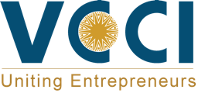 Australian Aid logo 

Contents

Executive summary 7

Acronyms 8

About this project 10

Part 1: Introduction 12

1. Background 12

2. Purpose of this guidance 13

3. The tourism industry in Vietnam 14

4. Responsible business conduct and sustainable tourism in Vietnam 16

Part 2: Business and human rights: Key developments and frameworks 18

1. Overview of the human rights framework 18

2. International framework on human rights and business 21

3. National framework on human rights and business 27

Part 3: Rights at risk: Key challenges for the tourism industry in Vietnam 31

1. Labour rights 32

2. Human trafficking and sexual exploitation 36

3. Human rights and the environment 37

4. Land rights and cultural rights 40

5. Other challenges for the tourism industry 41

6. COVID-19 recovery 43

Part 4: How should business respond? 44

1. Develop a policy commitment 46

2. Conduct human rights due diligence 49

3. Use the UN Guiding Principles process of human rights due diligence 51

4. Ensure access to an effective remedy 66

Part 5: Putting principles into practice in the tourism industry 71

1. Focus on risks to people 71

2. Place human rights at the heart of business operations, strategy and culture 72

3. Engage and listen to rights-holders and other stakeholders 72

4. Build relationships for collective action 74

Executive summary

Tourism plays an important role in Vietnam’s economy by creating jobs, infrastructure, and market opportunities. It can also assist in fostering greater mutual understanding across cultures, regions and nations. However, the tourism sector can also create significant challenges for the promotion, protection and realisation of human rights. Given the diversity within the tourism industry and its extensive footprint, the risks associated with the tourism sector are extensive and will vary from business to business. A range of human rights risks exist for workers, local communities and tourists.

Globally, there is an increasing expectation that businesses will operate responsibly and sustainably, based on a core respect for human rights. Following the unanimous endorsement of the United Nations Guiding Principles on Business and Human Rights (UN Guiding Principles) by the UN Human Rights Council in 2011, there is a growing focus on responsible business conduct among governments, business, investors, civil society and unions. This has led to numerous legal, policy and practical developments globally and in the ASEAN region.

As a tourism destination that is growing in importance and market share, the tourism industry is one of Vietnam’s most important service industries. Yet, like most countries around the world, Vietnam’s tourism industry has been significantly impacted by the COVID-19 pandemic. As the industry looks to rebuild towards pre-pandemic levels, now is a critical time to ensure that human rights are placed front and centre in recovery efforts. This guidance seeks to support business to emerge from the pandemic in a responsible and sustainable manner by assisting them to understand the key human rights challenges in the tourism industry and how to respond appropriately.

Acronyms

AHRC Australian Human Rights Commission

AICHR ASEAN Intergovernmental Commission on Human Rights

ASEAN Association of Southeast Asian Nations

COP26 26th Conference of the Parties (UN Climate Change Conference in Glasgow)

CSR Corporate Social Responsibility

DFAT Department of Foreign Affairs and Trade

EVFTA EU-Vietnam Free Trade Agreement

GCNV Global Compact Network of Vietnam

GSO General Statistics Office

ICCPR International Covenant on Civil and Political Rights

ICESCR International Covenant on Economic, Social and Cultural Rights

ILO International Labour Organization

IATA International Air Transport Association

ITUC International Trade Union Confederation

MOLISA Vietnam Ministry of Labour, Invalids and Social Affairs

NAP National Action Plans

NCP National Contact Points

NGO Non-government Organisation

NHRI National Human Rights Institution

OECD Organisation for Economic Co-operation and Development

OHCHR Office of the High Commissioner for Human Rights

SDGs Sustainable Development Goals

UDHR Universal Declaration of Human Rights

UN United Nations

UNDP United Nations Development Programme

UNGC United Nations Global Compact

UNGPs United Nations Guiding Principles on Business and Human Rights

VCCI Vietnam Chamber of Commerce and Industry

VGCL Vietnam General Confederation of Labour

VNAT Vietnam National Administration of Tourism

About this project

This guidance was developed under the ‘Advancing Responsible Business Conduct Project’, a collaboration between the Vietnam Chamber of Commerce and Industry and the Australian Human Rights Commission. This project aims to strengthen business capability and cultivate future business leaders to promote responsible business conduct and respect for human rights in Vietnam. The project is supported by the Australian Government’s Department of Foreign Affairs and Trade (DFAT). The views expressed in this guidance are the authors’ alone and are not necessarily the views of the Australian or Vietnamese Government.

The **Vietnam Chamber of Commerce and Industry (VCCI)** is the only national organisation that assembles and represents the business community, employers and business associations in Vietnam for the purpose of developing, protecting, and supporting the business community. This contributes to the country's socio-economic development, promoting economic, trade, science and technology cooperation with foreign countries on the basis of equality and mutual benefit, according to regulation of the law.

The **Office for Business Sustainable Development (SDforB)** is an office of VCCI with the function of supporting businesses and entrepreneurs in sustainable development. Through the work of SDforB and related teams, VCCI is actively involved in efforts and initiatives to promote responsible business conduct and corporate responsibility to respect human rights in Vietnam.

**The Australian Human Rights Commission (AHRC)** is Australia’s national human rights institution (NHRI), established in 1986 by legislation of the Federal Parliament. The AHRC’s operations are determined independently of the government by its President and Commissioners. The AHRC’s role is to work towards an Australia in which human rights are respected, protected and promoted, finding practical solutions to issues of concern, advocating for systemic change and raising awareness across the community. The AHRC provides human rights analysis to courts and parliamentary inquiries, conducts research, and contributes to national and international partnerships to promote and protect human rights. The AHRC also has a complaint-handling function which requires it to investigate and, where appropriate, try to conciliate complaints made under federal anti-discrimination laws.

In addition to its public education, complaint handling and policy functions, the AHRC plays a role in advancing the protection and promotion of human rights in the Indo-Pacific region and globally by engaging and partnering with governments, other NHRIs, international non-government organisations (NGOs) and donors through regional meetings, capacity-building activities and bilateral cooperation programs. The AHRC is pleased to be partnering with the VCCI for this project in Vietnam.

Part 1: Introduction

## Background

Vietnam’s economy has grown and evolved significantly over the last 30 years. Economic and political reforms have propelled Vietnam’s integration into the global economy and elevated its status to a lower middle-income country.[1] This rapid economic growth has been driven by the success of several industries, including in the services sector and, specifically, tourism.[2] Tourism plays an important role in the Vietnamese economy by creating jobs, infrastructure, and market opportunities. It can also assist in fostering greater mutual understanding across cultures, regions and nations. However, the tourism sector can also create significant human rights challenges for the promotion, protection and realisation of human rights.

Globally, there is an increasing expectation on businesses to operate responsibly and sustainably, based on a core respect for human rights. Following the unanimous endorsement of the United Nations Guiding Principles on Business and Human Rights (UN Guiding Principles) by the UN Human Rights Council in 2011, there is growing focus on responsible business conduct amongst governments, business, investors, civil society and unions. This has led to numerous legal, policy and practical developments globally and in the ASEAN region.

Vietnam is a tourism destination that is growing in importance and market share, regionally and internationally. As such, the tourism industry is one of Vietnam’s most important service industries. Yet, as in most countries around the world, Vietnam’s tourism industry has been significantly impacted by the COVID-19 pandemic. As the industry looks to rebuild towards pre-pandemic levels, now is a critical time to ensure that human rights are placed front and centre in recovery efforts. This guidance seeks to support business to emerge from the pandemic in a sustainable manner by assisting them to understand the key human rights challenges in the industry and how to respond appropriately.[3]

## Purpose of this guidance

The purpose of this introductory guidance is to highlight some of the human rights challenges and issues that arise in the tourism industry in Vietnam and provide practical advice for businesses in the tourism sector to meet their responsibility to respect human rights.

This guidance is relevant and appropriate for local and international businesses operating in Vietnam in the tourism sector, including but not limited to accommodation, transport, attractions, events and conferences, retail, food services, wellness, information services and online services. While the primary focus of this guidance is to assist businesses in the formal tourism sector in Vietnam, it is also important to recognise that the value chain of such businesses includes many enterprises, such as micro- and sole traders. While the concepts and principles contained in this guidance are applicable for businesses of all sizes, small businesses operating in the sector will likely need more tailored guidance and support.

This guidance provides general information only and is not intended to constitute legal advice. Organisations or individuals should seek their own legal advice if they have concerns regarding their compliance with domestic legislation or international standards. Any case studies or examples are included for educational purposes and do not constitute an endorsement of the company or organisation mentioned.

This guidance is produced in Vietnamese and English.

## The tourism industry in Vietnam

According to the World Bank, Vietnam is ‘one of the most dynamic emerging countries in East Asia region’.[4] Over the past years the tourism and travel sector has substantially increased its contribution to Vietnam’s GDP from 6% in 2013 to 7.9% in 2017.[5] Given this contribution, and the relationship with other sectors such as retail and hospitality, the sector has been prioritised by the Government of Vietnam as a key driver of economic growth and socio-economic development.[6] Prior to the onset of the COVID-19 pandemic, the tourism sector’s contribution to gross domestic product (GDP) had been growing annually, reaching a 9.2% share of direct GDP in 2019.[7] In 2019, the sector’s contribution to employment in Vietnam was 2.55 million jobs.[8]

However, as in many countries, Vietnam’s tourism industry has been severely impacted by COVID-19. In 2020, due to the impacts of COVID-19, Vietnam welcomed just 3.7 million international tourists – a sharp fall of 80% compared to 2019 – and 56 million domestic tourists, a decrease of 34% on the previous year.[9] While Vietnam has re-opened its borders to international visitors, the industry’s recovery is likely to be slow and many businesses in both the formal and informal sector are struggling to re-emerge.[10]

Tourism is a broad, complex and diverse industry in Vietnam. Figure 1 provides a high-level overview of the key components that makeup the tourism value chain. Across each component of the value chain, businesses range from multinational companies to localised, family-operated micro-businesses. The tourism sector also includes a mix of public and private actors. Increasingly, tourism-related goods and services are being delivered via the ‘gig’ or platform economy.[11]

##### Components of the tourism industry

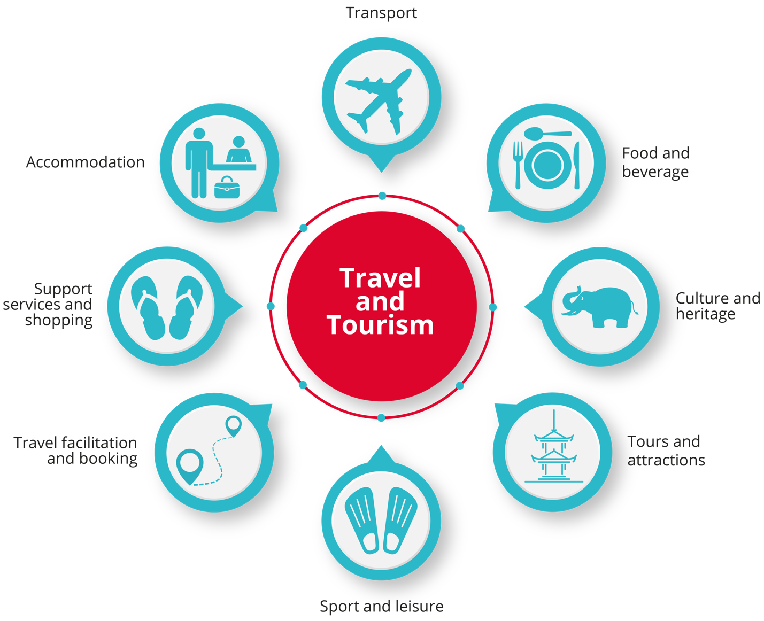

## Responsible business conduct and sustainable tourism in Vietnam

**What is responsible business conduct?**

According to the Organisation for Economic Co-operation and Development (OECD), responsible business conduct means businesses making ‘a positive contribution to the economic, environmental and social progress of the countries in which they operate and avoid[ing] and address[ing] negative impacts of their activities, including in the supply chain’.[12]

Being a responsible business means preventing and remedying the ‘adverse’ impacts of your activities and operations, while contributing to the sustainable development of the countries in which you operate. This expectation applies to all businesses, regardless of their size, sector, structure, location, ownership or legal status.

At the heart of responsible business conduct and practice is respect for human rights.

Vietnam has been taking positive steps to create an environment that supports the tourism industry to be sustainable, responsible and respectful of human rights. The Vietnam Tourism Development Strategy to 2030 was adopted on 21 January 2020. The Strategy aims to develop sustainable and inclusive tourism, on the basis of green growth, to maximise tourism’s contribution to Vietnam’s realisation of the United Nations’ Sustainable Development Goals.[13]

In recent years, Vietnam has also engaged in numerous reform processes to ensure greater adherence to international human rights and labour standards. For example, the Vietnam Ministry of Justice, in collaboration with the United Nations Development Programme (UNDP) and the Government of Sweden, released The Preliminary Assessment of the Regulatory Framework on Responsible Business Practice in Viet Nam (Preliminary Assessment) in October 2020.[14] The Preliminary Assessment provides a stocktake of the alignment of the regulatory framework in Vietnam with international standards on responsible business conduct. This is an important step towards developing a National Action Plan on Business and Human Rights.[15]

The tourism industry and related activities in Vietnam are regulated at both a national and provincial level. The Vietnam National Administration of Tourism (VNAT), operating under the Ministry of Culture, Sports and Tourism, is the Vietnamese government agency which manages tourist operations and activities throughout the country. It has full control of regulations relating to business development, planning, personnel training, and instructing and inspecting the implementation of policies and other regulations in the tourism sector. Tourism is also the local responsibility of the Provincial Departments of Culture, Sports and Tourism. These agencies work together with other relevant bodies (such as those managing security, agriculture, labor etc.), to formulate the policy framework within which national and regional tourism operates.[16]

Part 2: Business and human rights: Key developments and frameworks

## Overview of the human rights framework

Human rights are important for everyone, all over the world.

Human rights recognise the inherent value of each person, regardless of our background, where we live, what we look like, what we think or what we believe.

Human rights are about being treated fairly, treating others fairly and having the ability to make genuine choices in our daily lives. Respect for human rights is the cornerstone of strong communities in which everyone can contribute and feel included.

Since the founding of the UN in 1945, many governments around the world have agreed to a set of common standards for upholding human rights. These standards are based on principles of dignity, equality and mutual respect, which are shared across cultures, religions and philosophies.

The human rights standards agreed to by governments are outlined in three core UN documents, which together form the ‘International Bill of Human Rights’:

1. **The Universal Declaration of Human Rights** (UDHR), adopted by the United Nations in 1948, recognises the basic rights and fundamental freedoms to which all human beings are entitled. It has become a foundation document that has inspired many legally binding international human rights instruments.
2. **The International Covenant on Economic, Social and Cultural Rights** (ICESCR) was adopted by the United Nations General Assembly in 1966 and ratified by Vietnam in 1982.
3. **The International Covenant on Civil and Political Rights** (ICCPR) was adopted by the United Nations General Assembly in 1966 and ratified by Vietnam in 1982.

International human rights law obliges States Parties to respect, protect and promote the human rights of individuals within their territory or jurisdiction.[17] Human rights include civil and political rights – like the right to vote and the right to freedom of speech; and economic, social and cultural rights – like the right to social security and the rights to speak your language and practise your religion. The right to work is set out in the UDHR, with Articles 6 and 7 of ICESCR outlining the right to access to livelihood, right to work and right to just and favourable conditions of work.[18]

**International human rights instruments and Vietnam**

Vietnam has ratified the following international human rights instruments:

* International Covenant on Civil and Political Rights
* International Covenant on Economic, Social and Cultural Rights
* Convention on the Elimination of All Forms of Discrimination against Women
* Convention on the Rights of the Child (and its Optional Protocols)
* Convention on the Rights of Persons with Disabilities
* Convention on the Elimination of All Forms of Racial Discrimination
* Convention against Torture and Other Cruel, Inhuman or Degrading Treatment or Punishment.

##### RightsApp

The full text of the human rights instruments to which Vietnam is a party are available on **RightsApp**, a smartphone application.

To download RightsApp search for ‘[RightsApp](https://apps.apple.com/au/app/rightsapp/id1175228227)’ in your Apple or Google Play Store.

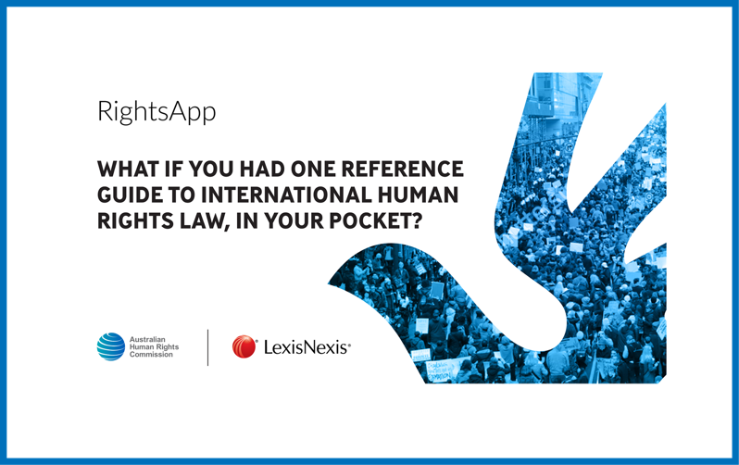

Labour rights framework

In parallel with the human rights system, the International Labour Organization (ILO) brings together governments, employers and workers to set labour standards, develop policies and devise programs promoting decent work for all.[19] Vietnam re-joined the ILO in 1992.[20] The ILO has developed many legal standards and instruments to protect and advance the rights of workers. A key ILO instrument is the Declaration on Fundamental Principles and Rights at Work,[21] which outlines that member states are obliged to respect, promote and realise the principles of four fundamental rights:

1. freedom of association and the effective recognition of the right to collective bargaining
2. elimination of forced labour or compulsory labour
3. abolition of child labour
4. elimination of discrimination in respect of employment and occupation.

These rights are further developed in the ILO’s eight Fundamental Conventions and other goverance and techical conventions.[22] As of July 2022, Vietnam has ratified 25 ILO Conventions, which include seven of the eight Fundamental Conventions, three of the four Governance Conventions and 15 of 178 technical Conventions.[23]

In addition, the ILO has adopted instruments on working conditions in tourism, including Convention No. 172 Concerning Working Conditions in Hotels, Restaurants and Similar Establishments (1991); and ILO Guidelines on Decent Work and Socially Responsible Tourism (2017). The ILO Guidelines on Decent Work and Socially Responsible Tourism provide a framework for the promotion and protection of labour rights and decent work in the tourism industry that will ultimately enhance its sustainability and overall contribution to the achievement of the Sustainable Development Goals.[24]

## International framework on human rights and business

The business and human rights landscape has evolved significantly over recent decades. Driven by increased globalisation, liberalisation of markets, new societal demands and technological developments, the role of business in society has become more prominent. As a result, there has been increased attention on the impact of businesses in society, including their relationship to human rights.

All human rights are relevant to all businesses, including those operating in the tourism industry. The activities of a business can have an impact – both positive and negative – on many people, including employees, customers, suppliers and their employees, and communities in which a business operates.

Globally, businesses are increasingly recognising that respecting human rights is not only the right thing to do, but also good for business. Increasingly, consumers, investors and governments are all expecting businesses to operate in a responsible and sustainable manner. There is growing evidence of the social and economic value for a company that embeds human rights considerations into its core business practices, and the significant costs and reputational risks when human rights are ignored.[25] Respecting human rights is not just about risk management, it can also create new business opportunities, including access to markets, capital, suppliers and consumers.

**Business case for respecting human rights**

* Minimise legal, reputational and operational risks
* Strengthen the business competitive advantage
* Create an environment that attracts, retains and motivates employees
* Attract ethically-concerned investors and consumers
* Strengthen relationships with relevant stakeholders including customers, suppliers and local communities

The UN Guiding Principles on Business and Human Rights

In June 2011, the UN Human Rights Council unanimously adopted the UN Guiding Principles on Business and Human Rights (UN Guiding Principles). The UN Guiding Principles provide a global standard for addressing and preventing human rights impacts associated with business activity. Their endorsement signalled the first time the global community agreed to a common understanding of the relationship between business and human rights, outlining the roles and responsibilities of nation States and business.

The UN Guiding Principles operate on a three-pillar framework, known as the Protect, Respect, Remedy Framework, which consists of:

* State duty to protect human rights
* Corporate responsibility to respect human rights
* Access to appropriate and effective remedy for victims of business-related abuse.

The responsibility to respect human rights is a global standard of expected conduct for all business enterprises wherever they operate. It exists independently of States’ abilities and/or willingness to fulfil their own human rights obligations, and does not diminish those obligations. And it exists over and above compliance with national laws and regulations protecting human rights.

Commentary to UN Guiding Principle 11

The UN Guiding Principles are now the global standard for preventing and addressing adverse human rights impacts related to business. Nearly a decade after their adoption, the UN Guiding Principles have been implemented into law, policy and practice around the world. The widespread and rapid uptake of the UN Guiding Principles, and other key frameworks outlined below, has underlined the increasing expectation on companies to operate in a sustainable, responsible and respectful manner.

**How is this different from corporate social responsibility?**

Corporate social responsibility (CSR) is often viewed as a voluntary commitment, philanthropic exercise, or a form of self-regulation. While there is no universal definition of CSR, and its practice varies widely, CSR efforts tend to focus on making a positive contribution to society by helping certain causes. It is often seen as an ‘add-on’ and exists separately to core business functions and operations.

Unlike optional CSR approaches, the business responsibility to respect human rights, as enshrined in the UN Guiding Principles, requires businesses to investigate and address the potential or actual human rights impacts of their operations. It requires embedding policies and practices into business operations and strategies.

A key component of the UN Guiding Principles is that a business cannot offset its human rights responsibilities: a business cannot negate its responsibilities in one area by doing good in another.

Other relevant frameworks

The UN Guiding Principles do not operate in isolation. A number of other relevant and complementary frameworks need to be considered by businesses.

* **The OECD Guidelines for Multinational Enterprises** (OECD Guidelines) are recommendations for multinational companies on responsible business conduct. The OECD Guidelines provide a global framework and articulate responsible business conduct standards across a range of issues, including human rights, labour rights and the environment. The OECD Guidelines were revised in 2011 to ensure alignment with the UN Guiding Principles. The OECD Guidelines apply the UN Guiding Principles’ concept of due diligence (which will be discussed further in Part 4) to all aspects of corporate responsibility.[26] The OECD Guidelines require adhering States to develop grievance mechanisms to address complaints by individuals who feel negatively impacted by irresponsible business conduct by relevant companies. The grievance mechanisms established by States are called National Contact Points (NCPs) and can be accessed by anyone who considers that the standards articulated in the OECD Guidelines have been breached. While Vietnam is not an adhering country to the OECD Guidelines, it has participated in various forums and regional programs organised by the OECD, including a joint project on promoting responsible supply chains in Asia.[27]
* **Sustainable Development Goals** **(SDGs)** were adopted by the UN General Assembly in September 2015. The SDGs provide a blueprint for a sustainable and just future for all by 2030 and call for concerted action by States, business and civil society to end poverty and promote equality.[28] The SDGs have placed a spotlight on the role of business in advancing social goals and outcomes. They specifically emphasise the role of business as a key partner, calling on all businesses to apply their creativity and innovation to solving sustainable development challenges’.[29] Acknowledging the role of business as a driver of economic development and infrastructure, the SDGs explicitly call for business to act in accordance with the UN Guiding Principles.[30] Vietnam adopted the National Action Plan to implement the 2030 Agenda for SDGs through the Prime Minister’s Decision 633/QD-TTg on 10 May 2017.[31]
* **The UN Global Compact**, adopted in 2000, is the world’s largest corporate sustainability initiative. It is a voluntary initiative that seeks to align business operations and strategies with ten universally accepted principles in the areas of human rights, labour, environment and anti-corruption. In Vietnam, implementation of the UN Global Compact’s Ten Principles is driven by the local network, the Global Compact Network of Vietnam (GCNV). GCNV was launched in 2007 by VCCI and the United Nations in Vietnam. The goal of GCNV is to be a national centre of excellence for corporate responsibility. The GCNV seeks to identify challenges and solutions related to interactions between business and the community, environment, government and consumers, in order to advance corporate sustainability and contribute to the achievement of the SDGs. By signing up to the UN Global Compact, a business is making a commitment to uphold and implement the UN Global Compact’s Ten Principles. The UN Guiding Principles and the OECD Guidelines provide the practical tools and actions to make this possible.

## National framework on human rights and business

A decade after their endorsement by the UN Human Rights Council, the UN Guiding Principles are increasingly being embedded into law, policy and practice globally. Following a call from the UN Human Rights Council for all Member States to develop National Action Plans on business and human rights (NAPs),[32] a number of countries worldwide have been engaging in processes to develop NAPs to support the implementation of the UN Guiding Principles and drive responsible business conduct. Notably, several countries have explicitly addressed the risks and challenges posed by the tourism industry in their NAPs. For example, Poland’s NAP commits to amending legislation to address sexual exploitation of minors in the hospitality industry, and the German NAP commits to providing increased financial support for the Round Table on Human Rights in Tourism.[33]

**National Action Plans on Business and Human Rights in Asia**

While many of the earlier NAPs on business and human rights were developed in Europe, an increasing number of countries in Asia are engaging in the process, signalling the drive within the region to increase the quality of foreign direct investment and ensure that economic growth is achieved in a sustainable and rights-respecting manner.

Following an extensive and wide-ranging consultation process, Thailand was the first country in Asia to publish a stand-alone NAP on business and human rights in 2019. Since then, a number of Asian countries have published a NAP including Japan, Taiwan and Pakistan. In addition, South Korea has a chapter on business and human rights within its broader human rights national action plan. Many other countries in the region have committed to developing a NAP, including India, Indonesia, Malaysia, Mongolia and the Philippines.

In Vietnam, the Ministry of Justice is working with UNDP to develop its NAP.[34]

In addition, business and human rights has become a priority area for the ASEAN Intergovernmental Commission on Human Rights (AICHR). Through its meetings and workshops, AICHR has provided an important platform for governments in the ASEAN region to learn from each other, particularly in relation to the development of NAPs.

In addition to the development of NAPs, some countries have introduced national legislation to mandate corporate transparency or human rights due diligence. Given the global footprint of the tourism industry, many businesses outside of these jurisdictions will be affected and will have to engage with the legislation in some manner. For example, businesses that are in the value chains or have a business relationship with a reporting entity will be asked what they are doing to identify, address, and remedy their human rights risks and impacts.

**Legislative developments**

There is growing momentum from countries around the world to develop legislation that requires businesses to ‘know and show’ they respect human rights.

The content and scope of these laws varies from country to country. For example, some legislation is issue-specific, focusing on areas such as modern slavery or child labour, while other laws cover all human rights and environmental issues. Some legislation is focused on reporting (for example, Australia and the United Kingdom have modern slavery legislation), whereas other laws require businesses to engage in the process of human rights due diligence (such as the French Duty of Vigilance Law). Examples include:

* Australia: Modern Slavery Act 2018 (Cth), Modern Slavery Act 2018 (NSW)
* France: French Corporate Duty of Vigilance Law 2017
* United Kingdom: Modern Slavery Act 2015
* United States: California Transparency in Supply Chains Act of 2010 (SB 657)
* Netherlands: Child Labour Due Diligence Act 2019
* EU: EU Directive on Non-Financial Disclosures (Directive 2014/95/EU)
* Germany: Act on Corporate Due Diligence in Supply Chains 2021 (which will enter into force in 2023)
* Norway: Norwegian Transparency Act 2022

In addition, the EU Commission is currently developing a Directive on Corporate Sustainability Due Diligence, which would require EU Member States to legislate mandatory corporate human rights and environmental due diligence.

Part 3: Rights at risk: Key challenges for the tourism industry in Vietnam

Following the introduction of the UN Guiding Principles, businesses are expected to ‘know and show’ that they respect human rights in their operations, activities and relationships. This section is designed to assist businesses working in the tourism sector in Vietnam to understand and identify key human rights risks that may exist in their operations, supply chains or business relationships.

Given the diversity within the tourism industry and its extensive footprint, the risks associated with the tourism sector are extensive and will vary from business to business. As such, the human rights risks outlined below should be seen as a starting point, rather than a definitive list.

In addition, there are some groups of people that experience heightened vulnerability and may therefore be at greater risk of discrimination, exploitation and/or abuse. In the tourism industry in Vietnam, these groups include women, children, ethnic minority and Indigenous communities, persons with disabilities and migrant workers (including internal migrants). Special consideration must be given to these groups when considering potential business impacts on workers, local communities and tourists. The attributes of these groups and the challenges they face do not exist in isolation and may intersect with each other, further impacting the ability of individuals to push back against power or abuse. For example, it can be the interplay of migrant status and gender that makes migrant women particularly vulnerable to exploitative recruitment and working conditions.[35]

## Labour rights

A number of labour-related risks may arise for businesses operating in the tourism sector.[36] The COVID-19 global pandemic has both highlighted and exacerbated the precarious and insecure nature of work within the tourism industry. The complex, seasonal and labour-intensive nature of the sector, and the predominance of small businesses, has meant that employment is often precarious in nature and unregulated. Furthermore, the sector often relies on seasonal work, shift work, and unskilled labour.[37] This creates challenges related to working conditions, wages and the ability for workers to organise collectively. It also creates greater worker vulnerability to discrimination, abuse and/or exploitation. In addition, unethical recruiters may take advantage of workers by charging a fee and/or tying workers into a contract which requires them to pay a percentage of their salary.[38] Given these workers are generally in low paying roles, this burden can be significant. The ‘Employer Pays Principles’ have created a growing expectation that no worker should have to pay for a job.[39] For instance, Kempinski Hotels and Radisson Hotels have a public policy aligning with the ‘Employer Pays Principles’.[40]

Child labour is also common in the tourism industry, particularly in family businesses in the informal economy where, in Vietnam as elsewhere, it goes largely unreported and unrecorded.[41] The ILO and UNICEF have warned that the socio-economic and financial impacts of the COVID-19 pandemic may push more children into the workforce.[42]

In Vietnam, the Constitution (2013) recognises that workers shall be provided with ’equal and safe conditions of work’ and prohibits discrimination, forced labour, and employment of workers under the minimum age of labour.[43] The Labour Code (2019) and relevant related legislation provides regulation on matters such as working time, including working hours, rest breaks while working, social insurance and occupational safety and health. Despite this, labour rights remain one of the most significant risks for the tourism industry.

The following table is designed to assist businesses to identify labour-related risks to workers within its operations and supply chain.

Labour rights risk identification table

|  |  |
| --- | --- |
| Wages | * Does my business and our business partners (including suppliers) pay workers a living wage? That is, an income that enables a decent standard of living for the worker and their family. |
| Occupational health & safety | * Has our business and/or our business partners conducted an occupational health and safety assessment? * Do workers have access to necessary and appropriate personal protective equipment? * Do workers have the necessary skills, training and tools to conduct their work in a safe manner? |
| Working hours and conditions | * Do workers in our business and supply chains record their working hours and overtime work and do they have access to this record? * Do workers in our business and supply chains have access to appropriate meal breaks and rest? * Are workers compensated appropriately for overtime? |
| Freedom of association and collective bargaining | * Can workers in our business and supply chains form and join independent organisations without fear of retaliation or reprisals? * Are workers free to meet without management present? |
| Discrimination, harassment and bullying | * Are workers in our business and/or supply chains exposed to discrimination, harassment or bullying? * Are policies in place to prevent and address discrimination, harassment and bullying throughout the employment relationship? |
| Forced labour | * Are workers in our business and/or supply chains subjected to: * Restrictions on freedom of movement? * Withholding of wages or identity documents? * Physical or sexual violence, threats and intimidation? * Work in order to pay a fraudulent debt? |
| Child workers | * Does my business and our business partners verify the age of workers? * If younger workers are being legally engaged, is the work being undertaken safe, non-hazardous and age appropriate? |

**The Sustainable Hospitality Alliance’s Principles on Forced Labour**

Unfortunately, forms of modern slavery – such as forced labour, debt bondage and human trafficking – are prevalent in the tourism sector. No country is immune from these gross human rights violations, which affect all regions of the world.[44]

In 2018, the Sustainable Hospitality Alliance (formerly known as the International Tourism Partnership) launched the Principles on Forced Labour. The aim of the Principles is to ‘prioritise action to address the primary drivers of forced labour within the hotel industry’.[45]

The three principles are:

1. Every worker should have freedom of movement
2. No worker should pay for a job
3. No worker should be indebted or coerced to work[46]

The Sustainable Hospitality Alliance has also developed free online training to assist hotels in identifying modern slavery risks.[47]

## Human trafficking and sexual exploitation

The trafficking and sexual exploitation of women and children is a significant challenge within the tourism sector.[48] According to the ILO, sexual exploitation accounts for approximately 19% (4.8 million people) of all modern slavery cases globally.[49] Of these cases, the overwhelming majority of victims are women and girls (99%).[50] ECPAT’s 2018 review of Vietnam found that child sexual exploitation is a prevalent issue for the whole country.[51] In particular, the review warned that the trafficking of under-aged girls for child marriage is on the rise in the northern districts.[52]

Trafficking and sexual exploitation is frequently and unknowingly facilitated by tourism businesses, including by airlines, hotels and other forms of transportation.[53] As such, the risks associated with trafficking and other types of modern slavery must be front of mind for those operating in the tourism industry.

**Human Trafficking and the Airline Industry**

In 2018, the International Air Transport Association (IATA) unanimously approved a resolution denouncing trafficking in persons and committing to actions to identify and address trafficking.[54]

IATA has developed a range of materials and resources for airline staff including guidance material and an e-learning course.[55] IATA is also collaborating with airports and other stakeholders within the air transport sector to raise awareness and share resources and guidance material.[56]

One response available to tourism enterprises is to commit to the Code of Conduct for the Protection of Children from Sexual Exploitation (The Code). The Code is a voluntary commitment on the protection of children from sexual exploitation in the tourism sector. As of July 2022, the Code had 396 members across 245 countries, most of which were business enterprises in travel and hospitality.[57] Some tourism companies in Vietnam, such as Accor Hotels Vietnam, are members of The Code.[58]

## Human rights and the environment

Human rights are intrinsically linked to the environment in which people live. The UN Framework Principles on Human Rights and the Environment states that ’environmental harm interferes with the enjoyment of human rights, and the exercise of human rights helps to protect the environment and to promote sustainable development’.[59] In 2021, the UN Human Rights Council recognised for the first time that having a clean, healthy and sustainable environment is a human right.[60] In 2022, the UN General Assembly adopted a landmark resolution recognising the right to a clean, healthy and sustainable environment as a human right and calling for increased efforts worldwide to promote and protect that right for all.[61]

The tourism sector often relies on thriving and sustainable physical environments. Tourists travel to Vietnam to enjoy clean beaches, flourishing forests, abundant wildlife and mountain ranges. Yet, the environmental impacts of the tourism industry can be significant.[62] For example, activities related to tourism can lead to air and water pollution, depletion of natural resources, excessive waste and greenhouse gas emissions.[63]

The UN World Tourism Organisation defines sustainable tourism as ’tourism that takes full account of its current and future economic, social and environmental impacts, addressing the needs of visitors, the industry, the environment and host communities’.[64] Given the interconnected relationship between human rights and the environment, business must take steps to understand their environmental and social footprint. Undertaking a comprehensive process to identify, prevent and mitigate negative environmental impacts will not only preserve the natural environment, ensuring the long-term viability of the tourism sector, but will also ensure that the rights of local communities are not negatively impacted.

**The right to clean water**

Access to clean water and sanitation are internationally recognised human rights.[65] However, business activities related to the tourism sector can lead to water scarcity and contamination.[66] Climate change is also impacting the availability of water, often leading to a competition for scarce resources.[67] Those operating in the tourism sector have a vested interest in ensuring that they reduce their water consumption and eliminate contamination.

The UN Global Compact’s CEO Water Mandate seeks to establish a critical mass of business leaders to address global water challenges through corporate water stewardship, in partnership with the United Nations, governments, civil society organisations, and other stakeholders.[68] By endorsing the Mandate, businesses commit to advancing water stewardship across the six key areas of:

* Direct Operations
* Supply Chain & Watershed Management
* Collective Action
* Public Policy
* Community Engagement
* Transparency

## Land rights and cultural rights

Access to land is closely linked to the enjoyment of a wide range of human rights. The development of tourist facilities and infrastructure – such as hotels, parks or airports – may lead to the displacement of people, housing and, indeed, whole communities.[69] Such displacement may deny local communities access to natural resources including agricultural lands, forests, water and other essentials. Cultural rights are often closely connected to land.[70] When local communities are displaced, they lose access to traditional ways of living, farming and fishing resources, and traditional and sacred sites.[71] People in local communities in existing or emergent tourism destinations, particularly those living in poverty, may have little power or choice when faced with development projects. Any real or perceived power imbalance must be taken into consideration when engaging with communities and/or individuals around the use of land.

Vietnam has legal provisions that protect local communities from being displaced for development, including the Law on Land (2013), the Law on Environmental Protection (2014), and the Decree from the Ministry of Natural Resources and Environment covering compensation, support and resettlement options when the displacement occurs on state-related land. However, challenges exist in law and practice, particularly around the lack of free, prior and informed consent processes.[72]

Beyond the human rights impacts of displacement, tourism can have other socio-cultural and economic impacts at a local level. These can include the loss of identity and traditional ways of living and an increased cost of living for local communities.[73] The cultural rights and linguistic needs of local communities must be taken into consideration when engaging people from local communities in the planning and development of tourism projects.

## Other challenges for the tourism industry

The relationship between tourism and human rights is highly complex, yet the sector’s long-term viability and sustainability relies on embedding responsible business conduct standards and principles. It is important to understand some of the challenges that the industry is facing and the risks they create for the realisation of human rights.

**A diverse and complex industry**

Similar to other countries, in Vietnam the tourism industry is highly diverse, fragmented and complex. It relies heavily on small businesses, particularly in the informal sector, and many businesses outsource services such as cleaning and security.[74] This creates significant operational and regulatory challenges, especially for vulnerable people.

The industry is also interconnected with other industries including construction, retail and hospitality and therefore shares the risks of those industries.[75] For many businesses, understanding their role and responsibility in addressing human rights issues can be very challenging. Parts 4 and 5 of this guide will provide further insight into how businesses can respond to these challenges.

**Lack of human rights knowledge and awareness**

Unlike other industries, such as the apparel sector or agriculture, the tourism sector in Vietnam has faced less scrutiny and pressure around its human rights performance to date. All stakeholders, including government, industry and civil society, have a role to play in increasing both the industry’s and rights-holders’ knowledge, awareness and capacity in relation to human rights.

**Impact of climate change**

According to the UN World Tourism Organisation, ’the tourism sector is highly vulnerable to climate change and at the same time contributes to the emission of greenhouse gases, which cause global warming. Accelerating climate action in tourism is therefore of utmost importance for the resilience of the sector.’[76] A tourism industry that is not sustainable endangers the rights of those whose livelihoods depend on tourism, whether individuals or communities. Workers have, in many cases, committed to a career in tourism after leaving their traditional livelihoods, sometimes migrating elsewhere in the country or even seeing their villages and farms lost irretrievably to tourism development and infrastructure building. If tourism is unsustainable in their area or region, their ability to obtain decent and sustainable work may be at risk. Moreover, Vietnam as a whole is highly susceptible to the impacts of climate change. The Intergovernmental Panel on Climate Change (IPCC) has identified Vietnam as one of nine countries where at least 50 million people may be exposed to the impacts of rising sea levels, powerful storms and other threats associated with climate change.[77]

**The Glasgow Declaration: A Commitment to a Decade of Tourism Climate Action**

The Glasgow Declaration was launched at the COP26 UN Climate Change Conference in 2021. The Glasgow Declaration proposes a coordinated plan for tourism to support the global commitment to halve emissions by 2030 and achieve net zero by 2050.[78] By becoming a signatory, organisations are expected to make tangible commitments around planning, measuring and reporting their activities.[79] For more information, see: <https://www.oneplanetnetwork.org/programmes/sustainable-tourism/glasgow-declaration>.

## COVID-19 recovery

The impact of COVID-19 on tourism in Vietnam has mirrored that in most other countries of the world, with major business closures during periods of lockdown and the absence of international visitors negatively affecting the sector. Vietnam has also seen little and sporadic domestic travel during the 2020–2022 period, further impacting on enterprises and their employees. While employees in the formal sector may have benefited from a degree of employment protection and social welfare support, those in the informal sector have faced even greater challenges.

It is too early to estimate the long-term impact on tourism in Vietnam and the consequences that any changes may have for the human rights of individuals and communities that depend on the sector for their livelihoods. Given the impact of COVID-19 on the tourism industry, it may be tempting for businesses to recoup losses by cutting corners and adopting exploitative business practices.[80] However the social and economic impacts of the pandemic have highlighted the need for stronger safeguards and a people-centred approach to business activities.

Part 4: How should business respond?

It is now globally recognised that businesses have a responsibility to respect human rights. The UN Guiding Principles outline that, regardless of States’ abilities or willingness to protect human rights, businesses themselves must respect human rights, no matter their ‘size, sector, operational context, ownership and structure’.[81] This means that businesses should not infringe upon people’s human rights, and should address any adverse human rights impacts in which they are involved.[82]

The UN Guiding Principles state that businesses must:

* avoid causing or contributing to adverse human rights impacts through their own activities, and address such impacts when they occur; and
* seek to prevent or mitigate adverse human rights impacts that are directly linked to their operations, products or services by their business relationships, even if they have not contributed to those impacts.[83]

The purpose of this section is to assist your business to understand and discharge its responsibility to respect human rights.[84] This process will vary for each company depending on the type of business, its size and where it operates. However, at a minimum, it should include the business taking the following steps:

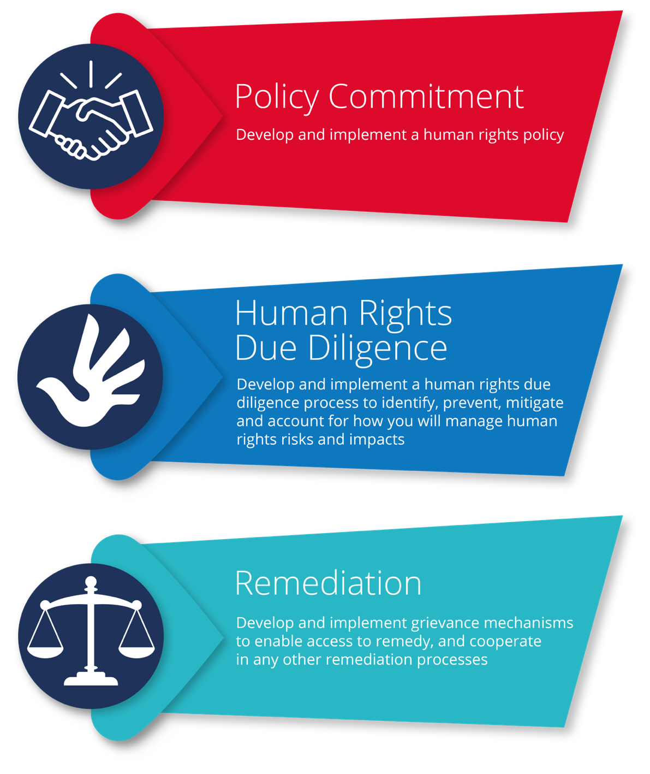

## Develop a policy commitment

Both the UN Guiding Principles and the OECD Guidelines highlight the need for a policy outlining your business’ commitment to human rights.[85] A policy commitment should clearly articulate your business’ position and expectations regarding human rights to employers and employees within the business, other businesses with which your business has a relationship, and external stakeholders. By developing a policy commitment and embedding it into your company’s operations, you will be indicating to all stakeholders, both internal and external, that your business takes human rights seriously.[86]

Before you start to develop your policy commitment, it is worth remembering that a human rights policy does not have a set template. It will vary in form from business to business and should be reviewed and developed over time.[87] Businesses may choose to make their policy a stand-alone document, or they may decide to include their human rights commitments in other policies or codes of conduct. Those businesses that have developed a stand-alone policy may have done so because their human rights risks are so widespread and significant that it warrants a stand-alone document.[88] For others, it sends a strong signal to their workers and the broader community about the seriousness with which the business is approaching the issue and provides an entry point for dialogue and discussion.[89] Ultimately, each business will have to determine which form is most appropriate to their situation.

It is generally unrealistic to expect everyone within your business to become a human rights expert overnight. As such, you may want to consider engaging input from external experts. It is important to note that input from experts should not come at the cost of engaging key stakeholders such as workers in your operations and supply chain. Rather, it should assist you by providing technical input on the process and potential issues that may arise.

##### Key actions for developing a human rights policy

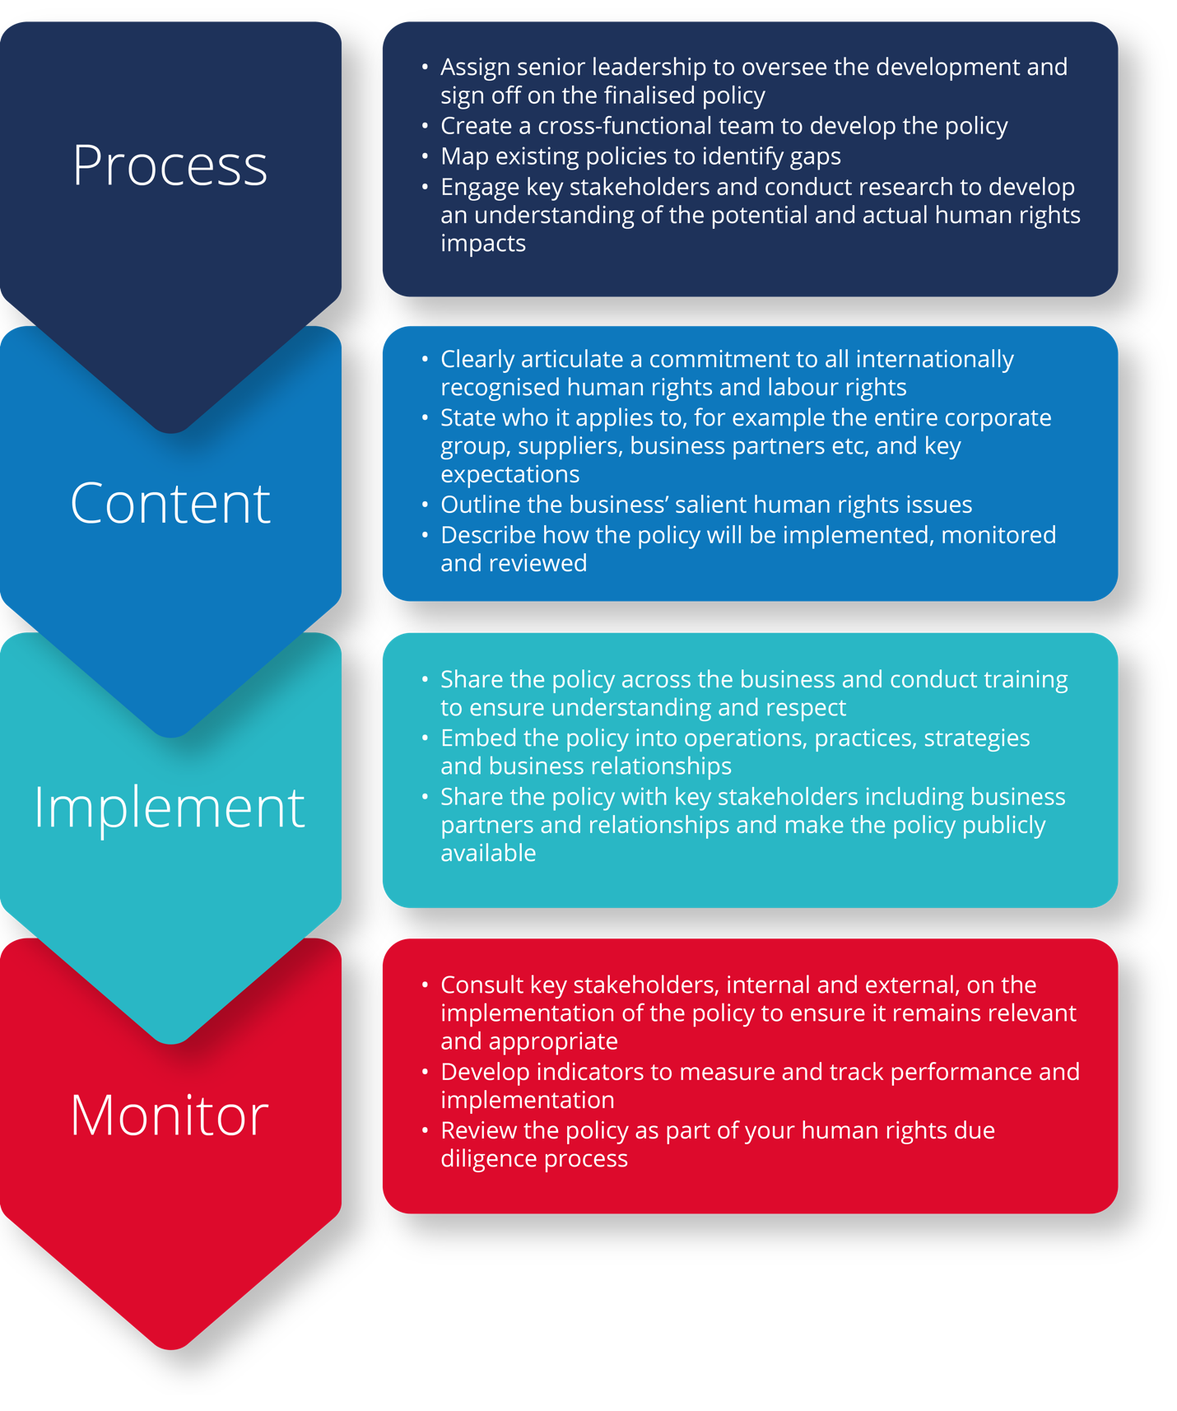

**Human Rights Policy: IHG Hotels & Resorts**

IHG Hotels & Resorts (IHG) has been operating in Vietnam for over a decade and has 14 hotels across four brands with another 15 properties in the pipeline (as of September 2021).[90]

IHG’s Human Rights Policy was significantly updated in 2019.[91] The company’s approach is informed by the OECD Guidelines, the UN Global Compact and the UN Guiding Principles.

IHG’s Human Rights Policy set out its human rights commitments in accordance with the Universal Declaration of Human Rights, the International Covenant on Civil and Political Rights and the ILO Declaration on Fundamental Principles and Rights at Work.[92] It also outlines its expectations of its business partners, particularly franchisees. The Human Rights Policy also outlines IHG’s commitment to providing remedy.[93]

The Human Rights Policy also refers to IHG’s Supplier Code of Conduct which outlines minimum standards to which suppliers should adhere.[94] Under the Supplier Code of Conduct, IHG suppliers are expected to respect human rights in accordance with the international human rights standards listed in its policy.[95] IHG expects suppliers to adhere to these standards both within their own business and across their supply chains.[96]

## Conduct human rights due diligence

A business’ responsibility to respect human rights is applied in practice through a process called human rights due diligence – a process through which your business can ‘know and show’ that it respects human rights.[97] The purpose of human rights due diligence is to identify, prevent, mitigate and account for any adverse human rights impacts your business might have on people.[98] Your human rights due diligence will be guided by your human rights policy.[99]

Human rights due diligence should not be confused with business due diligence, as these are separate concepts. While there is often overlap, human rights due diligence focuses on impacts the business has or may have on people, while business due diligence focuses on risks to the business. Human rights due diligence asks businesses to prioritise addressing potential human rights risks, regardless of whether there is a ‘business case’ for addressing those risks, or whether the risks are the easiest to address or getting the most attention.[100]

There are many types of business enterprises that operate in the tourism industry in Vietnam. Although they all have a responsibility to respect human rights, how this will be applied in practice will vary depending on the business. The scale and complexity of human rights due diligence will vary between businesses, depending on the size of the business, the type of business, its location/s, its sourcing models and its potential to cause adverse impacts on human rights. For example, a local tour operator with a staff of 50 operating in one region, will have a different approach and face different human right risks compared to a transnational travel company with operations and supply chains in multiple locations in Vietnam and globally.

In many business operations, some human rights may be more at risk than others, and therefore require greater attention in the due diligence process.[101] For example, a hotel may face greater human trafficking, sexual exploitation or labour exploitation risks and may therefore need to place greater emphasis on addressing these risks. Examples of some of the common types of human rights risks in the tourism industry are outlined in Part 3 of the Guide, and these issues will likely need to be considered by your business in developing your human rights policy and human rights due diligence processes. Where adverse human rights impacts are identified, they should be remediated (see Part 4.4 on access to an effective remedy).

## Use the UN Guiding Principles process of human rights due diligence

The UN Guiding Principles outline that the process of human rights due diligence involves four key steps:

##### UN Guiding Principles process of human rights due diligence

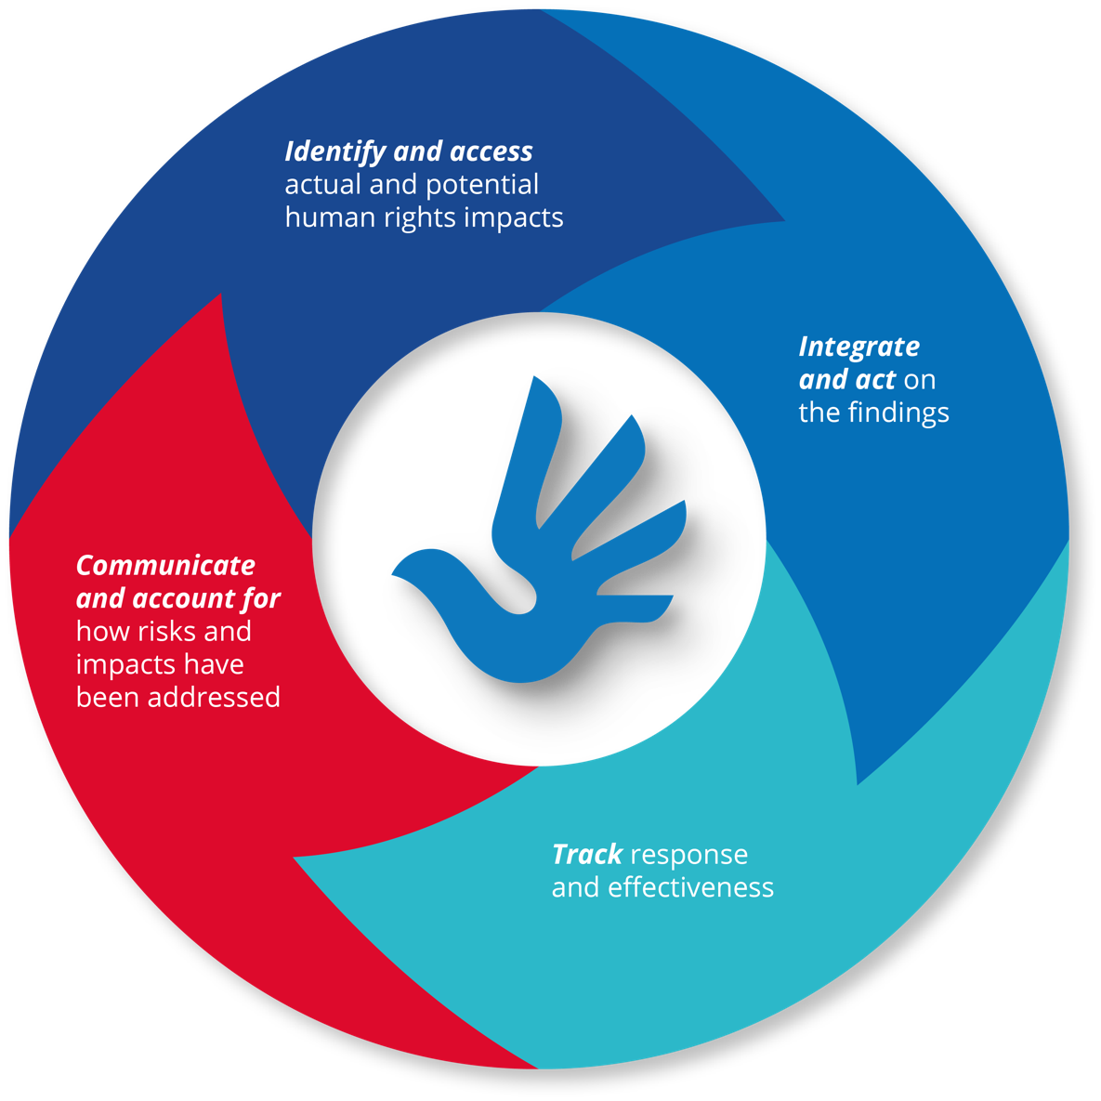

### Identifying and assessing human rights impacts

Human rights due diligence begins with identifying and understanding the human rights harms your business may be associated with. This involves assessing the actual and potential adverse human rights impacts that your business may be involved with through its activities, operations and relationships.[102]

To effectively identify potential risks and impacts, it is important to develop an understanding of your business’ structure and operations, including your supply chains. Understanding the structure of your business and your business relationships will assist you to develop an understanding of where risks may exist. For example, if you are tour operator and use a food and beverage provider, do you know where the food is being produced? Or where the raw materials are sourced?

Once you have a clear overview of your business and its relationships, it is time to begin the process of identifying what actual or potential adverse human rights impacts your business may be causing, contributing to or directly linked to. This process can take various forms, however it is often useful to begin by conducting research and engaging with internal and external stakeholders about potential risks and impacts. Engaging with rights-holders themselves, such as employees, workers in your supply chain, and communities or customers who may be affected by your business, is also critical to gain a better understanding of the situation.

For the tourism industry, it is recommended that you start by looking at your business operations and supply chains with regard to the human rights issues outlined in Part 3 to understand where there may be either risks of human rights impacts occurring, or actual instances of human rights impacts occurring.

**Supply chain risk analysis**

The Roundtable Human Rights in Tourism, an open network to support tourism businesses on their way to respecting human rights in tourism, has developed a list of potential human rights risks that may occur within the tourism supply chain focusing on specific stages and processes including retail and sales, tour operators, transportation, accommodation, food and beverage, and tourist activities.[103]

Some businesses may be able to address all their human rights risks at once. However, many businesses have complex structures, multifaceted projects and investments, and global supply chains with numerous tiers. Recognising these complexities, the human rights due diligence process does not ask businesses to address every human rights risk immediately, but rather to prioritise addressing their most severe human rights risks first.[104] For instance, the Intercontinental Hotels Group (IHG) identified what the business’ most severe potential human rights risks were, based on their scale, scope and whether and how they can be remediated,[105] and then elected to address modern slavery as a priority.[106]

**Industry-wide human rights and child rights impact assessment: Starwood Foundation, UNICEF and Article One**

Starwood Foundation partnered with UNICEF and Article One to conduct an industry-level human rights and child rights impact assessment in a popular tourism destination.[107] An industry-wide assessment examines the actual and potential human rights impacts of a particular industry within a geographical context, enabling stakeholders to see the ‘bigger picture’ of an industry’s impacts.[108]

This assessment focused on operational hotels in three popular markets. The methodology included:

* the establishment of a Stakeholder Advisory Board
* engagement with over 80 representatives from civil society, unions multilateral organisations, government, suppliers and industry associations
* engagement with over 350 rights-holders, including hotel employees, local children, indigenous community leaders and trafficking survivors[109]

In addition to seeking to understand and address the human rights risks and impacts of the industry, the assessment also sought to increase the tourism industry’s level of understanding of human and child rights risks.[110] As such, the project team engaged closely with the International Tourism Partnership (now the Sustainable Hospitality Alliance) to share findings and explore solutions.[111]

In addition to severity, the UN Guiding Principles also ask business to look at the likelihood of an impact occurring when considering a risk. It is important to note that a low likelihood of a severe human rights risk occurring does not necessarily mean the risk should be downgraded, especially where the harm to the person affected cannot be remediated.[112]

|  |  |
| --- | --- |
| Scale | The gravity of the impact on the human right(s) |
| Scope | The number of individuals that are or could be affected |
| Irremediability | The ease or otherwise with which those impacted could be restored to their prior enjoyment of the right(s)[113] |

The UN Guiding Principles outline that human rights due diligence is an iterative and ongoing process that takes into account the evolving nature of both businesses and human rights risks.[114] Once your business has addressed its most severe human rights impacts, the human rights due diligence process expects businesses to progressively take action to address other human rights impacts. As with other business risks, human rights risks should be assessed before key decisions are made such as commencing a new project or entry into a new market, launching a new product, or entering a new business relationship (for example with a supplier).[115]

**Identifying and assessing risks: a snapshot**

1. Develop a clear understanding of your business’ structure and operations, including supply chains.
2. Research key human rights issues for the sector, drawing information from media reports, international organisations, civil society organisations, industry associations, unions and academics. Also draw on internal information, for example from any existing grievance mechanisms.
3. Engage in meaningful consultation with potentially-impacted groups and stakeholders to develop a deeper understanding of possible risks and impacts.
4. Once you have mapped out the potential human rights issues, assess the risks based on severity and likelihood.

### Integrating the findings and addressing adverse human rights impacts

Once your business has identified and assessed its human rights impacts, the findings will need to be integrated into the business’ practices and processes, and appropriate action taken to ensure potential impacts are addressed and actual adverse human rights impacts are prevented.[116] In cases where actual adverse human rights have occurred, a business will need to be involved in remediation processes[117] (discussed below).

**Integrating the Findings of a Risk Assessment: Hilton Hotels and Resorts**

In 2019, Hilton Hotels and Resorts (Hilton) conducted an in-depth risk assessment related to the South Asia to Qatar migration corridor.[118] The assessment involved in-person interviews with recruitment agencies, candidates and operating hotels in Qatar. The risk assessment identified industry risks around recruitment fees. As a result, Hilton developed a new list of preferred labour suppliers which is reviewed on an annual basis.[119]

This phase within the human rights due diligence process requires businesses to examine internal procedures and processes to ensure that risks are addressed and, where impacts do occur, they can be addressed appropriately. Integration relates to the process of ‘taking the findings about a potential impact, identifying who in the enterprise needs to be involved in addressing it and securing effective action’.[120] What constitutes an appropriate response depends on the relationship to the harm. Your business may cause or contribute to adverse human rights impacts through your businesses’ own activities. Your business may also be ‘directly linked’ to human rights risks or impacts through business relationships, such as your business’ supply chains.[121]

**Understanding ‘cause’, ‘contribute’ and ‘directly linked’**

A business may cause an adverse human rights impact through its own operations. For example, underpaying its workers, engaging child labour or exploiting women in exchange for a promotion. In these situations, the business should take the necessary steps to prevent and cease these activities and provide remediation.

A business may contribute to an adverse human rights impact through its acts or omissions. For example, agreeing to a purchasing order with a supplier whose timeframe makes it impossible to complete the order without cutting corners and breaching human rights standards. In these situations, the business should take the necessary steps to cease or prevent its contribution and use its leverage to mitigate any impact. It should also take action to ensure remediation is provided.

Situations where a business is directly linked to an adverse impact become more complex. These involve situations where a business has not caused or contributed to an adverse impact, but that impact is linked to the business’ operations, products or services through its business relationships. For example, a supplier subcontracts work, without your knowledge, to a contractor that uses forced labour. In this scenario, if this business has leverage it should use it to prevent or mitigate the harm. If leverage does not exist, the business should look for ways to build it. In cases where a business is directly linked to an adverse impact, there is no direct responsibility under the UN Guiding Principles to provide remediation, however the business may take a role in doing so.

While the UN Guiding Principles outline these categories to assist in identifying a business’ relationship to a harm and an appropriate response, the nature of business operations means that, in practice, there is a continuum between these categories depending on the acts or omissions of the business. Your business’ risks may not always fit neatly into one of these categories.

**Understanding leverage**

Leverage is all about a business’ ability to influence others. The UN Guiding Principles states ‘leverage is considered to exist where the enterprise has the ability to effect change in the wrongful practices that causes harm’.[122]

**Addressing Systemic Issues: The TUI Group**

The TUI Group is a large tourism business and includes subsidiaries in a number of European countries as well as operating partners worldwide, including in Vietnam. In addition to its policy commitments and auditing and training programs, TUI has invested in initiatives to prevent young people and adolescents being trafficked and exploited.[123]

The TUI Care Foundation has partnered with Plan International to deliver training for young people in Vietnam to assist them in breaking the cycle of poverty and reduce the risk of future exploitation. The four-month training program includes two and a half months of vocational training at a local training centre, and a six-week paid internship in a training restaurant in Hué.[124] The initiative also includes business skill development and small loans for the young people to establish their own small businesses.[125] The aim is to assist the students to gain long term and good quality employment.[126]

Integrating and addressing risks: a snapshot

1. Review and revise policies, procedures and practices to ensure risks are appropriately addressed.
2. Ensure internal leadership, responsibility and accountability for addressing risks and impacts.
3. Allocate an appropriate budget to implement measures.
4. Train relevant staff on human rights, with a particular focus on your business’ most salient human rights risks.
5. Decide on actions to mitigate and manage risks and adverse human rights impacts where they are found.
6. Collaborate with stakeholders, peers, suppliers and/or purchasers on specific risks to your business and systemic issues.

### Tracking the effectiveness of your response

Monitoring and tracking activities are essential in helping your business to understand whether the measures you are taking to manage your human rights risks are effective.[127] There are a variety of ways your business can track its response. Tracking can be undertaken internally, by third parties or a combination of both.

To track performance, it is important to develop indicators that draw on both qualitative and quantitative data. Each type of data tells a different part of the story. For example, a worker complaint hotline may only have had two complaints in the last month. At face value, one may conclude that there are no issues, and the business is fully compliant with all human rights and labour standards. However, it is important to interrogate the lack of complaints in order to understand whether this reflects the reality on the ground or whether there are barriers that are preventing individuals from making a complaint or identifying risks. This scenario highlights the importance of having qualitative data to tell the story behind the numbers and figures.

Potential data sources include staff surveys and feedback to human resources, internal audits, supplier audits, grievance mechanisms and stakeholder feedback. When assessing effectiveness, it is important to engage with affected stakeholders to gain an understanding of whether their situation is improving and whether adverse impacts have been appropriately addressed. Although social auditing can be used as a tool to monitor the due diligence practice in the supply chain, this process alone is not sufficient to track human rights impacts.[128]

**Tracking Performance: TUI Group**

TUI Group is required to report under the UK Modern Slavery Act. To track the performance of its modern slavery efforts, the company has developed a number of indicators. These include:

* Number of customers staying in a Global Sustainable Tourism Council certified hotel
* Number of employees that have received human rights training
* Actions taken to strengthen the company’s policies
* Steps taken to strengthen supply chain due diligence and management
* Number of modern slavery cases reported, and actions taken in response
* Human right projects and partnerships in TUI Group’s destinations.[129]

**Tracking effectiveness: a snapshot**

1. Develop systems and indicators to track what mitigation and remediation actions are taking place and whether they are effective.
2. Draw on a range of qualitative and quantitative data sources including the perspective of potentially impacted stakeholders.
3. Learn from monitoring and tracking efforts, and integrate learnings into policies, processes and practices.

### Communicating how your company is addressing human rights impacts

The business responsibility to respect human rights also includes having processes and procedures in place that allow the business to ‘show’ their respect for human rights by communicating their efforts to assess and address their human rights impacts to stakeholders.[130] Communicating openly about your business’ efforts helps demonstrate transparency and accountability to affected individuals or groups (i.e., rights-holders) as well as to stakeholders, such as civil society and investors.[131]

The form of these communications can vary and may include in person and online meetings, reports and other documentation available on the business’ website or in hard copy.[132] Depending on who your stakeholders are, you may want to consider making this information available in different languages. For example, if your workers are primarily made up of migrant workers from another country, you should make the information available in their language. Or, if your workforce is primarily from mountainous and remote areas with poor literacy levels, it is important to think about other ways to communicate effectively. Businesses within the tourism industry should also consider how they communicate with customers and ensure that information is available in an accessible and culturally respectful manner.

There is a growing trend of enhanced transparency in the private sector. As discussed in Part 2, increasingly governments around the world are mandating that companies be more transparent about their human rights risks and impacts through publicly available reports. As a result, the public is receiving more information about how companies are identifying and addressing their human rights risks and impacts. However, analysis of the reports made available under various reporting regimes indicates that there is significant room for improvement as many reports only contain high-level information and fail to provide detailed information about specific risks and mitigation strategies.[133]

**Communicating how risks and impacts have been addressed: a snapshot**

1. Publicly report information related to your policies, strategies, processes and outcomes. Ensure this information is accessible and fit for purpose.
2. Engage with potentially impacted stakeholders on the human rights risks, impacts and mitigation strategies of your business in an appropriate manner taking into account language, culture and literacy.

**Additional guidance**

The UN Guiding Principles Reporting Framework, developed by Shift and Mazars, is a comprehensive guide to assist companies to report on human rights issues in line with their responsibility to respect human rights. It is available here:

[www.UNGPreporting.org](http://www.UNGPreporting.org)

## Ensure access to an effective remedy

‘Access to effective remedy’ is a core component of the UN Guiding Principles. Where business-related human rights harms occur, the UN Guiding Principles articulate three types of mechanisms to provide access to effective remedy: state-based judicial mechanisms, state-based non-judicial grievance mechanisms, and non-state-based grievance mechanisms. While effective state-based mechanisms are at the core of ensuring access to remedy,[134] this guidance is focusing on the role of business grievance mechanisms.

##### Access to remedy

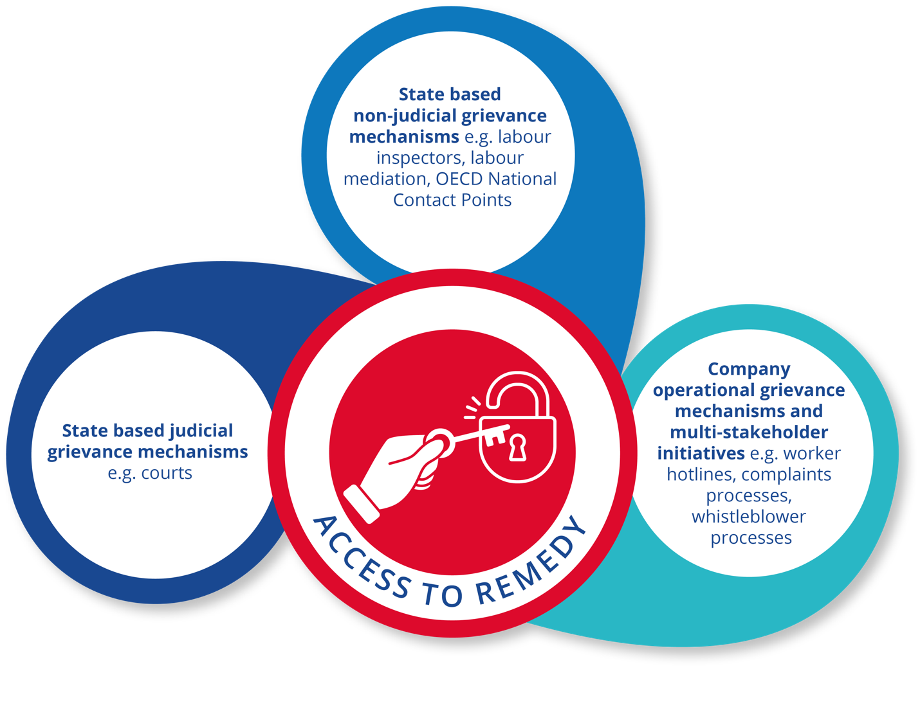

Remedy for an adverse human rights impact should include the process of providing the remedy, and the offer of something to counteract, or make good, the adverse impact.[135] Remediation can be achieved through a number of avenues, including restitution, compensation, satisfaction, rehabilitation, and guarantees of non-repetition.[136] It is critical to listen to the impacted individual or community to ensure that their needs are met and the harm they have suffered is restored.

The primary aim of human rights due diligence is prevention and mitigation, whereas remediation is a response to something that has already happened. Even with the most comprehensive due diligence process, a business may still cause or contribute to an adverse human rights impact. When this happens, that business must provide remediation for this impact on human rights.[137]

To make it possible for grievances to be addressed early and remediated directly, business enterprises should establish or participate in effective operational-level grievance mechanisms for individuals and communities who may be adversely impacted.

UN Guiding Principle, 29

Under the UN Guiding Principles, a business should establish accessible and appropriate systems to address grievances to ensure the remediation of negative impacts your company may have caused or contributed to. Having an effective grievance mechanism provides a direct line between an impacted individual or community and the business. This can enable a business to address a harm early before it escalates further. Going through the courts can also be a timely and expensive exercise. Examples of operational grievance mechanisms may include a confidential hotline, complaints box and an internal alternative dispute resolution process.

**Company operational grievance mechanism: IHG Resorts & Hotels**

IHG has established an independent and confidential channel where complaints can be made online or via the phone.[138] Those who can make a complaint include IHG employees and anyone with a relation to IHG including its suppliers and their workers.[139] Complaints can be made in relation to breaches of the company’s Code of Conduct which covers a broad range of issues related to human rights, the environment, fraud and theft, tax evasion and corruption and bribery.[140] Complaints can be made in any language and the complaints management system is administered on an external server. Complaints are then sent to a small group of IHG staff who are responsible for reviewing and respondingto the complaints.[141]

### Ensuring the effectiveness of operational grievance mechanisms

Article 31 of the UN Guiding Principles outlines a number of key criteria to consider when designing and implementing an operational grievance mechanism. According to the UN Guiding Principles, to be effective the grievance mechanism must be:

1. **Legitimate:** earning trust from the stakeholder groups for whose use they are intended, and being accountable for the fair conduct of grievance processes.
2. **Accessible:** being known to all stakeholder groups for whose use they are intended, and providing adequate assistance for those who may face particular barriers to access.
3. **Predictable:** providing a clear and known procedure with an indicative time frame for each stage, and clarity on the types of process and outcome available and means of monitoring implementation.
4. **Equitable:** seeking to ensure that aggrieved parties have reasonable access to sources of information, advice and expertise necessary to engage in a grievance process on fair, informed and respectful terms.
5. **Transparent:** keeping parties to a grievance informed about its progress, and providing sufficient information about the mechanism’s performance to build confidence in its effectiveness and meet any public interest at stake.
6. **Rights-compatible:** ensuring that outcomes and remedies accord with internationally recognised human rights.
7. **A source of continuous learning:** drawing on relevant measures to identify lessons for improving the mechanism and preventing future grievances and harms.
8. **Based on engagement and dialogue:** consulting the stakeholder groups for whose use they are intended on their design and performance, and focusing on dialogue as the means to address and resolve grievances.

While all components of the above criteria are important in ensuring the effectiveness of a grievance mechanism, being perceived as a legitimate grievance mechanism and having the trust of its potential users is essential. Without such trust, the grievance mechanism will not be utilised and will effectively be useless. One way to build such trust is to involve potential users in the design of the mechanism. This will ensure it is fit for purpose for those for whose use it is intended.

Remediation is often seen as separate from human rights due diligence, but it is an integral component of the human rights due diligence process. Having an effective grievance mechanism enables a business to identify issues early before they escalate or become more severe. For example, in cases of harassment and bullying, being able to respond early will limit the harm to the complainant and limit the potential number of victims. In addition, by analysing the trends in complaints, a business can identify systemic issues and respond accordingly.[142]

Part 5: Putting principles into practice in the tourism industry

Making a practical start to the process of identifying and addressing human rights risks and impacts can be challenging. The following section provides some tips for businesses that are looking to get started in embedding responsible business practices or strengthening existing approaches and strategies.

## Focus on risks to people

People are at the heart of the tourism industry – whether it is workers keeping businesses running, local communities providing tourism attractions or tourists themselves. Understanding the human rights risks involved in this industry is therefore essential for its long-term viability and sustainability. Integrating human rights due diligence means looking at risk through the lens of ‘risk to people’. For many businesses, this will require embracing a different mindset and understanding of risk, which traditionally focuses on ‘risk to businesses’.

Taking a people-centred, human rights-based approach is critically important for businesses during the COVID-19 recovery and rebuild period. As your business navigates these challenging times and is placed under increased financial pressure, it may be tempting to cut corners. To avoid exacerbating adverse human rights impacts, it is important to view business decisions and actions through the lens of those who might be negatively impacted, particularly the most vulnerable.[143]

Taking a people-centred approach requires your business to ask: who will be impacted by our decisions, operations, relationships and strategies, and what do we need to do to address these risks and impacts?

## Place human rights at the heart of business operations, strategy and culture

Human rights should not be seen as an ‘add-on’ but rather as central to business strategy, operations and culture. A rights-respecting culture seeks to embed respect and responsibility for the realisation of human rights through all levels of an organisation and across society more broadly. Increasing awareness and knowledge of human rights across your business, including the potential impacts of risks across the sector more broadly, is a critical first step to building a rights-respecting culture.

In addition to human rights awareness, it is important to build human rights actions into your business’ policies, reporting processes and strategy, including ensuring appropriate responsibility and accountability. This process will also require looking at systems and processes which disincentivise respect for human rights, for example purchasing practices or other business key performance indicators, and exploring how to incentivise staff to embed the business responsibility to respect human rights into workplace and business decisions.

## Engage and listen to rights-holders and other stakeholders

Due to the complexity of the sector and the insidious nature of many human rights harms, it can be challenging to fully appreciate and understand the human rights risks that are faced by workers, communities and tourists across the sector. Critical to this understanding is the capacity to ‘see the world through their eyes’ and this can only be achieved through genuine and meaningful engagement.

Engaging with key stakeholders, such as rights-holders, is critical to effective human rights due diligence. Meaningful engagement and consultation will enable owners and employers of tourism enterprises to get a holistic and deeper picture of its human rights risks and impacts. Such engagement needs to go beyond a ‘tick-box’ approach and should be a two-way and ongoing dialogue. Due to the existence of power imbalances and other vulnerabilities, engaging with rights-holders may require the support of an intermediary, such as a union, worker organisation or civil society organisation. Such organisations can assist in amplifying the voices of rights-holders.

The COVID-19 pandemic has created significant challenges for organisations from all sectors, and this is particularly the case for the tourism industry in Vietnam. Businesses building recovery strategies may need to reimagine how they operate, deliver products and services, and connect with their employees, local communities and consumers. In addition to risk identification and mitigation, engagement with human rights principles will likely assist your business to navigate the pandemic recovery period.[144]

Businesses which embrace meaningful engagement and see rights holders as their eyes and ears on the ground are able to identify and mitigate risks earlier and form a deeper understanding of the actual and potential impacts of their business.

## Build relationships for collective action

Many of the human rights challenges that arise in the tourism industry are systemic and structural and cannot be solved by one enterprise in isolation. They require sector-wide leadership, investment and collaboration.

To generate transformational change and real social impact, genuine commitment to collaborative action is required from businesses, industry associations and State agencies at a national and provincial level in Vietnam. Working with a broad range of stakeholders, including with governments, civil society organisations, unions and international organisations, will generate new ideas and solutions to address the complex problems facing the industry. Multi-stakeholder collaboration also enables problems to be tackled from different entry points and provides an opportunity to learn from peers and other stakeholders.

**Examples of Multi-Stakeholder Initiatives**

The **Roundtable Human Rights in Tourism** is a non-profit association under German law and an international multi-stakeholder initiative promoting human rights in tourism.[145] The Roundtable acts as an open network to support businesses to implement the UN Guiding Principles. The Roundtable has 33 members from six countries which include tour operators, travel associations and civil society organisations.

The **Sustainable Hospitality Alliance** brings together hospitality companies and uses the collective power of the industry to address key challenges affecting people and the planet. Members of the Sustainable Hospitality Alliance make up 25% of the global hotel industry by rooms and include 14 world-leading hotel companies with a combined reach of over 30,000 properties and 4.5 million rooms.[146] Members include both large and small hotels.

Given the prominence of small businesses throughout the tourism industry’s supply chain it is important to look for opportunities to build their capacity to identify and respond to human rights risks and challenges.

Engaging in multi-stakeholder dialogue and collaboration can take time, and may also take your business out of its comfort zone. However, it is a necessary step to revitalise the tourism industry and generate change.

1. World Bank, ‘The World Bank in Vietnam’ (14 April 2022) <<https://www.worldbank.org/en/country/vietnam/overview#1>>.
2. Wurong Shih and Ninh Do, ‘Impact of Tourism on Long-Run Economic Growth of Vietnam’ (2016) 07 Modern Economy 371–376.
3. This guidance draws on previous guidance developed by the Vietnam Chamber of Commerce and Industry and the Australian Human Rights Commission for the apparel and footwear sector: AHRC and VCCI, ‘Responsible business conduct and the apparel and footwear industry: Guidance for companies in Vietnam’ (2021) <<https://humanrights.gov.au/sites/default/files/vcci_apparel_and_footwear_guidance_2021_eng_web_7.pdf>>.
4. Above, n 1.
5. World Bank, ‘Taking Stock: Recent Economic Developments of Vietnam’ (July 2019) 43. <<https://documents1.worldbank.org/curated/en/821801561652657954/pdf/Taking-Stock-Recent-Economic-Developments-of-Vietnam-Special-Focus-Vietnams-Tourism-Developments-Stepping-Back-from-the-Tipping-Point-Vietnams-Tourism-Trends-Challenges-and-Policy-Priorities.pdf>>.
6. Above, n 5, 34.
7. Statista, ‘Share of direct GDP contribution from the tourism sector in Vietnam from 2015 to 2021’ (2022) <<https://www.statista.com/statistics/1077200/vietnam-share-tourism-sector-direct-gdp/>>.
8. World Data Atlas, ‘Tourism indicators, Vietnam’ <<https://knoema.com/atlas/Viet-Nam/topics/Tourism/Travel-and-Tourism-Direct-Contribution-to-Employment/Direct-contribution-of-travel-and-tourism-to-employment>>.
9. General Statistics Office, ‘Vietnam Tourism 2021: Needs determination and effort to overcome difficulties’ (2021) <<https://www.gso.gov.vn/en/data-and-statistics/2021/03/vietnam-tourism-2021-needs-determination-and-effort-to-overcome-difficulties/>>.
10. Tuyen D. Quang et al, ‘Is Vietnam ready to welcome tourists back? Assessing COVID-19’s economic impact and the Vietnamese tourism industry’s response to the pandemic’ (2020) Current Issues in Tourism <<https://doi.org/10.1080/13683500.2020.1860916>>.
11. European Parliament, ‘Tourism and the Sharing Economy’ (2017) <<https://www.europarl.europa.eu/RegData/etudes/BRIE/2017/595897/EPRS_BRI(2017)595897_EN.pdf>>.
12. OECD, ‘Responsible Business Conduct and the Sustainable Development Goals’ (2020) <<https://mneguidelines.oecd.org/RBC-and-the-sustainable-development-goals.pdf>>.
13. Vietnam Industry and Trade Information Center, ‘Tourism Development Strategy to 2030’ (29 June 2020) <<http://asemconnectvietnam.gov.vn/default.aspx?ZID1=14&ID8=95695&ID1=2>>.
14. Ministry of Justice, UNDP Vietnam and Government of Sweden, ‘Preliminary Assessment of the Regulatory Framework on Responsible Business Practice in Viet Nam’ (October 2020) <<https://www.vn.undp.org/content/vietnam/en/home/library/democratic_governance/preliminary-assessment-of-the-regulatory-framework-on-responsible-business-practice-in-viet-nam.html>>.
15. For more information on these commitments, see AHRC and VCCI, ‘Responsible business conduct and the apparel and footwear industry: Guidance for companies in Vietnam’ (2021) <<https://humanrights.gov.au/sites/default/files/vcci_apparel_and_footwear_guidance_2021_eng_web_7.pdf>>.
16. V. Dao Truong, ‘Tourism policy development in Vietnam: a pro-poor perspective’ (2013) Journal of Policy Research in Tourism, Leisure and Events, 5(1) 28-45.
17. United Nations, ‘Guiding Principles on Business and Human Rights’ (2011) 3 <<https://www.ohchr.org/documents/publications/guidingprinciplesbusinesshr_en.pdf>>.
18. Australian Human Rights Commission, ‘Right to work and rights in work’ (1 May 2013) <<https://www.humanrights.gov.au/our-work/rights-and-freedoms/right-work-and-rights-work>>.
19. International Labour Organization, ‘Mission and impact of the ILO’ (2020) <[https://www.ilo.org/global/about-the-ilo/mission-and-objectives/lang--en/index.htm>.](https://www.ilo.org/global/about-the-ilo/mission-and-objectives/lang--en/index.htm%3e.)
20. International Labour Organization, ‘About the ILO in Viet Nam’ (2020) <<https://www.ilo.org/hanoi/Aboutus/lang--en/index.htm>>.
21. International Labour Organization, ‘ILO Declaration on Fundamental Principles and Rights at Work and its Follow-up’ (18 June 1998, revised 15 June 2010) <<https://www.ilo.org/wcmsp5/groups/public/---ed_norm/---declaration/documents/normativeinstrument/wcms_716594.pdf>>.
22. International Labour Organization, ‘Conventions and Recommendations’ (2020) <<https://www.ilo.org/global/standards/introduction-to-international-labour-standards/conventions-and-recommendations/lang--en/index.htm>>.
23. International Labour Organization, ‘Ratifications for Viet Nam’ <[https://www.ilo.org/dyn/normlex/ en/f?p=NORMLEXPUB:11200:0::NO::P11200_COUNTRY_ID:103004](https://www.ilo.org/dyn/normlex/%20en/f?p=NORMLEXPUB:11200:0::NO::P11200_COUNTRY_ID:103004)>.
24. International Labour Organisation, ‘ILO guidelines on decent work and socially responsible tourism’ (23 November 2017) <<https://www.ilo.org/sector/activities/sectoral-meetings/WCMS_546337/lang--en/index.htm>>.
25. Dr Başak Bağlayan et al, ‘Good Business: The Economic Case for Protecting Human Rights’ (December 2018) <<https://www.icar.ngo/wp-content/uploads/2020/01/GoodBusinessReport_Dec18-2018.pdf>>.
26. UN OHCHR, ‘Frequently asked questions about the Guiding Principles on Business and Human Rights’ (2014) 46 <<https://www.ohchr.org/Documents/Publications/FAQ_PrinciplesBussinessHR.pdf>>.
27. OECD, ‘Promoting Responsible Supply Chains in Asia’ (2020) <<http://mneguidelines.oecd.org/responsible-supply-chains-asia/>>.
28. United Nations, ‘Take Action for the Sustainable Development Goals’ (2020) <<https://www.un.org/sustainabledevelopment/sustainable-development-goals/>>.
29. United Nations, ‘Transforming our World: The 2030 Agenda for Sustainable Development’ (2015) 67 <<https://sustainabledevelopment.un.org/post2015/transformingourworld/publication>>.
30. Ibid.
31. Văn Phòng Thủ Tướng Chính Phủ [Prime Minister Office], ‘National Action Plan for the implementation of the 2030 sustainable development agenda’, Decision 633/QD-TTg (10 May 2017) <[https://vietnam.un.org/sites/default/files/2020-08/ke hoach hanh dong quoc gia_04-07-ENG_CHXHCNVN.pdf](https://vietnam.un.org/sites/default/files/2020-08/ke%20hoach%20hanh%20dong%20quoc%20gia_04-07-ENG_CHXHCNVN.pdf)>.
32. Human Rights Council Res 26/22, UN Doc A/HRC/RES/26/22 (15 July 2014).
33. National Action Plans on Business and Human Rights, ‘Tourism Sector’ (2022) <<https://globalnaps.org/issue/tourism-sector/>>.
34. United Nations Development Programme, ‘Viet Nam takes next steps in developing NAP on Responsible Business’ (22 April 2022) <<https://www.undp.org/news/viet-nam-takes-next-steps-developing-nap-responsible-business>>.
35. El Didi, Hagar, et al, ‘Reducing vulnerability to forced labour and trafficking of women migrant workers from South-to West-Asia’ (2022): Development in Practice 1-12.
36. International Labour Organisation, ‘ILO guidelines on decent work and socially responsible tourism’ (2017) <<https://www.ilo.org/wcmsp5/groups/public/---ed_dialogue/---sector/documents/normativeinstrument/wcms_546337.pdf>>.
37. Ibid.
38. Institute for Human Rights and Business, ‘Recruitment Fees’ (2018) Migrant Workers Briefing <<https://www.ihrb.org/focus-areas/migrant-workers/briefing-recruitment-fees>>.
39. Institute for Human Rights and Business, ‘The Employer Pays Principle’ <<https://www.ihrb.org/employerpays/the-employer-pays-principle>>, see also International Organization for Migration, ‘Establishing Ethical Recruitment Practices in the Hospitality Industry’ (2022) <<https://sustainablehospitalityalliance.org/wp-content/uploads/2022/02/Guidance-note-for-hospitality-sector-on-ethical-recruitment_FINAL.pdf>>.
40. Business and Human Rights Resource Centre, ‘Wake-up call: Exploitative recruitment risk to migrant workers in Qatar’s World Cup hotels’ (July 2022) 12 <<https://media.business-humanrights.org/media/documents/2022_World_Cup_hotels.pdf>>.
41. D. Edralin, ‘Child labour in tourism, Notes on Business Education’ (2002) 5(2) 1-6; H.A.N Hewttiarachchi and T.M.S.P.K. Thennakoon, ‘Child Labour Utilization in the Tourism Industry: A Case Study from Ampara District in Sri Lanka’ International Journal of Multidisciplinary Studies (2018) 5(2).
42. International Labour Organisation and United Nations Children’s Fund, ‘COVID-19 and Child Labour: A time of crisis, a time to act’ (2020) <<https://data.unicef.org/resources/covid-19-and-child-labour-a-time-of-crisis-a-time-to-act/>>.
43. Constitution of Vietnam (2013) Article 35.
44. Office of the United Nations High Commissioner for Human Rights, ‘Human Rights and Human Trafficking’ (2014) Fact Sheet No. 36 <[https://www.ohchr.org/sites’ /default/files/Documents/Publications/FS36_en.pdf](https://www.ohchr.org/sites’%20/default/files/Documents/Publications/FS36_en.pdf)>.
45. Sustainable Hospitality Alliance, ‘Principles on Forced Labour’ (2021) <<https://sustainablehospitalityalliance.org/our-work/human-rights/principles-on-forced-labour/>>.
46. Ibid.
47. Sustainable Hospitality Alliance, ‘Risks of Modern Slavery in Labour Sourcing’ (2021) <<https://sustainablehospitalityalliance.org/courses/risks-of-modern-slavery-in-labour-sourcing/>>.
48. Above, n 33.
49. International Labour Organization and Walk Free Foundation, ‘Global Estimates of Modern Slavery’ (2017) 29 < <https://www.ilo.org/wcmsp5/groups/public/---dgreports/---dcomm/documents/publication/wcms_575479.pdf>>.
50. Ibid, 22.
51. ECPAT, ‘Viet Nam: Child sexual exploitation present “all over the country”’ (22 March 2018) <<https://www.ecpat.org/news/viet-nam-child-sexual-exploitation-present-all-over-the-country/>>.
52. Ibid.
53. A Paraskevas and M Brookes, ‘Nodes, guardians and signs: Raising barriers to human trafficking in the tourism industry’ (2018) Tourism Management, 67, 147-156.; ECPAT International, ‘Summary Paper on Sexual Exploitation of Children in Travel and Tourism’ (2020) <<https://ecpat.org/wp-content/uploads/2021/05/ECPAT-Summary-paper-on-Sexual-Exploitation-of-Children-in-Travel-and-Tourism-2020.pdf>>.
54. International Air Transport Association (IATA), ‘Airlines Denounce Human Trafficking and Commit to Action’ (5 June 2018) <<https://www.iata.org/en/pressroom/pr/2018-06-05-03/>>.
55. IATA, ‘Human Trafficking: Consumer and Passenger Issues’ (2022) <<https://www.iata.org/en/policy/consumer-pax-rights/human-trafficking/>>.
56. Ibid.
57. The Code, ‘Our Members’ (2021) <<https://thecode.org/ourmembers/>>.
58. Ibid.
59. UN, ‘Framework Principles on Human Rights and the Environment’ (2018) <<https://mk0globalnapshvllfq4.kinstacdn.com/wp-content/uploads/2018/08/framework-principles-on-human-rights-and-the-environment.pdf>>, Paragraph 1.
60. United Nations Human Rights Council, ‘Resolution 48/13: The Human Right to a Clean, Healthy and Sustainable Environment’ (2021) <[https://documents-dds-<ny.un.org/doc/UNDOC/GEN/G21/289/50/PDF/G2128950.pdf?OpenElement](https://documents-dds-ny.un.org/doc/UNDOC/GEN/G21/289/50/PDF/G2128950.pdf?OpenElement)>.
61. United Nations, ‘With 161 Votes in Favour, 8 Abstentions, General Assembly Adopts Landmark Resolution Recognizing Clean, Healthy, Sustainable Environment as Human Right’ (Press Release) (28 July 2022) <<https://press.un.org/en/2022/ga12437.doc.htm>>.
62. Megan Epler Wood et al, ‘Destinations at Risk: The Invisible Burden of Tourism’ (2019).
63. Ibid.
64. United Nations World Tourism Organisation, ‘Sustainable Development’ Our Focus <<https://www.unwto.org/sustainable-development>>.
65. Derived from article 11 of ICESCR and the 2010 UNGA resolution (A/RES/64/292).
66. Helen Jennings, ‘Tourism Concern’, Transforming Tourism (webpage) <<http://www.transforming-tourism.org/goal-6-clean-water-and-sanitation.html>>.
67. R Nobel et al, ‘Water Equity in Tourism: A Human Right, A Global Responsibility’ (2012) London: Tourism Concern.
68. CEO Water Mandate (webpage) <<https://ceowatermandate.org/>>.
69. Andreas Neef, ‘Tourism, Land Grabs and Displacement’ (2019) <<https://www.tourism-watch.de/system/files/document/Neef_Tourism_Land_Grab_Study.pdf>>.
70. UN Office of the High Commissioner for Human Rights, ‘Land and Human Rights: Standards and Applications’ (2015) <<https://www.ohchr.org/sites/default/files/Documents/Publications/Land_HR-StandardsApplications.pdf>>.
71. Above n 69.
72. UNDP, ‘The Preliminary Assessment of the Regulatory Framework on Responsible Business Practice in Vietnam’ (2020) p. 84.
73. UNESCO, ‘IMPACT: the effects of tourism on culture and the environment in Asia and the Pacific: cultural tourism and heritage management in the world heritage site of the Ancient Town of Hoi An, Viet Nam’ (2008) <<https://unesdoc.unesco.org/ark:/48223/pf0000182646>>.
74. Sustainable Hospitality Alliance. ‘Human Rights Area of Action’ (2021) <<https://sustainablehospitalityalliance.org/our-work/human-rights/>>.
75. Above, n 33.
76. United Nations World Tourism Organisation, ‘Transforming Tourism for Climate Action’ (Webpage) <<https://www.unwto.org/sustainable-development/climate-action#:~:text=The%20tourism %20sector%20is%20highly,the%20resilience%20of%20the%20sector>>.
77. Michael Tartaski, ‘New climate change report highlights grave dangers for Vietnam’ (30 October 2018) Mongabay <<https://news.mongabay.com/2018/10/new-climate-change-report-highlights-grave-dangers-for-vietnam/#:~:text=Vietnam%20is%20among%20the%20most,to%20worsen %20in%20coming%20years>>.
78. Above, n 76.
79. Ibid.
80. United National Office of the High Commission for Human Rights, ‘Ensuring that business respects human rights during the Covid-19 crisis and beyond: The relevance of the UN Guiding Principles on Business and Human Rights’ (2022) <<https://www.ohchr.org/en/statements/2020/04/ensuring-business-respects-human-rights-during-covid-19-crisis-and-beyond>>.
81. United Nations Office of the High Commissioner for Human Rights, ‘Guiding principles on business and human rights: Implementing the United Nations ‘Protect, Respect and Remedy’ Framework’ UN Doc HR/Pub/11/04 (16 June 2011), Principle 14 at p15 <<https://www.ohchr.org/documents/publications/guidingprinciplesbusinesshr_en.pdf>>.
82. Ibid, Principle 11 at p13.
83. Ibid, Principle 13 at p14.
84. United Nations Global Compact, ‘A Guide for Business: How to Develop a Human Rights Policy’ (2015) 4 <[https://d306pr3pise04h.cloudfront.net/docs/issues_doc%2Fhuman_rights %2FResources%2FHR_Policy_Guide_2nd_Edition.pdf](https://d306pr3pise04h.cloudfront.net/docs/issues_doc%2Fhuman_rights%20%2FResources%2FHR_Policy_Guide_2nd_Edition.pdf)>.
85. See above n 81, Principle 16 at p16; and OECD, ‘OECD Due Diligence Guidance for Responsible Supply Chains in the Garment & Footwear Sector’ (2018) OECD Publishing <https://mneguidelines. oecd.org/responsible-supply-chains-textile-garment-sector.htm>.
86. United Nations Global Compact, ‘A Guide for Business: How to Develop a Human Rights Policy’ (2015) 3 <[https://d306pr3pise04h.cloudfront.net/docs/issues_doc%2Fhuman_rights%2FResources %2FHR_Policy_Guide_2nd_Edition.pdf](https://d306pr3pise04h.cloudfront.net/docs/issues_doc%2Fhuman_rights%2FResources%20%2FHR_Policy_Guide_2nd_Edition.pdf)>.
87. United Nations Global Compact, ‘A Guide for Business: How to Develop a Human Rights Policy’ (2015) 11 <[https://d306pr3pise04h.cloudfront.net/docs/issues_doc%2Fhuman_rights%2FResources %2FHR_Policy_Guide_2nd_Edition.pdf](https://d306pr3pise04h.cloudfront.net/docs/issues_doc%2Fhuman_rights%2FResources%20%2FHR_Policy_Guide_2nd_Edition.pdf)>.
88. Shift, Oxfam and Global Compact Network Netherlands, ‘Doing Business with Respect for Human Rights: A Guidance Tool for Companies’ (2016) <https://www.businessrespecthumanrights.org/>.
89. Ibid.
90. IHG Hotels and Resorts, ‘IHG continues growth in Vietnam with signing of Crowne Plaza Vinh Yen City Centre’ (13 December 2021) <<https://www.ihgplc.com/en/news-and-media/news-releases/2021/ihg-continues-growth-in-vietnam-with-signing-of-crowne-plaza-vinh-yen-city-centre>>.
91. IHG Hotels and Resorts, ‘Response to BHRRC Survey on Qatar Hotels’ (12 March 2021) <[https://media.business-humanrights.org/media/documents/IHG_2021_BHRRC_Qatar_ Hotels_survey_response_12.03.21.pdf](https://media.business-humanrights.org/media/documents/IHG_2021_BHRRC_Qatar_%20Hotels_survey_response_12.03.21.pdf)>.
92. IHG, ‘IHG Human Rights Policy’ (18 September 2019) <<https://www.ihgplc.com/en/-/media/ihg/files/pdf/policies/policies-2019/en_ihg_human_rights_policy_september_2019.pdf?la=en&hash=B42BBB9610597BB5FFDBC8A5788AAA71>>.
93. [Ibid.](https://www.ihgplc.com/en/-/media/ihg/files/pdf/policies/policies-2019/en_ihg_human_rights_policy_september_2019.pdf?la=en&hash=B42BBB9610597BB5FFDBC8A5788AAA71)
94. Above n 92; IHG, ‘IHG Supplier Code of Conduct’ (2020) <<https://www.ihgplc.com/en/-/media/ihg/files/pdf/policies/en_supplier_code_of_conduct_feb2020.pdf?la=en&hash=7310809AF0B0142161BB75842496440D>>.
95. Ibid.
96. Ibid.
97. Above n 81, Principle 15 Commentary; United Nations Global Compact, ‘A Guide for Business: How to Develop a Human Rights Policy’ (2015) 30 <[https://d306pr3pise04h.cloudfront.net/docs/ issues_doc%2Fhuman_rights%2FResources%2FHR_Policy_Guide_2nd_Edition.pdf](https://d306pr3pise04h.cloudfront.net/docs/%20issues_doc%2Fhuman_rights%2FResources%2FHR_Policy_Guide_2nd_Edition.pdf)>.
98. Above n81, 17.
99. United Nations Global Compact, ‘A Guide for Business: How to Develop a Human Rights Policy’ (2015) <[https://d306pr3pise04h.cloudfront.net/docs/issues_doc%2Fhuman_rights%2FResources %2FHR_Policy_Guide_2nd_Edition.pdf](https://d306pr3pise04h.cloudfront.net/docs/issues_doc%2Fhuman_rights%2FResources%20%2FHR_Policy_Guide_2nd_Edition.pdf)> 30.
100. UN General Assembly, ‘Report of the Working Group on the issue of human rights and transnational corporations and other business enterprises: Note by the Secretary-General’ GA 73rd Session, UN Doc A/73/163 (16 July 2018) 8.
101. OECD, ‘OECD Guidelines for Multinational Enterprises’ (2011) 32 [40] <<https://www.oecd.org/daf/inv/mne/48004323.pdf>>.
102. Above n 81, 19.
103. Roundtable Human rights in Tourism, ‘Value chain risk analysis’ <<https://www.humanrights-in-tourism.net/value-chain/travel-organisation-booking>>.
104. Above n 81, 26.
105. Above n 81, 15.
106. IHG Hotels and Resorts, ‘Modern Slavery Statement 2020’ (19 February 2021) <<https://www.ihgplc.com/-/media/ihg/files/responsible-business/2020-reporting/ihg-modern-slavery-statement-2020_-final.pdf>>.
107. Starwood Foundation Hotels and Resorts, ‘Challenge: seeking to understand and address industry-level human and child rights impacts, the Starwood Foundation partnered with Unicef and Article One to conduct a Human and Child Rights Impact Assessment in a popular tourism Destination’ (webpage) <<https://www.articleoneadvisors.com/starwoodfdt>>.
108. The Danish Institute for Human Rights, ‘Sector-wide Impact Assessments’ <<https://www.humanrights.dk/sites/humanrights.dk/files/media/document/Sector-wide%20impact%20assessments%20%28EN%29.PDF>>.
109. Above n 107.
110. Above n 107.
111. Above n 107.
112. UN OHCHR, ‘The Corporate Responsibility to Respect Human Rights’ (2012) <<https://www.ohchr.org/documents/publications/hr.pub.12.2_en.pdf>> 83.
113. Shift and Mazars LLP, ‘UN Guiding Principles Reporting Framework’ (2015) <[https://www.ungpreporting.org/glossary/severe-human-rights-impact/ - :~:text=Scale means the gravity of,of the right(s)](https://www.ungpreporting.org/glossary/severe-human-rights-impact/#:~:text=Scale%20means%20the%20gravity%20of,of%20the%20right(s))>.
114. Above n 81, 18-20.
115. Above n 81, 18-20.
116. Above n 81, 19-20.
117. Above n 81, 24.
118. Hilton, ‘Hilton’s Response to the 2021 Questions for Hotel Companies Migrant Worker Rights’ <<https://media.business-humanrights.org/media/documents/Hilton_200521.pdf>>.
119. Ibid.
120. UN OHCHR, ‘Corporate Responsibility to Respect: Interpretative Guide’ (2012) <<https://www.ohchr.org/documents/publications/hr.pub.12.2_en.pdf>> 47.
121. UN OHCHR, ‘OHCHR response to request from BankTrack for advice regarding the application of the UN Guiding Principles on Business and Human Rights in the context of the banking sector’ (2017) <<https://www.ohchr.org/Documents/Issues/Business/InterpretationGuidingPrinciples.pdf>>.
122. Above n 81, 21-22.
123. TUI Group, ‘Modern Slavery Statement 2020’ <[https://www.tuigroup.com/damfiles/default/ tuigroup-15/en/sustainability/msa/Modern-Slavery-Statement-2021_TUI-Group.pdf-d359e81285d84fb4441d9cb883ae23b5.pdf](https://www.tuigroup.com/damfiles/default/%20tuigroup-15/en/sustainability/msa/Modern-Slavery-Statement-2021_TUI-Group.pdf-d359e81285d84fb4441d9cb883ae23b5.pdf)>.
124. TUI Group, ‘Bamboo’s recipe for social empowerment’, (webpage) <<https://www.tuigroup.com/en-en/responsibility/tui-care-foundation/vietnam?donate-to-the-tui-care-foundation/spende>>.
125. Above n 124.
126. Above n 124.
127. Above n 81, 22-23.
128. See ‘understanding the limitation of audits’ in VCCI and AHRC (2021) above n 3, p47; Focus on Labour Exploitation (FLEX), ‘Worker-Driven Social Responsibility: Exploring a New Model for Tackling Labour Abuse in Supply Chains’ (March 2020) 20.
129. Above n 123.
130. Above n 81, 23.
131. Above n 81, 24.
132. Above n 81, 24.
133. See reports from Modern Slavery Registry (2020) <<https://modernslaveryregister.gov.au/>>; Amy Sinclair and Freya Dinshaw, ‘Paper Promises? Evaluating the early impact of Australia’s Modern Slavery Act’ (Human Rights Law Centre, 2022) <<https://www.hrlc.org.au/reports/2022/2/3/paper-promises-evaluating-the-early-impact-of-australias-modern-slavery-act>>; Alexander Coward, ‘Moving from paper to practice: ASX200 reporting under Australia’s Modern Slavery Act’ (Australian Council of Superannuation Investors, July 2021) <[https://acsi.org.au/wp-content/uploads/2021/07/ACSI_ModernSlavery_July2021.pdf](https://acsi.org.au/wp-content/uploads/2021/07/ACSI_%20ModernSlavery_July2021.pdf)>.
134. Above n 81, 28-29.
135. UN OHCHR, ‘Frequently asked questions about the Guiding Principles on Business and Human Rights’ (2014) 44 <<https://www.ohchr.org/Documents/Publications/FAQ_PrinciplesBussinessHR.pdf>>.
136. United Nations General Assembly, United Nations Principles and Guidelines on the Right to a Remedy and Reparation for Victims of Gross Violations of International Rights Law and Serious Violations of International Humanitarian Law, G.A. Res. 60/147, art. 3, U.N. Doc. A/RES/60/147 (entered into force 21 March 2006).
137. Above n 81, 2.
138. Navex Global Inc. ‘Confidential Reporting Hotline’ IHG Hotels and Resorts (webpage) <<https://secure.ethicspoint.com/domain/media/en/gui/20831/index.html>>.
139. Ibid.
140. IHG Hotels and Resorts, ‘Code of Conduct’ (2022) <<https://www.ihgplc.com/en/-/media/ihg/files/pdf/corporate-governance/march-2022/ihg-final-code-of-conduct-pdf-english---external-document.pdf?la=en&hash=C0B600EEA20532FC15A3298E6CECAAD7>>.
141. Above n 138.
142. Above n 81, 31–32.
143. Shift, ‘Making Rights-Respecting Business Decisions in a COVID-19 World’ (14 May 2020) <<https://shiftproject.org/resource/making-rights-respecting-business-decisions-in-a-covid-19-world/>>.
144. Ibid.
145. Roundtable Human Rights in Tourism, ‘Who we are’ (2018) <<https://www.humanrights-in-tourism.net/>>.
146. Sustainable Hospitality Alliance, ‘Members’ <<https://sustainablehospitalityalliance.org/about-us/members/>>.