4th. ANNUAL LAL0R ADDRESS
on
COMMUNITY RELATIONS
AUSTRALIANS - WE MUST KNOW WHO WE ARE

Sunday December 3, 1978 Administrative Building Theatrette Canberra, Australia.

Commissioner for Community Relations,
Canberra. 1979
ISSN 0314-3694
PROGRAM

Page
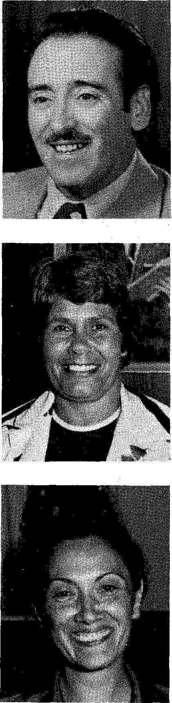
Official Welcome
The Hon. A. J. Grassby, Australian Commissioner for
Community Relations 1
Address
Miss Lois O'Donoghue,
Chairman, National
Aboriginal Conference 5
Mrs. Maria Cristina Sus Pastrana,
Consul for Colombia 16

Belconnen High School Choir, Conducted by Mrs Wendy Northwood.
Selection of Aboriginal Songs, Colombian National Anthem, Advance Australia Fair.
Belconnen High School Recorder Class.
Two South American Folk Songs.

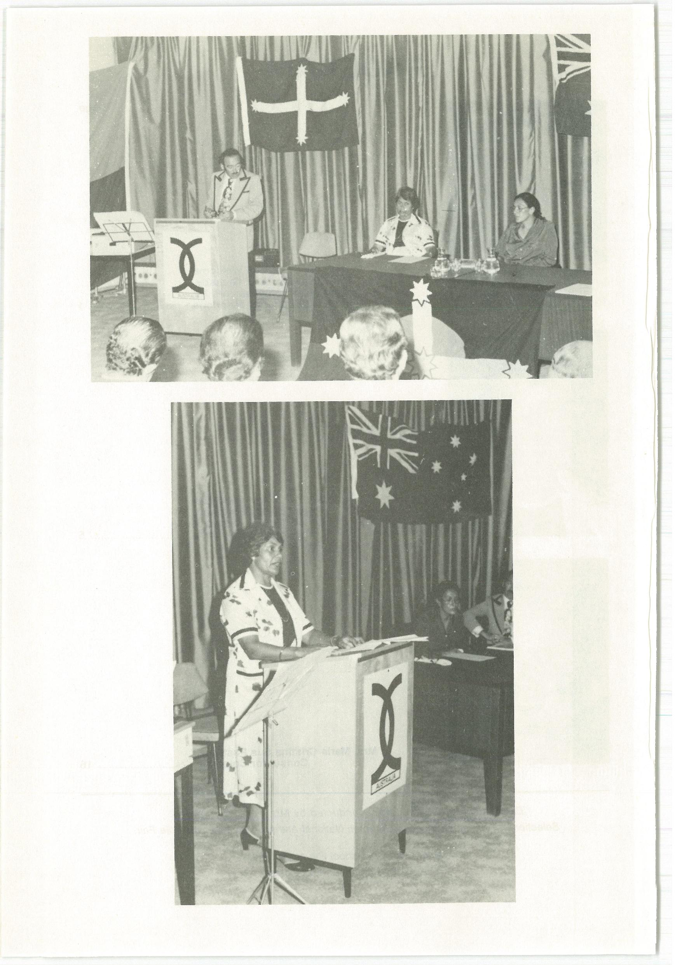
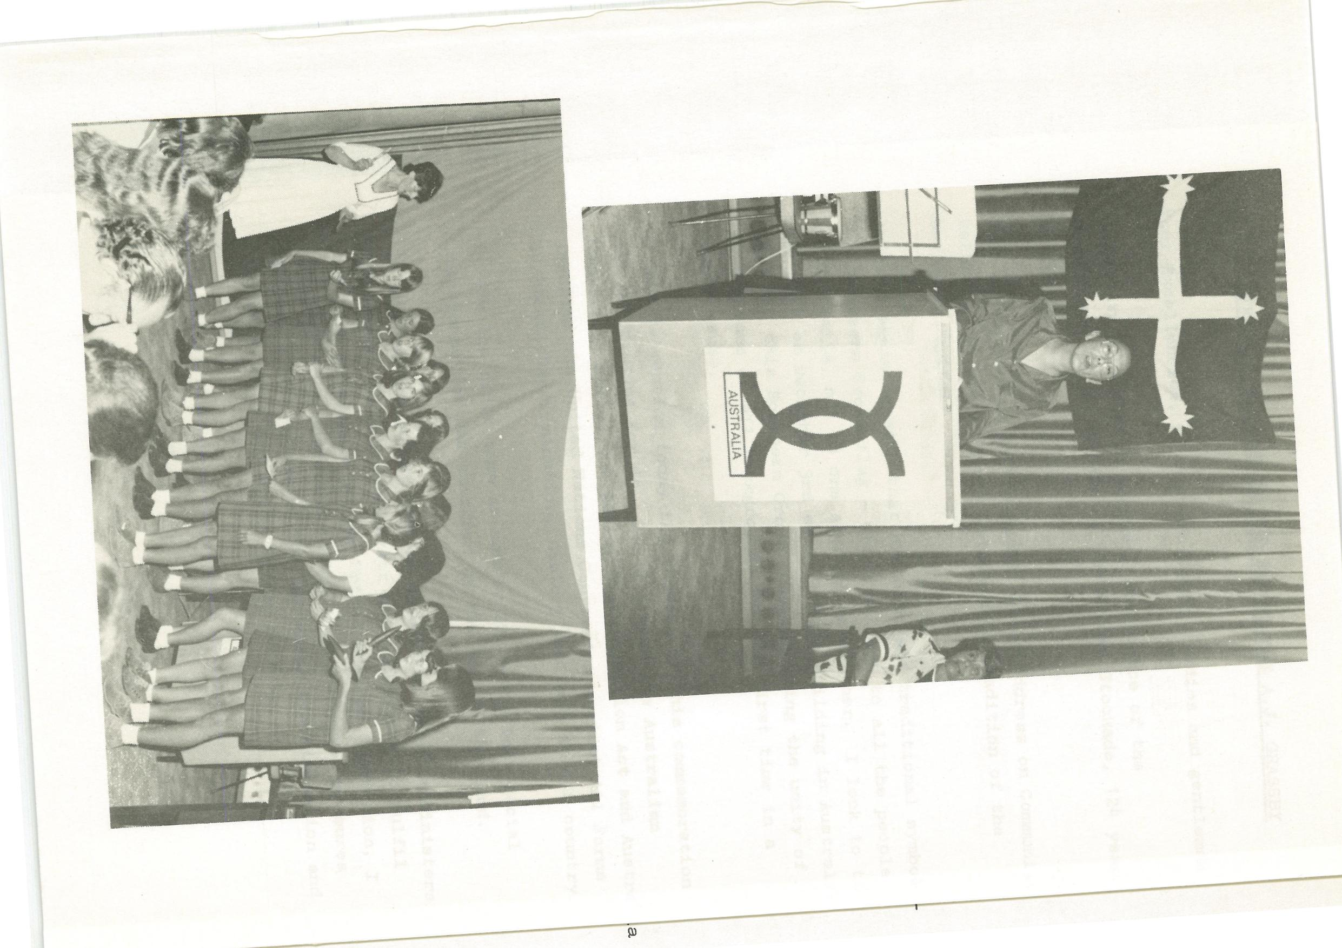
Following a luncheon with Sir John Nimmo and Mr Brian Murray, a senior officer of the then Department of Immigration, ways and means of propagating the Convention and the principles
2.
of the Racial Discrimination Act were discussed.
It was Brian Murray, who is attending this commemoration today, who suggested an annual address on community relations dedicated to an Australian who symbolised unity. The name
of Peter Lalor immediately came to mind as a man who for the first time brought Australians of many backgrounds together in a common cause.
I proceeded to implement the idea and the very first address on December 3, 1975 was given by Sir John Nimmo, who is not only a Judge of the Supreme Courts of the Northern Territory and the Australian Capital Territory, and of the
Commonwealth Industrial Court and the Supreme Court of Victoria, but also by invitation Chief Justice of the multicultural and multiracial independent nation of Fiji. He was also born in Ballarat, the site of the Battle and of the events we commemorate.
He was joined in that historic first gathering by Ambassador Paolo Canali of Italy, as we commemorated the centenary of the death of Raffaelo Carboni, the second-in-command at Eureka.
In the second year the theme was the role of good neighbours in community relations at home and abroad. Ambassador Gregorio Abad of the Philippines and Ethnic Communities Council Chairman Walter Lippmann of Victoria were our guests.
Last year it was Ambassador Joseph Forace of Malta and Professor Jerzy Zubrzycki, Chairman of the Australian Ethnic Affairs Council.
This year the theme is "We must know who we are".
This is related to the fact that as one of the great cosmopolitan nations of the world, the Australian community of 1978 must know itself to be able to relate to our neighbours in the world. We must recognise the great diversity of our fellow Australians drawn from half the world. We have to recognise the inalienable right of all Australians to their culture, language and heritage, whatever it might be. To achieve unity indiversity, all the
flowers must flourish in the national garden.
To fulfil this theme that the family of the nation must know itself, our first distinguished guest today is Miss Lois 0,Donoghue, Chairman of the National Aboriginal Conference. Lois 0,Donoghue has already been recognised for her contribution to the nation by the award of the Order of Australia and the M.B.E. She was born in Indulkana, South Australia and has traditional links with the Pitjantjatjara people. She was a Home/School Liaison Officer at Port Augusta and is a trained nursing sister. She is a former Regional Director of the Department of Aboriginal Affairs in South Australia, a Director of Aboriginal Hostels Limited and a Director of Aboriginal Arts and Crafts.
Lois O Donoghue now occupies the position of highest authority in relation to Aboriginal Australia and her contribution to nation building is among the most significant of this decade.
Our second distinguished guest is Mrs Maria Cristina Sus Pastrana, Consul for Colombia, born in Bogota, the capital of Colombia and the home of Simon Bolivar who shares with Peter Lalor a common tradition of fighting for freedom and justice.
3
She studied in Colombia, and later in the United States, and ja4ned the Diplomatic Corps in 1973 and was posted to Canada, where she pursued further studies in the field of Asian languages and cultures. During her stay in Australia she has continued to study at the University of Sydney.
4.
Her uncle, Misael Pastrana Borrero, was President of Colombia from 1970 to 1974 and continues to serve his country as a Minister for Public Works and Finance in the Administration of State.
Her address will trace the links between Australia and the Spanish-speaking world, and will refer particularly to the work of Bolivar as the liberator of most of the Americas.
Last year's Eureka address brought a wonderful response from Louis Stellato of East Brighton in Victoria who has written a magnificent Hymn to Australia. I quote from two of the verses:
Australia, our sunny land,
Beautiful, wild and free,
Surrounded by the mighty sea,
With the Southern Cross high over thee.
At Eureka the chains were torn,
And vision of freedom born,
Their spirit burst into thunder,
And our democracy arose from the storm.
I am going to hand over the music and the words of the Hymn to the wonderful Belconnen High School Choir and I hope it will be performed for the first time on Eureka Day next year.
To present the first part of this Eureka Day commemoration I now introduce Miss Lois O'Donoghue.
ADDRESS BY MISS LOIS O'DONOGHUE, CHAIRMAN OF THE
NATIONAL ABORIGINAL CONFERENCE
5.
Honourable Commissioner, Your Excellencies, Distinguished Guests.
The theme of this year's Community Relations Address: Australians - We Must Know Who We Are is certainly most appropriate as far as Aboriginal Australians are concerned.
The fact is that after nearly 200 years Aboriginal Australians and the newcomers have hardly yet come to know each other,
to understand each other and, above all, to respect each other.
The responsibility for this clearly lies with the conquerors of the continent who took possession of every single hectare and then resettled at will, moved and removed and moved again. The original owners lost the long battle of the frontiers against the invaders.
So today we have the victorious and the dispossessed. It is true that significant steps have been taken in recent years to make peace, to rectify some of the worst features of
the occupation and expropriation, but despite significant progress and a great deal of goodwill among Australian men and women, it can hardly be said even today that the newcomers since 1788 have come to know us and who we are.
Against this background it could be said that the events of Eureka and the dedication of Peter Lalor to liberty was of little consequence to Aboriginal Australians.
I think it is fair to say that a Government which oppressed its own people, denied them rights and connived at their exploitation could hardly be expected to give any consideration to the people whom they had dispossessed.
Like Al Grassby I can see the seeds of liberty in Eureka. I can see in the events a genuine bid for justice.
6.
It is significant to me that the first of the rebels to
be brought to trial was a Black, an American Black. Perhaps the authorities selected him hoping an all-white jury would disregard his service to the rebels in the cause of justice and simply convict him out of naked racial prejudice.
In the event the jury refused to convict the Black nor would other juries of the time convict the Irishmen, the Italian, the Germans, other Americans, an Englishman and all the others who had come together in the cause of liberty under the Southern Cross.
But when the diggers were fighting at Eureka what of the struggles of the Aboriginal people at that time? What were they doing?
Australian history books suppressed the real events of Eureka for 100 years. How much more have they suppressed the truth about the Aboriginal people and their struggles and their striving for justice?
By all means let us know who we are. Let us find out what our situation was at the time of Eureka. Let me set the scene for you by quoting from the sermon of a man who was not known in Australian history for his sympathy for the Aboriginal people. In view of his stand for the Aboriginal people in that far-off barbarous year of 1838 perhaps he
has been misjudged.
He was the Reverend John Dunmore Lang. The scene was Scots Church, Sydney on Friday, 2nd November, 1838, 140 years ago.
The Governor, George Gipps, had appointed the day as a day of "fasting and humiliation on account of the drought" raging
7.
at the time. The thought was that God was punishing the colonists for their public and corporate sins.
Let us listen to the words of John Dunmore Lang on that November day 140 years ago.
"I (refer) to the wretched Aboriginal inhabitants of this land? Alas! we are verily guilty concerning these our brethren; for not only have we despoiled them of their land, and given them in exchange European vice and European disease in every foul and fatal form, but the blood of hundreds, nay of thousands of their number, who have fallen from time to time in their native forests, when waging unequal warfare with their civilised aggressors, still stains the hands of many of the inhabitants of the land!
"And think you, my brethren, that if God visited the slaughter of the Gibeonites which had been perpetrated by the bloody house of Saul alone, on the whole nation of Israel, with three
successive years of famine, will the blood of these innocents call to heaven for vengeance in vain against this whole European community? Assuredly not; if it is the same Almighty God who still sitteth in the heavens, and reigns supremely among the inhabitants of the earth!
"Jehovah himself became their mighty avenger, and required that innocent blood of the whole house of Israel! Much more then will the Lord avenge the blood of the wretched Aborigines of this territory, who have fallen unnecessarily before the progress of European colonization, on the
European inhabitants of this land. For no withering and blasting curse stands recorded against them in the book of God, to place them beyond the reach of His tender mercies.
8.
They are still bone of our bone and flesh of our flesh - formed originally after the image of
God, like ourselves, and guilty only, as far as we are concerned of an Ethiopian skin, and an untutored. soul. We may rest assured, therefore, that these Gibeonites, so to speak, are especially under the divine protection; that the cry of their wrongs has already entered
into the ears of the Lord of Sabaoth; and that "when he maketh inquisition for blood, he remembereth them".
Yes, brethren, every district of this land of our adoption has been defiled with the blood of these innocents; and who knows but that it is for this that the Lord has been pleased, a second time, "to call for a drought upon the
land and upon the mountains, and upon the corn and upon the new wine, and upon the oil, and
upon that which the ground bringeth forth, and upon men and upon cattle, and upon all the labour of our hands."
You may be horrified. These words by one of the founders of modern Australian are complemented only seven short years later in 1845 by Archbishop Folding, the Head of the Roman Catholic Church in Sydney. This is what he said:
If occupation by force, accompanied by murders,
ill-treatment, ravishment of their women
What did those burning words mean in terms of what was happening to the Aboriginal people?
It is estimated by many authorities today that there were
9.
one million Aboriginal Australians. It is true that colonial history books constantly wrote down the number in case they had to explain what happened to the population that reached
a low point of 50,000 in this century. Many history books today around our schools still claim there were only 200,000 in the continent in 1788. What was the position actually like at the time of Eureka, which was only 66 years after the First Fleet?
Commissioner A. Halloran who operated from Sydney made regular tours of the frontiers. He wrote on the first anniversary of Eureka in December 1855 of a state of siege in many areas and he reported to the Governor as follows:
"When it is considered that the blacks are
fully 15 to 1 as regards the white population, it will not be thought surprising that they are beginning to feel their own strength. ."
In the northern settlements at the same time Burketown settler A. Turnbull recorded:
"During this period of settlement a continual guerilla warfare was waged with the blacks ... Many whites lost their lives, usually solitary shepherds or stockmen, while hundreds of Aborigines fell whenever whites turned out
to retaliate
The Queensland Figaro was still describing the war more than 30 years after Eureka in these terms:
"Out on the very borders of civilizations, where absolutely new country is being opened up, and where blacks are brought into contact with whites for the first time, the use of the rifle is
undoubtedly necessary. Where every white man has to fight for every inch of country he occupies, where there is constant border warfare on the verge line of settlement, the
10.
white man has an excuse for taking life in defence of his own.... "
You might ask when did the fighting stop? The last major battle was only 50 years ago. It was in 1927 in fact
on the Forrest River in Western Australia. It all began when an Australian Aboriginal was attacked for trespassing on his own tribal land by a white stockman who was resisted and who died. The result was a mobilisation of police and hired hands who killed 100 men, women and children at the Marndoe Reserve and then burned their bodies.
It is true that by 1927 the war was supposed to be over and you will be interested to know there was a Royal Commission of Inquiry which did absolutely nothing.
Against this backdrop of history how great is the need for us to know each other. Let me go on now to tell you of my own cultural heritage and background.
My own personal experience has been a mixture of sadness and pleasure.At the age of 2 years I was removed from my mother during the early 1930's "to be given a better chance in life."
The Protector of Aborigines took over guardianship from my mother. I was reared in an institution for half-caste children, administered by the United Aborigines Mission. There I remained until I was 16 years of age.
Never during those years was I told or even allowed to ask questions about my parentage. I was forbidden to speak the language, although during those years we had many opportunities to hear the language spoken and to hear
the legends as told in secret by the new children coming into the home. But of course they soon forgot, because
11.
they were forced to forget the old ways. Apart from my very basic needs to know and be nurtured by my own mother, to speak my own language and understand my own culture, I was well cared for and received a good education. After all, the only sin my mother committed was that she was a full blood and she dared to give birth to a half-caste child.
At the tender age of 16 years I was on my own, the world outside was foreign and hostile to me, the battle was now ahead of me.
My first job was in domestic employment. I had no intentions of staying but it was a start. I wanted to be a nurse.
After 6 years of fighting I was eventually accepted as the first Aboriginal to commence Nurse Training in South Australia. The year was 1954 - one hundred years on from the stirring event of Eureka that marked the beginnings of social equality for all Australians.
From that time onwards I have never given up the fight for equality.
In 1967 I left Adelaide to go north to find my mother and in December of that year I met my mother for the first time in my life, and made contact with the Pitjantjatjara people. What a wonderful experience it has been since that time!
There are many stories to be told like mine but others are not so fortunate, my wounds are now healed, but the scars remain. Many wounds are still weeping today, because children have been denied their basic right to know who they are.
I belong through my mother to the Pitjantjatjara people. They have occupied for 40,000 years the region extending across the west of South Australia into the east and northeast of Western Australia, which includes part of the mountainous range country of northern South Australia and Central Australia.
12.
The Pitjantjatjara people occupy the Gibson and Great Victoria deserts as well as seven great Central Australian mountain ranges.
The Pitjantjatjara people live in a hard land adopting a pattern of wide-ranging mobility to survive. The contact by Europeans with the Pitjantjatjara was very little, right up until the 1930's and even today, because it is a hard land, Europeans have not moved in on it in the same way as elsewhere in the continent.
So we were in a way blessed by isolation and a hard climate, a lack of minerals and lack of pastoral potential. Yet because of the movement of Europeans to the periphery of the Pitjantjatjara and the fact that there had been a movement southwards for hundreds of years the people progressively spread out.
Today the majority of the more than 2,000 Pitjantjatjara people are redeeming their land and rediscovering their heritage. The joy of returning to country given in the spirit time has to be seen to be believed.
A white man, Peter Brokensha has summed up the movement of people back to their homelands in this way:
"I am therefore convinced both from the evidence of the strength of this religious tie between man and landscape and from evidence of the persistent and repeated return of groups to their homeland
sites, that the principal motivation for this
return is what could be termed an act of religious faith."
13.
The Pitjantjatjara like most Aboriginal peoples ask very little. They want support to enable them to form their own communities in their own lands. They want tolerance and understanding. Above all they want inviolate security for ownership of their lands. Brokensha who knows them well comments:
"My firm view is that the Pitjantjatjara people will be able to solve these problems and self-determining communities like Pipalyatjara will survive. But this can only happen if the
Europeans administrators provide the sort of climate to let it happen. The necessary climate is one of tolerance, patience and understanding that the solutions the people themselves develop
may be quite different to Western-orientated solutions which should not be forced on the people."
I believe the National Aboriginal Conference, of which I have the honour to be Chairman, has a very vital role to play in bringing peace and justice between Aboriginal Australians
and the newcomers since 1788.
The NAC is composed of 35 members elected for three years. Its role is to provide a national forum for Aboriginals to develop long term goals and objectives which the Government should pursue.
The first meeting of the new Aboriginal Conference was held in March 1978. It was elected by more than 32,000 voters in a nation-wide poll in November 1977.
The State branches of the NAG meet and elect their delegates to the National Executive. It is important to realise that
there were 300 candidates contesting the 35 places. The election material was translated into 17 major Aboriginal languages.
Our electorates have special problems. For example some NAG electorates have as many as seven different language groupings. Aboriginal society operates within a system of
consensus whereby all the members agree before a decision is reached and then adhere to that decision. The size of the electorate is many times that of any other of the people's representatives in Federal or State Parliaments. Nevertheless we have a structure and now it is a matter of building the future.
What do Aboriginal people want? Our hopes and aspirations were summed up rather magnificently by Kath Walker who had a message not only for all Aboriginal people but for all
Australians of all backgrounds in building the family of the nation. Here are the words of a poem. The first part is "Assimilation No"
"Pour your pitcher of wine into the wide river
And where is your wine? There is only the river Must the genius of an old race die
That the race might live?
We who would be one with you, one people, We must surrender now much that we love, The old freedoms for new musts,
Your world for ours,
But a core is felt that we must keep always, Change and compel, slash us into shape,
But not our roots deep in the soil of old. We are different hearts and minds
In a different body. Do not ask of us
To be deserters, to disown our mother,
To change the unchangeable.
The gum cannot be trained into an oak.
15.
Something is gone, something surrendered, still We will go forward and learn.
Not swamped and lost, watered away, but keeping Our own identity, our pride of race.
Pour your pitcher of wine into the wide river And where is your wine? There is only the river."
The second part, of Kath Walker's poem, on which I end this Community Relations Address, is "Integration Yes".
"Gratefully we learn from you, The advanced race,
You with long centuries of lore behind you.
We who were Australians long before You who came yesterday,
Eagerly we must learn to change, Learn new needs we never wanted, New compulsions never needed, The price of survival.
Much that we loved is gone and had to go,
But not the deep indigenous things.
The past is still so much a part of us, Still about us, still within us.
We are happiest
Among our own people. We would like to see
Our own customs kept, our old
Dances and songs, crafts and corroborees.
Why change our sacred myths for your sacred myths? No, not assimilation but integration,
Not submergence but our uplifting,
So black and white may go forward together
In harmony and brotherhood."
ADDRESS BY MRS MARIA CRISTINA SUS PASTRANA
CONSUL FOR COLOMBIA
16.
Honourable Commissioner, Your Excellencies, Distinguished Guests,
The theme of this year's Community Relations Address, "Australia - We must know who we are," is a theme I want to warmly commend.
Socrates said: Know thyself. This truth, applied in the context of a country with a multicultural society, will lead to an understanding of its true identity. When we know ourselves we know each other, and then we can understand one another and our hopes and aspirations for our lives as members of one community.
I felt that in my Community Relations Address, which I am honoured to be giving to this national gathering today, I would draw attention to the links between Australia and the Spanish-speaking countries and say something about one of the heroic figures of the Spanish-American world whose message is a message for Australians as well as Latin Americans.
I arrived from Taiwan, where I was previously posted, three years ago. During that time I have come to appreciate the Australian community as one of wide diversity, yet one of great harmony. Among the many component parts of the Australian population is the Spanish-speaking part and it is about the greatest of the founders of Spanish-American independence that I wish to talk today, in this commemoration of the 124th Anniversary of the Battle of the Eureka Stockade and as my contribution to the Fourth Annual Lalor Address on Community Relations.
The links between the Hispanic peoples and Australia can best be symbolised through the fact that the name "Australia" was conceived and given by a Spanish navigator who could well be given the title of the Christopher Columbus of Australia.
That great navigator was Pedro Fernandez de Quiros, Who
17.
sailed from Callao in Peru on 21st December, 1605 at the head of a fleet sent out to discover the Southern Continent, to take possession of the lands, and to convert the people. It was on 14th May, 1606, 371 years ago, that Captain Pedro Fernandez de Quiros took possession of the Great South Land
in the name of God and of Spain.
In fact he had been five months at sea when he landed on what he thought was the mainland and took possession of all the
lands as far as the South Pole. Quiros named the land Australia del Espiritu Santo - the South Land of the Holy Spirit - which was a name he invented as a tribute to King Phillip III of the House of Austria.
For most of the European history of Australia there have been Spanish-speaking people playing their part in the development of the nation. Today Ethnic Radio broadcasters estimate that
there are more than 150,000 Spanish-speaking people in Australia, drawn from 30 countries in Europe, South and Central America,
and in Africa.
The gold rushes brought many fortune hunters of Hispanic backgrounds to Australia but this did not result in a permanent local community. Among the handful of 19th century adventurers were the Benedictine Monks of New Norcia north of Perth. Two monks exiled from their monastery in Spain established a mission on the banks of the Moore River, planted vines and grew grain and established a work with the Aborigines which is still flourishing. The architecture of the monastery and chapel is still unique in Australia.
Upheavals in Spain before the first World War caused several hundred Basques to migrate to north Queensland,where their descendants are well established today in the sugar industry. However, by 1947 there were still fewer than 3,000 Spanish-speaking people in the whole of Australia.
Following the agreement between the Spanish and Australian Governments in 1959, a larger scale migration movement began which subsequently had to compete against the movement of Spaniards as guest workers to Germany and Northern Europe.
18.
Census statistics show that Spanish migrants have settled mainly in New South Wales and the A.C.T., which together account for 50% of all those in Australia. However, they have not concentrated their settlement in the Australian capital cities to the same extent as most other Southern European communities.
The third and final wave of Spanish-speaking immigrants took place in the late 60's and early 70,s. As a result, those from Central and South America now outnumber the earlier settlers from Spain. The Latin Americans include many intellectuals.
The advent of Ethnic Radio has provided a great boost to the life of the Hispanic Community in Sydney and Melbourne. It
has also been instrumental in underlining the separate identity of the many Spanish-speaking countries. Indeed the one strong common feature among the Hispanic communities is their use of the same language. While most of the Latin Americans have come from Chile, Argentina and Uruguay, in addition Colombia, Peru, Bolivia, Ecuador and Mexico have all contributed distinctive local communities.
The energy and cultural initiative of the Hispanic community are attested by the existence of over 30 Spanish-speaking clubs and associations, sporting teams, welfare groups, ethnic radio committees, church bodies of varied denominational character, and language schools in all capital cities of Australia. Five Spanish-language publications appear in various parts of Australia, the largest circulation being by the Spanish Herald.
An analysis of use made of the Telephone Interpreter Service in Australian capital cities has indicated that throughout Australia, Spanish was the major language used, covering 17% of the total calls received. The users of course included Latin Americans aslell as Spaniards.
Spanish is offered as a subject for University study in New South Wales, Victorian and South Australian 'universities, although the community orientation of such courses has not been a strong factor. The Beazley Committee on Migrant Languages in Schools recommended that vigorous efforts were needed to provide a permanent supply of teachers in order to ensure the teaching of Hispanic language and culture in Australia on a permanent footing.
19.
The continuity of Spanish-Australian culture is assured. The Spanish language is heard on the air waves of Sydney, Melbourne, Adelaide and Canberra. More students and more schools are according it recognition, not only as an Australian community language but as the third most important language numerically on earth after Chinese and English.
Against all this background it is perhaps sad that not one Australian schoolchild in a thousand would know the name of Quiros who coined the name of Australia. Sadder still, there would not be one Australian in ten thousand who has heard the name of Simon Bolivar. Yet in many ways he parallels Peter Lalor whom we are commemorating today.
Peter Lalor was a man who felt impelled, not by personal needs but in the interests of justice, to lead a crusade for his fellow countrymen. Lalor felt he would be untrue to himself if he took advantage of the fact that he was comfortable while they were suffering persecution.
As President and Commander-in-Chief of the forces that brought Australians of all backgrounds together in a common cause for the first time in history, he paralleled Simon Bolivar who on
a wider canvas and grander scale liberated six countries, became president of three, is commemorated in the name of one of them - Bolivia - and whose achievements in the New World approach those of George Washington.
Peter Lalor was born on 5th February, 1827 in Raheen in Leix County in Ireland. His family was descended from the OtLalours
who had been fighters for the rights of the people for centuries.
20.
Simon Bolivar was born on 24th July, 1783 in Caracas, Venezuela and died in Santa Marta, Colombia on 17 December, 1830. The Liberator started his brilliant career in 1810 and ended it in 1830 with his death.
In 1827, when Lalor was born, Bolivar was already besieging Quito in his great conviction to liberate the Latin Americans from colonialism. By the time Lalor arrived in Australia in October 1854, Bolivar had finished his work and had been glorified with the title of Liberator.
It was idealism which moved Peter Dalor to assert his rights and those of his fellows as well; it was high idealism that moved Bolivar to dedicate his life to the cause of independence.
I want to tell you about the thought behind the man Bolivar, to tell you about the humanity of our Liberator. Bolivar's words:
"This immense disorder, America, justifies my political conduct and the principles that have guided it. I
hope my friends will remember me in this period of
upheaval as a contrast to the effects of anarchy, and do me the justice I have desired"
capture the spirit of his times, his desire for justice, and his confidence in the verdict of posterity.
In the history of Latin America, highlighted by periods of spiritual confusion, deep division and great political ferment, there is hardly one hour of stability. The work of Bolivar reflects this sad circumstance. His times were marked by an anarchy which was to emerge as the victory over the colonial forces was won° Its origins are rooted in war, itself a sign that the revolution was far from over. Bolivar described the situation by saying: "America as a whole is nothing but a mob more or less extended".
That mob, which from Mexico to Argentina shook the continent reflected the passion for power manifested simultaneously by most of the leaders who forged the revolution against Spain, backed by desperate, dissatisfied masses, whose dream was to end the misery and turmoil of their lives at the cost of any sacrifice.
21 .
Bolivar anlaysed the intolerable conditions in the Spanish colonies: "Americans have no other place in this society but that of servants, if that much, or of mere consumers. Even this is shockingly restricted. We are not allowed to
cultivate fruits from Europe, products are monopolised by the King, factories that Spain does not have are restricted, exclusive privileges exist for trade even in essentials, obstacles between Spanish and American provinces prevent
any business agreements. Well, do you want to know what our destiny is? Cropping the fields, working cattle on the arid plains, hunting wild animals in the deserts, tearing at the soil to excavate the gold that will never satiate that avaricious nation."
He clearly recognised that the ignorant masses could frustrate true reform unless they were given a proper part in a real revolution. The same peasant multitudes who followed the Spanish General, Boves, were later to follow the patriots' flag, seeing their social redemption to be at hand.
These deficiencies reflected the demographic situation: the Colombian population was very small, Bolivar was not exaggerating when he wrote from Arequipa: "The Country in which we work covers more than 1,000 leagues, yet there are hardly four men
in it who could handle the most important jobs." In addition to the few men morally and intellectually capable of bearing state responsibilities there was no lack of others, of lesser stature, bent on control of the republic. Many times they are seen side by side with the true patriots of high standing,
striving self-interestedly and hindering the task of liberation.
Bolivar's work was dogged by two powerful forces: hatred and ingratitude. They came as no surprise to him: "No one who is great remains immune, no one fails to escape the bitter bite of envy."
22.
Once the war was over, the fighting fever of the leaders found an outlet in continuing anarchy. War moulds a new mentality, imposes new values. Anarchy is the logical consequence of an incomplete revolution. If Bolivar's ideals had been realised, anarchy would never had had such tragic results, because it would have been averted by permanent economic, spiritual and moral solutions.
In the years of Bolivar's activity we see two wars being fought one after the other: the war against the Spanish Empire and
a civil war, devastating, bloody and always won by the strongest. Bolivar,s warnings about the fearful disorientation and anarchy reveal the Liberator's warm humanity and are worth dwelling on today: "America is a horrible picture of blood and disorder.
We live on a volcano and we grow demoralised to the point of not recognizing any principles of right and duty."
The Latin American revolution was impeded by the inaction and non-cooperation of those whose unity could have made it possible. Anarchy was the outcome of an unfinished revolution, a revolution without real social, economic or historic change.
To break out of this vicious circle required two elements; a plan for action and the will-power for action. The plan was produced by Bolivar but the action was up to America.
His effectiveness was also hindered by the pathetic lack of capable support, resulting in administrative crisis in the newly freed Latin America. Bolivar said "Americans have suddenly been thrust without previous knowledge and experience of public administration, onto the world stage, into eminent positions as legislators, magistrates, administrators of finance, diplomats, generals and whatever supreme or secondary authorities form the hierarchy of a state."
Hatred is the natural reaction from those who experience the loss of possessions and privileges. From Peru he writes: "I am working for total reform of patterns and customs that are vile and old-fashioned. The army and administration badly need the reforms I am implementing, therefore I am hated." This hatred was to dog all his great endeavours and was to be the prime factor in all the attempts on his life, especially the infamous 25th of.September, "la noche septembrina" which ushered in the most painful period of his life.
23.
Ingratitude was another bitter pill which the Liberator had to swallow. If Bolivar was at times almost the
object of a personality cult, at other times he experienced a destructive opposition and ingratitude from those he sacrificed himself for. "My sorrow will be eternal,"
he wrote in 1828, as if sensing deeper sufferings to come.
He set himself a task, the enormity of which can only be measured by the extent of the opposition he had to face. It is not to be wondered at that he would fall prey to pessimism. But in the light of history and considering the greatness of his achievements Bolivar must be seen as a herald of hope.
In the end he died conscious of how little of his ideals had been realised. Political separation from Spain was not enough: it was still necessary to unify and inspire the new nation towards a destiny of its own making, towards solving the agrarian problem, achieving economic justice, and abolishing slavery forever.
We must see Bolivar not only as a warrior but also as a nation-builder. For him, independence meant not merely separation from the Spanish Empire, but the building of a free and just continental society with complete economic sovereignty. He
said: "The victory of our army is not enough, nor is it
enough that our enemies vanish from our territory, or that the whole world recognises our independence. We need to be
free, under free laws that emanate from the most sacred source: the will of the people."
He conceived independence as such an enormous enterprise that it could hardly be achieved in a single generation.
The second step in Bolivar's task was to find a balance between law and the social realities, between the government and the people, between change and stability. He also strove to achieve a balance between anarchy and tyranny. To avoid both extremes he foresaw the necessity for a popular, centralist and republican government. He saw this government having two main tasks: to complete the revolution, and to channel its energy into the creation of a just socio-economic order.
Bolivar's ambition was to achieve a government that matched the Latin American circumstances. Although his speciality was not law, he accepted the challenge of law-making out of love for his countlyand its people. It was his conviction that the institutions of government should truly serve the society and reflect its genius. Government and people are so closely interwoven that if a government forgets its origin it is doomed
- to failure.
That is why Bolivar wanted the government cfColombia, as the body entrusted with the success or failure of his total work, to be based on our customs, our aspirations, our religion, our origins and history. He said: "What makes a government
excellent is not its theory, form or machinery, but its ability to match the nature and character of the nation for which it has been formed."
As a convinced and forthright universalist, the Liberator dreamed of incorporating his America, as an active force, into the union of all the countries of the world. Bolivar appreciated the spiritual unity of the Hemisphere: "In its origins America is one. A sign of this common origin is that the first movements for independence took place almost at
25.
the same time, and from the beginning there has been a solidarity amongst all the countries."
Spiritually the Liberator's aspirations were towards a league that would be more positive than the weak association
of states existing until then. He foresaw a World Federation in which the principles that had brought life to Latin America would have full sway. Then "in the march of the centuries,
we could perhaps find only one nation covering the whole universe: a federation."
In his search for unity Bolivar insisted on maintaining at all costs the Panama Congress as the political expression of harmony. In Panama was to be gathered the assembly of his
America„ "It is time now for the interests and relations between the American republics, previously Spanish colonies, to have a fundamental base that will make the duration of those governments eternal. Such authority could only exist in an assembly of delegates appointed by each one of those republics and united under the victory of our army against the Spanish power."
The Governments of Peru and Colombia pledged themselves to intercede with the other Governments of Latin America, to come under one pact and create the General Assembly of the Confederation. From geographical motives Bolivar chose the Isthmus of Panama for this purpose, since it is equidistant from Europe, Asia, Africa ad at the same distance from both the poles. Thus, the Panama Congress for him was to be the
central institution of union, having two main objectives, the co-ordination of Latin American foreign policy and the building of understanding between the nations. Moreover,
it should resolve any inter-American disputes. In a word the Congress was to be the instrument of peace and harmony in the continent.
Pre-eminently Latin America is one because of its language, the Castilian, imposed on it by conquest. For Bolivar the Spanish language was a powerful reason for America's unity. When he referred to America, he used the word in a restricted form, alluding to South America - or more precisely to the countries between Mexico and Argentina, with the exception of Brazil and the European Guyanas.
Another unifying element in the America of Bolivar was religion, likewise imposed by the conquerors. At the time of liberation, Catholicism was almost exclusively dominant in the Ibero-American lands. Religion of course has a profound effect on the shaping of morality, traditions and customs.
It was however in the common customs that Bolivar saw the real basis for Latin American unity, since the period of colonisation imprinted on all countries of Hispanic origin similar customs, with only slight variations from one country to another. Behaviour patterns did not differ greatly so that the whole realm of social life revealed remarkable commonality .
His other great concern, for agrarian reform, was a focal point of so much of his work. It stemmed from his egalitarian ideals: land redistribution was to be a means of thorough-going change throughout the Hemisphere. His first step towards it was to abolish slavery. In this he was seeking to achieve in the economic field what he had done in the political arena, based on his dream of social justice.
26.
Adverse circumstances were to frustrate this dream, which remains unmistakeably clear in our history: he wanted to give land to the destitute, to redistribute the state's land amongst the liberators.
27.
Bolivar himself recognised that by the end of his life only a very small part of his ideals had been achieved: most conspicuously separation from the Spanish Crown. But in the political realm success eluded him. Unity in Latin America was not to be attained and Colombia, his immediate and transitory dream, was to split up into its three original parts. Agrarian reforms were to be frustrated for the benefit of the same rich owners; slavery was to be adopted again; the ideal of Panama was never to be realised. Historically, Latin America turned aside from its main task to embrace a series of diminutive problems in regional politics. The continent forgot itself, forgot the vital enterprise of creating itself, and forgot its mystical union.
Bolivar's expression: "I have ploughed the Ocean," is a sad and strange truth.
This is the first time in the four years of Community Relations Addresses that two women have been the guests of honour. I
am deeply conscious of the honour and I want to take this opportunity to say something of Manuelita, who was such an inspiration to Bolivar and his work. She has been described as Manuelita the ardent, Manuelita the beautiful. For him, Manuelita left her husband, family and country and became as universal as Bolivar. She said: Mi pais es el continente de la America, he nacido bajo la linea del Ecuador. (My home-
land is the American Continent, I was born below the Equator).
Maauelita, wham we remember with the title of Liberator of the Liberator, after saving Bolivar from his assassins, had him escape through the window of her room while she confused his pursuers. Manuelita - the one who followed Bolivar on
horseback or on foot during battles and campaigns. Manuelita - the one who shared his life and glory, as well as his sorrows.
28
In conclusion I have concentrated in this Community Relations Address on placing on record the links between the Spanish-speaking peoples and Australians. I have tried to introduce Australians to something of the greatness and inspiration of Simon Bolivar, the Liberator. I have tried to draw some parallels with Peter Lalor in his high dedication to liberty and justice.
I want above all to say that unless Australians learn to know each other, know each others, heroes, backgrounds, hopes and aspirations, then Australians will not come together in the unity of a common inspiration. If Australia is successful in embracing in the family of the Australian nation half the world, then it will be a model indeed and I would like to think that perhaps the inspiration of Simon Bolivar, El Libertador, will have contributed something to Australia's inspiration for the future.
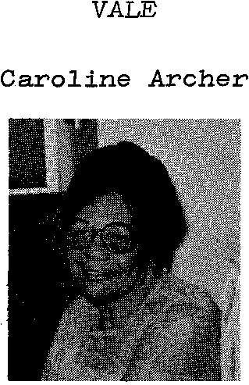
The Aboriginal songs which were sung by Belconnen High School Choir were taught by Mrs. Caroline Archer who worked as an Education Consultant on Aboriginal culture with the Department of Aboriginal Affairs.
29.
Caroline had suffered a foot injury but she attended the 4th Annual Lalor Address with her daughter.
Two weeks later while being driven to Brisbane for an operation on her feet she was tragically killed in a car accident at Coonabarabran N.S.W.
Our final salute to a great lady and activist.
COLOMBIAN NATIONAL ANTHEM
30.
OH GLORIA INMARCESIBLE OH JUBILO INMORTAL
EN SURCO DE DOLORES EL BIEN GERMINA ALLA
Repite
CESO LA HORRIBLE NOCHE LA LIBERTAD SUBLIME DERRAMA LAS AURORAS
DE SU INVENCIBLE LUZ
LA HUMANIDAD ENTERA QUE ENTRE CADENAS GIME COMPRENDE LAS PALABRAS
DEL QUE MURIO EN LA CRUZ
INDEPENDENCIA GRITA EL MUNDO AMERICANO
SE DANA EN SANGRE DE HERON LA TIERRA DE COLON

