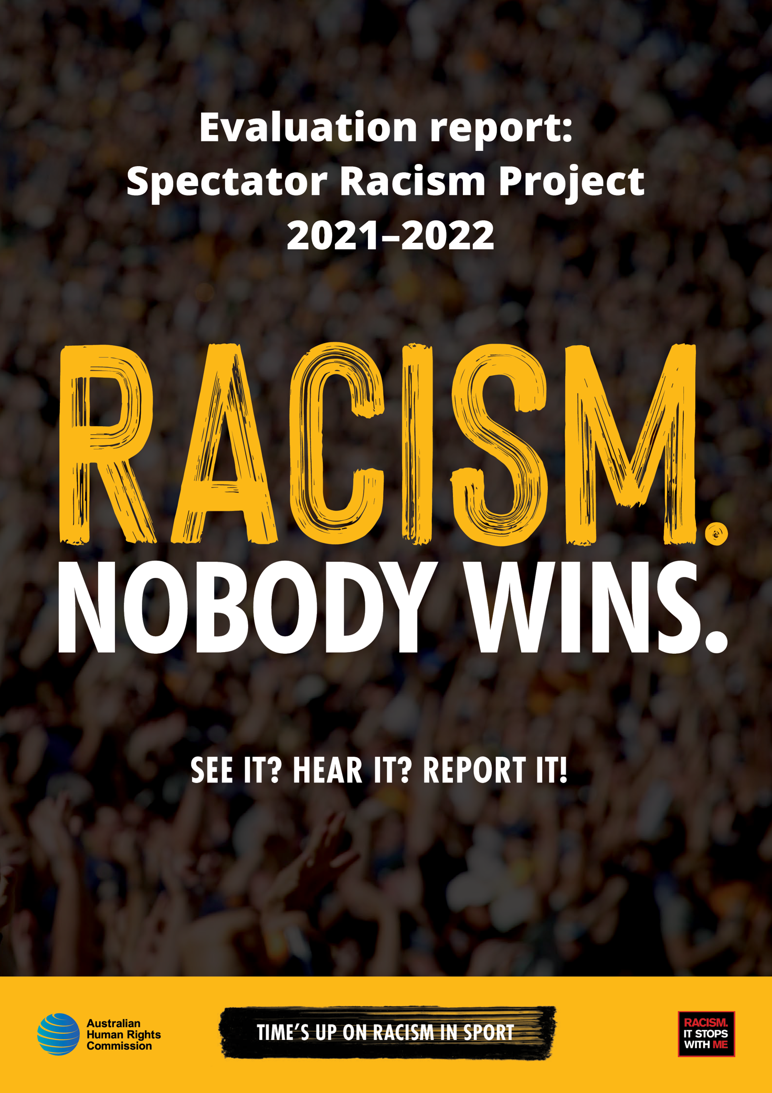

The Australian Human Rights Commission encourages the dissemination and exchange of information provided in this publication.
All material presented in this publication is licensed under the Creative Commons Attribution 4.0 International Licence, with the exception of:
- photographs and images;
- logos, any branding or trademarks;
- content or material provided by third parties; and
- where otherwise indicated.
To view a copy of this licence, visit http://creativecommons.org/licenses/by/4.0/legalcode.
In essence, you are free to copy, communicate and adapt the publication, as long as you attribute the Australian Human Rights Commission and abide by the other licence terms.
Attribution
Material obtained from this publication is to be attributed to the Australian Human Rights Commission with the following copyright notice:
© Australian Human Rights Commission 2023.
Evaluation Report: Spectator Racism Project 2021-2022 • June 2023
ISBN 978-1-925917-79-6
Electronic format
This publication can be found in electronic format on the website of the Australian Human Rights Commission: https://humanrights.gov.au/our-work/publications and the Racism. It Stops With Me campaign: https://itstopswithme.humanrights.gov.au.
Contact details
For further information about the Australian Human Rights Commission, please visit www.humanrights.gov.au.
Design and layout Dancingirl Designs

Evaluation report:

Spectator Racism Project

2021–2022
June 2023

Australian Human Rights Commission

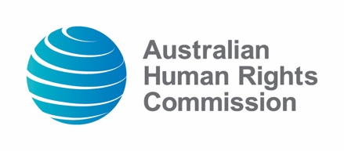

Contents

1 Project overview 6
2 Evaluation approach 8
3 What we learned 9
3.1 Evaluation survey 9
3.2 Other 17
4 Recommendations and next steps 18

The Racism. It Stops With Me campaign and the Australian Human Rights Commission acknowledge the traditional custodians of land, sea, waterways and sky throughout Australia and pay respect to First Nations Elders past and present. The Commission also acknowledges the ongoing work of Australia’s First Peoples in anti-racism since colonisation.

Project overview
In early 2021, various incidents of spectator racism re-ignited national conversations about racism in Australian sports. This prompted the Race Discrimination Commissioner and others to consider what could be done to address this ongoing issue.
From January to March 2021, the Commission conducted a preliminary review of Australian sporting codes and professional sporting venues and their response to racism and racial discrimination. The review found that there was no uniform approach to incidents of spectator racism. While each of the major sporting codes had policies that prohibit racism and racial discrimination, many lacked clear guidelines on how these incidents should be dealt with, or did not directly include spectators within the scope of their policies. Venues (such as stadiums) were also found to have varying levels of infrastructure in place to support the prevention and response to incidents of spectator racism. Simultaneously, events such as the launch of the report, Do Better – Independent review into Collingwood Football Club’s responses to incidents of racism and cultural safety in the workplace by Distinguished Professor Larissa Behrendt and Professor Lindon Coombes highlighted the need to address racism in a way that is proactive and grounded in an understanding of structural racism.
In response to these issues, the Australian Human Rights Commission (the Commission) convened a roundtable of representatives from across the Australian sporting sector, and anti-racism experts, to discuss opportunities to work together and potential ways forward.
Held on 27 April 2021, the roundtable included a discussion of the need for a set of guidelines to promote a coordinated approach to spectator racism in sports. Over subsequent months, the Commission led a working group in the drafting of these guidelines, which were released by the Commission and over 20 partner organisations in November 2021.
The 2021 Guide to Addressing Spectator Racism in Sport (the Guidelines) are intended to promote best practice responses to spectator racism at the professional level. They identify actions that can be taken consistently across sporting codes to ensure that spectators, officials, and players are safe and aware of how to respond to incidents of spectator racism. The Guidelines also propose proactive measures to prevent racism from occurring via a commitment to anti-racist practice. The Guidelines are intended to be broad enough to facilitate their adaptation by each sporting code, while maintaining a level of consistency across the sporting sector.
To accompany the release of the Guidelines, the Commission developed a suite of resources to support their implementation. These include templates, guides, and additional resources to promote best practice in identifying, preventing, and responding to racism at the interpersonal and institutional level. The resources advocate for an understanding of racism as systemic, as well as commitments to better practice across organisations and the sporting sector. Among other things, these resources advocate for an understanding and approach to racism that is trauma-informed, culturally safe, and guided by the expertise of those from First Nations and other negatively racialised communities.
This project is one part of an important conversation about racism in sports. The Commission hopes this conversation will be an iterative one, and intends to continue this work with diverse stakeholders including players, players associations, sporting peak bodies, venues, clubs, and codes. Additional recommendations for next steps are provided in section four.

Evaluation approach
Following the launch of a refreshed Racism. It Stops With Me campaign in July 2022, the Commission developed an evaluation strategy. This included two distinct yet overlapping phases: an initial phase that sought to evaluate the extent to which campaign initiatives had met immediate and intermediate outcomes, and a second phase, to be undertaken throughout 2023, that will involve ongoing consultations to evaluate the extent to which campaign initiatives align with longer-term goals. In November 2022, as part of the initial phase, the Commission circulated four surveys. These included:
- A survey sent to Racism. It Stops With Me campaign supporters
- A survey sent to users of the Workplace Cultural Diversity Tool
- A survey sent to individuals and organisations who participated in consultations regarding the campaign
- A survey sent to individuals and organisations who had signed on in support of the Spectator Racism Guidelines.
Consisting of 14 questions, the fourth survey sought to understand the utility and efficacy of the Guidelines and supporting resources, barriers to their implementation, and potential next steps for the project, from the perspective of those organisations that had signed on in support of the Guidelines.
Developed via the survey software Qualtrics, the survey was circulated to endorsing organisations via email, with participants provided an anonymous link to submit their feedback. Through a mix of question styles and content, the survey gathered both qualitative and quantitative data. It is important to note that both this distribution method and the decision to only engage existing supporters of the project places considerable limitations on the quality, depth, and diversity of survey feedback. However, survey data does provide useful insights into the utility and efficacy of the Guidelines and supporting resources. In future, the Commission should prioritise the establishment of robust Monitoring and Evaluation Frameworks that also seek to understand the perspective of target audiences, prospective target audiences, and other relevant stakeholders.

What we learned

Evaluation survey
The survey collected a total of 12 responses, representing approximately 50 percent of supporting organisations. However, most questions were answered by a smaller number (approximately five) respondents.

Key findings included:
When asked why their organisation signed up in support of the Guidelines (selecting all that apply):
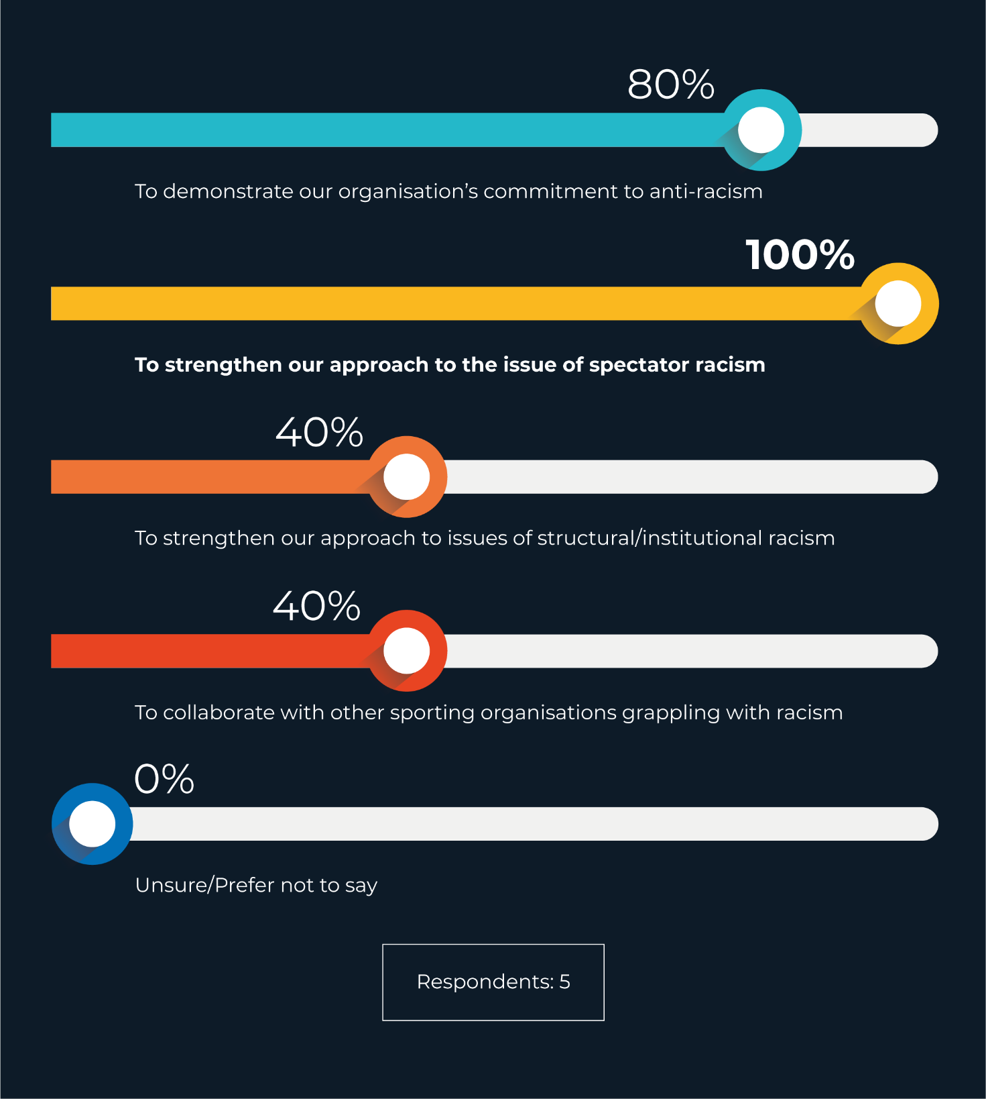

When asked to describe the impact of the Guidelines on their organisation’s approach to racism and racial discrimination to date:
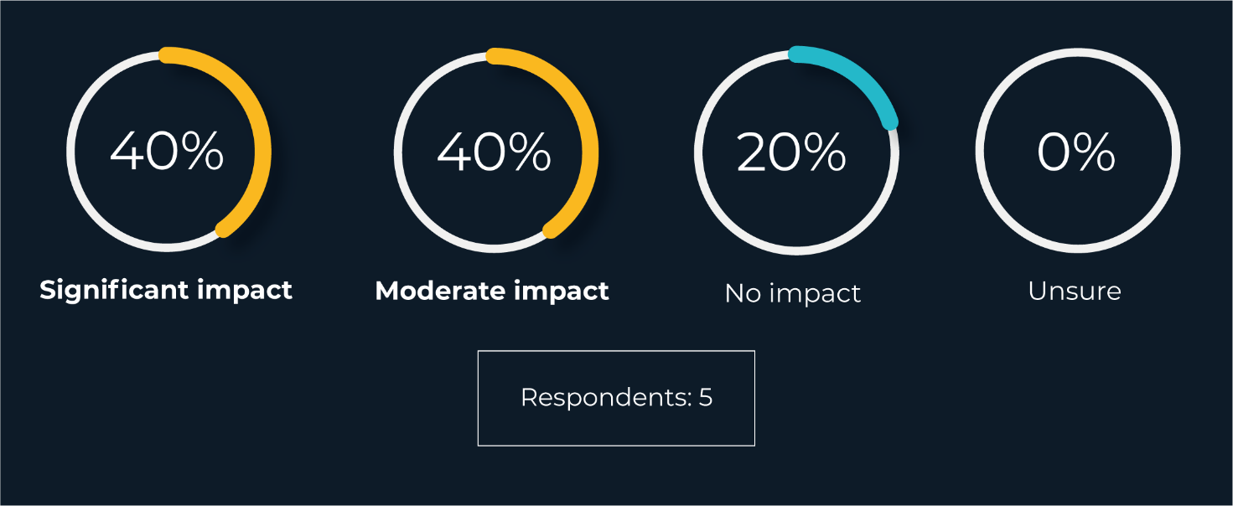

When asked to describe their organisation’s relationship to each of the 13 steps provided in the Guidelines:
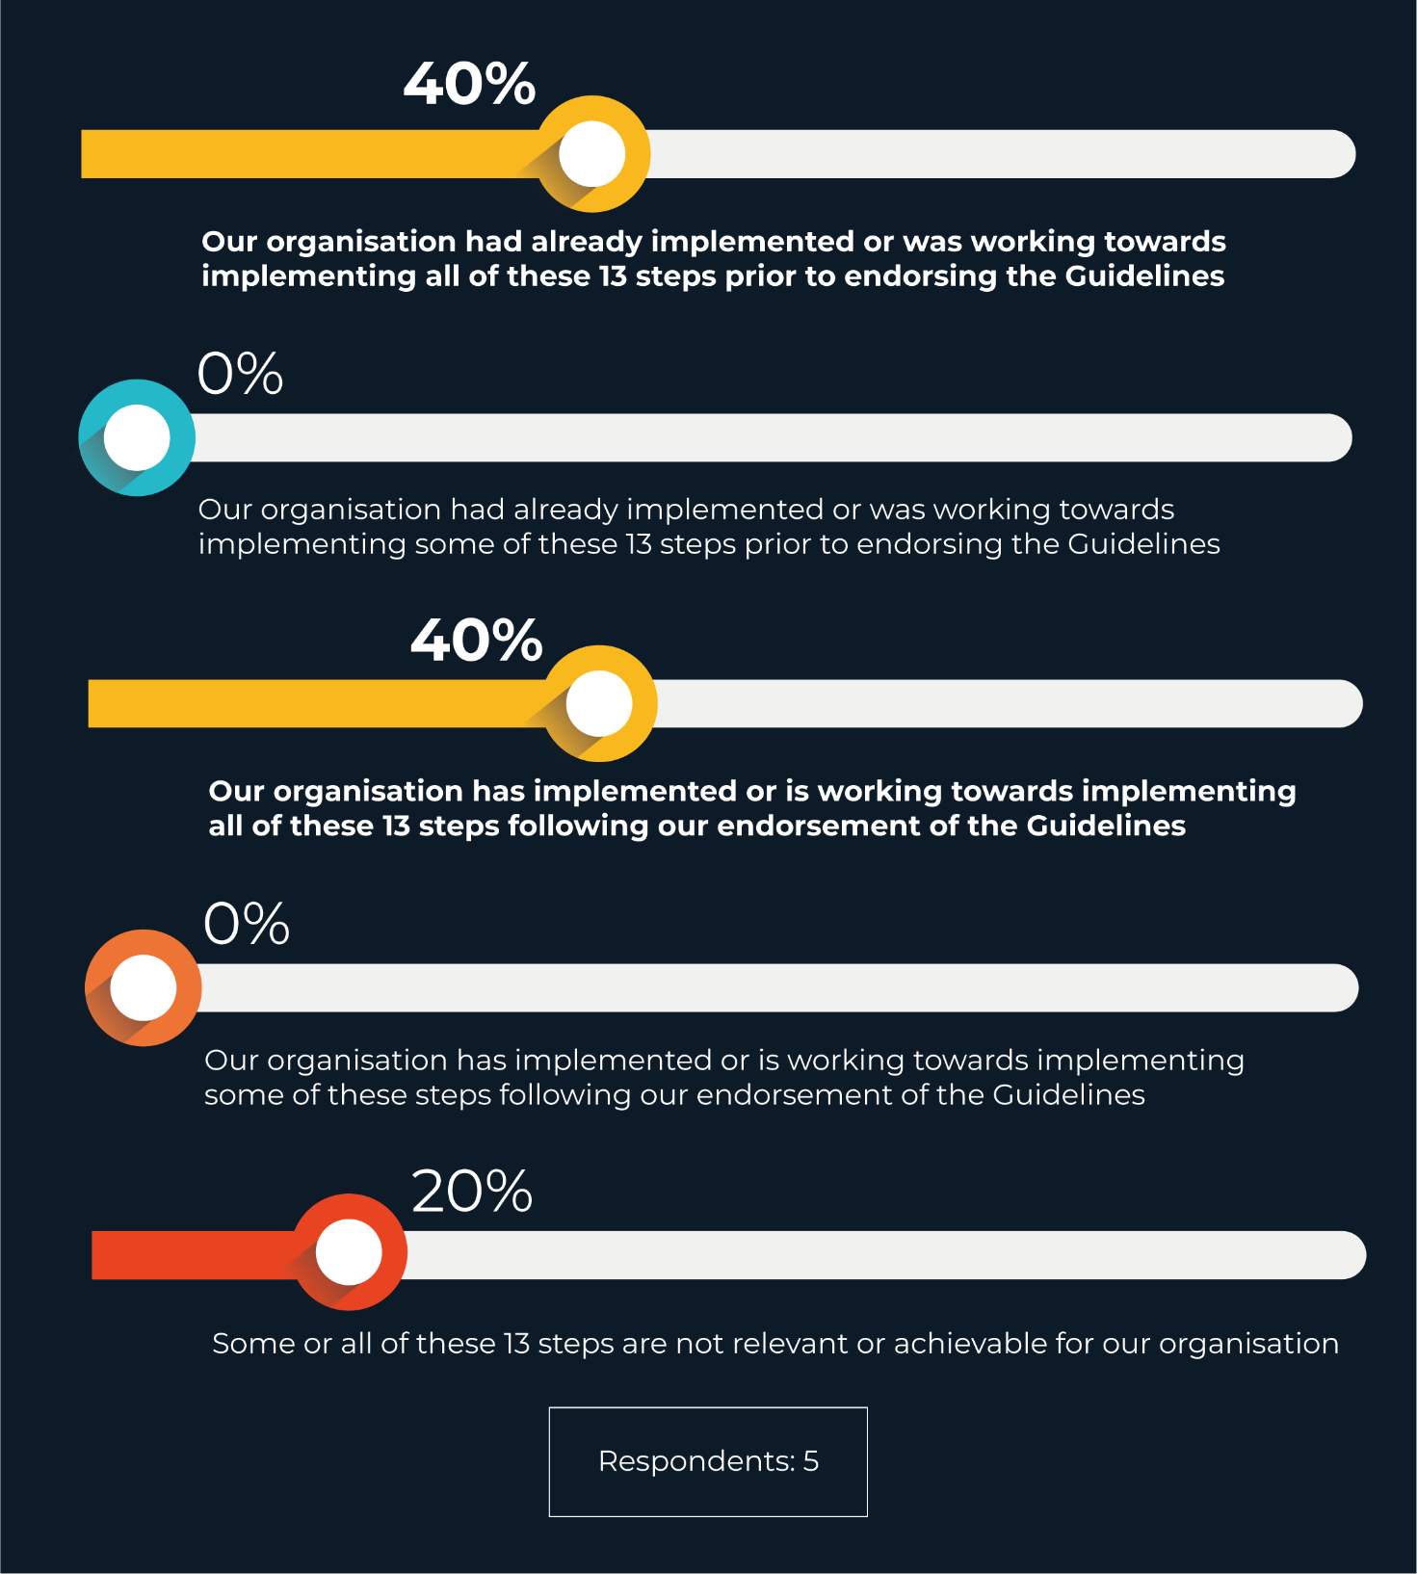

When asked, if their organisation has not yet implemented the 13 steps included in the Guidelines, what has prevented this:
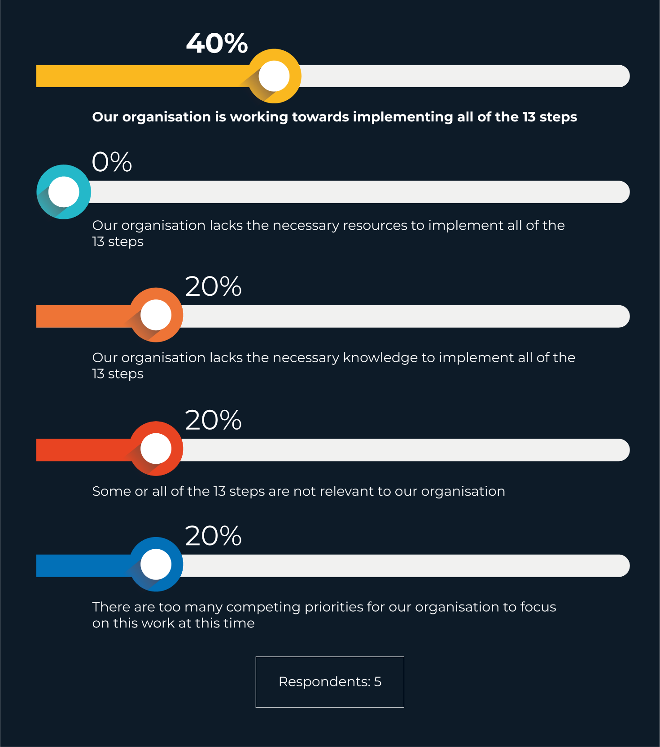

When asked if they, or anyone in their organisation, had accessed any of the following supporting resources created to accompany the Guidelines (selecting all that apply):
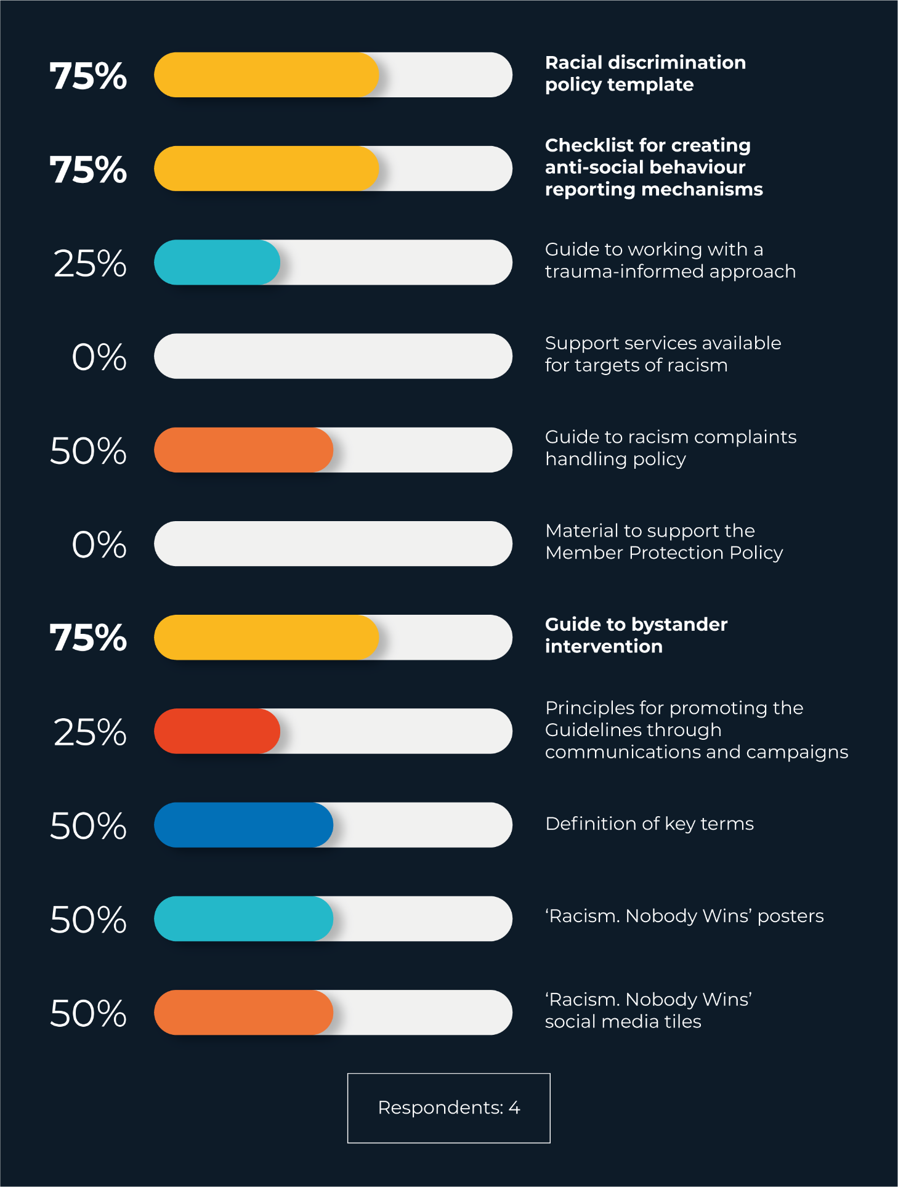
When asked how useful they found each of the following supporting resources for promoting better practice within their organisation (rating only those resources that had been accessed by someone in the organisation):
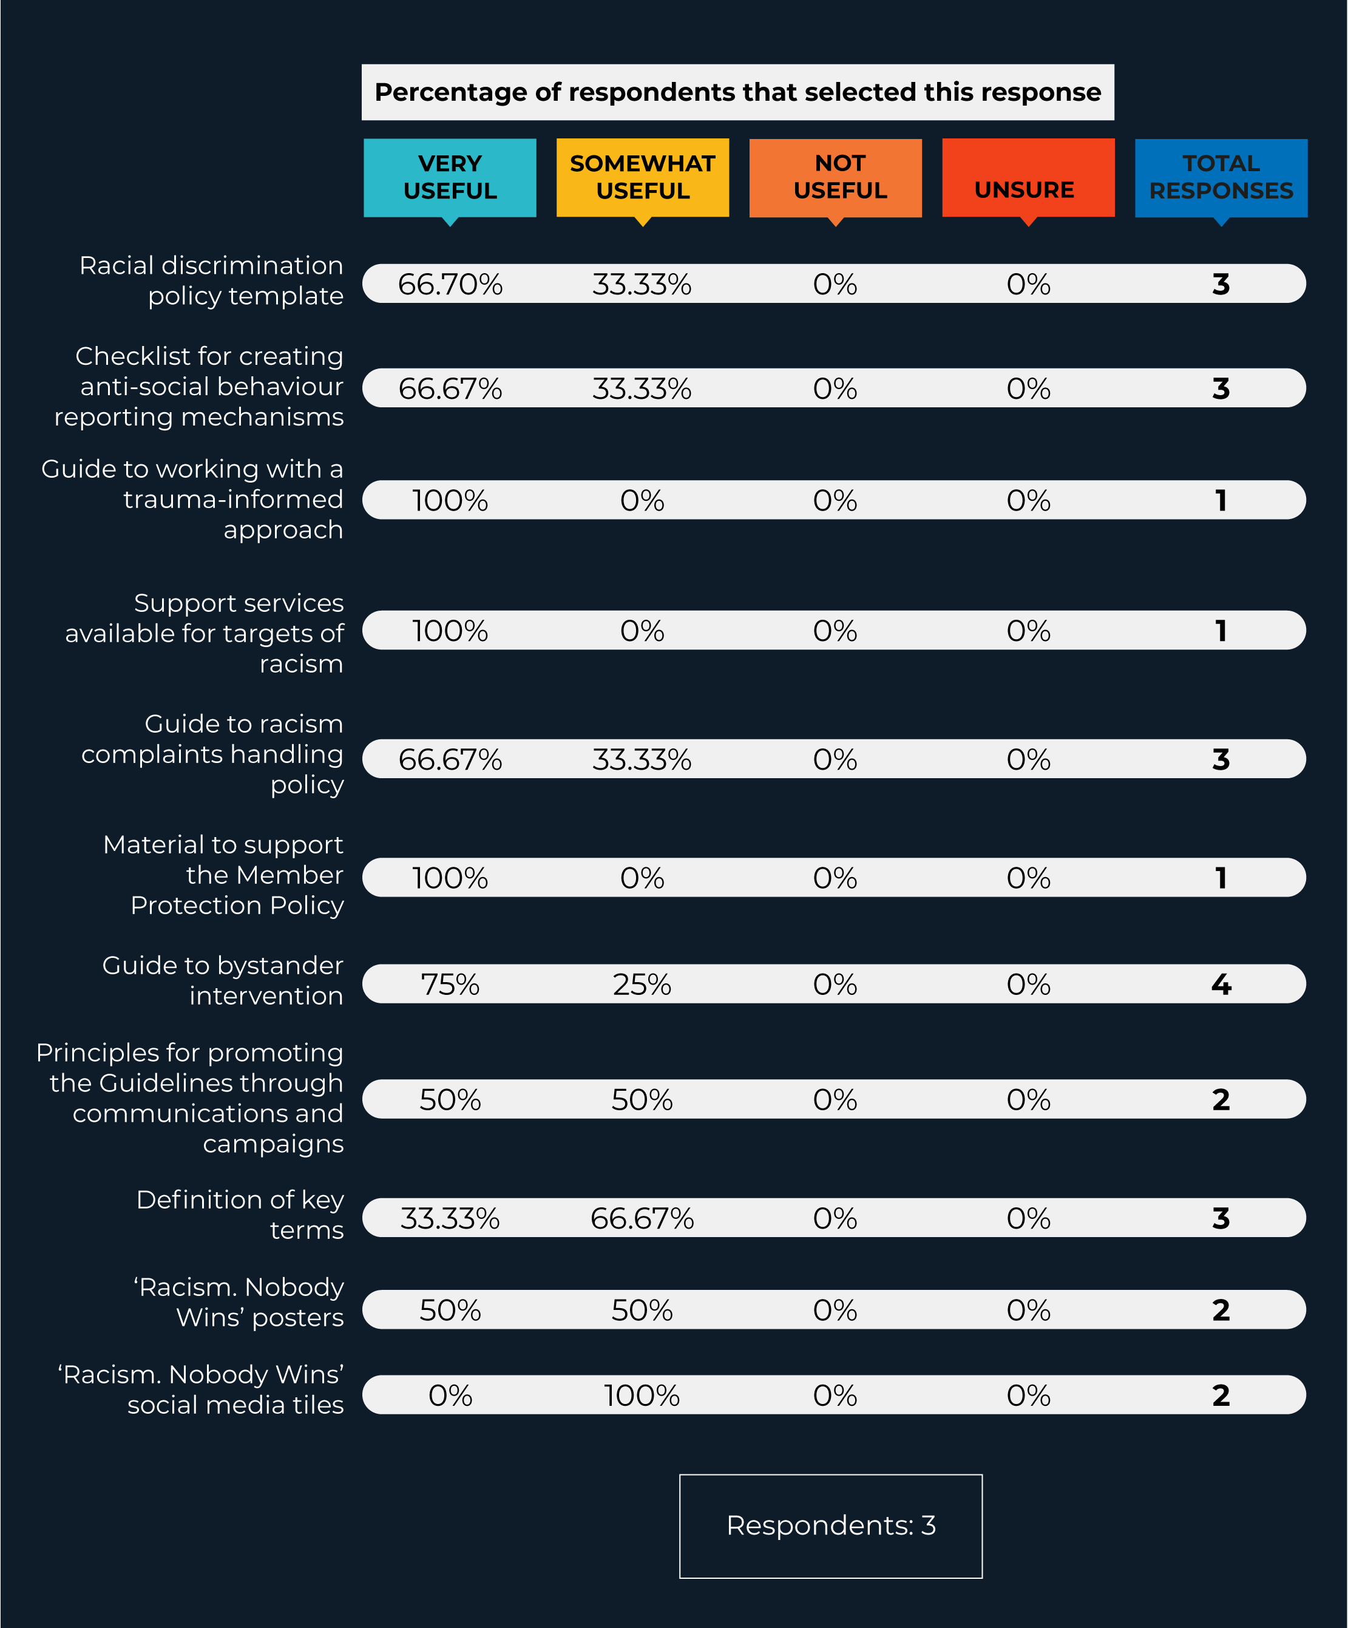
When asked what kinds of resources would be most useful to them as they engage in anti‑racism within their organisation or facility (selecting all that apply):
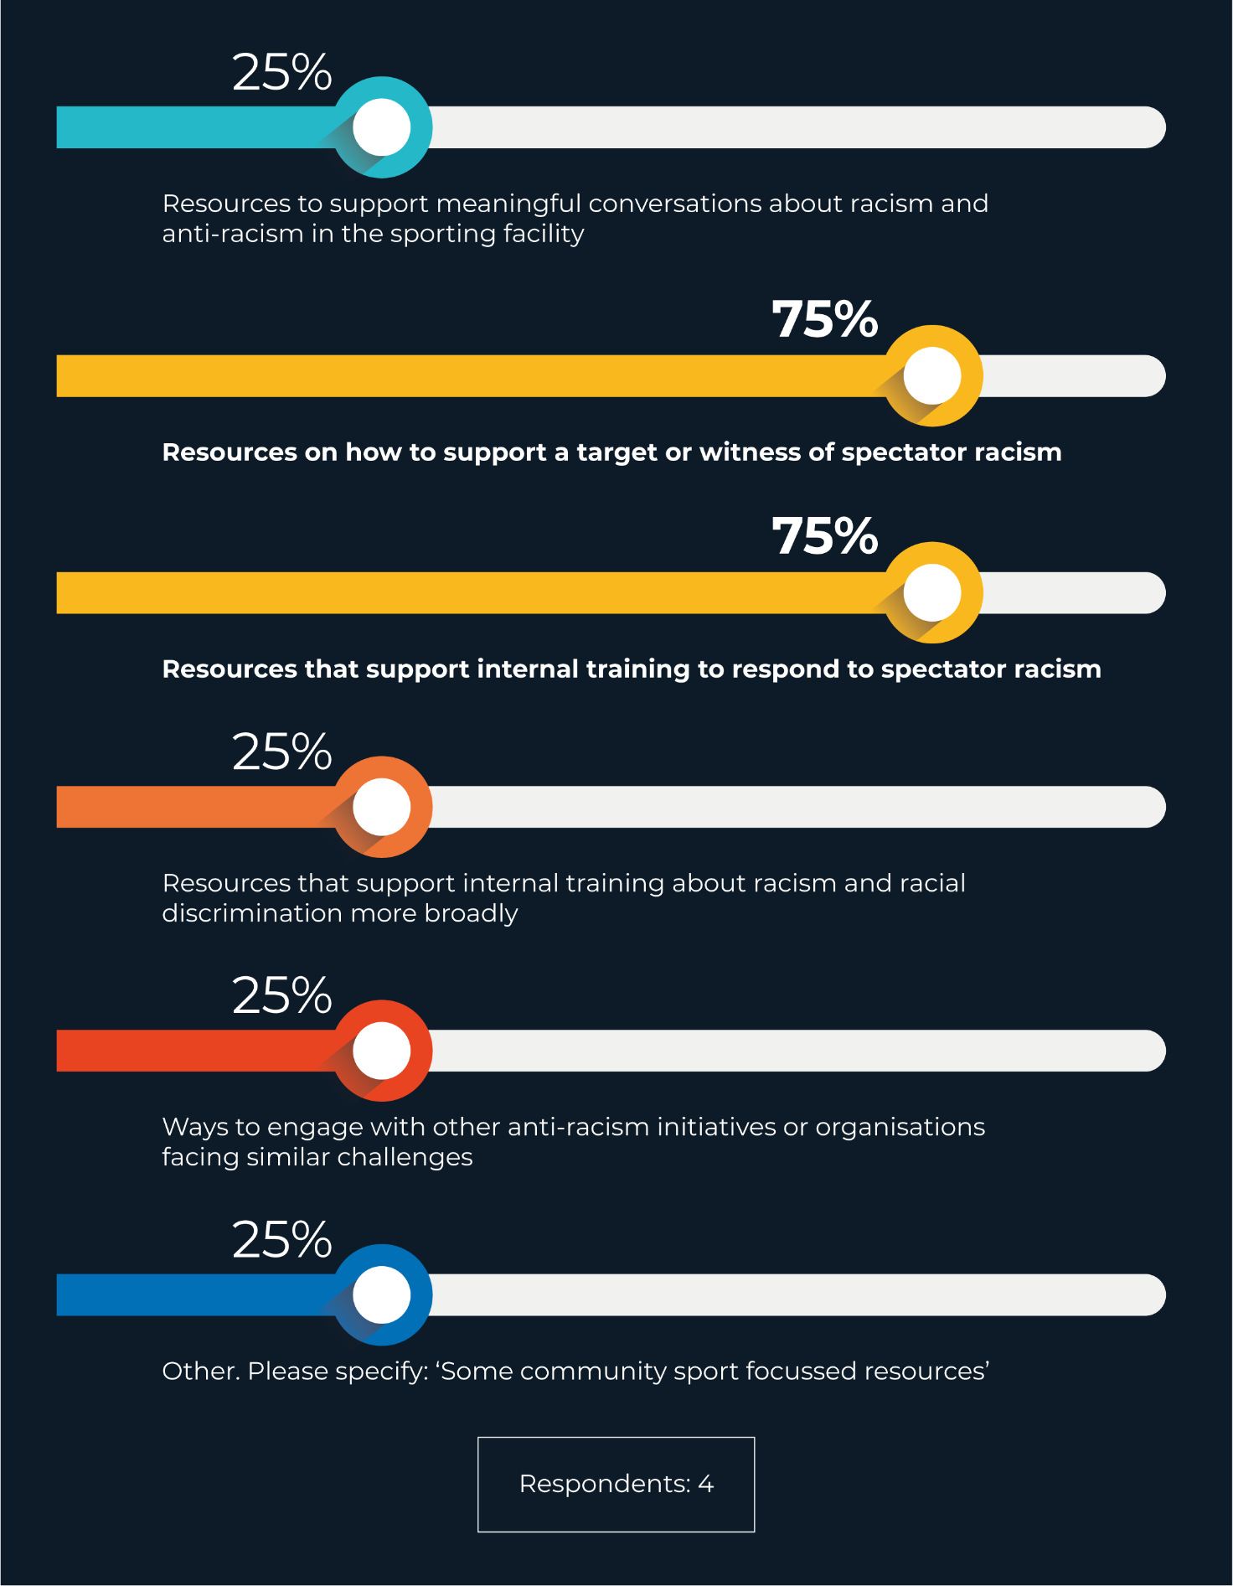

Other
In September 2022, the Guidelines and supporting resources were awarded a silver medal at the Sydney Design Awards in the category of ‘Better Future – Equity and Inclusion’.
In November 2022, the Guidelines and supporting resources were awarded Bronze at the Transform Awards ANZ 2022 in the category of ‘Best Visual Identity by Charity, NGO or NFP’.
Finally, in 2023, the project won Gold in the Better Futures – Equity and Inclusion category of the 2023 Australian Design Awards.
The project’s evaluation also included an analysis of media reach, the consultation and drafting process, and web analytics for the project page. For more information on this evaluation, please contact the Race Discrimination Team: antiracismsecretariat@humanrights.gov.au.

Recommendations and next steps
While the Spectator Racism project has so far enjoyed relative success and recognition, ongoing incidents demonstrate that more must be done to address the issue of spectator racism in sports, and to situate this within a broader approach to addressing racism at the institutional and systemic level.
Based on insights gained throughout the roundtable, drafting process, launch and evaluation, the Commission recommends four areas of development for this project:

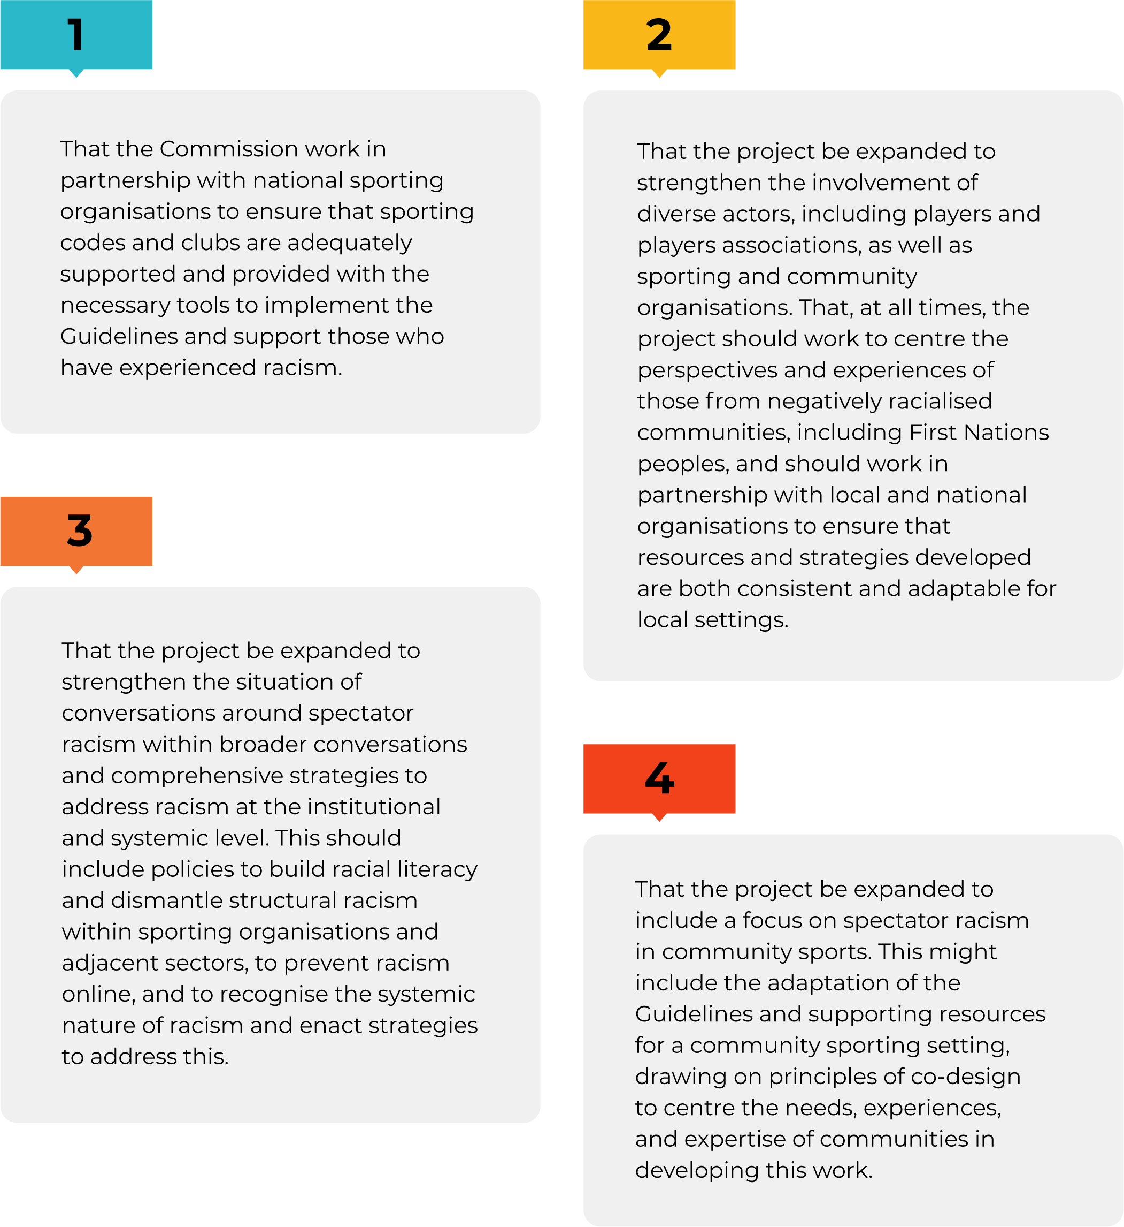

Further Information
Australian Human Rights Commission
GPO Box 5218
SYDNEY NSW 2001
Telephone: (02) 9284 9600
Complaints Infoline: 1300 656 419
General enquiries and publications: 1300 369 711
TTY: 1800 620 241
Fax: (02) 9284 9611
Website: www.humanrights.gov.au
For detailed and up to date information about the Australian Human Rights Commission visit our website at www.humanrights.gov.au. To order more publications from the Australian Human Rights Commission, download a Publication Order Form at www.humanrights.gov.au/about/publications/, call: (02) 9284 9600, fax: (02) 9284 9611 or email: publications@humanrights.gov.au.

